Gear Contact Geometry

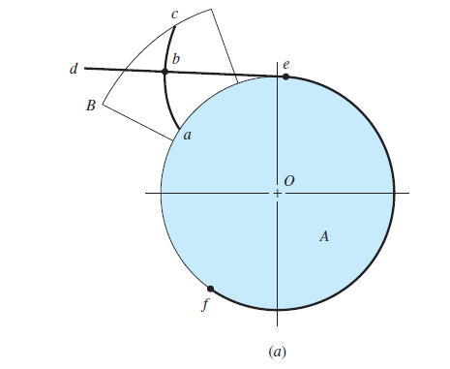
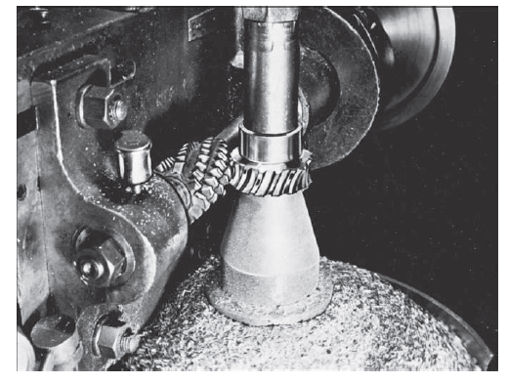

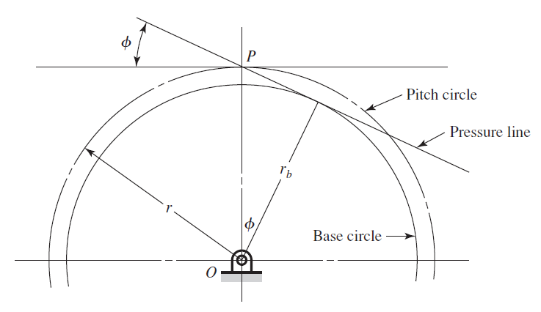

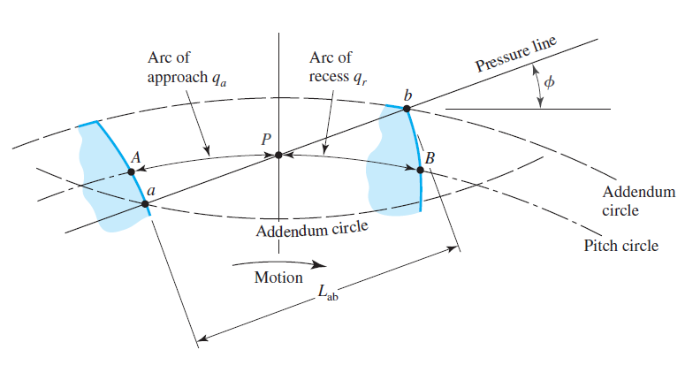

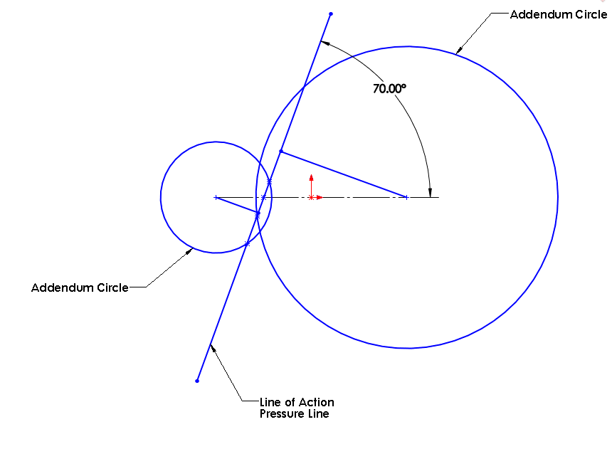

Contact starts when the line of action (all contact points are on the line of action) intersects the top of (addendum circle) of the mating gear (Gear). The contact ends when the line of action intersects the addendum circle of the driving gear (Pinion).

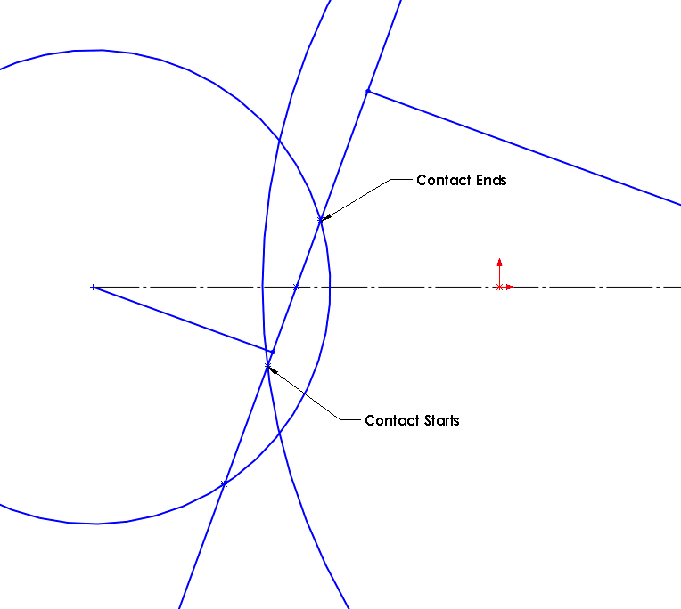

Since only the portion of profile above base circle can be involute, the contact in this case extends beyond the involute profile and hence interference (undercutting) occurs.

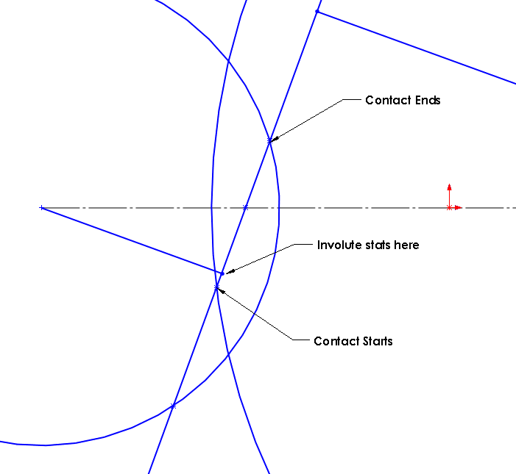

The contact ratio is the distance between the points of contact on the line of action divided by the base pitch.

