ME 314 HW#7

- In the figure shown below, gear 2 is input and gear 5 is out. The gears form a regular gear train (the arm is fixed and pins are fixed in place). Determine the gear ratio, the output gear rpm, and the output gear direction of rotation. Gear 2 is input running at 100 rpm CCW. Gear 5 is a ring gear and is the output. Note that the drawing is not to scale. All the gears have the same diametral pitch. The number of teeth are as follows (you can find N₅):

N₂=20
N₃=20
N₄=30

Answers: 616 CCW
2
3
4
5

- In the figure shown above, gear 2 is input and gear 5 is fixed. The arm is the output. The gears form a planetary gear train (the arm is free to rotate). Determine the gear ratio, the output arm rpm, and the output arm direction of rotation. Gear 2 is input running at 100 rpm CCW. Gear 5 is a ring (internal) gear. Note that the drawing is not to scale. All the gears have the same diametral pitch. Also determine the rpm of gear 4. Answers: n_{A}= 20 rpm cw

- Consider the planetary gear train shown in the figure below. The number of teeth for each gear is indicated in the figure.
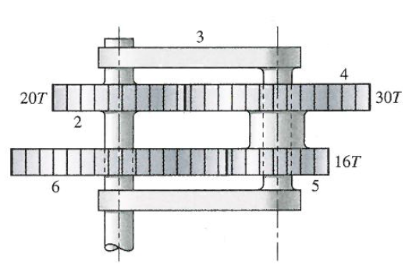

Gear 6 is rotating at 12 rpm CW. Gear 2 is fixed. Find the speed and direction of the arm. Note: the fillet shapes indicate fixed or welded attachment. No fillet means free to rotate. Dashed lines also mean free to rotate. The two-piece arm is for physical stability, for kinematics analysis you can ignore the lower arm and the kinematics would not change. Answer n_{A} = 17.5 cw

- A 2-inch pitch diameter pinion is transmitting 3 horsepower at 500 rpm. The diametral pitch is 16 teeth per inch and the pressure angle is 20 degrees. The gear shaft is cantilevered as shown. The details of the bearing fit into housing are not shown. The drawing is not to scale.

2 in
1 in

Determine:
- Tangential force [ 378 lbs]
- Radial force [136 lbs]
- Total Force [402 lbs]
- Largest bearing radial load [603 lbs]

