ME 314 HW#6

- A 17-tooth spur pinion has a diametral pitch of 8 teeth/in, runs at 1120 rpm and drives a gear at a speed of 544 rpm. Find the number of teeth on the gear and the theoretical center distance between the shafts.

- A 21-tooth spur gear mates with a 28-tooth gear. The diameteral pitch is 3 teeth per inch. The pressure angle is 20 degrees. Create a table (for gear and pinion) showing the following results:

  - Pitch diameters
  - Base diameters
  - Addendum diameters
  - Dedendum diameters
  - Addendum
  - Dedendum
  - Circular pitch
  - Tooth thickness

Example for the first two diameters:
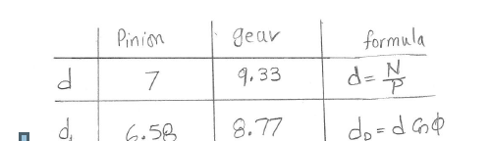

- For the problem above, make a drawing of the following information in correct scale. Draw both gears at their theoretical center distance. You must use SolidWorks or an equivalent CAD system.
  - Pitch circles
  - Base circles
  - Addendum circles
  - Dedendum circles
  - Line of action (rope)
  - Start and end of contact on the line of action (label with two large dots). The start and end of contact is determined by the intersection of the two addendum circles with the pressure line) – See Figure 13-15 in text.

Something like this:

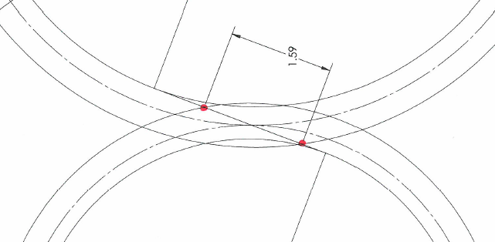

- For the above problem, find the contact ratio using the Excel formula. [1.6]

- A spur gearset has a pressure angle of 20 degrees. To avoid interference, what is the minimum number of teeth allowed on the pinion for the following gear ratios:
  - Two to one [15]
  - Four to one [16]

