ECE 241L * Intro to EE Lab
Lab 1 : Introduction to Basic Lab Equipment

Objective: To become familiar with building a circuit on a protoboard, using a DC power supply and making measurements with a multimeter.

Equipment: Lab bench DC power supply, multimeter and computer
ECE toolbox with protoboard, wires, cables and assorted resistors

Introduction: Welcome to the ECE 241 lab! In this first experiment, you will build and make measurements on a few resistor circuits. This lab will demonstrate the basic laws of circuit analysis (KVL, KCL and Ohm’s Law) but the main objective of the lab is to familiarize yourselves with basic lab equipment and measurement techniques.

Before the lab:
1. Find the Quick Guides on the lab web page (http://web.cecs.pdx.edu/~ecelab) for the Protoboard (also called a breadboard), DC Power Supply (“PS”) and Multimeter (“MM”). I suggest you look these over quickly before the lab and have them open on the computer during the lab for reference. This handout will only provide general instructions, while the guides have detailed instructions for the specific equipment in the lab.

2. For the circuit below:
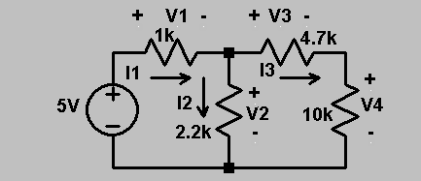
a) Write one KCL and two KVL equations. Use Ohm’s Law to write all the equations in terms of the three currents.

Figure 1.
KCL:
KVL:
KVL:
b) Solve for the three currents (you can do this on your calculator; if you haven’t used it to solve simultaneous equations before, now is a good time to learn!) and then find the voltages from Ohm’s Law. Put the values in Table 1 on the next page.
Note: remember “1k” = 1 kΩ = 1000 Ω. Put currents in the table in mA (0.001 A) and use 3 decimal places.

 | Calculated | Measured | Calc. with meas. R
I₁
I₂
I₃
V₁
V₂
V₃
V₄

Table 1.

Procedure:
1. Select 1k, 2.2k, 4.7k and 10k resistors. These are the nominal resistor values; the actual values may be a few percent different. Measure each resistor with the MM. Do not plug the resistors into the protoboard for these measurements. Be sure the MM is set properly to measure resistance. Record the measured values in Table 2 below.

Nominal R | Measured R
1 kΩ
2.2 kΩ
4.7 kΩ
10 kΩ
Table 2.
2. Build the circuit in Figure 1 on your protoboard. Do not turn on the PS until you have set up and carefully checked your circuit. Refer to the protoboard layout in the quick guide to see how the rows and columns are connected.
It is good practice to lay out the circuit on the board (i) neatly, (ii) with the wires short and close to the board (this is mostly important at higher ac frequencies, but excessively long wires contribute to messiness) and (iii) in a configuration closely following the circuit schematic. All this will be very helpful when you need to troubleshoot a dysfunctional circuit. Look at the figure below and see which circuit you would prefer to debug!
Figure 2.
3. Set the PS to 5 V, following the instructions in the quick guide. Measure all the voltages and currents, and record the measurements in Table 1 (read the following instructions first!) Be careful that you have the MM connected correctly and set correctly for the two kinds of measurements! It is very easy to blow the fuse in the MM (and in the lab manager ☺) if this is not done right. Refer to the MM quick guide, and if you have any doubts, ask the TA.
(i) For voltage measurements, place the MM leads across the component, and set the MM for DC voltage. In Figure 3, the V-box represents the placement of a voltmeter to measure the voltage across R.
(ii) For current measurements, place the MM in series with the component, and set the MM for DC current. In Figure 3, the A-box represents the placement of an ammeter to measure the current through R.
Where multiple ranges are available, start with the highest to be safe and then turn it down as needed. Use the lowest possible range to get the best resolution.
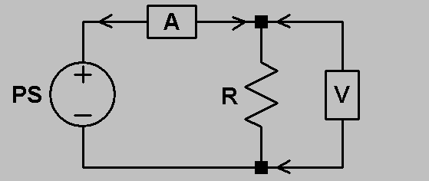

Figure 3
4. Your calculations and measurements in Table 1 should be very close, but are probably not exact. (If they are way off, more than say 10%, double-check both your calculations and measurements and ask for help if needed – something is wrong!) Repeat the calculations using the actual measured values of the resistors from Table 2. How do they compare now? If they do not agree exactly, what are some other possible sources of error?

5. This step is to give you some practice in troubleshooting. First build the circuit in Figure 4 below by adding on a few components to the circuit you already have. You don’t need to find all the currents and voltages this time, but as a quick check verify that V across the 4.7 kΩ resistor is approximately 2 V with the polarity shown.
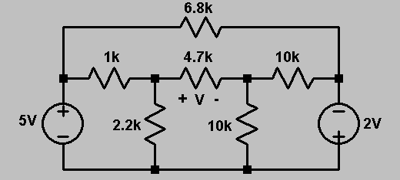

Figure 4.

Now one person should intentionally move a wire so that the circuit doesn’t work while their lab partner looks away. The partner then needs to find the misplaced wire. Just make sure that when you move a wire, you’re not shorting out the power supply! Repeat with the partner’s roles reversed. You can do this exercise a couple of times if you want, and feel free to try and make it hard for each other! You should find that a methodical approach to troubleshooting works best: check the power and ground connections first, then trace through the circuit following the schematic.

6. The final experiment is to investigate the effect of the MM on the currents and voltages in the circuit.

An ideal voltmeter has infinite resistance and draws no current; a realistic voltmeter has very large but not infinite resistance and draws very little but not zero current. As long as the voltmeter resistance is much greater than other resistors in the circuit, the amount of current it draws and its effect on the circuit will be negligible. Similarly, an ideal ammeter has zero resistance and no voltage across it; a realistic ammeter has very small but not zero resistance and drops very little but not zero voltage. As long as the ammeter resistance is much smaller than other resistors in the circuit, the amount of voltage it drops and its effect on the circuit will be negligible.

a) Build the circuit in Figure 5 below with R₁ = R₂ = (i) 1 kΩ and then (ii) 1 MΩ. In each case, measure the actual resistances, calculate and measure V across R₂, and record the results in Table 3 below. Use the actual resistor values for the calculations.
b) Measure the current in the circuit with R₁ = R₂ = (i) 1 kΩ and then (ii) 10 Ω. Use the actual resistor values for the calculations. Record the results in Table 3 below.
What do you observe about the effects of the meter in this experiment? Note: you might not observe a lot! Digital meters are much less sensitive to these effects than analog meters. If you do not see any difference, you can try increasing the resistors in a) and decreasing the resistors in b), though be careful how much current you are drawing (note we have already turned the voltage down in this step to keep the currents low with smaller resistors.) In addition, you may not see 1 V coming out of the PS with the 10 Ω resistors due to the internal resistance of the PS. If this is true, can you still determine the effect of the ammeter?
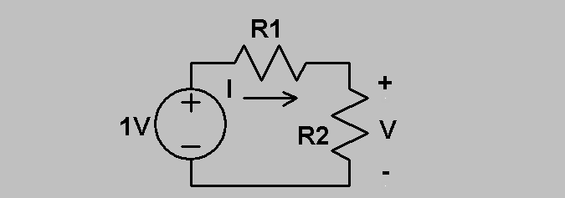
.

Figure 5.

R₁ = R₂ = 1 kΩ | V_{calc} = | V_{meas} =
R₁ = R₂ = 1 MΩ | V_{calc} = | V_{meas} =
R₁ = R₂ = 1 kΩ | I_{calc} = | I_{meas} =
R₁ = R₂ = 10 Ω | I_{calc} = | I_{meas} =
Table 3.

7. Discuss your conclusions from this lab (all of it.) What did you learn? What do you think of it? Any suggestions for improvement? Turn in this handout with all tables filled in and all questions answered. Continue on another page if you need more room.

Tsividis, Y., A First Lab in Circuits and Electronics, Wiley 2002

