Robotics Kits: Inventory
Make sure your LEGO kit has all of the following pieces, and that they are marked with the number from your KIT’s box (e.g. II.10). If you are missing any of these pieces notify your mentor immediately:

OUT |  | KIT # |  | IN
 |  | 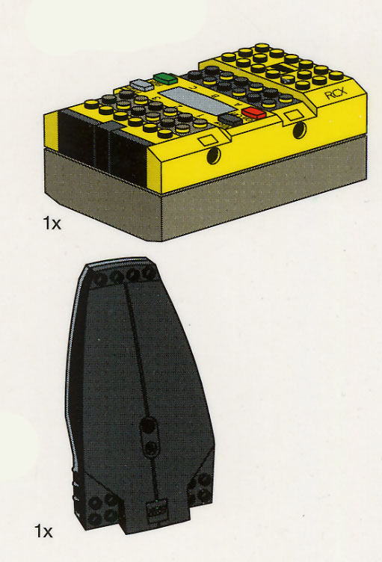 | RCX computer
 |  |  | infrared tower
 |  | 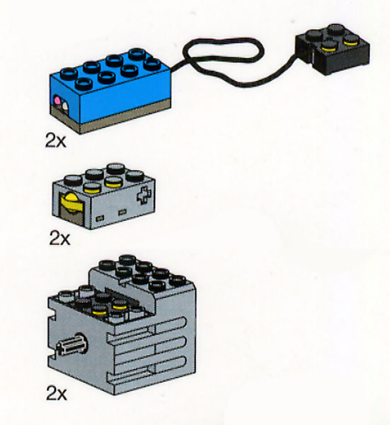 | bump sensors (2)
 |  |  | light sensors (2)
 |  |  | motors (2)

Statement of Responsibility
I understand that in accepting this LEGO Mindstorms robotics kit for use in Portland State University’s ‘Design and Society’ Freshman Inquiry class, I am expected to maintain and return the kit in complete form and working order.

Should the kit be returned with any pieces from this table missing, I understand that our team will be financially responsible for their replacment.

student
signature / name date

student
signature / name date

student
signature / name date

student
signature / name date

