WHY OUTREACH?
The OSO was created in response to national concerns about a potentially inadequate supply of trained American scientists and engineers to fill future jobs in the U.S., as well as concerns about the significant under-representation of women and ethnic minorities in science and technology careers. Science outreach is now required by some federal R&D funding agencies, such as the National Science Foundation and NASA, as a condition of funding major science and technology research centers. The need for science outreach is evidenced by the following data:
Articles & Information
Click here to read about the latest concerns behind the OSO's outreach efforts.
U.S. Demographic Trends [top]
Although future workforce needs are notoriously difficult to predict, the U.S. government projects significant increases in the numbers of scientists and engineers needed in American by 2010. Non-minority men (36% of the U.S. population) constitute 65% of the science and technology (S&T) workforce. However, the proportion of non-minority men earning bachelors’ degrees in S&T fields dropped 28% between 1977 and 1997 and the proportion earning PhD's dropped 19%.
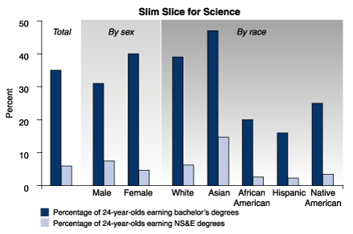
Women and most minority groups are less likely to earn natural science and engineering degrees than the population as a whole. SOURCE: NSF, 2002
Increases in the numbers of PhD's granted to women and ethnic minorities in the past few years have helped to make up for the drop in non-minority men. But women now represent only about 8% of American researchers with at least a bachelor’s degree in natural sciences or engineering. And ethnic minorities, the fastest growing segment of the U.S. population, are even less well represented in the fields of Natural Sciences and Engineering.
In 1995 minorities constituted 25% of the U.S. total workforce; by 2050 they are projected to constitute 48%. This trend is even more dramatic in California where two out of every three children in public schools are now ethnic minorities. Hispanics alone constitute 45% of all students in California public school, as compared to 34% ten years ago. But only 3% of scientists in the U.S. with at least a bachelor’s degree are Hispanic. In fact, only 10% of Hispanics graduate from college (as compared to 32% of non-minorities in the U.S.). 30% of Hispanics drop out of high school, a drop-out rate that is projected to increase by 2010.
U.S. Science & Engineering Education as Compared to Other Countries [top]
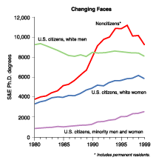
Decline in US white male recipients of Ph.Ds
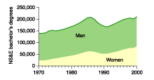
Comparison of Males and Females in Natural Sciences and Engineering Fields
In 1975 Japan was the only nation in the world to educate a higher proportion of its youth in natural science and technology fields than the U.S. America now ranks 14th among nations in the proportion of 24-year-olds with a bachelors (or equivalent) degree in natural sciences and technology fields. Further, the performance of American students in middle and high schools on international math and science exams is below the average of 38 other countries in the world. In 2000 only 17% of U.S. high school seniors scored at the “proficient” level in math on the National Assessment of Education test.
Projected Declines in Numbers of Foreign Nationals Studying/Working in U.S. [top]
For the past quarter century foreign nationals have constituted a large portion of graduate students in the U.S., many of whom have become a permanent part of the US science and technology workforce. However, in 2003 there was a 27% drop in State Department-issued student visas, and in 2004 most major American research universities are experiencing noticeable declines in foreign student applications. Applications from Chinese students are down almost 50%. (Although the number of international graduate students at Stanford is now at an all-time high, Stanford also has a 14% decrease in the number of foreign applications for the Fall, 2004 enrollment.) Moreover, an increasing proportion of foreign nationals who get advanced degrees in the U.S. are now returning to their home countries to work.
Summary [top]
Sources National Science Board’s report, "Science Indicators", 2002
"Ensuring a Strong U.S. Scientific, Technical, and Engineering Workforce in the 21st Century", April 2000, National Science & Technology Council, Office of the President
California Department of Education Data
U.S. Census Bureau
National Center of Education Statistics
Chronicle of Higher Education, 2/26/04
Trends in International Mathematics & Science Study (http://nces.ed.gov/timss/)
In summary, America is facing a decline in the numbers of foreign graduate students and workers in science and technology fields, a decline in the number of non-minority American men entering these fields, a significant under-representation of women in the natural sciences and engineering, and an increasing number of ethnic minorities in the U.S., groups which traditionally have not gone into science and technology fields. Moreover, science policy is becoming increasingly complicated, requiring the general public and policy makers to understand at greater depths science and its broader implications, especially in emerging new fields such as bio-engineering and nano-scale science and technology. If the current trends discussed above continue, and if the science and technology workforce needs increase as predicted, we will inevitably see a decline in American's science and engineering capabilities. Therefore, Stanford shares the concerns of NASA and NSF and other federal agencies about the need for universities to engage in vigorous science outreach targeted at people of both genders and all ethnicities in America.
Patricia Devaney, Director of the Office of Science Outreach
March 1, 2004 [top]
Critical reading

- What is the goal of this article?

- What is the thesis?

- What evidence is used to support the thesis?

- What context is provided to help in interpretation?

- Why were these graphs selected?

- Are they easy to read? Are they misleading or incomplete?

- What questions does this raise? How would you try to find answer those questions?

