Drought in the Klamath River Basin
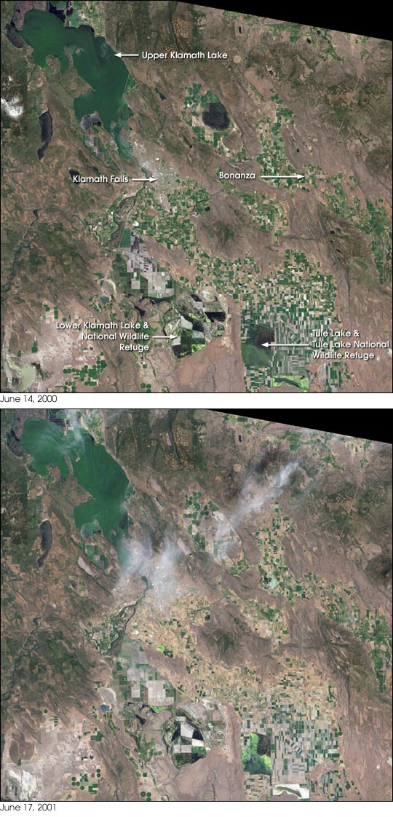
full-resolution images
June 14, 2000 (2.7 MB JPEG)
June 17, 2001 (2.6 MB JPEG)
For more than 100 years groups in the western United States have fought over water. During the 1880s, sheep ranchers and cattle ranchers argued over drinking water for their livestock on the high plains. In 1913, the city of Los Angeles began to draw water away from small agricultural communities in the Owen Valley, leaving a dusty dry lake bed. In the late 1950s, construction of the Glen Canyon Dam catalyzed the American environmental movement. Today, farmers are fighting fishermen, environmentalists, and Native American tribes over the water in the Upper Klamath River Basin.
A below-average winter snowpack and low rainfall throughout the year have caused an extreme drought in the area along the California/Oregon border. In April 2001 a U.S. District Court stopped water deliveries to farms in the Klamath Irrigation District to preserve adequate water levels in Upper Klamath Lake to protect two endangered species of Mullet fish (called suckers). Water was also reserved for the threatened Coho Salmon which need enough water to swim downstream from their spawning grounds to the ocean. In addition, several Native American tribes have rights to Klamath River water. Further complicating the situation are a handful of wildlife refuges which usually receive enough irrigation wastewater to support upwards of a million migratory birds and 900 Bald Eagles. This year, however, several of the refuges may not have enough water for the birds which begin arriving in early fall.
The severity of this year’s drought is underscored by the town of Bonanza, Oregon. Famous for its natural springs, and entirely dependent on wells for drinking water, the town’s water supply is now contaminated with pesticides, fertilizer, and manure. The water quality is so bad it’s not even safe to bathe in, much less drink. The problem stems from a very low water table. The drop in underground water levels is caused directly by the drought, and indirectly from the increased irrigation from underground aquifers to compensate for the lack of water from Upper Klamath Lake. As the water table drops, clean water stops flowing from the springs and wells, and dirty water from fields flows into the water beneath Bonanza.
Area farmers, many of them entirely dependent on irrigation, immediately launched protests when the court’s decision to stop irrigation flows was announced, leading to national media coverage. On July 24 the Department of the Interior approved the release of some irrigation water from Upper Klamath Lake, but the flow lasted only until August 23. The water was enough to save some fields growing winter feed for livestock, but some other crops were unsalvageable, and water didn’t reach every farmer who needed it.
The Klamath Project dates back to 1903, when the Reclamation Service (now the Bureau of Reclamation, a branch of the U.S. Department of the Interior) investigated the possibility of converting rangeland, wetlands, and natural lakes into irrigated farmland. Construction began in 1906, the first water deliveries were made in 1907, and the project was completed in 1924. The Bureau of Reclamation supplies water to the farmers at the cost of delivery, without charging for the water. Fodder, barley, oats, potatoes, and wheat are the principal crops on the 225,000 acres of irrigated land. In addition, the irrigation dams control floodwaters, and the Link River Dam supplies hydroelectric power.
The images above show the northeast portion of the Klamath Basin in 2000 (top) and 2001 (lower). These true-color images were acquired by the Enhanced Thematic Mapper Plus sensor aboard the Landsat 7 satellite, launched by NASA and operated by the U.S. Geological Survey. Upper Klamath Lake, with its endangered sucker fish, is at the upper left, with the town of Klamath falls immediately below it. Bonanza is to the right of Klamath Falls. Tule Lake, which has been partially converted to farmland, is at the lower right and is surrounded by the Tule Lake National Wildlife Refuge. To the left of Tule Lake are the remains of Lower Klamath Lake and the marshes of the Lower Klamath National Wildlife Refuge.
Farms left dry by the water shortage appear brown in this year’s image. Most of the farms without irrigation water are between Upper Klamath Lake and Tule Lake. The land immediately surrounding Tule Lake did receive irrigation water this year, and as a result is greener than the fields to the north. Some farms rely on wells and not Klamath Project water, and many of these remained green, as well.
Images courtesy USGS EROS Data Center and the Landsat 7 Science Team

http://www.pbs.org/newshour/bb/environment/july-dec01/fish_8-20.html#

video

Indian Water Resources News
Monday July 02, 2003
Native American Rights Fund Exposes Bias of National Resource Council Committee, Urges Withdrawal of Interim Report on Klamath Basin
Source: Native American Rights Fund
Boulder, Colo. – The president of the National Academy of Sciences has affirmed his support for Academy actions that are "blatantly discriminatory against Native American people," it was revealed today by Native American Rights Fund (NARF) executive director John Echohawk.
n a recent letter to Dr. Bruce Alberts, president of the National Academy of Sciences (NAS) and chairman of the National Research Council (NRC), Echohawk called for the withdrawal of the NRC committee’s initial findings on water issues in the Klamath River Basin, citing socioeconomic bias and sloppy science.
It is with great regret that I am making public our correspondence to Dr. Alberts and his reply," Echohawk said. "The Native American Rights Fund had hoped that when presented with incontrovertible evidence that one of the Academy’s National Research Council panels had knowingly and deliberately subjugated the rights of a Native American tribe and demeaned the value of the tribe’s resources, president and chairman Alberts would take steps to restore the Academy’s social responsibility and scientific integrity." "Instead," Echohawk continued, "he simply denies that racially biased and scientifically unsound statements, or that the focus on the importance of farm economics to the exclusion of the economic concerns of native Americans, by his panel’s leadership played any role in the NRC interim report recommending that the Klamath Tribes’ endangered fish be deprived of their natural water supply."
In his letter to Alberts, Echohawk asserts that the interim report and statements by committee chair William Lewis Jr. clearly indicate that the committee has applied standards inconsistent with the NRC’s extensive guidance on species protection under the Endangered Species Act.
Specifically, the committee considered the "economic stakes" involved in the agency decisions, even though the NRC has instructed that such decisions must be based only on scientific aspects of species protection. Moreover, as Echohawk’s letter pointed out, the "economic stakes" considered by the panel were only those of non-Indians, and equivalent Indian interests were ignored.
"Dr. Alberts does not deny that his panel chair made remarks that are clearly biased against Native American people, that discount the value of Native American resources, and that violate the National Academy of Sciences' own standards for evaluating the science of protecting endangered species," said Echohawk. "Rather, Dr. Alberts asks us to believe that this intemperate and unsound thinking had nothing at all to do with his panel’s conclusion that non-Indian farmers should have gotten water that the Interior Secretary, on the advice of U.S. Fish and Wildlife Service scientists, had allowed to stay in Upper Klamath Lake to protect tribal fisheries."
Many in the scientific community also have identified inherent problems with the NRC committee’s interim report that prompted the Bureau of Reclamation to release water for irrigation in the Klamath Basin in 2002. Recent articles in Science and Fisheries magazines reported that the hastily organized NRC Committee on Endangered and Threatened Fishes in the Klamath River Basin employed flawed logic in its evaluation and preparation of the report.
Contact:
Don Wharton, Native American Rights Fund, 303-447-8760
Bud Ullman, 541-783-3081
Joe Browder, Washington D.C., 202-546-3720
Monica Shovlin, The Ulum Group, 541-434-7028
More Indian Water Resources News
Search for more stories
Klamath Basin Water Crisis
Upholding Americans' rights to grow food,
own property, and caretake our wildlife and natural resources.
This previously ran in the Herald and News, and has been re-edited. Posted to KBC 10/24/03
Article about the Klamath Tribes, by Brad Harper

Writer’s caption
Brad Harper is Executive Director of Water for Life, Inc. a statewide organization defending agricultural water rights. This article is a re-edited version initially published during the Klamath Project Shutdown of 2001. You can contact Water for Life at: P.O. Box 12248, Salem Oregon, 97309, Phone (503) 375-6003, brad.harper@waterforlife.net.
Klamath Water Crisis
Those of you familiar with Water for Life, Inc., know that we take water very seriously. We cannot abide the injustice of recent events, which threaten to shatter the communities of the Klamath Basin.
In irrigation season of 2001, over 170,000 acres of fertile land cultivated by Klamath Basin family farmers did not receive water. This disastrous action by federal bureaucrats meant more than the ruin of the 2001 growing season. For many farming families the shut off spelled the permanent end to their way of life.
Despite what anti-production extremists suggest, farmers and ranchers are not relics of a bygone age. They are a linchpin to our national security. America’s ability to provide abundant, high quality food has always kept us strong in times of war and peace.
Our message to the federal managers is simple: we will not go quietly. The agricultural community is united in our resolve to shine light on bad faith dealing and reckless disregard for our rural communities.
The massive water claims
In exchange for a cash buyout, the Klamath Tribes’ reservation was extinguished by an act of Congress – the Klamath Termination Act of 1954. The terms of the buyout were revisited as part of the decades long Klamath Adjudication of pre-1909 water rights. Specifically, the federal government filed the landmark court case, United States vs. Adair. The federal court deciding the Adair case found the Tribes had relinquished their reservation property rights in exchange for compensation. The court found the Tribes retained certain rights to hunt and fish on their former reservation; primarily lands now managed by the federal government.
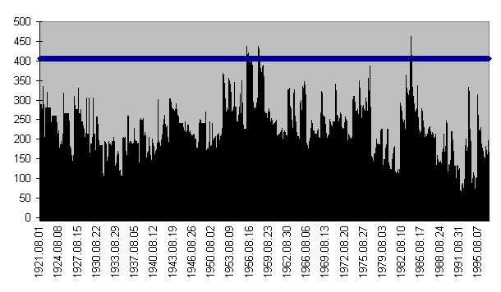
August Flow Graph: August flow on the Sprague River in cubic feet per second for years 1921-97 compared with one of the Tribal/BIA claims (the horizontal line). This Riparian Habitat Maintenance Claim is one of three Tribal/BIA claims filed on this reach. If granted, all claims would have to be satisfied prior to anybody getting water (Raw data source USGS).
Enlarging on these hunting and fishing privileges, the federal Bureau of Indian Affairs [BIA] and the Tribes are attempting to justify massive claims to Basin water with priority dates termed "time immemorial." As part of the adjudication, they have filed identical claims for water on 49 stream reaches and two elevation claims (Klamath Lake and Klamath Marsh), and one claim for multiple seeps and springs. Each claimed stream reach has three additional claims for water, all of which must be met prior to anybody irrigating. Furthermore, they are demanding the claimed amount must be met in the entire reach of the stream. Taken together, these claims amount to more water than actually exists!
These flow numbers get even worse on small tributaries. Before the Tribes sold their reservation, Crooked Creek was wholly diverted at the headwaters for agricultural use. That diversion did not, and could not, exceed the natural flow of about 5 cfs. Yet now BIA and the Tribes are claiming 91 cfs for instream use on Crooked Creek. This is a whopping 18 times the natural flow at the headwaters.
Lawsuits
Both BIA and the Tribes jointly filed a lawsuit to reopen Adair, attempting to drag the entire adjudication of their claims out of state court and back into federal court. They did so with full knowledge that, if successful, many basin farmers would no longer receive water.
So far, however, the litigation strategy has failed. The latest ruling by the Ninth Circuit Court of Appeals was a significant setback for the tribes, returning the adjudication process back to the State of Oregon.
The Tribes’ historical use of resources
Insofar as there are allegations the Basin’s resources have been mismanaged, federal and Tribal land managers are far from innocent. In particular, BIA should be held to account for decades of decisions that likely caused significant declines in fish population and created irreversible damage to the very lands the Tribes were authorized to steward.
When the reservation still existed, BIA authorized the harvest of billions of board feet of timber. In order to mill the lumber ponds were created, damming up entire river systems. Most of these mill ponds were built without fish ladders. These were massive dams blocking fish passage to the entire river system, not just small tributaries.
Considering current attempts to shut down irrigated agriculture, we cannot let pass the irony that BIA (formerly called Indian Services) filed claims in 1919 to irrigate 144,592 acres, plans which included draining what is now the Klamath Marsh National Wildlife Refuge. The Termination Act passed before these plans could be implemented.
As a result of BIA’s acquiescence to building mill ponds and developing irrigated agriculture, at least six dams were built blocking the mainstream of the Sprague River. As a result of these dams, fish habitat has been partially blocked for the past 85 years. The remaining Sprague River dam has been identified as the greatest obstacle to fish passage on the river.
How important is the Sucker Fish?
The land management practices exemplified above seem inconsistent with tribal insistence the sucker fish have always been a critical part of their culture. The Tribes are currently very active in their efforts to protect suckers, but we are struck by their seeming indifference when they still held a reservation.
W. H. Slattery, a reservation engineer, made the following observations while investigating potential repairs to the Chiloquin Dam in 1940. Please note that suckers are also referred to as "mullets":
Bray’s Dam; Another long forgotten reservation dam, since removed or washed away. This dam also lacked a fish ladder. | 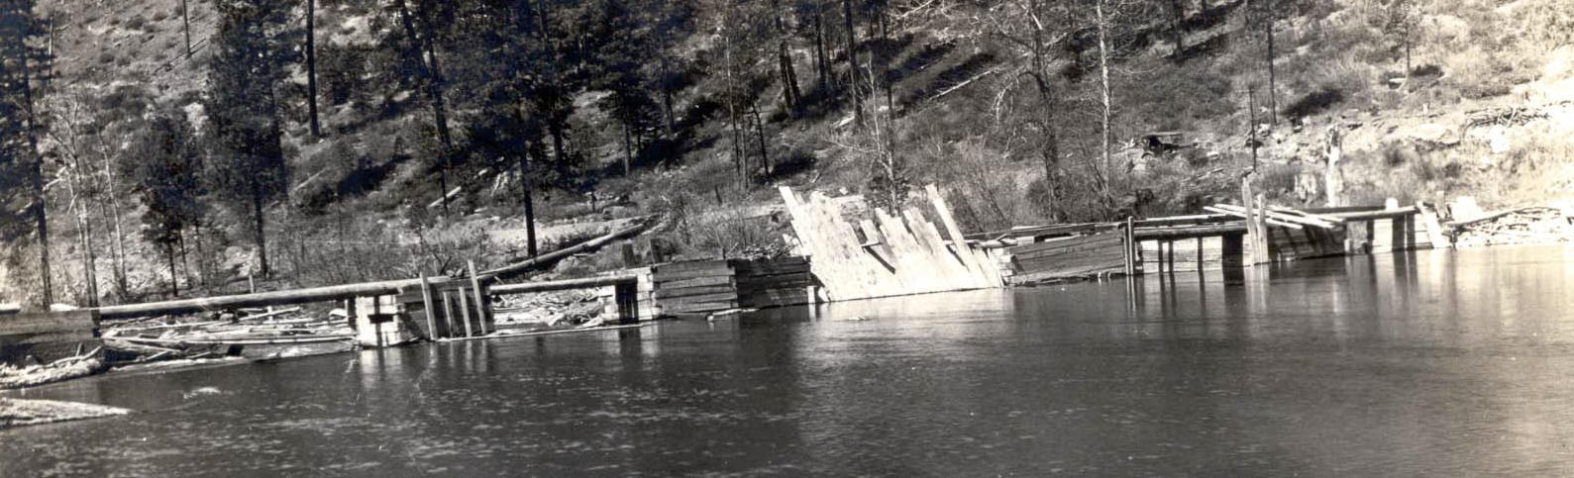
"It is my observation that the fishing activities of the Indians near the dam could render serious injury to a great number of fish. In attempting to "gaff" trout, which seem to be more desirable than mullets, the fishermen often "gaff" mullets, which they immediately return to the stream after serious mutilation by the removal of the gaff hook. In fishing along the stream for trout immediately below the dam with rod and tackle the fishermen often snag mullets, the hooks entering their body which necessitates the bringing the fish to shore for removal of the hook by cutting it out with a pocket knife, or by allowing the fish to tear itself free from the hook while being brought into shore. The trout fishermen do not enjoy these difficulties since it results in the loss of much time and effort besides the lost of valuable tackles.
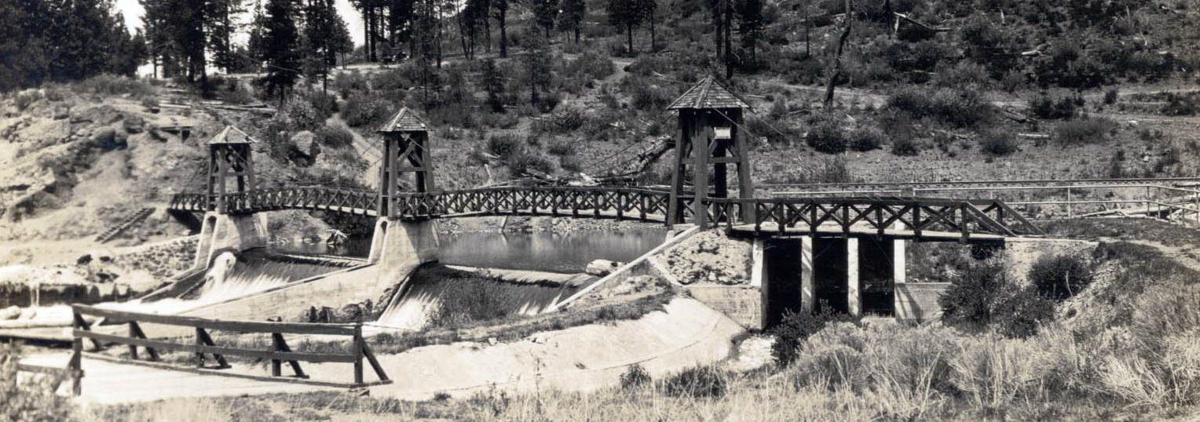 | Chiloquin Dam; The Chiloquin dam built in 1914, in order to develop irrigation for Native American Farmers in the Modoc Point area; historical development plans called for irrigation of 12,803 acres.
During the run of fish I have observed as high as twenty-five fishermen both with tackle and gaff hooks, below the dam and I feel that these fishermen would mutilate a great number of fish in the above manner."
"As to the fish which have died in their attempt to pass the dam on their migration upstream, referred to in office letter July 24 1939, Mr. Blocklinger claims that the only dead fish he has seen in the vicinity of the dam are those which have been removed from the stream by fishermen and left upon the dam to rot. Also, he states that these fish are called ‘suckers’ and are not preferred for food." (Slattery 1939)
We suspect that most Basin residents agree with this assessment of the suckers suitability as a food source.
The decline of Bull Trout by hybridization
Past BIA action also lead directly to the current depletion of Bull trout populations: According to internal documents, the cause of declining Bull trout populations is the result of competition from hybridized Brook trout: "Perhaps the most significant threat to the remaining Bull trout populations in the Klamath Basin is hybridization with introduced Brook trout. Where the two species reside together, Bull trout abundance is alarmingly low, and hybrids are common,…" (U.S. Fish and Wildlife Service, Federal Register June 13, 1997).
Who is responsible for this Brook trout hybridization? At the time of the reservation, thousands of Brook trout were being planted on the Reservation: "There are several very good trout streams on the reservation. Rainbow and Brook trout are planted in them each year (250,000) by the State in exchange for use at the hatchery of water from the spring on tribal land." (C. C. Presnall, 1941).
We contend today’s management is still poor
Federal agencies disburse millions of tax dollars each year to finance Tribal biologists, who in turn develop data that supports their hypotheses. Many of these studies are biased from the outset by the Tribes desire to obtain all the water.
Family farmers do not have similar access to federal funding to dispute these studies. Yet our questions persist: Why do federal biologists claim the suckers need high lake levels despite increased mortality during high lake levels and lower die offs during low lake levels? Why do these scientists recommend releasing millions of gallons of warm, low oxygen water out of Klamath Lake, into the Klamath River when we know Coho salmon die when they encounter that warm, oxygen-depleted water?
Individual Native Americans fare no better
In 1887 Congress passed the General Allotment Act. Prior to the Act the Tribes held the reservation land in communal ownership. Pursuant to the terms of the Allotment Act, however, ownership of certain tribal lands were granted to individual members, roughly 25 percent of the reservation was transferred in this manner. Adjudication irrigation shutdowns will include these Tribal irrigators (allottees) who hold family parcels of land. These allottees have held these lands for generations only to see their own Tribes try to shut off their water.
At the many public meetings throughout the basin we hear how individual Native Americans are also victims of the water shutdown and we are genuinely sympathetic. Individual Native Americans are our friends, neighbors and coworkers. We know that many Tribal members would rather have available funds spent on healthcare, housing, and education. Instead it is being spent on efforts to destabilize our shared agricultural economy.
The good news
Klamath project irrigators have installed a multimillion dollar fish screens as part of an aggressive program to install screens and ladders wherever necessary. We all are proud of this because Water for Life was a leader in getting state cost share programs for fish screening.
These are win-win situations allowing irrigators to remain economically self-sufficient while meeting the community’s obligation to protect wildlife. Credit is also due for the many miles of riparian fencing and other private environmental restoration activities implemented by responsible landowners.
BIA and Tribal animosity towards Basin farmers and ranchers is counterproductive at best. Precious money and time has to be expended protecting producers’ livelihoods instead of going toward additional restoration activities – where those resources would do much more good.

Top of Form
Advanced Search
Bottom of Form
NARF Publications | Justice Newsletter | Spring 2001
Klamath Water Case Gets Slippery
The Native American Rights Fund represents the Klamath Tribes in a series of cases that are at the heart of a pitched battle to protect the treaty and water rights in Southern Oregon. Walter Echo-hawk is the lead counsel for NARF on the cases. In addition, Don Wharton, Yvonne Knight, Kim Gottschalk, and Kate Weatherly provide representation on these related proceedings, with Carl Ullman as local counsel.
Since the 1970s, NARF has represented the Tribes in the areas of tribal restoration and protection of treaty, hunting, fishing, gathering and water rights. In addition, NARF represents the Tribes in their Economic Self-Sufficiency Plan (ESSP).
The ESSP case is a land recovery matter being handled under the direction of NARF staff attorney, Don Wharton. In 2000, the tribe delivered a completed proposed ESSP to the Office of the Secretary of the Interior. The ESSP was mandated by Congress in the Klamath Tribes' Restoration Act of 1986. The purpose of the ESSP is to define the foundation for the ability of the Tribes to regain economic autonomy primarily through return of federally held lands taken from the Klamath Indian Reservation in the 1960s and 1970s. The plan would incorporate the freedom to exercise subsistence and treaty rights with the ability to provide the tribal members with employment, education, housing, and health. The Tribes also seek to re-establish the cultural, spiritual and social fabric of their people through this plan. Currently the Tribe is in consultation with their local, state and national representatives concerning the details of the ESSP for final approval.
Related to the water rights struggle, the Bureau of Reclamation must develop and implement an annual water allocation plan to protect the endangered fish species in Southern Oregon, meet tribal trust obligations and provide water at the same time to a large irrigation project. Each year the plan involves a battle to ensure that the Bureau of Reclam-ation preserves the survival of two endangered species that are part of the Tribes' treaty-protected fishery. Klamath Lake serves as a natural reservoir for a 200,000-acre irrigation project established in the early 1900s. Over the last 80-90 years, the project has met the agricultural needs of local non-Indian farmers. Unfortunately, after years of constant diversions, which lower the lake water level, the two treaty-protected fish species have become endangered.
This year, for the first time in history, the Bureau of Reclamation will provide very little water to agriculture in order to meet its legal obligations to protect the endangered species and fiduciary obligations to the Klamath Tribes. Residents in Southern Oregon are now facing a drought affecting nearly 1,000 families. If local farmers are allowed to deplete water from the Klamath Lake under existing drought conditions, the reduction in water levels could cause the extinction of the fishery that has been listed as endangered since 1988, including wild coho salmon. The farmers have filed suit challenging the Bureau's water management plan.
Walter Echo-hawk notes that, "There is extreme pressure on the new Department of Interior officials to breach the trust responsibility to the Tribes and duck compliance with the Endangered Species Act." The Klamath homeland encompasses two national forests, wetlands, and a wildlife refuge. The water rights of the Klamath Tribes involve a sufficient level of water to supply habitat for treaty-protected fishing, hunting and gathering subsistence activities. The fishery is enormously important to the Klamath Tribe for its cultural, ceremonial and subsistence uses. The Tribes are trying to recapture all that was lost culturally when their tribal recognition status and lands were stripped from them by Congress' 1954 Klamath Termination Act.
The present situation is bleak for the endangered fish of this region. If protective action is not taken, these species will be lost forever. Along with the loss of species is the loss of tribal culture that affects future generations. The Tribes' water objectives, which are being advanced by NARF in these related cases, are to restore the water quality, quantity and habitat from the headwaters of the Klamath River all the way to the California border as an integral part of maintaining the environmental integrity of their precious aboriginal homelands and wildlife.

