Quantum learning application

Quantum associative memory (QUAM)

Quantum learning application 1
Quantum associative memory (QUAM) 1
INTROUDUCTION 2
Quick review of the quantum computing 3
Measures 4
Flip transformation 4
Control flip transformation 5
Example 5
AND transformation 6
Quam based on Grover algorithms[1] 8
Learning Phase 8
Grover algorithm is as following[3] 9
Step by Step example 11
Quam Network 15
Grover algorithm’s Complexity 15
Pattern recall phase 16
The algorithm steps: 16
Step By Step example 16
Comparison between the classical NN Associative memory and the QUAM. 17
References 18

INTROUDUCTION

The field of quantum computation, which applies ideas from quantum mechanics to the study of computation, was introduced in the mid 1980's [6]. With the increase of the speed of computation as well as decreasing the size of the computers, The Quantum computers will immerge. These quantum computers will adapt the quantum mechanics.
Therefore, Quantum bit is introduced in these kinds of computers rather than a classical bit. This report is one of series of reports, which I do as an attempt from me to answer two questions. What is the quantum computing? Why do we need it? Two questions needed to be answered, in studying this field. Even though, the purpose if this report is not to explain the basics of the quantum computers as an answer of the first question, a quick review of the basics will be given. Rather, this report focuses on answering the second question. One way to answer this question is to study the advantage of using the quantum computing and quantum algorithm in real application over the classical computers. In this report, I focused on the Quantum Associative Memory as one of the applications. Artificial neural networks (ANN) seek to provide ways for classical computers to learn rather than to be programmed. If quantum computers become a reality, then artificial neural network methods that are amenable to and take advantage of quantum mechanical properties will become possible. In particular, can quantum mechanical properties be applied to ANNs for problems such as associative memory? Recently, work has been done in the area of combining classical artificial associative memory with ideas from the field of quantum mechanics. It goes a step further by proposing an actual model for a quantum associative memory. The work here further develops this model by exhibiting a physically realizable quantum system for acting as an associative memory. This Quam is based on Grover’s algorithm. As we will show later, using the QUAM , the memory capacity increases exponentially, and the speed of search to O($\sqrt{N}$) compared to Hopefield NN Associative memory.

In this report, a quick review of the quantum computing basics will be given, then An explanation for QUAM based on Grove’s quantum will be given . A sep by step example of storing set of patterns as well as calling one of the patterns, will be developed, finally a comparison between the Hopefiled NN Associative memory and the QUAM is developed.

Quick review of the quantum computing

In the quantum computer, a Qubit is used rather than the classical bit.
Quantum systems are described by a wave function y that exists in a Hilbert space. The Hilbert space has a set of states, fi , that form a basis, and the system is described by a quantum state y , y is said to be in a linear superposition of the basis states fi , and in the general case, the coefficients ci may be complex. A qubit is avector in two dimensional complex vectoer space. In this space a vector has two components and the projections of the vector on a basis of the vector space are complex number.
$|ψ\text{>=}α|0\text{>+}β|1>$
$|{\overset{˙}{α}}^{2}|+|β^{2}|=1$
where $α∧β$ are the complex number and the $|0>|1>$ are the two orthonormal basis for the two dimension vector space. It can be shown that the Qubit is a linear superposition of the basis state, by changing the coefficients$α∧β$ values.
$|ψ\text{>=}\text{cos}θ/2|0\text{>+}\text{exp}(iφ)\text{sin}θ/2|1>$
from 2 we can see that the qubit can be represented as a vector r from the origin to a point of the three dimensional sphere with a radius of one, called the bloch sphere as shown in the following fig.

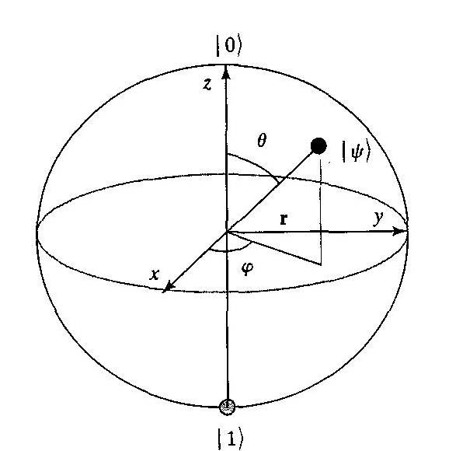

It is obvious here that the phase of the coefficients affects the state of the qubit. This is a very important features of the qubit. The classical bit does not hav a feature corresponding to this on. As shown later, this feature has a great advantage in the application. While the classical bit takes only either state 0 or state 1, the qubit can take any value represented by the vector r on the Bloch sphere.
0
1
0
1

Classical bit qubit

Measures

The quantum system is said to be collapsed when we make the projection on one of the basis. That is also called decoherence or the measures. For example, if we take the projection of $|ψ>$ on the |0> basis then it will be $|ψ\text{>=}α|0>$.
$|{\overset{˙}{α}}^{2}|$ is the probability of the qubit to collapse on the state |0>.

Now I am going to introduce some transformations which are used in our discussion about the Quam. Those transformation are implemented by a quantum circuit.

Flip transformation

This transformation can be done by the matrix M =[$\begin{matrix}0 & 1 \\ 1 & 0\end{matrix}$]
For $|ψ\text{>=}α|0\text{>+}β|1>$ then $|ψ\text{>=}[\begin{matrix}α \\ β\end{matrix}]$

Then $|ψ\text{>=}M|ψ>$
$|ψ\text{>=}[\begin{matrix}0 & 1 \\ 1 & 0\end{matrix}][\begin{matrix}α \\ β\end{matrix}]$
$|ψ\text{>=}[\begin{matrix}α \\ β\end{matrix}]$
$|ψ\text{>=}β|0\text{>+}α|1>$

Control flip transformation
It is well known by Control Not. We use this transformation if we have two qubits and we need one of them to control the flip transformation on the other one. For more explanation, lets define the transformation matrix, $F=[\begin{matrix}0 & 1 & 0 & 0 \\ 1 & 0 & 0 & 0 \\ 0 & 0 & 1 & 0 \\ 0 & 0 & 0 & 1\end{matrix}]$

Let’s consider two qubits
$$|ψ1\text{>=}1|0>$$
$$|ψ2\text{>=}β|0\text{>+}α|1>$$
To flip the qubit state from |0> state to |1> state, if and only if the control qubit is in |0 > we use the $F^{0}=[\begin{matrix}F & 0 \\ 0 & I\end{matrix}]$ .

Example

$$F^{0}ψ1ψ2=[\begin{matrix}0 & 1 & 0 & 0 \\ 1 & 0 & 0 & 0 \\ 0 & 0 & 0 & 1 \\ 0 & 0 & 1 & 0\end{matrix}][\begin{matrix}1 \\ 1 \\ 0 \\ 0\end{matrix}∗\begin{matrix}β \\ α \\ β \\ α\end{matrix}]$$

As a result $|ψ2\text{>=}α|0\text{>+}β|1>$

Similar to flip the vector from |0> state to |1 > state, if and only if the control qubit is in state |1> we use the $F^{1}=[\begin{matrix}I & 0 \\ 0 & F\end{matrix}]$
Let’s consider two qubits
$$|ψ1\text{>=}1|1>$$
$$|ψ2\text{>=}β|0\text{>+}α|1>$$
$$F^{1}ψ1ψ2=[\begin{matrix}1 & 0 & 0 & 0 \\ 0 & 1 & 0 & 0 \\ 0 & 0 & 0 & 1 \\ 0 & 0 & 1 & 0\end{matrix}][\begin{matrix}0 \\ 0 \\ 1 \\ 1\end{matrix}∗\begin{matrix}β \\ α \\ β \\ α\end{matrix}]$$

As a result $|ψ2\text{>=}α|0\text{>+}β|1>$

AND transformation
This transformation is a 3-qubit operation. It flips the state of one qubit if and only if the other two are in the |00> states.
$A^{\text{00}}=[\begin{matrix}F & 0 \\ 0 & I\end{matrix}]$

Let’s take an example
consider 3qubits $|ψ1\text{>=}1|0>$ and $|ψ2\text{>=}1|0>$ and $|ψ3\text{>=}β|0\text{>+}α|1>$

$$\begin{aligned}A^{\text{00}}ψ1ψ2ψ3=[\begin{matrix}0 & 1 & & & & & & \\ 1 & 0 & & & & & & \\ & & 1 & & & & & \\ & & & 1 & & & & \\ & & & & 1 & & & \\ & & & & & 1 & & \\ & & & & & & 1 & \\ & & & & & & & 1\end{matrix}][\begin{matrix}1 & 1 & B \\ 1∗ & 1∗ & α \\ 1∗ & 0∗ & B \\ 1∗ & 0∗ & α \\ 0∗ & 1∗ & B \\ 0∗ & 1∗ & α \\ 0∗ & 0∗ & B \\ 0∗ & 0∗ & α\end{matrix}] \\ A^{\text{00}}ψ1ψ2ψ3=[\begin{matrix}α \\ B \\ 0 \\ 0 \\ 0 \\ 0 \\ 0 \\ \begin{aligned}0 \\ \end{aligned}\end{matrix}]\end{aligned}$$
$$|ψ3\text{>=}α|0\text{>+}β|1>$$

As we said earlier that the main purpose of this paper is to answer the 2nd question. Here I am going to explain the advantage of using the quantum Assocaitive memory over the classical NN Hopefield Associative Memory. The quantum associative memory is based on Grover algorithms. A step by step pattern recognition example will be explained through the explanation of the Grover quantum algorithms. A construction of a quantum network which will be used in the QUAM will be provided. Finally a comparison between the Hopefiled Associative memory and the QUAM will be presented.

Quam based on Grover algorithms[1]

As in the classical NN hopefield Associative memory, the Quam works in two phases. The learning phase and the pattern recall phase. Following we are going to explain both phases as well as the quantum network used, based on Grover algorithms

Learning Phase

According to Grover algorithm, the idea is to construct a coherent quantum system which its bases represents the m patterns [2] and [3]. That is called pattern-storing process.
In other words if we are giving a set D={F (z)} which has m patterns as a training set, the goal is to produce |f> such that

|f> =${\sum{}}_{z∈P}f(z)|z>$

where Z represent the different patterns in the training set. Z can be represented in a binary format b1 b2 b3. Using Grover algorithms we need n qubits to represent m patterns, in addition to n+1 qubits as required control qubits in the learning algorithms. That gives us total of 2n+1 qubits required to represents m patterns. It also gives us total of 2n+1 registers in implanting the quantum network. A state |f> can be constructed using a polynomial number (in n and m) of elementary operations on one, two, or three qubits. That means the f will be constructed recursively using three operations, as we will see later. At the start, the coherent state will be
|f> = |X1 X2……Xn, G1G2…..Gn-1,C1C2>

Where X1,X2 , Xn are n register to restore the patterns
G1, G2, Gn as well as C1 C2 are controlled register.

Grover introduced three operations, which will be carried out on the coherent state.

a) The S operation . It is called the state generation matrix.

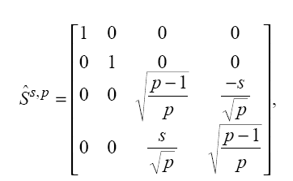

Where s is the values of the F(z) and s {1,-1} and 1 <= P<=m.

b) Second is the $F^{0}=[\begin{matrix}F & 0 \\ 0 & I\end{matrix}]$ and $F^{1}=[\begin{matrix}I & 0 \\ 0 & F\end{matrix}]$ as we explained them in the previous section.

C) Third is $A^{\text{00}}=[\begin{matrix}F & 0 \\ 0 & I\end{matrix}]$ where the ˆ0 are 6×2 and 2×6 zero matrices and ˆI6 is the 6×6 identity matrix, conditionally flips the third bit if and only if the first two are in the state 00 . We explained them in the previous section. There is also $A^{\text{01}}\text{and}A^{\text{10}}\text{and}A^{\text{11}}$
Which are similar except that the third bit will flipped when the other two bits in state |01> and |10> and |11> respectively.

Grover algorithm is as following[3]

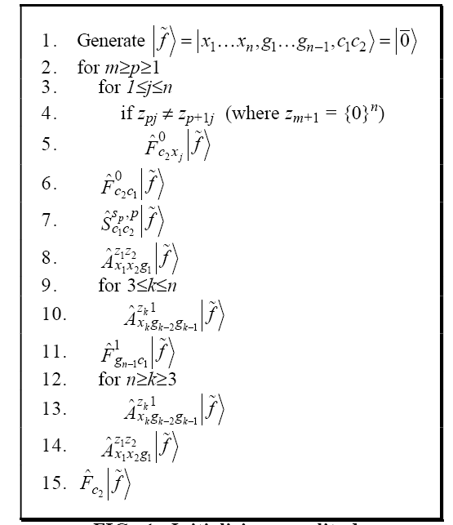

The x register will hold a superposition of the examples in the set D -- there are n qubits in the register, and the value of f for an example will be used as the coefficient for the state corresponding to that example. The g and c registers contain only ancillary qubits and are restored to the state 0 by the end of the algorithm. A high-level intuitive description of the algorithm is as follows. The system is initially in the state 0 . The qubits in the x register are conditionally flipped so that their states correspond to the first example. The ˆS s, p operator corresponding to that example then changes the basis of the system such that one of the states has a coefficient that matches the example’s value for f. This same state then is changed to one that exists outside of the subspace affected by the ˆS s, p operators, in effect making it permanent, and the process is repeated
for each example. When all the examples have been processed, the result is a coherent
superposition of states corresponding to the sample points, where the amplitudes of the states all have the same magnitude but have different phases according to the values of their corresponding examples.

Step by Step example

To understand the algorithm, let’s assume the following set of learning patterns

D = {f(01)=-1, f(10)=1, f(11)=-1}
From D we can deduce the following
Z3 is 01
Z2 is 10
Z1 is 11
n = 2 number of qubit to represent the patterns
m=3 number of patterns to be represented

then follow the algorithm’s step

1- |f > = |00,0,00 > X1=0 X2=0 g1=0 , C1=0 and C2 =0
- do the for loop
P=3
Z3= 01 Z31=0 Z32=1
Z4= 00 Z41=0 Z42=0
Z32 not equal Z42 then flip X2 this done by the $F^{0}c2X2|f>$
$F^{0}C2X2=[\begin{matrix}0 & 1 & 0 & 0 \\ 1 & 0 & 0 & 0 \\ 0 & 0 & 1 & 0 \\ 0 & 0 & 0 & 1\end{matrix}][\begin{matrix}C\text{20} \\ C\text{20} \\ C\text{21} \\ C\text{21}\end{matrix}∗\begin{matrix}X\text{20} \\ X\text{21} \\ X\text{20} \\ X\text{21}\end{matrix}]$

$$F^{0}C2X2=[\begin{matrix}0 & 1 & 0 & 0 \\ 1 & 0 & 0 & 0 \\ 0 & 0 & 1 & 0 \\ 0 & 0 & 0 & 1\end{matrix}][\begin{matrix}1 \\ 1 \\ 0 \\ 0\end{matrix}∗\begin{matrix}X\text{20} \\ X\text{21} \\ X\text{20} \\ X\text{21}\end{matrix}]$$

$$F^{0}C2X2=[\begin{matrix}X\text{21} \\ X\text{20} \\ 0 \\ 0\end{matrix}]$$

X2 is flipped to state 1. X2=1|1>

Then |f > = |01,0,00 >

- Flip C1 state

$$F^{0}C2c1=[\begin{matrix}0 & 1 & 0 & 0 \\ 1 & 0 & 0 & 0 \\ 0 & 0 & 1 & 0 \\ 0 & 0 & 0 & 1\end{matrix}][\begin{matrix}C\text{20} \\ C\text{20} \\ C\text{21} \\ C\text{21}\end{matrix}∗\begin{matrix}C\text{10} \\ C\text{11} \\ C\text{10} \\ C\text{11}\end{matrix}]$$

$F^{0}C2c1=[\begin{matrix}C\text{11} \\ C\text{10} \\ 0 \\ 0\end{matrix}]$

then C1 flipped to be in the state 1 . 1|1>
then Then |f > = |01,0,10 >

- Generate a new state by applying S on C2 C1

$S^{−\text{13}}C1c2=[\begin{matrix}1 & 0 & 0 & 0 \\ 0 & 1 & 0 & 0 \\ 0 & 0 & \sqrt{2/3} & \sqrt{1/3} \\ 0 & 0 & −\sqrt{1/3} & \sqrt{2/3}\end{matrix}][\begin{matrix}C\text{10} \\ C\text{10} \\ C\text{11} \\ C\text{11}\end{matrix}∗\begin{matrix}C\text{20} \\ C\text{21} \\ C\text{20} \\ C\text{21}\end{matrix}]$

$S^{−\text{13}}C2c1=[\begin{matrix}1 & 0 & 0 & 0 \\ 0 & 1 & 0 & 0 \\ 0 & 0 & \sqrt{2/3} & \sqrt{1/3} \\ 0 & 0 & −\sqrt{1/3} & \sqrt{2/3}\end{matrix}][\begin{matrix}0 \\ 0 \\ 1 \\ 1\end{matrix}\begin{matrix}C\text{20} \\ C\text{21} \\ C\text{20} \\ C\text{21}\end{matrix}]$

then |f > = -1/$\sqrt{3}$ |01,0,11 > + $\sqrt{2/3}$ |01,0,10>

- flip g1 to mark the register

$$A^{\text{01}}\text{01}g1=[\begin{matrix}F & 0 \\ 0 & I\end{matrix}]g1$$

then |f > = -1/$\sqrt{3}$ |01,1,11 > + $\sqrt{2/3}$|01,1,10>

- Flip C1 which is controlled by g1

$F^{1}g1c1=[\begin{matrix}1 & 0 & 0 & 0 \\ 0 & 1 & 0 & 0 \\ 0 & 0 & 0 & 1 \\ 0 & 0 & 1 & 0\end{matrix}][\begin{matrix}g\text{10} \\ g\text{10} \\ g\text{11} \\ g\text{11}\end{matrix}∗\begin{matrix}C\text{10} \\ C\text{11} \\ C\text{10} \\ C\text{11}\end{matrix}]$

$$F^{1}g1c1=[\begin{matrix}1 & 0 & 0 & 0 \\ 0 & 1 & 0 & 0 \\ 0 & 0 & 0 & 1 \\ 0 & 0 & 1 & 0\end{matrix}][\begin{matrix}0 \\ 0 \\ 1 \\ 1\end{matrix}∗\begin{matrix}C\text{10} \\ C\text{11} \\ C\text{10} \\ C\text{11}\end{matrix}]$$

as a result C1 will be in the state 0 again,
and |f > = -1/$\sqrt{3}$ |01,1,01 > + $\sqrt{2/3}$ |01,1,00>

The first term of |f>, which is -1/$\sqrt{3}$ |01,0,01 >, is saved in the register since it has the first pattern. While the second part will be corrected by flipping g1 again to |0>

8- The whole process repeated again with start
|f > = -1/$\sqrt{3}$ |01,0,01 > + $\sqrt{2/3}$ |01,0,00>
after the 3rd loop
|f> =
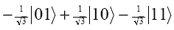

that is what is called storing the pattern.

Here I just want to mention that the construction of the |f> using this way is called “ Initializing the amplitude distribution of a quantum state.

Quam Network

The quantum network used in the Quam is as the following

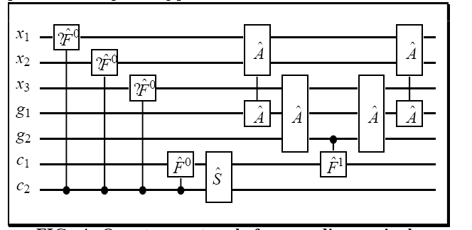

Grover algorithm’s Complexity

In analyzing the complexity of the algorithm it is assumed that line 1 can be done trivially. The loop of line 2 is repeated m times and consists of n (lines 3-5) + 3 (6-8) + n-2 (9-10) + 1 (11) + n-2 (12-13) + 1 (14) operations, and line 15 requires one more operation. Thus, the entire algorithm4requires m(n + 3 + n-2 + 1 + n-2 + 1) + 1 = m(3n+1)+1 operations and is O(mn). This is optimal in the sense that just reading each instance once cannot be done in any fewer than mn steps.

Now we are going to talk about the second phase which is the pattern recall phase.

Pattern recall phase

After doing the learning phase, |f > has all the patterns as its bases. The idea of recalling the pattern is to collapse |f > on the required pattern(basis).

Grover used his quantum search in data base algorithm in recalling the pattern[4],[5],[6].
The idea of this search is to change the phase of the desired state and then rotate the entire |f > around the average. This process repeated (3.14/4)*
$\sqrt{N}$. Where N is the total possible state.

The algorithm steps:

1-change the phase of the desired state.
2- compute the average A
3- rotate the entire quantum set around the average. |f>= 2A-|f >
4- repeat 1-3 for (3.14/4)* $\sqrt{N}$
5- Measure the desired state.

Step By Step example

Let’s continue on the same example, used in the learning phase. Let’s assume we want to recall the pattern 01. Since we have only 2 qubits then the possible combination is 4. |f> will collapse on the desired state after repeat the algorithm for (3.14/4)*2, which roughly 1 times.
1- |f >
- |f > 1/$\sqrt{3}$ (0,-1,1,1)
- Average =1/4$\sqrt{3}$
- |f > 1/2$\sqrt{3}$ (1,3,-1,-1)
- Measure the desire state |f >= ($\sqrt{3}$/2) |01>

It is obvious that the probability of the system to collapse on the desired state is ¾= 75%. The Higher the number of qubits the Higher the percentage of collapsing . The system collapse in the O($\sqrt{N}$). Which means it is faster than the classical NN which takes O(N)

Comparison between the classical NN Associative memory and the QUAM.

- Using the Quam the capacity of storing patterns increased exponentially more than Hopefield. Assume n= 16 ,the algorithm would require only 2n +1= 2*16+1 = 33 qubits!. These number of qubits will allow the Quam to store up to $2^{n}$ patterns, which is 4096 patterns. For comparison, a classical Hopfield type network used as an associative memory has a saturation point around 0.15n. In other words, about 0.15n patterns can be stored and recalled with n neurons. Therefore, with n=16 neurons, a Hopfield network can store only 0.15*16   2 patterns. Conversely, to store 214 patterns would require that the patterns be close to 110,000 bits long and that the network have that same number of neurons.
- Using Quam The speed of the pattern recall increased by O($\sqrt{N}$). For Comparison to Hopefield NN, it requires O(N) to recall the pattern. Where N = total number of possible patterns=$2^{n}$.
- Table of comparison between Hopefield and the Quam[7]
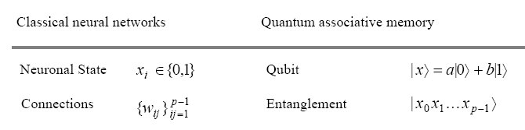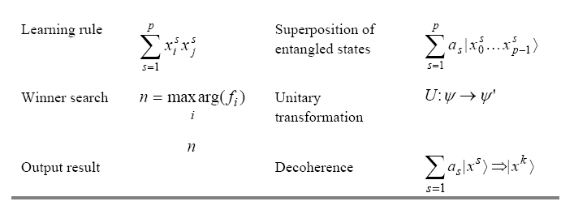

References

[1] A Quantum Associative Memory Based on Grover’s Algorithm
Dan Ventura and Tony Martinez
Neural Networks and Machine Learning Laboratory (http://axon.cs.byu.edu)
Department of Computer Science
Brigham Young University, Provo, UT 84602 USA

[2] Artificial Associative Memory Using Quantum Processes
Dan Ventura
fonix corporation
180 West Election Road, Draper, UT 84020 USA
dventura@fonix.com

[3]Initializing the amplitude distribution of a quantum state
Dan Ventura* and Tony Martinez†
Neural Networks and Machine Learning Laboratory‡,
Department of Computer Science, Brigham Young University, Provo, Utah 84602
(Received 26 June 1998)

[4] Quantum Associative Memory
Dan Ventura and Tony Martinez
Neural Networks and Machine Learning Laboratory (http://axon.cs.byu.edu)
Department of Computer Science
Brigham Young University
dan@axon.cs.byu.edu, martinez@cs.byu.edu

[5] A fast quantum mechanical algorithm for database search
Lov K. Grover
3C-404A, Bell Labs
600 Mountain Avenue
Murray Hill NJ 07974
lkgrover@bell-labs.com

[6]Quantum Search on Structured Problems
Lov K. Grover, 3C-404A Bell Labs, 600 Mountain Avenue, Murray Hill NJ 07974 (lkgrover@bell-labs.com)

[7] Quantum neural networks
Alexandr A. Ezhov¹ and Dan Ventura²
¹Department of Mathematics, Troitsk Institute of Innovation and Fusion Research
142092 Troitsk, Moscow Region, Russia
² Applied Research Laboratory, The Pennsylvania State University
University Park, PA 16802-5018 USA

