CHAPTER 17

Towards Grover-Based Parallel Quantum Computers for Robotics

17.1. Introduction.

In previous chapters we discussed oracles for various applications but these were mostly toy problems (like the SEND+MORE=MONEY problem) or problems of classical and quantum combinatorial problem solving. It should be however observed that the general problem formulations based on oracles, such as satisfiability, mapping problems, path problems and constraint satisfaction problems occur in many other areas. Because we believe that future most powerful robots will be controlled by quantum computers, we looked to potential applications of quantum computers in robotics.

17.2. Constraint Satisfaction Model for Robotics.
One weakness of contemporary intelligent robotics is the insufficient speed of robot’s image processing, pattern recognition, reasoning and motion planning algorithms. Also in other areas related to perception and reasoning the contemporary computers are just too slow for both the requirements and the existing mechanical abilities of modern robots. This problem can be solved by using special processors which are usually multiprocessors, and thus expensive and difficult to use. Another approach is using Digital Signal Processors (DSP processors) which have applications especially in image and sonar processing, sometimes also in intelligent motion planning and generation. Finally, highly parallel, sometimes dynamic (adaptable) Field Programmable Gate Array (FPGA) architectures are also used in robotics, and especially in robot vision. The PSU group experimented already with some of these approaches in their past research and found them difficult to use and restricted in applications. The trouble is that designing parallel systems or programming the multi-processing or DSP algorithms is very time consuming. On the other hand, it is well-known that there exist the concepts of the “universal problem solvers”; as an example one can give “automatic theorem proving” programs based on resolution, or logic programming languages such as Prolog. They find applications in CSP. These universal problem solvers allow to write all kinds of such highly complex rule-based hierarchical search programs very quickly, but their practical applications are limited because they just run too long on contemporary computers. It is still fascinating to be able to formulate and solve many different problems using the same general model. This model may be predicate calculus, Satisfiability, Artificial Neural Nets or the Constraints Satisfaction Model. We will show in chapters 12 and 13 that Grover algorithms with the ability of designing oracles for this algorithm are in a sense such a “universal problem-solving algorithm in the quantum world”. This approach, as illustrated in chapter 6 has also a natural synergy with parallel processing. In previous chapters we showed thus two strongly interrelated general purpose problem-solving models:
- the general search on a standard (serial architecture) computer and on a parallel computer (using any parallel architecture, such as pipelined processor, systolic processor, Single Instruction Multiple-Data architecture (SIMD), etc).

- the quantum search algorithm by Grover with user-designed problem-specific oracles.

These two models can be combined when a high-level standard computer with search algorithm calls many quantum accelerators for specific sub-problems to be solved independently (possibly in parallel) with Grover-like speedup each.

What may be then the general purpose model for robotics? It is well-known from published robotic research that many known and practical algorithms, for instance the well-known “Waltz algorithm” for “blocks world model vision” (and its derivative algorithms) can be reduced to the general purpose constraint satisfaction problem which in turn can be reduced to the generalized satisfiability problem. For instance, Huffman and Clowes created an approach to polyhedral scene analysis, scenes with opaque, trihedral solids, next improved significantly by Waltz [Waltz75], which popularized the concept of constraints satisfaction and its use in problem solving, especially in image interpretation. Objects in this approach had always three plane surfaces intersecting in every vertex. Thus there are 18 possible trihedral vertices in this problem out of 64 possible.

There are only three types of edges that are possible between these blocks:

- Obscuring edge is a boundary between objects or objects and background. Boundary lines are found using outlines with no outside vertices,
- Concave edges are edges between two object’s faces forming an acute angle when seen from outside,
- Convex edges are those between two faces of an object forming an obtuse angle as seen from outside.

There are only four ways to label a line in this Blocks World Model. The line can be convex, concave, a boundary line facing up and a boundary line facing down (left, or right). The direction of the boundary line depends on the side of the line corresponding to the face of the object that causes it. Waltz created the famous algorithm which for this world model always finds the unique correct labeling if a figure is correct. Moreover, the algorithm handled also shadows and cracks in blocks. Mackworth and Sugihara extended this work to arbitrary polyhedra and Malik extended it to smooth curved objects. The extended approach becomes a well-known approach to image recognition based on constraint satisfaction and a prototype of many similar approaches to vision and planning problems in robotics.

Waltz algorithm is an example of constraints satisfaction and the Constraint Satisfaction Model is one of few fundamental models used in robotics [Beach03, Minton90, Fromherz01, Gualandi04, Huang01, Pai96]. Constraint Satisfaction is used in main areas of robotics and especially in vision, knowledge acquisition, knowledge usage, etc., including in particular the following:

17.1. planning, including motion planning, gesture planning, assembly planning, spatial and temporal planning for robot groups, experiment planning, [ref]
17.2. scheduling, combined planning and scheduling, multi-robot task planning and scheduling, [ref]
17.3. allocation, including resource allocation in AI, graph theoretical problem formulations of robotic problems including graph coloring, graph matching, floor-plan design, [ref]
17.4. temporal reasoning, [ref]
  - assignment and mapping problems, [ref]
  - arc and path consistency, [ref]
  - general matching problems, [ref]
  - belief maintenance, [ref]
  - satisfiability and Boolean/mixed equation solving, [ref]
  - machine design and manufacturing, [ref]
  - diagnostic reasoning, [ref]
  - qualitative and symbolic reasoning, [ref]
  - decision support, [ref]
  - computational linguistics, [ref]
  - hardware design and hardware verification for robotic applications, configuration of robot systems and factory automation systems, [ref]
  - real-time systems related to robot planning, [ref]
  - implementation of non-conflicting sensor systems, [ref]
  - man-robot and robot-robot communication systems and protocols, [ref]
  - contingency-tolerant motion control, multi-robot motion planning, , [ref]
  - coordination of a group of robots, [ref]
  - and many others. [ref]

Oracles for some of the above problems are either identical or similar to those discussed by us in this book. Universal components for these and other algorithms were presented in Chapter 14. We created thus a general approach to solve many of these problems. Moreover our approach can be applied to all constraint satisfaction problems, at least in theory, as they can be all reduced to satisfiability, as known from Garey and Johnson [Garey79]. There are however better ways than reduce everything to SAT. For instance the “robot guard problem” is the problem of placing the minimum number of robot guards to watch certain territory of a given shape. This problem is reduced to the unate set covering problem from Chapter 6 for which we built a quantum oracle in Chapter 12. As another example, the problem of robot scheduling can be reduced to the binate covering problem with costs, also discussed in Chapter 14.

Now we will rephrase the main methodology of this book from the robotics point of view:

- Reduce robotic problems that need speed to the problem of building a quantum oracle, possibly using a unified constraint satisfaction framework. (Because of fundamental role of basic combinatorial problems, this step can be applied to both CAD and robotics problems.)

- If there exists a quantum computer based on the “classical quantum circuit model” (which we so far assumed to exist in this book) then use this computer to solve the problem.

- If there is a quantum adiabatic computer available, reduce the problem from the quantum circuit model to the adiabatic quantum model and solve it using the adiabatic quantum model. The match of the constraints satisfaction and the adiabatic quantum computing seems to be perfect. This synergy determines thus the future area of quantum robotics, at least in the coming years, because as of 2011 very likely adiabatic quantum computing will be available first.

17.3. Adiabatic Quantum Computing to Solve Constraint Satisfaction Problems Efficiently.
It is quite possible that the date of February 13th 2007 will be remembered in annals of computing. DWAVE Company demonstrated their 16-qubit Orion quantum computing system in Computer History Museum in Mountain View, California. It was the first time in history that a commercial quantum computer was presented, although it was only a prototype model, needed scaling up, and there is also a doubt among some researchers if the computer really gives the quadratic speedup. On November 27, 2007 a 28-qubit Orion was demonstrated. The Orion system is a hardware accelerator designed to solve in principle a particular NP-complete problem called the two-dimensional Ising model in a magnetic field (for instance quadratic programming). It is built around a 28-qubit superconducting adiabatic quantum computer (AQC) processor. The system is designed to be used together with a conventional front-end for any application that requires the solution of an NP-complete problem. The first application that was demonstrated was pattern matching applied to searching databases of molecules. The second was a planning/scheduling application for assigning people to seats subject to constraints. This is an example of applying Orion to constraint satisfaction problems. The third was Sudoku. The company promises to provide free access by Internet in 2008 to one of their systems to those researchers who want to develop their own applications.

The plans in 2007 were that by the end of year 2008 the Orion systems will be scaled to more than 1000 qubits. It is even more amazing that the company plans to build in 2009 new processors specifically designed for quantum simulation, which represents a huge commercial opportunity. Interesting information can be found on the company’s webpage. These problems include protein folding, drug design and many other in chemistry, biology and material science. Thus the company attempts to dominate enormous markets of NP-complete problems and quantum simulation. If successful, the arrival of adiabatic quantum computers will create a need for the development of new algorithms and adaptations of existing search algorithms (quantum or not) for the DWAVE architecture. The arrival of Orion systems is certainly an excellent news for any research group that is interested in formulating problems to be solved on a quantum computer. we hope that in forthcoming projects some next Ph.D students at PSU will concentrate on robotic applications of the Constraint Satisfaction Model and will use the ORION computer according to the method specified below.

Adiabatic Quantum Computing was proved equivalent [Aharonov03, Mizel07] to standard QC circuit model that we illustrated in previous chapters and used in [Bae07, Giesecke07, Giesecke06, Hung06, Khan06, Khan05a, Khan05b, Kumer07, Lee06, Lukac07, Lukac07a, Lukac07b, Li06, Perkowski05, Perkowski07a, Perkowski07b, Raghuvanshi07, Song06, Yang06, Yang05e]. Therefore, at least in theory, each of the developed by us oracles together with the Grover’s Algorithm problem-independent circuits in the Grover Loop create together a very large quantum circuit that in principle can be transformed to an equivalent adiabatic quantum program and run on the Orion computer. In previous chapters we developed both: the algorithms for problems and the methods to design oracles for them. Thus the final description can be created by hand. we hope that in future some PSU students will develop automatic software for “quantum layout” to compile a composition of small circuits to one big circuit and its matrix. We want to solve at first the relatively simple problems such as Maximum Clique or SAT. This programming would be now like on the “assembly level” or “machine language” but with time more efficient methods will be developed in the PSU quantum group. DWAVE gives API in XML as an interface for remote running of their computer. This is conceptually similar to programming the contemporary Field-Programmable Gate Arrays. The processor is programmable for a particular graph abstracting the problem. we think that one can safely predict that in future the adaptations of many methods developed for FPGAs will be used for quantum computers, including the adiabatic quantum computers.

Several aspects presented below should be used in further research and can be considered while creating “software API” for the Orion AQC:

17.3.1. One method of creating software for AQC is by formulating an oracle for Grover algorithm and next converting it to the AQC model [Aharonov03, Mizel07]. As discussed in previous two chapters, the quantum oracle is a quantum permutative circuit that has a mapping given to oracle’s input qubits. The oracle answers only yes/no at its output. For instance, building a graph-coloring quantum computer requires constructing an oracle that gives answers only like this: “this mapping of nodes to colors is a proper coloring” while a proper coloring is one that every neighbor nodes are mapped to different colors. Another quantum oracle may answer “this coloring is proper and the number of colors used is smaller than 5”. Designing practical oracles for Grover algorithm [Li06] is not a well researched area yet and this book is the first that tries to contribute to it, but the interface to DWAVE is not yet completed. Oracles for famous fundamental NP problems in robotics, CAD and other areas should be built to practically evaluate the synthesis methods that are known or proposed in this book. Building an oracle requires the ability to synthesize a complex permutative circuit from universal binary gates such as Toffoli or Fredkin [Lukac03] and new gates, such as the affine gates proposed in this book . It helps also to know and reuse standard quantum logic blocks (see chapter 11 and [Khan05a, Khan05c]).
17.3.2. The Adiabatic equivalent of Grover algorithm is implemented in Orion system and Hamiltonians for 16-qubit oracles can be built for the Orion system. Twenty eight qubits is still a “toy problem” for some problems and is not enough for many practical robot-related constraint satisfaction problems. It is however a good starting point for self-education, software development and to prove a point of quantum computing. The created in our group minimization methods ([Alhagi08], and [Kumar07]) can be used to synthesize complete oracles or their parts for incomplete functions. Thus the approach of Parallel Quantum Computing can be also used as the machine learning method based on learning oracles.
17.3.3. To practically design oracles for Grover algorithm as quantum circuits the researcher has first to formulate various NP-complete problems and NP-hard problems as oracles or sets of oracles. Some robotic problems, especially in vision (such as convolution, matching, applications of Quantum Fourier Transform and other spectral transforms [Curtis04, Fan07, Breazeal02, Nielsen00, Perkowski07b, Waltz75, Wong89]) require quantum circuits that are not permutative but use truly quantum primitives like the controlled phase gate. The methods to convert these circuits to AQC model should be investigated and the problems should be converted to AQC model and executed on Orion. This material is beyond the present book because it is related to synthesis of non-permutative quantum gates, while this book focuses on permutative circuits synthesis only. Hopefully, some methods developed here will be useful in the future research of new students in the PSU quantum research group.
17.3.4. Our group proposed an algorithm to find the best polarity Fixed-Polarity-Reed-Muller transform [Li06]. Several extensions to this method are presented in section 11.4 of this chapter. The presented general approach of representing unknown values as superposed values is very general and it can be used as another machine learning method when a function with don’t cares (i.e. a set of “examples”) is given at the inputs. Similarly the method presented in [Kumar07] is a general purpose machine learning method from examples which can be used in many robotics, Data Mining and learning applications.
17.3.5. In another approach, Quantum Neural Networks or Quantum Associative Memories can be used [Perkowski05]. There is already research at PSU on this topic by David Rosenbaum. In a non-published research the PSU group extended also the Quantum Fourier Transform based convolution/matching methods to Haar Transform, Complex Hadamard Transform and other spectral transforms [Perkowski07b]. Several image processing algorithms can be created for quantum computers with significant complexity reduction [Beach03, Curtis04]. These algorithms use not only the constraint satisfaction, SAT and search subroutines but also quantum spectral transforms and solving general purpose Schroedinger equations. It is an open problem how they can be transformed to specifications for the Quantum Adiabatic computer.
17.3.6. We developed oracles for classical problems such as SAT, maximum clique, exact ESOP minimization, maximum independent set, general constraint satisfaction problems such as cryptographic puzzles, and other unate/binate/even-odd covering problems, non-Boolean SAT solvers and equation-solvers. For all these problems we built oracles: in principle all these oracles can be converted to the AQC model of DWAVE. However in practice the Hamiltonians are so complex that the software should be developed to do this. It should be pointed that all our problems for oracles in Chapters 12, 13 and 14, although have simple formulations, are either used in practical applications or are very similar to more complex problems of this type that are used in practical applications. For instance, the logic puzzles are simplifications of certain logistics problems that have important applications in military operations and transportation planning.
17.3.7. The development of new quantum algorithms based on extensions and adaptations of Grover Algorithm, Hogg Algorithm and other quantum search and Quantum Computational Intelligence models is perhaps also possible. Generalizations of Grover, Simon and Fourier transforms to multiple-valued quantum logic [Fan07, Khan05a, Khan05b, Perkowski05] as implemented in the circuit model of quantum computing should be considered. Analysis and comparison with binary quantum algorithms and their circuits should be performed. Methods of converting these problems to the AQC model should be investigated. This work is beyond the scope of this book, but we believe many quantum logic blocks and methods developed in this book but specifically in Chapters 11 - 14 will be of extended use.
17.3.8. Generalizing the well-known quantum algorithms to multiple-valued quantum logic. For instance, in paper [Fan07] Yale Fan generalized the historically famous algorithm by Deutsch and Jozsa to arbitrary radix and he proved that affine functions can be distinguished by this algorithm in a single measurement. Moreover, functions that can be described as “affine with noise” can be also distinguished. This can be used for very fast texture recognition in robot vision. Work on generalization of Grover to multiple-valued quantum circuits is also possible and will find applications in quantum robotics. Affine functions in general have interesting applications beyond those presented in this book. Moreover, using Chrestenson transform properties Yale Fan generalized [Fan07] the Deutsch-Jozsa algorithm [Nielsen00] for other texture recognition problems in robot vision tasks. PSU Group uses also the Grover algorithm [Nielsen00] for robot action planning [Dong05, Dong06], problem solving and vision [Beach03, Curtis04].
17.3.9. Many problems listed above are useful in robotics to solve various vision and pattern recognition path-planning, obstacle avoidance and motion generation problems. Many NP problems from robotics and vision can be found in literature [Garey79]. Observe that every NP-complete problem can be reduced to Grover algorithm by building the respective oracle, and the Grover algorithm with its oracle can be further reduced to the AQC model that can be run on Orion. Similarly the classes of quantum simulation algorithms will be run using future DWAVE architectures. Although the speedup of the Grover class of problems is only quadratic, it will be still a dramatic improvement over current computers. It is also well-known and was demonstrated in previous chapters, that if some heuristics are known for an NP problem, one of several extensions and generalizations to Grover can be used, which may provide better than quadratic speedup. This approach is problem-dependent. Since however all classical solvers of NP-Complete problems that are used now in industry are heuristic and are usually more useful than their exact versions, we believe that the same will be observed when quantum programming becomes more advanced. It is not known yet what will be the speedup of problems from the “quantum simulation” class – it is an area of active research now.
17.3.10. The ideas proposed here in the framework of “Quantum Robotics” are new. They are different from the “quantum robots” proposed by Benioff [Benioff98] where a robot operates in structured quantum mechanics environment rather than in standard mechanics environment. Similarly, the robots from [Dong05, Dong06] are limited to only one aspect of mobile robotics, while the robots from Martin Lukac [Lukac07] are limited to emotional learning behaviors. The PSU model of a quantum robot, which may use quantum sensors but operates on normal effectors in standard environment is a generalization of the model from [Dong05, Dong06] rather than the original model from [Benioff98]. The PSU model of a quantum robot applies quantum concepts to sensing, planning, learning, knowledge storing, general architecture and movement / behavior generation [Lukac07, Lukac07a, Perkowski07a]. It uses quantum mappings as in [Raghuvanshi07, Brawn05], quantum automata [Raghuvanshi07, Lukac07a], Deutsch-Jozsa-based texture recognition [Fan07], Grover-based image processing, emotional behaviors [Lukac07], quantum learning based on logic synthesis [Fan07] and other models [Kumar07, Perkowski05a, Lukac03, Lukac07], motion planning and spectral transforms as its special cases. It is however this book that discussed for the first time how Grover algorithm can be used in selected robotics applications, in particular to robot learning, including the learning of symbolic formulas as a special case of learning (section 11.5).

The algorithms and oracles introduced so far in this book use the so-called classical “circuit” model of quantum computing. There are however also other models which may be implemented soon by physicists who work on new quantum technologies, and that may be will be even more practically successful than the “classical” quantum circuit model. The adiabatic model is only one of these new models. Although now we can only simulate quantum circuits using standard simulators such as QUIDDPRO on a standard computer, soon it will be possible to use the commercial prototype quantum computer from DWAVE Corporation [DWAVE07] to test at least some of our algorithms on a model of adiabatic quantum computer.

Concluding, when coupled with the truly quantum computer [DWAVE07], the quantum robots based on Grover oracles introduced here would speed-up all NP problems quadratically. Using variants of Deutsch-Jozsa and Bernstein-Vazirani generalized to multiple-valued logic some vision tasks would be speeded up exponentially, thus allowing to solve in real-time certain problems that are several orders of magnitude more complex than those solved by the existing computers [Fan07, Perkowski07a].

17.4. Machine Learning Using Spectral Approach.
17.4.1. General remarks about Machine Learning
As shown in Chapter 10, the quantum algorithm for searching unstructured databases invented by Grover finds a number (or a set of numbers) that satisfies a certain constraint expressed by an “oracle”. Here we describe a generalization of Grover’s algorithm that finds the simplest expression of a certain form among all possible expressions for all possible solutions. The innovation of this approach is in finding (learning) a symbolic specification of a problem. The work presented in this section is an extension of paper by Lin et al [Li06]. This paper has motivated our entire book . Our particular transform type used here is the Fixed Polarity Reed-Muller transform for which the number of non-zero spectral coefficients should be below certain threshold value. Thus our approach finds the particular FPRM form (among all 2^{n} FPRM forms) that has the minimum number of terms. In contrast to [Li06] where the completely specified function was considered, we observed that it is relatively easy to extend the approach from [Li06] to the incompletely specified functions.

Using this trick, in a standard way, the logic synthesis approach from [Li06] is made applicable to Data Mining and Machine Learning. Moreover and most importantly, the used by me representation of “unknown value” as the superposition is very logical. It is applicable to all other synthesis methods and Data Mining/Machine Learning methods that include incomplete sets of examples. Observe that in next applications the data are incomplete.

In the most fundamental terms, our design here is based on a generator of all formulas for the problem specified as follows:
- Given is a set of positive and negative examples (positive examples are true minterms, negative examples are false minterms)
- All other minterms are treated as don’t cares (unknown, or not presented examples).
- This generator is controlled by a binary word, each selection of bit values for the control word creates another formula candidate (i.e. another FPRM transform from the family of all polarity transforms).
- The generator is a quantum circuit so that the controls and the formulas can be superposed.
- The cost of the formula is calculated as the number of terms (spectral coefficients of FPRM) that are non-zero.
- The Grover algorithm is run to find such controls that the formula is as simple as possible (i.e. has as many zero coefficients as possible). In other words, Grover is run to find such input polarity vector that the cost of the solution expression is smaller than some threshold value NX and the solution does not exist for value NX - 1.
17.4.2. Oracle for completely specified FPRM.
The Quantum Oracle for the entire “Grover Architecture for FPRM Minimization”, called the “FPRM Oracle” is implemented as a quantum permutative circuit that contains a subcircuit (butterfly) that expresses all possible FPRM solutions of a given function. This approach illustrates how butterfly circuits for fast transforms, as known from the spectral theory, can be combined with quantum computing ideas as a part of a Grover Oracle.

The original quantum search algorithm of Grover finds a single solution. This solution is a binary vector that satisfies the quantum oracle. A quantum oracle can be considered as a Boolean function with a solution minterm m_{i} that satisfies F (i.e.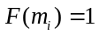). Finding a solution can be thus visualized as finding a single number (cell) with value “1” (a true minterm) in a Karnaugh Map of function F in which all other cells have values 0. Obviously, when one solves this problem in the classical world and no additional information is available, the classical SAT algorithms can be employed. These SAT algorithms have worst-case exponential complexity. When there are > 1 solutions, in the quantum search case one of many variants of the Grover’s Algorithm can be employed to find all solutions (SAT-ALL).

As we remember from chapter 5, a generalization of PPRM is called the Fixed Polarity Reed-Muller (FPRM) form where every variable is either negated or not consistently in the same polarity in every term of the expression. Thus, FPRM 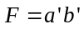 has the polarity number 0 (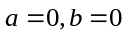) and the equivalent PPRM 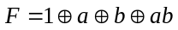 has the polarity number 3 (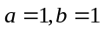). As illustrated in chapter 5, in binary form, each FPRM represents a two-level circuit consisting of a set of conjunctions of literals (AND operations) followed by a multi-input addition modulo-2 operation (EXOR operation).

Several heuristic methods have been formulated in the past for both ESOP minimization [Sasao93, Mishchenko01] and for FPRM minimization (chapter 7 and [Sasao96, Dreschler96]). Here, however, we present a fundamentally new approach to FPRM minimization (with incomplete data) that is based on quantum logic and the use of Grover’s algorithm. This approach can be extended to several canonical EXOR forms [Sasao96] as well as to the non-canonical ESOPs; however, in this section only the FPRM case is discussed. It can be observed that the method is based on controlling stages of butterfly diagrams and thus similar approaches can be applied to any spectral transform that can be described by some kind of a butterfly diagram. We present the binary case here, but the ternary case [Cheng05] is very similar. We will use the general blocks developed in chapter 14 (Figure 17.4.2.1). The FPRM Processor and the “Ones Counter” (Cost Counter) are built as in Chapter 14. The “Inverse Cost Counter and Comparator” is just the mirror circuit of the “Cost Counter and Comparator” circuit so it can be easily created by reversing order of inverse gates (a standard method of “mirrors” discussed in chapters 5 and 7??). Similarly the Inverse FPRM processor is designed as a mirror circuit.

Let us discuss this complex oracle in more detail. The entire proposed oracle, part of the Grover Loop, for finding minimum FPRM is shown in Figure 17.5.2.1. There are four blocks in this oracle architecture: the FPRM processor, the Cost Function and Comparator, and the corresponding inverse blocks Inverse FPRM processor, Inverse Cost Function and Comparator.

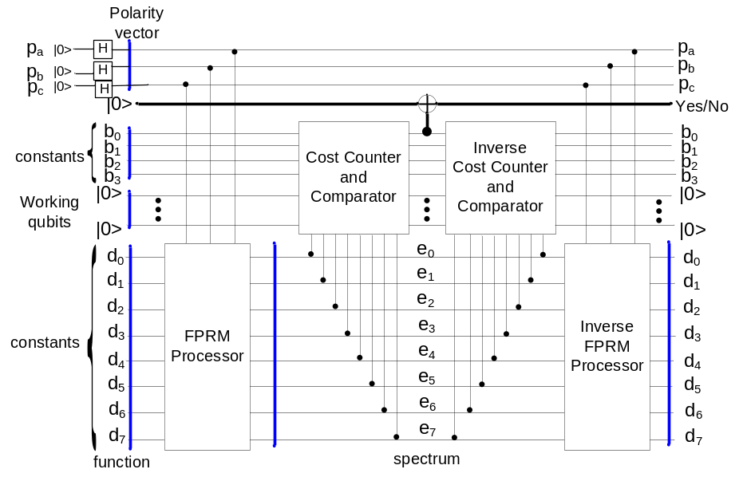oracle qubit
Figure 17.4.2.1: Quantum Architecture for FPRM Oracle for Grover’s Algorithm. This is the case of 3-variable functions, there are thus eight minterms d₀ to d₇ and three qubits for polarity p_{a}, p_{b} and p_{c} (on top left).

Whether we solve the completely or incompletely specified function case, the inputs of the FPRM processor (see Figure 17.4.2.1) are:
(1) the binary values - the “vector of minterms” for a given Boolean function, and
(2) the polarity vector.
In case of complete functions only the care minterms, i.e. true minterms or false minterms are given as d_{i}. These values are constants: 0 for false minterm and 1 for a true minterm. Minterms are denoted as d_{i}, we = 0, …, 7 at the left of Figure 17.4.2.1.

The output of the FPRM processor is the binary vector of the FPRM spectrum coefficients for the given Boolean function and the polarity specified by binary (p_{a}, p_{b}, p_{c}). Observe however that this value is available only in quantum inside the Grover Loop. The measured output of the entire “Grover Architecture for FPRM Minimization” is only the polarity specified by binary (p_{a}, p_{b}, p_{c}). From these data a standard computer has to recalculate the vector of coefficients (e₀,.. e₇), but this can be done fast as no search is involved and the process is completely algorithmic as was discussed while presenting butterflies in chapter 5.

There are two input busses for the Cost Function and Comparator block, the threshold value and the polarity vector. The FPRM processor requires the 2^{n} sized truth vector of the Boolean function and produces binary values of the 2^{n} FPRM spectral coefficients corresponding to the function and polarity vector. Two tasks are accomplished in the Cost Function and Comparator block. First, the number of ones in the vector of spectral coefficients is counted. Second, a comparison of the number of ones with the threshold value is accomplished. If the number of ones in the coefficients is less than the threshold value, the Cost Function and Comparator block will output a one, otherwise zero. The corresponding inverse blocks, Inverse FPRM processor, Inverse Cost Function and Comparator, accomplish the inverses (mirrors) of these functions.

The FPRM processor accepts:
- a vector corresponding to the Boolean function and a
- polarity vector
FPRM Processor outputs the FPRM spectral coefficients.

The core part of the FPRM processor is the “butterfly” quantum circuit. The polarity of the “butterfly” is controlled by the polarity bits. Figure 17.13.1 in chapter 17 shows the 1-variable FPRM processor which has a 2-bit function input (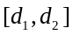) and a 1-bit polarity input (p). If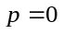, the output is positive polarity coefficients, otherwise, it is negative polarity coefficients. To understand this oracle in detail the careful reader should analyze the constructions of all blocks used in this oracle, as they are explained in chapter 17.

17.3.4. Oracle for incompletely specified FPRM.
In the case of incompletely specified datac the oracle is exactly the same as in Figure 17.4.2.1 but it is differently controlled. The qubits d₀ to d₇ are now set not only to Boolean values zero or one (for negative and positive minterms, respectively). These qubits must now correspond also to don’t cares. The don’t cares are created as shown in Figure 17.4.3.1 by using Hadamard gates. Every input qubit that corresponds to a minterm being a don’t care goes through the individual Hadamard gate. Qubit d₇ in the Figure can be an example.

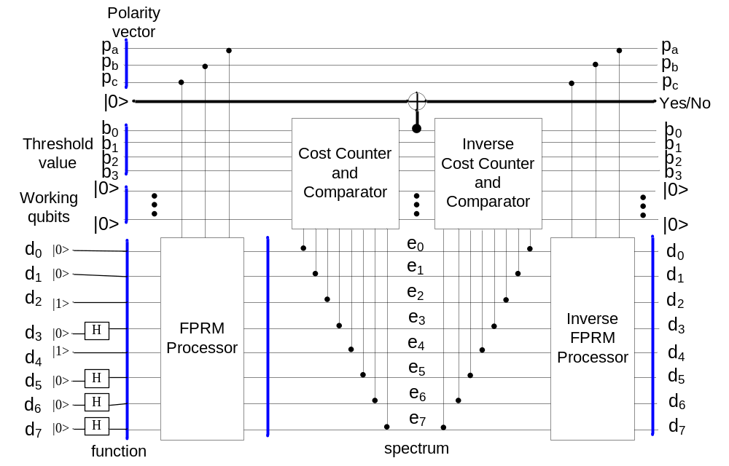
Figure 17.4.3.1: Quantum Architecture for FPRM Oracle for Grover’s Algorithm. This is the case of incompletely specified function so all don’t cares go through Hadamard gates. The circuit illustrates the incomplete function for which d₀ = 0, d₁ = 0, d₂ = 1, d₃ = -, d₄ = 1, d₅ = -, d₆ = -, d₇ = -.

The architecture from Figure 17.4.3.1 finds the cheapest solution for a given polarity p_{a}, p_{b}, p_{c} when the input of polarity qubits is fixed to a binary vector.

However, when the polarity is not assumed, which means the inputs p_{a}, p_{b}, p_{c} are provided through Hadamards (as in Figure 17.4.2.1), and the minterm data qubits are still as presented above, then the entire quantum architecture finds both: the best FPRM polarity and the best assignment of values to data minterms.

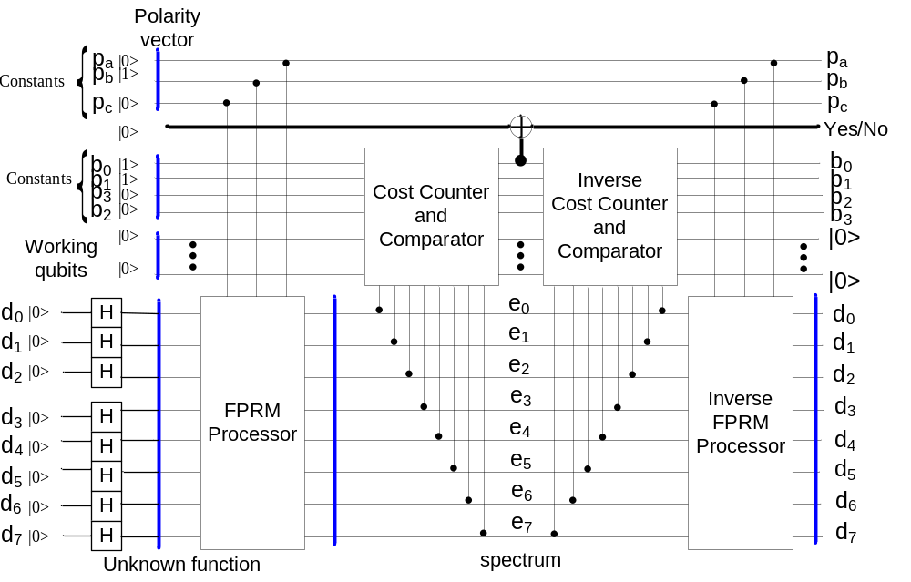
Figure 17.4.3.2: Quantum Architectures for spectral-based Oracle for Grover’s Algorithm for the problem 17.4.3.2 from section 17.4.3.

Concluding on variants of search problems solvable with FPRM oracles, let us observe that we can formulate four different search problems. All these problems use exactly the same oracle. Each of these four cases is selected by some specific way of providing input values to all inputs of the Grover’s Oracle.

Problem 17.4.3.1.
- Given are:
- a completely specified function f specified by the vector of its minterms.
- the integer number bound B on the cost C(S(f)) of the solution S(f) being a binary vector.
- The cost C(S(f)) is the number of non-zero spectral coefficients in vector S(f).
- Find the FPRM polarity Pi for which the cost of spectrum S(f) is below the value of the bound B.
This problem is illustrated in Figure 17.4.2.1. It was discussed in section 17.4.2 and in the original paper by Lin et al [Li06].

Problem 17.4.3.2.
1. Given are:
- The polarity Pi as a binary vector
- The integer number bound B on the cost C(S(f)) of the solution S(f) being a binary vector.
- The cost C(S(f)) is the number of non-zero spectral coefficients in vector S(f).
- Find the function f such that the FPRM in this polarity Pi has the cost C(S(f)) of spectrum S(f) that is below the bound value B.
This approach can be used to automatically invent new gates with small costs. This case is illustrated in Figure 17.4.3.2.

Problem 17.4.3.3.
1. Given are:
- The polarity Pi as a binary vector
- The function f specified by the vector of its minterms.
2. The cost is the number of non-zero spectral coefficients.
- Find the bound such that this function f in this FPRM polarity Pi has the cost of the spectrum vector that is below the bound that is found.
This problem makes no particular practical sense but is added here for completeness and to show our general methodology of asking different questions to an oracle.

Problem 17.4.3.4.
Given are:
- an incompletely specified function f specified by its care and don’t care minterms.
- The cost is the number of non-zero spectral coefficients.
- Find the FPRM polarity P_{i} for which the cost of the spectrum vector is the minimum. Find this binary spectrum vector and the assignments of cares to don’t care minterms.
This is the most important and useful generalization that we found. It is illustrated in Figure 17.4.3.1 with additional Hadamard gates on bits p_{a}, p_{b}, p_{c}.

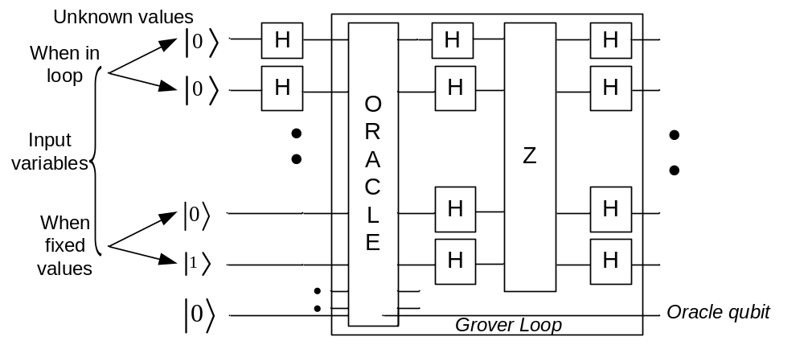
Figure 17.4.3.3: Explanation of using inputs for known and unknown values on inputs to extended Grover Algorithm. The known values are initialized to basis states 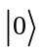 or 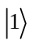. The unknown values are initialized to state 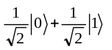.

Concluding, the same oracle can be used to answer several questions, depending which data to it are fixed and which are unknown. Figure 17.4.3.3 shows the general way to create preprocessing circuits to oracles in Grover algorithm. Every input, for every subset of inputs with different meanings can be set to value if this data bit is negative, to if this data bit is positive and to superposed value 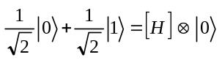representing an unknown value that its definite value is searched for. This principle of creating oracles and formulating data for them is very general and we applied it to other problems not discussed in this book.

This principle can be summarized as:
“Create such an oracle that
      - the care data inputs are fixed to binary values
      - the don’t care data inputs are set to
and next measure all don’t care qubits.”

17.4.4. Generalizations and Applications of Spectral Learning Model.
17.4.4.1. Generalizations and applications of methods from sections 17.4.2 and 17.4.3.

Let us observe that the selection of FPRM spectrum as the spectral transform in the section 17.4.3 was purely incidental. As we know the FPRM is just one family of AND/EXOR spectral transforms. Because it has the simplest butterflies, the FPRM forms are practically the most popular. Therefore the authors of [Li06] selected this family of spectral transforms. The approach illustrated in section 17.4.3 can be however applied to any family of spectral transforms, especially the transforms related to AND/EXOR logic. It can be also used to other transforms for which butterflies can be built as permutative quantum circuits, see Chapter 9, section 12. Hadamard, Fourier, Cosine and other transforms are for instance possible. This is because one can build in principle the oracles like in sections 9.4.2 and 9.4.3 for every family of expansions controlled by certain parameters. We tried to build oracles for such AND/EXOR spectral transforms as GRM and GPMPRM [Zhang99]. We found it possible to build such oracles, but very complicated. However, we make here a point that this is possible in principle. We can thus formulate the following generalized problems, each problem below generalizes the concept of an oracle from the FPRM oracle to every imaginable polarity-based (parameter-based, parameterized) spectral transform oracle.
Problem 17.4.4.1.
Given are:
            - The function F: I → O defined as a mapping (Boolean, Multiple-Valued or hybrid)
            - The bound B on the cost of realization of this function
            - The function is realized as an expression based on selecting some subset of non-zero coefficients of some spectral transform ST of this function.
Find
the polarity of this expansion (or equivalently, the value of the parameter)
for which the cost of the spectrum (number of non-zero coefficients) is below the given bound B.

Problem 17.4.4.2.
Given are:
            - The function F: I → O defined as a mapping (Boolean, Multiple-Valued or hybrid)
            - The cost of realization as the number of non-zero spectral coefficients.
            - The bound B on the cost of realization of this function
            - The function is realized as an expression based on selecting some subset of non-zero coefficients of some spectral transform ST of this function.
            - The spectrum
            - The polarity Pi
Find
the function F such that the given instance of the family of transforms in this polarity P has the cost of the spectrum that is below the bound B.

Problem 17.4.4.3.
Given are:
            - The function F: I → O defined as a mapping (Boolean, Multiple-Valued or hybrid). The function is realized as an expression based on selecting some subset of non-zero coefficients of some spectral transform ST of this function.
            - The cost of realization as the number of non-zero spectral coefficients.
            - The bound B on the cost of realization of this function
            - The spectrum
            - The polarity Pi
Find
the bound B such that this function F in this family of spectra in this polarity P has the cost of spectrum that is below the bound B.

Problem 17.4.4.4.
Given are:
            - The incompletely specified function F: I → O defined as a mapping (Boolean, Multiple-Valued or hybrid). The function is realized as an expression based on selecting some subset of non-zero coefficients of some spectral transform ST of this function.
            - The cost of realization as the number of non-zero spectral coefficients.
            - The bound B on the cost of realization of this function
            - The spectrum
            - The polarity Pi
Find
the polarity of the expression within the family of transforms for which the cost of spectrum (the number of non-zero coefficients) is the minimum.

This is the most important and useful generalization of generalizations, as it relates to quantum, Grover-based machine learning with arbitrary spectral transforms.

Applications of methods from section 17.4.2 and 17.4.3 can be in all those areas of research and practical technology in which the spectral transforms are now being used. This includes the following:

- General Logic design (also logic minimization for reversible and quantum circuits themselves),
- Logic Design for Test, highly testable circuits,
- Image processing and DSP,
- Data compression,
- Communication,
- Cryptography,
- Error detecting and error-correcting codes,
- Machine Learning.

In section 17.4.2 and 17.4.3 only a particular approach was illustrated because as the spectrum transform we used the family of FPRMs, the reader remembers however from chapters 5, and 6 that there are many parameterized AND/EXOR forms such as GRM, GKRM, KRM and also many other spectral transforms such as adding, arithmetic, generalized, Haar Transform, Fourier Transform, etc. Each of these families can be used to build the generator being the part of the oracle. We found the way to build generators for all these forms. By the way, each of these generators can be created similarly to the generators for FPRM in this chapter, based on the knowledge of the butterfly structures [Perkowski97a, Perkowski97b, Zeng95]. What is most important is that we found a general method to create quantum oracles for all problems described by families of spectral transforms. The Zhegalkin hierarchy finds therefore one more practical application. Such families include not only the classical AND/EXOR transforms but also the entire (some new, some old) families of Haar transforms and wavelets, polarized Walsh, complex Walsh, complex Haar, multivalued Haar and Walsh (Hadamard, Paley, Karczmarz), Chrestenson and Fourier. Some problems in signal processing and image processing use adaptive filters that change dynamically the transform applied in real-time as an approach to adopt to the changing environment. Our approach is applicable directly to all these problems with no any modification. This is a very general method with many new applications.

17.4.4.2. Applications in Quantum Game Theory.

It is difficult to predict future of technology but one can observe that general methods to represent data such as the spectral methods find applications in very many areas and are used in many commercial products, the Cosine Transform with applications in JPEG and MPEG can be just one convincing example. Slant and Haar transforms were used by Intel and other companies. Reed-Muller codes are used in interplanetary communications. The list goes on. In addition, there is also a quickly developing area of quantum game theory where many known results from quantum algorithms were assigned very interesting new interpretations. All problems represented above as the design, construction, mapping problems are interpreted as games between two or more participants. This will have applications in economy and Internet gambling with future quantum internet. For instance, the learning problem discussed above is more general than the known quantum game of finding the conjunctive formula of literals for a given set of data. Our machine from previous sections could be just set to the threshold of two (limit to a single product of literals) to obtain a product of literals (not necessarily a minterm like in many games) that satisfies the input data being formulated as a set of minterms. In quantum games the number of players is the number of qubits and the number of strategies per player is the radix of logic used in the respective qudit. Therefore, all circuits presented here can be generalized to ternary quantum gates [Khan05, Kalay99c], allowing to create ternary butterflies [Cheng05] and more efficient arithmetic for larger counters and comparators. Next they can be generalized to arbitrary radix of logic and applied to respective games. The Classical Game Theory finds many applications in robotics, especially to military and social robotics. We can speculate that the same will happen to the Quantum Game Theory.

17.4.4.3. Advances in the design of quantum arithmetics.

There is one more aspect which should be discussed at this point. In this and previous chapters we showed how Grover’s algorithm can be extended to practical problems in classical logic minimization and Machine Learning. Thus our examples illustrated also the design of practical reversible circuits using quantum gates for blocks that will be normally incorporated inside oracles. In many oracles that we tried, always exist arithmetic blocks such as adders, subtractors, comparators, counters of ones (compressors), butterfly transforms and logic blocks. In chapters 14 - 16 we showed usefulness of some of these blocks. We see that much more work can be done on arithmetic of quantum computers, but this is beyond this book.

17.4.4.4. Quantum oracles for learning based on non-spectral approaches and types of transforms.

The next goal of research in the area of Machine Learning and Data Mining can be to design and simulate algorithms similar to those listed above that would use representations based on Galois Fields other than the GF(2) field [Kalay99c]. The goal of these algorithms would be to create ESOP-based and GFSOP-based optimized quantum arrays and quantum state machines. In terms of Machine Learning the above methods would be characterized as classical “Occam Razor” learning methods.
We look in them for a formula of certain type (like a GFSOP expression) that has a cost as low as possible and has either no error or an error smaller than some Error Threshold Value. The desired cost is the smallest possible number of non-zero spectral coefficients. The type of the circuit synthesized is the learning bias of the method.
To our knowledge this kind of learning algorithm was never proposed to be implemented in a quantum circuit. So far only learning of DNF formulas and Neural Nets was applied in the area of Quantum Computational Intelligence [Ventura98, Ventura99, Behrman96, Hopfield82, Perus96].

When one discusses the choice of the spectral transform in the oracle, special attention must be paid to Karhunen-Loeve transforms [Thornton05] because these transforms, although difficult to implement, allow for the best approximation for a wide set of base functions and are therefore the optimal spectral transforms. Wavelet transforms should be also analyzed as a candidate for transforms used in quantum oracles. The PSU Group intends also to build quantum oracles for other spectral transforms, especially those used in robotics, and particularly in robot vision. One of the aims of the entire work of PSU group is to discover practical and efficient methods of designing binary, multi-valued and hybrid quantum circuits, blocks and algorithms not for random benchmarks but for practical blocks and architectures that have practical applications in quantum oracles of algorithms that speed-up very time consuming algorithms. The work presented in this book can contribute to this broad task by delivering several practical circuits, re-usable blocks (such as sorters or comparators), quantum algorithms (such as graph coloring) and partial methodologies.

The proposed approach can be also applied to any problem (like filter design or processor design) described by:
- certain discrete parameters (encoded to binary for our algorithms)
- there exists a cost function based on the complexity of the output data (the number of the FPRM transform coefficients in case of sections 17.4.2 and 17.4.3)
We created thus, particularly in this chapter, a general quantum method to solve many classical problems in image and signal processing, filtering, matching and learning. In particular, every problem for which there exists a Linearly Independent Transform can be solved this way, which includes wavelets, Fourier transforms and other “orthogonal transforms”.

