HOMEWORK II

FIFO CONTROLLER

As Part of CourseWork

Of ECE 590

DIGITAL DESIGN IN HARDWARE DESCRIPITIVE LANGUAGE

By

Mithun Bista
Graduate Student
ID #: 990081129

Instructor: Dr. Marek Perkowski
Professor, ECE Department
Portland State University
Spring 2006
Definition of FIFO:
FIFO is an acronym for first in first out. Usually this term is related in software programming such as FIFO queue or in hardware as hardware buffer from which items are taken out in the same order they were put in. A FIFO queue is also known as a "shelf" from the analogy with pushing items onto one end of a shelf so that they fall off the other.

Uses of FIFO are:
- A FIFO is useful for asynchronous buffering of stream of data between a sender and a receiver.
- FIFO buffers are used to reduce the frequency of interrupt processes for UART chips, such as the C16550C, used in serial communications.

In this homework, I’ll be designing the FIFO controller as part of a Moore Machine. The generalized block diagram of Moore Machine is given below:
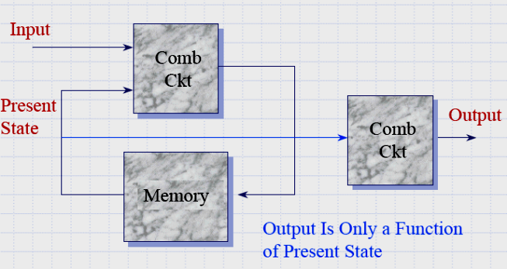

We design the FIFO controller as a state machine, in which the state machine feeds the control input of the memory and the inputs of an address counter

The operation of the state machine is as follows:

■ When the push input is asserted and the address counter is less than 250, the address counter is incremented and a byte of data is written to memory.

■ When the pop input is asserted and the address counter is greater than 0, the address counter is decremented and a byte of data is read from memory.

■ When the address counter is equal to 0, the empty flag is asserted.

■ When the address counter is equal to 250, the full flag is asserted.

Top Level Schematics of FIFO:
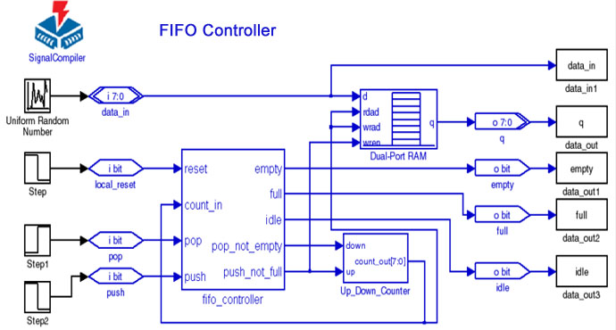

The state table for the controller is given below:

State Flow Diagram: 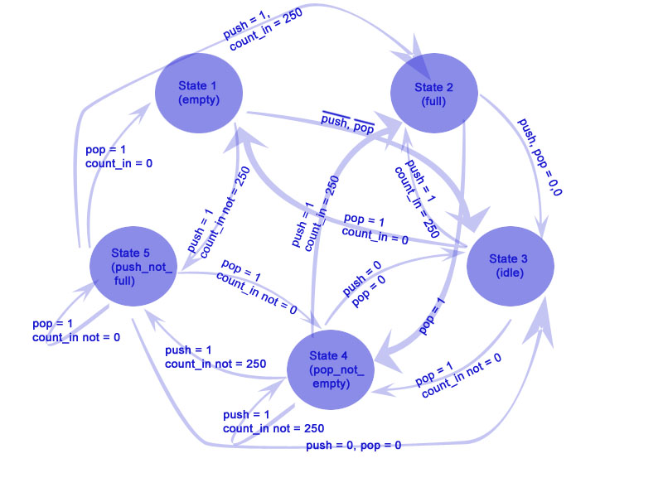

VHDL CODE:
From the state diagram, we can directly write the HDL code. The code is given below:

library ieee;
use ieee.std_logic_1164.all;
use ieee.std_logic_unsigned.all;

entity fifo is
generic ( DEPTH_RAM : integer := 1024;
DEPTH_COUNTER : integer := 256;
SIZE : integer := 8;
WIDTH : integer := 8
);
port (
clk : in bit;
reset : in bit;
din : in std_logic_vector(7 downto 0);
push_sig : in bit;
pop_sig : in bit;
dout : out std_logic_vector(7 downto 0)
);
end fifo;

architecture behav of fifo is

type mem_array is array (DEPTH_RAM-1 downto 0) of std_logic_vector(WIDTH-1 downto 0);
--type counter_array is array (DEPTH_COUNTER-1 downto 0) of std_logic_vector(WIDTH-1 downto 0);
signal ram : mem_array;
signal waddr : std_logic_vector(SIZE-1 downto 0);
signal raddr : std_logic_vector(SIZE-1 downto 0);
signal count_in_sig : std_logic_vector(SIZE-1 downto 0);
signal current_state : std_logic_vector(1 downto 0);
signal next_state : std_logic_vector(1 downto 0);
signal empty_st : std_logic_vector(1 downto 0);
signal full_st : std_logic_vector(1 downto 0);
signal push_not_full_st : std_logic_vector(1 downto 0);
signal pop_not_full_st : std_logic_vector(1 downto 0);

begin

dout <= ram(conv_integer(raddr));

process (clk, reset)
begin
if (reset='1') then
current_state <= empty_st;
waddr <= (others => '0');
count_in_sig <= (others => '0');

elsif clk'event and clk='1' then
current_state <= next_state;

end if;

end process;

-- Next state assignment based on the present state and present inputs
process (current_state, count_in_sig, pop_sig, push_sig)
begin
case current_state is
when empty_st=>
if ((push_sig='1') and (count_in_sig/='250')) then
next_state <= push_not_full_st;
ram(conv_integer(waddr)) <= din;
waddr <= waddr + 1;
count_in_sig <= count_in_sig + 1;

elsif ((push_sig='0') AND (pop_sig='0')) then
next_state <= idle_st;

else
next_state <= empty_st;

end if;

when full_st=>

if ((push_sig='0') AND (pop_sig='0')) then
next_state <= idle_st;

elsif ((pop_sig='1')) then
next_state <= pop_not_empty_st;
dout <= ram(conv_integer(raddr));
count_in_sig <= count_in_sig -1;

else
next_state <= full_st;

end if;

when idle_st=>

if ((pop_sig='1') AND (count_in_sig='0')) then
next_state <= empty_st;

elsif (push_sig='1') then
next_state <= push_not_full_st;
ram(conv_integer(waddr)) <= din;
waddr <= waddr + 1;
count_in_sig <= count_in_sig + 1;

elsif ((pop_sig='1') AND (count_in_sig/='0')) then
next_state <= pop_not_empty_st;
dout <= ram(conv_integer(raddr));
raddr <= raddr + 1;
count_in_sig <= count_in_sig -1;

elsif ((push_sig='1') AND (count_in_sig='250')) then
next_state <= full_st;

else
next_state <= idle_st;

end if;

when pop_not_empty_st=>

if ((push_sig='0') AND (pop_sig='0')) then
next_state <= idle_st;

elsif ((pop_sig='1') AND (count_in_sig='0')) then
next_state <= empty_st;

elsif ((push_sig='1') AND (count_in_sig/='250')) then
next_state <= push_not_full_st;
ram(conv_integer(waddr)) <= din;
waddr <= waddr + 1;
count_in_sig <= count_in_sig + 1;

elsif ((pop_sig='1') AND (count_in_sig/='0')) then
next_state <= pop_not_empty_st;
dout <= ram(conv_integer(raddr));
raddr <= raddr + 1;
count_in_sig <= count_in_sig -1;

elsif ((push_sig='1') AND (count_in_sig='250')) then
next_state <= full_st;

end if;
end case;

end process;
end behav;

