HOMEWORK I

PULSE AMPLITUDE MODULATOR

As Part of CourseWork

Of ECE 590

DIGITAL DESIGN IN HARDWARE DESCRIPITIVE LANGUAGE

By

Mithun Bista
Graduate Student
ID #: 990081129

Instructor: Dr. Marek Perkowski
Professor, ECE Department
Portland State University
Spring 2006

Mini-Project Proposal:
As part of the first homework, I will be designing a PAM modulator in hardware and hardware descriptive language, and simulating the design and the code in Matlab/Simulink together with Mentor Graphics ModelSim tools.

So what is PAM?
Pulse-amplitude modulation, acronym PAM, is a form of signal modulation where the message information is encoded in the amplitude of a series of signal pulses. Let m(t) be the message signal (like voice or data) which is generally low frequency signal and s(t) be the pulse train which has a time period of Ts. The period of m(t) is >> Ts. T is the time when the pulse remains high.

Original Message Signal

SCOPE

m(t)
DELAY (1/z)
DELAY (1/z⁴)

Modulated Signal
Message Signal m(t) = Sinwot; fo = 500 Khz
s(t),
Ts = 1/40e6

Figure a: Block diagram of PAM modulator

Figure b: modulated signal p(t)

So our PAM modulator will have a 500 kHz sinusoidal signal and an input, 40 MHz pulse train as the modulating signal generating 40 MHz modulated p(t) signal.
Components Required:
The components that are required are:

- A sinusoidal signal generator:
- A pulse train generator
- A multiplier circuit.
- Delay circuit.
- Generalized Registers.

1) Sinusoidal Signal Generator:

Clock = 2.5e9 pulse per sec (2.5 GHz)

RLC
Circuit
Sample
& Hold

ADC
x(t) y(t) Bn

(digitized samples)

The clock pulse @ 2.5 GHz is also the sampling frequency of the analog sinusoidal signal produced from the RLC circuit. The sampling frequency of 2.5 GHz is not to be confused by the sampling frequency of 40 MHz of the pulse train signal.

I’m not going to talk about designing how to build a pulse train generator because it can be designed in similar ways as the sinusoidal generator. I am using bit stream block (which models the pulse train) and sine generator block (which models the sinusoidal signal) from Matlab to model my overall hardware design.

Generalized Dataflow Diagram:

16

MULTIPLIER
CIRCUIT

SCOPE
18

2

Registers
Simulink/ Altera DSP Builder Hardware Dataflow Schematics:
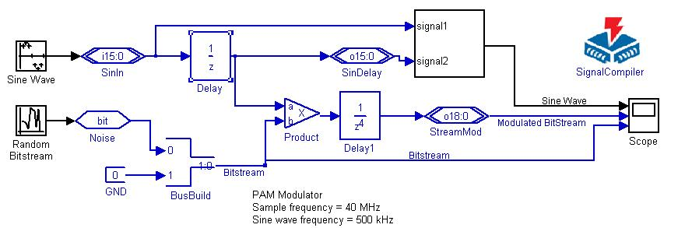

The above dataflow schematic is the actual simulation performed in Matlab/Simulink. The blocks used to model are part of package from Altera DSP Builder tools for Matlab/Simulink.

Some description of the blocks:
and
These two blocks represent the BUS. The sign i7:0 represents 8 bit input bus with 0 referring to VHDL structure of (7 downto 0). Similarly the output block has “o” to represent the output. Signals are directly cast into these blocks.

This block is the multiplier block which we’ll be designing later.

The delay block delays by one clock pulse. Since in our later discussion, we’ll have the multiplier requiring four clock pulses to obtain the output. This block is used to model delays due to the circuit components.
BusBuild is used to build a bus from different signal sources. Here we have for our project 2 bit bus representing the signals for the pulse train.

How all these work?

- First of all we have a Sine Wave block which generates a 500 kHz wave sampled at the clock rate of 2.5 GHz. When we right click this block we can see all sort’s of parameters that we can change. We also set the bits per frame of 16 bits. So instead of sending individual bits we’ll sending 16 bits at a time. This simulates the pipelined flow. Also introduces 1 clock pulse delay.

- Second, the input and output bus is set to 16, so we effectively have a 16 bit bus. Each bit in the frame that comes from the sinusoidal block is casted to the 16 channels in the bus.

- The delay block after the input bus delays the signal but 1 clock pulse, this is due to the fact that we’re simulating the real hardware. If we did not have this block all the calculations are instantaneous and the model won’t effectively represent the real hardware. This delay is due to the time required to load the input registers.

- The random bit stream generates a pulse train with the sampling period of 1/40e6 sec. Then this bit is casted to the bus-build block. We also have gnd that casts a 0 bit because we want two bit to represent the high and low values of the pulse train.

- Then these two signals are sent to the multiplier and the output of the multiplier is send to a time domain scope. The scope also generates the waveforms of the bit stream and the original sine wave.

16 * 2 bit Multiplier Design:

We define the system to work as follows. A and B are input into the system. The system waits for a user to assert the Simulation start button in Simulink. At that point, Sim_Start is asserted and the system begins multiplication. Similarly, when the Simulation ends in a predefined period of time, the Sim_Stop is asserted. This causes the final value of the product to be available on the outputs.

Sim_Stop
Global_Clear
CLK
18
2
16

Sim_Start

Lets say A = 1 0 1 1 1 0 1 1 1 1 1 0 1 0 1 1 (16 bit input multiplicand)
B = 1 0 (two bit multiplier)

1 0 1 1 1 0 1 1 1 1 1 0 1 0 1 1
X 1 0

0 0 0 0 0 0 0 0 0 0 0 0 0 0 0 0 (M1)
1 0 1 1 1 0 1 1 1 1 1 0 1 0 1 1 X (M2)

1 0 1 1 1 0 1 1 1 1 1 0 1 0 1 1 0

The output is always 17 bits in length, so as you can see we can implement this adder by shifting and adding. If 1 is the MSB bit of the multiplier then we need to shift the multiplicand i.e. (M2) and the LSB of that shifted multiplicand is don’t care. We will put 0 for don’t care condition. Similarly if zero comes the all the multiplicand i.e.(M1) is zero.

Since the output is 17 bits length is not a standard for a shifter or an adder, we use 18 bit shift register.

0 A16 A1 A0
……………………………….
18 BIT SHIFT REGISTER
……
CLR
SO
Global_Clear
Sim_Start
Sim_Stop
S1

CLK

0

B1 B0
A
B
SO
Sim_Start
A
18 Bit Adder Sum
2 Bit Shift Register
S1
Global_Clear
Sim_Stop

CLK
CLK
….
Register
CLK

18 bit Shift- Register Design:
The design for the 18 bit register can be done by using multiplexers and D-Flip Flop. This design was illustrated by you in the class. So I won’t be discussing on how to implement this register. It is obvious that we can design this shift register iteratively.

VHDL Code for Multiplier:
The primary goal of this homework 1 for me was to build a multiplier and write the multiplier code in VHDL. The code is given below:

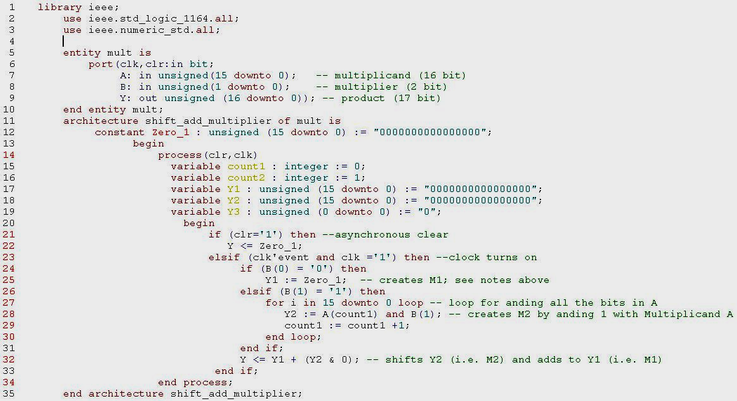
The code is written in Mentor Graphics/ ModelSim 6.1 tool. This file has been directly pasted from the model sim tool. Appropriate comments are provided where necessary. The Test-
Bench for the code is provided in the next page.

Multiplier’s Test-Bench Code

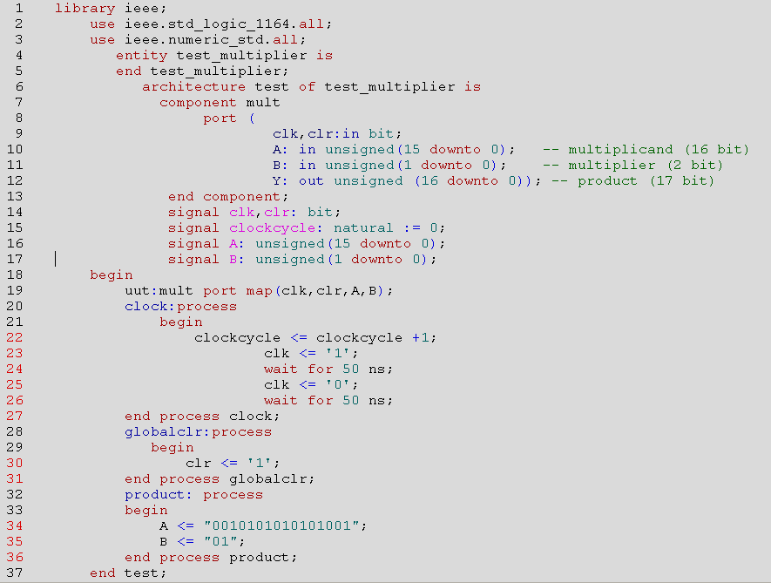

This code is for the multiplier design only, not for the whole PAM modulator. The simulation results are provided in the next page. The simulation consists of three graphs which are the sine wave and the delayed sine wave, the modulated bit stream and the original bit stream. As you can see in the figure below, the second graph shows the modulated stream, which can now be transmitted. The receiver after receiving this signal can use demodulation i.e. multiplying the received signal by the original sine wave (fig 1 below) to extract the base band signal.

Simulation Results:

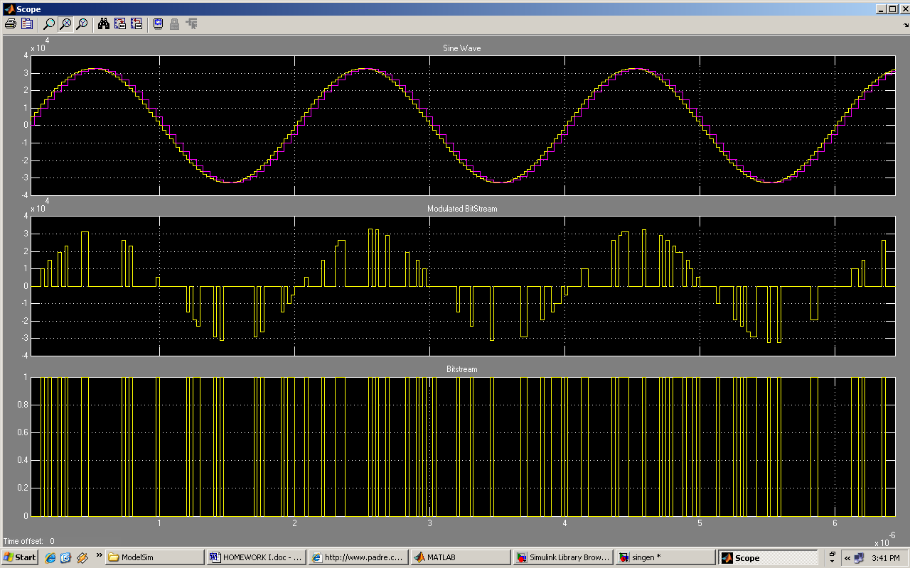

Conclusion:
This project (homework I) builds upon the concept of use of adders and multipliers and expands them for use in larger applications in digital circuits, communication, dsp etc. PAM modulator is still used in Ethernet applications and is contemplated to be used in future applications of Ethernet. So overall these projects provided me with the basis on how to construct and formulate a problem in digital design and expand them in larger more complex applications.

Bibliography:

- Internet References:
PAM Modulator
http://en.wikipedia.org/wiki/Pulse-amplitude_modulation/
www.mathworks.com/matlabcentral/fileexchange/loadFile.do?objectId=5794
www.web.media.mit.edu/~lifton/acad/dcom/L11-02.pdf
Multiplier:
http://padre.ca/house/multiplier_example_web.pdf
http://cegt201.bradley.edu/projects/proj2003/dspproj/logmul.htm
Books: Digital Design, 3rd Edition, 2001 – Morris Mano
VHDL:

Selected Books:
VHDL and FPLD’s – Zoran Salcic, Kluwer academic publishers, 1998

