ECE 590 Homework 2
Andrzej Janczak

Comparison two Gray counters (mod 10) – manually (‘hand made’) vs VHDL automatically generated from state graph

Introduction
Gray code was designed to prevent problems with reading and interpretation of the actual state of complex switches. Each change generates only one bit change at a time. Currently Gray code is often used for example in correction codes.
Because of restricted sequence not for all n values mod n Gray counter can be build. However, it is possible to design 4-bit Gray counter modulo 10 (after state 9 – ‘1100’ follows state 15 – ‘1000’ and after rollover- ‘0000’). In this way gap between 9 and 15 doesn’t impact Gray sequence (change on one position).
The design has been made in two ways: a “handmade” from VHDL implementation of equation from truth table, second one by synthesis from VHDL state machine description (both solutions presented below).

States
Input K is a direction choice bit: ‘1’ – counter counts up, ‘0’ – down.

However, after power up the real circuit can be locked at one of the unused states so designer needs to check if from each unused states there is a sequence that eventually leads to any of the legal states.

Truth table:

$Q_{3}^{'}$$Q_{2}^{'}$$Q_{1}^{'}$$Q_{0}^{'}$

Equations
$$Q_{3}^{'}={\overline{Q}}_{2}{\overline{Q}}_{1}{\overline{Q}}_{0}\overline{K}+Q_{2}{\overline{Q}}_{1}{\overline{Q}}_{0}K={\overline{Q}}_{1}{\overline{Q}}_{0}({\overline{Q}}_{2}\overline{K}+Q_{2}K)={\overline{Q}}_{1}{\overline{Q}}_{0}(\overline{Q_{2}⊕K)}$$
$$Q_{2}^{'}=Q_{3}\overline{K}+Q_{1}{\overline{Q}}_{0}K+{\overline{Q}}_{3}Q_{2}{\overline{Q}}_{1}+Q_{2}Q_{0}$$
$$Q_{1}^{'}={\overline{Q}}_{3}Q_{1}{\overline{Q}}_{0}+Q_{2}Q_{0}\overline{K}+{\overline{Q}}_{2}Q_{0}K={\overline{Q}}_{3}Q_{1}{\overline{Q}}_{0}+{\overline{Q}}_{0}({\overline{Q}}_{2}K+Q_{2}\overline{K})={\overline{Q}}_{3}Q_{1}{\overline{Q}}_{0}+{\overline{Q}}_{0}(Q_{2}⊕K)$$
$$\begin{aligned}Q_{0}^{'}={\overline{Q}}_{3}{\overline{Q}}_{2}{\overline{Q}}_{1}K+{\overline{Q}}_{3}Q_{2}Q_{1}K+{\overline{Q}}_{3}{\overline{Q}}_{2}Q_{1}\overline{K}+{\overline{Q}}_{3}Q_{2}{\overline{Q}}_{1}\overline{K}={\overline{Q}}_{3}K(\overline{Q_{2}⊕Q_{1})}+{\overline{Q}}_{3}\overline{K}(Q_{2}⊕Q_{1})= \\ {\overline{Q}}_{3}(K⊕Q_{2}⊕Q_{1})\end{aligned}$$
The circuit can be synthesized by using 4 D flip-flops.

VHDL code from above equations
----------------------------------------------------------------------------------
----------------------------------------------------------------------------------
library IEEE;
use IEEE.STD_LOGIC_1164.ALL;
use IEEE.STD_LOGIC_ARITH.ALL;
use IEEE.STD_LOGIC_UNSIGNED.ALL;

---- Uncomment the following library declaration if instantiating
---- any Xilinx primitives in this code.
--library UNISIM;
--use UNISIM.VComponents.all;

entity Gray10updown is
port ( K, CLK, RESET: in STD_LOGIC;
Q: out STD_LOGIC_VECTOR(3 downto 0));
end entity gray10updown;

architecture Beh of Gray10updown is
component INV
port (I: in STD_LOGIC;
O: out STD_LOGIC);
end component;
component XOR2
port (I0, I1: in STD_LOGIC;
O: out STD_LOGIC);
end component;
component AND2
port (I0, I1: in STD_LOGIC;
O: out STD_LOGIC);
end component;
component AND3
port (I0, I1, I2: in STD_LOGIC;
O: out STD_LOGIC);
end component;
component OR2
port (I0, I1: in STD_LOGIC;
O: out STD_LOGIC);
end component;
component OR4
port (I0, I1, I2, I3: in STD_LOGIC;
O: out STD_LOGIC);
end component;
component FDC
port (D, C, CLR: in STD_LOGIC;
Q: out STD_LOGIC);
end component;
component BUF
port (I: in STD_LOGIC;
O: out STD_LOGIC);
end component;

signal Q3_NEG, KQ2_XOR, Q1_NEG, Q0_NEG, KQ2_XNOR, KQ3_AND, Q20_AND, Q321_AND, KQ10_AND,
KQ20_AND, Q310_AND, KQ21_XOR, RESET_NEG: STD_LOGIC;
signal D, bufQ: STD_LOGIC_VECTOR (3 downto 0);

begin
INV_Q3: INV port map (bufQ(3), Q3_NEG);
XOR_KQ2: XOR2 port map (bufQ(1), K, KQ2_XOR);
INV_Q1: INV port map (bufQ(1), Q1_NEG);
INV_Q0: INV port map (bufQ(0), Q0_NEG);

INV_KQ2XOR: INV port map (KQ2_XOR, KQ2_XNOR);

AND1_Q2: AND2 port map (bufQ(3), K, KQ3_AND);
AND2_Q2: AND2 port map (bufQ(2), bufQ(0), Q20_AND);
AND3_Q2: AND3 port map (Q3_NEG, bufQ(2), Q1_NEG, Q321_AND);
AND4_Q2: AND3 port map (K, bufQ(1), Q0_NEG, KQ10_AND);

AND1_Q1: AND2 port map (KQ2_XOR, Q0_NEG, KQ20_AND);
AND2_Q1: AND3 port map (Q3_NEG, bufQ(1), Q0_NEG, Q310_AND);

XOR1_Q0: XOR2 port map (KQ2_XOR, bufQ(1), KQ21_XOR);

Q3_OUT: AND3 port map (KQ2_XNOR, Q1_NEG, Q0_NEG, D(3));
Q2_OUT: OR4 port map (KQ3_AND, Q20_AND, Q321_AND, KQ10_AND, D(2));
Q1_OUT: OR2 port map (KQ20_AND, Q310_AND, D(1));
Q0_OUT: AND2 port map (KQ21_XOR, Q3_NEG, D(0));

INV_RES: INV port map (RESET, RESET_NEG);

FDC3: FDC port map (D(3), CLK, RESET_NEG, bufQ(3));
FDC2: FDC port map (D(2), CLK, RESET_NEG, bufQ(2));
FDC1: FDC port map (D(1), CLK, RESET_NEG, bufQ(1));
FDC0: FDC port map (D(0), CLK, RESET_NEG, bufQ(0));

BUF3: BUF port map (bufQ(3), Q(3));
BUF2: BUF port map (bufQ(2), Q(2));
BUF1: BUF port map (bufQ(1), Q(1));
BUF0: BUF port map (bufQ(0), Q(0));

end Beh;
----------------------------------------------------------------------------------
----------------------------------------------------------------------------------

Simulation results
Circuit has been simulated using Xilinx ISE 8.1 software.

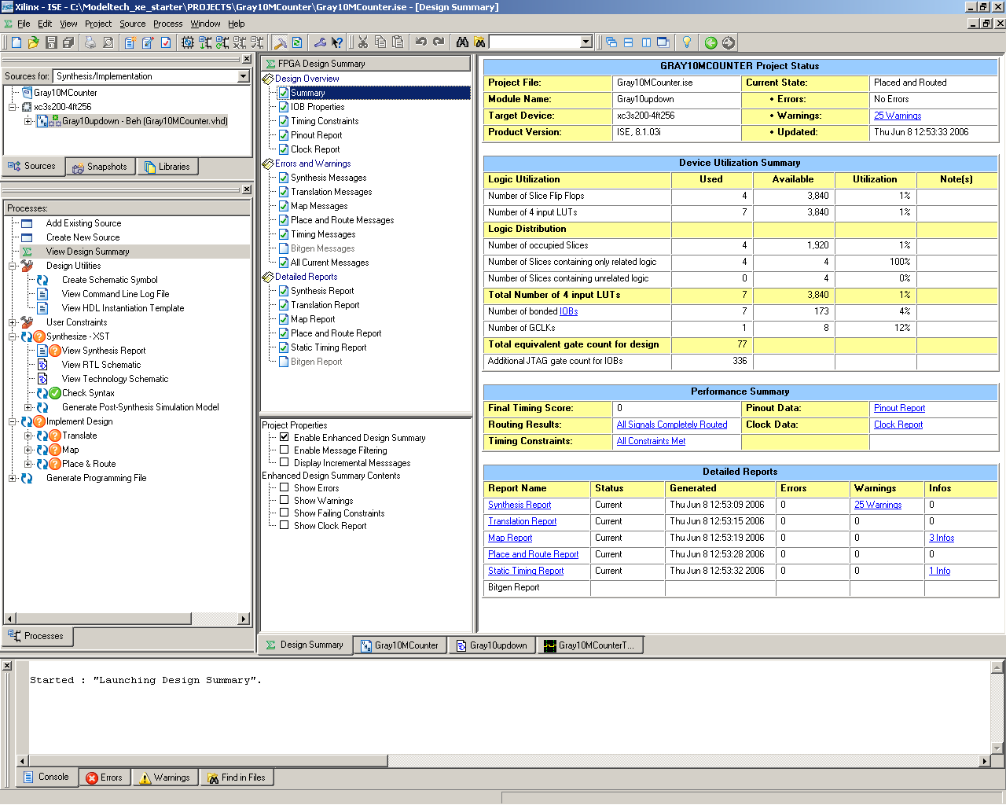

“Hand made” Gray counter modulo 10.

Part of the generated report.

Release 8.1.03i - xst I.27
Copyright (c) 1995-2005 Xilinx, Inc. All rights reserved.
--> Parameter TMPDIR set to ./xst/projnav.tmp
CPU : 0.00 / 0.25 s | Elapsed : 0.00 / 0.00 s

Design Statistics
# IOs : 7

Cell Usage :
# BELS : 21
# AND2 : 4
# AND3 : 4
# BUF : 4
# INV : 5
# OR2 : 1
# OR4 : 1
# XOR2 : 2
# FlipFlops/Latches : 4
# FDC : 4
# Clock Buffers : 1
# BUFGP : 1
# IO Buffers : 6
# IBUF : 2
# OBUF : 4
=========================================================================

Device utilization summary:
---------------------------

Selected Device : 3s200ft256-4

Number of Slices: 2 out of 1920 0%
Number of Slice Flip Flops: 4 out of 3840 0%
Number of bonded IOBs: 7 out of 173 4%
Number of GCLKs: 1 out of 8 12%

=========================================================================
TIMING REPORT

NOTE: THESE TIMING NUMBERS ARE ONLY A SYNTHESIS ESTIMATE.
FOR ACCURATE TIMING INFORMATION PLEASE REFER TO THE TRACE REPORT
GENERATED AFTER PLACE-and-ROUTE.

Clock Information:
------------------
-----------------------------------+------------------------+-------+
Clock Signal | Clock buffer(FF name) | Load |
-----------------------------------+------------------------+-------+
CLK | BUFGP | 4 |
-----------------------------------+------------------------+-------+

Timing Detail:
--------------
All values displayed in nanoseconds (ns)

All constraints were met.

Data Sheet report:
-----------------
All values displayed in nanoseconds (ns)

Setup/Hold to clock CLK
------------+------------+------------+------------------+--------+
| Setup to | Hold to | | Clock |
Source | clk (edge) | clk (edge) |Internal Clock(s) | Phase |
------------+------------+------------+------------------+--------+
K | 2.000(R)| 0.904(R)|CLK_BUFGP | 0.000|
------------+------------+------------+------------------+--------+

Clock CLK to Pad
------------+------------+------------------+--------+
| clk (edge) | | Clock |
Destination | to PAD |Internal Clock(s) | Phase |
------------+------------+------------------+--------+
Q<0> | 8.432(R)|CLK_BUFGP | 0.000|
Q<1> | 9.109(R)|CLK_BUFGP | 0.000|
Q<2> | 9.096(R)|CLK_BUFGP | 0.000|
Q<3> | 8.834(R)|CLK_BUFGP | 0.000|
------------+------------+------------------+--------+

Clock to Setup on destination clock CLK
---------------+---------+---------+---------+---------+
| Src:Rise| Src:Fall| Src:Rise| Src:Fall|
Source Clock |Dest:Rise|Dest:Rise|Dest:Fall|Dest:Fall|
---------------+---------+---------+---------+---------+
CLK | 3.160| | | |
---------------+---------+---------+---------+---------+

OFFSET = OUT 10 ns AFTER COMP "CLK";
Largest slack: 1.568 ns; Smallest slack: 0.891 ns; Relative Skew: 0.677 ns;
-----------------------------------------------+-------------+-------------+
PAD | Slack |Relative Skew|
-----------------------------------------------+-------------+-------------+
Q<0> | 1.568| 0.000|
Q<1> | 0.891| 0.677|
Q<2> | 0.904| 0.664|
Q<3> | 1.166| 0.402|
-----------------------------------------------+-------------+-------------+

Timing summary:
---------------

Timing errors: 0 Score: 0

Constraints cover 22 paths, 0 nets, and 29 connections

Design statistics:
Minimum period: 3.160ns (Maximum frequency: 316.456MHz)
Minimum input required time before clock: 2.000ns
Minimum output required time after clock: 9.109ns

Analysis completed Thu Jun 08 12:53:32 2006
--------------------------------------------------------------------------------

2. VHDL synthesis from state machine description
The following VHDL code describes the state graph.

----------------------------------------------------------------------------------
-- Company: PSU
-- Engineer:
--
-- Create Date: 10:48:34 06/14/2006
-- Design Name:
-- Module Name: GrayCounter10 - Behavioral
-- Project Name:
-- Target Devices:
-- Tool versions:
-- Description:
--
-- Dependencies:
--
-- Revision:
-- Revision 0.01 - File Created
-- Additional Comments: comparing - "auto" vs "hand made" synthesis solution
--
----------------------------------------------------------------------------------
library IEEE;
use IEEE.STD_LOGIC_1164.ALL;
use IEEE.STD_LOGIC_ARITH.ALL;
use IEEE.STD_LOGIC_UNSIGNED.ALL;

---- Uncomment the following library declaration if instantiating
---- any Xilinx primitives in this code.
--library UNISIM;
--use UNISIM.VComponents.all;

entity GrayCounter10 is
port ( CLOCK : in STD_LOGIC;
RESET : in STD_LOGIC;
DIRECTION : in STD_LOGIC;
GRAYOUT : out STD_LOGIC_VECTOR (3 downto 0));
end GrayCounter10;

architecture Gray10A_Struct of GrayCounter10 is
signal GrayState: STD_LOGIC_VECTOR(3 downto 0);

constant S0: STD_LOGIC_VECTOR(3 downto 0):= "0000";
constant S1: STD_LOGIC_VECTOR(3 downto 0):= "0001";
constant S2: STD_LOGIC_VECTOR(3 downto 0):= "0011";
constant S3: STD_LOGIC_VECTOR(3 downto 0):= "0010";
constant S4: STD_LOGIC_VECTOR(3 downto 0):= "0110";
constant S5: STD_LOGIC_VECTOR(3 downto 0):= "0111";
constant S6: STD_LOGIC_VECTOR(3 downto 0):= "0101";
constant S7: STD_LOGIC_VECTOR(3 downto 0):= "0100";
constant S8: STD_LOGIC_VECTOR(3 downto 0):= "1100";
constant S15: STD_LOGIC_VECTOR(3 downto 0):= "1000";

constant S9: STD_LOGIC_VECTOR(3 downto 0):= "1101"; --unused
constant S10: STD_LOGIC_VECTOR(3 downto 0):= "1111"; --
constant S11: STD_LOGIC_VECTOR(3 downto 0):= "1110"; --
constant S12: STD_LOGIC_VECTOR(3 downto 0):= "1010"; --
constant S13: STD_LOGIC_VECTOR(3 downto 0):= "1011"; --
constant S14: STD_LOGIC_VECTOR(3 downto 0):= "1001"; --unused

begin
process (CLOCK, RESET, GrayState)
begin
if (RESET='0') then Graystate <= S0; -- RESET on low level '0'
elsif (CLOCK'event and CLOCK='1') then -- changes only on CLOCK rising edge
if (DIRECTION='0') then -- count "UP"
case GrayState is
when S0 => GrayState <= S1;
when S1 => GrayState <= S2;
when S2 => GrayState <= S3;
when S3 => GrayState <= S4;
when S4 => GrayState <= S5;
when S5 => GrayState <= S6;
when S6 => GrayState <= S7;
when S7 => GrayState <= S8;
when S8 => GrayState <= S15;
when S15 => GrayState <= S0;
when others =>GrayState <= S0; -- required
end case;
elsif (DIRECTION='1') then -- count "DOWN"
case GrayState is
when S0 => GrayState <= S15;
when S1 => GrayState <= S0;
when S2 => GrayState <= S1;
when S3 => GrayState <= S2;
when S4 => GrayState <= S3;
when S5 => GrayState <= S4;
when S6 => GrayState <= S5;
when S7 => GrayState <= S6;
when S8 => GrayState <= S7;
when S15 => GrayState <= S8;
when others =>GrayState <= S0; -- required
end case;
end if;
end if;
GRAYOUT <= GrayState;
end process;end Gray10A_Struct;

Simulation results

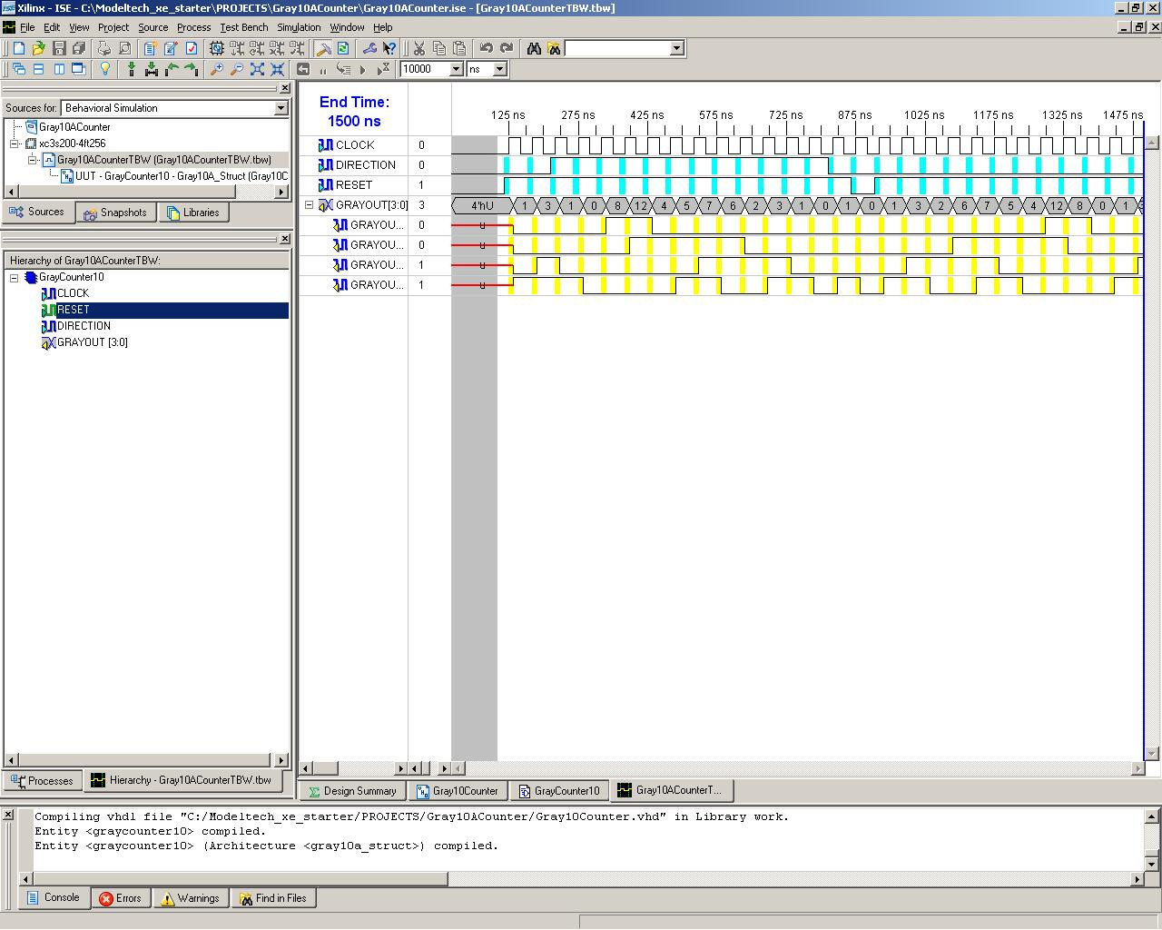

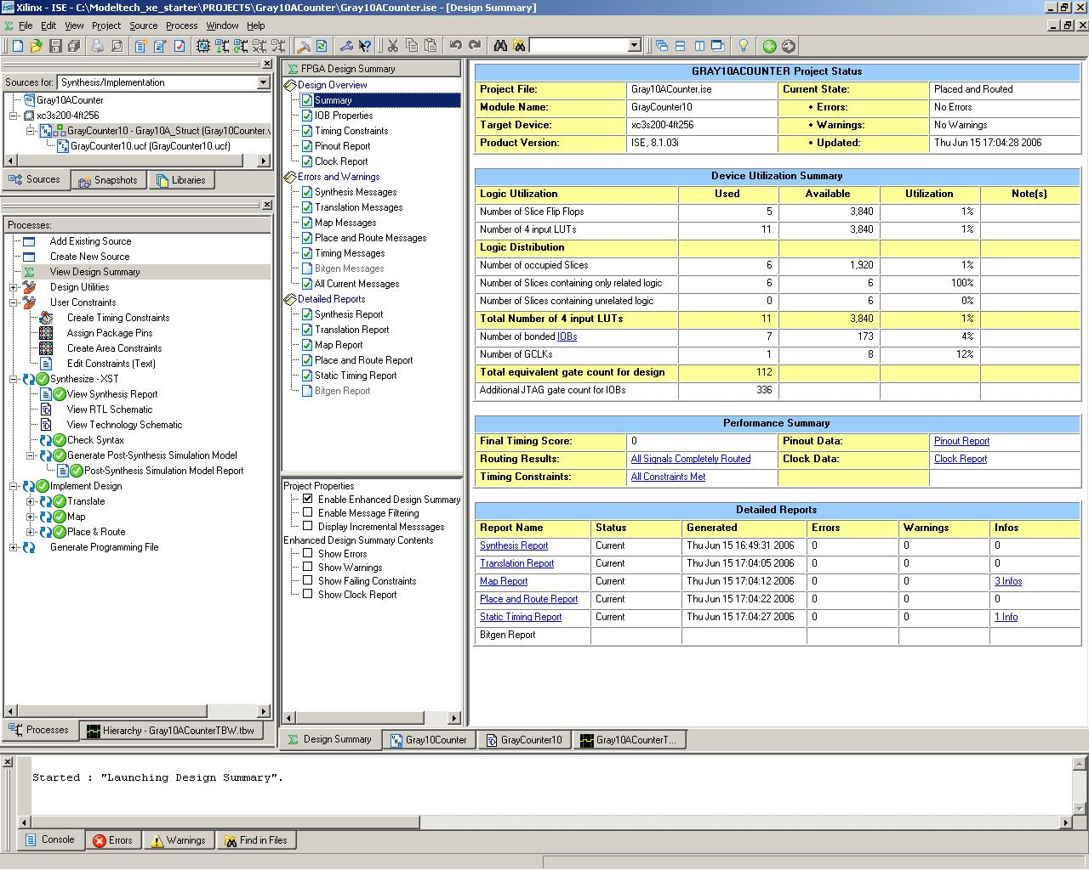

Part of the report
--------------------------------------------------------------------------------
Release 8.1.03i Trace I.27
Copyright (c) 1995-2005 Xilinx, Inc. All rights reserved.

C:\Xilinx\bin\nt\trce.exe -ise Gray10ACounter.ise -intstyle ise -e 3 -l 3 -s 4
-xml GrayCounter10 GrayCounter10.ncd -o GrayCounter10.twr GrayCounter10.pcf

Design file: graycounter10.ncd
Physical constraint file: graycounter10.pcf
Device,speed: xc3s200,-4 (PRODUCTION 1.37 2005-11-04)
Report level: error report

Environment Variable Effect
================================================================================
Timing constraint: TS_CLOCK = PERIOD TIMEGRP "CLOCK" 25 ns HIGH 50%;

10 items analyzed, 0 timing errors detected. (0 setup errors, 0 hold errors)
Minimum period is 2.503ns.
--------------------------------------------------------------------------------

================================================================================
Timing constraint: OFFSET = IN 10 ns BEFORE COMP "CLOCK";

5 items analyzed, 0 timing errors detected. (0 setup errors, 0 hold errors)
Minimum allowable offset is 2.070ns.
--------------------------------------------------------------------------------

================================================================================
Timing constraint: OFFSET = OUT 13 ns AFTER COMP "CLOCK";

21 items analyzed, 0 timing errors detected.
Minimum allowable offset is 12.147ns.
--------------------------------------------------------------------------------

---------------+---------+---------+---------+---------+
CLOCK | 2.503| | | |
---------------+---------+---------+---------+---------+

OFFSET = OUT 13 ns AFTER COMP "CLOCK";
Largest slack: 2.011 ns; Smallest slack: 0.853 ns; Relative Skew: 1.158 ns;
-----------------------------------------------+-------------+-------------+
PAD | Slack |Relative Skew|
-----------------------------------------------+-------------+-------------+
| Clock | CLOCK (rising_edge) |
| Reset | RESET (negative) |
| Reset type | asynchronous |

=========================================================================
* Advanced HDL Synthesis *
=========================================================================

Analyzing FSM <FSM_0> for best encoding.
Optimizing FSM <GrayState> on signal <GrayState[1:5]> with johnson encoding.
-------------------
State | Encoding
-------------------
0000 | 00000
0001 | 00001
0011 | 00011
0010 | 00111
0110 | 01111
0111 | 11111
0101 | 11110
0100 | 11100
1100 | 11000
1000 | 10000
-------------------

=========================================================================
Advanced HDL Synthesis Report

Macro Statistics
# FSMs : 1
# Registers : 5
Flip-Flops : 5

=========================================================================

Device utilization summary:
---------------------------

Selected Device : 3s200ft256-4

Number of Slices: 6 out of 1920 0%
Number of Slice Flip Flops: 5 out of 3840 0%
Number of 4 input LUTs: 11 out of 3840 0%
Number of bonded IOBs: 7 out of 173 4%
Number of GCLKs: 1 out of 8 12%

=========================================================================
TIMING REPORT

NOTE: THESE TIMING NUMBERS ARE ONLY A SYNTHESIS ESTIMATE.
FOR ACCURATE TIMING INFORMATION PLEASE REFER TO THE TRACE REPORT
GENERATED AFTER PLACE-and-ROUTE.

Clock Information:
------------------
-----------------------------------+------------------------+-------+
Clock Signal | Clock buffer(FF name) | Load |
-----------------------------------+------------------------+-------+
CLOCK | BUFGP | 5 |
-----------------------------------+------------------------+-------+

Timing Summary:
---------------
Speed Grade: -4

Minimum period: 2.735ns (Maximum Frequency: 365.631MHz)
Minimum input arrival time before clock: 2.835ns
Maximum output required time after clock: 10.605ns
Maximum combinational path delay: No path found

Timing Detail:
--------------
All values displayed in nanoseconds (ns)

=========================================================================
Timing constraint: Default period analysis for Clock 'CLOCK'
Clock period: 2.735ns (frequency: 365.631MHz)
Total number of paths / destination ports: 10 / 5
-------------------------------------------------------------------------
Delay: 2.735ns (Levels of Logic = 1)
Source: GrayState_FFd3 (FF)
Destination: GrayState_FFd2 (FF)
Source Clock: CLOCK rising
Destination Clock: CLOCK rising

Data Path: GrayState_FFd3 to GrayState_FFd2
Gate Net
Cell:in->out fanout Delay Delay Logical Name (Net Name)
---------------------------------------- ------------
FDC:C->Q 7 0.720 1.261 GrayState_FFd3 (GrayState_FFd3)
LUT3_L:I1->LO 1 0.551 0.000 GrayState_FFd2-In1 (GrayState_FFd2-In)
FDC:D 0.203 GrayState_FFd2
----------------------------------------
Total 2.735ns (1.474ns logic, 1.261ns route)
(53.9% logic, 46.1% route)

=========================================================================
Timing constraint: Default OFFSET IN BEFORE for Clock 'CLOCK'
Total number of paths / destination ports: 5 / 5
-------------------------------------------------------------------------
Offset: 2.835ns (Levels of Logic = 2)
Source: DIRECTION (PAD)
Destination: GrayState_FFd3 (FF)
Destination Clock: CLOCK rising

Data Path: DIRECTION to GrayState_FFd3
Gate Net
Cell:in->out fanout Delay Delay Logical Name (Net Name)
---------------------------------------- ------------
IBUF:I->O 5 0.821 1.260 DIRECTION_IBUF (DIRECTION_IBUF)
LUT3_L:I0->LO 1 0.551 0.000 GrayState_FFd4-In1 (GrayState_FFd4-In)
FDC:D 0.203 GrayState_FFd4
----------------------------------------
Total 2.835ns (1.575ns logic, 1.260ns route)
(55.6% logic, 44.4% route)

=========================================================================
Timing constraint: Default OFFSET OUT AFTER for Clock 'CLOCK'
Total number of paths / destination ports: 21 / 4
-------------------------------------------------------------------------
Offset: 10.605ns (Levels of Logic = 3)
Source: GrayState_FFd4 (FF)
Destination: GRAYOUT<2> (PAD)
Source Clock: CLOCK rising

Data Path: GrayState_FFd4 to GRAYOUT<2>
Gate Net
Cell:in->out fanout Delay Delay Logical Name (Net Name)
---------------------------------------- ------------
FDC:C->Q 6 0.720 1.342 GrayState_FFd4 (GrayState_FFd4)
LUT4:I0->O 1 0.551 0.996 _n00041 (N11)
LUT2:I1->O 1 0.551 0.801 _n00042 (GRAYOUT_2_OBUF)
OBUF:I->O 5.644 GRAYOUT_2_OBUF (GRAYOUT<2>)
----------------------------------------
Total 10.605ns (7.466ns logic, 3.139ns route)
(70.4% logic, 29.6% route)

Number of errors : 0 ( 0 filtered)
Number of warnings : 0 ( 0 filtered)
Number of infos : 0 ( 0 filtered)

Conclusions
From timing analysis (static time reports) there is not significant difference in speed between the two implementations however, the ‘hand made’ circuit is smaller. The ‘hand made’ counter used 4 flip-flops (2 slices) only and automatic used 5 flip-flops (6 slices). Number of gates is comparable. Because the difference in chip area cost is relatively small and manual implementation takes much more time, there is no benefit of manual implementation (maybe just to prove that one is still capable to do something without modern tools ☺)

