8-Bit Polarity Checker
Mark Hughes
ECE 590-Hardware Description Languages
May 21, 2006
Homework #2

Objective:
Create an eight bit polarity checker. The design should be capable of reading an eight bit input and determining the best polarity for that eight bit input using Reed Muller transform and the butterfly approach.
Specification:
The checker under design will accept a reset input, a “run” status input and an eight bit input. If the “Run” input is asserted high, the design will output the 3-bit “best polarity” vector, the 5-bit “best cost” vector and the 8-bit “best polarity output” vector. If the Run input is asserted low, the system stops the evaluation process. If the Reset is asserted high, the system is reset (i.e. all bits are on the outputs are reset to 1’s and the internal functions of the checker are assigned to their initial states). The system is a synchronous system that uses a global clock to synchronize instructions and evaluations.

Theory of Operations:
The system receives the 8-bit input and it cycles through all the possible polarity Reed-Muller combinations to find the best fixed polarity for the specific 8-bit input. Since the input is 8 bits, the polarity evaluation, whether negative or positive, requires three stages. This is evident in the following figures, which document the gate level description of how a positive polarity and negative polarity is determined using the butterfly architecture.

The different polarities for a specific input can be evaluated by mixing stage-types for each stage. For example, you can have the first stage evaluate the “positive first stage,” the second stage evaluate the “negative second stage” and the third stage evaluate the “negative third stage.” Hence, the gate level result would look like the following.

Therefore, to cover all the possible polarities for the three stages, a 0-to-7 binary counter was implemented. The value of the counter will act as the control to choose whether to use positive or negative polarity in the specific level in the following figure. Notice the most significant bit controls the first level of the Reed Muller fixed polarity evaluator. The least significant bit controls the third level of the evaluator. Therefore, the middle bit controls the second level of the evaluator. For every value in the counter, the Reed Muller fixed polarity function was implemented. Hence, all polarity possibilities are evaluated.

The following three figures show how each level was designed. Notice for each level, both the negative and positive polarities for that level are evaluated. The output of each polarity is submitted to an eight bit 2-to-1 multiplexer. The appropriate control bit for that level (i.e. the appropriate bit from the counter) selects which polarity to implement. For all the multiplexers in each level, if the control bit is 1 the negative polarity is selected. Otherwise, if the control bit is 0 the positive polarity is selected.
Keep in mind the input for the first level of the evaluator is the user’s 8-bit input. However, the inputs for the 2nd and 3rd levels of the evaluator are the previous level’s multiplexed output (i.e. 1st Stage Polarity and 2nd Stage Polarity, respectively). The output of the third level is the final fixed polarity value.

The possible polarity (“control”) combinations is eight. The system cycles through all of these combinations. The optimum polarity output is determined in terms of minimum cost. The system outputs the minimum cost for the optimum polarity as well as the polarity combination that produces this cost. The possible polarity combinations are noted below.

Level 1 Polarity | Level 2 Polarity | Level 3 Polarity | Control (Counter/Incrementer )Status
Positive | Positive | Positive | 000
Positive | Positive | Negative | 001
Positive | Negative | Positive | 010
Positive | Negative | Negative | 011
Negative | Positive | Positive | 100
Negative | Positive | Negative | 101
Negative | Negative | Positive | 110
Negative | Negative | Negative | 111

Implementation:
The design will start in an initial state where the “best polarity output” will be set to 1111111, the “best cost” will be set to “11111” and the “best polarity” will be set to 111. The current control status will be 000. The system will evaluate the polarity output using the control polarity 000. Upon completion, the system will count the number of 1’s in the output polarity (this will be the current cost). This current cost will be compared to the stored “best cost.” If the current cost is less than the “best cost,” the current cost is stored as the new “best cost” and the current polarity and control are stored as the “best polarity output” and the “best polarity” respectively. Then the design determines if it is necessary to stop. If no stop is necessary, the design increments the current control and executes the polarity evaluation, comparison and storage functions again. If the current cost is not less than the “best cost,” the design skips the storage process and checks for the stop property. The system continues this loop until the user pauses the process or until the control evaluation expires (i.e. when all 8 combinations have been evaluated, compared and stored, if necessary). The following flowchart can be used to describe the design.
A synchronous reset is implemented in the system. When this reset is asserted high, the design is reset to its initial state and the “best polarity output” will be set to 1111111, the “best cost” will be set to “11111” and the “best polarity” will be set to 111. A run input will be used to implement the system and halt the system. If Run is 1, the system runs. If Run is 0, the system pauses.
The following block diagram was designed to outline the design intended. Notice there is control unit that controls the datapath of the design. This notion of a “control-unit-driven datapath” is the focus of project two.
Figure 10 demonstrates the block diagram of the design. The control unit receives the Reset and Run inputs from the user and it controls when to activate the incrementer/counter and the evaluation process. The evaluation process consists of evaluating the fixed polarity for a specific input and polarity (counter value) in the same way we described earlier (see Figure 5-8). Once the fixed polarity is found, the design determines how many 1’s exist in the eight bit fixed polarity output. This is referred to as the current cost. This “current cost” is then compared to the “best cost” in the system. Both the “current cost” and the “best cost” are submitted to a five-bit 2-to-1 multiplexer. If the “current cost” is less than the “best cost,” the “current cost” is selected and stored as the new best cost in the register. Two additional multiplexers are implemented to select between the control and best polarity and the current polarity output and the best current polarity respectively. The result of the comparison between the current cost and the best cost also acts as the control for these two multiplexers. If the current cost is less than the best cost, the control and current polarity output is selected. Otherwise, the best polarity and best polarity output are selected. The appropriate selections are then stored in the appropriate registers as the new best polarity and best polarity output. All blocks with dashed lines received and were synchronized with the global clock. The diagram does not show the direct connections to the clock signal in order to avoid confusion.

The control unit contains six states. It begins in the initial state where the system is reset and initialized. If Run is asserted high, the control unit will propagate from the initial state to the increment state. As long as the Run is asserted high and the Terminate signal is asserted low, the state toggle back and forth between the increment and evaluate state (i.e. it increments the adder and evaluate the polarity and then repeats). If Run is 0 and the current state is the increment state, the control unit increments the counter and then propagates to the Pause Increment state to pause the system. Once the Run input is asserted high again, the system transitions to the evaluate state and the last incremented value is evaluated. If Run is 0, the current state is the Evaluate state and Terminate is 0, then the system evaluates the current incrementer value and then transitions to the evaluate pause state. Here, the system is paused again. However, when Run is asserted high, the system transitions to the increment state and the system continues normal functionality. If the current state is the evaluate state and Terminate is 1, then the system will complete the current evaluation and then transition to the stop state. In the stop state, the system will not execute because all evaluations for all possible polarities have already been conducted. The only way to exit the stop state is to reset the system via the Reset input. However, if Reset is asserted high in any of the states, the control unit returns to the initial state. The following is a state diagram for the control unit. The dashed line indicates that the Reset status has priority over all the other inputs. All transitions of the state diagram are synchronized with any edge (rising or falling) of the global clock. This state machine was implemented in VHDL using two PROCESS statements. One PROCESS statement had a nested IF statement and the other had a nested CASE statement and several IF statements (nested in the CASE statement). See Code 1 for the VHDL description.

The counter was designed using a state machine. Simply, the counter is initialized at 000. If the Reset input of the counter is asserted high, the system is reset to its initial state. In the case that the counter is reset and the current state is the initial state, the state simply just does not change. If the Increment_enable signal is asserted low, there is no state transition (the counter does not increment). However, if the Increment_enable is asserted high, the current state transitions to the next state and the counter is incremented by one. Once the system reaches the seventh state (i.e. binary value of 7), the counter’s value does not change based on the Increment_enable signal. The Terminate signal is asserted to 1 in the seventh state. At this point, all possible polarities have been exhausted. The only way to exit the seventh state is to reset the counter to its initial state via the Reset input. All transitions in the state diagrams are synchronized with the rising edge of the global clock. This state machine was implemented in VHDL using two PROCESS statements. One PROCESS statement had a nested IF statement and the other had a nested CASE statement. The dashed line indicates that the Reset status has priority over all the other inputs. See Code 2 for the VHDL description.

The cost detector was implemented by simply implementing a 1-bit incrementer every time a bit of value “1” was observed in the current polarity output. A different approach was used for this incrementer. A PROCESS statement with a nested FOR loop was used to parse the current polarity output every time the current polarity output or clock changed. When parsing every bit, if a bit was found to be of the value “1” the following circuit was implemented. This circuit is essentially a logic description of a full adder. However, this circuit adds current cost and 00001 each time it is executed (i.e. a 1-bit current cost incrementer). See Code 3 for the VHDL description of this design.

The comparator was implemented by using a PROCESS statement which would reset and then execute every time the current cost, the best cost or the clock changed. The following circuit was executed in this statement. The most significant bits were compared to see if current cost was greater than or less than the best cost. The outputs were used as input to the second most significant bit comparison. In this comparison, if the previous comparison evaluated a “carry greater” then current cost is greater than the best cost. If the previous comparison evaluated a “carry less” then the current cost is less that the best cost. Otherwise, the current bits need to be compared. This same process is repeated until the least significant bit comparison is made. In this system, we are only concerned with the least significant bit’s carry less result (since we only care if the current cost is less than the best cost). The bit-by-bit comparison was implemented by executing an “most significant bit” comparison and then implementing a nest FOR loop to evaluate the middle bits. Finally, an assignment used to evaluate the least significant bit’s “current cost carry less than best cost” status. See Code 3 for the VHDL modeling for this approach.

The Reed Muller approach explained earlier was implemented in VHDL (See Figure 5). For this evaluation, the concurrent WITH-SELECT statements were used in order to implement the logical evaluation and the multiplexer evaluation in the same VHDL commands. See Code 3 for the VHDL modeling of this approach.
The best case registers and their respective 2-to-1 multiplexers were implemented in VHDL by means of PROCESS statements with nested IF statements. If the output of the comparator was high and the Evaluate_enable is asserted, the current cost, control and current polarity output were assigned to the “best cost”, “best polarity” and “best polarity output” outputs respectively at the next falling edge of the clock. Otherwise, the “best cost”, “best polarity” and “best polarity output” outputs remain unchanged. See Code 3 for the VHDL modeling of this best case register approach.
In terms of modules, the following figure shows how the VHDL code structure communicates to implement the eight bit best polarity checker. In the Top Level cod (See Code 4), three instantiated entities interact: the control unit, the incrementer and the evaluation. Note that both the incrementer and the evaluation are components in the datapath. Here you can see the “control unit driven datapath” architecture in the design.

The following figure demonstrates how the VHDL test bench code interacts with the VHDL source code. The test bench provides a simulation of a user’s Reset, Run and Input requests. In addition, the test bench also supplies the global clock for the system. The VHDL source code receives these test vectors and generates the resulting output vectors “best cost”, “best polarity” and “best polarity output.”
Figure 16: High Level View of VHDL Implementation of the 8-Bit Best Fixed Polarity Checker

Verification:
The design was implemented and verified in ModelSim using VHDL. The design was tested with three separate test benches. Two of the test benches simply test two different user “input” inputs. The remaining test bench tests the Run and Reset functionality. See Code 5, 6 and 7 for the VHDL descriptions of these test benches. Please refer to the “Simulation Results” section for further evidence of verification.

VHDL Implementation:

--Declaration of control unit entity
ENTITY control_unit IS
PORT (Reset, Run, Terminate, clk: IN bit;
Increment_enable, Evaluate_enable, System_reset: OUT bit);
END control_unit;

ARCHITECTURE state_machine OF control_unit IS
--declare a new datatype of state which has 6 states
TYPE state IS (initial, increment, pause_increment, evaluate, pause_evaluate, stop);
--initialize signals for these states
SIGNAL present_state, next_state: state;
BEGIN
--execute this process everytime reset or clk changes
PROCESS(reset, clk)
BEGIN
--if reset is one then control unit is reset to the initial state
IF (Reset = '1') THEN
present_state <= initial;
--otherwise when Run is one and there is a clk event the control propagates to
--next state
ELSIF(Run ='1' AND clk'EVENT) THEN
present_state <= next_state;
END IF;
END PROCESS;

--execute this process every time clk changes
PROCESS(clk)
BEGIN
CASE present_state IS
--initial state
WHEN initial =>
--system reset is 1 to initialize all components
System_reset <= '1';
IF (Run = '1') THEN
--if Run is 1, the increment enable is activated
--and the next state is the increment state
Increment_enable <= '0';
Evaluate_enable <= '0';
next_state <= increment;
ELSE
--otherwise the control unit stays in its current initial state
next_state <= initial;
END IF;
--increment state
WHEN increment =>
--system not reset and increment enable is activated
System_reset <= '0';
Increment_enable <= '1';
Evaluate_enable <= '0';
IF (Run = '1') THEN
--if run is 1 the system moves to the evaluation state
next_state <= evaluate;
ELSE
--otherwise the system pauses the increment process
next_state <= pause_increment;
END IF;
--pause increment
WHEN pause_increment =>
--system not reset and not enables are asserted so that no
--functionality occurs
System_reset <= '0';
Increment_enable <= '0';
Evaluate_enable <= '0';
IF (Run = '1') THEN
--if Run is asserted the control unit propagates to the
--evaluate state
next_state <= evaluate;
ELSE
--otherwise it remains in its pause state
next_state <= pause_increment;
END IF;
--evaluate state
WHEN evaluate =>
--system not reset and Evaluate enable bit is asserted
System_reset <= '0';
Increment_enable <= '0';
Evaluate_enable <= '1';
IF (Terminate ='1')THEN
--if terminate is 1 then the next state is stop
next_state <= stop;
ELSIF (Run = '0') THEN
--or if Run is 0 the oontrol unit goes to the pause evaluation state
next_state <= pause_evaluate;
ELSE
--otherwise the next state is another increment
next_state <= increment;
END IF;
--pause evaluate state
WHEN pause_evaluate =>
--system not reset and not enables are asserted
System_reset <= '0';
Increment_enable <= '0';
Evaluate_enable <= '0';
IF (Run = '1') THEN
--if Run is asserted the next state is the increment state
next_state <= increment;
ELSE
--otherwise the control unit remains in its pause state
next_state <= pause_evaluate;
END IF;
--stop state
WHEN stop =>
--system not reset and no enables are asserted and the next state is Stop
--unless there is an asynchronous reset by the user
System_reset <= '0';
Increment_enable <= '0';
Evaluate_enable <= '0';
next_state <= stop;
END CASE;
END PROCESS;
END state_machine;

Code 1: VHDL Design for the Control Unit

--Declare the entity of the counter
--Reset, Run and clk inputs
--Outputs a conrtol bit vector and a Terminate bit
ENTITY counter IS
PORT (Reset, Run, clk: IN bit;
control: OUT bit_vector(2 downto 0);
Terminate: OUT bit);
END counter;

ARCHITECTURE behavioral OF counter IS
--Declare a new datatype state which has 8 possible values
TYPE state IS (initial, two, three, four, five, six, seven, eight);
--Initialize the signals of type state
SIGNAL present_state, next_state: state;

BEGIN
--execute the process everytime Reset and clk changes
PROCESS (Reset, clk)
BEGIN
--if Reset is 1 the counter is reset to its initial state
IF (Reset='1') THEN
present_state<= initial;
--If Run is 1 and there is a rising edge on clk then
--the incrementer transitions to the next state
ELSIF (clk'EVENT and clk = '1' AND Run ='1') THEN
present_state<=next_state;
--otherwise, the incrementer remains in its current state
ELSE
present_state<=present_state;
END IF;
END PROCESS;

--execute this process everytime clk changes
PROCESS (clk)
BEGIN

CASE present_state IS
--initial state
--control is 000
--next state is two
WHEN initial=>
control<="000";--XXX
next_state<= two;
--two state
--control is 001
--next state is three
WHEN two=>
control<="001";--0XX
next_state<= three;
--three state
--control is 010
--next state is four
WHEN three=>
control<="010";--00X
next_state<= four;
--four state
--control is 011
--next state is five
WHEN four=>
control<="011";
next_state<= five;
--five state
--control is 100
--next state is six
WHEN five=>
control<="100";
next_state<= six;
--six state
--control is 101
--next state is seven
WHEN six=>
control<="101";
next_state<= seven;
--seven state
--control is 110
--next state is eight
WHEN seven=>
control<="110";
next_state<= eight;
--eight state
--control is 111
--next state is eight
WHEN eight=>
control<="111";
next_state<= eight;
Terminate<='1';

END CASE;
END PROCESS;

END behavioral;
Code 2: VHDL Design for the Incrementer of the Datapath Unit

--The evaluation of the datapath unit receives the clk,
--Reset and input from the user and outside environment
--it all receives te Evaluate_enable from the control unit
--and the control input from the incrementer.
--The system outputs the best polarity, the best cost,
--and the best polarity output
--Declare the entity
ENTITY datapath IS
PORT (clk, Reset, Evaluate_enable: IN bit;
control: IN bit_vector(2 downto 0);
input: IN bit_vector (7 downto 0);
best_polarity_output: OUT bit_vector(7 downto 0);
best_cost: OUT bit_vector(4 downto 0);
best_polarity: OUT bit_vector (2 downto 0));
END datapath;

ARCHITECTURE behavioral OF datapath IS
--initialize the necessary intermediate signals
SIGNAL int1, int2: bit_vector(7 downto 0);
SIGNAL current_polarity, b_polarity_output: bit_vector(7 downto 0);
SIGNAL current_cost, b_cost: bit_vector(4 downto 0);
SIGNAL b_polarity: bit_vector(2 downto 0);
SIGNAL observe: bit;

BEGIN
--this WITH SELECT statement determines how to evaluate each bit of the first level in
--the Reed Muller problem
--if Control(2) bit is 0 each of the eight bits are evaluated using positive polarity
--if Control(2) bit is 1 each of the eight bits are evaluated using negative polarity
WITH control(2) SELECT
int1(0)<=input(0) AND (NOT Reset) WHEN '0',
(input(0) XOR input(1)) AND (NOT Reset) WHEN '1';
WITH control(2) SELECT
int1(1)<=(input(0) XOR input(1)) AND (NOT Reset) WHEN '0',
input(1) AND (NOT Reset) WHEN '1';--0
WITH control(2) SELECT
int1(2)<=input(2) AND (NOT Reset) WHEN '0',
(input(2) XOR input(3)) AND (NOT Reset) WHEN '1';--0
WITH control(2) SELECT
int1(3)<=(input(2) XOR input(3)) AND (NOT Reset) WHEN '0',
input(3) AND (NOT Reset) WHEN '1';--1
WITH control(2) SELECT
int1(4)<=input(4) AND (NOT Reset) WHEN '0',
input(4) XOR input(5) WHEN '1';--1
WITH control(2) SELECT
int1(5)<=(input(4) XOR input(5)) AND (NOT Reset) WHEN '0',
input(5) AND (NOT Reset) WHEN '1';--0
WITH control(2) SELECT
int1(6)<=input(6) AND (NOT Reset) WHEN '0',
(input(6) XOR input(7)) AND (NOT Reset) WHEN '1';--1
WITH control(2) SELECT
int1(7)<=(input(6) XOR input(7)) AND (NOT Reset) WHEN '0',
input(7) AND (NOT Reset) WHEN '1';--1

--this WITH SELECT statement determines how to evaluate each bit of the second level in
--the Reed Muller problem
--if Control(1) bit is 0 each of the eight bits are evaluated using positive polarity
--if Control(1) bit is 1 each of the eight bits are evaluated using negative polarity
WITH control(1) SELECT

int2(0)<=int1(0) WHEN '0',
int1(0) XOR int1(2) WHEN '1';
WITH control(1) SELECT
int2(1)<=int1(1) WHEN '0',
int1(1) XOR int1(3) WHEN '1';
WITH control(1) SELECT
int2(2)<=int1(0) XOR int1(2) WHEN '0',
int1(2) WHEN '1';
WITH control(1) SELECT
int2(3)<=int1(1) XOR int1(3) WHEN '0',
int1(3) WHEN '1';
WITH control(1) SELECT
int2(4)<=int1(4) WHEN '0',
int1(4) XOR int1(6) WHEN '1';
WITH control(1) SELECT
int2(5)<=int1(5) WHEN '0',
int1(5) XOR int1(7) WHEN '1';
WITH control(1) SELECT
int2(6)<=int1(4) XOR int1(6) WHEN '0',
int1(6) WHEN '1';
WITH control(1) SELECT
int2(7)<=int1(5) XOR int1(7) WHEN '0',
int1(7) WHEN '1';

--this WITH SELECT statement determines how to evaluate each bit of the last level in
--the Reed Muller problem
--if Control(0) bit is 0 each of the eight bits are evaluated using positive polarity
--if Control(0) bit is 1 each of the eight bits are evaluated using negative polarity
WITH control(0) SELECT
current_polarity(0)<=int2(0) WHEN '0',
int2(0) XOR int2(4) WHEN '1';
WITH control(0) SELECT
current_polarity(1)<=int2(1) WHEN '0',
int2(1) XOR int2(5) WHEN '1';
WITH control(0) SELECT
current_polarity(2)<=int2(2) WHEN '0',
int2(2) XOR int2(6) WHEN '1';
WITH control(0) SELECT
current_polarity(3)<=int2(3) WHEN '0',
int2(3) XOR int2(7) WHEN '1';
WITH control(0) SELECT
current_polarity(4)<=int2(0) XOR int2(4) WHEN '0',
int2(4) WHEN '1';
WITH control(0) SELECT
current_polarity(5)<=int2(1) XOR int2(5) WHEN '0',
int2(5) WHEN '1';
WITH control(0) SELECT
current_polarity(6)<=int2(2) XOR int2(6) WHEN '0',
int2(6) WHEN '1';
WITH control(0) SELECT
current_polarity(7)<=int2(3) XOR int2(7) WHEN '0',
int2(7) WHEN '1';
--every time the current_polarity changes or the clk changes this process
--is evaluated
PROCESS(current_polarity, clk)
VARIABLE c, cout:bit_vector(0 to 4):="00000";

BEGIN
--this FOR LOOP determines how many 1's are in the current_polarity output
--the number of 1's is stored as the current cost
cost_count: FOR i IN (current_polarity'LENGTH-1) DOWNTO 0 LOOP
IF (current_polarity(i) ='1') THEN
cout(4):= c(4);
c(4):= (NOT c(4));
cout(3):= cout(4) AND c(3);
c(3):=cout(4) XOR c(3);
cout(2):= cout(3) AND c(2);
c(2):=cout(3) XOR c(2);
cout(1):= cout(2) AND c(1);
c(1):=cout(2) XOR c(1);
c(0):=cout(1) XOR c(0);

END IF;

END LOOP cost_count;
current_cost<=c;
c:="00000";
END PROCESS;

--every time the current_cost, clk or b_cost changes this
--process is evaluated
PROCESS(current_cost, clk, b_cost)
--declaration of process variables
VARIABLE carry_less, carry_gtr: bit_vector(4 downto 1):="0000";
VARIABLE carry_out: bit:='0';
BEGIN
--comparison of the most significant bits of b_cost and current_cost
carry_less(4):= ((NOT current_cost(4)) AND b_cost(4));
carry_gtr(4):= (current_cost(4) AND (NOT b_cost(4)));
--FOR LOOP evaluates comparison of the middle bits of b_cost and
--current_cost while considering all previous comparisons
carry_process: FOR i IN 3 DOWNTO 1 LOOP
carry_less(i):=((NOT carry_gtr(i+1))
AND ((carry_less(i+1) OR
((NOT current_cost(i)) AND b_cost(i)))));
carry_gtr(i):= ((NOT carry_less(i+1)) AND
(carry_gtr(i+1) OR
(current_cost(i) AND (NOT b_cost(i)))));
END LOOP;
--final bit is compared while considering all previous comparisons
carry_out:=((NOT carry_gtr(1)) AND (carry_less(1) OR ((NOT current_cost(0)) AND b_cost(0))));
--if observe is 1 current cost is less than b_cost
observe<=carry_out;
END PROCESS;

--process evaluated every time clk and reset change
Best_Case_Register: PROCESS (clk, reset)
BEGIN
--when Reset asserted all the outputs are initialized to worst case values
IF (Reset = '1') THEN
b_cost <= "11111";
b_polarity_output<="11111111";
b_polarity<="111";
--if falling edge of clock and the Control Unit is enabling the Evaluate function
ELSIF (clk'EVENT and clk = '0' AND Evaluate_enable = '1') THEN
--and current cost is less than b_cost
IF (observe = '1') THEN
--replace b_cost with current_cost, b_polarity_output with current_polarity
--and b_polarity with control
b_cost <= current_cost;
b_polarity_output <=current_polarity;
b_polarity<= control;
ELSE
--otherwise, keep the same values
b_cost <= b_cost;
b_polarity_output <= b_polarity_output;
b_polarity<=b_polarity;
END IF;

END IF;
--assign intermediate "b_xxx" values to their appropriate outputs
best_cost<=b_cost;
best_polarity_output<=b_polarity_output;
best_polarity<=b_polarity;

END PROCESS Best_Case_Register;

END behavioral;

Code 3: VHDL Design for the Evaluation of the Datapath Unit

--The top level entity will simple receive the clk, Run, Reset and Input
--inputs from the outside environment and output the best_cost, best_polarity,
--and the best_polarity_output
--Declare entity top level
ENTITY top_level IS
PORT (clk, Run, Reset: IN bit;
input: IN bit_vector(7 downto 0);
best_polarity_output: OUT bit_vector (7 downto 0);
best_cost: OUT bit_vector (4 downto 0);
best_polarity: OUT bit_vector(2 downto 0));
END top_level;

ARCHITECTURE structural OF top_level IS
--declare the control unit component
COMPONENT control_unit
PORT (Reset, Run, Terminate, clk: IN bit;
Increment_enable, Evaluate_enable, System_reset: OUT bit);
END COMPONENT;
--declare the incrementer component
COMPONENT incrementer
PORT (Reset, Run, clk: IN bit;
control: OUT bit_vector(2 downto 0);
Terminate: OUT bit);
END COMPONENT;
--declare the datapath (evaluation) component
COMPONENT datapath
PORT (clk, Reset, Evaluate_enable: IN bit;
control: IN bit_vector(2 downto 0);
input: IN bit_vector (7 downto 0);
best_polarity_output: OUT bit_vector(7 downto 0);
best_cost: OUT bit_vector(4 downto 0);
best_polarity: OUT bit_vector(2 downto 0));
END COMPONENT;
--assign the components to their appropriate entities and architectures
FOR ALL: control_unit USE ENTITY work.control_unit(state_machine);
FOR ALL: incrementer USE ENTITY work.counter(behavioral);
FOR ALL: datapath USE ENTITY work.datapath(behavioral);
--declaration of appropriate intermediate signals
SIGNAL System_power, System_reset, Increment_enable, Evaluate_enable, Terminate: bit;
SIGNAL control: bit_vector (2 downto 0);
SIGNAL b_polarity_output: bit_vector (7 downto 0);
SIGNAL b_cost: bit_vector(4 downto 0);
SIGNAL b_polarity: bit_vector(2 downto 0);

BEGIN
--instantiated control unit
cu: control_unit PORT MAP(Reset, Run, Terminate, clk,
Increment_enable, Evaluate_enable, System_reset);
--instantiate the incrementer so that it receives its appropriate inputs from the control unit
inc: incrementer PORT MAP(System_reset, Increment_enable, clk, control, Terminate);
--instantiate the datapath(evaluation) so that it receives its appropriate inputs
--from the control unit and the incrementer
dp: datapath PORT MAP(clk, System_reset, Evaluate_enable, control, input,
b_polarity_output, b_cost, b_polarity);
--assign output intermediate signals to the appropriate outputs
best_polarity_output<=b_polarity_output;
best_cost<=b_cost;
best_polarity<=b_polarity;

END structural;
Code 4: VHDL Design for the Top Level of the 8 Bit Polarity Checker

--This is a top level test bench with vectors chosen to test
--functionality using input 00011110
ENTITY top_level_test IS
END top_level_test;

ARCHITECTURE structural OF top_level_test IS

COMPONENT top_level
PORT (clk, Run, Reset: IN bit;
input: IN bit_vector(7 downto 0);
best_polarity_output: OUT bit_vector (7 downto 0);
best_cost: OUT bit_vector (4 downto 0);
best_polarity: OUT bit_vector(2 downto 0));
END COMPONENT;

FOR ALL: top_level USE ENTITY work.top_level(structural);

SIGNAL clk, Run, Reset: bit;
SIGNAL input: bit_vector(7 downto 0);
SIGNAL best_polarity_output: bit_vector(7 downto 0);
SIGNAL best_cost: bit_vector(4 downto 0);
SIGNAL best_polarity: bit_vector (2 downto 0);

BEGIN

top: top_level PORT MAP (clk, Run, Reset, input, best_polarity_output, best_cost, best_polarity);

Reset<='1',
'0' AFTER 10 NS;
Run<='1';

input<="01111000";

clk<='0',
'1' AFTER 50 NS,
'0' AFTER 100 NS,
'1' AFTER 150 NS,
'0' AFTER 200 NS,
'1' AFTER 250 NS,
'0' AFTER 300 NS,
'1' AFTER 350 NS,
'0' AFTER 400 NS,
'1' AFTER 450 NS,
'0' AFTER 500 NS,
'1' AFTER 550 NS,
'0' AFTER 600 NS,
'1' AFTER 650 NS,
'0' AFTER 700 NS,
'1' AFTER 750 NS,
'0' AFTER 800 NS,
'1' AFTER 850 NS,
'0' AFTER 900 NS,
'1' AFTER 950 NS,
'0' AFTER 1000 NS,
'1' AFTER 1050 NS,
'0' AFTER 1100 NS,
'1' AFTER 1150 NS,
'0' AFTER 1200 NS,
'1' AFTER 1250 NS,
'0' AFTER 1300 NS,
'1' AFTER 1350 NS,
'0' AFTER 1400 NS,
'1' AFTER 1450 NS,
'0' AFTER 1500 NS,
'1' AFTER 1550 NS,
'0' AFTER 1600 NS,
'1' AFTER 1650 NS,
'0' AFTER 1700 NS,
'1' AFTER 1750 NS,
'0' AFTER 1800 NS,
'1' AFTER 1850 NS,
'0' AFTER 1900 NS,
'1' AFTER 1950 NS,
'0' AFTER 2000 NS,
'1' AFTER 2050 NS,
'0' AFTER 2100 NS,
'1' AFTER 2150 NS,
'0' AFTER 2200 NS,
'1' AFTER 2250 NS,
'0' AFTER 2300 NS,
'1' AFTER 2350 NS;

END structural;
Code 5: VHDL Test Bench for Testing the Input 01111000

--This is a top level test bench with vectors chosen to test
--the run and reset functions
ENTITY top_level_test IS
END top_level_test;

ARCHITECTURE structural OF top_level_test IS

COMPONENT top_level
PORT (clk, Run, Reset: IN bit;
input: IN bit_vector(7 downto 0);
best_polarity_output: OUT bit_vector (7 downto 0);
best_cost: OUT bit_vector (4 downto 0);
best_polarity: OUT bit_vector(2 downto 0));
END COMPONENT;

FOR ALL: top_level USE ENTITY work.top_level(structural);

SIGNAL clk, Run, Reset: bit;
SIGNAL input: bit_vector(7 downto 0);
SIGNAL best_polarity_output: bit_vector(7 downto 0);
SIGNAL best_cost: bit_vector(4 downto 0);
SIGNAL best_polarity: bit_vector (2 downto 0);

BEGIN

top: top_level PORT MAP (clk, Run, Reset, input, best_polarity_output, best_cost, best_polarity);

Reset<='1',
'0' AFTER 10 NS,
'1' AFTER 1100 NS,
'0' AFTER 1150 NS;
Run<='1',
'0' AFTER 600 NS,
'1' AFTER 700 NS;

input<="01111000";

clk<='0',
'1' AFTER 50 NS,
'0' AFTER 100 NS,
'1' AFTER 150 NS,
'0' AFTER 200 NS,
'1' AFTER 250 NS,
'0' AFTER 300 NS,
'1' AFTER 350 NS,
'0' AFTER 400 NS,
'1' AFTER 450 NS,
'0' AFTER 500 NS,
'1' AFTER 550 NS,
'0' AFTER 600 NS,
'1' AFTER 650 NS,
'0' AFTER 700 NS,
'1' AFTER 750 NS,
'0' AFTER 800 NS,
'1' AFTER 850 NS,
'0' AFTER 900 NS,
'1' AFTER 950 NS,
'0' AFTER 1000 NS,
'1' AFTER 1050 NS,
'0' AFTER 1100 NS,
'1' AFTER 1150 NS,
'0' AFTER 1200 NS,
'1' AFTER 1250 NS,
'0' AFTER 1300 NS,
'1' AFTER 1350 NS,
'0' AFTER 1400 NS,
'1' AFTER 1450 NS,
'0' AFTER 1500 NS,
'1' AFTER 1550 NS,
'0' AFTER 1600 NS,
'1' AFTER 1650 NS,
'0' AFTER 1700 NS,
'1' AFTER 1750 NS,
'0' AFTER 1800 NS,
'1' AFTER 1850 NS,
'0' AFTER 1900 NS,
'1' AFTER 1950 NS,
'0' AFTER 2000 NS,
'1' AFTER 2050 NS,
'0' AFTER 2100 NS,
'1' AFTER 2150 NS,
'0' AFTER 2200 NS,
'1' AFTER 2250 NS,
'0' AFTER 2300 NS,
'1' AFTER 2350 NS;

END structural;
Code 6: VHDL Test Bench for Testing the Run and Reset Functionality

--This is a top level test bench with vectors chosen to test
--functionality using input 01100011
ENTITY top_level_test IS
END top_level_test;

ARCHITECTURE structural OF top_level_test IS

COMPONENT top_level
PORT (clk, Run, Reset: IN bit;
input: IN bit_vector(7 downto 0);
best_polarity_output: OUT bit_vector (7 downto 0);
best_cost: OUT bit_vector (4 downto 0);
best_polarity: OUT bit_vector(2 downto 0));
END COMPONENT;

FOR ALL: top_level USE ENTITY work.top_level(structural);

SIGNAL clk, Run, Reset: bit;
SIGNAL input: bit_vector(7 downto 0);
SIGNAL best_polarity_output: bit_vector(7 downto 0);
SIGNAL best_cost: bit_vector(4 downto 0);
SIGNAL best_polarity: bit_vector (2 downto 0);

BEGIN

top: top_level PORT MAP (clk, Run, Reset, input, best_polarity_output, best_cost, best_polarity);

Reset<='1',
'0' AFTER 10 NS;
Run<='1';

input<="11000110";

clk<='0',
'1' AFTER 50 NS,
'0' AFTER 100 NS,
'1' AFTER 150 NS,
'0' AFTER 200 NS,
'1' AFTER 250 NS,
'0' AFTER 300 NS,
'1' AFTER 350 NS,
'0' AFTER 400 NS,
'1' AFTER 450 NS,
'0' AFTER 500 NS,
'1' AFTER 550 NS,
'0' AFTER 600 NS,
'1' AFTER 650 NS,
'0' AFTER 700 NS,
'1' AFTER 750 NS,
'0' AFTER 800 NS,
'1' AFTER 850 NS,
'0' AFTER 900 NS,
'1' AFTER 950 NS,
'0' AFTER 1000 NS,
'1' AFTER 1050 NS,
'0' AFTER 1100 NS,
'1' AFTER 1150 NS,
'0' AFTER 1200 NS,
'1' AFTER 1250 NS,
'0' AFTER 1300 NS,
'1' AFTER 1350 NS,
'0' AFTER 1400 NS,
'1' AFTER 1450 NS,
'0' AFTER 1500 NS,
'1' AFTER 1550 NS,
'0' AFTER 1600 NS,
'1' AFTER 1650 NS,
'0' AFTER 1700 NS,
'1' AFTER 1750 NS,
'0' AFTER 1800 NS,
'1' AFTER 1850 NS,
'0' AFTER 1900 NS,
'1' AFTER 1950 NS,
'0' AFTER 2000 NS,
'1' AFTER 2050 NS,
'0' AFTER 2100 NS,
'1' AFTER 2150 NS,
'0' AFTER 2200 NS,
'1' AFTER 2250 NS,
'0' AFTER 2300 NS,
'1' AFTER 2350 NS;

END structural;
Code 7: VHDL Test Bench for Testing the Input 11000110

Simulation:

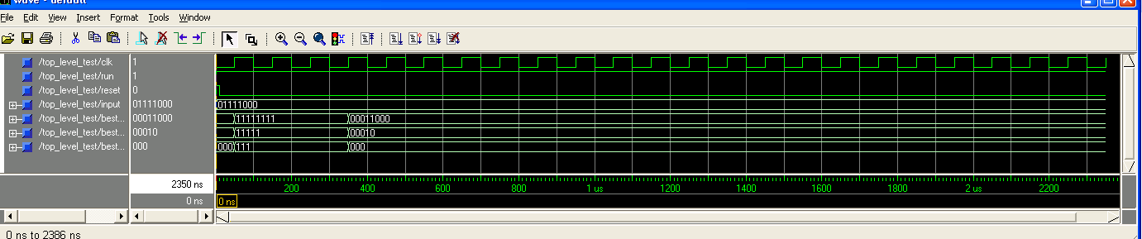
Figure 17: Top Level Waveform Results for Input of 01111000

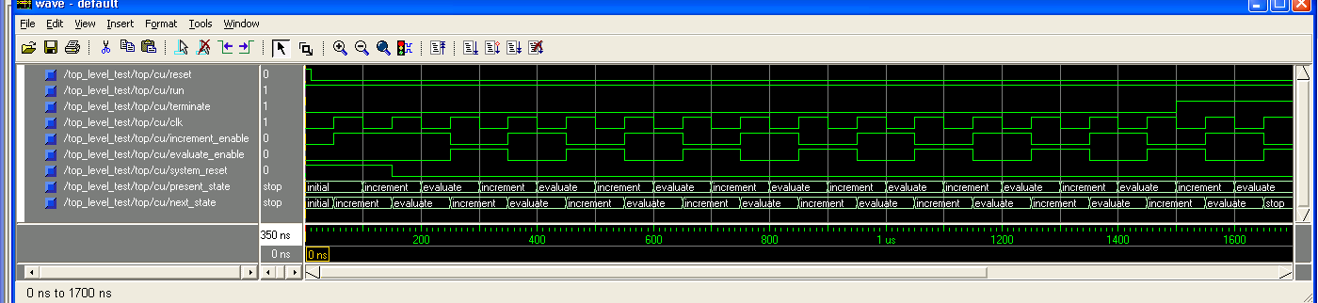
Figure 18: Control Unit Waveform Results for Input of 01111000

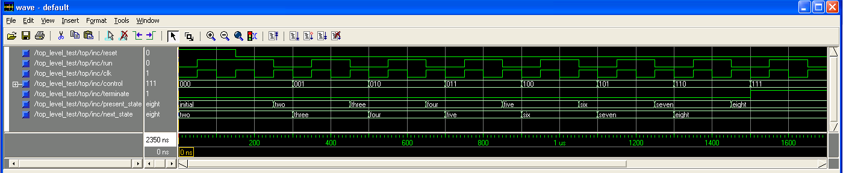
Figure 19: Datapath (Incrementer) Waveform Results for Input of 01111000

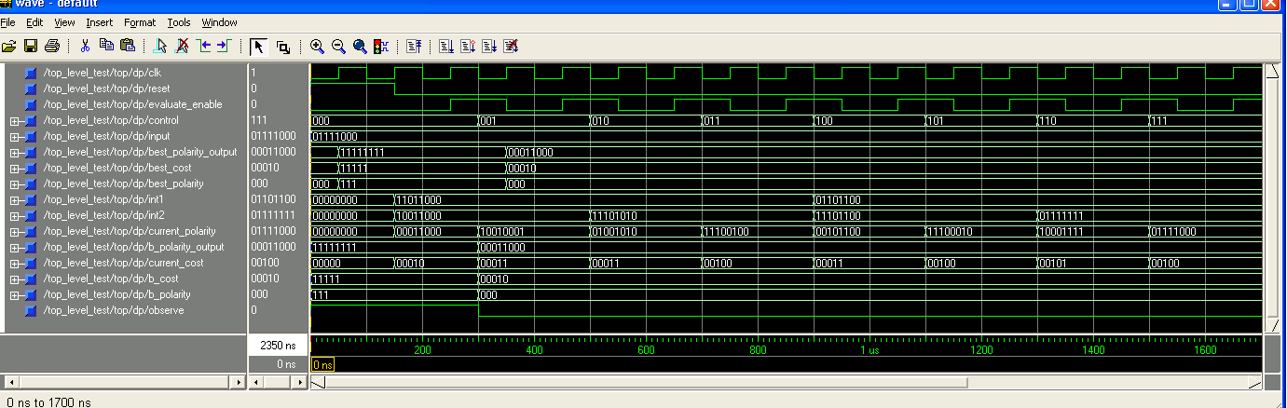
Figure 20: Datapath (Evaluation) Waveform Results for Input of 01111000

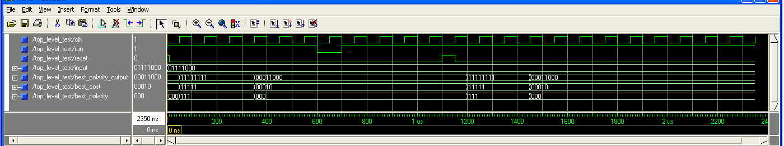
Figure 21: Top Level Waveform Results for Reset & Run Command Test

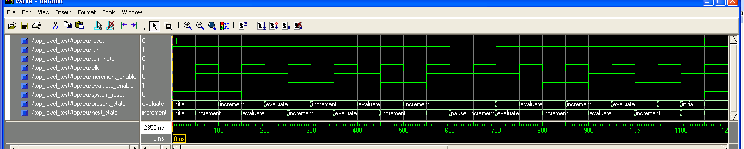
Figure 22: Control Unit Waveform Results for Reset & Run Command Test (0 ns-1200ns)

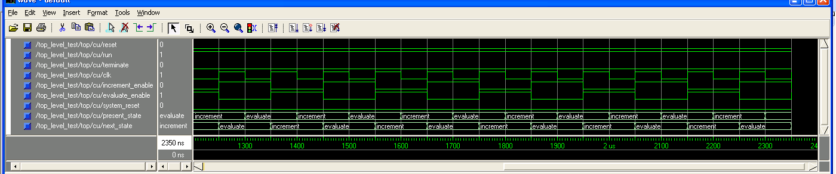
Figure 23: Control Unit Waveform Results for Reset & Run Command Test (1201 ns – 2400 ns)

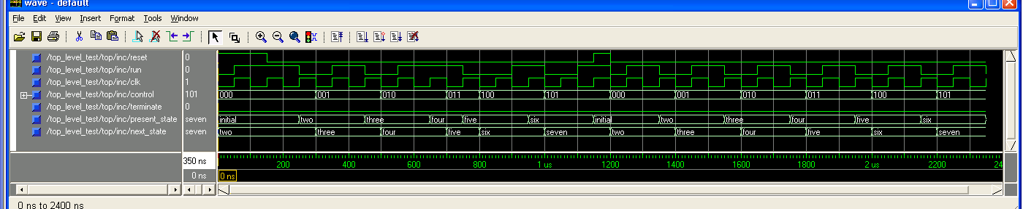 Figure 24: Datapath (Incrementer) Waveform Results for Reset & Run Command Test

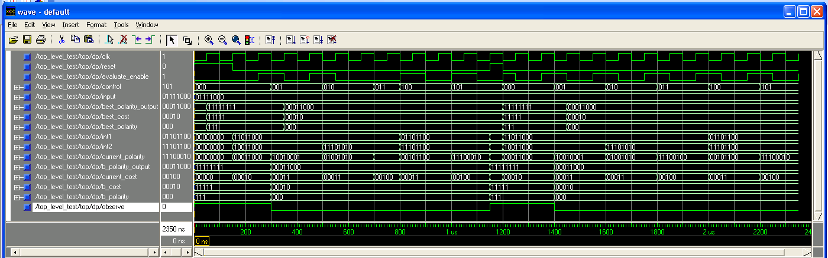
Figure 25: Datapath (Evaluation) Waveform Results for Reset & Run Command Test

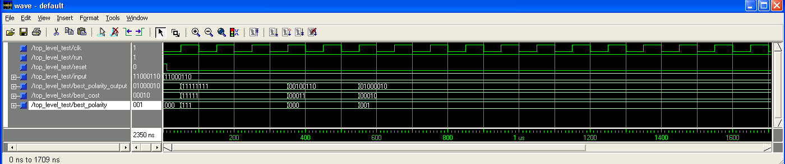
Figure 26: Top Level Waveform Results for Input 11000110

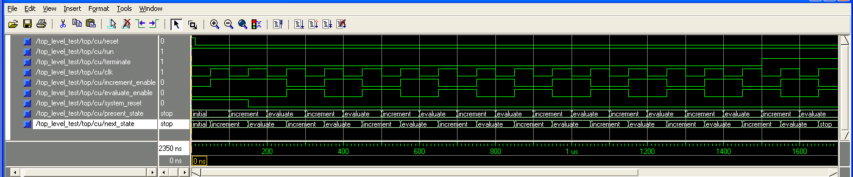
Figure 27: Control Unit Waveform Results for Input 11000110

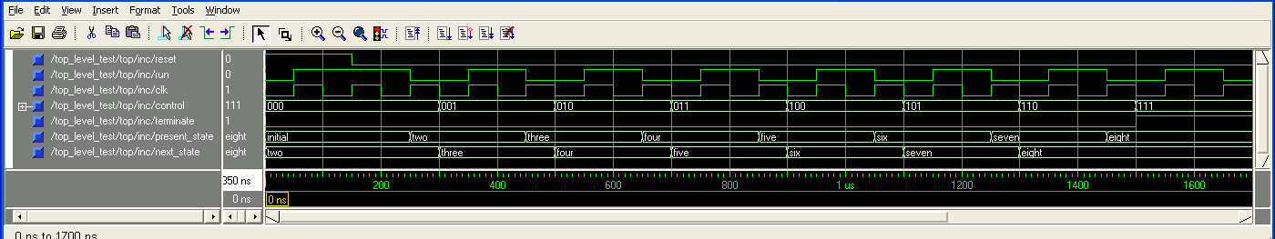 Figure 28: Datapath (Incrementer) Waveform Results for Input 11000110

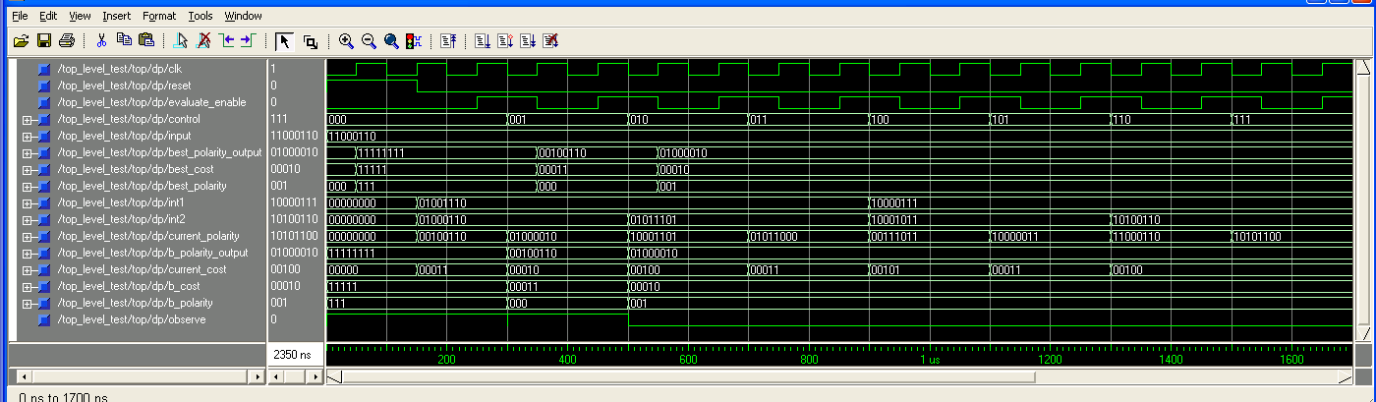
Figure 29: Datapath (Evaluation) Waveform Results for Input 11000110

Limitations & Improvements:
The design is implemented to solve the best polarity in sequential manner. The time necessary for evaluation of the problem can be significantly reduced by pipelining the control (count) values into the datapath. By instantiating a PROCESS statement that executes at each clock edge, you can implement the Reed Muller polarity evaluation using a CASE statement rather than a WITH-SELECT statement. With this approach, each level is evaluated at the clock edge and the output will be evaluated at the following level at the next clock edge. You would need to manipulate the incrementer to account for pipelining. For example, the following sequence of control (polarity) values would implement the Reed Muller for 000 and 001. After the initial 3 clock cycles, a new output polarity is being evaluated for a specific polarity during every clock cycle.

Incrementer | Level Evaluation (Previous Evals) | Polarities Complete
0xx | L1 = 0, L2 = x, L3 = x | -
00x | L1 = 0, L2 = 0 (0), L3 = x | -
000 | L1 = 0, L2 = 0 (0), L3 =0 (00) | 000
x11 | L1 = x, L2 = 1 (0), L3 =1 (00) | 000, 001
xx0 | L1 = x, L2 = x, L3 =0 (01) | 000, 001, 010

