Reversible Adder

Derek Schmidlkofer
Homework 1
ECE 590
4-26-06

1. Introduction:

Many researchers believe that Moore’s law is at an end. The power requirements of traditional methods used to increase performance are too great. Laundauer’s principle states that logic computations that are not reversible generate kT ln 2 Joules of heat energy for every bit of information energy that is lost. It has been proven that using traditional irreversible logic gates necessarily leads to power dissipation regardless of underlying technology. A reversible logic design will not result in information loss, this avoids the unwanted heat generated. For power not to be dissipated in an arbitrary circuit, it must be built from reversible gates.

2. Reversible Gates:

A digital combinational logic circuit is reversible if it maps each input pattern to a unique output pattern. There are many types of reversible gates including: inverter/NOT, Feynman, Toffoli, and Fredkin. Table 1 lists the behavior of each of these reversible gates.

Table 1: Gate functionality

2.1 Not Gate:

The most primitive of logic gates, the one-input one-output not gate simply inverts the logic value of the input on it’s output.
------------------------------------------------------------------------------------------------------------
library ieee;
use ieee.std_logic_1164.all;

entity rev_not is port (
a : in std_logic;
x : out std_logic);
end rev_not;

architecture config of rev_not is
begin
x<='1' when a='0' else '0';
end config;
------------------------------------------------------------------------------------------------------------

2.2 Feynman Gate:

When A = 0 then Q = B, when A = 1 then Q = B’. The Feynman Gate can be used as a fan-out/copying gate or an XOR gate where$Q=A⊕B$.

Figure 1: Feynman gate

------------------------------------------------------------------------------------------------------------
library ieee;
use ieee.std_logic_1164.all;

entity feynman is port (
a : in std_logic;
b : in std_logic;
p : out std_logic;
q : out std_logic);
end feynman;

architecture config of feynman is
begin
p <= a;
q <= a xor b;
end config;
------------------------------------------------------------------------------------------------------------

2.3 Toffoli Gate:

Both A and B inputs are passed directly though the gate to P and Q outputs respectively. The R output uses more complex logic, $R=C⊕\text{AB}$. By setting C = 0, it becomes an AND gate R = AB.

Figure 2: Toffoli gate
------------------------------------------------------------------------------------------------------------
library ieee;
use ieee.std_logic_1164.all;

entity toffoli is port (
a : in std_logic;
b : in std_logic;
c : in std_logic;
p : out std_logic;
q : out std_logic;
r : out std_logic);
end toffoli;

architecture config of toffoli is
begin
p <= a;
q <= b;
r <= c xor (a and b);
end config;
------------------------------------------------------------------------------------------------------------
2.4 Fredkin Gate:

In this gate, the input signals A and B are routed to the same or exchange putout ports depending on the value of the control signal C.

Figure 3: Fredkin gate
------------------------------------------------------------------------------------------------------------
library ieee;
use ieee.std_logic_1164.all;

entity fredkin is port (
a : in std_logic;
b : in std_logic;
c : in std_logic;
p : out std_logic;
q : out std_logic;
r : out std_logic);
end fredkin;

architecture config of fredkin is
begin
p <= c;
q <= (a and not(c)) or (b and c);
r <= (b and not(c)) or (a and c);
end config;
------------------------------------------------------------------------------------------------------------

3. Adder:
3.1 Half-Adder:

The simplest case of Boolean addition arises when two one bit numbers are to be added. With one bit, only the numbers 0 and 1 can be represented. All possible scenarios can be summarized by the following table:

A | B | Y1 | Y0
0 | 0 | 0 | 0
0 | 1 | 0 | 1
1 | 0 | 0 | 1
1 | 1 | 1 | 0

The least significant bit of the output, Y0, is the result of XOR-ing the inputs. The other bit, Y1, results from AND-ing A and B. The bit Y1 is called the carry bit. Hence, the circuit below can be used to construct a half-adder.

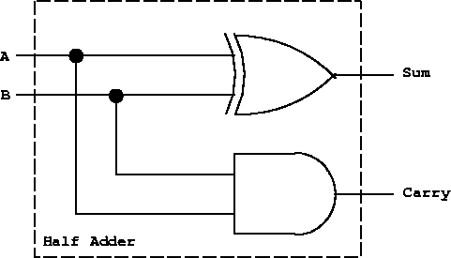
Figure 4: Half-adder using standard logic gates

A half-adder can be realized using a Toffoli gate to perform the summation and a Feynman gate to perform the xor function for the carry. The C bit on the Toffoli gate is set to zero.

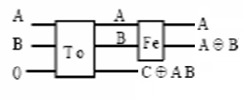
Figure 5: Half-adder using Toffoli (To) and Feynman (Fe) gates
------------------------------------------------------------------------------------------------------------
library ieee;
use ieee.std_logic_1164.all;

entity half_add is port (
a : in std_logic;
b : in std_logic;
c : in std_logic;
p : out std_logic;
q : out std_logic;
r : out std_logic);
end half_add;

architecture config of half_add is
component feynman port (
a, b : in std_logic;
p, q : out std_logic);
end component;
component toffoli port (
a, b, c : in std_logic;
p, q, r : out std_logic);
end component;
signal i, j : std_logic;
begin
tof: toffoli port map (a, b, c, i, j, r);
fey: feynman port map (i, j, p, q);
end config;
------------------------------------------------------------------------------------------------------------

3.2 Full-Adder:

When two (or more) bit binary numbers are added, the problem is somewhat more complicated. Example: Add binary representations of 3 (11) and 1 (01).

 | 1 | 1 | Three
+ | 0 | 1 | One
1 | 1 |  | Carry
1 | 0 | 0 | Result

The example illustrates that for all but the rightmost bit, not two but three bits must be added. The carry bit from the previous bit addition must be reflected. The truth table for the full adder (with carry input) is:

A1 | B1 | C1 | C2 | S1
0 | 0 | 0 | 0 | 0
0 | 0 | 1 | 0 | 1
0 | 1 | 0 | 0 | 1
0 | 1 | 1 | 1 | 0
1 | 0 | 0 | 0 | 1
1 | 0 | 1 | 1 | 0
1 | 1 | 0 | 1 | 0
1 | 1 | 1 | 1 | 1

The carry bit is 1 if both A1 and B1 are 1, or exactly one of A1 and B1 is 1 and the input carry is 1. The sum bit S1 is 1 if an odd number of the three inputs is on, i.e., S1 is the XOR of the three inputs. Hence, the full adder can be realized as shown below. Notice that the full adder can be constructed from two half adders and an OR gate.

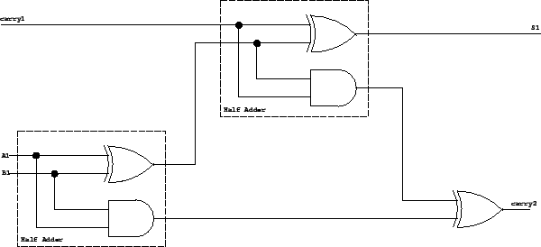
Figure 6: Full-adder using standard logic gates

Just as in the example of the full-adder using standard logic, two half-adders using the reversible gates can be connected to form a reversible full-adder. There is no need to add an additional xor gate to this design because the Toffoli gate already has one available to use. This design has two primary outputs, two potential garbage outputs, three primary inputs and 1 constant input.

Figure 7: Full-adder using Toffoli (To) and Feynman (Fe) gates

------------------------------------------------------------------------------------------------------------
library ieee;
use ieee.std_logic_1164.all;

entity full_add is port (
a : in std_logic;
b : in std_logic;
c : in std_logic;
p : out std_logic;
q : out std_logic;
r : out std_logic;
s : out std_logic);
end full_add;

architecture config of full_add is
component half_add port (
a, b, c : in std_logic;
p, q, r, s : out std_logic);
end component;
signal i, j, zero : std_logic;
begin
zero <= '0';
ha1: half_add port map (a, b, zero, p, i, j);
ha2: half_add port map (i, c, j, q, r, s);
end config;
------------------------------------------------------------------------------------------------------------

3.3 Complete Bit Vector Adder:

Adders for arbitrarily large binary numbers can be constructed by cascading full adders. The carry bit ``ripples'' from one stage to the next. A drawback of this circuit is that the carry information has to propagate through all stages. I.e., there is an electrical path from A0 and B0 to S5 in the diagram below. This path traverses 2N-1 gates in an N-bit adder. This may lead to undesirably long delays before the output stabilizes. The problem can be overcome by more complex carry computations.

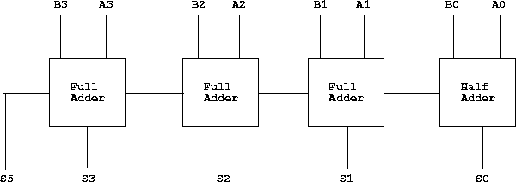
Figure 8: Four Bit Binary Adder w/ Carry

------------------------------------------------------------------------------------------------------------
package globals is
constant WIDTH : integer := 3;
end globals;

library ieee;
use ieee.std_logic_1164.all;
use work.all;
use globals.all;

entity reverse_adder is port(
a_in : in std_logic_vector(WIDTH downto 0);
b_in : in std_logic_vector(WIDTH downto 0);
c_in : in std_logic;
a_out : out std_logic_vector(WIDTH downto 0);
a_xor_b_out : out std_logic_vector(WIDTH downto 0);
sum_out : out std_logic_vector(WIDTH downto 0);
carry_out : out std_logic);
end reverse_adder;

architecture config of reverse_adder is
signal temp : std_logic_vector(WIDTH downto 0);
signal one : std_logic;
signal zero : std_logic;
component full_add port (
a, b, c : in std_logic;
p, q, r, s : out std_logic);
end component;
begin
one <= '1';
zero <= '0';
generate_add: for i in WIDTH downto 0 generate
-- first case for adder --
first: if i = 0 generate
fa1: full_add port map (a => a_in(i), b => b_in(i), c => c_in,
p => a_out(i), q => a_xor_b_out(i), r => sum_out(i), s => temp(i));
end generate first;
-- repetitive middle cases --
middle: if ((i > 0) and (i < WIDTH)) generate
fa2: full_add port map (a => a_in(i), b => b_in(i), c => temp(i-1),
p => a_out(i), q => a_xor_b_out(i), r => sum_out(i), s => temp(i));
end generate middle;
-- last case --
last: if i = WIDTH generate
fa3: full_add port map (a => a_in(i), b => b_in(i), c => temp(i-1),
p => a_out(i), q => a_xor_b_out(i), r => sum_out(i), s => carry_out);
end generate last;
end generate generate_add;
end config;
------------------------------------------------------------------------------------------------------------

4. Test Bench:

------------------------------------------------------------------------------------------------------------
library ieee;
use ieee.std_logic_1164.all;
use work.all;
use globals.all;

entity testadd is
end testadd;

architecture test of testadd is

component reverse_adder_c port(
a_in : in std_logic_vector(WIDTH downto 0);
b_in : in std_logic_vector(WIDTH downto 0);
c_in : in std_logic;
a_out : out std_logic_vector(WIDTH downto 0);
a_xor_b_out : out std_logic_vector(WIDTH downto 0);
sum_out : out std_logic_vector(WIDTH downto 0);
carry_out : out std_logic);
end component;

signal a_in : std_logic_vector(WIDTH downto 0);
signal b_in : std_logic_vector(WIDTH downto 0);
signal c_in : std_logic;
signal a_out : std_logic_vector(WIDTH downto 0);
signal a_xor_b_out : std_logic_vector(WIDTH downto 0);
signal sum_out : std_logic_vector(WIDTH downto 0);
signal carry_out : std_logic;

begin
uut: reverse_adder_c port map(a_in, b_in, c_in, a_out, a_xor_b_out, sum_out, carry_out);
waveformgen: process
constant interval: time:=50 ns;
begin
a_in <= "000";
b_in <= "000";
c_in <= '0';
wait for interval;
a_in <= "001";
b_in <= "001";
c_in <= '0';
wait for interval;
a_in <= "011";
b_in <= "001";
c_in <= '0';
wait for interval;
a_in <= "011";
b_in <= "011";
c_in <= '0';
wait for interval;
a_in <= "111";
b_in <= "000";
c_in <= '0';
wait for interval;
a_in <= "111";
b_in <= "001";
c_in <= '0';
wait for interval;
a_in <= "101";
b_in <= "010";
c_in <= '0';
wait for interval;
a_in <= "111";
b_in <= "111";
c_in <= '0';
wait;
end process waveformgen;
end test;
------------------------------------------------------------------------------------------------------------

4.1 Test Bench Results:

5. Contact info:

http://www.geocities.com/dschmidlkofer/ECE590.html
E-mail: dereks@covad.net

