Overview

For this class I will be designing various blocks of a pacemaker in VHDL as a vehicle to explore both the language and digital design.

Background

The following diagram shows a model of a basic single chamber pacemaker. This project focuses on the timing engine of the pacemaker which controls when it paces and when it does not according to the patients need. In this case, the pacemaker timing engine is programmed by the physician through the physcians interface block, it receives notification of intrinsic events from the sense detection block, and it tells the pace pulse generation block when to pace.

The Pacemaker Timing Engine operates as follows:
- If intrinsic contractions are not detected after a programmed interval ( e.g. 1000 ms corresponding to 60 beats per minute), the pacemaker stimulates the heart with a pacing pulse.
- If intrinsic events are detected, the pacemaker inhibits (does nothing) for that cardiac cycle and restarts its timer for another programmed interval looking for intrinsic contractions.
- As a natural human heart has a refractory period where once an intrinsic event occurs, the heart will most likely not contract again for a certain period (can be around 200 ms), thus this pacemaker will also ignore events that occur within a programmed interval of either a pace or sense.

Design of the Pacemaker Timing Engine

While my initial design will be for a simple single channel pacemaker ( termed VVI for Ventricular Pacing, Ventricular Sensing and Inhibiting), my intent is to incrementally expand it to a dual channel pacemaker This means that the design needs to follow a layered approach inorder to manage complexity and to allow for future growth. The following diagram shows the internal architecture of the block at a very high level.

The following sections break apart the design of the two blocks shown above and a general purpose timer that was used in both blocks. The approach is to keep the discussion at a very high-level ,and allow the VHDL to document the details of the implementation.

----------------------------------------------------------------------------------
-- VVIPacer
--
-- Top - Level model for a simple VVI Pacemaker.
----------------------------------------------------------------------------------
library IEEE;
use IEEE.STD_LOGIC_1164.ALL;
use IEEE.STD_LOGIC_ARITH.ALL;
use IEEE.STD_LOGIC_UNSIGNED.ALL;

---- Uncomment the following library declaration if instantiating
---- any Xilinx primitives in this code.
--library UNISIM;
--use UNISIM.VComponents.all;

entity VVIPacer is
port ( clock : in std_logic;
reset: in std_logic;
base_interval : in std_logic_vector (15 downto 0);
vref_interval: in std_logic_vector (15 downto 0);
ventricle_pace: out std_logic;
ventricle_sense: in std_logic );

end VVIPacer;

architecture Behavioral of VVIPacer is

component VVIPacingModeEngine
port ( reset : in std_logic;
clock : in std_logic;
base_interval : in std_logic_vector (15 downto 0);
ventricular_sense : in std_logic;
pace_request : out std_logic);
end component;

component VRefractory
port ( pace_request : in std_logic;
clock : in std_logic;
reset : in std_logic;
ventricle_detect : in std_logic;
refractory_period : in std_logic_vector (15 downto 0);
vsense : out std_logic);
end component;

signal used_sense: std_logic;
signal pace_request: std_logic;

begin

pacer: VVIPacingModeEngine port map(
reset,
clock,
base_interval,
used_sense,
pace_request);

vref: VRefractory port map(
pace_request,
clock,
reset,
ventricle_sense,
vref_interval,
used_sense);

ventricle_pace <= pace_request;

end Behavioral;

Timer

This block was written at the Behavioral Level so that I could quickly move on to more pacemaker specific elements of the architecture while at the same time getting a feel for doing behavioral simulations in VHDL. It also would be an ideal block to design quickly at the high-level and have somebody optimize at a later date. A key feature of the timer is that it can be used in two ways:
- As a recirculating timer that will run continuously (VVI Pacemaker Engine will use this)
- As a count up and stop timer, that counts until it timeouts and then resets

----------------------------------------------------------------------------------
-- Timer
--
-- Behavioral model of count up recirculating timer with synchronous reset.
--
----------------------------------------------------------------------------------
library IEEE;
use IEEE.STD_LOGIC_1164.ALL;
use IEEE.STD_LOGIC_ARITH.ALL;
use IEEE.STD_LOGIC_UNSIGNED.ALL;

---- Uncomment the following library declaration if instantiating
---- any Xilinx primitives in this code.
--library UNISIM;
--use UNISIM.VComponents.all;

entity Timer is
port ( timeout_value : in std_logic_vector (15 downto 0);
enable : in std_logic;
start : in std_logic;
reset : in std_logic;
clock : in std_logic;
timer_value : out std_logic_vector (15 downto 0);
timeout_occured : out std_logic);
end Timer;

architecture Behavioral of Timer is
signal internal_time : std_logic_vector(15 downto 0):= x"0000";

begin

main: process (clock)

begin

if clock'event and clock='1' then
if reset='1' then
internal_time <= x"0000";
timeout_occured <='0';
elsif enable = '1' then
if (internal_time = x"0000" and start='0') then
timeout_occured <= '0';
else

if internal_time >= timeout_value then
internal_time <= x"0000";
timeout_occured <= '1';
else
internal_time <= internal_time +1;
timeout_occured <='0';
end if;

end if;
end if;

end if;

end process main;
timer_value <= internal_time;

end Behavioral;

VRefractory Block

This block was separated into two elements: a controller ->VRefController and a data path -> a timer. The following diagram shows the basic structure and the state-machine of the controller.

The controller was implemented using a combination of structural and behavioral vhdl with the idea of using muxs to implement the control logic for the statemachine.

----------------------------------------------------------------------------------
-- VRefractory
--
-- Hardware block implementing a pacemaker refractory period.
----------------------------------------------------------------------------------
library IEEE;
use IEEE.STD_LOGIC_1164.ALL;
use IEEE.STD_LOGIC_ARITH.ALL;
use IEEE.STD_LOGIC_UNSIGNED.ALL;

---- Uncomment the following library declaration if instantiating
---- any Xilinx primitives in this code.
--library UNISIM;
--use UNISIM.VComponents.all;

entity VRefractory is
port ( pace_request : in std_logic;
clock : in std_logic;
reset : in std_logic;
ventricle_detect : in std_logic;
refractory_period : in std_logic_vector (15 downto 0);
vsense : out std_logic);

end VRefractory;

architecture Behavioral of VRefractory is

component VRefController
port ( clock : in std_logic;
reset : in std_logic;
pace_request : in std_logic;
detect : in std_logic;
timeout: in std_logic;
refractory: out std_logic;
sense: out std_logic;
restart_timer:out std_logic);
end component;

component Timer
port ( timeout_value : in std_logic_vector (15 downto 0);
enable : in std_logic;
start : in std_logic;
reset : in std_logic;
clock : in std_logic;
timer_value : out std_logic_vector (15 downto 0);
timeout_occured : out std_logic);
end component;

signal timer_timeout: std_logic;
signal refractory: std_logic;
signal high: std_logic:='1';
signal restart_timer :std_logic;
signal timerval:std_logic_vector (15 downto 0);
begin

vref_contr: VRefController port map(
clock,
reset,
pace_request,
ventricle_detect,
timer_timeout,
refractory,
vsense,
restart_timer);

tim: Timer port map(
refractory_period ,
high,
restart_timer,
reset,
clock,
timerval,
timer_timeout);

end Behavioral;

----------------------------------------------------------------------------------
-- VRefController
--
-- Controller for Ventricular refractory built using muxes for sequential circuit design.
----------------------------------------------------------------------------------
library IEEE;
use IEEE.STD_LOGIC_1164.ALL;
use IEEE.STD_LOGIC_ARITH.ALL;
use IEEE.STD_LOGIC_UNSIGNED.ALL;

---- Uncomment the following library declaration if instantiating
---- any Xilinx primitives in this code.
--library UNISIM;
--use UNISIM.VComponents.all;

entity VRefController is
Port ( clock : in STD_LOGIC;
reset : in STD_LOGIC;
pace_request : in STD_LOGIC;
detect : in STD_LOGIC;
timeout: in STD_LOGIC;
refractory: out STD_LOGIC;
sense: out STD_LOGIC;
restart_timer: out STD_LOGIC);

end VRefController;

architecture Behavioral of VRefController is
signal s0: STD_LOGIC:= '0';
signal s0_prime: STD_LOGIC;
signal s1: STD_LOGIC:= '0';
signal s1_prime : STD_LOGIC;
signal high: STD_LOGIC := '1';

signal Not_Pace_And_Sense: STD_LOGIC;
signal Not_timeout: STD_LOGIC;

component mux_4_to_1
port ( in0 : in std_logic;
in1 : in std_logic;
in2 : in std_logic;
in3 : in std_logic;
sel1 : in std_logic;
sel0 : in std_logic;
out0 : out std_logic);
end component mux_4_to_1;

begin

Not_Pace_And_Sense<= Not pace_request and detect;
Not_timeout <= Not timeout;

mux_s1: Mux_4_to_1 port map(
Not_Pace_And_Sense,
high,
high,
Not_timeout,
s1,
s0,
s1_prime
);

mux_s0: Mux_4_to_1 port map(
pace_request,
high,
high,
Not_timeout,
s1,
s0,
s0_prime
);

mem: process (clock, reset)
begin
if reset='1' then
s1 <= '0';
s0 <= '0';
elsif clock'event and clock='1' then
s1 <= s1_prime;
s0 <= s0_prime;
end if;

end process mem;

output: block
begin
refractory<= s1 or s0;
restart_timer <= s1 xor s0;
sense <= s1 and Not s0;
end block output;

end Behavioral;

----------------------------------------------------------------------------------
-- Mux_4_to_1
--
-- This block de-multiplexes four inputs into a single output based on two select inputs.
--
----------------------------------------------------------------------------------
library IEEE;
use IEEE.STD_LOGIC_1164.ALL;
use IEEE.STD_LOGIC_ARITH.ALL;
use IEEE.STD_LOGIC_UNSIGNED.ALL;

---- Uncomment the following library declaration if instantiating
---- any Xilinx primitives in this code.
--library UNISIM;
--use UNISIM.VComponents.all;

entity Mux_4_to_1 is
port ( in0 : in std_logic;
in1 : in std_logic;
in2 : in std_logic;
in3 : in std_logic;
sel1 : in std_logic;
sel0 : in std_logic;
out0 : out std_logic);
end Mux_4_to_1;

architecture Behavioral of Mux_4_to_1 is

begin

out0 <= in0 when sel1='0' and sel0='0' else
in1 when sel1='0' and sel0='1' else
in2 when sel1='1' and sel0='0' else
in3 when sel1='1' and sel0='1';

end Behavioral;

VVI Pacemaker Engine

The VVI Pacemaker Engine was broken into a similar structure to the V Refractory block discussed above. The only difference is the functionality and that the controller was implemented using the dataflow style with just combinational logic controlling the progression of the statemachine.

Note: The timer is held in recirculating mode and merely reset on every paced and sensed event by the controller. As shown, this result in a three state state-machine with all unused states automatically transitioning to the reset state.

----------------------------------------------------------------------------------
-- VVI Pacing Mode Engine
--
-- High-level block for pacing state-machine.
----------------------------------------------------------------------------------
library IEEE;
use IEEE.STD_LOGIC_1164.ALL;
use IEEE.STD_LOGIC_ARITH.ALL;
use IEEE.STD_LOGIC_UNSIGNED.ALL;

---- Uncomment the following library declaration if instantiating
---- any Xilinx primitives in this code.
--library UNISIM;
--use UNISIM.VComponents.all;

entity VVIPacingModeEngine is
port ( reset : in std_logic;
clock : in std_logic;
base_interval : in std_logic_vector (15 downto 0);
ventricular_sense : in std_logic;
pace_request : out std_logic);
end VVIPacingModeEngine;

architecture Behavioral of VVIPacingModeEngine is

component VVIController
port(
vsense : in std_logic;
vtimeout : in std_logic;
reset : in std_logic;
clock : in std_logic;
reset_timer : out std_logic;
pace_request : out std_logic
);
end component;

component Timer
port ( timeout_value : in std_logic_vector (15 downto 0);
enable : in std_logic;
start : in std_logic;
reset : in std_logic;
clock : in std_logic;
timer_value : out std_logic_vector (15 downto 0);
timeout_occured : out std_logic);
end component;

signal timeout: std_logic;
signal timer_reset: std_logic;
signal timer_value: std_logic_vector (15 downto 0);
signal high: std_logic := '1';

begin
vvi_controller: VVIController port map(
ventricular_sense,
timeout,
reset,
clock,
timer_reset,
pace_request);

main_timer: Timer port map(
base_interval,
high,
high,
timer_reset,
clock,
timer_value,
timeout);

end Behavioral;

----------------------------------------------------------------------------------
-- VVI Controller
--
-- Control unit for the VVI statemachine logic.
----------------------------------------------------------------------------------
library IEEE;
use IEEE.STD_LOGIC_1164.ALL;
use IEEE.STD_LOGIC_ARITH.ALL;
use IEEE.STD_LOGIC_UNSIGNED.ALL;

---- Uncomment the following library declaration if instantiating
---- any Xilinx primitives in this code.
--library UNISIM;
--use UNISIM.VComponents.all;

entity VVIController is
port ( vsense : in std_logic;
vtimeout : in std_logic;
reset : in std_logic;
reset_timer : out std_logic;
pace_request : out std_logic;
clock: in std_logic);
end VVIController;

architecture Behavioral of VVIController is
signal s0 : std_logic;
signal s1 : std_logic;
signal s0_prime: std_logic;
signal s1_prime: std_logic;

begin

combinational: block
begin
s1_prime <= not (vsense) and vtimeout and not(s1) and s0;
s0_prime <= (not s1 and not s0) or
(not(vsense) and not (vtimeout) and not (s1) and s0) or
(s1 and not(s0));

end block combinational;

state: process (clock, reset)
begin
if reset ='1' then
s1<= '0';
s0<= '0';
elsif clock = '1' and clock'event then
s1 <= s1_prime;
s0 <= s0_prime;
end if;

end process;

outputs: block
begin
reset_timer <= not (s0) and not (s1);
pace_request <= s1 and not (s0) ;
end block outputs;

end Behavioral;

Simulation Results

Simulations were run using Xilinx’s ISE Webpac tool and all non-trivial blocks were tests separately as shown by the following test structure:

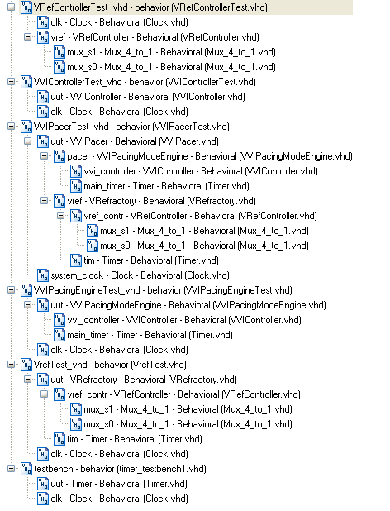

The following shows the results of the toplevel simulation.

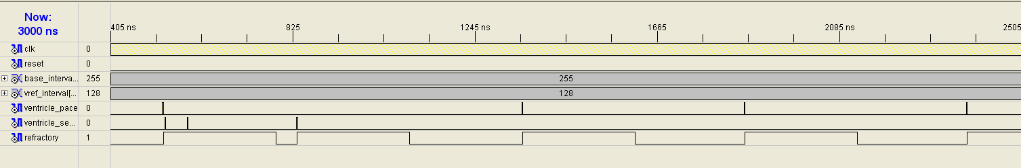

The simulation shows the following behavior:
- An initial pace occurs which starts a refractory period.
- 2 sense events occur and are ignored because they are in the refractory period.
- A 3rd sense outside the refractory causes the pacemaker to restart its timing cycle
- 3 more paces occur as no more sense events are injected.

NOTE: The clock used for this simulation was set for a period of 2 ns, the base_interval was 0xFF ns and the refractory interval 0x80 ns. In a real device a slower clock would be used but the simulation package does not seem to allow adjustment of the time unit for the sim. Working in nano-seconds was easier to test the results.

Here is the result of the timer simulation:

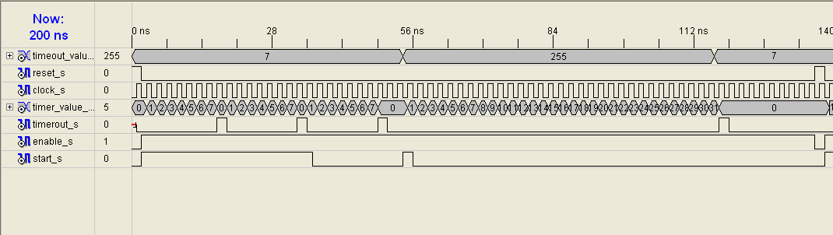

The simulation shows the following behavior:
- The timer starting to count from 0 to the timeout value.
- If start is held high, it just repeats.
- If start is not held high, it resets and stops at zero.
- If the timeout value is changed from 255 to the value less than the current count, the timer times out immediately. This is a safety feature.

The following simulation result shows the tests conducted for the VVI controller. In the case of systems driven by timers, testing the controller separately is a great way to speed up the system. The test shows the system responding to the vsense, vtimeout and reset inputs, while delivering the appropriate reset_tiemr and pace_request outputs.

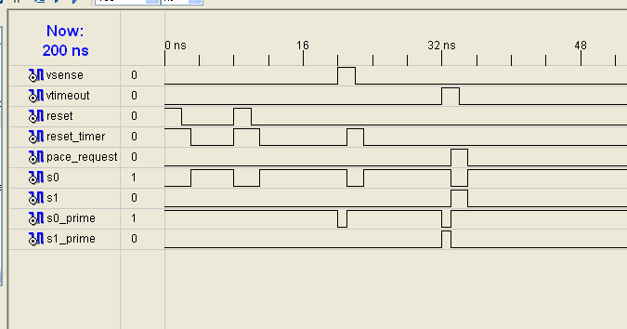

For the final example, the following diagram shows the test results for the VRefController block.

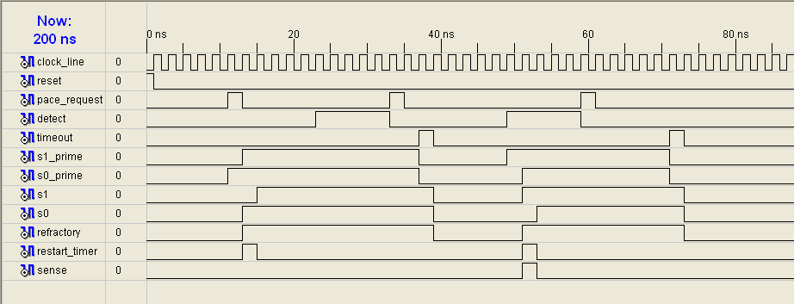

Here we can see:
- Pace requests, resetart the timer and start a refractory period
- Senses and paces in the refactory period are ignored
- Sense requests, restart the timer and start a refractory period
- Sense events are also passed on to the sense output as long as they are outside the refractory period.

