  - Contents
Abstract 5
1 Introduction 5
Motivation From Animation 5
What’s Wrong with Behaviors of Social Robots? 6
Motivation: Robots with natural-looking gaits 11
Summary 14
Structure of the Dissertation 14
2 REBeL: A Language for Social Robot Behaviors 15
A Taste of REBeL 15
A Lesson or Two from Storytelling and Animation 19
Other Useful Components for Socially-interesting Robot 21
How Actions from BEs are Executed 23
Summary of the Proposed Contributions of this Dissertation 26
3 Related Works 28
Selected Works in Human-robot Interaction 28
Interactive and Dynamic Motion Synthesis in Computer Animation 35
Use of LMA and DAP (Badler, Portuguese team, iCat) 39
Automata, Languages, Formal Robot Control 41
Dynamic System-based Natural-looking motion 43
Methods, Algorithms and Technologies from Computer Animation to be Used in REBeL 44
Past Work 46
Evaluation in HRI 47
4 Anthropomorphism, Gestures and Expressiveness 48
Anthropomorphism 48
Gestures and Expressiveness 50
Disney Animation Principles 51
Laban Movement Analysis 53
SUMMARY 54
5 Automata Theory 55
Models of automata 55
Moore Machine 58
Mealy Machine 60
Rabin-Scott Machine 61
Nondeterministic Finite Automata. 62
Probabilistic Finite Automaton 64
Hybrid Finite Automaton 66
Augmented Finite State Machine (AFSM) 68
Regular Grammar, Regular Languages, Finite Automata, and Regular Expressions 69
Automata as Model for Robot Motion and Robot Actions 73
Summary 74
6 Regular Expressions 75
Regular Expression Operations 76
Concatenation 76
Union 76
Kleene Star 77
Intersection and Complement in Regular Expression 78
Parallel Operators 78
Conversion of a Regular Expression to a Finite Automaton 78
Thompson’s Construction Algorithm 78
Converting NFA to DFA 81
Brzozowski’s Derivation Method 84
Example: The Aggressive Braitenberg Vehicle 89
Brzozowski’s Method 91
State Removal Method 92
Parallelism (Product Machine) by Brzozowski’s Derivation 93
7 Behavior Expressions 96
Some Definitions 96
Basic Behavior Expression (BE) 97
Probabilistic Behavior Expression 98
Analysis of Behavior Expression 102
Behavior Expression Example: Labanotation 105
Fuzzy Behavior Expression 106
Behavior Expression for Input and Output Behaviors 108
Summary 108
8 Robot Expressive Behavior Language (REBeL) 109
Basic Syntax 109
Parsing 109
Evaluation of Expression 110
Concatenation 111
Union 111
Repetition 112
State Symbols 112
Summary 113
9 The REBeL System 115
Architecture of the Complete REBeL System 115
Input from Environment 116
Input Behavior Automata 117
Internal State Model 117
Input-output Behavior Automata 117
Library of Atomic Motions 117
Output Motion Pre-processing 117
Kinematic Description Framework 119
Dynamic Description Framework 120
Action Queue 121
Action Buffer 122
Anticipation Calculator 122
Dynamics Simulator 122
Servo Drivers 122
Selected Dynamic Motion Qualities 123
The Framework 124
Summary 124
10 From Traditional Animation to Robot Animation 125
11 Interactive Gene Expression Programming 129
Interactive Fitness Evaluation 130
Summary 132
12 Experiments and Evaluations 133
Evaluation 133
Interactive Experiment 133
As a Theatrical Play 134
Using REBeL 135
13 Timeline and Milestones 139
Schedule/Goals 139
MILESTONES 139
Schedules: 139
Upcoming Papers 139
Target Journals/Publications: 139
14 References 141

Dissertation Proposal

Abstract
TBD

Introduction
I think robots are awesome. Particularly those that can show human-like social behaviors like: curious, friendly, observing, searching, and playing. These robots are called as socially-interactive [1], specifically to human social interaction norms. Social awareness requires some sort of mental model of interaction based on some culturally-sensitive human interaction norms.

Motivation From Animation
I am interested in the study of human-robot interaction, particularly how to make the interaction between a person and a robot fun, interesting, and engaging. There are many elements of interaction, but with my experience in hand-drawn animation, I am particularly interested in the utilization of nonverbal communication cues of the robot such as simple sounds, lights, gestures and emotional expressions through body movements for interactive robots. In hand-drawn animation there is a big emphasis of communicating the mind and emotion of a character through their pose and body language. I believe the same can be achieved on actual robots.
My inspiration for this dissertation originates from watching the robots Wall-E from the movie Wall-E and R2-D2 from the movie Star Wars. One of the things that the movie Wall-E was lauded for was that in the first half of the movie, there is barely any verbal (spoken) dialogue between Wall-E, and the other characters. In that section of the Wall-e movie, the story was effectively and clearly conveyed to the audience through the characters’ gestures, attitudes and with little verbal dialogue. However, Wall-E does have some ability to “say” short words like “whoa”, “ta-dah!”, in some sort of digitized synthetic voice. But much of what Wall-E is 'thinking' such as hesitation, shock/surprise, fear, happy-ness are was conveyed through his movements, posture and pose, and gaze.
There is a major caveat, however: camera angles, special effects, lighting, background music/sounds, color scheme in addition to the robot’s “acting”, contribute much to the storytelling as well. Mr. Andrew Stanton who directed Wall-E said that because they have to tell the story without speech, they had to work hard to carefully use these other cinematic elements to help tell the story such as camera angle, lighting, ambient sounds, music, color palette, etc. These elements are external to the robot itself, but in movies, they work together to tell the story to the audience in an engaging way when they are done right. In real robots, there is no such luxury of manipulating the environment just to be engaging with the audience (except in a controlled environment, e.g. robot theater).
The R2-D2 robot is slightly different from Wall-E since it does not have as many degrees of freedom for expressions. But while R2-D2 can only makes synthetic Morse code-like sounds of beeps, and clicks, it can also modulate its voice to express excitement, fear and other emotions. However, everything is choreographed, of course. In the movie, every character who interacts with R2-D2 understands what it is saying through those sounds, and conveyed those messages through their dialogue while in reality none of us (the audience) understands that ‘language’ of R2-D2. This is a big ‘cheat’ that makes us understands what R2-D2 is doing, on top of other cinematography tricks such as close-ups, sound effects, etc.
I purposefully chose Wall-E and R2-D2 as examples, and avoided mentioning android-type robots (robots with human-like features: eyeballs, hair, skin, teeth, etc.). The main reason is that androids are expensive, highly complicated to build, and highly prone to the Uncanny Valley problem. I prefer to focus attention to simpler robots that are cheaper to build, because I believe even simple robots can be affective (such as R2-D2), and highly human-like features are unnecessary (Wall-E) for affective and socially interactive robots.

What’s Wrong with Behaviors of Social Robots?
However, today's robots are still very limited in the way they respond in interactive social settings. These robots tend to only playback canned responses that have been mapped to some input types. For example: when a person says “Hello”, the robot only responds with the same hand-waving gesture every time. In human-human interaction, there are many ways a person can respond to a greeting.
Additionally, when dealing with emotional expressions, or attitudes, the expressions or gestures are only programmed superficially. When showing “surprise”, the robot merely replays a pre-programmed surprise facial expression. When ‘happy’ the robot only plays back a ‘happy’ response, or one of the pre-programmed ‘happy’ responses; maybe a smiling face. In human-human interaction, there are other things that happen, for example: looking at the source of surprise or happiness, sometimes followed by the hands covering the mouth, and other gestures along with combinations and permutations of those actions. New gestures are also being created.
When a person is presented with an interactive robot, the inclination is to test the robot by giving it the same stimulus repeatedly to invoke its ability to respond (e.g. express emotions), to see if the robot will repeat the same responses (expressions). Humans, on the other hand, can rarely perform such expressions in the same, exact way every time. Humans adapt their responses depending on the circumstances. For example, when surprised, we may jump away from whatever caused our surprise e.g. if from behind, we jump forward or up; if it is ahead of us, we jump back. Moreover, a person can quickly grow weary of being stimulated for surprise after a few times which can lead the person to other emotions such as angry, or fear, and avoiding the interaction altogether.
Good animators master the art of conveying such expressions in hand-drawn animation or in 3D/computer-generated animation [2]. For an example of a genuine “surprised”, consider the short sequence from a scene of Wall-e depicted in Figure 1.1. The scene shows two expressions from Wall-e. The first was surprise, and the second was concern. Unfortunately, print media such as this document cannot fully express the timing of how this sequence happens. In the actual video clip, the transitions between frames 2 through 6 for the surprise ‘take’ TAKE IS NOT EXPLAINED AND INTRODUCED IN MAIN TEXT happens in about 1 second. There is a lot of movements that happened: looking down to check what he just ran over (frame 2), ‘compressing/squashing/ anticipating’ (frame 3), ‘jump back’ by raising his whole body, raising and extending both arms, raising the head/extending the neck, and raising the “eyebrows” (frame 4), bringing the body back to neutral position and have the hands cover his eyes (frames 5 – 6). These sequence of movements happened very fast (in about 1 second) but were paced (timed) well, thus creating a convincing “surprised” action. Additionally, Wall-e immediately transitions from the end of the “surprised” action to the next follow-up action of being “concerned”. Before transitioning to the concern ‘take’, there was a delay for about 1 second. In contrast, the concern ‘take’ consists of very little movements of Wall-e closing in to get a better look at his cockroach friend; the whole action took about 1 second which is very little movements compared to the surprise take in the same amount of time.
The KOBIAN robot is arguably the most sophisticated robot in terms of expressive capabilities today [3]. In the latest demonstration (dated 2009), KOBIAN was shown to display some emotional expression. As shown in Figure 1.2, to show “surprise”, it took KOBIAN roughly 3 seconds from its resting/default position (frame 1) to its full “surprise” pose (frame 3). The action begins with the robot assuming a wider stance from the rest position, while simultaneously begins to raise its arms and setting the “surprise” facial expression (frame 2). The arms continue being raised until its final pose in frame 3. Here, the impression is that the robot is “showing surprise (expression)” instead of “being surprised” and the illusion failed.
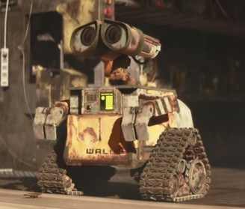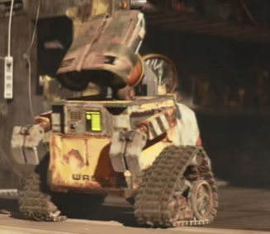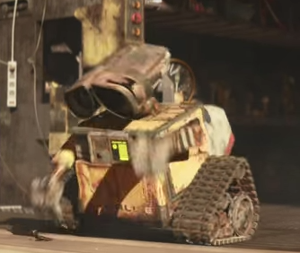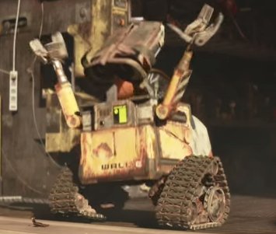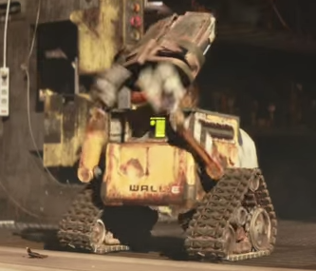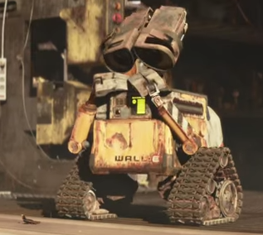
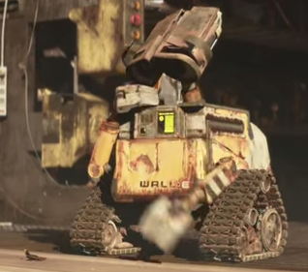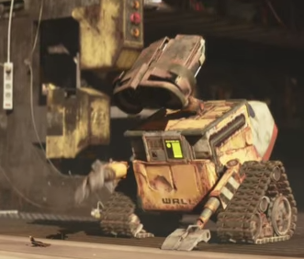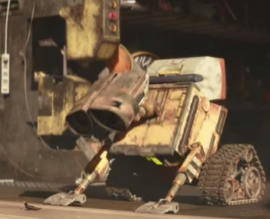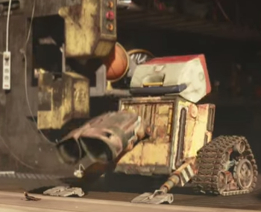
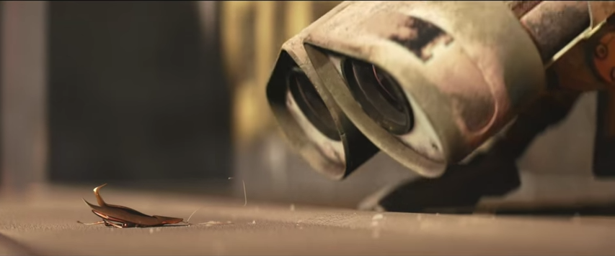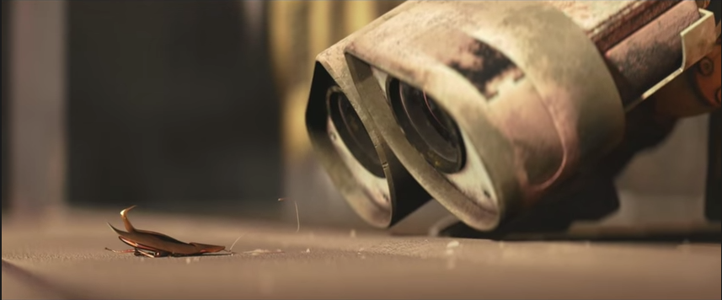
Figure 1.1 Wall-E showing surprised (frames 1-6) and concern (frames 7-12)

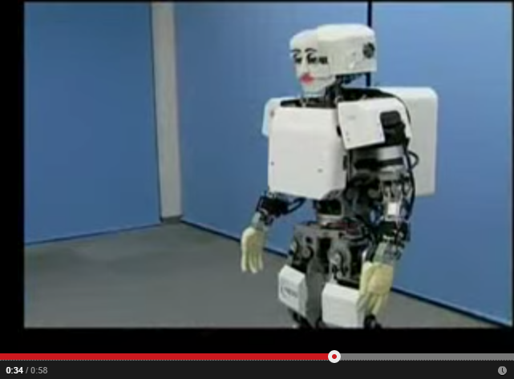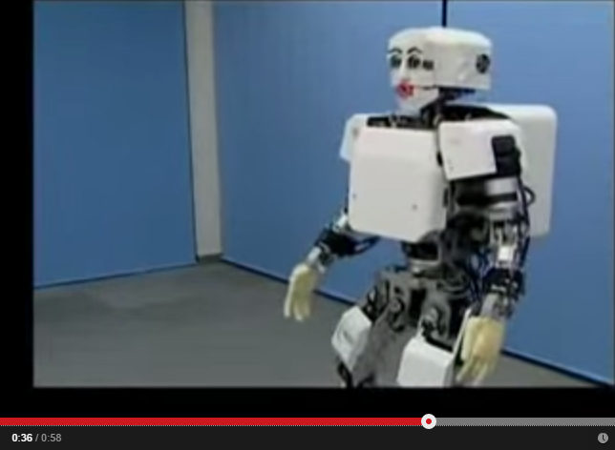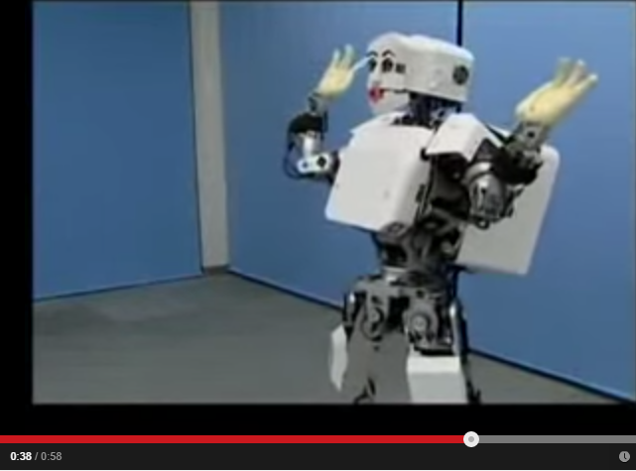
Figure 1.2 KOBIAN robot showing surprised

Comparing the surprise action of Wall-e and Kobian, there are several differences that can be observed:

Table 1. Difference of expressing "surprise" between Wall-E and KOBIAN robots
 | Wall-e | KOBIAN
Preparation/anticipation | “Compressing” (preparation) prior to the “jump back” | No preparation for “jump back” except changing stance
Movement properties re: acceleration/deceleration, speed, range of motion | Very fast, free “jump back” action. The arms were raised so quickly and high, the sudden arm-raising action is pulling the whole body upwards and back which reacts in a spring-like manner (bounced) | Very controlled, deliberate “jump back” to maintain balance. Every part of the body is moved deliberately to the final pose.
The action apex/peak | The apex pose of the “surprised” (frame 4) happens in a fraction of a second | The apex of the “surprised” is the final pose. The action stops at the apex.
The final pose | The final pose is a “taken aback” pose (hands covering imaginary mouth) | The same as the action apex
Gaze | Gaze is affixed at the source/cause of the surprise | No obvious gaze direction towards source/cause of surprise
Secondary actions | There are other tiny motions such as quickly looking around (moving the head) ‘nervously’ (secondary action) | No secondary actions.
Symmetry/Synchronicity | Asymmetry:  - the left arm starts moving followed by the right arm  - the body is tilted to one side at the apex pose | Symmetrical pose:  - The arms start moving at the same time at the same speed
Continuity | After “surprised”, immediately and seamlessly transition to the next expression of “concern” from its current pose. | After “surprised”, resets back to its home position.
Pacing | A very energetic “surprised” action (large, fast movements), followed by a smaller, slower action of “concern” | Monotonous, consistent action

The sudden, jerked reaction of Wall-e shows that he is “being surprised.” Quite possibly, safety constraints such as maintaining the robot’s balance trumps the surprise expression on KOBIAN hence it cannot perform the “surprise” as fast as desired. Perhaps there is a more culturally-motivated influence for the way KOBIAN was programmed to express these emotions (e.g. Eastern vs. Western) that they just still seem stiff to me. WHAT DO YOU EXACTLY MEAN?
There are other styles of surprise expressions too. Figure 1.3 shows a surprise expression only by the animation of the head/face from a test scene made by animator Victor Navone for the movie The Incredibles by Pixar Animation Studios [4]. In his tutorial for animating the surprise expression, Navone explained in detail the choices he made and the use of animation principles in this scene. Frames 1 through 3 shows the transition from a happy expression into the surprise take. Some notable keys are in frames 4, 6 through 9. In frame 4 is the ‘Anticipation’ – Navone called this the ‘extreme squash’ pose, with the eyes closing in ‘fast-in’ speed (i.e. fast/sudden movement). Frames 6-9 show the ‘release’ of the squash into the surprise expression. In Frame 6, there is a big change in the character’s eyebrows as they raise up high and fast. The rest of the face “lags behind” the action of the eyebrows to emulate the elasticity of the fleshy/muscle movements of the face. The raising the eyebrows also raises the eyelids but the opening of the eyes is held a frame longer to give the ‘pop’ or sudden opening in frame 7. Additionally, in frame 7, the pupils shrunk considerably to show an element of fear and surprise. WHY BOLD

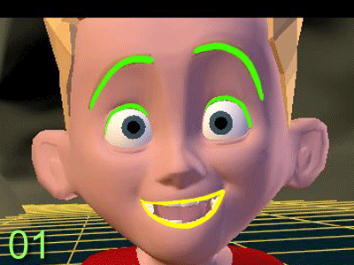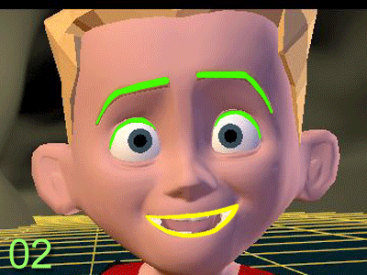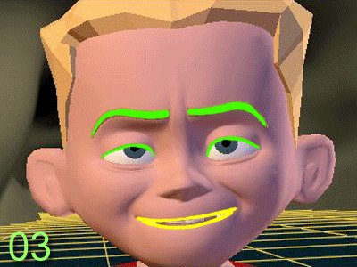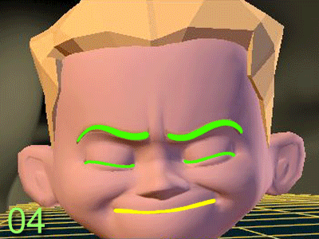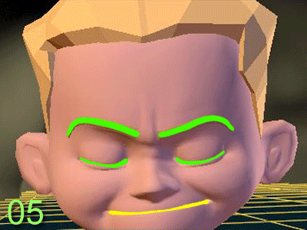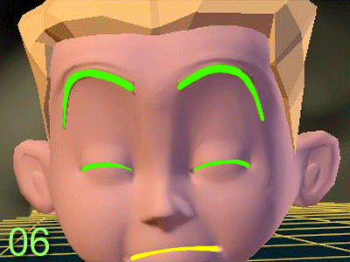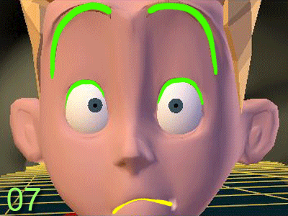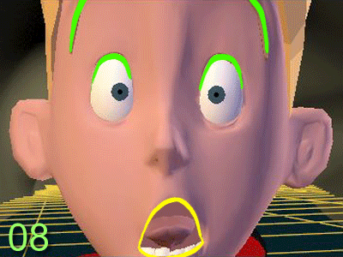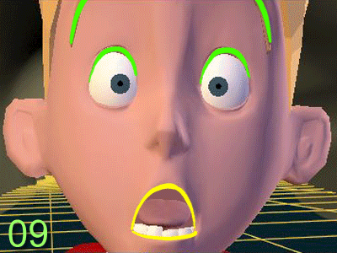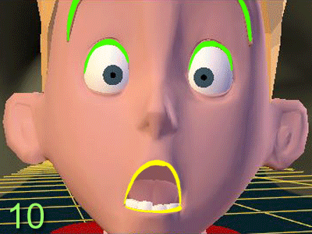
Figure 1.3 A surprise expression using frame-by-frame breakdown by Victor Navone (Pixar) [Source]

A different, yet highly stylistic type of surprise for a comic effect by the character Austin Powers is shown Figure 1.4. In this case, there is little to none anticipation at all. The first three frames show a very relaxed, calm facial expression. The facial expression starts to change on frame 4, and his body starts to tense up. The change from frame 4 to 5 and 6 are big and fast/sudden: the arms suddenly raised up (frame 5) and pressed down (frame 6), the widening of the eyes (frame 5) and wide opening of the mouth (frame 6) – this is the characteristic ‘pop’ of a surprise take. In the frames after frame 6, the character practically did not change his pose but he shows tension in the body and slightly shaking when viewed in the animated scene (it is not apparent when the frames are laid out like above).
The other things we can notice is how the character in all three examples is looking directly in the direction of the source of their surprise. We also notice that the characters are moving slightly away from the direction of the source of surprise – we call this the ‘taken aback’ action.
Three things we learned from this observation:
- the characteristic surprise ‘take’ involve the ‘pop’: sudden, big movements. In exaggerated surprise, a jump (off the ground) action may even be involved.
- the pop happens in the vertical dimension (e.g. raising of eyebrows, dropping of jaw, raising of arms and/or body) and away from the source of surprise
- there is no single ‘right’ surprise action

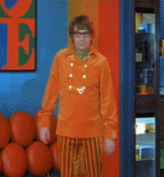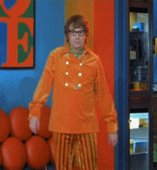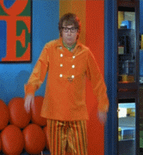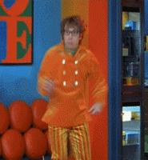
Figure 1.4 Other Surprise expressions: a), b) a sampled clip from the movie Austin Powers showing a surprise reaction of the main character.

The third point is an important one: the movement can consist of different actions with respect to hands, arms, head, torso, etc. However, the essence of the surprise ‘take’ is in the ‘pop’ (big, sudden movements) and ‘taken aback’ (moving away from source) actions. Note that surprise can be caused by something scary/threatening or pleasant to the character.
Yes, I am well aware that since Wall-e is not real, and hence subject to many manipulations and tricks to make him so expressive e.g. very many degrees of freedom, no safety constraints, no velocity or torque constraints, and so on while real-life robots have very many (electromechanical) constraints. Moreover, Wall-e’s expressions were done by professional animators who have knowledge to theatrical/performance arts. But the point is, that is the goal – that is the kind of robot we want: robots that genuinely express themselves.
Victor Navone provides this useful insight when animating non-human characters to exhibit human-like gestures and expressions [4]:

” The solution is often to not try to force human movement into a car (or robot or fish) but to try to find something unique about the limited physiology of your character that can convey the same emotion in a new way.”

Based on these observations, the questions I am trying to answer in this dissertation are:
- How can we tell a robot to execute movements that meet certain characteristics without exactly telling it how to do it (i.e. controlling the joint angles directly)?
- What does it take to have a robot that can genuinely/authentically express itself like Wall-E?
- How to create these just-in-time expressions in real time.

These questions are really difficult to answer as it requires a multidisciplinary approach. To answer these questions, let’s look at the current, real-life robots that can produce natural-looking gaits.

Motivation: Robots with natural-looking gaits
Perhaps an analogy can be drawn between the problem of “genuine expressions” in human-robot social interaction and producing natural gaits for robots: the interaction flow is the environment dynamics of the robot (i.e. water, air, land), and the expressions are the gaits produced. The “gaits” in this context are the means of travel, e.g.: walking for legged robots, flying for winged robots, and swimming for underwater robots.
There are several robots that appear to have successfully utilized gaits that are similar to their counterpart/inspiration in nature such as the robotic octopus [5], steerable flying robots called SmartBird [6], AirPenguin [7], kangaroo robot that jumps and is steerable [8], and Big Dog robot from Boston Dynamics. Some computer-animated models (e.g. biomechanically-inspired/accurate) are able to produce natural-looking gaits as well without the use of motion capture data [9] [10]. Some of these examples are shown in Figure 1.5 below.
Note that the gaits that are produced as the result of dynamic interaction of the creatures or contraptions with their environments as opposed to playback i.e. replaying from motion capture data. It seems that the robots that are most successful at producing natural actions (e.g. gaits) are the ones where the gaits are the product of a set of simple behaviors modeled as the control of a dynamical system with feedback from the environment to achieve some goals or satisfy some constraints (e.g. navigate to a target location, walk without falling).
The Big Dog robot was built by Boston Dynamics as a DARPA-funded project to develop a robust, all-terrain robot that can help carry heavy payloads [11]. To generate its gait, each leg employs a state machine that controls the phases of walking. For each leg, a gait coordination mechanism is used to control the initiation of the leg state transitions by taking into account the states of the other legs, and also communicates to the state of this particular leg to the other legs’ gait coordination mechanisms. The actuation of the leg is controlled by a PD controller as a function of the desired walking speed, the expected next state of the leg, and the estimates of the actual current state of the leg as a result of interaction with the environment. The human operator of BigDog only controls the high-level behavior such as different gaits: walk, trot, jog, stand up, squat down, starting or stopping of its engine, and steering and velocity commands. The control system of BigDog takes care of the balance and regulation of ground interaction forces to achieve the commands. And yet, by only the definition of the basic gait phases as a state machine, the robot can adapt its gait to different situations which looks natural and genuine.
Similarly, I believe to achieve that natural interaction, the robot must work with the dynamics of the interaction such that the response is a natural response to the interaction. The robot must be able to recognize its social situation, have some goals for that interaction (e.g. keep the person engaged, entertained), and consequently choose the appropriate actions for the situation and to achieve the goals.
Meanwhile, the current approaches to expressive robots tend to be too static and predictable. The simplest approach is to have a single response for a particular input. For example: always say “hello” when a face is detected. The more advanced approach is to have a set of pre-programmed responses that are appropriate for a certain input. For example: when the person says “hello, robot”, the robot can randomly choose between “waving the right hand and saying hello back”, “looking left and right, and say “who’s there?””, or “wave both left and right hands.” Many robotic toys such as iSobot, RoboSapien employ these two approaches. It is often the case for more sophisticated robots like KOBIAN, ASIMO, iCat, NAO, and Pepper to also use the same trick.
This is a very mechanistic way of responding. If the set of responses is very small, and when done repeatedly, after some time the robot quickly becomes boring to the audience. It is boring despite the mechanical design of the robot is outstanding, and the techniques used to create the different facial expressions are very creative and innovative, for sure. But somehow it is still lacking something – it still feels too static, robotic, “not organi” for lack of better terms.
The BigDog robot can reactively perform adjustments to its gait to meet the commands, yielding natural-looking gaits that works functionally and not specifically for aesthetic. Analogously, in order to have a truly socially-interactive robot, the robot may need to perceive many things that are relevant to social interaction, such as: gaze of the person, gaze of the robot itself, the person’s attitude (e.g. bored, happy), etc. Robot needs also the ability to adjust its actions to achieve some goals e.g. keep the person engaged with the robot and not leave the interaction angrily.
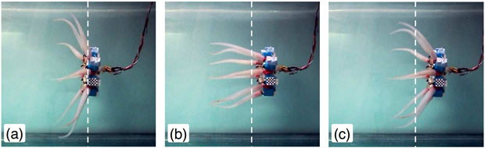
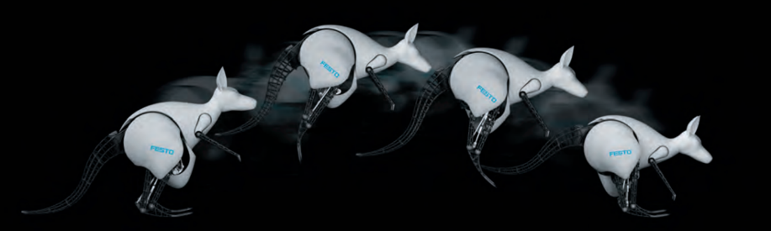
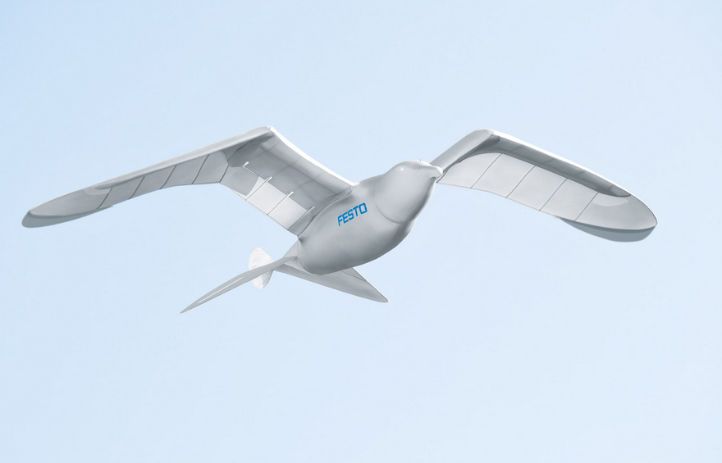
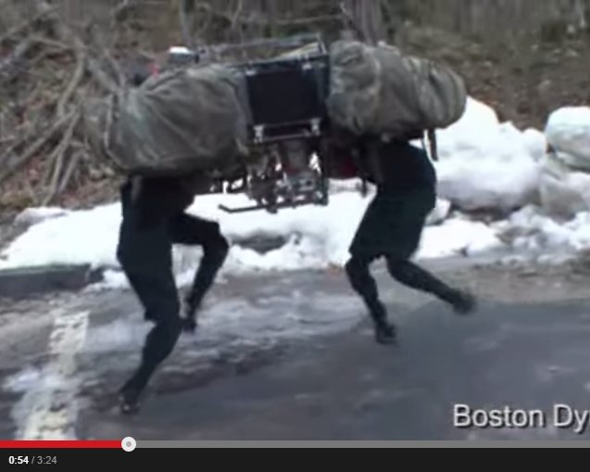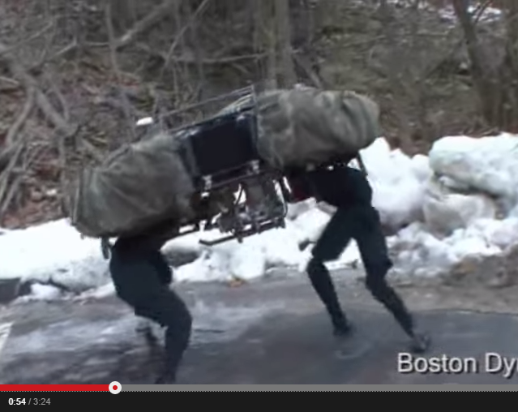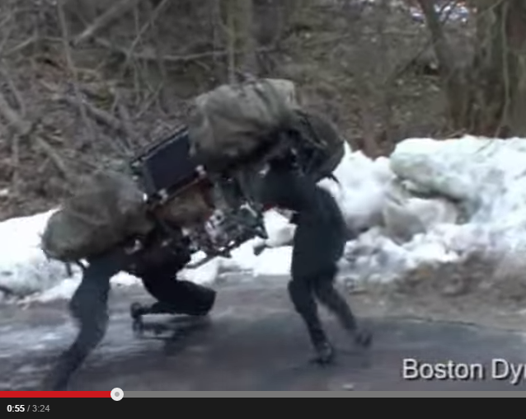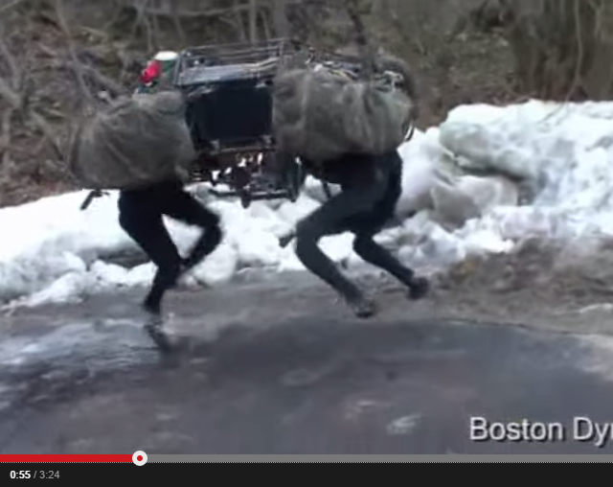
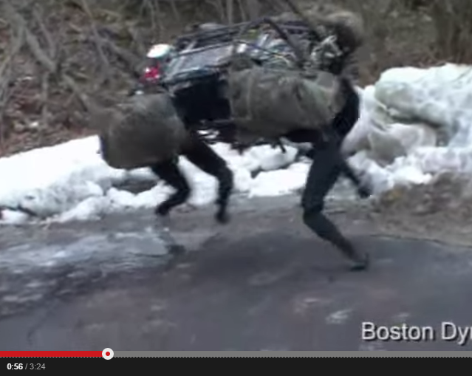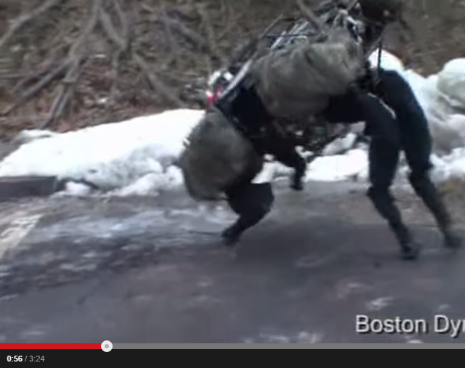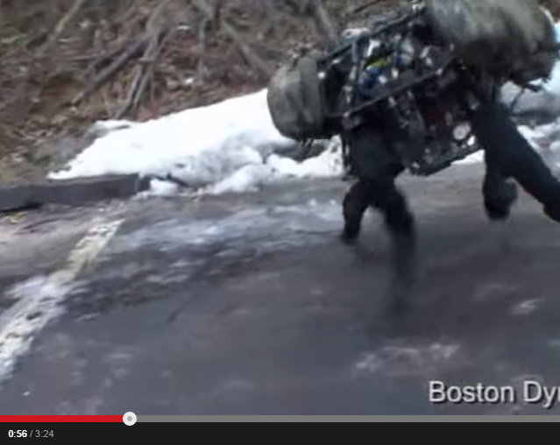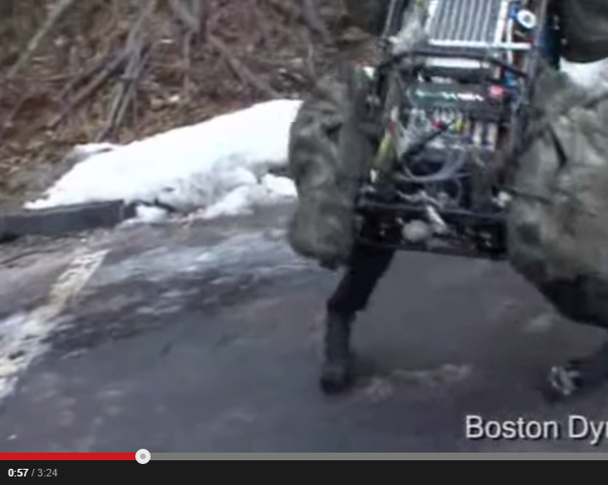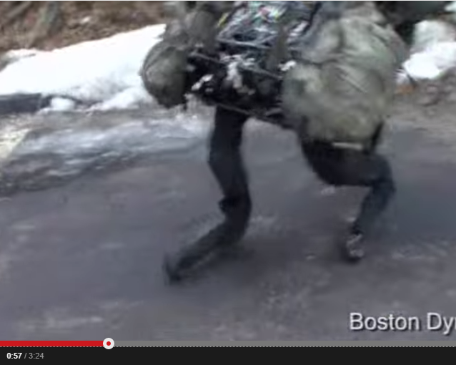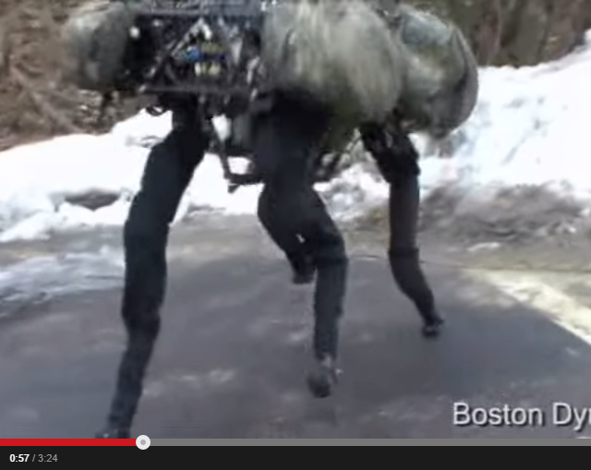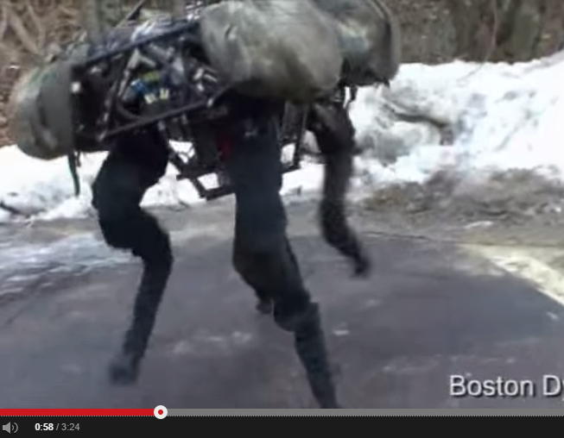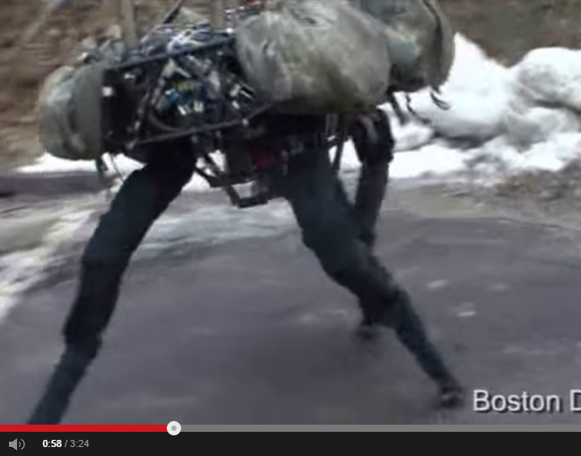
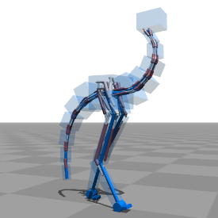
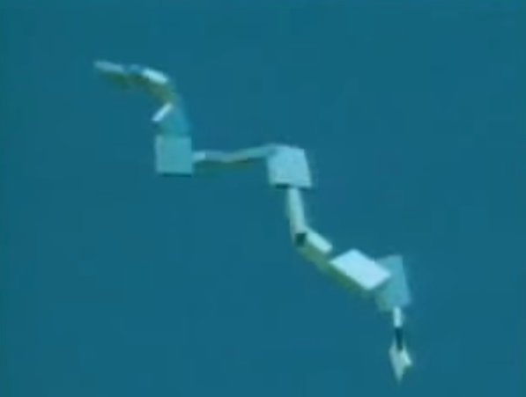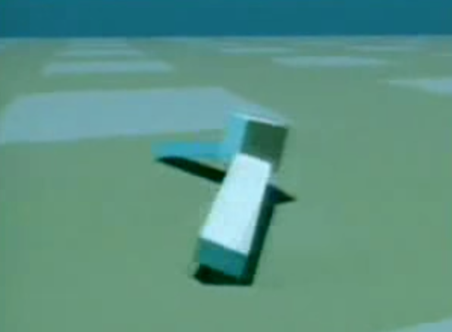
Figure 1.5 (From top to bottom) Octopus robot that propels itself using its tentacles [Source], Kangaroo robot that jumps [Source], Smartbird that flies solely by the flapping of its wings [Source], Boston Dynamics’ Big Dog robot slipping and recovering while walking on icy surface (all of these actions happen in 4 seconds) [Source], automatically-generated gait on bipedal creatures [Source] from [9], creatures which shapes and gaits are generated using GA [Source] [Karl Sims]

On the other hand, the computer animation field has made progress in the dynamic motion synthesis area to generate non-scripted motion (e.g. motion capture, or manually animated) of connected rigid bodies (e.g. humanoid, bipeds) that appears natural. It was accomplished using combination of biomechanical models, controller (e.g. PD controller), and either optimization, machine learning (ML), or evolutionary algorithms (EA). The controller is used to control the actuation of the muscle model (inverse dynamics), while the optimization algorithms, ML and EA are used to modify the controller parameters and/or to find seamless transitions between motion clips for different actions from the motion capture data. These techniques have been used in video games and the movies to generate animation, for example: collision between characters such as in a football game, movie scenes with many on-screen computer-generated figures. With respect to the work in this dissertation, I would like to leverage the method to blend/making seamless transitions between two different actions since concatenation of two actions is a major part of it.
However, I also want the generated motions to be aesthetically pleasing, almost like how actors on stage have to slightly exaggerate their movements to make the performance more convincing to the audience. In order to achieve this, I am borrowing concepts from art such as the Disney Animation Principles and Laban Movement Analysis to create different dynamics in the movements of the robot.
With regards to dynamic motion synthesis for robots, there are some major differences between how the motion is realized on the robot and rendered on screen. For example: in computer animation using biomechanical model, the program can directly produce the necessary and exact amount of torque to actuate the muscle model, while on real physical robots, this control is not trivial. Moreover, applying artistic concepts such as animation principles to robot motion is difficult. Traditionally, animators iteratively fine-tune their animation down to each frame, where each frame lasts for 1/24th of a second (24 frames per second animation is often the standard for television). In synthesizing motion for robots, this is near impossible due to constraints of the hardware (e.g. signal propagation delays, servo resolution). In chapter 7, I present a method to incorporate the concepts from art to motion data generation, which is another contribution of this dissertation.

I believe, that in order to enhance robot interaction experience, the following elements are needed:
- A method that is easy to use to quickly program variations of behaviors
- The ability to allow the generated behaviors to dynamically interact with the robot's environment
- Employing concepts from art and animation for natural-looking movements
- The ability to learn new behaviors and generate complex and/or new responses by combining and manipulating known responses and make new ones

Summary
In this chapter, the topic of this dissertation, the specific problem areas, and the approach to address those areas have been introduced. This dissertation focuses on the dynamic generation of robot motion, particularly for non-verbal communication modalities by borrowing some techniques from computer animation, and traditional animation.

Structure of the Dissertation
The rest of this dissertation proposal is organized as follows. In Chapter 2 I give a brief overview of the proposed methodology and contributions of this dissertation: the language REBeL and the Behavior Expressions. They are further explained in greater detail in Chapters 7 through 12. Chapters 3 through 6 cover the previous/related works, and the basic theories behind the proposed methodology.
- Chapter Two: REBeL: A Language for Social Robot Behaviors
- Chapter Three: Related Works
- Chapter Four: Anthropomorphism, and Gestures
- Chapter Five: Automata Theory
- Chapter Six: Regular Expression
- Chapter Seven: Behavior Expressions
- Chapter Eight: Robot Behavior Language (REBeL)
- Chapter Nine: The REBeL System
- Chapter Ten: From Traditional Animation to Robot Animation
- Chapter Eleven: Interactive Gene Expression Programming
- Chapter Twelve: Experiments and Evaluations
- Chapter Thirteen: Timelines and Milestones

REBeL: A Language for Social Robot Behaviors
To address all the elements mentioned above, I propose a new language for programming robot behaviors.

A Taste of REBeL
I propose a language called REBeL (Robot Expressive Behavior Language) to program robot behaviors. REBeL uses an expression called Behavior Expression (BE) to program a set of behaviors. A single BE can represent a variety of behaviors, i.e. a set of behaviors. The syntax for BE is based on regular expression and regular languages, but we added probabilistic and other algebraic operations such as intersection to manipulate BEs. BE can be used to express both input behaviors and output behaviors of the robot. In some cases, a BE can be programmed using input-output pairs as its variables and literals. Since BE is based on regular expressions hence can be translated to automata model, the robot's behavior or interaction between multiple robots can be further analyzed e.g. reachability analysis, liveness property, safety property, and perhaps more importantly, finding interesting behaviors. We shall see more of these analyses in chapter 7.
A BE defines a robot’s behavior, for example: greeting, dancing, obstacle avoiding, light following, etc. Thus, a behavior consists of a sequence of actions arranged in some order. The simplest case is a behavior of a single action. The simplest action is “do nothing”. But for the sake of making our discussion interesting, let’s use actions that actually do something. In the example below, a Greeting behavior of a robot (Greeting_{robot}) consists of actions “wave_right_hand” and “say_hello” which if done repeatedly, their actual order of execution may differ as defined by the BE. So, to execute an output behavior from a BE, the BE must be evaluated and only then will the output behavior be generated.
In formal language terms, the actions are analogous to the characters in an alphabet. In this system, the alphabet of basic actions ∑ is defined, pre-programmed, and later new basic actions can be added. Basic actions are simple actions (i.e. output) of the robot such as “say_hello”, “wave_right_hand”, “go forward”, “turn left”, etc. “Basic actions” can also be inputs to the robot when the BE is defined for input behavior such as Greeting_{person}. Some behaviors may be also defined as combinations of input and output behaviors , for example: an obstacle-avoiding behavior requires the robot to detect any obstacles in its path (using some sensors). If an obstacle is detected, then the robot must perform an avoidance maneuver, otherwise keep going in the current direction.
There are more to BE which will be discussed below. But to illustrate the usage of BE, the following are some examples in the context of greeting interaction between a person and the robot:
- Greeting_{robot} = wave_right_hand • (wave_right_hand + say_hello)*
- Greeting_{person} = say_hello•say_robot_name?•(ask_how_are_you + say_good_morning)
- Interact = Greeting_{person}•Greeting_{robot} + Greeting_{robot}•(Greeting_{person}•Talk_About_the_weather_{robot} + $\overline{Greeting_{person}}•$Wander_{robot})
The meaning of the symbols in the BEs above are similar to those in Regular Expressions with some additional symbols where: • means concatenation, + means union or option, ? means zero or one time execution, * means zero or more times repetition, $\overline{x}$ (bar) means complement, and parentheses group the evaluations of the expressions.
The Greeting_{robot} shows the EE for Greeting behavior for a robot; the robot can perform its greeting by:
- waving its right hand at least once, or
- waving its right hand at least once and may be followed or interleaved with saying “hello”.
The Greeting_{person} is the greeting the robot can expect from a person, which may be in the form:
- The person say hello followed by saying the robot’s name (at most once) followed by asking the robot “how are you?” OR
- The person say hello followed by saying the robot’s name (at most once) followed by saying “good morning”
The Interact EE encode some possible interaction scenarios between a person and the robot:
- If the person initiates greeting, then the robot should respond by a greeting (Greeting_{robot})
- If the robot initiates the greeting, then if the person respond with a greeting (defined in Greeting_{person}), the robot may start to talk about the weather (e.g. “nice weather, huh?”), otherwise if the robot does not receive any recognized greeting from the person ($\overline{Greeting_{person}}$) the robot may go into wandering mode (Wander)
These three behaviors are actually the output of the robot (we refer as ‘motion’), the input (referred as ‘perception’), and input-output system (we simply call as ‘behavior’). The distinction is that motions do not consider feedback, perception does not necessarily cause motion, while behavior defines the interactions and mappings between perception and motion.
I believe REBeL and BE will enhance robot interaction experience in the following ways:
A method that is easy to use to quickly program variations of behaviors. Variation of behavior helps avoid the monotonicity of interaction by reducing the likelihood of repeating the same behavior in a short period of time. There are some indications that people’s perception of anthropomorphism of robots can decay over time, particularly when the behaviors become repetitive [12]. However, it is difficult to implement a robot without this weakness, mainly because it is time-consuming to build a large database of behaviors and program each behavior variation individually. Using BE, a large (and potentially infinite) set of behaviors can be programmed using a single expression. This is accomplished by utilizing the * operator (i.e. Kleene Star operator in Regular Expression), its probabilistic variants and other similar new operators.
By allowing probabilistic expression in BE, the robot can be programmed to have certain tendencies toward a particular behavior variation. For example: the Greeting_{robot} behavior can be modified so that the robot will wave its right hand at least once followed by another wave with 1/3 probability and say hello with 2/3 probability.
Greeting_{robot} = wave_right_hand • (wave_right_hand +_{1/3} say_hello)*
The operator +_{1/3} indicates that the left argument has 1/3 probability and the right argument has 1 – 1/3 = 2/3 probability. This is a slightly different interpretation from classical probabilistic automata [ref Rabin?] where the symbols in the expression are the input to the automata and thus the probability is associated with the probability the automata transition to several different states under a given input symbol. Here, the symbols (i.e. action) in the expression are states, and the “input” can be thought as a symbol denoting the completion of those actions. Thus, there are two kinds of probability specification: probability assigned to input symbols and probability assigned to operators. The former has the same interpretation as in classical probabilistic automata, while the latter is interpreted as the probability of executing one out of a set of possible next actions. This is explained more in Chapter 7 on BE.

The ability to allow the generated behaviors to dynamically interact with the robot's environment. Because behaviors also include perceptions/inputs for the robot (when available on the robot), BEs can be programmed with interaction with the robot’s environment in mind. Another way to allow interaction is to have a separate behavior (again, defined as a BE) that runs parallel with the current selected behavior. For example: the selected behavior is to go forward, and the secondary behavior is an obstacle avoidance behavior. Therefore, when the robot is moving forward, and there is an obstacle detected in front of the robot, the avoidance behavior can override the forward behavior. The policing of parallel behaviors is discussed in more detail in Chapter 8.

Borrowing from traditional animation concepts, Rhythm and Texture can be used to regulate the generated motions and behaviors to keep the interaction interesting [13]. Navone defines rhythm and texture for movements as follows:
- Rhythm: how the actions or "beats" in a shot are spaced out over the length of a scene. You might also call this "tempo". Unlike with music, good animation has an inconsistent rhythm, making it less predictable.
- Texture: the variations of timing and poses in your shot. Big and little actions, slow and fast timing, flurries of action and holds. A shot in which all the actions are the same size, have the same timing, and occur in an even rhythm has no texture.
Another possible way to make the robot gesticulation interesting is to keep the same gesture/movements but vary the rhythm and texture, and not too focused on spatial variation (e.g. movement in different directions).
With the Behavior Expression, we will be able to perform some reachability analysis, i.e. analyze the feasibility of behaviors by expressing those behaviors in BE and performing algebraic operations between them. For example: suppose the robot is going to perform a sequence of movements that is akin to dancing Waltz. Since Waltz is a traveling dance, we must make sure that the robot will not run into walls or its surroundings. We can then do an intersection operation between the sequence for the “Waltz” dance and a set of sequences of travelling steps that are within the confines of the walls (safe and does not collide with the walls so that only the sequence of Waltz that is within the area of the confined travel is selected/performed and not beyond. Thus intersection operation can be considered as applying constraints to the robot.

The ability to learn new behaviors can be accomplished by generating new sequences of actions from a set of basic actions from time to time. However, these new behaviors (either generated automatically by some algorithm or by hand) need to be evaluated whether or not they would be useful or interesting. For example, if a new interaction behavior is generated, then reinforcement learning type may be appropriate. The evaluation then requires feedback from a person (or persons) to provide reward to the robot to determine whether to ‘keep’ the new behavior or discard it. Otherwise, because EE relies on correct/valid algebraic expressions, we can use Gene Expression Programming since it has been shown to be able to generate new expressions that are valid [14]. Therefore the approach I use to leverage feedback from people is called Interactive Gene Expression Programming. In a nutshell, IGEP is a kind of genetic expression programming where the fitness of each individual is evaluated by a person instead of using a computable fitness function. To avoid pure subjectivity, the fitness can be evaluated using some scoring system such as the ELO Rating system [15].
Thomaz and Breazeal proposed an interactive reinforcement learning approach using a modified Q-Learning method to involve human guidance and human feedback [16]. The idea is to teach a robot for some tasks using the same way humans teach other humans. Their robot performs a sequence of actions to accomplish a certain task, and a human user can give the robot feedback “that was good” or “that was bad”. Additionally, they implemented UNDO behavior which corresponds to performing an ‘opposite’ action, for example: UNDO(Pick-up[object]) = Put-down[object], UNDO(GO[direction]) = GO[-direction], and so forth. When the feedback is “bad”, and if the action can be undone, then the last action in the sequence will be undone.

Allow programming behaviors that are rule-based such as human social interaction norms. Some rudimentary understanding of human social interaction norms is necessary to make the interaction between the human and the robot becomes more natural. Breazeal demonstrated a type of interaction where a robot can learn new things only using human communication techniques as opposed to artificial techniques like in machine learning [17]. For example, the person can introduce the robot to a new object it never seen before either by holding the object in his hand and present it in front of the robot, or pointing towards the object (e.g. on a table). The robot, in turn, can turn and look in the direction where the person is looking by estimating his gaze based on his head orientation. To emulate the behavior of a person learning, the robot will look in the direction of the thing it is trying to learn, then look back at the person to look for signs of affirmation (positive or negative feedback). Moreover, focus/gaze projects require some kind of attention or intention and thus feedback to the person of what the robot is “thinking”. Here, providing the robot with the ability to recognize social situations hence being able to select appropriate actions might be beneficial. Wagner and Arkin [18] introduced a method to do this for robots, using the “interdependency theory” from social sciences.
Most interaction behaviors consist of a sequence of actions. For example: when greeting someone, one would first catch the other person’s attention either by calling his/her name, waving the arm, and/or establishing eye contact. Once the other person gives his/her attention, then one could proceed by saying “hello”, “good morning” or other verbal greeting. If one would introduce himself to the other person, he also extend his hand to offer a handshake, and say “Allow me to introduce myself, my name is …” and so forth. This sequence is one of the many acceptable ways to greet and introduce oneself to another person. Other sequences might not work as well, for example: first saying “Allow me to introduce myself, my name is …,” followed by waving the arm, and offer the hand for a handshake. This latter sequence is not the norm in most cultures I believe, and would give a very awkward effect to the person that “greeting” is directed to. Such interaction dynamics can be programmed using BE as we have seen in the example above with the “interact” expression, and the BE user have the freedom to conform or break from the norm. Having a Permutation operator in our language will allow to create many funny behaviors of crazy robots similar to the above example.
There are many other ways to perform a gestural behavior like greeting above, and there needs to be a kind of dynamics in the way the sequence of greeting actions are executed to make the robot more appealing and convincing. The term “dynamic” here does not mean in terms of “dynamical systems” (although there is some relationship to it), but instead one that conveys some meaning which could be emotional, habitual, or character-related. It also distinguishes between a mechanical vs. organic look and feel of the greeting action itself. For example: when waving the hand to hail someone, there are different heights the hand can be raised to, and different speed of raising the hand. When the hand is only raised a little bit, it often indicates shyness, while raising the hand high indicates confidence. When combined the dimension of speed to the hand-waving action, now the meaning can also include energetic meanings such as: lazy and excited.

Table 2 Combination of Height and Speed of raising hand for hand waving creates different meanings
Speed  Height | Slow | Fast
Low | Shy, lazy | Shy but excited
High | Unsure?? | Excited, confident

Furthermore, I propose that the robots must have the ability of being animated: we must make robots break away from the mechanistic movements and have a wider range of expressions in their movements in order to make more engaging and effective human-robot interaction. By “animated”, I mean the robot can perform simultaneous movements of its body parts, and perform varying types of movement phrasing (see below). To accomplish this goal, I employ concepts from art and traditional animation under the mechanical and electrical constraints of the robot. Making a robot animated involves quantitative measures such as range of motion, number of degrees of freedom, and also qualitative measures such as appeal.
In LMA terms, these “dynamic” quality of movements are explained through its “Phrasing” concept. Bishko defines phrasing of LMA as “the transitions of Effort qualities within a movement sequence” [ref Bishko], in which there are five classes of phrasing:
- Even: continuous, no change of Effort qualities
- Increasing: increase in intensity, such as accelerating
- Decreasing: decrease in intensity, such as decelerating
- Accented: consists of a series of accents (?) I DO NOT WANT TO SEE ANY QUESTION MARKS, THE TEXT MUST BE COMPLETELY READY
- Vibratory: “a series of sudden, vibrating movements”
- Resilient: “series of rebounding, resilient movements” such as rubber ball (?)

One of the main goal in traditional animation is to show intent and what the character is thinking by their movements [19], and I believe intent is the element that is missing from a lot of social robots today. There are many different elements in a person that convey intent: facial expressions, the way the person moves, the way the person talks, the little movements like tapping the foot, body language, poses, etc. While these expressions are easy to create on an animated virtual characters like Wall-E, they are very difficult to do on real, physical robots due to hardware limitations, complexity of control, and maintaining safety requirements.

A Lesson or Two from Storytelling and Animation
Andrew Stanton presented a few key points on good storytelling during his talk at TED Talk [20]:
“Make them [the audience] care” – Andrew Stanton on good storytelling
Stanton also suggested that the audience wants to understand the story by themselves – they do not want the narrator or storyteller telling them everything about the story:
“The audience actually wants to work for their meal. They just don’t want to know that they’re doing that.”
“It’s the well-organized absence of information that draws us in. … The unifying theory of 2+2”
“Any well-drawn character has a ‘spine’. The idea that the character has an inner motor; a dominant, unconscious goal that they’re striving for – it’s an itch that they can’t scratch.”
I believe in order to have a really engaging robot, we have to have a story for the robot – a character. Then the user, the person, is the audience, and they will have to figure out what is the story and character of this robot.
Glen Keane is one of the most famous of Disney animators, wrote this note regarding “Anticipation” in animation [21]
“Anticipation – A Key ingredient
Definition: (1) look forward to, expect (2) realize in advance; foresee, foretaste.
It will cause audience to expect and look forward to the payoff.
Milk the moment. As long as you have not released the tension the audience is with you. Don’t waste the moment but milk it for all it’s worth.”
We want to have these abilities for our robot and engage the audience. Is it possible using REBeL?
In this sense, BEs become more than just describing the robot’s behavior. Ultimately, REBeL becomes the language to tell the story and character of the robot to some extent. For example, assume a robot that is always attracted (approach??) to pictures of birds, planes, and other flying objects. Then for some time the robot will stand in front of the picture and spread its arms. Ultimately – perhaps – the audience may eventually perceive that the robot have this yearning to be able to fly.

To express dynamic and natural movements on the robot, I am using inspiration from concepts from art and animation, particularly Laban Movement Analysis (LMA) and Disney’s Animation Principles (DAP). Particularly, parameterization of interpolation and motion data processing using LMA Effort category, the principles of Anticipation, Secondary Action, Follow Through and Overlapping actions, and Exaggeration from DAP. These parameters will be explained in more detail in the Chapter 4, but in this introduction, we provide a quick overview of this concept of an association between movements and intent.
LMA provides Effort category to describe movement expressed in terms of energy expenditures. The Effort category consists of four parameters: Weight, Space, Time, and Flow. Each of these parameters is valued between [-1, 1] to represent their extremes;
- Weight: Strong vs. Light,
- Space: Direct vs. Indirect,
- Time: Sudden vs. Sustained, and
- Flow: Free vs. Bound.
A combination of two Effort parameters creates an Effort states (inner attitudes) and three parameters create Effort drives. These Effort states and drives are associated with terms like “awake”, “dream”, “near”, “remote”, “stable” and “mobile” for states, and “action”, “spell”, “passion”, and “vision” for drives. LMA has been used to teach performers (actors, dancers) to become more aware of their own natural or habitual movements. By understanding the elements of movements using LMA parameters and terminologies, the performers can then change or learn new movements, which may at first come as unnatural for them but enhances their acting or dancing performance [22].
DAP provides principles that are very useful for showmanship, which are a key component in theatrical performance. For example: Anticipation is the concept of doing preparatory action prior to the main action, such as when a person first glancing only with the eyes at an object before picking it up. This kind of action indicates the intent of the person to the audience/observer. Another example is the crouching or bending at the knees prior to a jump. The former example prepares the audience by showing that the person is focusing on the object which cause the audience to expect the person to interact with the object in some way; in this case, picking it up. The latter is preparation as physical necessity; crouching recoils the body to build potential energy to power the jump. By crouching first, the audience will not have a jarring experience as opposed when the person suddenly jumps without warning. Another useful DAP concept is the secondary action principle, which says that in most people (or creatures) there are times where another “minor” (secondary) action is executed alongside a main action. For example, while standing waiting, a person may also scratch their head, or tap their foot. These kinds of actions help give a sense of ‘organic’ behavior to robots. Blinking and gazing, breathing and tapping of the foot are simple useful examples.
These parameters are used to characterize the execution of a particular action or sequence of actions. There are many more elements that contribute to a more convincing interactive robot. But to keep this introduction section short, the details of the usage of the other LMA parameters and DAP principles will be explained in Chapter # (on implementation).
Unlike LMA Effort which parameters can be modified using a range of values, DAP principles are harder to implement in the same manner. Instead, I apply DAP principles when the sequence of actions are about to be executed. A pre-processing program buffers a sequence of actions with the desired expression in LMA Effort parameter values. Anticipation is applied for every action in the sequence and the transition between actions are smoothed out using the spline interpolation. The resulting motion data is then analyzed to determine how it is best executed given the limitations of the hardware i.e. servo controller board, servo specifications, etc. The analysis is done either manually by simulating the motion, seeing the results and determining whether to keep the motion or not, or let the system perform the default translation to motor commands determined by previous experiments.

Other Useful Components for Socially-interesting Robot
“Socially-interesting robot” refers to a robot that is void of the Uncanny Valley, which attracts people to interact with or observe it, where people can enjoy interacting with it for an extended period without getting bored, and looking forward to interact/observe it again. Give a definition of Uncanny Valley and refer to the paper that introduced it. The robot should have some degree of social interaction capabilities but not necessarily have the ‘complete’ set of capabilities, i.e. as a person does, with appealing physical features and/or interesting behaviors. In a sense, I envision a robot that behaviors are analogous to a popular video game where people keep coming back to play.
Anthropomorphism is the set of features of an object that a person can associate to human physical or behavioral traits [23]. For example: a computer screen is often associated with a “face” and sometimes “head”. The headlights on a car are often associated as the “eyes”, and the grille as the “mouth” of the car. The spout of a teapot is associated as its “nose” (this is more association with an elephant’s trunk, but you get the idea). It is difficult to anthropomorphize basic shapes like a torus or a cone, especially when they don’t have any other features on them. Once two dots are placed side-by-side however, then most people can immediately associate them as “eyes”. Figure 1.4 shows some examples of (perhaps) unintentional anthropomorphism of everyday items that looks like faces.
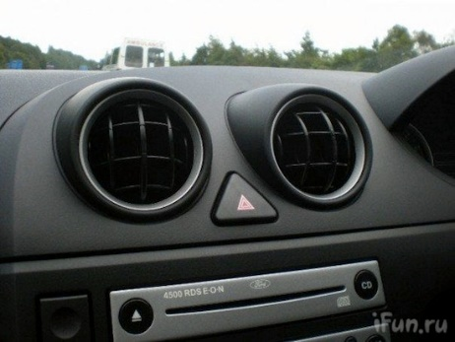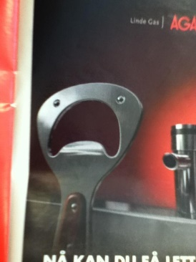
Figure 2.1 Everyday objects that look like faces (left to right): a doorway, dashboard of a car, power outlet, bottle opener.

The examples in Figure 2.1 show that simple features are enough for us to anthropomorphize inanimate objects.
Anthropomorphism helps set expectations to the human user, particularly what level of interaction he/she can expect out of the robot [24]. Most of the time, anthropomorphic robots are expected to understand spoken natural language and gestures, and also respond using speech and gestures. To me, at least, these objects are more interesting than an android-type robot which tries to use realistic human faces (with hair, teeth, lips, skin-like materials), i.e. humanoid. I believe that this is also the approach Breazeal took with her robot Kismet [25] and more recently, Jibo [26]. Unlike Kismet, Jibo’s physical anthropomorphism is shown in its form as a neck/head robot with a round head, with only a screen as its face, and no other facial features like a physical eye, mouth, lips, ears, etc. The physical features are designed to make Jibo appear friendly and non-assuming, but its main selling point is its ability to respond anthropomorphically. For example: according to the promotional video, when Jibo’s owner walks into the room, it orients its face towards the owner, and reports that there are voice mails. The owner then asks Jibo to order some food (Jibo is connected to the internet and able to submit orders online).
I believe that socially-interactive robots just need to be necessarily anthropomorphic, and avoid pretending to be human like an android. Instead, think of the puppets in The Muppet Show, Sesame Street, and Wall-E where they only remotely humanoid but can act with a believable personality. This view is also shared by other social robotics researchers [24].Therefore, the robots I am using to demonstrate the concepts of REBeL and BE is necessarily anthropomorphic. There are two robots in my experiments: the MCECS guide robot Jeeves, and Pepe, a small mobile robot with a 5 DOF arm which acts both as a manipulator and its head/face. Unlike Pepe, Jeeves has a more humanoid upper body form with a pair of arms, articulated torso, neck, and head. Jeeves also has a mobile base.
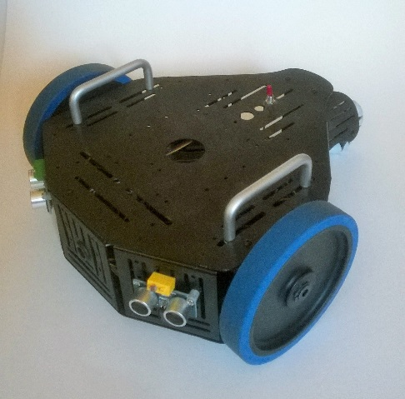
Figure 1.5. Pepe robot based on Parallax’s Stingray platform

Spontaneity. Some definitions of “spontaneous” (from google.com):
- “performed or occurring as a result of a sudden inner impulse or inclination and without premeditation or external stimulus.”
- “(of a person) having an open, natural, and uninhibited manner.”
For example: when listening to a catchy music that you like, you might start to “dance” to the music, either by tapping the foot, bobbing the head, or pulsing your whole body to the beat/rhythm. The spontaneity referred here is related to the principle of secondary action in Disney Animation Principles (which will be elaborated in Chapter 4). In short, spontaneous actions are not the main action. In the example, tapping the foot to the music is not the main action. The person may be sitting at a desk typing his PhD dissertation (the main action) while listening to some music, and thus the foot-tapping is just a secondary action.
Reactive architectures (e.g. Subsumption Architecture [27]) can sometimes be understood as being spontaneous, for example: the navigation layer outputs a command to the motor control layer (lowest level layer) for the robot to go to a target location. But along the way, if the obstacle-avoidance layer will detect an obstacle in the robot’s path, it can subsume the navigation command and temporarily issue a command to avoid the obstacle. In this sense, the robot can be said as “spontaneously” avoiding the obstacle.
Spontaneity must be expressed clearly, but cannot be entirely random and must not endanger people and the robot itself. For example: if the robot is currently interacting with a person, the robot must not suddenly move towards the person running into him, or suddenly moving towards the wall. The robot can automatically mimic the pose or posture of the person if the interaction is doing well (both the person and the robot are “happy”).
Some representation of the internal state of the robot and input from environment regulates the choices of actions the robot takes. The internal dynamics of the robot can also be expressed using Behavior Expressions. For example: happy = smile_{person} (if the person is smiling, then the robot is happy). We can also extend to some degree of internal state so by statistical measurement based on the perceived input over a period of time vs. the language of happy and neutral, we can influence the state of the robot. For example: happy = (smile_{person} + laugh_{person} + looking_at_me_{person})*, also neutral = (looking_at_me_{person} + talking_at_me_{person})*. After 5 time steps suppose the robot perceived: looking_at_me_{person}talking_at_me_{person}smile_{person}looking_at_me_{person}smile_{person} then we can match this string with some samples of 5-character words from the language of happy and neutral. The match can be rated by the number of matching characters, and the partially-matching sequences.

How Actions from BEs are Executed
Once we are able to express the behavior of the robot in BE, the obvious next question is: how will the robot execute those actions?
The ‘how’ of executing the actions expressed by BEs is part of the main contribution of this work. I approached this from both automata theory and traditional animation points of view. Since BE is in the class of regular languages, due to Kleene’s Theorem, it is subject to analysis in automata theory such as reachability analysis. Even more interesting is to analyze the dynamics of multiple interacting automata. For example: one robot which behaviors are defined as a “gentleman”, while another robot’s behaviors are defined as “angry man”. Since both the “gentleman” and “angry man” behaviors are expressed by BEs, hence automata, the dynamics of the two agents can be observed by taking a product of the two automata using methods from classical automata theory.
To execute the behavior defined by an BE, the first step is to generate a sequence of actions from the BE. In other words: generate a word that is in the language of the BE. A generator called Probabilistic Event Generator (PEG) is used for this. The generation of the word is in general probabilistic, particularly when the union (+), Kleene Star (*), and probabilistic operators are used in the expression, except when the BE only consists of a single action or only concatenation (•) operators.
Once a sequence is generated from the BE by the generator, the sequence must first be analyzed. This is because the sequence consists of both input and action symbols which determines the kind of transition to be used. If it is an input symbol, then the transition occurs once that input is satisfied (also depends if it is a probabilistic input), or after a timeout period (i.e. not receiving the input after some period). If it is an action symbol, then the transition occurs when the action is completed, or terminated prematurely by some interrupt flag. We call the subsystem that handles all this work the Kinematic Description Framework.
Multiple behaviors can be triggered at the same time. If there are conflicts or resource contention, then the arbitration system takes over and decides which behavior to execute. Some behaviors may have priority levels. If the contending behaviors are at the same level, then the arbitration looks for other factors that may “tip the balance/scale” to choose one behavior over another. If none exists, then the system randomly chooses between the behaviors with some probability. Some rules can be set such as: “a secondary action may not be executed if it requires use of a resource that is currently being used in a main action.” For example: the robot cannot execute the secondary action of scratching its head with its right hand while it is performing the main action of hand waving also with the right hand. Or if possible, merge them into one behavior (if they don’t cancel each other, e.g. turning left and turning right at the same time.
Basic actions that describe gestures are described as a sequence of poses. Poses are a particular configuration (joint angle positions) of the robot’s body and are analogous to keyframes in animation. They are inflection points in the movement, in other words usually the point in time where the movement changes direction. In traditional hand-drawn animation, a lead animator usually only draws the keyframes and another person ‘fills in’ the missing frames between the keyframes. For example, in a 24 frames per second animation, the lead animator may draw three keyframes for a raising hand on a person: one keyframe where the hand is on the side of the person, a second keyframe when hand is raised, the third where the hand is returned to the person’s side. Suppose the action should last for three seconds, then there are (24 x 3) – 3 = 39 more frames needed to be drawn (in practice, there could be less and still be acceptable). These missing frames are called in-between frames, and they are crucial to the dynamics of the action. In computer animation tools such as Adobe Flash, Autodesk Maya, animation is created by first defining the keyframes, and then the user can define the interpolation between those keyframes. The in-between/interpolation frames is detrimental to make the motion expressive, such as showing emotion, energy. For example: if the hand is moved with very small increments between the first and second keyframes, then the hand will appear to move very slowly, and the movement may be interpreted as ‘cautious’ or ‘afraid’ hand-raising. In contrast, if the hand is moved with large increment, the movement appears to move fast, as if ‘energetic’ or ‘excited’. This is what we call motion dynamics – variation of movement properties (speed, acceleration, range of motion).
Similarly, when a behavior is a gesture which consists of a sequence of basic actions (i.e. movements), the sequence generated by PEG is only the sequence of poses (i.e. keyframes). The second step is to interpolate between these poses to produce motion dynamics. Thus motion data can be thought of and hence processed as a signal. The simplest method of interpolation is linear interpolation where in-between points are generated between two known data points with equal distance between them. When motion data is interpolated using linear interpolation, the resulting motion have constant speed, zero acceleration, and appears monotonous, and mechanical.
However, the movements I am interested in is not of this kind unless it is deliberate, or for specific effect. A gestural movement starts with acceleration, stops with deceleration and smoothly transition to the next action. For this kind of effect, polynomial-based interpolation methods are more appropriate, such as Bezier and Hermite splines. In my system I use the Kochanek-Bartels spline interpolation which is a variation of cubic Hermite spline. The KB interpolation provides three parameters: tension, bias, and continuity. These parameters allow greater control over the interpolation. When all parameters are set to zero, then KB interpolation is equivalent to Catmull-Rom spine [28]. KB spline interpolation has been widely used in computer animation [29], and popular tools such as Adobe Flash, and Autodesk Maya.
Figure 1.6 shows some example of the Kochanek-Bartels (KB) interpolation method. The example uses eight data points arranged in some order. When the points are interpolated using KB method, and setting the continuity, tension, and bias parameters to zero, the result is the curve in the middle column under the “0” label (notice that the three curves are identical). Each row in Figure 1.6 shows the effects of setting the values between -1 to 1 for the continuity, tension, and bias parameters to the curves from top to bottom, respectively. However, each row only shows the effects of changing the values of one parameter while keeping the other parameters at zero. For example: the top row shows the effects of the different values for the continuity parameter, but the values for the tension and bias parameters are zero. The effects of setting the values of multiple parameters simultaneously are not shown. For a quick summary: the continuity parameter affects the tangent of the incoming and outgoing segments at a data point in a disjoint way. The tension parameter affects the length of the tangent at a data point. Finally, the bias parameter affects the angle of the tangent at the data point. In computer graphics tools, the interpolation is often represented by a set of “handles” on the data points. The handle is a line of some length that goes through the data point and the data point lies in the middle of that line. When the line is “broken” and the handle on the right side of the data point can be moved independently of the left side, the continuity parameter is modified. When the handle is not “broken”, changing the length of the handle is equivalent to changing the tension parameter (shorter line = higher tension value, longer line = lower tension value). The bias parameter is changed by rotating the handle about the data point.

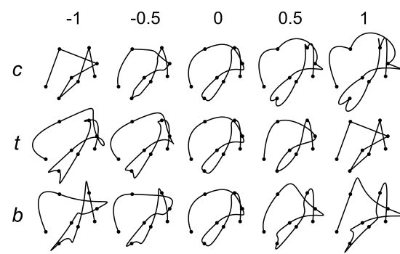
Figure 1.6. Effect of continuity (c), tension (t), and bias (b) parameters on an arbitrary curve

We call this subsystem that handles all this work of interpolating and processing motion data as the Dynamic Description Framework.

For example, Figure 1.7 (top) shows a behavior consisting of a sequence of actions: Action 1, Action 2, and Action 3. Each action consists of four-point motion data (i.e. poses) and assumed they are for the same DOF. There is a discontinuity between the end of Action 1 and the start of Action 2, and also the end of Action 2 and the start of Action 3. The bottom curve shows the interpolated motion data superimposed over the original pose data. The black solid lines show the linear interpolation between the poses, the red dashed line show linear interpolation between the actions, and the blue solid line show the interpolated motion curve.
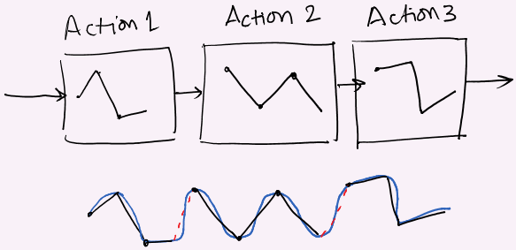
Figure 1.7. Interpolation of a sequence of 3 actions (assumed for the same DOF)

This method is similar to the one used by van Breemen in the iCat robot’s animation engine [30], but I want to incorporate more influence from animation into the synthesis process. The animation concepts I look to incorporate are: secondary action, follow-through, anticipation, stretch and squash, and arcs.

In order to facilitate interesting interaction dynamics, some other components must also be established which are beyond the scope of this work. I include an internal state model for the robot for emotions. Other things include implementation of inputs such as speech recognition, face recognition, object recognition which can use sample codes from open-source and other freely available resources from the web.
Recently there have been many consumer products which showcased speech and gesture inputs. For example: Microsoft Kinect to play games using whole body gestures, Leap Motion’s peripheral that is able to track hand gestures. In the speech recognition front, Apple’s Siri, Microsoft’s Cortana, and Google provide robust speech recognition features that are deeply integrated with their respective smartphone functionalities such as making a call, a text message, checking the weather and so on. (Many times people are still struggling to interact with the robot or computer because these machines would often misinterpret the inputs from the person).

The ability to maintain or release control over a DOF is important for expressing emotions and attitudes. For example: when tired or relaxed, our limbs are usually limp. In Asimo, every movement is controlled and so it always look tense. When control is released, it shows relaxation. A person communicating with someone who is tense all the time gets tiring, but if on the opposite a person relaxes, this person is also at ease. It is almost impossible to do release of control in a robot using normal servos in a safe manner. This may be achieved using compliant actuators such as pneumatics and McKibben muscles, but they are beyond the scope of this thesis (some of Dr. Perkowski’s students work on hydraulic and pneumatic humanoids but this will be not included in the dissertation). Therefore, the closest thing I was able to do is to emulate these movements using common RC servos (radio-controlled servo-motors). To accomplish this, however, some workaround and tradeoffs must be made, and the results are still limited. Specifically, to exhibit different acceleration, I had to manipulate the speed control features of the servo controller board (Pololu SSC-32) from my program by timing the commands sent to the board [ref].

Summary of the Proposed Contributions of this Dissertation
The contributions from the work on this dissertation are as follows:
- A new language REBel for robot motion that allows:
  - Very many (potentially infinite) variations of behaviors
  - Simple algebraic manipulation between motions that can be used for validation, combining, and creating new motions
  - Probabilistic and nondeterministic behaviors
  - Hierarchical control from the lowest level (e.g. motor commands) to higher level behaviors (e.g. interaction between two characters)
- An interpreting system of this language that incorporates concepts from art (Laban Movement Analysis) and animation (Disney’s Animation Principles) into online generation of robot motion for a more animated and intentional robot.
- Introducing Interactive Gene Expression programming to generate and evaluate new robot motions by automatic generation and human-aided evaluation of programs in the new language.

Related Works
In this chapter, we review some related works in human-robot interaction and particularly those regarding robot motion control in context of social interaction with humans. Based on these past works, we identify what ideas work, what abilities are important for robots in social settings, and how the work presented here relates to these ideas and abilities.

Selected Works in Human-robot Interaction

Social Robotics
Social robotics refers to interaction between human and robots, and among a group of robots. This includes animal social behaviors such as swarm, flocking, foraging.
For the purpose of this dissertation, we only discuss related works of robots in which social interaction plays a major role to their function. This type of robots are called socially interactive robots [1]. But particularly, I am interested in robots that are socially interacting with a person. The type of robots in this area are assistive robots, toys, guide robots, and robot actors. The work of socially-interactive robotics was pioneered by researchers such as Breazeal, Fink, Scaselatti, Nourbakhsh, Dautenhahn.
The classes of social robots are organized in the order of social competencies from low to high [1]:
- Socially evocative – robots that recognize and respond with emotional expressions
- Social interface – robots that can interface from human social cues and modalities
- Socially receptive – robots that can learn from interaction (e.g. learning from teaching by humans)
- Sociable – robots that proactively seek social interaction with humans
- Socially situated – robots that operate in an environment mixed with social agents and other objects
- Socially embedded – socially situated robots and have some understanding of human interaction norms
- Socially intelligent – “Robots that show aspects of human-style social intelligence”
A component of social interaction is the concept of proxemics – the use of space in social interactions. The space can be physical, or psychological between the interacting parties. For example, human-robot interaction in a noisy environment may require the robot to adjust its positioning relative to the person to get better perception of the person [31]. There is also a psychological distance (often referred to as “personal bubble”) where the robot must be aware and maintain a comfortable distance between itself and the person [32]. Interestingly, proxemics have been shown to be the core concept for gameplay between human (children) and a robot albeit unintentionally. For example: the robot is programmed to track a child and maintain a certain distance from him/her. As the child approaches the robot, the robot will back away to maintain the distance. The child then perceives this as ‘chasing’ the robot. When the child moves away from the robot, the robot will approach the child. This is perceived as being ‘chased’ by the robot [33]. The point is, with simple robot behaviors, depending on the way the person interact with the robot, the person may perceive/interpret the behavior as something else and treat it as something more interesting e.g. a game.
There are common human social interaction cues that are detrimental to make the interaction awkward vs. comfortable such as: looking/gazing at the person, poses, gestures, body language, intention, etc. Bruce et. al. [34] found that expressive face combined with showing attention by simply looking in the direction of the person makes the robot more “compelling to interact with” than without the expression and communication cues. Their result suggests that visually appealing expression and making the robot perform simple, subtle communication gestures makes people want to interact with the robot.
Naturally, the ideal would be to be able to use human social communication modalities both ways; that the robot understands the human modalities (e.g. natural language/speech, visual recognition for face, object, gestures, etc.), and the robot to be able to exhibit the same human communication modalities.
The use of hand and body gestures to complement speech is well researched in communication theories [refs]. Using computer animation, virtual agents can be made to synchronize their speech with appropriate hand gestures [35] [36]. Additionally, the usage of hand gestures, poses, and body language (mannerisms) of a popular talk show host have been extracted and applied to a virtual agent, and observers were able to associate the mannerisms back to the person that they originated from [ref].
In addition to natural language processing, many researches have contributed by incorporating human gesture recognition to interact with robots in a more natural way [37]. Waldherr et. al. [38] implemented a gesture-based system to interact with robots using arm gesture. The person can instruct the robot using arm gestures such as pointing to a direction to navigate or to pick up an object. In similar vein, systems have been developed to allow the robot to learn the way humans learn such as by instructional cues [17], imitation/mimicking or demonstration [39] [40].
Several anthropomorphic robots are already very comprehensive. The Asimo robot is promoted as a helper robot which politely interacts with people, such as serving a drink, greeting, and telling stories about itself. Figure 3.1 shows Asimo’s current ability of autonomously serving a drink from a closed container into a cup. Additionally, it can run (i.e. with a brief moment when both feet are off the ground) up to 9 km/h, and jump with one leg or both legs. A video of the demonstration can be seen on the internet [41]. However, Asimo lacks facial features due to its helmet-like head.
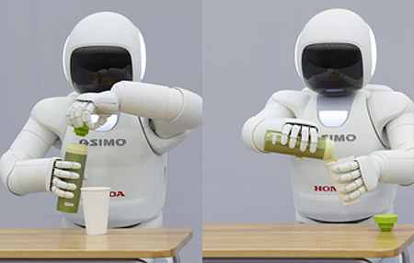
Figure 3.1 Asimo showing dexterous manipulation opening a beverage container and pouring to a cup.

Whereas Asimo lacks facial expressions, The Kobian is equipped with very sophisticated facial expression system with 24 degrees of freedom on the head alone, which involves complex eyebrow shapes, LED panels under the face to show emotions using colors, articulated eyes, eyelids, mouth and lips [42]. Additionaly, Kobian is a bipedal humanoid robot that is capable of bipedal walk, fully articulated arms and hands, which allows an expansive set of facial expressions, and gestures. Figure 3.2 shows some of the programmed expressions on Kobian such as surprise, sadness, and shyness.
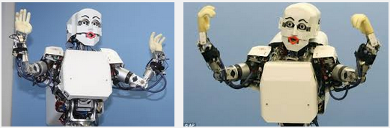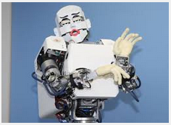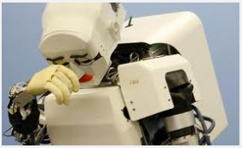
Figure 3.2 Kobian showing expressions (clockwise from top left): surprise, angry, shy, sad [3]

Kismet’s system involves gaze detection, proxemics, natural speech processing, object and face tracking, and highly articulated and expressive face to communicate with a person of its needs and emotions [25]. Figure 3.3a shows Kismet interacting with its creator, Cynthia Breazeal. Kismet has 15 degrees of freedom total which enables it to show many facial expressions. The goal of Kismet is to investigate application of human communication cues on robots to facilitate more natural means for human-robot interaction. This was done in the context of Kismet having a child-like personality which requires attention and need to be entertained. Based on the expressions Kismet show, the person tries to understand what emotion Kismet is expressing, and what they need to do to keep Kismet “happy”.
The Leonardo robot is another one built by Breazeal and her team. Breazeal demonstrated a type of interaction where a robot can learn new things only using human communication techniques as opposed to artificial techniques like in machine learning [17]. For example, the person can introduce the robot to a new object it has never seen before, either by holding the object in his hand and presenting it in front of the robot, or pointing towards the object (e.g. on a table). The robot, in turn, can turn and look in the direction where the person is looking by estimating his gaze based on person’s head orientation. To emulate the behavior of a person learning, the robot will look in the direction of the thing it is trying to learn, then look back at the person to look for signs of affirmation (positive or negative feedback). Moreover, focus/gaze projects some kind of attention or intention and thus feedback to the person of what the robot is “thinking”. In Figure 3.3b Leonardo is showing a “wanting” gesture towards a red doll which it has been taught to associate with “good”. If the object was taught as being “bad”, Leonardo will gesture like saying “keep that thing away from me.”
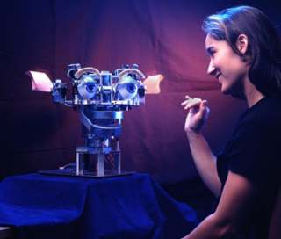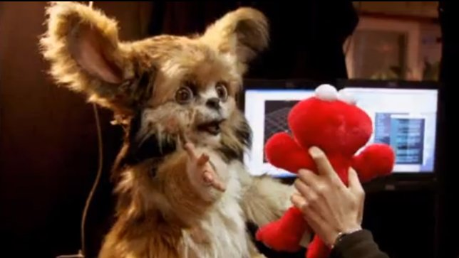
(a) (b)
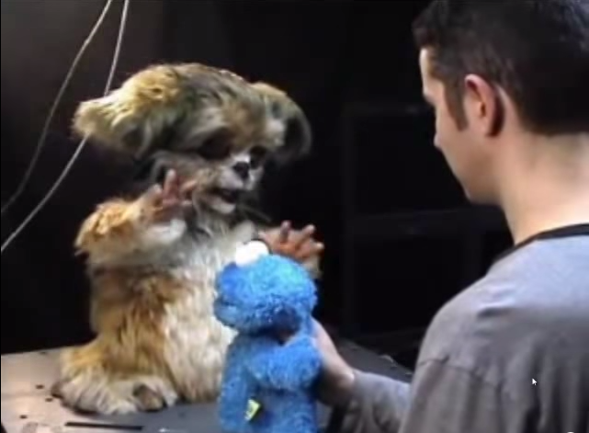
(c)
Figure 3.3 (a) Kismet interacting with Cynthia Breazeal, (b) Leonardo’s expression towards an object it was taught to associate with “good”, (c) Leonardo’s expression towards an object it was taught to associate with “bad”

The iCat robot also has similar facial expressive ability as Kismet. In the demo, a person can interact with iCat by asking it to tell a joke, and playing a game of tic-tac-toe. But in particular, van Breemen emphasized the animation engine behind iCat and that was highly inspired by Disney Animation Principles [30]. He argued that applying some concepts from DAP helps making iCat’s gestures look more natural to a person. For example, when turning the head, instead of only rotating the neck, iCat would first direct its eyes to the direction it is going to turn, followed by rotating the neck. In DAP this is called ‘Anticipation’ because by moving the eyes first, it gives the observer some idea (i.e. anticipates) where the robot is going to turn.
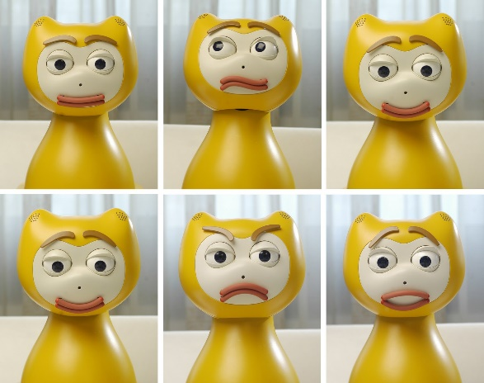
Figure 3.4 Some facial expressions of iCat,

Interactive social robots are also used to teach and/or improve social skills of children with autism. These children have difficulties in social interaction with another person, but tend to be able to interact with objects such as toys. Robots provide a medium for teaching these children social interaction skills. For example: using the Aibo robot, Walters [33] distinguished two types of interaction styles. Five continuous-valued touch sensors on the Aibo robot are used to detect whether the interaction was gentle or rough. In addition, the experiment also measured the frequency of interaction. There are four tiers of interaction: low/sparse, medium-low, medium-high, high. The frequencies are categorized by 15 seconds or more delay between interaction, 10-15 seconds, 5-10 seconds, and less than 5 seconds, respectively. The ideal case would be somewhere between the second and third tiers. Based on these two indicators (interaction style : gentle vs. Rough, and frequency : low to high), the robot may response with a bark if the interaction is not ideal (rough, too frequent or too low), and wag its tail otherwise. This behavior of the robot then influence the children to control their interaction style.
A compelling human-robot interaction performance can be choreographed. Marco Tempest worked with a team at MIT Media Labs to create a magic trick performance with a Baxter robot he named “Eddie” shown in Figure 3.5 [43]. Recently he performed the show at a TED talk, and several websites and blogs claimed that it might be the best robot demo ever; and it is hard to argue otherwise. Tempest started the performance by talking to the audience and explaining about the vision of robotics from the Victorian era. He then introduced Eddie, which ceremoniously unveiled himself by pulling the fabric that was covering him using a winch that was attached to his back. Tempest then told the audience that Eddie is sleeping, which can be seen from Eddie face which is an animated face rendered on a screen. Tempest then wakes Eddie up, and Eddie started to show a happy face, and starts waving his 7-DOF arms. Throughout the presentation, there is music playing in the background while Tempest would initiate Eddie to either respond with speech, or interact by following a ball that Tempest was holding in his hand. From time to time, Eddie would move his head and show different expressions on his face. Eventually, Tempest and Eddie collaborated to show several magic tricks to make the ball appear and disappear. At one point, Eddie would reach his hand out toward Tempest to receive the ball. Eddie then holds the ball in his “hand” and flipping it over to put it on a hat Tempest was holding, and Tempest flips the hat and the ball was gone. It was a fascinating performance, which was choreographed of course, but it was done well, in such a way that it was able to captivate the audience.
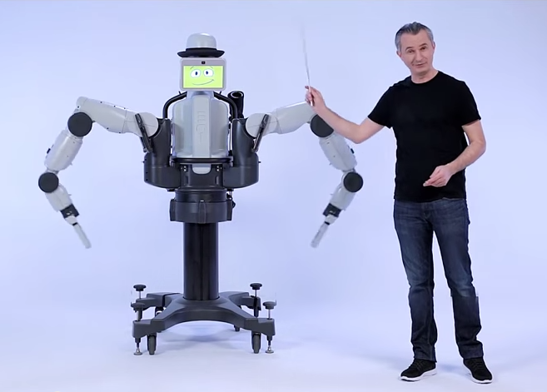
Figure 3.5 The Baxter robot platform named “Eddie” (left), and Marco Tempest (right). Together they performed a magic trick in front of an audience at one of the TED talks.

Tempest’s project page on this performance has a video that shows a glimpse of the work done behind this performance. Eddie’s movements were created using a puppet aid, which is a miniature model of Eddie. Instead of motors, the aid has potentiometers on its joints to allow a person to create movements by moving the limbs on the aid, and record the joint values in a computer. The recorded data can then be used for movements and poses on Eddie. Additionally, Eddie is equipped with compliant motors, which allow a person to interrupt and refine the movements without the risk of getting injured.
The performance was timed, because timing is an important aspect in a performance so that the audience has a pleasant experience, but it is particularly important for a magic trick. The timing of the sequence of actions greatly influences the flow of the performance [ref]. There are also audio cues used to indicate to Tempest or Baxter what action is happening next and when it is going to happen. Of the few people I met who had seen the video of Tempest’s performance, most of them expressed that they were highly entertained by the performance. The other few who are more critical (i.e. not as impressed) about the performance were people who are already familiar with entertainment robot technologies.
While Tempest’s performance with Baxter/Eddie robot was geared towards human-robot interaction, the Stickboy robot built by Frank Barnes is a musician robot which plays a drum set. Stickboy does not use music playback for the drums, he really does play the drums. Stickboy has four arms and two legs to use the 14-piece drum set, and a head which bobs to the rhythm of the music he is currently playing. The robot’s limbs are powered by pneumatics, and the coordination of movements is controlled using MIDI [44].
Lemaignan et. al. [12] suggests that there is some dynamical model for robot anthropomorphism. For example, over a period of time of interaction between a human and a physically anthropomorphic robot, if the robot is not complemented with anthropomorphic behaviors, or only has predictable behaviors, the robot becomes less anthropomorphic to the human, and seen only as another tool. Although initially the robot may possess highly anthropomorphic features, overtime the effect fades away.

Motion qualities affect user’s perception
Park and Lee [45] discovered that differing motion types on an interactive user interface affect how the user perceives the system, but the impression is application-dependent and content-dependent. Park and Lee devised two applications: the first one is a circle that moves across the screen when the user clicks on the interface. The second is a slideshow-type application, where the user can cycle through a set of images when they click on the interface. The slideshow application have two sets of images: of tropical resort sceneries, and of action shots in a soccer match. The circle and images move with three different transition types (i.e. motion quality): sudden (i.e. disappearing from one location and reappearing in another location), slowly decelerating, and accelerating. For example: a sudden change of position is associated with “powerful” and “youthful” terms in the circle animation application, but less so in the slideshow application. On the other hand, smooth motions which concludes in overshoot and deceleration were attributed to the term “luxurious” in the slideshow application with resort images, but less so with soccer match images.
Heider and Simmel [46] observed that humans tend to try to attribute human-like behaviors to what they see. In their experiment they used an animation of two triangles, a circle and a hollow box. The triangles and circle are moving in some orchestrated manner. When Heider and Simmel asked a group of people to describe what they saw, most of the participants interpret it as interaction between two men and a woman. Their experiment indicated that movement, apparent interaction between moving agents and stationary objects (environment) can be interpreted in terms of human social interaction despite none of the agents possess human forms.

Human social interaction and communication norms
Lee et. al [47] discovered that a) It is possible for people to identify a robot’s introverted vs. extroverted personalities through the motion qualities of the robot’s gestures and the prosody, and b) people apply the complimentary attraction social rule when interacting with their robot. The latter suggests that people tend to perceive the robot as being more intelligent and enjoyable to interact with when the robot exhibited personalities opposite than robots with similar personality to their own. Extroverted personality was shown through faster movements, larger ranges of motion, faster speech rate (number of words per minute), higher volume, and higher fundamental frequency. This study supports my view that robots with personalities are more interesting to people and suggests that they are more engaging. With REBeL, I am hoping that creating personalities for robots – albeit mostly through nonverbal cues, will become much easier.
Emotional intelligence (EI) has been suggested as an indicator for people who are successful at work, or life. EI has been described as the ability to be aware of one’s and of others’ emotions, and to regulate those emotions to some purpose (e.g. to solve problems, to help/cheer other people) [48]. The ability to understand and respond based on emotions plays an important role in human social interaction. As humans, we adjust the way we speak and gesticulate, and even use different words and phrasing when we identify ours’ and the other person’s emotions, depending on where we want the interaction to go. Therefore, for a truly socially-interactive robot, the robot must have (be programmed with) some understanding of emotional intelligence concepts.
Dopamine effect: in gambling, a person who always wins may stop playing after 10 games. But a person who wins some, and lose some, will play maybe 30 times [ref]. Perhaps manipulation of the dynamics in the interaction is influential – a mix of some “hits” – communications that makes sense, and “misses” - communications that are disconnected or misunderstood, may make the interaction more engaging. “hits” vs “misses” maybe interpreted as “agreement” vs “disagreement” as the “ebb” and “tide” of the interaction.
Duffy [24] suggested creating a balance between the anthropomorphism components in social robots which idea resonates with my own views. To be an effective socially interactive robot, the robot must have some degree of anthropomorphism, and understand some basic social communication norms. There are some basic social communication gestures that are relatively simple to implement to a robot, such as looking at the person’s face, can show focus or interest to an object (if presented with/encounters it). Additionally, the robot’s movement needs to be interesting and organic [49]. Additionally, the robot needs to know how to regulate the conversations, and understand rules and strategies such as turn-taking, talking-over (talking while the other is talking) and “hijack” the conversation, how to effectively use facial expression and gestures to drive the conversation dynamics, etc.
With Kismet, the communication structure is based on infant psychology, and thus the human as the care-giver of the robot [25]. The robot is programmed to exhibit child-like behaviors so that when there is too much stimulus, it will cry or close its eyes. Kismet can also tell the human caregiver whether it is comfortable or otherwise through facial expressions and gestures such as relaxed or anxious expression, respectively.

Interactive and Dynamic Motion Synthesis in Computer Animation
The Computer Animation field have been more successful in creating natural-looking motions than in the robotics field. In the past decade, advances in computer graphics and animation have enabled creation of computer-generated characters that looks look and move realistically, like they would be real living beings. This allows for epic movie scenes such as massive battle scenes, hordes of zombies consisting of hundreds, even thousands of computer-animated characters. Similar technologies are also used in video games, creating immersive and entertaining experiences for the players.
The classical method for creating a natural-looking animation for the characters is using the motion capture systems [ref]. A motion capture system usually consists of a special room with several infrared cameras carefully positioned to capture the movements of the actor(s) with as much coverage as possible. The actor(s) are performing the motions wearing a body suit adorned with reflective markers placed at minimum in important points of the body such as elbow, shoulders, hips, wrists and so on. The cameras are calibrated so that the relative positions of each camera with respect to a global coordinate point are known. As the actor moves in the room, the cameras capture the movements of the markers on the actor’s body/suit. A special software then combines the video frames from all cameras, perform triangulation calculation for each marker and tracks the movements of the markers in a virtual 3D space. [ref]. The positions of the markers can then be applied to a 3D model of a character, and so the motions of the actors can be applied to the 3D character.
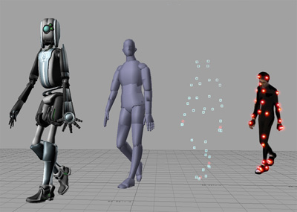
Figure 3.6 (left to right) Movements of actor captured by the markers are applied to 3D models.

More recently, motion capture systems have been used to capture detailed facial expressions in movies such as Avatar (Figure 3.7 top) and video games such as L.A. Noire (Figure 3.7 bottom).
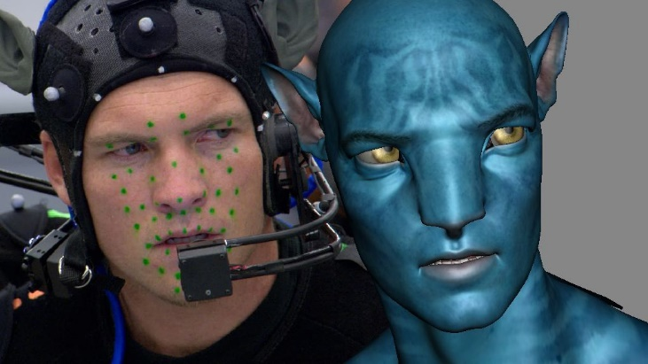
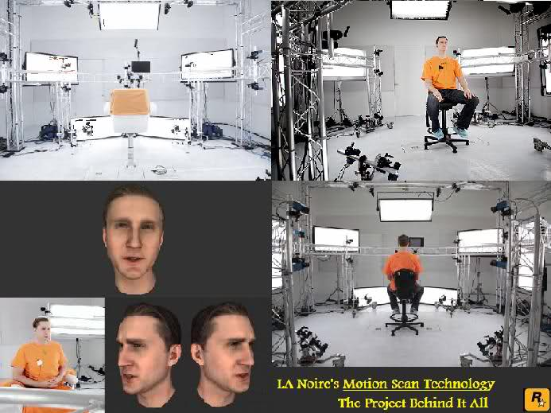
Figure 3.7 Facial expression capture systems for Avatar (top) and L.A. Noire (bottom)

Some works have started using motion capture systems for robotics applications. Using motion capture equipments/suits, motion performed by a human are used for translation onto humanoid robots either for real-time teleoperation [50] [51], or for playback [52], while others use it as an input to the robot (to recognize the person’s gestures) so the robot can choose the appropriate response [53].
For interactive medium such as video games, the motion capture method have one major drawback, which is that the motion is pretty much fixed. For example, in a falling motion, it will look strange when the character falls in the same way every time regardless of the form of the ground e.g. staircase vs. level floor.
To overcome this problem, physics simulation was introduced to computer animation by Baraff and Witkin [54] and applied to character animation in what is now known as ragdoll physics. Ragdoll physics can be described as:
“A collection of multiple rigid bodies … tied together by a system of constraints that restrict how the bones may move relative to each other.” [55]
When joint/skeletal muscle stiffness is not considered, the figure will collapse like a ragdoll toy causing the body to be in unnatural positions, which is undesirable. Biomechanical model of skeletal/joint and muscle systems are then added to create a more believable and natural looking movements such as in Natural Motion’s Euphoria tool [56].
Sometimes it is desirable for the animated character to catch the fall instead of just falling lifelessly. The Euphoria tool allows augmenting a motion with a desired behavior and ensures that there is a smooth transition between the motion capture animation and the added behavior. For example: the “catching a fall” animation consists of the character doing a body roll. This is usually achieved using a global search in real-time to find a posture in the beginning of the body roll animation that is ‘closest’ to the posture during the fall, and interpolates/blend the postures so the transition is seamless. Figure 3.8 shows a comparison between the augmented model (blue) and a simple ragdoll model (grey). The augmented model is able to keep itself standing on both feet after landing. It allows also the robot to balance itself. The ragdoll model just falls lifelessly to the ground.
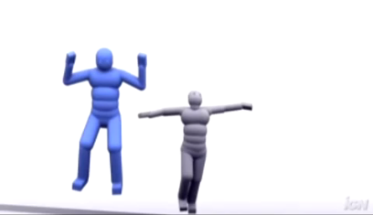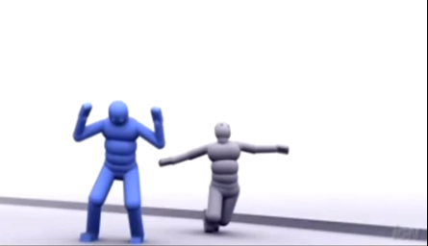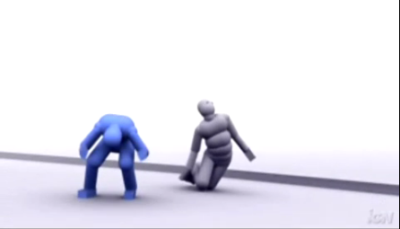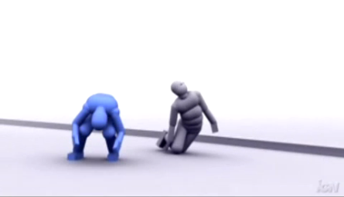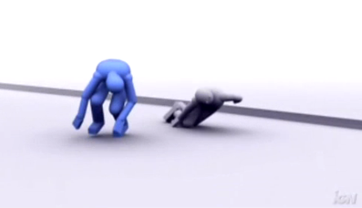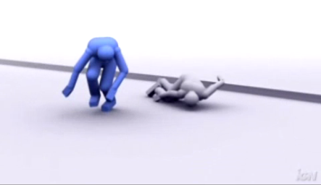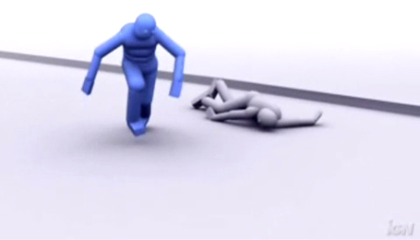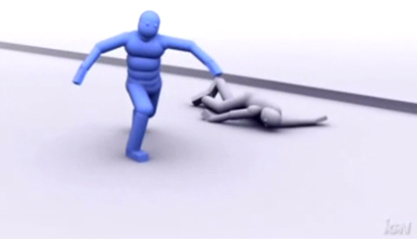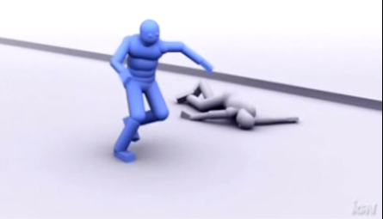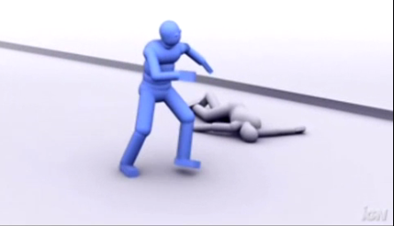
Figure 3.8 Comparison of falling animation of Euphoria-controlled model (blue) vs. ragdoll model (grey). The Euphoria-controlled model is able to adjust itself to keep standing, while the ragdoll model just falls lifelessly to the ground.
One method to dynamically synthesize motions in video games is by using motion graphs [refs]. “A motion graph is a directed graph where all edges correspond to clips of motion. Nodes serve as choice points connecting these clips, i.e., each outgoing edge is potentially the successor to any incoming edge.” [57]. Typically, pre-made animation clips are used, either obtained from motion capture or animated by hand.
The basic idea for motion graphs is to enable transitions between a set animation clips from a database in a seamless manner. Kovar first introduced motion graphs and showed how to build the motion graphs from a set of animation clips [57]. The result is a directed graph where each edge is a transition between frames of animation clips (each animation clip consists of multiple frames), and each node is a frame of an animation clip. The graph combines all the clips in the database, and may consist of thousands of nodes and edges. Some transitions between different animation clips had to be added using interpolation. Often, linear interpolation is sufficient, since the transition frames that were selected were already chosen to be the ones that are similar (by some similarity measure, as a function of the joint angles of the model) from the two clips. Other times, not all transition between frames of clips are possible. For example: transitions between sitting and walking cannot be done automatically. In this case, some additional behavior must be added in between the two behaviors, such as standing up.
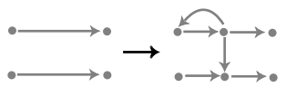
Figure 3.9. (left) Two motion clips where the nodes on the left represents the start frame for the clip, and the right nodes are the end frames for each clip. The edge represents all the frames (i.e. transitions) between the start and end frames. (right) The motion graph for these clips can be made by taking intermediate frames (middle nodes) and creating transitions from the top clip to the bottom clip (the middle down arrow), or transition to some frame of the same clip given that the transition is possible or the similarity constraints are satisfied.
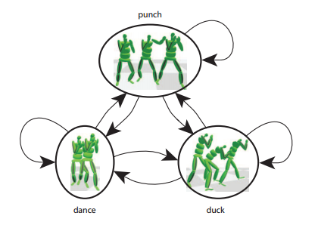
Figure 3.10. A parametric motion graph for boxing animations [58].

When a behavior is described using Behavior Expression (BE), often it consists of a concatenation of several ‘basic’ behaviors from the behavior database (i.e. alphabet). The synthesis of the motions on the robot poses some challenges because the transitions – particularly with respect to timing and joint angles – between the behaviors are not explicitly determined beforehand. Moreover, those transition decisions cannot be explicitly programmed using BE. Therefore, dynamic motion synthesis techniques such as motion trees [59] and motion graphs [57] are very promising to synthesize behaviors described by BE for the robot, particularly to ensure seamless transitions between behaviors. Motion trees have been cited as the most common method used in interactive video games, but they exploited the fact that characters in video games have very limited number of behaviors. The game designers then have to manually adjust the transitions between behaviors to ensure smooth transitions. Using BE, the number of behaviors and the transition between them can be enormous, and hence manual tweaking to ensure the behaviors transition seamlessly like in motion trees becomes completely unfeasible.
Alternatively, automatic behavior transition generation is one of the key features of motion graphs. Methods from Heck and Gleicher [58] of parametric motion graphs or optimization-based graphs by Ren et. al [60] have been used to interactively control the behaviors of the 3D model. In contrast to the vanilla motion graphs, parametric motion graph edges define transitions in the parameter space (e.g. desired punching target position) instead of just the joint angles. From my initial review of these methods, they are promising options to produce robot movements as the product of BE.

Use of LMA and DAP (Badler, Portuguese team, iCat)give numbered references plus full names of people

How LMA has been used for computer animation
Park and Lee showed the association between motion parameters and Effort category of Laban Movement Analysis in the movements of the elements of a user interface [45]. Chi et. al created a tool called EMOTE that allows modification of ready-made motion data using parameters of Effort and Shape categories from LMA [61]. They validate the EMOTE model (i.e. mapping between the parameter values and the resulting animation) with the help of a certified LMA practitioner.

How LMA has been used for robotics
LMA has been used to recognize the types of motion the human is exhibiting [62] [63]. Rett and Dias used Bayesian models and Laban Movement Analysis to predict the type of movement a person is exhibiting, which then the robot can anticipate the movement and choose an appropriate response action with a quick reaction time [37].
One part of human-robot interaction is the analysis to understand the human’s gestures so the robot can give an appropriate response. LMA parameters have been used as features for classifications of movements in human-robot/computer interaction research. Khoshhal et. al. [1] used a motion capture system to collect the motion data of a person’s movements and associate the movements to LMA Effort-Time and Effort-Shape components. Khoshhal suggested that by taking only the first four coefficients of the power spectrum of the acceleration from the motion data in 3D (using Fast Fourier Transform) is enough to characterize movements that are similar but at different speeds e.g. walking vs. running by mapping the coefficient values to the Effort-Time spectrum of quick vs. sustained. Khoshhal experimented with the Effort-Shape component by using fixed thresholds of changes in height to determine ‘rising’, ‘still’, or ‘sinking’ shape. The information from Effort-Time and Effort-Shape is used to classify the person’s actions using a naïve Bayesian model.
Zhao used a feedforward neural network with one hidden layer and backpropagation of error to associate properties of body movements to LMA parameters [62]. The motion data is obtained using a motion capture system. The body movement properties observed include: swivel of the elbow, displacements of the torso, amount (frequency) of acceleration and deceleration, curvature and torsion, and angles of the wrist. Zhao worked with two LMA practitioners who performed the types of movements according to LMA Effort combinations. Worked so what, what are results of conclusions>?

How DAP has been used in computer animation
The Disney Animation Principles (DAP) is a checklist for animators of elements of movements that they must consider when animating a character. DAP in particular was introduced by Ollie Johnson and Frank Thomas who are animators at Walt Disney Studios [19]. John Lasseter of Pixar Studios then showed that the same principles can be applied for 3D computer [2]. 3D computer animation? WHAT DO YOU MEAN?
In essence, computers are just another medium for animation like paper, or clay figures. Moreover, the underlying method for all three media is practically the same: the illusion of motion is created by a sequence of discrete poses over time.
However, there are different challenges and tradeoffs between the three media. For example: hand-drawn animation on paper hast has the most freedom to create any shapes and deformations, however to achieve smooth, high quality animation the process is very time consuming and requires many man-hours due to the number of frames required, and the amount of work for each frame. Clay animation allows reuse of character models and backdrop objects making it relatively easy to make complicated scene moving in space compared to hand-drawn method. However, it also requires highly skilled artists to create each model and tricky to animate certain things like a flying character. It is also difficult to do pose-to-pose animation in stop-motion media.
Computer animation provides the freedom of creating odd-shapes from simple to highly detailed and realistic characters/objects. It also provides the freedom of placing and moving objects in space. The animator also has full control to of each frame. In fact, in most 3D computer animation tools, the process of animating is very similar to hand-drawn animation by using keyframes. The similarity in process makes applying DAP natural for computer animation. However, the application of DAP is still largely an artistic judgment of the animator – it is not that the software will do that for them. The animator first creates key poses of the action he/she envisioned for the character. Then, after he/she is satisfied with the key poses, the poses/frames in between the key poses are added in according to the desired look-and-feel and the personality of the character.
Some concepts from DAP are even easier to apply in these animation tools. For example, acceleration and deceleration can easily be done using interpolation. As mentioned above, motion data often recorded only on the keyposes, thus the rest of the transitions (i.e. poses) between keyposes can be ‘filled’ using interpolation methods. Usually the tool will offer several interpolation methods such as linear, bicubic, or spline. Linear interpolation produces the classic robotics ‘look’ of the motion where the movement is with constant speed and abrupt change in directions. Of particular interest is the Kochanek-Bartels Spline interpolation which provides three parameters: tension, bias, and continuity to control the shape of the interpolated curve, which in turn can affect the timing, acceleration, and deceleration of the movement.

How DAP has been used in robotics
Creating robot movements that are convincing and believable in social situations are akin to making believable animated characters. To-date, there is no known work on a system to synthesize movements in a computational way using Disney Animation Principles (DAP). Many of the works done using DAP in robotics is that the principles are applied when the gestures and movements for the robot are programmed off-line and pre-recorded by an animator [11] [8] [12]. But the results from those studies support the hypothesis that when the animation principles are applied to the robots movements, the human observers have a better perception of the robot (e.g. the person is more confident of the ability of the robot, thinks the robot is intelligent, and is more comfortable around the robot) [8] [12] [11] [13].
The robot iCat (Figure 3.4) is arguably one of the earliest efforts of explicitly utilizing DAP in creating the robot’s movements [30]. For example, the Arc principle states that organic characters move in an arc instead of a plane or straight line. Therefore, when iCat turns its head, the movement was programmed to follow an arc to create a more natural-looking movement. Ribeiro and Paiva [49] demonstrated the application of the animation principles on the humanoid robot Nao and their robotic head EMYS.
The iCat robot is a desktop robot with a cartoon cat head/face and was developed as HRI experiment platform by Philips [15]. iCat does not have any limbs and instead has 13 degrees of freedom in its head and neck, which allows it to have head and facial gestures. The gestures of iCat were canned (pre-programmed), and were meticulously designed by applying DAP. By applying DAP in iCat’s animations, the experiments show that the robot was perceived better by the person interacting with it in the sense that the person had a more pleasant interaction with the robot instead of awkward and boring.

Automata, Languages, Formal Robot Control

Automata
When I was thinking about fundamental formalism for my robotic applications, I realized that there already exists an area of research that has defined several concepts that may be of use – Automata Theory. The similarity of automata and robots was known already in 17th Century [Ref ???]. In 18th Century J. de La Mettrie [64] has seen a human as a system of gears and springs, a kind of automaton similar to clocks. Leibniz believed that a machine can simulate human behaviors based on logic and E.B. de Condillac created an idea of a monument equipped with devices that simulated human perceptions and senses [65]. I.P. Pavlov believed that a human organism is an automaton that processes food to body tissues [66]. Pearson, Ch. S. Sherrington and E. L. Thorndike seen human brain as a telephone central station that connects inputs with outputs [refs?].
The concept of brain as a machine was rediscovered in the fundamental works of Turing [ref], and other early pioneers of robotics. Fundamental works of Norbert Wiener believed that control in machines and living organisms has the same fundamental nature [67]. This gave a beginning of construction of simple organisms like bugs of Wiener [ref], tortoises and fox of W. Walter, homeostat of Ashby, squirrel of E. Bercley, fox of A. Ducrocq and a mouse of Shannon. However, there was no common model of a machine that would allow to compare and further develop the “automaton” ideas to describe human behaviors. The introduction of a formal model of automaton by Moore [68], Mealy [69], Rabin and Scott [70] created a base for the research area of Automata Theory that has brought many powerful ideas and methods to formal linguistic, Machine Learning, cybernetics, but to a lesser extent to robotics and especially few to describe motions. While Automata Theory has developed on its own, it was not much used in the area of formal robotics, despite people were commonly building robot controllers as state machines using PLDs and FPGAs.
In the old approach, robots have been designed as deterministic machines, and hence models such as finite state machines are used e.g. modeling walking sequence for a hexapod robot. The FSM approach is good when the robot has a specific task that can be described in a deterministic way, for example: moving a stack of boxes using a robotic arm.
However, when the robot is tasked with more complex tasks such as navigating through a building to get from one location to a target location while avoiding all obstacles in the way and not running into walls, the state machine design approach can quickly become too cumbersome. With many conditions and uncertainties to account for, the state machine becomes very large and difficult to design by a person. The strategy to design such machine is to use hierarchies of state machines. Inspired by observations that insects exhibit complex behaviors which can be broken down into low-level and high-level tasks, Brooks developed the Subsumption Architecture [27].
Lau and Kuffner [71] introduced a FSM-based method for generating a sequence of behaviors for an animated character to reach a goal location (or locations). A FSM is used to represent the set of behaviors the character is capable of and the transitions between the behaviors. Each state of the FSM is a behavior e.g. Jog, Jump, Crawl, and each behavior may consists of a set of motion clips for the behavior. Their system uses A* search to find the best sequence of actions that takes the character towards the given goal location. The algorithm can be used in a changing environment which changes are known ahead of time (i.e. the search takes into account the occurrence of these changes in time).

Emergent behavior from Braitenberg Vehicle
Valentino Braitenberg was a neuroscientist who was interested in the study of behaviors. He introduced the concept of emergent behavior – a seemingly intelligent behavior of an agent from simple interactions between its sensors and actuators/effectors. The Braitenberg vehicle is a mobile agent (robot) which has three wheels, two actuated and one flywheel (freely rotating). The robot has two light sensors: one on the right side and another on its left side. The sensors are connected directly to the motors, such that when the sensor receives a stimuli (detects light), the corresponding motor is activated/runs. Depending on how the sensors are connected to the motors, the vehicle can exhibit different behaviors. When the left and right sensors are connected to the left and right motors, respectively as in Figure 1.3 b, the vehicle is said to exhibit “avoiding” or “shy” behavior because now it will always move away from a light source. Conversely, when the sensors are connected in a crossed connection (left sensor to the right motor, and right sensor to the left motor) as in Figure 1.3 b, the vehicle is said to exhibit “aggressive” behavior because it will move towards the light source.
(a)
(b)
Figure 3.11 (a) “Shy” Braitenberg vehicle will avoid the light source, (b) “aggressive” Braitenberg vehicle will move towards the light source.

In a similar vein as the Braitenberg vehicles, Dautenhahn investigated the interaction between a child and a mobile robot. The robot was equipped with two sensors: an infrared sensor which is used to avoid obstacles, and a heat sensor that can detect the body heat of the child and programmed to approach the heat source but the robot will stop at some distance from the heat source. There are several interaction dynamics that happened but each of them has a different meaning, depending on the circumstances. For example: when the child doesn’t move, the robot will approach the child and this is called “approach” behavior. If the child is moving around the room, the robot will try to follow the child, and this is interpreted as “keeping contact”. When the child pays attention to the robot and is intentionally stopping and moving to make the robot stopping and going, then this is observed as “playing” (e.g. like “red-light-green-light” game). The robot was not explicitly programmed to “play” this game, but yet by the robot only programmed with two very simple behaviors, one can “play” with this robot.
Observe that in the Braitenberg vehicle case, we assume that the light source is stationary. If we draw an analogy between the Braitenberg vehicle and the experiment by Dautenhahn, we can associate the child with the light source as the source of stimuli for the robot. The main difference is that the source of stimuli in the latter (the child) can move around, and particularly has its own dynamics such that it has the ability to move depending on: its own decisions and the actions of the robot.

Dynamic System-based Natural-looking motion
The goal is to enable the robot to autonomously generate its own natural motion.
Natural-looking motion and gesticulations of robots are often achieved using motion capture data, or very detailed animation created by a skilled animator. The Aurora robot by Asoro can perform a very natural-looking gestures as it introduces itself to a guest, but the gestures were programmed by a person performing the gestures using a motion capture system [52]. The robot’s systems then processes the input data and only performs motions that satisfy its respective constraints such as the joint velocity limits, and the collisions of body parts.
The main contribution of this dissertation is the autonomous generation of natural-looking motion for robot that can be expressive using concepts from animation, encoded using the Behavior Expressions in REBeL.
I am aware that natural-looking motion is not the only factor for engaging a socially interactive robot. There are many other factors such as robust recognition algorithm for speech, object, person/face, learning capability, and others [72]. For the evaluation, we may “simulate” those other factors using the Wizard-of-Oz (WoZ) technique where an operator may have some control over the robot or interpret the input for the robot but the robot still performs the gesticulations by its own, using the Behavior Expression system. And it is the performance of the robot and the overall usefulness of the system which will be evaluated. Wizard-of-Oz (WoZ) IS NOT CLEAR TO ME, GIVE AN EXAMPLE>
When generating motions on a robot, we do not have the freedom to create any movement such as in computer animation, but we are limited by constraints and requirements such as:
- Joint limit, velocity limits
- Safety (e.g. avoid collisions, must never harm the user, etc)
- Liveness, i.e. to never get stuck in an infinite loop or get stuck/deadlocks in general.
On the other hand, computer–generated animations struggle with creating an animation that looks realistic and seems to conform to the real-world laws of physics and dynamics, which often involves complex dynamical models. In actual robots, the laws of physics are applied on the robot naturally, meaning for free, without special programming. This is a very meaningful possibility of creating robot motions, which has been however not utilized powerfully enough in literature. This will be the task of this thesis. It may lead to use additional mechanical elements in body parts of the robot, such as springs, hydraulic pipes, rubber strings or counterweights. Also several robots use these methods, I am not familiar with any theory of their use.

Methods, Algorithms and Technologies from Computer Animation to be Used in REBeL
In computer animation, motion data are defined as a sequence of joint angle values or position data for each degree of freedom. Therefore, in most computer animation tools, motion data are often represented as signals. Bruderlin and Williams demonstrated the use of several digital signal processing methods to manipulate motion data [29] [73]. For example: Multiresolution filtering is a method to decompose a signal (e.g. an image) into a set of bandpass components. The bandpass components are obtained by passing the signal through a cascade of lowpass filters where at each stage the output of the lowpass filter is downsampled before being passed to the next filter stage. The result is a set of bandpass and lowpass signal components from which the original signal can be obtained by adding the bandpass and the DC components. Multiresolution filtering is used for creating seamless morphing of one image to another by performing interpolation at the bandpass components, and image enhancement and segmentation which allow analysis of an image with faint features (e.g. understanding physical phenomena in deep-space imaging) [74].
Bruderlin and Williams showed that by adjusting the gains of the bandpass components, one can remove noise in the movements by reducing the high frequency band gain, or exaggerate the movement by increasing the middle frequency band gains, e.g. making a walking animation take bigger steps (Figure 3.12 left, top). They also applied multi-target interpolation to blend two motions together synchronized in time using dynamic time-wrapping (Figure 3.12 middle). Waveshaping and Motion Displacement Mapping taken together allow allows manipulation of motion data where the former applies a shape function over the motion data e.g. to set bounds to the motion range (Figure 3.12 right), and the former WRONG allows local manipulation of data points. These approaches allow high-level, quick modifications to the existing motion data e.g. those that come from motion capture.
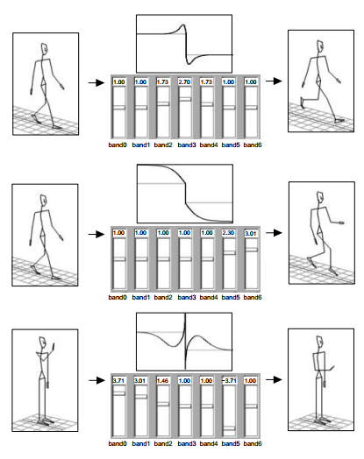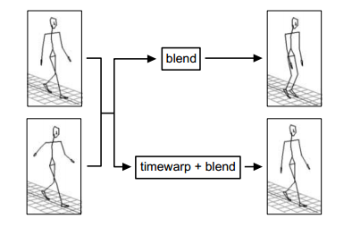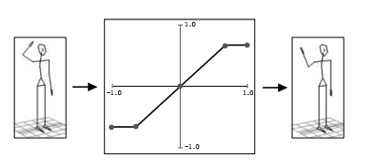
Figure 3.12 (left) Multiresolution filtering examples (top: increasing middle frequency gains, middle: increasing high frequency gains, bottom: increasing low frequency gains and reducing high frequency gain), (middle) blending requires time-wrapping for coherent blending (bottom), (right) wave-shaping example that limits the minimum and maximum range of motion for a degree of freedom (shown DOF of shoulder). Images from [29].

Similarly, Amaya et. al. showed that processing motion data using Fourier analysis allows manipulation in the spectral domain which translates to things like removal of noise. Also, morphing one motion to another e.g. walking to running and back can be done using a coefficient in the range [0,1] for the spectral data for the two motions, with the caveat that the motions have to be periodic. Unuma et. al. was able to extract characteristics of a motion e.g. “briskness” by taking the difference between a “brisk” walking motion minus the “normal”/default version of the walking motion in the spectral domain (Fourier) [ref]. The spectral characteristics can then be used on a different kind of motion, say, running. The motions can also be interpolated using a coefficient value between the normal and the expressive one.
Natural Motion Euphoria engine has been used to create natural reactive motion in computer games [ref]. While the technology is proprietary, there are some discussions on how it works. Euphoria uses a combination of physics simulation, some biomechanical model of the character/figure, motion capture data and neural networks. For example: a figure falling from a building can be programmed with behaviors to catch its fall, or do nothing (e.g. dead). As the figure falls from the edge, the interaction between the physics simulation and the biomechanical model of the figure makes the figure flail ?? around (within the constraints of the model, e.g. joint limits). If the figure is set to have the behavior of catching its fall, using a neural network, the system selects the best animation for catching a fall out of a library of such animations, based on the attitude (position) of the figure during its fall. The system then also interpolates the animation between the figure falling as it approaches the ground and the animation of the selected as the catch-falling behavior.

Interpolation (Kochanek-Bartels, Spline, Bezier)
The common method to create animations is the pose-to-pose method. In a sense, the process is a hierarchical method. First, the sequence of main poses and positions of the motion in the animation sequence is established (called ‘keyframes’ in 2D animation, or ‘keyposes’ in 3D animation). This process gives the rough look of the movement. Then, the frames (or poses) in between those keyframes/poses are created in the process called ‘in-betweening.’ The in-betweening process determines the dynamics of the whole movement. Depending on the quality of movement desired, and the frame rate of the animation, the animators must determine the number of frames/poses in between two keyframes, and the amount of movement created in each in-between frame/pose.
The simplest interpolation method is the linear interpolation. This method produces motion with constant speed without acceleration or deceleration, and abrupt change of directions. Cubic interpolation fits the given data points onto a continuous function of third-degree polynomial using four Hermite basis functions. Figure 3.13 shows the result of interpolation of some data points (solid dots) with linear interpolation (solid line) and cubic interpolation (dashed line).
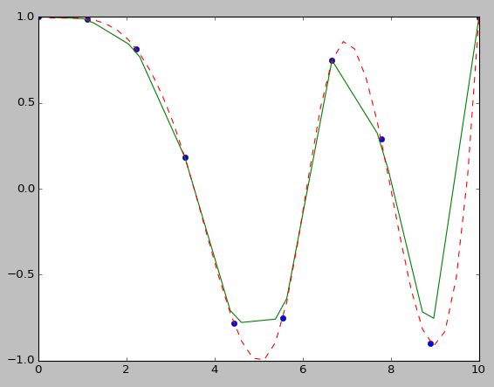
Figure 3.13 Interpolation comparison: the dots are the original data points, the solid line is the result of linear interpolation, and the dashed line is the result of cubic interpolation.
Cubic interpolation is often used in computer animation to interpolate in-between frames between keyframes, since it guarantees the positions at each keyframes are reached, and continuous tangent along all segments of the curve [75].

Past Work
During my studies for my master’s thesis, I conducted an experiment on applying multiresolution filtering on motion data for a KHR-1 humanoid robot. The hypothesis was that using the filter, I would be able to show the changes in expression of a particular gesture (e.g. hand waving, pushup) from normal to exaggerated or subdued on the KHR-1 robot as was shown by Bruderlin and Williams on a computer animation [29]. The result was inconclusive as when the gestures were shown to a group of students, the differences in the exaggerated and normal movements were barely noticeable, and the meaning was lost to them. When the pushup motion was subdued, it was more noticeable with unintended consequences. In the normal motion, the robot would stand back up to its standing/rest position. But since the movements are pre-programmed (it was open-loop control), because the range of motion was reduced, the robot was not able to get back up, and instead fell to the side while trying to finish the motion sequence on its back. Dr. Perkowski saw this and interpret it as ‘dying old man’ motion which he found amusing. SO WHAT IS THE CONCLUSION TO BE USED NOW FROM THIS?
Because of the inconclusive nature of using the filtering method at the time, I ultimately used data from music files (in MIDI format) to generate motion data for a simple arm robot. The MIDI file format represents all of the data of a music in plain text format, such as: beats per minute, the notes, duration of the note hits, the type of instrument, and other information. Using this data, I was able to generate motion for the robot which is on-time with the tempo, and associating ranges of motion to the change in note pitch and intensity creates an illusion of the robot dancing with the music. SO WHAT IS THE CONCLUSION TO BE USED NOW FROM THIS?

Evaluation in HRI

Metrics Human-Robot Social Interaction
Most robot tasks can be measured using objective, quantitative measures. For example: the performance of a robot that can clean a room can be measured in terms of the amount of time it takes the robot to clean the room, the length of the path it took, and the cleanliness of the room. Measuring human-robot interaction often requires the subjective input of the person, which is often obtained using surveys from human subjects.
To measure effectiveness of social robots, Steinfeld et. al suggested the following metrics [76]:
- Interaction characteristics
- Persuasiveness - how the robot can change/affect the behavior of the person
- Trust – the feeling related to safety of the person with respect to the robot’s actions.
- Engagement – the ability to produce social characteristics that captivate the person’s attention while maintaining interest
- Compliance – how well the robot follows human social interaction norms, safety, etc.
Metrics are social presence ??? in terms of Intelligence (perceived as being intelligent), Social Attraction (makes people want to interact socially with it) and Enjoyment of interaction (interaction experience) [47].

Anthropomorphism, Gestures and Expressiveness

Anthropomorphism

Definition of anthropomorphism
Anthropomorphism is the attribution of human or person physical and behavioral traits to non-human objects (including animals) [23] [24].
In the context of this dissertation, I am interested in robots that are interesting and engaging in a social interaction setting. For such robots, anthropomorphism is an important feature. In some sense, it is the most important feature for the robot. As indicated by the definition of anthropomorphism above, the factors that contribute to anthropomorphism can be categorized into the physical and behavioral aspects. Physical aspects include embodiment, anthropomorphic features such as head, face, arms, legs, and torso. Behavioral aspects include Emotional Intelligence (ability to recognize and regulate emotions), emotional expressions, showing preference (likes and dislikes), social presence (e.g. showing attention, awareness of the environment of objects of interest and other social agents), etc. Animal-like physical and behavioral traits are also acceptable for ‘interesting and engaging’ robots, but people will tend to interact with the robots in a manner which they interact with animals (e.g. pets), whereas anthropomorphic robots tend to be expected to interact like a person would.
Duffy suggested that at least part of the missing “ingredient” for a truly appealing and engaging social robot is the balance between anthropomorphic elements of the robot [24]. For example: the android robot is designed to have human-like physical features related to height, hair, eyes, teeth, and skin. When a person sees the robot, he may immediately expect the robot to have most – if not all, human abilities such as communication through natural speech and gestures, facial expressions, etc. In most androids today, they tend to fall into the uncanny valley [77] because they cannot move and express things the way humans do, as expected of them.
The main focus of this dissertation is creating expressiveness on robots through their whole body movements. In other words, to improve robot anthropomorphism through the way they move.
Anthropomorphism can be understood as: “the tendency to attribute human characteristics to inanimate objects, animals and others with a view to helping us rationalize their actions” [24]. There are two components of “human characteristics” in this sense: the physical/visual and the behavioral. The physical/visual concerns with the shape, proportion, facial features, limbs and so on. For example: Luxo Jr. is a character created by John Lasseter in the form of a desk lamp. The “head” of the lamp is easily considered as a metaphorical “head”. As another example, with some imagination, the Parallax PING ultrasound sensor can appear like a pair of “eyes”.
Figure 4.1 a) A poster for the Luxo Jr. animated short by Pixar [source], b) a Parallax PING))) ultrasound sensor [source]

What is the role of anthropomorphism?
A robot with anthropomorphic features is easier to relate in a social interaction application. Duffy [24] discussed that people often associate humanistic attributes and behaviors to objects anyway.
The appearance of the agent affects how a person perceives the agent. For example: when the robot has human-like appearance, then a person would expect to interact with the robot using human approaches like natural languages and gestures. While a robot that looks like a dog such as AIBO, a person would try to interact with the robot as one would interact with a dog, like by attempting to pet its head, or calling it.

How I’m using anthropomorphism?
I am using two robot platforms. The first robot is the MCECS Bot Jeeves which is a humanoid robot with a mobile (wheeled) base.
Jeeves has an articulated torso, head, neck and arms. The face and another arm is still under development. Jeeves was designed to be a tour guide robot for the Maseeh College of Engineering and Computer Science. In order to make Jeeves more interesting, Dr. Perkowski and I agreed that he needs to have a persona. In his case, we wanted him to have a gentleman, butler-like persona. This persona needs to be apparent to the people who will be interacting with him through speech, gestures and manual input (through an application on a touchscreen/tablet), which Jeeves will respond through his gestures and other actions.
The second robot is Pepe (Figure 1.5). Pepe is built from the Stingray mobile robot platform from Parallax. As it is, I believe a mobile base by itself is not enough to exhibit a truly interesting persona. Three ultrasound sensors were added on the front, left and right corners of the base so it can be programmed to detect objects and obstacles in its forward path. With these sensors, the robot can be used to at least exhibit the behaviors of the Braitenberg vehicle. To make the robot appear more anthropomorphic, on top of the platform, there will be added a 5 degrees of freedom arm including a 1 DOF gripper. This arm can perform double-duty as the “head” as well (think of it like in the case of a hand puppet).
While Jeeves is physically more humanoid than Pepe, but I will attempt to demonstrate in this dissertation that using similar anthropomorphic behaviors can be programmed on both robots using REBeL. For example: both robots programmed with greeting behaviors, or looking at a person. The Behavior Expressions for each of those behaviors will be the same for both robots, but the execution will be customized for each robot.

Gestures and Expressiveness
For socially-interactive robots, gestures play an important role in the robot’s interaction with humans [78] [79] [80] [81] [33]. By our definition of behaviors in Chapter 2, gestures are a kind of manifestation of a robot’s output behavior. I firmly believe that in order for such robots to be effective in social interaction, they need to have some ability to gesticulate. Some gestures are integral in human social interaction norms. For example: to look at the face of the person one is talking with, or to point or look in a certain direction in order to direct attention. When the Leonardo robot is presented with an object it has learned to “like”, it will show a smiling face and both arms reaching for the object [17]. When Wall-E wants to catch someone’s attention, he raises and waves his hand, and also tilt his head and whole body.
The types of gestures include: symbolic/conic, metaphoric, deictic, and beat gestures [82]. Symbolic gestures are often in the form of shaping the hand a certain way creating a symbol. The same symbol can have different meaning across different cultures; one may be positive in one culture while highly offensive in another. Metaphoric gestures are gestures that are used to represent abstract concepts such as height, size, or love. Deictic gestures are pointing gestures. Lastly, beat gestures are those gestures with repetitive motions such s nodding, tapping of the foot, and so on.
What I mean by ‘expressiveness’ is how those gestures are executed. Are they done very fast or slow? Are they done in big motions, or small motions? Together, gestures and expressiveness of the execution of those gestures create a meaning/message. The same gesture executed in a different way may have different meanings such as different confidence or emotion. In other words, if gestures are the words in a sentence, expressiveness is the prosody in the speech.
One of the problem is to know the right combination of gesture and expressiveness to convey the right message. Animators, actors and directors are experts at finding this combination. However, there is no exact formula to this combination. Moreover, while a director can tell the actor of the expressions the actor needs to do, a good actor can sometime bring in his/her own personality to the acting, making it unique to the actor. For example: the actor Robin Williams is known to ad-lib his lines, and sometimes his improvisations are so good, they made it to the final version of the movie.
To provide some common language to this process, there are some common “language” that were created. In particular, the Disney Animation Principles from the animation industry, and the Laban Movement Analysis which originated from the dance field.

Disney Animation Principles
The Disney Animation principles do not constitute an exact formula to animate, rather a set of tools for the animators to create a compelling character. Some principles
The Disney Animation Principles (DAP) were originally a set of guidelines for Disney’s animators to use in creating hand-drawn animations [6]. DAP provides guidelines for animators to pay attention to aspects that make the animation come to life. Some of these principles are theatrical techniques, while others are related to physical laws in the real world. It turns out that DAP is also useful for animators that use using WHY I AM CORRECTING THE SAME ERROR AGAIN AND AGAIN. PLEASE INCORPORATE ALL MY CORRECTIONS WITH WHICH YOU AGREE AND DISCUSS OTHERS any medium such as a stop-motion (e.g. clay, puppet) and or a computer-generated (e.g. 3D) animation [7]. The following two paragraphs give a brief introduction to the principles by dividing them based on their nature: theatrical/artistic and physical.
There are seven principles in DAP related to theatrical or artistic aspects: Staging, Anticipation, Exaggeration, Straight Ahead and Pose to Pose, Secondary Action, Solid Drawing, and Appeal. Staging is a theatrical concept to set up a scene in such a way that the audience can understand what is happening in the scene unambiguously. Anticipation can be related to Staging in the sense that the animator or director sets up a scene or the action of a character that the audience can expect what is going to happen next. Exaggeration is the act of making an action or facial expression more pronounced, for example: when surprised, the character’s mouth would open very wide. When Exaggeration is done to the extremes, the effect is comical and cartoonish. Straight Ahead and Pose to Pose refer to the two different approaches to animation. Pose to Pose animation uses ‘key frames’ which are key points in the animation akin to inflection points in a highly non-linear curve. Once the key frames are established, then the animator draws the frames in between those key frames to make the animation work. In contrast, Straight Ahead animations do not use key frames, and the animation is created by creating each pose for each frame in succession. The number of frames to be created depends on the desired timing of the actions and the number of frames per second used. Secondary Action refers to the observation that in an action, usually a character performs more than just one action at a time. For example: while speaking, in addition to the movements of the mouth, the character might also move his head up and down, blinks, moving his eyebrows, and showing emotion through his facial expressions. Solid Drawing applies specifically to hand-drawn animations where the animators must have sufficient drawing skills to draw well and consistently. Finally, Appeal refers to the design of the animated characters so that they are interesting to the audience, either by the personality/charisma, visuals, or other aspects of the character.
The remaining principles are related to physical aspects of the action and the movements of objects: Stretch and Squash, Follow Through and Overlapping action, Slow In and Slow Out, Arcs, Secondary Action, and Timing. The Stretch and Squash principle describes how an object changes its shape when moving, or interacting with other objects (e.g. collision). The classic example is a bouncing ball. To make the animation appealing, the ball is drawn slightly elongated parallel to the ground (squashed) as it hits the ground, and drawn elongated in the direction it is moving (stretched) while on air. The use of stretch and squash illustrates the type of material the object is made of. The amount of stretch and squash (i.e. elongation) between a ball made out of rubber and a ball made out of steel will be different. Follow Through and Overlapping action principle explains that when a character is moving, usually there are several things moving alongside the character’s body. For example: in a walking sequence, in order to make the animation believable, while the character’s legs and arms swing, the character’s clothes and hair may also sway. The way the character’s clothes and hair sway depends on the movements of the character’s body and maybe on other factors such as wind. The Slow In and Slow Out principle refers to the acceleration and deceleration in the way most things move in nature. The Arcs principle explains that the trajectory of movements of organic characters such humans or animals are usually in form of some kind of an arc instead of straight lines, unless in some very special cases. The Timing principle actually affects both the theatrical/artistic and physical aspects in the animation. As a theatrical/artistic aspect, timing refers to the moments a character performs certain actions which may reveal some aspects of her personality, or even for comedic or dramatic effects. As a physical aspect, the timing of an action of an object illustrates the physical properties of the object itself. Using the bouncing ball example above; when hitting the ground, a ball made of softer material like rubber takes a few moment to squash, while a ball made of steel, does not squash as much, and does not bounce as high as the rubber ball.
Animation remains largely an art form, rather than a mechanistic process. John Lasseter used the following animation notes from Glen Keane during his days as an animator at Disney Animation Studios [83]:
- “Don’t illustrate words or mechanical movements. Illustrate ideas or thoughts, with the attitudes and actions.
- Squash and stretch entire body for attitudes.
- If possible, make definite changes from one attitude to another in timing and expression.
- What is the character thinking?
- It is the thought and circumstances behind the action that will make the action interesting.
Example: A man walks up to a mailbox, drops in his letter and walks away.
OR
A man desperately in love with a girl far away carefully mails a letter in which he has poured his heart out.
- When drawing dialogue, go for phrasing. (Simplify the dialogue into pictures of the dominating vowel and consonant sounds, especially in fast dialogue.
- Lift the body attitude 4 frames before dialogue modulation (but use identical timing on mouth as on X sheet).
- Change of expression and major dialogue sounds are a point of interest. Do them, if at all possible, within a pose. If the head moves too much you won’t see the changes.
- Don’t move anything unless it’s for a purpose.
- Concentrate on drawing clear, not clean.
- Don’t be careless.
- Everything has a function. Don’t draw without knowing why.
- Let the body attitude echo the facial.
- Get the best picture in your drawing by thumbnails and exploring all avenues.
- Analyze a character in a specific pose for the best areas to show stretch and squash. Keep these areas simple.
- Picture in your head what it is you’re drawing.
- Think in terms of drawing the whole character, not just the head or eyes, etc. Keep a balanced relation of one part of the drawing to the other.
- Stage for most effective drawing.
- Draw a profile of the drawing you’re working on every once in a while. A profile is easier on which to show the proper proportions of the face.
- Usually the break in the eyebrow relates to the high point of the eye.
- The eye is pulled by the eyebrow muscles.
- Get a plastic quality in face — cheeks, mouth and eyes.
- Attain a flow thru the body rhythm in your drawing.
- Simple animated shapes.
- The audience has a difficult time reading the first 6-8 frames in a scene.
- Does the added action in a scene contribute to the main idea in that scene? Will it help sell it or confuse it?
- Don’t animate for the sake of animation but think what the character is thinking and what the scene needs to fit into the sequence.
- Actions can be eliminated and staging "cheated" if it simplifies the picture you are trying to show and is not disturbing to the audience.
- Spend half your time planning your scene and the other half animating.”
Most of the concepts above are geared towards making the ideas in the animation obvious and unambiguous to the audience (#1 – 15, 27, 28) – this is the goal of the animator. Moreover, some of these concepts are very closely related to theatrical performance techniques. I believe Keane’s insights to good animation techniques are also applicable to robots since the goal of “animation” is to bring inanimate objects to appear alive. By including considerations regarding intent, thoughts, and circumstances of the character, these ideas are even more powerful than the DAP alone. Which of these points are applicable to robots and how to realize them are some of the questions I am trying to address in this dissertation.

Laban Movement Analysis
Rudolf Laban was a German artist who developed a language to document aspects of movements in a systematic way [22], which will be introduced below. One of Laban’s students, Ingrid Bartenieff, did most of the work to develop the language, which is now known as the Laban Movement Analysis (LMA). Prior to their work, dancers and actors have to follow a ‘master’ dancer/actor in order to learn and produce (or reproduce) the quality of movements in the dance or acting performance. With LMA, the performers and choreographers/directors have a common language to describe the desired movement qualities. In the next few paragraphs, some of the concepts from LMA are introduced.
There are four major categories in LMA: Effort, Space, Body and Rhythm. Effort refers to the dynamics in the movement, and in general relates to the amount of energy spent to create the movement. For example: the difference of the movement between a person lifting a heavy crate vs. a light matchbox. Space refers to the relationship between the person’s movement with his/her environment and the objects in that environment. Body refers to how the person uses his/her body parts to create movements. For example: a throwing motion that is initiated from the hips vs. just the movements of the arm. Finally, rhythm refers to the rhythm or pacing of the movement, such as: repetition, pulsing, etc.
The Effort category is further categorized into four components: Weight, Time, Space, and Flow. The first three Effort components in particular are explained using analogies to movements in space with 3 dimensions: vertical, horizontal, and sagittal. Effort-Weight has the spectrum of light and strong, which is related to movements in the vertical dimension in the up and down directions, respectively. The Effort-Weight component refers to the physical weight or emotional ‘weight’ in the movement, e.g.: lifting a heavy box, or walking while being tired or sad (i.e. dragging the feet). The Effort-Time component has the sustained and quick spectrum and is associated with forward and backward motions in the sagittal plane, respectively. This component can be associated with slow (sustained) vs. quick actions such as: slowly picking up a cup of coffee, or flicking a fly away from the cup. The Effort-Space component is described with the spectrum of direct and indirect. Effort-Space is relative to either the left or right side of the person’s body, but in general, the movements across the person’s body are referred to as direct, while movements moving away from the person’s body are considered indirect. For example: spreading the right arm outwards to the right side of the person’s body is indirect, while crossing the right arm in front and towards the left side of the person’s body is direct. Effort-Flow does not have an analogy in the spatial dimension, but Flow describes the continuation (gradual vs. discrete) between changes in movement trajectories using the bound vs. free spectrum. Sometimes there are overlaps among the use of these components when performing a motion, and often it is impossible to do a motion demonstrating just one isolated component. For example: since Strong (Effort-Weight) refers to heavy-ness, and moving heavy objects tend to be slow, then it seems to be an overlap with the use of Sustained Time (Effort-Time).
In our case, to execute movements and gestures on the robot from an output word of a Behavior Expression, we will use the Flow parameter to control the transition between motion segments. We use ‘bound’ to be the discrete transitions, while ‘free’ to be the smooth transitions between segments. The Effort-Time component is reflected in the Duration parameter. I will have to think some more on how the other two (Weight & Space) should be used: a) if as an additional parameters for the animator, then it might be overloading the animator (too many parameters to control), b) maybe they can be used to create new movements just by those high-level descriptions e.g. Strong-Indirect would be a slower movement towards the right side by the right arm.
The other part of human-robot interaction is the synthesis of movements or gestures as a medium of communication. The EMOTE system allows application of LMA parameters to the animation of a 3D character [61]. A base (‘neutral’) movement is first created using keyframes and linear interpolation, for example: spreading of the arms outwards. A person can then modify the LMA parameters provided in EMOTE to make the arms spread wider if the Spreading shape parameter is used, and a smaller spread if the Enclosing shape is applied.

SUMMARY
In this chapter, we discussed the role and effects of anthropomorphism in social robots. We view the anthropomorphism of a robot in two aspects: the visual (embodiment, shape, facial features, etc), and the behavioral in the form of gestures. Gestures can further be characterized by two parts: the form (the what, e.g. hand-waving, pointing, etc.) and the expressiveness in the execution (the how, e.g. fast, slow, varying range of motion). Finally we discussed concepts from Disney Animation Principles (DAP) and Laban Movement Analysis (LMA) to help us have a common language to describe the expressive elements (properties) of movement and the meanings associated with them. One of the major goals of this dissertation is to make creation of robot movements with various expressive qualities easier. The vocabularies from DAP and LMA will be used in the REBeL system to describe these movements.

Automata Theory

Models of automata
In this work I try to return to old traditions of cybernetics by basing my fundamental concepts of motion on formal notions of Automata Theory that were developed by successors of Turing, Mealy, Moore, Rabin and Scott in the areas of formal linguistics and logic/sequential machine design. It seems to me that the concepts and methodologies developed there can find many interesting applications also for motion description, generation, transformation and optimization. EXTEND THIS SECTION. THIS IS YOUR BASE AND MOTIVATION. THIS IS INNOVATIVE AND “REASON FOR FAME”.
I have heard over and over again when people talk about music or dance styles, they refer to the music or dance as some kind of a language. Most any kind of dance styles will have some vocabulary of the dance, for example: names for different kind of foot placements, a particular dance pattern, or a family of dance patterns (patterns with variations), and so on. Some dances like Swing and Waltz have some structure, i.e. grammars, while others have less structure such as Blues or interpretive dance. By structure we mean there are patterns that defines the dance style which differentiate it from other dance styles. For example, Waltz is known for its basic ‘box step’ pattern. The ‘box step’ pattern can be repeated and the dancer will return to his/her original position. On the other spectrum, Blues dance is more free-flowing, and the dancers move according to what he/she feels at the moment to the music. Structured dance tends to be recognizable without music than unstructured.
There are many parallels between concepts in music and dance/movements. The basic elements of music are notes, and pauses. In dance, the basic elements are specific types of footwork, turns, leaps, and so forth. Certain combination of notes at a given moment creates a sound which is called the harmony, and the progression of sound that changes over time is referred to as the melody. In dance, the combination of the basic elements creates a dance pattern. Harmony is expressed through chords, which is the set of notes being played at that moment. The analog of “harmony” in dance would be the posture of the dancer at a given moment in the dance (e.g. when a picture is taken of the person dancing). A pianist friend of mine explained that the composer or musician can manipulate elements in the music to capture the attention of his/her audience. For example, he said when playing harmonic chords (combination of notes that are multiples of a certain base frequency), the listener is easily ‘absorbed’ or tune in the music. The composer can incorporate chords that are non-harmonic to give the audience a jolt, which he describes as ‘creating conflict’ in the flow of the music, and thus captures the audience’s attention. In a way, it is similar to storytelling where a conflict is introduced between the characters in the story to make the story interesting. There are many more vocabulary in music such as the different type of tempo, dynamics, and so forth. The combination of these elements create musical pieces that can affect the mood of the listeners such as major vs minor scales that gives the impression of cheerful vs somber, respectively.
The basic elements of music and dance are analogous to the alphabet in a language, and the different construction rules, i.e. ways to combine these elements determines the type of dance or music genre, and draws interaction or attention from the listener.
Similarly, what I am trying to create with this dissertation is something to enable robots to interact with humans using the basic elements of nonverbal cues (e.g. gestures) as it is with notes in music, but it needs the structural support and production rules to combine these basic elements and construct coherent communicative messages through movements. In principle, a robot can only be a computation machine: therefore, it is appropriate that we look into the fundamental concepts of computation in automata theory to build the supporting structure. With the different variations of automata and established formal synthesis and analysis methods, we try to find a universal model for robot behavior control in general, and non-verbal robot-human interaction as the particular interest of this dissertation to model human-robot interaction problems, and motion generation for affective gestures. Particularly, I am interested in robots that can communicate using gestures, body language and minimal verbal speech such as R2-D2 from Star Wars and Wall-E from the movie Wall-E.
The basic idea of using formal language for definition of robot control has been explored in the area introduced by Brockett called Motion Description Languages (MDL) [84] which will be discussed in more detail in Chapter X. In MDL, a robot has a set of basic motions called alphabet of basic motions, which is the set of simple movements such as going forward, turning left 90 degrees, and so on. Using MDL, a sequence of actions (hence, a behavior) for the robot can be constructed by arranging the basic motions into a sequence, i.e. a ‘string’ in formal linguistic parlance. Using MDL, a robot can be used for mapping applications and hallway navigation with obstacle avoidance with a vocabulary of few basic actions for the robot as mentioned above, and a set of plans consisting of a sequence of the basic actions in some order [85] [86].
Normally in classical Automata Theory, a system is modeled in a discrete and finite space (e.g. discrete input values, finite states). However, most actual robots work in both the analog/continuous and discrete spaces. For example, the robot may have discrete and finite number of states of wandering and idling. When in the wandering state, instead of taking discrete steps, the robot travels in a continuous manner, and the control is governed by a differential equation. Using classical Automata Theory, it is very difficult to model the continuous wandering behavior, or at least takes very many more additional states to cover all the possible situations. Automata Theory is basically a discretization of analog/continuous control space like in classical control theory. To leverage the advantages from both classical Automata Theory and the classical control theory, hybrid models have been explored such as the hybrid automaton, and most recently, MDL.
Kleene’s theorem states that for every regular language defined there is an equivalent deterministic finite automaton (DFA) that accepts the strings of that language, and vice versa [ref]. So, there is a direct relationship between automata theory and formal languages, particularly with respect to regular languages and finite automata. There are two formal ways to produce regular languages: regular expressions and regular grammars. Consequently, deterministic finite automata can be constructed from both regular expressions and regular grammars, but requiring the help of non-determinism in the form of non-deterministic finite automata (NFA). While NFA helps the synthesis process, it is equivalent in expressive power as DFA, that is: any NFA can be converted into a DFA and vice versa. In some cases, the state diagram of NFA can be more concise than DFA, and using NFA is much easier to convert regular expressions to DFA and back. The relationship between automata, regular languages, and regular grammars can be seen in the diagram in Figure 5.1. This chapter presents the recapitulation of Automata Theory from the point of view of my dissertation.
Deterministic Finite Automata
Nondeterministic Finite Automata
Regular Grammars
Regular Expressions
Finding an automaton
Finding the grammar
Finding an automaton
Finding the
expression
Synthesis of an automaton using Brzozowski’s derivation
Convert NFA
to DFA
Convert DFA
to NFA
Produces/recognizes regular languages
Figure 5.1. Transformations among various representations of finite automata

Formally, a state machine is a mathematical model for computation. The concept of state machine is a very powerful concept used to describe how things work. By “things” we mean any kind of system, where at any point in time, the system is said to be in a certain state out of a number of possible states. The system then can change (transition) from one state to another state given some input, and in some systems they can transition without any input. The system may also produce some outputs at any given state or during transition to another state. This section discusses these machines and their intricacies.
A state machine M can be described as a set: M = {S, ∑, s₀, δ, F}, where S is the set of states, ∑ is the set of input symbols, s₀ is the initial state (s₀ ∈ S), and F is the set of final states (F ⊂ S) which may be empty. δ is the transition function of a state u₁ ∈ U to another state u₂ ∈ U given some input symbol v ∈ ∑, in other words: δ = U × ∑ U. To illustrate this set, let’s examine a simple FSM as shown in Figure # below.
The FSM in Figure 5.2 is a very simple machine which “accepts strings with odd number of 1’s”; it is not very exciting, but will serve to explain the definition of the state machine. In this FSM, the set of states S = {A, B}. The machine accepts the input symbols ∑ = {0, 1}, and has the initial state s₀ = A. The set of final states only have one state, the state B, so: F = {B}. The transition functions are:
δ(A, 0) A
δ(A, 1) B
δ(B, 0) B
δ(B, 1) A
Where δ(x, y) z means, the transition from state x¸to state z, with input symbol y.
A
BF
1
0
0
1
Figure 5.2. A state machine that accepts strings with odd number of 1’s.

In theory, there is no limit for the number of states for a machine. In practice, machines with an infinite number of states would require an infinite amount of memory which is currently not possible. Most of the time, the machines with practical use have finite (limited) number of states. Let us note, that from the formal point of view even a supercomputer is a finite state machine, but analyzing behavior or synthesizing a supercomputer as a state machine is completely nonsensical. One needs some special concepts built on top of the concept of state machine to make them practical. And so people came with the concepts of Turing Machines, Post Machines, Random Access Machines, Stack Machines, Petri Nets, and also blocks such as Memories, counters, arithmetic units, to describe various specific state machines from which larger complex systems can be built. Special types of machines and associated languages are built for specific purposes. In this dissertation we are interested in a language and its interpreter (in software/hardware) specifically aimed at behavior of humanoid robots.
In order to explain basic concepts of machines, for the remainder of this chapter, we will focus on the finite state machines (FSM). Another name for finite state machine is finite state automaton.
First, we will discuss the different types of state machines: Moore machine, Mealy machine, Rabin-Scott machines with examples. Next, we discuss deterministic vs. nondeterministic finite automata, probabilistic state machines, and the concept of hybrid machines.

Moore Machine
The Moore machine is a type of state machine where the outputs of the machine are only determined by its current state. The concept for this machine was introduced by Edward Moore in 1956 [].
An example of a Moore machine is a vending machine which dispenses a candy when given 15¢ in any combinations of dimes (10¢) and nickels (5¢). If given 20¢, the machine will dispense the candy but gives no change. All other nominations (pennies, quarters, dollars) are not accepted. To design the machine, systematically create a graph of possible scenarios:
Start a node give it label 0¢ denoting no money has been given yet.
From there, consider the possibilities of the machine receiving the first coin: it can either receive 5¢ coin, or 10¢ coin. Draw an arrow from the 0¢ node for the 5¢ option and label the arrow “5¢”, and draw a node at the end of the arrow with label “5¢” indicating that the machine has received 5¢ total so far. Similarly, draw a second arrow with label “10¢” to indicate the when the machine receives 10¢, and at the end of this arrow draw a node with label “10¢”.
For the two new nodes, consider the possibilities for each node like was done in step 2. If before the machine received 5¢ (at node 5¢), what if the machine receives 5¢ next? What if the machine receives 10¢ next? Do the process like in step 2 for both the 5¢ node and the 10¢ node.
Continue the processes in step 2 and 3 until all the last nodes in all the paths are sums up to at least 15¢ which means the machine had received enough funds to dispense the candy. There is some possibilities the total would be 20¢ which the machine would also dispense the candy.
For now, once the total reaches 15¢ or 20¢, we will denote the output of the machine as “Dispense candy”, otherwise the output is “Keep candy”. We can encode the outputs using binary values as such: “Keep candy” = 0, “Dispense candy” = 1. Since for a Moore machine the output happens at the state, the states are labeled as: <state name>/<output>. For example, state “20¢” with output 1 (“Dispense candy”) will be written as: “20¢/1”. The graph in figure 5.3 illustrates the process of the candy dispenser machine.
0¢/0
10¢/0
5¢/0
10¢/0
20¢/1
15¢/1
15¢/1
15¢/1
20¢/1
5¢

5¢

5¢

5¢

10¢

10¢

10¢

10¢

Dispense candy

Dispense candy

Dispense candy

Dispense candy

Dispense candy

Keep candy

Keep candy

Keep candy

Keep candy

Figure 5.3 A generic graph representation for the candy dispenser machine.

The nodes in this graph are the states for the state machine. However, notice there are duplicate states – the states with the same labels. This machine can be simplified by combining the nodes with the same labels, with one catch: since both the 15¢ node and 20¢ node are the point where the machine dispenses the candy, we can combine them into one state. Figure 5.4 shows the steps of minimizing the state machine. Since from the state “10¢” if the machine receives either 5¢ or 10¢ the machine will go to the same state which dispenses the candy, the transition to the state can be labeled with “5¢, 10¢”. The last thing to note is that at each state there is a transition to itself when no money is given; that is, an edge with label “0¢” from the state to itself. Since these 0¢ transitions are not interesting (does not cause state transitions), they are not drawn in the graph.
0¢/0
10¢/0
5¢/0
10¢/0
20¢/1
15¢/1
15¢/1
15¢/1
20¢/1
5¢

5¢

5¢

5¢

10¢

10¢

10¢

10¢

0¢/0
10¢/0
5¢/0
10¢/0
15¢, 20¢/1
5¢

5¢

5¢, 10¢

10¢

10¢

5¢, 10¢

0¢/0
10¢/0
5¢/0
15¢, 20¢/1
5¢

5¢

5¢, 10¢

10¢

10¢

1
2
Figure 5.4. The first minimization step (arrow 1) is to combine the states with output “Dispense candy” from the original machine (left machine, in green). The second minimization (arrow 2) is to combine the remaining states with the same labels. In this case, only the states labeled “10¢” (middle machine, in green). The minimized machine is on the right. When minimizing by combining some states, one must be careful to make sure the state transitions are preserved.

Mealy Machine
In contrast to Moore machine, a Mealy machine can be recognized by having its output as a function of its current state and current input [69]. As a state diagram, a Mealy machine can be identified by having its output values written on the arcs (state transitions) together with the input value for that transition. A Moore machine can be converted into a Mealy machine with little modifications: by denoting the output of the next state at the transition (edge) to that state for the given input. The modulo-3 machine from the example above can also be described as a Mealy machine as seen in the state diagram below. However, generally conversion from Mealy machine to Moore machine is not trivial. [refer to Perkowskis paper[]
A
B
C
$${x=0}/0$$
$${x=0}/1$$
$${x=1}/2$$
$${x=0}/1$$
$${x=0}/2$$

$${reset=1}/0$$

$${reset=1}/0$$

$${x=1}/0$$
$${reset=1}/0$$

Figure 5.5. A Mealy machine for a modulo-3 counter.

The inverse is not always true. While converting a Moore machine into a Mealy machine can be done by keeping the same states, a machine that was originally designed as a Mealy machine may have different output values on the transitions to a state for a given input. Converting a Mealy machine to an equivalent Moore machine may require the addition of new states. In some cases, Mealy machine representation may have less states than the Moore machine representation.

Rabin-Scott Machine
A Rabin-Scott machine is a type of FSM with a starting/initial state and a set of final/accepting states [70]. A Rabin-Scott machine is a special case of a Moore machine. The idea behind initial and accepting states in a Rabin-Scott machine is that there is a set of sequences of inputs (i.e. strings) for the machine that would take the machine from the initial state to one of the accepting states. If after receiving the final input value the machine arrives at one of the accepting states, then the machine is said to accept the string.
Because of the concept of final/accepting states, Rabin-Scott machine is suitable as the model of computation for recognizing patterns. The model of computation for recognizing patterns is formalized as formal language theory. If M is a Rabin-Scott machine and M = {S, ∑, s₀, δ, F}, where S is the set of states, ∑ is the set of input symbols, s₀ is the initial state (s₀ ∈ S), δ is the state transition function, and F is the set of final states (F ⊂ S) which may NOT be empty, then ∑* is the set of all possible strings of any length where each string is a sequence of symbols in ∑. ∑* is called the language of the machine M. Another interpretation is: “$Σ^{*}$ is the language recognizable by machine M.” Let’s be more specific by saying that the language for our Rabin-Scott machine M is ∑_{M}*. Then if a string w is such a sequence of input symbols in ∑ that drives the machine from the initial state s₀ to an accepting state s_{f} ∈ F as the machine consumes the last symbol in w, then string w is in the language ∑_{M}*.
As an example, we can modify the modulo-3 counter machine above as a Rabin-Scott machine that only returns true if the inputs sequence yields a number that is divisible by 3 (i.e. with remainder = 0). The State A is set as both the accepting state and the initial state. In the state diagram, an accepting state is denoted by a double-bordered circle, while an initial state is denoted by having an incoming arrow with no state/node of origin. For this example, we use the state diagram of the Moore machine version of the modulo-3 counter, but the Mealy machine version can be used just the same with little modifications. Note that the state diagram below has been modified slightly: the input reset has been removed, and now only state A yields the output 1, and all other states give the output 0.
A/0
B/0
C/0
x=0
x=1
x=1
x=1
x=0
x=0
A/1
Figure 5.6. A Rabin-Scott machine for a modulo-3 counter. The machine only returns 1 (True) if it counted to a number that is divisible by 3.

To find examples of strings accepted by this machine, we can simply write down the sequence of input values of x that would take us from state A back to state A. For example: 000, 111, 110001, 111111, etc. From the sample strings, we can see that to verify that those sequences equate to modulo-3 numbers, one just need to add the number of 1’s in the string to yield the number that is divisible by 3. For instance, 000 = 0, 111 = 3, 110001 = 3, 111111 = 6, and so on. So when given the string 11011, after “consuming” the input symbols from that string starting at state A, the machine will arrive at state B and outputs 0 which is not an accepting state, and we can verify that the string is equal to 4 which is not completely divisible by 3.
Later, we will see that the Rabin-Scott machine is the simplest possible (and original) model of computation related to regular expressions. A regular expression is a pattern that describes a language (in the formal language theory sense). The simplest example is that to find a certain word or parts of word in a body of text (e.g. email), one would use regular expression. For example: to regular expression “cat” will match with words: “cat”, “caterpillar”, “concat” and other words with the pattern “cat” in them. This section will only touch a little bit on the definition of regular expression and focuses more on the relationship between regular expression and state machines. The formal definition of regular expression is discussed in the next chapter. Below we will show the proof of Kleene’s Theorem that states: for every language defined by a regular expression there is an equivalent finite state machine that accepts the strings of that language, and vice versa.
In order to discuss Kleene’s Theorem, we must first introduce the concepts of deterministic finite automata (DFA) vs. nondeterministic finite automata (NFA). Various representations of automata and equivalent concepts are shown in the figure. We found that all the presented below transformations are useful for description, optimization, verification and testing of robot’s behaviors (motions). The transformations between Regular Grammars and Regular Expressions should be done through the intermediate medium of deterministic automata.

Nondeterministic Finite Automata.
So far the automata we have discussed are called deterministic. A deterministic finite automaton is a finite automaton (state machine) where at each state, for a given input symbol, there is only one next state the machine can transition to. Using the modulo-3 detecting machine in Figure 6.x, it is clear to see that for each input symbol, the machine can only transition to one other state. For example; δ(A, x=0) = A, δ(A, x=1) = B. Because of this, we say the machine is deterministic.
In contrast, a nondeterministic finite automaton is characterized by two things: a) for a given input symbol, there may be more than one next state the machine can transition to, and b) the existence of ε-transition (read: epsilon transition). (this type of transition is introduced only by some authors). For point a, we can say that the state transition function δ of an NFA yields a set of states instead of a single state in DFA. The symbol epsilon (ε) denotes the empty string. Thus, the ε-transition is a state transition which does not require any input symbol. Note that ε is not the same as the empty symbol ∅. One can consider ε as a transition which does not require any input, while ∅ means there is no transition between states. The state diagram in Figure 5.7 illustrates a NFA of a fictional dog’s decision process.
Look around
Wander around
Approach human
Love human
Chase squirrel
Sees a squirrel
Sees a squirrel
Sees a squirrel
Sees a squirrel
Does not see
a squirrel
Sees a
human
Sees a human
Bored
ε
ε
Sees a human
Human gives
Toys/food
Human walks away
ε
Does not see a squirrel
Human rubs belly, Human gives more toys/food
Figure 5.7. A nondeterminstic finite automaton for a hypothetical dog’s thought process.

Let’s look at the things that make this decision process diagram a NFA. At the “wander around” state, we suppose that the dog will be wandering around aimlessly for some time. When at this state, and the dog sees a human, it can either stay in the “wander around” state or go and approach the human in the “approach human” state. This choice of what to do when receiving the input “sees a human” is the first NFA characteristic. The second NFA characteristic is the ε-transitions between the “look around” state and the “wander around” state. At the “look around” state, we suppose the dog will look at its surrounding for some time until it finds something of interest (e.g. a human, or a squirrel). There are two ε-transitions going from the “look around” state. The ε-transition from the “look around” state to itself indicates that after looking around for some time and not finding anything of interest, the dog may look around again. The second ε-transition from the “look around” state to the “wander around” state indicates that after looking around for some time, the dog may instead starts to wander around aimlessly. These three transitions characterize this dog’s decision “state machine” as a NFA. Let us observe that similar models, introduced early in tortoises of W. Walter were realized as analog circuits (computers) and were not formalized. My goal is to apply fully formal models to robots motions and the formalisms are based on classical automata theory. Based on practical examples such as the play about Quantum Consciousness that is being prepared at PSU [ref] I will investigate how useful are these concepts in the framework of robot’s motion and artistic/social behaviors of individual robots and groups of interacting robots. I observed that in some cases it is easier to describe the motion by a grammar, in some other by a regular expression, yet in another by a deterministic or a non-deterministic machine. Therefore, a complete systems to describe motions should have transition algorithms from one form to another, as well as user-convenient methods to specify each type of machine or language. From a practical point of view it is also very important that the programmer in REBeL knows several real-life examples of system animation that illustrate various types of machines and their transformations. Although the concepts of state machines should be familiar to every Electrical Engineering or Computer Science student, while teaching robotics classes Dr. Perkowski found that associating concepts of automata to real robots and their state spaces is not so obvious to many students. Because future users of REBeL will be initially ECE PSU students and teenagers that work on robot theatre, I will try to create several examples that will illustrate all concepts related to this thesis to practical automata and their transformations that may appear in types of problems typical to entertainment and social robots.

Probabilistic Finite Automaton
Probabilistic finite automata are similar to non-deterministic finite automata (NFA) with the main difference of having the probabilities of nondeterministic transition (i.e. one input symbol can make the automaton transitions to more than one states) are explicitly defined [87]. In regular NFA, the transition probabilities are not specified; if a transition between two states exists for a given input symbol, then that transition is marked with 1 in the transition matrix, and 0 otherwise. Again, we constrain the automata to be finite with respect to the number of states and input symbols.
A probalistic finite automaton $A=\{Q, Σ, δ, q_{0}, F\}$ where:
- Q is the finite set of states
- ∑ is the finite set of input symbols
- q₀ is the starting state
- F is the set of accepting states and $F⊂Q$
- δ is a transition function where $δ:Q×Σ→P(Q)$ where P(Q) is the powerset of Q.
The transition function for a NFA can be defined in one of several ways: (1) Boolean or Multi-valued function equations, (2) state tables, (3) state graphs, (4) flow-charts, (5) matrices. For instance one can use a set of square (n × n) matrices M(x) where each matrix is the transition function for the input symbol x and the dimension of the matrix (n) corresponds to the number of states. A transition from state q to a next state q’ for input symbol a can be represented as $δ(q, a, q^{'})$. If the transition exists, then $δ\left(q, a, q^{'}\right)=1$, and $δ\left(q, a, q^{'}\right)=0$ otherwise. The elements of matrix M(a) is the value $δ(q, a, q^{'})$ and usually written with the rows of the matrix as the current state, and the columns are the next states. Therefore, for a NFA, the entries of the transition function matrix M(x) is zero or one. In contrast, for probabilistic automata each element of the matrix is a real number, denoting the probability of transition from one state to another when the automaton receives the input symbol x. For example, given a probabilistic automaton A in figure 5.8 has the following:
- Q = { A, B }
- ∑ = { 0, 1 }
- q₀ = A
- F = {B}
- There are two transition functions M(0) and M(1), which are explained below.
A
B
1 (0.3)
1 (0.7)
1 (1.0)
0 (0.5)
0 (0.5)
0 (1.0)
Figure 5.8. Probabilistic automaton A with two states A and B as the starting and accepting states, respectively. The transitions are marked as the input symbol, followed by the transition probability in parenthesis: “Input_symbol (probability)”.

The probabilistic automaton A has two states: {A, B}, two possible input symbols: {0, 1}, with starting state A and the accepting state {B}. Notice that in state A there are two transitions with input 1: to A, and to B. Similarly, on state B, there are two possible transitions with input 0: to B, and to A. Suppose we assign the transition probabilities for these transitions:
- $δ\left(A, 1, A\right)=0.3$
- $δ\left(A, 1, B\right)=0.7$
- $δ\left(A, 0, A\right)=1.0$
- $δ\left(A, 0, B\right)=0.0$
- $δ\left(B, 0, B\right)=0.5$
- $δ\left(B, 0, A\right)=0.5$
- $δ\left(B, 1, A\right)=0.0$
- $δ\left(B, 1, B\right)=1.0$.
The transition matrices are called stochastic matrices and can be defined as:
- $M(0)=\left[\begin{matrix}1 & 0 \\ 0.5 & 0.5\end{matrix}\right]$
- $M(1)= \left[\begin{matrix}0.3 & 0.7 \\ 0 & 1\end{matrix}\right]$
The termination problem is the problem of determining whether or not an arbitrary program will terminate given some input string. In other words, given a particular sequence of input symbols, will the program stop/complete? An automaton is equivalent to some program, and in the case of a probabilistic automaton, one can calculate the probability of the termination of the automaton as such:

$$ρ^{T}M_{1}\left(x\right)M_{2}(x)...M{}_{k}\left(x\right)F>0$$

Where $ρ^{T}$ is the vector of starting state, $M_{1}\left(x\right)M_{2}\left(x\right)…M_{k}(x)$ is the input string of length k (consists of k number of symbols), and F is the vector of accepting states. If the probability is greater than 0, then there is a chance that that the automaton will terminate for that input string. For example, for the automaton A above:
- $ρ^{T}=\left[1 0\right]$ is a row vector of two elements which represents the number of states in automaton A. A value 1 indicates the active state, 0 otherwise. In this case, the first element represents the state A, and the second the state B. Since this vector represents the starting state, the position for state A has the value 1, and 0 for state B.
- $F= \left[\begin{matrix}0 \\ 1\end{matrix}\right]$ is the column vector representing the accepting states. The elements of F has value 1 for the accepting states and 0 for non-accepting states. In this case, since the first element represents state A and it is not an accepting state, its value is 0 and since the state B is an accepting state, its value is 1.
- $M_{1}\left(x\right)M_{2}\left(x\right)…M_{k}(x)$ represents the input string of length k. Let’s suppose the input string 1001, which is represented by the sequence of four M matrices: $M_{1}\left(1\right)M_{2}\left(0\right)M_{3}\left(0\right)M_{4}(1)$.
The probability of the automaton A terminating its calculation for the input 1001 is:
$$\left[1 0\right]\left[\begin{matrix}0.3 & 0.7 \\ 0 & 1\end{matrix}\right]\left[\begin{matrix}1 & 0 \\ 0.5 & 0.5\end{matrix}\right]\left[\begin{matrix}1 & 0 \\ 0.5 & 0.5\end{matrix}\right]\left[\begin{matrix}0.3 & 0.7 \\ 0 & 1\end{matrix}\right]\left[\begin{matrix}0 \\ 1\end{matrix}\right]=0.7525$$
There are several variants of probabilistic machines that find applications in Machine Learning, Artificial Intelligence, biology and robotics. One of them are the popular Hidden Markov Models used in digital signal and image processing, as well as in natural language processing. In this dissertation, however, our notions and notations of probabilistic systems will be uniformly applied, based on BEs.

Hybrid Finite Automaton
Hybrid automaton is a type of state machine which combines continuous-valued variables and discrete controls, in contrast to the state machines above which only consider discrete variables. Hybrid automaton can be used to model control for a continuous system that is governed by some differential or difference equations. For example: control for an air conditioning system of a building, fuel injection system on a car by a microcontroller, or a dog’s decision-making process.
One can observe that theoretically the whole universe can be described as a network of state machines, which is equivalent to a single state machine (if quantum phenomena were not taken into account). However such model would be completely useless. Some researchers claim that a good model of everything is a set of partial differential equations, or an equivalent model of communicating state machines, such as a Cellular Automaton. These models require discretizing differential equations which would lead to machines with very many states. Therefore, this model is not practical in most applications. This is why it is convenient to introduce a two-level model of behavior in which a higher level is a finite state machine (or equivalent) and a lower level corresponds to the “physical dynamics” described by differential or difference equations or by some other equivalent means (like Cellular Automata). This way a more intentional and intelligent behaviors are described in the upper level and the more mundane, physical or biological processes are in the lower level. The concept of a hybrid automaton is not new and it has been already used in robotics in hierarchical control of robot systems [88] but it is applied here for the first time to the description and transformation of social/theatrical robot behaviors and especially motions.
In certain situations, a system may change states due to state changes of some internal variables. For example, consider the model of a dog’s decision–making process above. Suppose we add an energy level component E(t) to the “Chasing squirrel“ state indicating how much energy the dog has as it is running around chasing a squirrel. Because of running, the energy level will deplete over time according to some equation, say, E(t+1) = E(t) – 1 (i.e. an autonomous system). When the dog finally spent its energy, it would stop chasing the squirrel to rest, and maybe start to look around again. In other words, when E(t) reaches below some threshold, the system will change from the state “Chasing squirrel” to the “Look around” state even when the squirrel is still in view.
In reality, the robot is interacting with its environment where variables change, governed by some differential or difference equations. Hence, a hybrid automaton can be used to define how the robot reacts to its external environments. One of the simplest example of this concept is the control of a room heater shown below.
A state of a hybrid automaton can be comprised of a state machine, systems of state machines, or some dynamical systems. Therefore, in a sense, hybrid automata allows a description of / building a hierarchy of machines/systems. This concept of hierarchy is useful for us because now we can both describe and transform social/theatrical motions at different levels. Let us for instance think about a robot theatre. There is a collection of interacting robots with different embodiments and personalities, different types of interactions. This is the highest level of the machine. Next, each of the robots is a machine composed of it limbs, head and possibly a mobile base, each of these components can be a machine. The robots are located in a 3-Dimensional space with certain constraints how an object can move from place to place in time (for instance some corridor can be full of people at noon and empty at night to mobile robot navigation in this corridor is time-dependent). The space can be described by a next machine. The individual body components and their controls can be described as individual machines in the hierarchy. The robot body and location in space is another constrained machine. Finally the “mind” of the robot can be a hierarchy of state machines, each representing some emotion or behavior, like in the dog example given earlier. One can create several hierarchies and compositions of these machines.
The following is the definition of a hybrid automaton according to Henzinger [89] :(WARNING!!! THIS LIST IS USING QUOTED DEFINITIONS) PLEASE ADVISE. WHY it is OK to me
- Variables:
  - A finite set X = {x₁, …, x_{n}} of real-numbered variables. The number n is called the dimension of a hybrid automaton H.
  - $\dot{X}=\{\dot{x_{1}}, …, \dot{x_{n}}\}$ is the set of dotted variables which represent the first derivatives during continuous change.
  - $X^{'}=\{x_{1}^{'}, ... , x_{n}^{'}\}$ is the set of primed variables which represent values at the conclusion of discrete change.
- Control graph: a finite directed multigraph (V, E). V is a set of vertices/nodes which are called control modes. E is a set of edges which are called control switches.
- Initial, invariant, and flow conditions: three functions which serve as predicates for each control mode v ∈ V.
  - Initial condition: init(v) is a predicate whose free variables are from X.
  - Invariant condition: inv(v) is a predicate whose free variables are from X.
  - Flow condition: flow(v) is a predicate whose free variables are from $X∪ \dot{X}$
- Jump conditions: an edge labeling function jump that assigns to each control switch e ∈ E a predicate. Each jump condition jump(e) is a predicate whose free variables are from $X∪X'$.
- Events. A finite set ∑ events, and an edge labeling function event: E ∑ that assigns an event to each control switch e ∈ E.
Figure 5.9 below illustrates an example of a hybrid automaton for the control of a thermostat from [89]. The desired behavior of the system is as follows. The thermostat has two control modes (i.e. states): On and Off. Initially, the thermostat is in the Off mode, and the initial temperature is 20 degrees. The variable x is the input to the system and represents the sensed temperature. At the Off mode, the temperature drops at the rate of change $\dot{x}=-0.1x$. This rate of change is the flow condition for the Off mode. The heater may be turned on when the temperature drops below 19 degrees, but the heater will be turned on when the temperature drops to 18 degrees at the least. When the heater is On, the temperature rises at the rate of $\dot{x}=5-0.1x$. When the temperature reaches above 21 degrees, the heater may be turned off. The heater will immediately be turned off when the temperature reaches at most 22 degrees.

Off
$$\dot{x}= -0.1x$$
x > 18
On
$$\dot{x}=5-0.1x$$
x < 22
x = 20
x < 19
x > 21
Figure 5.9. A hybrid automaton for a heating system.

The flow condition of the Off mode is $\dot{x}=-0.1x$, and the invariant condition is x > 18. For mode On, the flow condition is $\dot{x}=5-0.1x$, and the invariant condition is x < 22. The control switch from Off to On has the jump condition x < 19, and the control switch from On to Off has the jump condition x > 21. The change of temperature is calculated per some unit of time (e.g. seconds). Can you give dog postman example briefly as another illustration.?

Augmented Finite State Machine (AFSM)
Another interesting model of state machines is the concept of the Augmented Finite State Machine (AFSM) introduced by Brooks [90]. Brooks uses AFSM as the core model for each layer of robot behaviors of his subsumption architecture model. By providing means to “suppress” and “inhibit” inputs and outputs signals, the AFSM lends itself to be used in a hierarchy of behaviors. The hierarchy concept is different from what we introduced in our Kinematic Description framework where we say that the higher level behavior is a complex behavior constructed out of simple behaviors, while in the subsumption model, higher level behaviors have control over lower level behaviors. Nevertheless, subsumption architecture has shown to produce interesting, emergent behaviors of robots by carefully constructing a network of simple machines (AFSMs) [90] [91] [92] (double-check ref 4). We will investigate how and if concepts in AFSM would be useful to our proposed system that interprets REBeL programs on a simulate and real robots.
The AFSM consists of an internal FSM, some registers, timer and optionally, “taps” at the input and output lines. The internal FSM is any kind of state machine in the conventional sense. The timer is connected to the internal FSM and may control the state transitions of the FSM. The registers at the input which can come from control, other AFSM, feedback from the internal FSM or sensors. The “side-taps” at the input lines are called “suppression” which means an output from other AFSM can ‘suppress’ the input to the AFSM (e.g. from sensors) so that the internal FSM accepts the output from the other AFSM as input instead. Similarly on the output line, the output of the AFSM can be inhibited by data from other AFSMs. Another type of side-tap is called “default” which is the opposite of suppression and inhibition, where the original signal have priority over the other incoming signals.
The suppression and inhibition features are unique to AFSM that allows it to be used in a network of AFSMs. In this network, some AFSMs can be programmed as ‘low level behaviors’ e.g. walking, and another AFSM as a ‘high level behavior’ e.g. maintain balance during walking [90]. The higher level AFSMs have the ability to suppress or inhibit the input or output of lower level AFSMs, respectively. For example, a Prowl AFSM receives input from an array of forward-facing IR sensors which would activate if a movement (e.g. a person walks by) is detected. The Walk AFSM generates the movement sequence commands for all of the robot’s legs. The Prowl AFSM can inhibit the output of the Walk AFSM such that the robot would not move until there is some movements detected by the IR sensors.

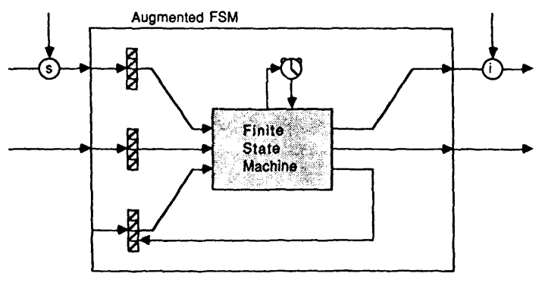
Figure 5.10. Conceptual model of AFSM from [90]. At the heart of AFSM is a regular FSM with timer that regulates state transitions on timeouts. The inputs to the FSM is buffered (only three inputs are shown as an example – the FSM can have arbitrary number of inputs and outputs). Side-tap with (s) indicates suppression of input line of the AFSM from another AFSM. Side-tap with (i) indicates inhibition of the output of the AFSM from another AFSM. Not all AFSM must have suppression or inhibition lines. The FSM may also receive feedback from itself.
Walk
Prowl
i
Leg actions
IR array
Figure 5.11. A simplified model of the walking robot AFSM network from [90]. The circle with label “i” indicates an inhibition side-tap. The filled boxes are AFSMs. The Walk AFSM generates signals for controlling the leg movements of the robot. The Leg actions block abstracts the AFSMs that controls the leg actuators. The Prowl AFSM receives input from an array of IR sensors, and outputs a signal that inhibits the walk signal if no movement is detected by IR array, so the robot does not move. Otherwise, the robot will start walking.

So far there has been very few efforts to formalize AFSM and Subsumption architecture (SA). There are researches that analyze hierarchical state machines [93] [94] [95] and timed finite state machines [96] [97] but none specifically addresses AFSM and SA. Perhaps using combined knowledge from the two domains of hierarchical and timed finite state machines, a formalization can be derived. But for now, it is beyond the scope of this dissertation.

Regular Grammar, Regular Languages, Finite Automata, and Regular Expressions
As mentioned above, there are relationships between Automata, Regular Expressions and Regular Languages: for every regular expression, there is an equivalent automaton, and vice versa [ref to Kleene]. The automata in this case only recognizes regular languages. In addition, there is the concept of context-free grammars which recognizes more than just regular languages, but also context-free languages and nonlinear languages. These classes of languages will be discussed below.
Because regular expressions can only represent/recognize regular languages and grammars can do more than regular languages, a general grammar is more powerful than regular expressions. Furthermore, every regular language can be represented by a regular grammar which is a subset of context-free grammars that only produces regular languages. Hence, there is a relationship between regular grammars, regular languages, and automata. In other words, now one can convert a regular grammar to an automaton, and vice versa.
If the behaviors of robot actors can be described in some formal language, grammars provide another way to represent robot behaviors. In many cases, robot behaviors can be represented by regular languages, but only few cases may require non-regular languages such as: returning to an original orientation given a number of fixed-angle rotations. If the robot turned 30 degrees to the right twice, it could know that to return to its original orientation, it needs to turn 30 degrees twice in the opposite direction (left). In any case, some behaviors may be easier/intuitive to describe as grammars, while others may be more intuitive described as an automaton or regular expressions. In the interest of demonstrating these relationships between regular grammar, regular languages, regular expressions, and finite automata, we will first focus on regular grammars, and later discuss non-regular languages.
A grammar G is defined as the set G = (V, ∑, S, P) where V is the set of variables (non-terminal symbols), ∑ is the set of terminal symbols (i.e. alphabet), S is the starting variable ($S∈V$), and P is the set of production rules. With respect to automata, ∑ is the set of input symbols, for example: {0, 1}, {False, True}, {a, b, c ,…} etc. By convention, usually non-terminal symbols are written in capital letters, and terminal symbols in lower-case letters if it uses letters at all. In general, a production rule is a rule that transforms a non-terminal symbol to another form which may consists of a combination of terminals and non-terminal symbols. To make these concepts clearer, consider the following example: A grammar G = ({S}, {λ, a, b}, S, P), where P consists of:
$$S→aS$$
$$S→bS$$
$$S→λ$$
Often, production rules for the same non-terminal symbols are written in a more concise way as:
$$S→aS\left|bS\right|λ$$
The grammar G has one non-terminal/variable S, the set of symbols {λ, a, b}, starting variable S, and three production rules in P. The language represented by this grammar can be generated by derivation, that is, by using the production rules. The first production rule $S→aS$ ruled that the variable S can be replaced by the terminal a followed by the non-terminal S. Similarly for the second rule with b instead of a. The third rule says that the non-terminal S can be replaced with the terminal λ (empty string). Following the derivation rules, below are some words in the language of grammar G or L(G):
- $S⟹aS ⟹abS⟹abλ=ab$
- $S⟹aS⟹a$
- $S⟹bS⟹bbS⟹bbbS⟹bbbaS⟹bbba$, and so on.
The first derived word is obtained by applying the first, second, and third production rules in succession.
- $S⟹aS$ by applying $S→aS$
- $aS⟹abS$ by $S→bS$
- $abS⟹abλ=ab$ by $S→λ$
The second and third words, and the rest of the words in the language L(G) can be obtained in a similar way by applying the production rules non-deterministically.
There are several kinds of production rules for a grammar:
- Nonlinear grammar
- Linear grammar
  - Right-linear
  - Left-linear
A nonlinear grammar is characterized by having at least one production rule which may have more than one non-terminal symbol on the right-hand side. Nonlinear grammar does not produce regular languages. For example:
$$S→SS$$
$$S→aS$$
$$S→bS$$
$$S→λ$$

On the other hand, a linear grammar is defined by having production rules that at most have one non-terminal symbol on the right-hand side. Linear grammars can produce both regular and non-regular languages. An example of non-regular language from a regular grammar is G = ({S}, {λ, a, b}, S, P), where P consists of:
$$S→aSb$$
$$S→λ$$
Which produces the language L(G) = { w | w = a^{n}b^{n}, n > 0 }.
The subset of linear grammars that can only produce regular languages are the right-linear and left-linear grammars, and thus are called regular grammars. In right-linear grammars, if a production rule have a non-terminal symbol on the right-hand side, the non-terminal is the last symbol produced. Similarly for left-linear grammar. For example:
- Right-linear grammar:
  - $S→aB$
  - $B→λ$
- left-linear grammar:
  - $S→Ba$
  - $B→c$
Now that we have introduced regular grammars, next we shall see that regular grammars can be easily converted into a finite state automaton. Consider the grammar H = ({S}, {λ, a, b}, S, P), where P consists of:
$$S→aA$$
$$A→baS|a|λ$$
The construction of the finite state automaton from the grammar H is described in table 5.1 below.
Table 5.1 Step-by-step construction of a finite state automaton from a grammar.
Step | Description | Automaton
1 | Identify the starting state by the starting non-terminal symbol. In this case: S | S
2 | Consider the production rule of S. Non-terminal symbols of the right-hand side is considered as the input symbols, and the non-terminal following it is the next state. So the production rule $S→aA$ can be interpreted as: If the automaton is in state S and receives input symbol a, then it will transition to state A. | S  A  a
3 | Consider the production rule for A. There are three possibilities for A: a) with a sequence of terminal symbols ba and transitions back to S, b) produces terminal symbol a, or c) produces the empty string.  Let’s apply possibility a) first.  Since there are two terminal symbols b and a prior to the non-terminal S, this indicates creating a intermediate state between inputs b and a. Let’s label this intermediate state B.  It does not matter which possibility is applied first. Follow the next steps for applying b) and c) | S  A  a  b  B  a
4 | Since the other possible production for A is a terminal symbol a without any non-terminal symbol following it, this m that in the automaton, input symbol a leads a transition from A to an accepting state. | S  A  a  b  B  a  a
5 | Finally, A also may produce λ (empty string), which means that A is also an accepting state.  And we are done! | S  A  a  b  B  a  a  A

Similar to regular grammars, regular expressions (RE) can be used to derive a finite state automaton. Because Behavior Expressions are based on REs, we discuss RE separately in the next chapter.

Automata as Model for Robot Motion and Robot Actions
One way to think about robot motion is as a sequence of poses, where a pose is a configuration of the robot’s joint angles at a given time. A motion is then a movement in time transitioning from pose to pose. For example, a walking motion can be modeled as a cycle of walking phases as in Figure 5.12 [98]:
Heel strike
Early Flatfoot
Toe off
Leg swing
Late flatfoot/early heel rise
Support Phase
Swing Phase
Figure 5.12. Phases of walking. Two major phases: Support and swing phase. Support phase consists of four sub-phases: heel strike, early support, late support, heel lift/toe off.

For example: a description of how a person perform the basic box step in Waltz consists of:
- start with standing with feet together with weight primarily on the right foot,
- stepping forward with the left foot and place weight on the left foot,
- step forward-right with the right foot and place weight on the right foot,
- bring left foot in and place side-by-side with the right foot (step-together), and transfer weight to the left foot,
- step back with the right foot and place weight on the right foot,
- step back-left with the left foot and place weight on the left foot,
- bring right foot in and place side-by-side with the left foot (step-together), and transfer weight to the right foot,
- repeat steps 2 through 7.
For an able human, those descriptions are relatively easy to follow and she/he can perform the steps without thinking too hard. For a robot, the programmer may have to program a “step forward with the left foot” (step No. 2) as follows:
- Make sure the body weight is transferred to the right foot, so that lifting the left foot will not cause the robot to lose balance and fall,
- Bend the left leg at the left hip, left knee, and ankle until the left foot is off the ground
- Rotate the left leg at the left hip x degrees, straighten the left leg, and rotate the ankle up y degrees
- Transfer weight forward, push off the right foot until body moves forward and off-balance for a short period
- Catch the ‘fall’ with the left leg that is already stretched forward, and so forth.
In this case, the “step forward with the left foot” description is at a lower level than the “basic Waltz box step” description because: a) it involves defining some joint angles, b) the robot cannot perform the next step in the “basic Waltz box step” until the former is satisfied/accomplished. Furthermore, the transition from step 4 to step 5 of the “step forward with the left foot” motion, depends on the condition of the dynamics of moving the body forward. Thus, a finite state machine model is not sufficient to describe such complex motions because of its discrete nature and the assumption of instantaneous output when the system arrive at a certain state (in case of Moore machine), or during transition between states (in case of Mealy machine). In such a case, a hybrid automaton model might be more appropriate.

Summary
In this chapter we reviewed some models of finite automata from Moore machine, Mealy machine, deterministic and non-deterministic automata, to probabilistic finite automata, hybrid finite automata and the more contemporary augmented finite state automata models. We also showed that robot motions and behaviors can be modeled as a finite state automaton.

Regular Expressions
Regular Expression is a finite sequence of symbols that represents a pattern. Regular Expression can then be used to find the pattern from a body of such symbols (e.g. finding a certain word in a paragraph), or to generate instances of that pattern. Formally, Regular Expression consisted of a set of symbols (alphabet) and a set of operators that operates on the symbols. The alphabet can be a collection of one or more symbols (most commonly used are alphanumeric characters), and the set of basic operators are: concatenation, union, and Kleene Star. First, let’s establish some terminologies. As mentioned before, a Regular Expression represents a set of sequences that matches that pattern. Each sequence in that set is called a word, and the set of sequences/words that can be recognized by the Regular Expression is called the language of the Regular Expression.
Kleene’s Theorem stated: 1) A language over an alphabet is regular iff it can be accepted by a finite automaton, and 2) for a given nondeterministic finite state automaton, there is one or more regular expressions that represents the automaton. Later in this chapter, we show some examples of conversion between regular expression and finite automata.
The rest of this section provides a brief introduction to Regular Expression starting with the operators using simple and slightly more complex examples, followed by a more formal discussion.
Formally, Regular Expression consists of a set of symbols or characters, and a set of operators. The set of symbols or characters is commonly referred to as the alphabet and represented by the symbol ∑ (sigma), although it is permissible to use any other letters (Greek or Latin) and is usually capitalized. A Regular Expression E is a sequence of the symbols and operators that describe a pattern. A word is a sequence of some combination of the symbols in the alphabet ∑ which the order of symbols in the sequence is governed by the Regular Expression E. The set of all possible words that can be constructed from the alphabet ∑ is denoted as ∑*. The set of words that matches with the pattern E over the alphabet ∑ is called the language of E and denoted as L(E).
The following symbols are valid Regular Expressions:
- ∅ : the empty set, or the language { } (contains no words)
- e : the empty string symbol. Sometimes the symbol lambda (λ) is also used. The language { e }, { λ } or { “” }. Different from the empty language.
- a : is the singleton set, the language that only contains one character { a }. In other words, { a } such that $a∈Σ$.
The class of languages made from Regular Expressions is called regular languages. A language is regular when it can be represented by an equivalent finite state machine. If the language requires an infinite amount of states (i.e. memory) to represent, then it is not a regular language. For example:
0*1(0*10*1)*0* is a regular language. This is a regular language because there is a state machine with a finite number of states that can represent this language (more formally, that accepts this language).
a^{n}b^{n} is the language of n number of ‘a’s followed by n number of ‘b’s. This is not a regular language because it will require an infinite number of states to take arbitrary n into account.
Regular languages over an alphabet ∑ are closed under Union, Concatenation operations and unbounded repetitions. Closed means the language generated by the operations are always a subset of the language ∑* (the set of all possible words under the alphabet ∑).

Regular Expression Operations

Concatenation
Concatenation is a binary operation which denotes a sequence of two symbols. The symbol for the concatenation operator is dot (∘), but in practice the operator is often omitted. For example, consider the following regular expression:
a ∘ b = ab
L(a ∘ b) = { ab }

The following convention is used for the Regular Expression examples. The right hand side of the symbol is a set (hence the curly brackets) of ‘words’/’strings’/sequence of symbols that can be recognized (or generated) by the Regular Expression on the left hand side. Verbally, the expression can be said as “the symbol a followed by b”. Thus, the language for that expression is L(a ∘ b) = { ab }.
Formally: If $G⊂Σ^{*}$ and $H⊂Σ^{*}$then $GH=\left\{ vw \right| v∈G and w∈H \}⊂Σ^{*}$
Concatenation can also be used in chain when there are more than two symbols in the sequence. For example:
a ∘ b ∘ c ∘ d ∘ e ∘ f ∘ g = abcdefg
L(a ∘ b ∘ c ∘ d ∘ e ∘ f ∘ g) = { abcdefg }
Using parentheses, the evaluation for the chained symbol is formally done as a ∘ (b ∘ (c ∘ (d ∘ (e ∘ (f ∘ g))))). The examples above show that the representation of the expression a ∘ b is equivalent to ab, which the latter is more commonly used in practice. From this point on, concatenation will be expressed using the latter representation with the symbol omitted.

Union
Union is a binary operator which denotes choice, and often understood as ‘or’. The symbol for the union operator is ∪. In most programming languages, the symbol for union is the vertical line (|). To avoid confusion when discussing sets, the symbol | will be used instead to represent union in Regular Expression. Consider the following example:
a | b { a, b}
The meaning of the expression is “the symbol a or the symbol b”. Therefore, the language for the expression a | b is the word a and the word b { a, b }.
Formally: If: $G⊂Σ^{*}$ and $H⊂Σ^{*}$then $G ∪H=\left\{ w \right| w∈G or w∈H \}⊂Σ^{*}$
Another example:
ab | ac | bc { ab, ac, bc }
The Regular Expression in this example match with the words ab, ac, and bc. In other words, ab, ac, and bc are the words in the language of the expression ab | ac | bc.

Kleene Star
The Kleene (pronounced: kl i:n i:) Star is a unary operator which denotes repetition and represented by the asterisk symbol (*). The operator is used by placing it on the right side of a symbol. When a symbol is followed by the Kleene Star operator, it means that the symbol may be repeated zero (no occurrence) or more (n) times. For example, given the alphabet ∑ = {a}:
a* { ε, a, aa, aaa, aaaa, … a^{n} }
Where ε (epsilon) denotes the empty string; a word which contains no character/symbol. Here, ε is when the symbol a is repeated zero times. a^{n} denotes that the symbol a is repeated n times. So the language for the expression a* is an infinite set.
Some additional symbols are used to make the expressions more compact and useful. The left and right parentheses “(“ and “)” are used to group symbols together and have the meaning of association in mathematical expressions, and are generally processed first. For example:
a( b | c ) { ab, ac }
The expression a( b | c ) can be read as “a followed by b OR c”, therefore the language of that expression is { ab, ac }.
The following examples show some more expressions with more meaningful patterns (as opposed to the ‘toy’ examples above):
Alphabet: { a … z }
Expression: ca(b|d|m|n|p|r|t|w) { cab, cad, cam, can, cap, car, cat, caw }
Meaning/language: all three-letter words starting with the letters “ca”)
Alphabet: { 0, 1 } (binary/boolean)
Expression: 1(11)* { 1, 111, 11111, 1111111, … , 1^{p} }
Meaning/language: odd numbers of 1’s (p will always be odd)
Alphabet: { 0, 1 }
Expression: 0*1(0*10*1)*0*
Meaning/language: all words that contain odd number of 1’s. Note: the number of repetition for each 0 symbol can be different in each word. For example: 0110010000 (the first * matched with 0 occured once, the second * matched with 0 occurring zero times, the third * matched with 0 repeated twice, the fourth * matched with (1001) occurred once, and the last/fifth * matched with 0 repeated four times).
Note the third example of the Kleene Star (repetition) operation over the expression in the parentheses. You can think of the expression (0*10*1) being evaluated first, yielding the string “1001”. The Kleene Star operation then repeats over the pattern inside the parentheses. Since regular languages are context-free and thus do not have memory, repetition over a pattern allows matching of two different strings where both strings match the given pattern. WHAT DO YOU MEAN HAVE NO MEMORY, THEY HAVE MEMORY AS STATES OF THE FSM.
If function L is a relation between a regular expression and a language, such that if R is a regular expression, then L(R) is the language represented by the regular expression R. Furthermore from [99]: (here be quoted texts)
L(∅) = ∅ and L(a) = {a} for each a ∈ ∑.
If α and β are regular expressions, then L((αβ)) = L(α)L(β).
If α and β are regular expressions, then L((α ∪ β)) = L(α) ∪ L(β).
If α is a regular expression, then L(α*) = L(α)*

Intersection and Complement in Regular Expression
The classical Regular Expression can be extended with the intersection and complement operations. The symbol for intersection is $∩$. Intersection is a binary operation and operates the same way as in sets. Given an alphabet ∑ = { a, b } and the language G = { aa, ab } and H = { ab, bb }, where $G⊂Σ^{*}$ and $H⊂Σ^{*}$ then $G∩H=\left\{ ab \right\}⊂Σ^{*}$. Notice that $G∩H$ is also closed.
The complement operation is unary, the symbol is $¬$, and used by placing the operator in front of the symbol or expression to be complemented. For example: using the alphabet ∑, and languages G and H as in the last paragraph, the complement of language G is: $¬G=Σ^{*}-G$. If used on a symbol instead of a language, then the complement is taken out of the alphabet. That is: $¬a=Σ-\left\{a\right\}=\{b\}$. For example: the language$J=¬ab=\{ bb \}$. If the alphabet ∑ = { a, b, c }, then $J=¬ab=\{ bb, cb \}$.

Parallel Operators
The parallel operator is used to denote behaviors that are executed at the same time. When a set of behaviors are given, separated by commas, and surrounded by the curly brackets, the behaviors will be executed simultaneously. There are intricacies within parallel executions, and they will be discussed in this section.
The simplest case of parallel executions is given in the following example. Suppose the symbol of parallel execution is the list of behaviors enclosed in {} (curly brackets). Given a set of behaviors, greeting and dancing, the expression:
{ greeting, dancing }
will cause the greeting behavior and dancing behavior to be executed at the same time. Naturally, one might ask, “what happens when the two behaviors compete (e.g. for the same DOFs) with each other?” Prior to execution, the behaviors are analyzed for conflicts. The resolution to this issue is discussed in Chapter X. For now, let’s assume that there is no conflict, so both behaviors will be executed in complete (i.e. from start to finish).
Suppose now it is desired to have a complex behavior (consists of a sequence of behaviors) to be executed in parallel with another behavior. There are two options: 1) write the sequence and optionally surround with (…), or 2) define a new behavior variable for this sequence. For example: the sequence is wave_hand ∘ say_hello, and the parallel behavior is dancing. The parallel expression can be written in the first form as: { wave_hand ∘ say_hello, dancing }. In the second form, suppose “greeting” is defined as: greeting = wave_hand ∘ say_hello. Then, the behavior can be written as: { greeting, dancing }.

Conversion of a Regular Expression to a Finite Automaton
In this section, two methods to convert regular expressions to their corresponding finite automaton are discussed. The first method is called Thompson’s Construction Algorithm [100], and the second is called Brzozowski’s derivation method [101].

Thompson’s Construction Algorithm
Thompson’s algorithm consists of five transition “rules” which are the state machine representations for each type of basic regular expressions:
With q as some start state, f as the end/accepting state.

Empty/epsilon transition:
q
f
ε
Transition by input symbol (e.g. a)
q
f
a
Concatenation (e.g. ab)

f
b
q
a
Union (e.g. a + b):

f
b
q
a

ε
ε
ε
ε
Kleene star (e.g. a*)

f
a

q
ε
ε
ε
ε

The construction of the Nondeterministic Finite Automaton (NFA) for a given regular expression is done using these rules. There is also an order of precedence of operation. Kleene star > concatenation > union. Suppose a regular expression: A(A + B)*B. The process starts from left to right because order matters.

Expression | NFA
A | q  f  A  From rule 2:
A(A+B)*  Step 1: X = (A+B)  AX* | f  X  q  ε  ε  ε  From rule 5: X*:  q  A  f  X  q  ε  ε  ε  ε  AX*: connect end state of A to start state of X*  (Rule 3)
Expand X to A+B  To replace X with A + B:  Substitute the left and right inner nodes (states) in X with the start and end states of A + B machine. | ε  q  A  f  (X)  q  ε  ε  ε  ε  f  B  q  ε  ε  ε  ε  A  X A + B  (Rule 4)  B  ε  ε  ε  ε  A
Finally, concatenate with D | ε  q  A  (X)  ε  ε  ε  ε  A(A+B)*B  (Rule 3)  B  ε  ε  ε  ε  A  f  B

Converting NFA to DFA
Nondeterministic Finite Automaton can be identified by the existence of epsilon transitions, and transition from one state to two different states or more with the same input symbol. When a NFA is converted to DFA, the set of states will be different. The algorithm used to convert the NFA to DFA here is called Subset Construction Algorithm [102]. For clarity and ease going through the algorithm, let’s enumerate the states in the NFA.

1
A
9
2
ε
ε
ε
ε
4
8
B
3
5
6
7
ε
ε
ε
ε
A
10
B
ε
Figure 6.1. The nondeterministic finite automaton for regular expression: A(A + B)*B.

The construction starts with the start state of the NFA. The first step is to define the epsilon closure: the set of states that can be reached from the start state only by epsilon transitions.

q (states) | δ(q, A) | δ(q, B)
1

Epsilon transition allows at least to stay at the same state. So, state 1 only have transition to itself. Next, check all the possible states that state 1 can reach for each input symbol (in this case {A, B}).
δ(q=1, A) = {2}
δ(q=1, B) = ∅
Next find any new state by checking the epsilon closures for each of next states:
ε({2}) = {2, 3, 4, 6, 9}
ε(∅) = ∅
The new state is {2,3,4,6,9}. Notice, a state for the DFA can be a set of states from the NFA.

q (states) | ε(δ(q, A)) | δ(q, B)
1 | {2, 3, 4, 6, 9} | ∅

Next, evaluate all the next states by repeating the process above:
δ(q={2, 3, 4, 6, 9}, A) = {5}
δ(q={2, 3, 4, 6, 9}, B) = {7, 10}
The epsilon closures:
ε({5}) = {3, 4, 5, 6, 8, 9}
ε({7, 10}) = {3, 4, 6, 7, 8, 9, 10}
So the new states are: {3, 4, 5, 6, 8, 9} and {3, 4, 6, 7, 8, 9, 10}

q (states) | ε(δ(q, Ay)) | ε(δ(q, B))
1 | {2, 3, 4, 6, 9} | ∅
{2, 3, 4, 6, 9} | {3, 4, 5, 6, 8, 9} | {3, 4, 6, 7, 8, 9, 10}
∅ | ∅ | ∅

If we continue the process:

q (states) | ε(δ(q, A)) | ε(δ(q, B))
1 | {2, 3, 4, 6, 9} | ∅
{2, 3, 4, 6, 9} | {3, 4, 5, 6, 8, 9} | {3, 4, 6, 7, 8, 9, 10}
∅ | ∅ | ∅
{3, 4, 5, 6, 8, 9} | {3, 4, 5, 6, 8, 9} | {3, 4, 6, 7, 8, 9, 10}
{3, 4, 6, 7, 8, 9, 10} | {3, 4, 5, 6, 8, 9} | {3, 4, 6, 7, 8, 9, 10}

For brevity, let’s represent each of the DFA states with symbols:
1 W (start state)
∅
{2, 3, 4, 6, 9} X
{3, 4, 5, 6, 8, 9} Y
{3, 4, 6, 7, 8, 9, 10} Z (accepting state)

Since the state Z contains the accepting state from the NFA (state 10), state Z is an accepting state of the DFA. The DFA is:

W
X
Y
Z
A
A
A
A
B
B
B
Z
∅
B
A, B
Figure 6.2. The deterministic finite automaton for the regular expression: A(A + B)*B

Let’s check:
The regular expression was: A(A+B)*B, which is the set of strings which starts with A and ends with B. Does the DFA always generate such strings when starting from state W and ends in the accepting state Z?
AB = W X ((Z)) (yes)
AABAB = W X Y Z Y ((Z)) (yes)
Thus, the automaton is equivalent to the regular expression.

Brzozowski’s Derivation Method
Given a regular expression E, Brzozowski’s derivation method is done by left-side derivation using a set of rules [101]. Given the alphabet ∑ = { x_{i}, x_{j} } and E_{k} ∈∑*, the derivation properties are:
P1. $x_{i}/x_{j}=\left\{ \begin{aligned} ε if i=j \\ ∅ if i≠j\end{aligned}\right.$
P2. $\left(E_{1}∪E_{2}\right){/x}_{i}=\left(E_{1}/x_{i}\right)∪(E_{2}/x_{i})$
P3. $e\left(E\right)= \left\{\begin{aligned}ε if ε ∈E \\ ∅ if ε∉E\end{aligned}\right.$
P4. $E_{1}E_{2}/x_{i}=\left(E_{1}{/x}_{i}\right)E_{2}∪e(E_{1})E_{2}/x_{i}$
P5. $E_{1}{/x}_{1}x_{2}…x_{n}=[[\left[E/x_{1}\right]/x_{2}]…]/x_{n}$
P6. $E^{*}/x_{i}=(E/x_{i})E^{*}$
P7. $E/ε=E$
P8. $εE=Eε=E$
P9. $∅E=E∅=∅$
P10. $∅∪E=E∪∅=E$
P11. $\left(E_{1}∩E_{2}\right)/x_{i}=\left(E_{1}/x_{i}\right)∩(E_{2}{/x}_{i})$

Using the expression above: A(A+B)*B, with alphabet ∑ = {A, B}, and substitute + for ∪, let’s perform the derivation starting from the original expression denoted as L₁.
L₁ = A(A∪B)*B
Start the derivation by choosing an arbitrary symbol from the alphabet. Suppose the first derivation is done for the symbol A:
L₁/A = $(A{\left(A∪B\right)}^{*}B)/A$
= $(A){(\left(A∪B\right)}^{*}B)/A$
The above form is derivable by P4, where:
E₁ = A
E₂ = ((A ∪ B)*B)
Applying P4 on L₁ yields:
L₁/A = $\left(A{/A)(\left(A∪B\right)}^{*}B\right)∪e(A){(\left(A∪B\right)}^{*}B)/A$
Applying P1 on $A/A$ and P3 on $e(A)$:
= $ϵ\left({\left(A∪B\right)}^{*}B\right)∪∅({\left(A∪B\right)}^{*}B)/A$

And finally, by P9 on $∅\left({\left(A∪B\right)}^{*}B\right)$:
L₁/A = ${\left(A∪B\right)}^{*}B$ = L₂
In this first derivation, we arrive at the expression: ${\left(A∪B\right)}^{*}B$. We register the expression as L₂ which will become one of the states in the automaton. Next, we have the option to continue deriving L₂ or deriving L₁ with the next symbol in the alphabet. Let’s do the latter for now:
L₁/B = $(A{\left(A∪B\right)}^{*}B)/B$
= $\left(A{/B)(\left(A∪B\right)}^{*}B\right)∪e(A){(\left(A∪B\right)}^{*}B)/B$
= $∅({\left(A∪B\right)}^{*}B)∪∅{(\left(A∪B\right)}^{*}B)/B$
= $∅$ = L₃
We found two new states: L₂ and L₃. Next, let’s derive L₂ by A:
L₂/A = ${(\left(A∪B\right)}^{*}B)/A$
E₁ = (A∪B)*
E₂ = B
= ${(\left(A∪B\right)}^{*}/A)B∪ e({\left(A∪B\right)}^{*})(B/A)$
= ${((A∪B)/A)(\left(A∪B\right)}^{*})B∪ e({\left(A∪B\right)}^{*})(B/A)$ (By P4)
= ${((A/A)∪(B/A))(\left(A∪B\right)}^{*})B∪ϵ∅$ (By P2 and P1)

= ${(ϵ∪∅)(\left(A∪B\right)}^{*})B∪ϵ∅$ (By P1)
= ${(\left(A∪B\right)}^{*})B$ = L₂ (By P10)
To find the automaton, we proceed to perform the derivations until the there are no new expressions found.
L₂/B = ${(\left(A∪B\right)}^{*}B)/B$
= ${(\left(A∪B\right)}^{*}/B)B∪e({\left(A∪B\right)}^{*})(B/B)$
= ${((A∪B)/B\left(A∪B\right)}^{*})B∪ϵϵ$
= ${((A/B)∪(B/B))\left(A∪B\right)}^{*})B∪ϵϵ$
= ${((∅∪ϵ)\left(A∪B\right)}^{*})B∪ϵϵ$
= ${(∅\left(A∪B\right)}^{*}∪{\left(A∪B\right)}^{*})B∪ϵϵ$
= ${\left(A∪B\right)}^{*}B∪ϵ$ = L₄

L₃/A = L₃/B = $∅$

L₄/A = ${(\left(A∪B\right)}^{*}B∪ϵ)/A$
= $({\left(A∪B\right)}^{*}B)/A∪(ϵ)/A$

For brevity, since we already did the derivation for the left argument as L₂/A:
= $({\left(A∪B\right)}^{*}B)∪∅$
= ${\left(A∪B\right)}^{*}B$ = L₂

L₄/B = ${(\left(A∪B\right)}^{*}B∪ϵ)/B$
= $({\left(A∪B\right)}^{*}B)/B∪(ϵ)/B$

Again, the derivation for the left argument was done as L₂/B:
= ${(\left(A∪B\right)}^{*}B∪ϵ)∪∅$
= ${\left(A∪B\right)}^{*}B∪ϵ$ = L₄

There are no new states (i.e. expressions) being found, so the state machine is:

L₁
L₂
L₃
L₄
A
B
A
B
B
A
A, B
L₄
Figure 6.3. The deterministic finite automaton for the regular expression: A(A + B)*B using Brzozowski derivation method.
As shown, the Brzozowski’s derivation method directly produces the DFA from the regular expression without first producing a NFA. The automaton also has one less state than the first state machine.
Consider a machine which defines a language:
$$E_{1}=X_{2}X_{1}^{*}∪X_{1}X_{2}$$
Let us first find the different derivatives for language $E_{1}$ over alphabet $∑=\{X_{1},X_{2}\}$. For brevity, some obvious transformations of regular expressions are not shown.
$$E_{1} / λ =E_{1}$$
$$E_{1}∕X_{1}=\left(X_{2}X_{1}^{*}∪X_{1}X_{2}\right)∕X_{1}$$
$$=(X_{2}X_{1}^{*})∕X_{1}∪(X_{1}X_{2}) /X_{1}$$
$$=\left(\left(X_{2}∕X_{1}\right)X_{1}^{*}∪ϵ\left(X_{2}\right)\left(X_{1}^{*} {∕X}_{1}\right)\right)∪(\left(X_{1}∕X_{1}\right)X_{2}∪ϵ\left(X_{1}\right)\left(X_{2}∕X_{1}\right))$$
$$=\left(∅X_{1}^{*}∪∅\left(X_{1}∕X_{1}\right)X_{1}^{*}\right)∪\left(λX_{2}∪∅∅\right)=X_{2}=E_{2}$$
$${E_{1}}/{X_{1}X_{2}}=\left({E_{1}}/{X_{1}}\right)∕X_{2}={E_{2}}/{X_{2}}={X_{2}}/{X_{2}}=λ=E_{3}$$
$${E_{1}}/{X_{1}X_{1}}={\left({E_{1}}/{X_{1}}\right)}/{X_{1}}={E_{2}}/{X_{1}}={X_{2}}/{X_{1}}=∅=E_{4}$$
$${E_{1}}/{X_{1}X_{2}X_{1}}={\left({E_{1}}/{X_{1}X_{2}}\right)}/{X_{1}}={E_{3}}/{X_{1}}=λ/{X_{1}}=∅=E_{4}$$
$${E_{1}}/{X_{1}X_{2}X_{2}}={\left({E_{1}}/{X_{1}X_{2}}\right)}/{X_{2}}={E_{3}}/{X_{2}}=λ/{X_{2}}=∅=E_{4}$$

$${E_{1}}/{X_{2}}=\left(X_{2}X_{1}^{*}∪ X_{1}X_{2}\right)∕X_{2}$$
$$={\left(X_{2}X_{1}^{*}\right)}/{X_{2}}∪(X_{1}X_{2})∕X_{2}$$
$$=\left(\left({X_{2}}/{X_{2}}\right)X_{1}^{*}∪ϵ(X_{2})({X_{1}^{*}}/{X_{2}})\right)∪(\left({X_{1}}/{X_{2}}\right)X_{2}∪ϵ(X_{1})({X_{2}}/{X_{2}}))$$
$$=\left(λX_{1}^{*}∪∅∅\right)∪\left(∅X_{2}∪∅λ\right)$$
$$=X_{1}^{*}=E_{5}$$
$${E_{1}}/{X_{2}X_{1}}=\left({E_{1}}/{X_{2}}\right)∕X_{1}=E_{5}∕X_{1}$$
$$=X_{1}^{*}∕X_{1}=\left({X_{1}}/{X_{1}}\right)X_{1}^{*}$$
$$=λX_{1}^{*}=X_{1}^{*}=E_{5}$$
$${E_{1}}/{X_{2}X_{2}}={\left({E_{1}}/{X_{2}}\right)}/{X_{2}}={E_{5}}/{X_{2}}$$
$$={X_{1}^{*}}/{X_{2}}=∅=E_{4}$$

$${E_{1}}/{X_{2}X_{1}X_{1}}={\left({E_{1}}/{X_{2}X_{1}}\right)}/{X_{1}}={E_{5}}/{X_{1}}$$
$$={X_{1}^{*}}/{X_{1}}=X_{1}^{*}= E_{5}$$

The derivatives obtained above (E₁, E₂, E₃, E₄, E₅) are all the derivatives that can be created from the language E₁ with all words $s∈Σ^{*}$, because if we will find derivatives of any of them with any letter of ∑ then only the derivatives that already exists will be created.
The machine corresponding to this expression is shown in Figure 6.4 below and created in the following way:
Subordinate one node of the graph to each derivative, The initial node is subordinated to expression $E_{1}$
The arrow labeled with $X_{j}$ leads from the node corresponding to derivative $E_{i}$to the node corresponding to derivative $E_{i}∕X_{j}$
$$E_{1}=X_{2}X_{1}^{*}∪X_{1}X_{2}$$
$$E_{2}=X_{2}$$
$$E_{5}=X_{1}^{*}$$
$$E_{3}=λ$$
$$E_{4}=∅$$
$$X_{1}$$
$$X_{2}$$
$$X_{2}$$
$$X_{2}$$
$$X_{1}$$
$$X_{1}$$
$$X_{1}, X_{2}$$
$$X_{1}, X_{2}$$
Figure 6.4 The DFA produced using Brzozowski’s derivation method
Derivatives $E_{i}$correspond to the respective states $A_{i}$. The regular expression corresponding to derivative $E_{i}$describes a regular event which consists in transition of the machine from state $A_{i}$ to one or more of the final states of the machine. For instance, $E_{2}=X_{2}, E_{5}=X_{1}^{*}$. We can observe, that such sets of words describe transitions from state $A_{2}$ to final state $A_{5}$ and from state A₅ to final state A₅ (figure x). Let us also observe $ϵ\left(E_{i}\right)=λ$ for $A_{i}∈F$ and $ϵ\left(E_{i}\right)=∅$ for $A_{i}∈F$ where F is a set of final (accepting) states of the machine. For example: $ϵ(E_{4})=ϵ\left(X_{1}^{*}\right)=λ$, $A_{4}∈F$, $ϵ\left(E_{2}\right)=ϵ \left(X_{2}\right)=∅$, $A_{2}∈F$.
Let $P=\left[E_{1}, …, E_{n}\right]$ be a vector of languages, where coordinates $E_{i}, i=1, …, n$ are regular languages over alphabet ∑.
The derivative P/X_{j} is defined as a vector of languages:
$$P/{X_{j}}=\left[{E_{1}}/{X_{j}}, ⋯, {E_{n}}/{X_{j}}\right]=P_{k}$$
Two derivatives P_{i} and P_{j} are equivalent when for each $i = 1, 2, ⋯, n$ languages E_{i} are equivalent. However, this must not necessarily mean that the regular expressions are identical. For example, the derivatives P₁, P₂, P₃ are equal:
$$P_{1}=[X_{1}^{*}∪λ, {\left(X_{1}∪X_{2}\right)}^{*}]$$
$$P_{2}=[{\left(X_{1}^{*}\right)}^{*}, {\left(X_{1}^{*}∪X_{2}^{*}\right)}^{*}]$$
$$P_{3}=[X_{1}^{*}, {\left(X_{1}^{*}X_{2}^{*}\right)}^{*}]$$
It was proven, that when $E_{i}, i=1, …, n$are regular, then the number of different derivatives $P_{j}=P∕s$, where s is an arbitrary word from $Σ^{*}$is finite and equal to the minimum number of states of the machine, which recognizes the words over alphabet ∑, that belong to languages $E_{i}, i=1, ⋯, n$.
We will discuss only the case of synthesis of the Moore machine. The method for Mealy machines is somewhat more complex albeit using very similar methods.
Dividing the vector P by all words from $Σ^{*}$we construct a machine $M=[A, X, Y, δ, λ$] with initial state A₁ where:
$$A_{1}=P$$
$A_{j}=P_{j}$, where P_{j} are all different derivatives P/s, where $s∈Σ^{*}$
$δ\left(P_{i}, X_{j}\right)={P_{i}}/{X_{j}}=[{E_{i1}}/{X_{j}}, {E_{i2}}/{X_{j}}, ⋯,{E_{in}}/{X_{j}}]$
$Y$ is the set of all values:” $ϵ\left(P_{j}\right)=ϵ\left(P/s\right)=[ ϵ\left({E_{1}}/s\right), ⋯, ϵ({E_{n}}/s)]$ for each derivative $P/s, s∈Σ^{*}$.
$$λ\left(P_{j}\right)=ϵ(P_{j})$$
Machine M is minimal in the class of Moore machines equivalent to it. However, if we cannot determine if the two derivatives are equal, we shall assign two different states to them. The machine obtained in this way must not necessarily be a minimal one. It is often convenient to minimize this machine concurrently with generation of new derivatives.

Example: The Aggressive Braitenberg Vehicle
To illustrate the relationship between automaton, regular grammar, and regular expressions, let’s see an example using Braitenberg Vehicle model.
The Aggressive Braitenberg vehicle is a mobile automaton that was hard-wired to approach a light source. The vehicle has two rear wheels which are individually motorized, and a flywheel on the front. It is also equipped with two light-detecting sensors; one on the front-left side and one on the front-right side. The left light sensor is connected to the right motor, and the right sensor to the left motor. When the sensor detects light, a signal will be sent to activate the motor that is attached to the sensor. With this configuration, when a light source is detected on the left side, the robot will turn to the left, and turn right when the light is on the right side. Thus, this configuration makes the vehicle appear to have the “aggressive towards light” behavior. For this example, we will keep the automaton deterministic.
Once the behavior of the deterministic automaton is understood, one can start describing the automaton with either the finite-state machine model, regular expression, or regular grammar. Suppose we start with a FSM as shown in figure 6.5 below. The automaton has four modes of operation: Stop, Forward, Turn left, and Turn right. We may define the system such that the next states from any state are determined solely by the input values from the sensors as shown in the table T below. For example: when the input values from the sensors are 00, the automaton always go to state Stop regardless of the current state.
Left Sensor  (0 = no light,  1 = light) | Right Sensor  (0 = no light,  1 = light) | State
0 | 0 | Stop
0 | 1 | Right
1 | 0 | Left
1 | 1 | Forward

Stop
Left
Forward
Right
10
10
10
10
00
00
00
00
01
01
01
01
11
11
11
11
Figure 6.5. Automaton for the aggressive Braitenberg vehicle.

To simplify the conversion of the system into regular language and regular grammar, the input value combinations are represented using symbols of our choosing, say: 00 = a, 01 = b, 10 = c, 11 = d, therefore the alphabet is ∑ = {a, b, c, d}. Let’s also represent each state with symbols instead of words: Stop = S, Left = L, Right = R, Forward = F, such that the set of states S = {S, L, R, F}. The updated automaton is shown in figure 6.6. Now we can find the corresponding regular expression for each state.

Brzozowski’s Method
Using the system of regular equations introduced by Brzozowski [101]:
Stop: S = aS + bR + cL + dF
Left: L = aS + bR + cL + dF
Right: R = aS + bR + cL + dF
Forward: F = aS + bR + cL + dF
Normally, the machine to convert to regular expression would be a Rabin-Scott machine with well-defined strating state and the set of accepting states. Since the Braitenberg vehicle automaton in general does not have a predetermined set of starting and accepting states, for this exercise, we arbitrarily decide that Stop (S) is the starting state and Forward (F) would be an accepting state for this automaton.
F = ε + aS + bR + cL + dF
S = (a + bb*a + cc*a + bb*ca + cc*ba + dd*a)*(d + bb*d + cc*d + bb*cc*d + cc*bb*d)d*
In general, the expression consists of two parts: E = X*Y, where:
X = all the possible transitions from the starting state back to itself
Y = the transition(s) from the starting state to the accepting state
S
L
F
R
c
c
c
c
a
a
a
a
b
b
b
b
d
d
d
d
F
Figure 6.6. Automaton for the aggressive Braitenberg vehicle with state names and input symbols represented using variables. For states: S=Stop, L=Left, R=Right, F=Forward. Inputs: a=00, b=01, c=10, d=11

State Removal Method
For this automaton, we can assume the starting state is always the Stop state. The expression for a state is then calculated by setting the accepting state to be the state of interest. For example: to find the expression for the Stop state, the accepting state is the Stop state itself. Once the starting and accepting states have been decided, the state removal method can be performed.
We have a choice of removing either L or R first. Let’s remove L. By choosing L, it means now L is considered an intermediate state, and the transitions between all other states that goes through L must be written as a regular expression.
S
F
R
a
b
b
b + cc*b
d + cc*d
d
d
F
cc*d + d
a + cc*a
a + cc*a
Figure 6.7. Updated automaton after state L is removed.
Next, remove R:
S
F
d + cc*d + b(b+cc*b)*d
F
cc*d + d + b(b+cc*b)*d
a + cc*a + b(b+cc*b)*a
a + cc*a + (b+cc*b)*a
Figure 6.8. Updated automaton after state L and R are removed.

To yield the expression for this automaton:
F = (a + cc*a + b(b+cc*b)*a)*(cc*d + d + b(b+cc*b)*d)((d + cc*d + b(b+cc*b)*d) + (a+cc*a+b(b+cc*b)*a) (a + cc*a + b(b+cc*b)*a)*(cc*d + d + b(b+cc*b)*d))*.
If we may replace the unwieldy expressions with new symbols {W, X, Y, Z}:
W = a + cc*a + b(b+cc*b)*a
X = cc*d + d + b(b+cc*b)*d
Y = d + cc*d + b(b+cc*b)*d
Z = a + cc*a + b(b+cc*b)*a
Then the final expression is:
F = W*X(Y + ZW*X)*
F
W*X(Y + ZW*X)*
F
Figure 6.9. The reduced machine

Notice that the same machine can be represented by two different regular expressions, but in this example Brzozowski’s method gives an expression that is easier to read than the state removal method.

Parallelism (Product Machine) by Brzozowski’s Derivation
An advantage of Brzozowski’s derivation method is the construction of a state machine from a vector of regular expressions. The processing of a vector of regular expressions using Brzozowski’s derivative method can be considered as running parallel operation of the state machines which are represented by the regular expressions in the vector. Observe that using Brzozowski’s derivation method to process a vector of regular expressions can also be understood as ‘feeding’ all the regular expressions in the vector with the same input values at one time.
The ability to process multiple machines in parallel is useful for reachability analysis of interaction between multiple systems to find if some interesting interactions can be achieved or not. For example, interaction between a gentleman-robot and a rude-robot, a guard dog and a thief. For the former, an interesting interaction would be if the gentleman-robot and the rude-robot can get into a quarrel. Otherwise, if the two robots end up never interacting with each other, or all the interactions would be very short, then it is not very interesting. For the latter, it would be more interesting if sometimes the dog would catch the thief, the thief would sometimes be successful in avoiding the dog, and sometimes they get into a chase. If the dog would always catch the thief or the thief would always escape the dog, then the ‘play’ is not very interesting.
A tuple of regular expressions is referred as a regular vector R = (R₁, …, R_{n}), where R_{k} ∈ R is a regular expression. The resulting state diagram is the product automaton of the machines in R, and illustrates the behavior of the whole system considering the interaction between the machines in R. For example: the product of two machines in R = (R₁, R₂) with R₁ = (0 + 10*1)*10*1 and R₂ = (0 + 1)*01. States that differ by ε or ∅ can be considered as the same state. Additionally, Z = (Z₁, … , Z_{n}) is the tuple of output at each transition (i.e. consumption of character). Each Z_{k} is a binary variable which value is 1 if R_{k} contains ε, and 0 otherwise. Figure 6.10 shows the product machine.

E₀ = ( R₁, R₂ )
E₀/0 = ( R₁/0, R₂/0 ) = ( R₁, R₂ + 1 ) => E₁ (Z = (0,0)) | Z = (0, 0)
E₀/1 = ( R₁/1, R₂/1 ) = ( 0*1R₁ + 0*1, R₂ ) => E₂ | Z = (0, 0)
E₁/0 = ( R₁/0, (R₂ + 1)/0 ) = ( R₁, R₂ + 1 ) => E₁ | Z = (0, 0)
E₁/1 = ( R₁/1, (R₂ + 1)/1 ) = ( 0*1R₁ + 0*1, R₂ + ε ) = ( 0*1R₁ + 0*1, R₂ ) => E₂ | Z = (0, 1)
E₂/0 = ( (0*1R₁ + 0*1)/0, R₂/0 ) = ( 0*1R₁ + 0*1, R₂ + 1 ) => E₃ | Z = (0, 0)
E₂/1 = ( (0*1R₁ + 0*1)/1, R₂/1 ) = ( R₁ + ε, R₂ ) = ( R₁, R₂ ) => E₀ | Z = (1, 0)
E₃/0 = ( (0*1R₁ + 0*1)/0, (R₂ + 1)/0 ) = ( 0*1R₁ + 0*1, R₂ + 1 ) => E₃ | Z = (0, 0)
E₃/1 = ( (0*1R₁ + 0*1)/1, (R₂ + 1)/1 ) = ( R₁ + ε, R₂ + ε ) = ( R₁, R₂ ) => E₀ | Z = (1, 1)
E₁
E₀
E₂
E₃
$$0/{Z=(0,0)}$$
$$1/{Z=(0,0)}$$
$$0/{Z=(0,0)}$$
$$1/{Z=(0,1)}$$
$$0/{Z=(0,0)}$$
$$1/{Z=(1,0)}$$
$$0/{Z=(0,0)}$$
$$1/{Z=(1,0)}$$
Figure 6.10. Product machine of R₁ and R₂.

The resulting machine can be considered as the parallel operation of the two machines R₁ and R₂
As a second example: let’s find the Moore machine which determines with the states of two outputs, whether the input words belong to the sets: $E_{1}=X_{1}X_{2}^{*}, E_{2}=X_{1}^{*}X_{2}$.
$$P=\left[E_{1}, E_{2}\right]=[X_{1}X_{2}^{*}, X_{1}^{*}X_{2}]$$
$$P_{1}=P/{X_{1}}=[{X_{1}X_{2}^{*}}/{X_{1}},{X_{1}^{*}X_{2}}/{X_{1}}]$$
$$=[\left({X_{1}}/{X_{1}}\right)X_{2}^{*}∪ϵ\left(X_{1}\right)\left({X_{2}^{*}}/{X_{1}}\right), \left({X_{1}^{*}}/{X_{1}}\right)X_{2}∪ϵ(X_{1}^{*})({X_{2}}/{X_{1}})]$$
$$=[X_{2}^{*}, X_{1}^{*}X_{2}]$$
$$ϵ\left(P_{1}\right)=(λ, ∅)$$

$$P_{2}=P/{X_{2}}=[{X_{1}X_{2}^{*}}/{X_{2}},{X_{1}^{*}X_{2}}/{X_{2}}]$$
$$=[\left({X_{1}}/{X_{2}}\right)X_{2}^{*}∪ϵ\left(X_{1}\right)\left({X_{2}^{*}}/{X_{2}}\right), \left({X_{1}^{*}}/{X_{2}}\right)X_{2}∪ϵ(X_{1}^{*})({X_{2}}/{X_{2}})]$$
$$=[∅, λ]$$
$$ϵ\left(P_{2}\right)=(∅, λ)$$

$$P_{3}={P_{1}}/{X_{1}}={\left(P/{X_{1}}\right)}/{X_{1}}= [X_{2}^{*}∕X_{1}, X_{1}^{*}X_{2}∕X_{1}]$$
$$=[∅, X_{1}^{*}X_{2}]$$
$$ϵ\left(P_{3}\right)=(∅, ∅)$$
$${P_{3}}/{X_{1}}=\left[∅, X_{1}^{*}X_{2}\right]=P_{3}$$

$$P_{4}={P_{1}}/{X_{2}}=P/{X_{1}X_{2}}=\left[X_{2}^{*}, λ\right]$$
$$ϵ\left(P_{4}\right)=(λ, λ)$$
$$P_{5}={P_{4}}/{X_{1}}=P/{X_{1}X_{1}X_{1}}=\left[∅, ∅\right]$$
$$ϵ\left(P_{5}\right)=(∅, ∅)$$
$$P_{6}={P_{4}}/{X_{2}}=[X_{2}^{*}, ∅]$$
$$ϵ\left(P_{6}\right)=(λ, ∅)$$
$${P_{6}}/{X_{1}}=\left[∅, ∅\right]=P_{5}$$
$${P_{6}}/{X_{2}}=\left[X_{2}^{*}, ∅\right]=P_{6}$$
$${P_{3}}/{X_{2}}=\left[∅, λ\right]=P_{2}$$
$${P_{2}}/{X_{1}}=\left[∅, ∅\right]=P_{5}$$
$$P_{2}\backslash X_{2}=\left[∅,∅\right]=P_{5}$$
Thus, the output alphabet:
$$Y=\{\left(λ, ∅\right), \left(∅, λ\right), \left(λ, λ\right), \left(∅, ∅\right)\}$$
Calculation of derivatives is presented in graphic form in Figure 3. The graph from Fig 3a has derivatives of P as nodes, while the graph from Fig 3b has nodes corresponding to simplified expressions of these derivatives.
Kleene’s theorem stated that regular expressions and finite state automaton are equivalent [103]. Because robot behaviors, particularly those in the form of robot motions such as gestures, are by nature a sequence, they can be naturally be described as finite state automata. Hence, I believe a regular language would be sufficient and perhaps more intuitive to program robot behaviors.

Behavior Expressions
Behavior Expressions (BE) is our attempt to further extend probabilistic exPERE for our purposes of creating a formal method for generating behavior/motion controllers for robots. In general, we are using EE to describe non-deterministic finite automata (NFA) for recognizing input patterns, mapping between input and output, and the output itself.
In BE, we try to include more operators to meet our needs for generating robot motion controllers. Some of the fundamental concepts of automata theory that we try to incorporate in the context of motion description, analysis and synthesis are the following:
1. probabilistic behaviors,
2. fuzziness,
3. constraint satisfaction,
4. validation, and
5. verification.

Some Definitions
Definition 1. Pose. A pose is a particular configuration of one or more joint positions on the robot. Usually a pose will have a certain meaning. For example: positioning the head slightly tilted to the right (or left) involves only the position of the roll (sagittal) joint of the head, but it can be associated with “showing interest” or “confusion” gestures. Looking down can be associated with “sad”, “shame”, “defeated”, or “tired” gestures. In contrast, bending the arm at the elbow such that the forearm is pointing forward (without the finger-pointing), generally does not have any particular meaning. If the hand would also open up while the forearm is pointing forward, it could mean “please” or “asking for something”, or if the hand is making a pointing shape, then it indicates the robot is indicating the person, or telling the person to look in that direction.
Definition 2. Atomic action. An action could be a motion, speech (speaking a sentence), blinking a light, or others. An atomic action is a complete action that has some meaning and is analogous to a verb in Rose et. al. terminology [1]. Thus, an atomic action where the action is a motion can consist of a single pose, or a short sequence of poses. Here, we have the liberty to choose what we consider to be an atomic action for the robot, but generally the motion should be simple. For example: if the robot is mobile, an atomic action could be “drive forward”, “turn clockwise” or “turn counter-clockwise” [3]. For a humanoid robot, “nodding”, “shaking head”, “look left”, “look up”, “salute” could be considered atomic actions. Additionally, if it is possible, “walking forward”, “step to the right” and other complex actions can be included as long as the designers feel those actions are ready to be considered as atomic. A good indicator for considering an action as atomic is if the action is often used as a component to construct complex motions or the motion can be used as secondary actions (parallel motions - see Disney Animation Principles section below??).
An atomic action α is described as a tuple (U, ξ, T) where U is the set of joint angle positions of the robot (u1, … , uk), ξ is a Boolean valued-variable with 1 indicating the action is active and inactive if the value is 0, and T is the maximum time to complete the motion. The notation for atomic action is adapted from MDLe [3] because we found that this notation satisfies our requirements. But here we expanded the meaning beyond just physical movements of the robot, hence we use the general term ‘action’. In the case where an atomic motion is a relatively complex motion such as “walking”, instead of a set of joint angle positions, U would be the motion description for walking. ξ remains to have the same meaning but can be used as an interrupt to stop the motion, for example if it is no longer possible to maintain a balance of “walking”. T remains as the maximum duration of the motion.
Definition 3. Motion Alphabet. The Motion alphabet is the set of atomic motions. Motions and gestures for the robot are constructed by combining elements from the Motion alphabet using the operators described below. The Motion alphabet is denoted by the symbol Α, where Α = { α1, … , αm}, where αi = (Ui, ξi, Ti).
Definition 4. Motions, Actions, Gestures. These three words tend to be used interchangeably to refer to the sequence of movements constructed using a set of atomic motions arranged in some order and executed by the robot. For example: a gesture gi can be described by the sequence gi = α2α1α1α3. This gesture could be some sort of greeting where: α2 = “raise right hand”, α1 = “blink eyes”, α3 = “say hello”.
Definition 5. Behavior. A behavior can be either motions, actions, gestures, or any combination of these in some way (e.g. sequence), which have some meaning and a function of some input. Examples for behavior: “lose contact”, “found object of interest”, “follow (object of interest)”, “approach”, “wander”, “look around”, “greeting”, “averse/avoiding”, “playing”

Basic Behavior Expression (BE)
In the basic form, an EE is very similar to a pattern in regular expression. For example, let’s define a greeting gesture.
greeting = wave_right_arm
In the above BE, we just defined the greeting gesture with one atomic gesture: wave_right_arm. For now, let’s assume the robot does have a right arm, and wave_right_arm is a pre-programmed motion. Next, we can update the gesture and say that a greeting should have the robot saying “Hello”. We modify our BE as follows:
greeting = wave_right_arm•say_hello
The greeting behavior is now waving the robot’s right arm followed by saying “Hello” (assume say_hello is an atomic gesture where the robot speaks “Hello”). The • operator is the concatenation operator, which creates a sequence of gestures. The order of execution of the sequence is first the left argument of the • operator, followed by the argument to its right.
Once again, we shall change our mind. Now we say that a greeting gesture can be only waving an arm (as in the first case) OR waving an arm followed by saying “Hello” (second case). We can quickly update our gesture:
greeting = wave_right_arm + wave_right_arm•say_hello
We can even simplify the BE:
greeting = wave_right_arm •( e + say_hello)
where ‘e’ is a “do nothing” symbol, equivalent to the symbol for empty string in regular expression. The + operator can be considered the Union operator, where either one of its arguments can be true, but not both. Or equivalently, we can express greeting as:
greeting = wave_right_arm • say_hello?
where the operator ? is borrowed from the set of regular expression special symbols, which indicates the expression preceding it may occur zero or at most once.
Notice, in one interpretation, we are starting to deal with some probabilistic behaviors: the + and ? operators are probabilistic operators. We can for instance assume that by default, the + operator cause either one of its two arguments to be selected with equal probability (i.e. ½). The symbol followed by the operator ? also has ½ probability of being selected, or not.

Probabilistic Behavior Expression
As an example for probabilistic behavior, let’s consider the following BE for the greeting behavior:
greeting = wave_right_arm +_{1/3} say_hello
The above behavior consists of two atomic gestures: wave_right_arm and say_hello. The union operator (+) is used because in this example, we decided that a greeting behavior is either waving the right arm OR saying “hello”, but never both, and never neither. Notice the subscript 1/3 on the union operator (+). We have arbitrarily chosen the meaning of the subscript to indicate the probability of choosing/executing the left argument, and therefore, the probability of choosing the right argument is 1 – 1/3 = 2/3. The probabilistic operation can be illustrated in Figure 7.1.
wave_right_arm +_{1/3} say_hello
wave_right_arm
say_hello
$1/3$
$2/3$
Figure 7.1 Interpretation of the probabilistic union operator. The fractional number subscript indicate the probability of choosing the left-hand argument, while the probability for the right-hand argument is one minus that number.

When we desire a possibility of no execution at all, we can use the * (iteration) operator, like such:
greeting = wave_right_arm* +_{1/3} say_hello
In this second case, there is a possibility that nothing will be executed at all when wave_right_arm is to be executed, but the system decides (with some probability) that it is to be repeated 0 times. Alternatively, the same effect can be achieved when the * operator is applied to say_hello. The side effect, naturally, is now both atomic gestures have the possibility to be repeated more than once, but only one of them at a time. If we want both atomic gestures to have the possibility to be repeated at least once, then we modify the EE to be:
greeting = wave_right_arm•(wave_right_arm)* +_{1/3} say_hello.(say_hello)*
Notice from the examples above; we can quickly grow the set of behaviors. In the first example this is our set:
wave_right_arm +_{1/3} say_hello = {(1/3)wave_right_arm, (2/3)say_hello}
In the second example we have the set:
wave_right_arm* +_{1/3} say_hello
= {e, wave_right_arm¹, wave_right_arm², …, say_hello}
Finally, in the third example, we have the set:
wave_right_arm•(wave_right_arm)* +_{1/3} say_hello.(say_hello)*
= {wave_right_arm¹, wave_right_arm², …, say_hello¹, say_hello², …}
Where the superscripts indicate the number of repetitions for the symbol/gesture preceding it. The repeated gesture g is in the form g^{n} where n is the number of repetitions. g⁰ = e = repeated 0 times – in other words: not executed. Since the operator * does not impose a limit to the number of repetitions, we do not give the probabilities for each element/gesture in G*. In our implementation, we may limit the maximum number of repetitions to a finite number, e.g. 5.
For a more complex expression, it is quite easy to trace and calculate the probabilities of the generated set. Consider the following example (for brevity, we use the symbols {0, 1, a, b} to represent the atomic gestures):
(0 +_{1/3} 1)•(0 +_{1/3} 1) +_{1/3} (a +_{1/3} b•b)
Let’s suppose we use the +1/3 probabilistic operator, and the operator • is deterministic. We can calculate the probabilities and draw a tree for the set of gestures from this complex expression:
(0+_{1/3}1)•(1+_{1/3}0) +_{1/3} (a+_{1/3}b)•b
P((0+_{1/3}1)•(1+_{1/3)}0))=1/3
P((a+_{1/3}b)•b)= 2/3
(0+_{1/3}1)
(1+_{1/3}0)
(1+_{1/3}0)
(a+_{1/3}b)
a
b
P(0)=1/3
P(1)=2/3
P(b)= 2/3
P(a)=1/3
01
00
11
10
ab
bb
P(1)=1/3
P(1)=1/3
P(0)= 2/3
P(0)=2/3
P(b)=1
P(b)=1
P(01)= 1/27
P(00)= 2/27
P(11)= 2/27
P(10)= 4/27
P(ab)= 6/27
P(bb)= 12/27
Figure 7.2 A more complex use of the probabilistic union operator. The probabilities of generating the possible behaviors from that expression can be calculated by traversing down the graph and multiplying the probabilities of each edge traveled as shown in table 3.
Table 3 Probability calculation for each possible behaviors from Figure 5.2
Generated behavior (G) | Probability P(G)
01 | 1/3*1/3*1/3 = 1/27
00 | 1/3*1/3*2/3 = 2/27
11 | 1/3*2/3*1/3 = 2/27
10 | 1/3*2/3*2/3 = 4/27
ab | 2/3*1/3*1= 2/9 = 6/27
bb | 2/3*2/3*1 = 4/9 = 12/27

In the more classical probabilistic expression representation, probabilities are written next to the input symbols. For example:
$$\frac{2}{3}a^{*}⋅\left(\frac{1}{3}a+b\right)$$
Which corresponds to the probabilistic finite state automaton:
1
2
$$a,\frac{2}{3}$$
$$a,\frac{1}{3}$$
$$b,1$$
Figure 7.3 Classical probabilistic FSM model
Whereas using the probabilistic operators, the expression:
$$a{ +}_{1/3} b$$
is equivalent to the following automaton:
1
2
$$a,\frac{1}{3}$$
$$b,\frac{2}{3}$$
Figure 7.4 Behavior Expression probabilistic operator FSM model
Or effectively:
$$\frac{1}{3}a+\frac{2}{3}b$$
In this case, the transition probability was defined by +_{1/3} such that P(1, a, 2) = 1/3 and P(1, b, 2) = 1 – P(1, a, 2) = 2/3. The probabilistic operator has a completely different interpretation of probabilistic expression than the classical counterpart. The meaning of this automaton is: “from state 1, there is 1/3 probability of transitioning to state 2 (accepting state) with action a, and 2/3 probability with action b.”
Thus, in this interpretation the sum of probability must equals one only among the actions/input symbols between two states, whereas in the classical notation, the sum of probability must equals one for each transition from a given state with a particular action/input symbol.
Another way to look at the probabilistic operator model is that the probability is effectively the input to the machine, and the symbols are the outputs on the transitions. This means this model is very similar to the Mealy machine model (output is a function of current state and input), with real values at the input.
An example use of the probabilistic operator is on a robot’s “wandering behavior”. Suppose it is desired that the robot will keep exploring its environment until it finds some object that it is interested in (e.g. objects with the color red). Figure 7.5 shows the automata model of the “wandering behavior”. The state “Look around” in Figure 7.6 is another probabilistic behavior, where the robot has probability r of turning left, and 1-r of turning right. If no object is detected after the robot took a turn to the left or right, the robot may go forward for x feet with probability p, or remain in state “Look around” with probability 1-p where it will randomly turn left or right again. There is also some probability q after the robot went forward x feet to remain in that state and go forward another x feet. Or, the robot may go to the “Look around” state with probability 1-q.
Look around
Go forward x feet

Found interesting obj.

Object detected
Object detected
no object detected [p]
no object detected [1-p]

no object detected [1-q]
no object detected [q]

Figure 7.5 Wandering behavior. As long as there is no object (of interest) detected by the robot, it will “wander” by looking around and moving in some random direction which decision is done probabilistically. “Look around” is a compound action, which is shown in Figure 8.3.
Turn left

Turn left

Turn right

r
1-r

Figure 7.6 “Look Around” action. Anytime the “Look around” is invoked, with some probability the robot may turn left or right at some randomly-chosen degrees.

In order to introduce the set of operators for the kinematic description, we must first discuss Behavior Expression in the next chapter as one of the main contributions of this dissertation.

Analysis of Behavior Expression
Ultimately, one of the intended application of REBeL is in Robot Theater. Instead of having fully scripted scenarios for the robot actors, it would be more interesting to have several robots with different personalities interact with each other in a non-fully-scripted way. We assume that “personality” can be considered as equivalent to a set of behaviors. Hence, personality can be programmed as a set of BEs that are related to each other, where each BE is a trait of that personality.
As an example, let’s suppose we have two robots each with different personalities: the first robot is a “gentleman” and the second is an “angry man”. To keep this example simple, let’s say each personality has a few traits:
- Gentleman:
  - Idle/Do nothing: If the robot does not see anyone to interact with (person, robot).
  - Greet: Because the robot is a gentleman, he will always greet if he sees someone he can interact with.
  - Happy: If the person/robot responds in a polite manner, the gentleman robot happily responds back politely.
  - Unhappy: However, if the person/robot treats the gentleman robot rudely, or with insults, he can become unhappy/sad but remains to respond politely. But if the person/robot apologizes, the gentleman robot will be Happy again.
  - Ending interaction: the interaction will end if from having a good (Happy) interaction the other person/robot says goodbye, or from a bad (Unhappy) interaction the person/robot insulted him.
- Angry man:
  - Neutral/Do nothing: If the robot does not see anyone to interact with (person, robot).
  - Angry: If he sees someone or if someone greets him, he will become angry. Even if the other person/robot talks politely he will still be angry.
  - Very angry: When he sees a frowning/sad/unhappy face, he becomes even angrier. Nothing can makes him happy again at this point.
In the description of the personalities and traits above, there are input behaviors and output behaviors. Note that the behaviors are viewed as input or output depending if it is being perceived, or performed by the robot, but the set of behaviors is the same. In this case, the behaviors are:
- Sees a new person/robot (negation: does not see new person/robot)
- Person greets back politely
- Polite reply (slightly different from greeting)
- Rude response (e.g. rude gesture, or words)
- Insult
- Goodbye
- Apology
Now, each of these traits can be programmed using BE. However, sometimes it is easier to start representing these behaviors using a diagram and then write the BE. The diagrams for the gentleman and angry man personalities are shown in Figure 7.7.
Idle (I_{G}) / Do nothing
Happy (H_{G}) / Talk politely
Unhappy (U_{G}) / Talk politely, frown
Sees a new person
Person greets back politely
Polite reply
Rude response,
insult
Rude response
Person says Goodbye
Rude response, insult
Insult
Apology
Greet (G_{G}) / Greet
No new person
End interaction (E_{G}) / Goodbye
λ
Person doesn’t respond
Rude response
Insult
Angry (A_{A}) / Rude response, apologize, insult
Very angry (V_{A}) / insult, rude response
Polite talk

No new person
Frown, goodbye

Neutral (N_{A}) / Do nothing
Greet, sees a new person
Polite talk, goodbye

Frown, Polite talk

Figure 7.7 (top) Personality diagram for Gentleman, (bottom) personality diagram for Angry Man. The texts in the boxes indicate the state and output combination, written as <state>/<output/response>. The texts along the directed edges are the input to the agent, and the direction of the edge indicates which state the agent will be next upon receiving the input.

Now, each trait can be written as a BE. For example, for the Gentleman traits:
  - Ig = No_new_person•Ig + Sees_a_new_person•Gg + Insult•End_interaction
  - Gg = Person_does_not_respond•Ig + Person_greets_back_politely•Hg + (Rude_response + Insult)•Ug
The other traits for both the Gentleman and Angry Man can be obtained in the same way. Note that we are making assumptions that the robot knows how to do all of these actions; we are only concerned with the relationships between the actions (input and output) and the traits. To analyze the interaction between the two personalities, we can then use the method known from classical automata to analyze how two state machines interact by taking the product machine. The product machine for the Gentleman and Angry Man is shown in Figure 7.8.
I_{G}, N_{A} /
Do nothing, Do nothing
G_{G}, N_{A} /
Greet, Do nothing
G: sees new person
A: no new person

G: No new person
A: sees new person

G: sees new person
A: Greeted

G_{G}, A_{A} /
Greet, (Rude response, apology, insult)
G: Rude response, insult
A: Greet

I_{G}, A_{A} /
Do nothing, (rude response, apologize, insult)
U_{G}, A_{A} /
Talk politely, (Rude response, apologize, insult)
U_{G}, A_{A} /
Frown, (Rude response, apologize, insult)
G: Rude response, Insult
A: Greet

G: Rude response
A: Sees new person

E_{G}, A_{A} /
Goodbye, (Rude response, apologize, insult)
G: Insult
A: Sees new person

G: λ
A: Goodbye

I_{G}, V_{A} /
Do nothing, (insult, rude response)
U_{G}, V_{A} /
Frown, (Rude response, insult)
G: Rude response
A: Frown

G: Apology
A: Polite talk

G: Rude response
A: Polite talk

H_{G}, A_{A} /
Talk politely, (Rude response, apologize, insult)
G: (Rude response, insult)
A: Polite talk
(G: Apology)
A: Polite talk

(G: Apology)
A: Greeted

G: Rude response
A: Sees new person

(G: Apology)
A: Sees new person

G: Sees new person
A: sees new person

G: No new person
A: No new person

G: Rude response
A: Frown

G: Apology
A: Frown

G: Insult
A: Frown
E_{G}, V_{A} /
Goodbye, (Rude response, insult)
G: λ
A: Goodbye

H_{G}, V_{A} /
Talk politely, (Rude response, insult)
G: Rude response
A: Polite talk

Inputs in parentheses mean that input was not defined in the FA, so assume no state change.
For example, I_{G} receives input Apology is not defined.
(G: Rude response, insult)
A: Goodbye

(G: Rude response, apology, insult)
A: Goodbye

Figure 7.8 The product machine between Gentleman and Angry Man. In this model, if the input-output combination is not defined in the original personality graphs, the robot is assumed to stay in the same trait/state. Trait = state in this model.
By creating the product machine, we can analyze how the interaction between the two personalities could be. For example:
- At the U_{G}, V_{A} node (at the bottom center of the graph), there is no more possible transition to another traits, hence this is like a limbo state. Therefore, the two robots should not start at traits U_{G} and V_{A} (for Gentleman and Angry Man, respectively) since there would not be any interesting interaction from there.

Behavior Expression Example: Labanotation
Labanotation is a notation system similar to musical score, but for movements such as dancing. Special symbols and shapes are used to describe parts of the body that are to be used in the movement (Figure 7.9a), and a different set of symbols are used to describe the progression of positions to reach in space (Figure 7.9b). Additionally, another set of symbols is used to describe the Laban Effort categories (dynamics) of the motion the performer needs to exhibit (Figure 7.9e). On the motion staff (Figure 7.9 c, d), the vertical axis is time, the start of the motion is at the bottom where the double lines are. The size/length of each symbol on the motion staff denote the duration for that motion. Each “segment” is defined as some unit of time according to some units of time, e.g. beats in the music. The center line denotes the center of the body i.e “the support column”, thus the left of the line denotes the left side of the body, and likewise for the right side. The staff in Figure 7.9c is separated into regions in the horizontal axis (Figure 7.9d) which tells which side of the body and which part of the body will be used.
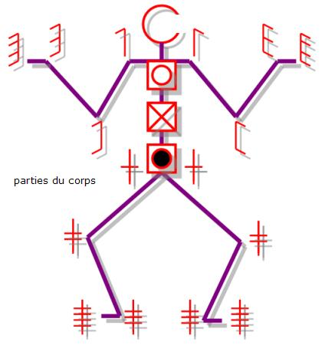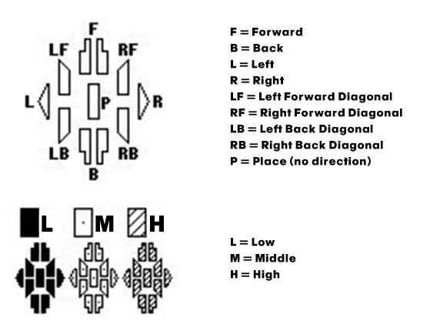
a b c
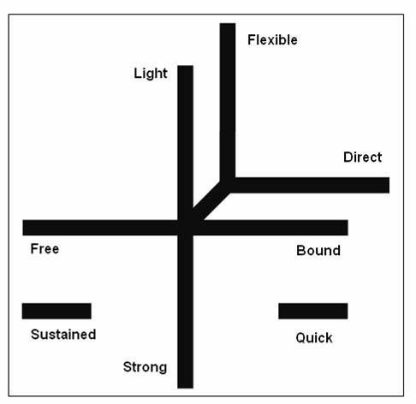
Left hand
Left arm
Body
Left leg gesture
Left support
Right support
Right leg gesture
Body
Right arm
Right hand
Head

Left
Right
d e
Figure 7.9. Symbols used in Labanotation. a) Symbols for the parts of the body. b) Symbols for directions in space. c) Example use of the directional symbols on the motion staff. d) The regions on the motion staff correspond to the sides and parts of the body. e) The Effort signs.

The progression in Figure 7.9c does not explicitly show the Effort values. However, it is clearly seen that the motion is a sequence, and thus we can write a BE to describe the motion. For example (start of movement is from the bottom):
{Left_arm_mid_outward, Left_foot_support, Right_arm_forward}•{Left_arm_high•walk_two_steps_right_foot_first•Right_arm_high}•{Left_arm_forward, Step_foward_ball_right_foot, Right_arm_mid_outward}•{Left_arm_low_outward, Left_leg_back_knee_bent, Right_leg_support_knee_bent}
Note:
- Recall curly braces are used to indicate actions contained within them are done in parallel.
- Labanotation uses implicit meanings to some of the symbols. For example, a “In place, low, support right leg” means standing on the right leg with knee bent. “Forward, high, right leg” means: taking a step forward with the right foot on the ball of the foot.

Fuzzy Behavior Expression
We can also interpret EE using Fuzzy Algebra. A fuzzy algebra is a set F = <[0..1], max(.,.), min(.,.), 1-x>. The set F consists of domain for fuzzy algebra is the range of real numbers [0..1], inclusive. The max(.,.) is the maximum binary operator which returns the biggest value among its two arguments, while the min(.,.) operator returns the minimum of its two arguments. 1-x is the negation operator, such that if x=0.3, its ‘negation’ is 1-0.3 = 0.7.
The fuzzy min(), max() operators can then be used to operate on two atomic gestures. Specifically, the min/max evaluation are done at the numerical values of the gestures, e.g. joint angles. For example:

max(raise_right_arm, punch_right_arm)

Suppose both of the gestures raise_right_arm and punch_right_arm use the sagittal shoulder joint, and the elbow joint. Then the max() operator will evaluate and use the maximum values of these two joints as the resulting gesture. For example:

Suppose the neutral position as the starting position (right arm is hanging down on the side of the robot torso):
r_shoulder_sagittal = 30 (min=0, max=180)
r_elbow = 10 (min=0, max=100)

Let’s assume the raise_right_arm gesture rotates the arm forward and up and keeping the elbow straight:
raise_right_arm = { r_shoulder_sagittal =170, r_elbow=0}

Then, let’s assume the punch_right_arm (punching forward) gesture consists of two poses: the preparation, which pulls the hand close to the body, and the execution which extends the hand as far as possible in front of the body:
punch_right_arm = { {r_shoulder_sagittal =30, r_elbow=90}{r_shoulder_sagittal=80, r_elbow=0}}

Notice that the raise_right_arm is a one-step gesture (regardless of the starting pose of the arm, the end pose of the arm is straight up), while the punching gesture requires two steps: the coiling of the arm, and the extension of the arm. How can the two be evaluated together using the max() operator? For the time being, let’s consolidate by introducing poses. A pose is the lowest level of movement symbol, where it is a particular joint angle configuration of the agent. It can also be considered as a particular state of the agent in space and time. A pose is defined by the joint angle value.
Next, we define start_pose and end_pose as the beginning/initial pose and final pose of the gesture, respectively. Also, let’s introduce in-between_poses, which are any other poses between the start_pose and end_pose. An atomic gesture is defined as a sequence of poses. When a gesture consists of only one pose, the gesture has no start_pose, no in-between_poses, and one end_pose. When a gesture consists of two poses, the gesture has one start_pose, one end_pose, and zero in-between_poses.
Thus, when we encounter a situation as above, where we are trying to apply the max() operator between gestures with different number of poses, the process can begin with the start_pose, middle poses, or with the end_poses. In the case of aligning with either the start or end poses, the process ends when there are less than two poses to operate between the two gestures. So, in the case of aligning with the end pose, the example above will be processed as:

max(raise_right_arm, punch_right_arm) = ( max(-, punch_right_armstart_pose), max(raise_right_armend_pose, punch_right_armend_pose))

And the result will be a gesture which is punching straight up:

{{r_shoulder_sagittal=30, r_elbow=90}.{r_shoulder_sagittal=170, r_elbow=0}}

So, the max() comparison happens for the joint angle values. The process is similar for the min() operation, except that the min() operator chooses the lower values.
We have introduced several operators that can be used to construct a kinematic description of an action for a robot and the framework called Behavior Expression. The operators adapted from regular expressions are concatenation, union, and the Kleene star operators. We also extended the union operator to be probabilistic where the probability parameter can be defined. Finally, fuzzy operators are introduced for construction of kinematic description of an action. Observe that fuzzy operators create new motions while the probabilistic operators only select from (potentially infinite) set of predetermined motions. As was shown in the above examples, the fuzzy operation allows us to combine multiple gestures into a new gesture. I expect the usefulness of the newly-created gesture will be subject to human evaluation in most cases; whether the new gesture is a meaningful gesture or otherwise. Here we have done an essential generalization of such a fundamental concept of computer science as regular expressions and we have found an immediate application of the new concept to motion generation of a robot. Perhaps there are many other applications that we cannot predict right now. I believe many new ideas and generalizations will be found during the programming and analyzing phases of my research, when I will create robot behaviors using my language and observe them on real robots located in real spaces with obstacles.
We can use the Behavior Expression by evaluating it in real time, only executing a part of the expression at a time, and choosing the next action in the sequence with some probability if it is defined in the expression. Partial execution of an EE will require some look-ahead before the current action in the sequence completes, so the Dynamic Description can determine the transition.
Kinematic Description Framework needs some IK solvers so motions can be described by paths and shapes. Particularly to realize LMA concepts of space and shape. I will use existing IK tools and use high-level concepts that relates to IK interpretation.
For example: forward is described as movement in front of the robot. It can be placing the hand in front, or actually taking a step/move forward. Similarly to the other spatial directions af up vs. down, left vs. right.

Behavior Expression for Input and Output Behaviors
I distinguish three types of behaviors that can be described using Behavior Expressions (BE):
- Input behaviors: are the perception of the robot. In a lot of cases, there are many ways a person can interact with the robot which have however all the same meaning. For example: there are many ways to greet, e.g. saying “hello” or “hi”, raising the hand and so forth. These different kinds of greeting can be expressed in one BE.
- Output behaviors: are the output of the robot. This can be dancing movements, blinking of lights on the robot, playing a sound or speech, or any combination of the actions. Like the greeting example as input behaviors above, conversely there are many ways the robot can perform greeting gestures. Likewise, those many different ways can be expressed in one or few BEs (if really necessary).
- Input-output behaviors: are interactive behaviors. The BEs that describe input-output behaviors are characterized by having both input and output symbols in the expression. An example for this behavior is like doing a simple maze-navigating behavior, where the robot will always turn right when an obstacle is detected and the robot should keep going indefinitely:
  - simple_maze_navigation = (no_obstacle•go_forward + obstacle•turn_right_90degrees)•simple_maze_navigation.
Observe recursion here.!

Summary
In this chapter I introduced the Behavior Expressions. The basic form of BEs and the use of some of the basic operators were shown. The probabilistic BEs was also introduced, followed by the use of BEs to analyze the interactions between multiple agents, example use of BEs on Labanotation, and the use of fuzzy operators with BEs was also shown. Finally, the three types of behaviors that can be programmed using BEs are defined.

Robot Expressive Behavior Language (REBeL)
REBeL is intended to be a new paradigm to program robots at the behavior level.
In general, ‘behaviors’ may include:
- Robot travel maneuvers/trajectories for mobile robots
- Movements of robot limbs such as arms, head/neck, body
- Lighting components such as LEDs
- Sounds
- Control of associated stage props, equipment and devices, for instance Marie Curie in [REF] controls with her arm a spectrophotometer that responds by blinking lights and some sound signals. Also lights and fogg machines or other theatrical props can be controlled [Bhutada].
The behaviors are programmed using Behavior Expression (BE). In most cases, it is sufficient to describe a behavior using the concatenation, union, and repetition operators and their probabilistic variants. Sometimes, it is also desired to have multiple behaviors running simultaneously (i.e. in parallel). Additionally, REBeL can be used to analyze the interaction between multiple robots when the behaviors of the robots are described using BEs.
Some parts of REBeL have been already programmed by me in the Python programming language: the tokenizer and the parser. Currently, the component that will translate the words generated by REBeL into commands to the hardware components is still under development. This chapter will discuss in more details the properties for each of these operators, their implementation, and some consolidations that are done to make the system work in a reliable and safe manner.

Basic Syntax
In REBeL, each Behavior Expression (BE) is written as a String type (enclosed in single or double quotes), and must be enclosed in a pair of parentheses. The basic form for a BE is:
‘(<behavior_expression>)’
Unless otherwise noted, from this point on, we will use the term ‘expression’ and ‘BE’ to refer to Behavior Expression. If the word ‘expression’ is used in any other reference/meaning, it should be clear from context or explicitly noted. Keep in mind that the following are BEs:
- Empty string: ‘’
- A single behavior symbol: ‘a’, ‘say_hello’, ‘go_forward’
- Compound of behavior and operator symbols: ‘(a *)’, ‘(a & b)’, ‘(a + b)’
In the current implementation, each expression for each operator should be enclosed in parentheses. In other words, each time an operator is used, it and its arguments must be enclosed in parentheses. For example:
Valid expressions | Invalid expression
‘(a & b)’ | ‘a & b’
‘((a & b) & c)’ | ‘(a & b & c)’
‘(a & (b *))’ | ‘(a & b*)’

Parsing
An expression is tokenized by scanning the string from left-to-right. The first symbol the parser is looking for is the left parenthesis ‘(‘, and recursively parse the expression contained within. Once the matching right parenthesis is found, the parser then returns the enclosed expression as a list data type of the tokens for the expression, i.e.: the operator symbol, and the arguments for the operator. If there is a nested expression, then the argument(s) for that operator would be of the list data type. We’ll call the list of parsed expression a PE.

Expression | Parsed | Number of PEs
‘(a)’ | [‘a’] | 1
‘(a & b)’ | [‘a’, ‘&’, ‘b’] | 1
‘((a & b) & c)’ | [[‘a’, ‘&’, ‘b’], ‘&’, ‘b’] | 2
‘(a & (b * ))’ | [‘a’, ‘&’, [‘b’, ‘*’]] | 2

Evaluation of Expression
The evaluation of an expression is done post-order traversal mode. For example, the parse tree for the following expression is shown in figure 8.1.
‘(a & (b + c))’
&
a
+
b
c
Figure 8.1 Parse tree for ‘(a & (b + c))’

The order of evaluation for this parse tree is:
Step | PE | Evaluation output
1 | a | a
2 | b | b
3 | c | c
4 | b + c | b OR c
5 | a & b OR a & c | ab OR ac (final)

&
a
+
b
c
Step 1
Start
Step 2
Step 3
Step 4
Step 5
Figure 8.2 Post-order traversal of the parse tree in Figure 6.1

The output of evaluation of a PE is a string of expressions.

Concatenation
Concatenation is a binary (takes two arguments) sequencing operation. The symbol for concatenation is ‘&’ (ampersand). Since concatenation is a binary operator (takes two arguments), its output is the two arguments ordered in a sequence of the left argument followed by the right argument. In the current implementatioin, concatenation is set up to use the infix form (the operator is between two arguments) and the syntax is:
‘(<behavior_expression> & <behavior_expression>)’
Below are some examples of concatenation operation (in actual code syntax):
- ‘(a & b)’ yields: {‘ab’}
- ‘(a & (b & c))’ = ‘((a & b) & c)’ yields: {‘abc’}

Union
Union is a binary choice operation. The output of the union operation is one of its two arguments. The symbol for union is ‘+’ (plus). As such, the union operation is probabilistic and by default each of the two arguments have equal, 0.5 probability. The probability can be modified by adding a floating-point number at the end of the expression. If specified, the probability value will refer to the probability of the first (i.e. left argument), thus the probability of the second argument is one minus that value.
The syntax for the union operation also uses the infix notation as follows:
‘(<behavior_expression> + <behavior_expression> [<optional: probability_value, default=0.5>]’
A few example:
- ‘(a + b)’ yields: {‘a’, ‘b’}
- ‘(a + (b + c))’ yields: {‘a’, ‘b’, ‘c’}
- ‘(a + b 0.3)’ yields: {‘a’, ‘b’} with ‘a’ 30% of the time, and ‘b’ 70% of the time
- ‘(a + (b + c 0.3) 0.4)’ yields: {‘a’, ‘b’, ‘c’} with ‘a’ 40% of the time, ‘b’ (0.3 * 0.6 = 0.18) 18% of the time, and ‘c’ (0.7 * 0.6 = 0.42) 42% of the time.

Repetition
Repetition is a unary operation i.e. takes one argument. The output of this operation is the input argument repeated zero or up to 4 times by default. The choice for the default value 4 is arbitrary with the rationale that people rarely do actions with high number of repetition except in very few cases. The syntax for the operation takes an extra optional integer-valued argument to specify the maximum number of possible repetitions. Use with caution.
The syntax for the repetition operation is:
‘(<behavior_expression> * [<optional: repetitions, default=4>])’
Some example:
- ‘(a *)’ yields: {‘’, ‘a’, ‘aa’, ‘aaa’, ‘aaaa’}
- ‘(a * 2)’ yields: {‘’, ‘a’, ‘aa’}

State Symbols
In Chapter 5 we have seen a form of Behavior Expression that seems unusual when we discussed the Angry man vs Gentleman example – it includes explicit notation of states. So far the syntax for REBeL have been discussed using basic BE form which constitutes of an operator and its arguments, where the arguments are symbols that represent some kind of action for the robot. In this section, we introduce a form of BE which includes states in the expression.
Consider an example of a light-avoiding Braitenberg vehicle. The inputs for the robot is the left and right light sensors, and the output is the activation of its left and right motors. The behavior of the robot can be described as follows:
- If light is detected on the right side, the robot will turn left.
- If light is detected on the left side, the robot will turn right.
- If the left and right sensors do not detect light, go forward.

Figure 8.3 shows the state machine representation of the behavior of the robot described above.
Forward
Turn Left
Turn Right
R
$$\overline{L+R}$$
R
R
L
L
L
$$\overline{L+R}$$
$$\overline{L+R}$$
Figure 8.3 Light-avoiding Braitenberg vehicle (left) and the corresponding state diagram for its behaviors (right).
The behavior of the robot can be written using BE by specifying each state as one BE.
- Forward = $\overline{L+R}∙Forward+R∙\text{Turn_Left}+L∙\text{Turn_Right}$
- Turn_Left = $R∙\text{Turn_Left}+\overline{L+R}∙\text{Forward}+L∙\text{Turn_Right}$
- Turn_Right = $L∙\text{Turn_Right}+\overline{L+R}∙Forward+R∙\text{Turn_Left}$
Here, the BEs use both input symbols (L, R), state symbols, and no output symbols. Note the fine difference: the state names corresponds to the expected output action, but it is not the output symbols themselves. In this case, the output for each state must be specified separately. E.g.
- Forward go_forward
- Turn_Left turn_left_90degrees
- Turn_Right turn_right_90degrees

Ultimately, the difference between a Basic Action, a Behavior, and a state can be very fine. The differences are the following (but still subject to change):
- Basic Actions are actions and behaviors that are already stored in the Library of Atomic Motions. They typically consist of a deterministic sequence of simple actions, whether it is joint angle positions, vocalization/phrases, LEDs activation, etc. They are described using names that are descriptive of the action but not names of gestures or complex actions. Typical names for basic actions are: raising arm up, raising the right arm to the side, turn left, etc. Names such as: dance waltz, avoid obstacle, scratch head, etc.
- Behaviors are always defined by BEs. A Behavior may be deterministic if the BE was constructed in such a way that the expression only contains a deterministic sequence of actions (e.g. only uses concatenation operation). As mentioned in Chapter 7, behaviors can be either: output (e.g. sequence of movements), input (e.g. recognizing a sequence of input stimuli), or input-output behaviors (e.g. the behaviors of the Braitenberg vehicle in Figure 8.3).

Summary
In this chapter, I introduced the REBeL language at its current state. The basic operations in REBeL such as concatenation, union, and repetition have been implemented in the Python programming language with some minor bugs still persist at the time this document was written. The implementation of the use of state symbols in the expressions is still in development. The syntax and the evaluation process of the expressions were discussed.

The REBeL System
In this chapter, the architecture for the REBeL system is presented. The REBeL system is the system of software and hardware components that enables the execution of behaviors expressed by the REBeL language on a physical robot. Figure 9.1 shows an example of the high-level view of the typical REBeL system on a robot. To make the discussion a bit more concrete, let’s consider this system is for the Jeeves guide robot. First, an overview of this architecture is presented, followed by a more detailed look at each component in the subsequent subsections.

Architecture of the Complete REBeL System
The environment of the robot provides input to the system in the form of person(s) and his/her attributes thereof (face, gestures, presence, facial expressions), objects (colors, labels), sounds (speech, music), and other objects (walls). The robot will be equipped with sensors such as Kinect (RGB camera, depth camera, microphones), sonars, and IR sensors. The input block also covers input post-processing such as filtering and object detection/recognition. In the case of Kinect, information such as presence of person, skeleton information, and depth/distance information are also available. The processed inputs are then used as input for the input behavior automata which are described in EE.
The input behavior automata interpret/recognize the sequence and combinations of input as one of the many behaviors known (i.e. programmed) for the robot. In other words, it acts as a classifier of behaviors. The recognized input behavior may then affect the internal state of the robot (e.g. “emotion”, “mood”). The recognized input behavior and the internal state of the robot together influence the input-output behavior of the robot, that is, determine how the robot should respond to those inputs. The response may involve performing some gestures, blinking some LEDs, or playing some sounds. Some of these responses may require some pre-processing to express the mood or emotion in the movements or sounds, for example. Once the desired output is processed, then the output signals/commands are sent to the respective hardware components (e.g. servo controllers and the servos, sound synthesizer, etc.).
So far this description has been pretty abstract, therefore we elaborate in more detail below with some examples.
Internal state model
Input behavior automata (EE)
Input (sensors, camera, microphones, sonar, etc.)
Motor control (servos, servo controllers)
Other outputs (lights, sounds, etc)
Input-output behavior automata (EE)
Output pre-processing (IK, simulation, motion planning)
Environment, person (face, gestures), objects, sounds
Gestures, poses, movements
Beeps, blinking LEDs, etc
Basic Actions
External/environment
Internal/robot system
Interface
Controller
Figure 9.1. High-level Architecture view

Input from Environment
Here we discuss the source of inputs and the input interface block.
The proposed system is meant to enhance human-robot interaction experience, so the inputs to the system come mostly from a person or a group of people. Which means, the following information is generally needed:
- Person/face detection: detect when a person (or persons) is present. This can be done by using a common webcam and perform face detection algorithm such as the popular Viola-Jones algorithm [104]. The Kinect for Windows SDK provides a Face Tracking interface [105].
- Gaze detection: detect which direction the person is looking. This information is useful usually to allow the robot to look in the same general direction as the person. This ability is helping to create a more natural interaction since it is showing attention to what the person is doing (mirroring). This is often used in teaching [17].
- Gesture detection: detecting which gesture is being performed. We can distinguish two types of gestures to detect: facial gestures and body gestures. Facial gestures will be interchangeable with facial expressions such as: smiling, frowning, laughing, angry, and so forth. Body gestures are gestures that are expressed through the use of arms, or body positions, such as: waving, pointing, crouching, crossing arms, shrugging, etc. For the purposes of this dissertation, sign languages such as American Sign Language are not considered.
- Speech recognition: detection of spoken words and sentences. Understanding speech/spoken language definitely influences the interaction experience not just by the messages in the sentences, but also by the prosody which can reveal the emotion and mood of the speaker [ref]. It is highly desired that interactive robots understand spoken language, and strides have been made by companies such as Apple, Google, and Microsoft to achieve that goal. Unfortunately most of those technologies are currently proprietary and not open for public use. Some speech recognition??? I pointed this last time
However, to complete the illusion, the robot must also be aware of its surrounding, such as obstacles in its path. Therefore, the robot still needs the ability to detect obstacles. This can be achieved using sonars, physical bumpers, laser scanners, or even depth images (e.g. from Kinect). For now, it is enough for the robot to detect the existence an obstacle and its distance from the robot without trying to recognize/identify the obstacle. A basic fuzzy logic control have be used for obstacle avoidance procedures. When using a framework such as the Robot Operating System (ROS), there exists ready navigation stacks [106]that include this feature as part of the SLAM algorithm [107]. Explain what is SLAM acronym and what it does.

Input Behavior Automata
A set of automata (described by a set of BEs) which determines what the robot perceives in terms of behavior from the environment or from a person. For example: when the person performs a sequence of actions, the sequence may belong to (understood as) a “greeting” behavior.

Internal State Model
Some model of the state(s) of the robot in terms of mood or attitude. The mood and attitude of the robot may be influenced by the input from the environment, from a person, a combination of both, or some sequence of inputs (e.g. history of interaction). Kismet and Kobian use some complex internal state models such as ‘drive’, ‘needs’ that are derived from human psychology literature [25] [108]. This component still requires further research to determine which existing model to use, if any.

Input-output Behavior Automata
Mapping between the external inputs (from input behavior automata), and internal inputs (internal state model), to output response (e.g. gestures, actions, behaviors) of the robot. The behaviors described by this type of automata are, for example: greeting interaction (like in the example in Chapter 2), obstacle avoidance, showing interest to objects with a certain color, and so forth.

Library of Atomic Motions
A database of atomic actions should be created that are stored to construct new actions and behaviors. Some abstract concepts about movements from LMA may be encoded such as: “rising”, “sinking”, “up”, “forward”, “left”. For example: “rising” is described as a change of height from lower to higher (while “sinking” is the opposite), but no specific movements (e.g. joint angles) is defined for the robot. This requires the use of inertial measurement unit (IMU) sensor to detect the change of elevation, and also inverse kinematics (IK).

Output Motion Pre-processing
The Output Pre-processing block in Figure 9.1 involves the following subcomponents: IK, Simulation, and Motion Planning. IK refers to inverse kinematics solver, Simulation refers to a simulation tool used to provide visualization of what the robot motion will look like before executing the motion on the physical robot. Motion planning refers to processing of the motion data to create expressive qualities (e.g. emotional) by changing the range of motion, timing or speed and acceleration using keywords from DAP and LMA.
- IK. Inverse kinematics (IK) is used to create movements where a target location, or a desired trajectory is given. For example: reaching for an object presented in front of the robot, gesturing a circular shape by hand. Some simulation tools such as V-Rep provide IK solvers.
- Simulation program (e.g. V-Rep, ODE) is used to visualize a behavior defined by an EE and simulate the physical properties of the execution. The simulation program will be useful when we want to create new behaviors using Interactive Gene Expression Programming (IGEP), particularly “bad” gestures that can potentially damage the robot physically can be observed on a virtual model, and discarded if necessary.
- Motion data can be represented as signals, thus subject to common signal processing techniques such as Fourier analysis [73], multiresolution filtering, blending [29] and spline interpolation. For example: motion can appear to be exaggerated by increasing the middle frequency band gains, which the bands are obtained from applying multiresolution filtering to the motion data (i.e. deconstruct signals into bandpass and lowpass components by filtering the signal in succession, each at half the resolution of the previous step).
- Disney Animation Principles (DAP) and Laban Movement Analysis (LMA) parameters. In reality, there are more to animation best practices than DAP such as tips from expert animators such as Glen Keane and Victor Navone. These “best practices” give insights to intangibles such as what makes an expression convincing, how to work with limited/non-humanoid characters to express emotions, Rhythm and Texture to keep the audience interested, etc. I think we must not be too narrowly focused with what social and anthropology studies say about human interaction and try to exactly apply them to robots, but utilize what have been done in animation and performing arts because for centuries they have been successful in capturing the attention of their audience, even engaging the audience emotionally. Nevertheless, DAP and LMA provides a useful set of vocabularies that are familiar to us (i.e. relatively easy to understand with everyday words/concepts) to describe actions, expressions, and motions.
There are three main approaches in controllable human figure animation: a) procedural animation, b) dynamic simulation, and c) interpolation-based animation. Procedural animation refers to a method of generating animation using some motion-calculating methods. For example, raising the arm of a character to a particular position is done by solving for inverse kinematics. In a sense, dynamic simulation is a kind of procedural animation, but it is distinguished by the former typically uses physics simulation engine where the articulated figures adhere to the physical properties/constraints in the simulated world (e.g. gravity, friction, mass, etc.). The figure is then controlled by dynamics-based controllers (e.g. PID) by physical parameters such as forces, torques, acceleration and velocity. Interpolation-based animation relies on pre-made short ‘clips’ of actions (e.g. walk, drumming, hand-waving) and multiple actions can be combined, morphed/transitioned between them by modifying some coefficients (e.g. in spectral domains [2][3]). Among the three approaches, the interpolation-based animation method seem to provide a nice balance of allowing artists/animators to create stylistic action clips or use motion capture data, while at the same time provides the flexibility of controlling the generated actions via some high-level parameters (e.g. interpolation coefficients vs. joint angles). Additionally, interpolation-based methods tend to cost less computationally than the procedural animation where the latter requires forward or inverse kinematics calculations (depending on the task), while the former can be done effectively in the spectral domain [2] [3] or computed on higher-level parameters [1]. Rose et. al. suggested that interpolation-based method is the better approach for creating dynamic, expressive animated figures. However, there is still some merit to interpolation–based methods, particularly when creating gestures.
The output motion pre-processing block produces the output to be performed by the robot whether it is in the form of movements/gestures or other actions such as blinking of an LED. This block refers to the hardware communication such as translation of timed motion data into commands for the servos/actuators and other output devices through some interface (e.g. servo controller boards, microcontrollers).

Motions in general can be considered to consist of segments or stages. For example: a simple hand-wave gesture is first done by raising a hand up until the forearm is perpendicular to the floor, then rotating the forearm left and right (or the other way around) at the upper arm. Sometimes, this motion of rotating the forearm can be repeated a few times. After the movement is finished, the hand is lowered to its rest position at the side of the body. In its simplest form, this hand-waving gesture consists of three movement segments: 1) raising the hand from the initial/rest position until the forearm is perpendicular to the floor, 2) rotation of the forearm at the upper arm, and 3) return to the rest position. The second segment can be repeated to achieve the same effect. In the American Sign Language vocabulary, some signs consist of the shape of the hand and the movement of the hand. For example: the sign for the word “girl” is to have the hand in the “A”-hand shape, and while in that shape, move the hand from near the ear towards the chin [1]. The ASL example shows how shapes and sequences of movements can be used to create meanings.
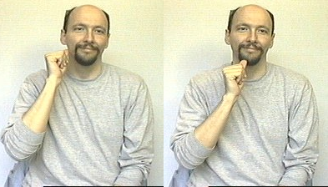
Figure 9.2. American Sign Language for the word “girl”. The sign starts with the hand in the shape for the letter “A” and placed on near the ear (left image). Then the hand is moved to near the chin (right image). This sequence is the sign for the word “girl”.
Based on the example above, we can consider two types of descriptions for motions: the kinematic description and dynamic description. The kinematic description of a movement is the sequence of joint angle positions in the movement denoting the beginning and the end of a segment of the whole gesture, analogous to keyframes in animation. The inflection points can be the set of joint angle configurations or the positions of a set of end effectors/body parts. In contrast, the dynamic description is the transition within a segment and between segments. In traditional animation, this is analogous to the in-between frames – the frames between keyframes. This transition defines the acceleration or deceleration, rate of change of the movement to reach the end of the segment. The rate of change can also be determined by a requirement that a segment must be done within a certain time. In the following sections, we will discuss more about the frameworks for the kinematic and dynamic descriptions.

Kinematic Description Framework (KDF)
As mentioned above, kinematic description is analogous to the set of keyframes in traditional animation. In computer generated (3D) graphics, animations are done by first defining the key poses, and then the software tool can interpolate the movements between these key poses. The most common interpolation method used in software animation tools is the Kochanek-Bartels cubic interpolation method as it provides three parameters: tension, continuity, and bias to define the interpolation, and a cubic Hermite interpolation by default (all parameters set to zero) [1]. In this case, the interpolation method used as well as the parameter values are parts of the dynamic description for the motion, which will be discussed in the next section.
Kinematic description can be interpreted in two ways: a) a sequence of motion segments, or b) a sequence of decisions. In the former, the kinematic description is applied at the lower level of the movement, i.e. movement of actuators and joints, such as the hand-wave example above. On the latter, the meaning is more appropriate in motion planning approaches like industrial assembly or control of mobile robots. For example: the mobile robot must navigate through a cluttered environment from a starting location to a given target location without running into obstacles or getting stuck. During the course of its travel to the target location, the robot must make a sequence of decisions of where to go next in order to reach the target location. Each decision the robot makes results in a sequence of movements of going forward, or turning left/right, and so forth. In the MDLe model, each movement lasts for a predetermined amount of time (e.g. timeout) or until an interrupt signal is raised (e.g. due to obstacle) [2].
We adopt the two interpretations of the kinematic description of a robot’s movement. The first interpretation still means the same; that is, to describe the start/end positions/configurations of a movement segment. The second interpretation considers the sequence of actions as a product of decision making at each start/end of a segment. In this sense, the concept is similar to a state machine, where the transition from one segment to the next in a kinematic description is akin to transitioning from one state to the next in the state machine. Because of this interpretation, we can associate a kinematic description as a kind of a state machine.
Let us observe the difference between the kinematic description of the hand-wave gesture and the mobile robot’s navigation examples. In the hand-wave gesture, the transition from one segment to the next is automatic and not by some decision-making process. The only indication to transition from one segment to the next is a signal that a segment is completed: either by a timeout condition (i.e. “perform movement for x seconds”) or the movement had arrived at the designated end position for the segment. When any of these conditions is satisfied, the movement transitions to the next segment. In the mobile robot example, the motivation is navigation control in an uncontrolled environment, so the robot cannot make a predetermined global plan. One common strategy is for the robot to make partial plans (some call it “local plans” [109]) which is a short-term plan based on the available nearby path found/calculated from sensor values. A local plan is then chosen by some cost function based on some criteria such as: how far will that path deviate from the target location, how much obstacle exists in that path, etc. In this case, the robot must make a decision and choose an action to take. In a simplified form, we can suppose assume that the robot has only have a limited set of actions e.g. {go_forward_1meter, turn_counterclockwise_40degrees, turn_clockwise_40degrees} and the robot can only choose between one of three possible actions it knows for each local planning.
Now suppose further that the robot is a bipedal, walking robot instead a robot on wheels. The bipedal walking can be modeled as consisting of segments as well: for each leg, walking can be modeled in four phases: lift-off phase, swing phase, impact/landing phase (heel strike), and support phase [3]. The walk cycle works with each leg starting at different phases, e.g. left leg starts support phase, right leg starts lift-off phase. Just now, we abstracted the traversal action of the robot from rolling on wheels to walking, where walking is a complex motion consisting of multiple segments/stages/phases. Then a kinematic description can be used to provide a hierarchy of actions. Although now the kinematic description seems to be at a higher level, the underlying model is the same – it is a model of an automaton.
The KDF is basically the evaluator of BEs which generates the sequence of actions (i.e. an instance of the behavior specified by the BE). The product of the KDF is called a kinematic description which is analogous to the keyposes and keyframes in the traditional animation sense. Also like its traditional animation counterpart, this sequence if run as-is, will create a very monotonous actions – each action in the sequence will be executed with the same speed. It will lack any rhythm or texture.

Dynamic Description Framework
With the kinematic description framework, we have a way to describe the ‘skeleton’ of the movement. Now we need a framework to fill in the ‘gaps’. The simplest method to complete the movement is a simple linear interpolation. A more advanced approach is to use parameterized interpolation method such as Kochanek-Bartels spline [1]. Beyond interpolation methods, techniques from signal processing such as Fourier transform [3], multiresolution filtering, and waveshaping can be used to globally manipulate the motion data [4]. Using Fourier transform, Unuma et. al. [3] showed that blending and transitioning between two motions are possible by shifting the weighting coefficients of the two motions (e.g. 0 = motion A, 1 = motion B, 0.5 = a blend of motion A and motion B). Bruderlin and Williams [4] demonstrated several methods that can be useful for different effects. Multiresolution filtering is useful to exaggerate or subdue motions, and also to add or remove noise. Motion waveshaping was used to shape the motion data globally using a function that envelopes (i.e. modulate) the original data. Rose et. al. [1] uses the term adverb to denote the parameter that can be used to transition between the different variations of the same verb (action) which are labeled with the words such as happy, sad, turn left, turn right, etc. In other words, if the verb/action is ‘walk’, samples of happy walk, sad walk, turn left walk, and turn right walk are collected beforehand, and changing the intensity of each adverb the multidimensional adverb space determines the final execution of the verb/action which can be a combination of the different variations.
This section details my approach to achieve dynamic motion qualities for the sequence of actions defined by the Kinematic Description Framework.
While the Kinematic Description Framework provides a multitude of ways new motions can be constructed and manipulated using algebraic operations, now those motions must be executed in a convincing manner. The Dynamic Description Framework provides control of motion execution using a set of operators we call Intent Operators. In essence the Intent Operators work on top of a Behavior Expression to seamlessly execute the represented motion from the robot’s current position/configuration, throughout the sequence of motions, and the completion of the motion.
In principle, the Behavior Expression is a concise representation of a set of sequences of actions. At any instance of time, however, only one of the sequences of actions in that set will be chosen and executed. As mentioned above, we can first generate the whole sequence, or partially if the expression allows it. To draw an analogy with animation terminology, the Kinematic Description is analogous to the keyframe animation and the Dynamic Description is the in-between frames which determines the dynamics of the animation.
The Dynamic Description Framework consists of several components:
- Action Queue
- Action Buffer
- Anticipation Calculator
- Dynamics Simulator
- Servo Drivers

Action Queue
The Action Queue contains the sequence of actions from a Behavior Expression. This queue can be considered as a first-in, first-out (FIFO) stack. Sometimes, multiple behaviors are triggered at the same time. A separate queue is created for each triggered behavior, and the queue is destroyed once the behavior is completely executed. There will be cases where more than one behaviors require a particular resource on the robot, for example: raising the arm and hand waving. Suppose both of the triggered behaviors require the use of the right arm. The system then must decide how to reconcile the resource contention. To do this, the Action Buffer is needed.

Action Buffer
The Action Buffer will store the first few actions of a behavior (recall a behavior is a sequence of actions). If there are multiple behaviors, each behavior will have its own Action Buffer channel. The buffer represents a segment of the final executed behavior. The actions in the buffer is prepared for immediate execution on the robot, whether they are joint movements, lights, sound playback, and so on. Prior to execution, the actions in all channels of the buffer are checked to see if there is any resource contention between the channels. If there is any contention, it must be resolved here. The resolution can be done by merging the two actions (e.g. interpolation), or choosing one over the other. Of course, it is desired for the executed behavior to still be recognizable and meaningful, but what is the best way to accomplish this? At this point, the merging and selection mechanisms that will best accomplish this goal are still in need of further research.

Anticipation Calculator
One of the most important concept from animation is ‘anticipation’ which is an action preceding the main action to prepare the observer of what is to come. The Anticipation Calculator is needed for this purpose. Typically, a behavior specified by a Behavior Expression only describes the main actions. When that behavior is called, then if anticipation is desired, then it needs to be calculated before the first few actions in the behavior are executed. Since anticipation only happens in the beginning of the behavior, the actions stored in the Action Buffer would provide enough information to perform the calculation. One of the ways anticipation can be created is using the Kochanek-Bartels interpolation, by setting the bias parameter to a negative value. Figure 10.2 shows the effects of the bias parameter on the KB interpolation. WHERE IS THIS FIGURE

Dynamics Simulator
Sometimes it is desired to create movements under some physical constraints. For example: a ‘relaxed’ look on a person can be recognized by the arms freely swinging as he walks, but it is different from when the arms uncontrollably flailing about. If the robot programmer desires such expression on the robot, then a dynamics simulator program such as V-REP [ref] can be used to experiment with the level of control on the arms necessary to create that look. He/she can then use the raw motion data (e.g. sequence of joint angles) or the amount of actuation on the motors required to generate the required to achieve the look on the robot.

Servo Drivers
Despite the close relationship between 3D computer animation and robot movements, controls for dynamic, ‘natural-looking’ motions in computer animation are often cannot be easily applied to robot controls. In computer animation, the animator and software tool have the freedom to manipulate the position of the 3D model at any given time. For example, interpolation methods would fill in the missing data points between keyframes, and the new position can be rendered almost instantly. In real robots, depending on the hardware of the robot, a servo controller board translates a position command from a controller software (e.g. on a PC) into signals for the servo. The way the servo responds to the command may differ depending on the specifications of the servo, and there are constraints such as maximum torque, acceleration, or angular velocity. In computer graphics, those constraints are nonexistent until one desires to implement them in the tool. Conversely, robot manipulations in the real world are by default constrained by the physical laws, such as: gravity, the torque and velocity limits of the actuators, safety conditions so that the robot does not damage itself or a person, and so forth. Controls for robot manipulators often have to come from the dynamical system models and using classical control theory methods. However, as robots become more sophisticated and have more degrees of freedom, as in the case of humanoid/anthropomorphic robots, the dynamical systems become extremely complicated to model, and even more costly to control and maintain. Because of these reasons, it is not always easy and usually quite difficult or even impossible to directly apply methods from computer animation to real robots.
Nevertheless, we believe there is a way to utilize the transformation methods from computer animation to our application of interactive entertainment social robots. First we must find out what we need; what are the dynamic motion qualities that we want to have on the robot, and what sort of transformation methods would be useful to achieve those qualities? In order to find the dynamic motion qualities we must understand what it means to have dynamic motion qualities, and what does those dynamic qualities mean? After we answer these questions in the next few subsections, we introduce our proposed dynamic description framework.

Selected Dynamic Motion Qualities
By dynamic motion qualities, we mean movement qualities that are opposite of rigid or robotic. Rigid or robotic movements are those linear movements with constant velocities, sequential movements where the robot stops its movements between motion segments, and motions that do not accelerate at the beginning and decelerate at the end. In contrast, dynamic motions have smooth transitions between motion segments, the motion accelerates and decelerates as necessary, and usually motions follow an arc trajectory.
We adapt the four parameters from Park and Lee [5] to define the dynamics of movements: Path Curvature (Arc), Duration/Timing, Acceleration/Deceleration, and Anticipation and Follow-through In addition to those four parameters, we also add the Flow parameter to indicate how smooth the transitions between segments should be. By defining the values of each of these parameters, one can (hopefully!) define the desired motion quality from rigid/robotic to dynamic.
The quality parameters above are directly inspired by Laban Movement Analysis [6] [5] and Disney Animation Principles [7] [8]. A brief introduction to these two frameworks was given in Chapter 4. The Arc parameter denotes the nonlinearity of the path of any given movement. A ‘robotic-looking’ motion tends to be linear, while a more ‘organic/natural-looking’ motion tends to move in an arc/curve. For example: when reaching for a cup on the table, a robotic arm moves the gripper in a direct line from its current position to the cup. On the other hand (pun not intended), a person’s hand rarely follows a linear path to reach the cup. Of course, there may be times when a linear ‘look’ is desired. For these reasons, the Kochanek-Bartels interpolation method is appropriate because it gives us the freedom to choose either a linear or non-linear curve using the tension parameter.
Duration/Timing and Acceleration/Deceleration are somewhat related. On the outcome, these parameters determine the speed of the movements of the actions in a behavior. These parameters will also be used to create rhythm and texture to the executed gestures, for example, in the beginning of the hand waving gesture the hand is raised fast at the start, then towards the end of the gesture the speed is slowed down and robot slowly moves the hand back to its rest position. These timing changes create a more dynamic motion (not to be confused with dynamical systems), whereas motions without variation of speed and timing are the ones we call ‘stiff’, or ‘robotic’.
Anticipation and Follow-through determines whether the behavior should be executed preceded by an anticipation movement (see Anticipation Calculator above), and whether the end of the behavior ends abruptly, or easing out to finish spending the momentum (e.g. the arm continues moving after throwing a ball). The dynamics simulator might be used to simulate movement that exhibits Follow-through. The Flow parameter is directly taken from LMA Effort-Flow parameter. Sometimes, in a transition between two actions, the end position of the first action is vastly different from the beginning position of the next action. If a smooth transition is desired, two resolution methods can be used. The first method adds a delay so that the two endpoints can be interpolated in a non-linear fashion such that the end position of the first action and the starting position of the next action are executed exactly. The second method eases the transition by allowing some time t after the end of the first action and using that time to transition into the t unit of time into the second motion. This method is called the transition filter and shown in Figure 10.3 [110]. In other words, the beginning of the second action would not be executed. WHERRE

Hardware
Currently, I am aiming to work with off-the shelf components such as servo motors, servo motor controllers (e.g. Pololu), which some of them already been used on the Jeeves/MCECSBot and Pepe robots. I understand that different robots may have different hardwares and capabilities. REBeL and behaviors expressed in BEs are meant to be usable across different robot hardware. That is, the same BEs can be used to control multiple different robots, given that the action elements (basic actions) used in the BE are already available on the robot. To achieve this, a collection of drivers must be written for different robots and components, which is still a work in progress. The robot theatre play being developed at PSU has four acts [ref]. There are five human-size android robots in the first two acts: Marie Curie, SchrÖdinger’s Cat, Albert Einstein, Niels Bohr and Isaac Newton. In the third act they are joined by Alan Turing and Richard Feynman androids and a Countess Quanta humanoid. In the fourth act there are two more androids: Confucius and Charles Darwin plus 4 humanoids: robot musician, Golem, Brazen Head of Saint Albertus Magnus and Frankenstein Monster. All these robots move, dance, talk and manipulate objects. Some play instruments. The detailed script [ref] contains many characteristics of robots, their personalities and motions required for this play. Because building a robot with all possible motions is still impossible, the theatre creates robots specific to certain motions. This restricts the language to describe their behaviors and will perhaps create interesting unexpected effects still within certain realism. Currently the system is programmed using software from [Bhutada] and [Brad Pitney]. This software is much simpler than one proposed in this dissertation but observing the behavior of the robot teams from the first act will give new ideas and methods to our work on developing REBeL and its interpreting system. It will be also a good test for my concepts to simulate first few scenes from the play using my tool with animated actors.

The Framework
The Dynamic Description Framework (DDF) needs to be able to apply the dynamic concepts from DAP and LMA onto the behaviors/gestures that are about to be executed. The data of these behaviors/gestures is the kinematic description produced by KDF. As mentioned above, the kinematic description is a sequence of actions which is equivalent to the keyposes or keyframes in the traditional animation sense. The DDF then applies transformation on these data points, whether it is filtering or interpolation on the sequence, based on the desired expression which is specified by the programmer, or through a higher-level BE (BE that uses state symbols, for example).
The DDF has not yet been developed at the point of this writing. However, the current plan is to have a collection of preset expression keywords which corresponds to a set of transformation that would be applied to a sequence from the KDF with some default parameter values. There also should be a way to allow programmers to specify the transformations they desire, with adjustable parameter values, preferably which can be expressed in the BE. But caution must be used to balance the freedom of customization with increasing complexity of the BE. The design of this system is still ongoing.

Summary
In this chapter I discussed the general design of the REBeL system to execute expressive motions on a robot from behaviors defined using Behavior Expressions. The system also incorporates concepts from animation such as Anticipation, Arc, and Flow, and presented some ideas on how to realize those concepts in the REBeL system. More experiments are still necessary to validate the effectiveness of these suggested ideas in realizing those concepts.

From Traditional Animation to Robot Animation
In the movies, animators are able to create believable robots by animating them using principles, techniques, and guidelines that originate from traditional animation and theatrical acting. For example, the surprise reaction of Wall-E (in Figure 10.1 as seen in Chapter 1). For brevity, the frame-by-frame breakdown will not be restated here, but I just like to iterate that elements that make this ‘surprise’ take believable:
- The action happens quickly – all three parts: (Figure 10.1 left to right) anticipation, the “take”, and rest pose happened in less than a second.
- The “jump” in the middle frame is a big action: the body is moved upwards (without the wheels lifted off the ground), the arms are thrown back with open palms, the head/neck was jerked back, the “eyebrows” are raised.
- Non-symmetrical motion – in the first frame, the left arm was raised first, in the second frame, the body tilted slightly to the right
- The other elements: the covering of the imaginary “mouth” in the third frame. The animators are aware that this is one of the poses that expresses “worry”. Even though Wall-E does not have a mouth, the pose itself is well-recognized by the audience and used anyway. The bounce that happens between frames two and three (not shown) as the body falls back after the jump in the second frame.
Figure 10.1 Anticipation for surprise action of Wall-E
However, these believable expressions are created by the artistic skills of the animators and difficult to generate on real robots in an autonomous way. The main difficulty is because believable expressions are rarely done the exact same way every time, yet still recognizable as the same expression whether it is surprise, disgust, happiness or other expressions.
At this point, I would like to emphasize that we will be focusing on whole body language and postures for expressions rather than facial expressions. The main reason is that there are too many nuances in facial expressions, that creating a robot face that is fully capable of performing those nuances are extremely difficult. There are three major muscle groups on the human face, and about over a dozen types muscles in the face that contributes to facial expressions. In most robots where the face is designed to be human-like, most of the time people expresses the eerie/awkwardness of the Uncanny Valley. In contrast, characters such as Wall-E, the puppets in the Muppet Show, where very little fascial movements occur, and a lot of expressions through gestures, body language and posture, are very successful and does not produce the Uncanny Valley phenomenon. Arguably, the latter are successful because they are controlled by people with artistic and acting knowledge. Still, I believe the production of expressions using whole body language and postures is more feasible and avoids the Uncanny Valley better than facial expressions.
With the REBeL and Behavior Expressions (BE), we know we can easily create sequence of actions such as Wall-E’s surprise expression above. For example:
Surprise = shrink . up+raise_both_arms . cover_mouth_with_both_hands
Let’s assume these actions have been pre-programmed and defined as the following poses:
- Shrink: curl torso forward slightly, bring arms in towards torso
- Up: raise body center of mass
- Raise_both_arms: raise the left and right arms upwards
- Cover_mouth_with_both_hands: the left and right hands are cusped in front of the mouth
But it is not enough to execute the sequence plainly – the timing, the range of motion, and the continuity between actions must be determined to make a believable expression. How fast should each of those actions be performed? Are they performed at the same speed? How high should the arms be raised? How spread apart should the arms be when raised? How the transitions between those actions are: is it smooth, or sudden/jerky?
The first and simplest solution is to have a predetermined timing and range of motion. For example; each action is defined by a sequence of joint angle values for the DOFs relevant to the action. The advantage of this approach is that it is easy to do, given that the programmer have some animation skills and understands how these expressions should be. The disadvantage is that the expression will be performed the exact same way every time. This is the most common approach in most real robots such as KHR-1.
The next step is to allow variation within some parts of each action. Perlin and Goldberg [111] implemented such system in the Improv language that was used to animate 3D characters. For example: a hand gesture which is to be done by the character as he is talking called Talk_Gesture1, can be defined in the following format:
define ACTION "Talk_Gesture1"
{
R_UP_ARM 25:55 0 −35:65 { N0 0 N0 }
R_LO_ARM 55:95 0 0 { N1 0 0 }
R_HAND −40:25 75:−25 120 { N1 N2 0 }
}
The first entry R_UP_ARM defines the movement of the right upper arm. The next three arguments are the range of motion of the joint in Pitch, Roll, and Yaw in that order. In the above example, the Pitch of the right upper arm ranges from 25 degrees to 55 degrees, while the Yaw ranges from -35 degrees to 65 degrees. The three values in the curly brackets denote the interpolant for each DOF (Pitch, Roll, Yaw). In this case, N0 is a pseudorandom noise function called the Perlin Noise [112], with 1Hz frequency, while N1 and N2 are noise functions with frequencies twice higher than the previous one i.e. N1 = 2Hz, N2 = 4Hz. The values of the noise functions ranges from 0 to 1, such that when the N0 value is 0.5 for the R_UP_ARM Pitch, the resulting angle is 40 degrees. The noise function N0 makes the upper arm moves back and forth once per second with varying degrees each time as dictated by the noise function.
Chi [61] uses Effort and Shape categories from Laban Movement Analysis (LMA) to add expressiveness to existing motion data in computer animation. She argued that LMA categories provide a more consistent and well-defined parameterization of movements and gestures, in particular. The motion data consists of keypoints – which corresponds to a particular joint positions (configuration) like the ones used in the first solution above, The Shape category consists of Horizontal, Vertical, and Sagittal parameters. These Shape parameters modifies the keypoints in the motion data, moving and rotating the position of the keypoint according to the value given in the Shape parameter. For example: closer or away to/from the center of the body. The parameters of the Effort category consists of Space, Time, Weight and Flow, which translates into values for interpolating the path curvature of the motion, the interpolation space (i.e. interpolation of elbow position, joint angle, or end-effector position), and the timing of the animation.
Signal processing techniques have been used to modify animation data for transition between movements (e.g. walking to running), extraction of motion characteristics using Fourier analysis [73], combining multiple movements (e.g. drumming and waving) using multitarget interpolation and, exaggerate or subdue movements using multiresolution filtering [29]. In particular, multiresolution filtering can be used to realize the animation principles of Exaggeration.
The animation principle Anticipation refers to preparing the audience to what is going to happen next. This could mean a character looking in a particular direction which cause the audience to anticipate that “something is coming from that direction” or it could also mean the pulling back of the arm before throwing a ball. The former is context dependent, so it could only be defined in the scope of interaction such as in a theatrical play. A similar kind of anticipation is to look first by moving the eyes or head first before orienting the body in the direction of interest. In this case, we can define such action using Behavior Expression by explicitly program the look action prior to orienting the body. The Kochanek-Bartels interpolation method can be used to realize Anticipation of the latter kind (throwing ball) by setting the Bias parameter to negative value, which makes the curve undershoot (Figure 10.2). If the points corresponds to the position of the right hand (holding the ball) seen from the right side (so front is to the right, the back is to the left), and suppose the first point is the starting position of the hand, on the side of the body, and the second point correspond to mid-throw position of the hand, the curve with Bias = -0.5 shows that the hand is moved slightly more backwards compared to the original curve (Bias = 0).
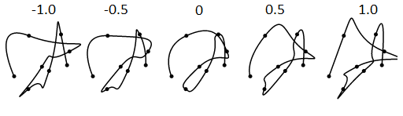
Figure 10.2 Effects of the Bias parameter in Kochanek-Bartels interpolation method on a curve fitted to an arbitrary set of data points (black dots). Bias=0 (the center curve) is the default shape of the curve. Negative Bias value causes undershoot, while positive values cause overshoots.

To realize the motion generated by the Behavior Exxpressions on the robot, we use a processing engine similar to the one introduced by van Breemen [110] and used on the robot iCat [30].
BE generates a string – a sequence of action symbols which each action corresponds to some animation of the robot. Because each action was defined independently of each other, there are times when the end position of one action and the starting position of the next action differs by a large amount, causing an abrupt transition. The Transition Filter in iCat’s animation engine addresses this problem by allowing a transition period between the end pose of the first action, and interpolates the motion data towards the next action within that period. The period can be modified such that shorter period will cause a more abrupt transition, and a longer period a smoother transition.
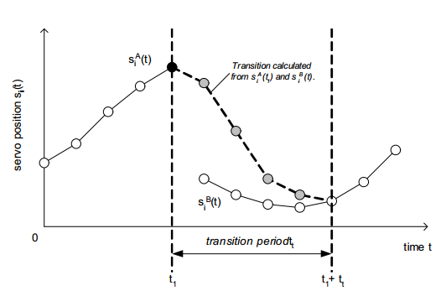
Figure 10.3 Transition filter creates new keypoints to avoid abrupt transitions. Image source: [110]

The keypoints are calculated as follows:
$$s_{i}\left(t\right)= \left\{\begin{aligned}s_{i}^{A}\left(t\right) t<t_{1} \\ α\left(t\right) ∙s_{i}^{B}\left(t\right)+\left(1-α\left(t\right)\right)∙s_{i}^{A}\left(t\right) t_{1}≤t<t_{1}+t_{t} \\ s_{i}^{B}\left(t\right) t ≥t_{1}+t_{t}\end{aligned}\right.$$
Where:
$$α\left(t\right)=\frac{t-t_{1}}{t_{t}}$$

When a BE is invoked, a new sequence of actions is generated, and the sequence must first be processed prior to execution on the robot itself (i.e. servos) among other things to ensure the motion is feasible and safe, the motion has the desired characteristics with respect to timing, smoothness of transition, and congruity of the actions. Thus, we have some parameterized tools that can be used to control the execution of the motion sequence generated by BEs.
- Transition filter is used to manage transitions between actions.
- Multiresolution filtering to exaggerate the actions
- Kochanek-Bartels interpolation to do anticipation (to some extent), smoothing of movement trajectory, and provides some control over ease-in/out (acceleration and deceleration).
- Perlin Noise to generate beat/repetitive gestures and varying the range of motion.
Eventually, the parameters of these tools can be mapped to some set of inputs category which values are influenced by the interaction with a person. For example: if the robot is programmed such that seeing the color “blue” would make the robot “happy”, to convey “happy”, then some of the parameters may be adjusted, for example: increasing the middle frequency gains of multiresolution filtering so the motions appears exaggerated, and making transitions between actions happen faster. The mapping between the parameters and input from interaction such that the process can be automated still requires further study at this point.
For now, I will develop a system that will allow setting the parameter values, either embedded in BEs or in a separate manner.

Interactive Gene Expression Programming
Gene Expression Programming (GEP) is an Evolutionary Algorithm that uses chromosomes of fixed length as its genotype and the phenotype is a parse tree of the genotype called expression tree [113]. GEP is used to evolve programs such as mathematical expressions and neural networks. At this point, I am still learning about GEP and need to spend more time with more examples. However, from my initial review, GEP is able to evolve expressions and produce new valid expressions. Using Genetic Algorithm, the validity of the evolved expression cannot be guaranteed because the reproduction operations are done at random (under some probability). In GEP, the gene is of fixed length and is structured into a head and tail. The head may contain operators and terminals (e.g. non-operator symbols, numbers), while the tail may only contain terminals. Thus, the reproduction operations are restricted to maintain this structure. There is no restriction on the boundary between the head and the tail. The gene is called K-expressions, from which a parse tree (called expression tree) can be constructed.
While the length of the gene is fixed, not all parts of the gene is always used to create the programs. GEP adapted the method of coding sequence of a gene in biology, called open reading frames (ORF). The part of the gene in GEP that can be used to create expression trees is the analog to ORF and is called K-expression. Figure 11.1 shows an example of a gene in GEP. The top row of the gene denotes the positions of the symbols in the gene, and the bottom row contains the symbols in the gene. Figure 11.2 shows the expression tree for the gene.
0 | 1 | 2 | 3 | 4 | 5 | 6 | 7 | 8 | 9 | 0
Q | * | + | * | a | * | Q | a | a | b | a

Figure 11.1 An example gene
‘
Q
*
+
*
a
*
a
b
Q
a
a
Figure 11.2 Expression tree for the gene in Figure 11.1

Because REBeL expresses robot behaviors using Behavior Expressions which is similar to regular expressions, GEP seems to be an appropriate tool to evolve Behavior Expressions for improving or creating new behaviors. However, since some of the evolved behaviors will be some form of gestures, or gestures with some emotional expressions, their quality (i.e. fitness) can only be evaluated by a person. For this reason, a person will perform the fitness evaluation for each generated expression. Also for this reason we cannot have a large population pool due to mental fatigue of the human evaluator.

Interactive Fitness Evaluation
What makes the evolutionary algorithm ‘interactive’ is the role of a person who evaluates the fitness of the phenotypes (i.e. generated behaviors; in this case, gestures) instead of using a computable fitness function. Naturally, this fitness evaluation might not always be fair, objective, or consistent. However, evaluating meaningful gestures or expressiveness of gestures are difficult to model. But since what matters is the perception of the person towards those gestures (i.e. visually), then it is still permissible to have a person ‘judge’ the quality of the gestures.
One way to enforce a little bit more consistency of the evaluation is to use a rating system. Here, I propose to use the Elo Rating system which today still is being used to rank chess players around the world [114] and also has been used to rank players in online-multiplayer video games and other sports [115]. Using the Elo Rating system, the person must evaluate two phenotypes and pick a winner/the best one based on his/her judgment. The rankings of those phenotypes will then be updated to reflect their fitness which will determine their chances to be used for the new population on the next evolution cycle.
In the Elo Rating system, a player’s skill is assumed to be a normal distribution, and his/her true skill is around the mean. By this assumption, it provides the player’s expected chance of winning, and a method to update a player’s Elo Rating. When a player has higher Elo ranking than his opponent, then he has a higher chance of winning (higher expected value) than his opponent, and vice versa. When both players have similar Elo rankings, the chance of a draw is higher.
After the match, both players’ rankings are updated with the same amount, but the winner gains that amount, while the loser loses that amount. However, when a stronger player wins against a much weaker opponent, then the rank changes are smaller. If a weaker player wins against a stronger opponent, the rank changes are greater than if they have similar rankings.
The Elo Rating process is illustrated using the following example. Suppose a Robot Battle Arena where robots fight against each other. With Elo Rating, a robot’s ranking is updated based on its expected value of winning (E), and the outcome of the match (S) or score, where: 1 = win, 0 = lose, and 0.5 = draw. The expected value is calculated as:
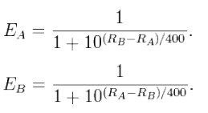
Where:
- E_{A}, E_{B} = expected score for robot A and robot B, respectively.
- R_{A}, R_{B} = the rankings of robot A and robot B, respectively.
Suppose robot A has higher ranking than robot B, where: R_{A} = 1500, and R_{B} = 1320. Then the expected score for the robots are:
- $E_{A}=\frac{1}{1+\frac{{10}^{1320-1500}}{400}}=0.738$
- $E_{B}=1-0.738=0.262$ (yes, this is correct. E_{A} = 1 – E_{B} and vice versa)
After the match, the ratings of the robots will be adjusted by the following formula:
$$R_{A}^{'}=R_{A}+K\left(S-E_{A}\right)$$
$$R_{B}^{'}=R_{B}+K\left(S-E_{B}\right)$$
Where:
- R’_{A}, R’_{B} = The new rating for robot A and robot B, respectively
- R_{A}, R_{B} = The current/old ratings of robot A and robot B, respectively
- K = Some ‘subjective constant’. Typical value is 24 (will be explained below)
- S = Score/match result (1=win, 0=lose, 0.5=draw)
- E_{A}, E_{B} = Expected scores for robot A and robot B, respectively
The ranking changes can then be calculated in the scenarios:
- Robot A wins:
  - R’_{A} = 1500 + 24*(1-0.738) = 1500 + 6.288 = 1506
  - R’_{B} = 1320 + 24*(0-0.262) = 1320 – 6.288 = 1314
- Robot B wins:
  - R’_{A} = 1500 + 24*(0 – 0.738) = 1500 – 17.712 = 1482
  - R’_{B} = 1320 + 24*(1 – 0.262) = 1320 + 17.712 = 1338
- A draw:
  - R’_{A} = 1500 + 24*(0.5 – 0.738) = 1500 – 5.712 = 1494
  - R’_{B} = 1320 + 24*(0.5 - 0.262) = 1320 + 5.712 = 1326
The calculation can also be done by aggregating the results of multiple matches, for example if we look only to robot A:
Opponent/match | Opponent rank (R_{B}) | E_{A} | Score/match outcome (1=win, 0=lose, 0.5=draw)
1 | 1320 | 0.738 | 1
2 | 1700 | 0.240 | 1
3 | 1480 | 0.529 | 0
4 | 1560 | 0.415 | 0.5
5 | 1800 | 0.151 | 0
Total |  | 2.073 | 2.5
The new ranking of robot A after the above 5 matches is:
R’_{A} = 1500 + 24*(2.5-2.073) = 1500 + 10.248 = 1510 (rounded to closest decimal)
Regarding the value for K, some Elo implementations may adjust K based on some criteria, for example:
- FIDE (World Chess Federation):
  - K = 30 for a player new to the rating list until s/he has completed events with a total of at least 30 games.
  - K = 15 as long as a player's rating remains under 2400.
  - K = 10 once a player's published rating has reached 2400, and s/he has also completed events with a total of at least 30 games. Thereafter it remains permanently at 10.
- USCF (United States Chess Federation):
  - Players below 2100 --> K-factor of 32 used
  - Players between 2100 and 2400 --> K-factor of 24 used
  - Players above 2400 --> K-factor of 16 used.

Summary
In this chapter, we discussed a brief overview of gene expression programming, and how I intend to augment the fitness evaluation to be done by humans. To reduce the effect of subjectivity measure on the fitness evaluation, I intend to use Elo Rating system, which was discussed in the second part of this chapter.

INCLUDE ALL PAPERS THAT YOU CO-AUTHORED, MAKE REFERENCES TO THEM,
THIS IS NORMALLY REQUIRED FOR PHD PROPOSAL

Experiments and Evaluations

Evaluation
To evaluate the ideas proposed in this dissertation, I have to involve human subjects to provide evaluation on the effectiveness of the proposed methods.
Evaluation of the effectiveness of the proposed topic is difficult due to the fact that because “expressiveness”, “engagement”, “entertainment” of the robot movement must always be evaluated in some context of interaction.
Steinfeld et al. suggested that to measure performance of robots whose role is to interact with humans in a social setting, some subjective measurements are inevitable [80].
In most experiments involving the ability of the robot to express emotions or behaviors, the set up often is as follows:
- A group of participants observe a robot.
- The survey provides a form consisting of a list of possible behaviors.
- The robot performs one of the behaviors.
- The person marks which behavior he/she observed.
- The experimenter knows in which order the behaviors are performed (ground truth).
- The survey results are then collected. If on average a particular gesture is guessed correctly better than random, then the gesture is said to be “good”. If it’s random or less, it is “poor” or “ambiguous”.
This type of experiment is relatively easy to perform, but the gestures are taken completely out of context. For example: with the KOBIAN robot above, the demonstration only shows the pose of surprise, instead of the robot being surprised by something. I performed similar experiment with a KHR-1 robot. What is 21? It is not your work. When only poses were presented, the human observers are having a difficult time trying to guess what the robot is doing. So what is your conclusion at this point?
I suggest evaluation of expressive gestures to be in a semi-controlled environment such that the participants are given some expectations about the robot but not given specific instructions or commands to interact with the robot, rather than letting them interact with the robot with no information at all. The evaluations can be done in two scenarios: interactive and as a performance.

Interactive Experiment
Here, the person is actively interacting with the robot. The goal of this experiment is to see which robot behaviors have social meaning to a person and in what context. For example: the combination of two behaviors: maintaining distance to a person and tracking a person can sometimes be interpreted as ‘chasing’ or ‘avoiding’ depending if the person keeps moving away or towards the robot, respectively and can subsequently become a game [32]. If the person walks slowly, the robot is ‘following’ instead of ‘chasing’ because the robot can quickly maintain the distance. Otherwise, if the person walks fast and the robot needs to speed up to catch up and close the distance with the person, the robot appears to be ‘chasing’.
Suppose a set of behaviors are programmed on the robot using EE:
- Greeting = (Face_detect say_hello) + (Person_say_hello say_hello)
- Red_attract = sees_red (approach + reach)*
- Blue_avoid = sees_blue avoid
- Other_color = not(sees_red + sees_blue) (look)*wander
- Wander = not(Greeting)
An example of such interaction is:
- Person meets robot
- If the person greets first, the robot responds. If the robot notices the person first, the robot may greet first.
- The person is told that the robot likes red things, dislike blue things and is apathetic to other colors.
  - The robot may attempt to hold a red object
  - The robot will avoid any blue object
  - The robot will look at objects of other colors but then look away (ignoring).
- The robot is secretly programmed to love a red ball specifically.
- The person is told that they can interact with the robot by showing it some objects (a red ball is among the objects).
- The robot can track the person. But if the person does not try to interact with the robot by presenting it with an object, the robot will start to wander around.
We can measure:
- The relative meeting of expectancies as a partial measure of ‘natural interaction’:
  - Did the robot respond in a relevant/expected manner? For example:
    - If the person was told that the robot likes red objects, an expected behavior would be: would pay attention to the red object and try to interact with it.
  - If not, was it perceived as completely out of context or unexpected but interesting? For example:
    - Out of context: the robot is presented with red object, but performs a greeting gesture.
    - Unexpected but interesting: the robot is presented with blue object, but tries to interact with it.
  - How many times did the robot respond in relevant/expected ways? This is to check if the person was able to guess the character model of the robot through its behaviors.
- How many different behaviors/emotion did the person infer? For example:
  - Surprised, excited, uninterested, avoiding, playful,
- How many variations of behaviors did the person observe? This is to evaluate the usefulness of probabilistic behavior generation to create variety.
  - When the robot is presented with the red ball, the robot gets excited. The excitement behavior is programmed using EE and thus have probabilistic variation of executions. How many of different executions did the person observe but was still able to recognize them as the same behavior (e.g. excited)

As a Theatrical Play
Here, multiple robots are programmed with different characters. The person acts as an audience and provides feedback on the dynamics between the robots that he/she observed. This experiment highlights the feature of EE language to synthesize interaction dynamics between two characters using known methods from automata theory, particularly product machine. This experiment can be carried out in a simulation software such as V-Rep or ODE, or on actual/physical robots.
Some example of this experiment is:
- “Gentleman vs. Rude man” – one robot is programmed as the gentleman who in general is polite in the way it interacts, while another robot is programmed as a rude man who is always angry and rude. The behaviors of these robots will be programmed using REBeL. I select the set of behaviors such that some interesting interaction dynamics can happen. Is this model strong enough that a new type of behavior can emerge that was not predicted before?
- “Mailman vs. Guard dog” – one robot is programmed as a mailman who is trying to reach a location (i.e. the front door to deliver a package), and the other robot is programmed as a guard dog that tries to attack the mailman if it ever detect him. The dog does not necessarily have the goal to prevent the mailman from delivering the package – it is only interested in biting the mailman.
- Heider & Simmel’s Box & Triangle experiment – three robots are programmed using REBeL, where each robot have their own sets of BEs to closely resemble the animation done in Heider & Simmel’s experiment [46].

Using REBeL
We might allow people to try to use REBeL to either program some robot behavior for human-robot interaction or an interaction dynamics scenario such as the plays mentioned above. In the former case, a person can try to use the language to create new robot behaviors. The newly-created behaviors can then be simulated in a simulation software (V-Rep or ODE) and evaluated using some scoring scheme such as ELO Rating (discussed in Chapter ##). The evaluated behaviors can then be evolved using evolutionary algorithm such as Gene Expression Programming (GEP) (discussed in Chapter #x#). Since the behaviors are now represented in a mathematical expression form, GEP is suitable for this case since it can guarantee well-formed expressions during the recombination process [ref]. This method of using human evaluation to drive the evolution of the population is called interactive evolution, and thus the approach I propose is called Interactive Gene Expression Programming.

To measure the effectiveness of social robots, Steinfeld et. al suggested the following metrics [76]:
- Interaction characteristics
- Persuasiveness - how the robot can change/affect the behavior of the person
- Trust – the feeling related to safety of the person with respect to the robot’s actions.
- Engagement – the ability to produce social characteristics that captivate the person’s attention while maintaining interest
- Compliance – how well the robot follows human social interaction norms, safety, etc.
Metrics are social presence in terms of Intelligence (perceived as being intelligent), Social Attraction (makes people want to interact socially with it) and Enjoyment of interaction (interaction experience) [47].
Because what I am trying to create is meaningful, expressive movements on the robot using the proposed Behavior Expression, the robot must be evaluated within some interaction context.
We evaluate the new Language on two robot platforms:
- Jeeves, the MCECS Guide Robot. Jeeves is a mobile robot with humanoid appearance: head, torso, arms. The robot main function is to greet and interact with people visiting the lobby of the Engineering Building, and providing tour of the building as requested. Jeeves has an array of sensors including Kinect, sonars, laser range finder, inertial measurement unit (IMU) which allows it to safely navigate the building, among other things. The articulated head/neck, arms and torso allows Jeeves to perform many human-like gestures.
- Pepe is a small mobile robot built on the Stingray platform from Parallax [ref]. The robot is equipped with sonars to avoid collisions but does not have navigation capabilities. An arm/neck armature is placed on top of the robot which acts as both a neck/face and gripper/manipulators.
- Robot Theatre (Portland Cyber Theatre play “Quantum Consciousness”)
The work of this dissertation falls under the social robotics category. The contribution of this work is a new language for programming robot behavior that can be manipulated using probabilistic algebraic operators, and a behavior and gesture control systems which employ concepts from art and animation. The result of this work is providing robot programmers with high-level robot behavior description that is easy to understand and manipulate. The language also allows evolving and generating new behaviors using evolutionary algorithms such as Interactive Gene Expression Programming. Ultimately, the behaviors executed by the robot, particularly in the motions of the robot, guaranteed to achieve the level of expressiveness and naturalness comparable to those seen in popular animated feature films like Wall-E.
The components that need to be measured are the following:
- What is the learning curve of this new language – how long does it take for someone to learn and be proficient with this language?
- Engagement
  - How long do people interact with the robot?
  - How intelligent (i.e. can think for itself) do people think the robot is? (e.g. a child, a pet dog, a wild animal, a mature person)
  - How charismatic is the robot? Does it make people want to interact with it?
  - How does the robot make people feel? Uncomfortable, angry, boring, entertained, happy, cute, WHAT CUTE MEANS HERE?etc.
  - Does the robot sufficiently pay attention to the person?
  - The rate of interaction – can it match human rate interaction? Does the user experience lag such that it makes the interaction awkward? (e.g. long pauses)
- Compliance – Does the robot respect social interaction norms?
- Expressiveness/ Persuasiveness:
  - How convincing are the robot’s gestures? E.g. if we have programmed “surprise”, do people perceive surprise? (this will be staged – the interaction will be set up so the person can actually try to surprise the robot by a predetermined set of stimuli , for example: suddenly comes in field of view, throwing something at the robot, bumping the robot from behind, etc.)
  - Can the robot change people’s (audience) mood/emotion? For example, by simply mimicking the person’s emotion. I believe there are studies Find REF or remove or change sentence, you must know not believe that show mimicking indicates showing interest (and to an extent, caring) which can improve one’s mood/attitude.
The first robot is programmed as the following character:
- The robot loves the color red, and always attracted to anything with the color red. It will always try to interact with red objects gently, unless it’s a red ball.
- The robot is deathly afraid of blue balls.
- If a person gives the robot a red ball, the robot will love the person forever! (it will try to maintain a close distance with the person and look at the person)
- If the robot finds a red ball, it will get excited and starts playing with the ball. (search for the ball and run into it).
- If the robot gets hit (e.g. by a ball), it is surprised.
- The robot will always avoid running into obstacles, unless it’s the red ball.
In order to do the experiment on the first robot, the following components are needed:
- RGB camera on the robot
- OpenCV to process face, and object color tracking
- IMU to detect shock
- Some touch-sensitive surfaces??
- IR & sonar for distance measurements
- Track and move head towards the red object. Even closer for red balls.
The second robot character:
- Hates the red ball. It will always try to destroy a red ball if it finds one, unless a person is present, in which case it will just stay away from the red object as far as possible
- Mobile, can move around and avoid colliding with obstacles
- It will play with any blue objects, poking, holding, putting down
Needed:
- Ability to circle around an object (for both robots)
Most robot tasks can be measured using objective, quantitative measures. For example: the performance of a robot that can clean a room can be measured in terms of the amount of time it takes the robot to clean the room, the length of the path it took, and the cleanliness of the room. Measuring human-robot interaction often requires the subjective input of the person, which is often obtained using surveys from human subjects.
To evaluate the generated actions, we can first simulate them using a physics simulation tool called Open Dynamics Engine (ODE) before executing on the robot. A 3D model of the robot is programmed in ODE using OpenGL, and the (approximate) physical characteristics of the actual robot are programmed into the model, i.e. dimensions, mass, maximum torque of the actuators. The sequence of actions is then executed as commands to the model. This way, we can do two things:
- Test safety constraints: whether or not the proposed system is able to generate safe actions and avoid physical damage to the robot (or people!).
- Perform IGEP for a newly-generated sequence. Users will have the option to observe the sequence on the 3D model or executed on the robot.
We use two scenarios to evaluate the performance of the robot: theatrical where the person only passively observes the actions of the robot (i.e. as a robot actor), and interactive where the person directly interacts with the robot (as a socially interactive robot).
For the theatrical performance, we set up a few autonomous behaviors for the robot and let the robot “live” in an environment. The robot will roam, or interact with some props on the stage. HOW IT WILL INTERACT? The person will evaluate how the robot is doing, and we ask how the person tells the story of the robot. This is to measure one part of the “passive engagement” aspect and the “entertainment” aspect of the robot as the product of the language.
In the interactive section, there are two parts: 1) the person is like a “director” for the robot and 2) the person interacts directly with the robot.
As a “director”, the person will use the Behavior Expression language system to direct the robot how to act. For example, the person programs the robot to be surprised when a wall is too close. The robot will perform a known surprise gesture, but the person may say that the surprise gesture must be exaggerated, or “bigger”. The person needs not to set the joint angles on the robot, but only specify qualifiers such as “more” or “less”.
This is to measure the effectiveness of the language to be used as a production tool.
In the second mode of interaction, some interaction behaviors are programmed on the robot, and the person will be in the vicinity of the robot and will try to talk with the robot. The person and the robot will be in a room monitored with a Kinect camera to detect the location of the person. We include some basic speech recognition capability. While we are aware that the quality of the speech recognition ability is detrimental to the whole interaction experience, improving the performance of speech recognition is beyond the scope of this work. We use the best freely-available tools from Carnegie-Mellon University for speech recognition (CMU Sphinx), natural language processing (NLP) and reasoning. Part of this work also touch upon the reasoning part as to associate meaning with gesticulation and expressions. WHAT EXPRESSIONS, BE SPECIFIC
The third experiment is to measure the “active engagement”, “anthropomorphism”, “entertainment”. Finally, we will evaluate the effectiveness of the language by the complexity of the language programs to create scenarios/performances that are rated as interesting, engaging. And the response time etc. LAST SENTENCE INCOMPLETE AND NOT CLEAR. PLEASE LINK ALL THESE IDEAS TO THE TEXT OF PLAY THAT I SEND YOU.

I would like to see some graphical representation of all your projected system.
I would like also to see some tabular comparisons of your approach versus your competitors
Who are your main competitors ? Where they published?
It would be good to add some questionnaires that will be given to the audience that will be evaluating your work.

Timeline and Milestones

Schedule/Goals

MILESTONES
- Fall 2014:
  - Implemented IK Module, set up environment for Kinect
  - Early prototype of EE based on Peter Norvig’s grammar code
  - Robot building
  - Proposal + Defense preparation
- Winter 2015:
  - Prototype of EE Language parser with probabilistic operators
  - Demo of generated gestures from EE
  - Integrate sensing capabilities (face detection, voice detection, object detection, distance, and inertial measurements)
  - Testing of interactive mode: through sensing, triggers possible EE-generated behaviors (e.g. focus on “surprise” gesture)
- Spring 2015:
  - Into EE analytics – product machine, reachability analysis, use for verification
  - (Maybe) go beyond probabilistic operators
  - Refinement for using DAP and LMA parameters as motion descriptors
  - Set up simulation environment (whether it’s V-Rep, Gazebo, PyODE+OpenGL or other convenient tool)
  - Implement and test Interactive Gene Expression Programming
  - First run of evolving gestures using IGEP WHEN YOU WANT TO GRADUATE? Be realistic, time for evaluation, add one more year.

Schedules:
- Affective Computing & Intelligent Interaction conference: April 24, 2015
- IEEE World Congress on Computational Intelligence: July 25-29 2016
- ACM/IEEE International Conference on Human-Robot Interaction: March 2-5, 2015

Upcoming Papers
- Interactive Gene Expression Programming – Use GEP to generate valid BEs, and ELO rating system for users to evaluate the fitness of the phenotypes.
- REBeL and Behavior Expressions
- The Minimally Anthropomorphic Robot
- Evolving The Animated Robot

Target Journals/Publications:
- Journal of Human-Robot Interaction
- International Journal of Social Robotics
- International Journal of Humanoid Robotics
- International Conference on Social Robotics
- International Conference on Robotics and Automation
- International Conference on Human-Robot Interaction

References

[1] | T. Fong, I. Nourbakhsh and K. Dautenhahn, "A survey of socially interactive robots," Robotics and Autonomous Systems, vol. 42, pp. 143-166, 2003.
[2] | J. Lasseter, "Principles of traditional animation applied to 3D computer animation," in ACM Siggraph Computer Graphics, 1987.
[3] | Takanishi Laboratory, "Emotion Expression Biped Humanoid Robot KOBIAN-RII," Takanishi Laboratory, 11 11 2011. [Online]. Available: http://www.takanishi.mech.waseda.ac.jp/top/research/kobian/KOBIAN-R/index.htm. [Accessed 5 12 2014].
[4] | V. Navone, "Animating Limited Characters," 6 February 2011. [Online]. Available: http://blog.navone.org/2011/02/animating-limited-characters.html. [Accessed 21 10 2014].
[5] | M. Sfakiotakis, A. Kazakidi, N. Pateromichelakis and D. P. Tsakiris, "Octopus-inspired eight-arm robotic swimming by sculling movements," in IEEE International Conference on Robotics and Automation (ICRA), 2013.
[6] | Festo, "SmartBird – bird flight deciphered," Festo, 2012. [Online]. Available: http://www.festo.com/cms/en_corp/11369.htm. [Accessed 5 12 2014].
[7] | Festo, "AirPenguin," Festo, 2009. [Online]. Available: http://www.festo.com/cms/en_corp/9780.htm. [Accessed 5 12 2014].
[8] | Festo, "BionicKangaroo – energy-efficient jump kinematics based on a natural model," Festo, [Online]. Available: http://www.festo.com/cms/en_corp/13704.htm.
[9] | T. Geijtenbeek, M. van de Panne and A. F. van der Stappen, "Flexible muscle-based locomotion for bipedal creatures," ACM Trans. Graph., vol. 32, no. 6, pp. 206:1-206:11, 2013.
[10] | K. Sims, "Evolving Virtual Creatures," in SIGGRAPH, 1994.
[11] | M. Raibert, K. Blankespoor, G. Nelson and R. Playter, "BigDog, the Rough-Terrain Quaduped Robot," Boston Dynamics, Waltham, MA, 2008.
[12] | S. Lemaignan, J. Fink and P. Dillenbourg, "The dynamics of anthropomorphism in robotics," in Proceedings of the 2014 ACM/IEEE International conference on Human-robot interaction, 2014.
[13] | V. Navone, "VNOG Blog: Rhythm and Texture," 09 09 2009. [Online]. Available: http://blog.navone.org/2009/09/rhythm-and-texture.html. [Accessed 22 10 2014].
[14] | C. Ferreira, "A Quick Introduction to Gene Expression Programming," GEP Tutorials: A Gepsoft Web Resource, 23 July 2013. [Online]. Available: http://www.gene-expression-programming.com/Tutorial001.asp. [Accessed 10 December 2014].
[15] | Wikipedia contributors, "Elo rating system," Wikipedia, The Free Encyclopedia, 10 December 2014. [Online]. Available: http://en.wikipedia.org/w/index.php?title=Elo_rating_system&oldid=637504304. [Accessed 11 December 2014].
[16] | A. L. Thomaz and C. Breazeal, "Teachable robots: Understanding human teaching behavior to build more effective robot learners," Artificial Intelligence, vol. 172, no. 6, pp. 716-737, 2008.
[17] | C. Breazeal, "Role of expressive behaviour for robots that learn from peopl," Philosopical Transactions of the Royal Society B: Biological Sciences, vol. 364, no. 1535, pp. 3527-3538, 2009.
[18] | A. R. Wagner and R. C. Arkin, "Analyzing social situations for human-robot interaction," Interaction Studies, vol. 9, no. 2, pp. 277-300, 2008.
[19] | O. Johnston and F. Thomas, The illusion of life: Disney animation, New York: Hyperion, 1995.
[20] | A. Stanton, "Andrew Stanton: The clues to a great story," TED, February 2012. [Online]. Available: https://www.ted.com/talks/andrew_stanton_the_clues_to_a_great_story. [Accessed 2 December 2014].
[21] | G. Keane, "www.aimeemajor.com," [Online]. Available: www.aimeemajor.com/anim/gknote.html. [Accessed 26 December 2014].
[22] | R. Laban and L. Ullmann, The mastery of movement, Boston: Plays, Inc., 1971.
[23] | "Anthropomorphism," Merriam-Webster, Inc., 2014. [Online]. Available: http://www.merriam-webster.com/dictionary/anthropomorphism. [Accessed 24 09 2014].
[24] | B. R. Duffy, "Anthropomorphism and the social robot," Robotics and autonomous systems, vol. 42, no. 3, pp. 177-190, 2003.
[25] | C. Breazeal, "Emotion and sociable humanoid robots," International Journal of Human-Computer Studies, vol. 59, no. 1, pp. 119-155, 2003.
[26] | "Jibo," Jibo, [Online]. Available: http://www.myjibo.com/. [Accessed 25 September 2014].
[27] | R. A. Brooks, "A robust layered control system for a mobile robot," IEEE Journal of Robotics and Automation, vol. 2, no. 1, pp. 14-23, 1986.
[28] | N. Pipenbrinck, "Hermite Curve Interpolation," 30 March 1998. [Online]. Available: http://cubic.org/docs/hermite.htm. [Accessed 6 December 2014].
[29] | A. Bruderlin and L. Williams, "Motion Signal Processing," in Proceedings of the 22nd annual conference on Computer graphics and interactive techniques, 1995.
[30] | A. van Breemen, X. Yan and B. Meerbeek, "iCat: an animated user-interface robot with personality," in Proceedings of the fourth international joint conference on Autonomous agents and multiagent systems, 2005.
[31] | R. Mead, "Space, speech, and gesture in human-robot interaction," in Proceedings of the 14th ACM international conference on Multimodal interaction, 2012.
[32] | R. Mead and M. J. Mataric, "A probabilistic framework for autonomous proxemic control in situated and mobile human-robot interaction," in Proeedings of the seventh anual ACM/IEEE international conference on Human-Robot Interaction, 2012.
[33] | M. L. Walters and et al., "The influence of subjects' personality traits on personal spatial zones in a human-robot interaction experiment," in Robot and Human Interactive Communication, 2005.
[34] | A. Bruce, I. Nourbakhsh and R. Simmons, "The role of expressiveness and attention in human-robot interaction," in Proceedings of the 2002 IEEE International Conference on Robotics and Automation, Washington, DC, 2002.
[35] | K. Bergmann and S. Kopp, "Increasing the expressiveness of virtual agents: autonomous generation of speech and gesture for spatial description tasks," in Proceedings of The 8th International Conference on Autonomous Agents and Multiagent Systems, 2009.
[36] | S. Kopp and I. Wachsmuth, "Model-based animation of co-verbal gesture," in Proceedings of Computer Animation, 2002.
[37] | J. Rett and J. Dias, "Human-robot interface with anticipatory characteristics based on laban movement analysis and bayesian models," in IEEE 10th International Conference on Rehabilitation Robotics, 2007, 2007.
[38] | S. Waldherr, R. Romero and S. Thrun, "A gesture based interface for human-robot interaction," Autonomous Robots, vol. 9, pp. 151-173, 2000.
[39] | P. Bakker and Y. Kuniyoshi, "Robot see, robot do: An overview of robot imitation," Society for the Study of Artificial Intelligence and Simulation of Behaviour, Brighton, 1996.
[40] | B. D. Argall, S. Chernova, M. Veloso and B. Browning, "A survey of robot learning from demonstration," Robotics and autonomous systems, vol. 57, no. 5, pp. 469-483, 2009.
[41] | E. Ackerman, "Honda Robotics Unveils Next-Generation ASIMO Robot," IEEE Spectrum, 8 November 2011. [Online]. Available: https://www.youtube.com/watch?v=Bmglbk_Op64. [Accessed 15 December 2014].
[42] | T. Kishi, T. Otani, N. Endo, P. Kryczka, K. Hashimoto, K. Nakata and A. Takanishi, "Development of expressive robotic head for bipedal humanoid robot," in Intelligent Robots and Systems, 2012.
[43] | M. M. Lab, "Magic Robot Interaction," MIT Media Lab Director's Fellow Program, 03 01 2014. [Online]. Available: http://directorsfellows.media.mit.edu/magic-robot-interaction. [Accessed 05 08 2014].
[44] | D. Greenfield, "automationworld.com," Summit Media Group Inc., 27 March 2014. [Online]. Available: http://www.automationworld.com/beyond-manufacturing-robot-musicians. [Accessed 5 August 2014].
[45] | D. Park and J.-H. Lee, "Investigating the affective quality of motion in user interfaces to improve user experience," in Entertainment Computing-ICEC, 2010.
[46] | F. Heider and M. Simmel, "An experimental study of apparent behavior," The American Journal of Psychology, pp. 243-259, 1944.
[47] | K. M. Lee, W. Peng, S.-A. Jin and C. Yan, "Can robots manifest personality? An empirical test of personality recognition, social responses, and social presence in human-robot interaction," Journal of Communication, vol. 56, pp. 754-72, 2006.
[48] | J. Segal, Ph.D and M. Smith, M.A., "Emotional Intelligence (EQ) Key Skills fo Raising Emotional Intelligence," Helpguide.org, December 2014. [Online]. Available: http://www.helpguide.org/articles/emotional-health/emotional-intelligence-eq.htm. [Accessed 18 December 2014].
[49] | T. Ribeiro and A. Paiva, "The illusion of robotic life: principles and practices of animation for robots," in Proceedings of the seventh annual ACM/IEEE international conference on Human-Robot Interaction, 2012.
[50] | C. Stanton, A. Bogdanovych and E. Ratanasena, "Teleoperation of a humanoid robot using full-body motion capture, example movements, and machine learning," in Australasian Conference on Robotics and Automation, Wellington, 2012.
[51] | N. S. Pollard, J. K. Hodgins, M. J. Riley and C. G. Atkeson, "Adapting human motion for the control of a humanoid robot," in IEEE International Conference on Robotics and Automation, 2002.
[52] | E. Guizzo, "Singapore Researchers Unveil Social Robot Olivia," IEEE Spectrum, 13 August 2010. [Online]. Available: http://spectrum.ieee.org/automaton/robotics/home-robots/social-robot-olivia. [Accessed 18 December 2014].
[53] | E. Wade and M. J. Matarić, "Design and Testing of Lightweight Inexpensive Motion-Capture Devices with Application to Clinical Gait Analysis," in Pervasive Computing, 2009.
[54] | A. Witkin and D. Baraff, "Physically based modeling: principles and practice (online course notes)," in SIGGRAPH, 1997.
[55] | Wikipedia contributors, "Ragdoll Physics," Wikipedia, The Free Encyclopedia, 26 November 2014. [Online]. Available: http://en.wikipedia.org/w/index.php?title=Ragdoll_physics&oldid=635451113. [Accessed 27 December 2014].
[56] | "Morpheme with Euphoria," NaturalMotion, 2014. [Online]. Available: www.naturalmotion.com/middleware/euphoria. [Accessed 27 December 2014].
[57] | L. Kovar, M. Gleicher and F. Pighin, "Motion graphs," ACM transactions on graphics, vol. 21, no. 3, pp. 473-482, 2002.
[58] | R. Heck and M. Gleicher, "Parametric motion graphs," in Proceedings of the 2007 symposium on Interactive 3D graphics and games, 2007.
[59] | M. Mizuguchi, J. Buchanan and T. Calvert, "Data driven motion transitions for interactive games," Eurographics 2001 Short Presentations, vol. 2, no. 3, pp. 6-11, 2001.
[60] | C. Ren, L. Zhao and A. Safonova, "Human Motion Synthesis with Optimization-based Graphs," Computer Graphics Forum, vol. 29, no. 2, pp. 545-554, 2010.
[61] | D. Chi, M. Costa, L. Zhao and N. Badler, "The EMOTE model for effort and shape," in Proceedings of the 27th annual conference on Computer graphics and interactive techniques, 2000.
[62] | L. Zhao and N. I. Badler, "Acquiring and validating motion qualities from live limb gestures," Graphical Models, vol. 67, no. 1, pp. 1-16, 2005.
[63] | D. Bouchard and N. Badler, "Semantic segmentation of motion capture using laban movement analysis," in Intelligent Virtual Agents, Paris, 2007.
[64] | J. O. De La Mettrie, Man a Machine, Read Books, 2007 (orig. 1748).
[65] | E. B. De Condillac and H. (. Aarsleff, Condillac: Essay on the Origin of Human Knowledge, Cambridge University Press, 2001.
[66] | D. Todes, Ivan Pavlov: Exploring the Animal Machine, Oxford University Press, 2000.
[67] | N. Wiener, The Human Use of Human Beings: Cybernetics and Society, Da Capo Press, 1988.
[68] | E. Moore, "Gedanken-experiments on sequential machines," Automata Studies, Annals of Mathematical Studies, vol. 34, pp. 129-153, 195.
[69] | G. H. Mealy, "A method for synthesizing sequential circuits," Bell System Technical Journal, vol. 34, no. 5, pp. 1045-1079, 1955.
[70] | D. Scott and M. Rabin, "Finite automata and their decision problems," IBM Journal of Research and Development, vol. 3, no. 2, pp. 114-125, 1959.
[71] | M. Lau and J. J. Kuffner, "Behavior planning for character animation," in ACM SIGGRAPH/Eurographics symposium on computer animation, 2005.
[72] | K. Dautenhahn, "Socially intelligent robots: dimensions of human-robot interaction," Philosophical Transactions of Biological Sciences, vol. 362, pp. 679-704, 2007.
[73] | M. Unuma, K. Anjyo and R. Takeuchi, "Fourier principles for emotion-based human figure animation," in Proceedings of the 22nd annual conference on Computer graphics and interactive techniques, 1995.
[74] | F. D. Murtagh and et al., "Multiresolution filtering and segmentation of multispectral images," in Astronomical Telescopes and Instrumentation, 2002.
[75] | W. contributors, "Cubic Hermite Spline," Wikipedia, The Free Encyclopedia, 27 November 2014. [Online]. Available: http://en.wikipedia.org/w/index.php?title=Cubic_Hermite_spline&oldid=635601511. [Accessed 21 December 2014].
[76] | A. Steinfeld and e. al., "Common metrics for human-robot interaction," in Proceedings of the 1st ACM SIGCHI/SIGART conference on Human-robot interaction, 2006.
[77] | M. Mori, K. F. (. MacDorman and N. (. Kageki, "The Uncanny Valley," IEEE Robotics and Automation, pp. 98-100, 12 June 2012.
[78] | C. Breazeal, "Social interactions in HRI: the robot view," IEEE Transactions on Systems, Man, and Cybernetics, Part C: Applications and Reviews, vol. 34, no. 2, pp. 181-186, 2004.
[79] | K. Dautenhahn, "Socially intelligent robots: dimensions of human-robot interaction," Philosophical Transactions of the Royal Society B: Biological Sciences, vol. 362, no. 1480, pp. 679-704, 2007.
[80] | A. Steinfield and et al., "Common metrics for human-robot interaction," in Proceedings of the 1st ACM SIGCHI/SIGART conference on Human-robot interaction, 2006.
[81] | M. A. Goodrich and A. C. Schultz, "Human-robot interaction: a survey," Foundations and trends in human-computer interaction, vol. 1, no. 3, pp. 203-275, 2007.
[82] | D. McNeill, Hand and mind: What gestures reveal about thought, Chicago: University of Chicago Press, 1992.
[83] | J. Lasseter, "FrankAnOllie.com," [Online]. Available: http://www.frankanollie.com/AnimationNotesFromOllie.html. [Accessed 4 October 2014].
[84] | R. Brockett, "Formal languages for motion description and map making," Robotics, vol. 41, pp. 181-191, 1990.
[85] | M. Egerstedt, "Motion description languages for multi-modal control in robotics," in Control problems in robotics, 2003.
[86] | D. Hristu-Varsakelis and S. Andersson, "Directed graphs and motion description languages for robot navigation," in Robotics and Automation, 2002.
[87] | M. O. Rabin, "Probabilistic automata," Information and control, vol. 6, no. 3\, pp. 230-245, 1963.
[88] | G. J. Pappas, G. Lafferriere and S. Sastry, "Hierarchically consistent control systems," IEEE Transactions on Automatic Control, vol. 45, no. 6, pp. 1144-1160, 2000.
[89] | T. Henzinger, "The theory of hybrid automata," in Logic in Computer Science, 1996.
[90] | R. A. Brooks, "A robot that walks; emergent behaviors from a carefully evolved network," Neural computation, vol. 1, no. 2, pp. 253-262, 1989.
[91] | J. H. Connell, "A behavior-based arm controller," IEEE Transactions on Robotics and Automation, vol. 5, no. 6, pp. 784-791, 1989.
[92] | M. J. Mataric and e. al., "Behavior-based primitives for articulated control," in Fifth International conference on simulation of adaptive behavior, 1998.
[93] | R. Alur, S. Kannan and M. Yannakakis, "Communicating hierarchical state machines," Automata, Languages and Programming, vol. 1644, pp. 169-178, 1999.
[94] | R. Alur and M. Yannakakis, "Model checking of hierarchical state machines," ACM SIGSOFT Software Engineering Notes, vol. 23, no. 6, pp. 175-188, 1998.
[95] | Y. Brave, "Control of discrete event systems modeled as hierarchical state machines," IEEE Transactions on Automatic Control, vol. 38, no. 12, pp. 1803-1819, 1993.
[96] | D. Bresolin, K. El-Fakih, T. Villa and N. Yevtushenko, "Deterministic timed finite state machines: equivalence checking and expressive power," arXiv, 2014.
[97] | M. G. Merayo, M. Núñez and I. Rodriguez, "Formal testing from timed finite state machines," Computer networks, vol. 52, no. 2, pp. 432-460, 2008.
[98] | J.-Y. Kim, I.-W. Park and J.-H. Oh, "Walking control algorithm of biped humanoid robot on uneven and inclined floor," Journal of Intelligent and Robotic Systems, vol. 48, no. 4, pp. 457-484, 2007.
[99] | H. R. Lewis and C. H. Papadimitriou, Elements of the theory of computatoin, Englewood Cliffs: Prentice-Hall, Inc., 1981.
[100] | K. Thompson, "Programming techniques: Regular expression search algorithm," Communications of the ACM, vol. 11, no. 6, pp. 419-422, 1968.
[101] | J. A. Brzozowski, "Derivatives of Regular Expressions," Journal of ACM, vol. 11, no. 4, pp. 481-494, 1964.
[102] | Wikipedia contributors, "Powerset construction," Wikipedia, The Free Encyclopedia, 3 September 2014. [Online]. Available: http://en.wikipedia.org/w/index.php?title=Powerset_construction&oldid=624008118. [Accessed 27 December 2014].
[103] | S. Yu, G. (. Rozenberg and A. (. Salomaa, "Regular languages," in Handbook of Formal Languages: Volume 1. Word, Language, Grammar, Springer, 1997, p. 41.
[104] | P. Viola and M. J. Jones, "Robust real-time face detection," International journal of computer vision, vol. 57, no. 2, pp. 137-154, 2004.
[105] | Microsoft, "Face Tracking," [Online]. Available: http://msdn.microsoft.com/en-us/library/jj130970.aspx. [Accessed 24 12 2014].
[106] | B. Gerkey, Santos and J. Santos, "gmapping," ROS.org, 06 August 2014. [Online]. Available: http://wiki.ros.org/gmapping. [Accessed 24 December 2014].
[107] | G. Grisetti, C. Stachniss and W. Burgard, "Improving Grid-based SLAM with Rao-Blackwellized Particle Filters by Adaptive Proposals and Selective Resampling," in IEEE International Conference on Robotics and Automation, 2005.
[108] | T. Kishi and et al, "Impression survey of the Emotion Expression Humanoid Robot with Mental Model based Dynamic Emotions," in IEEE International Conference on Robotics and Automation, Karlsruhe, 2013.
[109] | E. Marder-Eppstein, E. Perko, D. V. Lu and M. Ferguson, "base_local_planner," 05 October 2014. [Online]. Available: http://wiki.ros.org/base_local_planner. [Accessed 24 December 2014].
[110] | A. J. van Breemen, "Animation engine for believable interactive user-interface robots," in Intelligent Robotics and Systems (IROS 2004), 2004.
[111] | K. Perlin and A. Goldberg, "Improv: A system for scripting interactive actors in virtual worlds," in Proceedings of the 23rd annual conference on Computer graphics and interactive techniques, 1996.
[112] | K. Perlin and E. M. Hoffert, "Hypertexture," ACM SIGGRAPH Computer Graphics, vol. 23, no. 3, pp. 253-262, 1989.
[113] | C. Ferreira, "Gene expression programming in problem solving," in Soft Computing and Industry, R. Roy, M. Köppen, S. Ovaska, T. Furuhashi and F. Hoffmann, Eds., 2002, pp. 635-653.
[114] | A. Elo, The Rating of Chessplayers, Past and Present, Arco, 1978.
[115] | Wikipedia Contributors, "Elo rating system," Wikipedia, The Free Encyclopedia, 26 December 2014. [Online]. Available: http://en.wikipedia.org/w/index.php?title=Elo_rating_system&oldid=639739230. [Accessed 27 December 2014].
[116] | C. Pealchaud, "Studies on gesture expressivity for a virtual agent," Speech Communication, vol. 51, no. 7, pp. 630-639, 2009.
[117] | H. Prendinger, S. Descamps and M. Ishizuka, "MPML: a markup language for controlling the behavior of life-like characters," Journal of Visual Languages & Computing, vol. 15, no. 2, pp. 183-203, 2004.
[118] | G. Nelson, "Natural language, semantic analysis, and interactive fiction," 2006. [Online]. Available: http://inform7.com/learn/documents/WhitePaper.pdf.
[119] | H. Vilhjálmsson and e. al., "The behavior markup language: Recent developments and challenges," Lecture Notes in Computer Science: Intelligent Virtual Agents, vol. 4722, pp. 99-111, 2007.
[120] | F. Hegel and e. al., "Understanding social robots: a user study on anthropomorphism," in The 17th IEEE International Symoposium on Robot and Human Interactive Communication, 2008.
[121] | J. Demiris and G. M. Hayes, "Imitation as dual-route process featuring predictive and learning components: a biologically plausible computational model," in Imitation in animals and artifacts, MIT Press, 2002, pp. 327-361.
[122] | C. Rose, M. F. Cohen and B. Bodenheimer, "Verbs and adverbs: Multidimensional motion interpolation," Computer Graphics and Applications, vol. 18, no. 5, pp. 32-40, 1998.
[123] | W. Vicars, "American Sign Language: "boy & girl"," American Sign Language University (LifePrint.com), 2013. [Online]. Available: http://www.lifeprint.com/asl101/pages-signs/b/boygirl.htm. [Accessed 25 August 2014].
[124] | D. H. Kochanek and R. H. Bartels, "Interpolating splines with local tension, continuity, and bias control," ACM SIGGRAPH Computer Graphics, vol. 18, no. 3, pp. 33-41, 1984.
[125] | V. Manikonda, P. S. Krishnaprasad and J. Hendler, "A motion description language and a hybrid architecture for motion planning with nonholonomic robots," in Robotics and Automation, 1995.
[126] | K. Dautenhahn, "Socially intelligent robots: dimensions of human-robot interaction," Philosophical Transactions of the Royal Society, vol. 362, no. 1480, pp. 679-704, 2007.
[127]
[128]

The interpretation of the dynamics of interplay of robot behaviors in a social setting as some kind of anthropomorphic behavior is often associated with “emergent behavior”.
The simplest case of reactive social interaction is the face or object tracking behavior, which in interaction norms indicates the focus/attention.
Following behaviors also have powerful metaphors. A child can play a chasing game with the robot when the robot is following the child.
Maintaining distance
Avoiding behaviors
Can other social interaction behavior be modeled using simple behaviors like these?
Problem cause *replace with many factors of socially interactive robots*
This leads to me asking: why is it so? What are the differences that make robots in the movies so animated and believable while the robots in real life quickly gets boring <maybe not a good comparison>. Realistic & interesting behaviors, vs. interesting interaction behavior.
To understand the underlying cause of these awkwardness in current social robots, we must first understand the definition of a social robot.
Here show some comprehensive robot works which simultaneously work on emotional/cognitive model, interaction modalities, emotional expressions, e.g. Kismet, Kobian, Duffy’s?
The difficulty is that social robotics involve so many different concepts, validating one concept without the support of the rest of the concepts is prone to artificial setting and not reflective to real environment/life. For example, a sophisticated social interaction model on a humanoid biped robot but with poor speech recognition may skew the users’ perception that the robot is poor at social interaction although the interaction model was valid.
Socially interactive robots according to Dautenhahn [72]: express and/or perceive emotions; communicate with high-level dialogue; learn models of or recognize other agents; establish and/or maintain social relationships; use natural cues (gaze, gestures, etc.); exhibit distinctive personality and character; and may learn and/or develop social competencies.
With respect to the definition of socially interactive robots, the work in this dissertation addresses expressions of emotions, the use of natural (non-verbal) cues, exhibition of personality and character, and learning new competencies.
Dautenhahn focuses more on investigating the aspects of social robots,
Breazeal focuses on the mental model of social robots
Mataric …?
Robots can be socially ignorant or socially interactive. In any case, the robot must express this clearly through its attitude.
Sometimes, the actions must appear(?) spontaneous instead of planned/deliberate.

Duffy suggested that at least part of the missing “ingredient” for a truly appealing and engaging social robot is the balance between anthropomorphism elements of the robot [24]. For example: the android robot is designed to have human-like physical features from height, hair, eyes, teeth, and skin. When a person sees the robot, he may immediately expect the robot to have most – if not all, human abilities such as communication through natural speech and gestures, facial expressions, etc. In most androids today, they tend to fall into the uncanny valley because they cannot move and express things the way humans do, as expected of them.
The main focus of this dissertation is creating expressiveness on robots through their whole body movements. Or in other words, to improve robot anthropomorphism through the way they move.
Anthropomorphism can be understood as “the tendency to attribute human characteristics to inanimate objects, animals and others with a view to helping us rationalize their actions” [24]. There are two components of “human characteristics” in this sense: the physical/visual and the behavioral.
In this work, I am focusing the physical/visual on the iconic direction, where there is only a minimal set of features that allows the robot to be expressive enough. An example of iconic form is the puppets from the Muppet Show/Sesame Street, Wall-E. Thus, the robot I am using have a comical physical features.
The majority of the work in this dissertation is towards the anthropomorphic behavior of the robot. Particularly in expressing emotions and communicating with a person. This involves understanding the type of expressions for emotions, and gesticulations that are meaningful/useful in communication.
Perhaps EE can be thought of as a mishmash of different types of automata: regular, nondeterministic, probabilistic, and hybrid automata.
The “spontaneous action” must not be ‘robotic’ – it must not be performed in one dimension or only at constant speed. The spontaneous action must only last temporarily, and if the action takes the robot’s attention away from the person (i.e. being “distracted”), the robot must immediately return its attention to the person afterwards until the interaction ends.

Videos of interesting robots
Videos: http://www.youtube.com/watch?v=BdC00QBs0go http://www.youtube.com/watch?v=YqxZQru92gE
http://www.youtube.com/watch?v=V9FJvnzyxJw
Loki http://www.youtube.com/watch?v=nWd56Qj5548, http://www.youtube.com/watch?v=DSEoRi4VCu0
Heather Knight http://www.youtube.com/watch?v=hqScTrMb_TE
http://www.youtube.com/watch?v=asz9uHkSdOg
http://www.youtube.com/watch?v=R3U7I_e01xQ
http://www.hakenberg.de/automation/j2b2_human_interaction.htm

A second alphabet Ι (greek Iota) is defined which consists of a set of inputs (input symbols). Input symbols are functions that accepts sensor information such as sonar, image, speech, etc. and returns Boolean True or False value. For example: “face_detected”, “object_too_close”, etc.
The combined alphabet is ∑ Α ∪ Ι. EEs are generally considered as compound or complex actions since often they involve some combination of basic actions with or without inputs.
The language of EE is context-free, but most behaviors are sufficient to be described as regular languages. Here is the reason why: EE allows a description of behaviors in terms of actions, but also inputs for the robot. Classical regular expressions (RE) only expresses regular languages, and is equivalent to a finite state automaton. The symbols in the RE corresponds to the inputs to the automaton. For a robot, inputs are information received that is used to decide the next action, in other words the next state. Thus, “actions” in EE is analogous to states of the automaton. States are expressed in context-free grammars as non-terminal symbols per its formal definition, while there is no direct equivalent to states in RE according to its formal definition, only implicitly. Hence, EE is effectively a kind of context-free language.
*The two paragraphs below are kind of repeating what have been said above. Need to review if can be integrated/adapted/have good points unmentioned before or removed completely*
The robot also needs to be able to exhibit dynamic motions as previously mentioned. The ‘dynamics’ referred here is the ability to create contrast between movements, which can be characterized by the range of motion of all the degrees of freedom (e.g. “large” vs. “small” movements) and wide variations of speed and acceleration (e.g. slow vs. fast).
The kind of motion quality we are trying to avoid is ‘robotic’ or ‘static’ which are characterized by: constant speed and discrete motions. With constant speed, the robot’s movements seem monotonous. By discrete motions, I mean when the transitions between movements are obvious as opposed to be blended together and smoothly transition between them. These differences affect how a person perceive the expressivity of the actions or gestures, and thus have different meanings [116]. Therefore, robots controlled by my system will produce dynamic motions that are controlled, safe, and exciting. <I need to implement in software and hardware design which will allow this – have not fleshed out the idea yet>
The Dynamixel servos seem to be the best option http://www.trossenrobotics.com/dynamixel-ax-12-robot-actuator.aspx due to their programmability and other features which are better than common RC servos like Hi-Tec. Will probably use these servos.
Treat interaction as story-telling: instead of giving the audience the direct answer to the question, take them to an intermediary place, leading up to the answer. Make the audience care.
Be authentic.
Show a “theme” for the robot: what is the ‘itch’ its dying to scratch (achieve), “who am I?” the robot itself is trying to answer its own questions, trying to reach its own goals.
As much as I hate
Robots that are animal-inspired exhibit more natural looking gait, flying or even swimming abilities.
Robots still cannot generate reactive, communicative gestures that moves naturally, meaningful and
Additionally, most of commercially-available robots are pre-programmed with a small set of responses for interaction. After some time interacting with the robot, the person will quickly notice that the robot is repeating its responses and this makes the robot boring.

COPIED FROM CHAPTER REGULAR EXPRESSION:
TODO (strikethroughs = done):
Copy/add examples from Dr Perkowski’s Paper
Find the reference papers from Brzozowski’s paper re: derivatives of set {ref # 10, 14, 15}
Add bad vs. good man example (in separate document)
Add examples using vector of regular expressions (parallelism).
Integrate Braitenberg example (Try: use either expression for left motor + right motor, or combine the expressions of turning left + turning right)
Find who did generalizations regular expressions to Boolean Algebra w.r.t to NOT and intersection and vectors of regular expressions
Examples of robot behaviors easy using RE but difficult in FA
(11)*0(00)* U (00)*1(11)* find the NFA etc. ..
Man/thief vs. dog example
Definitions
In order to establish the context of this idea, several terminologies must first be defined.
Def: The input of the robot is the information about its environment from its sensors (external inputs) or some internal state of the robot (internal inputs). Some examples of input are: detection of certain keywords, lights, or sounds; distance from an object; the presence of an object, obstacle, a person or lack thereof; the internal/emotional state; location of the robot, etc. The robot’s inputs can be referred to as the robot’s circumstances.
Def: An action is the output of the robot which can be any type of “movement” or change such as movement of the robot’s base, or any body parts, the lighting of light, emitting sound, speech, etc. Outputs can also be any combination of multiple actions, executed in parallel, arranged in some sequence, or any combinations of parallel and sequential executions.
Def: A behavior is the mapping between what the robot perceives (input) and the robot’s actions (output) and usually associated with some tasks/goals. In other words, a behavior is how the robot responds to the given circumstances. For example: a tracking behavior is when the robot’s vision system detects a person’s hand and moves depending on the location of the hand. A following behavior can be defined as tracking behavior plus maintaining some distance from the tracked object.

Rationale/Why’s
Why is robot expressiveness a problem?
Expressiveness is an important feature in socially-interactive robots. Moreover, there are indications that embodiment is important i.e. the robot’s physical appearance [ref]. When the robot is unable to meet the social interaction requirement for expressiveness, then the robot is perceived to be just another tool, machine or just another “toy”, and not an agent that is adept at social interaction. Unless the robot serves a specific purpose (e.g. task, function), i.e. intended to be a tool, they can quickly be forgotten, ignored and replaced.
So?
Perhaps it is just a longing to realize the robots we seen in science-fiction movies.
We are interested in robots that are engaging, interesting, and can communicate with us (humans) using the same modalities such as speech, facial expressions, body language, gestures. In other words, the robots understand and respond with the same communication modalities we use for human-human interaction.
This is particularly a set of important features for robots that are operating in human social environment (socially situated), robots which human-robot interaction is central to its function/application (e.g. museum guide robot, assistive robots for the elderly, etc.).
There have been studies that evaluates the ability of robots expressing emotions and attitude [ref, ref, ]. While the studies reported some positive results, it was never convincing enough when we watch the actual footage of the robot’s expressions e.g. KOBIAN.
Why #2
Because special input peripherals are awkward and cumbersome. For example: you would utilize your robot more if you can call it simply by calling its name, or using hand gesture to tell it to come towards you. Moreover, special-purpose peripherals (e.g. special remote controller for the robot) require some learning curve, and more generic peripherals (e.g. video game controllers) are limited, and needs to be jerry-rigged to fully access the capabilities of the robot.
The other important requirement is for the robot to respond in an expected (but not predictable) manner, with a response time roughly the same as an average person would take to respond.
So gesture recognition?
There are many factors contributing to the quality of human-robot interaction, and most of them have been studied in the area called social robotics, particularly in the sub-category of socially interactive robots [1]. These kind of robots are characterized by their ability to: express/perceive emotions, communicate with high level languages, understand models and recognize other agents, establish and/or maintain social relationships, able to use non-verbal cues (e.g. gaze, gestures), exhibit some personality/character, and able to learn and develop social competencies [72]. Social robots and socially interactive robots are discussed in Chapter X.
I am particularly interested in the way the robot respond through gestures and expressive movements of the body of the robot. For example, to acknowledge that it recognized that you are calling it to come to you. As humans, when someone calls us, we may say “just a minute”, or orient our gaze to look in the direction of the call and starts walking in that direction. But suppose you were in the middle of taking a bite of your lunch, and cannot say “just a minute”, you may gesticulate to inform the person who called you that you are aware of her call.
Now, the more interesting response is when we are happy, or unhappy, tired or energetic. We will perform our acknowledgement differently than when we are not tired. If the call was loud and sudden, we may be surprised, which can be expressed by a jolt (sudden movement) on our bodies, and without planning, we turn towards the direction of the call/sound. We perform these responses without even having to plan them, most of the time. For us humans, these responses happen naturally. On the other hand, we have to consciously suppress those reactions if we want/have to.
The point is, the gesticulations we do were never precisely measured, and each time we gesticulate; it is always slightly different than the last, which may be caused by different circumstances of the moment. But a robot does not know of this – at least in the traditional way of programming robots. This is what I want to discover and contribute. Humanoid robots such as Asimo, KOBIAN, most of the time perform following a linear script (like a “movie script” sense) and executing pre-recorded animations/motion data (with exception for actions with some dynamics like walking). Moreover, from many examples we have seen, the movements still seem too robotic, with some exceptions of motions acquired from motion capture systems.
So?
Programming emotional expressions, gestures and these complex movements takes a lot of effort and to get movements that look good and natural, often it requires the help of an expert animator.
Therefore, in this dissertation I strongly believe that the problem of unnatural expression in robots must be approached
The interaction of most robots still does not exhibit natural flow of interaction as between humans. In most cases, interactive robots have very deterministic responses; i.e. one response for a particular input. The first workaround is to have a set of responses/answers and every time the particular input is encountered, randomly choose one response from that set. Because these are canned (pre-programmed) responses, they are executed the same way every time. After some time, the person will recognize that this robot is just choosing the answers. The common outcome of this “test” is that the person concludes that the robot is actually “dumb” and thinks of it as just another unintelligent machine. For example: The person asks the robot “How are you?” The robot has a set of responses: “I’m fine, thank you. Yourself?”, “I’m doing great! How about yourself?”, “I’m well. Thank you for asking.” After asking the robot “How are you?” four times, the robot will eventually give the same answer at least twice. Moreover, this answer will be said in exactly the same way every time. We can imagine the same thing if the robot would have gestures/movements instead of speech.
The more compelling robot may recognize that the person has been asking the same question repeatedly and starts to get annoyed. The robot may then end the conversation, maybe leave the person. Moreover, the robot may answer the question and gesticulate in a natural, calm manner when the person asks the question for the first time. After the robot recognizes that the person has been repeating his question (i.e. to “test the robot), the robot may get annoyed, and start to have more erratic gestures. However, this too may be subject to the person “testing” the robot by repeatedly following the sequence to get the robot to the annoyed state.
Similar to KOBIAN, Asimo [ref] always performs in a very carefully choreographed manner, and always seems like every gestural movement (excluding walking) is very careful and with hesitation. The NAO robot is a very robust humanoid robot platform and has been used in many human-robot interaction researches [refs], but it suffers the same symptoms as Asimo. Robots that exhibit natural, fluid movements in demonstrations in most cases were produced from motion capture data or done by some very skilled animators.
So, the key idea is not to focus on the dynamics of the interaction in terms of what the action (speech, gesture) itself, but instead the semantic/meaning of the action – how the action can affect the interaction.

Input from environment can be encoded using EE, but the EE needs to be interpreted in the sense of the classical probabilistic automata. Therefore, constraints can also be programmed using EE.

Other metrics would be:
- How well the robot detect the person, or objects
- How well the robot track the person, or objects
- What is the reaction time of the robot?
How well the robot avoid and recover from collisions or getting stuck in a corner

Converting Finite Automaton to Regular Expression
Sometimes it is more convenient to describe some behaviors using the finite automaton model than in regular expression. For example, consider a system of situation for a mail man, a guard dog, and some bounded environment with obstacles.
But to perform reachability analysis using Brzozowski’s derivative like the example above, the behavior must be in the form of a regular expression. Therefore, we need to know how to find the regular expression that can represent the behavior if we first describe it using the finite automaton model. In this section we show some methods to convert deterministic finite automata into regular expressions.
[Source]

WHY WE NEED IT? ALWAYS YOU SHOULD WRITE WHAT IS THE MOTIVATION AND APPLICATIONS OF THE METHODS THAT YOU INTRODUCE

THIS SECTION STILL NEEDS TO BE FINISHED AND CLEANED UP

We can use the DFA from previous example:
W
X
Y
Z
A
A
A
A
B
B
B
Z
∅
B
A, B

Start removing non-accepting states, while noting the transitions between the removed state and its neighboring states in regular expression form.

To remove Y, then the transition from Z to Y and back to Z can be written as: AA*B
Since there is also a loop on Z by B, the transition can be written as: AA*B + B*
Additionally, the transition between X and Z through Y can be written as: AA*B
Because there is also a transition from X to Z without going through Y: B, then the transition between X and Z can written as: AA*B + B
W
X
Z
A
AA*B + B*
Z
AA*B + B
Next, remove X:
W
Z
AA*B + B*
Z
A(AA*B + B)

Finally, remove W:

Z
A(AA*B + B) (AA*B + B*)
Z

We can simplify the resulting expression:
A( (AA*B + B)(AA*B + B*))
= A (AA*B + AA*BB* + BAA*B + BB*)
= AA*B + AA*BB* + ABAA*B + ABB*
= AA*B + AA*B*B + ABAA*B + AB*B
= A(A* + A*B* + BAA* + B*)B

Kleene's Theorem
[Source]
“To each NFA there corresponds a regular expression”
Strategy: Proof by induction over the states of the NFA
The language represented by a NFA can be partitioned into the union of a member of smaller languages, each defined as follows:

Let the states of the NFA be numbered from 1 to N.
Let p and q be states, and J be a number such that 0 < J < N.
Then:

L(p, q, J) = { x ∈ ∑* | x corresponds to a path in the NFA between p and q that passes through no state numbered as high as J }

Proof by induction:
Base case: J = 1
Transition from p to q without passing through any states.
Either p = q, or
Direct transition from p to q.
The only strings recognized in this case are ε and a character from ∑ (ε-transition and input symbol transition)
Inductive step: J = K + 1
Induction hypothesis: For some K such that 1 < K < N, the language L(p, q, K) has a corresponding regular expression.
Then prove L(p, q, K+1) has a corresponding regular expression.
Suppose L(p, q, K+1) consumes some string x, and passes through state K on the way.
Otherwise, x is in L(p, q, K).
Since the machine can loop on K arbitrarily many times, x can be split into three substrings:
a : moves the machine from state p to state K
b : causes the machine to loop on state K
c : moves the machine from state K to state q
$$x=abc$$
Since neither a, b, or c moves the machine through state K:
$$a ∈L(p, K, K)$$
$$b ∈L(K, K, K)$$
$$c ∈L(K, q, K)$$
By the induction hypothesis, each of the substrings has corresponding regular expressions, e.g. A, B, and C, respectively.
Thus, the regular expression for x is: A(B*) C
Since the choice for x was arbitrary, we proved the theorem.

*Was before the section Dynamic System-based Natural-looking motion*
A robot with more complex behaviors programmed into it sometimes falls short of the user’s expectation.
It seems there is a threshold or balance between task/behavior and interactivity.
Perhaps we have to adapt the “do one thing but do it really, really well” paradigm when programming behaviors for socially interactive robots.
Then it would be interesting to observe and analyze the dynamics between these behaviors of the robot.
Using an algebraically-inspired expression, we can analyze the dynamics of the behaviors of the robot.
“lose contact”
“found object of interest”
“follow (object of interest)”
“approach”
“wander”
“look around”
Emergent behavior from Subsumption Architecture
*copy from existing doc*
*REMOVE^*
Motion Description Language (MDL) *to copy from MDL chapter*
MDLe
Uses of MDL
Other language-like works?
MPML: a markup language for controlling the behavior of life-like characters [117]
Inform7 (inform7.com)
“Inform is a design system for interactive fiction based on natural language”. It is essentially a programming language for creating interactive fiction (stories) using natural language [118]
***NEW***The Behavior Markup Language [119]

Image source: http://www.themarysue.com/things-that-look-like-faces-pareidolia/
Image source: http://www.shutterstock.com/
Image source: http://churchmag.wpengine.netdna-cdn.com/wp-content/uploads/2013/12/Faces-in-Things-06-620x826.jpg
Ref: "Kochanek bartels spline" by Claudio Rocchini - Own work. Licensed under Creative Commons Attribution 2.5 via Wikimedia Commons - http://commons.wikimedia.org/wiki/File:Kochanek_bartels_spline.svg#mediaviewer/File:Kochanek_bartels_spline.svg
Image source: http://spectrum.ieee.org/img/asimo_hands-1320728799305.jpg
Image source: http://www.automatesintelligents.com/labo/2000/mar/images/lindakis.jpg
Image source: http://i.huffpost.com/gen/834593/original.jpg
Image source: http://www.newscientist.com/blog/technology/uploaded_images/iCat-752244.jpg
A video of their animation can be found on YouTube: https://www.youtube.com/watch?v=VTNmLt7QX8E
Image source: http://upload.wikimedia.org/wikipedia/commons/6/6d/Activemarker2.PNG
Image source: http://www.fxguide.com/wp-content/uploads/2011/02/avatar_sagar.jpg
Image source: http://i51.tinypic.com/juh01z.jpg
Images captured from the video: https://youtu.be/r6F3lT1v79I?t=1m35
There are many other “language” for specific types of dances like ballet, but Laban Movement Analysis is general enough that it has been applied to physical therapy, sports, acting, and animation.
When talking about regular expressions, most people with programming background will often associate with POSIX regular expressions or Regex. However, the regular expression discussed here is the formalism standpoint which explains how/why the POSIX or other implementations of regex works.
Interaction between two characters with different personalities - especially of polar opposites - is known as one of the formula for an interesting plot. For example: The Odd Couple TV series.
Image source: http://commons.wikimedia.org/wiki/File:Labanotation1.JPG
Image source: http://www.is-movementarts.com/wp-content/uploads/2013/12/DirectionSymbols.jpg
Image source: http://commons.wikimedia.org/wiki/File:Labanotation3.JPG
Image by Jeffrey Scott Longstaff. Source: http://commons.wikimedia.org/wiki/File:Laban-Effort-graph-labeled.jpg
Despite a significant difference in form (KOBIAN is roughly 5’ tall, KHR-1 is roughly 12” tall, and KHR-1 does not have any facial features), the quality of movement between the two were comparable (relatively slow speed with little acceleration and deceleration).

