**ROBOT THEATRE –**

**TECHNICAL AND THEORETICAL ASPECTS**

**Marek Perkowski and Dorota Zukowska**

*Intelligent Robotics Laboratory, Portland Cyber Theatre,*

*Portland State University, Portland, Oregon, USA.*

1. **INTRODUCTION. THE ORIGIN OF THE THEATRE**

**1.1. Machina Ex Deus**

In the silent anticipation of the audience, the majestic figures descend from the height of the stage’s ceiling to slowly reach the ground in the sparks of lightning to the sound of thunder.

The gods have arrived.

One of the first theatre technical devices has paid its homage to the duty of presenting the religious ritual to the masses, in the most accurate and respectable way.

The beginning of the theatre. Early theatre includes sometimes the most advanced technology of its time.

It is commonly accepted that the Greek celebration of the god Dionysus has been the root of the first theatrical performances. For centuries before, however, acted out rituals were a part of many other cultures and there are records of first written plays in Egypt.

The human need to control the natural forces, manifested in the development of myths, led to the creation of rituals expressing the everlasting desire to impact the untamed nature. Different forms of gatherings and processions accompanied by music and dances slowly evolved into simple performances by adding to the participation the attribute of entertaining pleasure of the spectacle.

In Greece, simple combinations of the choir singing and dancing eventually grew into the multiple actors’ performances. In time, what at first was only homage to the gods and unknown became a full entertainment in three distinct categories: tragedy, comedy and Satyr play. Writing plays became a profession, presenting them a competition, watching a civic duty; the theatre has acquired a social status of immense importance, becoming the first main mass communicator of the commonly accepted values of the times.

The new language inevitably required new set of technical resources allowing for the full presentation of its message. The first theatres were built, first stages were created, and first technical devices were developed to fully accommodate the medium.

Hero of Alexandria invented many mechanisms for the Greek theatre. He even created a ten-minute entirely mechanical play. His robots and stage elements were powered by a binary-like system of ropes, levers, pumps, knots, rotating cylindrical cogwheels and other simple machines that became the beginnings of many technologies outside theatre. The mechanisms invented by him closely correspond to modern concepts of cybernetics and programming languages. The sound of thunder was produced by the mechanically-timed dropping of metal balls onto a hidden drum. His temple door opener used heat and pneumatics and surely the temple-goers audience believed the magic of his theatre. The best available technology was used to create a sense of mystery.

Stories will then grow around rituals in order to explain their purpose. Performers begin to wear [costumes](http://en.wikipedia.org/wiki/Costumes) and [masks](http://en.wikipedia.org/wiki/Masks) to represent certain mythical beings or supernatural forces. As time passes some rituals get abandoned. The myths continue to shape the oral tradition and may come to be acted out under non-ritualistic conditions. If this occurs, the first steps towards theatre as an autonomous activity have been taken. [Brockett07].

Such a powerful tool of broad distribution could not be ignored nor taken lightly. In medieval ages the new form of entertainment was used for even a higher purpose of educating. That milestone step is credited to the Franciscan and Dominican monks of the 13th Century who have added actors and props to their sermons.

The dramatization of the liturgy found its way to churches. The cathedral stairs became the place of vivification of the annual celebrations of the Biblical events. The words of scripture sung by the choir, without the use of actors impersonating the characters, were a great way of passing the content to illiterate audiences.

The liturgy plays, that have developed as a result, led to the morality theatre that flourished in 15th and 16th Centuries. From the depiction of Biblical events, for the first time the struggle between the good and evil, with the literal personification of the values, was a representation of the internal life of human being. The morality issues were taught through the allegorical characters.

Guided by the principals of the Ten Commandments and fully enveloped in the fight between the sin and the virtue, the main character was usually led through major stages of life; from innocence, through temptation and sin to salvation, supporting the concept of certain control of after-death life, while still on earth.

Many times the lives of the saints served as story line. Among the more notable religious plays were "The Summoning of Everyman" (an allegory designed to teach the faithful that acts of Christian charity are necessary for entry into heaven), and passion plays [Kuritz88]. Morality and Mystery plays thrived in Spain. Religious plays written for Corpus Christi became *autos sacramentales*, or one-act plays about the sacraments. These plays combined religious and secular themes but their goal was always a moral lesson to teach. The plays involved supernatural elements, and Calderon can be a typical author of this genre.

For the first time educating while entertaining, the Morality Theatre was guiding the audience through the life dilemmas approaching more civic ones like Justice and Equality in its later stages.

Eventually, with the reformation of the church, all the religious plays were forbidden, first in England, later throughout the entire Europe. That significant demise of the theatre of the times caused the cessation of the important era in its history; each country however was prompted into the development of a new form of a dramatic and theatrical expression.

* 1. **Technology and Sacrum**

Fast progressing technology of 21st Century makes new means available to explore issues of human nature and existence. Theatre as a last medium, requiring direct social interactions, is challenged by new possibilities. In this paper, having in mind its high origins, we will look into the future of new options for theatre from both technological and meritorious points of view. As we look into various related technical aspects of robotic engineering, we keep also our eyes open at the classical philosophical and ethical issues that preoccupied the theatrical performances through the ages and now are about to gain a whole new meaning and perspective.

In the era of rapidly changing technology, what is the role of theatre? Can it become attractive to the “internet generation” used to a “fast food of information” and sitcoms? Can new technology contribute to the understanding of human nature on a deeper level? Is robotic/multimedia technology only a novelty or is it something that will change the theatre arts fundamentally?

This paper is organized as follows. Section 2 presents new trends in the theatre that have a strong correlation to the modern system-theoretic ideas developed in science and technology. Section 3 presents modern robot theatre and issues related to their proliferation. Section 4 discusses existing concepts, tendencies and technologies that may be integrated into futuristic robot theatres. In section 5 we ask the fundamental questions about the model of robot theatre that we propose. A goal of our project is to build robots that are inexpensive (Figure 3.1) but sophisticated from the software and theory point of view. This will allow to share this type of theatre worldwide through internet. Section 6 presents a simple theatre that combines elements of axiomatic morality and games, it is called “Narrow Bridge Universe” and this is a story of a fight for survival in the presence of a necessary evil, which should be however minimized by a good will and common effort. Section 7 discusses the visualization of ideas that is possible in Robot Theatre but not possible or very difficult in a standard theatre. The visualization serves to make a higher impression of moral concepts by appealing to human emotions rather than only to their logical deductions. Section 8 presents another example of a play that takes a story from Bible, “The Paradise Lost”, a story of choices of Eve and Adam, the primordial tale of good and evil, and a human nature. But this play gives a larger repertoire of choices to the characters than the Bible. The game-theoretic concepts in the context of morality as well as visualization of ethical choices are further expanded to illustrate our concepts of a futuristic game-theory-based improvisational robot theatre. Section 9 systematizes ideas of future integrated, game-theory based robot theatre and section 10 concludes the paper.

**2. NEW TRENDS IN THEATRE**

Continuing our short personal view of theatre’s origins from section 1, we observe that different times brought different approaches to the forms of theatre in the following centuries. Theatre permanently evolved and new forms emerged. From the strict structures of classicism through the syncretic compositions of the Romanticism, stages of the world were a place of a variety of dramatic and stage experiments. Towards the end of the 18th Century, the discovery of photography has eliminated the trend to copy the world in naturalistic way in all visual arts. Later, at the end of the 19th century, the development of film has pushed theatre further into areas of art, as reflected in the trends of futurism and modernism [Jurkowski]. The art object became an artifact, a subjective creation of new universes, internal to the artist. The role of theatre expanded, new resources such as sculptures in mobiles of Calder and installation art were used, and the place of interactivity and spontaneous improvisation in theatre and Para-theatrical happenings was emphasized. All kinds of emotional and physical aspects of human nature were explored to create a theatre of imagination. Non-animated items of everyday life that surround people became now part of that theatre.

Non-animated objects were used to represent people and people performed the roles of objects such as furniture or food (Grotowski). The roles of previously separated elements of the theatre become blurred and interchangeable, therefore everything became possible. The role of myth, mystery, grotesque and surprise grew and “isomorphic” realism became less of a value. Philosophically complex concepts and achievements of psychology started to be translated to theatrical allegories.

The new theory of art was formulated. Spanish philosopher and art critic José Ortega y Gasset (1883-1955) was a precursor of the field. In his opinion art was going towards dehumanization, avoiding forms that exist in real life. Art was supposed to be nothing else than a piece of art, should avoid any falseness, should be a form of ironic play and nothing more [Gasset56].

Puppet theatres have their specific and important role among the arts. The old art of puppet theatre will be soon transformed into future robot theatres, its deep roots will be expanded and without losing anything innovative techniques will change the art form adding higher dimensions. Thus the robot puppet theatre will appeal to young and old alike. There exist nowadays few practitioners who build robots for theatres but the "robot theatre theoreticians" did not appear yet -- we try to fill this void with our research and we will boldly attempt here to develop general concepts for such a theatre.

As noted previously [Perkowski00, Perkowski05] the robot theatre is more similar to puppetry than to the theatre of live actors. This is because the characters are not humans and they are not necessarily personifying people. Puppet theatre can convey stories, emotions and other artistic values. Its beginnings are credited to China, however as with the traditional theatre, the use of different forms of puppets during the rituals has been noted in many countries around the world as far as three thousand years B.C. Although puppet theatre has also mystical beginnings, it was for centuries treated as an art form of a lesser value. Puppetry had though its successes as the ones of “Bread and Puppet”, Sergei Obraztsov, Sesame Street and other theatres of the late century.

Puppetry raises high emotions, and not only in youngsters.

*“Puppetry is a form of ecstasy, just as music is. It is caused by an overthrow of muscle-power and brain activity and by an urgent happiness that can’t be held back, that has to manifest itself. The most evident fact of our life is; we are surrounded by sky, wrapped in weather. Stones speak, hills laugh, worms sing. The great beauty of the universe makes us dizzy. Puppetry is a simplification to make these incomprehensible riches accessible. Or, puppetry is a form giving technique that makes it possible to respond to creation.”* (Peter Schumann, creator of Bread and Puppets).

Observe that although it is possible to imbed artistry into puppet plays, the contemporary technology of puppetry is quite primitive and still closer to its ancient origins than to the modern era of smartphones, tablets and robotic toys. Now, however, robotic and multimedia technologies create entirely new and unbelievably powerful opportunities for this old art. Can we develop indirect (computer-based) animation technology that will match and exceed the direct animation methods of ancient (and at the same time modern) puppet theater? It would be a great success of robot theatre to outgrow the contemporary artistry of puppet theatre. Theoretically it is possible, for instance, just by using robots and computers to animate motions and sounds, instead of humans acting as puppet animators. In the area of robot’s dance and playing instruments this high level has been already achieved by few Japanese robots. Can it be done for a general-purpose puppet play? With dialogs, a dramatic story, with emotions, with all high art?

Can a future robot theatre be treated as an art, especially, a new form of art? It will include similar basic technology to puppet theatre and will be a product of people but it will go to a higher level of autonomy. We mean, a cybernetical autonomy where an unanimated agent – in this case a software, has much more to say about the puppet’s spirit than in the case of a mechanical puppet animated by a human hand. The robot puppet in a robot theatre may be more “alive” than a puppet in the traditional puppet theatre. Such robot may be more “conscious” because the controlling software will have some understanding of dialog, interaction, spatial relations, sequencing of actions and many other art components that have been so far only in the domain of a combined effort of many people – authors, directors, stage designers. Now a single person together with software will be able to be a complete author of all aspects of the theatre, starting from script and ending with stage design and puppet construction (using 3D printing technology). While these ideas are not new to a robotic engineer who using Artificial Intelligence software can evolve bodies and minds of robots in other types of applications, they are entirely new in case of theatre. The robots together with the whole controlling and learning software become the system of interacting agents – the actors. Or, the whole theatre becomes a one integrated actor. The robots become a self-reproducing artificial intelligence form of art, a new form of life. This is a life form that does not necessarily imitate the life and the intelligence as we know them.

Can robots and robotic technology in general reintroduce the mystery to the theatre, return to metaphysics? Can this new art form help to ask and answer the ancient fundamental questions about ourselves, about the Absolute, the meaning of life and the amazing world that we live in?

Technical means of modern robot design allow designing creatures that do not exist in real world. For instance, a robot actor can disconnect his head and use it as a ball or have a conversation with it, a robot can be half-human and half a fairy-tale character. All freedom of the puppet theatre still remains in robot theatre, but it is now dramatically enhanced by the means of modern media technology and the power of scientific programming (in contrast to the contemporary *animatronic programming* or *robotic scripting* which are only reproducing human stories and not creating new stories autonomously). The stage of the digital theater becomes a cybernetic space where nearly anything is possible and can be described by software scripts. Screens, robots, lights, audio-equipment, as well as the moveable seats in the audience can be all controlled by an integrated software system. This software will play the combined roles of the writer, the director, the actor, the animator and the stage engineer of the new theatre. The robot technology will allow the human body to be transformed, deformed, miniaturized or magnified – the physical size will become the only practical limitation. A robot face with many eyes and ears or with no mouth can be created as easily as a natural face – the artistic expressions already investigated in animated movies can be now realized in the physical aspect of robot theatre. These we mean as physical, low layer of the future robot theatre. In this paper we are also interested in the higher, conceptual and creative aspect of improvisation, interaction, philosophy and autonomy of the theatre.

There is an interesting question how soon robotics will find its way to the theatre of modern times. In hands of future artists – the theatrical-robot animators-programmers, the Artificial Intelligence, Machine Learning and Data Mining engineers, science and art of robotics will allow to find a good expression for a high artistry impossible otherwise. The first off-Broadway performance of a robot theatre already took place. Ibsen’s “Hedda Gabler” was shown in year 2006 in New York [Brantley06]. But a robotic engineer can see that the technical level of robots from this performance was lower than that already technically possible, though these robots were inexpensive. Some dancing and instrument playing Japanese robots are already technical wonders but the level of their artistry is low. Concluding, a meaningful theatre of robots can be built only in a collaboration of artists, engineers and technology visionaries.

Stanislaw Lem (1921-2006) was one of the first if not *the first* science fiction author who was interested in robot theatre. His works include humorous short pieces with innumerable philosophical ideas that make an excellent match with the robot theatre abilities and future possibilities. In the “Tales of Robots” (1964) he attempted to create a robot mythology. His other plays that can be adapted to robot theatre include The Cyberiad (Fables from the Cybernetic Age), a series of short funny stories and dialogs from robot world, and “Ksiega Robotow” (“Book of Robots”, translated to English as Mortal Engines).He wrote a relatively little-known play “The Faithful Robot” which some day will be an excellent play for robot theatre. Unfortunately this play, which involves a human-size biped robot (that could also pretend to be a real human) operating in a human environment and with human actors is still far beyond the abilities of the existing robotic technology worldwide.

Another area of our inspiration is modern mobile sculptures and art installations. Sculptors always missed the element of motion – hence the tendency of adding time as an additional dimension. Now robotics technology will allow for more sophisticated forms of movements for their kinetic sculptures – the theatrical robot as a mobile intelligent sculpture that reacts intelligently and has a long term memory as well as ability for interaction with its audience, improvisation and creativity. A piece of stage furniture, immobile for most of the play can transform itself to a giant robot in the eyes of the audience.

Concluding, we can predict that the theatre will soon reach a critical point of introducing robotics and Artificial Intelligence based software technology. This will correspond to the much-discussed “singularity point“ of human race evolution predicted by Kurzweil [Kurzweil05]. The amazing synergy between new theatrical tendencies and new potentialities given by the combined early XXIst Century technologies of robotics, multimedia and virtual reality will definitely lead to deep changes in the theatre art and also to changes in human perception of what a theatre is.

**3. ROBOT THEATRE AND ETHICAL ISSUES**

**3.1. The infancy of robot theatre**

Robot shows have been presented for many years in technical fairs, they are also known from theme parks such as Disneyworld or Disneyland. Drama-based robot performances and theatres have recently started to appear (Poland, New York, MIT). The first permanent drama and comedy robot theatre was opened in year 2010 in Warsaw, Poland, in the Copernican Center for Science Education. This theatre presented several plays of Stanislaw Lem in their repertoire [Teatr].

In contrast, much of the imagination of robot theatre in modern culture is that of childish or primitive, sometimes based on sex and violence (Artificial Intelligence movie by Steven Spielberg[Alcott]), and simple show biz on the level of vaudevilles, amusements fun and talk shows.

Concluding, the contemporary robot theatre is not a form of art yet. With few exceptions, robot entertainment is in its infancy. Can we create a more intellectually satisfying and morally demanding robot theatre?

When the film technology was invented and the first movies were created, they were seen only as a technical novelty. Computer games is another new technical form that is now at the stage of changing from pure entertainment or intellectual activity (SimCity) to a human enterprise related to art, culture and values [Weinberg]. Computer game industry is more advanced at the moment than the robot theatre, but perhaps in not too far future, with a concurrent progress in robot theatre technology, computer games and virtual reality technologies, robot theatre will repeat the fate of cinema and computer games in its advancement towards an intellectually and ethically charged form of art.

Moral and psychological aspects of human existence were definitely the foundation for the further direction the theatre took in the 20th century. Although much has changed since then, addressing the truly human questions of beliefs, faith, responsibility, metaphysics, morality and the Sacred will remain the major topic of modern theatre. In the theatres of great innovators such as Brecht, Grotowski, Kantor or Brooks, the audience is provoked to face eternal epic questions of existence. Many times it is also challenged to change the society, when stage has been used for expressing political concerns as well as raising the national awareness during the times of regime and oppression. For instance, “Life of Galileo” by Brecht challenges common ideologies, emphasizes reason and objectivity, using paradox and epic dimensions of modern life. Concepts of theatre of nonsense, experimental theatre, the "theatre laboratory" and the "poor theatre” dominate modern thinking, proposing interaction with audience, improvisation, free flow of thought and action and innovative use of space, light and movement. All these ideas have a synergy with robot technologies and modern cybernetics.

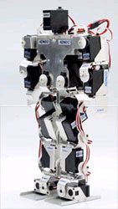 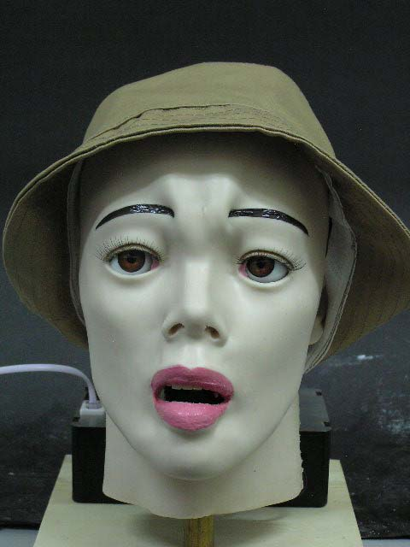 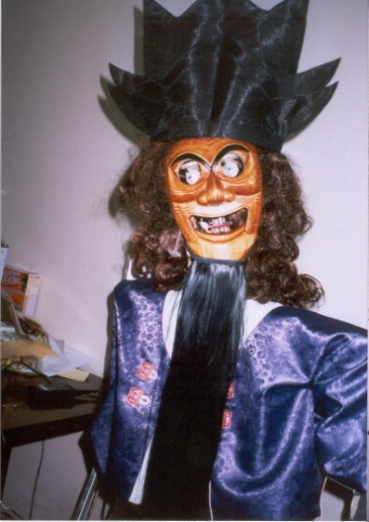

*Figure 3.1. Some of robots from Portland Cyber Theatre, Portland, Oregon, USA. (a) KHR-1 biped, (b) realistic oriental talking woman head, (c) Sonbi the Confucian Scholar from Hahoe Play – example of fairy tale robot.*

**3.2. Emerging ethical issues of the robot theatre**

The raise of modern civilization is marked by technical discoveries that, as one of the effects, tremendously increased the creative power of an individual. Inventions of press technology, photography, movies, video-taping, personal computing, internet, multimedia and computer games allow everyone for an easy access to publish books, design video games or to create and edit movies. The communication devices such as internet make the world-wide distribution a simple and easy task, despite the levels of artistic, intellectual or ethical values.

It can be easily foreseen that the robot theatre technologies can attain the same level of broad distribution impact with the proliferation of inexpensive robots and internet connections, especially in the context of the forthcoming “Internet of Things” with its ease of transmitting controlling and measurement data among arbitrary internet-connected agents/devices. Therefore the social and cultural impacts of various interconnected types of robots can be as strong as any other mass medium currently in existence.

The conveyed message can be however just an extension of cruelty, violence, sex and low instincts, lacking intellectual values, as many other currently produced entertainment forms by both professionals and amateurs. There is an opportunity however for an interconnected social robot to become a new art form that will stimulate peoples’ intellectual, moral and spiritual growth. The importance of creating the conceptual fundaments of such a robot society, especially a theatre, as early as possible, is at stake.

This paper is an attempt towards this direction. First, however, we will review the contemporary technologies that are already used, or that can be potentially used in social robotics and robot theatres.

1. **MODERN TECHNOLOGIES FOR ROBOT THEATRE**

Robotics technologies are already used in few areas of culture, entertainment and education. Several theories have been created for such robots that may be adapted in the theatre.

* 1. **What exists, what may be used?**

What are the contemporary technologies that may be used in future advanced robot theatres?

**4.1.1. Robotic toys** such as Aibo dog from Sony, Furby, Robosapiens or robot pets are becoming increasingly popular [Toy]. Their emotional influence on humans has been already analyzed [Linke]. They do entertain, but what is that they teach? Some are programmable, but most are basically smart extensions of radio-controlled car toys for boys. Although their sophistication increases every year, these robots are difficult to be used in advanced theatres because of limited programming and animation capabilities, especially for groups of robots.

**4.1.2. Entertainment robots** have become a big industry already. The form of kinetic toys and based on them simple robotic productions are quite popular in theatres such as Chuck E. Cheese’s Pizza Time Theatre [Chuck]. Individual robots greet public, dance, sing and advertise new products. In a contrast to the industrial, military or service robotics, the entertainment robots have not been developed for the utilitarian use. Their sole goal is to stimulate subjective feelings such as pleasure or sentimental agitation in the audience, something that even the most advanced machines are not equipped to do, yet. *Commercial (animatronic) robot theatres* such as Pizza Time Theatre or Disneyworld [June] are becoming more and more popular, especially among young audiences. American teenager has visited perhaps in his life more often a robot theatre than a human theatre (including a non-robotic puppet theatre). What does it say about the American culture is a different issue, but since it is a fact of life, one may ask in what direction should the robot theatre technology be advanced in order to foster teaching and moral upbringing of the youth? Audio-animatronics theme parks and theatres use very expensive equipment, such as hydraulic and pneumatic effectors and combine fixed behaviors (usually robot movements and dance) with a very limited preprogrammed interactive response which is limited to the choice of (preprogrammed) future actions. Creating a new play is expensive and it is done rarely, being severely limited by economics-related considerations.

**4.1.3. Museum and media art installations** are of two types. In one type, ambitious scientists working with artists strive for novelty, use advanced robotics, computer vision, digital signal processing and other sensor/actuator/processing technologies in which the environment (robots, furniture, vehicles, etc.) reacts in relation to viewers’ responses [Breazeal03]. Often it is one-of-a-time technology. In another type it is a quite primitive technically, but captivating artistically and emotionally new form of interaction; with humanoid street beggar robots or with field robots as high as cranes that blow fire. These theatres/installations may still remain less advanced than the robot toys and animatronics theatres mentioned earlier, but most importantly, they emphasize improvisation, interaction and extreme creativity. Sometimes also educational, artistic or moral values; like in productions of Frank Garvey and "OmniCircus" [Robotic].

**4.1.4. Emotional robots and affective computing** have been much investigated in the last few years [Brooks98, Breazeal99, Breazeal02, Raghuvanshi10, Williams07, Lukac07a, Lukac07b, Lukac07c, Raghuvanshi07, Raghuvanshi08]. Emotional robots will be built as assistive robot companions, care-takers, early-education-teachers or nurses. Two major aspects of their abilities are under the spectrum. First, the robot has to present human-like or other emotions that should be understood by people. Second, the robot has to recognize human emotions and body gestures. As much as these two are useful for good communication purposes, especially with non-sophisticated users such as children, mentally challenged or elderly, there is one more aspect that has been neglected, so far. It is of our major interest here: *what kind of emotions robots can steer in people by their behaviour and speech acts?* The theatrical aspects of both, non-theatrical social robots and theatrical robots, should be investigated.

**4.1.5. Programmed or autonomous?** Machine can demonstrate pre-programmed emotions. However, unable to experience emotions by itself, a machine transmits emotions intended by the person that puts them to use. This is for instance the case of the cinema industry, where the camera and the projector serve as the transmitter of the intended concept. This equipment has no understanding of the nature of the emotions that it transmits. Similarly, even a modern programmed robot can transmit emotions and thoughts of the performance creator, as one can appreciate observing children in Disneyworld. Furthermore, the new robot theatre technology will allow the following: (1) the play’s scenario itself can be created automatically using theories of “Artificial Life” or semi-automatically using Artificial Intelligence software, (2) a computer-controlled robots can be used and directly connected to the created scenario where the dialogs of the play, the behaviors and mannerisms of the actors evolve automatically in software rather than are human-created. With such a theatre, perception of the art will become rather different because of the higher autonomy, generality and knowledge of the “emotion-transmitting equipment”.

**4.1.6. Motions.** There is a huge body of research on motion for robotic, artistic, choreography [Calvert93] and health applications; Laban and other dance notations, Disney animation principles, and motion languages [Badler79] [Nakata98]. Our team develops motion languages for artistic and emotional robot motions [Perkowski13]. Simulated Darwinian evolution can be used to evolve sequences of elementary actions for robots [Goetz13]. Evolutionary programming (with or without human supervision), genetic programming and similar stochastic programming/simulation methods have been and can be used to evolve, learn and adapt motions and input/output interactive behaviors, imitations and improvisations for robot theatres (and social robots). The robot theatre can be evolved and controlled centrally, with one computer controlling the whole of the theatre and all the robots, or in contrast, each robot can be an individual agent run by its own computer or network, evolving individually as a reaction to others and communicating with other robots and humans by sensors such as vision. This will allow for many types of evolution, adaptation and synchronization of multiple robots. Interesting although simple synchronization can be observed in amazing Japanese theatres of dancing robots, where hundreds of robots are perfectly synchronized in spatial groups, making a new form of visual art.

**4.1.7. Gestures and Dances**. Because robots use bodily and facial gestures, “robot dance” seems to be a natural component of robot theatre. Also, it is easier to develop a robotic dance than a full theatrical play, so robot dance can become an early stage of improvisational robot theatres. *Pantomime* may become another option, exceeding the traditional one, as many robot parts can be moving and into more directions than in real life (think about a theatre of humanoid helicopters dancing in three dimensions).

**4.1.8. Facial Expressions and showing emotions**. The robot head/face can be very large and have thousands of individually controlled muscles, allowing to demonstrate not only facial emotions but also the processes of aging and transformation. What is known about facial expressions – starting at least back to Darwin who noted universal human facial expressions indicating various emotions to the recent awareness of all the various muscles in the face, and the realization that there are some people who are very sensitive to subtle combinations of muscles’ actions. Emotion-mapped Robotic Facial Expressions and its relations to philosophical theories of vagueness are discussed in [Serchuk06].Our program recognizes seven basic emotions in facial gestures and characterizes a human face in terms of a combination of these emotions [Labunsky]. A software can use your tablet camera to spy on your facial gestures, how do you like a product that you see, and store this information into your database. These technologies can be all used in future interactive robot theatre in which every audience member will be given at the entrance “an evaluation/feedback tablet” which will be taken back after the play to possibly analyze the collected motion and emotion data, together with stored notes and dialogs. Next, the Data Mining software will use advanced Machine Learning technologies to analyze the reception of the play and the ideas and reactions of the audience. There exist interesting theories of reversibility of recognizing and creating/mimicking facial emotions by humans and robots and how this is related to child’s development, for instance autism. Analyzing these data may help doctors to understand scientifically human emotions better, possibly leading to health benefits for humanity.

**4.1.9. Speech, intonation and natural language communication.** To convey ideas the medium of speech is a theatre necessity; mere replica of a human speech will obviously be a basis for it. A robot can use a recorded human voice, a human voice transformed by digital signal processing methods, or can use the text-to-speech synthesizer to convert any generated text with additional annotations to an emotional speech. Moreover, smart AI-based signal-processing technologies can mix these approaches allowing to create animal-like or ghost-like speech for an arbitrary text. There is also a whole area of semiotics to be investigated to create speech and sounds on a deeper level. Applying J. Derrida’s deconstruction ideas the current meaning of words and their correlations can be erased and replaced by completely new ones [Derrida73].

**4.1.10. Agents.** Agent-based programming is used in several areas of Artificial Intelligence, Game Theory, Decision Theory, Computer Games and System Science. Other robotic architectures useful in robot theatre are subsumption and behavioral robotics [Brooks86, Brooks91]. These are methods of programming based on individual behaviors of agents with local memories, hierarchies of reasoning/acting processes, and local structures of behavior generators. Agents are individual, autonomous and sensor-based, they have individual memories and can have various characteristics (characters, personalities), thus complete societies of agents can be created and modeled as cybernetic systems. Agents that additionally move in environment are the basic metaphor for robotics. Theatre could use dialog-related agent-based modeling [Perlin96] in parallel with a 'live' robot theatre event. Model robot theatre can also use an off-the-stage hidden agent-based simulation of variants. Many various questions come to mind: Should human actors be included in robot theatre as some form of agents about which the theatre controlling system learns using Data Mining and Machine Learning methods? Should we first model performances using computer graphics? How to visualize? Should we mix video and computer screens? Simplicity or baroque? What is the role of Virtual Reality? Agent-based methodology will allow to create hybrid forms of art with humans, animals and robots. Agent can be adapted or evolved, the evolution/adaptation can be related to both their “minds” and their bodies. This leads to an amazing concept of “emergence“ of the robot theatre’s forms.

**4.1.11. Emergence.** A System Science type of question that seems natural to arise: what “emergent forms” appear or might be expected to appear or would be especially interesting if they appeared in robot theatre? System Science theories like system dynamics and emergence can be created for everything, but the real problem is "are they of any practical use?" Many algorithms developed by early pioneers of System Science are very inefficient, as their authors were not interested in practical aspects. So the methods are being re-invented by engineers or physicists. But the System Science and Cybernetics were able to formulate some very good and general models, a kind of “mathematicised philosophy” that can be now used to model groups, societies and eco-systems. We believe that these fundamental meta-sciences should be used in robot theatre [Perkowski00]. What about a model of a human soul similar to a pandemonium of Maxwell’s demons in a sense of thermodynamics? Brain as a society of coalitions of thousands of fighting and collaborating agents? A robot with a battle of Good and Evil in his mind, visualized on a giant screen? This would be an emergent battle progressing in real time, rather than a preprogrammed one, invented ahead of time by the script’s creator!!

**4.1.12. Fuzzy Logic and Evolutionary Programming**. While in classical logic a logical value of a statement is true or false, in real life things are fuzzy or uncertain, somewhere in between the absolute categories. The Fuzzy Logic concept invented by Lotfi Zadeh [Zadeh65] allows for half-truth and uncertainty. Fuzzy logic is popularly used in research and industrial robots, especially when it is difficult or impossible to make a precise model of the controller or the environment. It replaces crisp concepts of classical logic with “fuzzy” and uncertain concepts of “fuzzy sets” and “fuzzy logic operators” making itself more useful to describe imprecisely defined concepts such as motions, emotions, perceptions and human behaviors. The logic value of each fuzzy variable is represented not only by two points (values, states, parameters) “true” (1) and “false” (0), but by any point in the entire interval [0, 1]. So the level of truth or emotion can be represented as a number 0.3 or 0.888. There are few attempts at using fuzzy logic and its extensions in robot theatre [Kim06, Brawn06]. The new concept of *modal fuzzy logic* and the “interactive genetic algorithm” [Goetz13] to program the theatre have been also created. Darwinian, Lamarckian or other type of evolution is simulated in software. The *genotype* (*chromosomes*) correspond to motions, body structures or robot behaviors, the individual *genes* in these chromosomes to their “atomic” components that can be combined in many ways in order to create new chromosomes (children) and next develop these chromosomes to corresponding phenotypes (like the robot behaviors). New chromosomes are created by mutations and crossovers that take genetic material from both parents. The goal is to use this Nature-invented stochastic mechanism to evolve new phenotypes that optimize certain *cost functions* (for instance, straight walking of a biped robot).The calculation of the cost function for every phenotype element can be done completely automatically in case of Genetic Algorithms. Or, in case of Interactive Genetic Algorithm, with the involvement of a human or a group of humans [Goetz13] who influence the direction in which the systems are evolved.

**4.1.13. Quantum Computing. (**An easy non-technical introduction can be found in [Perry04]).While in fuzzy logic every bit of parameter of measurement, motion, emotion or reasoning simulated in software is a real number from 0 to 1, in quantum logic it is called a quantum bit (a qubit) and is a point on a normalized sphere, like a ball or an Earth Globe. This is called a Bloch Sphere technically and has interesting links to emotions. Assume measuring (reading) a point (state) in North Pole has a value of 1 (yes) and reading a point from South Pole has a value of 0 (false). If the point is on the Equator, reading a value of 1 and a value of 0 have equal probabilities of ½. We created a logic of emotions [Raghuvanshi08, Raghuvanshi10] where intensity of emotions is on meridians of the Bloch Sphere and type of emotions on the equator – thus the 360 degrees of “phase” are used to encode various types of emotions. This way, consistently with the well-known from psychology “wheel of emotions”, the points on the entire sphere are used to represent emotion-related, energy-related and other types of values. Internal emotions are simulated by quantum operators that move the points on the sphere, but only measurement can be used to demonstrate the emotion to an observer (observation equals quantum measurement). It is like a human soul that has hidden dimension and shows somewhat probabilistic (random) “ready behaviors” only when provoked (“measured” in quantum sense). In case of a single sphere, the emotions located close to North Pole jump to value 1 in a measurement with high probability. This is only a simplified model, and we have no place here to explain our full model - quantum physics is conceptually complex. In case of the “ensemble quantum computers” (mixed quantum systems) described by the density matrices rather than classical Heisenberg unitary matrices [Nielsen10] the inside of the sphere represents mixed states and can be also used as values of quantum variables. This allows us to further generalize the concept of fuzzy logic in order to use all points inside the Bloch sphere. New operators can be defined in such a space. This new “generalized quantum fuzzy logic” is next used to represent various types of emotions and other control parameters of the robots. The arguments to use the concepts of quantum mechanics to describe human consciousness are presented in works of Penrose and Hameroff and the discussion about using quantum circuits to describe human emotions can be found in [Williams07, Lukac07a, Lukac07b, Lukac07c]. Instead of being just “happy” or “unhappy”, the robot can be happy with 0.43 degree and can be in many mixed states between various emotions. Thus a robot can be “happy” in many different ways, depending on the location of the “Emotion State” in the ball. And remember that the ball is for one qubit only, while we can now simulate tens of qubits to represent emotions, behaviors of perceptions! We developed software to evolve quantum circuits (robot behaviors), both in binary quantum logic, and in its generalization, the multiple-valued quantum logic (ternary and quaternary [Perkowski11]). It will be natural and useful to extend this approach further. While in the past we were evolving behaviors of individual robots, here we propose to evolve the complete theatrical plays. The reader can think about the whole performance as a single chromosome in a simulated quantum evolution, each gene of this chromosome encodes a mini-script such as a duel of two fencers, or even a single gesture. Examples of mini-scripts from our plays can be: the SchrÖdinger’s Cat introducing himself, a fist fight between Newton and Einstein, or even a short movement of raising the right hand up with the robot saying “heh” [Dhawan08]. Evolutionary robotics uses genetic and other evolutionary programming algorithms to evolve robot behaviors rather than design them systematically or teach from examples as in artificial neural nets. The motions, reasoning patterns and strategies or emotions of the robot can be quantum or not. Every non-quantum deterministic model can be converted to a quantum model and all ideas from the previous paragraphs in this section can be used. Thus nearly every approach of contemporary computer science can be generalized/adapted to its quantum equivalent and used in robotics technology. Of course, all evolutionary and genetic algorithms can be generalized to quantum ones.

**4.1.14. Game Theory.** Game Theory is a base of many concepts in Cybernetics and System Theory, and in our opinion should become the main fundament of Robot Theatre. We believe that “games” in the sense of Game Theory and particularly computer games will evolve into new forms of interactive, improvisational theatre performances. Modern sensors such as Kinect, WII or smartphones allow to make these games physical and interactive, with voice synthesis and recognition, various sensors such accelerometers and gyroscopes used to measure human motions. They will be realized in software and in a virtual world (using new breakthrough Virtual Reality devices such as Oculus Rift), or in a real world with physical robots, which is of our interest here. The robot technology will allow humans to have more real experiences, but perhaps there will be a convergence of broadly understood games and artistic plays that will allow the audience for many choices and variants of evolving actions. These important concepts will be discussed in more detail in section 9.

**4.2. Towards a new form of art**

Time is ripe for a new form of art. Exploring the relations of robot theatre and robotics, Machine Learning, System Theory, Artificial Intelligence, Game Theory, Decision Theory, Formal Logic, Psychology, and Quantum Computing will allow to create many entirely new ideas for artistic expression. The robot theatre of modern times can become at the end of 21st Century what the cinema has been since the 19th Century.

Definitely, many types of robot theatre will emerge and will reflect the ethical and aesthetical values of their creators. Here, however, assuming that the **task of our theatre** would be to teach by entertaining; we will present some particular exemplary, theoretically possible concepts, our view of robotic theatre’s future.

In the first phase of the proposed theatre, there are three components to the entire performance [Dhawan08, Perkowski07]:

1. an animatronics play with songs and dances (no viewers feedback),
2. an improvisational theatre where a genetic algorithm is used to create a new play with the mini-scripts in the phenotype corresponding to genes in the chromosome and the fitness function based on the feedback from the audience,
3. a question-answering session where the entire play is a response to questions from the audience, using the semantic network-based compositions of mini-scripts.

The whole play may be a single robot with integrated sensor systems and keyboards/tablets as input devices available to the audience for advice and questioning.

The concept of a **humanoid robot theatre** based on interactive dialogs was first introduced in 2004 where robots played the traditional Korean mask play of Hahoe [Perkowski05]. The robot control used the machine learning method called constructive induction: learning behaviors from examples. Using our experience and analyzing the weaknesses of the Hahoe theatre, a new theatre was conceptualized and partially created, which included some elements of the three points above [Dhawan08**].** Although interactive properties of the second variant were interesting as a concept, the performance was somewhat repetitive and boring. Thus this paper outlines a perhaps more entertaining concept of an interactive robot theater in which fuzzy modal logic is used for the first time as a programming model for robot behaviors. Also, more music and dances will be added. The atoms of the behavior selected by control are the “mini-scripts”, these are elementary robot motions, if-then-else rule-based reactive behaviors, and sound, completely pre-programmed (pre-scripted) by authors/directors/actors of our theatre.

* 1. **Towards Integrating Sensing, Artificial Intelligence and Machine Learning in new types of robot theatres**

When a human artist designs animated movies or interactive computer games he uses *new software programming technologies* and *theories*, such as Artificial Intelligence and computer graphics to create believable characters that raise human viewer emotions by demonstrating actor’s emotions. Unfortunately, the puppetry technology and the animatronics are not yet at this level. Let us observe that a script of the contemporary animatronic robot theatre can be compared to the movie tape or a program, that when played, is always the same. The only difference to movie animation is that the computer tools create physical motions of embodied robots (sequences of electrical pulses) rather than only sequences of pictures to be shown on a screen. Several computer languages have been created for such animation and motion programming, and one can expect that the level and sophistication of these languages will increase with time, also in animatronics applications.

However, this is where our interest is on another aspect – how to create an environment where new “emotion-raising robotic behaviors” of *(semi)-autonomous robots* can be *(semi)-automatically* created by the software. Theatres like this do not exist worldwide, according to our knowledge.

Our strong point here is that the animatronic robot theatres of the present should be clearly distinguished from the interactive dialog-based autonomous robot theatres of the future. These future robot theatres that we propose in our research will creatively interact with the public (and may also involve live actors) and will not only adapt but will allow to create new scripts dynamically. All sections below are our vision of futuristic robot theatre, that only partially is realized or even realizable in contemporary robotics, Artificial Intelligence (AI) and Machine Learning (ML) theories and technologies, it is a very optimistic expectation of what may happen.

1. **SOME QUESTIONS ABOUT MODELS OF ROBOT THEATRE**

We want to develop a robot theatre that will be relatively inexpensive so that people will reproduce it all over the world. Although the robots will be not too costly ($1000), the advanced software that can be easily reproduced and modified will allow this theatre to be interesting. Our goal is to create a theatre for highs schools and universities as the first early propagators of this idea. The questions that we asked ourselves were these:

1. “Can the technologies from section 4 be used in a robot theatre?
2. “Can this theatre be used in education, including raising ethical issues?”
3. “If yes, how these goals can be achieved?”
4. “Can we combine the best asset of each technology to create an inexpensive educational robot theatre, for instance for young audiences that can be played at schools?”
5. “How can the educational “high school robot theatre” be used to teach not only robotics and mathematics but also script writing, directing, stage design?
6. “How can robot theatre direct various young and mature audiences to contemplate deep questions of philosophy and morality?”

Technically, the theatre model proposed below is based on the new concept of “fuzzy modal logic”, which uses the familiar *fuzzy logic* and *modal logic* [Beall03] as well as game theory. For instance, the respective to the model “quantum entangled behaviors” [Nielsen10, Raghuvanshi07, Raghuvanshi08, Raghuvanshi10] (special types of correlations) can be observed on the robots; robot behaviors can be easily modified by students and experimented with: a new behavior is obtained by reading new unitary matrix of a quantum operator. What is amazing to the young student is that small changes in the circuit can cause big changes in the behavior. These properties being true for a single mobile robot remain of course true for the entire robot theatre, when this theatre is programmed as a single robot. Thus, as the starting point we observed that all ideas introduced by us in cited here works can be used in the new theatre, which, in contrast to previous works, is not an interaction of agents corresponding to robots but a single centralized robot controller – a mapper in an extremely large space of mappings from the state of integrated sensors to the state of integrated effectors.

Specifically, we have interest in the following questions:

* 1. How can one use our theoretical algebraic concepts to model behaviors in emotional robotics?
  2. How can one teach new intelligent robotics paradigms and philosophy/morality ideas in a fascinating and entertaining way?
  3. How can one can create school extra-curricula to include a robot theatre with all its associated art and technology?
  4. How to use the emotional robot based theatre to educate about science and philosophy and raise moral awareness?

Modern culture with its television and video-game dominated media, forces the educators to teach young people in ways that are fast, little-effort, easy and fun. While we cannot yet use a robot to teach young audiences modal logic or social responsibility, we can certainly create a robot theatre based learning environment that will initiate and enthuse the beginners. The robotic theatre being just the first step to mobilize their path to serious individual research in both robotics – the technical aspect that they learn while building the theatre, and the science/philosophy concepts - the subject of the play that they write, direct, stage and act in. We are interested how the education can be improved by teaching concepts of science, philosophy and ethics, interactive dialog, evolutionary programming, and robotics to high school students. Our answer is the interactive robot theatre that is build, programmed, scripted and evolved by the teenagers themselves [Raghuvanshi07, Perkowski07]. The role of professors and parents in this group is only auxiliary; to teach, to help, to enthuse, to advice, to keep the commitment. Most of the ideas, crazy and eccentric as they may be, should from the teenagers and should result from various multiple group interactions.

The ideas outlined above can be combined in numerous ways into different types of theatre. Our next sections will illustrate only few ways of realizing them in practice. Being not artists ourselves, we are not claiming what is right and what is best, we want only to raise the awareness of theatre professionals to the new technological and conceptual opportunities that will become available rather soon.

1. **THE “NARROW BRIDGE UNIVERSE” AND THE MORALITY TO OPTIMALLY SAVE LIFE**

In this section we give one concept of a robot play with elements of game theory and fuzzy modal logic. We believe that good examples can explain new concepts, especially to a non-specialist, better than pure sentences or mathematical formulas/ Thus several practical examples will be presented in more detail in the sequel.

**6.1. The problem of necessity of evil**

*Can the existence of Omnipotent, All-Powerful and Merciful God be consistent with all the evil that exists in the world? Can God create a world with no evil? Can there be a free will in a world with no evil? What would be contradictions in such a world? What choices humans have to make to avoid doing evil in a situation of a necessity to survive?*

The philosophical questions discussed by Leibniz can be now converted to a game with a moral goal and a limited resources of the simulated environment. Can the above deep questions be discussed, visualized and played as some kind of game in an interactive robot theatre?

Computer games create some simplified universes in which agents (game characters, or human players) select some actions in order to achieve some goals within more or less deterministic scripts, in the presence of some constraints (like rules of behavior or limited resources of the environment) that must be satisfied. Most games, not only computer games, but also other games that humans play for thousands of years (such as chess, checkers, halma) are based on the principle of annihilation of enemy: our symbolic soldiers like chess pawns are killing the symbolic representations of the enemy soldiers. The more you kill the higher chance of winning you have. Of course, each of these games can be converted to interactive improvisational theatre plays the same way as we discuss below. Observe however, that there exist only very few games based on principles of cooperation. In this section, following our principle of using the theatre to raise ethical awareness, we propose a theatrical performance based on a new type of a game, which is won by cooperation of players in order to save lives in a Universe that has clearly limited resources. In our game, those who contribute more to life saving - are the winners. The early variant of this game has been programmed in CTL logic [Emerson90], the same type of temporal (modal) logic that is used by industrial companies to verify the correctness of computer hardware. Next paragraph will present the rules and the constraints of our simple “universe” for this game.

**6.2. The Specification of the Narrow Bridge Game**

Conditions of the game.

1. There are two opposing teams: two kinds of people, Meaties and Vegies.
2. Meaties can eat only meat, Vegies can eat only vegetables.
3. Meaties live in North, Vegies live in South.
4. There is no meat in North.
5. There is an abundance of meat in South
6. There are no vegetables in South
7. There is an abundance of vegetables in North
8. To move to North Vegies have to go through a narrow bridge
9. To move to South Meaties have to go through the same bridge
10. If there are two humans in the same cell (place) on the bridge, then they must kill one another in order to make space. Otherwise they may not survive as they will die from hunger in their land of origin or on the bridge. Thus the evil action of killing serves a higher goal but should be exercised with extreme caution by ethical soldiers or their commanding generals.
11. If there are two humans in neighbor cells they may shoot or not. They have a “free will” but also the understanding of the consequences of their actions.
12. The human (Meatie or Vegie) can kill a human in the same place, do nothing or go to other location.
13. Meaties are obedient to General_Meat
14. Vegies are obedient to General_Vegie
15. If both armies do nothing, they will all die from starvation.
16. Some life sacrifice may be necessary to save more lives. The understanding of this fact is full or partial among some groups of soldiers.
17. In one variant the cost of his soldier‘s life 1 to a general, and the life of one enemy soldier costs ½ to him. In another variant of entirely ethical generals the costs of soldiers of both armies are the same. Various costs and groupings can be investigated at this point in the game.

Problem.

What is the best strategy of both generals that will save the maximum number of human lives?

Actually there are very many game and theatre variants that can be formulated based on above rules, but we discuss only one of them.

**6.3. Example of a solution to the Narrow Bridge Problem.**

A typical universe” for Meaties and Vegies is shown in Figure 6.1. Meaties soldiers are represented by red dots and Vegies by blue dots. They can move one cell at a time. The map in Figure 6.1 can be treated as a simplified model of the space of robots to move and act. Every change of cell, or a killing action is an abstract control to a mini-script executed by software robots. Software behaviors are next converted to real behaviors of physical robots at the stage. The knowledge, thoughts and emotions of all actors are visualized to the audience on large screens. Formally, all possible actions of all robots can be represented in software by a huge *decision tree* of all possible moves/actions of both parties (as in chess). The *nodes* of the tree correspond to states of the game, the *arrows* between the nodes are actions that create new states from old states. The actions are killing the soldier and occupying his cell or moving to an empty cell. The enemy responds: my possible move, your possible response. I kill your soldier, you may kill or not, my solider. In practice this large tree is not entirely created and the software (or the audience playing its role) generates some small subsets of this tree randomly or using some strategies, called “*search strategies*”. For explanation, one branch of this tree is shown in Figure 6.1. The first shape in left, composed of four cells in the north, four cells in the south and three cells on the bridge represents one possible environment of the game. We will call this “node of the tree” – a *game* *situation* or a *map* for short. The green arrow corresponds to a move, an elementary operator that changes an internal state to a new internal state of the game (in this case, the game is also the theatrical performance). Some maps (stages of action) are skipped in figures for the lack of space. The killing situation is shown in the third map from the left. The killing can be programmed or can be a result of an actual fencing duel of the red and blue robots. The complete behavior of the performance may be thus partially probabilistic. There is thus us a random element in this scenario, it can be influenced by interactive advice from the entire audience. After the second killing (map 6) further killing is no longer necessary if the parties agree to cooperate rather than compete. This is illustrated in Figure 6.2 and next in Figure 6.3. A careful reader can analyze from these sequences of maps that two red dots and two blue dots can survive.

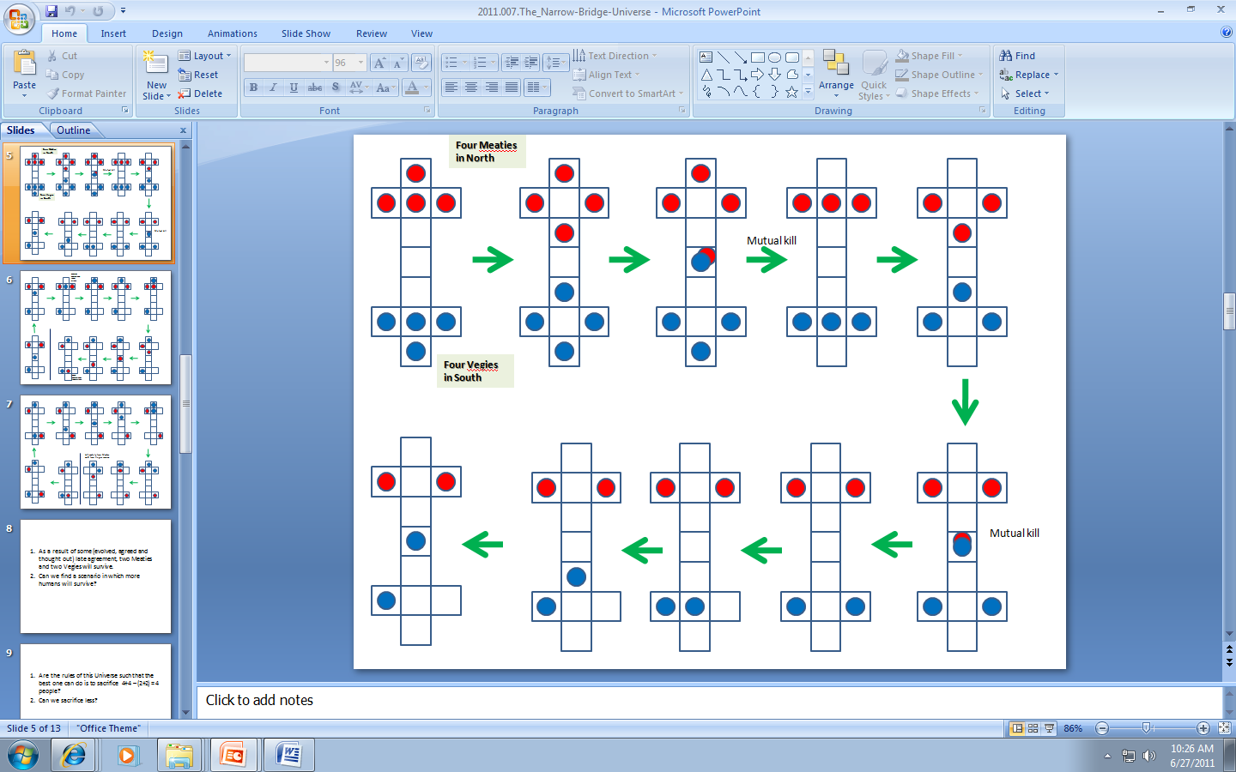

Figure 6.1. The initial branch of the search tree for Meaties and Vegies

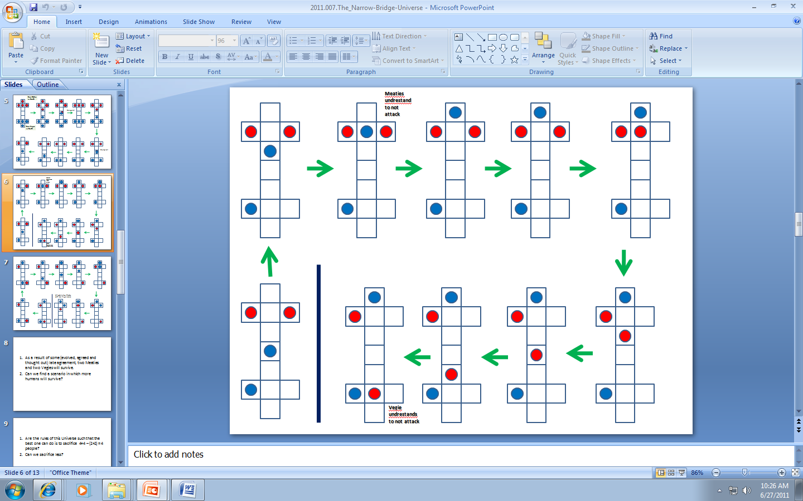

Figure 6.2. The next part of the branch of the search tree for Meaties and Vegies

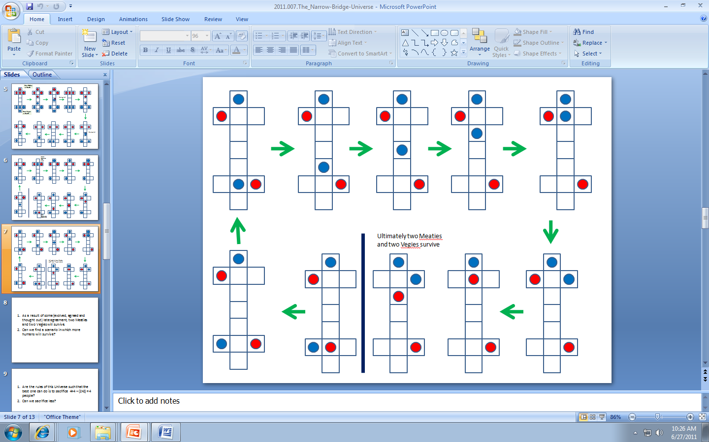

Figure 6.3. The next part of the solution branch of the search tree for Meaties and Vegies. A total of 4 soldiers were killed, which is an overkill and a non-optimal solution.

Concluding about this particular performance:

1. As a result of some (evolved, agreed and thought out) late agreement, two Meaties and two Vegies will survive.
2. Can we find a scenario in which more humans (robots) will survive?
3. Are the rules of this Universe such that the best one can do is to sacrifice 4+4 – (2+2) = 4 people?
4. Can we sacrifice less soldiers (dots)?

One problem to be considered is that of “Self-Sacrifice”. Observe that one of strategies to have the minimum death is when one of the generals, say General_Meat, sacrifices at the very beginning three of his soldiers. He gives thus hint to the “enemy” that he is not willing to fight for the sake of fighting, just willing to fight as a necessity for survival. If this general, say General_Meat, still treats his soldiers any differently than the enemy’s soldiers, he can give hint to the opposing General_Vegie that he expects a reciprocal self-sacrifice of at least one soldier. This gives him some trust to future behaviors of the opposite army. Observe that the army can still commit “over-kill” just from hate, not from survival necessity. Reactions of audience can be thus tested.

Observe that this is an example of a formal problem formulation described by rules, possibly non-deterministic or probabilistic rules. This formal specification can be developed to a board game, or a computer game. What interests us however is the development of this formal system to a dramatic robot theatre in which two boys or two parts of the audience perform as the generals and control all the robot-soldiers with joysticks or tablet computers.

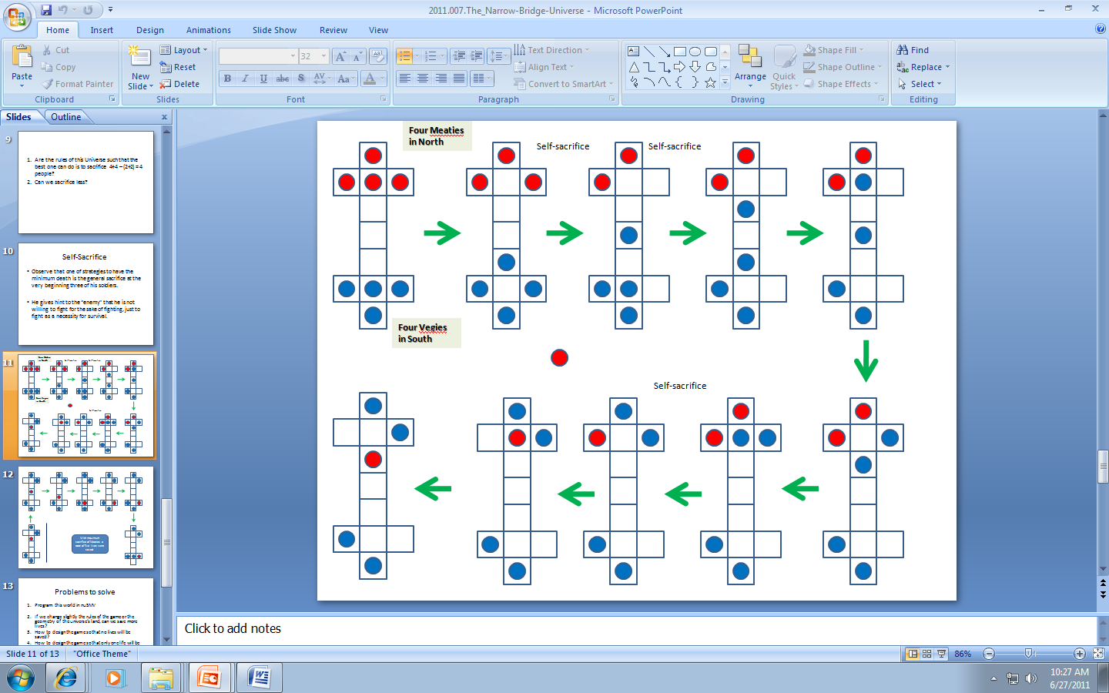

Figure 6.4. The another initial branch of the search tree for Meaties and Vegies

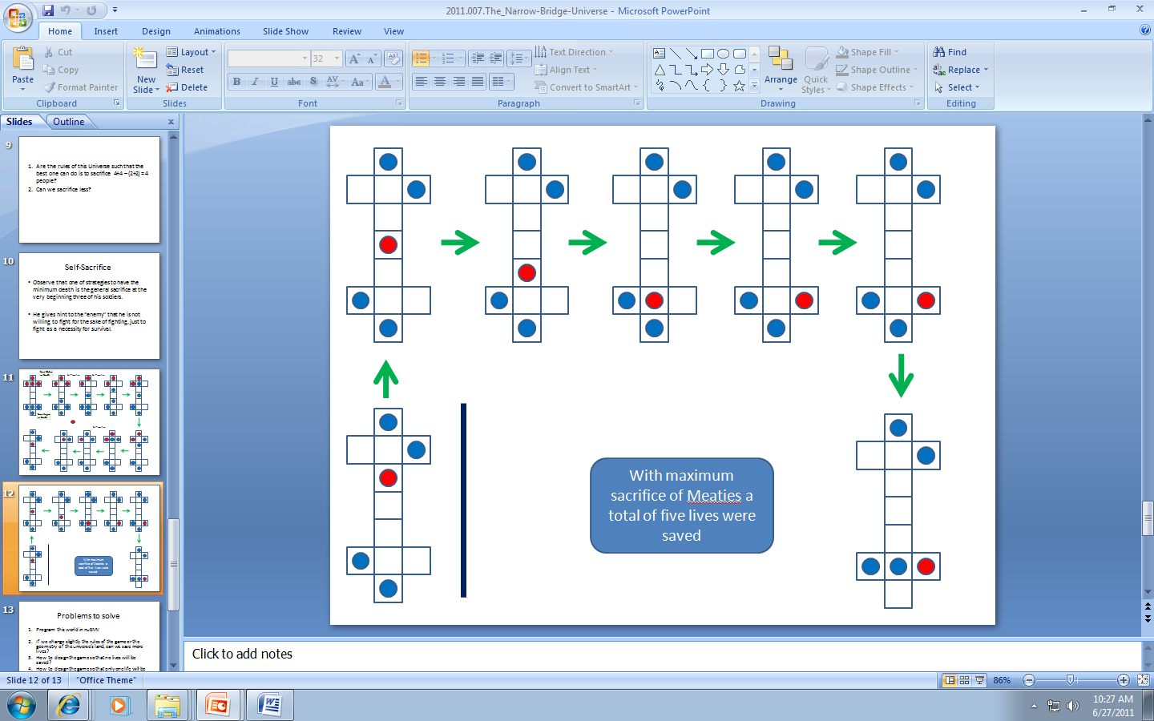

Figure 6.5. The final path of the search tree for Meaties and Vegies. Three soldiers died. Is this the optimal solution to the game?

1. **THE POWER OF VISUALIZATION AND METAPHORS BASED ON VISUALIZATION**

It is commonly known that an average human has better abilities to visualize some kind of truth rather than to deduct this truth from axioms in a logical way. For instance, in high schools they do not teach Euclidean Geometry in axiomatic way only, but the solutions are illustrated with three-dimensional line diagrams. These diagrams have a heuristic value and they help to find proofs in a formal system of Euclidean Geometry. There are various kinds of diagrams used in physics (Feynman Diagrams),Computer Architecture, analog design, and mechanics architecture and practically every area of science and human activity [Kulpa03]. These diagrams have a very important role to explain concepts of behaviors, plans and games. We believe that the visualization of states of formal systems should be therefore used to help actors or their parties to solve problems in contexts of particular performance games. This includes ethical, aesthetical or intellectual problems. The decision trees that we introduced in section 6 are absolutely necessary to understand more complex reasoning methods. Hopefully, they are similar to diagrams used by engineers and programmers, so modern humans are hopefully able to understand more complex metaphysical and concrete concepts than the humans in Middle Ages. Such data can be shown on large screen on top of the stage so that the audience can not only observe but also participate in thinking processes of the drama agents. Robot theatre technology allows to visualize using not only screens but also lights, sounds, sets of vibrating motors, lighted fountains, or even the transformable robots themselves.

The need for visualization explains also why humanity created metaphors, theatres, poetry and myths. These elements of human culture have been created in order to show people, in a form that is easier for them to perceive, the consequences of axioms, assertions and theorems, deduced by purely logical derivations. We humans are not rational beings, we are “emotional visualizers*”.*

Visualizations can emotionally influence humans, so they can have deep moral consequences for them. An example of a simple visualization can be the picture “ten years of prostitution and drug abuse” from Figure 7.1. Look at this figure and meditate for a moment. Preaching moral dogmas and morality based on deduction does not work for teenagers. Instead of preaching morality dogma to a young girl that “it is bad to take drugs”, or deriving deductively “what would be the consequences of having sex for a young girl like her?” we could just show her Figure 7.1 and expect her to think by herself. This example illustrates one of didactic approaches taken by the proposed “educational morality theatre” – “*visualizing consequences of game choices”.* The visualization principle makes visual systems such as the Game of Life (GOL) extremely fascinating to many people. GOL allows for visualization of the consequences of the initial state of a dynamic system, given only its simple rules of evolution. The player can change the initial state and observe what happens. A life visualized as dynamic color patterns can disappear, multiply, stabilize or change to chaotic patterns. Various cyclical behaviors are possible. A more sophisticated player can program his own rules of the dynamic game. In a more advanced system a player designs entire civilizations and as an all-powerful king observes consequences of his partial decisions (SimLife, etc.). It is truly amazing how complex can be a dynamics of Cellular Automata systems based on just few formal rules of dynamics and how much the behavior changes with the modification of a starting point (Figure 8.2). This illustrates the proverbial butterfly in Japan that causes a hurricane in America.

We believe that the power of visualization applies to much other partial truth (pieces of information) that the game/theatre performance developer may want to communicate to his audience. Sophisticated computer graphics software can be used to visualize any system based on finite states, differential equations or production rules, the well-known methods to describe dynamic systems.

If humans would only know the consequences of their choices, they would behave differently; more prudently and more ethically. “If I would only know ahead” you can hear many times from people who have done life mistakes. But it is our human responsibility to think and predict ahead of time. The proposed robot theatre may lead in this direction. Games and visualizations based on Formal Axiomatic Systems can have heuristic, moral and pragmatic values. One can create any system of rules, like the one in which “killing pays”, and next observe consequences. Morality robot theatre does not intend to preach, it intends to create a an environment to learn by experimentation.



Ten years of prostitution and drugs are hard on a girl, you know? (This 10 year progression was ordered published by a judge as part of the prostitute's sentence.)

*Figure 7.1. Visualization of an evolution of a system based on its internal dynamics, used here as a form of moral teaching.*

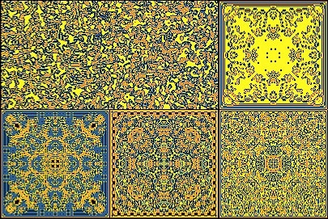

Figure 7.2. Visualization of various dynamic systems using Cellular Automata based on few very simple rules.

**8. PARADISE LOST OR ONE GAME-THEORETICAL MODEL FOR IMPROVISATIONAL THEATRE**

Life is a game. Market is a game. Art is a game. From a formal point of view, Game Theory [Davis97] is a base of most of the social science. In addition to theories and technologies from sections 4 to 7 we introduc Game Theory as a base of the upper, conceptual level of script creation and execution in future robot theatres. Here are some introductory ideas on demonstrating the emerging moral issues in our game-based theatre model.

The action is based on some non-deterministic scenarios that include many variables. These variables can be deterministic or non-deterministic (random, probabilistic, quantum). A script or an audience of the robot theatre collectively create values to these game state variables. They can collectively vote to change the evolution of the play, for instance in case of the Biblical paradise story they can vote for a continuation of uneventful life in a paradise or for Adam eating the fruit ahead of Eve. The audience has a script-controlled freedom to assign values to these variables. Here the values of variables are binary (Boolean) for simplification. What would this open, game-like script teach the audience? Let us first discuss in more detail a given scenario to explain some of our concepts better.

**Scenario example – “Paradise Lost”**

As an example of an open scenario, let us try to analyze the story of Adam and Eve in Paradise as a game. Let’s not repeat the details of the story here as all of us know it. Eve, deceived by the Serpent, picks the apple, eats, and convinces Adam to eat the apple as well. Adam eats and they are both thrown out from the Paradise.

In the simplest possible variant, this is formally a game with two variables. First variable is “E=Eve_eats_apple”. The value 0 of this variable means Eve refuses to eat an apple. The second variable is “A=Adam_eats_apple”. The value 1 of this variable means Adam eats apple. The game can be represented as an automaton with its internal states, input states and output states, Figure 8.1. This graph shows all possibilities that exist in the original Bible scenario, out of which the Bible discusses only one. The whole story of Adam and Eve from the Bible is just a path in this state graph from state “All well in Paradise” through state “Eve eats an apple” to state “Adam and Eve thrown out of Paradise”. There is no return to the upper states of the graph (arrows in the graph is oriented).

As we know, the Bible did not tell us what would happen if both Eve and Adam would be obedient to God. Would they stay forever in Paradise (top node circle in Figure 8.1 and a loop arrow in it)? Would therefore be no sin, no human history, and no life as we know it? Would they iterate forever? As they did not eat from the other tree they were not immortal, but they would spend few thousand years there, perhaps? Boring life in Paradise? Would God be bored as well? We do not know about God but definitely the play would be boring to the audience if based only on the automaton from Figure 8.1. There would be no events for us, the theatre spectators, to watch and learn. Given the total freedom, the audience of any theatre would try to redesign the scenario from Figure 9.1 to another automaton, or would at least experiment with other paths through this graph.

There are so many ways how the original sin story can be understood. The original sin was a chance given to Adam and Eve to learn the wisdom by their own effort. How can the play be redesigned interactively by the audience? What can be learned?

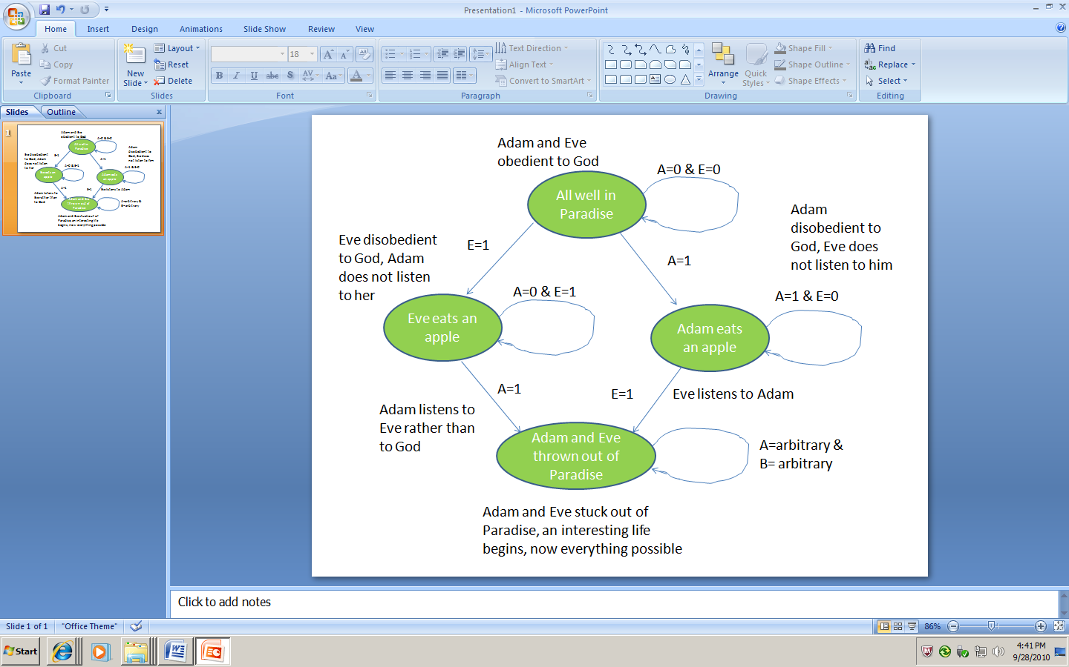

Figure 8.1. Automaton representing possible scenarios of Adam and Eve in Paradise.

One possible question is this: “What would happen if Eve would eat an apple but Adam would definitely refuse?” Would they iterate forever with Eve chasing Adam with apple and Adam escaping (the middle left node in Figure 8.1 and its loop? Would God remove Eve and will find another wife, Lilith II, for Adam. Bible tells nothing about these other possibilities, but for theatre they would be more interesting than happy Adam and Eve forever obedient to God.

What about Adam eats an apple and Eve refusing to it? Would Eve have to listen to her husband like it was expected in those ancient times? Would it be a sin for her to eat the apple then? Is the situation of Adam and Eve symmetrical in this story? Should it be symmetrical in our theatre?

Would God threw only Adam and find a new husband for Eve? Ancient Israeli writers would perhaps not like such a story. What God would do? The story can be analyzed from points of view of fuzzy or quantum logic with different scenarios and solutions. Answering these questions and (semi)automatically creating scenarios can become some form of meditation about fundamental choices by the audience. It can be also entertaining. The behavior and the intellectual level of every performance would depend on particular audience present in the robot theatre that day.

**9. GAME THEORY AND ROBOT THEATRE**

What is presented here applies not only to robot theatres but also to computer games and Virtual Reality art. We present briefly some ideas related to game-theoretical concepts in autonomous/interactive script-creation, as those illustrated in sections 6 to 8.

**9.1. Game variables and automata.**

Values of game state variables are simulated with random numbers. Think about the game state variables based on simulated “free will” of Adam and Eve. The audience, the individual agents (robots or actors), the “Simulated God” (Universal Omniscient, Omnipotent, Omnipresent Observer, a central program that knows all state variables of all agents), or a random number generator - all of these agents can make choices for variable values A and E in Figure 8.1. What are the other possible game variables in this play? What is the set of all attributes of a human that can be used as state variables? Thought, free will, cognition? Learning? Morality? Autonomy? Creativity? Deep Knowledge? These are all abundant sources of game variables. With their probabilities, and their mutual constraints.

There are many discussions in philosophy, literature and theatre that can be interestingly represented as games, especially quantum games. For instance, the known from Philosophy “Pascal’s Wage” marked the beginning of Mathematical Game Theory and is a good topic for robot theatre to meditate about the costs one is supposed to pay for her life decisions regarding the Absolute. Many moral, social and environmental issues have been already represented as games [Danielsen92]. In case of robot theatre, these should be ethical problems truly important to modern humans, or important to a particular audience. Moral problem is a constraint satisfaction problem. We have rules and constraints assigned by environment, government, tradition, religion or popular morality standards. There are also physics-based constraints of executing actions to be taken under the consideration, like speed or force that can be applied - this distinguishes the theatre of real robots from the Virtual Reality Theatres soon to be created. Think also about Tosca, Romeo and Juliet or any theatrical play as a game in which more paths through game graph are created for the actors-agents. An artist, a director and a visionary engineer can convert most known plays to truly amazing gaming scenarios.

**9.2. Robot Theatre is about spirit transcending on mechanical body**

What is the most fascinating about the robot theatre is the fact that it identifies two opposites. A living creature might be rather mechanical in its roots. And the opposite; a mechanical behavior has implicit in it the possible emergence of something that transcends this pure mechanistic. Cartesian duality reborn.

Brecht applying his 'alienation effects' idea, deliberately tried to force the viewer to remember that he/she was witnessing a play, an artificial construction, not a real human interchange. In robot theatre, the alienation effect is guaranteed. The impulse to identify and to project our feelings onto anything remotely humanlike or remotely alive however, is so powerful that it may overcome the 'guaranteed' alienation effect. But of course, we are already very well-prepared to project onto robots, proved by our familiarity with robots from science fiction books and films. Game theory based robot theatres will allow to investigate possible solutions to known dilemmas, meditate on possible worlds, on all possible Universes with their rules, constraints, cost functions and scenarios, defined by audience or taken from huge computer libraries of play elements. Some day in future, these libraries will become available on internet for free of for pay, similarly as now software tools to create games can be found.

**9.3. What robot theatres will tell us about ourselves?**

Robot theatre reveals possibilities to explore issues about ourselves, never addressed before. Various aspects of free-will decision making can be looked as in the Paradise Lost example in section 6.

In the original Bible story the sequence of assigning decision variables was Eve-Eats-Apple = 1, ahead of Adam-Eats-Apple = 1. This making of the decision by Eve may be random or may be done after her internal reasoning effort, that in turn can be based on various rule sets, heuristic hypotheses and computational approaches. It can be influenced by the devil-Serpent character robot who talks directly to her or the devil is a virtual choice of the theatre public asked by the narrator what the Eve should now do. The angel and devil can be also visualized as only contents of her brain. There can be many auxiliary decision variables leading ultimately to Eve-Eats-Apple = true or Eve-Eats-Apple = false.

Future generations will be smarter than we are now, they will be able to use more powerful reasoning and they will know more facts. Robot theatre will evolve, as the each scenario of each performance can be stored in computer memory. Think how interesting would be in 21st Century to know in full detail how the original audiences reacted to plays of Aeschylus or Shakespeare in their times. Modern information-storing and Data Mining technologies make this possible in robot theatre.

**9.4. The importance of the content.**

Robot performance is based on a story, a scenario. While the basic story structure is built into software, it leaves a great degree of freedom of choices to the actor-robots, alive actors if any, and to the audience to influence the actions.

There can be different options to the scripts, various technical solutions can be available, certain aspects of them can adapt, generate or evolve parts of the script. The limits of the robot theatre are unknown. Parts of the robots can easily become artifacts acting separately, being individually controlled, away from the robot body. At first, the participating “actors” can correlate together, next they can be separated, and from then on, they can decide for themselves, whether to act separately or in unison. The same separation can be applied to the body and the soul, for instance, or to individual components of a single body. Therefore there is a part of the scenario that is unpredictable and dynamically created, differing from performance to performance as the circumstances of each change.

Therefore, it is of great importance in our type of a theatre to provide the software with the strong skeleton of values so that regardless of the influence, each change remains within the initially set intellectual or ethical concept.

As Marshall McLt-uhan thought: “.. graphing the human use of an artifact could predict what society might do with the new invention. Hence, one could accept or reject from the beginning the future effects of any new artifact.”

So those effects need to be strongly considered, before we enthusiastically throw ourselves into the “unknown”. The results of the use of semi-independent technical robotics, need to be well thought through ahead of time, with the basic concept to stay within the preservation of the human kind and its general well-being.

“The medium is the message” we have been warned. This aspect can be extended to a greater depth. There are also dangers of giving all freedom to robots, software and the audience but this topic is worth another paper. Opening yet another door of human perception, regardless of how exciting it may be, the educational moral theatre should limit the potentials and call for a responsibility to make sure that the new invention effort is not used to the demise of what the best of the humanity we consider.

In another concept of avant-garde robot theatre the creators would perhaps like to experiment with scenarios that impose no morality rules, or with scenarios that would impose some other rules of behavior like “*lie if not afraid to be caught*”. This may be quite interesting to observe and analyze such theatres, but it is not a task of this paper.

**9.5. Robot theatre, games, quantum logic and emergence of value systems**

When we think, images come to mind one after another, thousands of thoughts work in parallel. But when we take a recorder to talk, only one idea is formulated and finished, all other are lost, isn’t it like in quantum measurement? Using robots can allow for simultaneous “viewing” of all those thoughts. How to add free will quantum variables? Quantum Game Theory is much more powerful than the Classical Game Theory. This should be investigated in robot theatre. The quantum emotional humanoid robots have been already discussed [Raghuvanshi08, Lukac07a, Lukac07b, Lukac07c]. Emotions, creativity, imagination, theatrical expression, they are all related to quantum mechanics, with its quantum information aspects, randomness, superposition, entanglement and measurement effects. This topic is worth another story.

In previous sections we described few fundamental ideas of the proposed Robot Theatre concept:

(1) Interaction and improvisation,

(2) Visualization,

(3) Game theory based scenario.

(4) Moral dilemmas as action evolvers.

The game-theoretical concepts should be compared between classical and quantum games. For instance, the robots can be visualizing two famous games of mathematical Game Theory: Prisoners Dilemma (PD) and Chicken. We think that a robot enactment of Chicken might be pretty simple and dramatic.

*Chicken.* The two robots could be rapidly moving towards a head-to-head collision which would knock both of them out unless one or both swerve. Experimenting with decision variables in repeated game of chicken may be a great lesson for risk-taking teenagers. Probabilities of behaviors can be tuned by the audience on visualized giant knobs with a lot of fun but no risk. Each game player or their group can adjust the knobs corresponding to the probabilities of the swerving and observe the consequences.

*Prisoner Dilemma.* This well-known problem of game theory investigates the value of cooperative versus competing, distrastful behaviors, the role of trust and how the trust wins in the long run of a repeated game. The PD isn't as dramatic as chicken but allows to create interesting theatre plays and is already used in US in tele-games with humans playing against humans. PD can be converted to “environmental robot theatre” by having robots take goods from some common resource pool, where those that defect take more than they can use and thus much resource gets wasted, while those that cooperate take just what they need, so more agents can benefit. This might also have real educational value – there is nothing else like seeing an abstract model as the PD or Chicken actually instantiated in live theatre action. This is a practical way to demonstrate that “MORALITY MAY NOT PAY IMMEDIATELY BUT MORALITY PAYS IN THE LONG RUN”.

Our games are based on System Science models. Historically, the most natural was the use of formal axiomatic systems in several areas of System Science, formal logic, and mathematics. For instance, in mathematics formal systems are used to prove theorems of integer arithmetic or Euclidean geometry. Another type of a formal system is the Game of Life (GOL) being an example of Cellular Automata (CA). In CA a formal proof of dynamics based on the initial state of the system and the rules of its evolution (derivation) is mathematically difficult, or even practically impossible. But the CA model is definitely formal and scientific by itself. The dynamics of the CA model can be thus usually only observed, visualized in a form of graphics and movies [Gaylord96]. The CAs are very powerful metaphors because of their visual similarity to the behaviors of sets of agents or patterns that exist in Nature (ants, crystals, vegetation patterns, hurricanes and floods).

Any game is kind of a closed universe with complete rules of behaviors and “internal physics”. Sometimes randomness is also used. A game like GOL has more or less connection to real world, but is interesting because of its visualization and its analogies to real situations in sports, war or social life. To discuss these models it is imperative to distinguish the internal view and the external view of a model. The internal view allows for mathematical analysis and visualization of the system itself. The external view tries to link the abstract model to the real world. The model can be simplified and abstract but the interpretation of the results is believed by some famous scientists like Wolfram or Fredkin to determine some actual truth about the dynamics of our real life or dynamics (fate) of our Universe. To verify or confirm these kinds of beliefs about formal systems is out of the scope of science, but may be a task of collective emotions raised in robot theatres. Here we want only to propose various mechanisms for robot theatre that would allow groups of people to create value-related and belief-related art forms in sequences of group experiments.

Art and ethics are different than science but are also based on rules that can be generated, analyzed and modified, evolved and that may emerge by themselves in performances. In robot theatre we can create any kind of universe, which may be very different from the one that we know. But these universes should have at least some similarity to our universe, by analogy, exaggeration or simplification, to become interesting to human audiences. These universes should have also some internal logic, and some language of their own. In contrast to formal models for physics or engineering where the experiment is the final verifier, in artistic robot theatre the human perception is the only verifier. In our opinion the final “cost function” for evolution and emergence of autonomous theatres should be: “can this form of art change me as a human, improve my value system, extend my culture?”

**10. CONCLUSION**

The paper introduced the new concept of robot theatre controlled by modal-fuzzy and quantum controllers and evolutionary game algorithms. The research goal of our laboratory is to investigate these concepts further. We believe that building robots with various types of “brain controllers” as well as writing and directing plays for robot theatre is an excellent method of exploring different aspects of life and educating the young audience about them. Already used to teach different disciplines, we propose to use robotics to creatively examine art and human condition. Robot theatre has a potential to become a new art form with boundaries beyond our current imagination.

A philosophical debate, deep questions about life can be raised by this new technology as it possesses unexplored possibilities of getting to the unknown levels of our consciousness. As it may seem odd at the moment, the use of robots, the mechanical androids, the replacement of the limited people, may open new door of our own perception, as well as the perception of the theatre and its many ways of conveying the dilemmas of human existence. Since the options are unknown, as with each creation, eventually it begins the life of its own, the theatre we know may transform to a completely new form of art. The addition of “emotional thinking” option to the societies of autonomous robots may really take us to the unexplored so far areas that our limited imagination of the moment cannot foresee yet.

The deepest and extremely difficult question of Artificial Intelligence is the following: “*can a computer become conscious*?” In contrast, our question asked in this paper is simpler and is more precisely formulated: “*can a robot theatre become a new art form, related to human value system, being also morally acceptable, aesthetically pleasurable and intellectually satisfying*?”

It is important to set the expectations and the clear purpose for the new discoveries however. As we all are becoming more aware of the well-being of our planet, taking steps to preserve it and to sustain its resources, we do have an obligation to do the same to our state of minds, to our spiritual well-being, the global consciousness.

**LITERATURE**

* [Alcott] T. Alcott, <http://www.toddalcott.com/spielberg-artificial-intelligence-a-i-part-3.html>
* [Brantley06] B. Brantley, In Robot world She Turns More Hedda than Hedda, <http://www.nytimes.com/2006/02/18/theater/reviews/18hedd.html?_r=0>
* [Badler79] N.I. Badler and S.W. Smoliar, Digital Representation of Human Movement*.* Computer Surveys*,* Vol. 11, No 1, March 1979, pp. 19-38.
* [Beall03] J.C. Beall and Bas C. Van Frassen, Possibilities and Paradox: An Introduction to Modal and Many -Valued Logic, Oxford University Press, 2003.
* [Brawn06] Ch. Brawn, N. Metzger, J. Biamonte, M. Lukac, A. Aulakh, I. Devanath, M. Sajkowski, T. Stenzel, D.H. Kim, T. Sasao and M. Perkowski, Hexor, a Walking and Talking Robot with Quantum and Fuzzy Inference*,* In: Proc. ULSI, Singapore, http://www.ntu.edu.sg/home/efalkowski/ismvl/
* [Breazeal99] C. Breazeal and B. Scassellati, How to build robots that make friends and influence people, In Proceedings of IROS, 1999, pp. 858–863.
* [Breazeal02] C. Breazeal, Designing Sociable Robots*,* MIT Press, 2002.
* [Breazeal03] C. Breazeal et al, Interactive Robot Theatre MIT, <http://web.mit.edu/zoz/Public/p76-breazeal.pdf>
* [Brockett07] O.G. Brockett and F.J. Hildy, History of the Theatre, Pearson, 2007.
* [Brooks86] R. Brooks, A Robust Layered Control System for a Mobile Robot*.* IEEE Journal R&A, Vo1.2, No. 8, 1986. pp. 14-23.
* [Brooks91] R. Brooks, Intelligence without reason. In: Proc. of the IJCAI-91, 1991. pp. 569-595.
* [Brooks98] R.A. Brooks, C. Breazeal, M. Marjanovic, B. Scassellati, M.M. Williamson, The Cog Project: Building a Humanoid Robot, in IARP First International Workshop on Humanoid and Human Friendly Robotics, (Tsukuba, Japan), Oct. 26-27 1998. pp. I-1.
* **[Buller03] A. Buller and M. Perkowski,** Evolved Reversible Cascades Realized on the CAM-Brain Machine (CBM), Proceedings of 2003 NASA/DoD Conference on Evolvable Hardware, July 9-11, 2003, Chicago, Illinois, USA. pp. 246 -- 251.
* [Calvert93] T.W. Calvert Bruderlin, S. Mah, T. Schiphorst and C. Welman, The Evolution of an Interface for Choreographers, Interchi, 1993, pp. 24-29.
* [Chuck] Chuck E. Cheese’s, <http://en.wikipedia.org/wiki/Chuck_E._Cheese's>
* [Davis97] M.D. Davis, Game Theory: A Nontechnical Introduction, Dover Books on Mathematics, 1997.
* [Danielsen92] P. Danielsen, Artificial Morality: Virtuous Robots for Virtual Games, Routledge, Taylor and Francis Group, 1997.
* [Derrida73] J. Derrida, “Speech and Phenomena”and Other Essays on Husserl’s Theory of Signs, translated by David B. Allison (Evanston: Northwestern University Press, 1973).
* [Dhawan08] S. Dhawan, A. Raghuvanshi, Y. Fan, F. Zhao, Y. Wang and M. Perkowski, What’s that? Schrödinger Cat*!* Proc. the Third International Conference on Science and Technology, Policy, Culture and Communication, Korea, December 4-5, 2008.
* [Emerson90] E.A. Emerson, Temporal and modal logic, In [Jan van Leeuwen](http://en.wikipedia.org/wiki/Jan_van_Leeuwen). Handbook of Theoretical Computer Science, vol. B. MIT Press. pp. 955–1072, 1990.
* [Files98] C. Files and M. Perkowski, An Error Reducing Approach to Machine Learning Using Multi-Valued Functional Decomposition, Proc. ISMVL'98, May 1998.
* [Gasset56], O.Y. Gasset, The Dehumanization of Art and Other Writings on Art and Culture, Doubleday Anchor Books, 1956.
* [Gaylord96] R.J. Gaylord, and K. Nishidate, Modeling Nature: Cellular Automata Simulations with Mathematica, Springer, 1996.
* [Goetz13] A. Goetz, C. Huffman, K. Riedl, M. Sunardi and M. Perkowski, Artistic Robots through Interactive Genetic with ELO rating system, Proc. 22nd International Workshop on Post-Binary ULSI Systems*,* May 21, Toyama International Conference Center, Toyama, Japan, 2013, pp. 27 – 35.
* [Grygiel04] S. Grygiel, M. Zwick and M. Perkowski, Multi-level decomposition of probabilistic relations, Kybernetes: The International Journal of Systems & Cybernetics, Vol. 33, Number 5/6, 2004, pp. 948 – 961**.** ISSN 0368-492X. SCI
* [June] L. June, Walt Disney World unveils incredibly scary, robotic version of President Obama, <http://www.engadget.com/2009/07/03/walt-disney-world-unveils-incredibly-poor-robotic-version-of-pr/>
* [Jurkowski14] H. Jurkowski, Aspects of Puppet Theatre, Paperback, pdf, edited by Penny Francis, Palgrave Macmillan,2014.
* [Kim06] D.H. Kim, Ch. Brawn, M. Sajkowski, T. Stenzel, T. Sasao, J. Allen, M. Lukac, T. Wang and M. Perkowski, Artificial Immune-Neuro-Fuzzy System to control a walking robot Hexor*,* In: Proc. ULSI, Singapore 2006. <http://www.ntu.edu.sg/home/efalkowski/ismvl/>
* [Kulpa03] Z. Kulpa, From Picture Processing to Interval Diagrams, IPPT PAN Reports, Warsaw 2003, <http://bluebox.ippt.pan.pl/~zkulpa/diagrams/fpptid.html>
* [Kuritz88] P. Kuritz, The Making of Theatre History,  Englewood Cliffs, NJ: Prentice-Ha1l,1988.
* [Kurzweil05] R. Kurzweil, The Singularity is Near, When Humans Transcent Biology, Viking, The Penguin Group, 2005.
* [Labunsky09] D. Labunsky, Facial Emotion Recognition System Based on Principle Component Analysis and Neural Networks, Masters of Science Thesis, Dep. Electrical and Computer Engineering, PSU, 2009.
* [Linke] Ch. Linke, Social Robotic Experience and Media Communication Practices: An Exploration on the Emotional and Ritualized Human-technology-relations, <http://www.fus.edu/intervalla/index.php?option=com_content&view=article&id=14&Itemid=11>
* [Lukac07a] M. Lukac and M. Perkowski, “Quantum Mechanical Model of Emotional Robot Behaviors,” Proceedings of ISMVL 2007*,* May 14-15, 2007, Oslo, Norway.
* [Lukac07b] M. Lukac and M. Perkowski, Inductive Learning and Quantum Behaviors, Facta Universitatis, Ser. Elec. Eng. Vol. 20, No. 3, December 2007, pp. 561-586.
* [Lukac07c] M. Lukac and M. Perkowski, Quantum Emotions: A Cellular Approach,” *Proceedings of ULSI 2007*, May 13, 2007, Oslo, Norway.
* [Lukac07c] M. Lukac, M. Kameyama and M. Perkowski, Using Probabilistic Cellular automaton for Adaptive Modules Selection in the Human State Problem, Book chapter, in CELLULAR AUTOMATA - Innovative modelling for science and engineering, ISBN:978-953-307-172-5, 2011
* [Nakata98] T. Nakata, T. Sato and T. Mori, *Expression of emotion and intention by robot body movement.* In: Proceedings of the 5th International Conference on Autonomous Systems, 1998.
* [Nielsen10] M.A. Nielsen, and I.L. Chuang, Quantum Computation and Quantum Information, Cambridge University Press, 2010.
* [Perkowski00] M. Perkowski, Oregon Cyber Theatre, *Proc. 3rd Oregon Symposium on Logic, Design and Learning*, May 2000. <http://web.cecs.pdx.edu/~mperkows/ISMVL/oregon-theatre.html>
* [Perkowski03] **M. Perkowski, T. Sasao, A. Iseno, U. Wong, M. Pivtoraiko, M. Folgheraiter, M. Lukac, D. Ng, M. Fix and K. Kuchs,** Use of Machine Learning based on Constructive Induction in Dialogs with Robotic Heads, Proceedings of ICORR 2003 (the 8th International Conference on Rehabilitation Robotics), April 22-25, 2003, KAIST, Korea. pp. 326 -- 329.
* [Perkowski05] M. Perkowski, T. Sasao, J-H. Kim, M. Lukac, J. Allen, and S. Gebauer: Hahoe KAIST Robot Theatre: Learning Rules of Interactive Robot Behavior as a Multiple-Valued Logic SynthesisProblem. In: Proceedings of the 35th International Symposium on Multiple-Valued Logic*,* May 19 - May 21, 2005 at Calgary, Canada, pp. 236-248.
* [Perkowski05a] M. Perkowski,“Multiple-Valued Quantum Circuits and Research Challenges for Logic Design and Computational Intelligence Communities,” *Invited Paper, IEEE ConneCtIonS,* IEEE Computer Intelligence Society, November 2005, pp. 6-12.
* [Perkowski07] M. Perkowski,Quantum Robots. Now or Never? Main address of the conference, Proceedings 5th National Conference on Information Technology*,* Gdansk, Poland, May 20-23, 2007.
* [Perkowski11] M. Perkowski and D. Shah, Design of regular reversible quantum circuits: quantum circuit design, <http://www.amazon.com/s?ie=UTF8&page=1&rh=n%3A283155%2Cp_27%3AMarek%20PerkowskiJ>.
* [Perkowski13] M. Perkowski, A. Bhutada, M. Lukac and M. Sunardi, On Synthesis and Verification from Event Diagrams in a Robot Theatre Application. Proc. ISMVL 2013, pp. 77-83.
* [Perlin96] Perlin K., Gikdberg A.: Improv: A System for Scripting Interactive Actors in Virtual Worlds*,* Computer Graphics Proceeding, 1996, pp. 205-216.
* [Perry04] R.T. Perry, The Temple of Quantum Computing, 2004. <http://www.freeinfosociety.com/pdfs/computers/templeofquantumcomputing.pdf>
* [Raghuvanshi07] A. Raghuvanshi, Y. Fan, M. Woyke and M. Perkowski**,** Quantum Robots for Teenagers, Proceedings of ISMVL 2007*,* May 14-15, 2007, Oslo, Norway. http://ismvl07.ifi.uio.no/
* [Raghuvanshi08] A. Raghuvanshi and M. Perkowski,Using Fuzzy Quantum Logic to learn facial gestures of a Schrödinger Cat puppet for robot theatre, Proc. ULSI 2008, Dallas, May 2008.
* [Raghuvanshi10] A. Raghuvanshi and M. Perkowski, Fuzzy Quantum Circuits to Model Emotional Behaviors of Humanoid Robots, Proc. Evolutionary Computation, IEEE Congress, 2010, pp. 1 - 8.
* [Robotic] Robotic Art, Frank Garvey, http://en.wikipedia.org/wiki/Robotic_art
* [Serchuk06] Ph. Serchuk, E. Sharlin, M. Lukac and M. Perkowski,Emotion-mapped Robotic Facial Expressions based on Philosophical Theories of Vagueness, ACM Conference on Human Factors in Computing Systems (CHI 2006) Workshop on HCI and the Face, April 22-27, 2006, Montréal, Canada
* [Sun12] T. Sun, L. Sun and M. Perkowski, Using Formal Verification and Robotic Evolution Techniques to Find Contradictions in Laws, *Proc. ISMVL,*  2012.
* [Teatr] Teatr Robotyczny w Centrum Nauki Kopernik, <http://www.kopernik.org.pl/wystawy/teatr-robotyczny/>
* [Toy] Category: Toy Robots, <http://en.wikipedia.org/wiki/Category:Toy_robots>
* [Weinberg] A. Weinberg, Top 10: Video Games Than Approach Art, <http://www.askmen.com/top_10/videogame/top-10-video-games-that-approach-art.html>
* [Williams07] Q. Williams, S. Bogner, M. Kelley, C. Castillo, M. Lukac, D.H. Kim, J. Allen, M. Sunardi, S. Hossain and M. Perkowski, An Emotional Mimicking Humanoid Biped Robot and its Quantum Control Based on the Constraint Satisfaction Model, Proceedings of ULSI 2007,May 13, 2007, Oslo, Norway.
* [Wong02] U. Wong and M. Perkowski, A New Approach to Robot’s Imitation of Behaviors by Decomposition of Multiple-Valued Relations, Proc. 5th International Workshop on Boolean Problems*,* Freiberg University of Mining and Technology, Freiberg, Germany, September 19-20, 2002, pp. 265-279.
* [Zadeh65] L. Zadeh, Fuzzy Sets, Information and Control 8, pp. 338-353, 1965