SOFTWARE DEFINED RADIO (SDR)
INTRODUCTION

According to SDR forum, “Software Defined Radio (SDR) are Radios that provide software control of a variety of modulation techniques wide and narrowband operation, communication security function and waveform requirements of current and evolving standards over a broad frequency range [SDR forum]”

SDR is a collection of hardware and software technologies that enable re-configurable system architectures for wireless networks and user terminals. SDR provides an efficient and comparatively inexpensive solution to the problem of building multimode, multi-band, multifunctional wireless devices that can be adapted, updated or enhanced by using software upgrades.

To achieve this purpose, the primary goal of SDR is to replace as many analog components and hardwired digital VLSI devices of the transmitter-receiver as possible with programmable devices. This include:
- Air interface
- Modulation and coding schemes
- Data converters (ADC/DAC)

The ultimate goal in radio transceiver design is to implement all transceiver functions in software. This idea is shown in the following figure:

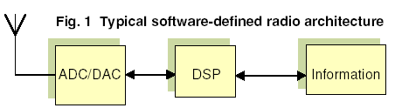
Figure 1: The SDR concept (taken from [1])

The SDR concept promises the main solution of supporting a multitude of wireless communication services in a single infrastructure design. The need to communicate with people using different types of equipment can only be solved using software programmable radios because of its flexible architecture [1].

In this course report, we describe a common software/hardware platform to implement two different radio systems to help understand the SDR concept. After that, we describe the important components of the SDR based system architecture and the challenges to transform them into SDR capable component. Then, we describe the development tools, which have been designed to reduce the design time and are used to reconfigure the platforms used to enable SDR concept.

Examples of implementation of the SDR concept

The software/hardware architecture, developed in [ICS] to demonstrate SDR concept is shown in figure 2. It consists of a PC (general purpose processor), an onboard ASIC chip (containing FIR filters with programmable coefficients and programmable frequency up-converters) and a Digital-to-Analog converter (DAC).

Base Band Processing
(Using PC)
Pulse shaping/Up conversion
(Using onboard ASIC)

DAC

Figure 2: PC-ASIC based SDR architecture

In the rest of the section I, we describe two examples to show how this architecture could be used to implement two different radio systems-namely Code Division Multiple Access (CDMA) and Orthogonal Frequency Division Multiplexing (OFDM).

a) Generation of CDMA signal:

Code Division Multiple Access (CDMA) is a cellular radio system in which the users in the coverage area are assigned unique codes (bit patterns) as channels. The codes are orthogonal to each other. The information is multiplied (spreading) with the assigned codes. At the receiver, a transmitter signal is multiplied with the same code assigned to the transmitter. The signal coming from the other transmitters remain un-decoded due to the orthogonality among the codes. In this way, multiple users are served simultaneously.

Before modulation/frequency up-conversion of the user message, various processes are applied on the information. These processes are termed as base band processing. The base band processing applied in CDMA systems is shown in figure 3 below:

Information
Source
Channel Coding
½ rate; length=9
Bit
Interleaving
Mapping
0
1; 1
-1
Demux
Spreading
I
Q

Figure 3: Base processing in CDMA System

These processes were carried out in software using C language. The program was written to generate ‘I’ and ‘Q’ coded data streams to be loaded in on-board buffers.

For the pulse shaping and frequency up-conversion, on-board ASIC was used. The desired pulse shaping filters’ coefficients and carrier amplitude, frequency and phase values were loaded through software interface to the ASIC. Finally the CDMA signal was converted into analog form using on-board DAC. These processes are shown in figure 4 below:




S(t)
Pulse shaping Filter
Pulse shaping Filter
I

Q
DAC

Figure 4: PC-ASIC based SDR implementation for CDMA signal generation

Figure 5 shows the transmitted CDMA signal in frequency domain that was captured using ADC.

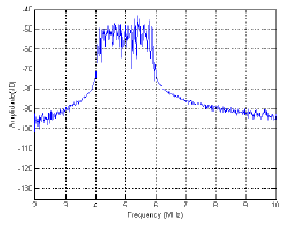
Figure 5 CDMA transmitted signal in frequency domain [ICS]

b) Generation of OFDM signal

In OFDM system, the user information, after base band processing is converted from serial to parallel stream and inverse Fourier Transform (IFFT) is applied. Then pulse shaping and up-conversion operations are performed. A possible structure to implement this system is shown in figure 6 below:
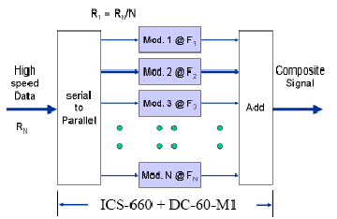

Figure 6: A simplified possible way of an OFDM signal generation

In this structure, the base band processed signal is converted to parallel data streams. Then pulse shaping is done on each sub stream. Then these sub-streams are up-converted using orthogonal sub-carriers and added together to form OFDM based band symbols. These OFDM symbols could be up-converted using a desired carrier frequency.

To implement this system using the same software/hardware platform, shown in figure 2, the base band processing was done in software. The generated ‘I’ and ‘Q’ streams are stored in on-board buffers. The IFFT (up-conversion), and pulse shaping were done using on the on-board ASIC. The desired pulse shaping filters’ coefficients and carrier amplitude, frequency and phase values were loaded through software interface to the ASIC. Finally the OFDM signal was converted into analog form using on-board DAC. Figure 7 shows the OFDM transmitted signal captured in frequency domain.
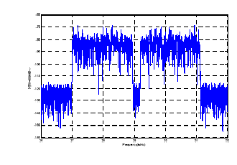
Figure 7 OFDM transmitted signal captured in frequency domain [ICS]

The software/hardware platform shown in these examples are just to help explain how the SDR concept could be realized. This architecture is very slow and inflexible and is not capable for typical real-time radio services (the PC is not fast enough; the ASIC has no/limited flexibility). In the following section, we describe the major components of SDR based architecture and enabling technologies to support applications that require real-time processing.

MAIN COMPONENT OF SDR BASED SYSTEM ARCHITECUTRE:

Figure 8 shows the main components that play vital role to enable SDR concept.
.
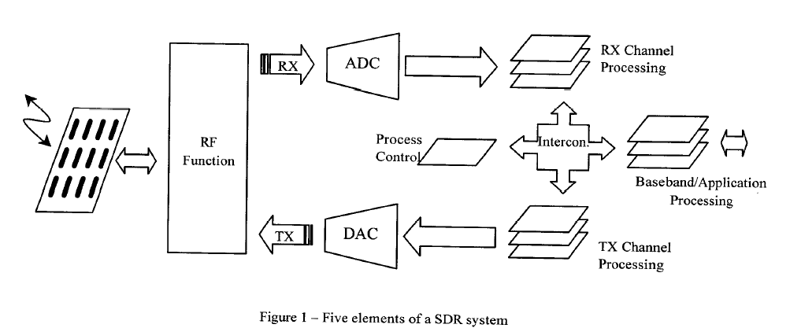

Figure 8: Main components of SDR-based system architecture [4]

The key components, which play vital role to support SDR-based architecture, which have been identified in the literature are as follows:

- Intelligent antenna,
- Programmable RF modules,
- Digital-to-Analog (DAC) and Analog-to-Digital Converters (ADC),
- Digital Signal Processing Techniques
- Interconnect Technologies

Intelligent Antenna Technology

Antenna front end can be split to the basic antenna element an the related array configuration and processing blocks. Antenna size is proportional to the operating radio frequency. The main activities in antenna domain to enable SDR concept (to support the broad range of frequencies with the same antenna elements) are in array processing blocks and techniques to make the antenna systems more performing and intelligent. Active research is going on to explore efficient related DSP techniques and high performance and flexible radiating elements.

Programmable RF modules:

It is a challenging task to cover the entire frequency band with the same peace of equipment. The essential RF component both in transmitter and receiver are band pass filters. In the SDR based RF domain the real challenge is to design programmable band pass filters. One of the employed techniques for existing SDR systems is to use a bank of RF modules. The Wideband synthesizer, MEMS and superconductor technologies and low noise high performance semiconductor processes are the subjects of active research in this domain.

Digital-to-Analog and Analog-to-Digital Conversion

They are the doors between physical and digital domains. The realization of a true SDR based systems depend upon their performance. In related literature, it is said that the goal of the SDR concept is to connect the converters directly to antenna element. The traditional converters are pushing the envelope to achieve more resolution and faster conversion rates. The super-conductivity and optical sampling techniques are the area of active research to achieve even higher performance. Some promising results are shown in the following table, taken from [essential]:

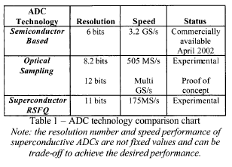
Taken from [essential]
Digital Signal Processing (DSP)

DSP is the key element to realize SDR based systems. The sampling techniques, rate conversion and multi-rate processing DSP techniques have been instrumental in the progress of SDR [essential]. To implement DSP algorithms to enable SDR concept, the candidate technologies are PDSP, ASICS, FPGA and mixture of them.

PDSP play a prominent role in SDR [1]. They offer development flexibility and are used primarily for number crunching operations in DSP algorithms. They have been used extensively for advanced digital communications transceiver designs and finding their way into detection, equalization, demodulation, frequency synthesis and channel filtering.
The PDSP are not fast enough to implement all radio functions.

High-speed instruction set processors are increasing in speed, decreasing in feature size, and improving low-power operation. As these new generations of chips begin to appear and feature size continues to decline, there are proportionate increase in speed, power efficiency and heat dissipation [2].

ASICS Application Specific Integrated Circuit (ASIC) is fast but not flexible; limited ability to add/modify new feature once the device is in the market. Companies that have tried to design parametized ASICs, have found that it takes an order of magnitude more effort to create the parameterized ASICS. This has led to Time-to-Market problems.
Field Programming Gate Arrays (FPGA) is an ASICS, which contain DSP blocks that can be re-configured to work as parallel multiplier/adder or MAC. They contain block/distributed memories, PLLs and programmable routing capabilities among the blocks. FPGA are extremely flexible and fast. Their performance is increasing rapidly to provide the flexibility of PDSP and the speed of ASICs. The following table, taken from [2], shows the comparison between PDSP, ASICs and FPGAs.

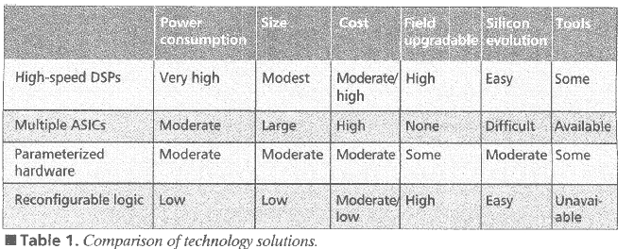

In the related literature, PDSP and FPGA are considered to be two main SDR enabling platforms. The following table, taken from [2], shows the comparison between PDSP and FPGA is details:
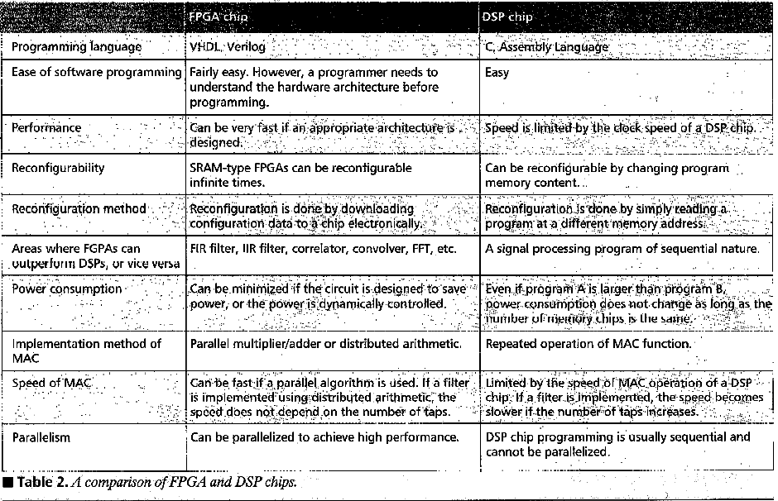

Interconnect Technologies:

It is required for a SDR enabled system to have the ability to connect various independent functional blocks to setup a radio link. The interface standards are needed to be developed within framework of an interconnect technology. Three main interconnect architectures are Bus, Switch fabric and tree. The following table shows the comparison of these three architectures:
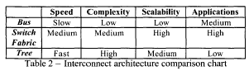
Taken from [essential]

A POSSIBLE COMPUTER ARCHITECTURE [1]

In the following paragraph, we provide a summery of possible computer architecture, taken from [1].

SDR implementations may be viewed in comparison with a generic PC model in the form of a multiple service model as illustrated below:

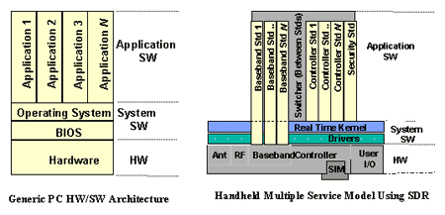

Figure9: Comparison of SDR-based and a generic PC-based service models

The base band implementations for each service are shown as directly interfacing the hardware layer because of the stringent performance constraints on execution speed and power consumption. In order to achieve processing speed and efficiency, the majority of base band implementations are programmed very close to the underlying hardware or logic. The task of switching between multiple operating bands using the same or different RF hardware is managed by a combination of the service switcher and the controller services for each individual operational mode.
DEVELOPMENT TOOLS
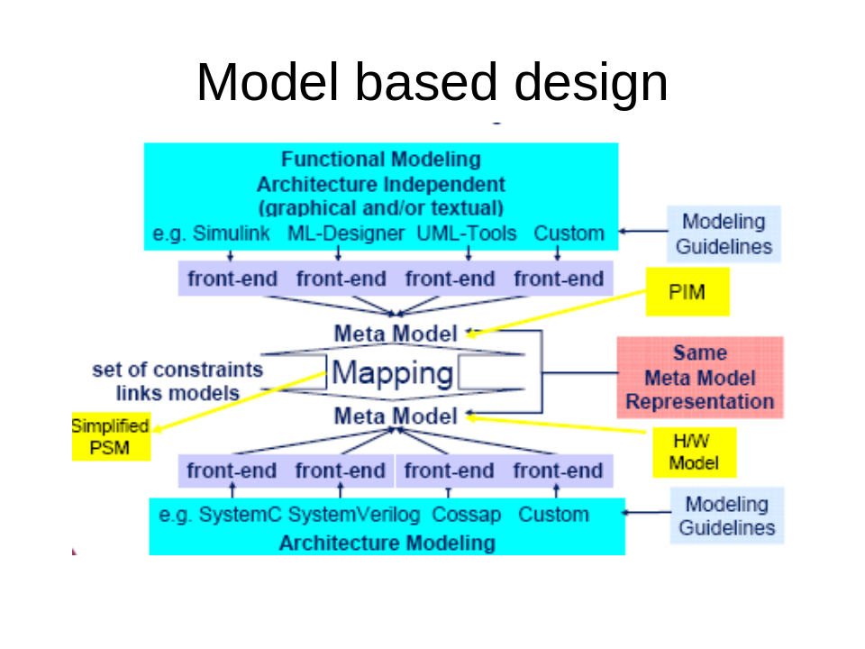

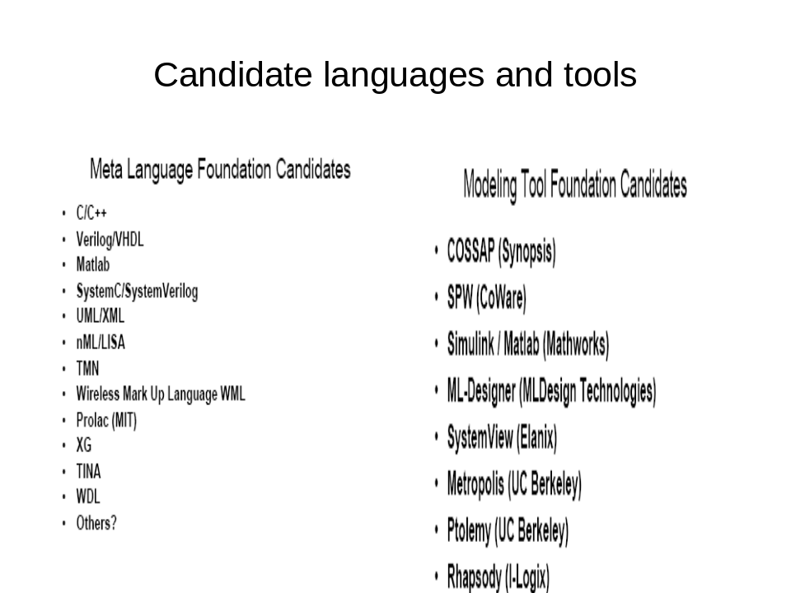

1-As examples, in this section, we will present the following development tools for FPGA:
- Quartus II from Altera
- Project Navigator from Xilinx
- Simulink
  - DSP builder from Altera
  - System Generator from Xilinx

2-Example of development tool for PDSP
    - Real-time workshop for the target PDSP

EXAMPLEs OF RECONFIGURABLE PLATFORM-ALTERA DSP BOARD
In this section we will present examples from DSP labs, we develop to demonstrate the reconfigurablity of DSP platform-FPGA:
Reconfiguring the precision (changing number of bits)
Frequency synthesizer
FIR filter
IIR filter

[1] Sadiku, M.N.O.; Akujuobi, C.M.;Potentials, IEEE;Volume 23, Issue 4, Oct-Nov 2004 Page(s):14 - 15
[2] FPGA in the software radio, Cummings, M.; Haruyama, S.;Communications Magazine, IEEE,Volume 37, Issue 2, Feb. 1999 Page(s):108 - 112

[3] http://www.ics-ltd.com/notes/Notes_902305.pdf

[4] A review on essentials and technical challenges of software defined radio
Haghighat, A.;
MILCOM 2002. Proceedings
Volume 1, 7-10 Oct. 2002 Page(s):377 - 382 vol.1

[5] Design and implementation of software framework for software defined radio system
Shiao-Li Tsao; Chia-Ching Lin; Chin-Lien Chiu; Hung-Lin Chou; Min-Chiao Wang;
Vehicular Technology Conference, 2002. Proceedings. VTC 2002-Fall. 2002 IEEE 56th
Volume 4, 24-28 Sept. 2002 Page(s):2395 - 2399 vol.4

[6] Mitola, J., III;
MILCOM 2000. 21st Century Military Communications Conference Proceedings
Volume 1, 22-25 Oct. 2000 Page(s):214 - 218 vol.1

