Evaluating window aggregate queries over streams

Author Name
email@small.medium.large

Abstract
Stream processing is important for many applications, such as network traffic monitoring, network trace analysis and financial data processing, but the features of streams and stream applications make some traditional database query evaluation techniques inappropriate for them.
Window queries are both natural and essential to stream processing. A window query breaks each input stream into potentially overlapping subsets (windows) of data, and the query is continuously evaluated over each.
The existing approaches for evaluating window aggregate queries over streams buffer tuples when a tuple belongs to multiple windows; also some approaches use buffering to sort out-of-order tuples when handling disordered streams. In this paper, we introduce our Explicit Window-Id approach, which evaluates window aggregate queries over streams (both ordered and disordered) without buffering. We offer a formal window semantics and show that our approach separates the logical definition of windows from physical data ordering and allows most query operators to be “window agnostic.” In the case that a tuple belongs to multiple windows, we introduce an improvement of our approach, the paned option, which avoids redundant computation. We give a performance comparison of our Explicit Window-Id approach with and without the paned option, and provide execution-time cost models for both cases. We demonstrate that our Explicit Window-Id approach inherently handles disordered streams. We experimentally study latency versus accuracy tradeoffs of alternative strategies for handling disorder using two types of disorder and different aggregates and window sizes.
- Introduction
A new class of data-intensive applications has attracted great research interest: applications that analyze or monitor data streams. Examples of such applications include network traffic monitoring, network trace analysis and financial data processing. In such applications, data are usually generated at distributed data sources, and are streamed into a central processing system. However, it is not a feasible solution for the central processing system to simply store the arriving bids into a traditional database management system (DBMS) and to operate on the stored relations. There are several reasons: 1) The high data volume of streams (e.g. network packets) could make storing all the stream data to a DBMS unrealistic. 2) Traditional DBMSs manage static data; when evaluating queries, the data are often scanned more than once or in some special order (e.g. sort order). However, without archiving, streaming data can only be accessed sequentially; even with archiving, historical data might not be conveniently retrieved during query evaluation. 3) Two classes of query operators are problematic for processing streams, blocking operators and stateful operators. A blocking operator, such as groupby, cannot output any results before processing the entire input, and a stateful operator, such as join, potentially maintains an unbounded number of state. 4) Applications monitoring and analyzing streams handles more unpredictable input data than does a traditional DBMS, and usually require that query results be turned in a near real-time manner. Therefore, such applications require a new class of data processing systems that focus on evaluating queries over streams.
Window queries are both natural and essential to stream processing. A stream is potentially unbounded. A window aggregate query breaks each input stream into potentially overlapping bounded sub-streams, and evaluates the query over each. An example of window aggregate queries is “Average the stock price of MSFT for the past 2 hours, and update the result every 10 minutes”. This query separates the stock price stream into overlapping 2-hour sub-streams that start every 10 minutes. For many stream applications, rather than querying over the whole stream, querying over only a sub-stream each time returns meaningful results. For example, averaging over the stock price of MSFT from the start of the stock does not tell much. In addition, window query semantics unblock the blocking operators, and help to reduce the amount of states that a state operator needs to maintain, because at each time instant, the semantics of window queries defines a bounded sub-stream.
The existing approaches [1, 12, 16] for evaluating window aggregate queries assume that stream tuples arrive in order or in order within a bound, both in query semantics and in query evaluation. Their window query semantics relies on the ordering assumption of input stream; disordered data arrival leads to non-deterministic window aggregate results; when evaluating the queries, the completion of each sub-stream depends on the ordering assumption. However streams are usually generated from distributed sources and are then transferred to the stream processing system, and thus in many cases, no exact arrival order of the stream data can be guaranteed at the stream processing system.
The existing approaches need buffering when evaluating window aggregate queries. Tuples are buffed when consecutive sub-streams overlap and each tuple belongs to multiple sub-streams. In addition, some approaches use buffering to sort out-of-order tuples to handle disordered input. Buffering may be acceptable in some scenarios, but is generally undesirable.
In this paper, we present our approach for evaluating window aggregate queries, Explicit Window-Id approach (EWID approach), which processes tuples as they arrive without buffering and inherently handles disordered input. In the following of this paper, Section 2 provides background related to window queries; Section 3 provides the formalism of our window aggregate query semantics, Window-Id semantics; Section 4 presents the implementation of our EWID approach; Section 5 discusses an improvement of our EWID approach, called paned option, which improves the execution-time cost; Section 6 discusses the sources of disordered streams and describes our EWID approach handling disordered input; Section 7 presents the performance study that shows the latency versus accuracy tradeoffs of alternative strategies for handling disorder of using two types of disorder, different aggregates and window sizes; Section 8 reviews related work; Section 9 concludes the paper and gives the future work direction.
- Preliminaries
In this section, we provide a working scenario, window query examples, and a discussion of existing query semantics over streams. We also provide examples of query languages that follow different query semantics and discuss query language support for various window semantics.
2.1 Working scenario
Consider an online auction system: Bids made at distributed auction sites are sent to a centralized online auction-processing system and are merged into a combined stream; a user can query the combined bid stream at the central site. The schema of the combined bid stream is <item-id, auction-site, bid-price, timestamp>, where the timestamp attribute indicates the origin time of a bid. This online auction scenario will be used as the working scenario throughout the paper.
2.2 Window queries
Window queries are an important kind of queries for applications monitoring and analyzing streams. A window query breaks each input stream into potentially overlapping sub-streams (window extents), and the query is evaluated over each. In this section, we provide three examples of window queries over the combined bid stream of the online auction system just described.
Q1: “Count the number of bids generated at each auction site for the last 10 minutes, and update the results every minute.”
Q1 is a time-based sliding-window query. It breaks the combined bid stream into 10-minute overlapping window extents starting every minute, and evaluates the query over each. Note that here the window extents are defined by a notion of time. For Q1, the time notion refers to the timestamp attribute of the bid stream. We call the attribute that is used to define window extents the windowing attribute.
Q2: “Find the number of bids for each auction site over the past 1000 tuples, and update the result every tuple.”
Q2 is a tuple-based sliding-window query, for which the windowing attribute is not a data attribute but the tuple’s position in the stream – we call it tuple sequence number.
Q3: “Count the number of bids generated at each auction site, and update the results every minute.”
Q3 is a time-based landmark-window query. It is similar to Q1, except that the scope of the window extents of Q3 keeps increasing, and each window extent subsumes all the previous ones.
There are various kinds of window aggregate queries. Potentially, a window aggregate query can use any data attribute with an ordered domain to define window extents. Also, the size of the window and the step by which the window moves lead to different window semantics. Section 3.3 provides the formal specifications for various window queries.
2.3 Semantics of queries over streams
For a stream query language, its semantics of queries over streams affects the window semantics it supports. We classify the existing approaches into two categories, continuous query semantics and stream-only query semantics, and provide examples of stream query languages that adopt each semantics. For each query language, we discuss its window semantics.
Continuous query semantics: Continuous query semantics has been in use for quite some time. Terry et al. [22] introduce the Tapestry system that supports continuous queries to filter documents and explicitly define continuous query semantics over append-only databases as: “The results of a continuous query is the set of data that would be returned if the query were executed at every instant in time.” Informally, a continuous query is issued once and henceforth run “continuously” over the input data, and the result of the query is a relation continuously updated at each time instant. The semantics of a continuous window query is that at each time instant, the query turns input streams into relations based on the window semantics of the query, and uses relational operators to evaluate the query over those relations. One important benefit of using continuous query semantics for stream queries is that it exploits the well-understood relational semantics.
One example of a query language that adopts continuous query semantics is Continuous Query Language (CQL) [3], which is proposed by the STREAM project as a general-purpose continuous query language over streams and updatable relations. In CQL, each stream element is modelled as a tuple associated with an implicit timestamp. In the STREAM system, window queries are viewed as a mechanism of reduction and approximation, which are used to reduce the memory usage and computation of query execution, rather than as a way to express what users exactly want. This interpretation of window operators leads to the restricted window semantics in CQL, in which the arrival of every tuple defines a window extent. For example, CQL can express Q2, but not Q1. Also, in CQL, only the implicit timestamp, which is tags by the query system as the tuple arrives, or the tuple sequence number is used as the windowing attribute to define window extents.
TelegraphCQ [6] also supports continuous query semantics over a combination of relations and streams, but it allows a broader range of window semantics than CQL does. For example, TelegraphCQ expresses time-based window queries and tuple-based window queries in a uniform way, and it allows users to explicitly specify the size of the window and the step by which the window moves. TelegraphCQ also assumes that the input stream of a window aggregate query is ordered on its windowing attribute.
Stream-only query semantics: Rather than transforming streams into relations and using relational operators, with stream-only query semantics, a query over streams operates over the input streams on the fly and returns streams directly.
Stream-processing systems for applications that monitor and analyze streams, such as Gigascope [7] and Aurora [2], usually adopt stream-only semantics. In such applications, the data arrival rate is fast and unpredictable, and the data volume is huge. Therefore, it is important to directly process the stream tuples on the fly and to stream out the results. Window queries are natural to stream processing systems for monitoring and analysis applications, rather than a mechanism of approximation to reduce the memory usage and the computation of query evaluations.
Gigascope developed a stream-only query language, GSQL, which requires that the input streams of window queries be ordered or ordered within a bound on the windowing attribute. As Gigascope is a specialized system for stream monitoring applications, it only supports limited window semantics. Compared with Gigascope, the Aurora Stream Query Algebra (SQuAl) [2] supports a broader range of window semantics. Users can specify the window size, the step by which the window moves and the windowing attribute. But SQuAl also requires the windowing attribute values of input tuples be ordered or ordered within a bound, and it defines the ordering specification of the input stream’s ordering property for an operator.
We see that the existing definitions of window semantics depends on the ordering assumption of data arrival order, and is thus non-deterministic with different physical arrival order of tuples.
- Window-Id Semantics and Formalization
In this section, we present our window query semantics, called Window-Id semantics, in which window-ids are used to identify window extents. Window-Id semantics enables a uniform expression of different window semantics, and separates query semantics from physical data arrival order.
  - Motivation
We believe that given a window aggregate query, we can uniquely identify each window extent, and the window extents to which each tuple belongs are fixed. For all the different window queries that we have seen so far, the window extents of a window query are ordered or partially ordered on the range of the windowing attribute values. For example, suppose the input stream of Q1 starts from 10:00 AM. Its window extents are ordered such as (10:00AM - 10:05AM) < (10:01AM - 10:06AM) < (10:02AM-10:07AM). Therefore, we can map each window extent to an ordered domain value, a window-id (e.g. a non-negative integer). For each tuple from the input stream, the window extents to which the tuple should belong are fixed, and so we can associate it with a set of window-ids to represent the window extents to which it belongs. In the rest of this section, we present the definition of window-ids for window extents, and mappings between window-ids and input tuples.
3.2 Defining and calculating window-id
In this section, we use Q1 as an example to show that given a window aggregate query, we can define a window-id for each window extent over the input stream and compute the window-ids for each input tuple.
Suppose that the start point of Q1 is 10:00 AM and the window-ids are non-negative integers. We can assign window-id 5 – 9 to the window extents as follows –
Window Extent Window-Id
10:01 AM – 10:06 AM 5
10:02 AM – 10:07 AM 6
10:03 AM – 10:08 AM 7
10:04 AM – 10:09 AM 8
10:05 AM – 10:10 AM 9
Note that for sliding-window aggregate queries, the first a few window extents are “partial” windows that do not have a full range of tuples, because a sliding-window query needs to update results every “step”. For example Q1, the first four window extents are partial windows.
For each input tuples, we calculate the window-ids to which the tuple belongs based on its windowing attribute value. For example, suppose t is a input tuple of Q1 with timestamp value 10:05:25 AM, then the first window-id for t is calculated by (10:05:25 AM – the query’s start time) mod SLIDE = (10:05:25 AM – 10:00:00 AM) mod 60 seconds = 5. As we know each input tuple of Q1 belongs to 5 window extents, tuple t belongs to window 5 to window 9.
In many cases, we can calculate the window-ids for each input tuple by applying a simple function. Next, we provide a formal definition of window specifications to express window semantics. Based on the window specification, we present the formalism of our window semantics using window-ids, and define the mapping between window-ids and input tuples.
3.3 Window specification
In this section, we consider two types of window specifications: non-partitioned window specification and partitioned window specification. Those two specifications can express most of the existing window semantics.
A non-partitioned window specification consists of three parameters: RANGE, SLIDE, and WATTR that represents the windowing attribute. Q1, Q2, and Q3 can be expressed with non-partitioned window specifications as follows.
Q1: SELECT auction-site, count(*)
FROM Bids [RANGe 300 seconds
SLIDE 60 seconds
WATTR timestamp]
GROUP BY auction-site
Q2: SELECT auction-site, count(*)
FROM Bids [RANGe 1000 rows
SLIDE 1 row
WATTR sequence-num]
GROUP BY auction-site
Q3: SELECT auction-site, count(*)
FROM Bids [RANGe ALL
SLIDE 60 seconds
WATTR timestamp]
GROUP BY auction-site
The RANGE parameter of the window specification defines the size of the window, and the SLIDE parameter defines the steps at which the window moves. Both RANGE and SLIDE are specified in terms of windowing attribute values, and are in the same unit as the windowing attribute values. For example, assume that the unit of timestamp attribute of the bid stream is in second; the RANGE and the SLIDE parameter of the window specification of Q1 are also specified in second. RANGE and SLIDE of Q2, a tuple-based sliding-window, are specified in terms of tuple sequence number. For Q3, we use “RANGE ALL” to define landmark-window queries, as each window extent of a landmark query contains all the tuples arrived from the start point of the query. Our definition of the window specification allows users use any data attribute with a totally ordered domain as the windowing attribute, such as timestamp attribute, tuple sequence number, and other non-temporal attribute of data.
A partitioned window specification has an additional parameter, PATTR, to define the partitioning attribute. Q4 shows an example of a partitioned window query.
Q4: “Average the prices of the last 1000 bids for each auction item, and update the results every bid.”

Q4: SELECT auction-site, count(*)
FROM Bids [RANGe 1000 rows
SLIDE 1 row
WATTR sequence-num
PATTR auction-site]
Q4 is similar to Q2, except that the auction-site attribute in Q4 is the partitioning attribute rather than the grouping attribute as in Q2. Logically, the partitioning attribute splits the input stream into sub-streams (each possibly unbounded); then the other three parameters of the window specification separate each sub-stream into bounded sub-sub-streams. Each bounded sub-sub-stream is a window extent. Thus, for Q2, each window extent contains 1000 tuples from different auction-sites; while for Q4, each window extent contains 1000 tuples from the same auction-site. Our window specification definition can express most of the window semantics we have seen so far, and it can be easily extended to express new semantics.
3.4 Defining window extents
Most existing approaches for evaluating window aggregate queries over streams assume that the arrival of stream tuples is totally ordered or ordered within a bound on the windowing attribute (e.g. timestamp); for example, “no bid will be late for more than 10 seconds”. This assumption implies that at each time instant, only a limited number of window extents can be active. When a tuple belonging to a later window extent arrives, the current window is closed. Essentially, the ordering assumption indicates the sequential processing of window extents. Thus, with the ordering assumption, the window semantics is affected by the physical arrival order of the data, and different tuple arrival order leads to non-deterministic results.
We believe that the definition of the window semantics should be independent of the physical arrival order of input tuples. Given the tuples, the content of each window extent is determined by the window specification of the query. We can establish the mapping between the window extents and the tuples that fall into each of them.
In our formalism, window extents are defined by the window specification S over a set of tuples T. Note that T is an unordered and potentially unbounded logical entity, which is not expected to be materialized in the implementation. For a window query over streams, T includes all the tuples that are considered as the input tuples of the query; depending on the system setting, T might contains all the tuples of the input stream, only tuples in the stream starting from the time when the window query is issued, or only tuples in the stream starting at a point in time before the time when the window query is issued. The window specification, S, defines window extents over T.
Based on the non-partitioned window specification, we define two functions windows and extent for non-partitioned sliding-window query and non-partitioned landmark-window query; based on the partitioned window specification, we define two functions windows and extent for partitioned sliding-window query.
Formally, for each type of window semantics, given a window specification S and a set of tupls T, the function windows maps S and T to a set of window-ids W that identifies the window extents: windows (S, T) = W. W might or might not depends on T. The function extent maps each window-id in W to a sub-set of T called U, which is the set of tuples that fall in the window extent identified by w:
extent (w, S, T) = U ⊆ T.
Given a non-partitioned window query such as Q1, Q2 and Q3, we use the non-negative integers for window-ids. Note that here the window-ids depend on neither T nor S. The windows function is defined as follows.
The extent function of sliding-window queries is different from that of landmark-window queries. We define the extent function of non-partitioned sliding-window queries, such as Q1 and Q2, as follows.
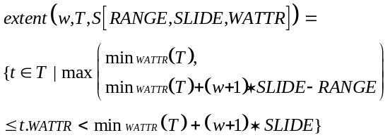
The value min_{WATTR}(T) represents the minimum windowing attribute value of the tuples that are in T. The max in the extent function above deals with the boundary cases to permit “partial” window extents.
We define the extent function of non-partitioned landmark-window queries, such as Q3, as follows.
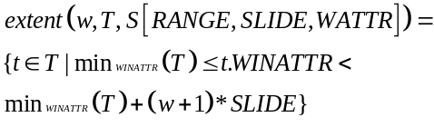
For a non-partitioned landmark-window query, each window extent ranges over all the arrived tuples, and a late window extent always subsumes all the early ones.
For a partitioned window query, such as Q4, the window-ids we use are compound values composed of a non-negative integer that represent a window extent in a partition and a partitioning attribute value.
Here T.PATTR stands for the projection of T on its partitioning attribute. The extent function of a partitioned window query is defined as:
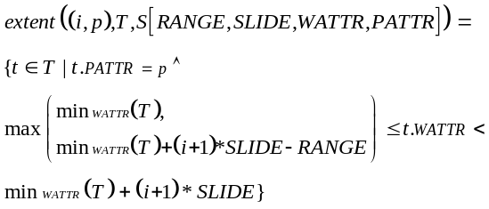
It is straightforward to extend the definition of the windows and extent functions for other types of window queries.
  - Mapping tuples to window-ids
Practically, given an input tuple, we need to know the window extents to which the tuple belongs. In Section 3.2, we introduced an example of calculating window-ids for input tuples. In this section, we formally define the wids function, which is the logical inverse of the extent function. Given a set of tuples T and a window specification S, the wids function maps a tuple t to a set of window-ids V to which the tuple t belongs. V is a subset of W = windows (T, S).
We define the wids function for each of the three kinds of window queries: non-partitioned sliding-window queries, non-partitioned landmark-window queries and partitioned sliding-window queries. For a non-partitioned sliding-window aggregate query, the wids function is defined as:
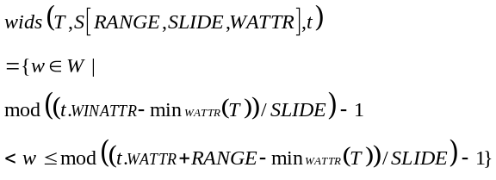
For a non-partitioned landmark-window aggregate query, the wids function is defined as:
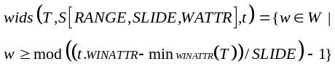
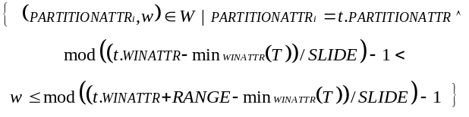
For a partitioned sliding-window aggregate query, the wids function is defined as:

The wids function lays the formal foundation to process each tuple as it arrives, because wids calculates the window-ids for each input tuple only based on the window specification of the query, and the value of the tuple.
- Explicit Window-Id Approach
In this section, we present our Explicit Window-Id (EWID) approach for evaluating window aggregate queries, and show three advantages of this approach: 1) Unlike the existing approaches, it does not buffer tuples when evaluating sliding-window queries; 2) it separates the logical definition of window extents from the physical data arrival order; 3) it allows most query operators to be “window agnostic”. For the ease of presentation, in this section we assume that input stream tuples arrive in order on the windowing attribute. In Section 6, we will demonstrate that our EWID approach inherently handles disordered input streams.
4.1 Motivation
The motivation for our EWID approach comes from the observation that a window aggregate query is a grouping aggregate query that groups on the range of the windowing attribute values, and the groups might overlap. For example, the query Q1 groups on each 300-second time period (of the tuples’ timestamp attribute) such as 10:00-10:05, 10:01-10:06, 10:02-10:07 and so forth, and evaluates the query over each group. In our approach, each 300-second time period (group) is a window extent; we identify each window extent with a window-id, and tag the window-ids to each tuple as explicit data attribute. Thus, we can transform a window aggregate query into a grouping aggregate query that uses window-id attribute as an additional grouping attribute.
4.2 Niagara query engine and punctuation
This section provides background on Niagara Query Engine and punctuation.
Our implementation of evaluating window aggregate queries is based on an extended version of Niagara Query Engine. Niagara [13] was initially developed at the University of Wisconsin-Madison as a system for querying XML data on the Internet and is written in Java. Niagara is a push-based (pipelined) query processing model and processes XML data. The extended version of Niagara supports data streams by enhancing the Niagara operators to support punctuation.
Punctuation [23] is a technique for adapting blocking operators and stateful operators to stream query processing. Blocking and stateful operators are problematic for stream query processing. A blocking operator, such as group-by, does not output results until it has processed the entire input; a stateful operator, such as join or duplicate elimination, may require an unbounded amount of state when the input is an unbounded data stream. A punctuation is a message embedded in a data stream that marks the end of a subset of data. Informally, a punctuation indicates that no more tuples having certain attribute value will be seen in the stream. Punctuations have the same schema as tuples in a data stream and are commingled with tuples in the inter-operator streams. In Figure 1 of Section 4.3, t1 is an example of tuples in the bid stream with the schema <item-id, bid-price, auction-site, timestamp> and p1 is a punctuation that matches t1 and indicates that all the bids belonging to window extent 6 and from auction-site and have been sent. Operators modified to handle punctuations are called punctuation-enhanced operators.
4.3 Window query evaluation and bucket operator
In Section 3.4, we formally discussed the mapping from a tuple to a set of window-ids. In this section, we describe the window aggregate query evaluation using our EWID approach in three steps: tagging window-ids to each tuple, computing window aggregation and outputting results. We first introduce our new operator, bucket, to calculate and to tag window-ids to each input tuple. Figure 1 shows a query plan of Q1 using our EWID approach.
As shown in Figure 1, the bucket operator takes the window specification (RANGE, SLIDE, WATTR) of the query as its parameter; and for each input tuple such as t1, it calculates the window-ids for it and appends the range of window-ids as a normal data attribute to the tuple. Appending a range of window-ids to each input tuple requires that the aggregate operator that follows the bucket operator understands range values. Another alternative that effectively appends a range of window-ids to each tuple is to replicate the tuple when it belongs to multiple windows and to append a window-id to each copy of the tuple. But this alternative implementation significantly increases the amount of the input tuples for the aggregate operator, and is thus abandoned.
(item-id, bid-price, auction-site,
timestamp)
(10, $5.00, 3, 12:16:40 PM) t1
(item-id, bid-price, auction-site,
timestamp, window-id)
(10, $5.00, 3, 12:16:40 PM, 6-10) t1
( *, *, 3, *, 6) p1
streamscan
bucket
(range = 5 minutes
slide = 1 minute)
count
(group on window-id
auction-site)

Figure 1: Query plan for Q1
The next step is to compute window aggregate for each window extent. The window-id attribute is added to the aggregate operator as an additional grouping attribute, and each input tuple (with a range of window-ids) is used to update multiple groups. As shown in Figure 1, the count operator groups on two attributes: auction-site and window-id, and it uses t1 to update 5 groups – window 6 to window 10 of auction-site 3. The window aggregate results of each window extent are the results from all the groups contained by that window extent. For Q1, the count results of window 6 are the counts of tuples in window extent 6, and each for a different auction-site.
We use punctuations to notify the aggregate operator to output window results. The bucket operator can generate punctuations based on the knowledge of the input stream’s ordering property. Assuming that the input tuples are ordered on the timestamp attribute, the bucket operator can generate a punctuation for each window extent when the first input tuple that falls out of the window extent arrives. For Q1, assume that tuples from each auction site arrive in order on the timestamp attribute. When the bucket operator receives the first tuple with a timestamp value greater than 10:07 AM from auction site 3, it generates a punctuation, p1 as shown in Figure 1, indicating the end of window extent 6 for auction site 3. Upon receiving punctuation p1, the count operator outputs the result for auction site 3 of window extent 6, and purges the internal data structure (e.g. hash table entry) for maintaining this result.
- The Paned Option
Figure 2: Window Extents Composed of Four Panes Each
In this section, we present an option, called paned option, to improve our EWID approach when evaluating sliding window queries. We provide the performance comparison of the paned option versus the non-paned original EWID option. We also present execution-time cost models for both non-paned option and paned option.
5.1 Implementation
In this section, we present the paned option, which improves the evaluation of sliding-window aggregate queries. For a sliding-window query, the overlapping consecutive window extents present an opportunity – we can avoid the redundant processing of the tuples in the overlapping part of consecutive window extents.

We divid each window extent into disjoint “panes”. Each window extent is composed of multiple panes, and each pane contributes to multiple windows. For example, if the RANGE of a sliding window query is 24 seconds, and the SLIDE is 6 seconds, each window extent of the query is divided into four 6-second panes, and each pane contributes to four windows. As shown in Figure 2, each window extent, w₁-w₅, is composed of four panes; and the pane, p₅, contributes to four windows, w₂-w₅. In general, given a sliding window query, we divide each window extent into multiple panes, whose size equals to the least common divisor of the RANGE and the SLIDE of the query. For example, if the RANGE of the query is 24 seconds, and the SLIDE of the query is 9 seconds, the pane size is 3 seconds. Then, each window extent is composed of 8 panes, and each pane contributes to at most 3 (= ceiling(8/3)) windows.
To compute the result for a window extent, we compute aggregate results for each pane, and when the last pane contained int the window extent completes, we roll up the results of the panes to get the final window aggregate results. Note that the aggregate operator used to compute the pane results might differ from the roll-up aggregate operator. For example, to evaluate a sliding-window count query with the paneed option, we count the number of tuples for each pane, and sum the count of the panes for each window extent.
The advantage of the paned option is that each input tuple is used to update only one pane, in contrast to the non-paned option, where each tuple is used to update multiple window extents. The disadvantage of the paned option is the operations and the extra output delays that the roll-up step takes to produce the final window-aggregate results. The two main determinants of the execution-cost comparison between the paned option and the non-paned option are the number of panes per window and the number of tuples per pane. Section 5.3 provides a detailed discussion on the analysis of the execution-time costs of the two options.
Note that the paned option resembles the process of constructing larger aggregates from smaller ones when using roll-up and cube operators. As with those techniques, the aggregate operator must be what Gray et al. term algebraic [9], such as MAX, COUNT, AVG, STD-DEV and TOP-N (but not MEDIAN).
With our EWID approach, evaluating sliding window queries with the paned option does not require any new operators. Figure 3 shows the query plan for evaluating Q1 (a sliding-window count query) with the paned option. As shown in Figure 3, the query plan consists of two bucket operators B1 and B2, a count operator C, and a sum operator S. The operators B1 and C compose a tumbling window sub-query, and compute the count for each pane. The bucket operator B1 calculates and tags each input tuple with a pane-id as a normal attribute, based on the pane size and timestamp attribute value of the tuple. Also, assuming that the input stream is ordered on the timestamp attribute, B1 generates punctuations on the pane-id attribute. The count operator C groups on pane-id and auction-site, and outputs the results for the pane upon receiving the punctuation on that pane-id; it also forwards punctuations on pane-id to its parent operator, B2. Tucker et al. have defined punctuation behavior for each query operator [23], which we follow. The operators B2 and S compose a sliding window sub-query, and roll up the pane-count results to derive the window-count results for each window extent. The bucket operator B2 calculates and tags each tuple with a window-id range as a normal data attribute, based on the pane-id attribute value of the tuple, and on the RANGE and SLIDE specified in terms of pane-id values. Also, B2 transforms punctuations on the pane-id attribute into punctuations on the window-id attribute. The sum operator S groups on the window-id and auction-site, maintains the sum of the results of the panes (pane-count) to derive the count for each window extent, and outputs the window-count results for the window extent upon receiving the punctuation on that window-id. Note that for each tuple, the count operator C only process it once; and for each window extent, the sum operator S at most has 5 tuples to process for each auction-site.
(itemss than e system n our pane approach described in Section ther than the pane id? itemi-idtioned queryoned query,s less than e system n our pane approach described in Section ther than the pane id? , bid-price, auction-site, timestamp)
(10, $5.00, 3, 12:16:40 PM) t1
(11, $8.93, 3, 12:17:02 PM) t2artitioned queryoned query,s less than e system n our pane approach described in Section ther than the pane id? artitioned queryoned query,s less than e system n our pane approach described in Section ther than the pane id?
(item-id, bid-price, auction-site,
timestamp, pane-id)
(10, $5.00, 3, 12:16:40 PM, 6) t1
(*, *, 3, *, 6) p1
(11, $8.93, 3, 12:17:02 PM, 7) t2
streamscan
count (*) C
(group on pane-id,
auction-site)

bucket B1
RANGE = 1 min
SLIDE = 1 min
WATTR = timestamp

bucket B2
RANGE = 5
SLIDE = 1
WATTR = pane-id
sum(*) S
(group on window-id,
auction-site)

(auction-site, pane-id, count,
timestamp)
(3, 6, 8, 12:16:40 PM) m0
(auction-site, pane-id, count,
timestamp, window-id)
(3, 6, 8, 12:16:42 PM, 6-10) m0

Figure 3: Window Pane Query Plan for Q1
Figure 4: Cost Ratio of Pane vs. Original Window-Id Approach
5.2 Performance comparision
We conducted experiments to compare the execution-time costs of evaluating window aggregate queries with the paned option and the non-paned option. We calculated the execution-time that each option takes by subtracting the cost of scanning the input stream from the measured time of the query execution. Figure 4 shows the execution-time ratios of evaluating sliding-window max queries with the paned option and the non-paned option when varying the number of panes per window and the number of tuples per pane. For example, we see from the figure that at 20 tuples per pane and 5 panes per window, the paned option only takes about 30% of the execution-time cost of the non-paned option. We can conclude from Figure 4 that the paned option has better execution-time performance than the original non-paned option in most cases.
The paned option can also be used with other window query evaluation approaches that buffer tuples. In such a case, the paned option reduces the amount of required buffer space. By using the paned option, a window aggregate query is divided into two sub-queries. The pane-level sub-query is always a tumbling window query, and tumbling window aggregate queries can be evaluated without buffering. The roll-up level sliding-window sub-query only has a limited number (at the maximum, the number of panes per window for each group) of tuples in each window extent. In most cases, the number of panes per window is much less than the number of tuples per window, and the paned option thus reduces the amount of buffer spaces needed.
  - Execution-time cost models
The experimental results described in Section xxx show that the paned option and the non-paned option favor different queries. We present an execution cost model for each option and use linear regression to estimate the coefficients of the execution-time cost model for each option. Such cost models are useful for a query optimizer to choose between these two options for a given sliding window query, either as a top-level query or a sub-query. To evaluate the cost models, we show the mean square error of each model; in addition, we define a penalty function and use it to evaluate the performance of the models when used by a query optimizer.
Given a window aggregate query, suppose the number of tuples per pane is T, and the number of panes per window is P. We can express the execution-time cost per output tuple of each option using T, P, and the time cost of the basic operations used.
(5.1)
(5.2)
In Equation (5.1), lcd represents the least common divisor of RANGE and SLIDE; other symbols used to represent the time costs of the operations in Equations (5.1) and (5.2) are explained as follows:
ht – time cost of processing each input tuple: hashing the tuple to a hash entry based on its grouping attributes and use the tuple to update the aggregate maintained for that hash entry;

w – time cost of tagging a tuple with a range of window-ids;

pp – time cost of processing a punctuation;
gp – time cost of generating a punctuation;
he – time cost of initializing a hash entry;
ga – time cost of generating an aggregate result tuple.

The Time_{NonPaneCost} function represents the execution-time cost of producing a window result using the non-paned option, which includes the cost of processing each input tuple for multiple window extents, and the overhead of producing a result. The Time_{PaneCost} function represents the execution-time cost of producing a window result using the paned option, which includes the cost of processing each input tuple for a pane, the overhead of generating multiple pane results, and rolling up the pane results to produce a window result.
Note that given the RANGE and the SLIDE of a window aggregate query, the two main parameters T and P are determined. For a tuple-based window query, T equals the least common divisor of the RANGE and the SLIDE, and T*P equals RANGE. For example, if the RANGE is 30 tuples, and the SLIDE is 10 tuples, then T is 10, and P is 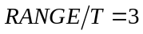; if the RANGE is 30 tuples and the SLIDE is 4 tuples, then T is 2 tuples and P is 15. For a time-based sliding window query, suppose that the input stream arrives at a regular rate r; then 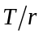 equals the least common divisor of the RANGE and the SLIDE, and 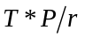 equals the RANGE.
Observing the two Equations (5.1) and (5.2), we see that each equation consists of a varying part, which changes with T and P, and a constant part, which is fixed regardless of T and P. In Equation (5.1), the varying part is 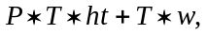 and the constant part is 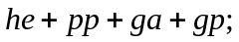 in Equation (5.2), the varying part is 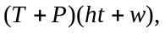and the constant part is 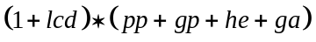. Let a denote ht, b denote w, c denote 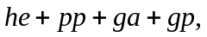 d denote ht + w, and e donate 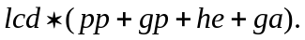 Thus, Equation (5.1) and Equation (5.2) are reduced to Equation (5.3) and Equation (5.4) respectively.
(5.3)
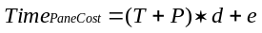 (5.4)
Consider Equation (5.3) and Equation (5.4). Given a query and a input stream, we know T and P; by executing the query with the paned option and non-paned approach, we measure Time_{NonPaneCost} and Time_{PaneCost}. We then use linear regression to estimate the parameters a, b, c, d and e. In Equation (5.3), Time_{NonPaneCost} is the response variable; P*T and T are the predicator variables; similarly, in Equation (5.4), Time_{PaneCost} is the response variable, and (T+P) is the predicator variable.
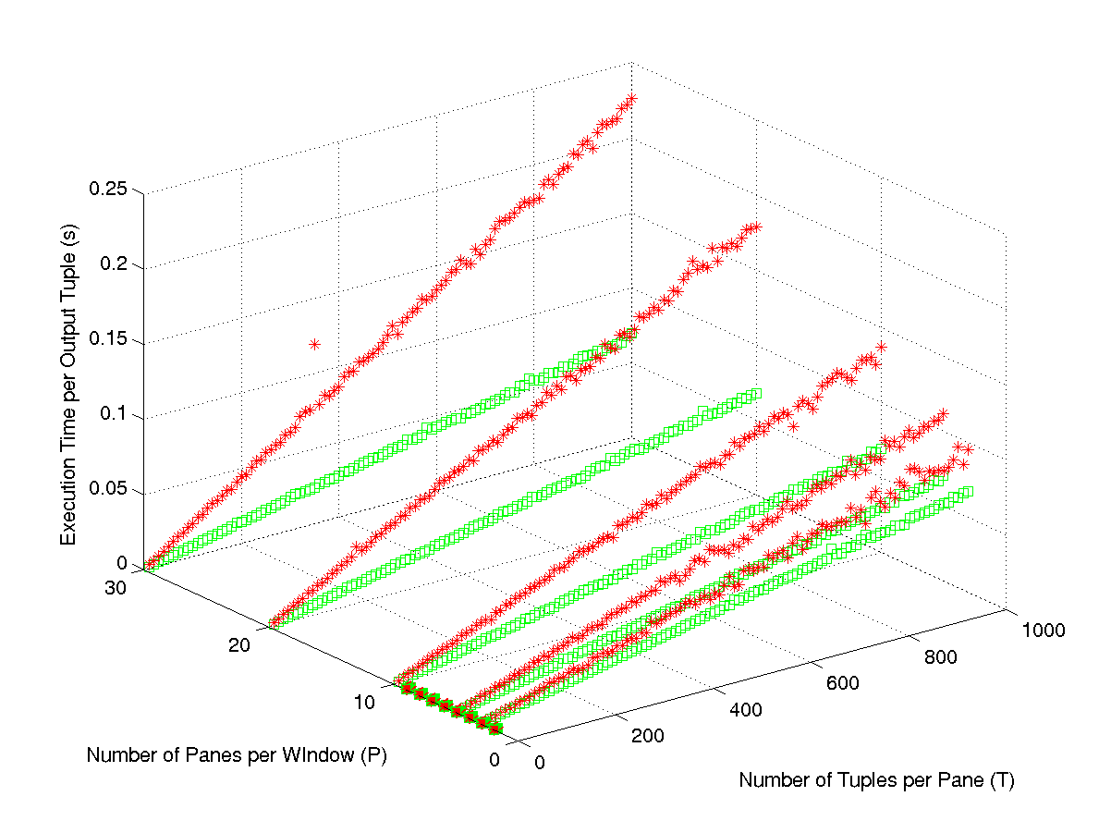
We measured the execution time of 572 window max queries with varied RANGE and SLIDE, with both the non-paned option and the paned option. Figure 5 shows the measured execution time per output tuple of both options for those 572 queries. Each square (green) data point represents the execution time per output tuple using the paned option, where the x-value of the data point denotes the number of tuples per pane and the y-value denotes the number of panes per window. Similarly, each star (red) data point represents the execution time per output tuple of using the non-paned option.
Figure 5: Cost Ratio of Pane vs. Original Window-Id Approach

From Figure 5, for each option, once we fix the value of either variable P or T, the execution time is almost linearly dependant on the other variable. So Equations (5.3) and (5.4) seem to be sufficient to represent the relations between the input variables and the output time cost.
We randomly took 150 samples as the fitting data set to estimate the coefficients of the model for each option, and use the remaining 422 samples as the test data set. By linear regression, we get a = 4.7e-6 s, b =3.21e-5 s and c = 7.907e-4 s for the non-paned option, with the residual = 4.8762e-3; we get d = 2.1804e-4 s and e = 1.5452e-5 s for the paned option, with the residual = 2.1804e-4. Relative to the execution-time cost per output tuple, the residuals for both options are very small. We also used the matrix pseudoinverse method [8], which also achieves the minimum squared error, to estimate those parameters, and the results were similar.
Based on the cost models for the two options, a query optimizer can determine which option to choose for a given sliding window aggregate query. The performance of the optimizer is determined by whether the models predicate the right option, rather than whether each model can estimate the exact execution-time cost; in addition, when the predication is wrong, the distance between estimated cost and the actual cost also affects the performance of the optimizer. Thus, to evaluate the performance of the cost models when used by the query optimizer, we define the penalty function, which intuitively, computes the extra execution-time cost when using the cost models to predicate the low-cost option for the queries in the test data set.
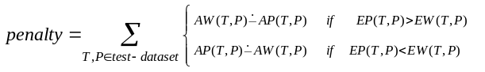 (5.5)
In Definition (5.5), AW and AP represent the query’s measured execution time of using the non-paned option and using the paned option respectively; EW and EP represent the query’s execution time estimated by the cost models of the non-paned option and the paned option respectively. The operator is defined as
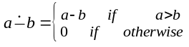 (5.6)
Using the 422 samples from the test data set, we get that penalty = 7.0151 s, where the sum of execution time of those 422 queries when using the query optimizer to choose a low-cost approach is 9.4926e+3 s. Also, we calculated the penalty over the test data set for the case that the query processor always uses the paned option, and the penalty = 857.3901 s, where the sum of execution time of those 422 queries is 1.0343e+4 s; we calculated the penalty over the test data set for the case that the query processor always uses the non-paned option, and the penalty = 4.0659e+4 s, where the sum of execution time of those 422 queries is 5.0145e+4 s.
Although both the performance study discussed in Section xxx and the cost moels show that the paned option outperforms the non-paned option in most cases, we cannot abandon the non-paned option for several reasons. As discussed in Section xxx, the paned option can only be applied to the algebraic aggregate operators. For time-based window queries, when the data arrive rate is so slow that many panes are empty, the non-paned might have better performance; for a special type of sliding window queries – tumbling window – the window approach is more appropriate, because each tuple belongs to only one window.
- Handling Disorder
In this section, we first discuss sources of disordered streams, and then describe using our EWID approach to handle disorder.
  - Sources of disorder
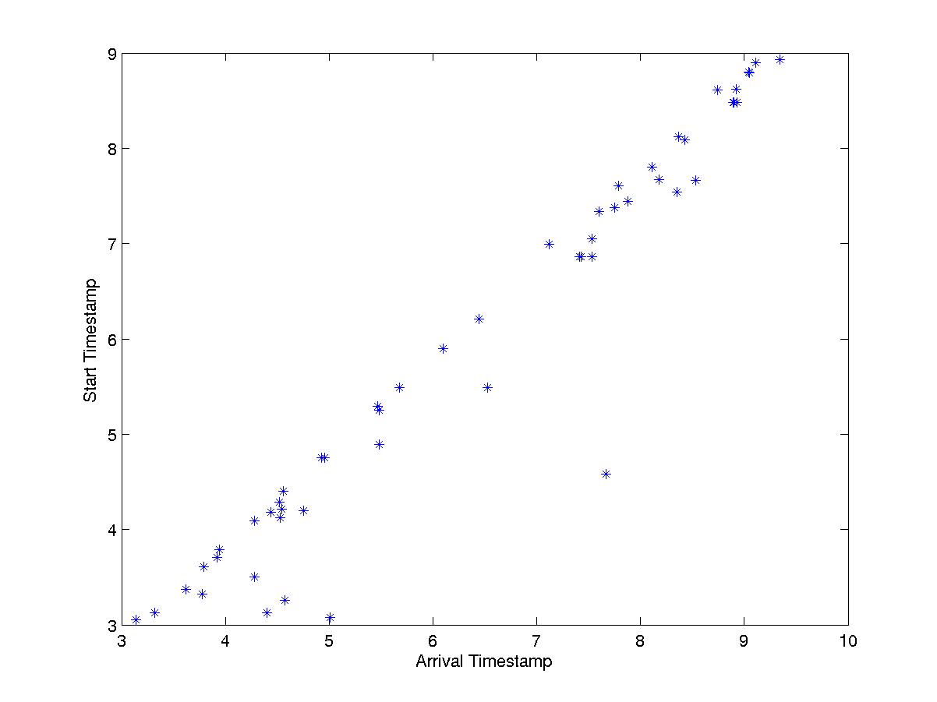
There are various causes of disorder in data streams. Network delays and merging unsynchronized streams are two common ones. Query processing, for example join, can lead to disordered streams [10] In addition, the windowing attribute of a window query can be different from the ordering attribute of the input stream. For example, network flow records have a start time attribute and an end time attribute; records arrive on the end time attribute, while queries over network flow records might define windows on the start time attribute [7] Further, prioritizing data results in disorder. For example, Raman et. Al [15]and Urhan and Franklin [24] present methods for reordering data on the fly to give certain sets of tuples processing priority.
Figure 6: Band Disorder
To better understand the disorder pattern of the stream data occurred in real systems, we obtained network flow data from the Abilene Observatory, a consortium using a high-performance (Internet2) network to study advanced Internet applications [1] and from the Passive Measurement and Analysis project at the San Diego Supercomputer Center [14] These projects record the traces of network data that passes through routers in the Internet and Internet2.
Figure 7: Block-sorted Disorder
A network flow is a connection between a source IP address and port and a destination IP address and port. A flow comprises one or more packets, each of which has a timestamp attribute and a size attribute (among other attributes). Each flow has a start time and an end time, which stand for the min and the max timestamps of the packets in the flow repectively.
Figure 6 and Figure 7 plot disorder patterns from real network flow data. We used a network analysis tool to extract the 8th packet of each network flow from a network trace captured by the PMA project [14] Figure 6 shows the timestamp of the 8th packet versus the start timestamp of the flow. We call the disorder pattern shown in Figure 6 band disorder. The relationship between 8th-packet arrival time and flow-start time is near linear. However, network delays and packet retransmission result in a “band” of disorder. Figure 7 shows a scatter plot of the stream of all netflow records emitted by a router in the Abilene Network [1]. The x-axis is the position of the netflow record in the stream, and the y-axis is the start time of the flow. The graph shows an ascending set of disjoint blocks, with data points scattered apparently at random in each block. We call this disorder pattern block-sorted-disorder. The reason for the surprising shape of this graph is that each minute the router outputs all its buffered netflow records; it then purges its cache of netflow records and starts over. Thus, each block in the figure represents netflows within that block of time. (The order within a block may be related to a router hash table.) Note that if a flow is over one minute (one block) long, it is represented as two separate netflow records in two blocks.
  - Using Explict Window-Id approach to handle disorder
To handle disordered streams, some approaches use buffering to sort out-of-order tuples back in order. For example, Aurora [2] uses B-sort operator to handle bounded disorder in the streams. Hammad et al. [10] buffer join result tuples when using SWF and MST shared multi-window join algorithms, in order to deliver the result tuples to each destination in the same order as each shared query is evaluated independently.
In order to sort out-of-order tuples back in order, one needs to decide the scope of tuples to be buffered. This decision may be based on the information such as: 1) the a priori information on the ordering property of the input stream; for example, no tuple will be more than n tuples or m minutes out-of-order; 2) arbitrary assumptions on the data arrival order; for example, tuples that are more than m minutes late are dropped ; or 3) some kind of message on the ordering semantics of the stream; for example, all tuples with timestamp values less than t have arrived.
In our EWID approach, each tuple is processed (possibly out-of-order) as it arrives. As we showed in Section 3, using our approach, the position of a tuple in the stream does not affect the processing of the tuple, because window-ids encapsulate the window semantics and are assigned only based on the tuple and the window specification of the query; the difference between processing ordered streams and disordered streams lies in knowing when to release a window extent.
We described in Section 4 that the bucket operator generates punctuations to notify the end of window extents for ordered streams. For disordered streams, based on the information such as a priori knowledge on the data arrival order, approximate ordering assumption and external message on the data arrival order, the bucket operator can generate punctuations for disordered streams.
It is also possible that data stream sources can produce and insert punctuations to the streaming data. Punctuations generated by data streams are called external punctuations; punctuations generated by query operators are called internal punctuations. Our EWID approach can use both internal and external punctuations.
  - Slack
Aurora uses the approximate order assumption to handle disorder, and calls it slack [2]. In Aurora, the Bsort operator implements slack. We can also implement slack by internal punctuations. In this section, we discuss three different types of slack. We will show, in the performance study section, the latency-accuracy tradeoffs of handling disorder using external punctuations and using slack.
We found multiple definitions of slack in the literature. In concept, slack mechanism handles disorder by fixed delay for which a system or operator waited for out-of-order tuples and drops any tuples late than the delay. This delay could be in terms of time or number of tuples. For example, one could set a slack of one minute. In this case, the aggregate operator (or the system) waits one minute past the end of the window extent for any out-of-order tuples to arrive for that extent. The end of the window extent is defined as the first arrival of a tuple with a timestamp beyond that extent’s time range. We refer to this variety of slack as generous slack. Compared to other definitions of slack, it rejects the fewest disordered tuples. Note that with generous slack, when a tuple belongs to multiple window extents, it might be dropped for some window extents and accepted for others.
A second Aurora paper [4] formalizes slack and defines it in terms of a sort with a fixed-size buffer. When a tuple arrives it is inserted into the buffer and the tuple with the lowest sort value is outputted. This definition of slack, which we call strict slack, rejects significantly more disordered tuples than generous slack: A tuple may be dropped even when an extent it belongs to is still open. Finally, we have also considered an approach between these two extremes that we call consistent slack. Consistent slack resembles generous slack, except that if a tuple is dropped from one window extent, it is dropped from all window extents to which it belongs. Note that all forms of slack can cause inaccurate results relative to processing the full stream.
- Performance Study
We tested the effectiveness and efficiency of EWID approach by conducting experiments using different types of disorder, sources of punctuation, kinds of aggregation and window sizes. We compared the latency and the accuracy of using our approach over disordered streams in the presence of external punctuations versus internal punctuations. We compared the latency, accuracy and slack tradeoffs of using our EWID approach for two different types of disordered input streams. Our experiments were conducted on an Intel® Pentium® 4 2.40 MHz machine, running linux 7.3, with 512MB main memory. The data size for the experiments was approximately 15.2MB.
  - Data generation
In this section, we describe the generation of the two types of disordered data sets used for the experiments. We implemented a data generator to generate bid tuples with increasing timestamps; then we pre-processed the data and mapped the band-disorder (Figure 6) or block-sorted-disorder (Figure 7) distribution onto it.
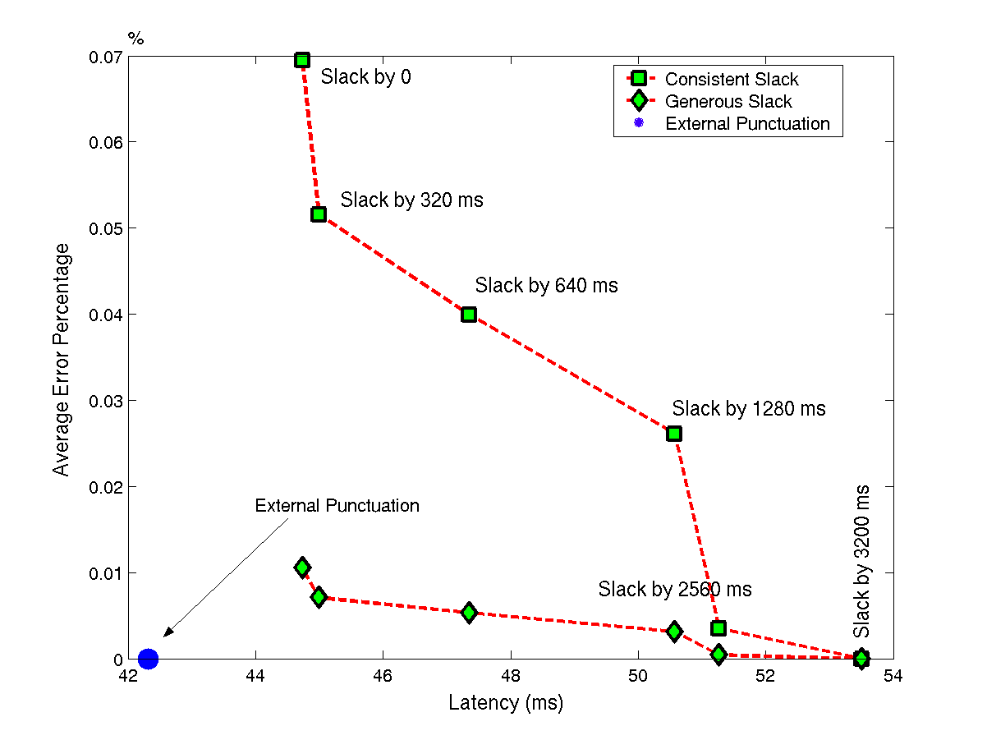
We pre-processed the ordered data set to simulate band-disorder distribution and block-sorted-disorder distribution. To simulate the band-disorder distribution, we first got ten short band-disorder data sequences by applying the network analysis tool [14] over TCP header traces; to get a large data sequence, we concatenated randomly-chosen copies of those ten sequences. To simulate the block-sorted-disorder distribution, we took a set of bids and divided them into segments of equal length on the timestamp attribute, and then randomized the positions of tuples in each segment. For experiments that need external punctuations, we pre-processed the disordered data to insert punctuations.
Figure 8: Latency vs. Accuracy Band-Disorder
(average error percentage)
  - Performance results
In this section, we report three different experiments. The experiments used the variations of the following sliding window query, Q5, and varied the parameters according to Table 1. Note that in Table 1, AggFcn stands for Aggregate Function, R for RANGE, and S for SLIDE.
Q5: SELECT auction-site, AggFcn(*)
FROM Bid [RANGE R seconds
SLIDE S seconds
WATTR timestamp]
GROUP BY auction-site
Table 1: Experimental Parameters
 | Agg  Fcn | Dis-order | Slack Size | Slack Approach | R | S
1 | avg | band | varies | consistent  generous | 64 s | 6.4 s
2 | avg  cnt  max | band | 0.32 s | consistent | 600 s  320 s  192 s  64 s | 60 s  32 s  19.2 s  6.4 s
3 | cnt | block-sorted | varies | consistent | 600 s | 60 s
Latency-accuracy tradeoffs for band-disorder: For experiment 1, we used the band-disorder data set and measured the latency-accuracy tradeoff of using
external punctuation, consistent slack, and generous slack, respectively. We used both average error percentage and percentage of incorrect answers as the error metrics. For consistent and generous slack, we vary the amount of slack from 0.32 second through 3.2 seconds and we used RANGE = 64 seconds, and SLIDE = 64 seconds.
The results of experiment 1 as shown in Figure 8 illustrate that as slack increases, error decreases and latency increases, as expected. It also shows that external punctuation has better latency and accuracy than either slack mechanism. In addition, generous slack has significantly better accuracy at comparable latency when compared to consistent slack.
Latency-accuracy tradeoffs for block-sorted-disorder: Experiment 2 is similar to Experiment 1, except that we used block-sorted disorder, with block duration 490 seconds. We varied the amount of slack from 0 to 600 seconds and used RANGE = 600 seconds and SLIDE = 60 seconds. In contrast to Experiment 1, where error decreases and accuracy increases as slack increases, for block-sorted disorder there is no linear relationship between slack
and latency, as shown in Figure 9 and 10. Figure 9 and Figure 10 use the average error percentage and percentage of wrong answers as the error matrices, respectively. For the block-sorted-disorder data set there is one slack that has the best latency, at the optimal accuracy, as shown in Figure 10, which is determined by the relationship between block size and window size. In our experiment, the optimal slack is 491 seconds. When slack is less than optimal, latency is essentially independent of slack. (The slight leftward bow seen in Figure 9 is due to complex interactions between block size and exact window extent.) As slack increases above the optimal, latency jumps dramatically. In this case, it would be difficult to use slack to tune the latency and accuracy of the query as one might hope to do.
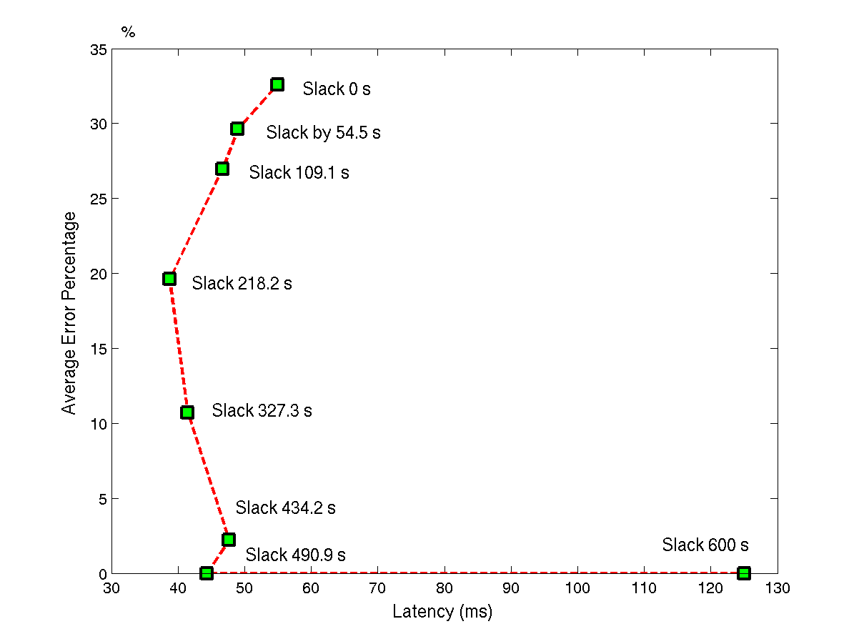
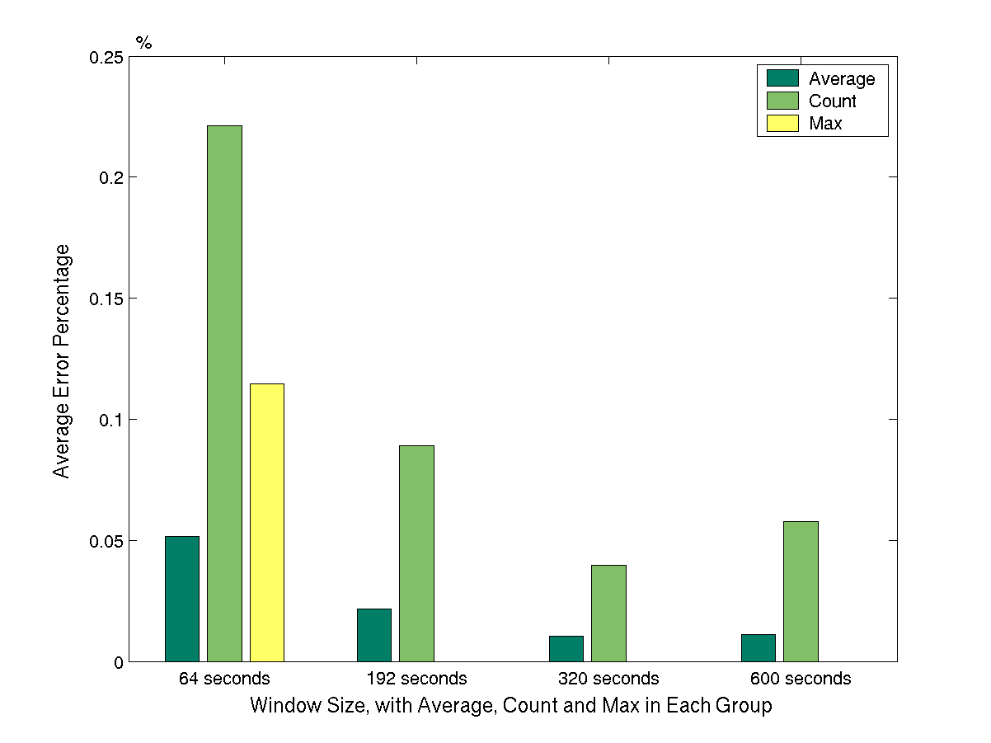
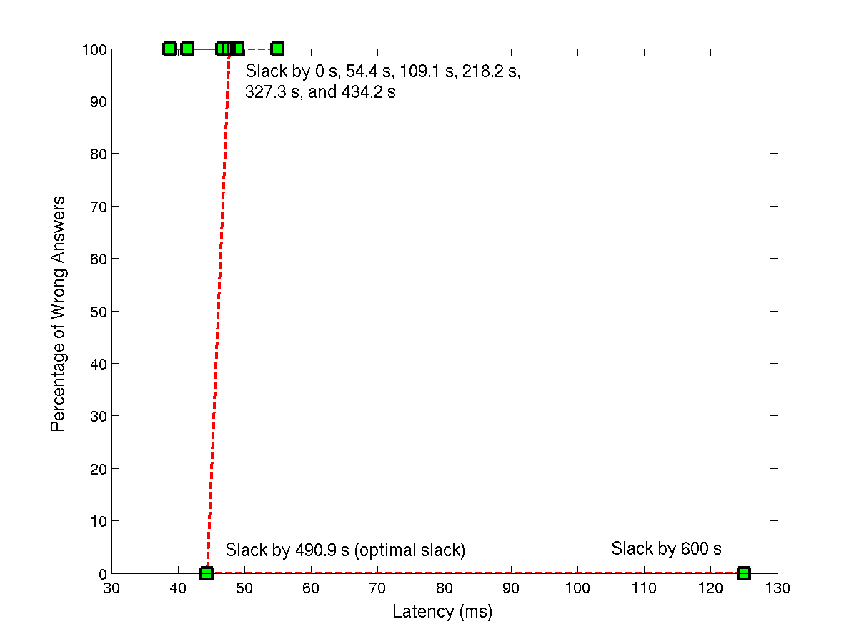
Window size and accuracy: In experiment 3, we measured the accuracy of average, count and max aggregate queries for consistent slack with a fixed slack amount when varying window sizes. The input data was the band-disorder data set. Figure 11 shows that, in general, the average error percentage decreases as the window size increases, because bigger windows can absorb more disorder. Consistent slack allows disorder within a window extent; therefore the larger the window the more disorder allowed – only disorder occurring at the “edge” of the windows causes tuples to be dropped. We note that sensitivity to window size depends on the aggregate function. Of the three aggregates, count is the most sensitive to window size, for a fixed slack. Average is somewhat sensitive to window size, while max is relatively insensitive to window size.
Figure 9: Latency vs. Accuracy Block-Sorted-Disorder
(average error percentage)
Figure 11: Accuracy by Window Size – with Fixed Slack
Figure 10: Latency vs. Accuracy Block-Sorted-Disorder
(percentage of wrong answers)
- Related Work
There are several research projects that study issues in processing data streams, including STREAM [19], Aurora [2][1], TelegraphCQ [6], Tribeca [20] and Gigascope [7]. Among them, Tribeca and Gigascope are stream processing systems supporting network traffic monitoring and analysis applications; STREAM, TelegraphCQ and Aurora are more or less general-purpose stream data management systems. STREAM is a stream processing project that focuses on the understanding of the memory requirements of executing queries over streams, and the semantics and language of queries over a combined input of streams and updatable (time-varying) relations. TelegraphCQ is a system that focuses on the support for shared, adaptive continuous query processing over streams; it extends the adaptive query processing techniques studied in Telegraph project [21] and is built on the ideas developed by the two initial approaches of continuous adaptive query processing engines, CACQ [12] and PSoup [5]. Aurora is a system that manages data streams for monitoring applications and focuses on the support for Quality-of-Service specification for individual queries.
Most existing approaches buffer tuples to materialize each window extent, and continuously evaluate the query over the materialized window extents. For example, STREAM buffers tuples to materialize each window extent as an updating relation, and continuously evaluates the query over the relation. In the initial implementation of STREAM [19], all tuples are assumed to arrive in order, and the STREAM system timestamps each tuple according to a central system clock. When evaluating window queries, the global clock generates periodic “heartbeats” that tell when no further stream elements will occur with a timestamp lower than the heartbeat value. Later on, Srivastava and Widom [18] study the generation of heartbeats based on parameters such as maximum latency, inter-stream disorder and network latency. The out-of-order streams are reordered by buffering and waiting for heartbeats.
In Aurora [2], a stream is an append-only sequence of tuples, and each tuple in a stream has a timestamp that specifies its time of origin. Order-sensitive operators in Aurora, such as Aggregae, assume that tuples arrive in bounded order (the amount of disorder is within a user-specified bounded value) on their timestamps. To deal with disordered streams, Aurora proposes slack, a concept of setting a fixed delay for which a system or operator will wait for out of order tuples. Aurora defines an approximate sort operator, BSort, which uses a fixed-length buffer to sort out-of-order input, given the amount of the disorder specified in terms of number of tuples. A window aggregate query operator over a disordered stream can be transformed into a window aggregate query operator over an ordered stream following by a BSort operator.
Tribeca processes live traffic from a network or recorded traces of network packets. Each trace is ordered on the arrival timestamp attribute of traffic data. Window queries are defined on the timestamp attribute, or on tuple sequence number. Tribeca supports two kinds of window queries, time-based tumbling window queries and tuple-based sliding window queries. Based on the ordering assumption, a circular buffer is used to evaluate sliding window queries, and the buffer size is bounded; tumbling window queries are evaluated without buffering. Tribeca does not support time-based sliding windows.
In Gigascope [7], a stream tuple can have more than one timestamp attributes, each representing a different notion of time, such as the start timestamp and end timestamp of a network flow record. Timestamp attributes of a stream have different ordering properties, such as strictly increasing, increasing in group and banded increasing. For example, a router in a network outputs a stream of netflow records; each record corresponds to a collection of network packets that passed through the router and has a start timestamp and an end timestamp. In Gigascope, the stream of netflow records is sorted on the end timestamp attribute; if all netflow records are dumped every 30 seconds, the stream is banded-increasing within 30 seconds. Gigascope uses both the ordering properties of input streams and the ordering update tokens, which are similar to punctuations, to unblock the blocking operators. Gigascope does not explicitly support window operators; instead, windowed aggregates are expressed as aggregate operators with the requirement of at least one “ordered” or “band-ordered” grouping attribute; Gigascope supports time-based tumbling window queries and tuple-based sliding window queries.
Window queries can also be defined over sequence or temporal data. However, query evaluation mechanisms for sequence and temporal data [16][18] cannot be directly applied to window queries on streams. Streams require one-pass algorithms, but this requirement is only a desirable property for sequence and temporal data. Sequence and temporal data is usually stored on disk, so it can be accessed and processed exactly in the desired order, and sequence and temporal queries do not have to consider the completion of window extents.
- Conclusions and Future Work
In conclusion, this paper present our recent work on window query processing as follows:
- A definition of window aggregate query semantics based on window-ids, which is independent of the physical data arrival order and the query processor implementation.

- The Explicit Window-Id approach for evaluating window aggregate queries based on the window-id concept, which processes the tuples as they arrives without buffering for both ordered streams and disordered streams.

- In implementation, based on explicit window-ids and punctuations, we made minimum change to the current system to support evaluating window aggregate queries.

- The option for our Explicit Window-Id approach, called paned option, which improves the execution-time of the original non-paned option; we provide execution-time comparison of paned and non-paned option, and execution-time cost models for each option.

- Our experimental study of the latency-accuracy tradeoffs of window aggregate evaluation in the presence of different types of disorder, aggregate, window size and amount of slack.

There are a few directions we plan to work on in the future:
- Other window query operators, such as window-join, window-distinct and window-set operators.

- More window query semantics, such as window queries whose RANGE and SLIDE are defined on different attributes.

- Shared execution of multiple window queries.

Reference:

- The Abilene Observatory. http://abilene.internet2.edu/observatory.
- Daniel J. Abadi, Don Carney, Ugur Cetintemel, Mitch Cherniack, Christian Convey, Samgdpm Lee, Michael Stonebraker, Nesime Tatbul, Stan Zdonik. Aurora: a new model and architecture for data stream management. VLDB Journal (12)2: 120-139, August 2003.
- Arvind Arasu, Shivnath Babu, and Jennifer Widom. The CQL Continuous Query Language: Semantic Foundations and Query Execution. Technical Report, October 2003.
- Carney, D., et al. Monitoring Streams – A New Class of Data Management Applications. In Proceedings of the 28th International Conference on Very Large Databases (VLDB 2002) (August 2002, Hong Kong, China).
- Sirish Chandrasekaran, Michael J. Franklin. PSoup: a system for streaming queries over streaming data. VLDB Journal (12)2: 140-156, August 2003.
- Sirish Chandrasekaran, Owen Cooper, Amol Deshpande, Michael J. Franklin, Joseph M. Hellerstein, Wei Hong, Sailesh Krishnamurthy, Samuel Madden, Vijayshankar Raman, Fred Reiss, Mehul A. Shah. TelegraphCQ: Continuous Dataflow Processing for an Uncertain World. In Proceedings of the 2003 Conference on Innovative Data Systems Research, January 2003.
- Chuck Cranor, Theodore Johnson, and Olive Spatashek. Gigascope: A Stream Database for Network Applications. In Proceedings of the 2003 ACM SIGMOD International Conference on the Management of Data, June 2003.
- Richard O. Duda, Peter E. Hart, David G. Stork. Pattern Classification. Second edition. A Wiley-Interscience Publication. Pages 239-242, 2001.
- J. Gray, S. Chaudhuri, A. Bosworth, A. Layman, D. Reichart, M. Venkatrao, F. Pellow, H. Pirahesh. Data Cube: A Relational Aggregation Operator generalizing Group-by, Cross-Tab, and Sub Totals. Data Mining and Knowledge Discovery 1(1), 1997, 29-53.
- M. Hammad, M. Franklin, W. Aref, and A. Elmagarmid. Scheduling for shared window joins over data streams. In Proceedings of the 29th International Conference on Very Large Databases (VLDB 2003) (September 2003, Berlin, Germany).
- H. V. Jagadish, I. S. Mumick, and A. Silberschatz. View Maintenance issues for the chronicle data model. In Proceeding of the 14th ACM SIGACT-SIGMOD-SIGART Symposium on Principles of Database Systems, Pages 113-124, May 1995.
- Samuel Madden, Mehul Shah, Joseph M. Hellersteinkk, and Vijayshankar Raman. Continuously adaptive continuous queries over streams. In Proceedings of the 2002 ACM SIGMOD International Conference on Management of Data, June 2002.
- Jeffrey Naughton, David DeWitt, David Maier et al. The Niagara Internet Query System. http://www.cs.wisc.edu/niagara.
- Passive Measurement and Analysis project. San Diego Supercomputer Center. http://pma.nlanr.net/PMA.
- V. Raman, B. Raman, J. M. Hellerstein. Online Dynamic Reordering for Interactive Data Processing. In Proceedings of the 25th International Conference on Very Large Databases (VLDB 1999) (September 1999, Edinburgh, Scotland, UK).
- A. Segev, A. Shoshani. Logical Modeling of Temporal Data. In Proceedings of the ACM SIGMOD 1987 Annual Conference (SIGMOD ’87) (San Francisco, CA May 1987).
- P. Seshadri, M. Livny, R. Ramakrishnan, R., The Design and Implementation of a Sequence Database System. In Proceedings of the 22nd International Conference on Very Large Databases (VLDB ‘96) (September 1996, Mumbai, India).
- Utkarsh Srivastava and Jennifer Widom. Flexible Time Management in Data Stream Systems. Technical Report, July 2003
- The STREAM Group. STREAM: The Stanford STREAM Data Manager. IEEE Data Engineering Bulletin, 26(1), March 2003.
- Mark Sullivan and Andrew Heybey. Tribeca: A system for managing large databases of network traffic. Proceedings of the USENIX Annul Technical Conference, June 1998.
- M. Shah, S. Madden, M. Franklin, and J. Hellerstein. Java Support for Data-Intensive Systems: Experiences Building the Telegraph Dataflow System. ACM SIGMOD Record, 30(4), December, 2001
- Douglas Terry, David Goldberg, David Nichols, and Brian Oki. Continuous queries over append-only databases. In Proceedings of the 1992 ACM SIGMOD International Conference on Management of Data, pages 321-330, June 1992.
- Peter A. Tucker, David Maier, Tim Sheard and Leonidas Fegaras. Exploiting Punctuation Semantics in Continuous Data Streams. Transactions on Knowledge and Data Engineering, 15(3):555-568, May 2003.
- T. Urhan and M. J. Franklin. Dynamic Pipeline Scheduling for Improving Interactive Query Performance. In Proceedings of 27th International Conference on Very Large Data Bases (VLDB 2001) (September 2001, Roma, Italy).

