The Hybrid Technique for Reference Materialization in Object Query Processing
Quan Wang¹ David Maier¹ Leonard Shapiro²
¹Oregon Graduate Institute of Science and Technology
²Portland State University
{quan, maier}@cse.ogi.edu¹ len@cs.pdx.edu²

Abstract
Resolving object references, or reference materialization, is a fundamental operation in object query evaluation. Existing reference materialization techniques fall into two categories: pointer-based and value-based. We identify several drawbacks of existing techniques, and propose a hybrid technique that combines the advantages of each category. This technique relaxes the limitations of value-based techniques, while preserving much of their performance advantage over pointer-based techniques; it performs well in the cases when no existing algorithm is applicable or efficient. The hybrid technique shows even stronger performance advantages when moving from single-valued to collection-valued attributes. We present algebraic transformations to enable the hybrid technique in the rule-based query optimizer. Initial experimental results using a commercial object-oriented database show that the hybrid approach achieves significant speedup over current algorithms in many cases.
The initial motivation for our work was optimization and evaluation of object-oriented query languages, particularly OQL [ODMG]. However, the key features we have concentrated on, references and collection-valued attributes, are present in object-relational products and the SQL:1999 proposal [EM99].

1. Introduction
In algebraic query optimization, a logical expression (or simply expression) is an algebraic tree consisting of logical operators, such as select and join. A rule-based optimizer accepts an expression as input, then transforms it into its equivalent expressions using transformation rules. Physical expressions are obtained by implementing the logical operators in an expression using specific algorithms, such as merge join or hash join. The goal of optimization is to pick the most efficient algorithms among all the physical expressions implementing expressions equivalent to the original query.
Most object and object-relational models include the notion of reference attributes, also called object-valued attributes. Thus, resolving referenced objects, or reference materialization, becomes an essential operation in object query evaluation. The reference to an object is also called object identifier or OID. In reference materialization, one object, containing an OID to a second object, is brought together in memory with that referenced object. In the remainder of this paper, we will generally shorten “reference materialization” to simply “materialization”.
Relational algebra, being value-based, does not have an operator for resolving OIDs. To explicitly indicate the resolution of inter-object references in logical expressions, the Open OODB query optimizer [BMG93] introduced the materialize operator. One way to view the materialize operator is that it brings referenced objects into scope, so that succeeding operators can access them. Figure 1 (1) is an expression that consists of a materialize (M) operator for attribute r.a , where r ranges over the output of expression R. The result of this expression can be regarded as pairs of objects <r, a>, where a is the object whose OID is r.a.
Existing reference materialization techniques are either pointer-based or value-based. The pointer-based technique retrieves referenced objects by converting OIDs (if necessary) to disk addresses and retrieving the appropriate pages. Pointer-based techniques directly implement the materialize operator using pointer-based physical algorithms such as assembly [KMG91], pointer-based hash, pointer-based nested-loops, pointer-based sort-merge [SC90], and partition-merge [BCK98]. Among these algorithms, sort-merge and hybrid-hash are popular and competitive [SC90]. The hybrid-hash algorithm would perform the logical materialize operator in Figure 1(1) as follows. First, r objects from R are partitioned using the OIDs of their r.a instances. Then, the objects in each partition are iterated, while the PIDs of r.a instances are looked up in the object table. The purpose of the first partitioning is to avoid random accesses to the object table, thereby reducing I/O cost if the entire table won’t fit in memory. Third, the objects from R are partitioned again using the PIDs of r.a instances. Finally, the objects in each of these partitions are iterated, using the PIDs to locate and fetch the r.a instances themselves. Notice that the first partitioning can be dispensed with if the OIDs are physical to begin with, or can be used to directly compute physical addresses. By default, a logical materialize operator is implemented using pointer-based operator; thus we use the term pointer-based expression to refer to an expression that contains materialize operators, for instance, Figure 1 (1).

Figure 1. Alternative materialization techniques and rules to derive them: (1) the pointer-based expression (2) the value-based expression (3) the hybrid expression.
R
M_{a}
A
r
⋈ ^{r.a=a}
a

The join
materialization rule

M_{r.a}
R
r
(2)

The hybrid rule
r
r
⋈ ^{r.a=a}
M_{a}
π^{r.a}
R
R
a

(1)

(3)

The value-based technique attempts to avoid “pointer chasing” on disk by instead performing joins between objects with references and the objects being referenced (using an OID as an implicit attribute) [BMG93]. Thus, whereas pointer-based techniques treat OIDs as physical pointers, valued-based techniques regard OIDs as just another kind of logical value, allowing the application of conventional join-processing technology to object query evaluation. We use the term value-based expression to refer to an expression that uses the value-based technique. Figure 1 (2) is a value-based expression that resolves r.a using the value-based technique. Here A is the extent for the type of r.a. The extent of a type is the collection that contains the OIDs for all the instances of the type. In Figure 1 (1), M_{a} brings A elements into memory in a pointer-based fashion; then the fetched A elements are joined with R on the OIDs of A elements. While materialize can be implemented by a single physical algorithm, value-based expressions require the combination of several operators to materialize references. Nevertheless, we will sometimes loosely refer to part of an evaluation plan that performs materialization as a value-based algorithm, even when it comprises several operators.
In a transformation-based optimizer, the join-materialization rule [BMG93] transforms a materialize, Figure 1 (1), into a value-based expression, Figure 1 (2).
Value-based techniques have many advantages. First, if the extent collection is appropriately ordered, these techniques sequentially fetch referenced objects, thus avoiding the effort in reordering object accesses that a pointer-based algorithm usually has to perform. Second, restrictive operations on referenced objects, such as selections, can be evaluated earlier in a value-based expression than in a pointer-based expression. Third, if the attribute to be materialized is shared, then operations on referenced objects are performed once for each object in a value-based expression, but multiple times in a pointer-based expression. Fourth, the value-based technique converts materialization into join, enabling the application of the conventional join re-ordering techniques to object query optimization. Fifth, the join predicate in a value-based algorithm only compares OIDs, thus the object table may be visited less frequently than in with a pointer-based algorithm. (Note that object table access is not totally avoided, as we assume the extent is a collection of OIDs that must be converted to PIDs. However, each OID is converted just once.)
However, value-based techniques have their shortcomings. First, they require the presence of appropriate extents. Most object-oriented database systems do not automatically maintain extents, and even in some object-relational systems, they are optional. (While SQL: 1999 requires REF columns to be scoped to a single table, object-relational products aren’t as restrictive.) Second, if an extent is sparse, i.e., few objects in the extent actually participate in the query, a value-based algorithm may be inefficient because of all the inapplicable objects in that join operand. In contrast, pointer-based techniques are not constrained by extents, and apply in any circumstance. Also they carry out materialization with a single operator, thus simplifying query optimization.
Besides these limitations, the behavior of the existing techniques for collection-valued attributes (CVAs) has not been studied thoroughly. Since the presence of CVAs is an important feature in object or object-relational data models, it is necessary to evaluate the existing techniques for CVAs.
In this paper, we address limitations of the existing materialization techniques. Section 2, present the hybrid technique that relaxes the drawbacks of the value-based technique, while preserving much of their performance advantage over the pointer-based technique. We present algebraic transformations to enable the hybrid technique in the rule-based query optimizer. Section 3 applies the hybrid technique to CVAs. In Section 4, initial experimental results using a commercial object-oriented database show that the hybrid approach achieves significant speedup over current algorithms in many cases when no existing algorithm is applicable or efficient. It shows even stronger performance advantages when moving from single-valued to collection-valued attributes. Section 5 and 8 discuss related work and draw conclusions.

2 The Hybrid Technique
Figure 1 (3) shows an expression equivalent to Figure 1 (1). This expression performs a join between R and the objects referenced by r.a. Within the right join operand, projection gathers all the OIDs of r.a instances, then materialize resolves them in a pointer-based fashion. This produces a collection more tight than the type extent A, in the sense that the collection contains and only contains the objects referenced by r.a. We call such a collection a tight extent. The materialization is accomplished by performing a value-based join between the original expression, R, with the tight extent. We use the term hybrid materialization to refer to the method that fetches the tight extent in the pointer-based fashion, then join the tight extent with the original expression in the value-based fashion. We use the term hybrid expression to refer to an expression using this technique.
The projection in a hybrid expression, π^{r.a} in Figure 1 (3), serves two purposes. First, it separates the object referencing and those being referenced, so that the succeeding materialize (and possibly other operators) processes only the objects being referenced, reducing the amount of data handled by those operators. (Note that this aspect mainly affects any copying an operator may have to do between its inputs and outputs.) Second, more importantly, the projection eliminates duplicate OIDs, thus minimizing the input cardinality to the successive operators. Figure 2 (3) illustrates the data flow for the hybrid expression, Figure 1 (3).
It might seem that the hybrid technique does all the work of both the pointer- and value-based techniques, as it is both dereferencing pointers and performing a join. However, in general, it is chasing fewer pointers than pointer-based methods and computing a smaller join than value-based methods. The hybrid technique does not always win out over the others, but our experimental results will show that in some instances it is much better than the other two. Also, the hybrid technique does introduce a repeated sub-expression, which we will discuss later.
Both hybrid and value-based techniques perform a join, however, they differ in join operands. Hybrid algorithms access referenced objects not through their extent, but through the tight extent, a collection of OIDs gathered on the fly. Therefore, the hybrid technique is not limited by availability of type extents. Also it is more efficient if an existing extent is sparse for the query. Figure 2 (2) and (3) illustrate the data flows for the value-based and hybrid expressions in Figure 1. Since extent A contains objects, such as a₃, that are not referenced by any object in R, the value-based expression will have a larger right join operand, thus a higher join cost than the hybrid expression.
The hybrid technique inherits some advantages over the pointer-based technique from the value-based technique. First, it allows restrictive operations on referenced objects to be performed earlier. For instance, if a query has the predicate a.x=4, a selection can be pushed down to restrict the right join operand. Second, when the attribute to be materialized is shared, any operation on the referenced objects is performed once for each instance in a hybrid algorithm, but multiple times in a pointer-based algorithm. In Figure 3 (1), a₁ is mentioned by two r objects. As a result, a₁ has to be resolved twice. In contrast, in Figure 3 (3), duplicate OIDs are eliminated, thus no redundant data is delivered to materialize. Third, in a pointer-based expression, for instance, Figure 1 (1), materialize accepts parent attributes as input, while only the OIDs of attribute instances are actually needed. In a hybrid expression, for instance, Figure 1 (3), materialize only accepts the OIDs, thus substantially shrinks the width of input data. As some physical algorithms for materialize move input data between disk and memory, reducing the amount of input data size may lower I/O costs. Figure 3 (1) and (3) illustrate the difference in input sizes of the two materialize operators. Note that the difference in width is equal to the number of attributes in the objects of R. We will see further benefits of the hybrid approach when we consider materialization of CVAs in Section 3.

r₁:a₁,b₁,c₁; a₁:x₁,y₁
r₂:a₁,b₂,c₂; a₁:x₁,y₁
r₃:a₂,b₃,c₃; a₂:x₂,y₂
r₄:a₂,b₄,c₄; a₂:x₂,y₂

⋈
r₁:a₁,b₁,c₁ a₁:x₁,y₁
r₂:a₁,b₂,c₂ a₂:x₂,y₂
r₃:a₂,b₃,c₃ a₃:x₃,y₃
r₄:a₂,b₄,c₄

r₁:a₁,b₁,c₁; a₁:x₁,y₁
r₂:a₁,b₂,c₂; a₁:x₁,y₁
r₃:a₂,b₃,c₃; a₂:x₂,y₂
r₄:a₂,b₄,c₄; a₂:x₂,y₂

M
r₁:a₁,b₁,c₁
r₂:a₁,b₂,c₂
r₃:a₂,b₃,c₃
r₄:a₂,b₄,c₄

r₁:a₁,b₁,c₁; a₁:x₁,y₁
r₂:a1,b₂,c₂; a₁:x₁,y₁
r₃:a2,b₃,c₃; a₂:x₂,y₂
r₄:a₂,b₄,c₄; a₂:x₂,y₂
⋈
r₁:a₁,b₁,c₁ a₁:x₁,y₁
r₂:a₁,b₂,c₂ a₂:x₂,y₂
r₃:a₂,b₃,c₃
r₄:a₂,b₄,c₄ M
a₁
a₂
π

r₁:a₁,b₁,c₁
r₂:a1,b₂,c₂
r₃:a₂,b₃,c₃
r₄:a₂,b₄,c₃

Figure 2. The data flows of the three expressions in Figure 1: (1) pointer-based (2) value-based (3) hybrid

(1) (2) (3)

While hybrid algorithms often have good costs, they are of little use unless they can be produced during query optimization. Therefore, we developed the hybrid materialization rule, that transforms Figure 1 (1) to Figure 1 (3), to generate hybrid expressions from pointer-based expressions during optimization. Like the join materialization rule, the hybrid rule transforms a materialize into a join, but using the tight extent.
(1) Pointer-based (2) Value-based

(3) Hybrid

Figure 3: Expressions for Query 1

π ^{f}

⋈ f.salary>d.head.salary AND f.dept=d

σ^{f.specialty =’math’} M_{d.head}

M_{f} M_{d}

^{f} ^{d}
Faculty Depts
π^{f}

σ ^{f.salary>f.dept.head.salary}

M_{f.dept.head}

M_{f.dept}

σ^{f.specialty=’math’}

M_{f}
^{f}
Faculty
π ^{f}

⋈ f.salary>d.head.salary AND f.dept=d

σ^{f.specialty=’math} M_{d.head}

M_{f} M_{d}
_{d}
_{f} π^{f.dept}
Faculty
σ^{f.specialty=’math’}
_{f}
M_{f}

Faculty

Query 1: The following query finds all the faculty members who specialize in Mathematics and earn more than their department heads. Here, collection Facutly consists of the objects of the Professor type, which contains attributes specialty, salary, and a reference attribute dept that references Department objects. The Department contains a reference attribute, head, of Professor type.
SELECT f
FROM Faculty AS f
WHERE (f.specialty = ‘math’) AND
(f.salary > f.dept.head.salary) .
Three expressions for Query 1 appear in Figure 4. The pointer-based expression contains three materialize operators that successively fetch Professor, Department, and Professor objects. Note that, besides the reference attributes, the objects in base collection Faculty also need to be materialized (M_{f}), since we assume a collection stores only the OIDs of its elements. In general, such materialization uses pointer-based algorithms. The other two materialize operators, M_{f.dept} and M_{f.dept.head}, each resolves some objects multiple times, due to the sharing of f.dept. Transforming the pointer-based expression using the join materialization rule yields the value-based expression. The hybrid expression, Figure 3 (3), can be generated by applying the hybrid rule to M_{f.dept}, then pushing down the succeeding select and materialize. Obviously, the value-based and hybrid expressions do not have the problem that resolves one object several times. However, the value-based expression is less efficient than the hybrid one when only a few departments have professors specializing in Mathematics, in which case, the effort of materializing most departments is useless work.
The presence of object sharing is an important factor motivating the hybrid approach. Object sharing occurs both directly, because of shared reference attributes, and indirectly, as the result of flattening an overlapping CVA, as demonstrated by the example query below.
Query 2: Let Courses be a collection of course objects and each course object contains a CVA Participants that refers to the collection of students who attend the course. The following query returns all CS courses and their participants:
SELECT STRUCT (c: c, p: p.name)
FROM Courses AS c, c.Participants AS p
WHERE c.dept = ‘CS’.
To evaluate this query, a pointer-based expression first filters Courses, then flattens c.Participants, giving <c, OID(p)> pairs, and finally materializes individual participating students. Note that c.Participants is an overlapping CVA, since several courses may enroll the same student. Therefore the result of flattening c.Participants will contain multiple references to some students. This sharing degrades the performance of the succeeding materialize operator, which will consequently resolve some objects multiple times.
Hybrid expressions do incur certain overheads in evaluation, from the need for projection and join, and the introduction of common sub-expressions. We designed the hybrid rule to explicitly duplicate expressions, rather than storing one to a temp and reusing the result. The reason is that other transformations may convert different occurrences of a common sub-expression by modifying one or both of them. For instance, in the hybrid rule of Figure 2, the projection operator might be pushed down into the underlying expression R, so that it outputs only the needed attributes. Alternatively, operators above the join might be pushed down towards the left occurrence of R. Note that such transformations can make the original common sub-expressions distinct, but may in the process generate new common sub-expressions. Based on the cost of a common sub-expression, an optimizer can choose to store and reuse its result, or evaluate it twice. Therefore the hybrid rule needs to be used in a cost-based framework, so that a hybrid algorithm is chosen only if its benefit dominates its overheads. For simplicity, the remaining paper assumes a hybrid expression represents both possibilities.
The introduction of a repeated sub-expression can also increase the cost of the query optimization process, due to increasing number of operators, and more importantly, possible duplicated effort from optimizing the same sub-expression twice. However, previous work [GM93, CG94] successfully avoided duplicate optimization of common sub-expressions using directed acyclic graphs (DAGs) representation of expressions and memo structure.

3 Materializing Collection-Valued Attributes
The presence of CVAs [SS86] is an important feature in both object and object-relational models. Query optimization techniques developed for single-valued attributes should be evaluated for CVAs. In this section, we explore the ramifications of the three materialization techniques in the context of CVAs. It turns out that, when applied to CVAs, the value-based technique is typically inefficient, while the hybrid technique becomes more competitive.
Materializing a CVA means bringing the elements of the CVA instance into memory. Some algorithms can assembly CVA in its nested form [BCK98]. Most algorithms handle only flat data, in which case references to CVA elements are accepted and resolved [SC90]. The first kind of algorithms is useful when the algebra of an optimizer [SS86] can directly manipulate CVAs without flattening them. More often, an algebra mainly supports relational operators, in which case the second kind of algorithms is more desirable. Therefore, we assume materialize accepts and outputs flat data (tuples of scalar values and OIDs). The example query below illustrates how CVAs are materialized using different techniques.
Query 3: The following query returns pairs of student and course title where the course is among the core requirements for the student. Students is a collection of Student objects. Type Student has CVA s.Core that contains the Course objects required for the student's major. Type Course has an attribute title.
SELECT STRUCT(s:s, c:c.title)
FROM Students AS s, s.Core AS c.

(3) Hybrid (intermediate) (4) Hybrid (final)

Figure 4: Expressions for Query 3
π^{s:s,c:c.title}

M_{c}
_{c}
μ_{s.Core}

M_{s.Core}

M_{s}
_{s}
Students
π ^{s:s,c:c.title}

⋈^{c=c}
_{c}
μ_{s.Core} M_{c}

^{c}
M_{s.Core} Courses

M_{s}
_{s}
Students
π ^{s:s,c:c.title}

M_{c}
_{c}

μ_{s.Core}

⋈ ^{s.Core=C}

M_{s} M _{C}
_{s} _{C}
Students π ^{s.Core}
M_{s}
^{s}
Students
π ^{s:s,c:c.title}
⋈ ^{s.Core=C}

M_{s} M_{c}
_{c}
^{s} μ_{C}
Students
M_{C}
_{C}
π ^{s.Core}

M_{s}
_{s}
Students
(1) Pointer-based (2) Value-based

Figure 4 (1) in is the pointer-based expression for the query. In this expression, M_{s.Core}, fetches the s.Core attributes, the collections of OIDs for Courses objects, then flattens the s.Core attributes using unnest (μ_{s.Core}) [FT83], which outputs pairs of Student objects and Course OIDs. The OIDs are resolved by the succeeding materialize. Figure 4 (2) is the value-based expression, obtained from Expression (1) by applying the join materialization rule to the upper materialize. In this expression, the left join operand provides a stream of Student object-Course OID pairs. The right operand provides a stream of Course objects. The streams are then joined.
Note that it is usually impractical to apply the join materialization rule to materialize on the CVA instances themselves, for example, M_{s.Core}, because the CVA instances (that is, the collections themselves) generally have no appropriate extent. The hybrid rule, however, does make sense for such operators. One can get Expression (3) from Expression (1) by applying this rule to M_{s.Core}. Further, one can get Expression (4) from Expression (3) by pushing down unnest and materialize. Note that, in both hybrid expressions, join predicate is an identity check on CVA instances, rather than on CVA elements as in a value-based expression.
In the context of CVAs, the hybrid technique has two advantages over the value-based approach. First, it applies to any CVA query, while the value-based technique is subject to the availability of appropriate type extents. Second, a hybrid expression in general has a smaller left join operand, because it does not flatten the CVA attributes in the left join operand, while a value-based expression does, as seen in Figure 4 (4) and (2). This difference makes the hybrid technique even more superior to the value-based technique in the context of CVAs.
The hybrid technique is superior to the pointer-based technique when the CVA being materialized is shared, because a hybrid expression eliminates duplicate CVA references using projection, thus reducing input cardinalities to materialize and possibly other operators. (We are assuming here that collections have their own identifiers that can be compared. We are not proposing to detect the case where two distinct collection instances happen to contain the same set of elements.) A pointer-based expression, however, has no such mechanism. Shared CVAs may occur in a database, for instance, s.Core in Query 3 is shared CVA, since many students have the same set of core courses. They may also be present in views, or intermediate query results, especially for queries involving several CVAs, as illustrated by the example query below.
Query 4 : The following query return all professors who advise PhD students. Here, collection Depts contains Department objects. A Department object has a CVA Majors, a set of Student object, and a CVA Faculty, a set of Professor objects.
SELECT DISTINCT f
FROM Depts AS d, d.Majors AS s,
d.Faculty AS f
WHERE s.status = 'Ph.D' AND f.name = s.advisor
Expression (1) in Figure 5 is pointer-based, where two CVAs, d.Majors and d.Faculty, are successively flattened and materialized. Expression (2) is value-based and materializes d.Faculty using a join. Expression (3) is hybrid, derived from Expression (1) by applying the hybrid rule to M_{d.Majors}, and then pushing down the succeeding operators. Expression (1) performs an operation similar to Cartesian product between d.Majors and d.Faculty (creating a tuple for every combination of student and professor in the same department), thus producing large intermediate results. Expression (2) has a larger left join operand than Expression (3). Therefore, Expressions (3) is superior to Expressions (1) and (2).

(3) hybrid

Figure 5: Expressions for Query 4
π^{f}
⋈ ^{s.advisor=f.name AND f=f}
f
μ_{d.Faculty} M_{f}

M_{d.Faculty} Faculty

σ^{s.status=’Ph.D.}

M_{s}
_{s}
μ_{d.Majors}

M_{d.Majors}

M_{d}
_{d}
Depts
π^{f}

⋈ ^{s.advisor=f.name AND d=d}

M_{f} σ ^{s.status=’Ph.D’}
^{f}
μ_{d.} _{Faculty} M_{s}
_{s}
M _{d.Faculty} μ_{S}

M_{d} M_{S}
_{d} _{s}
Depts π ^{d.Majors}

M_{d}
_{d}
Depts

π^{f}

σ^{s.advisor=f.name}

M _{f}
_{f}
μ_{d.Faculty}

M_{d.Faculty}

σ^{s.status=’Ph.D.’}

M_{s}
_{s}
μ_{d.Majors}

M_{d.Majors}

M_{d}
_{d}
Depts

(1) pointer-based (2) value-based

4 Experimental Results
In this section, we present experimental results from implementing the hybrid and enhanced techniques. The experiments were conducted on Intel Pentium II with 256M memory, running Windows NT 4.0 and GemStone/J 3.1, a commercial object-oriented database system [Gem99]. A query evaluator was developed on GemStone for these experiments. The evaluator supports such operators as unnest, pointer-based materialize, join, projection, and select. All the operators, except unnest and select, are implemented using hybrid hash algorithms. The operators are implemented in Java 1.2, the DML of GemStone/J. If not stated otherwise, a hybrid expression evaluates common sub-expressions as many times as they appear.
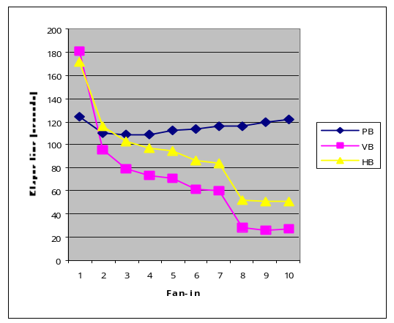
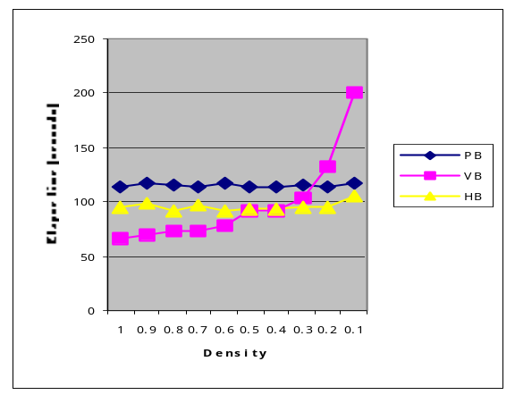
We present the experimental data for some of the queries mentioned in this paper. Our experiments on other queries showed the similar pattern as on these queries. For each query examined, the expressions representing different approaches were executed under various conditions. The varying parameters include sharing situations, extent densities, and (if applicable) CVA.
(2) Varying the density of f.dept

Figure 6: Query 1, elapsed time of the expressions in Figure 3 (PB stands for "pointer-based", VB for "value-based", HB for "hybird")
(1) Varying the fan-in of f.dept.
We measured CPU time, I/O amount, and total elapsed time. In most experiments, I/O and CPU costs were affected in the similar fashion. Therefore, we use elapsed time as our performance criterion in this presentation. The disk page and buffer page sizes in GemStone are 8K. Each OID occupies 8 bytes. We allocate 25 pages for each block operator, such as projection, join and materialize. Typically, the sample data occupied 250 data pages. All the tests cover the cases when the temporary data structures such as hash tables are much larger than the buffers available to the key operators, such as projection, join, and materialize. All the sample data are generated automatically conforming to normal distribution. Objects of the same type are clustered together on disk, but not sorted in any order.
We begin by demonstrating the performance of the three techniques in the setting of single-valued attributes using Query 1. The expressions in Figure 3 are executed when the fan-in or the density of Department objects varies. The Fan-in means the average number of professors in the same department; density is the ratio between the number of departments that have faculty member specializing in Mathematics and the total number of departments. Collection Faculty has cardinality 10240 and occupies 250 disk pages. The type extent of Department contains 1024 to 10240 elements, occupying 25 to 250 disk pages, as the fan-in and density changes.
Figure 6 (1) illustrates the elapsed time of three expressions when the fan-in of f.dept changes from 1 to 11. When the fan-in equals one, the pointer-based expression is the cheapest, while the other two expressions suffer from large join operands. However, once sharing occurs, the curves for the hybrid and value-based expressions drop steadily, while the one for the pointer-based expression remains high. From fan-in 7 to 8, the curves for both value-based and hybrid expressions drop abruptly, because the hash tables for both join operators start to fit in memory as the fan-in reaches 8. Note that in general, the value-based expression is better than the hybrid one, due to the overheads of the projection operator the duplicate common sub-expressions in the latter.

Figure 6 (2) contrasts the three expressions as the density of the type extent of Department decreases from 1.0 to 0.1, with the fan-in fixed at 4. The value-based expression is cheapest when the density is one, but degrades as the density goes down, and finally becomes the most costly.

Varying CVA cardinality

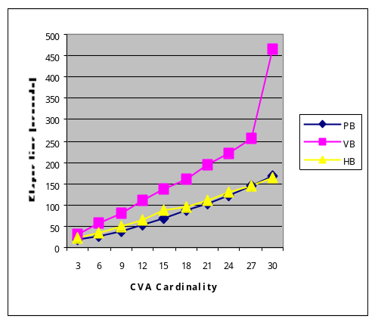
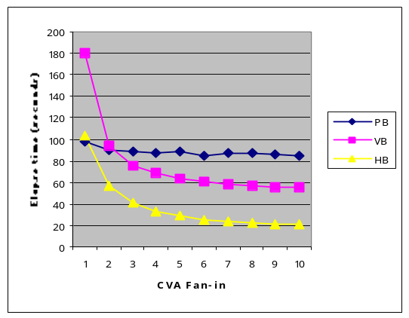
(2) Varying CVA Fan-in

Figure 7: Query 3, elapsed time for the expressions in Figure 4

(1) Varying CVA Cardinality

Figure 7 evaluates the three techniques in the context of CVAs using the expressions for Query 3. The test data consists of a total of 1024 Student objects, with 10 to 30 courses in each s.Core attribute. The total sample data occupies 300 disk pages. Figure 7 (1) shows the elapsed time for the expressions in Figure 5 (1), (2), and (4), as the cardinality of s.Core increases from 10 to 30. The value-based expression degrades rapidly as the CVA cardinality increases, due to the growing join input. This reflects the inherent disadvantage of the value-based technique when applied to CVAs, i.e., the large join input. The pointer-based and hybrid expressions, on the other hand, both perform well and have very close run time. The reason is that the M_{c} operator in Figure 4 (1) and that in Figure 4 (4) have similar I/O costs, while the join in Figure 4 (4) is efficient due to small right join operand.
Figure 7 (2) contrast the three expression as the fan-in of s.Core increases from 1 to 10. The fan-in denotes the average number of students with the same core course requirement. When the fan-in of s.Core instances is one, the hybrid and value-based expressions are more expensive than the pointer-based one. As the fan-in grows, the costs of the two expressions drop quickly. Note that the hybrid expression always outperforms the value-based expression, again because of different join input sizes. Figure 6(1) and Figure 7(2) suggest that value-based technique generally has fewer overheads than hybrid technique when applied to single-valued attributes, but more when applied to CVAs.
To evaluate the three techniques for a somewhat more complex CVA query, we present the test result for Query 4. The value-based expression, Figure 5 (2) uses the right branch as the inner join operand; the hybrid expression, Figure 5(3), uses the left branch as the inner join operand. The purpose is to have both expressions build hash tables using the Professor objects, such that they use the memory in the similar way. The test data includes 1000 departments, the average cardinality for CVA Faculty and CVA Students ranges from 2 to 12. Figure 8 (1) shows the performance of the three expressions in Figure 5 as the average CVA cardinality increases from 2 to 12, with the selectivity fixed at 1.0. The value-based expression degrades quickly when the CVA cardinality increases, the same tendency as the value-based expression in Figure 7(1). Both the value-based and hybrid expressions need to swap data between the memory and the disk, because neither join hash table fit in memory. However, the outer operand of the join in the value-based expression grows much faster than that of the hybrid expression, which explain why the value-based expression degrades much more significantly that the hybrid expression as the cardinality increases. Also note that, unlike in Figure 7 (1), where the pointer-based expression performs similarly to the hybrid expression, here, the pointer-based expression (Figure 4 (1)) suffers severely from the large input to its M_{f} operator.
Figure 8 (2) contrasts the three expressions as the student selectivity increases from 0.1 to 1, with the CVA cardinality fixed at 10. Student selectivity is the ratio between the number of Ph.D students and the total number of students. As the selectivity increases, the costs of both the pointer-based and value-based expressions grow rapidly, while the hybrid expressions are very stable. The explanation would be the same as that for Figure 8 (1). Figure 8 (1) and (2) demonstrate the superior performance of the hybrid technique when applied to complex CVA queries.

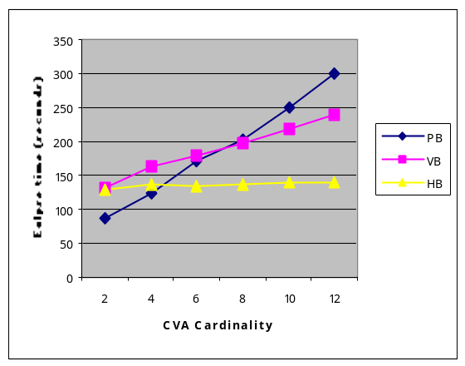
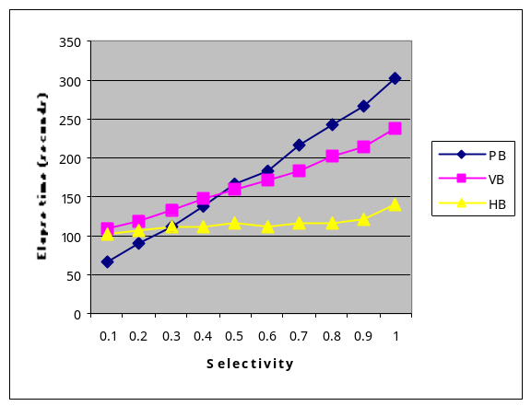
(2) Varying selectivity

Figure 8: Query 4, the elapsed time for the expressions in Figure 5

(1) Varying CVA cardinality

5 Conclusions and Future Work

Observing the limitation of the existing materialization techniques, we developed the hybrid technique that performs well when in many cases when no existing algorithm is applicable or efficient. When applied to collection-valued attributes (CVAs), this technique generally outperforms the value-based technique, especially for queries that involves several CVAs. Initial experiments with an evaluator written on a commercial object-oriented database confirm our informal analyses and the promising potential of the hybrid technique.
More techniques for materialization and CVAs mean a larger search space for the query optimizer. Exhaustive search of this space might not always be desirable. Therefore we will do more analytical and experimental evaluation to develop guidance for optimizers to generate promising expressions quickly. For instance, among many materialize operators in an original expression, an optimizer should seek to choose the most effective places to fire the hybrid rule and enhancement rules. One strategy is to apply the hybrid rule where attributes are highly shared, or where the materialization input has not had the hybrid rule applied already. Of course, we also need to develop appropriate cost functions and statistics so that we can reliably choose a relatively inexpensive plan among the alternatives.

Acknowledgement
The first and second authors are supported by NSF IRI-9509955, IRI9118630, DARPA(BAAB07-91-C-Q513). The third author is supported by NSF IRI-9119446, DARPA(BAAB07-91-C-Q513) subcontract from Oregon Graduate Institute to Portland State University.

Bibliography
[BCK98] R. Braumandl, J. Claussen, A. Kemper. Evaluating functional joins along nested reference sets in object-relational and object-oriented databases, 1998 VLDB.
[BK89] E. Bertino, W. Kim. Indexing techniques for queries on nested objects, in IEEE Trans. Knowledge and Data Engineering, June, 1989.
[BMG93] J. A. Blakeley, W. J. McKenna, G. Graefe. Experiences building the Open OODB query optimizers, 1993 ACM SIGMOD.
[Carey et al. 94] M. J. Carey, D. J. DeWitt, M. J. Franklin, N. E. Hall, M. L. McAuliffe, J. F. Naughton, D. T. Schuh, M. H. Solomon, C. K. Tan, O. G. Tsatalos, S. J. White, M. J. Zwilling. Shoring up persistent applications, 1994 ACM SIGMOD.
[CB97] R. G. G. Cattel, D. K. Barry. The object database standard: ODMG 2.0, Morgan Kaufmann Publishers, Inc, 1997.
[CM93] S. Cluet, G. Moerkotte, Nested queries in object basess, Proc. Int. Workshop on Database Programming Languages, 1993.
[Colby89] L. Colby. A recursive algebra and query optimization for nested relations, 1989 ACM SIGMOD.
[CG94] R. L. Cole, G. Graefe. Optimization of Dynamic Query Evaluation Expressions, 1994 ACM SIGMOD.
[EM99] A. Eisenberg, J. Melton. SQL:1999, formerly known as SQL3, SIGMOD Record, 18(8), March, 1999.
[Feg98]L. Fegaras. Query Unnesting in Object-Oriented Databases, 1998 ACM SIGMOD.
[FT83]P. C Fisher , S. J. Thomas. Operators for non-first-normal-form relations, Proc. IEEE Computer Software and Applications Conf., 1983.
[GM93] G. Graefe, W. J. McKenna. The Volcano optimizer generator: extensibility and efficient Searches, Proc. IEEE Conf. on Data Eng., Vienna, Austria, 1993.
[Gem99] Programming with GemStone/J, Gemstone Inc., 1999.
[GGT96] G. Gardarin, J. R. Gruser, Z. H. Tang. Cost-based selection of path expression processing algorithms in object-oriented databases, 1996 VLDB.
[Gra93] G. Graefe. Query evaluation techniques for large databases, ACM Computing Surveys, vol. 25, No. 2, June, 1993.
[HM97] S. Helmer. G. Moerkotte. Evaluation of main memory join algorithms for joins with subset join predicates, 1997 VLDB.
[KMG91] T. Keller, G. Graefe, D. Maier. Efficient assembly of complex objects, 1991 ACM SIGMOD.
[KM90] A. Kemper, G. Moerkotte. Advanced query processing in object bases using access support relations, 1990 VLDB.
[MS86] D. Maier, J. Stein. Indexing in an object-oriented DBMS, Proc. 1986 Int. Workshop on Object-Oriented Database Systems, 1986, IEEE CS Press.
[ODE95] C.Ozkan, A. Dogas, C. Everndilek. A heuristic approach for optimization of path expressions, Technical Report, Middle East Technical University, 1995.
[ODMG] The object database standard: ODMG 2.0, edited by R. G. G. Cattell, D. K. Barry, Morgan Kaufmann Publishers, 1997.
[Ross95] K. A. Ross. Efficiently following object references for large object collections and small main memory, Proceedings of the Fourth International Conference on Deductive and Object-Oriented Databases, December 1995.
[Rama97] R. Ramakrishnan. Database management systems, McGraw-Hill, 1997.
[Rama et al. 98] K. Ramasamy, P. M. Deshpande, J. F. Naughton, D. Maier. Set-valued attributes in O/R DBMS: Implementation options and performance implications, to be published, University of Wisconsin, Madison, 1998.
[Shapiro et al. 98] L. Shapiro, D. Maier, K. Billings, Y. Fan, B. Vance, Q. Wang, H. Wu. Safe pruning in the Columbia query optimizer, www.cs.pdx.edu/~len/pruning.doc or pruning.doc.zip.
[Steen95] H. J. Steenhagen. Optimization of object query languages, Ph.D dissertation, Universiteit Twente, 1995.
[Ses98] P. Seshadri. Query processing techniques for correlated queries, IBM Technical Report RJ 10129 (95004), 1998.
[SC90] E. J. Shekita, M. J. Carey. A performance evaluation of pointer-based joins, 1990 ACM SIGMOD.
[SS86] H. J. Schek, M. J. Scholl. The relational model with relation-valued attributes, Information Systems, 11(2), 1986.

