ECE 559 Project #4

Any problem involving finding the optimal ordering of a set of discrete objects is referred to as a combinatorial optimization problem (COP). Many of you are familiar with the *traveling salesman problem*, which is a good example of a COP. In the operations research domain the best known COP is the *quadratic assignment problem* (QAP), which is known to be NP-hard. In this project you are to use a GA to solve a small instance of QAP.

Problem Formulation:

QAP involves the assignment of resources. You are given a set of *N* ‘facilities’ that must be assigned to one of *N* physical ‘locations’. No location can host more than one facility and all facilities must be assigned. The objective is to find an assignment that minimizes the cost function

 (for facility *i* in location *k* and facility *j* in location *p*)

where *fij* = the flow of ‘material’ between facilities *i* and *j* (*fij* = 0 for *i* = *j*)

*dkp* = the distance between the *k*-th and *p*-th locations (*dkp* = 0 if *k* = *p*)

Since the material flow and distances are symmetric (i.e., *fij* = *fji* and *dkp* = *dpk*) a compact matrix form will be used to specify the problem you are to solve.

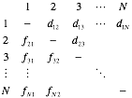

The problem you are to solve has *N* = 8 and the compact matrix describing the material flows and distances is

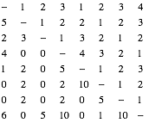

Requirements:

You may choose any type of GA, but your report must describe enough details about your GA so that a competent reader could duplicate what you did. All GA parameters (population size, termination criteria, genotype structure, variation operators, etc.) are your choice. Run your algorithm 15 or 20 times and plot the fitness versus generations from the best run. Be sure to give the optimal solution you found.