ECE 271 (extra credit) lab

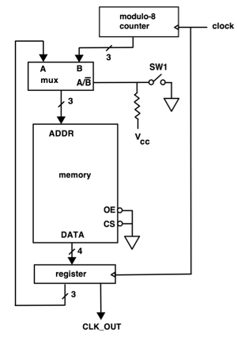
You are to design the above writeable control store (WCS) architecture. When the counter circuit generates the addresses, CLK_OUT should be a 75% duty cycle clock signal. When the register provides the addresses, CLK_OUT should be a 50% duty cycle. CLOCK should be at least 5 KHz.
This lab is optional. It is not required. However, if you complete it you will receive 10 points of extra credit. To receive this credit you must turn in
- a complete schematic
- a memory map showing what data is stored in the 8 memory locations
- a hardcopy of the timing diagram from the logic analyzer. Be sure to show both waveforms and the SW1 logic state on the timing diagram.

YOUR LAB REPORT MUST BE TURNED IN TO YOUR LAB TA BEFORE FINALS WEEK OR YOU WON’T GET ANY CREDIT.

