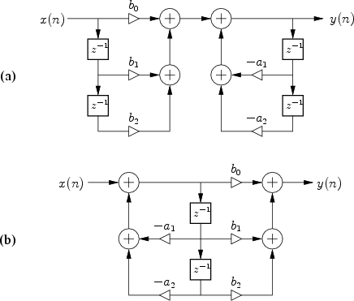

Direct Form I is shown in (a). Direct Form II is shown in (b)