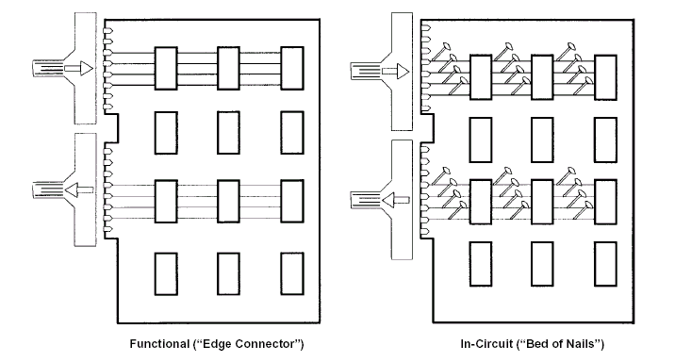

The above methods rapidly become unusable with the complexity of today’s designs.

In 1985, a consortium of United States and european companies formed the Joint Test Action Group (JTAG) to see if there was a better way.

The result was IEEE Std 1149.1

