COVER SHEET (FOR ALL STEP 1 PROPOSALS ONLY)

Intelligent Systems: NRA2-38169
Title: Self-reconfigurable electronics for the compensation of aging effect in analog control systems: using evolutionary computation and commercial off-the shelf reconfigurable hardware.
Principal Investigator Name: Garrison W. Greenwood
Department: Electrical & Computer Engineering
Institution: Portland State University
Address: P.O. Box 751
City: Portland State: Oregon Zip: 97207-0751
Country: USA E-mail: greenwd@ece.pdx.edu
Telephone: 503-725-3806 Fax: 503-725-3807

Name Institution Telephone Electronic Mail
Garrison Greenwood Portland State Univ.
Sushil Louis Univ. of Nevada
Didier Keymeulen NASA/JPL
Ken Hayworth NASA/JPL
Ed Ramsden Lattice Semiconductor

Budget (in $K):
1st Yr.: ______200________ 2nd Yr.: ______________ 3rd Yr.: ______________
Total: _______200_________
Requested Start Date: 1 October 2003 Requested Duration: 12 months

Technical Area Proposing Under: TA-5 Evolvable Systems

(TA choices: 1) TA-1 Automated Reasoning, 2) TA-2 Intelligent Data Understanding, 3) TA-3 Human-Centered Computing, 4) TA-4 Revolutionary Computing, or 5) TA-5 Evolvable Systems.

Authorizing Official: Ms. Barbara Sestak, Portland State University
(Name) (Institution)
Proposed Innovation or Breakthrough

The outcome of this research will impact the reliability of several deep-space missions such as Planetary Sample Return and Mars Exploration Program as well as the Nuclear Space Initiative where a nuclear power plant will be on board the spacecraft. In these programs, self-adaptation of the control electronics is essential for guaranteeing the safety and reliability of the spacecraft. Moreover, self-adaptation will be the only viable option for achieving fault-tolerance because redundant hardware systems are too expensive and the anticipation of all the electronics degradations cannot be modeled on earth.
Current fault-tolerant architectures for spacecraft rely on availability of redundant resources. These architectures will be ineffective for ultra-long life space missions (> 50 years) in part because anticipated failures will most likely be due to aging effects rather than random failures. The best way to compensate for aging effects is with in-situ adaptability⎯i.e., by providing a self-reconfigurable system that modifies its architecture as needed to counteract performance degradation resulting from component aging.
Field programmable gate arrays (FPGAs) are a type of integrated circuit ideally suited for adaptable system applications because they contain generic functional blocks that can be dynamically reconfigured. Unfortunately, FPGAs can only implement digital functions whereas many space subsystems are analog in nature. This means an analog equivalent of the FPGA is needed.
There are a few examples of commercial-off-the-shelf (COTS) integrated circuits that contain generic analog function blocks. Unfortunately, analog COTS devices are too general to be of practical for space applications because chip area is wasted supporting functions that may not be needed. For example, some COTS devices provide circuitry to generate arbitrary waveforms. What is actually needed is a dynamically reconfigurable analog chip with analog function blocks specifically tailored for deep-space missions. This problem can be formally stated as follows:

What resources should be provided in a generic analog function block used to compensate for aging related failures in ultra-long life space missions?

We have formulated a technique to precisely answer this question. Our technique merges two advanced concepts: (1) a reconfigurable analog chip, such as depicted in Figure 1, and (2) a biologically inspired search algorithm used to find the optimal analog hardware configuration.

Research Objectives

This research effort will create a reconfigurable analog hardware prototype system able to compensate faults in continuous analog control systems. The system performance will be demonstrated using control electronics circuits developed by JPL for the microgyroscope.

Technical Approach

The reconfigurable generic analog function block is based around the Anadigm AN220E04 Field Programmable Analog Array (FPAA), which is depicted in Figure 1. Based on fully differential switched capacitor architecture, this dynamically reconfigurable device now makes the detailed investigation of analog circuit adaptation a reality.
The key to finding a suitable AN220E04 configuration is the evolutionary algorithm. These algorithms use the principles of Darwinian evolution found in nature to search for solutions to difficult optimization problems. There are several types of evolutionary algorithms with the genetic algorithm (GA) as the most widely known. In particular, GAs are the primary search method currently used in evolvable hardware work.
A NASA relevant target application has been identified as a possible test case for this technology. The JPL microgyroscope program has as its goal the production of ultra low-drift navigation grade MEMS gyroscopes for NASA missions. Due to the diminutive size of these gyroscopes, the front-end analog preamplifier electronics requires high gain, and this can tax the amplifier bandwidth to some degree. Because of this, variability in the passive and active components of this circuit can lead to variable phase shifts and ultimately to gyroscope rate drift errors. The AN2204E04 FPAA may prove to be an efficient solution to phase compensating this critical front-end analog circuit. Figure 4 shows the microgyroscope’s main control loops, and where this analog front-end circuit resides.

Planned Approach

The system investigated is a closed-loop analog system (see Figure 2). The system has a voltage variable resistor that can change value under computer control to simulate aging. This, in turn, affects the transfer function G(s). Our objective is not to determine the cause of the transfer function change, but instead to compensate the system to restore its original performance as much as possible.
Figure 3 shows our analog hardware system with analog multiplexers that can be separately controlled by a PC. (Notice Figure 2 and Figure 3 are equivalent whenever the lower input is selected for both multiplexers.) The closed-loop system is periodically put into a diagnostic mode where the upper (lower) input of the left (right) multiplexer is selected. The PC generates input test signals with a digital-to-analog converter and monitors the system’s performance with an analog-to-digital converter. If everything is performing correctly, the multiplexers are switched back to operational mode.
The PC outputs a control voltage to the voltage variable resistor to simulate aging. The upper input is selected on the right multiplexer to insert the AN220E04 device in the signal path. An evolutionary algorithm⎯most likely a GA⎯will intrinsically evolve a AN220E04 configuration that renders a compensated G(s). The PC will then adjust the multiplexers to restore the original input x(s) while leaving the AN220E04 device inserted in the signal path. This compensated system is now the operational configuration.
The methodology used to define the generic analog block is as follows. JPL will define several G(s) transfer functions along with a set of aging scenarios for each transfer function. Only some of these transfer functions and scenarios will be used for testing; the remainder are reserved for verification. Each G(s) will be synthesized using active and passive components along with a voltage variable resistor to simulate aging. The aging information will be used to construct time-varying functions for control of the voltage variable resistor. The AN220E04 device provides a set of analog components along with a rich interconnection capability. (Both component selection and interconnections are programmable.) The GA will evolve candidate analog configurations for evaluation under PC control. An initial analysis of the best final analog configurations will be conducted to identify design trends⎯i.e., minimal component types, most common component values and most likely circuit configurations. This is the end of the testing phase and the beginning of the verification phase. During the verification phase all testing will be conducted only with those aging scenarios and transfer functions reserved for verification. However, now the evolving circuitry is restricted to those sets of analog components, component values and limited configurations identified during the testing phase. At the conclusion of this verification phase a recommendation for the composition and configuration for a generic analog function block can be released.
Although the AN2204E04 is reconfigurable, it is too cumbersome and too general purpose for in-situ intrinsic adaptation applications in spacecraft. For example, the AN220E04 has internal memory, which is used for generating arbitrary waveforms and a successive approximation register for implementing non-linear functions. What is really needed is a chip containing several analog blocks that are general enough to provide maximum functional flexibility, but optimized for maximum density. For instance, sacrificing some interconnection capability and eliminating some input multiplexers can increase the module density to achieve better performance.

Implementation Plan

The initial task will be to develop the GA. In principle, this process is straightforward but fine-tuning will require creating and evaluating thousands of AN220E04 configurations⎯a process best performed using a simulator. Once the GA is completed, it can be ported to the PC in the analog hardware prototype system. All further testing can then be conducted using an actual AN2204E04 device. The control system G(s) will be synthesized using passive components plus one voltage variable resistor. An aging profile function will run on the PC to render a time-varying G(s). The testing is automatic: the PC switches from operational to diagnostic mode; system testing is conducted; the AN220E04 is intrinsically evolved as needed; the PC switches back to operation mode.
All simulator work will be performed at the University of Nevada. The analog hardware prototype hardware will be designed and built at Portland State University. Finally testing and demonstration of the analog prototype system will be conducted at JPL.

Tasks & Milestones
- Concept (month 1). Milestone: JPL releases aging scenarios for microgyroscope to Portland State Univ. and Univ. of Nevada
- Develop System Specification (month 2). Milestone: release of hardware prototype design and test specifications to JPL
- Design and Test Genetic Algorithm (months 3-7) Milestone: source code transfer to Portland State University
- Design of Prototype Hardware (months 3-5) Milestone: schematic release to JPL
- Construction and Verification of Prototype Hardware (months 3-9) Milestone: submission of verification test results to JPL
- Integration and Test (months 5-11) Milestone: schedule demonstration at JPL
- Demonstration and Report (month 12) Milestone: final report submission to JPL

Potential Benefits to JPL

The introduction of reconfigurable analog and digital hardware in future long-life avionics system is the only path towards reliable and fault-tolerant spacecrafts. The strong interest of NASA and in particular JPL towards more adaptive systems in general and evolvable hardware in particular is an illustration of this need. The self-reconfigurable generic analog block technology will allow the infusion of autonomous reconfigurable hardware with the current fixed avionics architecture and thus profit of the legacy of expertise in fixed avionics system.

Expected Results
We will deliver an analog prototype system that will provide a framework for investigating generic analog function block definition for self-compensation of JPL control electronics circuit. Initial recommendations are constrained by the AN220E04 internal resources, but framework can be used with any candidate analog circuitry. Future investigations can study more sophisticated reconfigurable analog circuitry with little or no alteration to the framework.

Plans for follow-on funding

The future potential funding will be the long-life spacecraft Program at JPL as well as an SBIR for the development of self-tuning analog hardware by Lattice Semiconductor, Inc.
The outcome of this research effort is a recommended architecture for a generic analog function block. We intend to seek funding to have a field programmable analog module (FPAM) fabricated that will contain 16 or more of these generic analog function blocks. This will provide a framework for us to develop in-situ adaptive methods and procedures for analog circuitry to parallel what is currently available for digital circuitry. One potential source for this future funding is a SBIR proposal to The United States Special Operations Command. Under SOCOM02-009 (Analog/Video Communications Link), USSOCOM is looking for off the shelf configurable packages the permit easy tailoring to tactical users data and communications needs of Special Operation Forces.

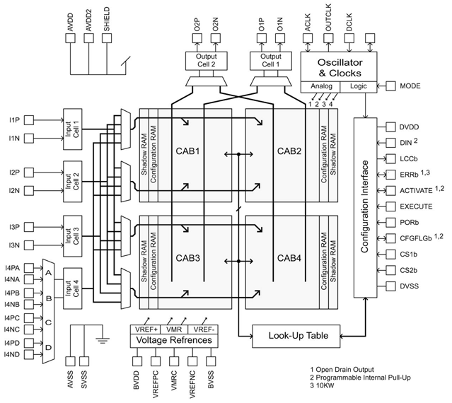

Figure 1 Anadigm Inc field programmable analog array

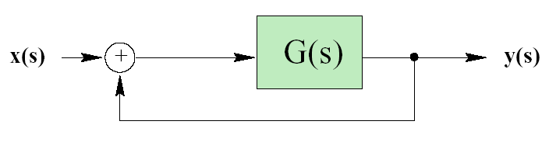
Figure 2: Control System to compensate

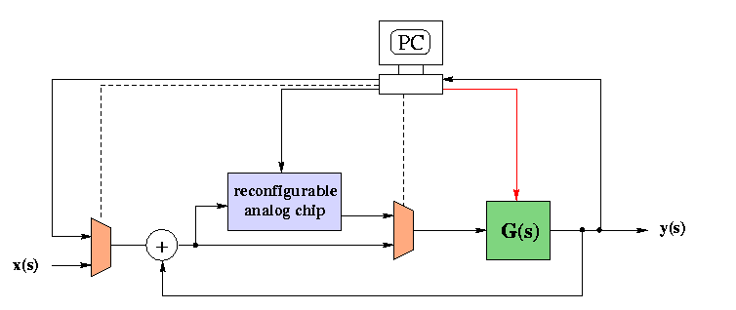
Figure 3: Compensation Architecture

Figure 4: Main microgyroscope control loops, zooming in on front-end preamplifier circuit. General variability and aging of the analog components in this part of the gyroscope electronics has the greatest impact on overall gyroscope performance. Specifically, variable phase shifts in this preamplifier circuit can lead to the gyro’s rate drifting.

