ECE 312 HW#7 Solution

1.

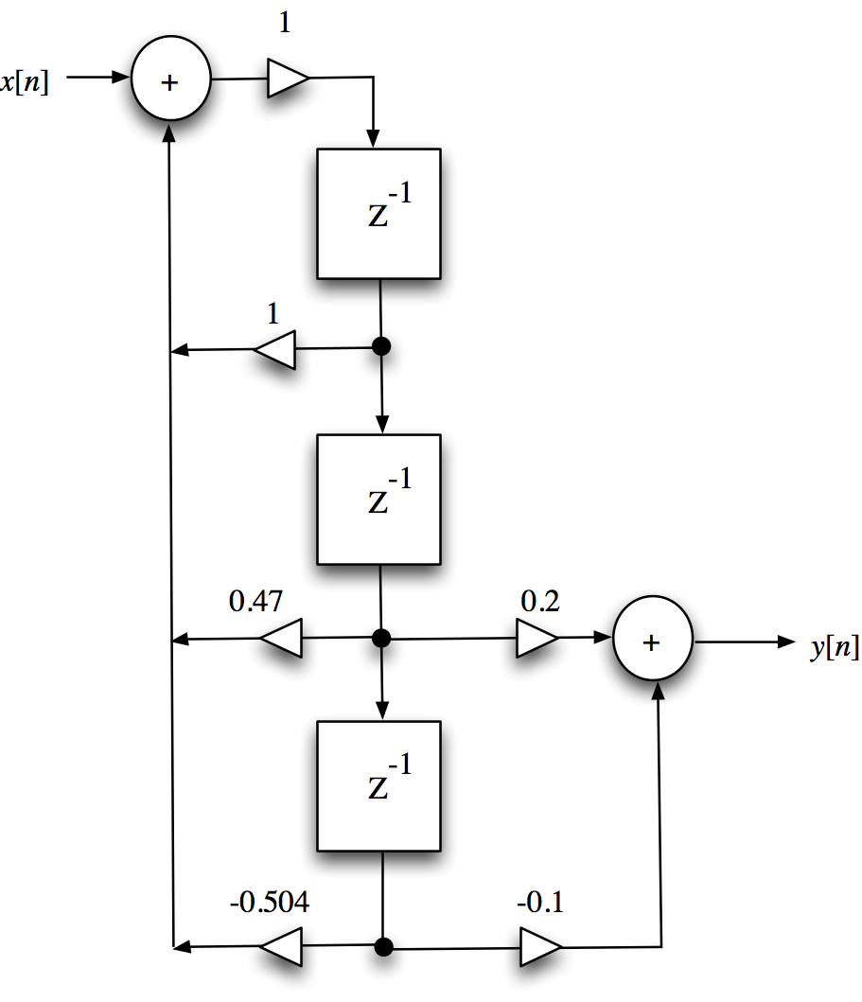

2. 

3. The ROC must contain all of the poles, which are at 0.8, -0.7 and 0.1. Thus the ROC contains the unit circle and the DTFT exists.

