ECE 312 HW#2

1. The convolution integral is



where is the system impulse response and is the system input.



Prove



given



let and when . Substituting



reversing the limits removes the minus sign.

1. The input to a LTI system is with The impulse response of the system is



1. Use convolution to find an analytical expression for the system output response.



and



The integrand product terms are

















Performing the integration yields



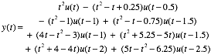

1. Plot .



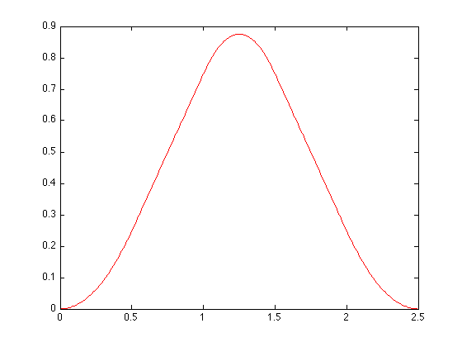

1. Problem 6-18

1.tiff

2.tiff

3.tiff

4.tiff

5.tiff

6.tiff

1. Problem 6-20

-3 to 3

1. Problem 6-25

7.tiff