ECE 312 Homework #1

1. Let .
2. Is this a power signal or an energy signal? (Justify your answer)

It is neither a power signal nor an energy signal.

1. If it is a power signal, what is the average power? If it is an energy signal, what is the energy?

Energy and Power are both infinite.

1. Let . Find *B* where





1. Let .
2. plot *g*(*t*)

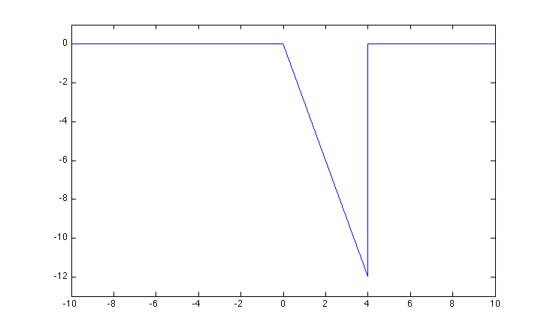

1. plot 0.5*g*(*t/*2)

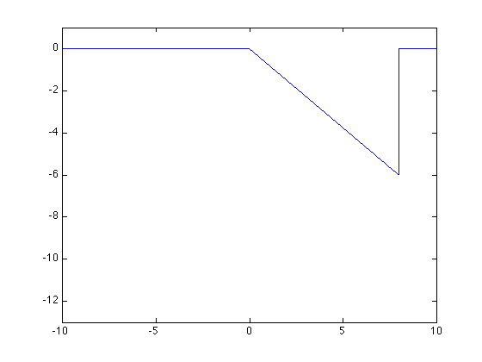

1. plot *g*(*t*-1)

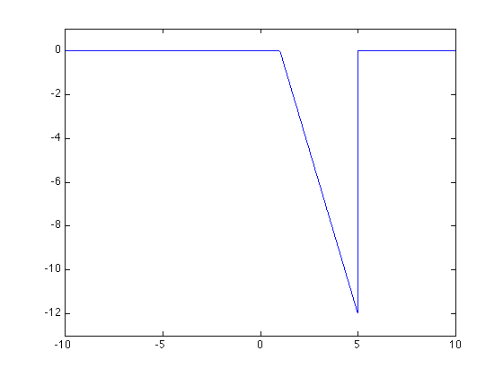

1. Let . What is the average power in this signal?

Notice  This is a periodic waveform with a period of π/3. Therefore, the average power is given by



(NOTE: students do not have to solve the above integral to get full credit for this problem.)

1. Let . One of your fellow students says *g*(*t*) is an even function. Do you agree? (Justify your answer.)

No.

Consider the product of the first 14 functions. Since the sine function is odd, that product will be even function. Multiplying the 15th function, which is odd, by that even product results in an odd function.