ECE 312 Exam #1 (SOLUTION)

This exam consists of 10 equally weighted questions. **Your answers must be on these sheets.** Any attached pages will not be considered when grading the exam.

1. *N* samples of a signal *x*(*t*) are taken over one period to calculate a set of 10 Fourier coefficients using a DFT. How would the DFT results change if the *N* samples were zero-padded with 3*N* additional samples?

The spacing between Fourier coefficients is  where  is the sample frequency and *N* is the number of samples. Zero padding with 3*N* samples makes the spacing .

1. Four samples are taken over one period of a signal. The sample values are

Plot the first 5 Fourier coefficients.

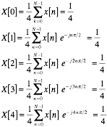

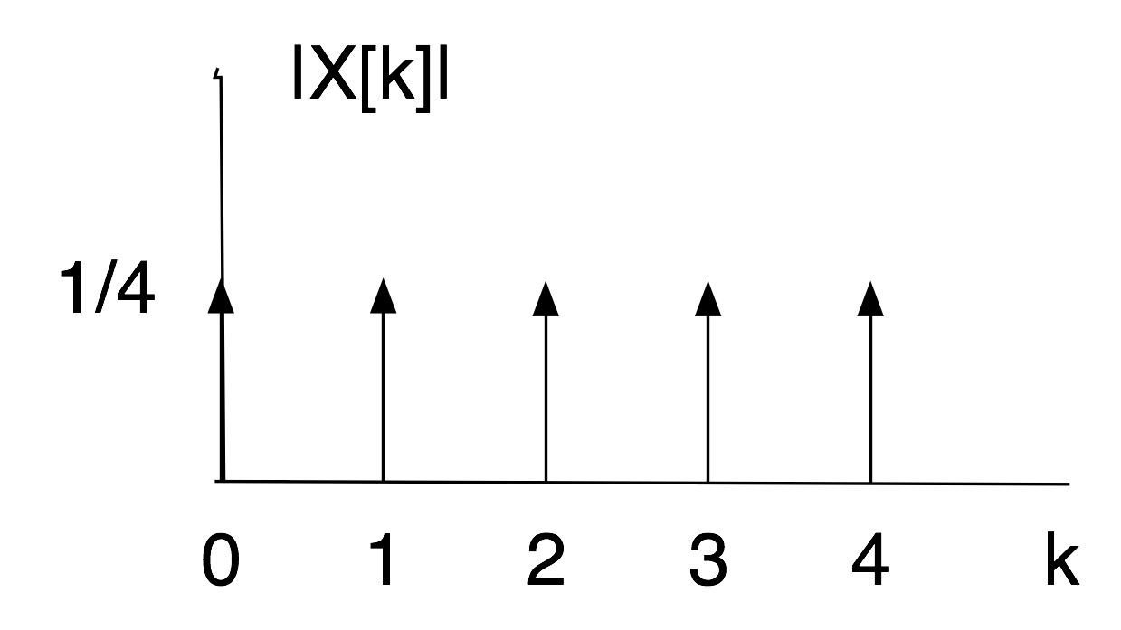

1. A periodic signal  is frequency limited.

What effect does frequency limiting have on the CTFS?

The CTFS of  will be finite.

1. In the following LTI system 

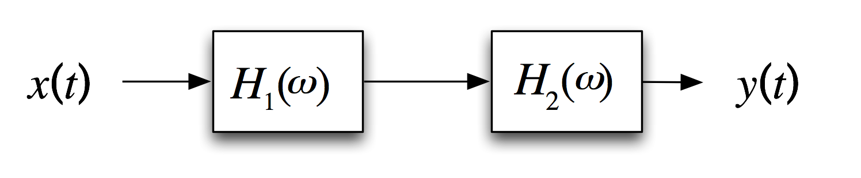

If  what is the output ?



and



From the Fourier transform tables this gives



1. Given 
2. Find all of the Fourier series coefficients for 
3. What is the average power in 

(a)

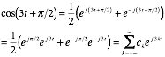

Thus,

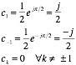

(b)

The average power is 

1. Briefly explain how the time compression of  effects 

Illustrate the effect by plotting the Fourier transform of  and the Fourier transform of 

A Fourier transform property is if



then



Now



thus,



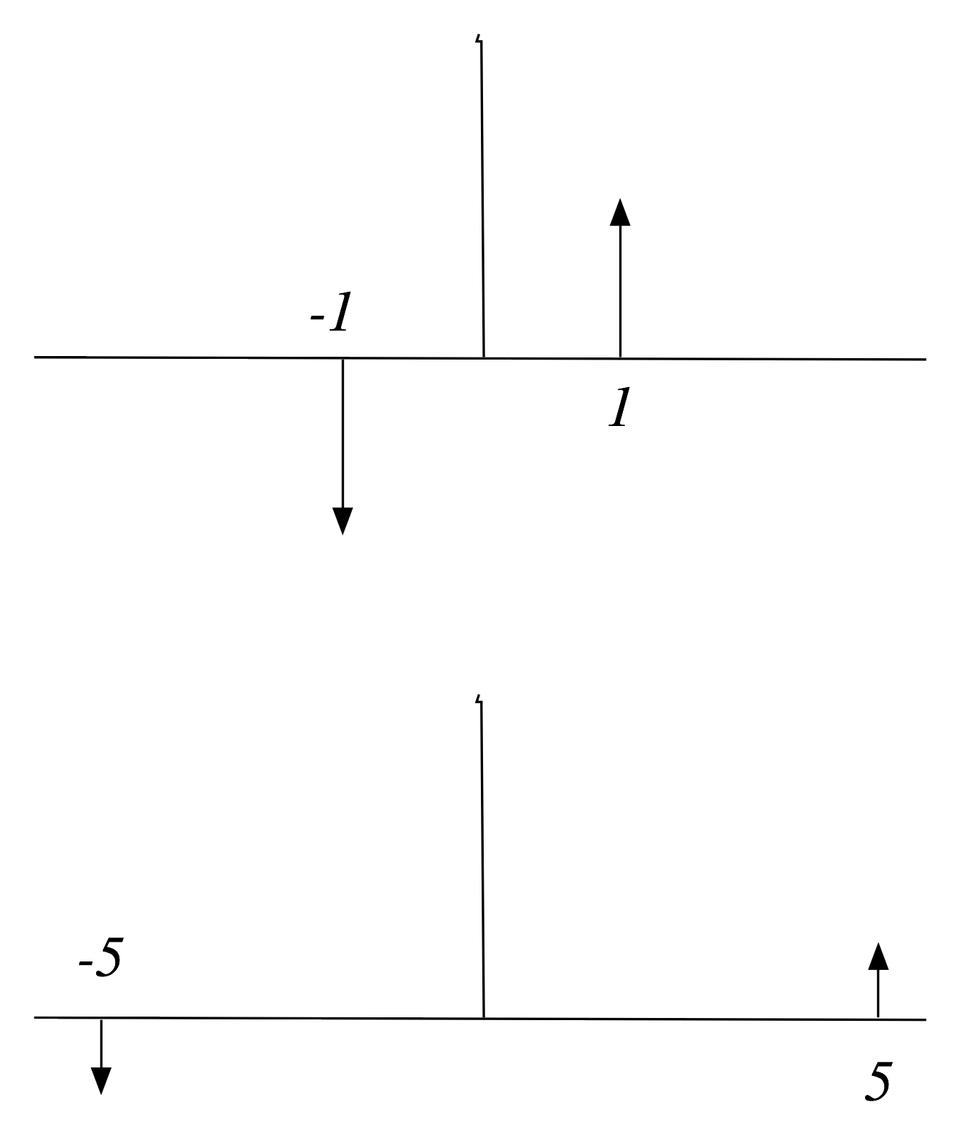

Let  Find 

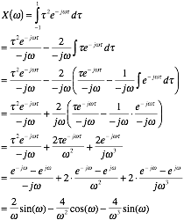

1. Briefly describe the Gibbs phenomenon.

Consider the pulse train

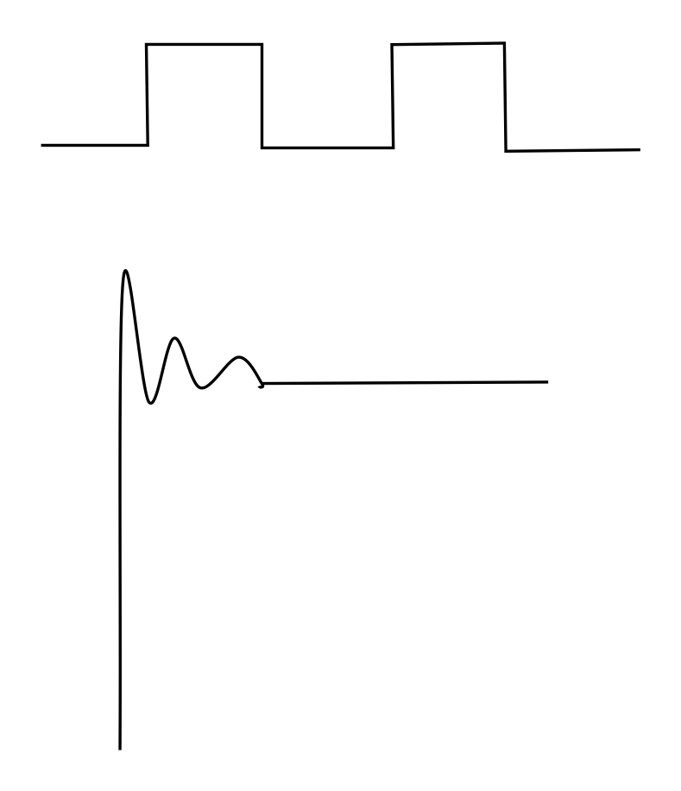

The CTFS will produce a pulse train with near infinite slopes but you get overshoot and ringing at the corners. That overshoot and ringing is the Gibbs phenomenon. Even taking an infinite CTFS will not eliminate it.

1. One of your classmates says

“*If the input to a LTI system can be represented with a CTFS, then the output can also be represented by a CTFS*.”

Do you agree or disagree? Justify your answer.

Agree.

the input is of the form 

but each term  is an eigenfunction for a LTI system. Hence this same complex exponential appears on the system output.

By superposition, a linear combination of eigenfunctions on the input of a LTI system creates a linear combination of eigenfunctions on the output of the system.

the output of the system is thus of the form



which is a CTFS.

1. For each of the following signals, indicate if they are power signals, energy signals or neither power or energy signals.

a) 



therefore it is an energy signal

b) 

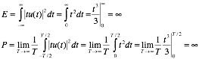

therefore the signal is neither an energy or a power signal

c) 



therefore it is a power signal