ECE 312 Final Exam (Summer 2011)

This exam has 6 questions. *All work must be done on this exam sheet*. You are required to do 5 problems.

If you do all 6, I will treat the 6th problem points as “bonus points” and will add them (unweighted) to your overall course point total. You are NOT required to do all 6 problems.

Do you want to do a bonus problem? (circle one) YES NO

If you circled YES, which problem number is your bonus problem? (circle one)

1 2 3 4 5 6

1. Consider a LTI system with input *x*[*n*] and an impulse response



1. (5 points) Find *H*(*z*).
2. (5 points) Find the unit step response (i.e., when *x*[*n*]=*u*[*n*])

(a)



(b) 

Thus, 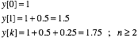

1. An aperiodic signal *x*(*t*) is sampled between  seconds. Samples are taken every 10 milliseconds to construct an *N*-point DFT.
2. (3 points) What is the sample frequency in Hz?

100 Hz

1. (3 points) What is *N*?

200

1. (3 points) The DFT harmonic  corresponds to what frequency in Hz?

(9)(100 Hz)/200 = 4.5 Hz

1. (1 point) One of your fellow students says the computed DFT harmonics will accurately indicate the spectrum of *x*(*t*) over any 2 second interval (e.g.,  seconds). Do you agree?

NO

1. Consider

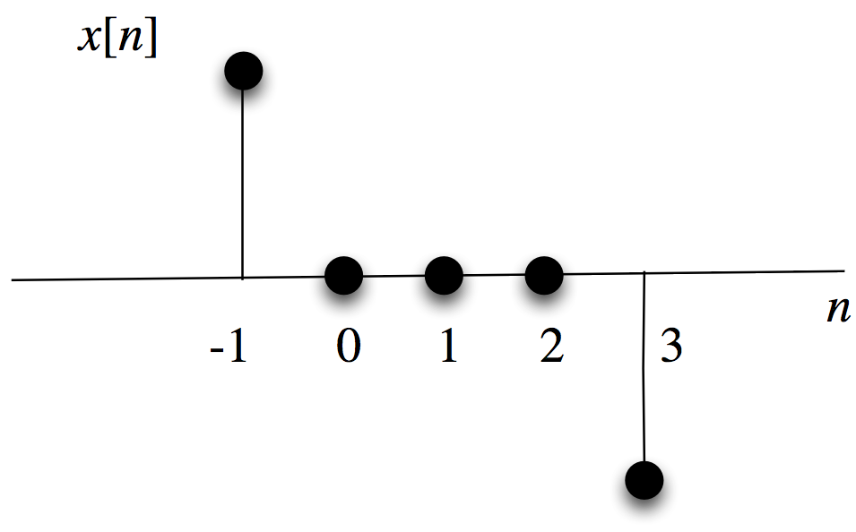

1. Find *X*(*z*)



1. Where are the poles and zeros located?

zeros: 1, -1, *j*, -*j* (I will accept 4 poles with |*z*|=1)

poles: 0,0,0

1. What is the ROC?



1. Find . (A formula is sufficient)



Since the ROC contains the unit circle, the DTFT exists.



1. A LTI system with input *x*[*n*] and output response *y*[*n*] is described by the difference equation



1. (3 points) Find *H*(*z*)



1. (4 points) Draw the direct form II implementation

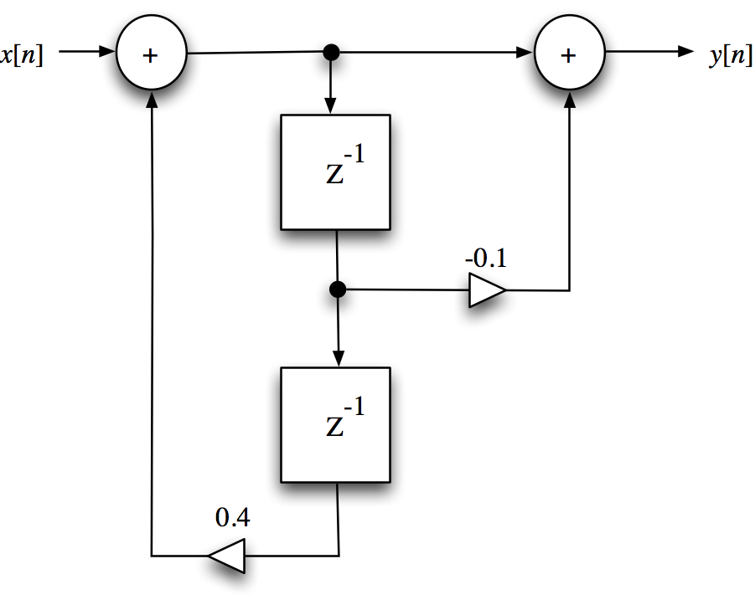

1. (3 points) Does this system have a DTFT? (You must justify your answer to get any points on this portion of the problem.)

The ROC is , which means the ROC contains the unit circle. Thus a DTFT exists.

1. Consider the three-point moving average FIR filter



1. (4 points) find the impulse response 



1. (6 points) show that the frequency response magnitude is 

(Hint: you should make use of the fact that for )

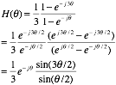

Since , 

1. A continuous time causal filter has the transfer function



Assume the impulse response of this filter is sampled at a rate *Ts* so that the discrete time filter has an impulse response



1. (5 points) Find the transfer function  of the IIR filter

The inverse Laplace (from the attached tables) gives . Therefore, 

Then 

1. (5 points) Find the difference equation describing the IIR filter

