Maseeh College of Engineering & Computer Science

Yakima T.O.C. Load Assist
ME 493 Final Report -- Year 2012
6/11/2012

Group Members:
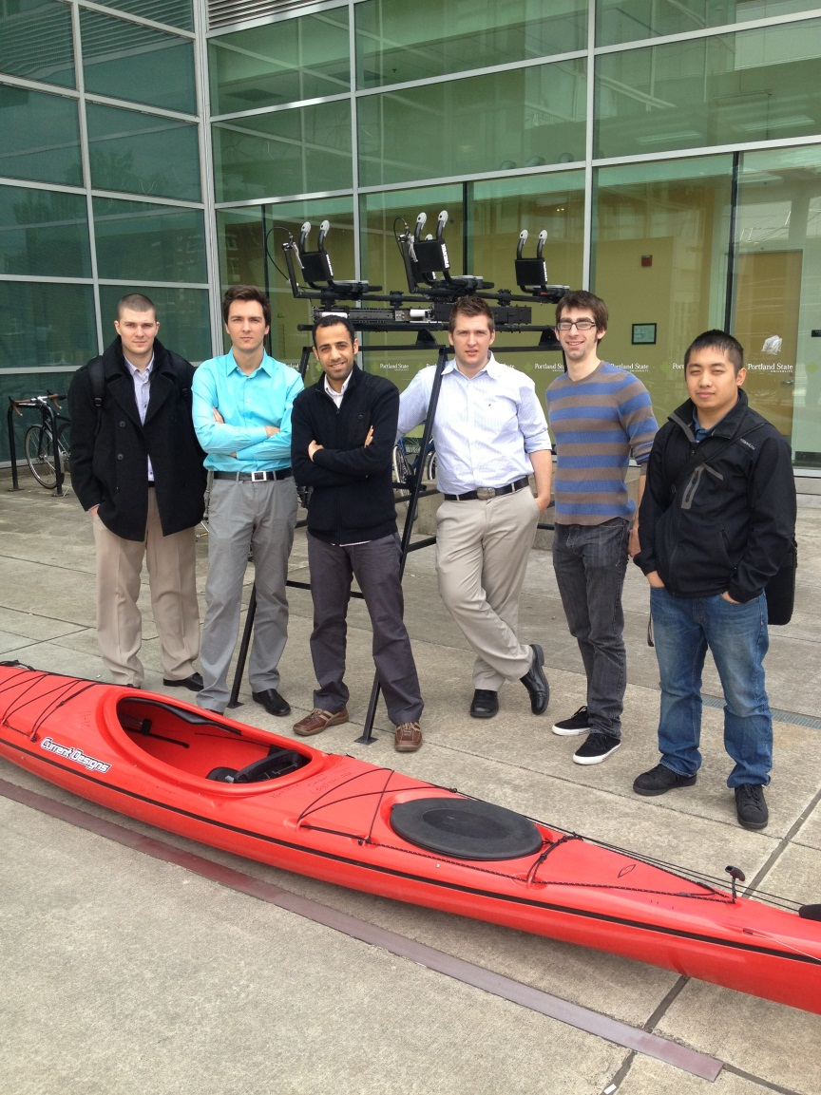
Haidar Al Gharash
Michael Dixon
Ben Gheliuc
Daniel Gheliuc
Fue Her
Zach McCurter

P.S.U Advisor:
Evan A. Thomas, Ph.D., P.E.

Yakima Sponsors:
Mark Elliot
Chris Sautter

Executive Summary
The Top of car load assist rack is a device created for Yakima Inc. as a new way to load kayaks. The purpose of the load assisted rack is to provide a unique helpful method that allows an individual to load their kayak easier than the conventional way of brute force.
The rack system is designed to load two 55 lb. sea kayaks. The system is within budget ($1,000), safe to use and maximizes the assist that the individual feels. The weight limit was not a constraint for prototyping purposes. Locking tabs are engaged when the system is closed and fully extended and the locks are released through two handles. The point of rotation on the rack is set at a 25° angle.

Special Thanks
The Yakima TOC load assist team would like to thank Yakima for their support and funding of this project. Yakima Inc. provided all parts that were needed to construct and manufacture this prototype. Parts included but not limited to: two sets of industrial sliders, constant force springs, bomber bars and Yakima J-cradles.

Table of Contents
Introduction: 6
Mission Statement: 7
Main Design Requirements: 7
Top-Level Final Design Alternatives: 7
Final Design: 11
Overview: 11
Base Slider Assembly: 11
Rotation Assembly: 12
Load Mechanism: 13
Release Mechanism: 14
Product Design Specification (PDS) Evaluation: 16
Ergonomics: 16
Performance: 17
Life in Service: 17
Recyclability: 17
Maintenance: 17
Safety: 18
Cost of Production: 18
Environment: 18
Materials: 19
Codes and Standards: 19
Conclusion: 19
Appendix 1: Detailed PDS Criteria: 21
Ergonomics: 21
Documentation: 21
Life in Service: 21
Disposal: 22
Maintenance: 22
Performance: 22
Safety: 23
Timeline: 23
Company Constraints and Procedures: 23
Cost of production per part: 23
Environment: 23
Manufacturing facilities: 24
Shipping: 24
Materials: 24
Appendix 2: External Research: 24
Appendix 3: Internal Research: 26
Internal Search: 26
Appendix 4: Bill of Materials: 27
Appendix 5: Operation Manual: 29
Appendix 6: Service Manual 36
Appendix 7: Assembly Procedures 37
Small Sliders Assembly: 37
Large Sliders Assembly: 38
J-Cradles and Handles Assembly: 41
Appendix 8: Yakima Test Standards 44
Appendix 9: Stress analysis on mechanical slider 47
Appendix 10: Roof load calculation 62
Appendix 11: Bolt stress analysis 64
Appendix 12: Drawings and Assembles 66

Introduction:
For people who enjoy water sports, loading a kayak onto the top of their car may be a very difficult thing to do. Kayaks have a weight range from 50 lbs. up to 120 lbs. Lifting a kayak that heavy to the roof of a car is a challenging task to do for some people and especially so, if doing it alone. This is where our project comes in. Yakima Products, Inc., a company that designs and sells rack systems, proposed this project (Top-of-Car Load Assist) to the Mechanical Engineering capstone class at Portland State University. The purpose of the project is to design a manually operated device that shall help a person lift a kayak (or two kayaks) from waist height and securely place it on top of a vehicle. Yakima Products, Inc. previously designed a system but the estimated market price for the system was too expensive for the market; therefore they wanted to design a new system that would be efficient yet affordable.
Yakima’s previous attempt at designing a load assist mechanism had an estimated retail price of $2000. The system could hold up to 100 pounds of load capacity of boats, bikes, or cargo boxes. All the loading is done on the side of the car as shown in Figure 1.

Figure 1: Yakima’s previous “Lowdown” load assist design

Mission Statement:
The top of car load assist capstone team will design and manufacture a prototype mechanism that will provide 60 pounds of assistance in loading up to two kayaks onto the top of the target vehicle, a Subaru Outback. The system must be intuitive and easy to use and have no pinch points or safety hazards. A 45 year old 5’ 2” woman should be able to operate the lift assist without extreme physical exertion. When the final prototype enters production it must have a retail value of less than 1000 dollars. A working prototype is to be completed and delivered in June 2012.

Main Design Requirements:
The main design requirements that were given by the customer are specified in the Product Design Specification (PDS). The main design requirements from the PDS are listed below (For more detailed criteria see Appendix 1).

- Target Persona: An average 45 year old 5’2” woman who paddles a sea kayak and drives a Subaru Outback.
- Ergonomic design allows user to easily load boat on top of vehicle.
- No sharp edges, corners, or pinch points.
- Product must have no mechanical or structural failures for five years of moderate use.
- The load assist must pass Yakima’s internal standards: horizontal pull at 4 times the rated carrier load and the vertical pull at 2500 N.
- Target assist of a total of 60lb.
- Target retail price of < $1000.
- Completion of final design must be done by June of 2012.

Top-Level Final Design Alternatives:
The Initial brainstorming yielded four concepts, three of which were seriously considered in the design process. The first concept consisted of a rotational linkage mechanism which was not feasible because the complexity added cost. The second concept consisted of a 40 inch mechanical slider that would rotate about a fixed pivot point, see Figure 2 below. The load assist would be connected to one end of the fixed base and the far end of the sliding arm. This design was eventually ruled out because the location of the pivot point makes it too difficult for the user to unload the mechanism as they would need to pull approximately 30 pounds in a horizontal direction before they could get enough leverage to rotate the assembly in order to pull downward.
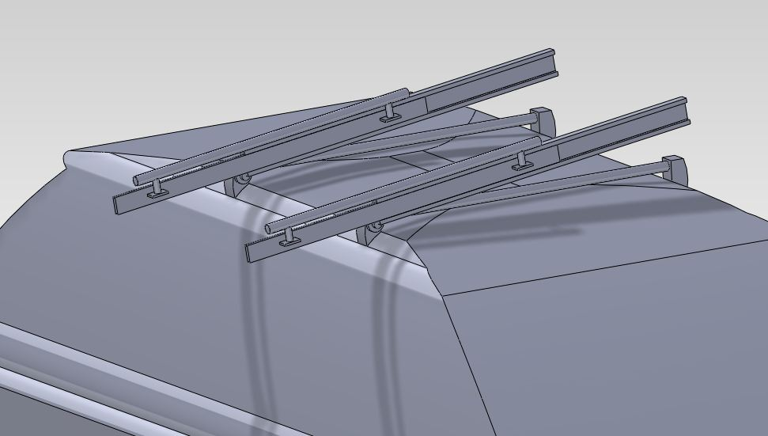
Fixed Pivot Point
Figure 2: Concept one with one set of mechanical sliders and a fixed pivot.
The third concept was much more user friendly to load because it has a horizontal loading platform for kayaks; this design may be used for multiple bikes as well. The mechanism consisted of a mechanical slider connected to the horizontal loading platform via slots and rails, see Figure 3. In order to accomplish a load assist with this design the load assist would need to be connected to the fixed base of the slider and the tip of the horizontal loading platform. The major flaw in the third design concept is the fact that a boat would apply force beyond industry standards to the roof of the car and would therefore not be an acceptable loading mechanism.
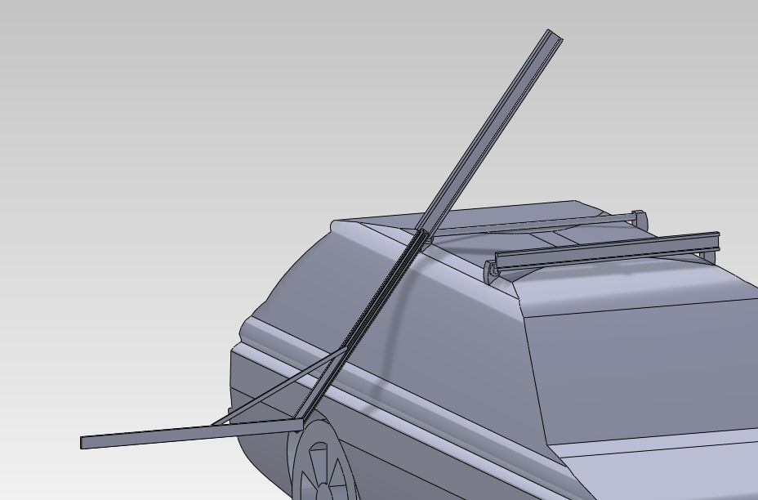
Fixed Pivot Point
Horizontal Loading Platform
Figure 3: Concept two with horizontal platform.
The final concept is a modified version of concept two. It is comprised of two sliding arms, one 16 inch, and one 30 inch. The 16 inch slider acts as a base and moves the rotation point in order to dramatically increase the ease of use of the mechanism, see Figure 4. The 16 inch slider attaches to the 30 inch slider ten inches from the telescoping end. The mechanism operates by the user pulling handles located at the end of the 30 inch slider which in turn causes the 16 inch base slider to extend and lock into place after it reaches its full extension. The user then continues to pull the 30 inch slider, loading constant force springs located at the opposite end of the 30 inch slider and connected to the inner most telescoping arm via an aluminum bracket. This design is a step above the competitor’s designs because it allows two boats to be loaded from one side of the car.
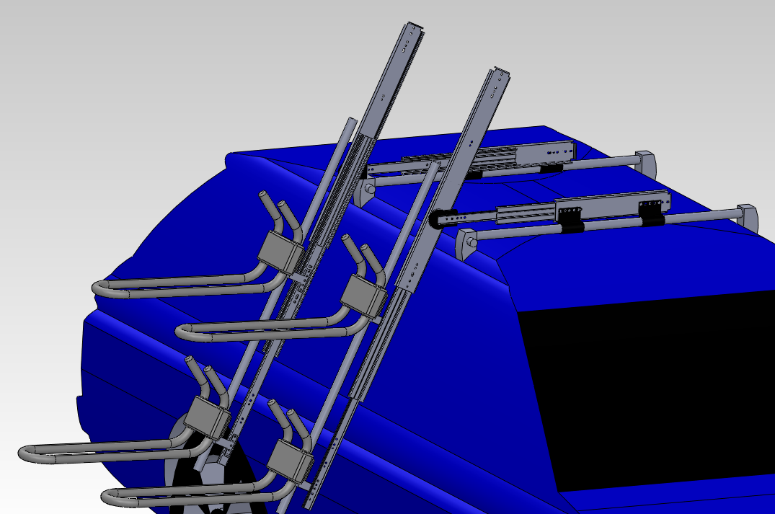
Loading Platform
16 inch Base Slider
Pivot Point
Constant Force Spring Location
Figure 4: Final top level concept with two J-cradles.
The team considers load assist, cost, weight, safety, ease of use, and manufacturability to be important qualities of the T.O.C. load assist design. These criteria are graded on a numerical scale with one being the lowest and ten being the highest. The decision matrix of the T.O.C. top-level design is shown in Table 1. The design team selected the two arm extension concept based on the total values it received in the design evaluation matrix. Ease of use is the most important factor used in the design of the prototype because it is very closely related to the overall design of the mechanism and would be very difficult for Yakima to improve without making major design changes to the prototype. All other design criteria are important; however Yakima can make improvements to these relatively easily.

Table 1: Concept design evaluation matrix. All concepts were rated for load assist, cost, weight, safety ease of use and manufacturability.
 | Load Assist-5 | Cost-2 | Weight-4 | Safety-4 | Ease of Use-10 | Manufacturability-5 | Total
Concept one | 1 | 1 | 4 | 3 | 2 | 2 | 13
Concept two | 4 | 2 | 4 | 4 | 1 | 4 | 19
Concept three | 1 | 1 | 1 | 1 | 10 | 1 | 15
Concept four | 4 | 2 | 2 | 3 | 7 | 3 | 21

Final Design:

Overview:
The final design of the top of car load assist mechanism is complex, so the design will be broken up into sub-assemblies that will be discussed individually and in depth. The basic design consists of a base slider assembly, that brings the boat loader from the center of the car to the edge, a rotation assembly, that allows the boat loader to rotate within the desired angular motion, the boat loader assembly, that contains the spring assist mechanism, and the release mechanism, that allows both of the slider mechanisms to lock and unlock at the correct time during motion.

Base Slider Assembly:
The base slider assembly attaches to standard Yakima roof racks. The 16” sliders bring the point of rotation out directly above the corner of the vehicle roof so the loading mechanism will not impact the vehicle when it is deployed, see Figure 5. The attachment method is accomplished by means of four bar clamps that were specifically designed to give the base sliders clearance so they would not interfere with the Yakima rack or the roof of the vehicle.
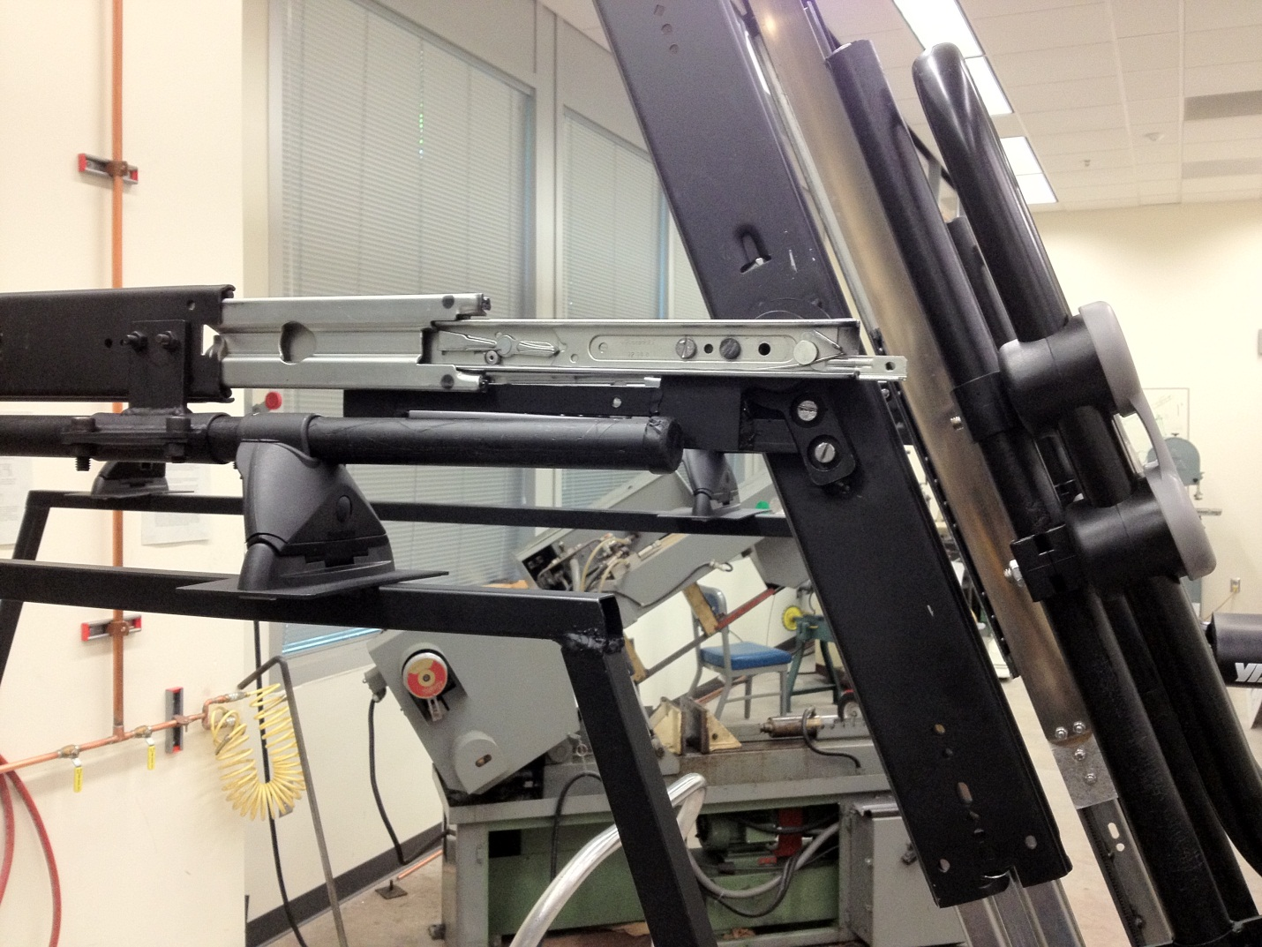
Figure 5: Image of prototype showing the location of the pivot point in the deployed position.

Rotation Assembly:
Bar clamps.
Pivot point moved out over edge of vehicle.
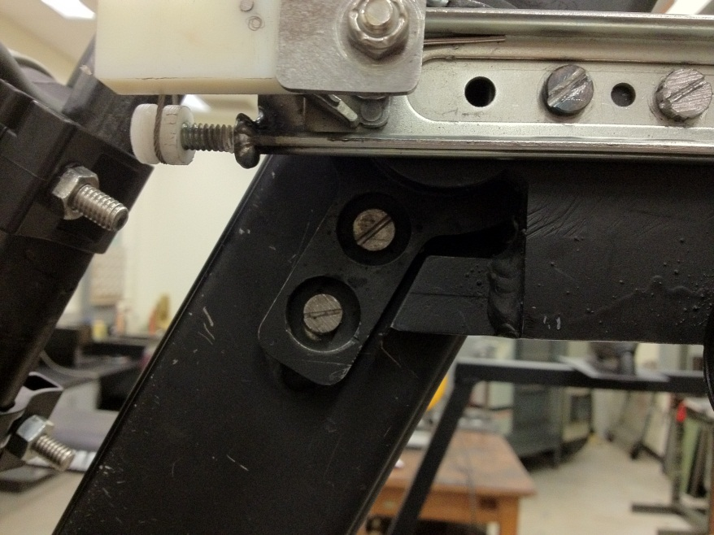
The rotation assembly attaches to the furthest extension of the 16” sliders and keeps the loading mechanism from rotating too far and hitting the roof of the vehicle, when in the stowed position, and keeps it from rotating too far and hitting the side of the vehicle when in the deployed position. The point of rotation is a high load bearing that is press fit into two steel brackets, one side attaches to the furthest extension of the 16” slider and the other attaches 10” in from the tip of the base of the 30” slider. The bearing bracket that attaches to the 16” slider has two additional features of interest. The first feature of the bracket is an offset tab that a bar is welded to in order to reduce twisting in the end of the furthest extension of the 16” slider. The second feature is an angled steel stop that the second half of the bearing bracket will rest on, this acts as a rotation stop that keeps the load mechanism from hitting the side of the vehicle, see Figure 6. The second rotation stop is two brackets that bolt to the back of the furthest extension of the 16” sliders, there is a bar welded between them that the load mechanism rests on when in the horizontal stowed position, keeping it from hitting the roof of the car, see Figure 7.
Angled steel rotation stop.

Load Mechanism:
Figure 6: Image of angled stop bracket.
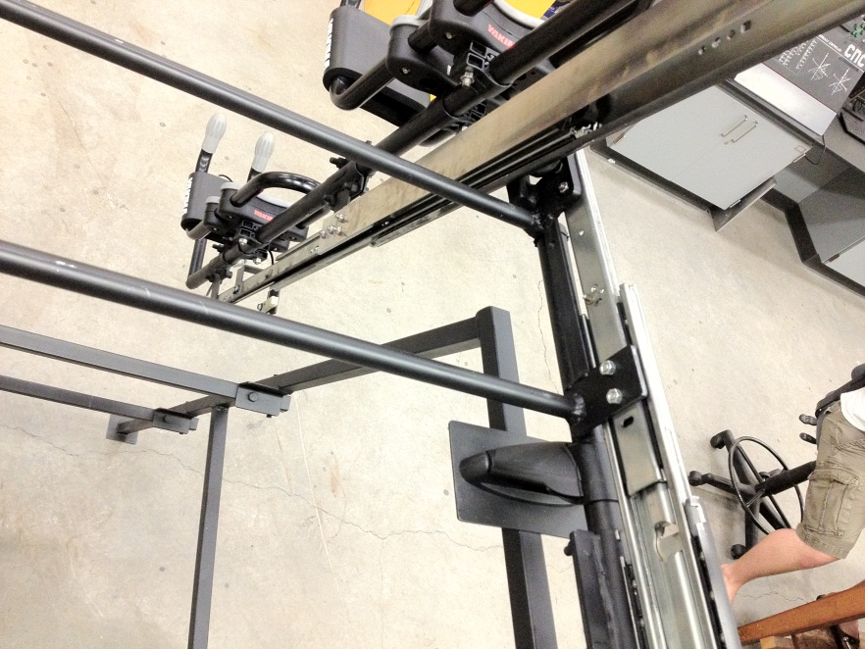
The load mechanism is the main part of the design; it lowers to the side of the vehicle and provides the load assist in lifting the kayak(s) to the top of the vehicle. The largest part of the load mechanism is the 30” sliders. The sliders bolt to the bearing housing bracket one third in from the tip of the slider base. The load assist is provided by a 40 lb. spring. The spring is mounted on a nylon roller. The nylon roller is bolted into a housing made of aluminum. The aluminum housing is bolted to the back of the 30” slider base and the tip of the spring is bolted to the back of the furthest extension of the slider by means of an aluminum bracket, see Figure 8. 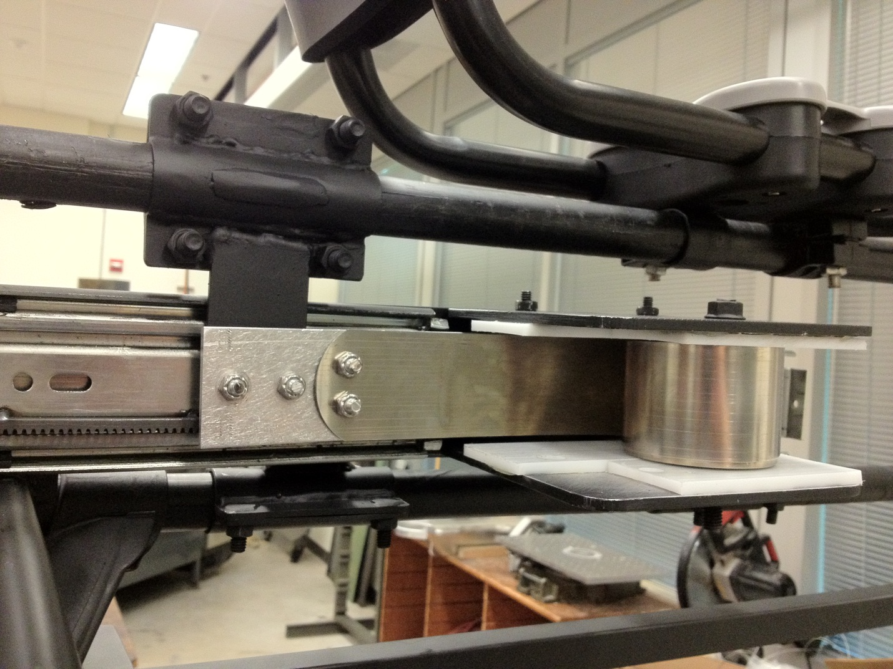
Figure 7: Image of horizontal rotation stop location.
Horizontal rotation stop.
Figure 8: Image of load assist mechanism assembly.
Constant force spring.
Aluminum spring mount bracket.
The kayak mount portion of the load mechanism attaches to the furthest extension of the 30” sliders by means of two brackets that bolt to the sliders and bolt around the upper pair of bomber bars, see Figure 8. The upper bomber bars are a standard Yakima product that has been modified by the addition of handles on one end. Standard Yakima kayak mounts are attached to the upper bomber bars. The kayak mounts were modified to mount the kayaks as close to the upper bomber bars as possible to bring the center of gravity closer to the rotation point in order to reduce the moment arm.
Spring housing
Upper bomber bar mount brackets.

Release Mechanism:
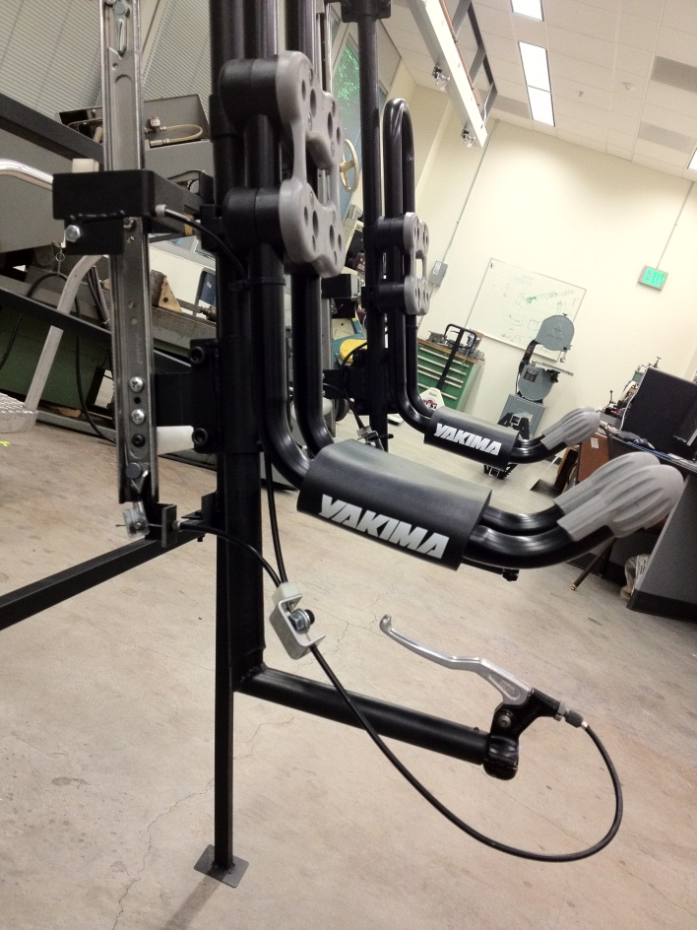
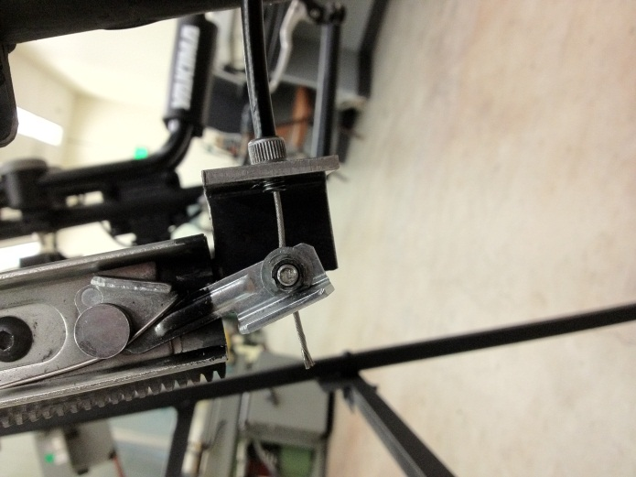
The release mechanism is made using bicycle brake handles and cables to actuate the manufacturers lock mechanism on the sliders. The bicycle brake handles are mounted to the end of the upper bomber bars at the handles, for ease of use, see Figure 9. The first cable exits the brake handle and goes to a cable splitter. The cable splitter is necessary so that each lock can be released from the same handle, the lock on the 30” slider and the lock on the 16” slider. The first cable goes directly to the 30” slider release by means of a bracket welded to the tip of the slider extension, see Figure 10. The second cable goes to a mechanism that is mounted to the 30” slider, see Figure 11. The mechanism is necessary because we want the 16” slider to be released only when the 30” slider is stowed, otherwise the base slider assembly could release and the load mechanism would impact the side of the vehicle. The 16” slider release mechanism operates by a cable actuated lever. The lever only contacts the lock release when the 30” slider is in the stowed position because the release mechanism is mounted to the furthest extension of the 30” slider and will disengage the 16” slider lock once the 30” slider is pulled out.
Figure 9: Image of release mechanism assembly.
Brake handle release.
Figure 10: Image of 30” slider release.
Cable splitter bracket.
Cable clamp
Manufacturer’s release tab.
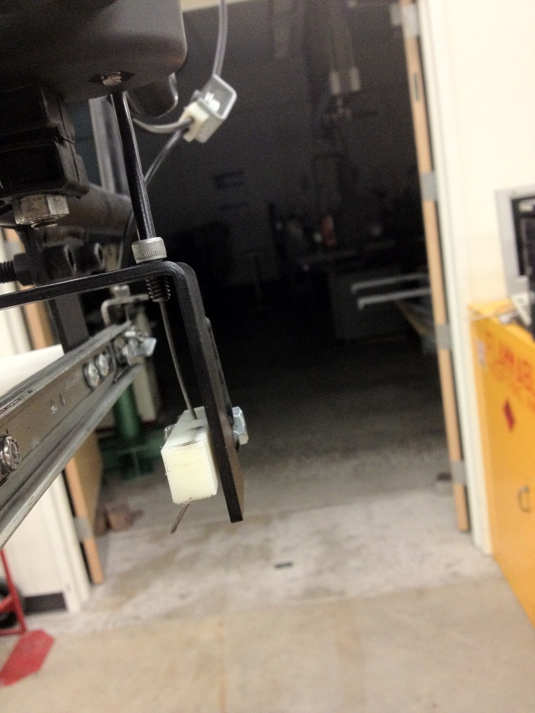
Release flipper
Cable tension adjustment screw
Slider release bracket
Figure 11: Image of 16” slider release mechanism.

Product Design Specification (PDS) Evaluation:

Ergonomics:
One of the key requirements is to make the system provide load assistance that would make the user apply low loading effort. The target was to make the system provide load assistance of 60 lbs. After the prototype was finished, the system was set to provide load assistance of 80lbs. That was done mainly to account for the weight of the parts of the system which is almost 20 lbs. Now the user gets 60 lbs. assistance when loading their kayak to the top of the car.
Another requirement was to provide the user with comfortable handles or levers that would allow for easier control and stability when the system is being used. This requirement was successfully accomplished by adding very comfortable handles.

Performance:
The ease of use requirement was met as it takes only four steps to make the system ready to load the kayak on and another three steps to securely place the system on the top of the car. Keeping the number of steps to use the system to a minimum made it easy to use and it takes only about half a minute to load or unload the user’s kayak.
The distance from ground to loading rack is 34 inches, which is two inches less than what it was in the specification. In order to achieve the target which is 36 inches a major cost increase had to be made. Therefore, the capstone team came up with a conclusion to just keep it to where it is at 34 inches, which is still in the acceptable range.
Using four perpendicular tabs that can be clamped to any round bars allows our system to be easily fitted to standard rack systems. That makes it much easier for the user to use as he/she doesn’t need to deal with any removal of the base rack system.
Unfortunately, to have the system make completely no audible sound was not accomplished. The noise and chatter during loading and unloading was kept to a minimum but the user can still hear it. This sound can be reduced by applying high viscous lubricating fluid on the constant-force-spring and slider bearings.

Life in Service:
What the team has built is just a working prototype; it is not applicable to say that our system will have no mechanical or structural failure for five years. This requirement was not of particular importance in the prototype phase.

Recyclability:
The Team was successful in making the entire system out of materials that are recyclable.

Maintenance:
The maintenance PDS requirement states that the product must use non-water-soluble lubricants and must withstand washing with mild soap and water. The reason for non-water-soluble lubricants is because the mechanism will be used in a wet environment and will also be washed whenever the vehicle owner washes their vehicle. The lubricants used in the prototype phase were only oil based lubricants, this fulfills the requirement. It is recommend that the owner lubricates the mechanism each time the vehicle is washed or every 10 uses, whichever is more often.

Safety:
The safety PDS requirement states that there must be no sharp edges and there must be no pinch points. During manufacture of the prototype many sharp edges are created, these edges were ground or sanded smooth. All sharp corners were ground to a fillet. There is only one pinch point in the entire design; it is the rotation stop that is welded onto the bearing bracket. This pinch point is considered acceptable because it is in an area that would be very difficult to get your hand during operation and is therefore considered acceptable risk. This requirement is not fulfilled but it is within acceptable limits.

Cost of Production:
The cost of production PDS requirement states that the cost of producing the prototype must be under 1000 dollars. This budget was later increased by our Yakima sponsors. We did nearly stay within the budget, however due to uncertainties in calculations and our sponsors desire that the prototype “feel” right we had to try a few combinations of springs and dampers. The overall cost of the prototype was greater than $1000; however the cost of the components that we actually used is within the budget. The PDS requirement of cost of production is met.

Environment:
The PDS requirement of environment states the all of the parts that we use must withstand a harsh and wet environment for five years without significant corrosion. We fulfilled this requirement by using parts that were zinc coated steel, aluminum or painted. The only part that may not fulfill this requirement is the spring. The spring has no special coating to protect it and if it were painted the paint would wear off quickly during use. As long as proper maintenance procedures are followed the spring should last five years, because it is to be lubricated with a non-water-soluble lubricant, which will form a barrier to corrosion. A weather-proof enclosure could also be added to protect the spring. The PDS requirement of environment is satisfied.

Materials:
The PDS requirement of materials states that we must construct the prototype using standard Yakima materials. Most of the prototype was made out of steel and the rest was made from aluminum, nylon and a few other readily available materials that Yakima did not have a standard material that we could use. The PDS requirement of materials is met.

Codes and Standards:
All Yakima products are subject to government regulations that give standards for any products used in vehicle applications. Yakima has developed their own in house standards that go beyond the government requirements. We did not have the capability to test our prototype to the Yakima standards. Yakima only wanted us to deliver a working prototype as a proof of concept. If Yakima does develop our prototype for the market then the testing standards would have to apply to that product. The PDS requirements of codes and standards is unmet, however we still fulfilled the design requirements that Yakima desired.

Conclusion:
Following the completion of the prototype, both Yakima Products, Inc. and our capstone team are very satisfied with the success of the top of car load assist prototype when measured against the PDS requirements. 8/10 PDS requirements were met successfully or within acceptable limits. The two requirements that were not met have little to no impact on the proof of concept Yakima was expecting the capstone group to complete. One is Life in service and the other is Codes and Standards. At the beginning of this project Yakima had stated that these are not critical PDS requirements, but they are requirements that they will be faced with in bringing the concept towards a marketable product and that the capstone group should keep these in mind during the design phase.
The PDS requirement that Yakima Products, Inc. was most interested in was that the prototype “feel right”. When the prototype was presented to Yakima they were very pleased with the ease of use and the amount of assist the system actually provided in loading a sea kayak onto the roof of a vehicle. Yakima Products, Inc. had expressed that this is a viable solution to the load assist problem and they will expand on the proof of concept further.

Appendix 1: Detailed PDS Criteria:
In this appendix, the detailed Product Design Specification is provided. These are the detailed specifications provided by the customer and turned into a table format by category. The requirements are divided into six sections including customer, requirement, metric, target, basis and verification. These six sections outline the entire requirement from who it is intended to satisfy, what is required, how it will be fulfilled, what the target is, the basis of the requirement and how the group would verify that the requirement has been implemented into the design.

Ergonomics:

Customer | Requirement | Metric | Target | Basis | Verification
Yakima | Low loading effort | Lbs. of lift assist | 60 lbs. | Customer Requirement | Measurement
Yakima | Comfortable handles or levers | Handles and levers | All | Physical testing | Customer verification

Documentation:

Customer | Requirement | Metric | Target | Basis | Verification
PSU | PDS Report | Completed Report | January 30, 2012 | Course requirements | Good Grade
PSU | Progress Report | Completed Report | March 12, 2012 | Course requirements | Good Grade
PSU | Final Design Report | Completed Report | June, 2012 | Course requirements | Good Grade

Life in Service:

Customer | Requirement | Metric | Target | Basis | Verification
Yakima | Product should have no mechanical or structural failures for 5 years of moderate use | Product life cycle | Theoretical life cycle of 5 years. | Yakima warranty standards | Testing

Disposal:

Customer | Requirement | Metric | Target | Basis | Verification
Yakima | Use only recyclable plastics | Plastic recyclability | 100% recyclable | Yakima recyclability standard | Customer definition and or standards

Maintenance:

Customer | Requirement | Metric | Target | Basis | Verification
Yakima | Non-water soluble lubricant on moving metal parts | Lubricant type | Use only non-water soluble lubricant | Chemical composition and lubricant manufacturer specs | Test Lubricant for non-water solubility
Yakima | Plastic parts to be cleaned with soft cloth and mild detergent | Plastic type | Use only plastics that can be cleaned with cloth and mild detergent | Customer definition | Test plastic for cleaning

Performance:
Customer | Requirement | Metric | Target | Basis | Verification
Yakima | Ease of use | Loading time | Load and lock bike or boat in less than 5 minutes | Customer definition and physical test | Testing
Yakima | Low reach distance | Distance from ground to loading rack | 36 inches from ground to rack in loading position | Height of 2011 Subaru Outback(64 inches) | Testing
Yakima | Should be easily fitted to standard rack systems | Modular design | No removal of base rack system | Customer definition | Testing
Yakima | No rattling when loaded or unloaded | Noise or chatter during loading and unloading process | No audible sound to loader | Customer defined | Testing

Safety:

Customer | Requirement | Metric | Target | Basis | Verification
Yakima | No sharp edges/corners | Number of sharp corners or edges | Zero | Customer Requirement | Inspection
Yakima | No pinch points | Number of pinch points | Zero | Customer Requirement | Inspection

Timeline:

Customer | Requirement | Metric | Target | Basis | Verification
PSU | PDS Report | Completed Report | January 30, 2012 | Course requirements | Good Grade
PSU | Progress Report | Completed Report | March 12, 2012 | Course requirements | Good Grade
PSU | Final Design Report | Completed Report | June, 2012 | Course requirements | Good Grade
Yakima | Final Product | Timely Completion | June 1, 2012 | Customer | Customer is Satisfied

Company Constraints and Procedures:
Customer | Requirement | Metric | Target | Basis | Verification
Yakima | Keep product inherently safe | N/A | Consider pinch points and potential user “misuse”. | Yakima Requirement | Inspection

Cost of production per part:
Customer | Requirement | Metric | Target | Basis | Verification
Yakima | Low retail price | Dollars | $1000 maximum | Customer feedback | Study of price in market

Environment:
Customer | Requirement | Metric | Target | Basis | Verification
Yakima | Operates in a harsh wet environment | Years of Resistance to rust and corrosion | 5 years | Group decision | Study of standards

Manufacturing facilities:
Customer | Requirement | Metric | Target | Basis | Verification
Project team and Yakima | Yakima provides facilities needed | Use of Yakima’s Facilities | No need to use other facilities | Customer input | Similar system comparison

Shipping:
Customer | Requirement | Metric | Target | Basis | Verification
Yakima | Fit in not too large shipping container | Cubic inches | 10” X 24” X 36” | Expert opinion | Study of standards

Materials:
Customer | Requirement | Metric | Target | Basis | Verification
Yakima | Product components | Yes/no | Typical Yakima materials | Yakima requirement | Inspection
Yakima | Aesthetics | Yes/no | Looks sturdy &  professional | Customer input | Inspection

Appendix 2: External Research:

The purpose of the external search is to examine competing products and identify the existing technologies that would be directly related to the design. The technologies that will be used to successfully satisfy the requirements of the PDS will be the primary focus of the external search.
The number of competing products on the market is very limited to a couple of direct competitors. Malone has a system that is fairly "low-tech" as it is a simple ratchet system and doesn’t actually provide any "load assist". The Malone system shown in Figure 3 was part of our external research as it is a kayak loader that is currently available on the market. The main competitor to Yakima's proposed top of car load assist is undoubtedly the Thule Hullavator. The Hullavator, shown in Figure 4 is a gas shock assisted kayak loader that uses a scissor and pivot motion to assist the user in loading one kayak from the side of the vehicle onto the roof of the vehicle.

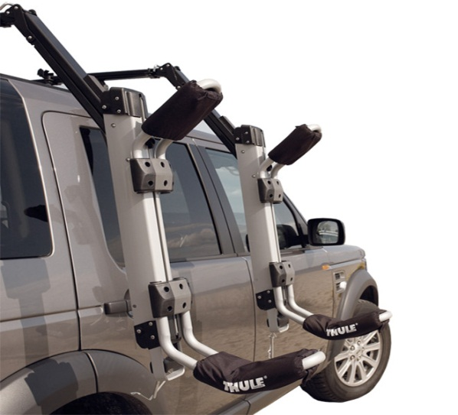
Figure 3: Malone kayak loader Figure 4: Thule Hullavator kayak load assist

The external search for the technologies we had available to use began in the most basic form of how to move a load/object from point A to point B. Various methods researched included pulley lever systems, scissor lift motions, pins/rails, bearings, linkages and mechanical sliders. The group settled on mechanical sliders to be the main weight bearing component due to the strength, weight and cost of the component. Once the group had decided that a mechanical slider would be used in the lift assist mechanism, a cost of material and extension vs. load rating analysis needed to be performed. Aluminum mechanical sliders held acceptable load ratings and excellent overall weight, but the price per unit would not satisfy the PDS requirement of low cost. Mechanical sliders made from steel turned out to be the best option for the load assist based on load rating and cost. The added weight of using steel components to aluminum was not favorable but still within acceptable limits for the project.
Further research on how to provide the load lift assist resulted in using either gas shocks or constant force springs paired with dampers. Both the constant force springs paired with dampers and the gas shocks provided the load assist required as well as similar benefits when comparing cost per load assist. Gas shocks would work excellent for the application as they would provide load assist and damping in the same unit. Gas shocks unfortunately are difficult to store in the system as space is limited when the system is fully collapsed in the stored load state. Constant force springs provided the benefits of low cost, low maintenance, storability and adequate load assistance.

Appendix 3: Internal Research:

Internal Search:
The capstone team went through the process of brainstorming to generate ideas and concepts to successfully fulfill the PDS requirements set forth by the customer. The main PDS criteria that lead the brainstorming phase was usability, low-cost, amount of load assist and the industry standards shown in Appendix 8.
The usability of the load assist system is defined as the ease of use by the end user; the system must feel natural while operating. The system must also be designed in a way such that the amount of possible pinch points is eliminated completely or reduced to a minimum.
The cost of each component was taken into consideration during the brainstorming phase with the goal of utilizing as many existing Yakima products as possible. The mechanical slides were evaluated for cost per extension length as these would be the most expensive component in the system. The constant force springs were relatively low in cost and did not impact the design much.
The scope of the project was slightly modified in the 11th hour after a progress report meeting with our industry sponsors. Yakima had suggested a minor design modification to allow for two kayaks to be loaded rather than just one. As a result of this, the group had to re-evaluate the load assist method. Constant force springs were still the primary choice after listing the pros and cons against a gas shock. The constant force springs were found to supply sufficient load assist for the new requirement along with reduced maintenance, lower cost and better storage capability.

Appendix 4: Bill of Materials:
BILL OF MATERIAL – YAKIMA T.O.C LOAD ASSIST
DWG NO. | DESCRIPTION | QTY. | SIZE/DIMENSION
Yakima Part | Landing Pads | 4 | -
Yakima Part | Control Towers | 4 | -
Yakima Part | Bomber Bars | 2 | Set of 58 in.
Yakima Part | J-Cradles | 2 | Set
91251A442* | Socket Head Cap Screw | 32 | 1” LG X Ø0.375”
93827A228* | Hex Nut | 32 | Ø0.25” - 20
04112012T | Perpendicular bracket tabs | 4 | See Dwg.
91735A537* | Pan Head Phillips Machine Screws | 32 | 0.5” LG X Ø0.50”
90101A230* | Hex Locknuts (Nylon) | 15 | Ø0.25” - 20
04282012BL | Custom Partially Threaded Bolts | 8
6603A44* | Industrial Sliders | 2 | 2 Locking Sides 16”
6603A52* | Industrial Sliders | 2 | 2 Locking Sides 30”
- | Nylon Handles | 2 | Ø1.125”
04302012A | Aluminum Angle Iron | 8 | See Dwg.
04282012 | Torsion Bar W/ angle stop | 1 | See Dwg.
04112012T2 | Parallel Bracket Tabs | 4 | See Dwg.
- | Double threaded Pin (housing) | 2 | Ø0.375” X 1” thd. each side
04302012L/R | Side Walls (housing) | 4 | See Dwg.
04302012S | Nylon Spool (housing) | 2 | See Dwg.
04302012B | Bottom Plate (housing) | 2 | See Dwg.
91735A542* | Pan Head Phillips Machine Screws | 2 | 1” Lg X ¼”-20
- | Spring mounting plate (to slider) | 2 | 2” X 4” X .125” thk.
9293K14* | Constant Force Spring | 2 | 40.14 lb. force
4768K1* | High load Steel Ball Bearing | 2 | 2595 lb.
04162012S | Bearing Bracket (For ID of Bearing) | 2 | See Dwg.
04162012B | Bearing Bracket (For OD of Bearing) | 2 | See Dwg.
- | Torsion Spring (for left slider lock) | 2 | -
- | Bicycle Brake Handle | 2 | -
- | Nylon Shaft (handles) | 2 | Ø0.88”
- | Steel hollow bar (at 20 degrees) | 2 | 8” Lg. X Ø1.00”
- | Bike Cable (and housing) | 6 | -
- | Cable splitter and splitter bracket | 2 | -
- | Tab lifting kit (right side) | 1 | -
- | Nylon plate (housing) | 4 | 4” X 4” X 0.25” Thk.

Appendix 5: Operation Manual:

Operation Manual: Yakima top of car kayak load assist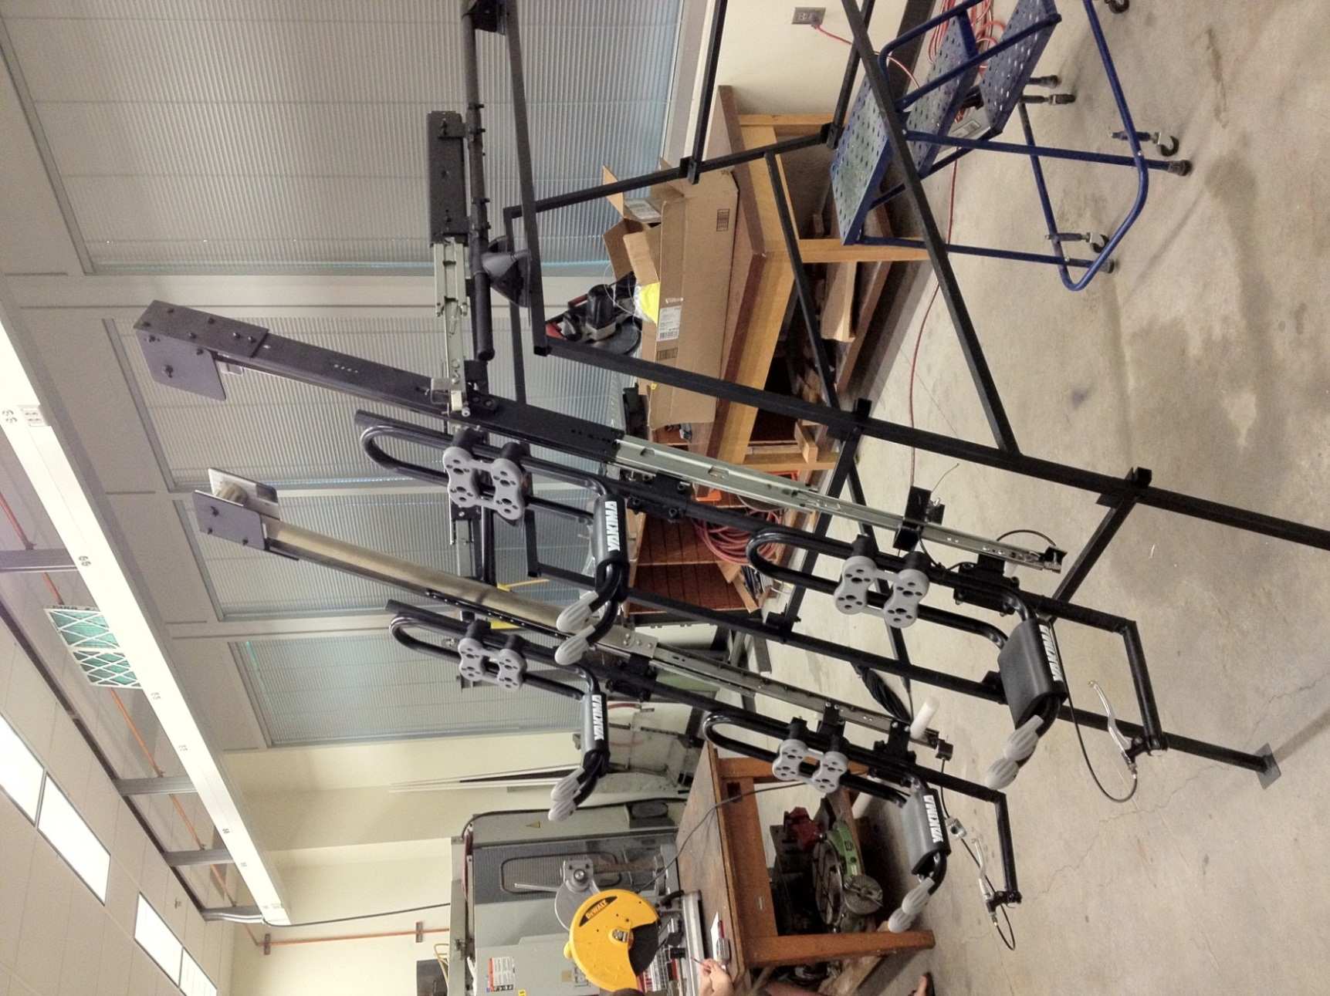
Figure 5.1: Image of complete prototype in the deployed position.
Loading Instructions
Step 1: Grasp both brake levers firmly and pull straight out in a horizontal direction. 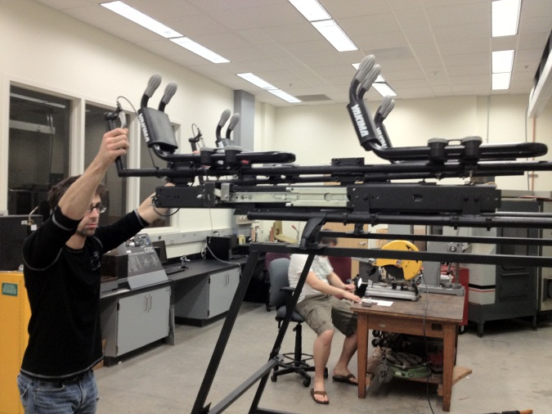
Figure 5.2: step one
Step 2: Grab the right handle only and rotate the loader until it stops.
Step 3: Grasp the right brake lever and pull the loader out. Warning: you must release the brake lever for the loader to lock in the extended position. If the loader is not locked when you let go of the handle then the loader will slam closed and may cause serious injury and may damage the loader.
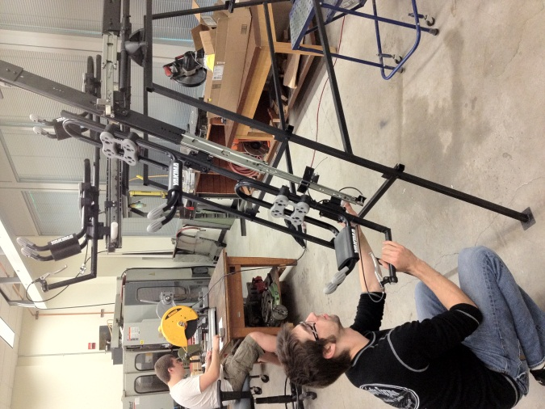
Figure 5.3: Step three
Step 4: Repeat steps 2 and 3 for the left side.
Step 5: Carefully load the kayak onto the J-cradles. If you are loading two kayaks make sure to load the upper J-cradle first.
Step 6: Secure the kayak to the J-cradles according to Yakima instructions.
Step 7: Center yourself between the two loader handles and crouch. Grasp both brake handles at the same time and push the loader up using your legs to lift.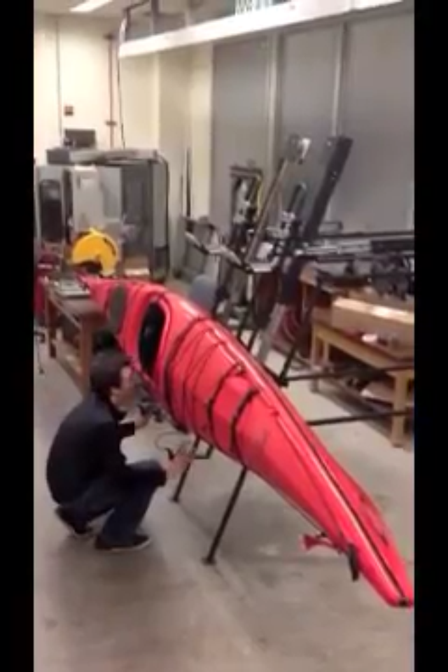
Figure 5.4: Step seven
Step 8: Once the loader is fully collapsed allow the loader to rotate to a horizontal position.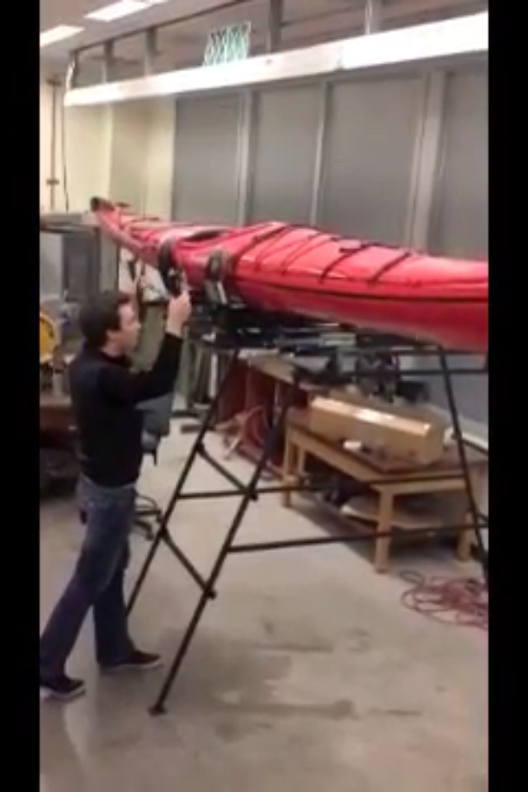
Figure 5.5: Step eight
Step 9: Grasp both brake levers and push the loader back over the center of the vehicle.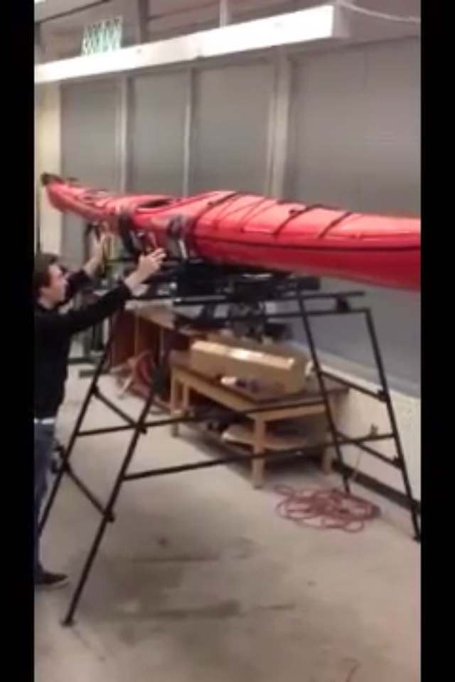
Figure 5.6: Step nine
Step 10: Make sure that all locks are engaged. You must release the brake handles for the locks to engage. Warning: if the locks are not engaged the loader may shift during driving and may damage the loader, kayak and vehicle.
Unloading Instructions
Step 1: Grasp both brake levers firmly and pull straight out in a horizontal direction.
Figure 5.7: Step one
Step 2: Grab both handles and rotate the loader until it stops.
Step 3: Squeeze both brake levers at the same time. Pull the loader out from both handles until it is fully extended. Warning: if you do not squeeze both levers at the same time the loader may jam and may cause damage to the loader or kayak.
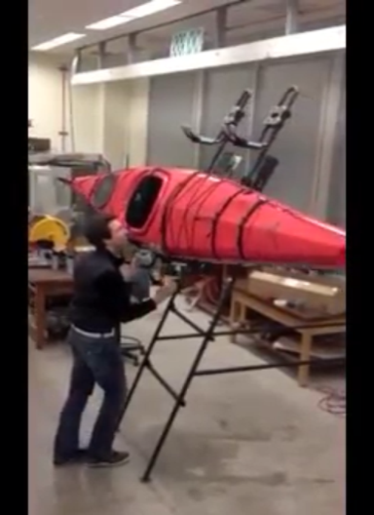
Figure 5.8: Step three
Step 4: Make sure that all locks are engaged. Warning: if you remove the kayak from the loader without all locks engaged the loader may slam closed causing damage.
Step 5: Grasp the right handle firmly and pull the brake lever. Slowly allow the loader to retract into the closed position and rotate to horizontal. Warning: Make sure you have a firm hold on the handle before you pull the brake lever. If you do not have a firm grasp you may slip and the loader will slam closed and may cause damage.
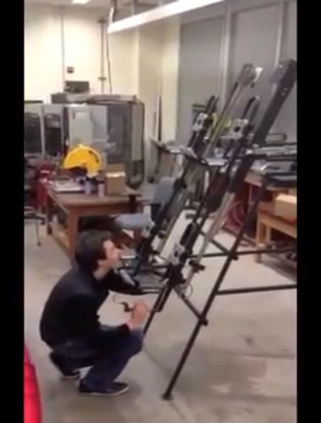
Figure 5.9: Step five

Appendix 6: Service Manual
Service Manual
To get the most out of your new kayak load assist a few points of maintenance are required. There are a few parts that require regular lubrication and a good cleaning after use in harsh environments is recommended.
Lubrication: The sliders on your kayak loader have several high precision bearings and high force coil springs. If debris gets into these sliders or springs it will cause wear and will shorten the life of your loader. Regular cleaning and lubrication will extend the life of your loader. It is recommended that you clean and lubricate both the sliders and springs once every 10 uses or every time you was your vehicle, whichever is more often.

Appendix 7: Assembly Procedures
The overall assembly is broken up into sub-assemblies as follows
Note: Some of the Assembly procedures may require two people.

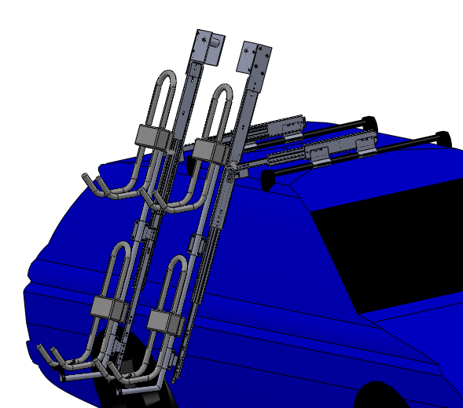
Figure 7.1: Model Showing the Full Assembly

Small Sliders Assembly:
Step 1: Clamp two perpendicular tabs on the bomber bar using ½ in bolts as shown in Figure 7.2
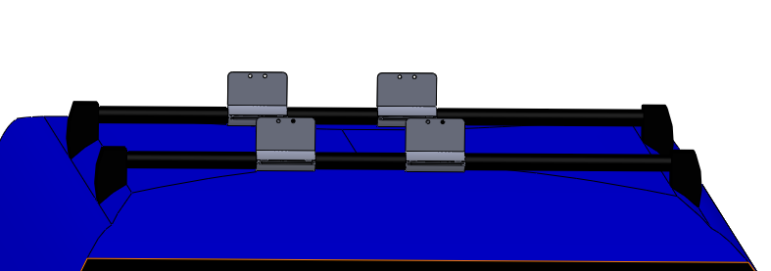
Figure 7.2: Model showing the perpendicular tabs mounted on the bomber bars.
Step 2: Do the same on the other bomber bar.
Step 3: Mount the first 16 inch sliders to the perpendicular tabs using ¼ inch bolts as shown in Figure 7.3
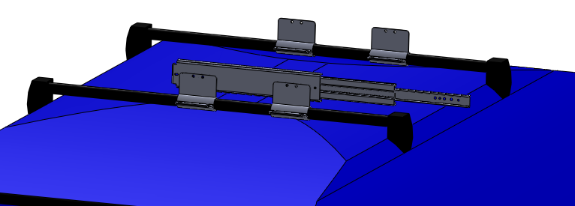
Figure 7.3: Model showing the 16" slider mounted to the perpendicular tabs.
Step 4: Now connect the two 16 inch sliders together by mounting the Rotation Assembly to them as shown in Figure 7.4. Use the costumed bolts for the Bearing Bracket tabs and ¼ bolts for the Rotation Stop tabs.
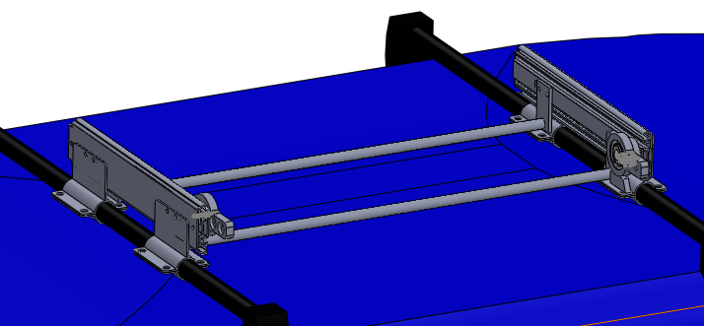
Figure 7.4: Model showing the Rotational Assembly connecting the two 16" sliders.

Large Sliders Assembly:
Step 1: Prepare the contestant-force-spring housing as sown in Figure 7.5
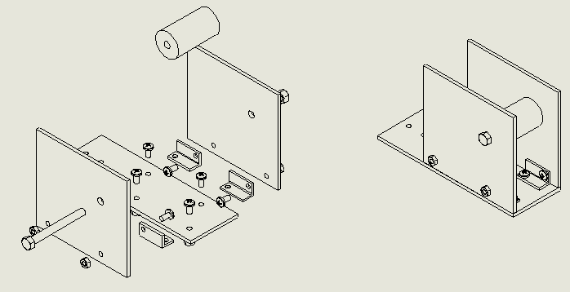
Figure 7.5: Image showing the method of assembling the spring housing.
Step 2: Install the vertical tab and the Aluminum Spring-Mount-Bracket to the 30 inch slider using ¼ inch blots as shown in Figure 7.6. Make sure separate the vertical tab and Spring-Mount-Bracket by a nut.
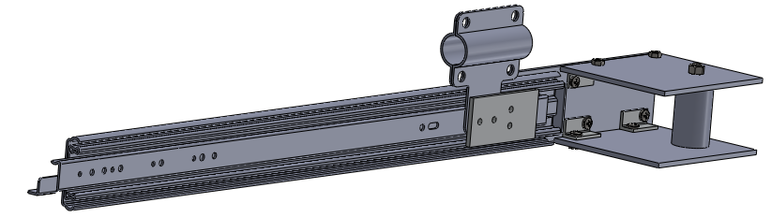
Figure 7.5: Model showing the orientation the vertical and spring bracket positioning.
Step 3: Connect the tip of the spring to the Aluminum Spring-Mount-Bracket and as shown in Figure 7.7
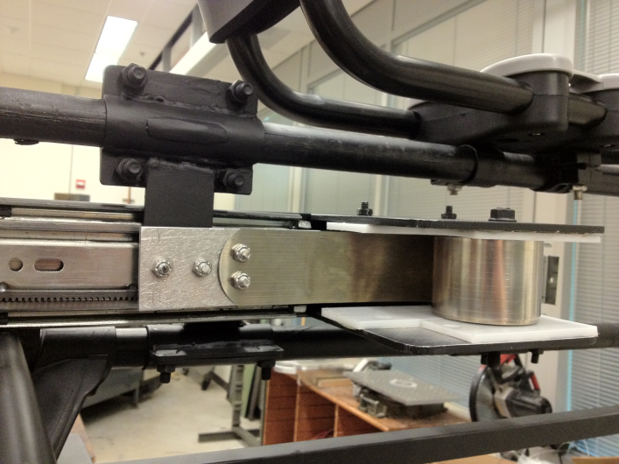
Figure 7.7: Model showing the orientation of connecting the spring and bracket together.
Step 4: Note: This Assembly procedure requires two people.
Put the 30 inch slider in a collapse position. One person pull the spring carefully into the spring housing. The next person insert the nylon roller and position it inline with the blot holes and then insert the spring axle blot. Make sure that all the nuts are tightened for security. Be very cautious when extending the 30 inch slider as the spring is now engaged and may cause harm when it not used carefully.

Step 5: Now, Using the costumed bolts, mount the 30 inch slider to the Bearing Bracket tab in the Rotation Assembly. As Shown in Figure7.8
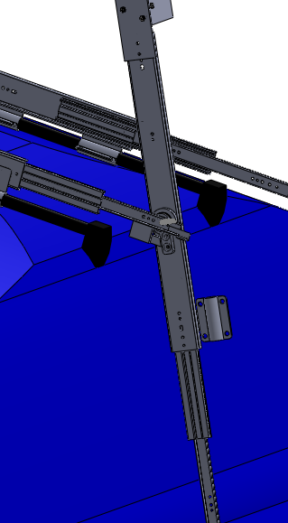
Figure 7.8: Model showing how the 30" slider is mounted to the bearing bracket.
Step 6: Repeat steps 1 through 5 to assemble the next 30 inch slider.

J-Cradles and Handles Assembly:
Step 1: Connect a vertical tab to the 30 inch slider using ¼ inch blots as shown in Figure 7.9
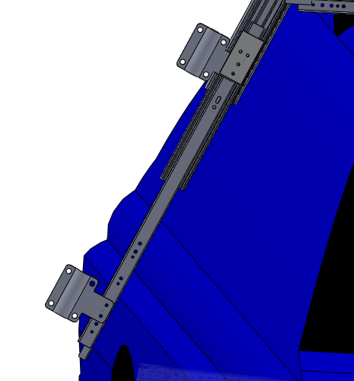
Figure 7.9: showing where the vertical tab should be attached on the 30" slider.
Step 2: Clamp one of the upper bomber bars to the vertical tabs as shown in Figure 9.10
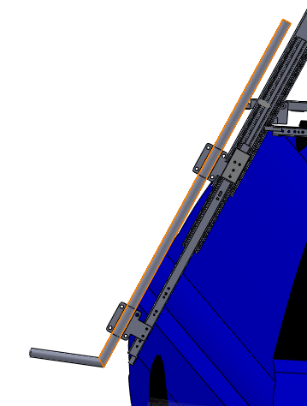
Figure 7.10: Model showing the orientation of the bomber bar before its clamped to the vertical tabs.
Step 3: Prepare the J-Cradles by flowing the J-Cradles Assembly guide.
Step 4: Mount the J-Cradles to the upper bomber bar using the associated special J-Cradles blots and nuts as shown in Figure 7.11
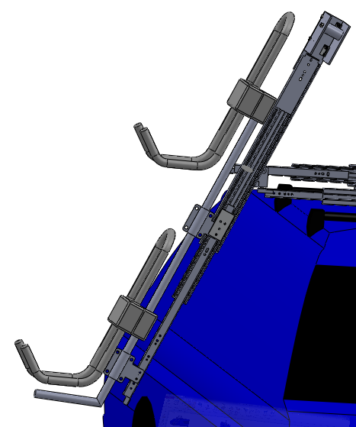
Figure 7.11: Model showing the orientation of the J-Cradles when mounted on the bomber bar.
Step 5: Mount the brake handles to the tip of the bomber bar handles using a hex wrench.

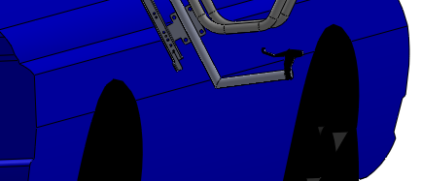
Figure 7.12: Model Showing the orientation of attaching the brake handle.
Step 6: Insert the brake cable tip into the brake handle and slide the first piece of cable housing onto the brake cable.
Step 7: Slide the cable into the cable splitter bracket and slide the cable clamp onto the cable, then slide the cable out the other side of the cable splitter bracket.
Step 8: Slide the second piece of cable into the cable splitter and into the cable clamp, then tighten the cable clamp on both pieces of cable.
Step 9: Slide the second piece of cable housing onto one of the cables coming out of the cable splitter bracket, then slide the cable through the bracket on the tip of the 30” slider and into the cable clamp on the slider lock. Make sure that all the slack is taken out of the cable and housing and then tighten the cable clamp.
Step 10: Slide the third piece of cable housing onto the second cable coming out of the cable splitter bracket, then slide the cable through the bracket that is mounted a third up from the end of the 30” slider. Then slide the cable through the lock release lever.
Step 11: With the 16” sliders fully extended and the 30” sliders closed and in a horizontal position, take up all of the slack in the cable and housing. Make sure that the lock release lever is touching the lock release of the 16” slider, and then tighten the set screw to clamp the cable in place.
Step 12: Adjust all of the cable tensioner screws so that the cable release mechanism operates as desired.
Step 13: Repeat steps 1 through 12 to assemble the next set of J-Cradles and Handles.

Appendix 8: Yakima Test Standards
In this appendix, you will find the industry along with Yakima internal standards for testing and performance. The ISO and DIN standards are industry standards that Yakima must abide by for this market. The YS is an internal Yakima standard that is derived from the industry standards. Yakima internal standards are set in a way such that they meet or exceed the ISO and DIN standards.
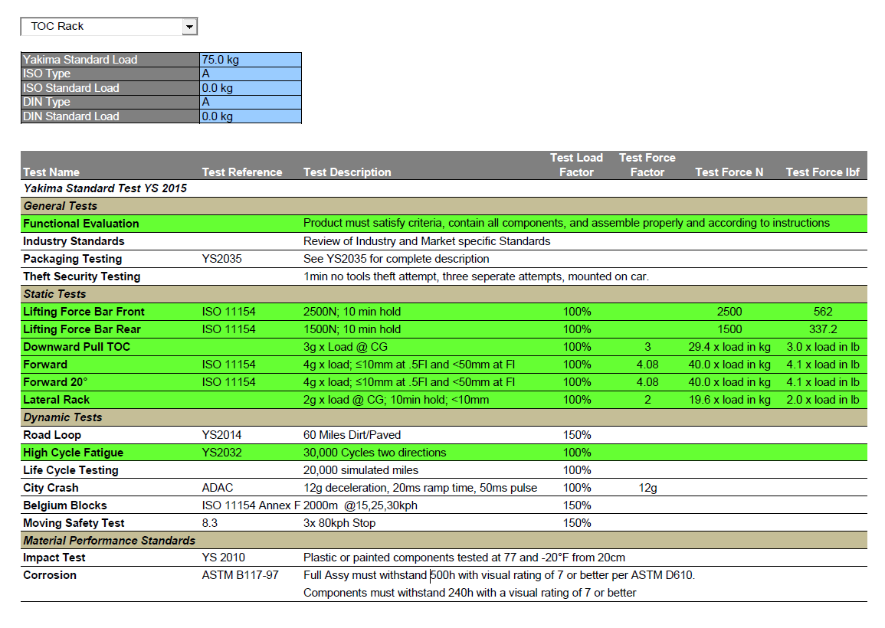
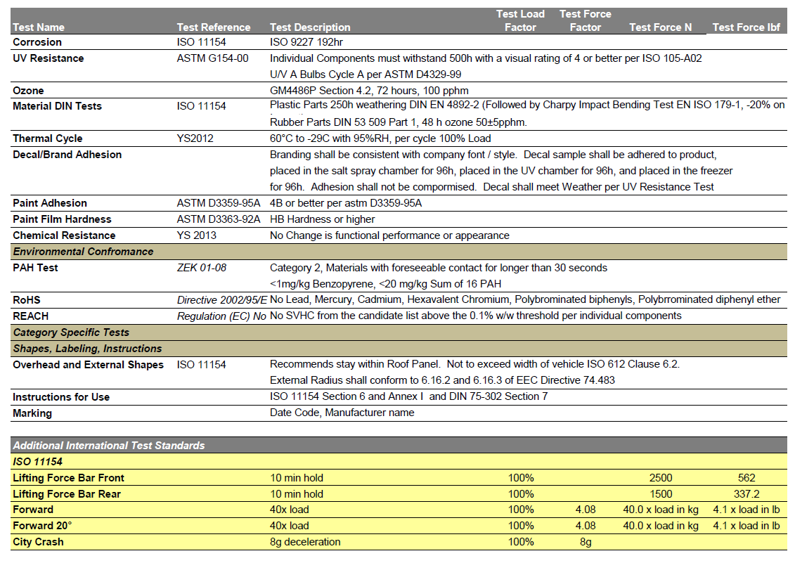
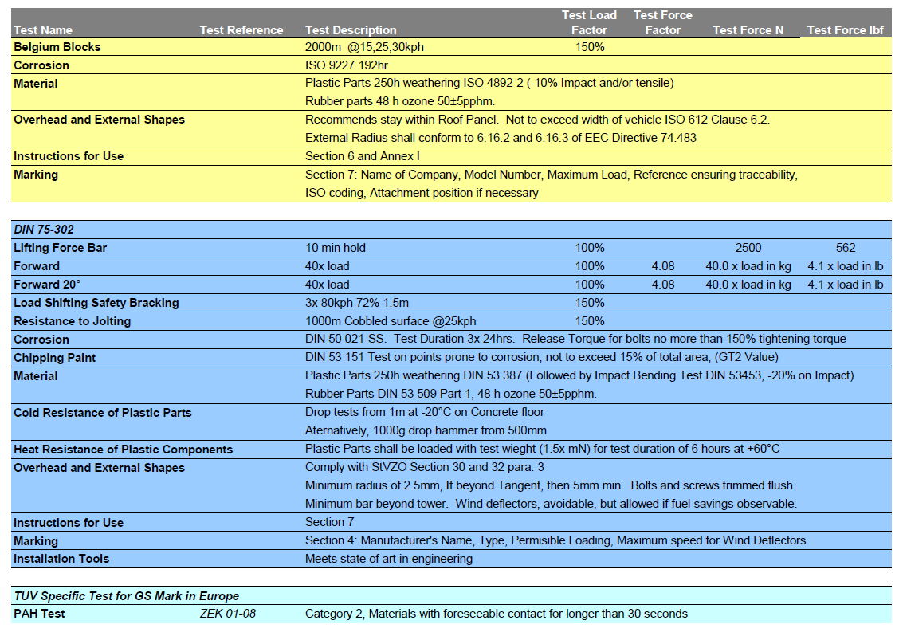

Appendix 9: Stress analysis on mechanical slider

Introduction
This experiment will identify the weakest areas of a member in a vehicle payload transportation system and compare an area of high stress with a theoretical model of the system. The main objective of this experiment is to experimentally obtain strain measurements in order to approximate the stresses in a critical area of the mechanical structure that is being subjected to a variety of loads. The structure being analyzed, as shown in Figure 9.1, is an industrial drawer slide that is designed for use in a variety of heavy duty storage applications. This slide is going to be installed and used for a top-of-car load assist as shown in Figure 9.2. The Top-of-carload assist is a multiuse loading and storage rack system for vehicle transportation of a variety of load configurations and materials. The rack system has many uses and can be modified to carry sports equipment, crates or boxes, building materials, and is being designed specifically for carrying kayaks and canoes. In the experiments the strain measurements obtained will be used to calculate the stress the apparatus is subjected to and compare the results to a theoretical model using finite element software. Under a variety of loads the data plots of stress versus applied load are analyzed and the theoretical results are compared to the experimentally obtained results.
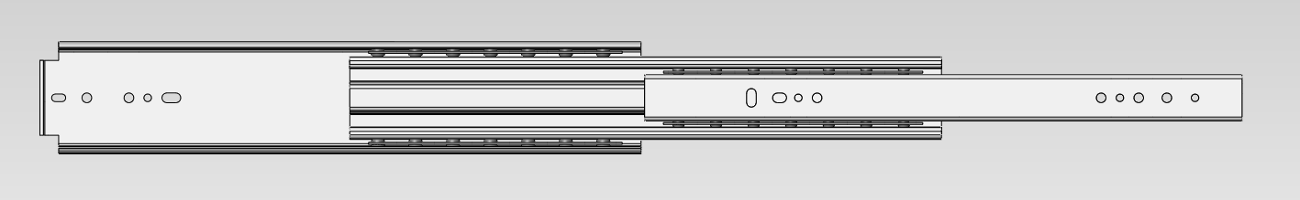
Figure 9.1: Full extension Drawer Slide

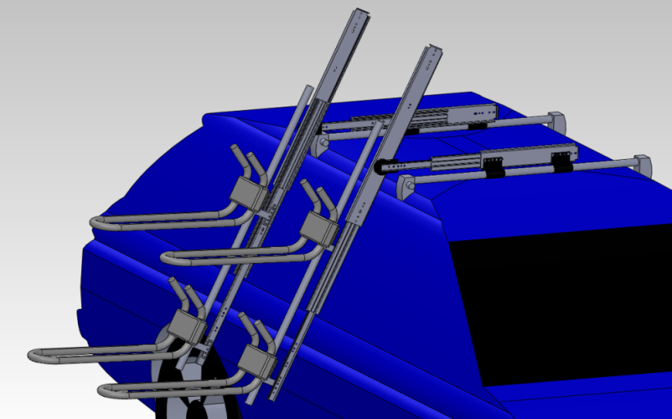
Figure 9.2: Vehicle payload transportation system

Theory
Measured stress and strain [1]
The slider is subjected to a load applied at the free end. The load will cause a plane stress/strain condition on the surface of the slider in which the strain will be measured in both the vertical and horizontal directions. The strain gauge is used as a resistor in a Wheatstone circuit to measure the change in resistance by outputting the voltage [2], described by
(1)
solving for strain ε
$ε=\frac{4V_{o}}{V_{ex }A F}$ (2)
Where $ε$ is strain, $V_{o}$ is the output voltage reading (V), $V_{ex}$is the excitation (input) voltage (V), F is the gage factor – provided by gage manufacturer (typ. ~ 2.05), and A is the strain gage circuit amplifier gain (external amplifier unit, typ. ~100). After getting result of the strain, stress can then be found using plane strain/stress theory, where the von Mises stress [4] is
$σ^{'}= \sqrt{{σ_{x}}^{2}-σ_{y}σ_{x}+{σ_{y}}^{2}+3 τ_{xy}^{2}}$ (3)

Where for two-dimensional geometry, subject to tensile loads in both x and y, the normal stresses and shear stress [4] is

$σ_{y}=\frac{E_{m}(ε_{y}+v_{p}ε_{x})}{1-v_{p}^{2}}$ (4)
$σ_{x}=\frac{E_{m}(ε_{x}+v_{p}ε_{y})}{1-v_{p}^{2}}$ (5)
$τ_{xy}=\frac{VQ}{Ib}$ (6)

Where $v_{p}$ is Poisson’s ratio,$E_{m}$ is the modulus of elasticity, V is the shear force, I is the moment of inertia and b is the width of the section. The first moment of area Q is defined as
$Q=\overline{y^{'}}A'$ (7)
Where $\overline{y^{'}}$ is the distance in the y direction from the neutral plane to the centroid area A’.
Theoretical Stress
The slider was modeled using Solidworks to perform finite element analysis. Load, dimensions, material properties, and all other boundary conditions were specified using the technical data sheet provided by the slide manufacturer to achieve the most accurate simulation ofthe behavior of the actual system. The F.E.A. helped with identifying the location of maximum stress and the theoretical values of stress under different loading conditions.
Methods and Apparatus
Materials
- A 16 in Slider
- A Rectangular Rosettes strain gauge
- A Flat steel plate (2X2 feet)
- ProtoBoard
- Three high precision 120 Ohm resistors
- Three c-clamps
- Signal amplifier
- Digital voltmeter
- Variety of different weights (18 lb up to 167lb)
Procedure
The finite element analysis showed the area of highest stress in the part was where the sliding member contacts the bearing closest to the free end, and the bending stresses in the region directly above this (see Figure 9.3).
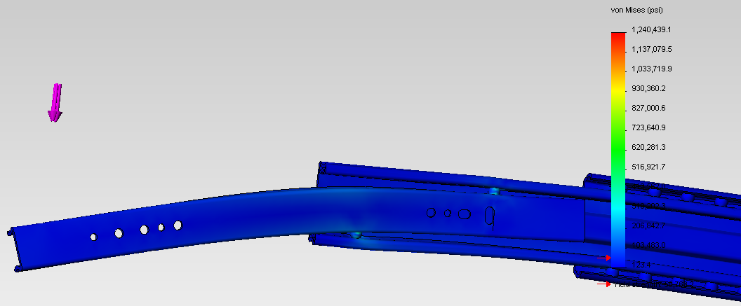

Figure 9.3: Finite element simulation showing areas of high stress when a point load is applied.
Due to the difficulty of mounting a strain gage on the surface of a 0.25 inch diameter ball bearing or the contacted surface of the slider, the strain gauge was mounted as close as possible to the area of maximum stress found in the F.E.A. (see Figure 9.5).
After the area of interest was found, a Rectangular Rosettes strain gauge was mounted on the surface of the slider in accordance to the installation instructions provided by Vishay Micro-Measurements (see Figure 9.5).
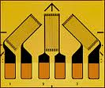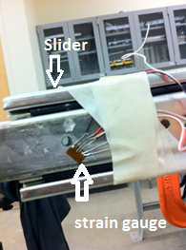
Figure 9.4: A Rectangular Rosettes strain gauge. [3] Figure 9.5: strain gauge mounted at the area of interest on slider.
The part (Slider) was then placed and bolted firmly on a flat steel surface which then was secured to the table using 3 c-clamps (see Figure 9.6a and 9.6b).
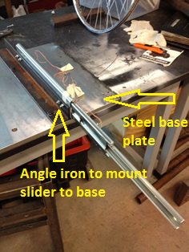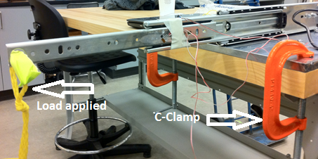
Figure 9.6a Figure 9.6b
Figure 9.6a, 9.6b: Mounting of slider and steel base which clamped to the table.
A Wheatstone bridge circuit was constructed with three high precision 120 Ohm resistors mounted on a ProtoBoard (see Figure 9.7). The strain gauge was set to be the 4th resistive element in the Wheatstone bridge (see Appendix 9-A).
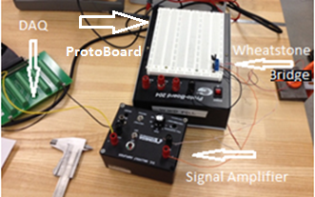
Figure 9.7: Strain gauge orientation and location, and circuit to DAQ setup.
The outputs of the Wheatstone bridge give a value of the voltage drop across the circuit. The bridge transmits the voltage drop to a signal amplifier. The amplifier delivers its output to a data acquisition system (DAQ) which in turn feeds the information to a Labview program (see Appendix). The LabView program collects data for a total of 10 seconds at a sampling rate of 500 Hertz. After making sure the slider is fully extended, the Labview program was ran to begin collecting data for the zero load condition. A total of 6 different loads were applied to the free end of the slider beginning with 18 pounds and a final load of 167 pounds (see Figure 9.8)
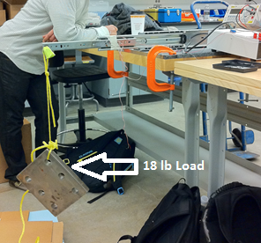
Figure 9.8: 18 lbs. load applied downward at the free end of the extended slider.
Data Analysis
Figure 9.9 compares the experimental and theoretical values of von Mises stress obtained from the experiment. The strain was measured in the horizontal and vertical directions at the area of interest. The strain was found by converting the input voltages from the strain gauges to strain using Eqn. 2. Since the area of interest is subjected to strain in two directions the stresses in the x and y directions, horizontal and vertical directions respectively, were found using Eqns. 4 and 5. After the shear stress was calculated using Eqn. 6, the von Misesstress was found using Eqn. 3. As shown in table 9.1 the theoretical results at most differ from the experimental by approximately 15%.

Figure 9.9: Comparing theoretical and experimental von Mises stresses for
6 different loads applied to the free end of the slider

Table 9.1: Theoretical and experimental von Mises found from measured strain and F.E.A.
Note: Notice the percent difference from theoretical and experimental range from 3.2% to 14.9%.
Applied Load (lbs) | Experimental von Mises stress (psi) | Theoretical von Mises stress (psi) | % Error from Theoretical
0 | 0 | 0 | 0
18 | 3012.1 | 2685.9 | 12.1
38 | 5796.9 | 5614.9 | 3.2
79 | 12485.6 | 11619.5 | 7.5
107 | 17397.8 | 15720.1 | 10.7
137 | 21922.1 | 20113.7 | 9.0
167 | 28156.7 | 24507.3 | 14.9

Discussion
As can be seen in table 9.1, the theoretical F.E.A. results differ from the experimental results by at most 14.9%. There are many sources of uncertainty in the experiment. Some are based on the uncertainty in the measurements taken and others are from the theoretical model we used and assumptions we made in order to calculate the theoretical stress (see Appendix 9-B). Although great care was taken to model the three-dimensional slider accurately, the actual geometry differs slightly from the model. The material the slider was made from was said to be cold rolled steel and the elastic modulus may differ from the published value we used and the actual elastic modulus of the material.
Conclusion
The von Mises stress, at a location subjected to high stress, in a telescoping member of a drawer slide assembly was found experimentally by analyzing the voltage generated by a strain gauge mounted on the surface. The maximum stress was found to be approximately 28 ksi when a 167 lb load was applied to the free end, which is approximately 15% higher than the theoretical finite element model generated. The error is a consequence of the combination of errors in the measurement as well as the model used in finite element analysis.
Due to the complicated geometry of the slider and the unusual loading conditions it is subjected to we cannot definitively conclude whether the majority of the error is most likely due to the finite element results or the assumptions and measurements used to find the experimental stress. In order to get more accurate results the material properties of the slider could be experimentally found and used in the analysis.

References
[1] Figliola, R.S. and Beasley, D.E., Theory and Design for Mechanical Measurements. (chapter 11) 4th Edition. John Wiley and Sons. 2006.
[2] ME 411 Measurement Class Lab Packet Experiment 2 (Winter 2012).Portland State University.
[3] Rectangular Rosettes. (2012, 3 18). Retrieved from Vishay Micro-Measurements: http://www.vishaypg.com/micro-measurements/

[4] Shigley, J.E., Mechanical Engineering Design, (3rd edit.), McGraw-Hill Book Co. 1977

Appendices
Appendix 9-A
Figures showing Wheatstone Bridge and LabView VI used to acquire data from the strain gauges.
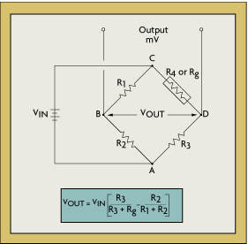
Figure 9.10: Circuit diagram for Wheatstone Bridge used in data acquisition. [2]

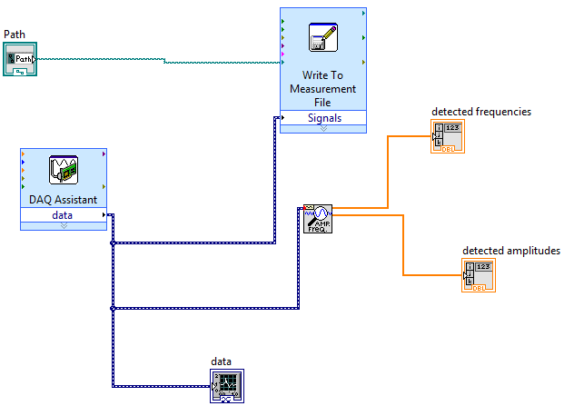
Figure 9.11: Labview VI used to acquire data from the strain gage, write the data to a text file and display the frequency of the measured vibration (damped natural frequency)

Appendix 9-B
Uncertainty Analysis
The error as a percentage of axial strain is described as
$e_{L}=\frac{K_{t}(\frac{ε_{L}}{ε_{a}}+v_{p0})}{1-v_{p0}K_{t}}*100$ (8)
Where $ε_{a},ε_{L}$are the axial and lateral strains, respectively (with respect to the axis of the gauge),${ v}_{p0}$ is the Poisson’s ratio of the material, $e_{L}$ is the error as a percentage of axial strain (with respect to the axis of the gauge), and $K_{t}$ is lateral (transverse) sensitivity of the strain gauge.
Table 9.2: Axial strain error of strain gauge
subjected to different loads
Applied Load | Percent error of axial strain
0 | 0
18 | 0.63
38 | 0.85
79 | 0.87
107 | 0.88
137 | 0.79
167 | 0.85

An inexpensive dial scale was used to measure the steel plates used for the applied loads. The resolution of the scale is 1 lbs approximately and is said to vary in accuracy by as much as 5% of the weight applied. The most weight the scale was used to measure was 41 lbs. Table 9.3 shows the uncertainty in the weights used in the experiment.
Table 9.3: Uncertainty of individual weight measurements
Weight (lbs) | 5% error in measurement (lbs) | Uncertainty in measurement (lbs)
18 | 0.9 | 1.9
20 | 1 | 2
28 | 1.4 | 2.4
30 | 1.5 | 2.5
30 | 1.5 | 2.5
41 | 2.05 | 3.05

Since the combination of weights was too large and dangerous to weigh at once, each individual weight was placed on the scale and then marked. For example if we placed 79 lbs of weight on the slider we really placed (18 + 20 + 41) lbs (i.e. we did not measure the weight to be 79 lbs we simply added the values of the weights). As can be seen from table 9.4 this becomes a major source of error in measurement since each time you add a weight the uncertainty of the preceding weights is added to.
Table 9.4: Combined uncertainty of weight measurements
Weight Total (lbs) | Combined uncertainty (lbs)
18 | 1.9
38 | 3.9
79 | 6.95
107 | 9.35
137 | 11.85
167 | 14.35

Table 9.5: Total uncertainty (Combined uncertainty of weight measurements and Axial strain error of strain gauge)
Weight Total (lbs) | Total uncertainty (lbs)
18 | 2.001724
38 | 3.991554
79 | 7.004242
107 | 9.39132
137 | 11.8763
167 | 14.37515

Appendix 9-C
Sample Calculations
Given measured voltages of Vx = -.322 V, and Vy = .305 V
Measured strain: $ε_{x}=\frac{4V_{o}}{V_{ex }A F}=\frac{4*-.322V}{5V*100*2.05}=.00126\frac{in}{in}$
$$ε_{x}=\frac{4V_{o}}{V_{ex }A F}=\frac{4*.305V}{5V*100*2.05}=.00119\frac{in}{in}$$
Measured von Mises stress: $σ^{'}= \sqrt{{σ_{x}}^{2}-σ_{y}σ_{x}+{σ_{y}}^{2}+3 τ_{xy}^{2}}$
$$σ_{y}=\frac{E_{m}(ε_{y}+v_{p}ε_{x})}{1-v_{p}^{2}}=\frac{{29*10}^{6}psi\left(.00119+0.29*-.00126\right)}{1-{0.29}^{2}}=26180 psi$$
$$σ_{x}=\frac{E_{m}(ε_{x}+v_{p}ε_{y})}{1-v_{p}^{2}}=\frac{{29*10}^{6}psi\left(-.00126+0.29*.00126\right)}{1-{0.29}^{2}}=-28891 psi$$

$$τ_{xy}=\frac{VQ}{Ib}=\frac{167lb*.0595in^{3}}{.03in^{4}*.093in}=3111psi$$

$$σ^{'}= \sqrt{{σ_{x}}^{2}-σ_{y}σ_{x}+{σ_{y}}^{2}+3 τ_{xy}^{2}}={\left({26180}^{2}-26180*28891+{26180}^{2}+3*{3111}^{2}\right)}^{0.5}=28156psi$$

Total uncertainty
$u_{x}={}_{-}^{+}{ \sqrt{e_{1}^{2}+e_{2}^{2}}=\sqrt{{1.9}^{2}+{0.63}^{2}}=2.001724 lb}$ [1]

Where $u_{x}$ is the total uncertainty, $e_{1}$ is the combined uncertainty of weight measurements, and $e_{2}$ is the axial strain uncertainty of strain gauge subjected to different loads.

Appendix 10: Roof load calculation
Static Stress analysis on perpindicular tabs that were bolted to short extended slider.
Given:
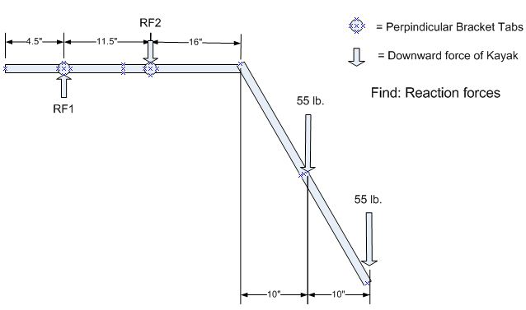
$$ΣF_{y}=RF1-RF2-130=0$$
$$RF2=RF1-130$$

$$ΣM_{RF2}=0$$
$$ΣM_{RF2}=RF1\left(11.5\right)-55\left(37.5\right)-55\left(47.5\right)=0$$
$$RF1=\frac{55(37.5)+55(47.5)}{11.5}$$
$$RF1=406.52 lb$$

$$RF2=406.52-130$$
$$RF2=276.52 lb$$

Static Stress analysis on landing pads that are attached to the car. These reaction forces are the net forces when the system is fully extended out and two 55 lb. kayaks.
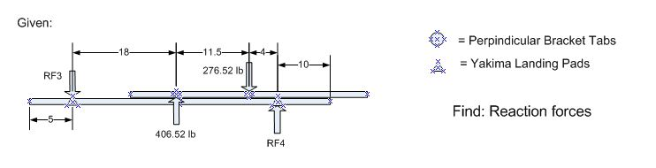

$$ΣF_{y}=406.52+RF4-RF3-276.52=0$$
$$RF3=406.52-276.52-RF4$$
$$RF3=130-RF4$$

$$ΣM_{RF3}=0$$
$$ΣM_{RF2}=406.52\left(18\right)-276.52\left(29.5\right)-RF4\left(33.5\right)=0$$
$$RF4=\frac{406.52\left(18\right)-276.52(29.5)}{33.5}$$
$$RF4=-25.07 lb$$

$$RF3=406.52-276.52-(-25.07)$$
$$RF2=155.07 lb$$

The net down force on the top of the car when the system is fully extended and two 55 lb kayaks are loaded is 155.07 lb.

Appendix 11: Bolt stress analysis
Given
Two loads of 27.5 lbs. separated 24 inches are applied to the 30 in. slider as shown in Figure 11.1. The slider is free to rotate about the pivot point and is constrained by the wedge shaped tab and 0.25 in. bolts shown below.
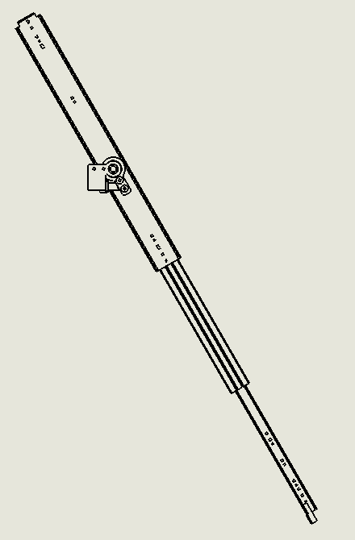
Pivot Point
Rigid Tab
27.5 lbs.
0.25 in Bolts
27.5 lbs.
Figure 11.1
Find
Find the load and shear stress the two mounting bolts are subjected to. Determine if cold drawn 1018 steel $(S_{y}=53,700 psi, S_{u}=63,800 psi)$ is adequate to withstand the stresses applied to the bolts.
Calculations
F.E.A. was performed on the assembly shown above. The reaction forces of the bolt holes were found as shown in Figure 11.2.
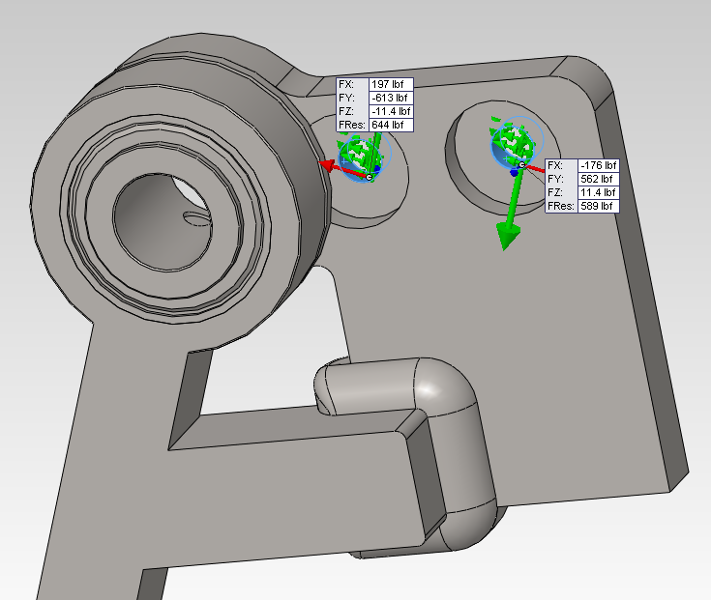
Figure 11.2

Shear force and stress calculations:
From the analysis above one bolt is subjected to approximately 589 lbs. and the other is subjected to approximately 644 lbs.
$$\frac{589lbs.}{\left[π*{\left(\frac{0.28in}{2}\right)}^{2}\right]}=9,565 psi$$
$$\frac{644lbs.}{\left[π*{\left(\frac{0.28in}{2}\right)}^{2}\right]}=10,458 psi$$

Assuming the ultimate shear strength of the material is $1/\sqrt{3}≈0.577$ (shear strength predicted by the distortion-energy theory) of the tensile strength of the material.
$$53,700 psi*0.577=30,985 psi$$
$$F_{safety}=\frac{30,985}{10,458}≈3$$
Conclusion
The analysis shows the two custom machined bolts are subjected to approximately 600 pounds yielding approximately 10,000 psi each. Since the shear yield strength of cold drawn 1018 steel is approximately 30,985 psi the bolts will have a factor of safety of approximately 3 when the loading in Figure 11.1 is applied.

Appendix 12: Drawings and Assembles

