[](http://www.google.com/imgres?um=1&hl=en&biw=1466&bih=740&tbm=isch&tbnid=MTPth2G4syAPLM:&imgrefurl=http://www.usnewsuniversitydirectory.com/Colleges-Universities/PortlandStateUniversity/info.aspx&docid=A7whUVjSiLjzhM&imgurl=http://www.usnewsuniversitydirectory.com/images/brands/PortlandStateUniversity/logo-portal-large.gif&w=300&h=100&ei=71exT6zTLampiQKjg6j1Aw&zoom=1&iact=hc&vpx=1182&vpy=252&dur=280&hovh=80&hovw=240&tx=178&ty=41&sig=105035680250722236729&page=1&tbnh=67&tbnw=202&start=0&ndsp=18&ved=1t:429,r:5,s:0,i:148)[](http://www.google.com/imgres?um=1&hl=en&biw=1466&bih=740&tbm=isch&tbnid=_oHQ4mUT4HCqAM:&imgrefurl=http://ieeenano2011.org/sponsors/sponsors-and-exhibitors/intel-logo/&docid=VsE3zej3vik20M&imgurl=http://ieeenano2011.org/wp-content/uploads/2010/08/Intel-Logo.jpg&w=1201&h=793&ei=n1exT_GwE-aJiALYltXWAw&zoom=1)

**Capstone**

**2012**

**Portland State University**

**Maseeh College of Engineering & Computer Science**

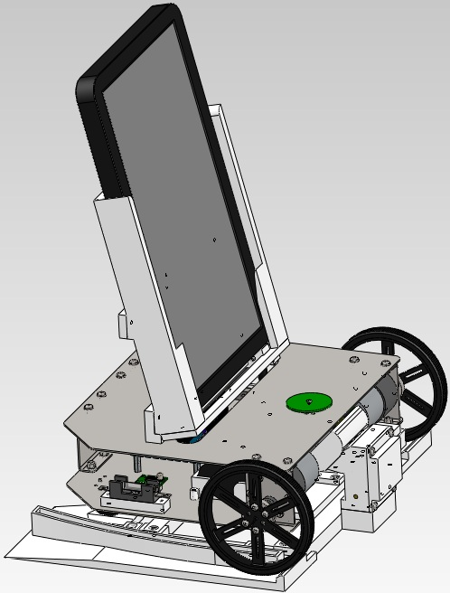

*This report elaborates the final design details and evaluations showing that it meets the customer’s product design requirements.*

**Group Members:**

Garrett Pauwels

Justin Carey

Hung Nguyen

Kevin Hughes

Nolan Igarashi

Richard Mullenburg

**Industry Sponsor:**

Dr. Douglas Heymann

**Industry Advisor:**

Evan Waymire

**PSU Advisor:**

Dr. David A. Turcic

**June 11 2012**

**ME 493 Final Report – Year 2012**

INTEL ROBOTIC TABLET CHARGER

# Executive Summary

The prototype and testing of the Intel Robotic Tablet Charger has been completed by the Portland State University senior capstone team and is ready to be delivered and presented to Intel. The team has gone through the final design process, manufacturing of the prototype and completed evaluating that the customer’s product design specifications (PDS) were met. This paperpresents the final chosen concept of the Robotic Tablet Charger, including testing and evaluation results on various parts of the PDS document.

# Table of Contents

1 Executive Summary 1

2 Table of Contents 2

3 List of Figures 3

4 List of Tables 4

5 Introduction 5

6 Mission Statement 5

7 Top-Level Alternative Designs 5

8 Final Design 8

8.1 Mechanical Design: 8

8.1.1 Chassis: 8

8.1.2 Tablet Holder: 8

8.1.3 Charging Station: 8

8.2 Electrical Design: 9

9 Design Evaluation 12

9.1 Evaluation for Safety and Ergonomics: 12

9.2 Evaluation for the Reliability: 13

9.3 Evaluation for Material and Mobility: 13

9.4 Evaluation for Maintenance: 13

9.5 Evaluation for Cost and Financial Performance: 14

9.6 Evaluation of Structural Integrity: 14

10 Conclusion 15

11 References 16

12 Appendix A. 17

12.1 Design Evaluation: 17

12.2 Product Design Specification Details: 17

13 Appendix B. 20

13.1 Motor Sizing Equations 20

13.2 Chassis sizing analysis 22

14 Appendix C. 25

14.1 Project Gantt Chart 25

15 Appendix D. 26

15.1 Detailed Drawings: 26

15.1.1 Charging Station 26

15.1.2 Charging Station: Female 32

15.1.3 Charging Station: Male 37

15.2 Robot: 42

15.2.1 2Amp Fuse 42

15.2.2 Battery Block 43

15.2.3 Ball Caster 44

15.2.4 Chassis 45

15.2.5 H-bridge 50

15.2.6 Switch 51

15.2.7 Wheel Hub 52

15.2.8 Tablet Holder 53

16 Appendix E. 59

16.1 Bill of Materials 59

# List of Figures

Figure 1. Tablet charging station and entire robot assembly prior to engagement. 10

Figure 2.Tablet charging station at engagement showing male-cover lifted and connection between rods and points. 10

Figure 3. Electrical components of the Intel Robot Tablet Charger and their locations 11

Figure 4.Detailed electrical schematic.A EZ-Board V3 is the control board, along with the 'red' H-Bridge 11

Figure 5: Free body diagram of a drive wheel indicating a driving torque at the centerline, with friction present. 20

Figure 6: A load of 3 lbs is applied to the top of the robot, compare three different sheet metal sizes to determine the best option for the application. 22

Figure 7: Applied pressure load of .122 lb/sqr in and necessary boundary conditions to fully constrain the structure. 23

Figure 8. Project Gantt chart showing timeline and completion dates of project 25

Figure 9. Charging Station: Base- left 26

Figure 10. Charging Station: Base- right 27

Figure 11.Charging Station: Base- support 28

Figure 12.Charging Station: Female- base 29

Figure 13.Charging Station: Left guide 30

Figure 14.Charging Station: Right guide 31

Figure 15.Charging Station: Female- back plate 32

Figure 16.Charging Station: Female- contact 33

Figure 17.Charging Station: Female- pin 34

Figure 18.Charging Station: Female- point 35

Figure 19.Charging Station: Female- support 36

Figure 20.Charging Station: Male- bracket 37

Figure 21.Charging Station: Male- cover pin 38

Figure 22.Charging Station: Male- cover 39

Figure 23.Charging Station: Male- pin 40

Figure 24.Charging Station: Male- support 41

Figure 25. Robot: Fuse base 42

Figure 26.Robot: Battery block 43

Figure 27.Robot: Ball caster 44

Figure 28.Robot: Chassis- bottom frame 45

Figure 29.Robot: Chassis- motor block 46

Figure 30.Robot: Chassis- rear bracket 47

Figure 31.Robot: Chassis- tablet bracket 48

Figure 32.Robot: Chassis- top frame 49

Figure 33.Robot: H-bridge block 50

Figure 34.Robot: Switch support 51

Figure 35.Robot: Wheel hub 52

Figure 36.Robot: Tablet holder- bottom spacer 53

Figure 37. Robot: Tablet holder- charger base 54

Figure 38. Robot: Tablet holder- left guide 55

Figure 39. Robot: Tablet holder- right guide 56

Figure 40. Robot: Tablet holder- tablet slide 57

Figure 41. Robot: Tablet holder- tablet spacer 58

# List of Tables

Table 1. Comparison between three chassis and two tablet holder designs highlighting their benefits and issues. 6

Table 2.Evaluation process of the functionality and performance of the robot. 12

Table 3.Evaluation process of the safety and ergonomics of the robot. 13

Table 4.Concept design evaluation matrix of the chosen designs and their weighted totals. 17

Table 5. Safety Criteria 17

Table 6. Ergonomic Criteria 17

Table 7. Performance Criteria 17

Table 8. Environmental Criteria 18

Table 9. Company Constraints Criteria 18

Table 10. Testing & Documentation Criteria 18

Table 11. Maintenance Criteria 18

Table 12. Size & Shape Criteria 18

Table 13. Aesthetics Criteria 18

Table 14. Materials Criteria 19

Table 15: Obtained F.E.A results for the three metal sizes 24

Table 16. Bill of Materials 59

# Introduction

Tablets provide a means of escape and entertainment. Immobile individuals who use tablets must have a source for charging their tablet. Often, the locations of wall outlets are not always accessible for these individuals. The current market does not provide a means for transporting a tablet in need of charging to a designated charging station. Furthermore, current market tablet chargers plug into standard 60Hz wall outlets or computer universal serial bus (USB) ports. The locations of these are not ergonomically designed for individuals with limited mobility and reach. Because of this, injury could be a result of over exertion.

# Mission Statement

The goal of our team is to design and prototype a robotic device which will transport a tablet in need of being energized to a designated charging station. This will resolve any issues of charging the tablet and ergonomics of the current charging methods for persons of limited mobility. The Robot Tablet Charger prototype will abide by all PDS requirements and be presented at the Intel Hillsboro Campus in June 2012.

# Top-Level Alternative Designs

In the research and development stages for the basic structure of the robot, a number of ideas were evaluated and discussed. These designs were compared to a set of requirements established by the PDS report. A list of the requirements and their summaries that the robot must satisfy is presented below.

* Maneuverability: depends on how well the design is capable of a turning 180 degrees
* Weight: depends on the number of components as well as the materials used
* Stability: the number of wheels and placement of the wheels
* Cost: based on number of components and materials
* Simplicity: based on design and selected components
* Ease of Use: depends on location and design

From this list a total of three robot chassis; two tablet holders and two charging station designs were developed. The benefits and issues of each design are represented below in Table 1.

Table 1. Comparison between three chassis and two tablet holder designs highlighting their benefits and issues.

|  |  |  |  |
| --- | --- | --- | --- |
| **Design** | **Benefits** | **Issues** | **Figure** |
| **Chassis – A** | * Stable * Less material required * Lightweight * Tighter turning radius | * Additional parts required |  |
| **Chassis – B** | * Stable * Tight turning radius | * Difficult to manufacture * Too many parts * Solid axle produces * turning issues | chassis b.JPG |
| **Chassis – C** | * Tight turning radius * Light weight * Fewer parts required | * Unstable * Higher manufacturing * cost |  |
| **Holder – A** | * Easy to manufacture * No movingcomponents * Strong one- piece design | * Weight * Lack of adjustability * Hard to manufacture |  |
| **Holder –B** | * Cheaper to manufacture * Less time to manufacture * Less material needed * Lightweight | * More parts are required to construct * Not as rigid |  |
| **Charger – A** | * Less material required. * Less resistance with connection * More rigid | * Complex design * More time required to manufacture * Sharp edges |  |
| **Charger – B** | * Simplistic design * Self-centering platform | * Needs precious alignment * Less rigid * More parts required |  |

From the scoring matrix presented in Appendix A and Table 1, it was concluded that tablet holder B, charging station A and chassis A were the most beneficial design. The major reasons for choosing chassis A is due to its maneuverability and stability. This is generated by the two drive wheels and the two ball casters. The casters provide the robot with a tighter turn radius and the capability to avoid objects. Also they give the robot a lower center of gravity and the proper ground clearance.

The major reasons for choosing the tablet holder design B is its adjustability and less material is required for manufacturing. The major issues with design A of the tablet holder is that it would require a lot more time to produce. Furthermore, it doesn’t conform to the constraints of the rapid prototype machine.

The major reasons for going with the charging station design A is that the contacts require less force to make a connection. The issues that developedwith charging station design A is that the platform doesn’t provide an adequate self-centering unit and more moving parts are required to make a connection. These moving parts can lead to error in the connection process if the components are not held to a tight tolerance in the construction phase.

# Final Design

The team came to an agreement that the choices of chassis A, tablet holder B and charging station design A will fulfill all the major requirements established in the PDS. These requirements consist of having the capability of traveling over multiple surfaces, having a low center of gravity and providing an easy interface with the included tablet. The design will consist of two motorized driving wheels and two metal ball casters for stability in the front and rear of the robot. This design will best fit our requirements due to a decrease in turning radius. To keep the center of gravity low, the batteries, control board and two electric motors will be mounted on internal brackets that are suspended 1.5 inches off the ground. This ground clearance will be sufficient for traveling over carpets and other low obstructions.

## Mechanical Design:

### Chassis:

In parallel to designing a chassis for the Robot Tablet Charger, FEA analysis was performed on several different thicknesses of sheet metal.We used this information to size the correct gauge of material to avoid deformation [see Appendix B]. For the purpose of cost, strength and the ease to modify the design— chassis A was sent off to Eagle Precision to be manufactured using 18 gauge low carbon steel. With the precision needed for the holes in the chassis to mount the electrical parts, Eagle Precision was required to drill the holes. The chassis was then assembled using 3mm bolts with washers and self-locking nuts. A completely assembled chassis can be seen in Figure 1.

### Tablet Holder:

A non-metal tablet holder was chosen because the team wanted to utilize Intel’s 3D printer due to the low cost and short lead time. Intel’s 3D printer could accommodate parts that fit within a 10”x10”x10” space. Thus,due to the space limitations of Intel’s 3D printer, our group manufactured the assembly in many parts that were then later assembled. After the holder was assembled and mounted to the chassis using 3mm bolts; the team decided that having a single steel L-bracket did not make the holder rigid enough. Therefore, two L-brackets were utilized.

### Charging Station:

The charging station was designed to allow the robot to interface the tablet and battery with a wall charger with ease. The overall charging station design was constructed out of ABS Polycarbonate plastic by Intel’s 3D printer and 3mm bolts were used to assemble. The main assembly consists of the platform, cross member supports and guides. The guide’s purpose is to self-align the robot prior to engagement for charging. The charging station (seen in figures 1 and 2) also consists of a male and female assembly, each of which must come into contact to complete the electrical connection.

**Female**

The female charging assembly consists of a back plate, female support and brass points; all of which were assembled using 3mm bolts. The main achievement in the design of this assembly is to protect the connection points for safety reasons and to allow the male cover to lift in order to complete the connection. The male brass pins come into contact with the female brass points creating the connection. However, to make sure a connection is always achieved, the points act as a spring to guarantee a good connection. This can be seen in Figure 2.

**Male**

The male charging assembly consists of a base, support, cover and brass rods; all of which were assembled using 3mm bolts. The cover in this assembly protects the brass rods for safety until making contact with the female support, lifting the cover open exposing the rods. There are a total of four rods, two of which are positive and negative. One set of rods are used for charging the tablet, and the other set are used for charging the robot battery pack. This can be seen in Figure 2.

## Electrical Design:

The main electrical components for the final design comprised of two motors, a control board and H-Bridge, a two amp fuse, a single rechargeable battery pack, an on/off switch and miscellaneous connectors. A detailed layout of these parts and electrical schematic can be seen in Figure 3 and 4. The major achievement that our group had was in controlling the motors and being able to wireless control the robot. The software that was used is provided by EZ-Robot and was very simple to operate.

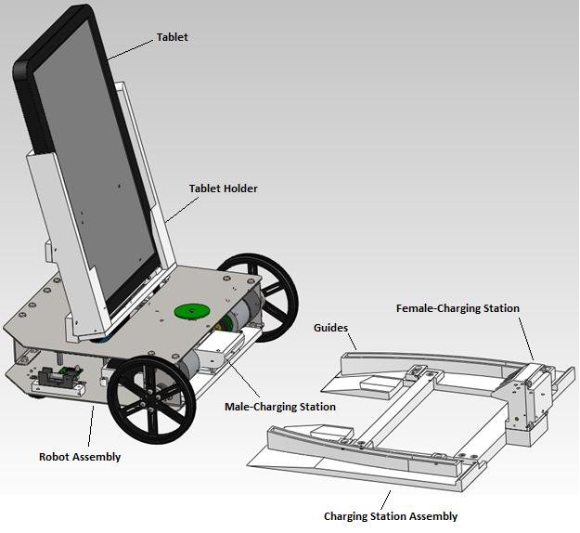

Figure 1. Tablet charging station and entire robot assembly prior to engagement.

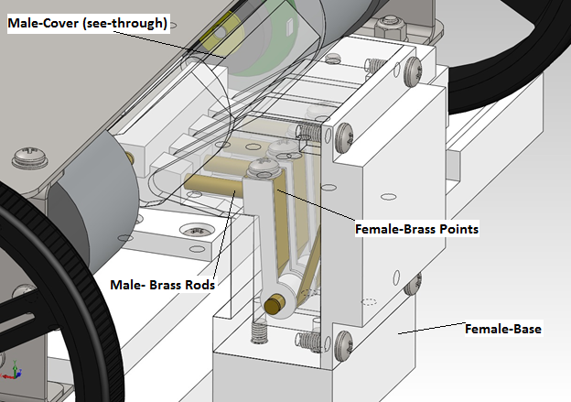

Figure 2.Tablet charging station at engagement showing male-cover lifted and connection between rods and points.

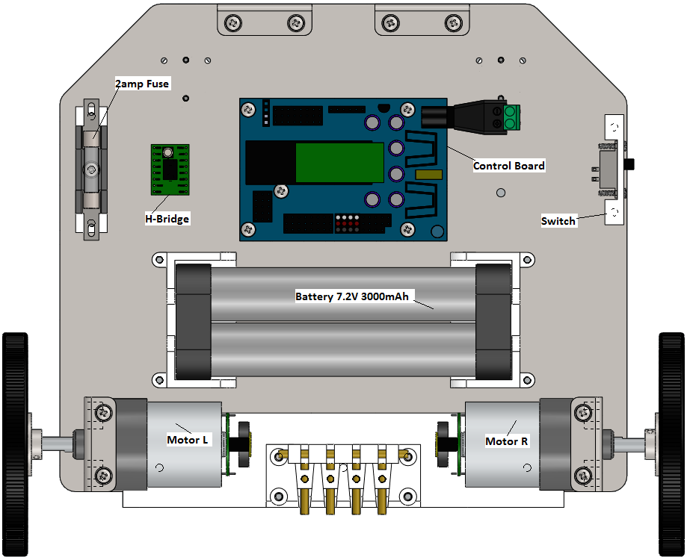

Figure 3. Electrical components of the Intel Robot Tablet Charger and their locations

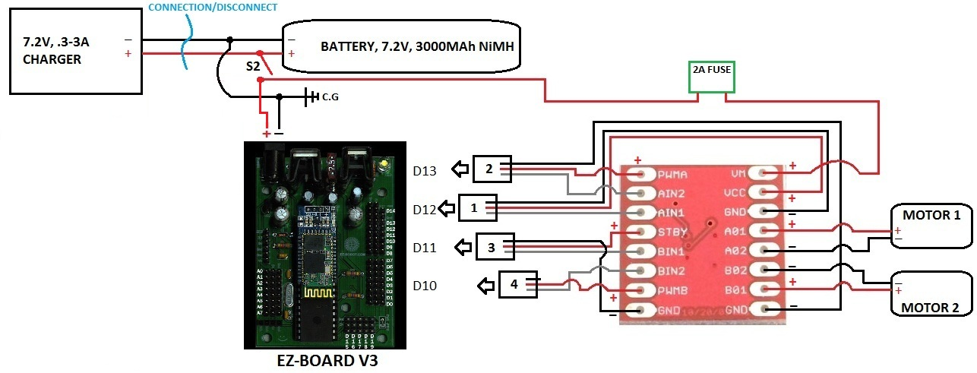

Figure 4.Detailed electrical schematic.A EZ-Board V3 is the control board, along with the 'red' H-Bridge

# Design Evaluation

The crucial components that the robot must fulfill for the performance and functionality of the customer needs is as follows; ability to recharge the battery of the robot and tablet once docked; be capable of rotating 180 degrees; have a wireless proximity of forty feet and be able to travel over multiple surfaces. The method that will be utilized to evaluate the ability to recharge the tablet and robot is to dock the chassis into the charging station and test the amount of voltage emitted from the connections. If the voltage output of the connections is equal to the input voltage then it can be concluded that there is no voltage drop in the circuit. The testing procedures of the maneuverability of the robot will involve having it rotate 180 degrees in one spot for three consecutive trials. The proximity and multi-surface test will be done simultaneously by having the robot travel forty feet over tile, rug, and hardwood surfaces.

Furthermore, the control board and motors of the robot were powered by a 7.2V rechargeable battery and therefore meets the criteria of under 14V Power Source. The evaluation for the function and performance is shown in Table 2 below.

Table 2.Evaluation process of the functionality and performance of the robot.

|  |  |  |
| --- | --- | --- |
| **Requirements** | **Actual** | **Goal Met** |
| Ability to recharge tablet: 19.0 volts | 19V | Yes |
| Battery voltage < 14V | 7.2V | Yes |
| Rotation angel: 180 degree | 360 degree | Yes |
| Distance travel: 40 feet | 52 feet | Yes |
| Travel over hardwood | - | Yes |
| Travel over carpet | - | Yes |
| Travel over tile | - | Yes |

## Evaluation for Safety and Ergonomics:

The chassis of the robot is designed to eliminate most electrical hazards. The body of the robot is covered by metal sheets which have the circuit put completely inside. All wire connections are covered by heat shrink to avoid being touched by mistake. The brass rods (seen in Figure 2) on the robot are designed to have a cover that will then lift exposing the rods when the robot docks.

When the tablet is in position for recharging, the total height of the system is 16 inches (See Table 3). This is high enough for the users to eliminate any abnormal bending motion while sliding the tablet into the tablet holder. Therefore it can help the users avoid injury when using the robot.

Table 3.Evaluation process of the safety and ergonomics of the robot.

|  |  |  |
| --- | --- | --- |
| **Requirements** | **Actual** | **Goal Met** |
| Height > 6.0 inch | 16 inch | Yes |
| Avoid injury | - | Yes |
| Avoid Electrical hazards | - | Yes |

## Evaluation for the Reliability:

The life span of the battery as well as all electrical devices can be decreased if the connections are interrupted. Therefore, the surface of the docking station has stops designed to keep the robot stable in charging position, which helps the system being connected to the outlet continuously.

The mission of the Robotic Tablet Charger is not only charging the tablet but the battery for the robot itself. To help users not be confused between the plug for the battery and the tablet, one is designed to be a male plug and the other is female.

## Evaluation for Material and Mobility:

Although this robot is a mobile device, it needs to have an appropriate size that can be noticed easily to avoid accidents. The prototype of the Intel Robotic Charger has the dimension of 9x9x11inch (LxWxH), which can be observed clearly when people are walking in the room. The total weight of the robot is 5.0lb, It is heavy enough to not being tiped up when the tablet is secured in the tablet holder. The sheet metal body is hard enough to support all the robot and the tablet without being deformed when the robot moves (see Appendix B).

## Evaluation for Maintenance:

If maintenance is required, access to the inside of the robot chassis requires the removal of 8 easily accessible screws. The tools required to remove the top of the chassis are an 8mm crescent wrench, a Philips head screwdriver and a 5mm Allen wrench. Access to replaceable parts, such as the fuse, are easily accessible without the removal of chassis components.

## Evaluation for Cost and Financial Performance:

The overall cost of the Robotic Tablet Charger is $234.56 out of a $500.00 budget set by our sponsor. We came very much so under budget due to the ability to use Intel's 3D printer and Eagle Precision for the sheet metal parts. A complete Bill of Materials can be seen in Appendix E.

## Evaluation of Structural Integrity:

Severe deformation of the sheet metal due to the loading caused by tablet transport cannot be tolerated. An adequately stiff frame was determined through use of Finite Element Analysis to choose 18 gauge steel as the building block for the chassis (see Appendix B).

# Conclusion

In conclusion, the robotic tablet charging system designed by this capstone team fulfills all major requirements set forth by the customer in the PDS requirements, all while remaining within budget. The final design of the robotic charger is able travel more than 40 ft wirelessly, turn 360 degrees, operate on multiple surfaces, and successfully transport the tablet for charging. The docking station works as designed and is able to help correctly align the charging contacts, of both the robot and tablet, even if its approach is not exactly head-on. Currently the robotic charger needs to be controlled manually with a Bluetooth enabled device both to pick up the tablet and to return to the docking station. The team is working on a method of automating the robot so that it will be able to return to its docking station autonomously after being controlled to the tablet’s location. In addition, a shell is to be designed to place over the chassis to give the robot a more finished look.

# References

1. Engineers Edge, Sheet Metal Gauge Sizes Data. Accessed: June 03 2012.

<http://www.engineersedge.com/gauge.htm>/

1. MatWeb, Material Property Data. AK Steel ASTM A 570, Grade 30 Hot Rolled Carbon Steel, Structural Quality. Accessed: June 03 2012.

<http://matweb.com/search/DataSheet.aspx?MatGUID=24a971583d324d1da526bdc4001193dd>

# Appendix A.

## Design Evaluation:

Table 4.Concept design evaluation matrix of the chosen designs and their weighted totals.

|  |  |  |  |  |  |  |  |
| --- | --- | --- | --- | --- | --- | --- | --- |
|  | **Maneuverability** | **Weight** | **Stability** | **Cost** | **Simplicity** | **Ease of Use** | **Weighted Total** |
| **Chassis Designs** | | | | | | | |
| **Chassis A** | 4 | 3 | 3 | 3 | 4 | - | **11** |
| **Chassis B** | 3 | 3 | 3 | 3 | 3 | - | **9** |
| **Chassis C** | 2 | 4 | 5 | 4 | 2 | - | **9** |
| **Tablet Holder** | | | | | | | |
| **Holder A** | - | 3 | - | 4 | 2 | 3 | **4** |
| **Holder B** | - | 2 | - | 2 | 5 | 4 | **10** |

## Product Design Specification Details:

Listed below is the Product Design Specifications developed from the information provided by Intel. The design criteria contained in the tables has been prioritized to fit the customer needs.

Table 5. Safety Criteria

|  |  |  |  |  |  |  |  |
| --- | --- | --- | --- | --- | --- | --- | --- |
| **Safety** | **Criteria** | **Customer** | **Metric** | **Target** | **Basis** | **Verification** | **Priority** |
| Electrical shock | Intel | Design & material | Aluminum & plastic | Electrical hazard standards | Electrical measuring equipment | High |
| User & robot collision | Vision distance (in) | 24 | Avoid collision | Experiment |

Table 6. Ergonomic Criteria

|  |  |  |  |  |  |  |  |
| --- | --- | --- | --- | --- | --- | --- | --- |
| **Ergonomic** | **Criteria** | **Customer** | **Metric** | **Target** | **Basis** | **Verification** | **Priority** |
| Convenient operation | Intel | Height (in) | > 6.0 | Avoid injury | Measurement | High |

Table 7. Performance Criteria

|  |  |  |  |  |  |  |  |
| --- | --- | --- | --- | --- | --- | --- | --- |
| **Performance** | **Criteria** | **Customer** | **Metric** | **Target** | **Basis** | **Verification** | **Priority** |
| Battery powered | Intel | Battery pack | 1 | Supplied battery harness | Motors operational | High |
| Rechargeable battery | Volts | < 12.0 | Controller capacity | Plug into outlet |
| Utilize outlet  charging station | 110 | Wall outlet | Robot placed on charging station |

Table 8. Environmental Criteria

|  |  |  |  |  |  |  |  |
| --- | --- | --- | --- | --- | --- | --- | --- |
| **Environment** | **Criteria** | **Customer** | **Metric** | **Target** | **Basis** | **Verification** | **Priority** |
| Travel over hardwood | Intel | Inch | 0 | Flat and smooth | Robot tested on hardwood | High |
| Travel over carpet | 1 | Different surface heights | Robot tested on carpet |
| Travel over tile | 0 | Different textures | Robot tested on tile |

Table 9. Company Constraints Criteria

|  |  |  |  |  |  |  |  |
| --- | --- | --- | --- | --- | --- | --- | --- |
| **Company Constraints** | **Criteria** | **Customer** | **Metric** | **Target** | **Basis** | **Verification** | **Priority** |
| Compatibility with CL900 tablet | Intel | 2.1mm barrel power jack | Yes | Tablet to interface and charge | Manufacturing | High |

Table 10. Testing & Documentation Criteria

|  |  |  |  |  |  |  |  |
| --- | --- | --- | --- | --- | --- | --- | --- |
| **Testing** | **Criteria** | **Customer** | **Metric** | **Target** | **Basis** | **Verification** | **Priority** |
| Testing the design | Intel | Number of tests | < 10.0 | To refine the design | Full test run w/o any issues | High |
| Robots ability to interface with  charging station | Inches off from ideal position | 1 | Robot may not enter charging station correctly | Test robot entering charging station |

Table 11. Maintenance Criteria

|  |  |  |  |  |  |  |  |
| --- | --- | --- | --- | --- | --- | --- | --- |
| **Maintenance** | **Criteria** | **Customer** | **Metric** | **Target** | **Basis** | **Verification** | **Priority** |
| Use common tools | User/Intel | # of tools  required | < 3.0 | Component replacement process | Design stages | Medium |
| Accessible components | # of components to maintain | 3 |

Table 12. Size & Shape Criteria

|  |  |  |  |  |  |  |  |
| --- | --- | --- | --- | --- | --- | --- | --- |
| **Size & Shape** | **Criteria** | **Customer** | **Metric** | **Target** | **Basis** | **Verification** | **Priority** |
| Ground Clearance | Intel | Inch | 1.5 | Accommodate for all ground surfaces | Design stages | Low |
| Robot width | 12 | Stability/  accommodate for components |
| Robot length | 12 |
| Height of robot | 16 |

Table 13. Aesthetics Criteria

|  |  |  |  |  |  |  |  |
| --- | --- | --- | --- | --- | --- | --- | --- |
| **Aesthetics** | **Criteria** | **Customer** | **Metric** | **Target** | **Basis** | **Verification** | **Priority** |
| Attractive | General  public | Yes/No | Should be  visually appealing | design attracts attention | Provide a survey | Low |

Table 14. Materials Criteria

|  |  |  |  |  |  |  |  |
| --- | --- | --- | --- | --- | --- | --- | --- |
| **Materials** | **Criteria** | **Customer** | **Metric** | **Target** | **Basis** | **Verification** | **Priority** |
| Light weight | User/Intel | lbs | < 10.0 | If batteries die, one must manually move robot | Weigh / design analysis | Low |
| Semi-disposable | % Recyclable | > 75.0 | Environmentally responsible | Design |

# Appendix B.

## Motor Sizing Equations

**Objective:**

The purpose of the following calculations are to determine adequate motor torque to move our robot. It is important to select a motor that has enough torque, but does not sacrifice linear velocity. The PDS requirement that involves the robot traveling over forty feet pertains to this limitation; if the speed is too slow, the robot will take a very long time to navigate.

It was found that a motor torque of approximately 115 oz*in would be sufficient to break static friction between the rubber wheels and concrete, causing the robot to slip as it traversed its course. We believe appropriate assumptions were applied in order to come to this conclusion with a factor of safety (FOS) = 2 applied to the weight of the robot.

**Given:**

A drive wheel with a torque applied at the wheels center line is at rest on a hard surface such as wood or concrete. Find the torque necessary to break contact between the two surfaces.

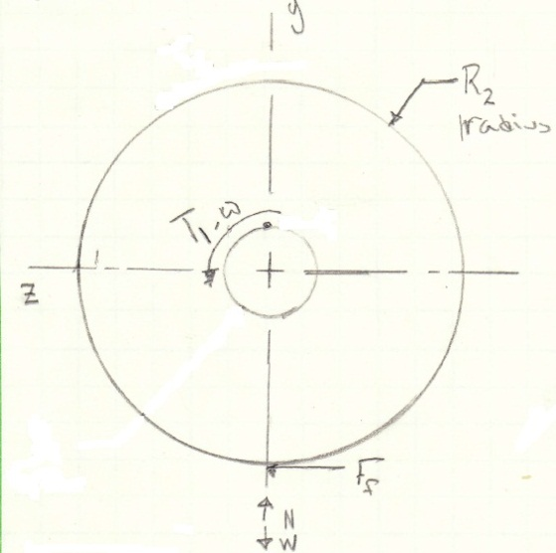

Figure : Free body diagram of a drive wheel indicating a driving torque at the centerline, with friction present. The purpose of this analysis is to find the torque that will break the static frictional force.

**Assumptions:**

* Weight of the total robot is roughly 12 pounds and is supported by the two drive wheels, W = 12lbfFOS = 2
* Static friction coefficient is between concrete and rubber, μs= .8
* Wheel diameter is 3 inches, D = 3in

**Solution:**

Summing the forces in the Y direction yields,

$$ΣFy=0 ⇒N- \frac{W}{2}=0$$

$$N=\frac{W}{2}=6 lbf$$

Summing moments about the shaft centerline,

$$ΣMo=0 ⇒ Ff*\frac{D}{2}-T1=0$$

Substituting for the frictional force Ff = μsN,

$$T1= \frac{μsND}{2}$$

$$T1= \frac{0.8*6lb*3in}{2}$$

$$T1=7.2 lb*in=115 oz*in$$

## Chassis sizing analysis

**Objective:**

The purpose of performing an analysis on the chassis is to determine an adequate structure for transporting the tablet. The greatest force on the system would be when the robot is stationary and the user loads the tablet into the tablet holder and presses it into the barrel jack. It is, therefore, necessary to implement a static analysis for the entire structure. Without proper support, the robot will not meet the PDS requirement of traveling over 40 feet.

The following analysis is comprised of a Finite Element Analysis. Three different sheet metal sizes- 18, 20, and 22 gauge- have been chosen for analysis to compare against one another. It was determined that 18 gauge sheet metal was an adequate material for chassis construction.

Because the final chassis design is not chosen, analysis is based on a preliminary design. It is believed that an adequate FOS of 4 has been applied to the load on the top sheet to account for excessive force during the docking process.

**Given:**

A load of 3 pounds is applied to the top surface of the structure shown in fig 6. Three low carbon steel sheet metal sizes – 18, 20, and 22 AWG- are to be analyzed to determine the best option.

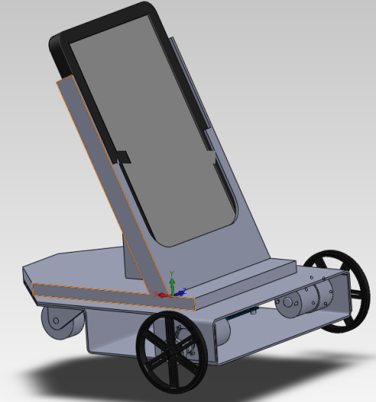

Figure : A load of 3 lbs is applied to the top of the robot, compare three different sheet metal sizes to determine the best option for the application.

**Assumptions:**

* A FOS of 4 is applied to the load the tablet causes to account for uncertainties in loading characteristics, F = 12 lbs
* The load is evenly distributed across the top of the chassis, $P=\frac{F}{A}=\frac{12 lb}{70.8 {in}^{2}}=.122 \frac{lb}{{in}^{2}}$
* 18 AWG steel thickness = 0.048 in [1]
* 20 AWG steel thickness = 0.036 in [1]
* 22 AWG steel thickness = 0.030 in [1]
* The chassis is constrained at the motor wheel connection as well as the caster location.

**Solution:**

Because the chassis is symmetric in one direction, the analysis can be split in half. A symmetry constraint replaces the previously present material. Two fixed constraints are applied to simulate bolting on the structure, see Fig 6. It is assumed that the two plates cannot move relative two each other in the highlighted areas due to the clamping force applied by the bolts. A static, linear analysis was implemented for each metal size with the results shown in Figure 7. The stress and displacement values are listed in Table 15 to summarize the findings.

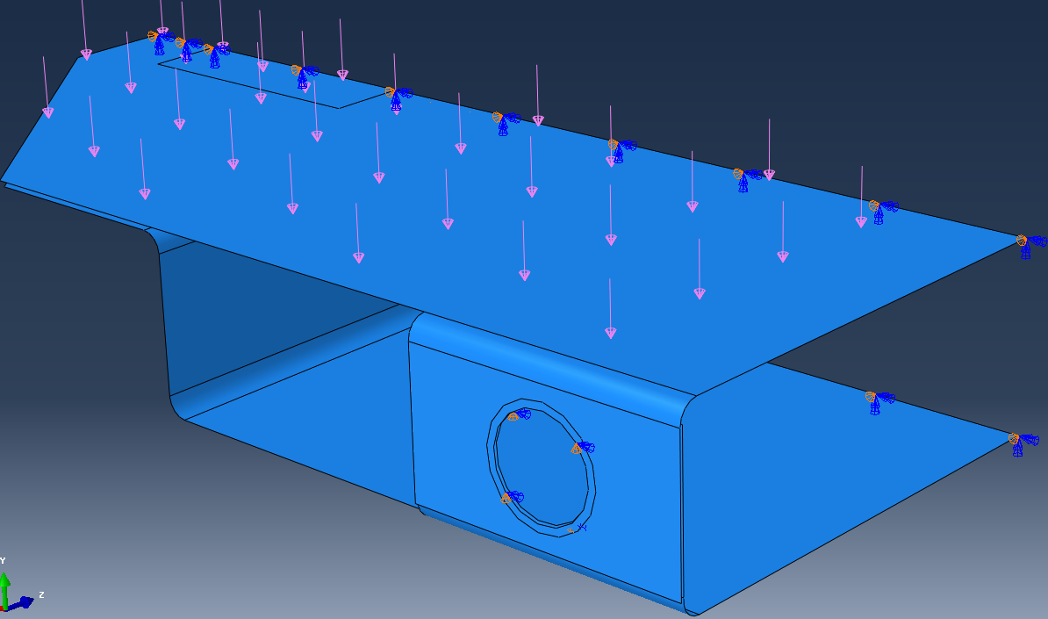

Fixed constraint

Fixed constraint

Figure : Applied pressure load of .122 lb/sqr in and necessary boundary conditions to fully constrain the structure.

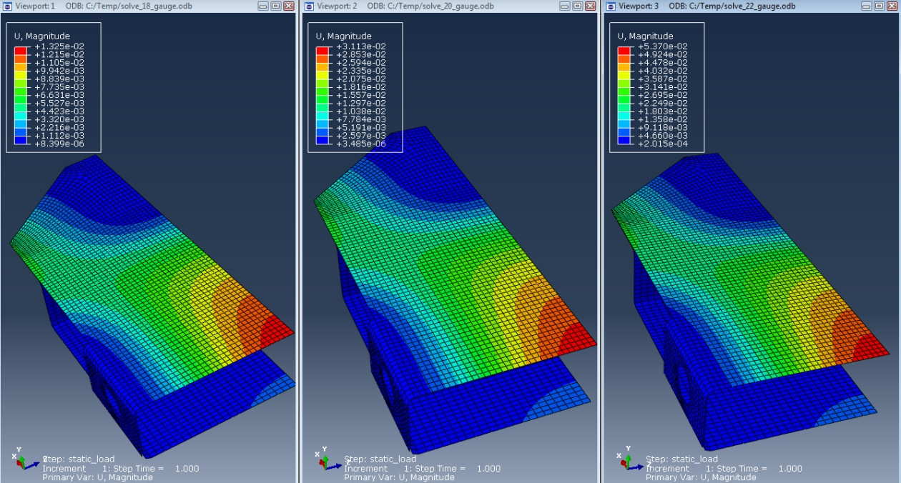

Max displacement and Stress

**Figure 7B: Shown from left to right are the displacement magnitude results for 18,20,22 AWG sheet metal sizes.**

Table : Obtained F.E.A results for the three metal sizes

|  |  |  |
| --- | --- | --- |
| Metal Size (AWG) | Max Stress (ksi) | Max Displacement (in) |
| 18 | 1.38 | 0.013 |
| 20 | 2.45 | 0.031 |
| 22 | 3.45 | 0.054 |

As Shown in Table 15, all sheet metal sizes, theoretically, are adequate for supporting the load; the Yield stress for low carbon steel is approximately 30 ksi. [2]

Since yielding is of no concern in all three cases, it is necessary to compare displacement. Our robot will have very little clearance between the motors and the top plate. Also, charging connection components will be attached in the center of the robot with little clearance as well. For this reason, little deflection is desired; 18 gauge steel has the least amount of deflection and is therefore chosen for our application.

# Appendix C.

## Project Gantt Chart

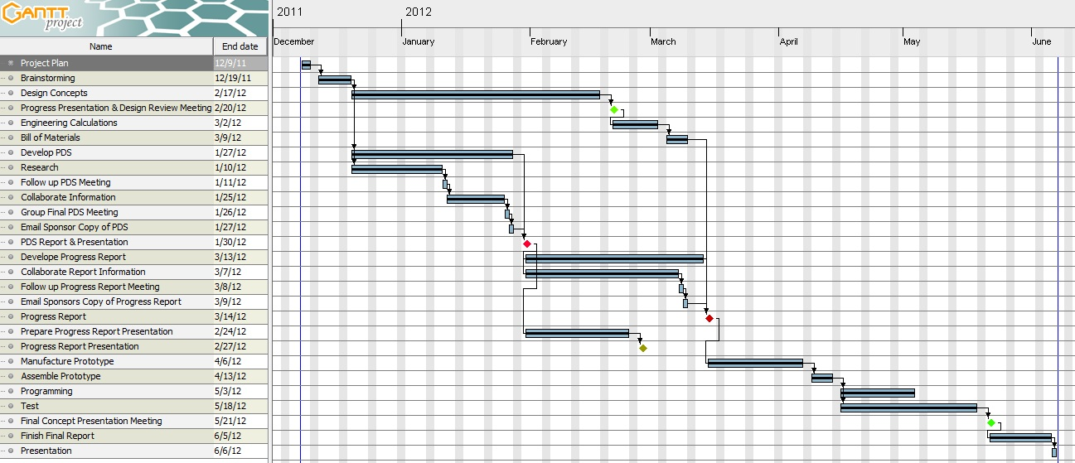

Figure . Project Gantt chart showing timeline and completion dates of project

# Appendix D.

## Detailed Drawings:

### Charging Station

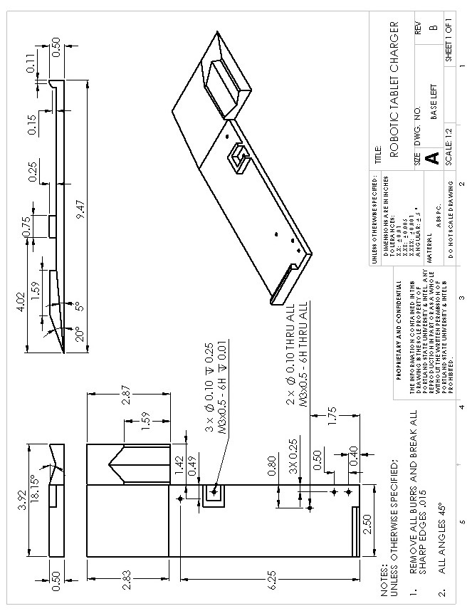

Figure 9. Charging Station: Base- left

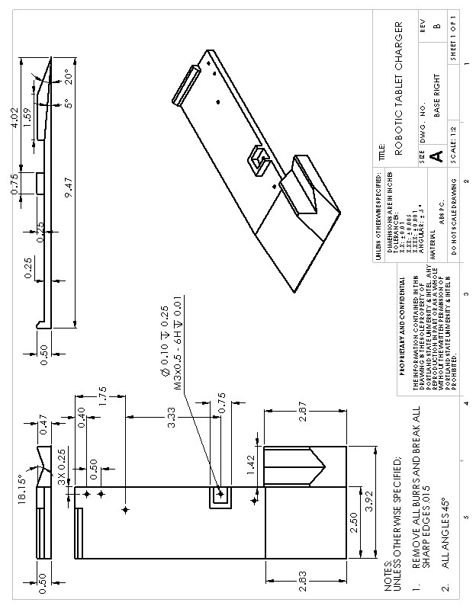

Figure 10. Charging Station: Base- right

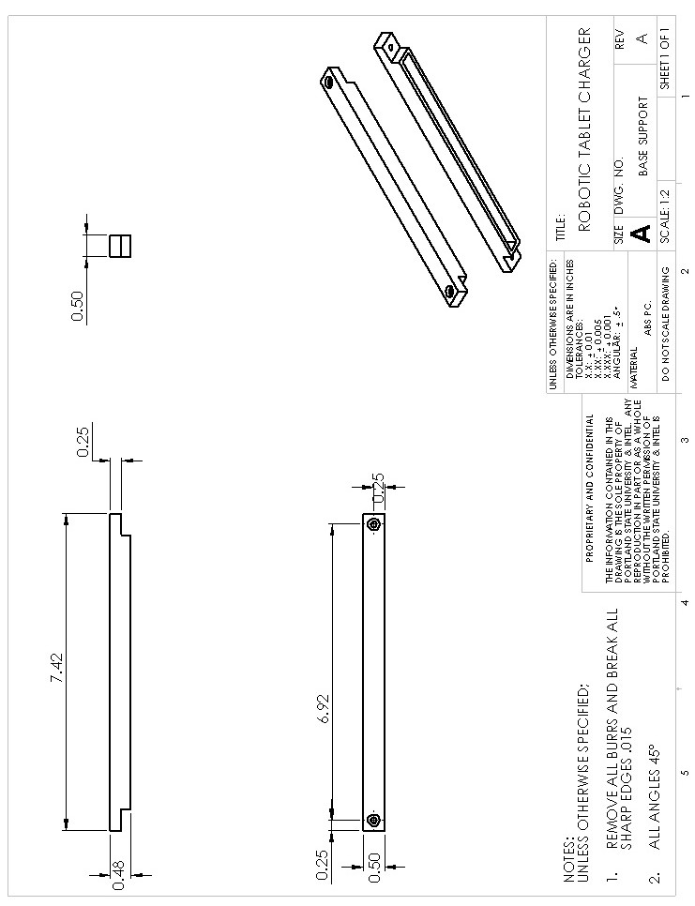

Figure 11.Charging Station: Base- support

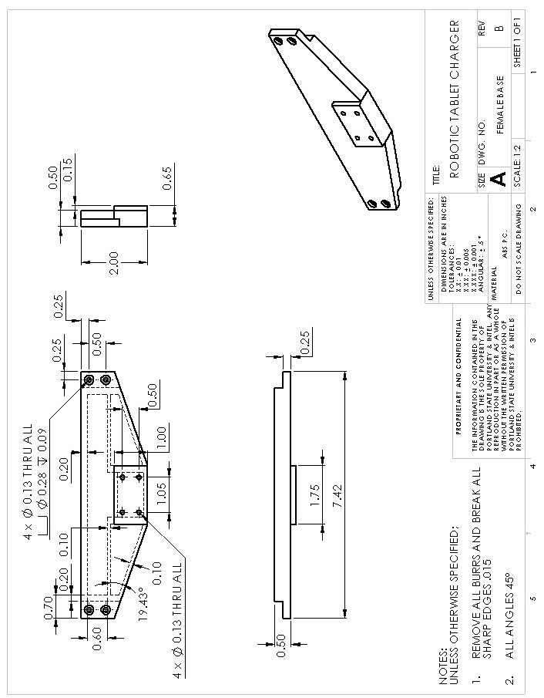

Figure 12.Charging Station: Female- base

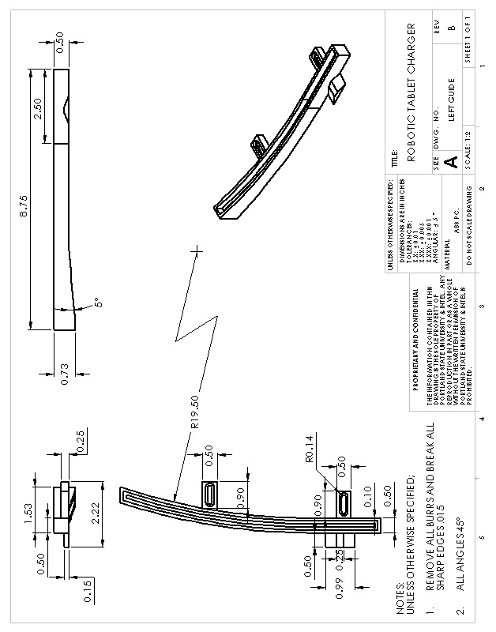

Figure 13.Charging Station: Left guide

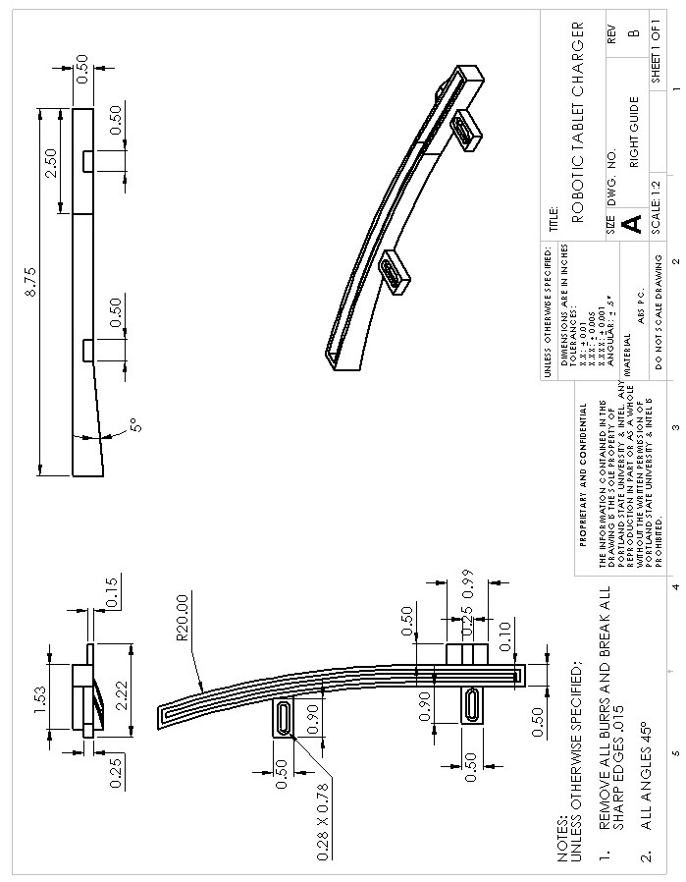

Figure 14.Charging Station: Right guide

### Charging Station: Female

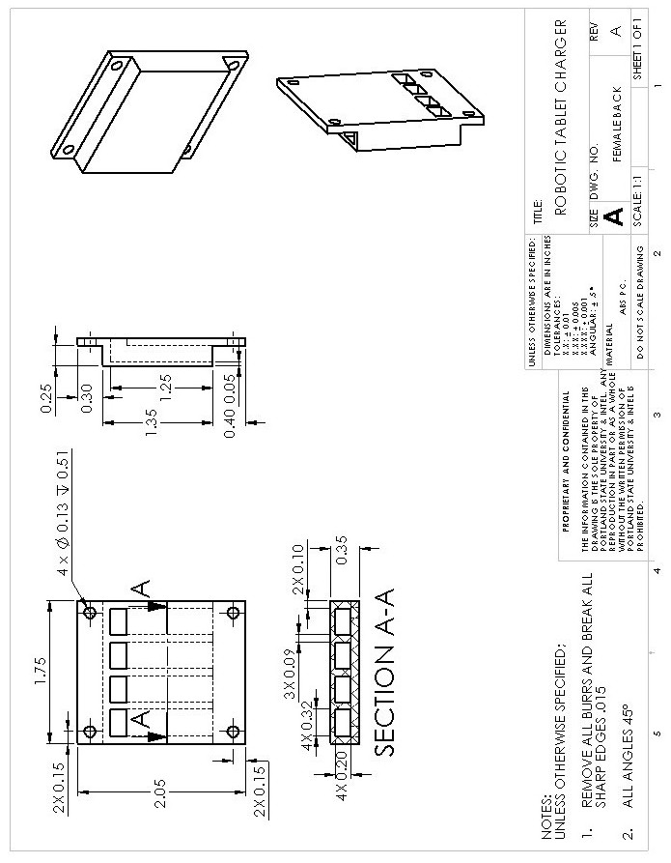

Figure 15.Charging Station: Female- back plate

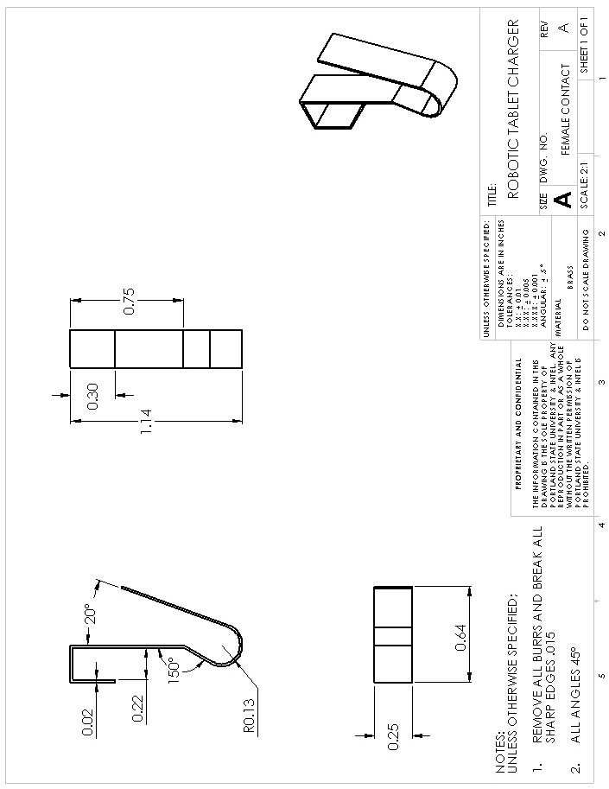

Figure 16.Charging Station: Female- contact

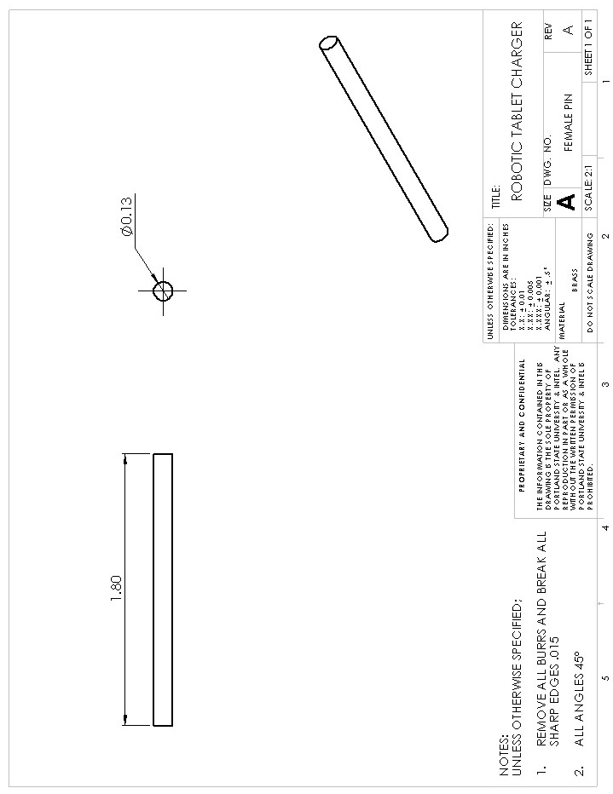

Figure 17.Charging Station: Female- pin

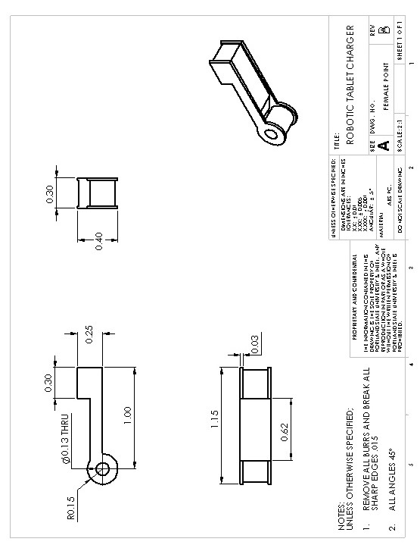

Figure 18.Charging Station: Female- point

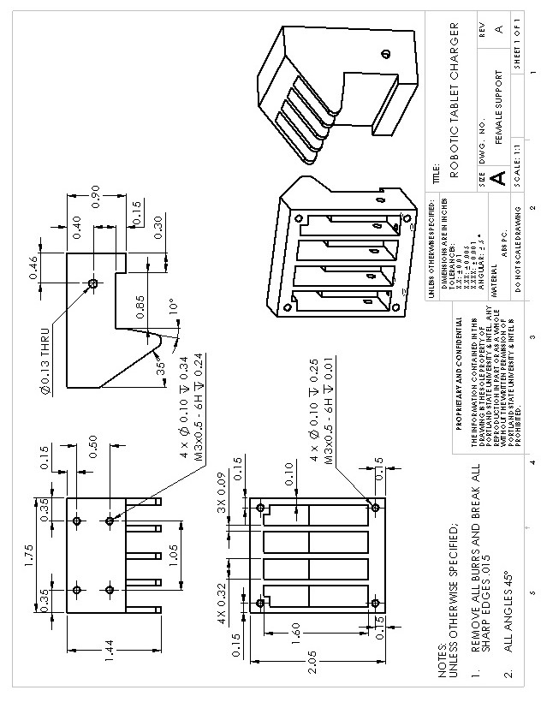

Figure 19.Charging Station: Female- support

### Charging Station: Male

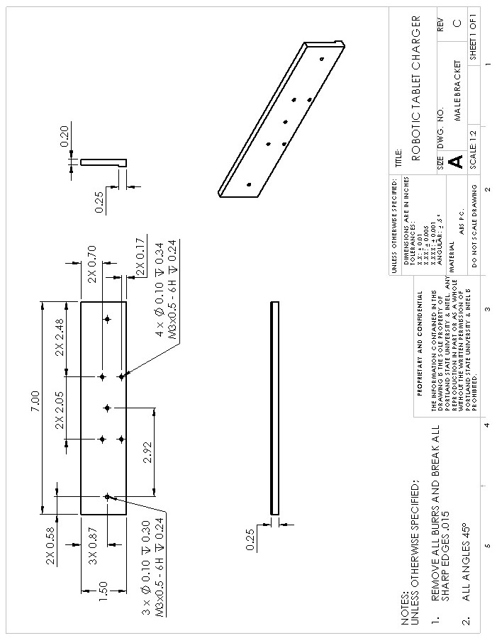

Figure 20.Charging Station: Male- bracket

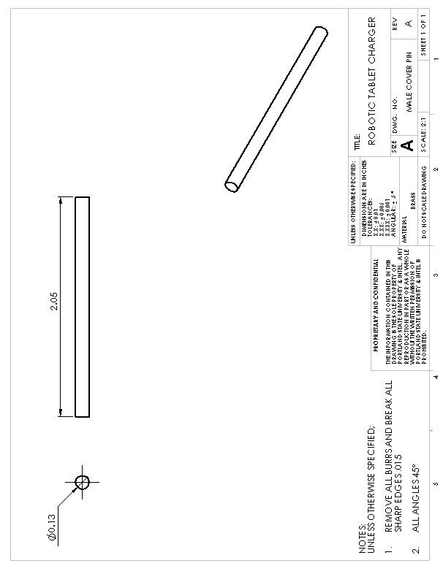

Figure 21.Charging Station: Male- cover pin

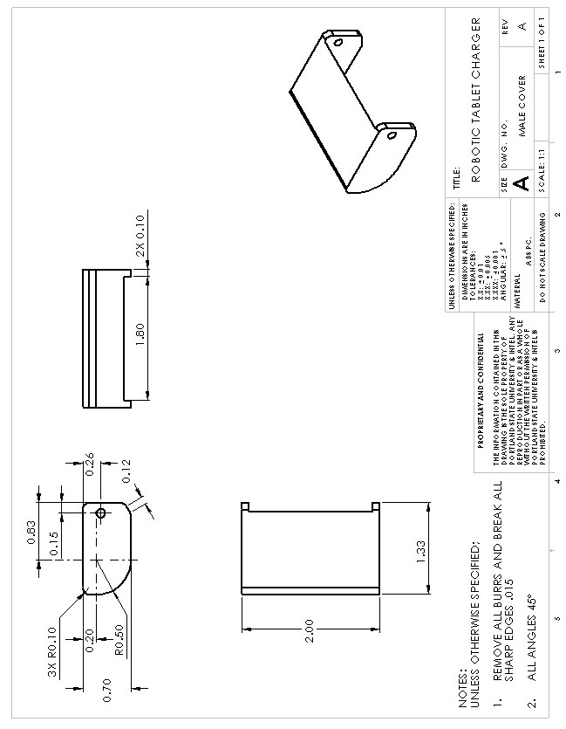

Figure 22.Charging Station: Male- cover

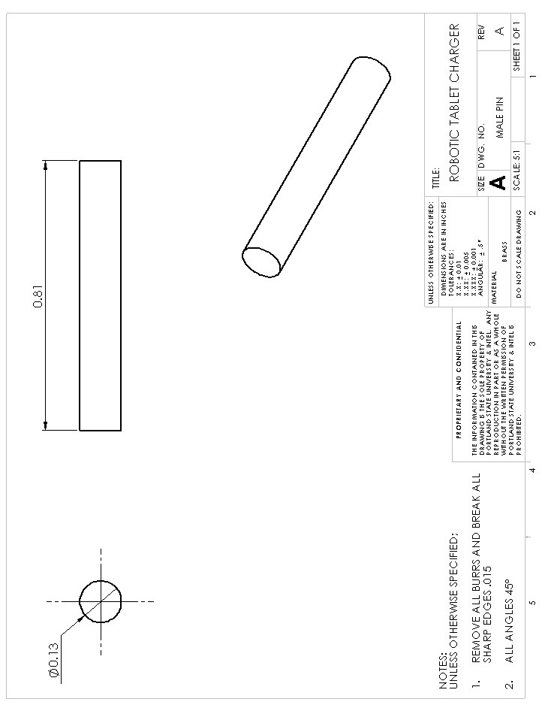

Figure 23.Charging Station: Male- pin

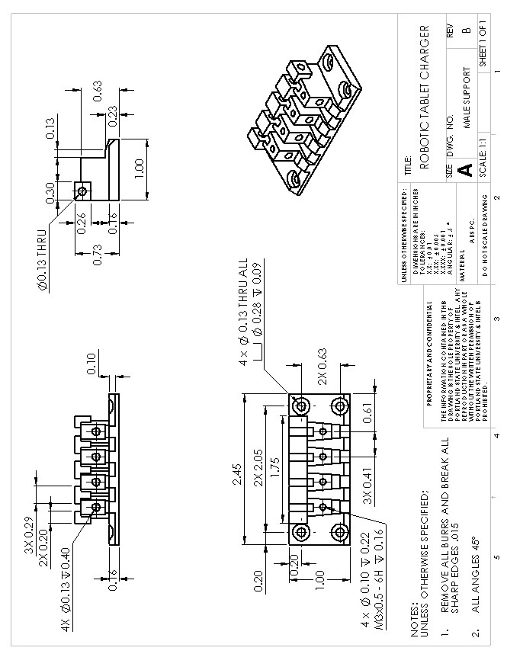

Figure 24.Charging Station: Male- support

## Robot:

### 2Amp Fuse

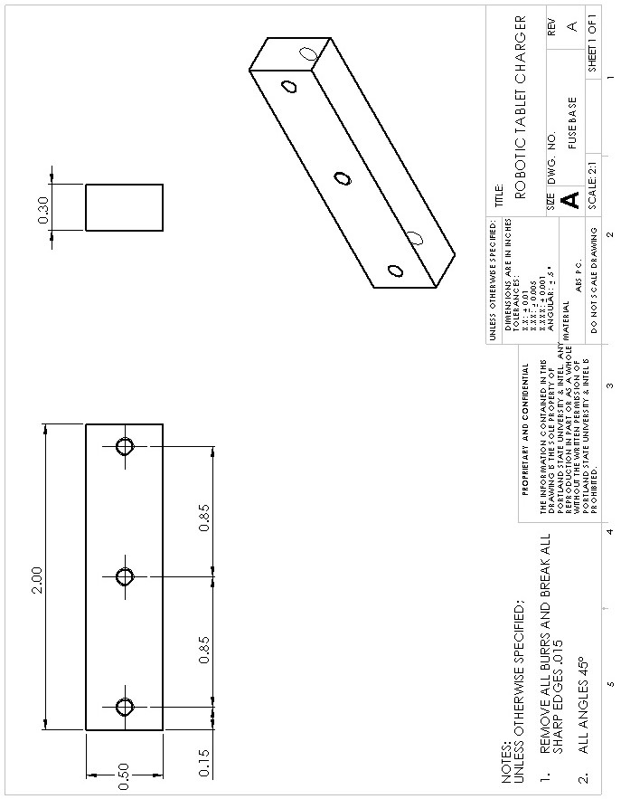

Figure 25. Robot: Fuse base

### Battery Block

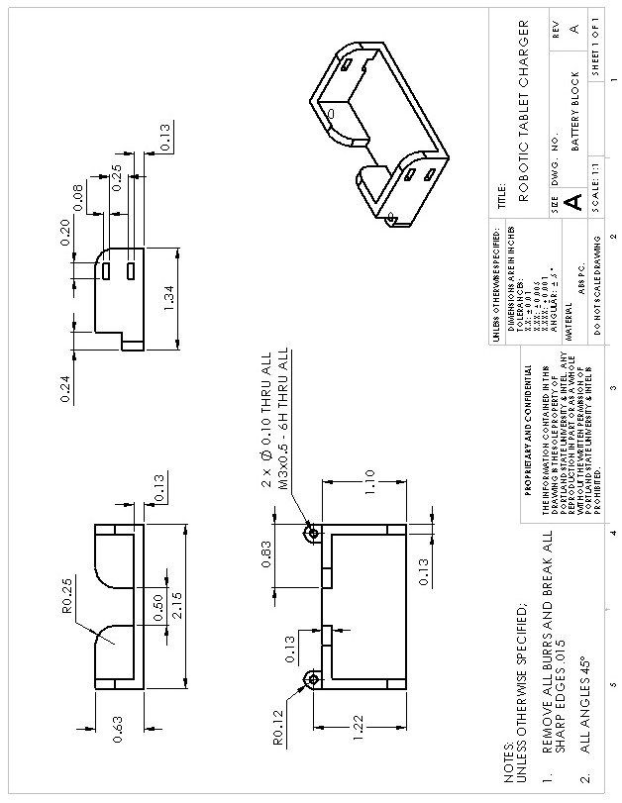

Figure 26.Robot: Battery block

### Ball Caster

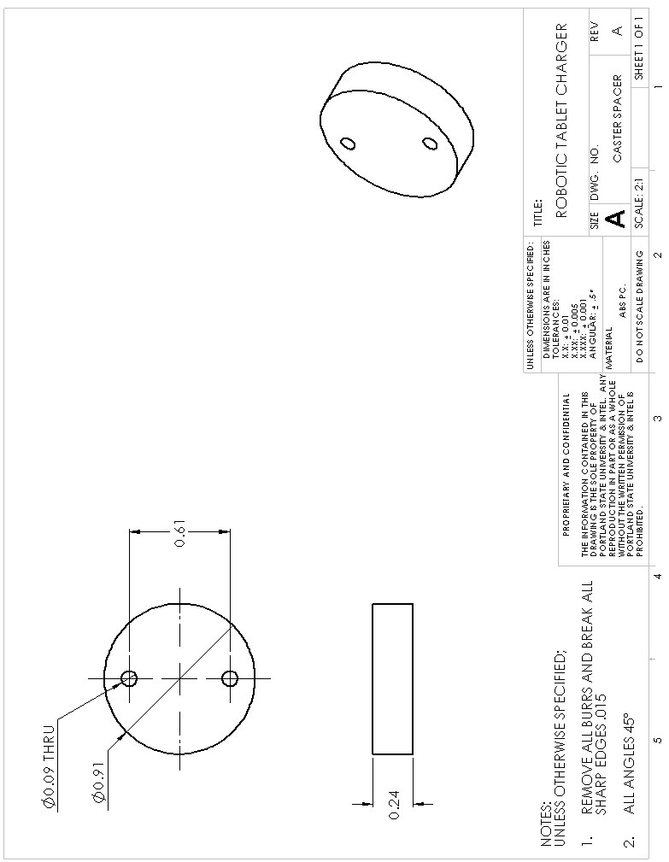

Figure 27.Robot: Ball caster

### Chassis

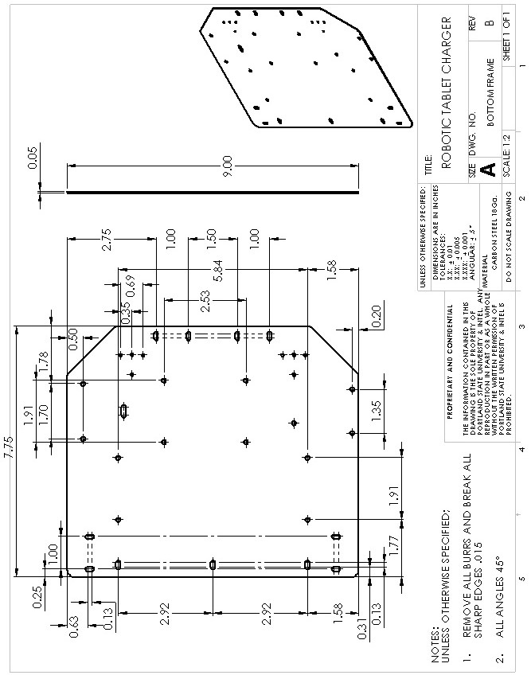

Figure 28.Robot: Chassis- bottom frame

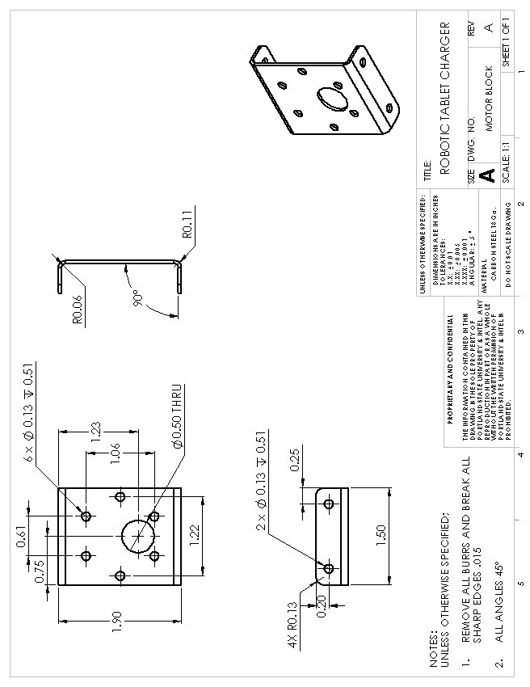

Figure 29.Robot: Chassis- motor block

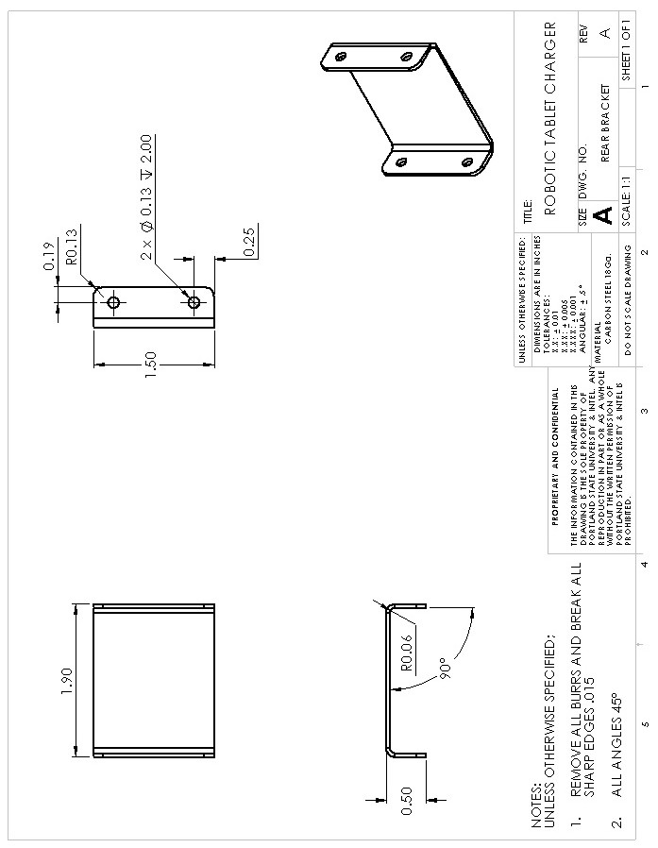

Figure 30.Robot: Chassis- rear bracket

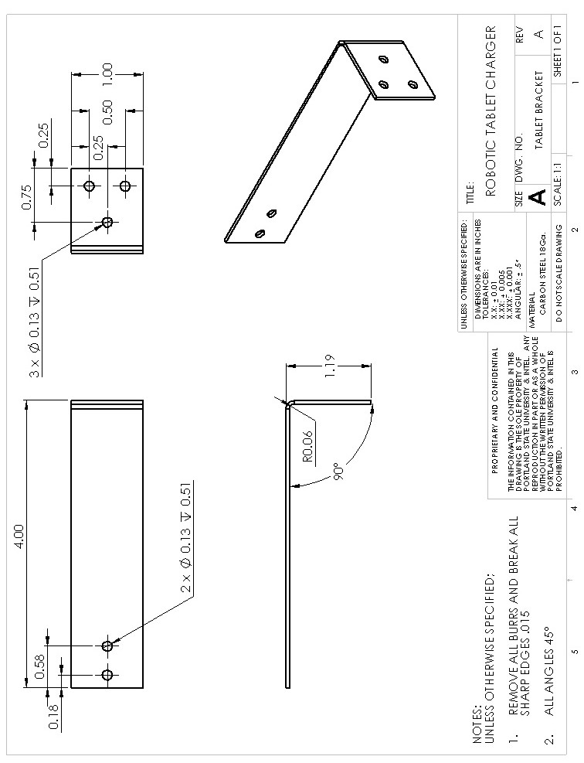

Figure 31.Robot: Chassis- tablet bracket

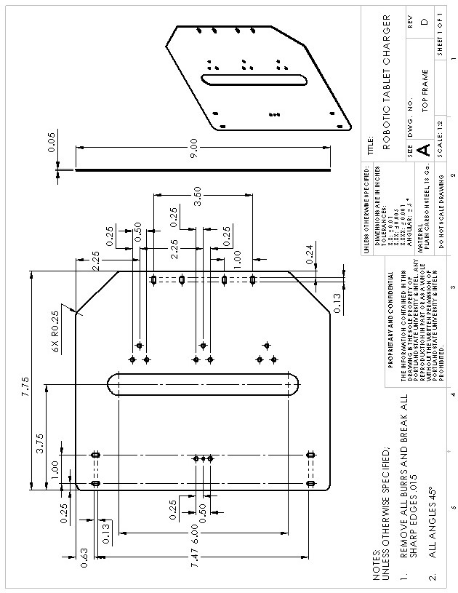

Figure 32.Robot: Chassis- top frame

### H-bridge

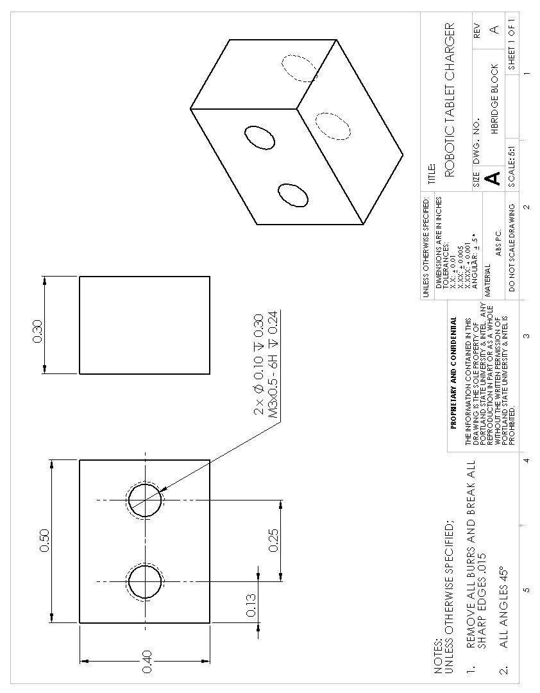

Figure 33.Robot: H-bridge block

### Switch

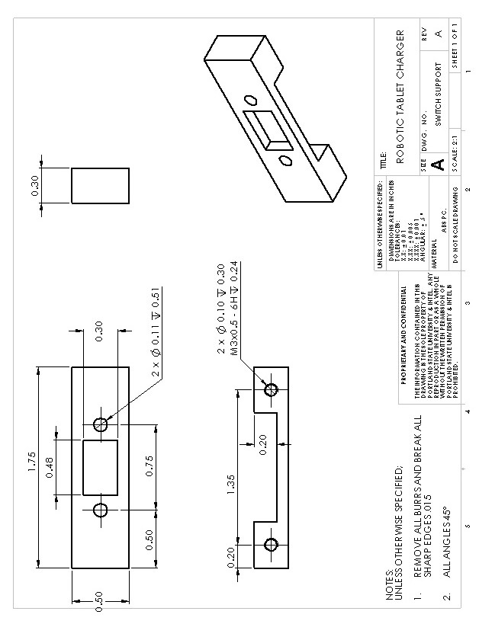

Figure 34.Robot: Switch support

### Wheel Hub

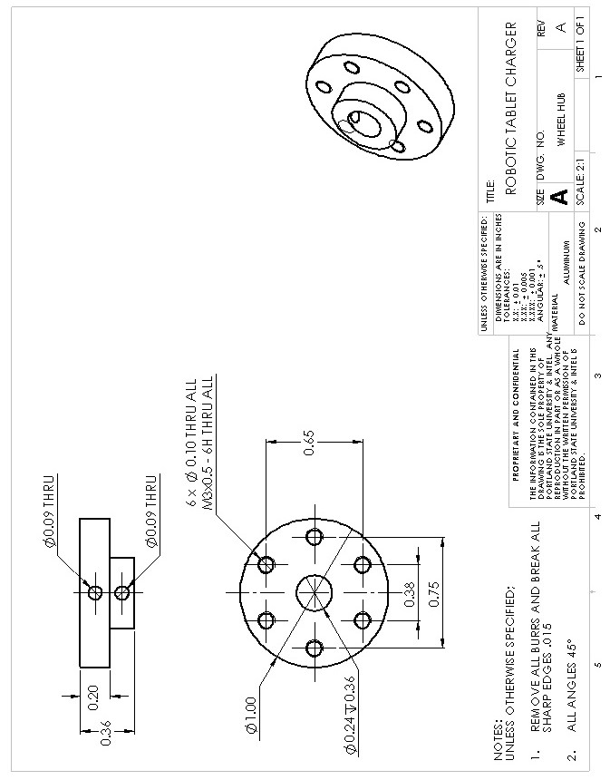

Figure 35.Robot: Wheel hub

### Tablet Holder

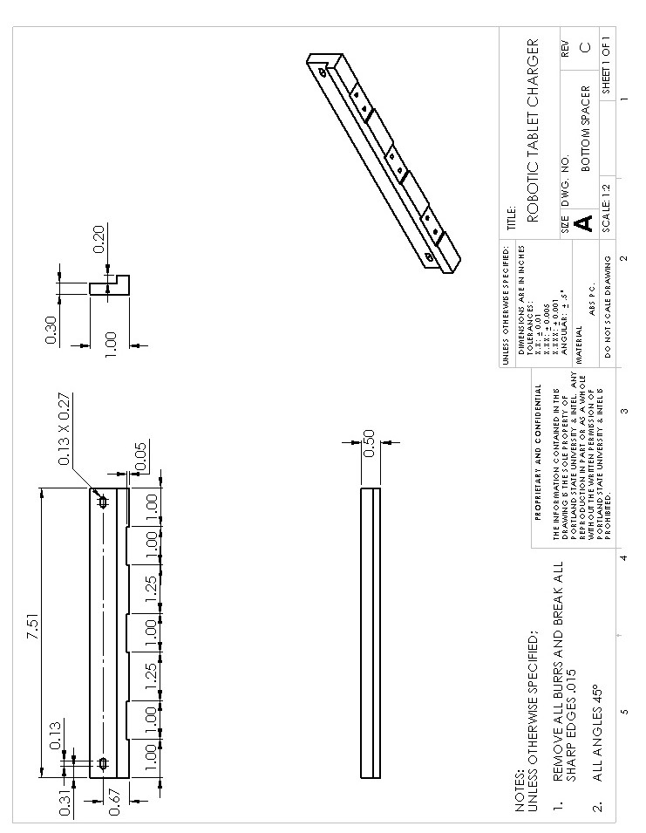

Figure 36.Robot: Tablet holder- bottom spacer

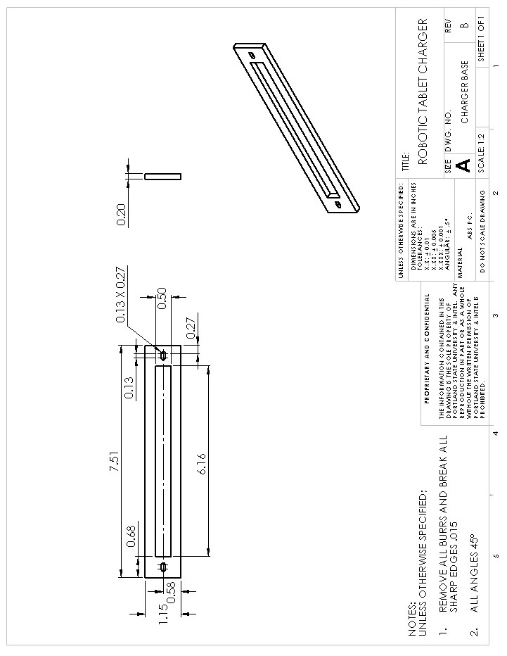

Figure 37. Robot: Tablet holder- charger base

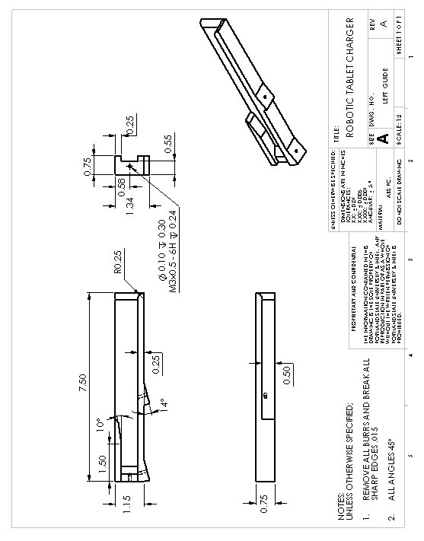

Figure 38. Robot: Tablet holder- left guide

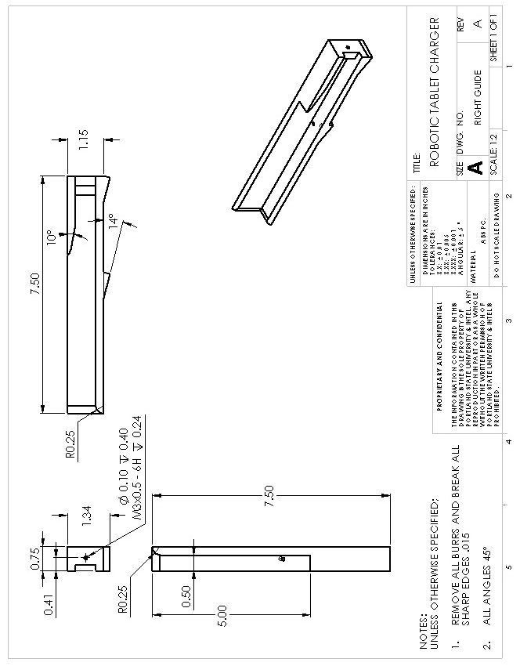

Figure 39. Robot: Tablet holder- right guide

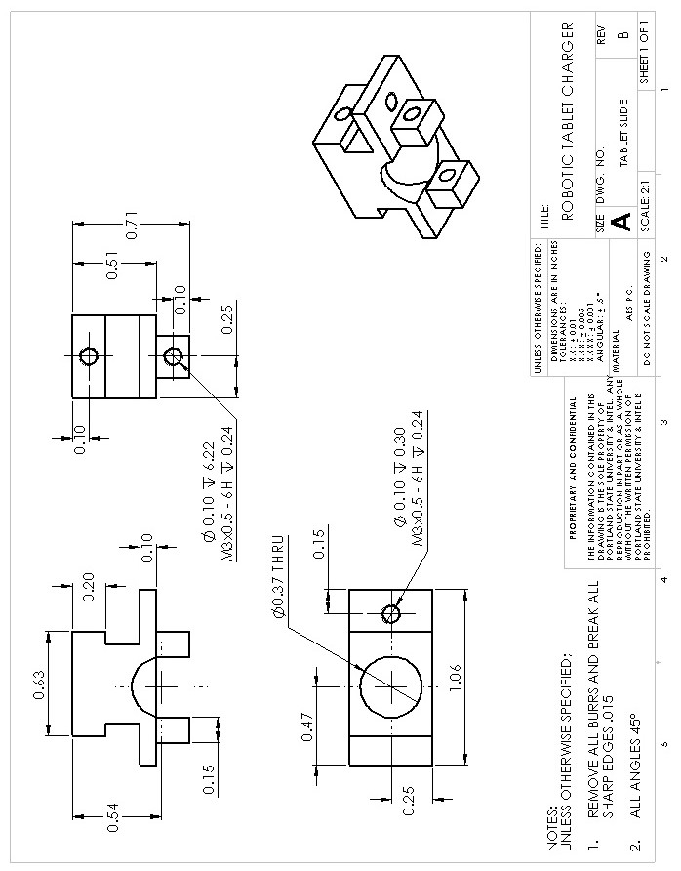

Figure 40. Robot: Tablet holder- tablet slide

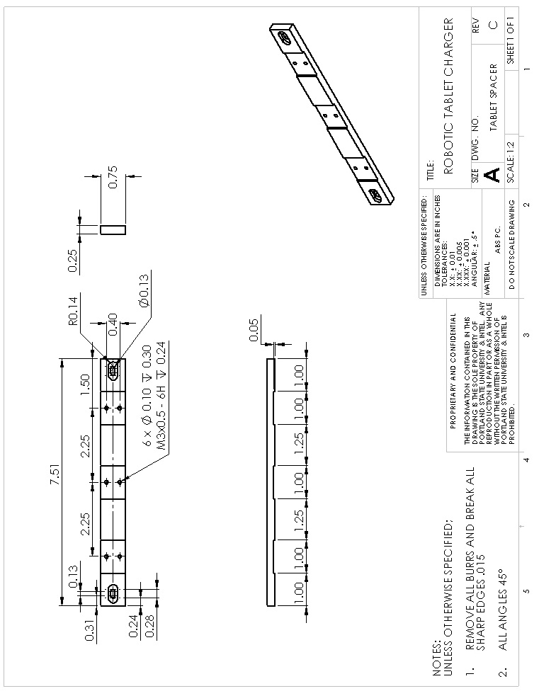

Figure 41. Robot: Tablet holder- tablet spacer

# Appendix E.

## Bill of Materials

Table 16. Bill of Materials

|  |  |  |  |  |  |  |  |
| --- | --- | --- | --- | --- | --- | --- | --- |
| Item | **Part number** | **Description** | **Manufacturer** | **Cost (not incl S&H)** | **Unit** | **Quantity** | **Total Unit Cost** |
| 1 | 6468002 | TENERGY 7.2V RC Car Battery | Fry's Electronics | $24.99 | EA | 1 | $24.99 |
| 2 | 1445 | 67:1, 6mm shaft, Metal Gear motor | Pololu | $39.95 | EA | 2 | $79.90 |
| 3 | 1439 | Pololu Wheel 90x10mm Pair - Black | Pololu | $9.95 | PK | 1 | $9.95 |
| 4 | 713 | TB6612FNG Dual Motor Driver | Pololu | $8.45 | EA | 1 | $8.45 |
| 5 | 2184 | Servo Extension Cable 12" Male - Female | Pololu | $2.49 | EA | 6 | $14.94 |
| 6 | 5864493 | FUSE BLOCK | Fry's Electronics | $1.79 | EA | 1 | $1.79 |
| 7 | GMA_5x_2A | GMA 2A 250v Fast Blow Fuses | Amazon | $3.99 | PK | 1 | $3.99 |
| 8 | 1945892 | SLIDE SWITCH DPDT ON/ON | Fry's Electronics | $0.99 | EA | 2 | $1.98 |
| 9 | 955 | Ball Caster with 3/4" Metal Ball | Pololu | $4.99 | EA | 1 | $4.99 |
| 10 | B001RNFQK8 | Male 2.1mm Plug Pigtail | Amazon | $9.99 | EA | 1 | $9.99 |
| 11 | B001RNHQ3S | Female 2.1mm Plug Pigtail | Amazon | $5.49 | EA | 1 | $5.49 |
| 12 | 95947A010 | Metric Aluminum Female Threaded Hex Standoff 4.5mm Hex, 14mm Length, M3 Screw Size | McMASTER-CARR | $0.68 | EA | 4 | $2.72 |
| 13 | 92005A118 | Metric Pan Head Phillips Machine Screw Zinc-Plated Steel, M3 Size, 8mm Length, .5mm Pitch | McMASTER-CARR | $2.60 | PK/ 100PC | 1 | $2.60 |
| 14 | 91166A210 | DIN 125 Zinc-Plated Class 4 Steel Flat Washer M3 Screw Size, 7mm OD, .45mm-.55mm Thick | McMASTER-CARR | $1.55 | PK/ 100PC | 1 | $1.55 |
| 15 | 93245A098 | Metric Alloy Steel Flat Point Sckt Set Screw M3 Size, 4mm Length, .5mm Pitch | McMASTER-CARR | $8.19 | PK/ 100PC | 1 | $8.19 |
| 16 | 90576A102 | Metric Zinc-Plated Steel Nylon-Insert Locknut Class 8, M3 Screw Size, .5mm Pitch, 5.5mm W, 4mm H | McMASTER-CARR | $3.09 | PK/ 100PC | 1 | $3.09 |
| 17 | None | Wheel hubs | PSU Machine Shop | $0.00 | EA | 2 | $0.00 |
| 18 | None | 3D printer parts | Intel | $0.00 | EA | 25 | $0.00 |
| 19 | None | Sheet metal parts | Eagle Precision | $0.00 | EA | 2 | $0.00 |
| 20 | 702 | IR Sensor | Pololu | $49.95 | EA | 1 | $49.95 |
| TOTAL: |  |  |  |  |  |  | **$234.56** |