Senior Exit Exam
The exam is 1 hour 50 minutes Long.
1. ME 313 – Analysis of Mechanical Components
2. ME 314 – Analysis and Design of Machine Elements
3. ME 351 – Vibrations and System Dynamics
4. EAS361 – Fluid Mechanics
5. ME 321 – Engineering Thermodynamics
6. ME 323 ‐Heat Transfer

There are a total of 20 questions: 10 questions covering topics 1‐3; and 10 questions covering topics 4‐6. All questions are in multiple choice, and solvable in around 5 minutes.
You are allowed to bring in up to 6 books:
- Textbooks for all the subjects listed above. Note: ME 313/314 use the same textbook.
- FE handbook (see http://www.ncees.org/exams/study_materials/fe_handbook/ to download a copy).

You are also allowed to bring in a calculator and writing materials.
A sample question for ME313 is shown below:
1. A 12.5 mm diameter steel rod is pinned between two rigid walls. The rod is initially unstressed. The rod’s temperature subsequently increases 50 deg C. The rod is adequately stiffened and supported such that buckling does not occur. The coefficient of linear thermal expansion for steel is 11.7 x 10‐6 1/deg C. The modulus of elasticity of steel is 210 GPa. What is the approximate axial force in the rod?
a. 2.8 kN
b. 15kN
c. 19kN
d. 58kN

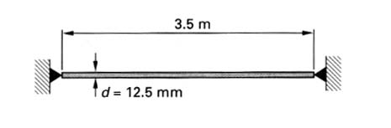
Correct answer is b

