MME Capstone Projects 2016

**Quail Egg Embryo Extractor (QEEE)**

The Children’s Cancer Therapy Development Institute conducts research in the fields of developmental biology and oncology. Their mission is to understand and prove new disease-specific treatment options for children with cancer. Their research on stopping metastasis is conducted on fertilized coturnix quail egg embryos due to the ease of manipulation and visualization. Since the process of removing the embryo from its egg shell is a delicate and time consuming process, the primary goal of this project is to construct a device that is capable of extracting the contents of a quail egg with higher efficiency than the current method used by the doctors.

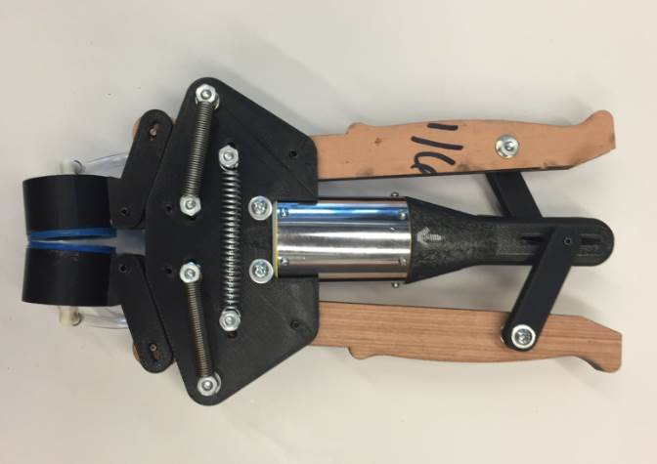

**Remote Sensor Applications in Informal Settlement Latrines**

The SweetSense Capstone team played a leading role in the design manufacture, and testing of two sensor types, in the installation of six prototypes, and in the analysis of sensor data following installation including an informed down-selection process.  The work done by the Capstone team forms a framework for unique servicing and maintenance optimization in informal settlement waste collection operations, with implications for existing and future operations in the developing world and in crisis response.

**BPA Spacer Cart**

Bonneville Power Administration (BPA) utilizes ‘Spacer Carts’ to perform maintenance on the power transmission lines throughout the Pacific Northwest. Linemen use these carts to travel along the power lines while performing repairs. The current carts utilized by BPA have been designed and fabricated by BPA’s in-house facilities. Over the years, the carts have demonstrated some issues in regards to ease of use while on the transmission lines, and safety concerns due to stress-induced cracking over time. The Capstone team has been charged with re-designing the cart to address these issues.

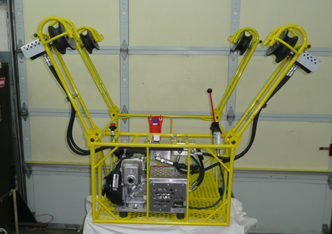

**Sheet Metal Transfer Device**

The purpose of this project is to design and fabricate a device that will allow for a safe, hands-free transportation method for various sized sheet metal between the decoiler and the CNC plasma table at Streimer’s production facility.

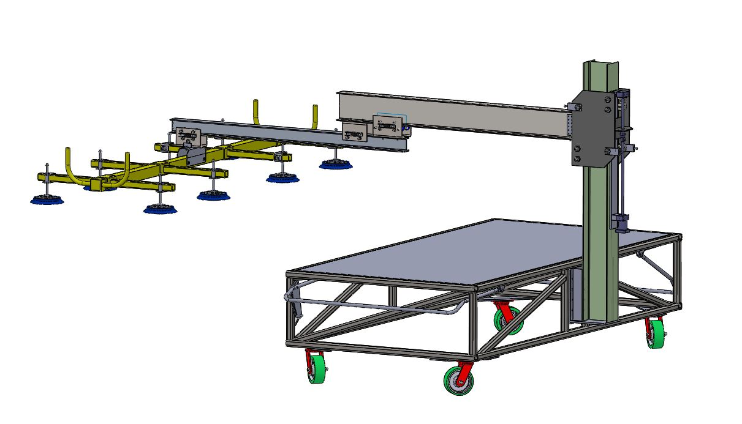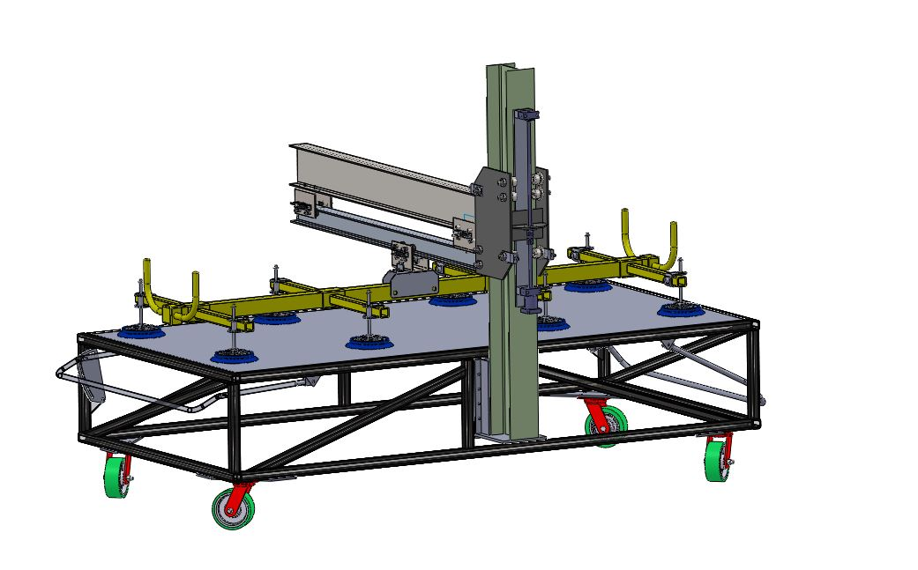

**Plantalytics**

The Plantalytics capstone team is developing a densely distributed environmental sensor network capable of giving vineyard managers real-time, actionable climate data. The data will include disease risk indexing, frost damage alerts, and flavor profiles within the vineyard. The sensors will detect ambient air temperature, humidity, leaf wetness, and light. The sensor housing shown in Fig. 1 will be the housing used for the densely distributed sensors. Figure 2 shows what an end user will see to be able to easily and quickly identify temperature profiles across the vineyard.

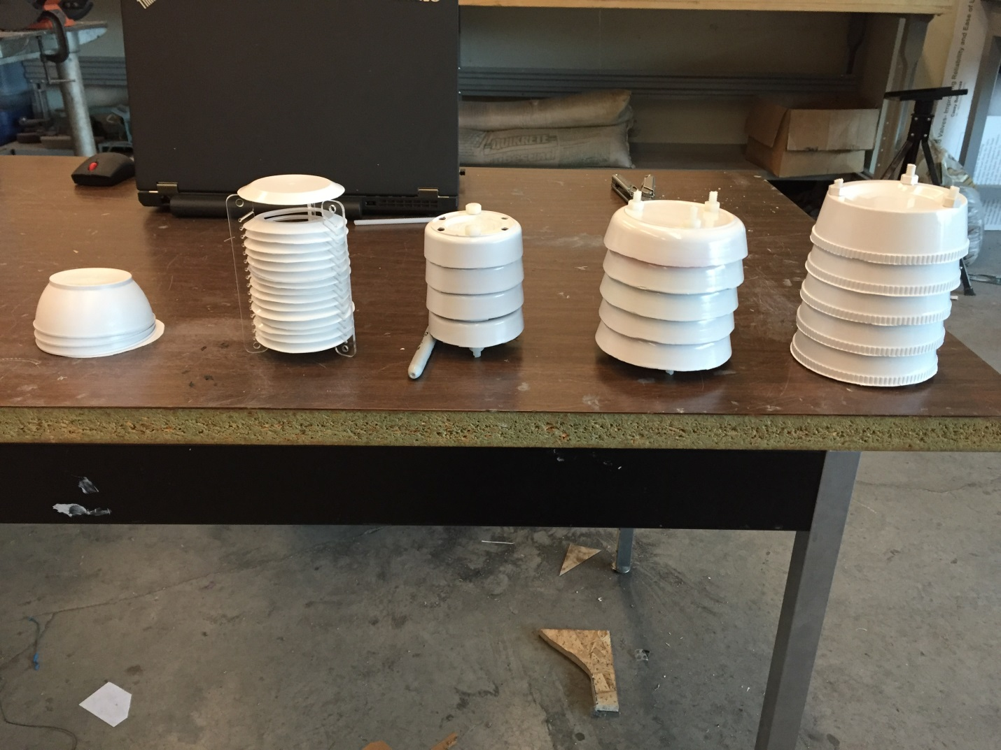

Figure 1. Selected housing for sensors.

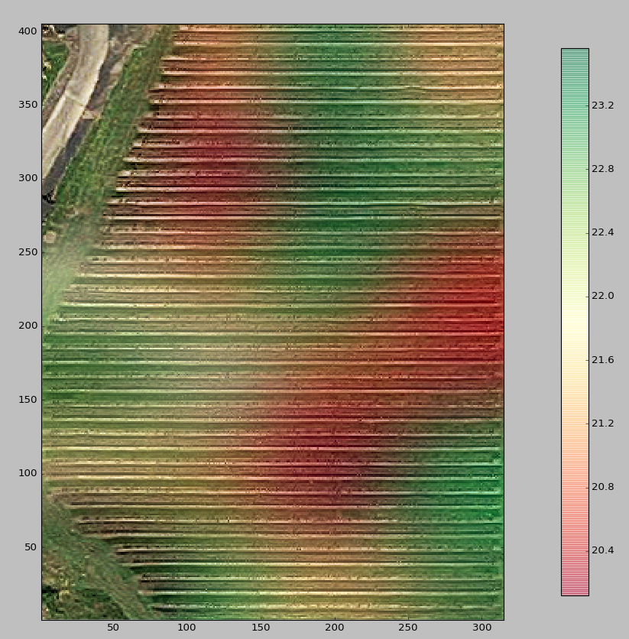

Figure 2. Map and temperature profile overlay for end user.

**Multi Axis Switch Testing Jig (MASTJ)**

Test Of Variable of Attention or TOVA is a test that measures a person’s time response to visual stimuli, determining if the individual has attention deficit hyperactive disorder. The TOVA test apparatus consists of a monitor used for visual stimuli, a computer to run the TOVA software, a signal processor for discrete timing of signals, and a switch that is the program’s interface.  As visual stimuli are received, the test subject will either actuate or not actuate a switch over a period of 20 minutes to create a characteristic profile. The Honeywell BZ-2RD72-A2 micro switch is used as the interface and has a discontinuous electrical signal after actuation, causing variation in the testing data. TOVA predicted that the signal variation increases with the lifespan of the micro switch which led to the request of constructing a test jig capable of determining a pass fail criterion and the effective lifespan for the micro switch.

The capstone team has been tasked with the design and fabrication of a switch testing jig. The jig must be able to securely hold the Honeywell Micro Switch while actuating the switch by linear or standard electric motors. The jig must have 2 rotational degrees of freedom, such that any arbitrary switch position can be achieved by the operator. The Jig will be operated without the use of tools. Total project cost must not exceed $3000 and must be compatible with Linux

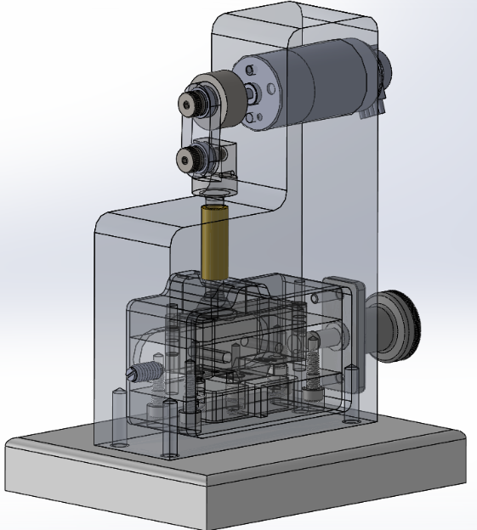**Demonstration:** <https://drive.google.com/open?id=0Bxz-vMR0f8U5M0JVcUR3TUR6ekU>

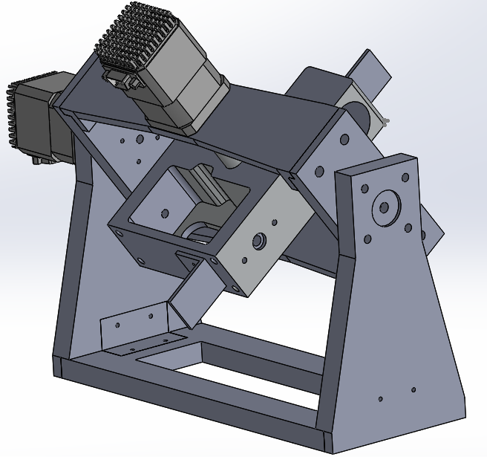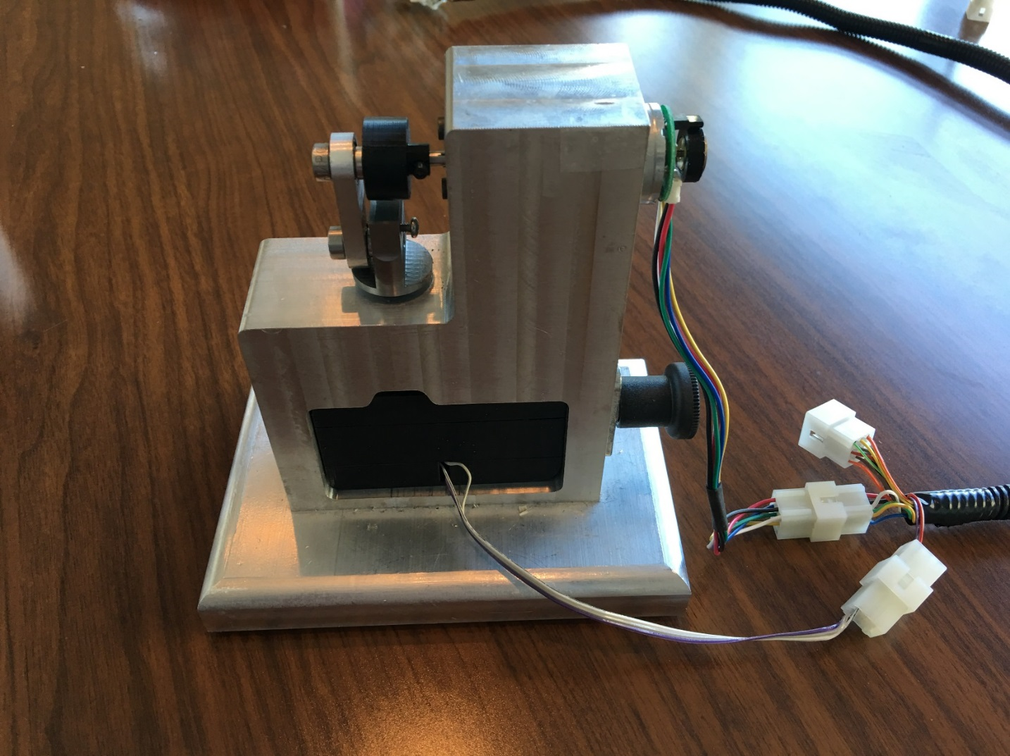

**E-Bike Drive System**

EcoSpeed is a small company in Portland that designs and produces electric bikes. It wants to replace their bikes’ gearboxes with a belt-drive system. The company’s current design uses a motor connected to a planetary gearbox that attaches to the main sprocket of the bike. While this design is effective, it tends to wear and then produce noise after about a year. The company wants a new design without the gearbox. The new design replaces the gears with belts and pulleys.

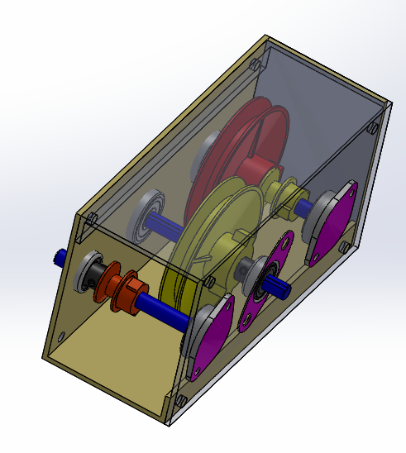

**Project name: KART2**

The objective of the Portland State University Kart2 capstone team is to design a reliable single operator stand for kart racers that can raise/lower and transport the kart around any racing complex. The stand must attach to a standard trailer hitch receiver for safe & secure device transportation while the cart resides inside the transport vehicle.

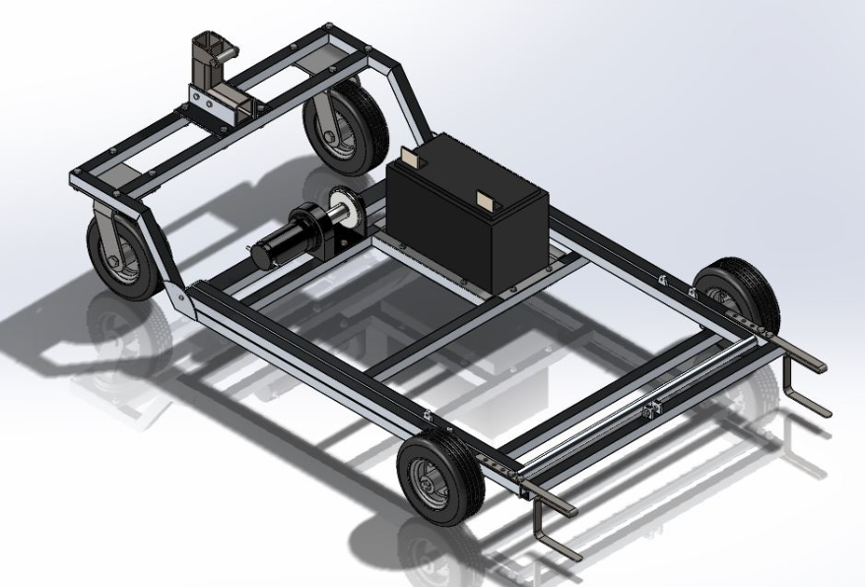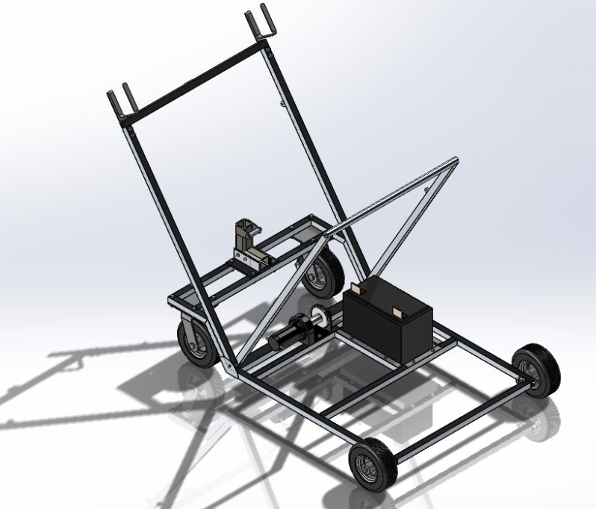

**PSAS LV3**

The Portland State Aerospace Society (PSAS) is an interdisciplinary group of engineering students and alumni of Portland State University (PSU) with the long term goal of putting a cubesat into orbit with their own rocket.

The current airframe, named Launch Vehicle 2 (LV2), has served for over 12 years, representing 10 of the group's 13 launches, and hosted experiments ranging from custom patch antennas and long range WiFi technology to GPS navigation and a cold gas reaction control system. The LV2 platform is mostly constructed of aluminum with a fiberglass shell, with many of the parts having been fabricated in home garages. This makes for a robust but heavy design. Additionally, this airframe is built with a 4.5 inch inner diameter which PSAS's experiments have outgrown.

The new airframe being designed, named Launch Vehicle 3 (LV3), aims to address these issues. The LV3 platform uses a 6 inch inner diameter, modules composed of carbon fiber and thin aluminum coupling rings, a carbon fiber nose cone, and a carbon fiber fin section. All of the airframe components connect via standardized rings, to accommodate future experimental modules and flight configurations.

The cylindrical LV3 airframe modules already outperform the old design with an 80% reduction in weight.

The primary goal of the LV3 project is to reproduce the process the 2014 capstone team developed for manufacturing the cylindrical carbon fiber sections of the rocket to be used on future PSAS projects, and to design and manufacture a nose cone and fin section using the same technology. We will clearly document our design and manufacturing processes, so that PSAS can easily produce cylindrical modules, nose cones, and fin cans as needed. A summary of the nose cone selection and the manufacturing process that we have implemented to date is detailed in the appendix.

**Sheet Metal Insulation**

The goal of this project is to design a machine that can improve the efficiency of installing insulation to air duct sheet metal. Key design components of the machine include: an increase in production speed of 400%, ease of use, able to fit different size and shape duct metal, minimized set up time and maintenance, a 95% successful rate, and safety for the operator.

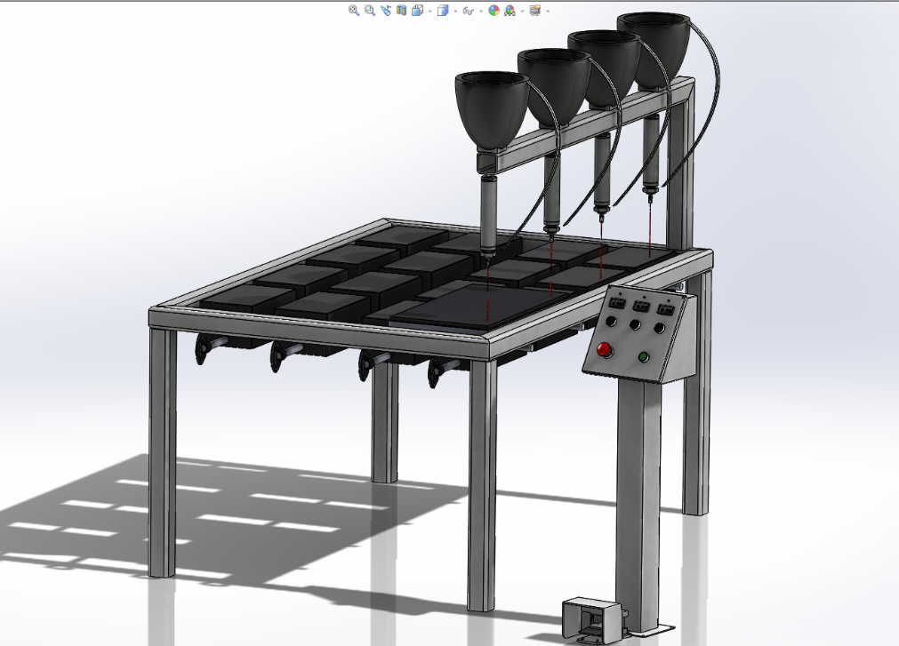

**Reihle Frame Design and Electronic upgrade**

The purpose of the Reihle capstone project is to design a rigid and movable frame and to upgrade the Reihle beam tester with an up to date electronic system. The specified requirements are to produce a automated balance mechanism with modern safeguarded controls and an ability to provide load-displacement data directly to a computer user interface.

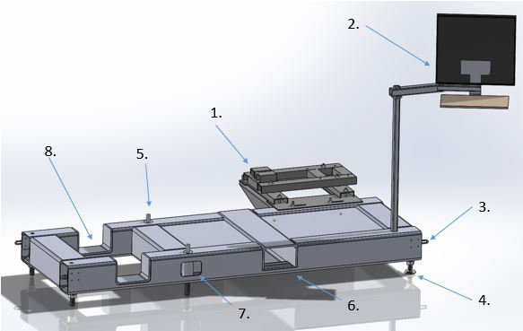

**Snow Bike**

The 2016 SnoBike Capstone team has been tasked with updating last year’s model with performance and aesthetic upgrades. Most importantly we will be making the bike collapsible to fit inside a backpack along with adding brakes and reducing the overall weight. The collapsible swing arm and frame will be manufactured from aluminum while the fork and brakes will be steel. It will utilize a fully adjustable mountain bike suspension and also feature folding foot pegs and a removable handlebar/fork assembly.

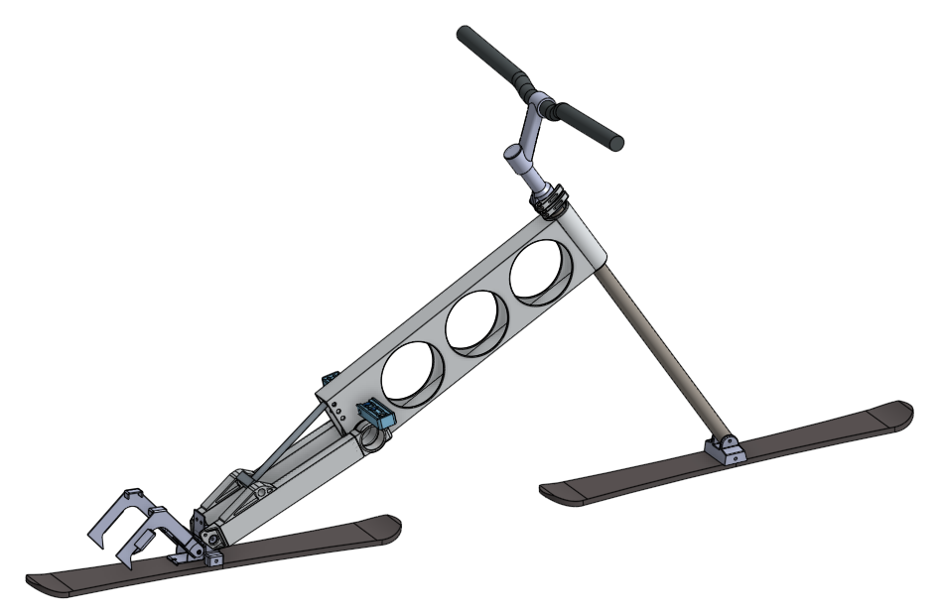

**Liquid Fuel Rocket Engine**

The Portland State Aerospace Society (PSAS) is a student group dedicated to building open-source rockets and avionic systems. The group's long term goal is to place a 1 kg cubesat into low Earth orbit with their own launch vehicle. To achieve this goal the group needs to transition from a solid to liquid fuel rocket engine. This project entails designing and building a small scalable engine for preliminary testing. 3D printing will be used to develop a regenerative cooling system with complex geometries unattainable with conventional machining. The the engine will produce 250 pounds of thrust with ethanol and liquid oxygen as the propellants. The engine will be tested on a static test stand in June.

