Thermal Resistance of Heat Sink Interface Material Testing Device (TIM Tester)

Progress Report for ME 492

3/8/2004

Design Team Members:
Joe Henry
Andy Hale
Nick Tenorio
Brian Francis

Academic Advisor: Dr. Gerry Recktenwald

Sponsoring Company: Tektronix

Industrial Advisor: Chris Coleman

Executive Summary

Thermal interface materials (TIMs) are placed between electronic devices and their heat sinks to enhance heat transfer. In electronics cooling design it is necessary to know the thermal resistance of interface materials. The current testing standard (ASTM D5470-01) for measuring the value of the thermal resistance of interface materials uses a steady state heat transfer method that is not accurate for modern TIMs [1]. The current testing standard is inaccurate considering that the test was designed for interface materials with substantial thermal resistances. Modern interface materials have resistances approaching zero. The purpose of this project is to design and build a device that employs a transient heat transfer method to determine the resistance value. This method has been shown to be far more accurate than the steady state method [1].

While TIM performance has improved vastly over the past few decades, so have the other technologies associated with moving heat away from electronic devices. These other technologies have improved to the degree that the thermal interface has become a major source of the total resistance of cooling systems [2]. There are many companies which face the problem of increasing the performance of their electronics cooling systems. Since their characterization of TIMs has high uncertainty, their models of prototype cooling systems do also.

There are no commercially available tools for measuring TIM performance with low uncertainty. A device made by Clemens Lasance of Phillips Research Laboratories uses the transient heat transfer method and claims to have low uncertainty, but is not being sold [1]. When contacted about their product they requested $30,000 for the plans alone [2]. Being the first to bring a tool to market that has low uncertainty would create an initial market share of 100%. Using free student labor for much of the design means that the machine offered by Portland State University could be priced very low. The companies which should have an interest in this product are any who design or implement high power electronic devices including such companies as Intel, AMD, Motorola, NVIDIA, and Tektronix.

The design of the PSU transient method TIM tester is continually evolving but has been generally defined. The TIM being tested will be pressed between the flat ends of two aluminum cylinders with thermocouples in them. One of the aluminum cylinders will have cold water moved across its surface for a short period of time. The cold water will then be switched to hot water and run for a short period of time. The hot water will then be switched back to cold water. The temperature data taken over the time of the test will be reduced to determine the thermal resistance of the TIM. The method of delivering the water to the aluminum cylinder surface is via plumbing from a water heater and a water chiller. The pressure will be applied by an electric actuator paired with a load cell in an active force control system. The plumbing and pressure application systems will likely be connected to a computer for a semi-automated or fully-automated testing procedure.

Throughout the design process the aim has been to create a machine which will give highly certain results. There is a large demand from big companies for a product which delivers low uncertainty results. These characteristics, paired with a lack of competition, have placed the PSU transient method TIM tester in a position to be highly successful.

Table of Contents
Executive Summary 1
Introduction 5
Mission Statement 5
Project Plan 6
Table 1 Project Plan Flow Chart 6
Product Design Specification 6
Table 2 Summary of Product Design Specifications 7
External Search 7
Existing Interface Materials 8
Existing Transient Testing Devices 8
Existing Non-Transient Testing Devices 9
Internal Search 9
Figure 1 Four Methods of Applying Pressure to TIM Sample 10
Figure 2 Plumbing Concepts for Applying Temperature Boundary Condition 11
Concept Evaluation 12
Phase I 12
Phase II 12
Table 3 Lower Puck Holder Decision Matrix 13
Table 4 Upper Puck Holder Decision Matrix 15
Table 5 Plumbing System Decision Matrix 15
Table 6 Rotational Alignment Decision Matrix 18
Table 7 Pressure Application Decision Matrix 18
Phase III 18
Final Concept Selection 20
Table 8 the Final Selected Concepts with advantages and disadvantages. 20
Progress on Detailed Design 20
Figure 3 Teflon Guide Rails 21
Figure 4 Core Assembly of TIM Tester 23
Conclusion & Recommendations 23
References 24
Appendices 26
PDS Document 26
External Search Document 26
Characteristics of Thermal Interface Materials 26
Figure 5 TIM Application Comparison [10] 26
Types of Thermal Interface Materials 26
Figure 6 Thermal Greases [19] 26
Figure 7 Thermal Compounds [19] 26
Figure 8 Phase Change Material [19] 26
Existing Testing Devices 26
Figure 9 Jet Impingement Schematic (Lasance) [1] 26
Figure 11 Philips Transient Tester [11] 26
Indirect Competitors -Steady State Testers 26
Figure 12 University of Arizona Steady State Tester [18] 26
Figure 13 Orcus Schematic [19] 26
Figure 14 Orcus Thermal Interface Tester [18] 26
Internal Search Document 26
Figure 15 Horizontal Puck Orientation 26
Figure 16 Vertical Puck Orientation 26
Figure 17 Weights Method for Pressure Application 26
Figure 19 Lever Method of Pressure Application 26
Figure 20 Screw Method of Pressure Application 26
Figure 21 Heater and Chiller w/o Circulating Loops Plumbing Method 26
Figure 22 Chiller w/ Inline Heater Plumbing Method 26
Figure 23 Dual Inline System w/ Shared Reservoir Plumbing Method 26
Figure 24 Heater and Chiller w/ Circulating Loops Plumbing Method 26
Figure 25 Press Fit Puck Holding Method 26
Figure 26 Air Gap Puck Holding Method 26
Figure 27 Spring/Set Screw Puck Holding Method 26
Concept Evaluation Document 26
Table 9 Lower Puck Holder Decision Matrix 26
Table 10 Upper Puck Holder Decision Matrix 26
Table 11 Plumbing System Decision Matrix 26
Table 12 Rotational Alignment Decision Matrix 26
Table 13 Pressure Application Decision Matrix 26
Table 14 Final Selected Concepts 26

Introduction

TIMs are placed between electronic devices and their heat sinks to enhance heat transfer. In electronics cooling design it is necessary to know the thermal resistance of interface materials. The current testing standard (ASTM D5470-01) for measuring the value of the thermal resistance of interface materials uses a steady state heat transfer method that is not accurate enough for modern TIMs [1]. The current testing standard is inaccurate because the test was designed for interface materials with substantial thermal resistances. Modern interface materials have resistances approaching zero. The purpose of this project is to design and build a device that employs a transient heat transfer method to determine the resistance value. This method has been shown to be far more accurate than the steady state method [1].

The device the team is designing will apply a constant pressure to a TIM while employing the transient heat transfer method. The pressure will be applied by pressing the TIM between the flats of two aluminum cylinders. Water at two different temperatures will be used to cycle the boundary condition thereby creating the condition of transient heat transfer. Thermocouples placed inside the aluminum will take temperature measurements. A computer data reduction program will use the temperature data to determine the thermal resistance of the TIM.

Mission Statement

The team is to design a device that can accurately measure the thermal resistance of interface materials using the transient technique developed by the Phillips Research Laboratory [1], [5], [6]. The goal is to be able to accurately measure TIM R-values between 0.84 and 0.0045°C-in²/Watt (±5%). This goal is based on mainstream industry’s most and least thermally resistive TIMs [7], [8]. The primary customer base for the TIM tester is the electronics industry and TIM manufacturers. The final prototype will be delivered no later than May 30th, 2004. The main performance criteria are that the system has the ability to test many TIM types, test at many pressures, have removable/reusable pucks, and have an electronically controlled plumbing system.

Project Plan

 |  |  |  | Week #
Task | Start | Days | Finish | 1 | 2 | 3 | 4 | 5 | 6 | 7 | 8 | 9 | 10 | 11 | 12 | 13 | 14 | 15 | 16 | 17 | 18 | 19 | 20 | 21
PDS Documentation | 1/5 | 21 | 1/26 | X | X | X | X
External Search Documentation | 1/19 | 14 | 2/2 |  |  | X | X | X
Internal Search Documentation | 1/26 | 14 | 2/9 |  |  |  | X | X | X
Final Concept Selection | 2/2 | 14 | 2/16 |  |  |  |  | X | X | X
Design Analysis | 2/16 | 34 | 3/21 |  |  |  |  |  |  | X | X | X | X | X | X | X | X | X | X
Progress Report Documentation | 3/3 | 7 | 3/17 |  |  |  |  |  |  |  |  | X | X
Design Review | 3/21 | 0 | 3/21 |  |  |  |  |  |  |  |  |  |  | X
Order Components | 4/4 | 0 | 4/4 |  |  |  |  |  |  |  |  |  |  |  |  | X
Send Plans to Tek Shop | 3/21 | 0 | 3/21 |  |  |  |  |  |  |  |  |  |  | X
Final Report Documentation | 3/21 | 70 | 5/30 |  |  |  |  |  |  |  |  |  |  | X | X | X | X | X | X | X | X | X | X | X
System Assembly | 4/25 | 0 | 4/25 |  |  |  |  |  |  |  |  |  |  |  |  |  |  |  | X
Controller Design/Implementation | 4/25 | 14 | 5/9 |  |  |  |  |  |  |  |  |  |  |  |  |  |  |  | X | X | X
Prototype Refinement | 4/25 | 35 | 5/30 |  |  |  |  |  |  |  |  |  |  |  |  |  |  |  | X | X | X | X | X | X
Prototype Delivery | 5/30 | 0 | 5/30 |  |  |  |  |  |  |  |  |  |  |  |  |  |  |  |  |  |  |  |  | X
Plans Delivered to Tek | 5/30 | 0 | 5/30 |  |  |  |  |  |  |  |  |  |  |  |  |  |  |  |  |  |  |  |  | X
Table 1 Project Plan Flow Chart

Product Design Specification

Dr. Recktenwald and Tektronix are the main customers for this device. Additional considerations were made for the end user operators, end user maintenance personnel, regulatory agencies, and part procurement.

Many design specifications have been created to ensure the quality and accuracy of the PSU transient method TIM tester. These design specifications are based on input from the customers. The customer based specifications led to internally generated specifications based on the need to meet the customers’ specifications. Additional specifications have been added as the design process has revealed additional important criteria. Table 2 below summarizes the most important specifications.

Specification | Priority | Metric | Target
Working Prototype | High | Yes/No | Yes
Powered by 110VAC | High | Yes/No | Yes
Prototype Test/Verification | High | Thermal Resistance | 0.84 to 0.0045°C-in^2/W
Electronic Plumbing | High | Yes/No | Yes
Removable Pucks | High | Yes/No | Yes
Safe to Operate | Low | Yes/No | Yes
Temperature Setup Time | Low | Time | 20 minutes
Constant Cold Cycle Temp | High | Temperature | 10°C
Constant Hot Cycle Temp | High | Temperature | 80°C
Puck Removal Time | Low | Time | 2 minutes
Number of Operators | Low | Count | 1
Floor Space Needed | Low | Area | 18 Sq. ft
Variable Pressure | High | Pressure | 0-60psi
Complete Detailed Report | High | Yes/No | Yes
Measurement Repeatability | High | Percent | ±5%
Uses Transient Method | High | Yes/No | Yes
Detailed Drawings | High | Yes/No | Yes
Puck Parallelism | High | Angle | <0.015°
Water Flow Rate | High | GPM | 1.5-3.0
Bill of Materials | High | Yes/No | Yes
Meets Regulatory Requirements | High | Yes/No | Yes
Tests Many TIM Types | High | Yes/No | Yes
No Patent Infringement | High | Yes/No | Yes
Table 2 Summary of Product Design Specifications

External Search

The design team performed a comprehensive search for information and technology related to thermal interface materials and thermal interface testing devices. This included detailed research into the functionality of similar thermal testing devices. The design team also researched the characteristics of different types of thermal interface materials currently available on the market. This information was compiled into an External Search Document submitted in January of 2004. From this information important data pertaining to the design of a thermal testing device were found. These include required temperatures, applicable pressure ranges, and thermal characteristics of each category of material. This research was necessary to ensure that all design options were fully explored and that the maximum number of TIM types would be testable in the machine.

Existing Interface Materials

There are five major types of interface materials that can be broken down into the following categories: thermal greases, thermal compounds, phase change materials, adhesive tapes, and epoxies. Understanding the characteristics of each of these materials enabled the team to choose requirements that are essential to conducting the thermal testing of each material. The search determined that phase change materials must reach at least 80°C to melt [3]. These types of TIMs must be brought above 80°C before the test may be performed. This means that the designed thermal tester will be required to attain a minimum temperature of 80°C. Increased pressure reduces the resistance to heat transfer between mating faces. Each of the thermal interface materials requires initial applied pressure to ensure joint integrity. The external search determined that common TIMs operate between 0 Pascal and 345 Kilopascals [3].

Existing Transient Testing Devices

The PDS requires that the design team focus of the transient method of thermal interface testing. The only known transient testing device was developed at the Phillips Research Laboratory by Clemens J.M. Lasance. Technical data sheets and documents pertaining to this machine are not available to the general public. The company charges $30,000 per copy of the technical documents; therefore strength and weaknesses could not be determined [1].

Existing Non-Transient Testing Devices

Designs of non-transient (steady state) interface material testers were also researched to understand the testing devices used in the past. The research into steady state machines’ strengths and weaknesses is helping with the detailed design. Schematics from steady state testers have given the team insight into possible methods of pressure application, orientation, and structure. This is proving useful in the design stage of the project.

The University of Arizona engineering department and computer manufacturer Compaq have an interesting design for their steady state thermal interface tester [4]. The most notable characteristics of their machine include the fact that it uses an LVDT to measure the thickness of the TIM during testing, it has precise flat surface mating, and it employs interchangeable heads (pucks). The use of an LVDT was seen to be such a good idea that is now under consideration for the PSU project.
For additional information concerning the external search refer to the external search document located in the appendix.

Internal Search

This section outlines some of the many concepts that were devised for the major sub-systems of the project. The major sub-systems include the pressure application system and the system that switches the temperature boundary condition. An internal search was conducted to produce ideas for securing the aluminum pucks. These parts were termed “puck holders”. Maturation of the design has made the puck holders unnecessary.

Different methods and devices can be used to apply pressure. Some examples include an actuator, weights, a threaded shaft, cam, spring, and lever. Figure 1.a through Figure 1.d are drawings of the pressure application concepts that the group generated.

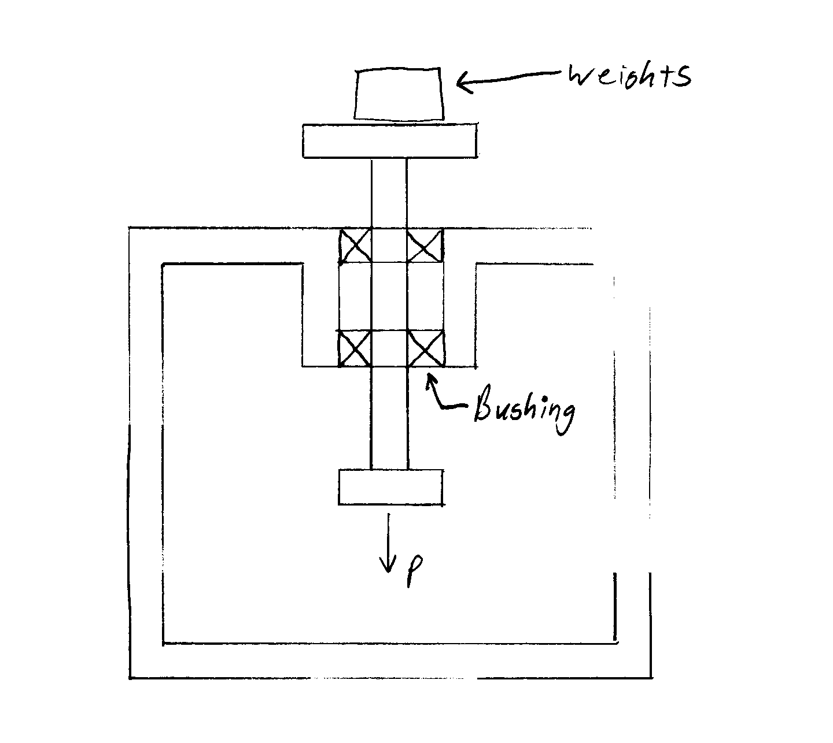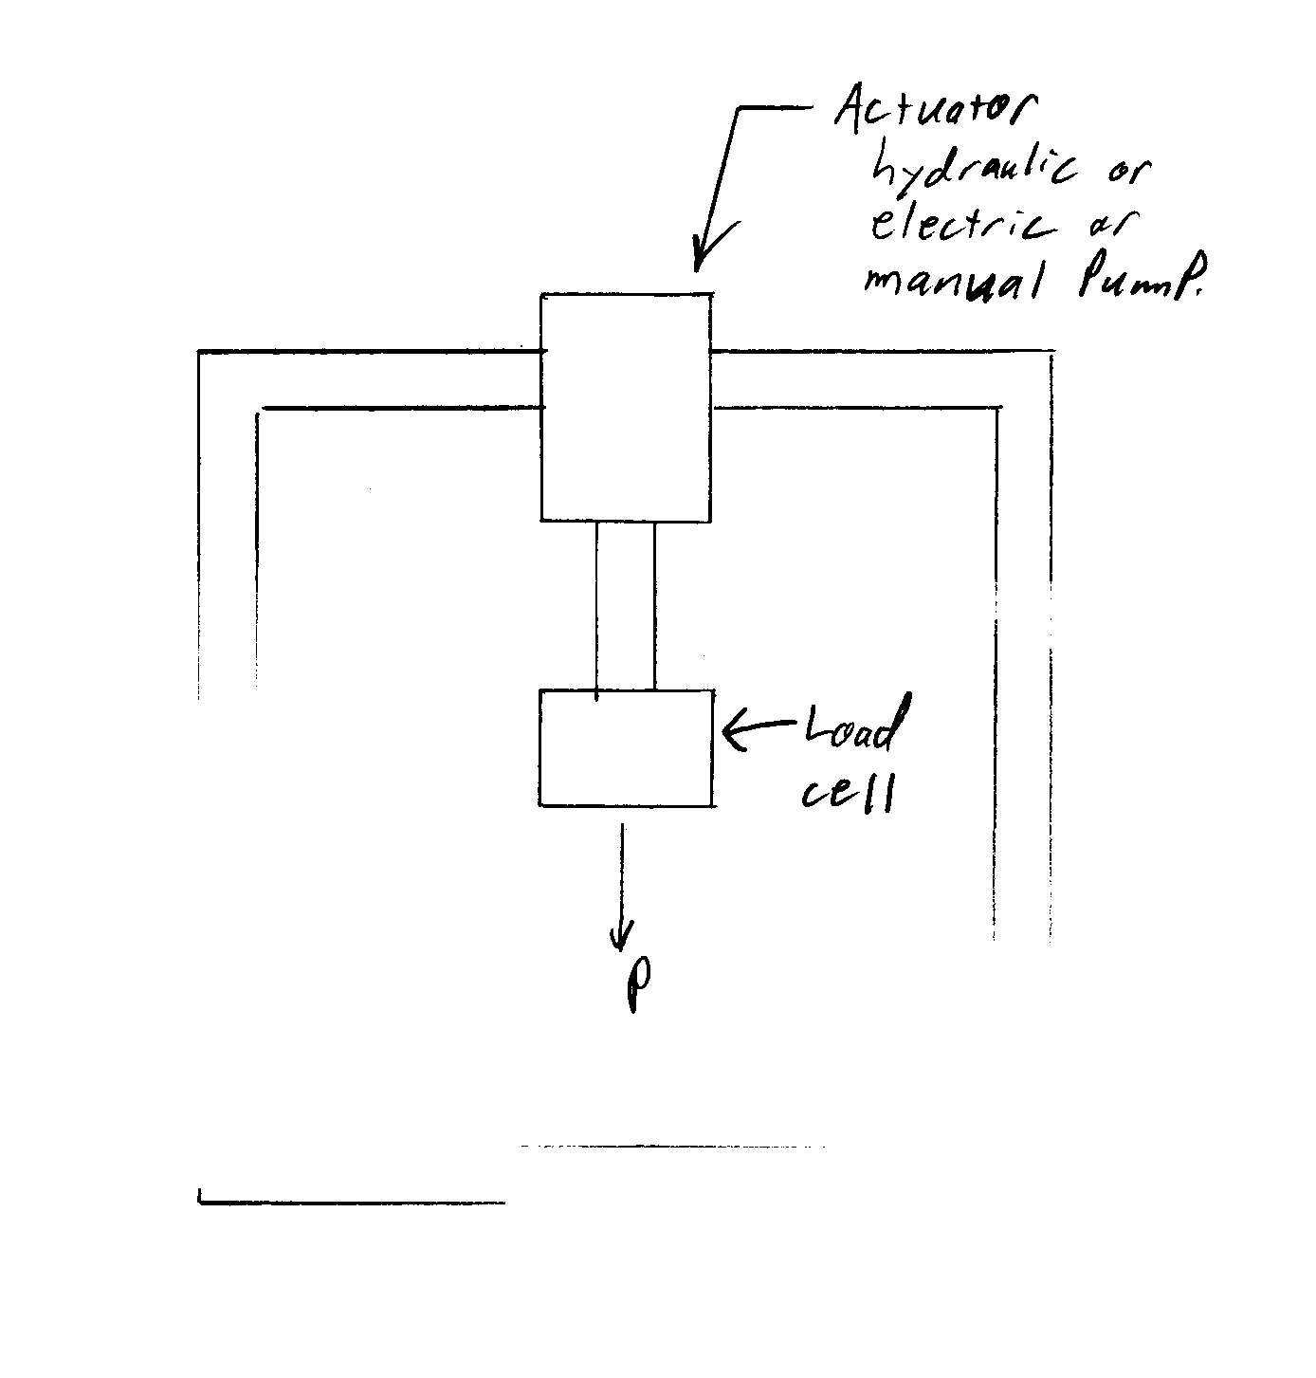
a.) Weights w/ Bushing Alignment b.) Actuator w/ Load Cell

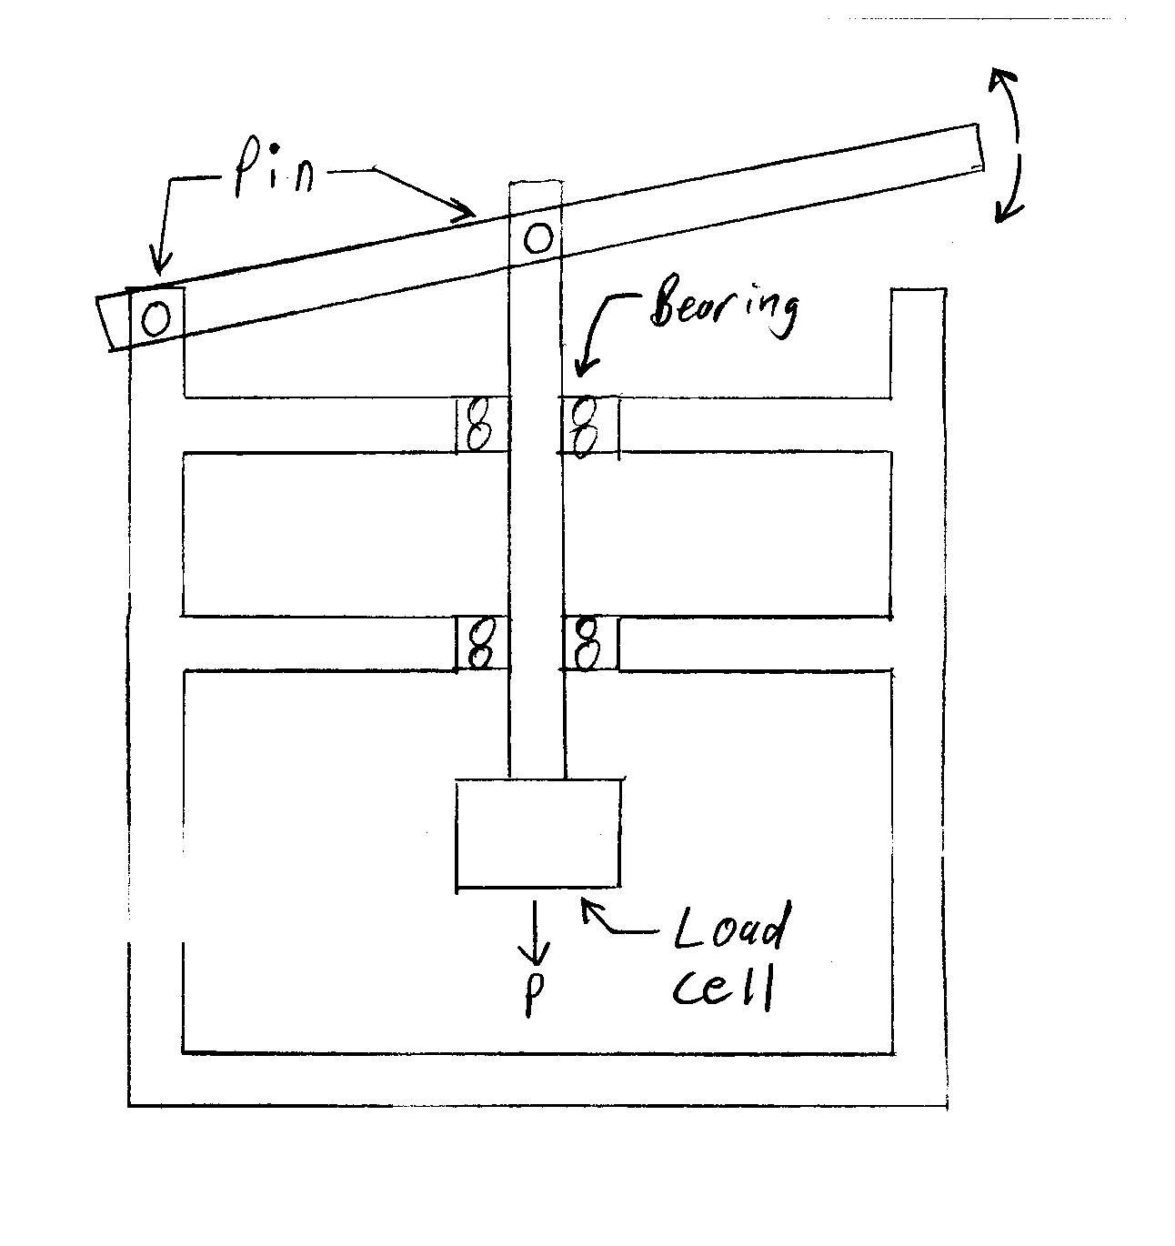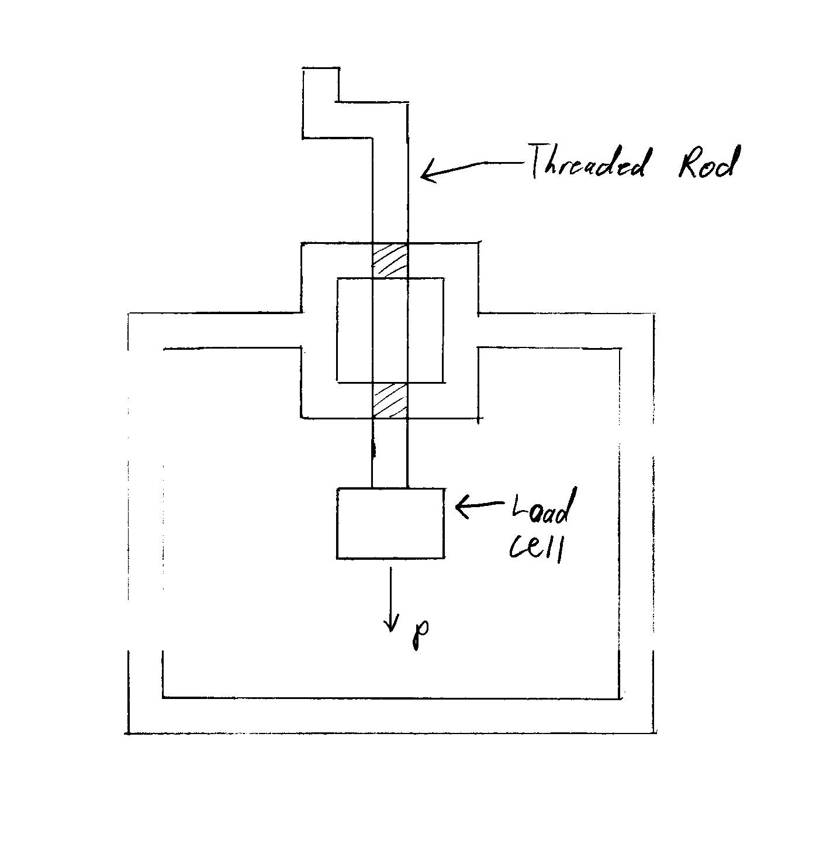
c.) Lever w/ Bearing Alignment d.) Threaded Shaft w/ Load Cell
Figure 1 Four Methods of Applying Pressure to TIM Sample

The team has established that the boundary condition can be changed in many different ways. For the hot boundary condition some of the methods under consideration were:

- Radiation
- Chemical reaction
- Convection with air via a jet impingement
- Convection with water via a jet impingement
- Water flowing through the puck
- Resistance heater
- Open flame

For the cold boundary condition some of the methods under consideration were:

- Chemical reaction
- Convection with air via a jet impingement
3) Convection with water via a jet impingement
4) Water flowing through the puck
5) Dry ice
6) Liquid Nitrogen

While continuing to consider all methods of applying temperature boundary conditions, the team leaned toward water jet impingement. Some of the water jet impingement systems that were considered by the team are illustrated in Figure 2.a through Figure 2.d.

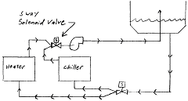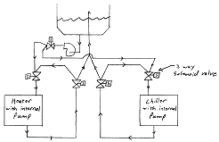
a.) Heater and chiller without circulating loops b.) Heater and chiller with circulating loops

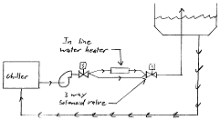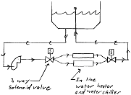
c.) Chiller with an inline heater d.) Dual inline system with single reservoir
Figure 2 Plumbing Concepts for Applying Temperature Boundary Condition

The internal search has gone over the ideas that the team has generated for the major components of the device. For additional information refer to the full text internal search document in the appendix.

Concept Evaluation

A three phase elimination process was used to narrow the possible design concepts to one final concept. The three phases consisted of: the initial screening phase, the decision matrix, and finally, the evaluation of the matrix results. The device was split into five subsystems for closer examination: top puck holder, bottom puck holder, rotational alignment, pressure application, and plumbing.

Phase I

The first phase was the initial screening phase. The screening was performed by informal group voting and discussion. Ideas that were unreasonable, overly complicated, or did not help to achieve the goals of the project were eliminated at this time. A vacuum based puck holding system was one such idea; it was eliminated in this round due to its complexity. There were much simpler ideas for puck holding that had all the benefits of the vacuum method.

Phase II

The decision matrix method was used for the second round of evaluation. This phase consisted of creating a decision matrix for each of the subsystems. Each subsystem was scored based on characteristics unique to that system. Those characteristics which were especially important were given weighting values.

The decision matrix for the lower puck holder is shown below in Table 3. Scores of one through five, one being the worst, were given to each of the concepts in each category. Each concept was scored with the requirements of the PDS in mind. The scores were then multiplied by their weighting value, and summed to obtain the final score. The winning concept was the concept with the highest score.

For further explanation of the scoring categories, the thought-process, and reasoning for eliminating the other concepts, see the full text concept evaluation document in the appendix.

Table 3 Lower Puck Holder Decision Matrix
 | Criteria
Idea | Accuracy | Machinability | Contact Area | Holding Force | Stability | Ergonomics | Durability | Total
Weighted Value | 2 | 1 | 3 | 1 | 1 | 1.5 | 1 | 10.5
Press Fit | 9.00 | 4.75 | 6.75 | 4.75 | 4.75 | 4.88 | 3.75 | 38.63
Air Gap | 6.50 | 4.75 | 14.25 | 3.75 | 3.25 | 6.00 | 3.75 | 42.25
Spring Loaded | 4.50 | 3.50 | 9.00 | 2.50 | 2.00 | 6.00 | 3.00 | 30.50
Set Screw | 7.00 | 4.00 | 9.75 | 3.25 | 3.00 | 5.63 | 2.75 | 35.38
Bolted Clamp | 6.00 | 3.00 | 5.25 | 4.25 | 3.75 | 4.13 | 3.75 | 30.13

The air gap for the lower puck holder was the winner by a significant margin. The winner is indicated with bold lettering in each of the decision matrices.

The decision matrix for the upper puck holder is illustrated below in . The winner is shown to be the set screw method.

Table 4 Upper Puck Holder Decision Matrix
 | Criteria
Idea | Accuracy | Machinability | Contact Area | Holding Force | Stability | Ergonomics | Durability | Total
Weighted Value | 2 | 1 | 3 | 1 | 1 | 1.5 | 1 | 10.5
Press Fit | 7.00 | 4.75 | 6.75 | 4.00 | 4.25 | 3.75 | 3.75 | 34.25
Spring Loaded | 4.50 | 3.50 | 9.00 | 3.00 | 2.25 | 6.00 | 3.00 | 31.25
Set Screw | 8.00 | 4.00 | 9.75 | 4.50 | 4.00 | 5.63 | 2.75 | 38.63
Bolted Clamp | 7.00 | 3.50 | 6.00 | 4.50 | 4.75 | 4.13 | 3.75 | 33.63

The main advantages of the set screw are the low contact area, the accuracy, the holding force and the ease of use.

Table 5 shows the final decision matrix for the plumbing system concepts. The winner was the heater and chiller with circulating loops due to its temperature precision and low thermal capacitance.

Table 5 Plumbing System Decision Matrix
 | Criteria
Idea | Complexity & Implementation | Temperature Accuracy | Thermal Capacitance | Total
Weighted Value | 1 | 2 | 1.5 | 4.5
Heater and Chiller w/o Circulation Loops | 4.00 | 6.50 | 4.50 | 15.00
Heater and Chiller w/ Circulation Loops | 3.00 | 9.50 | 6.38 | 18.88
Dual Inline System w/ Single Reservoir | 2.00 | 4.00 | 4.50 | 10.50
Chiller w/Inline Heater | 2.25 | 4.50 | 3.75 | 10.50

Table 6 below summarizes the decision matrix used for the rotational alignment subsystem. A scribe line is shown as the winner due to minimal flux disturbance, durability, and easy implementation.

Table 6 Rotational Alignment Decision Matrix
 | Criteria
Idea | Flux Disturbance | Implementation | Accuracy | Durability | Ergonomics | Total
Weight | 2.5 | 1 | 1.5 | 1 | 1 | 7
Notch In Puck | 7.50 | 2.75 | 6.00 | 3.25 | 4.50 | 24.00
Notch In Puck Holder | 8.75 | 2.25 | 6.00 | 3.25 | 4.50 | 24.75
Scribe Line | 11.88 | 4.75 | 5.63 | 5.00 | 4.25 | 31.50
Flats | 6.88 | 2.75 | 6.00 | 4.25 | 4.00 | 23.88
Set Screw | 6.25 | 3.25 | 5.63 | 3.00 | 3.50 | 21.63
Marker | 11.88 | 4.75 | 4.88 | 2.75 | 4.25 | 28.50

Table 7 shows the decision matrix results for the pressure application system. There was no clear winning concept from the second phase of elimination for this subsystem. The actuator and weights scored within 1% of each other, which means that further examination is necessary.

Table 7 Pressure Application Decision Matrix
 | Criteria
Idea | Uncertainty | Zero Pressure | Ergonomics | Complexity | Durability | Alignment & Stability | Total
Weight | 2.5 | 1 | 1 | 1 | 1 | 1.75 | 8.25
Screw | 8.75 | 3.50 | 3.75 | 3.25 | 4.50 | 6.56 | 30.31
Weight | 10.00 | 3.50 | 4.25 | 4.50 | 5.00 | 7.00 | 34.25
Actuator | 11.88 | 3.75 | 4.75 | 3.25 | 4.00 | 7.00 | 34.63
Lever | 3.13 | 2.25 | 2.50 | 2.75 | 4.25 | 4.81 | 19.69

Phase III

The third phase of elimination is called evaluation of matrix results. This phase consists of reviewing the matrix results and reflecting on the concepts that have been selected. Evaluating the matrix selected concepts proved important when choosing between the actuator and weights methods for pressure application. Also, it allowed for the consideration of better concepts that came to mind late in the process. One of the concepts that came to mind late in the process was that the puck that is impinged with water would have flatter isotherms and better heat transfer if the water was pushed through a cavity in the puck (as opposed to jet impingement). This idea was selected for further analysis.

The evaluation of matrix results round enabled the team to make decisions for the subsystems in which there was no clear winner, such as the pressure application system. The advantages and disadvantages of each of the closely scored concepts were outlined and compared. The conclusion was that an actuator was the best way to apply a pressure to the TIM. For further explanation of the phase III decision making process see the concept evaluation document in the appendix.

Final Concept Selection

The three phases of concept evaluation outlined above were used as a basis for the final concept selection. The results from the decision matrices were reviewed thoroughly and compared to the requirements of the product design specifications. The advantages and disadvantages of each of the selected concepts are outlined in Table 8. For additional details and explanation, see the attached document “Concept Evaluation.”

Table 8 the Final Selected Concepts with advantages and disadvantages.
Sub-System | Selected Concept | Advantages | Disadvantages
Pressure Application | Force Actuator | Zero force  Active control system  Very accurate | Harder to implement  More expensive
Plumbing System | Heater and Chiller w/ circulating loops | Less temperature variation | Number of Valves and Hoses
Rotational Alignment | Scribe Line | Simple operation  Easy to Incorporate | Subject to operator error
Top Puck Holder | Puck w/ cavity, Holder TBD. | Better heat transfer | Harder to design a sealed system
Bottom Puck Holder | Air Gap | Low contact resistance | Possible Instability

Progress on Detailed Design

The final conceptual design was determined by incorporating each of the winning concepts from the concept evaluation process. The team then split up to work independently on designing parts and selecting components. Some of the components that were ready to be designed (or selected) were the pucks, actuator, load cell, and some of the plumbing components such as the valves, chiller, heater, pumps, and hose. Each team member performed research on a component or assembly and started a search for suppliers and distributors.

The heater and chiller with circulating loops concept is in the process of being examined further. This idea was selected mainly due to the low thermal capacitance of the hoses, which enables a more constant temperature boundary condition. The group is currently researching the components necessary for the plumbing system. The search for an adequate heater and chiller is underway. Also, a number of valves have been identified as candidates. A promising hose material is cross-linked polyethylene. It has low thermal mass and is quite easy to implement. The system will be a closed system and will pump water through one puck. The other puck will not be part of the plumbing system.

Puck parallelism has been of critical importance throughout the design process. A scribe line will be used as the means for rotational alignment as it is simple, easy to use, and provides precise rotational alignment. Another important issue is puck alignment with reference to their central axes. The design team brainstormed an idea of using guide rails for the puck that essentially create a cylinder for the puck to travel in. The guide rails will be adjustable to allow for structural misalignment. The guide rails will consist of cylindrical rods with a bar of Teflon glued into each rod (see Figure 3). Teflon was used because of its low thermal conductivity. Low thermal conductivity is important in limiting the flux disturbance in the puck. The detailed analysis has not yet been performed on these components, so their final dimensions and materials have not yet been specified.

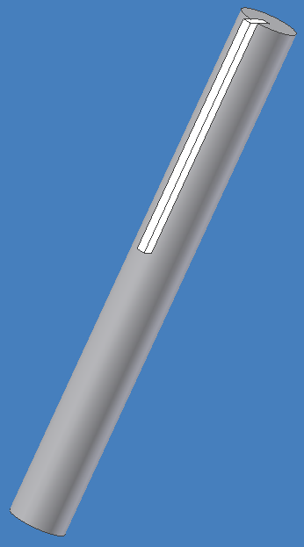
Figure 3 Teflon Guide Rails

The puck holders have been omitted from the final concept design. Instead, the pucks will be open to the air and made long enough not to interfere with the isotherms in the areas of interest. The advisors to the team have written a computer program which allows the team to model the effect various puck system changes have on isotherm development. This analysis has been used to determine viable puck options. The final puck system uses one puck with a sealed cavity (except for plumbing inlet and outlet) where the temperature condition will be introduced. No puck holder will be incorporated for either puck. The active puck will be fixed to the top plate in a manner that has yet to be rigidly defined. The inactive puck is envisioned to be basically free floating, in that it sits freely on top of the load cell. The puck is then guided by the aforementioned rails that ensure center-on-center alignment. The final diameter is likely to be 5cm. The final height is yet to be determined.

Being that the actuator is the core of the pressure application system and the component which the structure must be built around, it is proving to be a difficult choice. Adding to the difficulty of selecting an actuator is the myriad of actuator manufacturers. After a good deal of web research, speaking with applications engineers, and PDS consultation, it was determined that the ideal actuator would have the ability to apply 250 pounds of force, be ball screw driven , be powered with 12 or 24 Volts DC, have four to eight inches of stroke, have low backlash, and not be self-locking. These criteria have narrowed the field considerably. The leading candidate is the EC2-D series actuator made by Industrial Devices Corporation.

A load cell was selected to be incorporated in the final design to enable a precise measurement of the force put on the TIM. There are several types of load cells offered by thousands of manufacturers and distributors. The requirements of the load cell for this application were that it could withstand up to 250 lbs and that it must be less than five centimeters in diameter so that it fits below the puck and between the rails. It was decided that the height of the load cell should be small to avoid creating a long column with the potential of buckling. Also, the load cell will need only to measure compressive forces. Cost is an important consideration in searching for a load cell because some are very expensive.

A load cell that satisfies the requirements has been found for a reasonable price. It is the model 34 made by Honeywell. It is a button type compressive load cell that can measure loads up to 250 pounds. Its maximum diameter is 3.2 centimeters. Its height is 0.4 inches. The mounting method for this type of load cell can be easily incorporated into the design. The selected load cell costs $350. However, the output of the load cell is 0-20 mV, which means that an amplifier may be required. Research and analysis has yet to be done with respect to the necessity of a commercial amplifier. The group may be able to design its own amplifier.

The team has generated a model of what the system will look like with some of the components included. The model, without the plumbing system, is shown below in Figure 4.
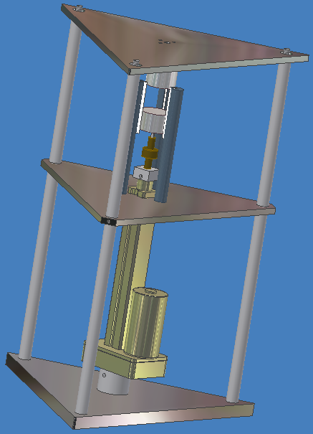
Figure 4 Core Assembly of TIM Tester

Conclusion & Recommendations

Current steady state thermal interface material testing devices deliver inaccurate and uncertain values of thermal resistance [9]. The TIM tester design team and industrial sponsor Tektronix will work together to design and manufacture a highly accurate, flexible testing device which will utilize the transient heat transfer method. The device will accurately measure the resistance of commercially available thermal interface materials. The only known transient testing device was developed by the Phillips Research Laboratory and Clemens J.M. Lasance. The design team’s goal is to produce an accurate testing device with equal or better performance. The PSU TIM tester will cost much less than Lasance’s $30,000 machine. Current estimates place the PSU designed thermal tester at approximately $5000.

The design team has assembled extensive amounts of information related to the project of designing a thermal interface material tester. The design has been complex, requiring continuous cycling between internal and external searches. The most problematic areas include concerns for the center alignment of the pucks, the paramount concern of applying even contact pressure to the TIM, the source of applied force, and the endeavor of purging the active puck of air.

References

[1] Lasance, Clemens J.M., Electronics Cooling, vol. 9, no. 4, 2003.

[2] Recktenwald, Gerald. “Transient Technique for Measuring Thermal
Resistance of Interface Materials.” Presentation, Nov. 5 2003.
http://www.me.pdx.edu/~gerry/class/ME492/interfaceTesterME492.pdf

[3] http://www.thermaflo.com/ifmat_phase.shtml

[4] http://info-center.ccit.arizona.edu/~thermlab/projects/itcr.html

[5] Bosch, Eric G.T., & Lasance, Clemens, Electronics Cooling, vol. 6, no. 9, 2000

[6] Lasance, Clemens, Electronics Cooling, vol. 8, no. 2, 2002
[7] Arctic Silver Incorporated, Arctic Silver 5 Product Specification, http://www.arcticsilver.com/as5.htm, 1/26/04

[8] Thermagon Incorporated, T-pli 2100 Product Specification, http://www.thermagon.com/pdf/t-pli200.pdf, 1/26/04

[9] Kearns, Don, “Improving Accuracy and Flexibility of ASTM D 5470 for High Performance Thermal Interface Materials,” 19th IEEE SEMI-THERM Symposium, pg 129-33, 2003.

[10] http://www.electronics-cooling.com/html/2002_may_a2.html

[11] http://www.electronics-cooling.com/html/2000_sep_a2.html

[12] http://www.electronics-cooling.com/Resources/EC_Articles/SEP96/sep96_01.htm

[13] http://www.electronics-cooling.com/html/2003_november_a1.html

[14] www.ocwarehouse.com/ articles/tc/

[15] www.ocwarehouse.com/ articles/tc/
[16] http://www.electronics-cooling.com/html/2003_november_a2.html

[17] http://www.electronics-cooling.com/html/2002_may_a2.html

[18] http://info-center.ccit.arizona.edu/~thermlab/projects/itcr.html

[19] http://www.phasechangematerials.com/how_to_test.htm

Appendices

PDS Document

Assisting in the project design are Dr. Gerry Recktenwald, graduate student John Farley, and Chris Coleman of Tektronix. Dr. Recktenwald and John Farley are in charge of designing the thermal sensor system and data reduction. They have already built a rudimentary prototype of the sensor support structure. Tektronix is offering the use of their machine shop and donating materials. Funding for machine components are being supplied by both Dr. Recktenwald (via PSU) and Tektronix.

Project Plan:

 |  |  |  | Week #
Task | Start | Days | Finish | 1 | 2 | 3 | 4 | 5 | 6 | 7 | 8 | 9 | 10 | 11 | 12 | 13 | 14 | 15 | 16 | 17 | 18 | 19 | 20 | 21
PDS Documentation | 1/5 | 21 | 1/26 | X | X | X | X
External Search Documentation | 1/19 | 14 | 2/2 |  |  | X | X | X
Internal Search Documentation | 1/26 | 14 | 2/9 |  |  |  | X | X | X
Final Concept Selection | 2/2 | 14 | 2/16 |  |  |  |  | X | X | X
Design Analysis | 2/16 | 34 | 3/21 |  |  |  |  |  |  | X | X | X | X | X
Progress Report Documentation | 3/3 | 14 | 3/17 |  |  |  |  |  |  |  |  | X | X | X
Design Review | 3/21 | 0 | 3/21 |  |  |  |  |  |  |  |  |  |  | X
Order Components | 3/21 | 0 | 3/21 |  |  |  |  |  |  |  |  |  |  | X
Send Plans to Tek Shop | 3/21 | 0 | 3/21 |  |  |  |  |  |  |  |  |  |  | X
Final Report Documentation | 3/21 | 70 | 5/30 |  |  |  |  |  |  |  |  |  |  | X | X | X | X | X | X | X | X | X | X | X
System Assembly | 4/11 | 0 | 4/11 |  |  |  |  |  |  |  |  |  |  |  |  |  | X
Controller Design/Implementation | 4/11 | 14 | 4/25 |  |  |  |  |  |  |  |  |  |  |  |  |  | X | X | X
Prototype Refinement | 4/25 | 35 | 5/30 |  |  |  |  |  |  |  |  |  |  |  |  |  |  |  | X | X | X | X | X | X
Prototype Delivery | 5/30 | 0 | 5/30 |  |  |  |  |  |  |  |  |  |  |  |  |  |  |  |  |  |  |  |  | X
Plans Delivered to Tek | 5/30 | 0 | 5/30 |  |  |  |  |  |  |  |  |  |  |  |  |  |  |  |  |  |  |  |  | X

External Customers:

PSU
Tektronix Management
Tektronix Engineering Group
End users (operators)
Maintenance personnel
Regulatory Agencies

Internal Customers:

Manufacturing
Procurement
Sources of parts
Tektronix Machinists
Dr. Recktenwald
John Farley
PSU

External Customer Requirements (without order):

- A working prototype
- Test results from the prototype to verify performance
- Temperature switching must be controlled electronically
- Removable pucks
- Safe to operate
- Pressure must be variable and measured
- Report outlining the design process, analyses, decisions making procedures and economic analysis
- High repeatability
- Use of the transient method
- Requires no more than one operator.
- Complete detailed drawings or CAD files of all designed parts
- Bill of materials
- Meet all regulatory and environmental standards
- Must be versatile enough to test many TIM types
- Must not infringe on any patents
- Relatively low setup time

PDS:

Specification | Customer | Priority | Metric | Target
Working Prototype | Recktenwald/Coleman | High | Yes/No | Yes
Powered by 110VAC | Recktenwald | High | Yes/No | Yes
Prototype Test/Verification | Recktenwald/Coleman | High | Thermal Resistance | 0.84 to 0.0045°C-in^2/W
Electronic Plumbing | Recktenwald/Coleman | High | Yes/No | Yes
Removable Pucks | Recktenwald/Coleman | High | Yes/No | Yes
Safe to Operate | Recktenwald/Coleman | High | Yes/No | Yes
Temperature Setup Time | Recktenwald/Coleman | Low | Time | 20 minutes
Constant Cold Cycle Temp | Recktenwald | High | Temperature | 10°C
Constant Hot Cycle Temp | Recktenwald | High | Temperature | 80°C
Puck Removal Time | Recktenwald/Coleman | Low | Time | 2 minutes
Number of Operators | Recktenwald/Coleman | Low | Count | 1
Floor Space Needed | Recktenwald/Coleman | Low | Area | 18 Sq. ft
Variable Pressure | Recktenwald/Coleman | High | Pressure | 0-60psi
Complete Detailed Report | Coleman/ME493 | High | Yes/No | Yes
Measurement Repeatability | Recktenwald/Coleman | High | Percent | ±5%
Uses Transient Method | Recktenwald | High | Yes/No | Yes
Detailed Drawings | Recktenwald/Coleman/ME493 | High | Yes/No | Yes
Bill of Materials | Recktenwald/Coleman/ME493 | High | Yes/No | Yes
Meets Regulatory Requirements | Recktenwald/Coleman/ME493 | High | Yes/No | Yes
Tests Many TIM Types | Coleman | High | Yes/No | Yes
No Patent Infringement | Recktenwald/Coleman/ME493 | High | Yes/No | Yes

Conclusions:

The PDS document has established project requirements, goals, and a timeline over which they will be achieved. The timeline was established with the date requirements of ME492 in mind. In trying to fit the schedule established for ME492, not much time is left for testing and refinement of the prototype(s). Time management has emerged as a critical issue for completion of the project, especially in the latter half of the project.

External Search Document

Heat dissipation of microchips has become one of the limiting factors in the race for higher processor clock speeds. Thermal resistance of interface materials now account for more than 80% of the total resistance between electronic devices and their heat sink packages [10]. Current testing devices are based on a direct application of Fourier’s law. This requires steady state heat transfer through the test material. These steady state devices deliver inaccurate and unrepeatable values of thermal resistance. The purpose of this group’s project is to assist the electronics industry by developing a more accurate testing device.

Portland State faculty member Dr. Gerry Recktenwald and industry leader Tektronics has challenged our group to design a custom, highly accurate, and flexible testing device that uses a transient heat transfer method rather than the currently standard steady state methods. The transient method exhibits advantages over the steady state method by allowing for shorter test durations (minutes instead of hours) and flexibility. The transient testing device will accurately measure the resistance of commercially available thermal interface materials including thermal greases, adhesive tapes, epoxies, and phase change materials.

Characteristics of Thermal Interface Materials

When two surfaces are brought together the percentage of physical surface contact is never 100%. In reality, as much as 99% of the surfaces are separated by a layer of interstitial air [10]. This interstitial air is very inefficient in transferring heat. Some of the heat is conducted through the minimal areas of physical contact but much of it has to transfer through the air gaps. A thermal interface material (TIM) is used to join the two surfaces and improve the joint conductivity improving heat flow across the thermal interface.
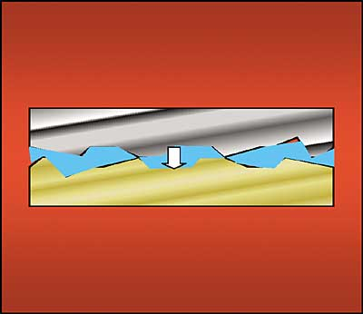
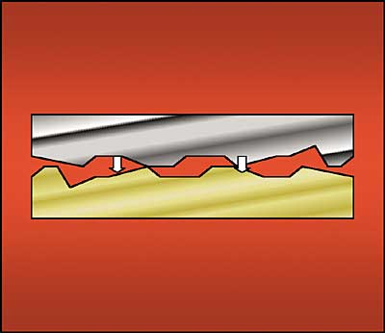

Figure 5 TIM Application Comparison [10]

Types of Thermal Interface Materials
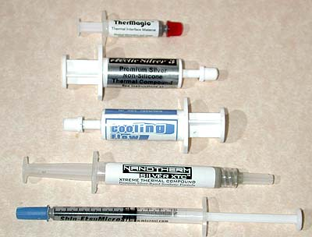
Thermal greases are made by dispersing thermally conductive ceramic fillers in silicone or hydrocarbon oils to form a paste. Sufficient grease is applied to one of the mating surfaces such that when pressed against the other surface, the grease flows into all voids to eliminate the interstitial air. Joint integrity has to be maintained with spring clips, screws, or other mounting hardware.
Figure 6 Thermal Greases [19]
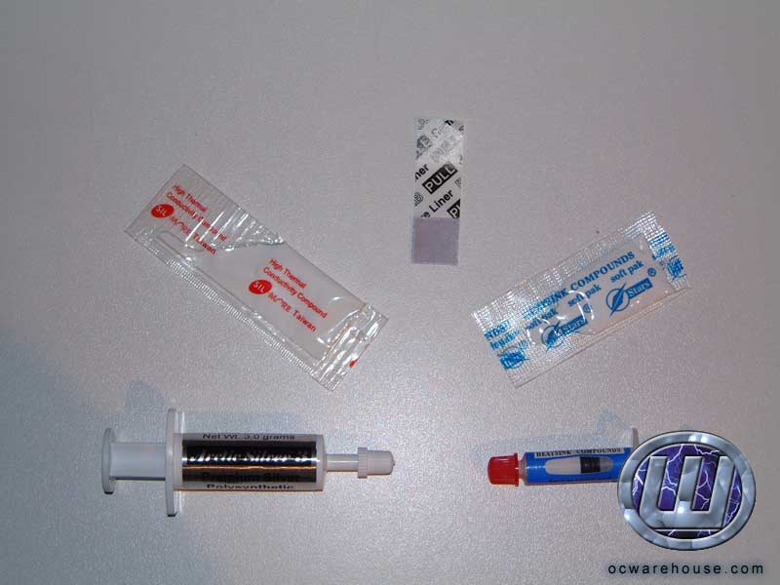
Thermally conductive compounds are similar to thermal greases. The compound spreads like a grease and cures into a rubber film. After the interface is formed the rubbery film becomes adhesive. These compounds then do not require mechanical fasteners to maintain the integrity of the joint.
Figure 7 Thermal Compounds [19]

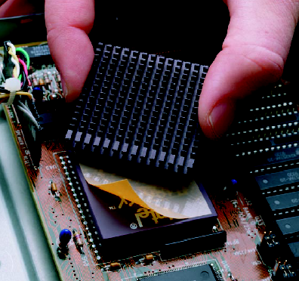
Thermally conductive elastomers/Phase change materials are silicone elastomer pads filled with thermally conductive ceramic. Unlike compounds and greases the elastomer pads provide electrical insulation. They are usually used with discrete power devices which require electrical isolation.
Figure 8 Phase Change Material [19]
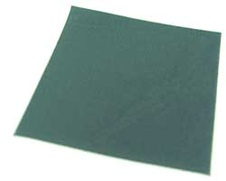
Thermally conductive adhesive tapes are double-sided adhesive films or tapes. The problem with adhesive tapes is that they are unable to fill large interstitials between surfaces. The adhesive tapes require no mechanical support to maintain the mechanical or thermal integrity of the interface.

Existing Testing Devices

The Phillips Research Laboratory tester designed by Clemens J.M. Lasance is the only publicly known device to employ the use of transient heat transfer. The device and a schematic of it may be seen in Figure 9, and Figure 10. This tester places the thermal interface material between two silver cylindrical pucks that can be pressed together at a specified pressure. A water jet shoots up at the bottom puck and cycles the boundary condition by switching between hot and cold water.
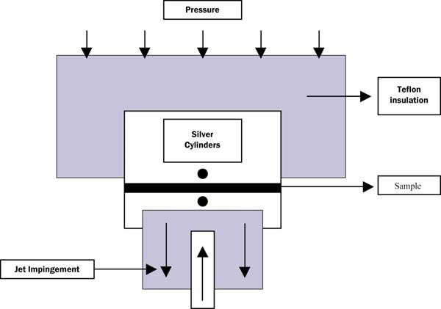

Figure 9 Jet Impingement Schematic (Lasance) [1]
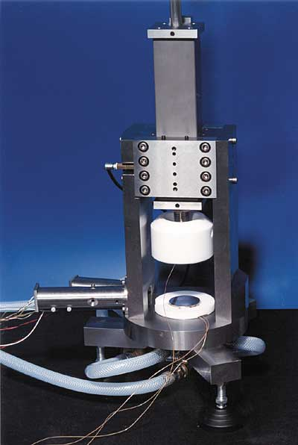
The test setup shows the sample material clamped between two silver cylinders. The temperature of the lower block can be changed very quickly using water jet impingement.
Figure 10 shows the Lasance thermal tester in its final form. Technical data sheets and documents are not available to the general public, therefore strength and weaknesses could not be determined.

Figure 10 Lasance Transient Tester [1]

Another project reported by the Phillips research lab orientates the tester in a horizontal fashion as shown in Figure 11. This setup is said to be simple and inexpensive to produce, but not as accurate as the other setup.
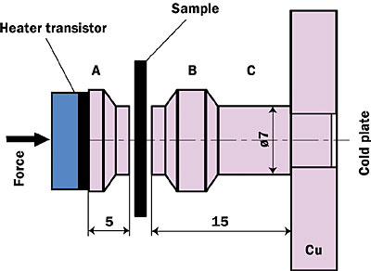
Figure 11 Philips Transient Tester [11]

At time = 0 the heater is activated and the temperature is monitored at points A and B. A transient tester using special software transforms the response curves into so-called differential structure functions or in short DSF.

Indirect Competitors -Steady State Testers

University of Arizona
The University of Arizona engineering department and computer manufacturer Compaq worked together to build a thermal interface tester. A custom testing device which uses the steady state method was produced. This device is pictured in Figure 12. The tester uses a heater to produce a downward heat flow from the top puck, through the interface material and into the bottom puck. A coolant is circulated around the bottom boundary of the lower puck to assist in the extraction of heat.

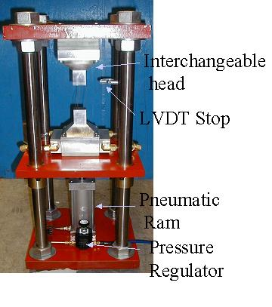
Figure 12 University of Arizona Steady State Tester [18]

A pneumatic ram can be adjusted to apply a specified pressure by observing the current applied force using a load cell. The displacement is measured with a LVDT to determine how far apart the pucks are from each other during operation (in other words, the thickness of the TIM between them).

Orcus Tester
Orcus Inc. has developed a thermal interface tester that uses 2” x 2” test specimens of all types. The force on the test material is reported to be 18 pounds (4.5 lbs per square inch). Having a single pressure setting proves to be one of the weaknesses of this tester.

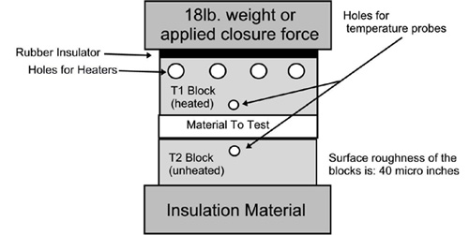
Figure 13 Orcus Schematic [19]

Any material can be sent to this company to determine its thermal resistance. The company is currently striving to make their machine the international standard. Below is a possible test setup.

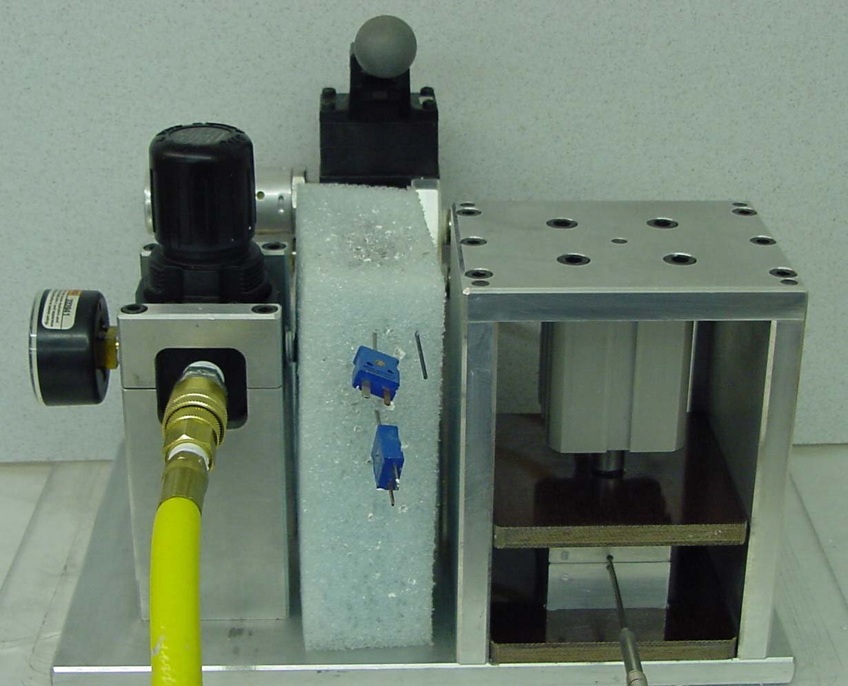
Figure 14 Orcus Thermal Interface Tester [18]

The engineering of electronic cooling solutions is becoming a more difficult task as electronic devices increase their power consumption and die surface areas shrink. Heat sinks provide a path for heat removal from these power hungry electronic devices. The joints between these electronic devices and their heat sinks are often filled with thermal interface materials which may account for 80% of the total resistance. The current standard provides inaccurate and unrepeatable results due to the resolutions of current testers and the shrinking resistance values of these new state of the art materials.
Knowing the need for a new testing standard, Clemens J.M. Lasance and others have determined that the transient method of testing may have a better resolution of these shrinking resistance values. The external search has determined that the Phillips Research and Lasance device is the only direct competition for testers using the transient technique. Schematics from steady state testers have given the team insight into possible methods of pressure application, orientation, and structure. This will prove useful in the design stage of the project.

Internal Search Document

Pressure application

A constant pressure in any orientation must be applied to the TIM. Figure 15 and Figure 16 show some of these orientations.

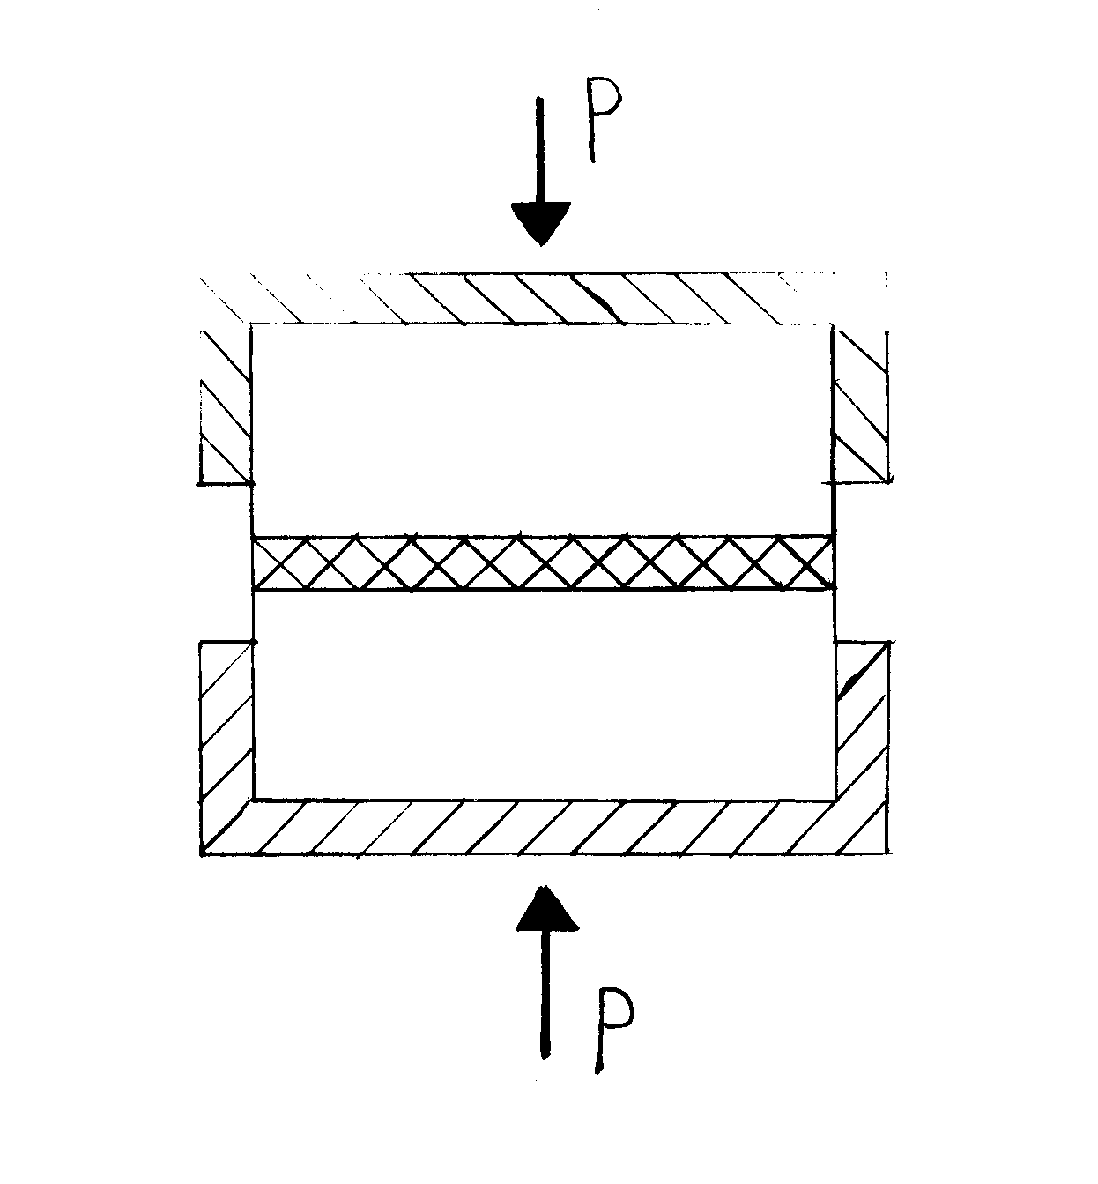
Figure 15 Horizontal Puck Orientation

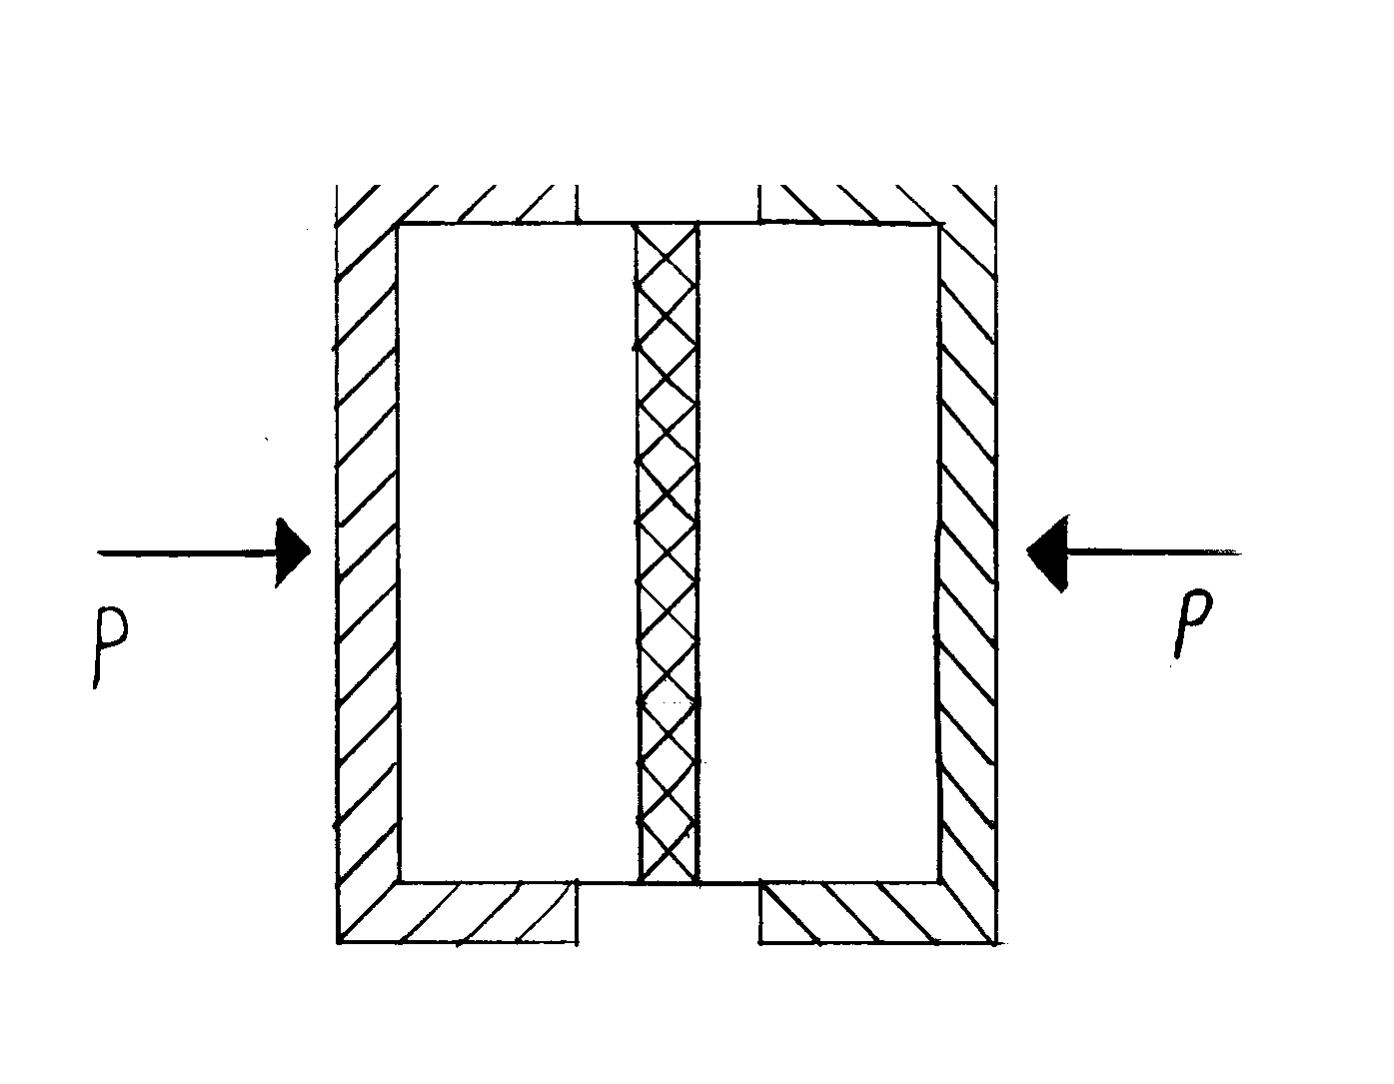
Figure 16 Vertical Puck Orientation

Different methods and devices can be used to apply pressure. Some examples include an actuator, weights, a threaded shaft, cam, spring and lever. See Figure 17 through Figure 20 for sketches of some of the possible pressure application methods.

Figure 17 Weights Method for Pressure Application

Figure 18 Actuator Method for Pressure Application

Figure 19 Lever Method of Pressure Application

Figure 20 Screw Method of Pressure Application

Temperature boundary condition

The team has found that the boundary condition can be changed in many different ways. For the hot boundary condition some of the methods under consideration are as follows:

- Radiation
- Chemical reaction
- Convection with air via a jet impingement
- Convection with water via a jet impingement
- Water flowing through the puck
- Resistance heater
- Open flame

For the cold boundary condition some of the methods under consideration are as follows:

- Chemical reaction
- Convection with air via a jet impingement
- Convection with water via a jet impingement
- Water flowing through the puck
- Dry ice
- Liquid Nitrogen

Plumbing systems

While continuing to consider all methods of applying temperature boundary conditions, the team has begun to lean toward water jet impingement.

Some of the water jet impingement systems that were considered by the team are illustrated in the following figures:

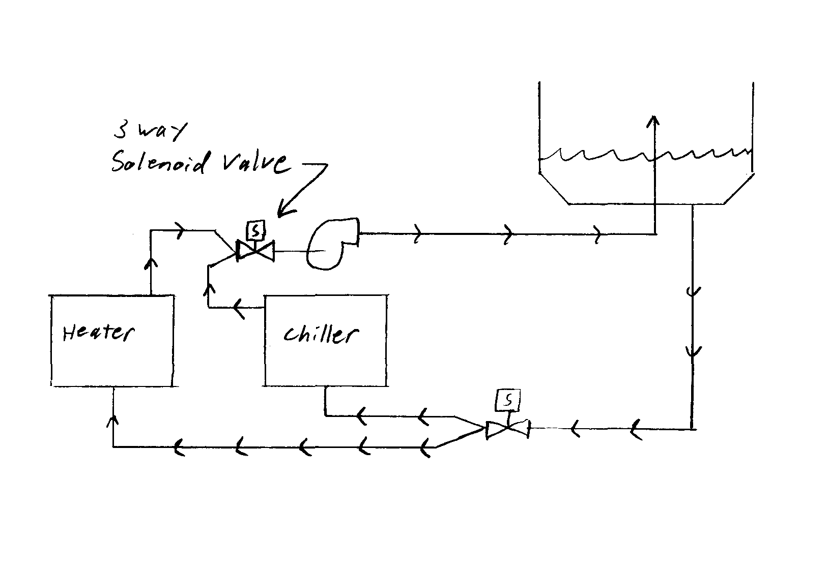
Figure 21 Heater and Chiller w/o Circulating Loops Plumbing Method

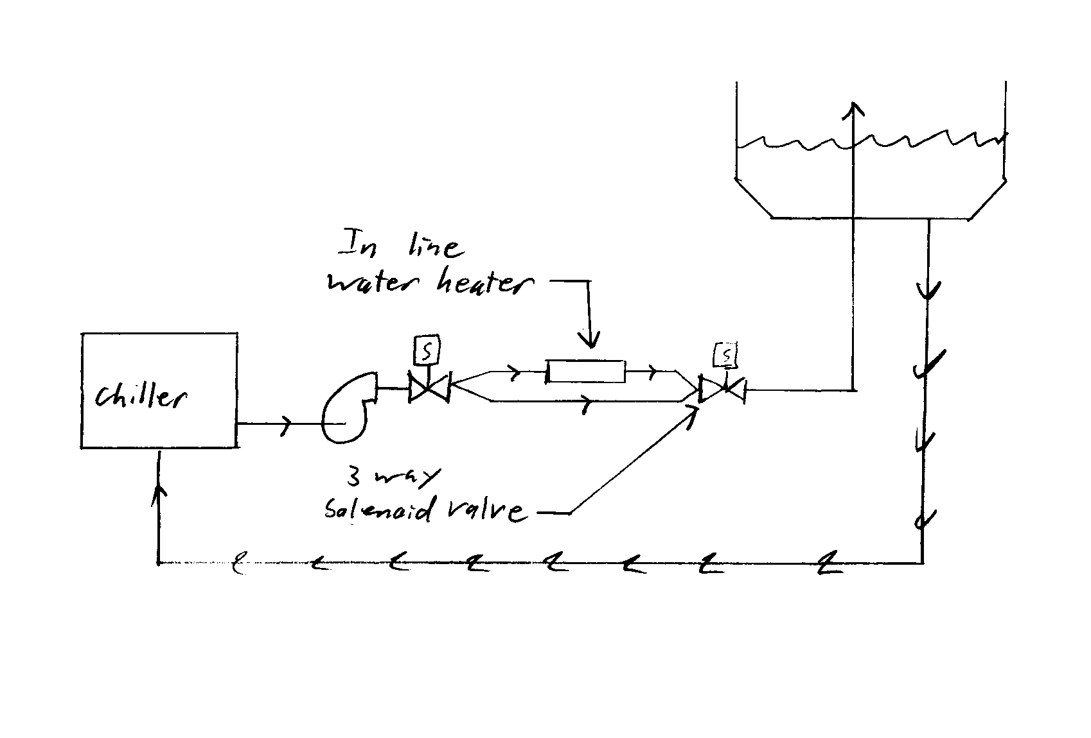
Figure 22 Chiller w/ Inline Heater Plumbing Method
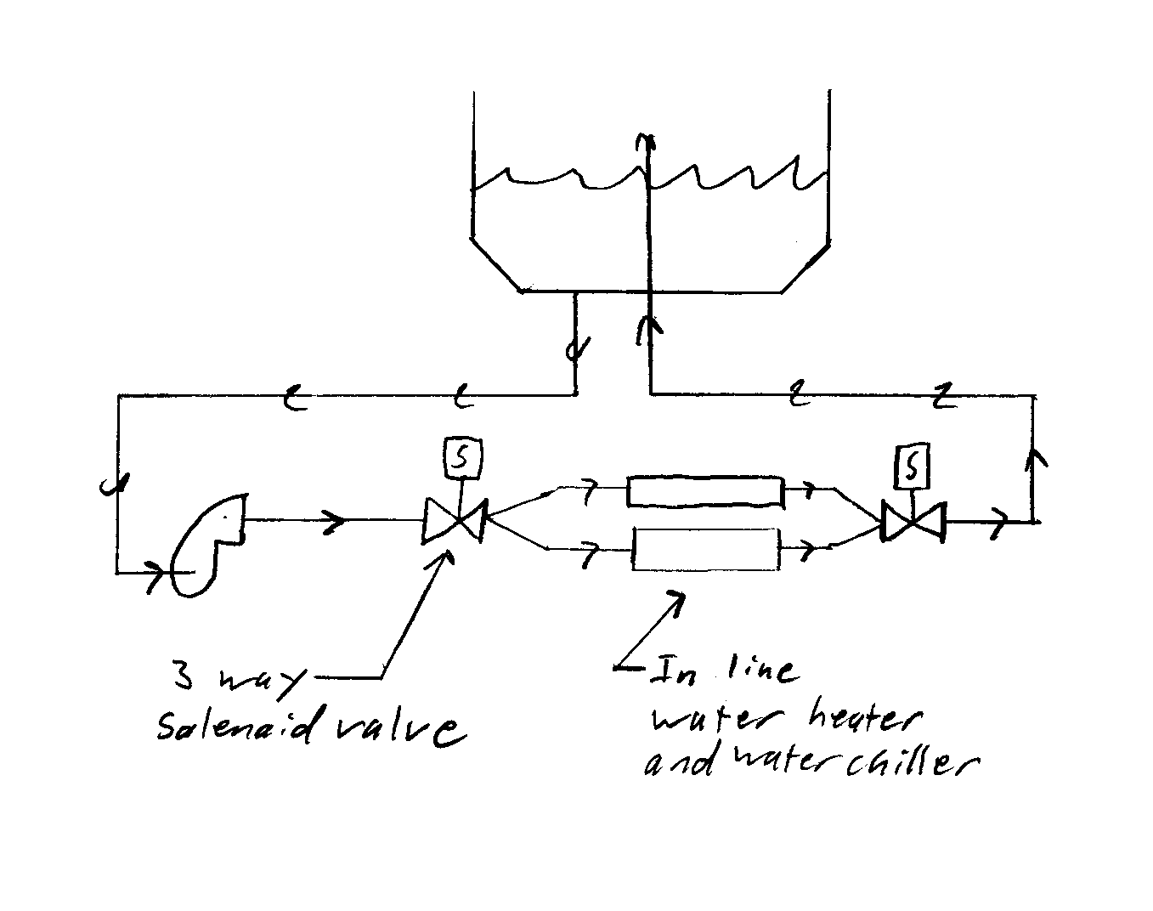
Figure 23 Dual Inline System w/ Shared Reservoir Plumbing Method

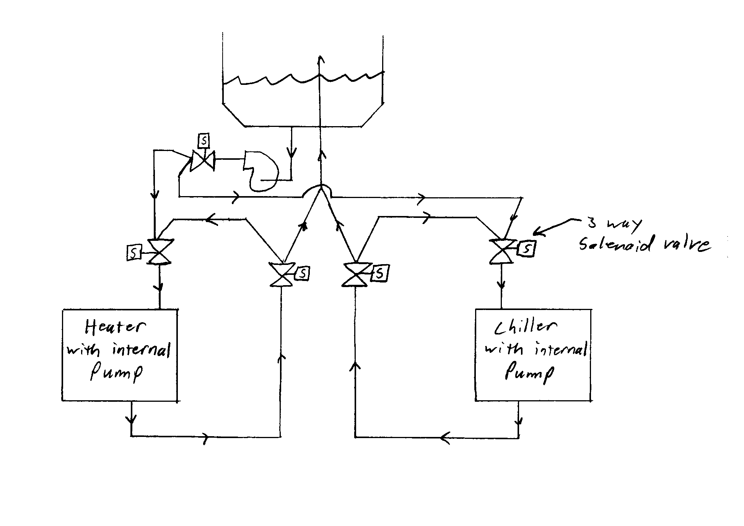
Figure 24 Heater and Chiller w/ Circulating Loops Plumbing Method

Controls

The controls for this project can be as simple or as complicated as the group desires. There are many parts of the system that could potentially be controlled. The possible controller design techniques include root locus, Bode, and state space. Some examples of types of controls are as follows:

- Digital
- Analog
- Active
- Passive
- Manual

Puck holders

The puck holders can be manufactured from a wide range of materials. Some ideas to take into consideration are machineability and material strength. Some possible material categories are shown below:

    - Metals
    - Plastics
    - Ceramics

The design team has generated several ideas for securing the pucks. Some of these methods are shown in the following figures:

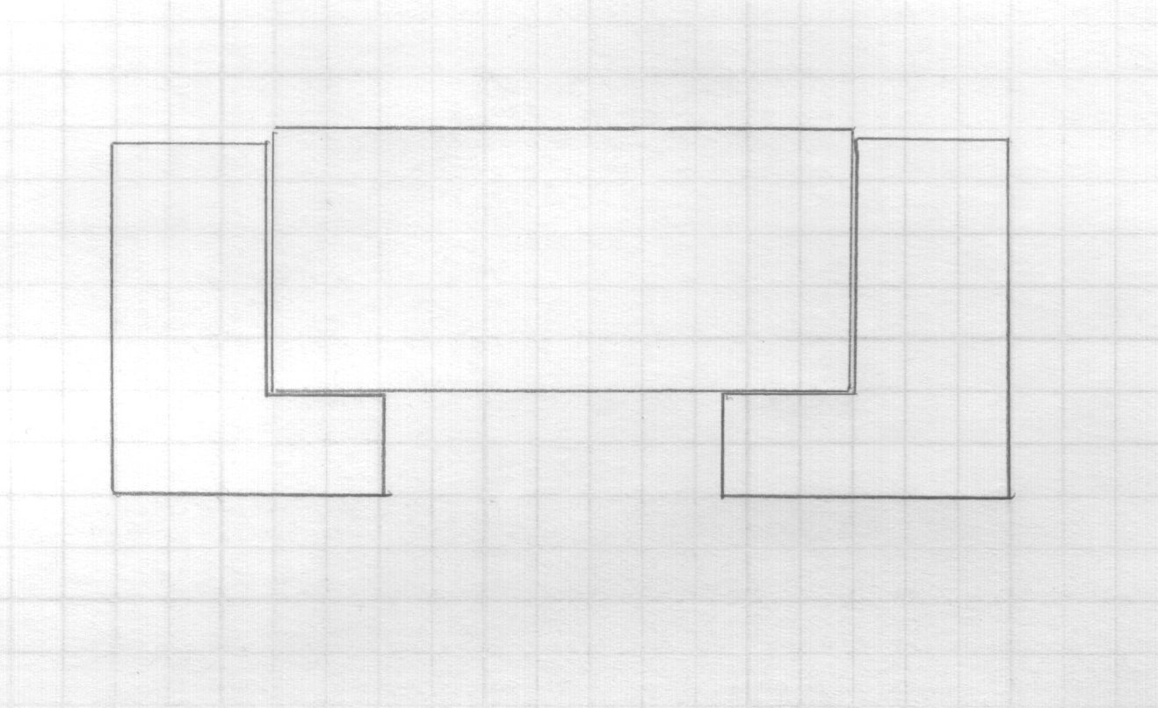
Figure 25 Press Fit Puck Holding Method

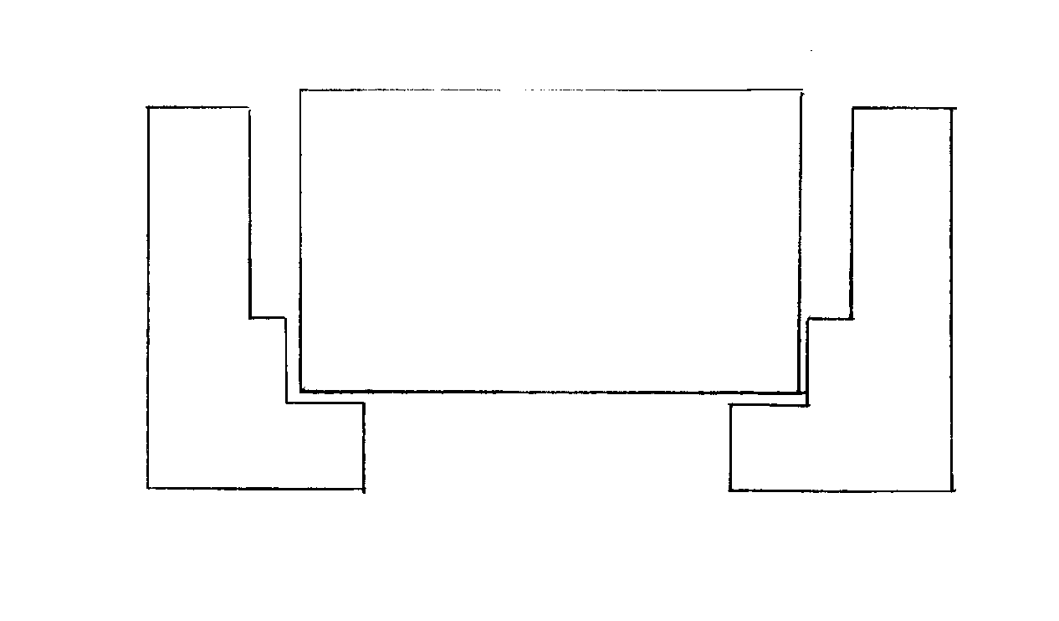
Figure 26 Air Gap Puck Holding Method

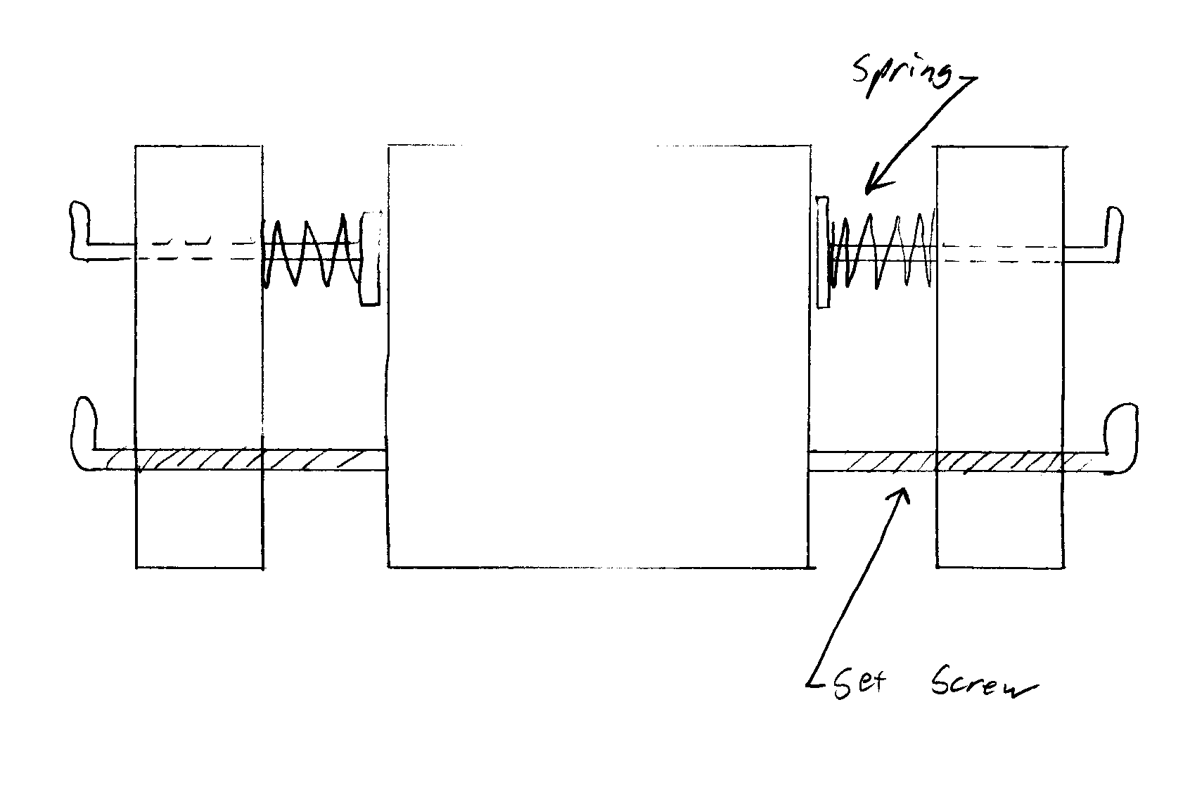
Figure 27 Spring/Set Screw Puck Holding Method

Structure

The super structure of the device must hold the sub-systems of the device such that they may accomplish their objectives and be strong enough not to deflect too much under load. With this in mind, the shape of the structure can be what ever the group wants it to be as long as it doesn’t impede on the functionality of the sub-systems.

Concept Evaluation Document

Concept Evaluation Process Overview:

The concept elimination phase consisted of three steps, the initial screening, the decision matrix, and finally, the evaluation of the screening matrix results. Each phase consists of evaluating concepts within five different sub-systems that make up the device. Each of the sub-systems was analyzed, and some of the concept ideas were eliminated through Phases I and II. Phase III, the evaluation of the results, brought together concepts from all of the subsystems to derive conclusions about how the device could function as a whole. This three step process enabled the group to clearly identify which design concept is most likely to meet the PDS criterion that has been established.

Phase 1: Concept Screening by Vote:

The first phase of elimination was performed by the design team during the scheduled meetings. Phase I was intended to reduce the number of concepts by eliminating the ideas that seemed completely unrealistic, or simply beyond the scope of the PSU Mechanical Engineering design sequence. A concept that was eliminated through the initial vote was the idea of using a vacuum system to hold the pucks in the place. It was decided early on that this may be a bad idea because it would require a pneumatic pump to hold the puck. Considering that the only function of the puck holder is to secure the pucks, a vacuum system puck holder is much too complex for the system that is being designed.

Phase II: Decision Matrix

Phase II consisted of creating a unique decision matrix for each of the sub-systems. This was accomplished by determining the important characteristics from the PDS that applied to each subsystem. Each of the sub-systems requires their own decision matrix because each performs a specific task, and has specific goals within the device. To create a decision matrix, the first step was to develop criteria for what is required from each sub-system. Each of these categories was assigned a weight value reflecting the importance of that aspect in the design. A score of 1-5, 1 being the worst, was given in each category for all concepts in each sub-system. For instance, alignment and stability of the force was considered to be rather important in the pressure application system. As a result, it was given a weighted multiplying value of 1.75. Once the categories and weights were established, each team member scored the subsystem concepts without consulting other team members. The scores from each team member were averaged to determine the winning concept for each sub-system.

 | Criteria
Idea | Accuracy | Machinability | Contact Area | Holding Force | Stability | Ergonomics | Durability | Total
Weight | 2 | 1 | 3 | 1 | 1 | 1.5 | 1 | 10.5
Press Fit | 9.00 | 4.75 | 6.75 | 4.75 | 4.75 | 4.88 | 3.75 | 38.63
Air Gap | 6.50 | 4.75 | 14.25 | 3.75 | 3.25 | 6.00 | 3.75 | 42.25
Spring Loaded | 4.50 | 3.50 | 9.00 | 2.50 | 2.00 | 6.00 | 3.00 | 30.50
Set Screw | 7.00 | 4.00 | 9.75 | 3.25 | 3.00 | 5.63 | 2.75 | 35.38
Bolted Clamp | 6.00 | 3.00 | 5.25 | 4.25 | 3.75 | 4.13 | 3.75 | 30.13
Table 9 Lower Puck Holder Decision Matrix

Table 9 lists the criteria for evaluation of puck width. The criteria of accuracy, stability, contact area, and durability were directly related to the PDS criteria of high measurement repeatability. Holding force is related to the sub-system’s ability to accept force. Holding force becomes important during high pressure tests. Ergonomics refers to the flexible PDS criteria of single operator capability and low puck removal time. While machinability is not directly related to any of the flexible PDS criteria, it is an important consideration for parts which will eventually have to be machined.

The air gap method proves to be the clear conceptual winner for the lower puck holder design. In second place is the press fit design concept. Press fitting requires friction between the surfaces of the puck and holder to provide a semi-permanent fitting. The set screw design then follows in third with the same weakness of a large surface contact area and poor durability when used over time. Next the spring loaded design exhibited a low score due its weakness in durability, stability, and accuracy. Springs may wear out faster than other methods of fastening and provided a smaller holding force compared to the other designs. In last place is the bolted clamp design. This design scored low in all categories with a large contact area being its greatest weakness. A large clamping force coupled with a large contact area may induce heat flow away from the puck.

 | Criteria
Idea | Accuracy * 2 | Machinability | Contact Area * 3 | Holding Force | Stability | Ergonomics * 1.5 | Durability | Total
Weight | 2 | 1 | 3 | 1 | 1 | 1.5 | 1 | 10.5
Press Fit | 7.00 | 4.75 | 6.75 | 4.00 | 4.25 | 3.75 | 3.75 | 34.25
Spring Loaded | 4.50 | 3.50 | 9.00 | 3.00 | 2.25 | 6.00 | 3.00 | 31.25
Set Screw | 8.00 | 4.00 | 9.75 | 4.50 | 4.00 | 5.63 | 2.75 | 38.63
Bolted Clamp | 7.00 | 3.50 | 6.00 | 4.50 | 4.75 | 4.13 | 3.75 | 33.63
Table 10 Upper Puck Holder Decision Matrix

Although the upper and lower pucks provide the same service, the final upper puck holder concept is different. The set screw design concept is the winning idea from the decision matrix due to its higher scores for accuracy, contact area, holding force, and ergonomics. The second choice behind the set screw concept is the press fit design. Again the weakness of the press fit design is the large amount of contact area between the puck and holder. Third is the bolted clamp. The clamp would provide more than an adequate amount of a holding force, but again the surface contact area is too large. And last is the spring loaded design. The main weaknesses of using springs to hold the puck is the possibility of low accuracy concerning the levelness of the puck in the holder, as well as the ability to support the force being exerted.

 | Criteria
Idea | Complexity & Implementation | Temperature Accuracy * 2 | Thermal Capacitance * 1.5 | Total
Weight | 1 | 2 | 1.5 | 4.5
Heater and Chiller w/o Circulation Loops | 4.00 | 6.50 | 4.50 | 15.00
Heater and Chiller w/ Circulation Loops | 3.00 | 9.50 | 6.38 | 18.88
Dual Inline System w/ Single Reservoir | 2.00 | 4.00 | 4.50 | 10.50
Chiller w/Inline Heater | 2.25 | 4.50 | 3.75 | 10.50
Table 11 Plumbing System Decision Matrix

In Table 11 the criteria for evaluation were not exactly those described by the flexible PDS criteria outlined in the PDS document. The criteria were described by terms which encompass the flexible PDS criteria but were more specific to plumbing systems. The criteria of complexity and implementation are related to the flexible PDS criteria of the system being powered by 110 VAC, high measurement repeatability, low temperature setup time, and constant heating/cooling supply temperature. The criteria of temperature accuracy and thermal capacitance refer to high measurement repeatability and constant heating/cooling supply temperature. The thermal capacitance is a phrase used to describe the amount of energy that will be absorbed into (or from) plumbing parts between the temperature source and the puck.

With heaters and chillers, the main concern documented in the PDS is that the boundary condition at the puck must be held constant and be measurable. One concern with pipes is that they needed to be at the same temperature as the water. This is necessary because heat will be added or lost if the temperature of the water and the pipes were not the same. With this concern in mind, the heater and chiller with circulation loops became the clear winner. The heater and chiller without circulation loops came in second with a weakness in temperature accuracy and thermal capacitance due to the heat loss or gain in the pipes. The dual inline system and the chiller with inline heater score low in thermal capacitance. Inline systems add constant heat to the circulating water no matter what the temperature of the water is entering the system. This type of design may provide uncontrollable boundary conditions and exit temperatures.

 | Criteria
Idea | Flux Disturbance * 2.5 | Implementation | Accuracy * 1.5 | Durability | Ergonomics | Total
Weight | 2.5 | 1 | 1.5 | 1 | 1 | 7
Notch In Puck | 7.50 | 2.75 | 6.00 | 3.25 | 4.50 | 24.00
Notch In Puck Holder | 8.75 | 2.25 | 6.00 | 3.25 | 4.50 | 24.75
Scribe Line | 11.88 | 4.75 | 5.63 | 5.00 | 4.25 | 31.50
Flats | 6.88 | 2.75 | 6.00 | 4.25 | 4.00 | 23.88
Set Screw | 6.25 | 3.25 | 5.63 | 3.00 | 3.50 | 21.63
Marker | 11.88 | 4.75 | 4.88 | 2.75 | 4.25 | 28.50
Table 12 Rotational Alignment Decision Matrix

In Table 12 the criteria for evaluation were not exactly those described by the flexible PDS criteria of the PDS document. The criteria were described by terms which encompass the flexible PDS criteria but were more specific to rotational alignment. Flux disturbance refers to any system that inhibits quick development of planar isotherms in the pucks. Flux disturbance can be induced by heat transfer into or out of the puck or by machining non-symmetrical grooves into the puck (such as those required for set screws). The flux disturbance and durability is related to the flexible PDS criteria of high measurement repeatability. Accuracy encompasses high measurement repeatability and constant heating/cooling supply temperature. Implementation refers to high measurement repeatability and 110 VAC. Ergonomics is directly related to puck removal time.

The pucks may have imperfections. For repeatability reasons the pucks should be tested in the same orientations each time. Rotational alignment then becomes important in puck holder design. The best solution to minimize uncertainties due to geometric rotational effects is the scribe line. Second to the scribe line is the marker with a weakness in durability. The mark may fade away or be scratched from the surface. Flats follow in third place. In order to implement flats, sections would have to be cut out of the pucks for alignment. This would affect the isotherm patterns in the puck. The next concept is a set screw. The screw would need an indentation on the puck surface to mate with thereby causing a change in puck surface geometry. Again this indentation may affect the isotherms. The last two concepts require notches either on the puck holder or the puck itself. Here durability becomes a limiting factor due the miniature size of the notch and any deformation of the puck may again affect the isotherms.

 | Criteria
Idea | Uncertainty * 2.5 | Zero Pressure | Ergonomics | Complexity | Durability | Alignment & Stability * 1.75 | Total
Weight | 2.5 | 1 | 1 | 1 | 1 | 1.75 | 8.25
Screw | 8.75 | 3.50 | 3.75 | 3.25 | 4.50 | 6.56 | 30.31
Weight | 10.00 | 3.50 | 4.25 | 4.50 | 5.00 | 7.00 | 34.25
Actuator | 11.88 | 3.75 | 4.75 | 3.25 | 4.00 | 7.00 | 34.63
Lever | 3.13 | 2.25 | 2.50 | 2.75 | 4.25 | 4.81 | 19.69
Table 13 Pressure Application Decision Matrix

In Table 13 above, the criteria for evaluation were not exactly those described by the flexible PDS criteria mentioned in the PDS document. The criteria were described by terms which encompass the flexible PDS criteria but were more specific to the pressure application system. Zero pressure is related to the flexible PDS criteria of being able to measure many TIM types. Ergonomics refers to being able to operate the machine with a single operator and low puck removal time. Complexity refers to many of the flexible PDS criteria including powered by 110 VAC, high measurement repeatability, low puck removal time, single operator capable, minimizing the required floor space, and the ability to test many TIM types.

A pressure application device must have the ability to apply a constant load on the pucks. Here an actively controlled actuator narrowly wins the concept selection. The possibility of applying weights proves to be simple by allowing for a constant load without active controls. The weights simply cannot provide the zero pressure requirement set forth by the PDS. Force application from a screw type of device can provide the zero pressure which the weights could not. It is in the uncertainty of constant pressure where the screw proposal does not excel. Last is the lever option. The lever’s weakness is in the uncertainty of the constant applied force. It may be difficult to accurately set the lever to provide a specified force and the lever cannot compensate for variations in thickness.

Phase III → Reflection and Evaluation of Matrix Results

Phase III is intended to reflect on the decisions that have been made through voting, and the screening matrices. Also, it is designed to act as a final brainstorming session to determine if any good ideas have been passed over. For this project, the reflection phase was critical. After the decision matrix had been completed, a meeting with the faculty advisor, Gerry Recktenwald, created some new ideas for the housings of the pucks. One freshly developed idea was to create a puck with a cavity that was closed off to air. Inside the cavity would be a turbulent flow of heated or cooled water to provide a temperature boundary condition. This would theoretically allow for optimal heat transfer to the puck. It was decided that this concept will be pursued for the final design.

In most cases there, there is a clear winner of which concept to use in each of the sub-systems. However, in the case of the pressure application system there was a very close tie between two ideas. The total scores illustrated in the decision matrix in Table 13 show that a pressure actuator scored higher by 0.38, or just about 1%. This is not a large margin of victory, so further discussion was needed. At this point, the team looked at the advantages and disadvantages of each concept, and determined that an actuator was the best way to go about applying the pressure. Part of the basis for selecting an actuator as opposed to weights is that it allows flexibility in the orientation of the pressure application, and as noted previously the ability to accommodate zero pressure. This will be discussed further in the following section entitled “Final Concept Selection.”

The winning concept for each of the other three sub-systems, rotational alignment, plumbing system, and bottom puck holder scored higher by a significant margin. For that reason, not much discussion on those topics was necessary. On the other hand, time was set aside specifically to reflect on the winning concepts that were selected, and their feasibility, to ensure that the best possible selection was made.

Final Concept Selection:

The decision matrix was used as a basis for the final concept selection. The results from the decision matrices were reviewed thoroughly and compared to the requirements set forth by the product design specifications.

The final selection for the design of the bottom puck will use the air gap method. This will lower the contact resistance between the puck and the puck holder, but may add a bit of instability in the parallelism of the pucks. The instability can be addressed by use of a set screw or a fair amount of support where the puck holder is in contact with the puck.

An actuator has been selected for the pressure application system. An actuator will provide forces ranging from zero to the design force that exerts the specified pressure. It would allow for hands off application and an active feedback control system. A force actuator will be somewhat harder to implement, but will theoretically provide a constant known force with high accuracy.

A heater and chiller with circulating loops will be used to supply the temperatures changes of water. The circulating loops will eliminate the problem of having the hoses at a different temperature than the water which would cause temperature variations. The circulating loops will maintain the hoses and the water at a specified temperature so that there is very little variation. The three way valve that connects the two circulating loops is connected to a pump that is placed as close as possible to the exit nozzle. The purpose of that specific placement is to minimize the length of the hose between the pump and the exit nozzle, thereby reducing the overall thermal capacitance of that portion of hose. Doing this would reduce the amount of heat that is absorbed or given off by the piping between the pump and exit nozzle. The main disadvantage for this concept the number of valves and the amount of hosing that is required.

A scribe line was elected as the means measuring the rotational alignment of the pucks. A scribe line is simple for the operator and can be quite accurate in its alignment depending on the precision of the marking. This will be a straightforward, no hassle way to align the pucks, but on the other hand will be subject to operator error.

A late decision by the design team resulted in the team throwing out the winning top puck holder concept from the decision matrix. Upon consulting the customers, it was decided that the best way to design the top puck is to create a cavity on one side. The idea here is that the water will flow in a turbulent manner through the puck ensuring to come in contact with all surfaces. This will make certain that the isotherms created within the puck are constant over all the areas of interest. Some main disadvantages of having a closed temperature changing bath is that it requires more extensive planning to create a sealed system, and the behavior of the fluid inside the cavity is unknown at the present time.

Table 14 shown below summarizes the decisions that have been made throughout the concept evaluation process.

Table 14 Final Selected Concepts
Sub-System | Selected Concept
Pressure application | Force actuator
Plumbing System | Heater and chiller with circulating loops
Rotational alignment | Scribe line
Top puck holder | Puck with cavity, holder TBD.
Bottom puck holder | Air Gap

