"Precision"
Adjustable Wheelchair Headrest for Patients
with Limited Head and Neck Control

A Portland State University Senior Design Project

Progress Report
March 6, 2005

Design Group Members
Kayin Talton
Jon Mabrey
Nichole Heller
Mirza Rasidagic

Academic Advisor
Dr. Sean Kohles

Industry Sponsor



Executive summary
Failure to provide proper alignment can make it difficult for many patients with debilitating diseases can cause difficulty swallowing and breathing, it is therefore imperative that their head, neck, and body be kept in proper alignment. Many conventional wheelchair headrests only provide support to keep the head from falling backward, not protecting the patient against other motions. Each patient has an ideal alignment for based on his or her stature, amount of neck control, and personal comfort. Therefore, it is necessary to design a headrest that is adjustable to meet the needs of each individual.

Keen Mobility, a local developer and distributor of innovative and attractive assistive devices, has shown interest in developing such a device, and will serve as community sponsor of a Portland State University senior design group, which will then present Keen with a test and evaluation-ready prototype by early June 2005.

The following document is to update the reader as to progress made on the design of a wheelchair headrest apparatus, attachable to hard or soft-backed wheelchairs having non-continuous-loop handles. Those currently on the market either fail to address all positioning needs of the wheelchair occupant, are difficult for the caregiver to adjust properly, or do not readily attach to soft-backed chairs. A final concept has been determined, with adjustments to be made pending material selection and regulation accordance.

Table of Contents

Introduction and Background 3
Mission Statement 3
Project Plan 4
Product Design Specifications 4
External Search 5
Internal Search 8
Concept Evaluation and Final Design Selection 8
Detailed-Design Progress 11
Conclusion and Recommendations 11
Appendix A: Project Planning and Progress Table 12
Appendix B: Detailed PDS Document 13
Appendix C: External Search Document 22
Appendix D: Internal Search Document 24
Appendix E: Concept Evaluation and Selection Document 30
Appendix F: Design Calculations 36
Appendix G: Referenced Anthropometric Data 42

Introduction and Background
The purpose of this project is to assist Keen Mobility in developing a detachable wheelchair headrest to provide full comfort and support for those with limited neck control. Patients with neck muscle weakness or paralysis are vulnerable to further injury if their head suddenly falls to the side, forward, or backward. Many conventional wheelchair headrests only provide support to keep the head from falling backward, not protecting the patient against other motions. For many patients with debilitating diseases, it is imperative that their head, neck, and body be kept in proper alignment, because failure to provide proper alignment can make it difficult for the patient to swallow and even breathe. The ideal alignment for each patient depends on his or her stature, amount of neck control, and personal comfort. Therefore, it is necessary to design a headrest that is adjustable to meet the needs of each individual.

In speaking with local healthcare providers, it was found that many headrests currently on the market are cumbersome to attach to the chair and require tools to adjust. Most are made for specific chairs and therefore are not adaptable to the many different types of wheelchairs that would be found in a medical facility. Therefore, another major goal of our project is to make the headrest as easy to use as possible, so the healthcare providers who use it will be able to do so efficiently and with ease.

Mission Statement
The design group's goal is to design a wheelchair headrest that provides optimal support and comfort to a patient with limited neck control. The headrest is also to be fully adjustable to conform to any patient that might need it, as well as be adaptable to most wheelchairs. The primary customers for the product are the nurses and healthcare providers at nursing homes and other medical facilities. The major features desired by these customers are a large range of vertical, horizontal, depth, and angle adjustments, to be adaptable to all patients. Ease of use is also a major priority, as well as safety. The aspects of the headrest that are most important to the patients are comfort and support. Keen Mobility, the internal customer, requires that the product conform to company standards in quality and reliability.

Project Plan
After project selection and definition, an outline of important dates was created in order to pinpoint deadlines and mark progress. Included in the plan are PDS creation, a timeframe for external and internal searching, concept creation and development, and prototyping. The design group is firmly in the concept development phase: improving the selected design and selection of materials, to be completed by early April. A preliminary test and evaluation-ready prototype is planned for completion by early May, with improved design and prototype completion by early June. All anticipated tasks and completion dates are listed in the Project Planning and Progress Table, located in Appendix A.

Product Design Specifications
The criterion for the design was developed from both external customer (nurses, patients) and internal customer (Keen Mobility) interviews, and surveys. The main requirements were performance, ergonomics, and safety. Anthropometric tables were used to create a 3D space of the range of motion of the human head based on the 5th to 95th percentiles.
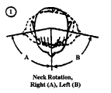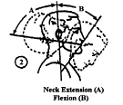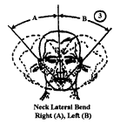
Figure 1: Basis of measurements from FAA Anthropometric tables

It was determined that the headrest needed to be adjustable to 16 inches laterally (width of chair), 8.5 inches vertically, and 6 inches in depth. The headrest also needed to tilt 45 degrees and provide lateral support for the head. To make the device easy to use it had to require a method of installation and adjustment that was free of tools (such as allen wrenches), and use simple hand knobs, levers, buttons, etc. It also had to weigh less than 15 lbs. so that one person could easily install it. The load requirement was determined using human body segment mass percentiles from human factor tables. The headrest needed to support 15-lbs. static loading and not slip out of adjustment, as well as structurally withstand 125 lbs. of sudden impact loading. The headrest also needed to withstand cyclic usage of 25 times per day for 10-15 years. A complete, detailed list of all the PDS requirements for the headrest is located in Appendix B.

External Search
The purpose of external searching for this project was to identify and examine directly competing and related products. There are a variety of wheelchair headrests already available on the market; therefore the majority of external searching has been focused on directly competing products. Although these products exist, none were found to meet all the requirements of the PDS. The headrests currently on the market provide insufficient range of motion, attach only to hardback chairs, or are complex to adjust by requiring additional tools. It has also been observed that none of the headrests currently on the market provide any shock absorption. Through speaking with medical professionals and doing medical research, it has become evident that shock absorption could be a very important feature for those with limited neck muscle control.

Primary Competitors
The figures below represent the three top competitors in available adjustments, attachment to chair, and typical usage.

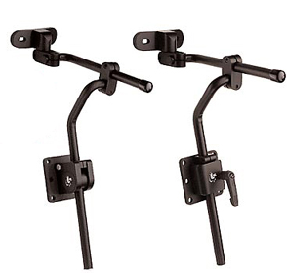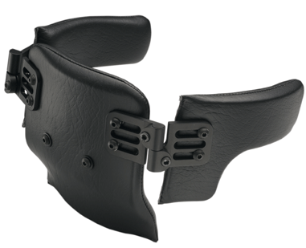
Figure 2: Adaptive Engineering Labs - provides lateral support by the hinged flaps, yet no lateral motion; supplies vertical and depth adjustment; attaches to hardback chairs only and requires tools to adjust the position.

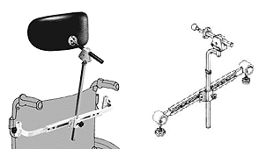
Figure 3: Otto-Bock - attaches to both hardback and soft back chairs a maximum of 18 inches wide; provides vertical adjustments, incremental lateral adjustments, and depth adjustment; requires tools to adjust; expensive at approximately $2000 for a full unit; is atypical of what is seen in local skilled care facilities.

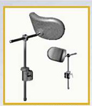

Figure 4: Whitmyer Biomechanixs - typical of what exists in local skilled care facilities; relatively affordable (~$200); provides only vertical and depth adjustment; requires an additional tool to make those adjustments; attaches to hardback chairs only.

Related Technologies
Available positioning technologies were also researched. The following figures represent a sample of those found.

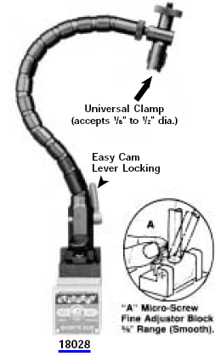

Figure 5: Flexible Positioning Arm - adjusts for a full range of motion and becomes rigid when the cam is locked. This device is made for light duty applications (up to 5 lbs.) and would need to be scaled up to support the weight of a headrest and head.

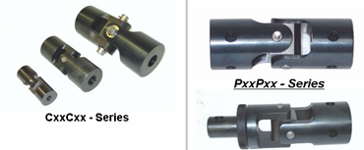
Figure 6: Universal joints - inexpensive, can be found to achieve two and three degrees of freedom, and can be used for heavy applications. If used for positioning in the headrest, a handle could be affixed to the universal joint for easier positioning by the medical staff.

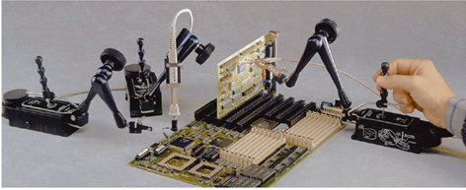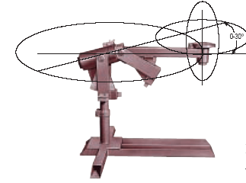

Figure 7: Positioners - XYZ positioners (right), such as those typically seen on optical microscopes. Universal balance positioners (left) generally used in welding applications.

Internal Search
The design team went through the process of brainstorming to generate ideas for a headrest that will meet the PDS requirements. The main functions of the headrest as well as sub-functions were evaluated. The headrest can be divided into three components: the headrest pad, the positioning device, and the attachment to the wheelchair. The positioning device can be broken up into lateral, vertical, depth, and angle adjustments.

Concepts were generated individually and then discussed as a group and improved. Each individual component of each design was evaluated, so that the best components could be pieced together. The final headrest design will be a combination of the best components from these designs. The Internal Search Document found in Appendix D details the concepts generated with diagrams as well as descriptions of their functions.

Concept Evaluation and Final Design Selection
Many concepts for functions and sub-functions were generated by the team and when combined, a total of seven complete designs were created. A short summary of each design is listed below. A complete, detailed description of each design, including pictures, can be found in the Concept Evaluation Document located in Appendix E.

- Telescoping Pivot Bar in Channel - adjustable bar which pivots on a locking joint attached to a carriage on rollers that slides along a channel.

- Incremental Vertical Bar on Lower Pivot Joint - collar attached to back of headrest slides in increments on vertical bar and locks in place with a spring-loaded latch. Fine tune adjustment available on collar. Lateral and depth adjustment achieved by universal locking joint attached to the vertical bar.

- Incremental Vertical Bar on Carriage - same principle for vertical adjustment as previous design except collar stays fixed and vertical bar slides in increments. Collar is attached to a carriage that slides along a rail. Movement of upper locking joint on top of vertical bar can achieve depth adjustment as well as further lateral adjustment.

- Curved Crossbar with Ratcheted Joint "Overhead Projector" - Carriage on curved rail allows for flexion of soft-back wheelchairs. Fine tune gear mechanism on carriage allows precise positioning. Ratcheted joint provides depth adjustment. Vertical adjustment uses rack and gear mechanism similar to overhead projectors often found in classrooms.

- Curved Crossbar with Dual Upper Joints - Same carriage and rail principle described above, except without fine tune adjuster. Upper joints allow for greater lateral and depth adjustment. Rack and gear system attached to back of headrest allows for vertical adjustment.

- Self-locking Worm Gear and Rack "Translated Motion" - worm gear transmits motion to pinion gear and vertical rack for height adjustment. Adjustable pin in slot attached to back of headrest allows for depth adjustment.

- Carriages on Worm Screw - principle of lateral and vertical motion similar to xyz-positioners for microscopes, utilizing a carriage which ride on worm threads. A pivot joint attached to vertical carriage used for depth adjustment.

Due to the multiple functions that were needed for the project the design team decided to split up each design into the vertical, lateral, and depth component of adjustment. A scoring matrix was used on each sub-function to determine which components to combine for the final design. The gear system similar to overhead projectors will be combined with the sliding carriage on a curved cross member. The depth adjustment will use a modified slot and pin fixture that can also rotate laterally to provide more adjustment range. Appendix E contains further detailed information and annotated pictures of the final concept for the headrest.
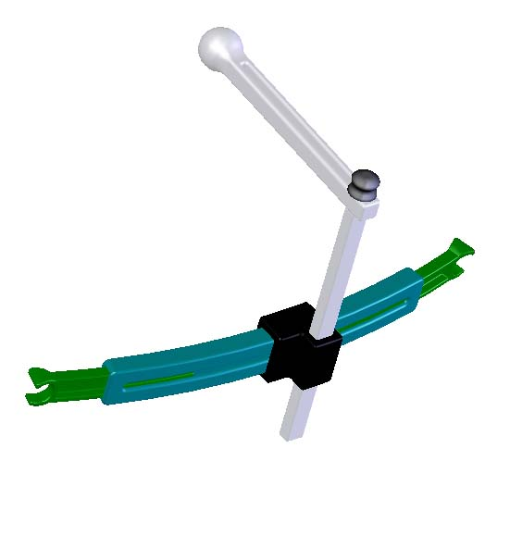
Figure 7: Complete Conceptual Design

Two other features of the design that had to be decided were the method of attachment to the wheelchair and the shape and design of the head support pad itself. Examination and comparison of many wheelchairs led to the conclusion that the only common location for attachment was the handles of the chair. The final design uses a method similar to a headrest for a car seat, adjusting outward freely but restricting movement inwards unless a spring-loaded button is pushed. The half circle shape fits over the bars of the handles. End user surveys led the design team to select a head pad section that provided lateral support as well as cradled the head. The final design will use such a head pad except the covering will be made up of Keen Mobility's pressure alleviation foam.

Detailed-Design Progress
The selected design has been modeled using SolidWorks to check against the dimensions of the chair, and to initiate thoughts on constructing the prototype. The headrest support frame dimensions were approximated to be appropriate for the range of use, as stated in the design specifications, but will likely be updated as materials are selected, and optimization takes place. The next immediate step is to determine how to integrate shock absorption.

Conclusion and Recommendations
The design team has made considerable headway in the design of an adjustable wheelchair headrest for patients with limited head and neck control. Though there are many products in the current market, none address the all the positioning needs of the chair occupant and the caregiver, or provide a method of shock absorption. The selected design concept - featuring a geared vertical adjustment, sliding carriage on a curved cross-member, slot-and-pin depth mechanism, and sliding notched members for attachment to handles - addresses all positioning needs, including ease of use.

Appendix A: Project Planning and Progress Table

Table A-1: Project Plan - Items above dotted line are completed; items below are, as of March 6, 2005, not yet completed

Appendix B: Detailed PDS Document

Performance
Customer Requirements:
• The device should be fully adjustable
• The device should be comfortable
• The device should provide head support (lateral as well)
Engineering Targets
• The device should have a lateral adjustment range of at least 16 inches
• The device should have a vertical adjustment range of at least 8.5 inches
• The device should have a horizontal (depth) adjustment range of at least 6 inches
• The device should have a head tilt range of at least 45 degrees front to back and sideways
• The device should use Keen Mobility's pressure point alleviation foam cushioning, and not constrain the head as to cause pain or irritation
• The device should support the head and prevent it from moving to a harmful position (define further later)

Environment
Customer Requirements:
• The device should be able to operate in outdoor conditions, and cleaning conditions
• The device should be able to withstand prolonged contact with hair and skin
Engineering Targets
• The device should withstand temperatures of 30*F – 212*F, be corrosion resistant, etc.
• The material should not deteriorate

Life in Service
Customer Requirements:
• The head pad should have a medium life
• The frame of the device should last for a long time
Engineering Targets
• The pad should last for 3 years
• The frame of the device should last for 10-15 years

Quantity
Customer Requirements:
• The device should sell at a reasonable rate
Engineering Targets
• The device should sell between 10-15 a month for the first year, then 50 a month in the second year (around one thousand total for the first 2 years)

Cost of production per part
Customer Requirements:
• The device should not cost more than the competitions to make
Engineering Targets
• The device should not cost more than $200 in material and manufacturing and $30 in designers’ labor

Size and Shape
Customer Requirements:
• The device should not protrude beyond the wheelchair width or interfere with movement and transportation of wheelchair
• The device should not have a bulky or odd shape
Engineering Targets
• The width of the device should not exceed 20 inches
• The height of the device should not exceed 24 inches
• The depth of the device should not exceed 12 inches

Weight
Customer Requirements:
• The device should be able to be lifted and transported by one person
• The separate parts of the device should be able to be easily adjusted
Engineering Targets
• The device should weigh less than 15 lbs.
• No single component of the device should exceed 5 lbs.

Maintenance
Customer Requirements:
• The device should require minimal service
• The device should be easy to clean
Engineering Targets
• The device should require less than one hour a year of maintenance costing less than $5
• The device should be free of cracks and crevices where dirt/grime can get into

Installation
Customer Requirements:
• The device should be easy and quick to install
Engineering Targets
• The device should take less than 3 minutes to attach/detach to the wheelchair
• The device should be adaptable to wheelchairs of 16in to 20in (including soft-backed wheelchairs)
• The device should require no additional tools to install to the wheelchair

Ergonomics
Customer Requirements:
• The device must be easy to transport by one person
• The device should be able to be adjusted easily by one person
Engineering Targets
• The device must not be bulky and weigh less than 15 lbs. fully assembled
• The Force needed to adjust any part of the device should be less than 5 lbs.
• The device should not require any tools (wrenches, etc) to adjust, and should use knobs, thumbscrews, or other easy adjustment controls
• The time needed to adjust any feature of the device should be less than 15 seconds

Safety
Customer Requirements:
• The device should be safe for the patient
• The device should be safe to use for the healthcare worker
• The device should be able to withstand current position after sudden impact load
Engineering Targets
• The device should be free of sharp edges or pinching parts
• The device should be able to support 25-lbs. static loading acting on headrest cushion
• The device should be able to withstand impact loading of 35 lbs.
• The device should conform to ASME/RESNA standards

Materials
Customer Requirements:
• The device should have a comfortable head cushion material
• The device should be made of light, strong material
Engineering Targets
• The device should contain patented pressure alleviation cushion made by Keen Mobility
• The material should be made of a strong lightweight material (possibly aluminum)

Manufacturing
Customer Requirements:
• The device is to be manufactured cheaply
• The device is to be manufactured easily
Engineering Targets
• The manufacturing of the device should be outsource overseas eventually
• The device should be made of simple shapes/components that can easily be cast, drawn, or made using other standard manufacturing techniques

Shipping
Customer Requirements:
• The device should conform to all shipping standards/regulations
Engineering Targets
• The device should be shipped in a small rectangular box no larger than necessary

Packaging
Customer Requirements:
• The device should be padded to avoid damage from handling
- The device should be distributed in a manageable size package
Engineering Targets
• The device should be able to withstand a drop from 4 ft
- The device should conform to packaging standards set by the United Parcel Service

Aesthetics
Customer Requirements:
• The device should not be too overbearing
- The device should be simple and sleek
Engineering Targets
• The device should use simple shapes (no oddball pieces, etc)
- The device should not have too many, or odd colors

Quality and Reliability
Customer Requirements:
• The device should be comfortable
- The device should be resistant to scratching and other damage
- The device should withstand repeated use
- The device should stay in the position set by the user
Engineering Targets
• The device should not cause any uncomfortable pressure points on the user
- The device should be made of hard, durable scratch resistant material
- The device should be able to withstand cyclic/fatigue loading over lifespan of product
- The device adjustments should be reliable and well designed

Codes and Standards
Customer Requirements:
• The device should conform to all applicable codes and standards
Engineering Targets
• The device should follow safety standards for rehabilitation devices
- The device should follow ASME/RESNA standards for design
- The device should follow ergonomic standards based on anthropometric tables

Testing
Customer Requirements:
• The device should be tested for failure in all applicable areas
- The device should be tested for ease of use and comfort
Engineering Targets
• The device should be tested for failure due to static loading of 25 lbs
- The device should be tested for failure due to impact loading of 35 lbs
- The device should be tested for failure due to fatigue loading
- The device should be tested for resistance to scratching/denting
- The device should be taken to a medical facility to be tested for manageability by the medical staff and comfort/support for the patient

Company Constraints and Procedures
Customer Requirements:
• The device should follow all company standards
Engineering Targets
• The device should be of high quality and reliability
- The device should be innovative

Documentation
Customer Requirements:
• The device should come with any necessary documentation
Engineering Targets
• The device should come with assembly and installation instructions
- The device should come with simple instructions for positioning and adjusting

Legal
Customer Requirements:
• The device should not interfere with other ideas that are already patented
- The device should follow safety regulations
Engineering Targets
• The design team will be required to search patent databases for any proprietary rights on ideas that might be considered for the product
- The design team will research any legal issues regarding safety for devices used by patients

Market and Competition
Customer Requirements:
• The device should be competitive on the market with other competitors' products
Engineering Targets
• The device should compete with Adaptive Engineering Labs products
- The device should compete with Whitmyer Biomechanixs products
- The device should compete with Otto-Bock products

Timeline
Customer Requirements:
- The device should be completed on time
Engineering Targets
• A final prototype for testing should be completed by June 2005

Disposal
Customer Requirements:
• The devices should be easily disposed and not harmful to the environment
Engineering Targets
• The device should be made of material that is re-usable and non-toxic

Appendix C: External Search Document

Table C-1: Designs on Market - Wheelchair headrest apparatuses currently on the market, range of movement, method of attachment, complexity, special features and photo.

Products | Adjustment |  |  | Attachment | Complexity | Special Features | Photos
Products | Lateral (in) | Vertical (in) | Depth (in)
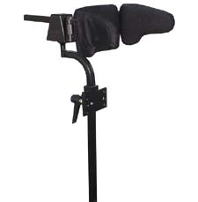  Symm. Designs | 0 | 16 | 6 | Hard Back | Vert. hand knob | Axion rotary interface
 |  |  |  |  | Tools req. rest | Axion rotary interface
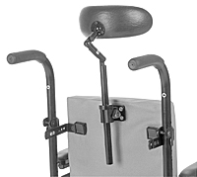  Therafin Surelock | (swivels) | 14 | 6 | Hard Back | Vert. hand knob | None
 |  |  |  |  | Tools req. rest | None
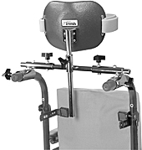  Therafin Universal | 0 | 10 | 0 | Handles | All hand knobs | None
 |  |  |  | 10-23” wide | All hand knobs | None
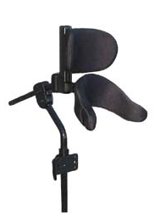  Stealth Ultra | 0 | 10 | 6 | H.B. | Fingertip release | Flip up lateral support
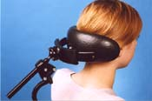  Stealth Combo | (swivels) | 12 | 8 | H.B. | Lever and knob adjustments | Wings provide lateral support

Table C-1: Designs on Market (Continued)

Products | Adjustment |  |  | Attachment | Complexity | Special Features | Photos
Products | Lateral (in) | Vertical (in) | Depth (in)
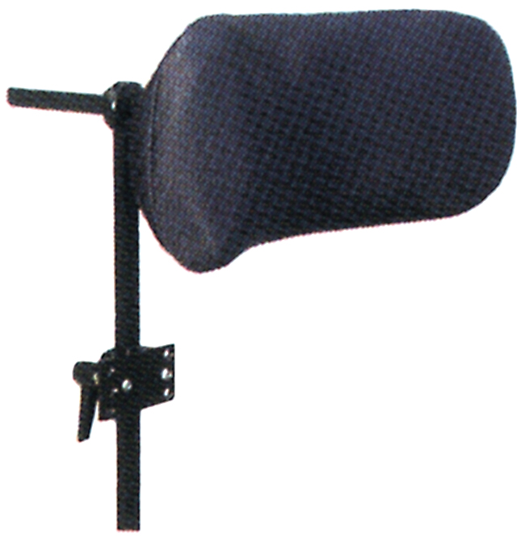  Invacare | 0 | 10 | 6 | H.B. | Vert. hand knob | None
 |  |  |  |  | Tools req. rest | None
AEL adj. | 0 | 10 | 10 | H.B. | Tools required | Flip down bracket
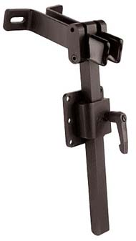  AEL std. | 0 | 8 | 6 | H.B. | Vert. hand knob | None
 |  |  |  |  | Tools req. rest | None
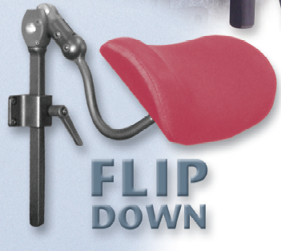  AES Cobra | 0 | 8 | 4 | H.B. | Vert. hand knob | Flip down headrest
 |  |  |  |  | Tools req. rest | Flip down headrest
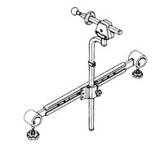  Otto-Bock | 10 | 8 | 4 | Handles | Vert. hand knob  Tools req. rest | Easy to remove
 |  |  |  | 16” – 18” | Vert. hand knob  Tools req. rest | Easy to remove
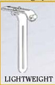  Whit. Bio. Light-weight | 0 | 14 | 6 | H.B. | Tools required | Lightweight

Table C-1: Designs on Market (Continued)

Products | Adjustment |  |  | Attachment | Complexity | Special Features | Photos
Products | Lateral (in) | Vertical (in) | Depth (in)
WB ONYX | 0 | 16 | 8 | H.B. | Tools required | None
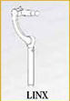  WB LINX | 0 | 8 | 10 | H.B. | Tools required | None
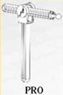  WB Pro | 0 | 14 | 10 | H.B. | Tools required | None

Appendix D: Internal Search Document
This document details the concepts generated by the design team. For each concept a diagram and brief description is included. Each design contains multiple components that could be blended with other designs. Each positioning component provides a way of achieving lateral, vertical, and depth adjustment that could be combined with other methods.

Design Concepts:

Telescoping Pivot Bar in Channel
The Telescoping Pivot Bar in Channel design is shown below. A telescoping bar for vertical adjustment is attached to a locking universal joint which allows for depth adjustments. In turn, the universal joint is connected through a short bar to a sliding base in a horizontal channel. The base is tightened into place using a clamping force applied through a screw mechanism.

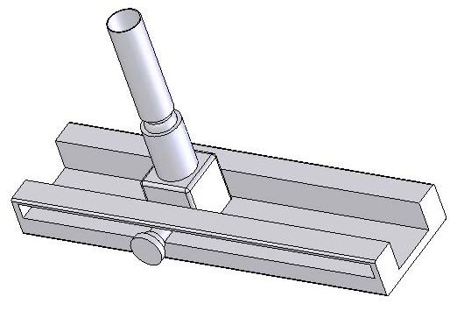
Figure D-1: Telescoping Pivot Bar in Channel

Incremental Vertical Bar on Lower Pivot Joint
The design seen below is the Incremental Vertical Bar on Lower Pivot Joint design. The user would adjust the vertical motion by pushing a button to slide a spring-loaded pin up and down the vertical bar. The pin would lock into one of the slots, preventing the headrest from falling down. A fine-tune adjuster would also be attached to the vertical bar for better accuracy. Both lateral and depth motion would be achieved by a locking ball joint at the base of the vertical bar. A hand lever would be affixed to the joint to allow convenient adjustment and locking by the user. A knurled ball at the back of the headrest pad would allow for angular adjustment.
The device would attach to the wheelchair handles. The clamps would press-fit onto the wheelchair handles once locked into place. The attachment would expand for the headrest to attach to any width of chair. The button on the top of the attachment segment would be pressed in, allowing the ends of the attachment to slide out. The attachment would expand much like the vertical motion mentioned above.

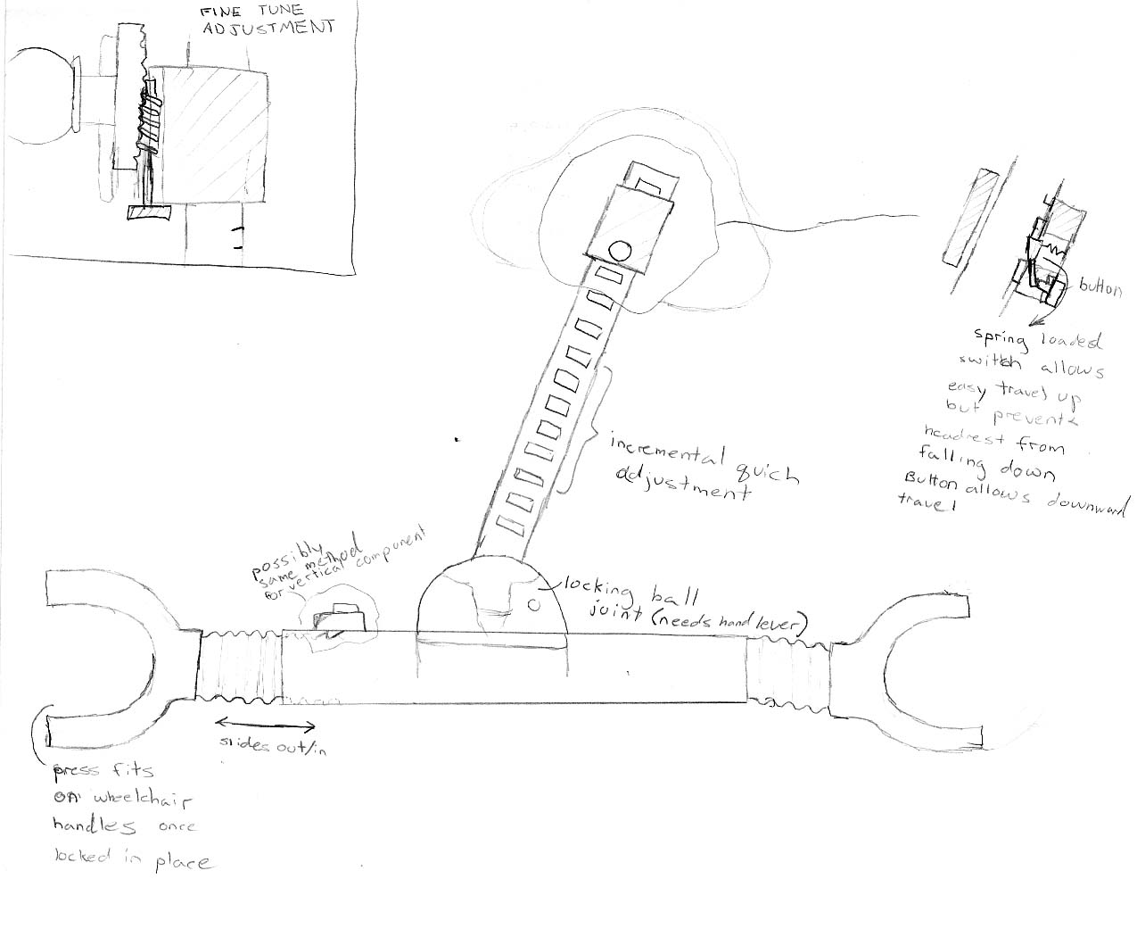
Figure D-2: Incremental Vertical Bar on Lower Pivot Joint

Incremental Vertical Bar on Carriage
In the sliding carriage design, vertical adjustment would be achieved with an incremental bar. The user would use a lever to loosen a clamp that allows the vertical member of the headrest to slide up and down. Further vertical and depth positioning can be achieved by adjusting the locking ball joint at the top of the vertical bar. Lateral adjustment would be achieved by a carriage sliding across a rail at the bottom of the device. Fine-tune adjustment would be achieved through a worm screw and gear rack system. A knurled ball at the back of the headrest pad in this design would achieve angular adjustment as well.

Much like the vertical bar design, this device would attach by fitting over the handles.

Figure D-3: Incremental Vertical Bar on Carriage

Curved Crossbar with Ratcheted Joint "Overhead Projector"
In the overhead projector design vertical motion would be achieved by loosening a knob and sliding the collar up and down the shaft, much like motion of an overhead projector. Another knob, located at the base of the device, would be loosened to adjust a locking ball joint for depth and angle adjustments. To achieve lateral motion, another knob would be loosened to allow the headrest to slide back and forth on a horizontal carriage. An internal gear mechanism would be used for fine-tune lateral adjustment.

The headrest would attach in a similar manner to the attachments in the previous concepts. However, the attachment bar would be curved to allow for the flexion of soft-backed chairs when a patient is seated.
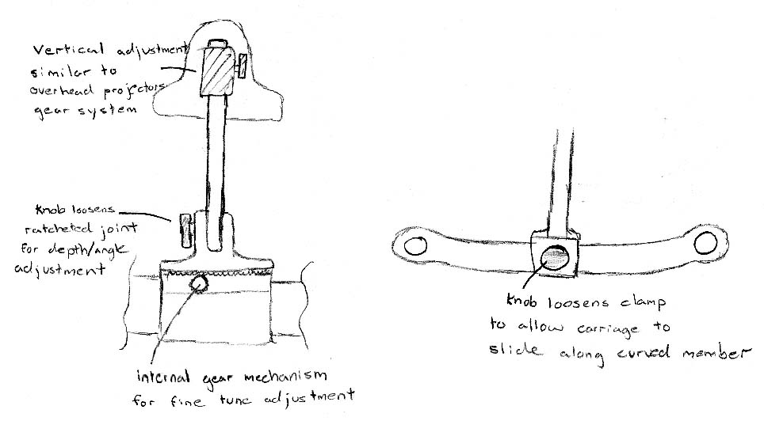
Figure D-4: Curved Crossbar with Ratcheted Joint "Overhead Projector"

Curved Crossbar with Dual Upper Joints
In the pivot joint a thumbwheel at the back of the headrest would allow for some vertical adjustment. The pivoting joints could achieve further vertical adjustment, as well as refined depth adjustment. Lateral adjustment would be achieved by loosening a knob to allow to carriage to slide back and forth on the horizontal bar. A knurled ball at the back of the headrest pad would achieve angular adjustment.

This device attaches to the wheelchair by the same method as the "overhead projector" design.
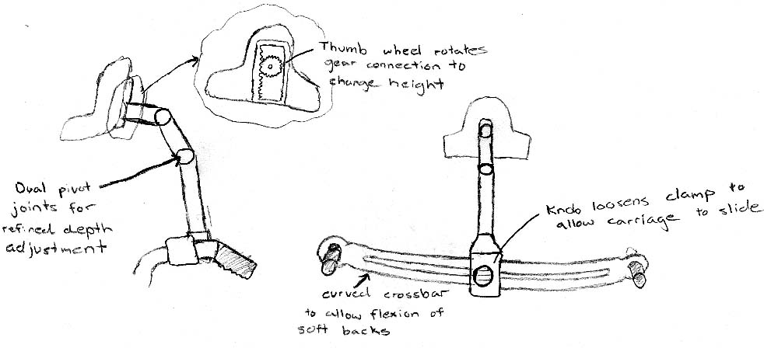
Figure D-5: Curved Crossbar with Dual Upper Joints

Self-locking Worm Gear and Rack "Translated Motion"
In the following design a worm gear and pinion translates rotational motion into linear motion to achieve vertical adjustment. Depth adjustment is achieved by moving a slot along a pin. No lateral adjustment has been added to this concept, but shows unique ideas for vertical and depth adjustment.

The device could attach to the chair by any of the methods mentioned in the previous designs.

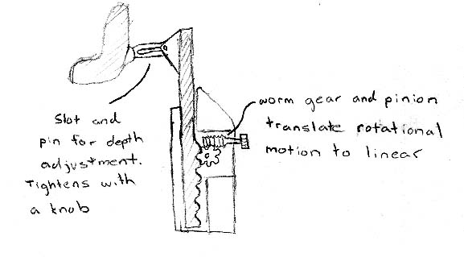
Figure D-6: Self-locking Worm Gear and Rack "Translated Motion"

Carriages on Worm Screw
In the worm screw design, the user would adjust the headrest vertically by turning knob to rotate the worm screw and cause the carriage to move. There would also be a knob for the user to turn causing a second carriage to move along the bar at the bottom of the device, allowing for lateral motion. Depth and some vertical adjustment would be achieved through the locking ball joint at the top of the device. Another ball joint behind the headrest pad would provide angular adjustment.
The headrest would be attached to the wheelchair in a manner similar to the vertical bar design.

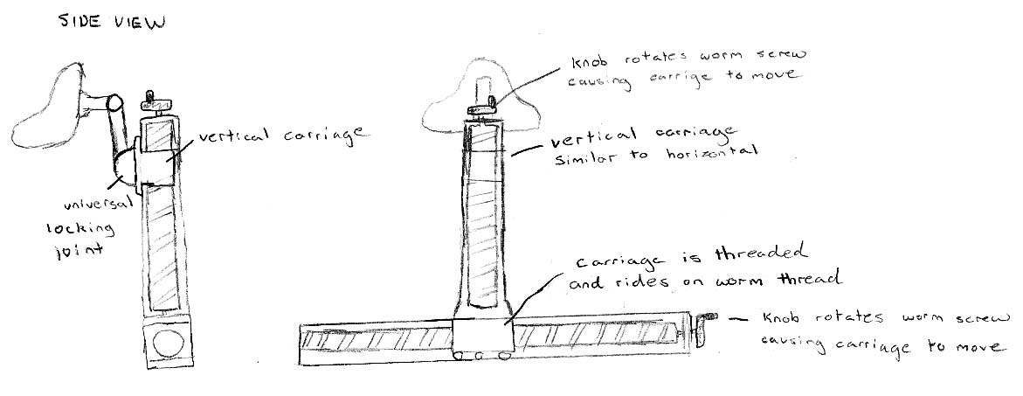
Figure D-7: Carriages on Worm Screw

Conclusion

The purpose of this document has been to present the concepts for a wheelchair headrest produced by our design team. Each concept contains ideas for the main function of the headrest, and well as individual sub-functions of the headrest. The methods of achieving vertical, lateral, and depth adjustment will be evaluated and combined to achieve the best positioning system possible. A method of attachment will also be chosen from the ideas presented above and attached to the headrest.

Appendix E: Concept Evaluation and Selection Document

This document explains the process and methods used by the design team to evaluate the concepts generated during the internal search phase and combine the functions and sub-functions into the final design that will be refined and built by the team.

Concept Generation
To fully define the project goals and requirements, the team visited a skilled nursing facility that had relations with Keen Mobility. Personnel there informed the team that the current adaptable and adjustable headrests require time and effort as well as tools such as wrenches to install and adjust. This information drove the team to generate concepts that greatly reduced, or eliminated the need for any kind of tools to operate the headrest.

Each member of the team was tasked with the job of coming up with several ideas for complete designs or individual functions that could be combined into a complete design. These ideas were sketched on paper or modeled using 3-D software such as Solidworks.

PDS Criteria Consideration
During the concept evaluation process the team referred to the main PDS criteria as a basis for rating each design. The criteria are as follows

- Ease of Use – important factors were number of hands required, number of knobs/levers, and force needed to adjust.
- Time to Adjust – less than 5 seconds received a 5, while greater than 25 seconds scored a zero
- Safety – factors included possible chance of mechanism failure or slipping as well as sharp edges or pinching points
- Cost – cost was affected by complex components that could not easily be machined or manufactured cheaply
- Range of Use – determined if device covered full range needed as well as accuracy or if it would have to be modified to achieve the desired range

Concept Evaluation Matrices
Since the team felt that the final design would more than likely include a combination of components from multiple designs, each concept was split into three sub-functions: lateral, vertical, and depth adjustment. A scoring matrix was used on each sub-function to determine which ideas would be combined. Each sub-function was analyzed with respect to the main PDS criteria and given a score of 0 to 5 with 5 being the highest. The tables below show the scoring matrix for the lateral, vertical, and depth adjustment sub-functions.
Lateral Adjustment Scoring Matrix
Lateral Adjustment | Ease of Use | Time to Adj. | Safety | Cost | Range of Use | Overall Score
Curved Carriage | 4 | 4 | 4 | 5 | 3 | 20
Curved Carriage - fine tune | 2 | 4 | 4 | 3 | 4 | 17
Worm Thread Carriage | 5 | 0 | 5 | 1 | 5 | 16
Lower Pivot Joint | 1 | 3 | 2 | 5 | 1 | 12
Slider in Channel | 4 | 5 | 4 | 3 | 3 | 19
Straight Rail Carriage | 4 | 4 | 4 | 5 | 3 | 20

Two concepts tied for the best design: curved carriage, and straight rail carriage. The concepts that were eliminated are described below.

Concept Elimination
- Curved Carriage with fine tune adjustment: This design was eliminated simply because the team decided that a fine tune adjustment in the lateral direction was not needed and would complicate the device.
- Worm Thread Carriage: While this concept allowed for greater accuracy and precision as well as safety, it was eliminated because of its time needed to adjust. The team felt that it would take too long and too many turns of the wheel knob to be seriously considered. The cost and weight of the design were also factors in its elimination.
- Lower Pivot Joint: This concept was eliminated because it required considerable force to unlock it, and required the user to hold on to the bar while loosening the joint to prevent the head rest from falling. The other factor that contributed to its elimination was the change in the lateral direction would affect the current height and depth of the headrest.
- Slider in Channel: While this concept only scored one less than the winning ones, it was eliminated because of its size and appearance.

Vertical Adjustment Scoring Matrix
Vertical Adjustment | Ease of Use | Time to Adj. | Safety | Cost | Range of Use | Overall Score
Telescoping Bar | 1 | 5 | 4 | 5 | 2 | 17
Incremental Slots with fine tune adj. | 3 | 4 | 5 | 3 | 5 | 20
Overhead Projector gear system | 5 | 5 | 3 | 3 | 5 | 21
Worm and Pinion gear system | 5 | 1 | 5 | 3 | 5 | 19
Worm Thread Carriage | 5 | 1 | 5 | 1 | 5 | 17

The design that scored the highest was the gear and rack system similar to overhead projector focus knobs. The team plans to implement a locking mechanism that will prevent the gears from turning when not needed. This concept is simple to use with one knob, and quick to adjust.

Concept Elimination:
- Telescoping Bar: This design was eliminated primarily because it required the user to hold onto the bar while loosening the clamp. It was also eliminated because it could not adequately cover the entire range necessary.
- Incremental Slots: This design was simple to slide up and down, but required more than one knob to adjust which the team felt was too complex.
- Worm and Pinion Gear: While this design was very accurate and safe, it was eliminated because of the time needed to adjust, which needed to be quick
- Worm Thread Carriage: This design was eliminated fairly easily because of the amount of time and turns of the knob that would be required to adjust.

Depth Adjustment Scoring Matrix
Depth Adjustment | Ease of Use | Time to Adj. | Safety | Cost | Range of Use | Overall Score
Lower Pivot Joint | 1 | 4 | 2 | 5 | 3 | 15
Upper Pivot Joint | 1 | 4 | 2 | 5 | 2 | 14
Ratcheted Joint | 1 | 4 | 2 | 5 | 2 | 14
Holes and Pin | 1 | 5 | 5 | 5 | 1 | 17
Upper Slot With Fastener | 4 | 4 | 3 | 5 | 4 | 20

The design that clearly was the best was the upper slot adjustment with a tightening knob. This design allows for depth adjustment as well as further lateral adjustment simply by rotating the member and sliding it in or out and then securing it.

Concept Elimination:
- Lower Pivot Joint: This concept was eliminated due to the same reason as the pivot joint for the depth adjustment. It required the user to hold on to the vertical member while loosening/tightening a clamp on the joint, as well as altered the height setting.
- Upper Pivot Joint: Elimination of this concept resulted from the limited range of use as well as the need for the user to hold on to the member while adjusting.
- Ratcheted Joint: This concept was eliminated due to the same factors as the pivot joints.
- Holes and Pin: While this concept was very safe and cost efficient, it was eliminated because it wasn’t handy to have to move a pin to adjust as well as its range limited to increments.

Final Design Concept
The final design, as shown below, consists of selected subsystems from the generated concepts. Further points of design improvement include optimization of dimensions, material selection, and the inclusion of a shock absorption component.

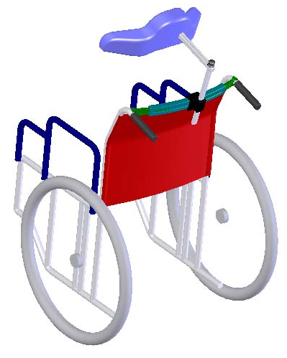
Depth adjustment -modified slot-and-pin fixture that can also rotate laterally; set in place by tightening "knob"
Vertical Adjustment - gear system similar to overhead projectors, but designed to be self-locking, or otherwise locked in place
Lateral Adjustment - sliding carriage kept in place through clamping force on curved cross-member
Method of attachment - notched bars adjust outward freely but inward movement restricted unless a spring-loaded button is pushed; half circle ends fit over the bars of the handles (wider on top to prevent rotation)
Headrest Pad - form to be selected and fitted with Keen Mobility pressure alleviating foam; connects to frame by way of locking ball and socket joint
Figure E-1: Final Concept - includes sub-systems from preliminary concepts; will be further optimized and include shock-absorption
Figure E-2: Selected Concept attached to wheelchair

Appendix F: Design Calculations

Lateral movement right 95th percentile

- Estimated distance from the bottom lip to the middle of the head (head concavity on the back of a head) is 4.9’’
- Pivot is point where neck and head intersect
- Angle of rotation is 31.75º

3.1"
4.9"

31.75º
Figure E-1: Horizontal distance covered during lateral motion of the head to the right for 95th percentile of population

Lateral movement left 95th percentile

- Estimated distance from the bottom lip to the middle of the head (head concavity on the back of a head) is 4.9’’
- Pivot is point where neck and head intersect
- Angle of rotation is 38.6º
4.9"
38.6^{oo}
4"

Figure E-2: Horizontal distance covered during lateral motion of the head to the left for 95th percentile of population

Extension 95th percentile

- Estimated distance from bottom of the nose to the middle of the head (head concavity on the back of the head is 4’’
- Pivot point is just below the nose
- Angle of rotation is 51.5º
5.1"
4"
51.5º

Figure E-3: Horizontal distance covered during extension of the head for 95th percentile of population

Flexion 95th percentile

- Estimated distance from the bottom of the neck (where neck and shoulders meet) to the middle of the head (concavity on the back of the head)
- Pivot point is bottom of the head

10.7"
11.7"
42.2º
Figure E-4: Horizontal distance covered during flexion of the head for 95th percentile of population

Forces on the head
- Mass of the head and neck is estimated to be 6 kg
- F_{R} - Reaction force on the head
- W - Weight of the head

Assumption:
Forces on the head are constant as head is positioned along lateral directions. The forces on the head change only during positioning of the head along flexion and extension direction.

Extension Free body diagram 95th percentile
F_{R}-W*cos(51.5º)= 0

F_{R}=6*(9.8)*cos(51.5º)

F_{R}= 36.61 N

or

F_{R} = 8.22 lbs.
F_{R}
51.5º
W

Extension Free body diagram 95th percentile
F_{R}-W*cos(42.2º)= 0

F_{R}=6*(9.8)*cos(42.2º)

F_{R}= 43.6 N

or

F_{R} = 9.8 lbs.
F_{R}
42.2º
W

The largest static forces on the head are 8.22 lbs. in extension and 9.8 lbs. in flexion. Figures E-5 and E-6 show that forces are declining as the position of the head is changed along extension and flexion direction
Figure E-5: Reaction Force vs. Angle of Head Position in Extension Direction

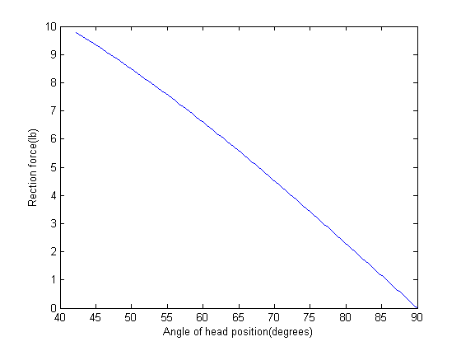
Figure E-6: Reaction Force vs. Angle of Head Position in Flexion Direction

Appendix G: Referenced Anthropometric Data

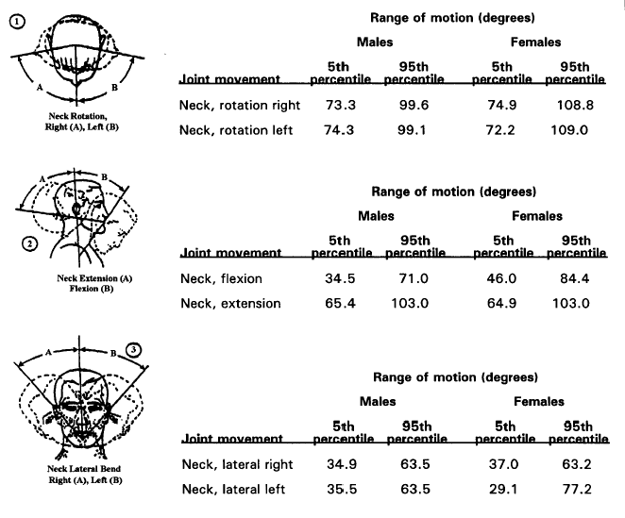
The following table is excerpted from Exhibit 14.3.3.2.1 - Joint movement ranges, found in Chapter 14 - "Anthropometry and biomechanics" of the FAA's Human Factors Design Standard, 2003. Anthropometry (as defined by the FAA) is "The scientific measurement and collection of data about human physical characteristics…"

