|  |
| --- |
| Maseeh College of Engineering & Computer Science |
| **Yakima T.O.C. Load Assist** |
| **Progress Report** |
| 3/11/2012 |
|  |
| **Group Members:** |
| Haidar Al Gharash |
| Michael Dixon |
| Ben Gheliuc |
| Daniel Gheliuc |
| Fue Her  Zach McCurter   |  | | --- | | **P.S.U. Advisor:**  Evan A. Thomas, Ph.D., P.E.  **Yakima Sponsors:**  Mark Elliott  Chris Sautter  ME492  Winter 2012 | |

Executive Summary:

Yakima Products, Inc. is a company that designs and sells rack systems. The Top-of-Car Load Assist is a project proposed by Yakima to the Mechanical Engineering department at Portland State University. The purpose of the project is to design a manually operated device that shall help a person lift a kayak (or two kayaks) from waist height and securely place it on top of a vehicle.

Yakima had previously designed a lift assist system but it has not brought to production due to some constrains, mainly cost. Design constraints and specifications were provided by Yakima’s design team to help narrow down the constraints that influence the design aspects. A detailed design, cost analysis, performance analysis and a final product prototype will be provided by the capstone team to the sponsor (Yakima) by June 2012.

The Top-of-car Load Assist capstone team has progressed from the research stage and completed a PDS (Product Design Specification) report, internal search, external search, concept design and top level final design evaluation and selection. A final design concept has been selected that includes a horizontal slider attached to the roof rails to move the mechanism pivot point to an optimal location for the user. The main sliders and constant force springs have also been selected based on load calculations, cost and weight.

The current design the capstone team came up with should solve all the issues and constraints that the previous Yakima design had. This new design will provide load assist for two kayaks totaling 100lbs. and cost less than $200 to manufacture. The capstone team currently is in the infant stages of prototyping.

Table of Contents

Executive Summary: 1

Introduction: 3

Mission Statement: 4

Product Design Specification Summary: 4

External Search: 5

Internal Search: 6

Top-Level final design evaluation and selection: 6

Progress on Detailed Design: 7

Conclusion: 8

Appendix 1: PDS Criteria 10

Appendix 2: Yakima Test Standards 15

# Introduction:

A product Yakima has not brought to production is a system that will assist the end user to load kayaks on top of a vehicle. Yakima had previously designed a system but the estimated market price for the system was too much, so they wanted to design a new system that would be efficient yet affordable. This is where they made the load assist system into a capstone project for the Portland State University students.

Yakima’s previous attempt at a load assist system had an estimated retail price of $2000, which was too expensive for the market. The system can hold up to 100 pounds of load capacity of boats, bikes, or cargo boxes. All the loading is done on the side of the car as shown in Figure 1.

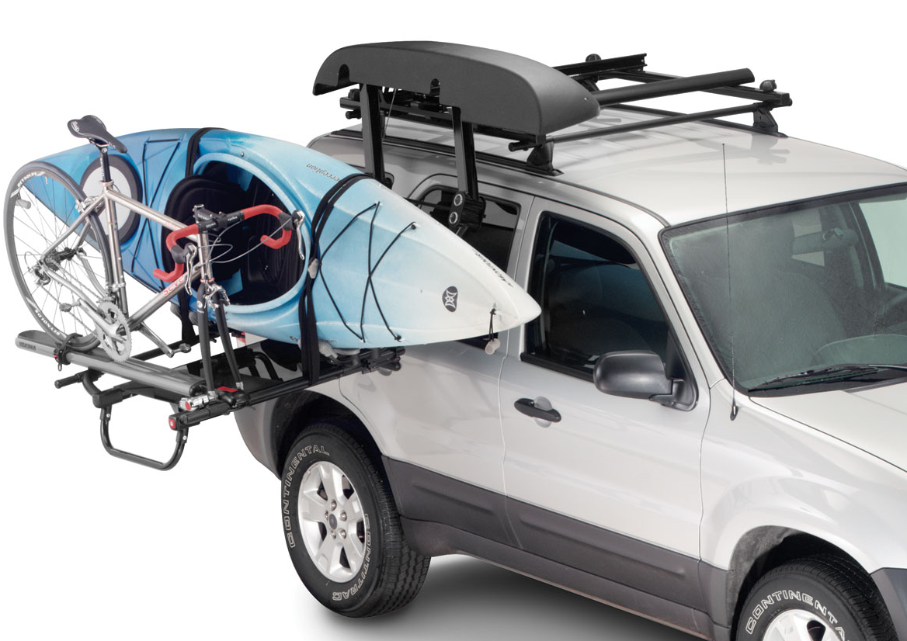

**Figure 1:** Yakima’s previous “Lowdown” load assist design

# Mission Statement:

The top of car load assist capstone team will design and manufacture a prototype mechanism that will provide 60 pounds of assistance in loading kayaks onto the top of a car. The system must be intuitive to use and have no pinch points or safety hazards. A 45 year old 5’ 2” woman should be able to operate the lift assist without extreme physical exertion. When the final prototype enters production it must have a retail value of less than 1000 dollars.

# Project Plan:

To make sure the project and product is delivered on time, a project plan was generated, shown in Figure 2, to keep a timeline of assignments and ensure that they are finished at the appropriate time. The finish date is an approximated time for when the task should be done. The majority of the time after the meeting with Yakima is spent on testing and the detail design. Much time is needed for testing because the aesthetics and ergonomics of the design cannot be modified or finished until testing begins. Dr. Evan Thomas (capstone advisor) is also notified of milestones that are met as well as weekly progress.

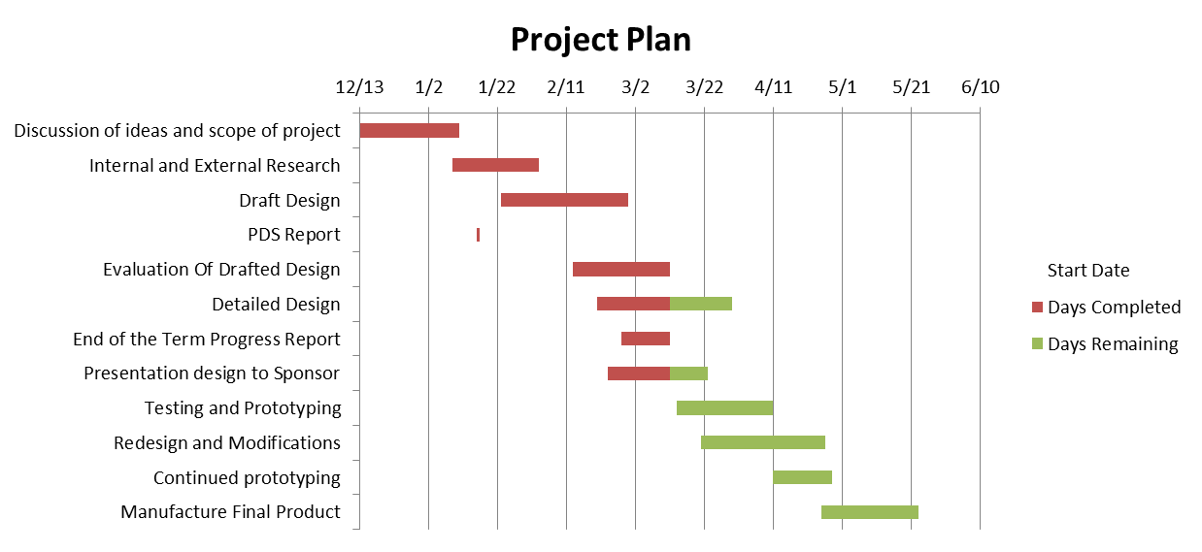

Figure 2: Gantt chart of milestones.

# Product Design Specification Summary:

The Product Design Specification (PDS) is a document that defines the customer requirements, lays out a project plan, sets milestones, discusses risk management and creates a design specification list. The main criteria from the PDS are listed below (For more detailed criteria see Appendix A).

* Target Persona: An average 45 year old 5’2” woman who paddles a sea kayak and drives a Subaru Outback.
* Ergonomic design allows user to easily load boat on top of vehicle.
* No sharp edges, corners, or pinch points.
* Product must have no mechanical or structural failures for five years of moderate use.
* The load assist must pass Yakima’s internal standards: horizontal pull at 4 times the rated carrier load and the vertical pull at 2500 N.
* Target assist of a total of 60lb.
* Target retail price of < $1000.
* Completion of final design must be done by June of 2012.

# External Search:

The purpose of the external search is to examine competing products and identify the existing technologies that would be directly related to the design. The technologies that will be used to successfully satisfy the requirements of the PDS will be the primary focus of the external search.

The number of competing products on the market is very limited to a couple of direct competitors. Malone has a system that is fairly "low-tech" as it is a simple ratchet system and doesn’t actually provide any "load assist". The Malone system shown in Figure 3 was part of our external research as it is a kayak loader that is currently available on the market. The main competitor to Yakima's proposed top of car load assist is undoubtedly the Thule Hullavator. The Hullavator shown in Figure 4 is a hydraulically assisted kayak loader that uses a scissor and pivot motion to assist the user in loading one kayak from the side of the vehicle onto the roof of the vehicle.

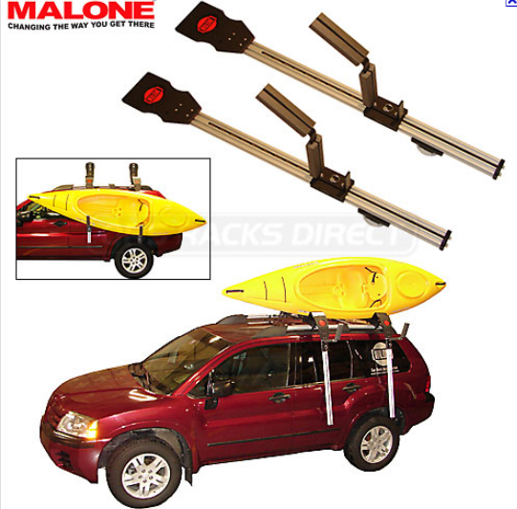 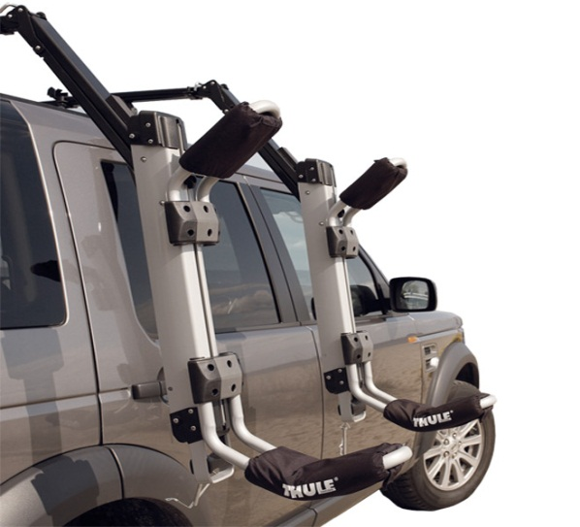

Figure 3: Malone kayak loader Figure 4: Thule Hullavator kayak load assist

The external search for the technologies we had available to use began in the most basic form of how to move a load/object from point A to point B. Various methods researched included pulley lever systems, scissor lift motions, pins/rails, bearings, linkages and mechanical sliders. The group settled on mechanical sliders to be the main weight bearing component due to the strength, weight and cost of the component. Once the group had decided that a mechanical slider would be used in the lift assist mechanism, a cost of material and extension vs. load rating analysis needed to be performed. Aluminum mechanical sliders held acceptable load ratings and excellent overall weight, but the price per unit would not satisfy the PDS requirement of low cost. Mechanical sliders made from steel turned out to be the best option for the load assist based on load rating and cost. The added weight of using steel components to aluminum was not favorable but still within acceptable limits for the project.

Further research on how to provide the load lift assist resulted in using either gas shocks or constant force springs paired with dampers. Both the constant force springs paired with dampers and the gas shocks provided the load assist required as well as similar benefits when comparing cost per load assist. Gas shocks would work excellent for the application as they would provide load assist and damping in the same unit. Gas shocks unfortunately are difficult to store in the system as space is limited when the system is fully collapsed in the stored load state. Constant force springs provided the benefits of low cost, low maintenance, storability and adequate load assistance.

# Internal Search:

The capstone team went through the process of brainstorming to generate ideas and concepts to successfully fulfill the PDS requirements set forth by the customer. The main PDS criteria that lead the brainstorming phase was usability, low-cost, amount of load assist and the industry standards shown in Appendix B**.**

The usability of the load assist system is defined as the ease of use by the end user; the system must feel natural while operating. The system must also be designed in a way such that the amount of possible pinch points is eliminated completely or reduced to a minimum.

The cost of each component was taken into consideration during the brainstorming phase with the goal of utilizing as many existing Yakima products as possible. The mechanical slides were evaluated for cost per extension length as these would be the most expensive component in the system. The constant force springs were relatively low in cost and did not impact the design much.

The scope of the project was slightly modified in the 11th hour after a progress report meeting with our industry sponsors. Yakima had suggested a minor design modification to allow for two kayaks to be loaded rather than just one. As a result of this, the group had to re-evaluate the load assist method. Constant force springs were still the primary choice after listing the pros and cons against a gas shock. The constant force springs were found to supply sufficient load assist for the new requirement along with reduced maintenance, lower cost and better storage capability.

# Top-Level final design evaluation and selection:

The Initial brainstorming yielded four concepts, three of which were seriously considered in the design process. The first concept consisted of a rotational linkage mechanism which was not feasible because the complexity added cost. The second concept consisted of a 40 inch mechanical slider that would rotate about a fixed pivot point, see Figure 5 below. The load assist would be connected to one end of the fixed base and the far end of the sliding arm. This design was eventually ruled out because the location of the pivot point makes it too difficult for the user to unload the mechanism as they would need to pull approximately 30 pounds at a very awkward position relative to their body.

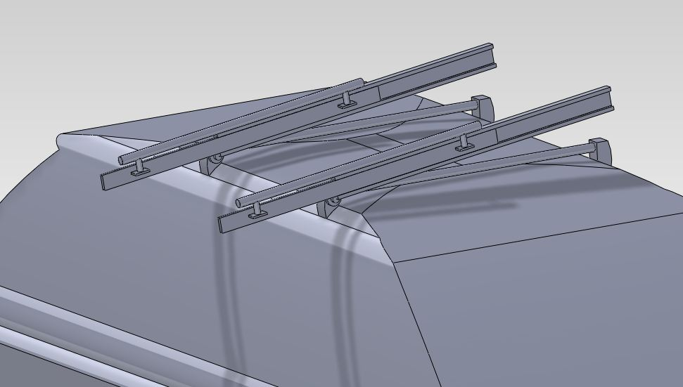

Fixed Pivot Point

Figure 5: Concept one with one set of mechanical sliders and a fixed pivot.

The third concept was much more user friendly to load as it has a horizontal loading platform for kayaks; this design may be used for multiple bikes as well. The mechanism consisted of a mechanical slider connected to the horizontal loading platform via slots and rails, see Figure 6. In order to accomplish a load assist with this design the load assist would need to be connected to the fixed base slider and the tip of the horizontal loading platform. The major flaw in the third design concept is the fact that a boat would apply force beyond industry standards to the roof of the car and would not be an acceptable loading mechanism.

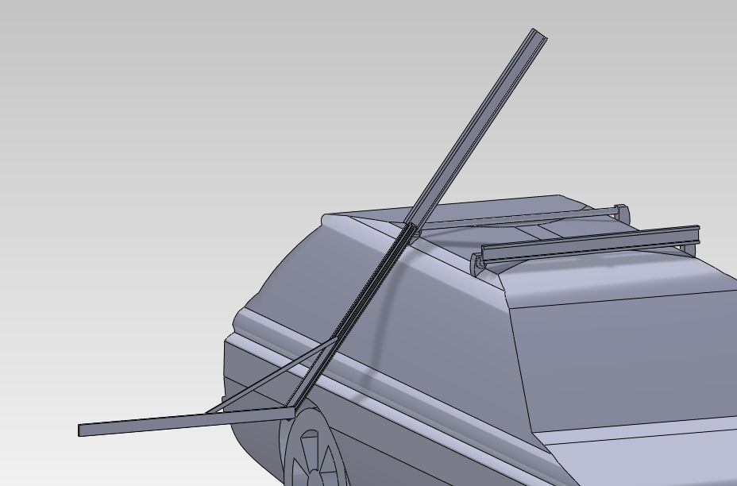

Fixed Pivot Point

Horizontal Loading Platform

Figure 6: Concept two with horizontal platform.

The final concept is a modified version of concept two. It is comprised of two sliding arms, one 16 inch, and one 30 inch. The 16 inch slider acts as a base and moves the rotation point in order to dramatically increase the ease of use of the mechanism, see Figure 7. The 16 inch slider attaches to the 30 inch slider ten inches from the telescoping end. The mechanism operates by the user pulling handles located at the end of the 30 inch slider which in turn causes the 16 inch base slider to extend and lock into place after it reaches its full extension. The user then continues to pull the 30 inch slider loading constant force springs located at the opposite end of the 30 inch slider and connected to the inner most telescoping arm via a steel cable. This design is optimized for loading kayaks since they are stored on top of the car rotated 90 degrees. This allows the kayak to be loaded onto a nearly horizontal platform. This design is a step above the competitor’s designs because it allows two boats to be loaded from one side of the car.

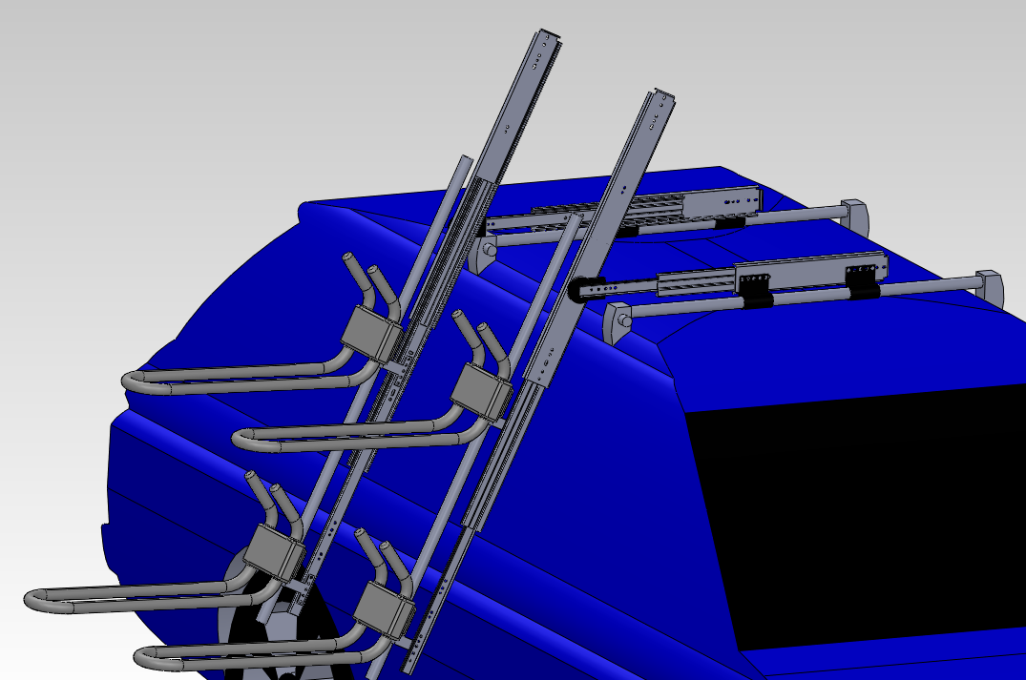

16 inch Base Slider

Near Horizontal Loading Platform

Pivot Point

Constant Force Spring Location

Figure 7: Final top level concept with two J-cradles.

The team considers load assist, cost, weight, safety, ease of use, and manufacturability to be important qualities of the T.O.C. load assist design. These concepts are graded on a numerical scale with one being the lowest and ten being the highest. The decision matrix of the T.O.C. top-level design is shown in Table 1. The design team selected the two arm extension concept based on the total values it received in the design evaluation matrix. Ease of use is the most important factor used in the design of the prototype because it is very closely related to the overall design of the mechanism and would be very difficult for Yakima to improve without making major design changes to the prototype. All other design criteria is important, however Yakima can make improvements to these relatively easily.

**Table 1:** Concept design evaluation matrix. All concepts were rated for load assist, cost, weight, safety ease of use and manufacturability.

|  |  |  |  |  |  |  |  |
| --- | --- | --- | --- | --- | --- | --- | --- |
|  | Load Assist-5 | Cost-2 | Weight-4 | Safety-4 | Ease of Use-10 | Manufacturability-5 | Total |
| Concept one | 1 | 1 | 4 | 3 | 2 | 2 | **13** |
| Concept two | 4 | 2 | 4 | 4 | 1 | 4 | **19** |
| Concept three | 1 | 1 | 1 | 1 | 10 | 1 | **15** |
| Concept four | 4 | 2 | 2 | 3 | 7 | 3 | **21** |

# Progress on Detailed Design:

**Summary** - The objective of this analysis is to determine which method of load assist to use. The load assist is specified to be 60 lbs. total. Table 2 shows the pros and cons of the two options, gas shocks and constant force springs.

**Table 2:** Decision table comparing properties of load assist methods

|  |  |  |  |  |  |
| --- | --- | --- | --- | --- | --- |
|  | force | extension | envelope | attachment | damping |
| Shocks | **** | ** | * | * | **** |
| Springs | ** | **** | *** | **** | * |

**Force** – When considering the lift assist force that each method could provide, the gas shocks far out performed the constant force springs; however if two of the springs were installed in parallel they could provide the lift assist force desired.

**Extension** – The constant force springs won out in the extension category because they could provide more extension than is needed; the gas shocks, however, had a 30 inch extension and would be very expensive.

**Envelope** – An issue that was encountered in the preliminary drawings was the length of the 30 inch extension gas shocks; when in the stowed position the length would be slightly longer than 30 inches. The constant force springs are very compact in the stowed position and so they ranked higher.

**Attachment** – The means and location of attaching the load assist to the mechanical slider was an issue because when the mechanism is stowed the attachment points must be on opposite sides of the slider. The constant force springs will be attached with a solid connection on one end and a cable on the other, whereas the gas shock needs two solid connections and would thus interfere with the sliding mechanism.

**Damping** – Gas shocks are a very attractive option because they have an integrated damper, so if the user accidentally releases the mechanism it will not slam closed. Constant force springs do not have an integrated damper, so an additional rotational damper must be added to each side of the mechanical slider.

**Decision** – The team decided to choose the constant force spring with a damper added because it will be easier to attach, it will provide the load assist that is needed, and it will provide the extension needed.

# Conclusion:

The major accomplishments that have been met are: Internal and external research, PDS report, final concept design, stress analysis on parts and a progress meeting with the engineers at Yakima. When the external research was done, the group concluded that the only close competitor would be the Thule Hullavator. Since it is hydraulically assisted, it is user friendly as it comes down. The Yakima load assist has the advantage that it will have the capability of loading two kayaks when the Hullavator is only capable of loading one. Mechanical sliders were also found to be the most effective mechanical part for the purpose of bringing an object from point A to point B. A conclusion was made that constant force springs are easier to store as well as lower cost and maintenance.

When the PDS report was produced, the importance of various requirements was ranked to determine what components can be neglected. The look of the final product is not as important as much as how it works. Another important aspect that was taken into account as the final concept design was finished was eliminating potential pinch points within the system.

A challenge that was overcome from the concept design was the difficulty of providing the load assist in a usable fashion while keeping it ergonomic and cost effective. Because a J-cradle will be used for storing the kayaks on the load assist, the kayaks will be loaded almost horizontally. A problem the product will face is where to place the cables for locking and unlocking the 16 inch mechanical slider. Recommendations that were made by the engineers at Yakima were to only focus on loading two kayaks rather than one large sea kayak. The reason for this is because the way the concept design is headed, it has the potential to be extremely competitive in its market.

Major tasks that are to be completed are: Detail design, testing and prototyping, redesign/modification for improvement, retesting and manufacturing of final prototype. For the detailed design, the load assist team will make refinements in the parts of the product and do finite element analysis on existing parts to ensure that they will not fail during testing. Information will be collected so that usability can improve. With the information gathered, modifications will be made to the detailed design so that continuous problems are properly addressed.**Appendix 1: Detailed PDS Criteria**

In this appendix, the detailed Product Design Specification is provided. These are the detailed specifications provided by the customer and turned into a table format by category. The requirements are divided into six sections including customer, requirement, metric, target, basis and verification. These six sections outline the entire requirement from who it is intended to satisfy, what is required, how it will be fulfilled, what the target is, the basis of the requirement and how the group would verify that the requirement has been implemented into the design.

|  |  |  |  |  |  |
| --- | --- | --- | --- | --- | --- |
| **Customer** | **Requirement** | **Metric** | **Target** | **Basis** | **Verification** |
| Yakima | Adhere to fatigue standards: YS2015, ISO 11154, and DIN 75-302 | Cycle Test | 100% Design load, 30k cycles | Standard Definition | Testing |
| Yakima | Adhere to Durability/Road Loop standard YS2014 | Durability/Road loop test | 100% Design Load | Standard Definition | Testing |
| Yakima | Adhere to Pull Tests standard: YS2015 | Pull tests | Pass Yakima standard pull test (refer to appendix) | Standard Definition | Testing |
| Yakima | Work Place safety codes | Number of codes to be violated | Zero | Safety and legal standards | Review of the safety and legal standards |
| Yakima | Adhere to Pull Tests standard: ISO 11154 | Pull tests | Pass 4x Max load FWD and AFT load @ CG | ISO 11154 | Testing |
| Yakima | Adhere to Pull Tests standard: ISO 11154 | Pull tests | Pass 4x Max load 20 degree horizontal force @ CG | ISO 11154 | Testing |
| Yakima | Adhere to Pull Tests standard: ISO 11154 | Pull tests | Pass 2x max load LAT load @ CG | ISO 11154 | Testing |
| Yakima | Adhere to Pull Tests standard: ISO 11154 | Pull tests | Pass 4x max load (up) load @ GC | ISO 11154 | Testing |
| Yakima | Mount shall meet performance standards | NA | Meet all standard criteria | ISO 11154, YS2015, and DIN 75-302 | Standard Definitions |

**Ergonomics**

|  |  |  |  |  |  |
| --- | --- | --- | --- | --- | --- |
| **Customer** | **Requirement** | **Metric** | **Target** | **Basis** | **Verification** |
| Yakima | Low loading effort | Lbs. of lift assist | 60 lbs. | Customer Requirement | Measurement |
| Yakima | Comfortable handles or levers | Handles and levers | All | Physical testing | Customer verification |

**Documentation**

|  |  |  |  |  |  |
| --- | --- | --- | --- | --- | --- |
| **Customer** | **Requirement** | **Metric** | **Target** | **Basis** | **Verification** |
| PSU | PDS Report | Completed Report | January 30, 2012 | Course requirements | Good Grade |
| PSU | Progress Report | Completed Report | March 12, 2012 | Course requirements | Good Grade |
| PSU | Final Design Report | Completed Report | June, 2012 | Course requirements | Good Grade |

**Life in Service**

|  |  |  |  |  |  |
| --- | --- | --- | --- | --- | --- |
| **Customer** | **Requirement** | **Metric** | **Target** | **Basis** | **Verification** |
| Yakima | Product should have no mechanical or structural failures for 5 years of moderate use | Product life cycle | Theoretical life cycle of 5 years. | Yakima warranty standards | Testing |

**Disposal**

|  |  |  |  |  |  |
| --- | --- | --- | --- | --- | --- |
| **Customer** | **Requirement** | **Metric** | **Target** | **Basis** | **Verification** |
| Yakima | Use only recyclable plastics | Plastic recyclability | 100% recyclable | Yakima recyclability standard | Customer definition and or standards |

**Maintenance**

|  |  |  |  |  |  |
| --- | --- | --- | --- | --- | --- |
| **Customer** | **Requirement** | **Metric** | **Target** | **Basis** | **Verification** |
| Yakima | Non-water soluble lubricant on moving metal parts | Lubricant type | Use only non-water soluble lubricant | Chemical composition and lubricant manufacturer specs | Test Lubricant for non-water solubility |
| Yakima | Plastic parts to be cleaned with soft cloth and mild detergent | Plastic type | Use only plastics that can be cleaned with cloth and mild detergent | Customer definition | Test plastic for cleaning |

**Performance**

|  |  |  |  |  |  |
| --- | --- | --- | --- | --- | --- |
| **Customer** | **Requirement** | **Metric** | **Target** | **Basis** | **Verification** |
| Yakima | Ease of use | Loading time | Load and lock bike or boat in less than 5 minutes | Customer definition and physical test | Testing |
| Yakima | Low reach distance | Distance from ground to loading rack | 36 inches from ground to rack in loading position | Height of 2011 Subaru Outback(64 inches) | Testing |
| Yakima | Should be easily fitted to standard rack systems | Modular design | No removal of base rack system | Customer definition | Testing |
| Yakima | No rattling when loaded or unloaded | Noise or chatter during loading and unloading process | No audible sound to loader | Customer defined | Testing |

**Safety**

|  |  |  |  |  |  |
| --- | --- | --- | --- | --- | --- |
| **Customer** | **Requirement** | **Metric** | **Target** | **Basis** | **Verification** |
| Yakima | No sharp edges/corners | Number of sharp corners or edges | Zero | Customer Requirement | Inspection |
| Yakima | No pinch points | Number of pinch points | Zero | Customer Requirement | Inspection |

**Timeline**

|  |  |  |  |  |  |
| --- | --- | --- | --- | --- | --- |
| **Customer** | **Requirement** | **Metric** | **Target** | **Basis** | **Verification** |
| PSU | PDS Report | Completed Report | January 30, 2012 | Course requirements | Good Grade |
| PSU | Progress Report | Completed Report | March 12, 2012 | Course requirements | Good Grade |
| PSU | Final Design Report | Completed Report | June, 2012 | Course requirements | Good Grade |
| Yakima | Final Product | Timely Completion | June 1, 2012 | Customer | Customer is Satisfied |

**Company Constraints and Procedures**

|  |  |  |  |  |  |
| --- | --- | --- | --- | --- | --- |
| **Customer** | **Requirement** | **Metric** | **Target** | **Basis** | **Verification** |
| Yakima | Keep product inherently safe | N/A | Consider pinch points and potential user “misuse”. | Yakima Requirement | Inspection |

**Cost of production per part**

|  |  |  |  |  |  |
| --- | --- | --- | --- | --- | --- |
| **Customer** | **Requirement** | **Metric** | **Target** | **Basis** | **Verification** |
| Yakima | Low retail price | Dollars | $1000 maximum | Customer feedback | Study of price in market |

**Environment**

|  |  |  |  |  |  |
| --- | --- | --- | --- | --- | --- |
| **Customer** | **Requirement** | **Metric** | **Target** | **Basis** | **Verification** |
| Yakima | Operates in a harsh wet environment | Years of Resistance to rust and corrosion | 5 years | Group decision | Study of standards |

**Manufacturing facilities**

|  |  |  |  |  |  |
| --- | --- | --- | --- | --- | --- |
| **Customer** | **Requirement** | **Metric** | **Target** | **Basis** | **Verification** |
| Project team and Yakima | Yakima provides facilities needed | Use of Yakima’s Facilities | No need to use other facilities | Customer input | Similar system comparison |

**Shipping**

|  |  |  |  |  |  |
| --- | --- | --- | --- | --- | --- |
| **Customer** | **Requirement** | **Metric** | **Target** | **Basis** | **Verification** |
| Yakima | Fit in not too large shipping container | Cubic inches | 10” X 24” X 36” | Expert opinion | Study of standards |

**Materials**

|  |  |  |  |  |  |
| --- | --- | --- | --- | --- | --- |
| **Customer** | **Requirement** | **Metric** | **Target** | **Basis** | **Verification** |
| Yakima | Product components | Yes/no | Typical Yakima materials | Yakima requirement | Inspection |
| Yakima | Aesthetics | Yes/no | Looks sturdy &  professional | Customer input | Inspection |

# Appendix B: Yakima Test Standards

In this appendix, you will find the industry along with Yakima internal standards for testing and performance. The ISO and DIN standards are industry standards that Yakima must abide by for this market. The YS is an internal Yakima standard that is derived from the industry standards. Yakima internal standards are set in a way such that they meet or exceed the ISO and DIN standards.



