**Cross Country Sit Ski**

Progress Report—Winter 2012

**Team Members:**

Cody Barnett

Elizabeth Camp

Josh Metzler

Robbie Quesada

Mark Scheel

Alex Triplett

**Academic Advisor:** Prof. Hormoz Zareh

**Industry Advisor:** Jennifer Armbruster

**Sponsor:** Portland State University Inclusive Recreation Department

## Executive Summary

A cross-country sit ski enables people with spinal injuries to ski from a seated position. The location of a spinal injury determines the degree of body functionality. Users with high-level spinal injuries do not have the core stability needed to sit upright, and need to be secured to the seat back. Users with lower spinal injuries have control of their abdominal muscles, and will likely choose be free of the seat back in order to put core strength into forward motion. Most sit skis on the market are custom-built for a specific body size and injury. The objective of the PSU Sit Ski Capstone Team is to design and build an adjustable cross-country sit ski to accommodate a variety of user size, weight, and injury type. The sit ski and supporting documentation will be delivered to the PSU Inclusive Rec Department in June of 2012.

To date, the team has identified product design specifications (PDS), completed external searches of existing products, and conducted group brainstorming sessions to develop and evaluate various concepts. The team is currently in the detail design phase of product development.

Key PDS define points of sit ski adjustability and project cost. An external search identified established solutions to design requirements. Key search parameters included materials and manufacturing, seating options, and restraints.

The team developed three concepts and evaluated them based on the PDS criteria. The chosen concept incorporates adjustability in the seat back angle, seat bottom angle, foot rest, and seat back height. The design is intended to minimize fabrication and material costs.

The current design exceeds the customer’s requirements in terms of adjustability. Inclusive Rec did not initially specify an adjustable seat back angle. While conducting external searches and customer interviews, the team found that an adjustable seat back angle significantly contributes to the comfort and versatility of the sit ski. There is concern among the team that the customer’s specification of a seat height of 19 in – 21 in may present a tip hazard to the user. Further analysis is planned to evaluate this possibility.

## Table of Contents

Introduction 1

Mission Statement 1

Project Planning 2

Final PDS Summary 2

External Search 3

Internal Search 5

Design Evaluation 5

Conclusion and Recommendations6

References  8

Appendix A – Detailed Project Schedule 9

Appendix B – Product Design Specifications 10

Appendix C – Detailed External Search 12

## Introduction

Adaptive equipment enables people with disabilities to enjoy common recreational activities. One such activity is cross-country skiing, in which participants propel themselves across snow covered terrain. A cross-country sit ski enables users with spinal injuries to ski from a seated position. Users move the ski using poles to push off the ground. As shown in Figure 1, the ski generally consists of a seat, foot rest, and frame mounted to two conventional cross country skis.

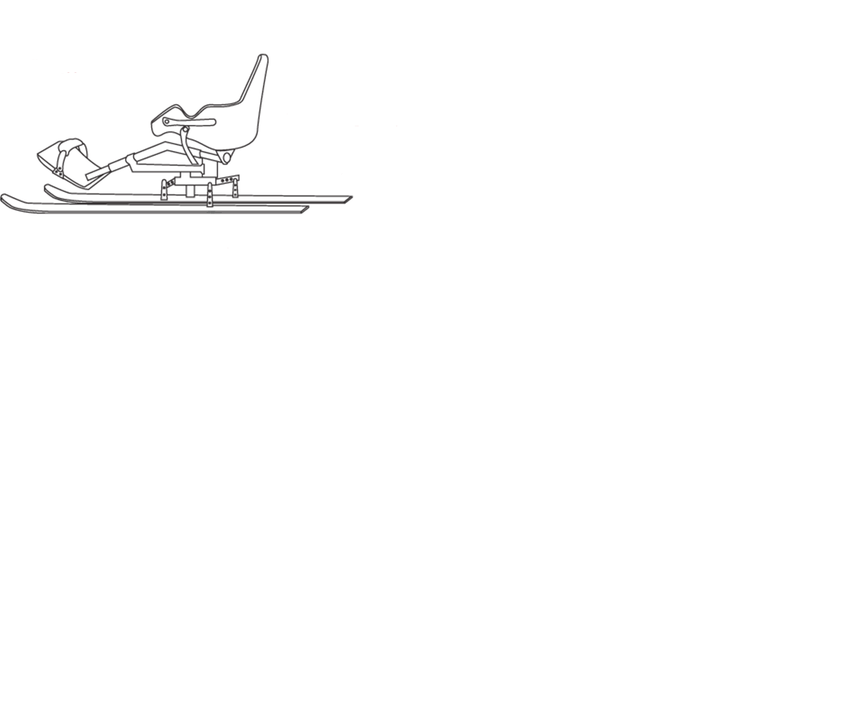

**Figure 1**: Example of a cross country sit ski [4].

The location of a person’s spinal injury determines the degree of body functionality. People with lower spinal injuries, in the lumbar region of the spine, will be able to use the abdominal muscles needed to sit upright. With higher spinal injuries, in the thoracic region, people begin losing trunk stability. Sit ski users with high level spinal injuries need to be secured to the back of the seat. Users with lower spinal injuries will likely choose not to use these torso restraints. Being free of the seat back will enable them to put their core strength into propelling the sit ski forward.

Many sit skis are commercially available, but they are often custom-built to a specific size and injury type. There is a need for an adjustable sit ski that can accommodate users of varying size and disability.

## Mission Statement

The objective of the Portland State University (PSU) Sit Ski Capstone Team is to design and build a cross-country sit ski for the PSU Inclusive Rec Department. The sit ski must accommodate varying user size, weight, and injury type. The product and supporting documentation will be delivered to Inclusive Rec in June of 2012.

## Project Planning

An updated project schedule is shown in Figure 2. To date, the team has identified product design specifications, completed external searches, and conducted group brainstorming sessions to evaluate various concepts. The team has selected a general concept, and is moving forward with the detail design phase of product development. Refer to Appendix A for a detailed project schedule.

|  |  |  |  |  |  |  |  |  |  |  |  |  |  |  |  |  |  |  |  |  |  |
| --- | --- | --- | --- | --- | --- | --- | --- | --- | --- | --- | --- | --- | --- | --- | --- | --- | --- | --- | --- | --- | --- |
|  | Jan | | | Feb | | | | March | | | | April | | | | May | | | | June | |
| PDS |  |  |  |  |  |  |  |  |  |  |  |  |  |  |  |  |  |  |  |  |  |
|  |  |  |  |  |  |  |  |  |  |  |  |  |  |  |  |  |  |  |  |  |
|  |  |  |  |  |  |  |  |  |  |  |  |  |  |  |  |  |  |  |  |  |
| External Search |  |  |  |  |  |  |  |  |  |  |  |  |  |  |  |  |  |  |  |  |  |
|  |  |  |  |  |  |  |  |  |  |  |  |  |  |  |  |  |  |  |  |  |
|  |  |  |  |  |  |  |  |  |  |  |  |  |  |  |  |  |  |  |  |  |
| Concept Development |  |  |  |  |  |  |  |  |  |  |  |  |  |  |  |  |  |  |  |  |  |
|  |  |  |  |  |  |  |  |  |  |  |  |  |  |  |  |  |  |  |  |  |
|  |  |  |  |  |  |  |  |  |  |  |  |  |  |  |  |  |  |  |  |  |
| Concept Selection |  |  |  |  |  |  |  |  |  |  |  |  |  |  |  |  |  |  |  |  |  |
|  |  |  |  |  |  |  |  |  |  |  |  |  |  |  |  |  |  |  |  |  |
|  |  |  |  |  |  |  |  |  |  |  |  |  |  |  |  |  |  |  |  |  |
| Detail Design |  |  |  |  |  |  |  |  |  |  |  |  |  |  |  |  |  |  |  |  |  |
|  |  |  |  |  |  |  |  |  |  |  |  |  |  |  |  |  |  |  |  |  |
|  |  |  |  |  |  |  |  |  |  |  |  |  |  |  |  |  |  |  |  |  |
| Prototyping & Testing |  |  |  |  |  |  |  |  |  |  |  |  |  |  |  |  |  |  |  |  |  |
|  |  |  |  |  |  |  |  |  |  |  |  |  |  |  |  |  |  |  |  |  |
|  |  |  |  |  |  |  |  |  |  |  |  |  |  |  |  |  |  |  |  |  |
| Documentation |  |  |  |  |  |  |  |  |  |  |  |  |  |  |  |  |  |  |  |  |  |
|  |  |  |  |  |  |  |  |  |  |  |  |  |  |  |  |  |  |  |  |  |
|  |  |  |  |  |  |  |  |  |  |  |  |  |  |  |  |  |  |  |  |  |

**Figure 2:** Top-level schedule of the Cross-Country Sit Ski project.

## Final PDS Summary

The product design specifications (PDS) articulate the requirements of the design. The PDS includes a target value for each requirement, allowing the team to clearly assess whether the design requirement has been met. A detailed PDS can be found in Appendix B. The key requirements in the PDS are

* The sit ski seat back distance, measured from the seat top to the seat bottom, will adjust from 19 inches to 25 inches.
* The footrest of the sit ski should be adjustable.
* The angle between bottom of the sit ski seat and the horizontal plane should adjust from 0 to 15°.
* The angle between the seat back and horizontal plane should adjust from 90° to 120°.
* The torso straps on the sit ski should accommodate users with spinal injuries at vertebra C5 to T12.
* The cost of the sit ski and the skis must cost less than $1500.

## External Search

The PSU Capstone Team reviewed existing sit ski models to develop a product that meets the PDS criteria. Refer to Appendix C for a detailed external search.

Kiwi X-Country Ski – Spokes n’ Motion

The Kiwi X-Country Ski, shown in Figure 3, has an adjustable foot rest and mounts to off the shelf bindings and skis. The aluminum frame weighs 12 lbs. The seat back angle is fixed in a reclined position. This seat position is comfortable, but it inhibits the user from putting any available core strength into forward motion. The seat is much lower than the standard height of a wheelchair. This makes transferring to the sit ski a challenge for the user.

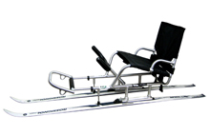

**Figure 3:** Spokes n’ Motion’s cross country sit ski model has a mesh seat and mounts to off-the-shelf bindings [5].

Nordic Sit Ski – Teton Sit Ski

The Nordic Sit Ski is shown in Figure 4. It has a telescoping foot rest and utilizes a molded plastic seating system. The seat must be sized to the user, and does not support high level spinal injuries. At $950, the ski is less expensive than most models. However, each frame must be custom built for a specific user size and disability. The sit ski mounts only to specially modified skis. An optional handbrake is available.

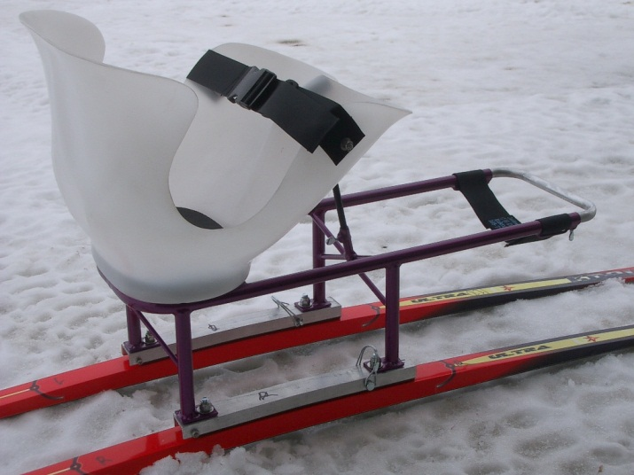

# Figure 4: The Teton Nordic Sit Ski comes with an optional handbrake (not shown here) [2].

Nordic Sit Ski – Central Cross Country

Figure 5 shows Central Cross Country’s Nordic Sit Ski. The seat angles are adjustable, and the foot rest can be mounted in several positions to accommodate varying user height. However, the PSU Sit Ski Capstone Team feels that round foot pegs do not adequately support the user’s heel. The seat cannot be configured to restrain users with high level spinal injuries. In addition, there have been noted rubbing issues with the seat’s mesh fabric.

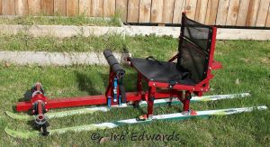

**Figure 5:** Central Cross Country has developed one of the most adjustable sit skis on the market [3].

## Internal Search

Brainstorming and concept development produced three main concept ideas.  Key differences relate to points of adjustability, seating options, and manufacturing methods.  Figure 6 provides a summary of the strengths and weaknesses of each concept.

|  |  |  |  |
| --- | --- | --- | --- |
| Design | Strengths | Weaknesses | Visual |
| Fundamental Design | * Simple design * Bucket seat | * Expensive parts & manufacturing * Limited points of adjustment * Strapping points not modular |  |
| Low Risk Design | * Simple design * Robust frame | * Limited points of adjustment * Limited strapping points * Expensive manufacturing | https://lh4.googleusercontent.com/kMI6IH6k9v_d_vlpuwVpuiNRIBx2gdc-9pQb_F3V20bKWc21RBd2EIUJz_r4YbdSuJ5SS09lozBgylo18wNrPMdL_WerhDCjlY-uSuZDqmxmd_wPdio |
| Improved Design | * Many points of adjustment * Many strapping points for security * Parts easy to manufacture | * Heavy * Requires significant manufacturing time/effort |  |

**Figure 6:** Comparison of strengths and weaknesses of primary concepts developed

## Design Evaluation and Concept Selection

The concept designs were evaluated based on the key PDS criteria. The key criteria used to compare the concept designs were

* Performance
  + Seat back height adjustability
  + Foot rest adjustability
  + Seat bottom angle adjustability
  + Seat back angle adjustability
  + Strap adjustability and ergonomics
* Cost
  + The cost is primarily determined by chosen manufacturing methods and the price of any off-the-shelf items.

A decision matrix was used to compare and select a concept for development (see Figure 7). Each criteria was assigned a weight on a 1 to 3 scale. Each concept design was then rated for each criterion on a 0 to 9 scale where 0 is undesirable and 9 is desirable. To determine the final weighted score, the weight and the rating were multiplied together and then the sum of all of these products was reported as the weighted score.

|  |  |  |  |  |  |  |  |  |
| --- | --- | --- | --- | --- | --- | --- | --- | --- |
|  |  |  |  |  | Weight | Initial | Low Risk | Improved |
| Performance | | | |  |  |  |  |  |
|  | Adjustable seat back height | | | | 3 | 8 | 8 | 8 |
|  | Adjustable seat back angle | | | | 3 | 0 | 0 | 7 |
|  | Adjustable seat base angle | | | | 1 | 0 | 0 | 7 |
|  | Adjustable foot rest height | | | | 2 | 4 | 7 | 9 |
|  | Adjustable foot rest length | | | | 2 | 4 | 7 | 9 |
|  | Adjustable seat height | | | | 1 | 0 | 0 | 0 |
| Cost | |  |  |  |  |  |  |  |
|  | Manufacturing cost | | | | 3 | 2 | 4 | 6 |
|  | Off the shelf parts cost | | | | 3 | 3 | 7 | 7 |
|  |  |  |  |  | **Totals** | 21 | 33 | 53 |
|  |  |  |  |  | **Weighted** | **55** | **85** | **127** |

**Figure 7:** Decision matrix used for concept selection suggesting the “Improved” concept should be chosen

## Conclusions and Recommendations

The PSU Sit Ski team has finalized the PDS, completed an external search, developed numerous design concepts, and selected a general concept. The team is ahead of schedule. Interviews with end users are arranged, and will provide the team with valuable input and feedback. This will be incorporated into the detailed design wherever possible. The next major tasks will be to develop a detailed design, and begin fabrication of the prototype. After prototyping, testing will be done and minor modifications will be made. The product will then be delivered to the Inclusive Rec Department.

The current design exceeds the customer’s needs in terms of adjustability. Inclusive Rec did not initially require an adjustable seat back angle. While conducting external searches and customer interviews, the team found that an adjustable seat back angle significantly contributes to the comfort and versatility of the sit ski. The concept meets all other adjustability requirements. It is unclear at this time whether the customer’s requirement for the seat height of 19 in to 21 in can be met. The desired seat height likely leads to an unstable sit ski. As framing design moves forward, the team will attempt to get as close as possible to the customer’s desired seat height while making the sit ski stable for the user. It is also unclear whether the team will be able to meet the 20 pound weight requirement set by Inclusive Rec, since the current model of the concept chosen for development has a weight of 30 pounds. The team will proceed to explore avenues to facilitate weight reduction of the sit ski.

## References

1. "ENABLING TECHNOLOGIES, LLC -- Leaders in Performance Adaptive Recreational Equipment." *ENABLING TECHNOLOGIES, LLC*. Web. 25 Feb. 2012. <http://www.superlite.org>.

2. "Home Page." *Nordic Sit Ski*. Web. 25 Feb. 2012. <http://www.tetonsitski.com>.

3. "A New Type of Nordic Sit Ski…." *RoosterSkier*. Web. 25 Feb. 2012. <http://roosterskier.com/2011/05/16/a-new-type-of-nordic-sit-ski/>.

4. "Push to the South Pole." *Push to the South Pole*. Web. 25 Feb. 2012. <http://www.southpolepush.com>.

5. "SPOKES'N MOTION Kiwi X-Country Ski." *Kiwi X-Country Ski*. Web. 25 Feb. 2012. <http://www.spokesnmotion.com/catalog/product.asp?product_id=1010>.

## Appendix A – Detailed Project Schedule

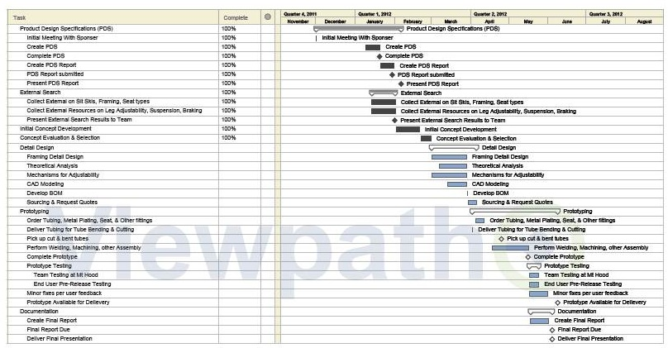

## Appendix B - Full Product Design Specifications

*** - High Priority ** - Medium Priority * - Low Priority

|  |  |  |  |  |  |  |
| --- | --- | --- | --- | --- | --- | --- |
| **Priority** | **Requirement** | **Customer** | **Metric** | **Target** | **Target Basis** | **Verification** |
| Performance | |  |  |  |  |  |
| *** | Adjustable seat back to accommodate different disabilities | Inclusive Rec. | Distance from seat top to bottom (in) | Adjusts 19in to 25in | Customer input | Prototype testing, computer modeling |
| *** | Adjustable footrest | Inclusive Rec. | Distance from base of seat back to end of footrest (in) | Adjusts 35in to 25in | Customer input | Prototype testing, computer modeling |
| *** | Adjustable seat back angle | PSU | Angle between seat back and horizontal seat bottom (°) | Adjusts 90° to 120° | Market analysis | Prototype testing, computer modeling |
| ** | Leg angle | Inclusive Rec. | Angle between anterior of thigh and shin (°) | 130° +/-15° | Customer input | Prototype testing, computer modeling |
| *** | Seat bottom angle | Inclusive Rec | Angle between seat bottom and plane containing skis (°) | 0° + 10° to 20° | Customer input | Prototype testing, computer modeling |
| ** | Orientation/angle of seat back | Inclusive Rec. | Angle from seat back to ground (°) | 90° +/-15° | Customer input | Prototype testing, computer modeling |
| ** | Seat elevated high enough off ground to accommodate ideal biomechanical motion | Inclusive Rec. | Distance from bottom of seat to ground (in) | 16-19.5 in | Customer input | Prototype testing, computer modeling |
| *** | Structurally sound | Inclusive Rec. | Yes/No | Max user weight 280lb (1.1 FS) | Customer input | Theoretical analysis |
| *** | Commercial binding compatibility | Inclusive Rec. | Yes/No | Frame mates with commercially available cross country bindings | Technology Capability | Prototype testing, computer modeling |
| *** | Torso straps accommodate range of user disabilities | Inclusive Rec | Yes/No | Straps accommodate spinal injuries at C5 to T12 | Customer input | Prototype testing, computer modeling |
| ** | Comfortable | End User | Yes/No | Users rate discomfort during use <2 on a 1-10 scale after 30 min of use | Customer input | Prototype testing, Interviews w/ end users |
| **Priority** | **Requirement** | **Customer** | **Metric** | **Target** | **Target Basis** | **Verification** |
| Size, Shape, Weight | |  |  |  |  |  |
| * | Sit ski frame weight | Inclusive Rec. | lb | <20lb | Customer input | Computer modeling |
| ** | Sit ski frame size | Inclusive Rec. | Number of persons required to transport frame | 1 | Customer input | Prototype testing |
| Safety |  |  |  |  |  |  |
| *** | No sharp edges | End User | Yes/No | Sharp edges ground or filed | Customer input | Prototype inspection |
| ** | Ease of disconnecting straps | End User | Yes/No | All straps easily disconnected with one hand | Customer input | Prototype inspection, BOM |
| ** | Braking mechanism | PSU | Yes/No | Hand actuated braking mechanism present | Market analysis | Prototype testing, computer modeling |
| * | Frame stability | PSU | lb | Frame will not tip from <50 lb horizontal force applied at highest point | Market analysis | Prototype testing, theoretical analysis |
| Maintenance | |  |  |  |  |  |
| * | Minimal tool requirements | PSU | Yes/No | Tools available in PSU shop | Market analysis | Inventory of tools in Outdoor Shop and ME Machine Shop |
| ** | Availability of wear items (straps and connectors) | PSU | Yes/No | Confirm availability of straps and connectors from multiple sources | Market analysis | BOM, vendor verification |
| Environment | | | | | | |
| *** | Material resistance to cold and wet environment | PSU | Yes/No | All materials used in construction withstand degradation from exposure to precipitation & temperatures >10OF | Market Analysis | Material specifications from vendors |
| Budget |  |  |  |  |  |  |
| *** | Cost of final product | Inclusive Rec. | $ | <$1500 | Customer input | BOM |

## Appendix C – Detailed External Search

Manufacturing and Materials

Research into bicycle frame construction was used to evaluate possible materials and manufacturing methods for the sit ski. The PSU Sit Ski Capstone Team has limited manufacturing capabilities. Any welding or other complex manufacturing process will need to be outsourced. Staying within budget constraints, and designing for the limited manufacturing capability of the team are major factors in evaluating possible materials and methods of fabrication.

The first option is to use Aluminum round tubing. It is a low-weight, high-strength material, and is used in many sit ski products. Round tubing can be easily bent to make a desired part. The frames are generally aesthetically pleasing. However, round tube frames require complex, high precision miter cuts to mate parts together for welding. These precision miters are expensive, and would have a dramatic effect on the project cost.

Aluminum square tubing has all the structural benefits of round tubing. Furthermore, only simple, straight miter cuts are required to mate structural members together. While not as aesthetically pleasing, the reduced manufacturing costs make square tubing a viable option.

A machined aluminum frame is another possible option. Aluminum is easily machined, and parts could be bolted together or attached with gussets. However, the team would need to outsource fabrication of large parts to a machine shop with the necessary CNC equipment. Billet aluminum is generally more expensive than aluminum tubing, making material costs higher with a machined aluminum frame.

Seating Options

The seat is a crucial component of the cross country sit ski. It must be structurally sound, and oriented in such a way that users can put all available core strength into forward motion. Choice of seat materials is the major factor in developing a comfortable seat. The PSU Capstone Team evaluated two possible choices for a seat: a bucket seating system and a fabric over tubing seat.

The Glove Seating System (Figure 6) would need to be purchased and integrated into the sit ski design. The seat has been developed specifically for sit skis, and would comfortably provide the necessary support. At $400 for the base model, the seat is expensive. Optional attachments increase the overall cost. Also, it does not provide the type of adjustability required by the PDS.

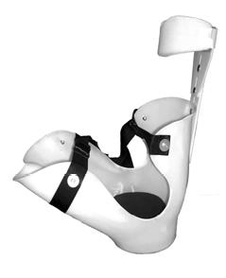

**Figure 6:** The Glove Seating System, sold by Enabling Technologies. It is used in several sit ski models [1].

A fabric seat, supported by a tubular frame, would need to be designed and fabricated by the PSU Sit Ski Capstone Team. This option would allow the team to dictate the seat’s form, articulation, how it mounts to the frame, as well has how and where the user is secured. A fabric seat would be lighter, cheaper, and more versatile than the bucket seat, with the major sacrifice being comfort.

Restraints

Vest restraint systems are available for purchase. The padded vest is comfortable. It fully secures the user to the seat back, making it ideal for quadriplegics. While the vests have some degree of adjustability, it is not a “one size fits all” product. The vest system would be undesirable for users with trunk stability, who do not want to be secured to the seat back.

Individual nylon straps are more versatile than the vest systems. They are easily adjustable, and would allow the user more configuration options to restrain various body parts.