Mt.Angel Abbey:

Library HVAC

Progress Report

Winter 2012

Team Members

Ali Al-sahaf
Ghassan Mustafa
Santiago Rodriguez
John Slate
Rasitha Wickramaratne

Portland State University Advisor

Dr. David Sailor

Executive Summary

This progress report provides evaluated and on-site experimented data as well as the design suggestions to meet the client requirements.
While choosing upgrades to the existing systems the team had to follow strict design restrictions. Changing the building aesthetics was not permitted as a result of building’s historic value. As a result of this any modifications to the existing glazing, overhangs, or roof/wall construction were not acceptable. The design restrictions led the team to consider mechanical systems and electrical controls to help improve library’s indoor environment. The team has considered a chiller, a dehumidifier, variable air volume boxes (VAV), and zonal control systems as a result of their cost effectiveness and ease of upgrades.
Even though the complete design report has not been produced yet, multiple building energy models from e-Quest have generated. By using the on-site tests and further research, it is team’s strategy to calibrate the e-Quest model and generate the best energy model possible. From this necessary equipment sizing and recommendations will be finalized.

CONTENTS
Executive Summary 1
Introduction 3
Mission Statement 3
Updated Project Plan 4
Product Design Specification Summary 5
External Search 5
Internal Search 7
Top-level Design Evaluation 9
Conclusions 13
References 14
Appendices 15

Introduction

Ms. Victoria Ertelt, the Mt.Angel Abbey library administrator first approached the Capstone class in early September 2011 to introduce her project. During the initial presentation, Ms.Ertelt described the project background and her expectations from the Capstone team. Since late September, the team has had meetings with the client to identify the direction of the project scope.
Mt. Angel Abbey library was built in 1970. It is a 44,000 square-foot three-story library with an undersized HVAC system. As a result, the thermal comfort in the overall library is significantly affected. The library holds over 5000 rare books and antiquities, and is a resource—both architecturally and educationally--for a number of students and visitors. The Capstone team has been tasked with evaluating the current HVAC system and recommending modifications to meet the desired thermal comfort levels that will make the library a more enjoyable environment for occupants and improve storage conditions for the books.

Mission Statement

The objective of this Capstone project is to model an efficient HVAC system for the Mt Angel Library. The team will design a cost effective system that will maintain a desired temperature and humidity for the safe storage of the valuable collection of books in the library. The team will also select a monitoring system for a vault that has temperature/humidity sensitive materials. Data loggers collect temperature, humidity, and light intensity information to calibrate the model for an effective system. The team will utilize the computer-aided simulations using e-Quest, EnergyPlus, and AutoCAD to verify the project goals.

Updated Project Plan
The dates in the table below are goals and deadlines for the project completion. Due dates are tentative and subject to change depending on project requirements.

Project Milestones
Task | Start Date | Finish Date | Due Date
Initial Brainstorming | Sept 26 | Sept 30
Research | Oct 1 | Dec 26
Data Collection (Data Loggers) | Jan 16 | May 11
Current Model Evaluation | Jan 23 | Feb 3
PDS Report | Jan 18 | Jan 30 | Jan 30
PDS Report Presentation | Jan 26 | Feb 5 | Feb 6
Design Evaluation | Feb 4 | March 24
Design (Modeling) | Feb 5 | March 31
Progress Report | Feb 27 | March 12 | March 12
Progress Report Presentation | Feb 27 | March 4 | March 5
Computer-aided Simulation | Feb 5 | April 11
Finalize/ Final Report | April 11 | May 31

- See Appendix A for the calendar.

Product Design Specification Summary

The major client requirements
- Design a system to maintain thermal comfort of the library.
- Air-conditioning unit.
- Humidity and temperature monitoring system in the rare-book
rooms.
- Bid-ready report from the team.

The minor client requirements
- Recommendation of an electricity monitoring unit and a natural gas
monitoring unit for the library.
- Low lifecycle cost.
- Low energy cost.

The major/minor ASHRAE requirements
Major:
- ASHRAE standard 55-2004, Thermal comfort for occupants
- ASHRAE standard 62.1-2004, Ventilation and indoor air quality
- ASHRAE requirements for preservation of public collections ( library specific standard)
Minor
- System needs to generate less than 40 Decibels of background noise

External Search

The external search for this project began with an investigation into mechanical system retrofits of older buildings. The overall approach was studied as well as the type of equipment used to upgrade older systems. Additionally, research was done to determine the equipment necessary to add cooling to the building.
The research into retrofits led to an analysis of the annual energy use of the library as a means of comparing its current performance. The library’s energy use for the 2011 calendar year was studied to determine the current energy demands of the building. This was used to generate an EUI (Energy Usage Index). As the use of electricity and natural gas are metered for the Mt. Angel Abbey as a whole, the percentage assigned to the library is an arbitrary value based on square footage. To gauge the accuracy of the library’s energy use, a comparable building model from the Commercial Buildings Energy Consumption Survey (CBECS) was chosen. This model was based on a public assembly building from a similar climate, of a similar size and without cooling. These values are shown below:
 | EUI (kBtu/ft²)
Mt Angel Library | 131
CBECS Model[1] | 143
Figure 1.This comparison gives an idea of the energy use of the library.
This range of EUI’s gave us a target EUI for use in determining the accuracy of our
E-Quest energy model.

The last component of our external search focused on the standards that dictate HVAC in commercial buildings. These standards include thermal comfort, ventilation and indoor air quality.
Thermal comfort is prescribed by ASHRAE Standard 55-2004 which accounts for metabolic rate, clothing insulation, air temperature and speed, radiant temperature and humidity. This standard ensures that 80% of the occupants wearing seasonally appropriate clothing and doing sedentary activities will be comfortable at any given time. This standard dictates a temperature range of 68-76 °F at 50% relative humidity.
Ventilation and indoor air quality is prescribed by ASHRAE Standard 62.1-2004 and 2009 Oregon Mechanical Code. These standards ensure that breathing air is safe from excessive levels of chemical, biological and physical contaminants, moisture and mold, CO₂ and other factors that affect human respiratory health. ASHRAE mandates a minimum mechanical ventilation rate of 17 CFM/ person for any room in a commercial building.
There are additional requirements to consider for preservation of books and other physical materials. These standards for public access collections in ASHRAE Applications Chapter 23 do not conflict with thermal comfort but place a greater emphasis on the acceptable ranges for temperature and humidity set points (See Appendix B) To maximize the lifespan of the collection, set points for relative humidity and temperature are typically 50% and 70 °F respectively. Humidity fluctuation should be no more than ±10%, and temperature no more than ± 9 °F for a type B class of control. This allows for set points to change slightly from one season to another (See Appendix).

Internal Search

The technical issue of this project is basically thermal discomfort in different zones of the library. This discomfort is due to the inconsistency of the temperature and humidity values in the zones. Moreover, the library’s HVAC system does not contain any cooling system.
Therefore, taking into consideration the requirements discussed in the external search and the PDS report, (i.e. thermal comfort determined by ASHRAE Standard 55-2004), the internal search concentrated on putting forward a solution for the problem, primarily by designing a retrofit to the current mechanical system.
The proposed design will include several devices including sizing and locations of installation. The recommended devices are a dehumidifier, a chiller, a VAV box and a zonal control system.
A dehumidifier is an appliance that reduces the humidity in the air. This device is recommended since a main cause of thermal discomfort in the library is the fluctuation of humidity levels (as shown in Appendix B).
Due to the lack of cooling in the building, the installation of a chiller is also suggested. A chiller removes heat from a liquid via a vapor-compression or absorption refrigeration cycle. Water is usually used which is distributed to heat exchangers or coils, cools the supply air and is then re-circulated back to the chiller to be cooled again.
In addition, a variable air volume (VAV) box is advocated, as it is an efficient, cost-effective expedient to control temperature in different zones. A VAV box is a quality-calibrated air damper with an automatic actuator that controls the flow rate of air in different zones to maintain the desired set point temperature. Consequently, the energy consumed by fans can be reduced with the use of a VAV.
The installation of zonal control devices such as thermostats and occupancy sensors will be advised to help maintain the desired temperature values and conserve energy. Currently, the library has no zone control system in place other than for the “rare book rooms” which have their own individual mechanical systems.
As an additional means of improving the thermal comfort and environmental conditions of the library, the placement of insulation and sealant in some locations of the building will be suggested. Thermal images of the building show thermal leakage in some walls, doors and windows.
Determining the sizing and installation locations of the recommended retofit devices requires an understanding of the energy use of the library. To accomplish this, an energy simulation model is being constructed (using E-Quest) to be able to evaluate and analyze the building’s energy use and to estimate the heating and cooling loads of the building.

Top-level Design Evaluation

Criteria | Recommended Equipment
Criteria | Dehumidifier | Chiller | VAV Box w/ reheat coil | Variable Speed Drive(VFD) | Zone System Controls | Insulation
Cost | 4 | 2 | 5 | 6 | 6 | 10
Performance | 10 | 10 | 10 | 10 | 8 | 7
Thermal Comfort | 7 | 10 | 8 | 8 | 8 | 5
Book Preservation | 10 | 10 | 6 | 6 | 5 | 5
Total | 31 | 32 | 29 | 30 | 27 | 27
Figure 2. Design decision matrix: each component is ranked on a scale of 1 to 10 (lowest to highest influence) with respect to each criteria.
Cooling Requirement
The primary concern with the current system is that there is no space cooling mechanism available. Initial simulations indicated a requirement of 1.8 MBTU/h during peak loading hours. This capacity requirement suggests that a 150-ton air-cooled water chiller would be the best choice. This is only a rough estimate and assessment, because future simulation may indicate a slightly different size is needed. (see Appendix C)

Humidity analysis
To evaluate the current state of thermal comfort, the team placed five temperature and relative humidity sensors in the Mt. Angel Abbey library. After an initial collection of data, it was observed that the temperature was steady but the relative humidity was fluctuating with a range of 25% in some zones. ASHRAE Fundamentals equation 1.32 tells the specific enthalpy value of the ambient air as a function of temperature and relative humidity. We compare the enthalpy values to the specific enthalpy of comfortable air to see the deviation from thermal comfort (see Figure 1). Fluctuations are not large on an hourly basis, which suggests that the discomfort is not entirely from the heating load on the library. Rather, it is dependent on the humidity of the outside environment. ASHRAE Fundamentals Appendix of design conditions indicates that design humidity ratio is 77.4%, which is 27.4% more than the comfortable ratio at 72 °F. To better control the ambient humidity the recommendations is to install a central dehumidifier for the system.

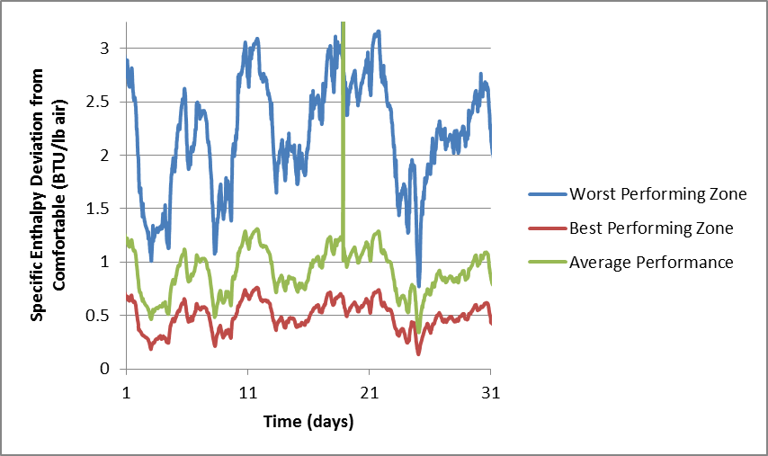
Figure 3: Average deviation from comfortable specific enthalphy of air in heating mode for all sampled zones in the library over a 40 day period. Includes the auditorium, catalog room, reading area, study carrel, and downstairs stacks.
Ventilation
Flow hood tests in problem areas indicated that some supply air and return ducts are underperforming by a minimum of 48% (see Table 2) and up to79 % (see Table 1). Additionally, tracer gas decay tests performed in problem areas revealed deficient mechanical ventilation. Figure 4 shows test results for the guest carrel which has adequate ventilation and the auditorium which has return vents that are not functioning. Ventilation can be improved by repairing the dampers in the ducting. The ducting system has not been serviced since installation, so another recommendation is to have a strict schedule to maintain the system.

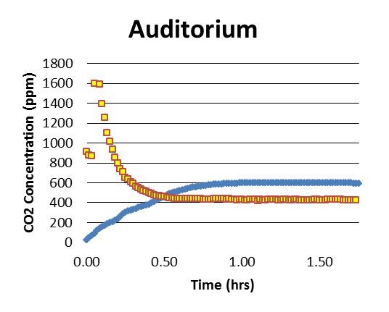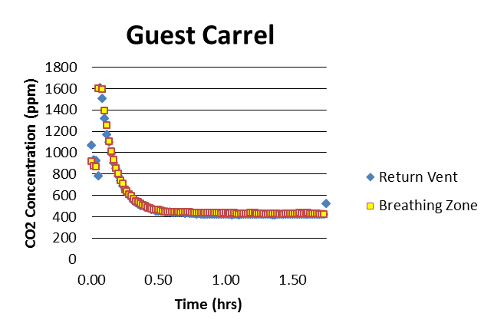
Figure 4. Results of tracer gas test for Auditorium (left) and Guest Carrel (right).

VAV (variable air volume) systems with zone reheat and separate operating points will be helpful in having multiple zones at desired temperatures and will improve the efficiency of the system. During seasons requiring heating, the supply fan will supply air to the individual VAV boxes in multiple zones and the VAV boxes will control the flow as needed to heat the space. When heating is needed, the VAV boxes will reduce flow rate to a minimum and use the reheat coil to control discharge temperature.

Catalog Room | Designed Flow (CFM) | Measured Flow (CFM)_{avg}
Supply 1 | 390 | 167
Supply 2 | 870 | 215
Supply 3 | 390 | 187
Return | 1500 | 309

Guest Carrel | Designed Flow (CFM) | Measured Flow (CFM)_{avg}
Supply | 130 | 69
Return | 130 | 68
Tables 1&2: desired performance of ducting compared to the onsite measurements of performance

Unexpected loads:
Problems in the comfort in certain zones result from unexpected thermal loads. In the temperature and humidity controlled book repair room, thermal control is difficult. Infrared images of the wall and door shared with the adjacent boiler room (see Figure 5) suggest that a large uncontrolled heat load is responsible. To control this problem, additional wall insulation, weather stripping on the door frame, and switching to an insulated door with thermal breaks will reduce the thermal gains in this space and others near heat producing zones. From infrared images of the window frames in the building, it is clear that there is some leakage through the window sashes. The image (see Figure 6) shows the leaks coming from the outside of the frame. A simple solution is to properly seal the fenestration from both the inside and outside of the envelope.

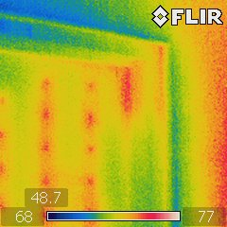
Figure 5. Thermal image of door to boiler room.

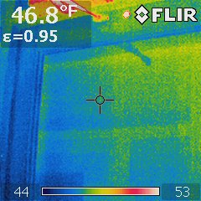

Figure 6. Thermal image of exterior window.

Conclusions

The recommendations for the system each have a different overall value for the thermal comfort of the library occupants and the goal of providing an increased lifespan for the books in the main stacks. These are all weighted in the design evaluation matrix (see Figure 2). At first glance, the chiller is the most critical element to improving thermal comfort. Although the chiller is the most obvious, the dehumidifier is also a crucial component to deal with thermal comfort problems in winter and to increase the lifespan of the collection. The VAV box will improve the ability of the system to compensate for discomfort in individual zones with minimal changes to the ducting plan as a whole. Changes to the envelope are purely to decrease the thermal loads in some zones in order to reduce the energy requirement for the HVAC. The next step for this project is to run more fine tuned simulations with these elements in mind. Simulations will provide a comparison between the system in its current state, and with the recommended modifications. The size and location of the suggested mechanical components also need further investigation.

References
2009 ASHRAE Handbook Fundamentals. Atlanta, GA: American Society of Heating, Refrigeration and Air-Conditioning Engineers, 2009.

Principles of Heating, Ventilating and Air Conditioning. 6th Edition. Atlanta, GA: American Society of Heating, Refrigeration and Air-Conditioning Engineers, 2009.

U.S Energy Information Administration. Buildings Energy Data Book: 2003. Accessed February 2012. http://buildingsdatabook.eren.doe.gov/CBECS.aspx

Appendices

Appendix A :

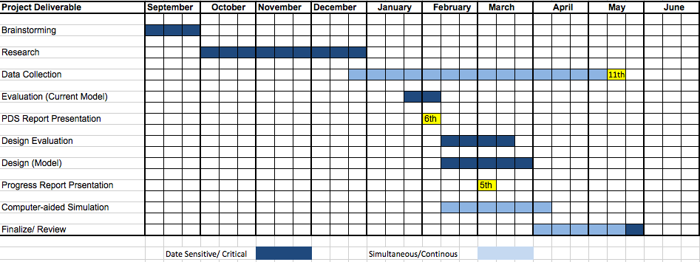

Appendix B :

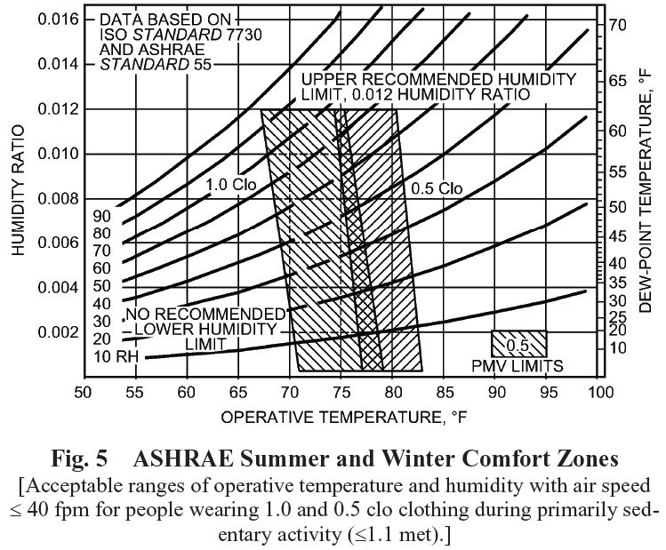

Appendix C :

