**ME 492: Progress Report I**

**Daimler Wind Tunnel Smoke Controller**

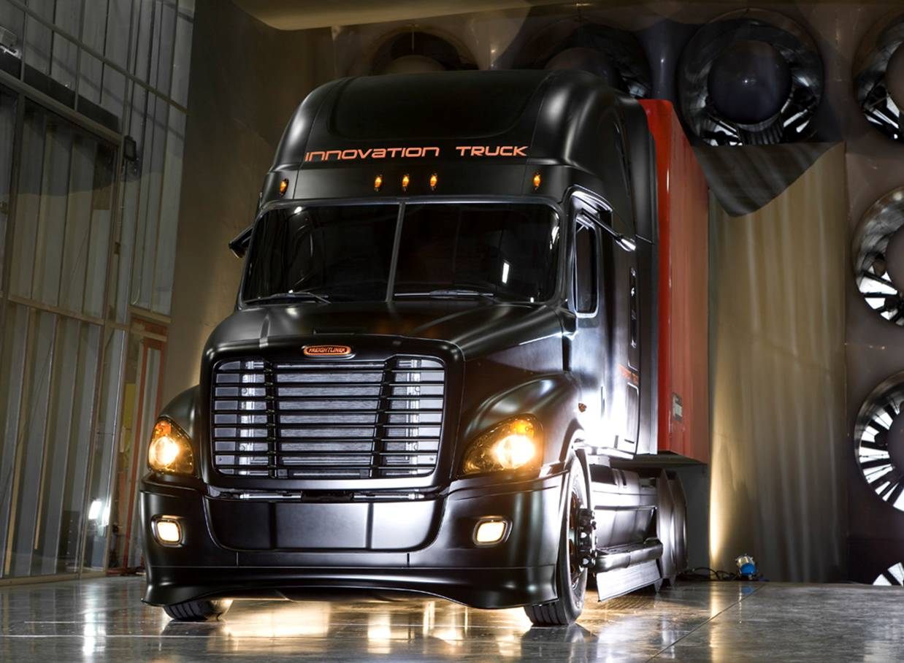

(Daimler-TrucksNorthAmerica.com)

**Sponsoring Company:** Daimler Trucks North America

**Contact Engineer:** Matt Markstaller

Product Validation

(503) 745-6857

5160 N. Lagoon Ave.

Portland, OR 97217

**Team Members:** Fadel Al Jutail

Chris Grewell

Craig Lechtenberg

Matt Melius

Andreas Nylund

Mufeed Yacoub

**Academic Advisor:** Dr Raùl Bayoàn Cal

Table of Contents

Introduction 3

Mission Statement 4

Project Plan 5

PDS Summary 6

External Search 7

Internal Search 8

Top Level Final Design Evaluation 11

Progress on Detailed Design 12

Conclusion 15

References 17

Appendix A: Product Design Specifications 18

Appendix B: Component Analysis of the Wand Support Roller Box 19

Appendix C: Component Analysis of the Horizontal Carriage 21

Appendix D: Component Analysis of the Smoke Wand 23

# Introduction

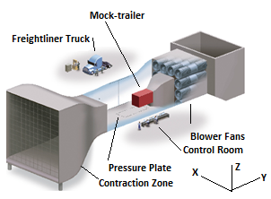In 2004, Daimler Trucks North America constructed an open loop wind tunnel in Portland, OR to test the aerodynamics of their medium and heavy-duty trucks. The wind tunnel’s test section, which is 26*ft* wide, 21*ft* tall, and 30*ft* long, is built to accommodate a full sized Freightliner cab as shown in Fig. 1. Prior to testing, the truck cab is parked in the tunnel and is connected to a permanently installed mock-trailer. During testing, air is drawn into the contraction zone by 10, 250*hp* industrial blower fans where it accelerates to velocities of up to 65*mph* and forms a nearly uniform velocity profile [1]. The force exerted on the truck by the incoming airflow is tested with pressure sensors in the floor, which aid in determining the overall drag coefficient of the truck.

Figure 1: Rendered view of the Daimler wind tunnel (Anne Saker, The Oregonian).

In addition to measuring drag forces, Daimler uses smoke visualization techniques to analyze flow characteristics such as boundary layer separation points. The smoke is generated and piped to a manual smoke wand that discharges fluid tracking particles 2*ft* upwind of the desired region of the truck. Areas with undesirable separation points are identified and adjustments to the truck’s external design are made to lower the overall drag coefficient and ultimately improve the fuel economy of their medium and heavy-duty trucks (Fig. 2).

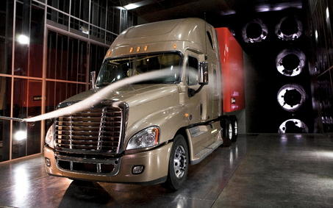Daimler has identified three major limitations of their current smoke testing system for our capstone team to improve. First, their smoke wand is 15*ft* long which restricts the range of the testable area, highlighted by Fig.3. The second issue is the inability to consistently repeat tests on areas of interest because of the manual positioning of the smoke wand. Lastly, the smoke wand deflects over 5*in* under its own weight and oscillates under wind loading leading to unacceptable levels of inaccuracy. Daimler has requested that our capstone team design an improved system that eliminates these problems with their smoke testing system.

Figure 2: Smoke testing at the Daimler wind tunnel (Ross William Hamilton, The Oregonian)

# 

**Figure 3: Illustration of Limited Smoke Wand Range with Daimler’s current smoke system.**

# Mission Statement

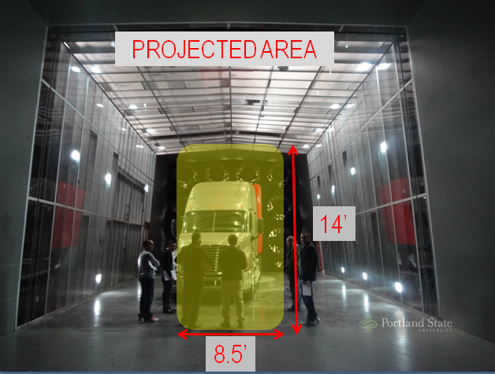Currently, Daimler is using a manual smoke testing system for their visual aerodynamic analysis and they would like to implement an automated system. The purpose of this project is to replace the current method of manual smoke wand placement with an electronically controlled system capable of traversing the projected face of a typical Freightliner medium and heavy-duty truck, 8.5*ft* by 14*ft* (Fig. 4). The system will also discharge smoke at desired locations while maintaining a minimal flow disturbance of the testing region. The goal of the capstone team is to produce all fabrication, installation, and operation documentation to Daimler by the end of the spring term which concludes on June 16th, 2012.

Figure 4: The projected area of the largest truck Daimler tests at their wind tunnel.

# Project Plan

Table 1 illustrates tentative dates and major milestones of the Daimler Wind Tunnel Smoke Controller project. The dates given are subject to change based on the needs of the customer, unforeseen complications, or design changes. A more detailed project schedule can be seen in Table 2.

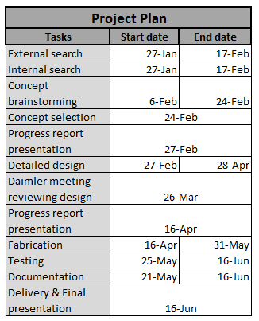

Table 1: Project plan milestones

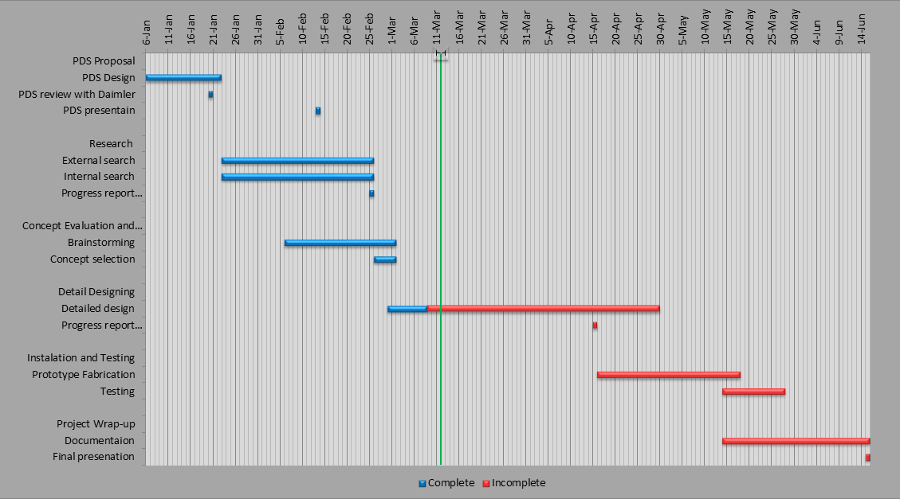

Table 2: Gantt chart showing the project progress as of March 7th, 2012.

# PDS Summary

A PDS was created and completed January 30th. It established what the final product is intended to do by fully defining its end user requirements (specifications). The specifications consist of the priority of importance, metric, target, basis, and a means to verify the specification. Table 3 shows the high priority product requirements. For the medium, low and not applicable requirements see Appendix A.

# 

Table 3: The high priority PDS criteria including the metrics and targets associated with the five criteria requirements.

# External Search

The external search presented numerous solutions for traversing a wind tunnel. Many systems are available for locating pressure probes downstream of the test subject (Fig. 5). Although these systems cannot be directly used for upstream smoke delivery, the individual traversing and locating components can be applied to the Daimler controller.

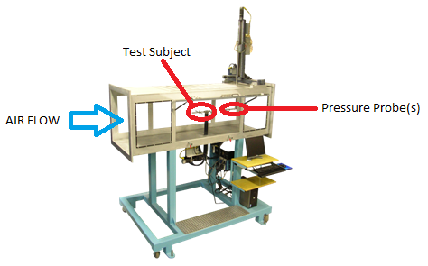

Figure 5: Typical wind tunnel testing system with a downstream testing probe

(http://www.aerolab.com)

Three downstream traversing systems applicable to our project are as follows:

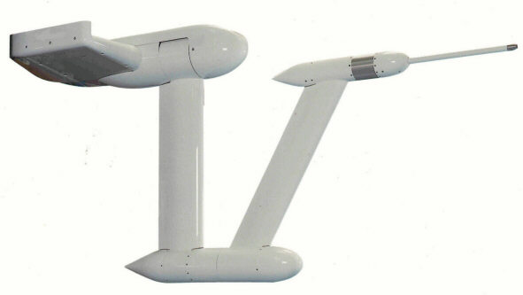**1) Roof mounted traversing system (Fig. 6):** This system allows for multiple probe attachments with integrated wiring. Modifying for smoke delivery is challenging due to multiple rotating joints and size limitations. At full extension, the traversing area is semi-circular, which would not cover the area required by DTNA.

**- Specifications:** The system can traverse a 3m x 4m x 6m volume with a +- 1mm positional accuracy while creating only a 3% blockage of the wind tunnel.

Figure 6: Roof mounted traversing probe with a pressure probe for downstream testing. (http://www.quadratec-ltd.co.uk)

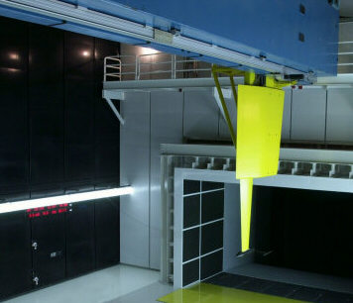**2) Roof mounted traversing system (Fig. 7)**: This system is used in an automotive acoustic wind tunnel. The large structural members are permanently affixed inside the wind tunnel to obtain the stiffness requirements necessary for a critical 1st mode frequency greater than 12*Hz* to prevent vibration during testing. Direct application of this system would be extremely difficult due to the support structure size.

**- Specifications**: The traversing system positions a range of aerodynamic and acoustic probes (with a mass up to 25kg) to an accuracy of 1.5*mm* in a working volume of 5*m* x 12*m* x 13*m*. Maximum traversing speed is 600*mm/s* and the entire assembly, nearly 20 tons, is hung from the roof of the wind tunnel.

Figure 7: Downstream probe used in an automotive acoustic wind tunnel (http://www.quadratec-ltd.co.uk)

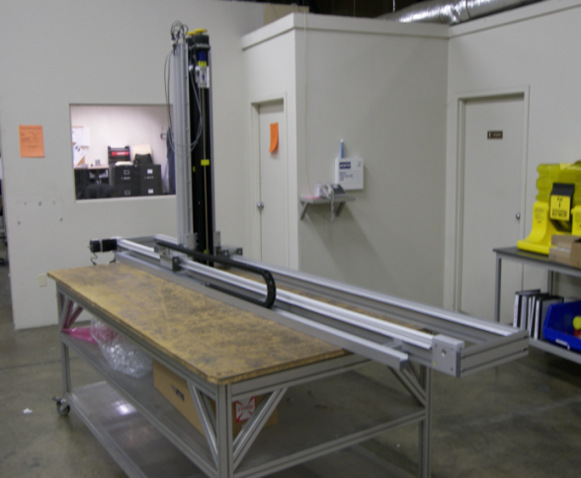

**3) Floor mounted traversing system (Fig.8):** Floor tracks must be permanently installed inside the wind tunnel and profile of the linear actuator would need modification to reduce effects of obstruction/ air turbulence.

**- Specifications**: The traversing volume is dictated by the floor rail length and the height of the vertical linear actuator. Motion is controlled via stepper motors and the carriage is belt driven.

Figure 8: A typical floor mount x-z traversing system with linear actuators (http://www.velmex.com)

# Internal Search

Without finding any traversing systems that meet the requirements for this project, several motion components were identified in the external search as integral pieces to meeting the PDS requirements. Components such as linear tracks, stepper motors and actuators were researched and implemented into the concept designs. After many design iterations the three main concepts are:

**1) Vertical Single Support (Fig. 9):** A vertically mounted linear actuator moves the smoke wand in the z-direction. The actuator is supported by two horizontal floor rails providing cross-stream motion (x-direction). The floor rails are located below the floor of the wind tunnel minimizing the effect on the boundary layer, and the vertical actuator is housed in a fairing. To store the system outside of the tunnel when not is use the side wall would have to be cut and modified.

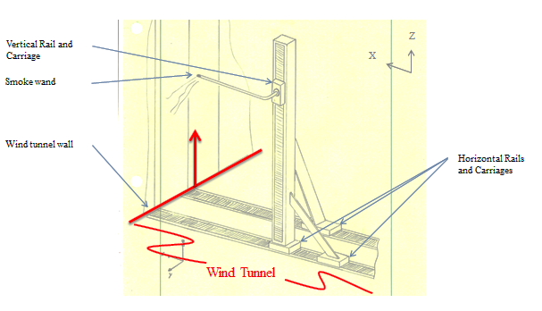

Figure 9: The Vertical Single Support concept design.

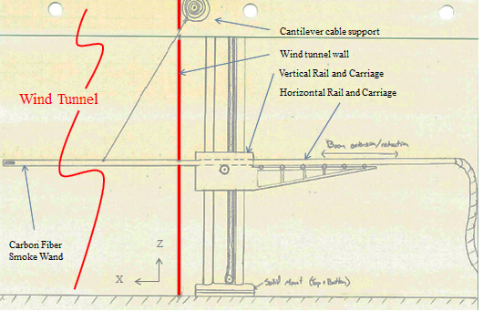**2) Cantilever (Fig. 10)**: A carbon fiber smoke wand is driven by a horizontally mounted linear actuator and extends from the side of the test section. Vertical rails allow for vertical motion while the extension and retraction of the wand provides horizontal motion. To limit the negative effects of vibration/oscillation, the smoke wand support needs to be rigid. Only one side of the tunnel would have to be modified and the main structure of this system would remain outside the wind tunnel, minimizing blockage effects and turbulence.

Figure 10: The Cantilever concept design.

**2) Vertical Dual Support (Fig.11):** Similar to the previous design, a vertical linear actuator moves the smoke wand in the z-direction and rides on a horizontal rail in the floor. An extra ceiling mounted rail is used to support both ends of the actuator to provide extra rigidity to the system, requiring additional structural members above the wind tunnel ceiling. For full retraction of the smoke system, the ceiling and sidewall of the tunnel would have to be cut and modified.

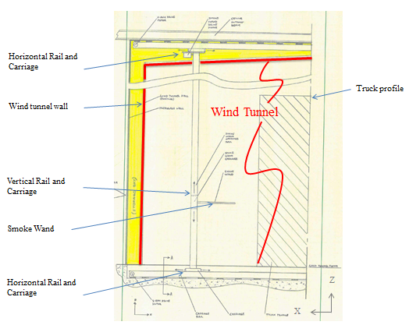

Figure 11: The Vertical Dual Support concept design.

# Top Level Final Design Evaluation

The three concept selections created from the internal search were evaluated in a Concept Scoring Matrix (Table 4) based upon their performance characteristics from the PDS (Table 1). The criteria for each concept was from 1 to 5, 1 being the lowest, and multiplied by a weight factor.

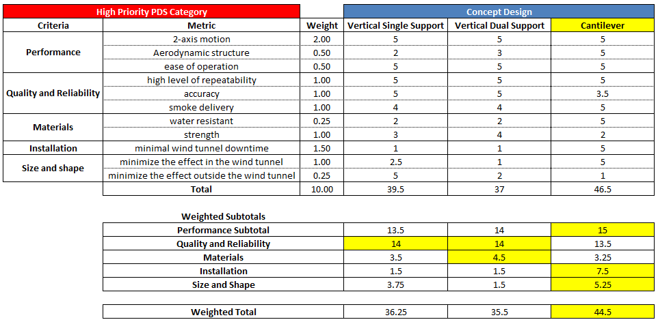

Table 4: Concept Scoring Matrix with the high priority PDS category criteria scored and weighted.

**Performance:** Although the traversing method is slightly different for the three designs, all of them are able to traverse the 340*ft2* cross section required by Daimler. However, each of them accomplishes this with a slightly different aerodynamic impact. The vertical single support requires the largest cross-stream profile to support the vertical linear actuator, the vertical dual support has a smaller cross-stream profile, however the cantilever out ranks them all with its relatively thin airfoil smoke wand support. Another advantage of the cantilever design is that the horizontal orientation disrupts the air stream at a single point in the plane of interest (x-z) unlike the vertical designs that disrupt the steam continuously in the z-direction. Operating each of the three designs will require the same control system.

**Quality and Reliability:** The ability to repeat movements and locations consistently is the same for the three designs as each design uses the same type of linear actuators. However, the wand tip accuracy of the cantilever design suffers more than the other designs because of the deflection of the unsupported wand due to gravity and wind loading when it is in operation. Also, the vertical and horizontal inaccuracy will vary depending upon the length of the wand extended into the wind tunnel making a precise prediction of the tip accuracy more difficult. The smoke delivery to the cantilever system is not as difficult to implement into the design when compared to the vertical designs that require a smoke hose reel system to lengthen and retract the hose during operation.

**Materials:** The cantilever design is more resilient to Daimler’s rain testing because the majority of the wear components are located outside of the tunnel. The vertical designs require an x-direction rail to be mounted on or below the wind tunnel floor and subjected to the rain testing. The cantilever design eliminates the need to use water resistant components, but it requires materials that can properly support the smoke wand 20*ft* into the tunnel. Because of this the components will experience more stress and the smoke wand itself will fatigue over time and will eventually need to be replaced. Similarly, the vertical single support design will fatigue faster when compared to the vertical dual support from the cyclical wind loading on the vertical rail, requiring more robust materials and components.

**Installation:** Maintaining the operation of the wind tunnel during installation is a primary concern for Daimler as they cannot afford long or short periods of downtime. The cantilever requires a 4-8 *in* slot in the wind tunnel wall to allow the wand to protrude into the tunnel during testing. In comparison, the vertical designs require cutting into the tunnel floor to mount a linear actuator, supplying a drainage system to accommodate rain testing, and modifying the tunnel wall and or roof to store the structure when not in use. Thus, the cantilever design received the highest score for the installation criteria.

**Size and Shape:** During drag testing the smoke system is not used and has to be stored flush to the wind tunnel wall. In its stored location, it is crucial the system does not affect the drag testing results as any alteration to the floor, walls, or ceiling will change the boundary layer characteristics in the wind tunnel. The vertical dual support was rated the lowest for this criteria. The vertical single support is slightly better as the ceiling does not need to be altered, but the cantilever system is the optimal design because of its low impact when not in use.

# Progress on Detailed Design

Among the three concept designs, the cantilever was selected with the guidance of Daimler based upon the five high priority PDS categories: performance, quality and reliability, materials, installation and size/shape (Fig. 12). Of the five criteria, it ranked the highest in performance, installation and size/shape out of the three concepts.

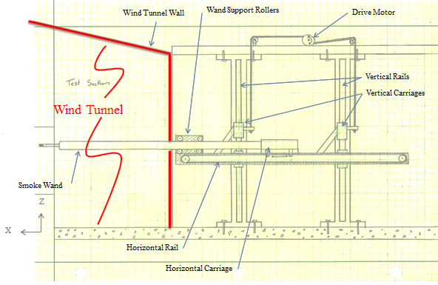

Figure 12: The Cantilever design was chosen as the best design and was slightly modified from the concept design to include two vertical rails and carriages.

**Cantilever Design Calculations**

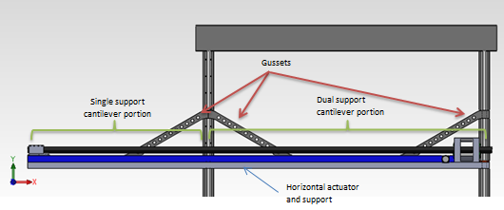The horizontal linear actuator will undergo defection in between the vertical support rails of the structure (Figs. 13 and 14). Deflection will cause the carriage of the horizontal actuator to bind. The purpose of this analysis is to perform maximum beam defection calculations on the horizontal assuming no supporting gussets are in place. These defection values will be compared to the maximum acceptable defections specified by the linear actuator manufacturer (to be determined) to validate this portion of the design. The resulting maximum defections were 0.0146*in* and 0.0046*in* for the dual support cantilever and single supported cantilever, respectively (Appendix C). These values will be used with the manufacturer’s max defection specifications in deciding proper linear actuator for application.

Figure 13: The SolidWorks drawing of the cantilever design shown with support gussets, the horizontal actuator, horizontal carriage, and the carbon fiber

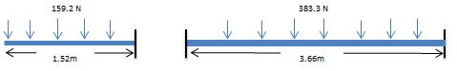

Figure 14: Detail of the distributed loads acting on the horizontal actuator

Figure 15 illustrates the initial concept of the tube support carriage shown with the reaction loading on the tube support carriage rollers. This information will be used to size the rollers and support structure. The analysis was performed at the maximum predictable loading. The resultant maximum radial load for any one of the support rollers is $796.2{lb}_{f} at 45°$ (Appendix B). The rollers will need to be sized accordingly.

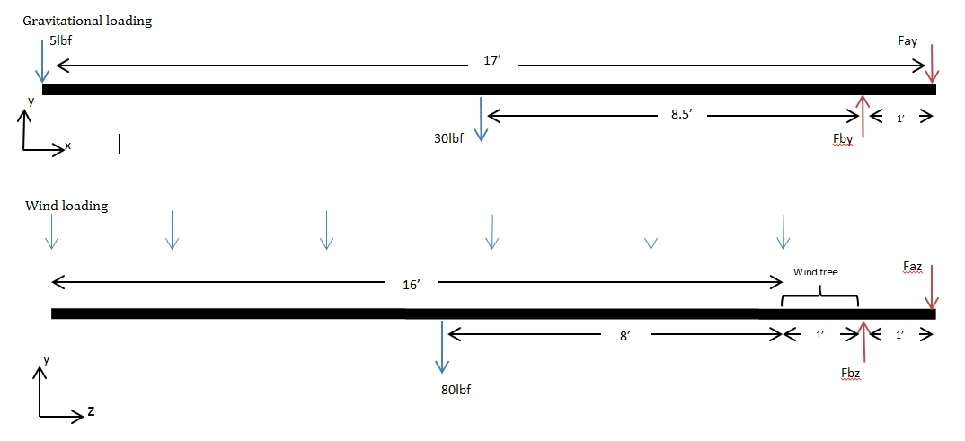

Figure 15: The reaction forces on the support rollers

An idealized analysis of the carbon fiber tube was performed in order to determine the deflection and vibration characteristics. The wand was analyzed as idealized due to the complexity of a composite finite element analysis, which is beyond the capabilities of the capstone team. Thus, a typical modulus of elasticity and density value for an isotropic tube with a unidirectional layup (axial) composed of T300 fibers were used in the analysis. Under wind loading, the wand does not deflect in the stream-wise direction by more than 1*in*. As a cylinder, the smoke wand deflects under its own weight by more than 1 *in*, unless it is larger than 4.5*in* in diameter. Vibration analysis was conducted to predict the forcing frequency on the wand caused by vortex shedding. Vortex shedding will occur at 1-6*Hz* for outer diameters of 1.5-6*in* while exposed to 30*mph* winds, causing the wand to vibrate at those frequencies (Appendix D). By altering the cross-section to make the wand more aerodynamic, the vortex shedding frequency will rise and drag forces decrease. However, a reduction in the cross-sectional area will reduce the moment of inertia and cause an increase in deflection. A solution will be to create lift through the aerodynamic shape, thus mitigating the negative deflections caused by the weight of the wand and reduce the effect of vortex shedding.

**Component Selection**

The cantilever design assembly is categorized into two sections; mechanical and structural components. Each selection was based upon the calculations performed above.

**Mechanical**

* Horizontal Actuator System: PBC Linear: MT Series MTB80 Belt Driven Linear Actuator without stepper motor. 3.15*in* x 3.15*in* x 236.22*in*
* Vertical Actuator System: Thompson: 2DA Dual rail shaft with integrated carriage
* Lifting motor: possibly a stepper motor winch, DC or AC motor

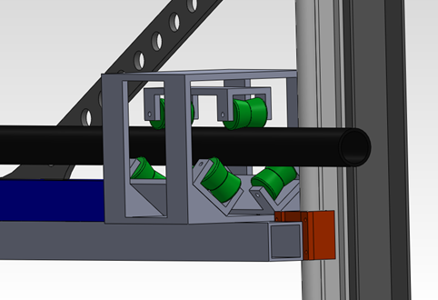**Structural**

* Vertical Supports: W10x22 Steel I-beam with 1 *in* thick baseplate, vertical rail mounts, and horizontal I-beam mounting plate
* Horizontal Actuator Support: 4*in* x 4*in* x 0.25*in* x 8*ft* long steel box tubing with horizontal actuator and Roller Support Box mounts and struts
* Roller Support Box: see Fig. 16 (TBD)
* Smoke wand: Forte Carbon Fiber Products sail mast tube 18*ft* long

Figure 16: SolidWorks drawing of the roller box.

# Conclusion

At this point the PDS, internal and external search, concept brainstorming and concept selection have been completed. The concept selected by Daimler is the cantilevered smoke delivery system. They selected this system because it provided most of their design requirements, while having the least installation impact on the tunnel. The team is now in the detailed design portion of the project. Major components such as the horizontal actuator, vertical linear support rail, and “I” beam support structure have been selected. A SolidWorks model of the cantilever system has been created using the aforementioned parts (Fig. 16). Effort is now being focused on designing the roller box and selecting the profile for the carbon fiber tube.

Daimler has expressed concerns about the pace of the project and has requested that the team dedicate the remainder of the capstone experience into more design revisions. Ultimately, the capstone team will deliver detailed design plans and specifications with minimal fabrication. Due to this and the concept chosen by Daimler, changes to the PDS and missions statement are required. The “accuracy ±0.5*in*” specification is to be omitted from the PDS due to unknowns associated with the behavior of a cantilevered carbon fiber tube under wind loading. The complex properties of composites make a finite element analysis of the purposed smoke wand unreliable with our level of knowledge. Thus, the accuracy of smoke delivery will not be verifiable until the system is installed. Also, the team’s mission statement will no longer include fabrication and installation of the system.

Going forward, the capstone team will focus its efforts in two directions, furthering the detailed design portion of the complete system, and designing fabricating and testing one part of the system. The complete system will be designed conceptually and tested analytically. The team and Daimler have tentatively agreed on the roller block as the part to be fabricated. A proposal will be submitted to Daimler, detailing the team’s intention in regards to the completion of the roller block. Upon their approval, the roller block will be fabricated and tested to verify the design. The team feels it is on track to complete the project on time.

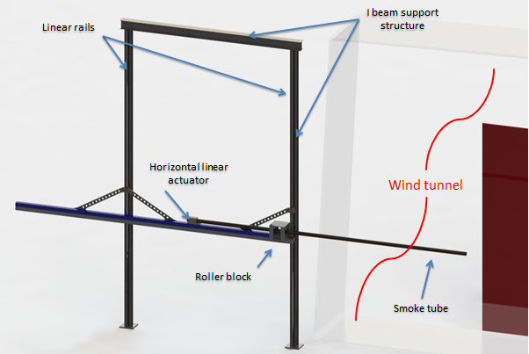

Figure 17: SolidWorks drawing of the cantilever design with the horizontal linear actuator, vertical rails, carbon fiber smoke wand, roller box, horizontal actuator support gussets and the support structure shown with the wind tunnel.

# References

1. Saker, Anne. "Swan Island Wind Tunnel Puts Big Rigs to the Test." Oregon Local News, Breaking News, Sports & Weather. The Oregonian, 28 Dec. 2008/. Web. 18 Feb. 2012. <http://www.oregonlive.com/news/index.ssf/2008/12/wind_tunnel.html>.
2. "Daimler Trucks North America North America's Leading Manufacturer of Commercial Trucks." Daimler Trucks North America LLC North America's Leading Manufacturer of Commercial Trucks. Web. 20 Jan. 2012. <http://www.daimler-trucksnorthamerica.com/news/mediaroom/resources/image-gallery-facilities.aspx>.

# **Appendix A**: Product Design Specifications

The medium priority, low priority, and not applicable criteria can be seen in Table 5.

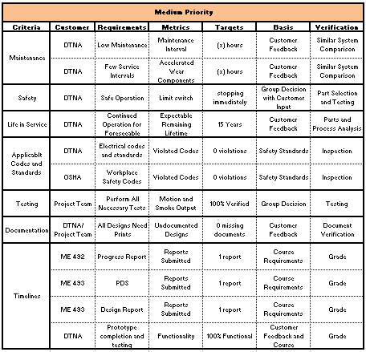

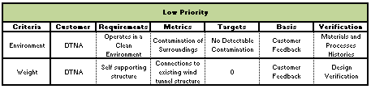

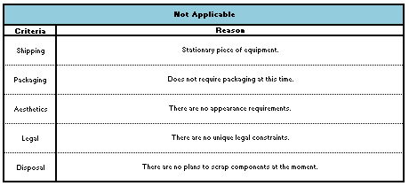

Table 5: The medium priority, low priority, and not applicable PDS criteria

# **Appendix B**: Component Analysis of the Wand Support Roller Box

Analyst: Chris Grewell

Date: 2-26-2012

**Summary:** To determine the reaction loading on the tube support carriage rollers. This information will be used to size the rollers and support structure. Figure 16 illustrate the initial concept of the tube support carriage.

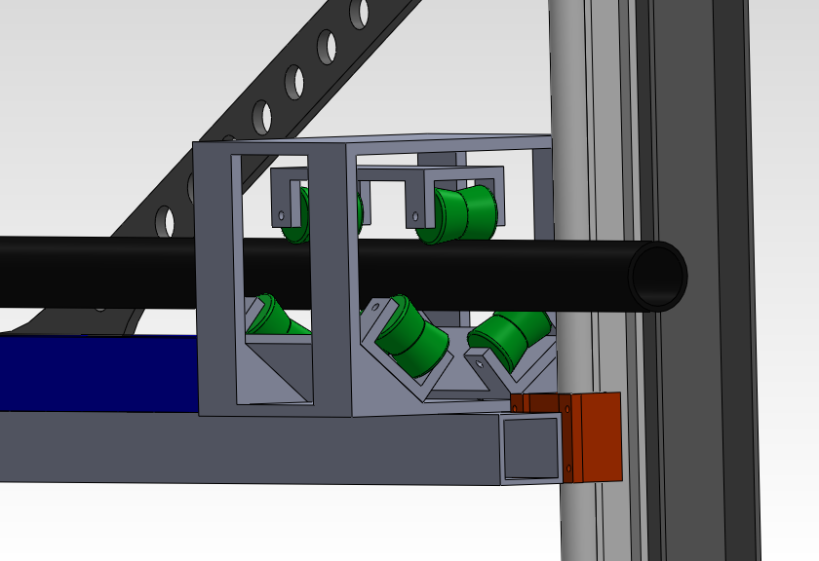

Figure 16: SolidWorks drawing of the roller box.

**Evaluation:** The analysis was performed at the maximum predictable loading as seen in Fig. 15. The resultant maximum radial load for any one of the support rollers is $796.2{lb}_{f}@45°$. The rollers will need to be sized accordingly.



Figure 15: The reaction forces on the support rollers

**Analysis:**

**Given:** Tube weight of 30lbf and end load of 5 lbf.; wind loading in z direction of a maximum 80 lbf distributed over last 16’ of tube; tube support rollers are 1’ apart

**Find:** Vertical (y) reaction forces, Horizontal (z) reaction forces at support rollers.

**Assumptions:** Wind loading is totally horizontal and the distributed loads of the tube weight and wind force can be approximated as lumped masses at the centroids.

**Solution:**

Gravitational loading

$$\sum{M_{ay}=F_{by}-17^{'}*5{lb}_{f}-8.5^{'}*30{lb}_{f}=0}, F_{by}=340{lb}_{f}↑$$

$$F_{ay}=340{lb}_{f}-30{lb}_{f}-5{lb}_{f}=305{lb}_{f}↓$$

Wind loading

$$\sum{M_{az}=F_{bz}-9'*80{lb}_{f}=0}, F_{bz}=720{lb}_{f}↑$$

$$F_{az}=720{lb}_{f}-80{lb}_{f}=640{lb}_{f}↓$$

Maximum resultant force

$$resultant=\sqrt{{720{lb}_{f}}^{2}+{340{lb}_{f}}^{2}}=796.2{lb}_{f}@45°$$

References: N/A

# **Appendix C**: Component Analysis of the Horizontal Carriage

Analyst: Chris Grewell

Date: 2-28-2012

**Summary:** The horizontal linear actuator will undergo defection in between the vertical support rails of the structure (Fig. 13). If this deflection is too large, it can cause the carriage of the horizontal actuator to bind. The purpose of this analysis is to perform maximum beam defection calculations on the horizontal assuming no supporting gussets are in place. These defection values will be compared to the maximum acceptable defections specified by the linear actuator manufacturer (to be determined) to validate this portion of the design.

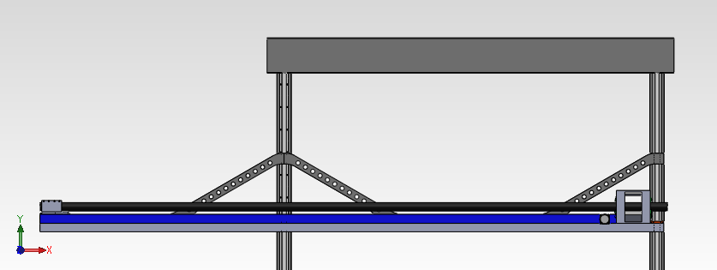

Horizontal actuator and support

Gussets

Dual support cantilever portion

Single support cantilever portion

Figure 13: The SolidWorks drawing of the cantilever design shown with support gussets, the horizontal actuator, horizontal carriage, and the carbon fiber

**Evaluation:** The resulting maximum defections were 0.372mm and 0.118mm for the dual support cantilever and single supported cantilever respectively from the loading seen in Fig. 14. These values will be used with manufacturers max defection specifications in deciding proper linear actuator for application.

383.3 N

159.2 N

1.52m

3.66m

Figure 14: Detail of the distributed loads acting on the horizontal actuator

**Analysis:**

**Given:** Dual cantilever supported length = 3.66m (12ft), distributed load = 383.3N

Single cantilever support beam length = 1.52m (5ft), distributed load = 159.2N

Moment of inertia (I) = 1.03732e-5 m4 (see Fig. 18)

Elastic modulus (E) = 7GPa

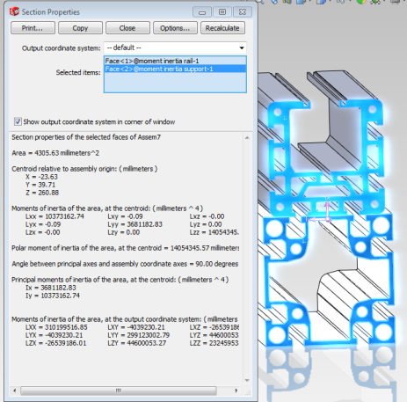

Figure 18: SolidWorks drawing of the extruded aluminum horizontal

carriage showing the moment of inertia, I

**Find:** Max defection of dual supported cantilever and single supported cantilever beam.

**Assumptions:** No gusseting (worst case scenario), the connections to the vertical rails act as a true cantilever and loading is evenly distributed.

**Solution:**

Max defection of dual cantilever support = $\frac{5}{348}\frac{{Wl}^{3}}{8EI}$ (1)

$\frac{5}{348}\frac{{383.3N*3.66m}^{3}}{70e9Pa*1.03732e-5m^{4}}=0.000372m or 0.372mm$ =0.0146*in*

Max defection of single cantilever support = $\frac{{Wl}^{3}}{8EI}$ (2)

$\frac{159.2N*1.52m^{3}}{8*70e9Pa*1.03732e-5m^{4}}=0.000118m or 0.12mm$ =0.0046*in*

**References:**

Equations 1&2, retrieved on 2-28-2013 from <http://www.engineersedge.com/beam_bending/calculators_protected/beam_deflection_1.htm>

# **Appendix D**: Component Analysis of the Smoke Wand

Analyst: Matt Melius

Date: 2-29-2012

**Summary:** Under wind loading the wand will not deflect in the stream-wise direction by more than 1”. Carbon fiber is light-weight and very strong which makes it ideal for the traverse system

As a cylinder, the smoke wand will deflect under its own weight by more than 1” unless it is larger than 4.5” in diameter. Vortex shedding will occur at very low frequency, which will cause the wand to vibrate under wind loading.

By altering cross-section to make the wand more aerodynamic vortex shedding frequency should rise and drag force should decrease. This will likely cost strength in direction of largest deflect. Solution will be to create lift through the aerodynamic shape.

**Evaluation:** Beam will deflect under its own weight by more than 1” unless it is larger than 4.5” in OD.

Vortex Shedding will occur at 1-6 hz under 30 MPH wind

Deflection in Y-direction is of greatest effect at low wind speeds. (30mph

**Analysis:**

**Given:** 3” OD, L = 17’, Cantilever Cylinder, Orientation = cross flow

**Find:** Re , Drag Coefficient (Cd), Drag Force = F, Vortex Shedding Frequency = *f* , Moment of Inertia = I, Deflection = y , Mass = m

**Assumptions:** Smooth Surface, Steady Flow, Incompressible Fluid, Distributed Load Strouhal number =0.19 (10^4<Re<10^6)

**Solution:**

Reynold’s Number : 

Drag Coefficient:

Cd = 1.18+6.8/(Re^(0.89))+1.96/(Re^(0.5))-0.0004*Re/(1+3.64*EXP(7*B6^2))

Drag Force : 

Vortex Shedding Frequency: 

Moment of Inertia: 

Deflection of a Cantilever Cylinder: 

Cross-sectional area: 

Mass: 

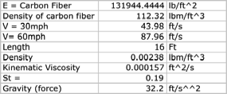

Table 6: The material properties of the isotropic tube with a unidirectional layup (axial) composed of T300

fibers used for the smoke wand analysis and the wind speeds associated with smoke testing

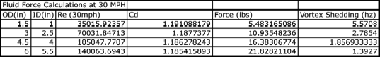

Table 7: Fluid force calculations on the carbon fiber tube at 30 MPH

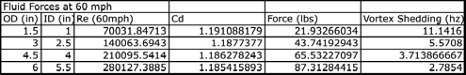

Table 7: Fluid force calculations on the carbon fiber tube at 60 MPH

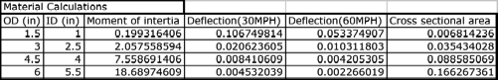

Table 7: Wind load deflections of the carbon fiber tube at different OD’s and ID’s

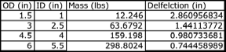

Table 8: Gravitational deflections of the carbon fiber tube at different OD’s and ID’s

**References:** White, Frank M. Viscous Fluid flow. McGraw-Hill Science/Engineering.Math; 2nd Edition. January 1, 1991.