Axle Temperature Control

Progress Report- Winter 2011

Team Members:

Mike Erwin

Emery Frey

Boun Sinvongsa

Lee Zimmerman

Advisor:

Lemmy Meekisho

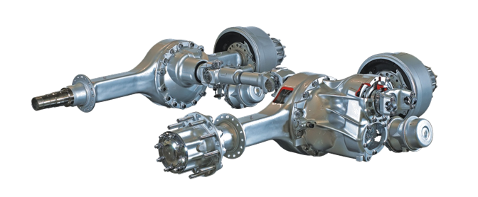

# Executive Summary

Daimler Trucks North America is committed to improving the efficiency of its tractor trailer product line to stay competitive in the marketplace. One potential area for improved efficiency is in the driveline of the vehicle. This document provides a progress report for the design of a system to manage the temperature of the axle lubricant to reduce vehicle driveline losses.

While no existing systems are currently available, the design team has looked at several technologies including electric heaters, insulation and heat exchangers which could be implemented into a solution. The team has generated several design concepts which have been individually evaluated and a design concept called “active insulation” has been selected as best meeting the design criteria.

A complete detailed design has not yet been produced, but the specific requirements determined thus far for the “active insulation” concept are documented in this report. In addition, possible strategies for implementing this concept are discussed.

It is recommended that the design team continue with the “active insulation” design concept and work to create a detailed design that will meet the challenges associated with it including, sufficient insulation to reach an optimum thermal resistance value for equilibrium temperature requirements, sufficient cooling capability to avoid fluid overheating and implementing a solution to reach the warm up rate requirement.

Contents

Executive Summary 2

Introduction 5

Mission Statement 6

Project Plan 6

Product Design Specifications 6

External Search 8

Internal Search 8

Concept Evaluation 8

Detailed Design Progress 10

Conclusions/Recommendations 12

References 14

Appendix A: PDS Specifications 15

Appendix B: Empirical Insulation Proof of Concept Test 19

Appendix C: Approximation of Required Insulation Thickness 20

Appendix D: Maximum Ramp Up Rate from Internal Heating 22

# Introduction

The modern line haul tractor-trailer is one of the primary methods of transporting goods in both the United States and in the world. Daimler Trucks North America (DTNA) is a leading producer of these tractor-trailers and is constantly searching for ways to improve its products. As a participant in the 21st Century Truck Partnership, Daimler Trucks North America is committed to improving the efficiency of its products. As outlined by 21st Century Truck, (See Figure 1 below) a modern tractor trailer requires approximately 400 kW of power per hour to maintain a constant speed of 65 MPH while fully loaded and traveling on level ground.

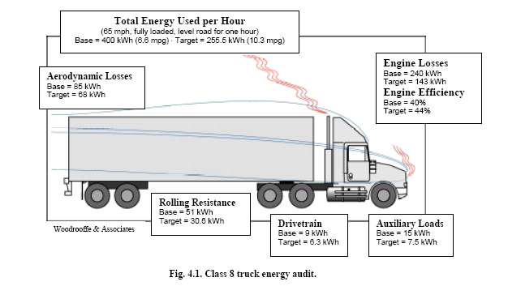

Figure 1 Truck Operating Losses (21st Century Truck, 2007)

Of the power required to move the truck in these conditions, approximately 9 kW is necessary to simply overcome the drivetrain losses. The energy lost in the drivetrain goes to two primary sinks: gear and bearing frictional losses and lubricant splash losses. The magnitude of these losses is impacted dramatically by the viscosity of the lubricating fluid. (See Appendix C.) A lower viscosity fluid would reduce both types of losses, but the weight of the lubricating oil is not easily changed due to wear concerns. One possible solution stems from the fact that the fluid can be warmed to lower its viscosity, while maintaining its lubricating properties. As the temperature of the fluid increases, the viscosity decreases in a predictable way which has been demonstrated by previous testing at DTNA. (See Appendix B.) The design team has been tasked with finding an efficient way to increase and control the temperature of the lubricating fluid to take advantage of the reduction in viscosity in an attempt to reduce driveline losses and improve overall vehicle efficiency.

# Mission Statement

The purpose of this project is to create a device or system that will heat the driveline lubricating fluid of the forward axle of a model ART-40.0-4 tandem axle set to a minimum of 65°C and a maximum of 80°C in ambient temperatures above 0°C. The device must also be capable of heating the axle fluid to 50-65°C in situations where the ambient temperature is as low as -15°C. The device must achieve a minimum warm-up rate of 2°C/min on average while the vehicle is traveling at highway speeds and must maintain the elevated temperature range during this type of operation. The final product must achieve these targets in a cost effective and energy efficient manner which allows for a net efficiency gain of the vehicle and a return on investment within the first two years of operation.

# Project Plan

To ensure that the design project is completed on time, a project plan has been outlined below in Figure 2. These deadlines will need to be met to ensure the project is completed with a sufficient amount of time remaining to complete the required testing to validate the device. While only one official design review is scheduled for March, it is expected that, through continuous communication with our sponsor, informal design reviews will occur throughout the duration of the project.

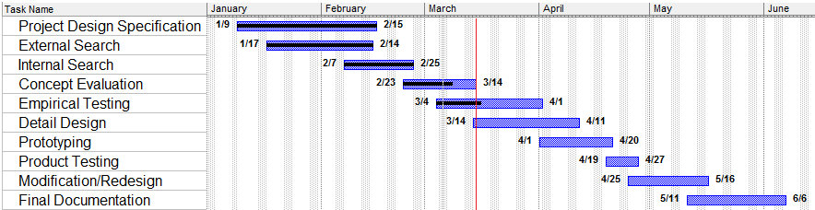



# Product Design Specifications

The criteria for the overall design of the product are presented in prioritized format in Table 1 shown on the next page. Each criterion is listed in order of importance, with high priority items at the top and non-applicable items on the bottom. A detailed breakdown including associated customer, metrics, basis of criteria, and verification method can be found in Appendix A on the corresponding pages listed in Table 1. Appendix A also includes the justification for each criterion deemed non-applicable by the team.

|  |  |  |
| --- | --- | --- |
| **Product Design Specification** | | |
| **Criteria** | **Priority** | **Page** |
| Performance | High |  |
| Reliability and Quality | High |  |
| Safety | High |  |
| Materials | High |  |
| Size and Shape | High |  |
| Applicable Codes and Standards | High |  |
| Testing | High |  |
| Environment | High |  |
| Timelines | High |  |
| Quantity | High |  |
| Cost of Production per Part (material and labor) | High |  |
| Maintenance | Medium |  |
| Documentation | Medium |  |
| Weight | Medium |  |
| Manufacturing Facilities | Medium |  |
| Life in Service | Low |  |
| Installation | Low |  |
| Shipping | N/A |  |
| Packaging | N/A |  |
| Aesthetics | N/A |  |
| Legal (related patents) | N/A |  |
| Disposal | N/A |  |
| Company Constraints and Procedures | N/A |  |
| Ergonomics | N/A |  |

Table 1: PDS Criteria

# External Search

While there is currently no device on the market which is designed explicitly to meet our design objective, there are several technology sources that could contribute to our solution. As the design team is constrained to the use of an existing onboard heat source, (i.e. electricity, exhaust heat, coolant heat or internally generated frictional heat), heat transfer devices, electric heaters and heat retention products were researched.

The most closely related system currently being produced is the exhaust heat recovery and transfer system in Toyota’s Prius. The system uses a set of heat exchangers to extract waste heat from the vehicles engine exhaust and use it to rapidly raise and maintain the engine coolant at an optimal operating temperature. This system’s design objective is nearly identical to our own. However, this system’s applicability to our project is only in concept. Many general types of oil heat exchangers were also examined as a means of transferring heat energy from either the engine coolant or exhaust to the axle.

The axle assembly dissipates the heat stored in the fluid to the passing air primarily though convection when the vehicle is travelling on the highway. To potentially minimize this loss, the team researched various types of insulation to retain the axle’s thermal energy. Product applications included mats, tapes, paints, sprays, foams and jackets. One or more types of insulation are almost certainly going to be a part of the team’s final design in order to reduce convective heat losses and lower if not eliminate the need for additional heat addition to the system.

As another potential way to add heat to the system, the design team looked at electrical resistance oil heaters. These units are widely used in engines operated in colder climates and offer many advantages in terms of initial cost and ease of control. A electric heater could easily be implemented into the current differential system. However, they tend to consume considerable amounts of electricity, particularly when heating rapidly which may make meeting the net efficiency increase a challenge.

# Internal Search

With the types of technologies from the external search in mind the team developed several design concepts to try to meet the PDS requirements.

The first concept would be the use of a type of heat exchanger system. This system could take two basic forms depending on the heat source used, the two best candidates being the engine coolant and the engine exhaust. Both of these sources are waste energy and so any collection of usable energy from these systems would increase the net efficiency of the vehicle. Both sources would also have sufficient energy two meet the needs of heating the differential fluid to the required goals. These design concepts would require several components including heat exchanging manifolds at both the heat source and at the axle as well as piping, valves and pumps to control the flow of the heat transfer fluid.

Another design concept generated by the team was called the passive insulation concept. In this concept the differential would be insulated to the point that the internal heat generation would be just sufficient to reach the required temperature delta without the addition of heat from another source. As this system would be passive there would be no control and the ambient temperature would greatly affect the equilibrium temperature of the fluid. As such the design would have to keep a factor of safety in mind to avoid fluid overheating. However, the passive insulation system would have the benefit of being very low cost and potentially easy to retrofit to current axles.

A third design concept was developed using the electric heater technology. By fitting an appropriately sized electric heater to the axle both the warm up rate and equilibrium temperature requirements could be met. However, depending on the power required to meet these goals the device could fall short on the net efficiency criteria.

A final concept called active insulation was also developed. In this scenario, the team would take advantage of the benefits of the passive insulation concept, but integrate some form of control so that the drawbacks of the passive insulation concept were overcome. While the net efficiency goal would be more likely to be met with this type of system than the electric heater, it is unclear if the goals of warm up rate could be met without the addition of heat energy.

# Concept Evaluation

To determine which of the design concepts to further develop, the five best concepts from the internal search were rated with performance scores on the most important criteria from the PDS. These categories were weighted according to the relative importance for the success of the final design and a final weighted score was calculated. The summary of these rankings can be seen in figure 2 and a description of the process will be provided below.

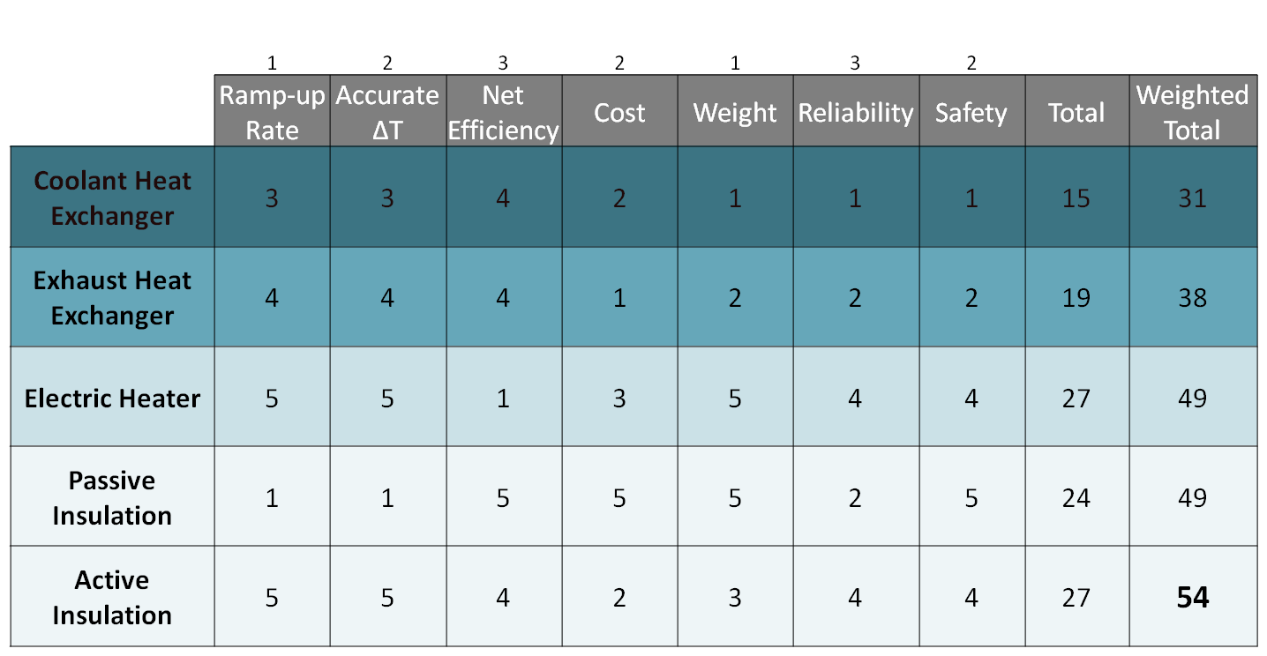

Figure 2. Concept design evaluation matrix. All concepts were rated for expected performance in the 7 most important criteria to determine the concept which would meet the collection of criteria best.

Both heat exchanger concepts received high scores for the temperature and efficiency performance criteria because they would harvest heat from sources with ample heat energy available, though the exhaust heat source would be somewhat greater than the coolant. However, the complexity and materials involved in these systems result in low scores for the remainder of the categories. These systems would require many components that would add weight to the vehicle and the potential for component failure could drastically affect reliability. In addition, the complexity involved would make meeting the cost requirement difficult.

The electric heater scores well in the performance categories as well, apart from the net efficiency. Because the electric heater would not harvest waste energy it would be the least likely to have a positive net effect on vehicle efficiency. However, the simplicity, controllability and flexibility of the electric heater concept results in good scores for the weight, safety, reliability and cost categories.

Conversely, the passive insulation concept would perform poorly in the performance categories other than net efficiency. This results from the fact that the lack of a control mechanism would mean a balance between the temperature increase provided by the insulation and the safety factor against overheating the fluid would have to be made. This would result in a lightly insulated axle that would warm up slowly and to a temperature at the lower end or below the specified range in most situations. Though this concept rates well for both cost and weight, in hot ambient conditions a poorly selected insulation value could result in overheated driveline fluid which could affect vehicle reliability.

The concept design matrix suggests that the active insulation concept is the best in terms of meeting the majority of the criterion. The fact that an active insulation system could combine the benefits of the passive insulation while providing a means of temperature control make it the best choice for meeting the temperature requirements and reliability requirements, while simultaneously improving the net efficiency of the vehicle system.

# Detailed Design Progress

Once the active insulation design concept was selected the team began working on designing the specific components required for this concept, and clarifying the direction to take. While insulation is a vital component of any active insulation design the temperature control component could be accomplished in several ways depending on the effectiveness of the insulation. The design was first evaluated by determining the approximate thickness of the insulation that would be required to reach the temperature design goal using a simplified model of the axle, see Appendix C for details.

This analysis suggests that, using a conservative insulation value of k~.05 $\frac{W}{m*K}$, the required insulation thickness to produce enough thermal resistance to generate the required temperature delta would be 1.06mm. While this result is highly dependent on the assumptions made in the analysis, it is sufficiently small to suggest that insulation alone may be capable of generating the needed equilibrium heat differential between the ambient air and the axle fluid. To attempt to validate this analysis the design team conducted an experiment to determine the effectiveness of a store bought insulation product, see Appendix B for details. The results of this experiment were that the insulation was clearly capable of meeting the temperature equilibrium requirements. The insulation had to actually be removed at one point in the test to avoid overheating the axle fluid. However, though the temperature ramp up rate was increased with the insulation it did not meet the design requirement.

Because the use of insulation will generate the more than the required equilibrium temperature differential, the control portion of the device can focus on providing adequate cooling to keep the differential fluid from overheating. As the PDS specification states that the differential fluid temperature be maintained in the required temperature range while the vehicle is travelling at highway speeds there are several potential cooling solutions that could take advantage of the forced convection available in these conditions.

One potential system would be a controlled ambient air ventilation system. Cool ambient air could be vented into the differential to provide cooling of the fluid directly. While this concept has the advantage of cooling the fluid directly, there would be several challenges involved with modifying the differential to use this system. To avoid contamination of the fluid, the air would need to be adequately filtered, and the venting system would have to avoid differential fluid leakage.

Another potential solution would be to control the forced convection across the existing surface of the differential by implementing a channel that would run along the surface of the differential, see figure 3. In this strategy, the differential would be insulated in all locations excluding the area under the channel. This would preserve the overall heat transfer coefficient in the duct channel and allow the differential case and fluid to be effectively cooled when air was allowed to flow through the duct.

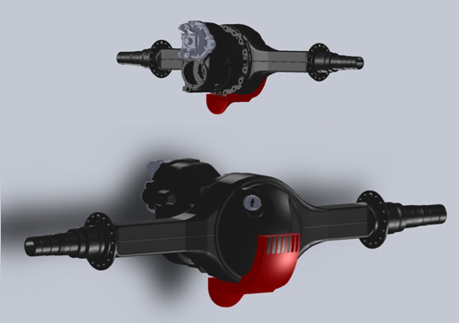

Figure 3: Convection Control Channel

An alternative to the duct type design would be a cooling device designed to replace the front access cover of the differential. There is the potential to create a type of heat sink device that would attach to the front of the differential to cool the fluid directly, rather than indirectly by cooling the differential case. While this cooling strategy has the benefit of cooling the fluid directly it is not currently clear if this would be effective cooling for the majority of the fluid which is located in the rear of the differential. If there is sufficient thermal continuity between the front and rear reservoirs, this could be an effective solution.

# Conclusions/Recommendations

The major milestones that have been achieved are: PDS, internal search, external search and concept evaluation. Based on the output from the concept evaluation, the team has decided to pursue an active insulation design. The team is currently in the midst of empirical testing and transitioning from concept evaluation to the detail design. Due to resource and time constraints, the team is unable to construct a model to accurately simulate the operating conditions of the axle. In lieu of a model, the team will rely on empirical testing on Daimler’s test vehicle to provide design direction. The project at its current state is at approximately 50% of total completion and all tasks are on schedule.

Results from empirical testing reveal that insulation alone is able to satisfy some of the customer needs. Insulation is relatively inexpensive, reliable, and most importantly it is able to attain the desired axle lubricant temperature range of 65-80°C. Insulation alone however, cannot meet the desired warm-up rate of 2°C/minute minimum, nor is it able to prevent the fluid temperature from exceeding the upper temperature limit. The current state of the product does not completely satisfy any of the performance criteria and will require further development. Adding an active cooling and heating function will result in a device that is able to attain the desired temperature and prevent the upper temperature limit from being exceeded. A concern that has surfaced as a result of additional test data is the feasibility of meeting the warm-up rate requirement. Daimler’s initial estimate of natural axle warm-up rate was higher than actual as revealed from test data, and the current rate will need to be quadrupled to meet the desired rate. This may pose a problem in terms of achieving a positive net efficiency, cost requirements, and utilization of available energy sources. Further analysis is necessary to determine if a compromise regarding this performance criterion needs to occur.

The major milestones to be completed are: detail design, additional empirical testing as required, prototyping/fabrication, product validation, modification or redesign, and lastly documentation of the final product. In the upcoming detail design activity, the team will continue to refine the active insulation design with further analysis based on additional data obtained from empirical testing. Design elements regarding method of heating, target locations of heating/cooling, an insulation material will be determined in the detail design stage. The team will continue to maintain an open channel of communication with the customer throughout the design process to ensure that the evolving design is in alignment with customer expectations.

# References

21st Century Truck, 2007. Roadmap and Technical Whitepapers. Retrieved from: [http://www1.eere.energy.gov/vehiclesandfuels/about/partnerships/21centurytruck/index.html 2/8/2011](http://www1.eere.energy.gov/vehiclesandfuels/about/partnerships/21centurytruck/index.html%202/8/2011)

# Appendix A: PDS Specifications

|  |  |  |  |  |  |  |  |  |  |  |
| --- | --- | --- | --- | --- | --- | --- | --- | --- | --- | --- |
| **High Priority** | | | | | | | | | | |
| **Performance** | | | | | | | | | | |
| **Customer** | | **Requirement** | **Metric** | **Target** | | **Basis** | | **Verification** | | **Priority** |
| DTNA | | Device is to achieve and maintain axle lube temperature | Fluid Temp | 65-80°C when Ambient is above 0°C and 50-65°C when Ambient is as low as -15°C | | Customer Data | | Test | | High |
| End User | | Net Vehicle Efficiency Increase | -ΔKW(Drive train Loss)/ΔKW(Energy Consumption) | >0 | | Customer Data | | Comparison | | High |
| DTNA | | Uses existing sources of energy | Y/N | Yes | | Customer Data | | Comparison | | High |
| DTNA | | Device is to heat the axle lube at a specified rate | Fluid Temp | 2°C/min average minimum | | Customer Data | | Test | | High |
| **Reliability and Quality** | | | | | | | | | | |
| **Customer** | **Requirement** | | **Metric** | **Target** | **Basis** | | **Verification** | | **Priority** | |
| DTNA | Device will not overheat axle lube | | Fluid Temp | Max Lube Temperature of 120°C | Customer Data | | Test | | High | |
| **Safety** | | | | | | | | | | |
| **Customer** | **Requirement** | | **Metric** | **Target** | **Basis** | | **Verification** | | **Priority** | |
| DOT | Device minimizes chance of igniting. | | Temperature / Spark | 150 °C / None | Department of Transportation | | Test | | High | |
| DTNA | Device minimizes chance of oil spill | | Y/N | Yes | Customer Feedback | | Analysis | | High | |
| DOT | Device uses comparably hazardous materials | | Y/N | No | Department of Transportation | | Comparison | | High | |

|  |  |  |  |  |  |  |
| --- | --- | --- | --- | --- | --- | --- |
| **Materials** | | | | | | |
| **Customer** | **Requirement** | **Metric** | **Target** | **Basis** | **Verification** | **Priority** |
| DTNA | Device uses readily available materials. | Y/N | Yes | DTNA Vendors / Manufacturing | Comparison | High |
| **Size and Shape** | | | | | | |
| **Customer** | **Requirement** | **Metric** | **Target** | **Basis** | **Verification** | **Priority** |
| DTNA | Device to be easily installed within existing design | Dimensions | Device fits within available space | Customer Feedback | Test fitment | High |
| **Applicable codes and standards** | | | | | | |
| **Customer** | **Requirement** | **Metric** | **Target** | **Basis** | **Verification** | **Priority** |
| DOT | Device must meet all applicable codes and standards. | Y/N | Yes | Governing body | Comparison of codes and standards | High |
| **Testing** | | | | | | |
| **Customer** | **Requirement** | **Metric** | **Target** | **Basis** | **Verification** | **Priority** |
| Team | Testing must validate that device meets performance criteria | Y/N | Yes | Customer Requirement | Test | High |
| **Environment** | | | | | | |
| **Customer** | **Requirement** | **Metric** | **Target** | **Basis** | **Verification** | **Priority** |
| DTNA | Device is to withstand the elements, road debris, salts, exhaust temperatures. | Degradation / Time | Comparable to other driveline components | Customer Feedback | Comparison to similar Materials/Devices | High |
| DTNA | Device to withstand vibration and shock from vehicle motion | Max Acceleration | TBD | Customer Requirement | Analysis | High |

|  |  |  |  |  |  |  |
| --- | --- | --- | --- | --- | --- | --- |
| **Timelines** | | | | | | |
| **Customer** | **Requirement** | **Metric** | **Target** | **Basis** | **Verification** | **Priority** |
| PSU | Meet all capstone deadlines | Y/N | Yes | Customer Requirement / Group Decision | Grade | High |
| **Quantity** | | | | | | |
| **Customer** | **Requirement** | **Metric** | **Target** | **Basis** | **Verification** | **Priority** |
| DTNA | 1 Device | Number of devices produced | 1 | Customer Requirement | N/A | High |
| **Cost of production per part (material and labor)** | | | | | | |
| **Customer** | **Requirement** | **Metric** | **Target** | **Basis** | **Verification** | **Priority** |
| DTNA | Device to be cost effective | Rate of return | < 2 years | Customer Requirement | Analysis | High |

|  |  |  |  |  |  |  |
| --- | --- | --- | --- | --- | --- | --- |
| **Medium Priority** | | | | | | |
| **Maintenance** | | | | | | |
| **Customer** | **Requirement** | **Metric** | **Target** | **Basis** | **Verification** | **Priority** |
| DTNA | Device to be easily serviced. | Time Req'd / Maintenance | < 1 hour | Group Decision with Customer Input | Similar System Comparison | Medium |
| DTNA | Device to require minimal service schedule. | Frequency of Req'd Maintenance | 3 years | Current Maintenance Schedule | Customer Follow-up | Medium |
| **Documentation** | | | | | | |
| **Customer** | **Requirement** | **Metric** | **Target** | **Basis** | **Verification** | **Priority** |
| PSU | PDS Document, Progress Report | Y/N | Yes | Customer Requirement | Grade | Medium |
| DTNA | Documentation of design process selection and testing | Y/N | Yes | Customer Requirement | Customer Feedback | Medium |

|  |  |  |  |  |  |  |
| --- | --- | --- | --- | --- | --- | --- |
| **Weight** | | | | | | |
| **Customer** | **Requirement** | **Metric** | **Target** | **Basis** | **Verification** | **Priority** |
| DTNA | Device should not add significant load to the vehicle | Weight | < 20lbs | Customer Requirement | Analysis | Medium |
| **Manufacturing facilities** | | | | | | |
| **Customer** | **Requirement** | **Metric** | **Target** | **Basis** | **Verification** | **Priority** |
| Team | All fabrication to axle is to be done at PSU or DTNA | Y/N | Yes | Customer Requirement | N/A | Medium |

|  |  |  |  |  |  |  |  |
| --- | --- | --- | --- | --- | --- | --- | --- |
| **Low Priority** | | | | | | | |
| **Life in service** | | | | | | | |
| **Customer** | **Requirement** | **Metric** | | **Target** | **Basis** | **Verification** | **Priority** |
| DTNA | Device should have a long service life. | Time | | 5 yrs. minimum | Comparable Components | Comparison | Low |
| **Installation** | | | | | | | |
| **Customer** | **Requirement** | **Metric** | | **Target** | **Basis** | **Verification** | **Priority** |
| DTNA | Device to be easily retrofitted to existing axles. | Installation/Removal Time | | 5 hours | Customer Feedback | Customer Test | Low |
| **Not Applicable** | | | | | | | |
| **Criteria** | | | **Justification** | | | | |
| Shipping | | | Device will be part of complete axle assembly. | | | | |
| Packaging | | | Device will not be shipped. | | | | |
| Aesthetics | | | There are no appearance requirements. | | | | |
| Legal (related patents) | | | No existing patents or comparable products exist. | | | | |
| Company Constraints and Procedures | | | No unique constraints or procedures. | | | | |
| Ergonomics | | | Device functions autonomously. | | | | |

# Appendix B: Empirical Insulation Proof of Concept Test

On March 4th and 5th of 2011, the team performed on-road experiments to collect information about the warming characteristics of the axle as a result of the gear and bearing frictional heat generation. The tests aimed to observe two main aspects of the heating characteristics: 1) the surface temperature of the axle at various key locations on the assembly for consideration in convective heat transfer analysis and, 2) the effect of insulating the differential on warm-up rate and maximum temperature. Plots of the change in fluid temperature with time are displayed below in Fig. 1B.

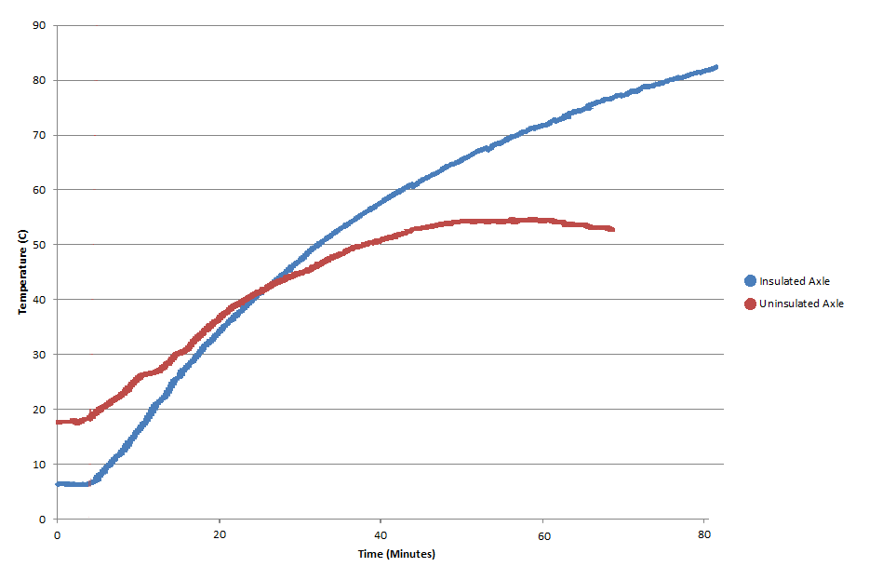

**Figure B1** – Axle temperature rise with operation. Two on-road tests to observe the warm up rate of the axle were conducted. The first was performed with an untreated axle assembly. The second test was run with a layer of fiberglass insulation coating the axle differential. A dramatic difference in the warm-up rate of the fluid as well as peak temperature was observed. Note: Ambient air temperature was different for each test as indicated by the different initial values.

Initial observations from the testing results indicated that the PDS target temperature range of 65°C-80°C could be achieved through passive insulation. However, the test indicated that the addition of the insulation tested did not satisfy the PDS warm-up rate of 2°C/min. Further analysis of the data is planned.

# Appendix C: Approximation of Required Insulation Thickness

## Summary

To determine the feasibility of meeting the fluid temperature requirements with only insulation, an estimation of the total thermal resistance required to meet the targets is needed. This value can then be compared to the thermal resistance of insulation materials to identify candidates for use.

The result of this analysis will be a required thickness for the insulation to meet the design criterion.

## Evaluation

This model represents a highly simplified system with assumptions that will greatly affect the outcome. Testing will be done to support the assumptions made in this analysis, but variation could still be significant

## Given

Bearing and gear losses are equal to .75% of the power transferred through the differential.

Power transmission required to maintain highway speed on level ground is 180Hp.

With no insulation the fluid heats to 43.5°C above the ambient temperature in the operating environment.

Thermal conductivity of steel is 60.5 W/(m*K)

## Find

The thickness of insulation required to create a temperature difference of 65-80°C.

## Assumptions

Differential is modeled as a 17 inch diameter sphere with an average thickness of .25 inch.

Differential surface temperature is assumed to be uniform

1-D (Radial) heat transfer

## Solution

### Heat Input

$$q=180Hp*.75\%*746\frac{W}{Hp}=1007.1W$$

### Total Resistance (no insulation)

$$R_{tot}=\frac{T_{i}-T_{∞}}{q}=\frac{43.5°C-0°C}{1007.1W}=.043193\frac{K}{W}$$

### Estimation of Convection and Radiation Coefficients

$$R_{tot}=\frac{1}{A}\left(\frac{L_{steel}}{k_{steel}}+\frac{1}{h+h_{r}}\right)$$

$$.043193=\frac{1}{.5857m^{2}}\left(\frac{.00635m}{60.5\frac{W}{m*K}}+\frac{1}{h+h_{r}}\right)$$

$$h+h_{r}=39.69 \frac{W}{m*K}$$

These values appear to be reasonable first approximations

### Required Total Resistance

$$R_{tot}=\frac{T_{i}-T_{∞}}{q}=\frac{80°C-0°C}{1007.1W}=.079436\frac{K}{W}$$

### Required Insulation Thickness

$$R_{tot}=\frac{1}{A}\left(\frac{L_{steel}}{k_{steel}}+\frac{L_{ins}}{k_{ins}}+\frac{1}{h+h_{r}}\right)$$

Assuming kins~.05 $\frac{W}{m*K}$ and $h+h_{r}$ remain ~constant

$$.079436 \frac{K}{W}=\frac{1}{.5857m^{2}}\left(\frac{.00635m}{60.5\frac{W}{m*K}}+\frac{L_{ins}}{.05\frac{W}{m*K}}+\frac{1}{39.69 \frac{W}{m^{2}*K}}\right)$$

$$L_{ins}=1.06mm$$

# Appendix D: Maximum Ramp Up Rate from Internal Heating

## Summary

To determine if the internally generated heat within the axle can raise the fluid temperature at the required rate (2ºC/min average), a minimum required time must be calculated to determine the maximum ramp up rate. The result of this analysis will determine if insulating the axle will be sufficient for meeting the required ramp up rate or if an additional heat will be required.

## Evaluation

This model represents a simple system to solely find how much time is required to heat the axle and fluid to a given temperature with no heat loss. The final temperatures of the axle and fluid are averages and represent the current temperature when the axle fluid first reaches equilibrium.

## Given

The mass of the complete axle is 453 kg and its specific heat is 450 J/kgºC

The mass of the axle fluid is 12.5 kg and its specific heat is 2000 J/kgºC

Both the axle and fluid start at the ambient air temperature of 15.5ºC. The final temperature of the axle fluid is 80ºC while the final temperature of the axle is 75ºC.

The heating rate from friction and splash loses within the axle is 4000 W (J/s)

## Find

The minimum amount of time required for the internally generated heat to raise the axle and axle fluid from their initial to final temperatures.

## Assumptions

No heat is lost to surroundings during the heating process (perfect insulation)

The internally generated heat remains constant

## Solution

### Energy Required to Heat Axle/Fluid to Final Temperatures

$$Q_{axle}=mc∆T$$

$$Q_{axle}=(453 kg)(450\frac{J}{kg℃})(75℃-15.5℃)$$

$$Q_{axle}=1.21*{10}^{7} J$$

$$Q_{fluid}=(12.5 kg)(2000 \frac{J}{kg℃})(80℃-15.5℃)$$

$$Q_{fluid}=1.61*{10}^{6} J$$

$$Q_{total}=1.21*{10}^{7} J+1.61*{10}^{6} J=1.37*{10}^{7} J$$

### Time Required to Produce Qtotal

### Current Ramp Up Rate

$$\frac{{∆T}_{fluid}}{t_{required}}=\frac{80℃-15.5℃}{57.3 min}=1.12 \frac{℃}{min}$$

This is an average ramp up rate over the period of time which the axle fluid temperature is raised from ambient to final.