

**Progress Report** **- *Winter 2011***

**2011 Human Powered Vehicle Challenge**

**Faculty Advisor:**

*Derek Tretheway, Ph.D.*

**Team Members:**  
*Tad Bamford*

*Ben Higgins*

*Neal Pang  
Chris Schultz*

*Aaron Stanton*

Sponsored By:



22094.gif

**Abstract**

The goal of the 2011 Portland State University (PSU) Human Powered Vehicle (HPV) team is to win the Unlimited Class Category of the 2011 American Society of Mechanical Engineers (ASME) Human Powered Vehicle Challenge (HPVC) by designing and building a race quality HPV. The competition and rules require the HPV to excel in speed, handling, reliability, efficiency, and safety. The external and internal research has provided the information and ideas to formulate our detailed designs. The HPV team’s detailed designs involve a leaning three wheel tadpole style recumbent with carbon-fiber hub-centered wheels and a partial fairing. The hubs, uprights, wheel molds and roll-bar have been fabricated and an analysis has been performed on the frame and the wheels. However, the steering and lean centering design concepts have yet to reach the detailed design phase. To counter the delay in the design details, team meetings are to be held more than once a week and design analyses have strict deadlines. By April 30th the HPV will be completely fabricated for testing.

Table of Contents

Introduction 1

Mission Statement 1

Project Schedule 1

PDS Overview 2

External Search 3

Internal Search 7

Wheels: 9

Steering: 9

Centering: 11

Design Selection and Evaluation 13

Progress Conclusion 15

References 16

Appendix A: Product Design Specifications Table 17

Appendix B: House of Quality 19

Appendix C: Fairing Computational Fluid Dynamics 20

Appendix D: FEA Analysis of Rollbar/Frame and Carbon Fiber Wheels 22

Appendix E: FEA Analysis of Carbon Fiber Wheels 26

Table of Figures

Figure 1. 2008 PSU HPV (two-wheeled recumbent) (left) and 2010 PSU HPV (tadpole) (right) 3

Figure 2. Rider change-out of 2006 PSU HPV with fully enclosed fairing 4

Figure 3. 2010 Rose Hulman HPV (three-wheeled delta leaner) 5

Figure 4. Hub centered wheel diagram (Wianecki 2002) 5

Figure 5. Delta lean-steer 7

Figure 6. Tadpole lean-steer 8

Figure 7. Tadpole leaner with front suspension 8

Figure 8. Preliminary fairing concepts 9

Figure 9. Integrated Swing and Lean steering concept design. 10

Figure 10. Elliptical steering concept design. 10

Figure 11. Kite controlled steering design concept. 11

Figure 12. Concept drawing of torsion spring return 12

Figure 13. A pair of springs for the frame centering design concept 12

Figure 14. Concept drawing using a leaf spring to center the frame with the horizontal. 13

Figure 15. HPV frame decision matrix 14

Figure 16. Boundary conditions and loads. The two coordinate systems (CS) are the part global CS and the load CS that was rotated by 12° to orient the top load at the correct angle. The extra frame members not seen in further representations are geometric aids and were not meshed for analysis 23

Figure 17. Part mesh of 163 elements 23

Figure 18. Deflection behaviors. Of note is that the top load produces deflections an order of magnitude greater than the side load. 24

Figure 19. Stress behaviors. Again, the side load produces much smaller results. 25

Figure 20. Deformed shape (exaggerated) and location of maximum stress for the \top loading (left) and side loading (right) 25

Figure 21. Boundary conditions and load. 27

Figure 22. Representative segment of the mesh used. The areas of high concentration of small elements were inevitable since small element regions were created by the partition line intersections. 27

Figure 23. Areas of maximum stress and deflection. Circled areas of maximum stress indicate where the actual peak stresses occurred, but large parts of the lighter areas in the figure showed stresses within 20% of the maximums. 28

Figure 24. The load curve in magnitude and components. 29

Figure 25. Velocity profile of fairing traveling at a velocity of 15 m/s. Moving wall boundary conditions are used to simulate rider traveling at 15 m/s in still air. Streamlines show fluid path around fairing. 21

# Introduction

The American Society of Mechanical Engineers (ASME) sponsors the annual Human Powered Vehicle Challenge (HPVC), a design competition and race at a chosen hosting school for engineering students. The challenge in this event is to apply sound engineering and design principles to build a Human Powered Vehicle (HPV) that is efficient, practical, agile, attractive, and safe. Portland State University (PSU) has a strong recent history with this event, taking three third place finishes and one second place finish in the past five years.

The goal of the HPV design is to make a vehicle that can beat the competition in the three HPVC events. The first event is the sprint/drag event which tests acceleration and top speed by either a head-to-head drag race tournament or an individual top speed sprint. The second event is the utility endurance event which tests the practicality and reliability the HPV design through a series of obstacles such as speed bumps and grocery pick-ups. The third and final event is the speed endurance event, a LeMans style road race where vehicles with speed, handling and reliability excel because of the variety in the course and length of the race. For more detail of the official rules and guidelines of the competition, refer to the HPVC Rules.

# Mission Statement

The 2011 PSU HPV design team’s goal is to design, test, and fabricate a human powered vehicle to win the Unlimited Class Category of the 2011 Human Powered Vehicle Challenge (HPVC) sponsored by the American Society of Mechanical Engineers and Knovel Corporation.

# Project Schedule

Since the HPVC event occurs May 13, 2011, before the deadlines of the ME capstone class, this project is on an accelerated timeline. Consequently some of the milestones listed are scheduled ahead of the deadlines that correspond to them in the capstone class series. An overview of the major design milestones are as follows:

* Internal and External research (Jan. 12th)
* Concept Evaluation and Selection (Jan. 24th)
* Detailed Design Completed (Feb. 28th)
* Review of Detailed Design (March 4th)
* Carbon Wheel Test Completed (March 8th)
* Frame Completed ( March 8th)
* Upright Pivot Design Evaluation and Selection (March 15th)
* Main Pivot Design Evaluation and Selection (March 17th)
* Cable Splitter Design Evaluation and selection (March 17th)
* Suspension Planks Completed (March 21st)
* Seat Design Selection and Evaluation (March 22nd)
* Seat Completed (March 25th)
* Main pivot Built (March 30th)
* Steering Design Selection and Evaluation (April 1st)
* Steering Completed (April 4th)
* Cast Carbon Wheels With Modifications from Testing (April 6th)
* Fairing Design Selection and Evaluation (April 8th)
* Upright Pivots Built (April 11th)
* Assembly Without Fairing and Commence Road Testing (April 15th)
* Fairing Completed (April 25th)
* Final Assembly and Road Testing With Fairing (April 29th)

# PDS Overview

The 2011 PSU HPV team aims to win the HPVC in Bozeman, MT in May 2011.  Customers were identified, their needs were assessed, and the goals for the vehicle design were extrapolated respectively.  Performance, cost, and safety (the most crucial criteria) were given target values for engineering metrics.  The design team can now focus on creating a product that meets these specifications.  This final design should focus on maneuverability, stability, speed, and ease of use.  If the goals set by the PDS are reached, the PSU HPV team will produce a vehicle of exceptional speed, handling, reliability, and comfort that will overcome all of the competition in Bozeman. PDS top level criteria are outlined in Appendix A.

# External Search

The focus of external research was to make a note of the ideas presented in designs associated with HPV. As such, HPV designs from previous PSU HPV teams, commercial producers, and hobbyists were analyzed for common successes and failures.   
 The external research began with understanding the differences between the two-wheel and three-wheel recumbent style HPVs offered.  In testing of the 2008 two-wheeled and 2010 three wheeled models, the 2008 model displayed greater high speed stability and had a smaller turning radius.  The 2010 three-wheeled design had greater control in cornering and better low speed stability.  The two-wheeler was found to be very difficult to accelerate from rest and was very unstable at low speeds. Also the, recumbent machines require less power from the rider than a standard upright bicycle (Reiser, 2001) because they place the rider closer to the ground in a reclined position, decreasing aerodynamic drag.   The two-wheel and three-wheel recumbent style HPVs are shown in Fig. 1.

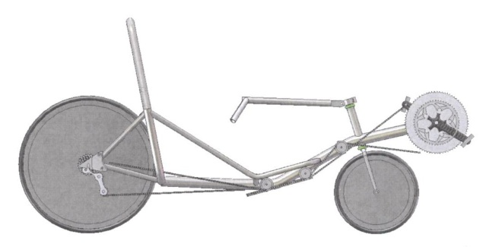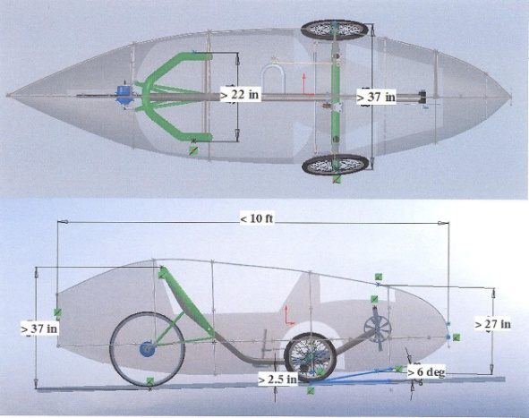

Figure 1. 2008 PSU HPV (two-wheeled recumbent) (left) and 2010 PSU HPV (tadpole) (right)

The three-wheel styles typically come in two forms, the tadpole (two wheels in front and one in rear) and delta (two wheels in rear and one in front) configurations.  The tadpole offers greater cornering stability due to the placement of the center of gravity behind the two-wheeled axle. The delta style (commonly front wheel drive) offers compact component location and eliminates the need for a long chain to the rear wheel increasing efficiency.  Common materials used in past HPV frame designs were 6061 T6 aluminum and 4130 chrome-molybdenum steel.  Both provide adequate specific strengths and are easily machined and manipulated.     
 The external research also showed incorporation of fairings into HPV designs.  While ultimately lowering the required power through the reduction of the coefficient of drag, a fairing does have negative aspects.  Fully enclosed fairings reduce visibility and increase the weight of the HPV dramatically.  Using a fully enclosed fairing may also increase the difficulty and decrease the speed of entering and exiting the vehicle. This is particularly undesirable during the HPVC endurance events, where rider exchanges are required and seconds lost can make a big difference in finish standings. Fig. 2 shows how difficult it is for the rider to exit the vehicle with a fully enclosed fairing.

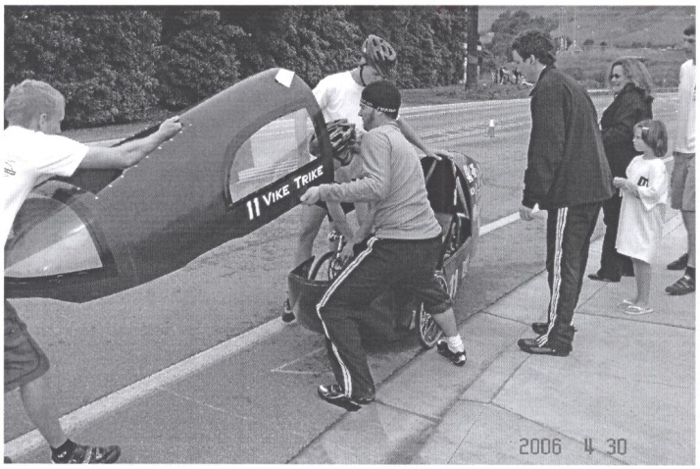

Figure 2. Rider change-out of 2006 PSU HPV with fully enclosed fairing

The 2006 PSU HPV required more than one person, other than the driver, to be helped to exit the vehicle and would require no less for the next driver to enter.

The previous competition has also helped our external research because it had revealed the dynamic camber system as an innovative concept design. This system allows a three-wheeled vehicle to effectively lean into turns by rotating along its longitudinal axis like a bicycle, and are referred to as “leaners.” Some tricycles have the steering incorporated into the leaning and are referred to as “lean-steer” tricycles. These leaning designs have strengths, such as increased cornering speed, as well as weaknesses, like increased weight and complexity.  Figure 3 shows “Ragnarok,” the 2010 HPVC champion designed by Rose Hulman Institute of Technology. This design is a leaning delta tricycle with the steering independent of the lean.

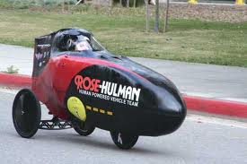

Figure 3. 2010 Rose Hulman HPV (three-wheeled delta leaner)

One innovation hobbyist HPV builders have had success with is the hub centered wheel. This dish style wheel offers better steering geometry by having the axis of steering in the wheel’s center plane. One result is the distance from the contact patch of the tire to the point where the steering axis pierces the ground stays relatively constant compared to designs where the steering axis is inboard of the wheel. The transverse force on the wheel form cornering should then more predictably return the vehicle to straight, resulting in a more stable ride. This style of wheel is useful mainly on multi-wheel HPVs where steering uses multiple tires.  An example is shown in Fig. 4.

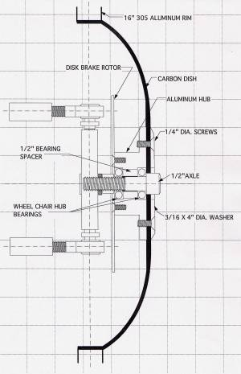

Figure 4. Hub centered wheel diagram (Wianecki 2002)

The example illustrates the necessary parabolic shape of the wheel for hub to align with the contact patch. The example also shows the required fixtures to have the hub supported in place. The steering system used on the vehicle will need to account for different turning radii of each front tire (for tadpole configuration) outlined by Fig. 5. The graph shows the increasing difference in steering angle between the inner and outer wheel.

Figure 5. Inner and outer wheel steering angle vs. turning radius

If the wheels maintain the same angle through a turn, tire slipping will occur and efficiency decreases (not to mention wear on components).This can be mitigated by use of “Ackermann” steering geometry correction. This allows for each steering tire to have its own angle corresponding to its individual turning radius. A common approximation for Ackermann correction is shown in Fig. 6. The angle of the steering knuckle must intersect the center of the rear axle.

[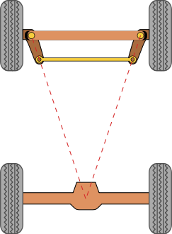](http://upload.wikimedia.org/wikipedia/commons/4/43/Ackermann_simple_design.svg)

Figure 6. Ackermann angle geometry

# Internal Search

The internal search focused on the most successful technologies discovered in the external search and the implementation of these into different concepts. The HPV was broken down into several design projects: frame, wheels, fairing, leaning, and steering. All other components pertaining to the complete manufacturing of the HPV were exempt because of time, budget, and design limitations.   
  
**Frame Design**  
 Previously, PSU HPV teams have made both recumbent three-wheelers and recumbent two-wheelers. Through testing of these older designs, it was discovered that the two wheelers were very unstable at low speeds. Low speeds and stops/starts are very important in the utility endurance event of the competition. Another key weakness of two wheel designs is the amount of practice necessary to use them. Since some of the race team is likely to see only a small amount of practice time, the more stable, three wheeled designs were deemed preferable. For the 2011HPV model, only three-wheeled design concepts were generated.

*Concept 1: Delta Lean-Steer*  
 The concept shown in Fig. 5 is a recumbent delta style lean-steer. The vehicle is front wheel drive with rear wheel steer provided solely by the lean of the vehicle. This is accomplished by the canted pivot of the rear axle and main frame coupled with the tie rod linkage of wheel pivots to the main frame.

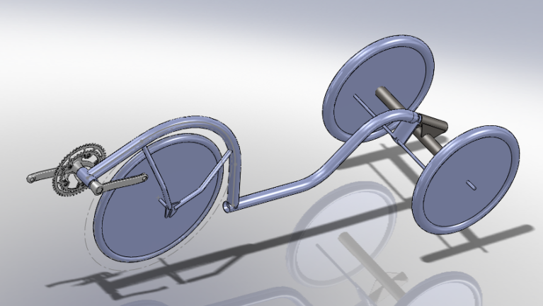

Figure 7. Delta lean-steer

*Concept 2: Tadpole Lean-Steer*  
 The concept shown in Fig. 6 is a rear-wheel drive, recumbent tadpole style lean-steer vehicle with additional external steering controls attached directly to the wheel pivots to control the wheels. These pivots’ movement is constrained by a tie-rod.

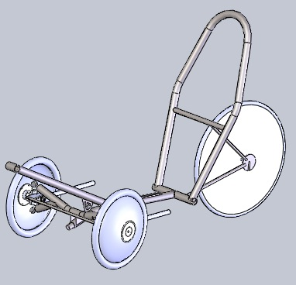

Figure 8. Tadpole lean-steer

This concept includes hub-centered wheels and has a partial lean-steer system where the lean of the rider creates some of the input to steer the vehicle. This steering system gives the rider more control over attitude through turns than a full lean-steer system.

*Concept 3: Tadpole Leaner with Front Suspension*  
 The concept shown in Fig. 7 is a recumbent tadpole style leaner.  The vehicle is rear-wheel drive.  The steering system consists of controls attached directly to the uprights.  The upright’s movement is constrained by a tie-rod.  This concept also includes hub-centered wheels.  The front beam is a wood plank structure that acts as a suspension device.

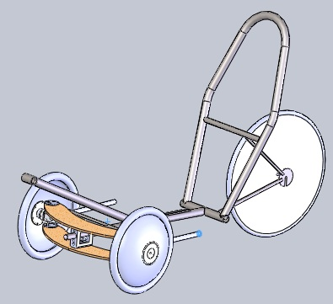

Figure 9. Tadpole leaner with front suspension

## Wheels:

The hub centered wheel was chosen to improve the wheel geometry of the selected tadpole styled tricycle. Aluminum, fiberglass, Kevlar, and carbon fiber were considered for the material. We chose carbon fiber because it is light, rigid, and has a high strength and could be easily formed into a dish shape. A detailed analysis is shown in Appendix E, outlining the deflection and maximum stress under large loading conditions.

**Fairing:**

A fairing is currently still in the concept generation stage and the design concepts have not yet been thoroughly analyzed. The reason for the design selection delay is because of its dependency on other components of the HPV.

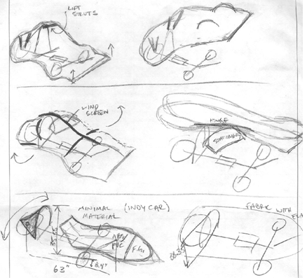

Figure 10. Preliminary fairing concepts

## Steering:

The steering design for the chosen leaning tadpole tricycle must be able to function as the tricycle leans, achieve minimum turn radius, and avoid safety risks.

The first design concept is having the steering positioned beside the seat. This steering system uses side-to-side swing motion of the handle bars to turn the wheels. An example of the design concept is shown in Fig. 9.

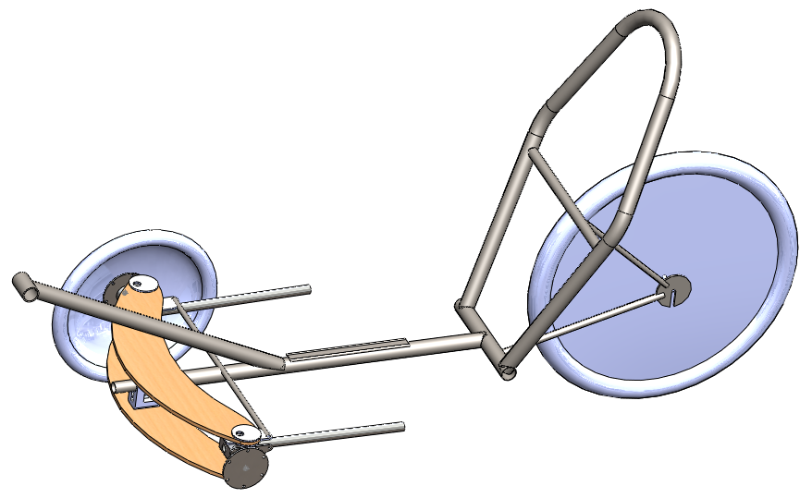

Figure 11. Integrated Swing and Lean steering concept design.

The driver would swing the handle bars right to make a turn. The right turn of the handle, turns the uprights which then turn the fronts of the wheels left. The handle bar swing is independent of the lean motion of the tricycle.

The second design concept is an elliptical steering system. There are two handle bars, and pushing one would cause the other handle bar to want to be pulled towards the driver’s chest. Figure 12 is a model of the design concept.

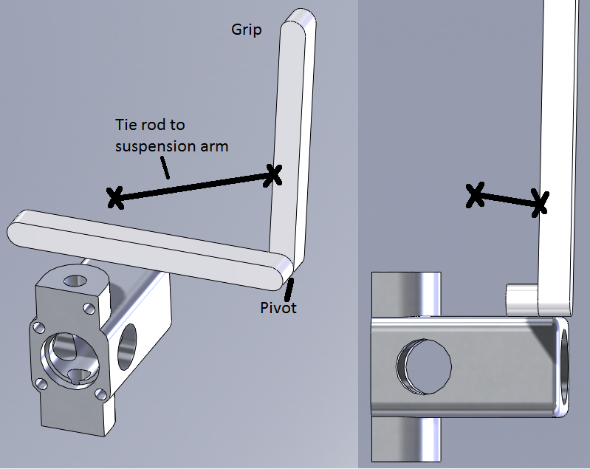

Figure 12. Elliptical steering concept design.

The rotation of the grip handle bar which extends or withdraws the arm connected to the uprights, changes the direction of the wheels accordingly.

The last concept design is kite controlled steering, using two handles which control the orientation of the front axle, with a flexible material, such as a cable, to connect them to the axle. Figure 11 shows a model of the design concept.

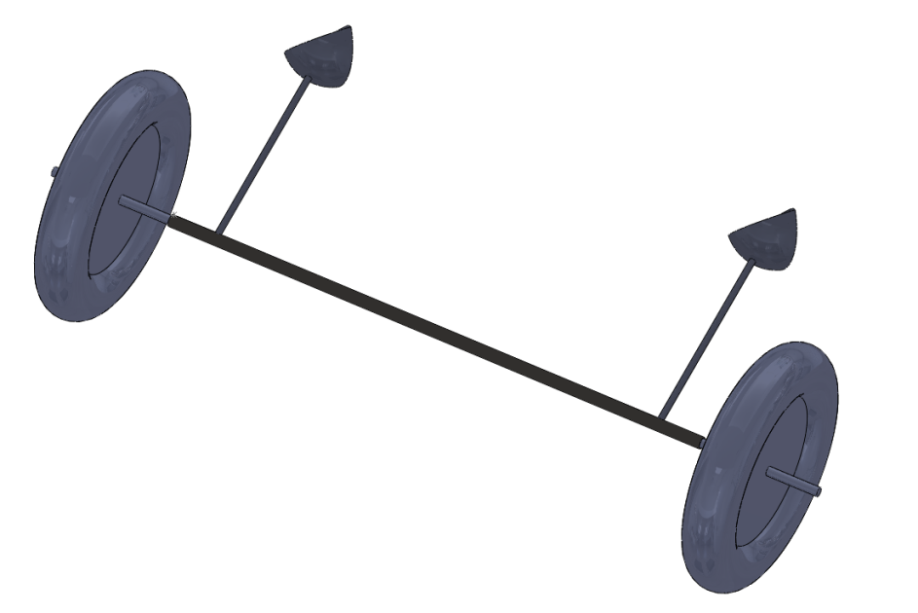

Figure 13. Kite controlled steering design concept.

The design is dependent on the lean of the tricycle and adjusts to the driver’s position.

## Centering:

The chosen design should allow the rider to lean into a turn. Without some restoring force, however, this lean could flip a rider all the way over onto his/her side. This means a device is required to store the forces of the lean and be able to use the same forces to return the frame to its upright position.

The first design concept is the torsion spring. The torsion spring would store the energy from the driver’s lean and its reaction forces. Figure 14 shows the concept design of the torsion spring. Energy is the force times a distance and therefore the design must incorporate an energy absorbing apparatus.

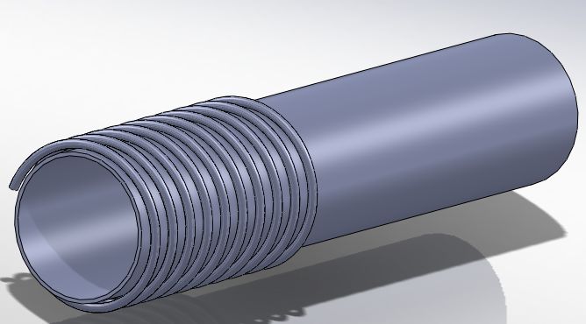

Figure 14. Concept drawing of torsion spring return

As the frame bar twists as the driver leans into a turn, the torsion spring stores the energy of the twist and recoils the frame back to its vertical position once the driver is out of the turn.

The second design concept is the pair of springs. This design functions much like the torsion spring but relies on displacement rather than twist. As the rotation of the lateral member increases, greater displacement of the springs occur, increasing the potential energy in the system. Figure 15 shows the concept design of the pair of springs.

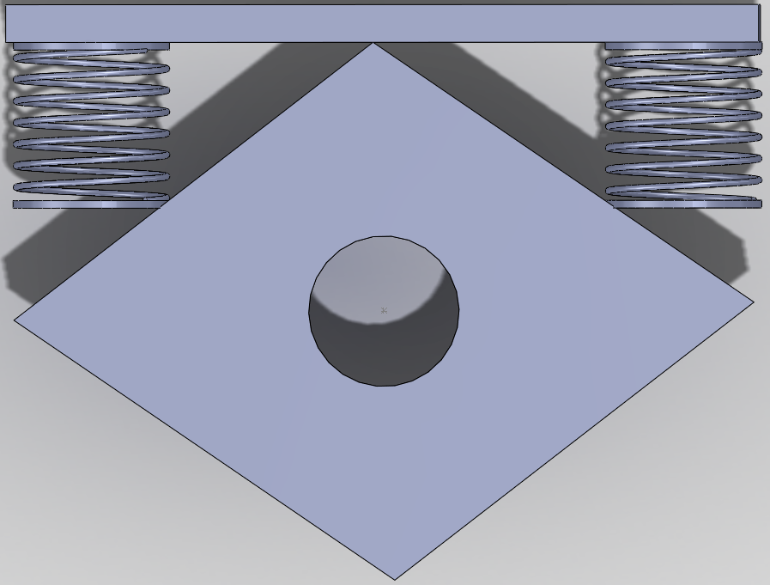

Figure 15. A pair of springs for the frame centering design concept

The third design concept is the using a leaf spring which functions similarly to the spring pair design. Shown below is a leaf spring operating when the frame is in a lean.

The both sides of the leaf spring are the storing energy from the torque applied by the lean. As the vehicle turns (left/right) the (left/right) side contacts the (top/bottom) of the boards and the (left/right) side contacts the (top/bottom) of the boards, storing the strain energy.

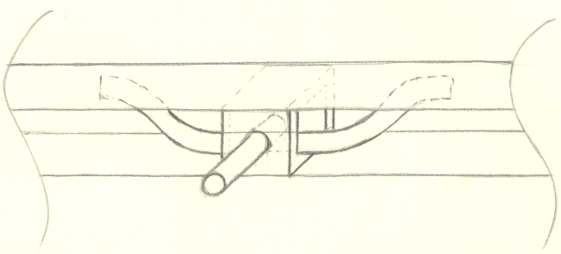

Figure 16. Concept drawing using a leaf spring to center the frame with the horizontal members as wooden supports for contact.

# Design Selection and Evaluation

The team considers safety, manufacturability, maintenance, implementation, function, and cost to be important qualities of the HPV design. These concepts are graded on a numerical scale with 1 being the lowest and 5 being the highest.  Lower-level components were evaluated on a +/- scale with a total positive score being important and a total negative score being unimportant. The decision matrix of the HPV top-level and lower-level design is shown in Fig. 17. The design team selected a three-wheel leaner with independent steering based on the total values of each component. A suspension device, hub-centered wheels, and a fairing were lower-level components that showed to be important.              The team selected the tadpole-style leaner concept because of the independent steering and suspension capabilities.

|  |  |  |  |  |  |  |  |  |  |  |  |  |  |  |
| --- | --- | --- | --- | --- | --- | --- | --- | --- | --- | --- | --- | --- | --- | --- |
|  | Rules | Weight | reliability | Looks | Top speed | Corner | Comfort | Safety | Ease of use | $ | Manuf | Maint | Simplicity | **Totals** |
| importance | 5 | 3 | 4 | 2 | 3 | 5 | 2 | 5 | 4 | 2 | 3 | 1 | 3 |  |
| 2 wheel | 3 | 5 | 5 | 3 | 5 | 3 | 4 | 3 | 2 | 5 | 3 | 5 | 5 | 156 |
| 3 wheel rigid | 3 | 4 | 4 | 4 | 4 | 4 | 3 | 4 | 3 | 4 | 3 | 4 | 4 | 154 |
| **3 wheel indep. steer** | **3** | **3** | **4** | **5** | **4** | **5** | **5** | **5** | **4** | **4** | **3** | **3** | **4** | **170** |
| 3 wheel integrated | 3 | 3 | 3 | 5 | 4 | 5 | 5 | 5 | 5 | 4 | 3 | 3 | 3 | 167 |
| Assist | -1 | -1 | - | 1 | 1 | - | 1 | - | 2 | -1 | -1 | -1 | -1 | -2 |
| **Hub Centered Wheel** | **-** | **1** | **-** | **1** | **-** | **1** | **-** | **-** | **-** | **1** | **-1** | **-** | **-1** | **6** |
| FWD | - | -2 | -1 | 1 | -1 | -1 | - | - | - | 1 | -1 | -2 | -2 | -27 |
| **Suspension** | **-** | **-1** | **-** | **1** | **-** | **-** | **2** | **1** | **1** | **1** | **-1** | **-1** | **-1** | **3** |
| **Fairing** | **1** | **-1** | **-1** | **1** | **2** | **-** | **1** | **1** | **-1** | **2** | **-1** | **-** | **-1** | **7** |

Figure 17. HPV frame decision matrix

# Progress Conclusion

In conclusion, the 2011 Portland State University HPV team is on track to deliver the prototype vehicle by the April 30th testing deadline. At this time construction is roughly 30% complete. Though we are slightly behind schedule because the steering, centering, seat, and plank casting are not designed in detail these delays are minor and the race team will still have time to ride the vehicle before competition. With a more formalized schedule, we are now adhering to more rigid deadlines. We will be finished with frame construction and test wheel lay-up by March 11th and can then move on to finalizing the details of systems that are incomplete. Documentation is 50% complete and will be finalized approximately one month prior to the HPVC (by April 11th, 2011).

# References

ASME. *Human Powered Vehicle Challenge.* 2011. http://www.asme.org/Events/Contests/HPV/Human_Powered_Vehicle.cfm (accessed March 7, 2011).

Frank P. Incropera, Davod P. DeWitt, Theodore L. Bergman, Adrienne S. Lavine. *Fundamentals of Heat and Mass Transfer.* Hoboken, New Jersey: John Wiley & Sons Inc., 2007.

Raul F. Reiser II, Michael L. Peterson, and Jeffrey P. Broker. "Anaerobic Cycling Power Output with Variations in Recumbent Body Configuration." *Journal of Applied Biomechanics*, 2001.

Wianecki, Rick. *Rick Wianecki's Leaning Trike Project.* March 26, 2002. http://www.recumbents.com/wisil/wianecki/leaning_trike3.htm (accessed March 6, 2011).

|  |  |  |  |  |  |  |
| --- | --- | --- | --- | --- | --- | --- |
| Appendix A: Product Design Specifications Table The Product design specifications are listed below in Table A-1. The top-level criteria are highlighted. | | | | | | |
| ***Priority*** | ***Requirement*** | ***Customer*** | ***Metric*** | ***Target*** | ***Target Basis*** | ***Verification*** |
|  | | | | | | |
| Performance | | | | | | |
| 3 | Top Speed | ASME/Self | Mph | 40 mph | Industry Expert | Testing |
| 3 | Acceleration | ASME/Self | Mph/s | 0-15 mph, 5sec | Industry Expert | Testing |
| 3 | Maneuverability | ASME/Self | Small turn radius | 15 ft | Competition Rules | Testing |
| 2 | Weight | ASME/Self | Lbs | <40 lbs | Benchmarking | Testing |
| 1 | Fairing (Cross Sectional Area) | ASME/Self | Ft^2 | <4 ft^2 | Benchmarking | Comp. Fluid Dynamics |
| 1 | Fairing (Coef. Of Drag) | ASME/Self | - | <.12 | Benchmarking | Comp. Fluid Dynamics |
| 1 | Braking Distance | ASME | 20ft from 15mph | <20 ft | Competition Rules | Testing |
| 2 | Ground Clearance | ASME/Self | Inches | 7 inch | Industry Expert | Testing |
| 3 | Maximum Stable Speed | Self | Mph | >40 mph | Industry Expert | Testing |
|  | | | | | | |
| Practicality | | | | | | |
| 2 | Comfort | ASME/Self | Yes/no | Yes | Benchmarking | Testing |
| 1 | Packing | ASME/Self | Height x Width x Depth | 4’x4’x8’ | Transport Vehicle | Design Measurements |
| 3 | Ease of Use | ASME/Self | Yes/no | Yes | Benchmarking | Testing |
|  | | | | | | |
| Maintenance | | | | | | |
| 2 | Reliability | Self | Service Life | Yes | Benchmarking | Competition Score |
| 2 | Accessibility to Components | Maintenance | No. of people to refurbish | 2 | Benchmarking | Manufacturing |
| 2 | Availability of Parts | Maintenance | Time until parts are accessible | 2-3 days | Benchmarking | Manufacturing |
| 2 | Uses Standard Tools | Maintenance | Yes/no | Yes | Benchmarking | Manufacturing |
| 2 | Maintenance Interval | Maintenance | Miles | 500 | Benchmarking | Maintenance |
| 2 | Maintenance Time | Maintenance | Minutes | 90 | Benchmarking | Maintenance |
| **Legend: High = 3 Medium = 2 Low = 1**  **Table A-1 (Continued):** Product Design Specifications | | | | | | |
| ***Priority*** | ***Requirement*** | ***Customer*** | ***Metric*** | ***Target*** | ***Target Basis*** | ***Verification*** |
| Materials | | | | | | |
| 1 | Aesthetics | ASME/Self | Visual Appeal | Stunning | Market Analysis | Competition Score |
|  | | | | | | |
|  | | | | | | |
| Documentation | | | | | | |
| 3 | Final Report | ASME/Self | Deadline Date | May 13th | Competition Rules | Course Evaluation /Competition Score |
|  | | | | | | |
| Safety | | | | | | |
| 3 | Visibility (Horizontal) | ASME | Degrees | 180 | Competition Rules | Testing |
| 3 | Visibility (Vertical) | Self | Degrees | >45 | Benchmarking | Testing |
| 3 | Rollover Protection System Top Load | ASME | Lbs | 600 lbs | Competition Rules | Testing |
| 3 | Rollover Protection System  Side Load | ASME | Lbs | 300 lbs | Competition Rules | Testing |
| 2 | Rider Restraint | ASME | Pass/Fail | Pass | Competition Rules | Testing |
| 3 | Frame Safety | Self | Factor of Safety | F.S.>1.5 | Benchmarking | Testing |
|  | | | | | | |
| Budget | | | | | | |
| 3 | Materials/ Fabrication | ASME/SALP | US Dollars | <$3500 | Funding Cap (SALP) | Final Documentation |
| 3 | Travel | ASME/SALP | US Dollars | <$2000 | Funding Cap (SALP) | Final Documentation |

**Legend: High = 3 Medium = 2 Low = 1**

## Appendix B: House of Quality

|  |  |  |  |  |  |  |  |  |  |  |  |
| --- | --- | --- | --- | --- | --- | --- | --- | --- | --- | --- | --- |
| Table B-1: House of Quality | | | | | | | | | | | |
| Customer | | Engineering Requirements | | | | | | | | Competition | |
| Needs | **Importance** | **Speed** | **HPV Geometry** | **Turning Radius** | **Drag** | **Frame Strength** | **Braking Distance (@15mph)** | **High-Speed Stability** | **Low-Speed Stability** | **2010** | **2008** |
| Performance | ***10*** | ***\*\*\*\*\**** | ***\*\*\*\*\**** | ***\*\*\*\*\**** | ***\*\*\*\*\**** | ***\*\*\*\**** | ***\*\*\*\**** | ***\*\*\*\**** | ***\*\*\*\**** | ***\*\*\*\*\**** | ***\*\*\*\*\**** |
| Material | ***8*** | ***\*\*\**** | ***\*\*\*\*\**** | ***\**** | ***\*\**** | ***\*\*\*\*\**** | ***-*** | ***-*** | ***-*** | ***\*\*\*\*\**** | ***-*** |
| Weight | ***7*** | ***\*\*\*\*\**** | ***-*** | ***-*** | ***-*** | ***\*\*\*\*\**** | ***\*\*\*\*\**** | ***\*\**** | ***\*\**** | ***\*\*\*\*\**** | ***\*\*\*\**** |
| Shape | ***5*** | ***\**** | ***\*\*\*\*\**** | ***-*** | ***\*\*\*\*\**** | ***\*\*\**** | ***-*** | ***-*** | ***-*** | ***-*** | ***-*** |
| Cost | ***10*** | ***\*\*\**** | ***-*** | ***-*** | ***\*\*\*\**** | ***\*\*\*\**** | ***\*\*\**** | ***\*\*\**** | ***\**** | ***\*\*\**** | ***\*\**** |
| Safety | ***10*** | ***\*\*\**** | ***\*\**** | ***-*** | ***-*** | ***\*\*\*\*\**** | ***\*\**** | ***\*\*\*\*\**** | ***\*\*\**** | ***\*\*\**** | ***\*\*\*\*\**** |
| Ergonomics | ***3*** | ***-*** | ***\*\*\*\*\**** | ***\*\**** | ***\*\**** | ***-*** | ***-*** | ***\*\*\**** | ***\**** | ***\*\*\**** | ***\**** |
| Aesthetics | ***2*** | ***-*** | ***\*\*\*\*\**** | ***-*** | ***\*\*\**** | ***\*\**** | ***-*** | ***-*** | ***-*** | ***\*\*\**** | ***\**** |
| Maintenance | ***4*** | ***-*** | ***\*\*\**** | ***-*** | ***\**** | ***\*\*\*\*\**** | ***\**** | ***-*** | ***-*** | ***\*\*\**** | ***-*** |
| Competition | | | | | | | | | | | |
| 2008 |  | ***45 mph*** |  | ***<25ft*** | ***<.14*** | ***1.5*** | ***<20ft*** | ***<5 degrees*** | ***N/A*** |
| 2010 |  | ***35 mph*** | ***-*** | ***<25ft*** | ***<.1*** | ***1.5*** | ***<20ft*** | ***-*** | ***-*** |
| Target(2011) |  | ***40 mph*** | ***-*** | ***<15ft*** | ***<.12*** | ***1.5*** | ***<20ft*** | ***-*** | ***-*** |
| Legend: High Importance = ***** Low Importance = * | | | | | | | | | |

## Appendix C: Fairing Computational Fluid Dynamics

Comsol Multiphysics CFD software package was used to generate flow fields around fairing models to determine coefficient of drag, Cd, of fluid on fairing for design selection.

**Restrictions of fairing design**

* Width of roll bar (23.5 in)
* Height of toe-box (lowest point of heel to highest point of toe in a rider’s pedaling motion) must be a minimum of 27 inches
* Clearance from ground (2.5 in)
* Height of roll bar from ground (42 in)
* Length of 10 ft. due to transportation restrictions

**Assumptions:**

ρ = 1.2 kg/m2 (density of air)

Vmax = 15 m/s

Area = 0.5891 m2 (frontal area)

Based on the restrictions above, a fairing model was generated and placed in a fluid domain. The selection of 10m x 5m x 5m was used to allow proper development of flow without sidewall interactions based on the assumption that far field effects of fluid flowing around object are assumed to be zero at a magnitude of 10 radii away. Inlet velocity of 15 m/s and outlet boundary condition set to zero pressure (Pa) where chosen. No-slip boundary condition was selected for the surface of the fairing and moving wall boundary conditions on all remaining boundaries. The moving wall condition was selected to be 15 m/s to simulate the rider traveling in still air at 15 m/s down the course. Stationary solver was used due to computational time restriction. Since drag is not time dependent, the stationary solver was valid.

As can be seen in Fig. 1, proper development of a velocity field around an elliptical, smooth body is shown. Stagnation points at the very tip of the nose, as well as velocities as low as 2 m/s behind the tail were calculated, and matches flow theory. Turbulence can be seen by the streamlines at the trailing end of the fairing.

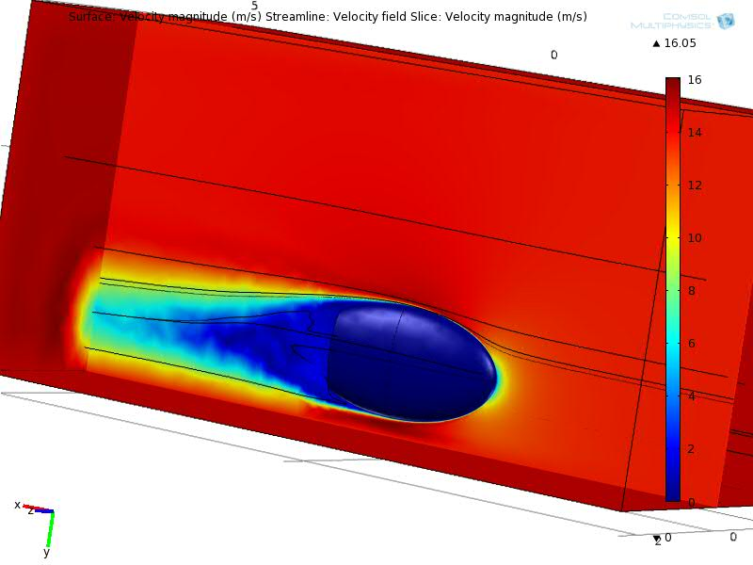

Figure C-1. Velocity profile of fairing traveling at a velocity of 15 m/s. Moving wall boundary conditions are used to simulate rider traveling at 15 m/s in still air. Streamlines show fluid path around fairing.

**Determining the coefficient of drag**

To determine the coefficient of drag on the fairing, we integrated pressure force over the front area of the fairing. This value becomes the drag force, Fd, in Eqn.C-1 (Incropera, 2007).

(C-)

With Fd given by CFD model and all other constants known, we then found our coefficient of drag, Cd on our fairing. Theoretical values of Cd for streamline bodies are given as 0.06. Our design model showed a value of 0.0675 for Cd. A 12.5% error between theory and calculated values was shown to exist. We know this value will increase as our fairing design changes and gets further way from perfectly streamlined bodies. The design above was used to help validate the CFD model. All wheel cutouts and imperfections were neglected for validation purposes.

Further analysis will be carried out on multiple fairing designs to determine which design is best suited for our need. It has yet to be determined if the weight and cost of the fairing will outweigh the benefit of increased aerodynamic performance.

## Appendix D: FEA Analysis of Rollbar/Frame and Carbon Fiber Wheels

The roll bar of the vehicle is meant to protect the rider in a crash and as such needs to meet certain strength requirements.  Static test guidelines are provided by ASME in the HPVC rules as follows in Fig. D-1.

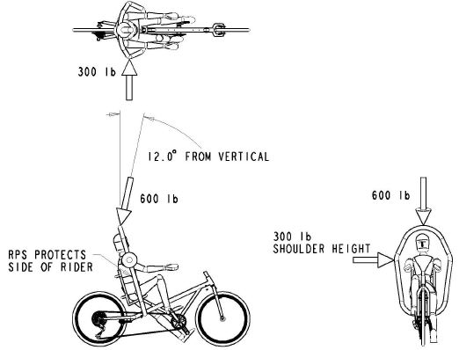

Figure D-1. Loading diagram for Rollover Protection System (RPS) from the HPVC rules. (ASME 2011)

Restraint of the frame during loading is left to the discretion of the design team, but “shall be reacted by constraints on the vehicle chassis in locations that represent the actual chassis loading in an inverted or side position with riders strapped in and clipped in to the pedals.” (ASME 2011)

Roll Bar and Frame:

To analyze the strength and rigidity of the roll bar design, a model of the frame was constructed in Abaqus finite element software from 3D, quadratic formulation, beam (B32) elements and subjected to a simulation of the tests specified by the competition rules. Boundary conditions imposed were x,y,z translational restraint where the seat stays meet the seat brace, and x,y translational restraint where the seat will be mounted to the main tube. These reflect the points that would be active in restraining the rider to the vehicle in a rollover. The first load applied was a 600lb concentrated force at the top of the roll bar, 12° from vertical, downward and toward the rear of the vehicle as specified by the competition rules. The second was a 300lb concentrated force applied horizontally at the widest point of the roll bar. These loads were applied separately, but Fig.D-1 shows these conditions together for simplicity.

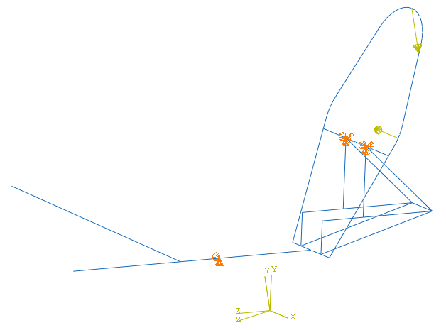

Figure D-1. Boundary conditions and loads. The two coordinate systems (CS) are the part global CS and the load CS that was rotated by 12° to orient the top load at the correct angle.

The part was meshed at a refinement level to adequately include behavior of the curved sections as seen in Fig. D-2.

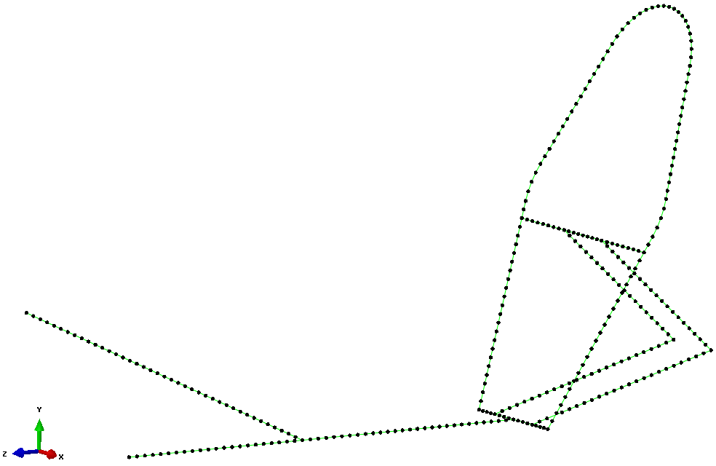

Figure D-2. Part mesh of 163 elements

Several plots were created from the results of the simulation. . Figure D-3 shows the deflection of the frame in each direction under loading conditions.

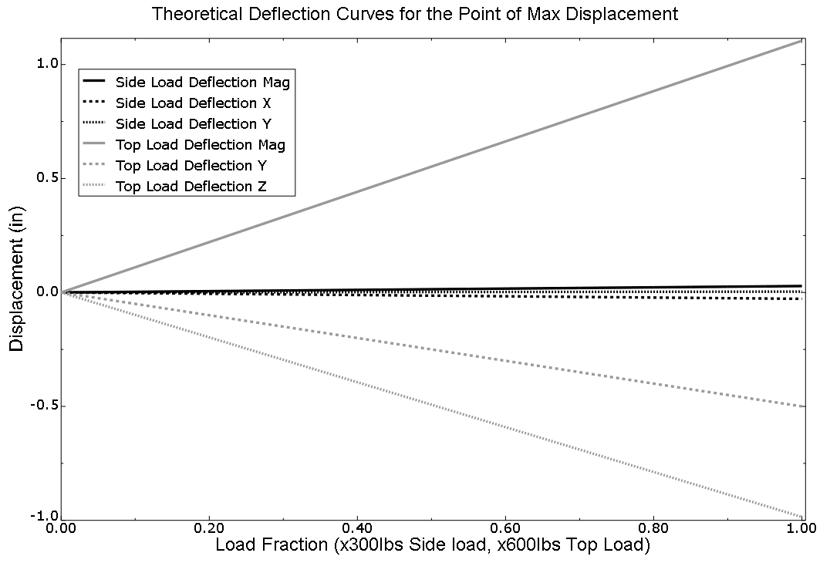

Figure D-3. Deflection behavior of frame under top and side loading.

The theoretical stress at the stress concentration is shown in Fig. D-4.

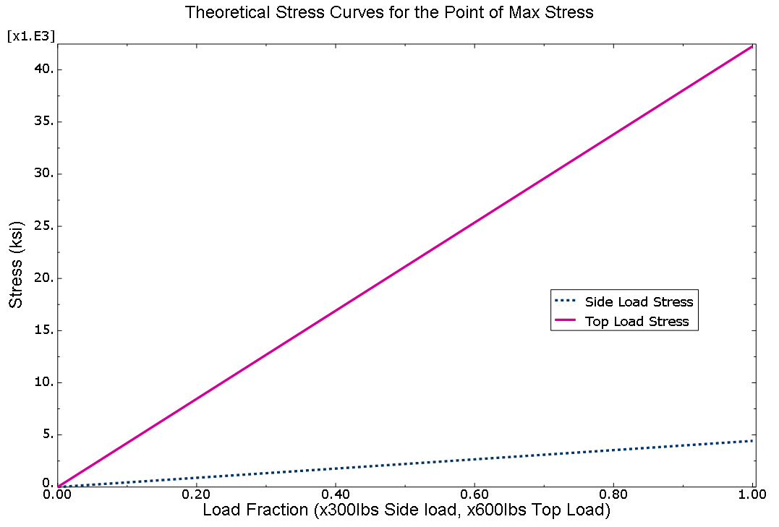

Figure D-4. Stress behavior of frame at stress concentration site.

Deformed properties from the top load were found to be: maximum stress of 42.3ksi, maximum deflection of 1.104”magnitude, -.985” Z (rearward), -.500” Y (downward). From the top load, these properties were: maximum stress of 4.4ksi, maximum deflection of 0.028” almost exclusively in the -Y direction. These maximum stresses are well below the 60ksi yield stress of the material (FS = 1.41).

The shape during loading and locations of the maximum deflections and stresses are depicted in

Fig. D-5.

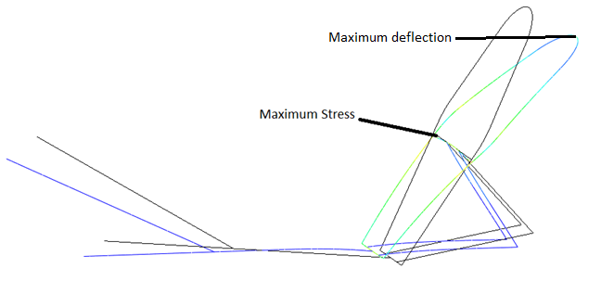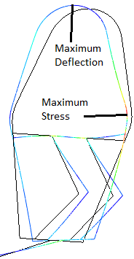

Figure D-5. Deformed shape (exaggerated) and location of maximum stress for the \top loading (left) and side loading (right)

## Appendix E: FEA Analysis of Carbon Fiber Wheels

Given:

The part to be modeled and tested is a heavily dished carbon fiber shell wheel with an aluminum rim. It is to be made of a layup of unidirectional carbon fiber strips onto the rim in a patterned epoxy resin composite. Material properties have been found from supplier documentation to be those shown in Table D-1.

Table D-1. Material data as supplied

|  |  |  |  |  |  |  |
| --- | --- | --- | --- | --- | --- | --- |
| Material | E,x (GPa) | E,y (GPa) | ■ | G,xy (GPa) | G,xz (GPa) | G,yz (GPa) |
| Carbon Layup | 135 | 10 | .3 | 5 | 5 | 5 |
| Aluminum | 70 | NA | .33 | NA | NA | NA |
| Bulker Foam | 5 | NA | .4 | NA | NA | NA |

Geometry is to be that imported from the 3D Solidworks models used for part form design. Load is a 600lb load transverse to the wheel plane at the rim to simulate double the maximum expected reaction force from the road in hard cornering.

Find:

1. Maximum stress and its location, as well as a factor of safety
2. Maximum deflection and its loaction

A model was created with Abaqus CAE software from 8-node, doubly curved, quadratic formulation shell (S8R) elements. Boundary conditions imposed were x,y,z translational restraint of the locations of the surface to be restrained in testing. Load applied was a 600lb shell edge load along a 45mm section of the rim edge, parallel to the axis of the wheel.

Results from this model show a maximum deflection in the load application region of 7.05mm as shown by Fig. D-6.

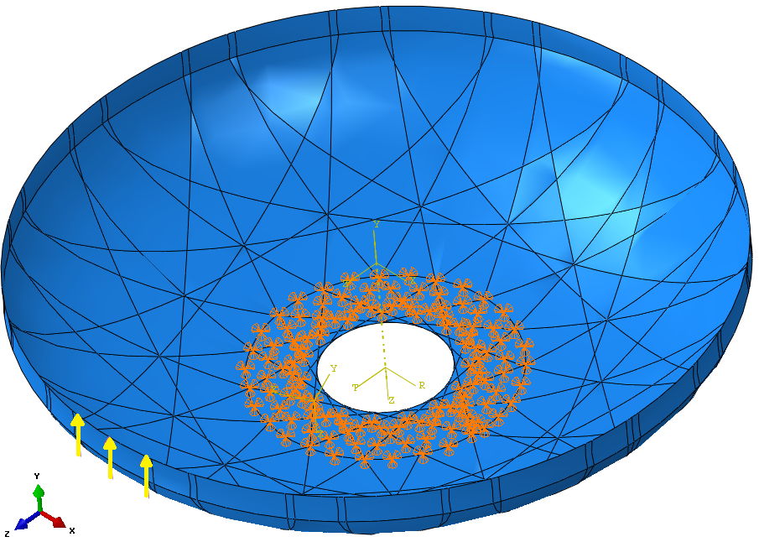

Figure D-6. Boundary conditions and load.

The part was partitioned into regions, which are visible in Fig. D-6, and is based on the edges of the unidirectional carbon strips to be laid on the part. The section of the shell was created using the Composite Layup feature, which enabled the placement and orientation of the strips of carbon to be described, rather than specifying the section and fiber direction combination of each individual region.

A Medial axis free mesh of 5570 elements, 16,730 nodes was used, a segment of which is shown in

Fig. D-7.

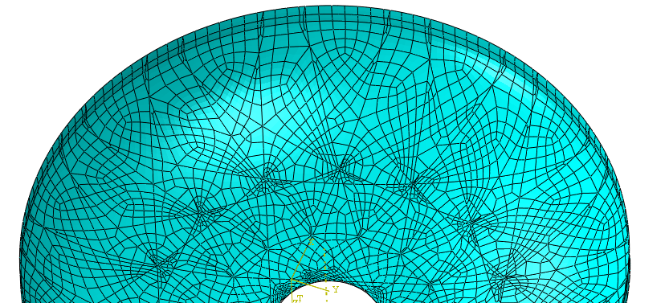

Figure D-7. Representative segment of the mesh used. The areas of high concentration of small elements were inevitable since small element regions were created by the partition line intersections.

Maximum stresses found at the discontinuities where elements are “pinched” as shown in Fig. D-8 were disregarded. Reliable, even field maximum stresses were found to be around 260MPa in locations shown in Fig. D-8.

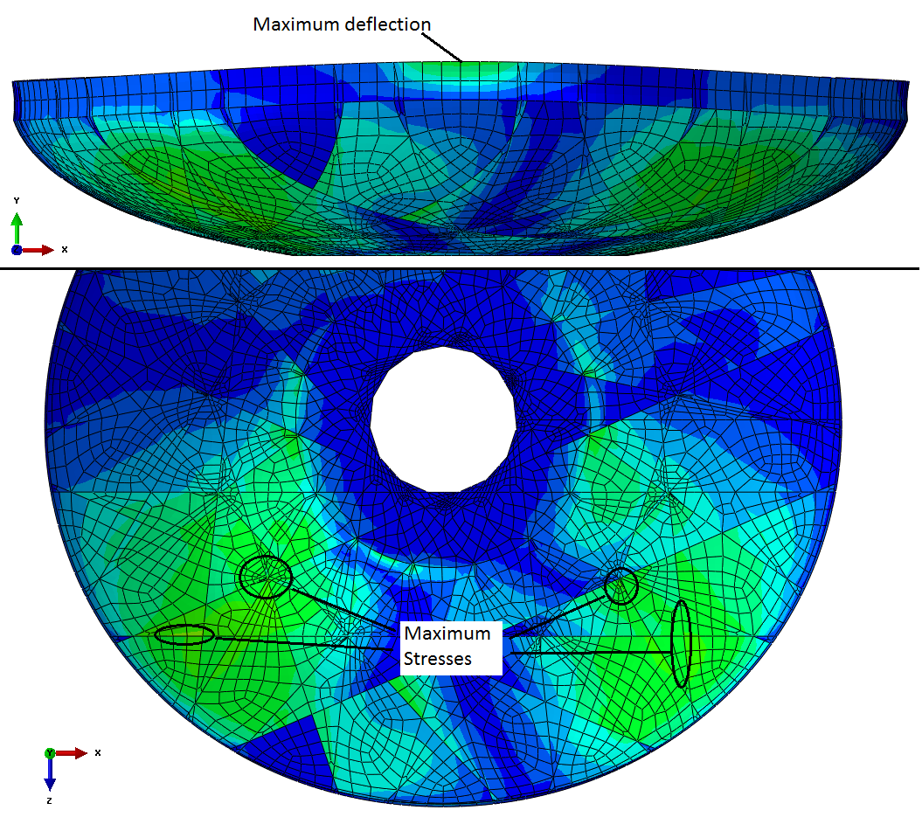

Figure D-8. Areas of maximum stress and deflection. Circled areas of maximum stress indicate where the actual peak stresses occurred, but large parts of the lighter areas in the figure showed stresses within 20% of the maximums.

The analysis also yielded the deflection/load plot of Fig. D-9.

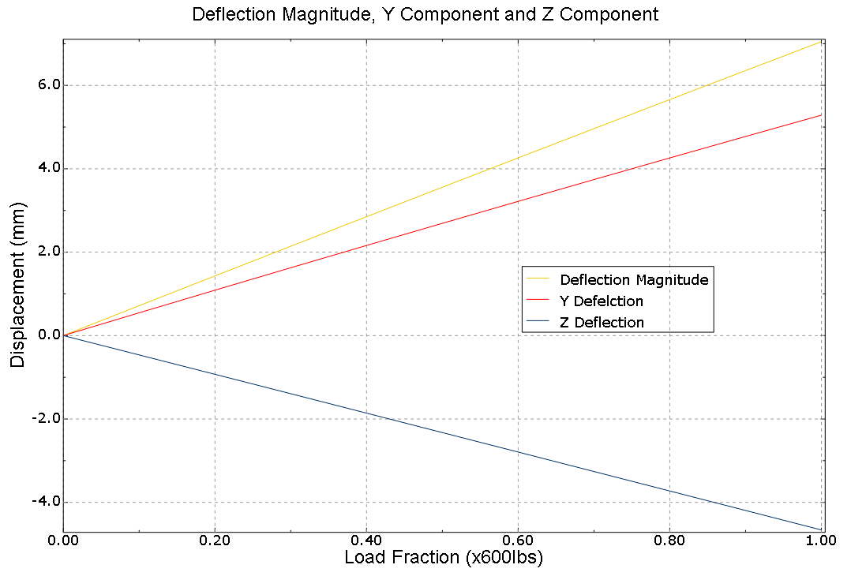

Figure D-9. The load curve in magnitude and components.

Using a typical tensile strength of 2,700MPa as provided by the manufacturer, the maximum stresses give a factor of safety of over 10. This is a very large safety factor, especially since the load applied is already twice the expected load, but the decision was made to proceed with this design since a decrease of rigidity would be detrimental.