**Contrast**

Our eyes always get drawn to contrast. Hence, we should decide the most important point on a slide and use contrast to draw attention.

Good contrast design makes “eye navigation” easier.

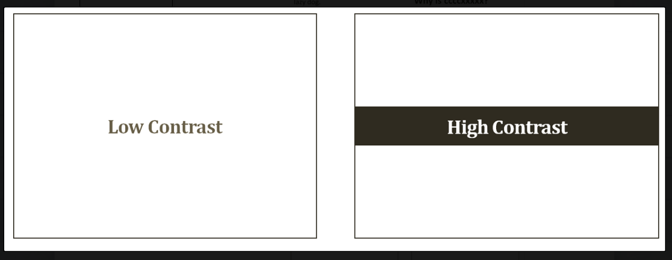

**Low contrast**

The contrast is poor in the following page. Whenever there is so much text in a design, you need a strong contrast to focus the eyes on the main point. There are many elements which get our attention and nothing stands out well. The eye movement is haphazard here.



**High Contrast**



The eye movements are well planned here. After we have looked at the product, our eyes move to the brand name (because of its larger bolder font), then to the header text (larger font size and blue color) and then to the bunch of text above Neutrogena. This contrast helps readers navigate better. It also focuses the readers on the brand name.

**Proximity**

On a slide there are many elements (images, text). The elements which are related should be placed together (physically closer) on the slide. The elements which are not related should never be placed together. Physical closeness (proximity) implies a relationship.



Related materials are not well-grouped (poor proximity)

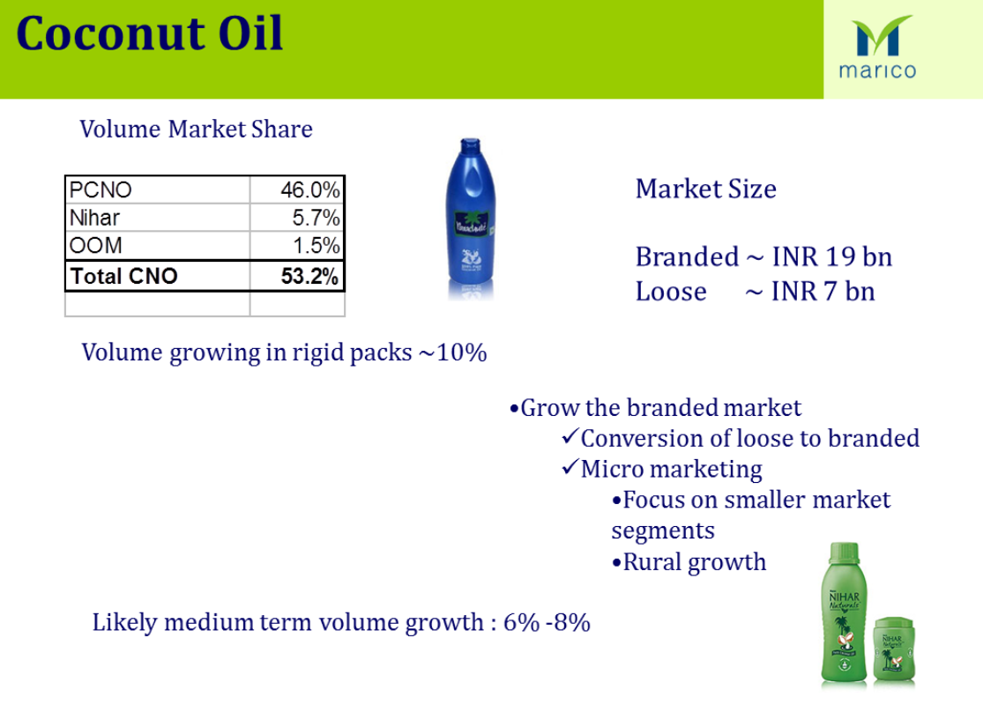

**After grouping the main elements together (Market Share, Market size, and images)**

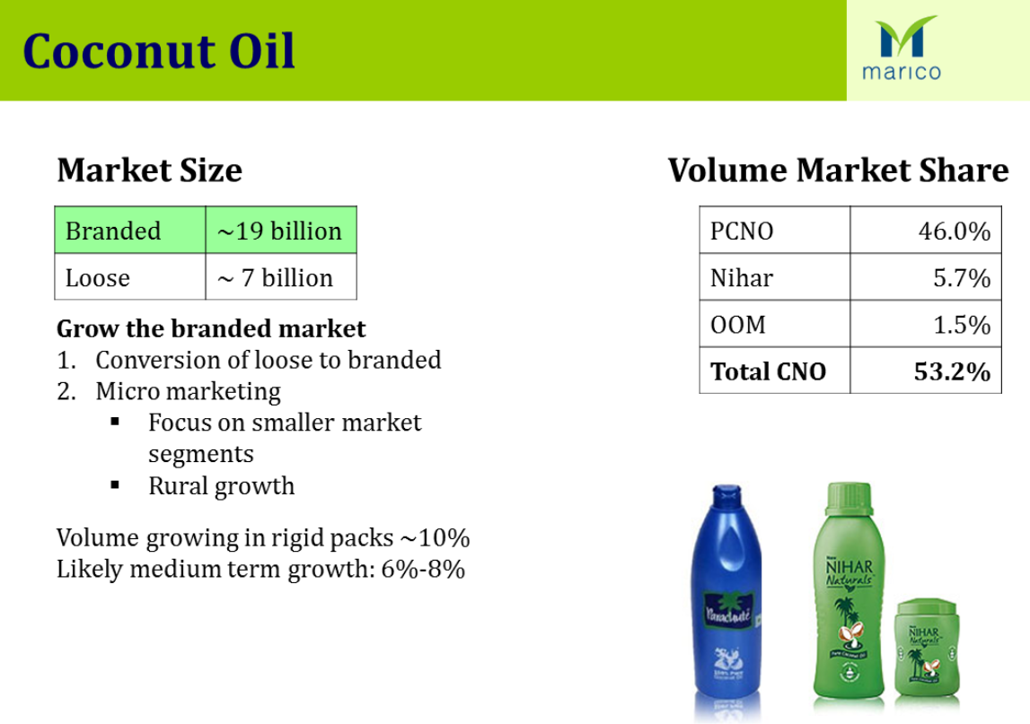

**Repetition**

This principle of good design states that we repeat some aspects of the design throughout the presentation. It helps organize information and guides your reader through the presentation.  
  
How to apply this principle  
  
1. Use a template so that the looks across all slides remain the same.  
2. Use the same font size across all slides (one size of header and one for body text).  
3. Use the same font type across all slides.  
4. Use the same font color across all slides.  
5. Use the same color scheme for all tables & charts (graphs) across all slides.

There can be a repetition within the slide as well. Look at this newspaper ad and find out what is being repeated here and how is it affecting the audience?



The element that is being repeated is the color green. This adds to our definition of element in the first post. An element on a slide is a text, an image, a combination of text and image or color of image or text. The green color which comes at the top and bottom is making sure your eye stays on the slide for more time and it alternates between the top and bottom. This way we spend more time reading the ad.

**Alignment**

Every element on the slide should have a visual connection with other elements on the slide. A slide which has all the elements aligned gives a more cohesive look. It appeals more to the eye.

