Strength of Materials and Failure Theories

State of Stress

σ_{x}
τ_{xy}
σ_{y}
σ_{z}
This is a 2D state of stress – only the independent stress components are named. A single stress component σ_{z} can exist on the z-axis and the state of stress is still called 2D and the following equations apply. To relate failure to this state of stress, three important stress indicators are derived: Principal stress, maximum shear stress, and VonMises stress.

Principal stresses:
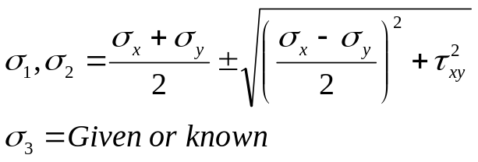
If σ_{y}=0 (common case) then
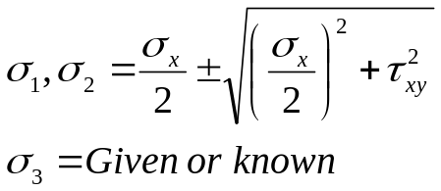
If σ_{x} = σ_{y}=0 then σ₁ = σ₂ = +/− τ_{xy}. If σ_{y}= τ_{xy} = 0, then σ₁ = σ_{x} and σ₂=0.

Principle stresses (₁,₂) can be both positive, both negative, or one positive and one negative. ₃ can also be positive or negative.

Maximum shear stress.
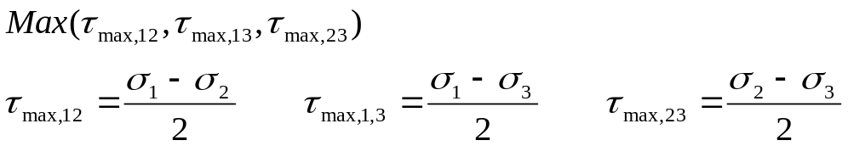
If σ₃=0, the
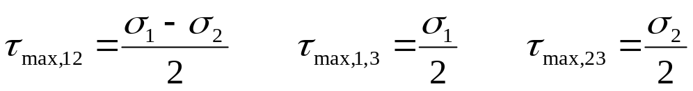

The Vom Mises stress:
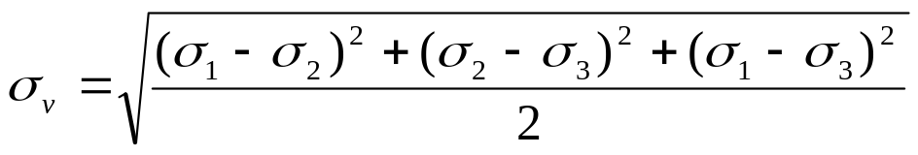
When σ₃=0, the von Mises stress is:
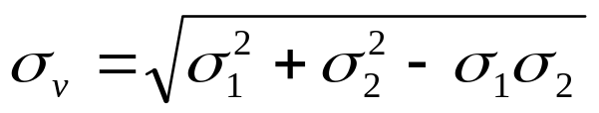
When only σ_{x}, and τ_{xy} are present (as in combined torsion and bending/axial stress or pure torsion), there is no need to calculate the principal stresses, the Von Mises stress is:
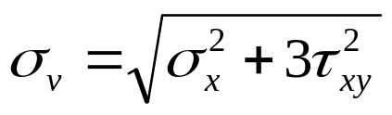
Note that in pure shear or pure torsion σ_{x} =0. If σ_{x} =0, then
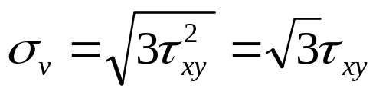

According to distortion energy theory, yielding occurs when σ_{v} reached the yield strength S_{y}. Therefore in pure shear, yielding occurs when τ_{xy} reaches 58% of S_{y}.

Common loading applications and stresses (when oriented properly)

Direct Tension/Compression (only σ_{x})

Beam bending (only σ_{x} on top/bottom)

Pure torsion (only τ_{xy} )

Rotating shafts (bending + torsion) – (σ_{x} and τ_{xy})

Problem #S1
A member under load has a point with the following state of stress:
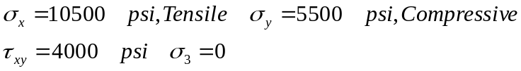
Determine σ₁, σ₂, τ_{max} (Ans: 11444 tensile, 6444 Compressive, 8944 psi)
σ_{x}=10500
τ_{xy}=4000
σ_{y}=5500
Strain (one dimensional)

A bar changes length under the influence of axial forces and temperature changes.
Final Length
Original Length
L
ΔL
Total strain definition:
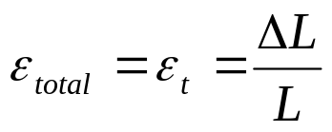
Total strain is a combination of mechanical and thermal strains:
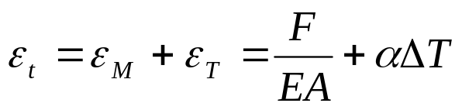
Both the mechanical and the thermal strains are algebraic values. T is positive for an increase in temperature. F is positive when it is a tensile force.

Problem #S2
The end of the steel bar has a gap of 0.05” with a rigid wall. The length of the bar is 100” and its cross-sectional area is 1 in². The temperature is raised by 100 degrees F. Find the stress in the bar. ANS: 4500 Psi Compressive.

100
0.05
Bending of “straight” beams

Bending formulas in this section apply when the beam depth (in the plane of bending) is small (by at least a factor or 20) compared to the beam radius of curvature.
x
y
F_{y}
z
y
F_{z}

Bending stress for bending about the Z-axis:

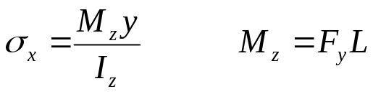
I_{z} is area moments of inertias about the z and represents resistance to rotation about z axis. Bending stress for bending about the Y-axis:

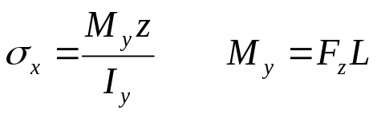
I_{y} is area moments of inertias about the y and represents resistance to rotation about y axis. Use tables to look up moments of inertia for various cross-sections. The parallel axis theorem can be used to find moment of inertia w/r a parallel axis. When both F_{y} and F_{z} exit, use superposition to find _{x}

Problem #S3

The solid circular steel bar with R=2” (diameter 4”) is under two loads as shown. Determine the normal stress σ_{x} at point Q. Point Q is on the surface closest to the observer and the 2000 lb goes into the paper.
6 ft
4.5 ft
4.5 ft
20000 lb
2000 lb
Q
[The most common stress analysis problems involve simple bending, simple torsion, or a combination of the two. This is an example of the combination – the torsion analysis would be treated later.]

Answer: 15600 psi

Problem #S4

A beam with the cross-section shown is under a bending moment of FL=M_{z}=10000 lb-in acting on this cross-section. The thicknesses of all webs are 0.25 inches.

Determine:
a) The location of the neutral axis (0.667 from bottom)
b) The moment of inertia about the z-axis (0.158 in⁴)
c) Bending stress at D (52700 psi)
d) Solve part b) if the cross-section was H-shaped

[Finding area moments of inertias are popular questions. This problem is a little longer than typical ones but it is a good preparation exercise]
7/8
3/8
1.5
D

Bending Stresses in Curved Beams
r_{i}
r₀

r_{n}

M

Maximum bending stresses occur at r_{i} and r_{o} - The magnitude is largest at r_{i}

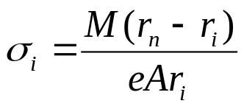
The stress at the outer surface is similar but with r_{o} replacing r_{i}. In this expression, M is the bending moment at the section, A is the section area and e is the distance between the centroidal axis and neutral axis. These two axes are the same in straight beams.
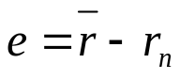
The radius of the neutral axis for a rectangular section can be obtained as:
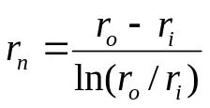

Refer to Shigley or other design handbooks for other cross-sections:
- Circular
- Trapezoidal
- T-shaped
- Hollow Square
- I-Shaped

Note: When finding bending moment of forces, the exact moment arm is r_{n} but the centroidal radius is also close enough to be a good approximation.

For a circular shape with a radius of R, r_{n} is:

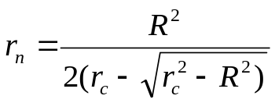

Where r_{c} = R + r_{i}

Check Shigley for other cross-section forms such as T-shaped beams.

Problem #S5

Given: r_{i} = 2 in r_{o} = 4 in
b
b = 1 in
F = 10000 lb

Find: maximum bending stress
Maximum total stress
F
Answer: 57900 psi (bending only)
62900 psi (total)

Torque, Power, and Torsion of Circular Bars

Relation between torque, power and speed of a rotating shaft:

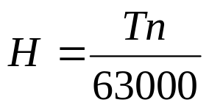
H is power in Hp, T is torque in lb-in, and n is shaft speed in rpm. In SI units:
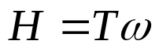
H is power in Watts, T is torque in N-m, and ω is shaft speed in rad/s.

The shear stress in a solid or tubular round shaft under a torque:

T
x
y

The shear stress is a maximum on the surface of the bar. The state of stress can be represented as a case of pure shear:
τ_{xy}
The shear stress is:
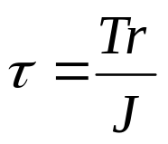
J is the area polar moment of inertia and for a solid (d_{i}=0) or hollow section,
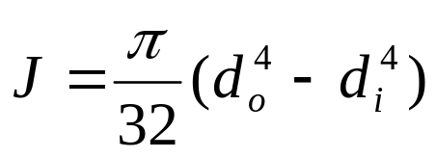

The Von Mises stress in pure shear is:
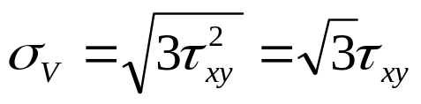
When the behavior is ductile, yielding occurs when σ_{v} reaches the yield strength of the material. This is based on the distortion energy theory which is the best predictor of yielding. According to this, yielding occurs when:
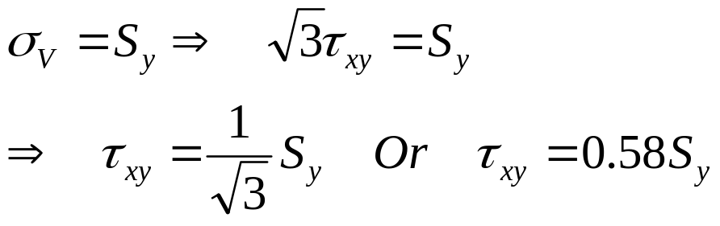
This predicts that yielding in pure shear occurs when the shear stress reaches 58% of the yield strength of the material.

The angle of rotation of a circular shaft under torque

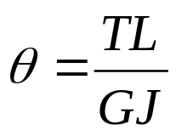
The angle of rotation is in radians, L is the length of the bar, and G is a constant called the shear modulus. The shear modulus can be obtained from the modulus of elasticity E, and the poisson’s ration ν:
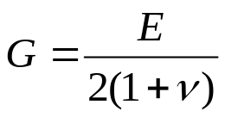
For steels, this value is 11.5*10⁶ psi.

Problem #S6

Consider the loading situation shown in Problem #S3. Determine:
- the torsional shear stress for an element on the shaft surface.
- The maximum shear stress at point Q. Use the given (as answer in Problem #S3) maximum normal stress at point Q to estimate the maximum shear stress.
Answers: a) 11460, b)13860

6 ft
4.5 ft
4.5 ft
20000 lb
2000 lb
Q
Beam and Frame Deflection - Castigliano’s Theorem

When a body is elastically deflected by any combination of loads, the deflection at any point and in any direction is equal to the rate of change of strain energy with respect to the load located at that point and acting in that direction – even a fictitious load.

When torsion or bending is present, they dominate the strain energy. The deflection due to torsional and bending loads is:

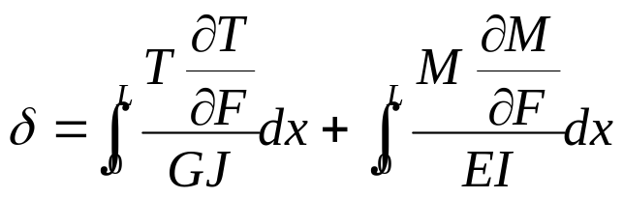

Example: Solid steel tube with ID=1.75 and OD= 2.75 inches. Determine the deflection of the end of the tube.
9 ft
P=100 lb
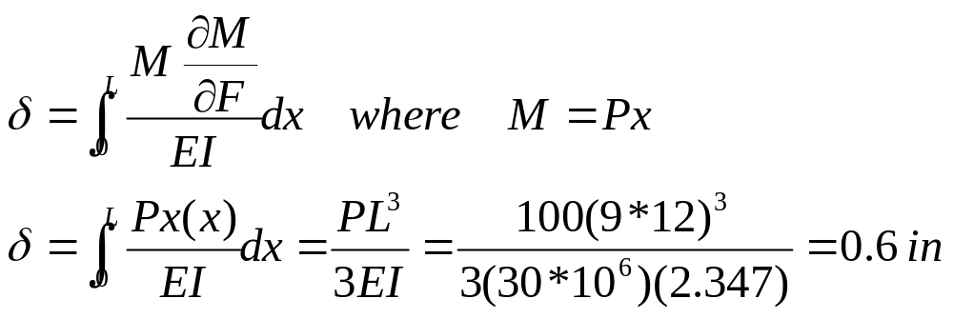

Example: Solid steel tube with ID=1.75 and OD= 2.75 inches. Determine the deflection of the end of the tube.
9 ft = L
P=100 lb
4 ft = L₁
x
Deflection from bending in the 9-ft span
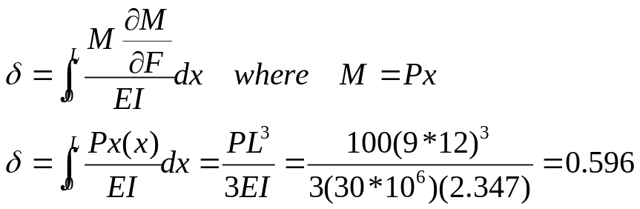

Deflection from bending in the 4-ft span
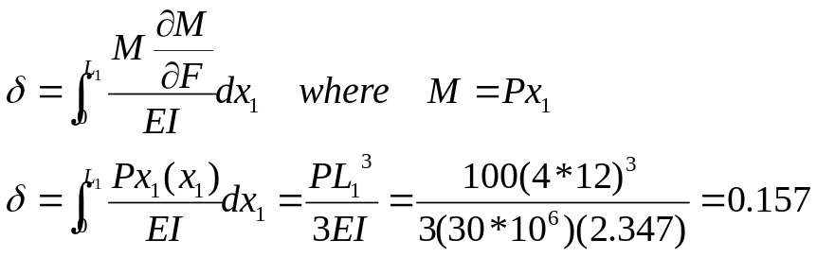

Deflection from torsion in the 9-ft span
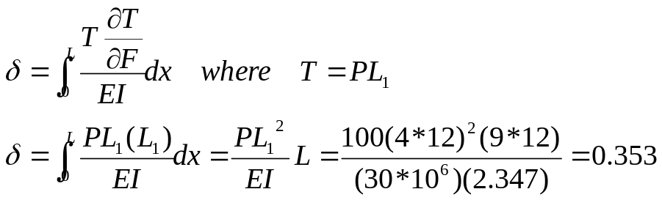

Total Deflection = 0.596 + 0.157 + 0.353 = 1.1 in
Deflections, Spring Constants, Load Sharing

Axial deflection of a bar due to axial loading

The spring constant is:
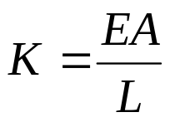

Lateral deflection of a beam under bending load

A common cases is shown. The rest can be looked up in deflection tables.

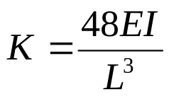
For cantilevered beams of length L:
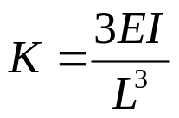
The end of a cantilever beam is 16 times easier to deflect compared to the middle of a simply supported beam of the same length.

Torsional stiffness of a solid or tubular bar is:
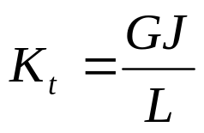
The units are in-lbs per radian.

Load Distribution between parallel members

If a load (a force or force couple) is applied to two members in parallel, each member takes a load that is proportional to its stiffness.
K₂
K₁
F
T
K_{t1}
K_{t2}

The force F is divided between the two members as:
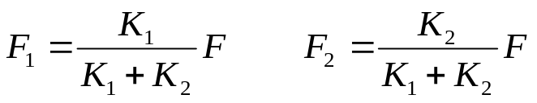
The torque T is divided between the two bars as:
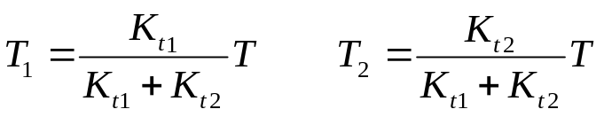

Problem #S7

A one-piece rectangular aluminum bar with 1 by ½ inch cross-section is supporting a total load of 800 lbs. Determine the maximum normal stress in the bar.

30”
20”
Answer: 960 psi

Problem #S8
A solid steel bar with 1” diameter is subjected to 1000 in-lb load as shown. Determine the reaction torques at the two end supports.

6 ft
4 ft

Answer: 600 on the left, 400 on the right.

Direct shear stress in pins

Placing pins in double shear (as in tongue and clevis) is one of the most common method of axial connection of parts.

The shear stress in the pin and bearing stresses are approximately uniformly distributed and are obtained from:
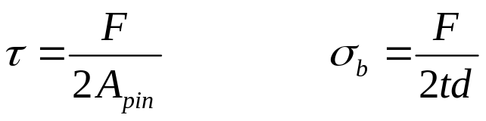
t
The clevis is also under tear-out shear stress as shown in the following figure (top view):
F
F
Tear-out shear stress is:

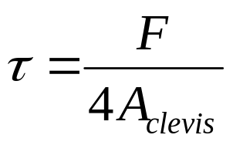
In this formula A_{clevis}=t(R_{o}-R_{i}) is approximately and conservatively the area of the dotted cross-section. R_{o} and R_{i} are the outer and inner radii of the clevis hole. Note that there are 4 such areas.
Shear stresses in beams under bending forces

When a beam is under a bending force, its “layers” are forced to slide on one-another as a deck of cards would do if bent. Since the beam “layers” cannot slide relative to each other, a shear stress develops within the beam just as shear stresses develop between card faces if they were glued together. This is shown below. The shear stress in beams is relatively small and can be ignored for one-piece beams. But for composite beams that are glued, welded, riveted, bolted, or somehow attached together, this shear stress can be significant enough to tear off the welding or shear off the bolts.
F
τ
σ
σ
τ
V

The value of the shear stress depends on the following:
- The shear force V acting on the cross-section of interest. In the above figure, the shear force is F in all cross-sections. The larger the force, the larger the stress.
- The width of the beam b at the cross-section. The wider the beam, the lower the stress.
- The area moment of inertia of the entire cross-section w/r to neutral axis. The more moment of inertia, the less the stress.
- The last parameter is Q which is the “bending stress balance factor”. The more Q, the more bending stress has to be balanced by shear.
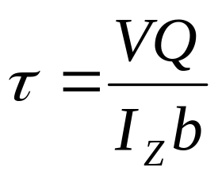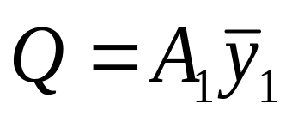

Y
y₁
b
A₁
y₁

A₁ is the area of the cross-section left hanging and y₁ is the distance between the centroid of A₁ and the neutral axis (which is the same as the centroidal axis of the entire cross-section).

The following is another example.
A₁
y₁
b

Problem # S9: 2 by 4 Pine wood boards have been glued together to create a composite beam as shown. Assume the dimensions are 2” by 4” (in reality they are less than the nominal value). If the shear strength of the glue is 11 psi, determine the largest load P that the beam can carry w/o glue failure. Assume the beam is long enough for the classical beam theory to apply. Do not consider failure due to bending stresses. Answer: 90.4 lbs

P
Cross-section

Problem #S10: A composite beam is glued as shown. Horizontal members are 1 by 6 inch and the vertical members are ¼ by 10 inch. Transverse load at this cross-section is F=250 lbs. Determine the required minimum glue strength in shear. Answer: 11.8 psi
Z
Y
250
Shear Center of a C-Channel

S
t

V

Shear Center
h

t
b

Transverse loads on non-symmetric sections can create twisting torques and warp beam flanges. If such transverse loads are applied at an offset location, the shear forces balance and do not twist the beam. This location is called the Shear Center. For the C-channel shown

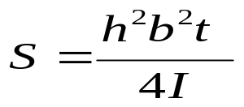

For a semi-circular cross-section, the shear center is at:

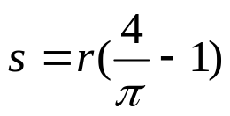
Torsion of Thin-walled Tubes

T

Shear stress in thin-walled tubes (left for closed tubes – right for open tubes)
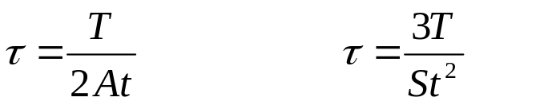
Where T is the torque, t is the wall thickness, S is the perimeter of the midline, and A is the cross-sectional area defined by the midline of the tube wall. Using area or perimeter of the inner or outer boundary is also acceptable since the wall thickness is small.

For a member of constant cross-section, the angle of twist in radians is
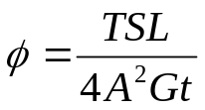
Where S is the perimeter of the midline, L is the length of the beam, and G is shear modulus. There is a similar formula for open tubes. [Shigley]

Problem #S11: A square tube of length 50 cm is fixed at one end and subjected to a torque of 200 Nm. The tube is 40 mm square (outside dimension) and 2 mm thick. Determine the shear stress in the tube and the angle of its rotation.

Answer: Stress 34.6 Mpa
Rotation (twist of the beam end): 0.011 radians or 0.66 degrees
Stress in Thin-Walled Cylinders

If the thickness t is less than 1/20th of the mid radius of the pressure vessel, the stresses can be closely approximated using the following simple formulas. The critical stress point in pressure vessels is always on the inner surface.
σ_{t}
σ_{a}
P

The tangential or hoop stress is:
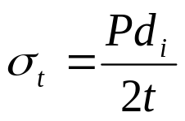

P is the internal pressure, t is the wall thickness, and d_{i} is the inner diameter. The axial stress is:
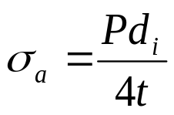

The radial stress on the inner surface is P which is ignored as it is much smaller than the hoop stress.

Stresses in Thick-walled Cylinders

In thick-walled cylinders the tangential and radial stresses vary exponentially with respect to the radial location within the cylinder and if the cylinder is closed the axial stress would be a constant. All the three stresses are principal stresses when stress element is cut as a pie piece – they occur on surfaces on which shear stresses are zero. The critical stress point is on the inner surface.

P_{o}
P_{i}
σ_{r}
σ_{t}
The tangential stress is:
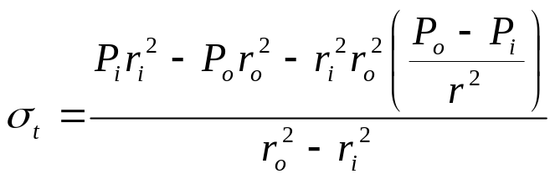
The radial stress is:
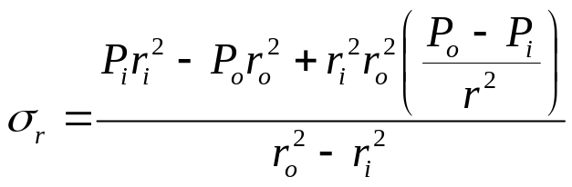

When the external pressure is zero, the stresses on the inner surface are:
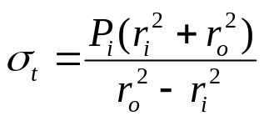
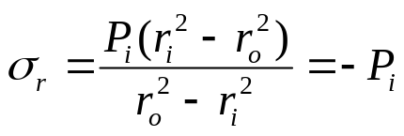
When the ends are closed, the external pressure is often zero and the axial stress is
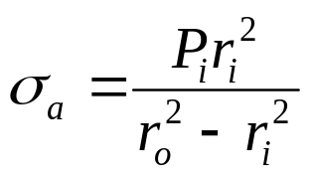

Problem #S12: A steel cylinder with a yield strength of 57 ksi is under external pressure only. The dimensions are: ID=1.25” and OD=1.75”. If the external pressure is 11200 psi, what is the factor of safety guarding against yielding. Use the distortion energy theory. Answer: 1.25.

Stresses in rotating disks

A rotating disk develops substantial inertia-caused stresses at high speeds. The tangential and radial stresses in a disk rotating at ω rad/sec is as follows:

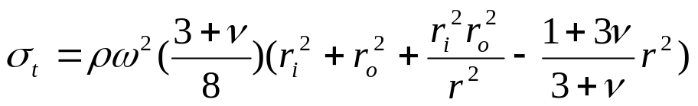
and
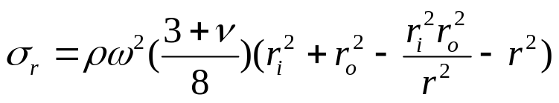
where ρ is the mass density and ν is the Poisson’s ratio. The disk thickness is to be less than 1/10 of the outer radius.
Problem #S13: A disk is rotating at 2000 rpm. The disk’s OD=150 mm and its ID is 25 mm. The Poisson’s ratio is 0.24 and the disk’s mass density is 3320 kg/m³. Determine the maximum tensile stress in the disk as a result of rotation. Answer: 0.71 Mpa.

Interface pressure as a result of shrink or press fits

When the internal pressure is high, shrink-fit cylinders lower the induced stresses. When two cylinders with a radial interference of δ_{r} are press or shrink fitted, an interface pressure develops as follows:
r_{i}
The interface pressure for same material cylinders with interface nominal radius of R and inner and outer radii of r_{i} and r_{o} is
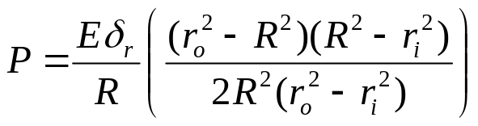

Problem #S14: A shaft collar is press-fitted on a solid shaft. Both parts are made of steel. The shaft diameter is 40.026 mm and the collar diameter is 40 mm. The outer diameter of the collar is 80 mm. Find the interface pressure. Answer: 50 Mpa.

When both shrink fit and internal pressure is combined, the method of superposition must be used to find the resulting stresses.

Impact Forces

The equivalent static load created by an object falling and impacting another object can be very large. Equations of energy in dynamics can be used to determine such loads. Two common cases involve an object falling from a height and a speeding object impacting a structure. In both cases the damping is assumed to be small (mostly elastic impacts).

h
w
k
w
v

For a falling weight (ignoring the energy loss during impact):
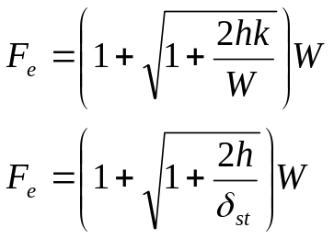

If h=0, the equivalent load is 2W. For a moving body with a velocity of V before impact, the equivalent force (ignoring energy losses) is:
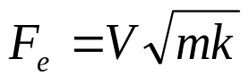

Problem #S15: A 1000 lb weight drops a distance of 1-in on a platform supported by a 1 in² steel bar of length 12 inches. What is the theoretical tensile stress that would develop in the bar. Answer: 70.7 ksi.

1000
12”
# S15
1000
6”
# S16
6”

Problem #S16: This is the same problem as #S15 but the bar is made up of two segments. The upper segment has an area of 2 in². Determine the maximum theoretical stress developing in the bar as the result of the weight dropping on the platform. Answer: 81.6 ksi.

Exercise Question: You have made grocery shopping and the cashier placed all your items in a paper bag. The bag’s dead weight is now 15 lbs. What force would the bag handles experience if you:
- Lift the bag gently and lower it?
- Slide the bag off the countertop and suddenly resist the weight of the bag at a rate of 30 lbs/in of drop?
- Let the bag slide off and drop 5” before you suddenly resist it at a rate of 30 lbs per/in of drop.
- Same as c) but rate of resistance is 60 lbs/in.

Failure of columns under compressive load (Buckling)

A beam under axial compressive load can become unstable and collapse. This occurs when the beam is long and its internal resistance to bending moment is insufficient to keep it stable. The internal resistance is a function of area moment of inertia, I, and the stiffness of the material.
P
Note that the longer the beam, the more bending moment is created at the center and for the beam to remain stable, it needs to be stiffer or have more bending resistance area.

For every long beams there is a critical load beyond which even a tiny nudge would result is a collapse. This critical load can be found using Euler formula.

In shorter columns the critical load may cause stresses well above the yield strength of the material before the Euler load is reached. For such cases, Johnson formula is used which relates the failure to yielding rather than instability.

The critical Euler load for a beam that is long enough is:
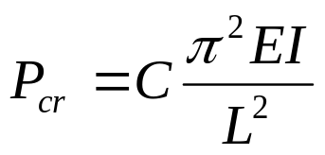

C is the end-condition number. The following end-condition numbers should be used for given cases:

- When both ends are free to pivot use C=1. Free to pivot means the end can rotate but not move in lateral direction. Note that even if the ends are free to rotate a little, such as in any bearing, this condition is applicable.
- When one end is fixed (prevented from rotation) and the other is free, the beam buckles easier. Use C= 1/4 .
- When one end is fixed and the other end can pivot, use C=2 when the fixed end is truly fixed in concrete. If the fixed end is attached to structures that might flex under load, use C=1.2 (recommended).
- When both ends are fixed (prevented from rotation and lateral movement), use C=4. Again, a value of C=1.2 is recommended when there is any chance for pivoting.

These conditions are depicted below:

Pivot - Pivot
Fixed - Free
Fixed - Pivot
Fixed - Fixed
An alternate but common form of the Euler formula uses the “slenderness ratio” which is defined as follows:
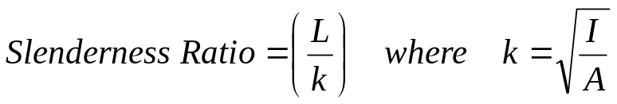

k is the area radius of gyration of the cross-section.
Range of validity of the Euler formula

Experimentation has shown that the Euler formula is a good predictor of column failure when:

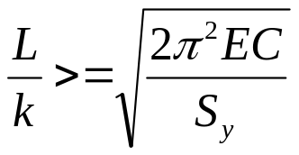
If the slenderness ratio is less than the value in the formula, then the better predictor of failure is the Johnson formula:

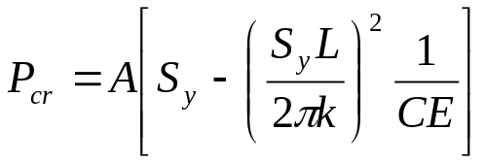

Alternatively, we can calculate the critical load from both the Euler and the Johnson formulas and pick the one that is lower.

Problem #S17: The axial load on a round solid steel bar in compression is 5655 lbs. The material is AISI 1030 HR. Assume the end conditions are pin-pin or pivot-pivot. Determine the factor of safety guarding against failure for the following two conditions:
- L=60” and D=diameter=1.5”
- L=18” and D= 7/8 ”
Answers: a) 3.6 and b) 3.1

Note: When a beam is under compression, it would buckle about the axis with smaller area moment of inertia.
Eccentrically loaded columns
c
The more general case of column loading is when the load is applied eccentrically. This eccentric load exacerbates the situation as it induces more bending moment due to its eccentricity. The prediction formula is known as the Secant Formula which is essentially a classical bending stress formula although it may not look like it. The secant formula is:
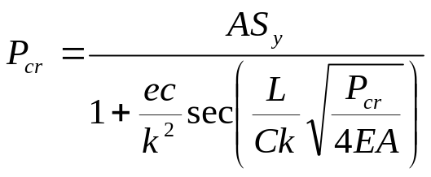
where e is the eccentricity, c is the distance from the beam outer layer to the neutral axis, and the rest of the symbols have already been defined.

A slight technical difficulty with this formula is that P_{cr} appears on both sides of the equation resulting in the need to use trial-and-error or use a non-linear equation solver. However, usually the load is given and you would calculate the stress (in place of S_{y} in the formula).

Example: A column has a fixed end and the other end is free and unsupported. The column length is 8 feet long. The beam cross-section is a square tube with outer dimensions of 4 by 4 inches. The area of the cross-section is calculated to be 3.54 in² and its smallest area moment of inertia is 8 in⁴. Determine the maximum compressive stress when the beam is supporting 31.1 kips at an eccentricity of 0.75 inches off the beam axis.

Solution

We find the stress  from the secant formula. The area radius of gyration is:
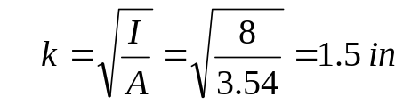
The applicable formula is
For this problem, P=31100 lbs is known and S_{y} becomes the unknown _{max}. Substituting the numbers:
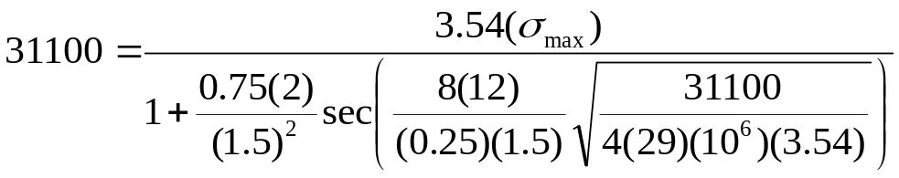
Calculating for _{max} we get:
_{max} = 22000 psi
Notes:
- The end condition is C=0.25 (some books do not apply C but instead they use an equivalent length L_{eq} which is L divided by square root of C.
- The argument in the secant function is in radians. Convert to degrees first before taking cosines unless the calculator is set to radians.
- The angle in degrees in secant function must be between 0 and 90 degrees (0 and /2 in radians). Add or subtract multiples of 90 degrees until the angle is between 0 and 90 degrees. In this problem the angle is 126 degrees.
Failure Theories

Failure under load can occur due to excessive elastic deflections or due to excessive stresses. Failure prediction theories due to excessive stresses fall into two classes: Failure when the loading is static or the number of load cycles is one or quite small, and failure due to cyclic loading when the number of cycles is large often in thousands of cycles.

Failure under static load

Parts under static loading may fail due to:

- Ductile behavior: Failure is due to bulk yielding causing permanent deformations that are objectionable. These failures may cause noise, loss of accuracy, excessive vibrations, and eventual fracture. In machinery, bulk yielding is the criteria for failure. Tiny areas of yielding are OK in ductile behavior in static loading.
- Brittle behavior: Failure is due to fracture. This occurs when the materials (or conditions) do not allow much yielding such as ceramics, grey cast iron, or heavily cold-worked parts.

Theories of ductile failure (yielding)

Yielding is a shear stress phenomenon. That means materials yield because the shear stresses on some planes causes the lattice crystals to slide like a deck of cards. In pure tension or compression, maximum shear stresses occur on 45-degree planes – these stresses are responsible for yielding and not the larger normal stresses.

The best predictor of yielding is the maximum distortion energy theory (DET). This theory states that yielding occurs when the Von Mises stress reaches the yield strength. The more conservative predictor is the maximum shear stress theory (MST), which predicts yielding to occur when the shear stresses reach S_{y}/2. For example in a pure torsion situation, the DET predicts the yielding to start when τ reaches 58% of S_{y}. But the MST predicts yielding to start when τ reaches 50% of S_{y}. Use of DET is more common in design work.

Note that in static loading and ductile behavior, stress concentrations are harmless as they only create small localized yielding which do not lead to any objectionable dimensional changes. The material “yielding” per se is not harmful to materials as long as it is not repeated too many times.

Problem # S18: A 2” diameter steel bar with Sy=50 ksi is under pure torsion of a 20,000 in-lb. Find the factor of safety guarding against yielding based on: a) Distortion energy theory, and b) Max shear stress theory. Rounded answers: 2.3 and 2.0

Theories of brittle failure

There are two types of theories for brittle failure. The classical theories assume that the material structure is uniform. If the material structure is non-uniform, such as in many thick-section castings, and that the probability of large flaws exist, then the theory of fracture mechanics predicts the failure more accurately. Many old ship hulls have split into two while the existing classical theories predicted that they should not. We will only look at the classical brittle failure theories.

An important point to remember is that brittle materials often show much higher ultimate strength in compression than in tension. One reason is that, unlike yielding, fracture of brittle materials when loaded in tension is a normal stress phenomenon. The material fails because eventually normal tensile stresses fracture or separate the part in the direction normal to the plane of maximum normal stress (or principal stress – see Page 1).

In compression the story is quite different. When a brittle material is loaded in compression, the normal stress cannot separate the part along the direction normal to the plane of maximum normal stress. In the absence of separating normal stresses, shear stresses would have to do the job and separate or fracture the material along the direction where the shear stresses are maximum. In pure compression, this direction is at 45 degrees to the plane of loading. Brittle materials, however, are very strong in shear. The bottom line is that it takes a lot more compressive normal stress to create a fracture.

We only discuss these theories for a 2D state of stress – 3D is similar but is more formula-based. Theories of failure in brittle fracture divide the σ₁-σ₂ region into 4 quadrants. In the first quadrant, both principal stresses are positive.
σ₁
σ₂
S_{ut}
S_{ut}
S_{uc}
S_{uc}
I
II
III
IV
When both σ₁ and σ₂ are positive (tensile), the fracture is predicted to occur when the larger of the two principal stresses reaches S_{ut}. When both ₁ and ₂ are negative (compressive), the fracture occurs when the magnitude of one of the two principal stresses reaches S_{uc}. The magnitude of S_{uc} is often more than S_{ut} as the prior discussion indicated.

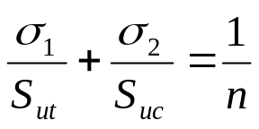In the other two quadrants, where one principal stress is positive and the other is negative, the Columb-Mohr theory is a conservative theory for failure prediction. It is also easy to use. The Columb-Mohr theory failure line simply connects the failure points as shown in the figure as double lines. Using only the magnitudes of the stresses, in Quadrant II or IV:
In this formula (σ₁,σ₂) is the load point (two principal stresses), and n is the factor of safety associated with that load point. The positive principal stress is associated with S_{ut} and the negative principal stress is associated with S_{uc}.

Problem #S19: A flywheel made of Grade 30 cast iron has the following dimensions: ID=6”, OD=10” and thickness=0.25”. What speed leads to the flywheel’s fracture? Answer: 13600 rpm
Summary of Failure Theories

Ductile Failure Definition
- Macroscopic and measurable bulk deformation
- Slight change in geometry

Conditions for ductile failure
- Metals (Except cast irons and P/M parts)
- At least 2% strain before fracture

Cause of failure (deformation)
- Excessive SHEAR stresses

Prediction Theories
- Maximum DET
  - Yielding occurs when 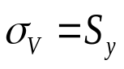

- Maximum Shear Stress Theory
  - Yielding occurs when 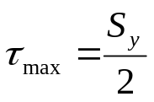

What to do with stress concentration?
- IGNORE them – They cause small areas of yielding and do not cause macroscopic and measurable bulk deformation.

Brittle Failure Definition
- Fracture

Conditions for Brittle failure
- Gray cast irons and P/M parts [I], ceramics [II]
- Other metals in special conditions:
  - Extreme cold or extreme impact
  - Extreme cold-working or extreme heat treatment

Cause of failure (fracture)
- Excessive normal stresses in tension, shear in compression

Prediction Theories
- Columb-Mohr theory
σ₁
σ₂
S_{ut}
S_{ut}
S_{uc}
S_{uc}
I
II
III
IV
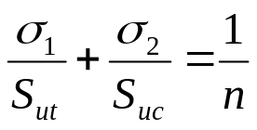

What to do with stress concentration?
- Ignore for [I] –their strength is already reduced, Apply for [II]
Fatigue Failure

Repeated loading can lead to fatigue failure at loads much less than those leading to static failure. Fatigue failure is sensitive to the magnitude of the stress regardless of how localized and small the stress area is. Therefore, stress concentrations play an important role in fatigue failure. Note: If the material bulk itself is full of unseen stress raisers (such as in grey cast iron), the geometric stress raisers should be ignored. This is because the test results always include such material-based stress raisers.

Design for infinite life starts with test results of the material in rotating bending test (known as Moore test). The Moore test stress limit is called the rotating bending endurance limit, S’_{n}. This is the stress for which no failure occurs regardless of the number of cycles (for steels). In the absence of direct experimental data, Moore test endurance limit is 50% of the ultimate stress for steels up to 200 ksi. Beyond 200 ksi, S’_{n} remains a 100 ksi.

Number of cycles - N
10³
10⁶
10⁵
S’_{n}
S_{f}
S₁₀³

The rotating bending or Moore test endurance limit has to be corrected for the actual part loading and conditions. This includes corrections for surface roughness, gradient effect, and size of the part (in Moore test, the specimens are polished, under rotating bending load, and are 0.3” in diameter). The result of these corrections is the endurance limit S_{n}. Another notation for endurance limit is S_{e}

Purely Alternating Load
σ_{a}

Combined Alternating Loading

When the state of stress is known, the Von Mises stresses can be analyzed. In the case of this figure all stresses are purely alternating.

σ_{x,a}
τ_{xy,a}
σ_{y,a}
σ_{v,a}
Most common loadings in shafts involves _{x}, _{xy}, or both.
σ_{V,a}
S_{n}
Endurance Limit
Von Mises
Stress
The index a in the above formula emphasizes that the loading is purely alternating.

Problem #S21

The steel shaft shown below is under purely alternating torque of 56 N-m. The torque fluctuates between 56 Nm CW and 56 Nm CCW. Determine the factor of safety guarding against eventual fatigue failure. Assume S_{ut}=518 MPa, and the correction factors of 0.9 and 0.78 apply for gradient and surface finish. Also assume a fatigue stress concentration factor of 1.48 for the shoulder fillets. All other correction factors are one. Ans: About 2

20 mm

Fluctuating and Steady Loads (optional)

Mean Stress
Alternating Stress

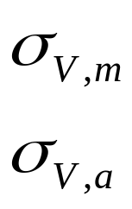When both mean and fluctuating loads are present, the Goodman criterion is used to determine how much the mean loading affects (reduces) the endurance limit. To begin the analysis, determine the mean and alternating Von Mises stresses. These are actual stresses and they do include the fatigue stress concentration factors. As a result we should be able to calculate the following:
The mean Von Mises is only due to mean loads and the alternating Von Mises is only due to alternating loads. In power transmission shafts the loading includes a steady shear (power torque) and an alternating bending stress (due to shaft flexure and rotating just like Moore test set up).

The load points plot in the Goodman diagram as shown below:

S_{n}
S_{u}
σ_{v,m}
σ_{v,a}
Load Point
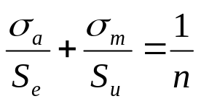
To determine the factor of safety guarding against fatigue failure, we must consider the overload mechanism. If both the steady and alternating components of stress are subject to increase as shown, the margin of safety is determined by the Goodman formula.

Fatigue Failure Definition
- Fracture

Conditions for Fatigue failure
- Repeated loading
- All metals

Cause of failure (fracture)
- Excessive LOCALIZED SHEAR stresses causing repeated yielding → Local brittle fracture → Crack growth

Prediction Theories

- Failure occurs when the local VonMises stress reaches the Endurance Limit.

What to do with stress concentration?
- Apply to all (mean and alternating stresses) except gray cast iron or other materials with type-I internal structure

Endurance Limit
Number of cycles - N
S₁₀³
10³
10⁶
10⁵
S_{n}
S_{f}

Cumulative Fatigue Damage (Miner’s or Palmgren Rule)

If a part is stressed to a load for which the fatigue life is 10³ cycles, then each cycle takes 0.001 of the life of the part. If stressed to a load for which the fatigue life is 10⁴ cycles, then each cycle takes 0.0001 of the life of the part and so on. This inference leads to the following cumulative fatigue damage formula:
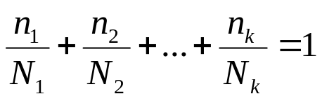
In this relation, n₁ is the number of cycles in a loading that would have a fatigue life of N₁ cycles, etc.

Example: A critical point of a landing gear is analyzed for fatigue failure. Experiments show that in each landing a “compound load cycle” is applied to the member consisting of 5 cycles of 80 ksi stress, 2 cycles of 90 ksi, and 1 cycle at 100 ksi stress. All stress cycles are fully reversed (no mean component). An experimental S-N curve is also available for this part (this curve can also be constructed using Moore test but for critical parts it is always best to spend the money and create a true S-N curve). The S-N curve shows the fatigue lives of the component at the loading stresses to be as follows:

Stress Level | Number of cycles | Fatigue life
80 Ksi | 5 | 10⁵ cycles
90 Ksi | 2 | 38000 cyc
100 Ksi | 1 | 16000 cyc

Determine the life of this part in the number of compound cycles (landings).

Solution: Each compound cycle takes the following fraction of life out of the part:
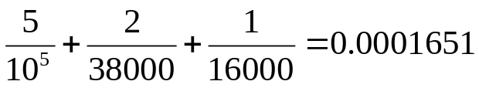
The number of cycles is the reciprocal of this value which is 6059 cycles.

Unit Conversions

Problem #S11: Length: 1.640 feet
Torque: 147.4 ft-lb OD: 1.575 in
Thickness: 0.07874 in Answer (Stress): 5 Ksi

Problem #S14: Shaft Diameter: 1.5758” Collar diameter: 1.5748”
OD of collar: 3.1496” Answer (Pressure): 7.25 Ksi

How to apply fatigue stress concentration factors when both mean and alternating stresses are present

From Shigley (Tenth Edition):



