Problem 7-6
Consider the part shown in the figure below. A default profile tolerance statement controls all the features of the part that do not need precision. The primary datum is the back face. The secondary datum is the axis of the left boss. The tertiary datum is the axis of the right boss. The related part geometry (the two cylinders) is sampled by a CMM.
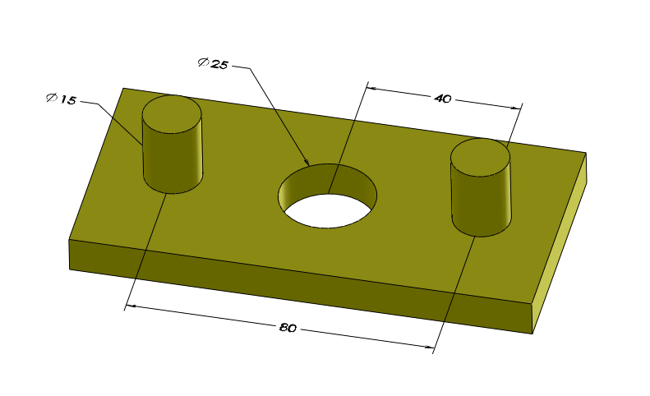

The axes of the two boss datum simulators are shown as dashed lines in blue color. The distance between the blue lines (axes) is the basic distance of 80 mm.
- Move the gage and align the datums. Datum-A is the plane of the paper. Datum-B is the left boss and it is specified RFS. Datum-C is the right boss and it is also specified RFS. Note that the basic distance of 80 mm between the two axes of the gage datum simulators is fixed. Use the “snip it” tool and cut and paste the graphics into your documentation.
- In the following page, assume datum-C is specified with the translation symbol? This releases the 80 mm fixed distance. Use the “snip it” tool and cut and paste the graphics into your documentation.

