4 June 2015

ME 493
Final Report

WINTER 2015

TEAM MEMBERS:
Westyn Anke
Katherine Flenniken
Lars Grund
Nicholas Jacob
Ian Rizzio
Pavlo Zlatov

ACADEMIC ADVISOR:
Phillip Henry

SPONSOR:
Sam Manafi
LED Trail
971-200-2761
3479 NW Yeon Avenue
Portland, OR 97210

Executive Summary:
Our design process started with talking to our sponsor in length, going over potential design requirements, and building our knowledge of the product. We then came up with design principles to help guide us to our first prototype. Our principles are: ergonomic, simple, safe, and proprietary.
The brainstorming of initial component resulted in four different ideas that brought up many concepts for discussion. The items proposed included a friction fit design, a circular rotating design, wire springs, and a spring and ball bearing latch design. The concepts were voted upon through a top two system. The top two selections of “friction pin” and “rotating design” were then further evaluated by a sub-committee of the Capstone group.
After careful consideration of many design options coupled with our design principles the LED Trail capstone group selected the “Friction Pin”, now called the “Cup and Post” design for initial prototyping. The design was one-off prototyped and submitted to our sponsor at LED Trail for consideration. Our sponsor accepted the design and we moved onto second phase prototyping.
Second phase prototyping involved obtaining a 2’x4’ troffer from a local hardware store. Then retrofitting it with a new bamboo fascia and mounting hardware to hold 4 round LED lights with our Cup and Post design. The prototype was fully retrofitted as our final product. Future design considerations include electrifying the connection to eliminate the need for any additional plugs.

Special Thanks:
Special thanks to the crew in the Prototyping Lab at Portland State University for helping with 3D printing and laser cutting. Without these vital resources being in-house our work and output would be slowed. Also special thanks goes to Oregon’s Best and LED Trail for sponsoring this project, it gave our group vital experience in part design and manufacturing that we all proudly put on our resumes.

TABLE OF CONTENTS

SECTION PAGE
Background Information 1
Mission Statement 2
Final PDS 3
External Search 4
Internal Search 5
Top Level final design evaluations and selection 6
Progress on Detailed Design 8
Conclusion 15
Works Cited 17
Appendix 18

Background Information:
Fluorescent lighting (FL) fixtures, known as troffers, utilized in offices, schools, hospitals and other commercial buildings use bulbs that contain a harmful and hazardous material known as mercury. Not only is it harmful when it is ingested, but even inhaling the vapor can cause serious complications to the human body. LEDs, however, contain no harmful materials and emit no pollution.
LED light technology has multiple advantages over fluorescent lights. According to the U.S. Department of Energy brochure in Appendix A, LED lights have up to 6x the lifespan of FL lights. There is no lag, or start up delay when a light is turned on. LED lights can be programmed to display a large array of colors. Lastly, LED lights produce much less heat per lumen than FL sources. There are numerous LED products in the market, however, LED Trail feels there is room for innovation. Current LED replacements for drop ceiling troffers are still expensive, have no means of modifying the lighting display and cannot be serviced by anyone other than trained or licensed technicians. CREE, a leader in LED technology has its own line of LED troffers, an example is shown in the figure below.
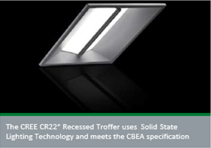
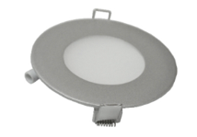

Figure 1: LED Trail 8in round LED light
Figure 2: CREE CR22 LED Troffer
The CREE LED troffer consists of a driver, LEDs, light diffuser and controller for dimmable lighting. Troffers are designed to fit the industry standard dimensions of 2’x2’ or 2’x4’. LED Trail has round 8in LED lights that they wish to be able to convert into a troffer system. Currently the lights are only used for small individual installations, which are mostly of the recessed type. The round lights offer a financially competitive option for LED Trail that they hope to utilize in commercial installations by having an easy solution to retrofit existing commercial troffers.

Mission Statement:
The goal of the capstone group is to utilize components provided by LED Trail, coupled with our capstone group Cup and Post design. With hopes of addressing the issues of modular design, end user servicing, and lighting inefficiencies. The group plans to submit a design and component sourcing that will exceed the performance of existing LED offerings, allow for some domestic production and at a cost that will place the LED Trail troffer in a competitive place within the market in hopes that this will place them above the competitors with an innovative design.

Final Project Design Specifications:

Safety Requirements:
The safety standards to ensure the product passes building codes or tests are identical to the fluorescent lighting options. Since the troffer is an expansion of an existing, approved group of products, it will be built to meet the industry standards. The requirements that must be met are:
- Size matches existing troffer that is being replaced.
- Weight is less than or equal to existing troffer.
- Office worker can replace individual bulbs without electrical certifications.
- Electrical components concealed to reduce risk of shock.

Performance Criteria
As stated, the aim for this project is to utilize existing components of LED Trail to create a competitive product. The goals and criteria outlined through discussion with LED Trail and through internal discussion are as follows:
- Troffer will be designed to allow end user modification, the key design consideration is that changing an individual LED panel should be no more difficult than changing a traditional incandescent light bulb.
- The design should be constructed so that an electrician must only be employed in the initial installation of the troffer in its final location.
- Skilled labor, (i.e. building maintenance professionals) should be able to service the drivers and electrical components.
- A proprietary connection between the LED disc, see Figure 4, and the finished panel of the troffer will be created.
- The product should be designed to include domestic construction of the housing, or some type of value added manufacturing.
- The product should meet or exceed California building code standards and thus be suitable for installation in any building in the U.S.

External Search:
Since the product to be designed is an adaptation of existing technology, numerous examples of the general troffer style are available for study. All standard troffers, regardless of manufacturer, conform to the standard 2x2 or 2x4 sizing, the LED trail troffer will not differ.
Current LED troffers are a simple adaptation of the standard fluorescent troffer, the fluorescent lights are replaced either with LED tubes or strips, see figures 3 and 4. Neither of the LED troffers surveyed allow for modular design or have an aesthetic that is a departure of the traditional fluorescent design. Offerings from CREE and Lithonia were investigated:
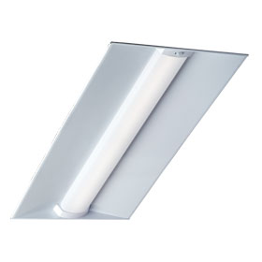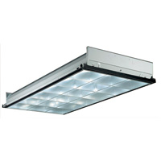
Figure 3: CREE LED Troffer Figure 4: Lithonia LED Troffer

With respect to individual components, the LED Trail project looked to familiar lighting and home fixture attachment methods to drive the light to face and face to troffer connections. This method means designing a proprietary attachment method that will connect each light to the troffer while being flush with and blending in with the fascia of the troffer. Initial designs drew inspiration from can lighting fixtures, smoke alarms and closet door latches. The team utilized the objective standard that the light to face connection should not be appreciably more difficult that screwing in an incandescent light bulb.

Internal Search:
The internal search was facilitated through robust discussion, white board drawings and SolidWorks modeling, some of which can be seen throughout the paper and in the appendix. All design decisions were made through consensus and have given the group much to discuss.
The plan for our project was to break the LED Trail troffer into three areas of focus, with each to be brainstormed in small groups, and then presented to the rest of the group. The ideas were to be evaluated against the PDS and voted on by the group, with the top 2 ideas of each focus will receiving a more in depth investigation along with prototyping and a top choice selected. The three areas of focus for the project were the light to face, face to troffer and troffer body designs. The primary area of focus was the light to face connection, which was evaluated against 4 specific criteria:

1. Simple (easy to manufacture, likely inexpensive)
2. Safe (no risk of electrical contact, stable in earthquake scenario)
3. Ergonomics (easy to operate and explain)
4. Proprietary

There was a fifth and sixth criteria of slightly lower importance. One is more applicable to the fascia of the troffer and visible parts of the light and troffer, is to have an aesthetically pleasing design. The other is that the sponsor would like a design that incorporates principles of sustainability.
By breaking into small groups the breadth of the internal search expanded to include a larger number of novel ideas and the likelihood of an exceptional design increases. Each group worked on bringing two ideas to the rest of the team at our weekly meetings and it resulted spirited and beneficial discussions.
Broad concepts were discussed early on in the design process; they were recorded and brought back up as the design process continued. An example is the idea of creating a cardboard troffer housing to allow for flat pack construction of the troffer assembly. This novel shipping plan would likely reduce freight costs and could be made of post-consumer recycled content, adding green appeal to the LED troffer.

Top Level final design evaluation and Selection:
The overall design was separated into three distinct parts: light to face, face to troffer and troffer body. The first main design task the group focused on was the light to face interface. It was chosen because this interface was the main focus of the capstone project, and the other two interfaces could possibly introduce mission creep. Our first goal and top priority was to produce a workable design for the light to face connection, to present to our sponsor.
To begin, the team broke into three smaller groups to come up with initial designs. The team then met and discussed seven initial design concepts. Sketches can be seen in appendix A. These designs included:
- Pen design with a click in push lock
- Mount with pins following a ramped track while twisting the bulb into place (“twist”),
- Alteration of circular track with a vertical spring,
- Ball bearing spring loaded push gate,
- Wire spring much like many light fixtures,
- Friction pin which would hold the light vertically using friction with a gasket (“friction pin”),
- Twist attachment much like a smoke alarm attachment (“circular track”).
Focusing on our top criteria: simplicity, safety, ergonomics, and ability to be proprietary we eliminated a few of the designs. The pen design was eliminated first because it was very complicated and would be expensive to manufacture. The vertical spring was eliminated because had a lot of moving parts that added complexity and expense without a foreseeable advantage. The ball bearing was well liked, but was finally eliminated due to the fact that it also had many moving parts and would be more expensive to manufacture than many of the other designs. The group then combined the two twisting designs into one.
With the remaining three designs: circular track, wire spring, and friction pin, the group discussed their pros and cons and finally voted on the two designs to continue. The wire spring was clearly the cheapest to manufacture by far and received top ratings for simplicity, but was also the design least prone to a proprietary arrangement and may be less intuitive for users who will need to change the bulb. Cons of the friction pin included that different environmental aspects may cause a range of performance issues in the rubber gasket. Also, the tolerances of the design would need to be more exact so the safety of the design was assured. A pro was that it could be relatively inexpensive to manufacture. The group decided that further research could be done to see if the cons could be mitigated with a more detailed design. The circular track seemed the good combination of safety, simplicity for manufacturing costs, intuitive and ergonomics for changing the light bulb, and proprietary design.
After the discussion, the group of six members, with two votes each, chose the two designs with which to move forward. The results were:

Table 1: Vote tally for final three designs
Design | Votes
Circular Track | 4
Friction Pin | 5
Wire Spring | 3

As a result, the designs we proceeded with to the next step are the circular track and friction pin. The rubber gasket of the friction pin was determined to be not viable. The ultimate design will need to be used in all climates. However, the rubber could deteriorate more rapidly in some climates. A sub group focused on how the design could be made better. This resulted in a change of design with elimination of the rubber gasket to create friction. Instead of a gasket, a circular component was designed with a cut in one side. For the post, a dimple was placed in a strategic location such that when connected, the circular component would open slightly for the diameter of the post, and then settle into the area with the dimple. This created the first iteration of our final design, which incorporated an interference fit in place of the friction fit.

A design matrix was completed on the three final designs, as seen in Figure 5.

Table 2: Design matrix for final three designs
Design | Inexpensive | Safe | Ease of Use | Proprietary | Total
Circular Track | 2 | 3 | 2 | 2 | 9
Friction Pin | 3 | 3 | 3 | 3 | 12
Wire Spring | 3 | 3 | 2 | 1 | 9

Due to the results from our group vote, design matrix, and improvements to the interference pin design, the interference pin was selected as the best design to pursue. A group decision was made to abandon the circular track design due to its nonconformity with the proprietary design goal, as well as concerns about user ergonomics, or ease of use. An in depth investigation of the interference pin concept commenced. Four group members elected to work solely on the design, prototyping and testing of the top level, interference pin design.

Progress on Detailed Design:
Because friction was no longer the main force in operation, the name of the top design was changed from friction pin or interference pin to ‘cup and post’. In further discussion of the cup and post design, a group consensus arrived at the importance of physical prototyping and testing in preparation to present the idea to LED Trail, our project sponsor. The design was modeled in SolidWorks and was constructed using 3D modeling technology in conjunction with readily available components.
The group has recorded and documented alternative ideas and theories in the event that the project sponsor rejected the initial presentation of the cup and post design. The group was prepared to take input from LED Trail and use it to pursue the engineering and design of a different plan. Concurrent with the engineering and prototyping of the cup and post design, two group members began the design and exploration of the troffer face plate. They planned to seek out low cost, sustainable and/or recyclable items to add to the green appeal of the LED light.
Once the first version of the design was completed in SolidWorks, as seen in Figures 5 and 6, both the cup and post sides of the component were 3D printed using plastic. The 3D printed parts were attached to wood to create the first viable prototype, as seen in Figure 7. The dimensions for the cup and post are in Appendix

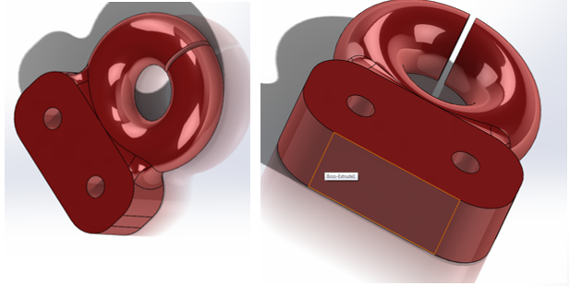

Figure 5: Cup component of Post and Cup design. Drawings are in Appendix B.

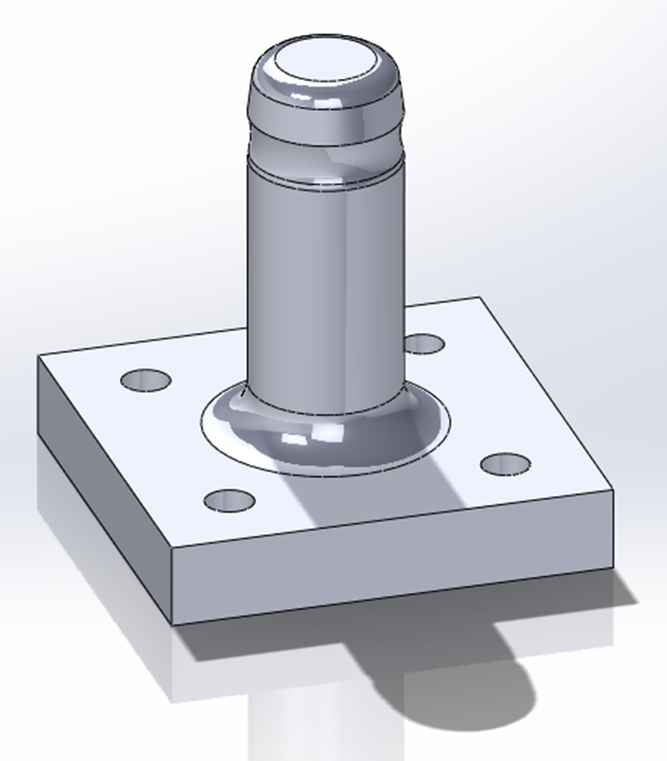

Figure 6: Post component of Post and Cup design. Drawings are in Appendix C.

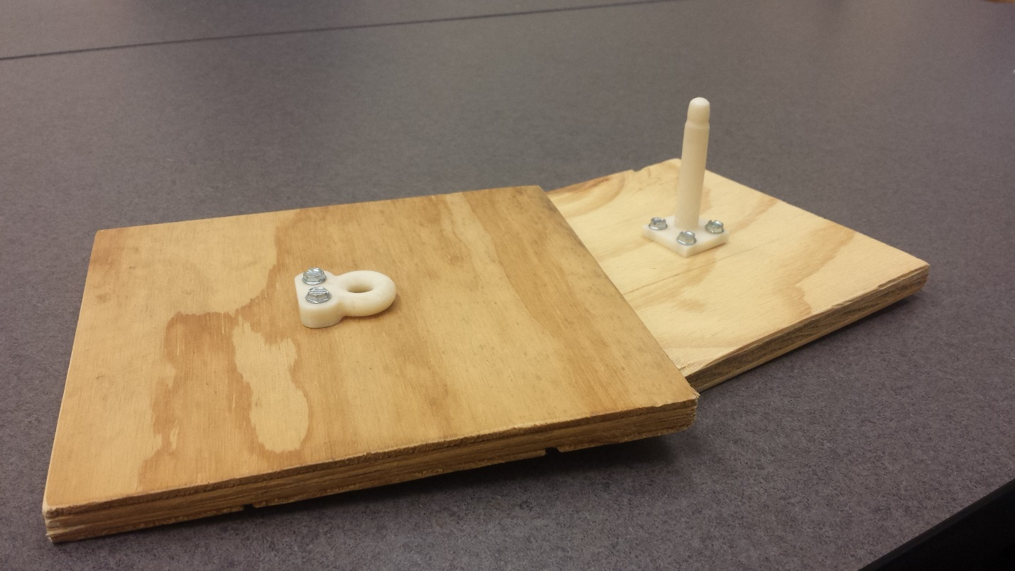

Figure 7: First post and cup design prototype

The prototype worked as planned and confirmed that the post and cup is the best design to pursue. Initial investigation of the prototype suggest that it meets all four of the stated criteria: proprietary, safe, easily operated, and low cost. Unexpected benefits of the design include that they allow, even better than anticipated, the future expansion in design of the product, as desired by the sponsor. Such future versions of the light connection include using the same post and cup attachment for other styles of lights, such as positional light bulbs. The design also allows for modifications to allow it to be an electrified connection. This is a very exciting possibility since, for now, a user would need to connect the LED light in two steps: connect the electrifying wires, and then connect the light using the cup and post attachment. With an electrified cup and post attachment, as user would only need to connect the main cup and post, and they are done.
The analysis of the prototype did reveal that the post is longer than required. Thus, one change will be making the post about an inch shorter to allow for a low profile design that will provide for a better fit in most troffers. Another refining action is to elaborate on the cup side of the system to make it easier to attach correctly to the light bulb.
A wooden box representing a troffer was built to fit one LED light. The post side of the component was attached to the wood brace representing the troffer side. The cup side of the component was attached to the LED light with the help of a plywood bamboo plate. It was determined this was the better arrangement due to the fact that the post sticks out further. When considering future shipping arrangements of the LED lights, the smaller profile of the cup side would allow for more compact packaging for the LED light bulb. The size of the troffer could easily absorb the height of the post in the troffer packaging.
The cup portion would be attached to the LED Light. The only potential issue of this would be fatigue of the cup component. However, in most uses, the light would be installed and removed only once. This is well under creating an issue for fatigue. If it was put on and off only a handful of times, it is still considerably less than any fatigue issues. The post will be used more, but will the life of an LED light, the times the connector will be used is still way under the amount that would cause any concern for fatigue issues.
The completed first prototype, with LED light and troffer box is seen in Figure 8.
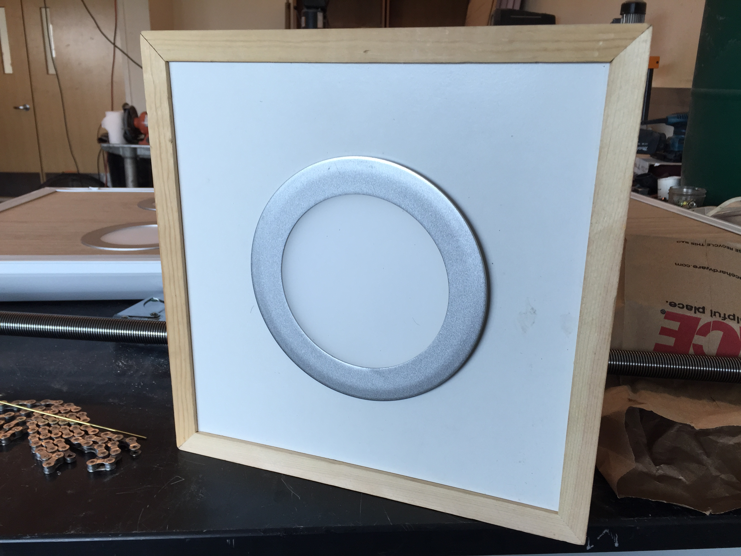

Figure 8: Box structure and fascia of first prototype.

The first prototype with the box troffer was presented to the sponsor. He did like the design and agreed that it met all the requirements and was a robust design that could be used to provide future requirements, such as electrification in the post, directional lights and position adjustable lights. At that meeting, we agreed to focus on getting a prototype of a complete 4 or 8 light troffer. An additional task discussed at the meeting was to compare the costs between retrofitting a customer’s current fluorescent light troffer and installing a completely new LED light troffer system.
The next phase of our project was focused on building the final complete troffer. We purchased an 8 light troffer and removed the fluorescent lights and light fixtures. We created a new fascia for the outside of the troffer that is visible to users and a new bracket system in the back to hold the lights. For the fascia, we decided to use bamboo plywood, as that is in keeping with our sponsor’s wish to make the design as sustainable as possible. Aluminum metal brackets were created to attached to create a robust structure attach the posts part of the connector component. Additional lights and drivers were be obtained from our sponsor to make the complete troffer.
One additional future adaptable use for our light design is to have position movable lights. A runner was purchased retail that can be installed in the troffer and make the light movable along one direction. The prototype troffer as designed would not show off this feature without taking much of it apart. One plan was to make an additional light attached to this runner as a separate prototype. In the end, building a separate prototype for that feature was abandoned and it was decided to just discuss that option with our sponsor.
During the cutting of the bamboo plywood fascia, it was discovered that the material splits easily. As the material was brittle and, eight identical LEDs were not provided by the sponsor, it was decided that only four holes would be cut in the 2x4 troffer to make it a four light troffer for the prototype, even though eight lights could be fit into a troffer of that size. The final prototype is seen in Figures 9-12. In hindsight he four lights used provided an abundance of light, eight lights would have been too bright.
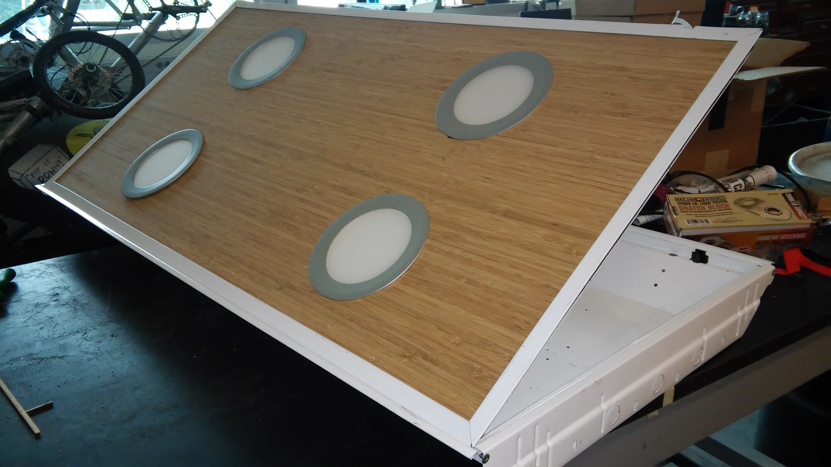

Figure 9: Top view of final 4 light troffer prototype with bamboo fascia.

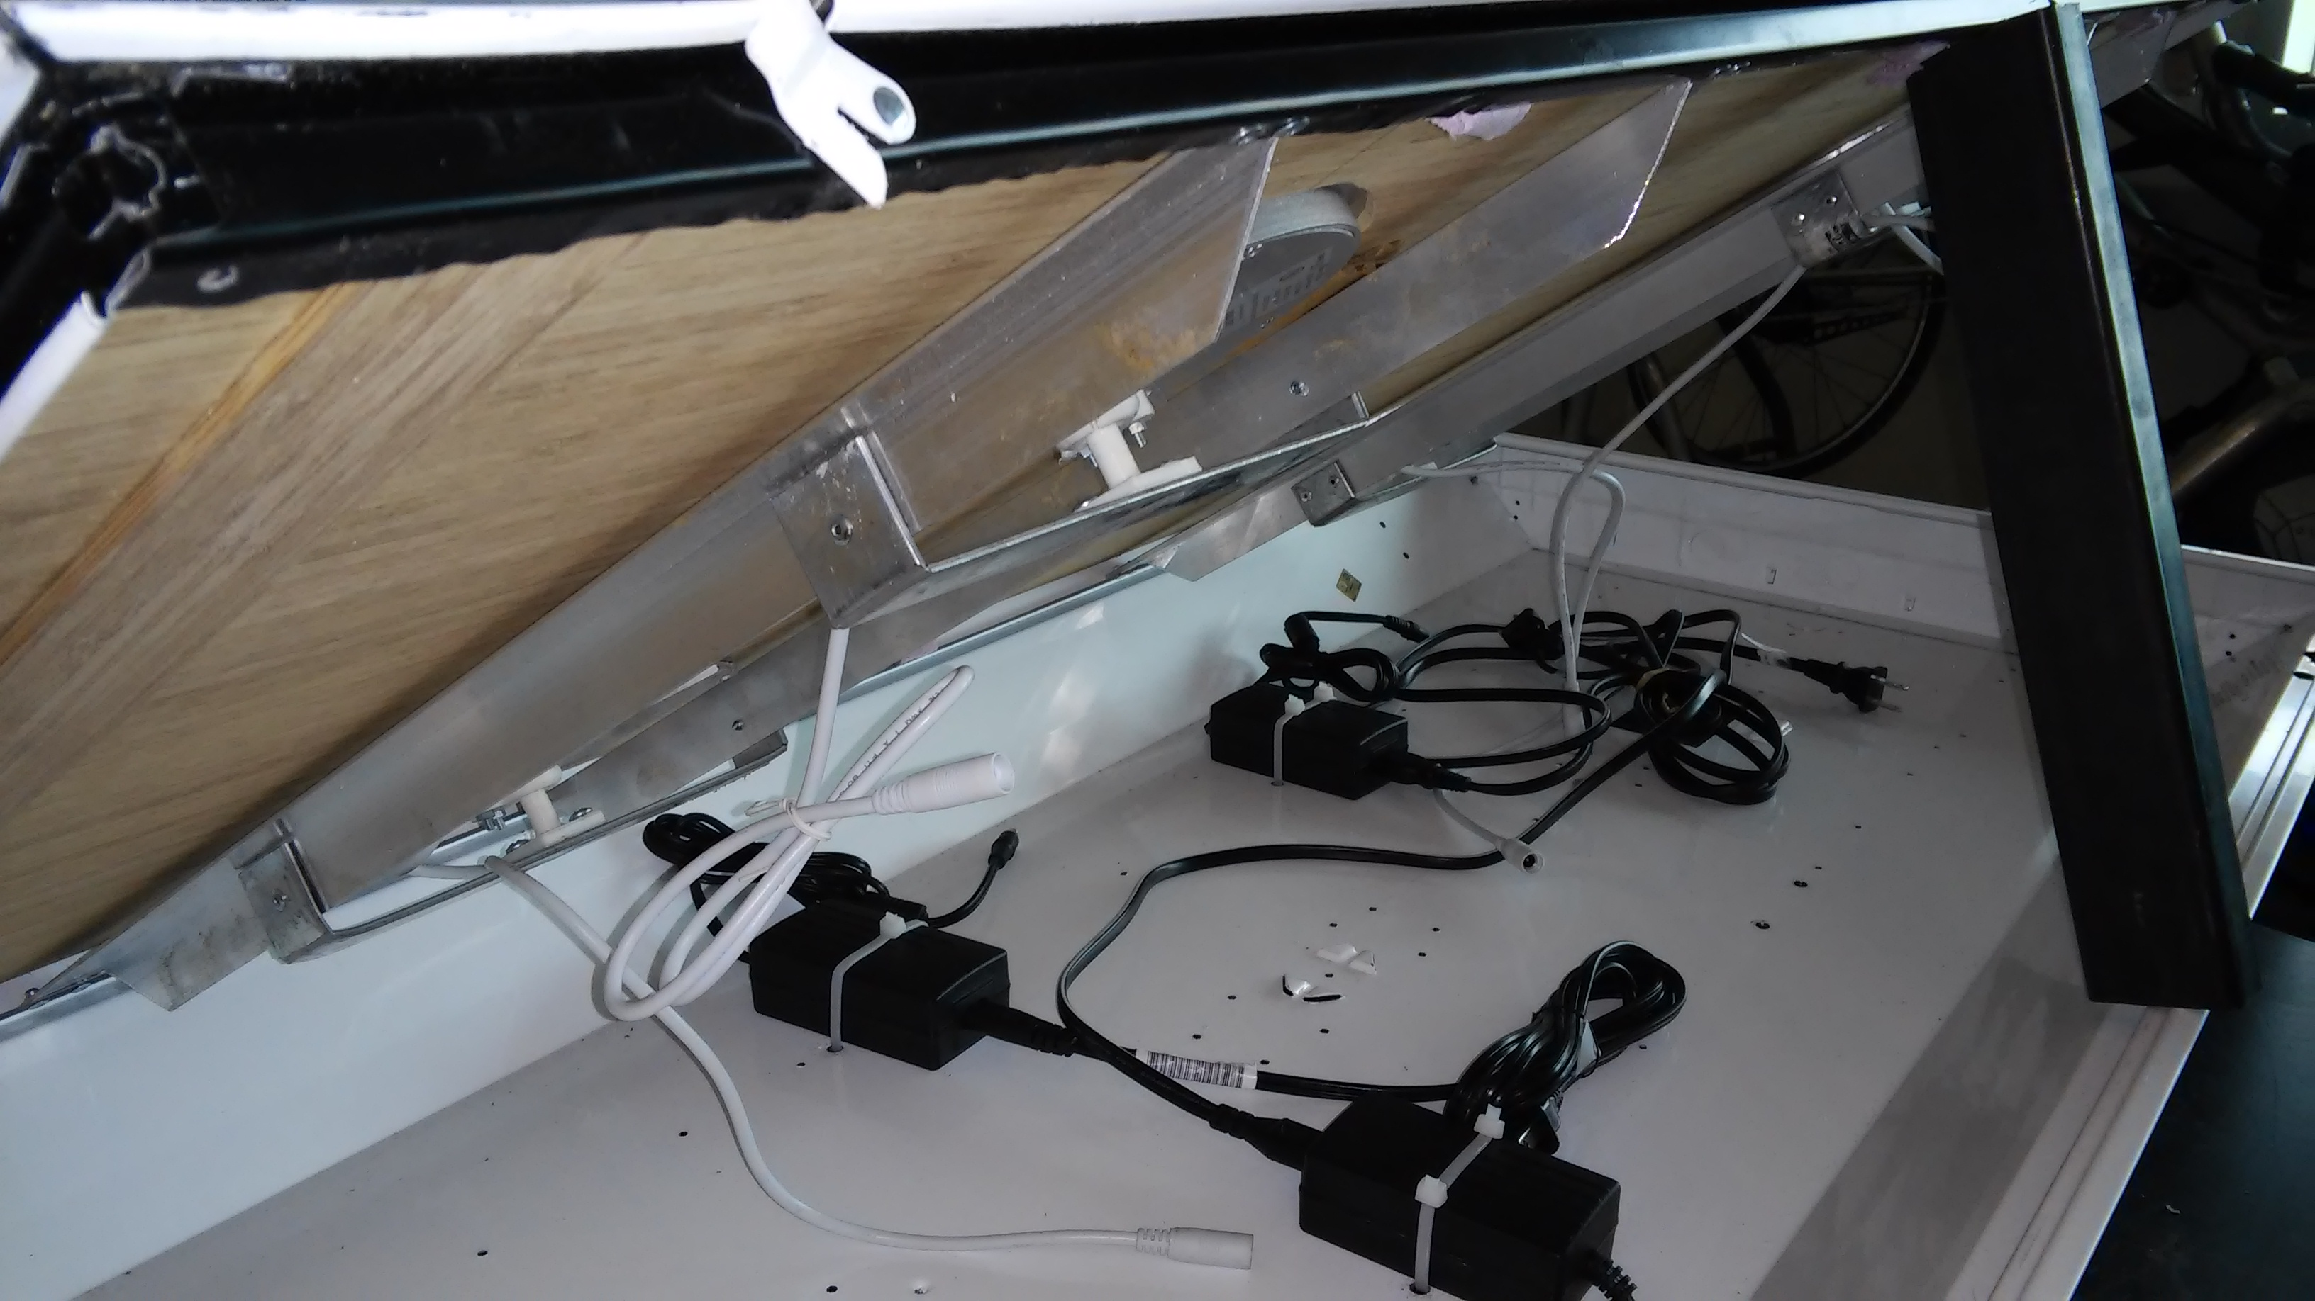
Figure 10: View under propped-up troffer with brackets and drivers.
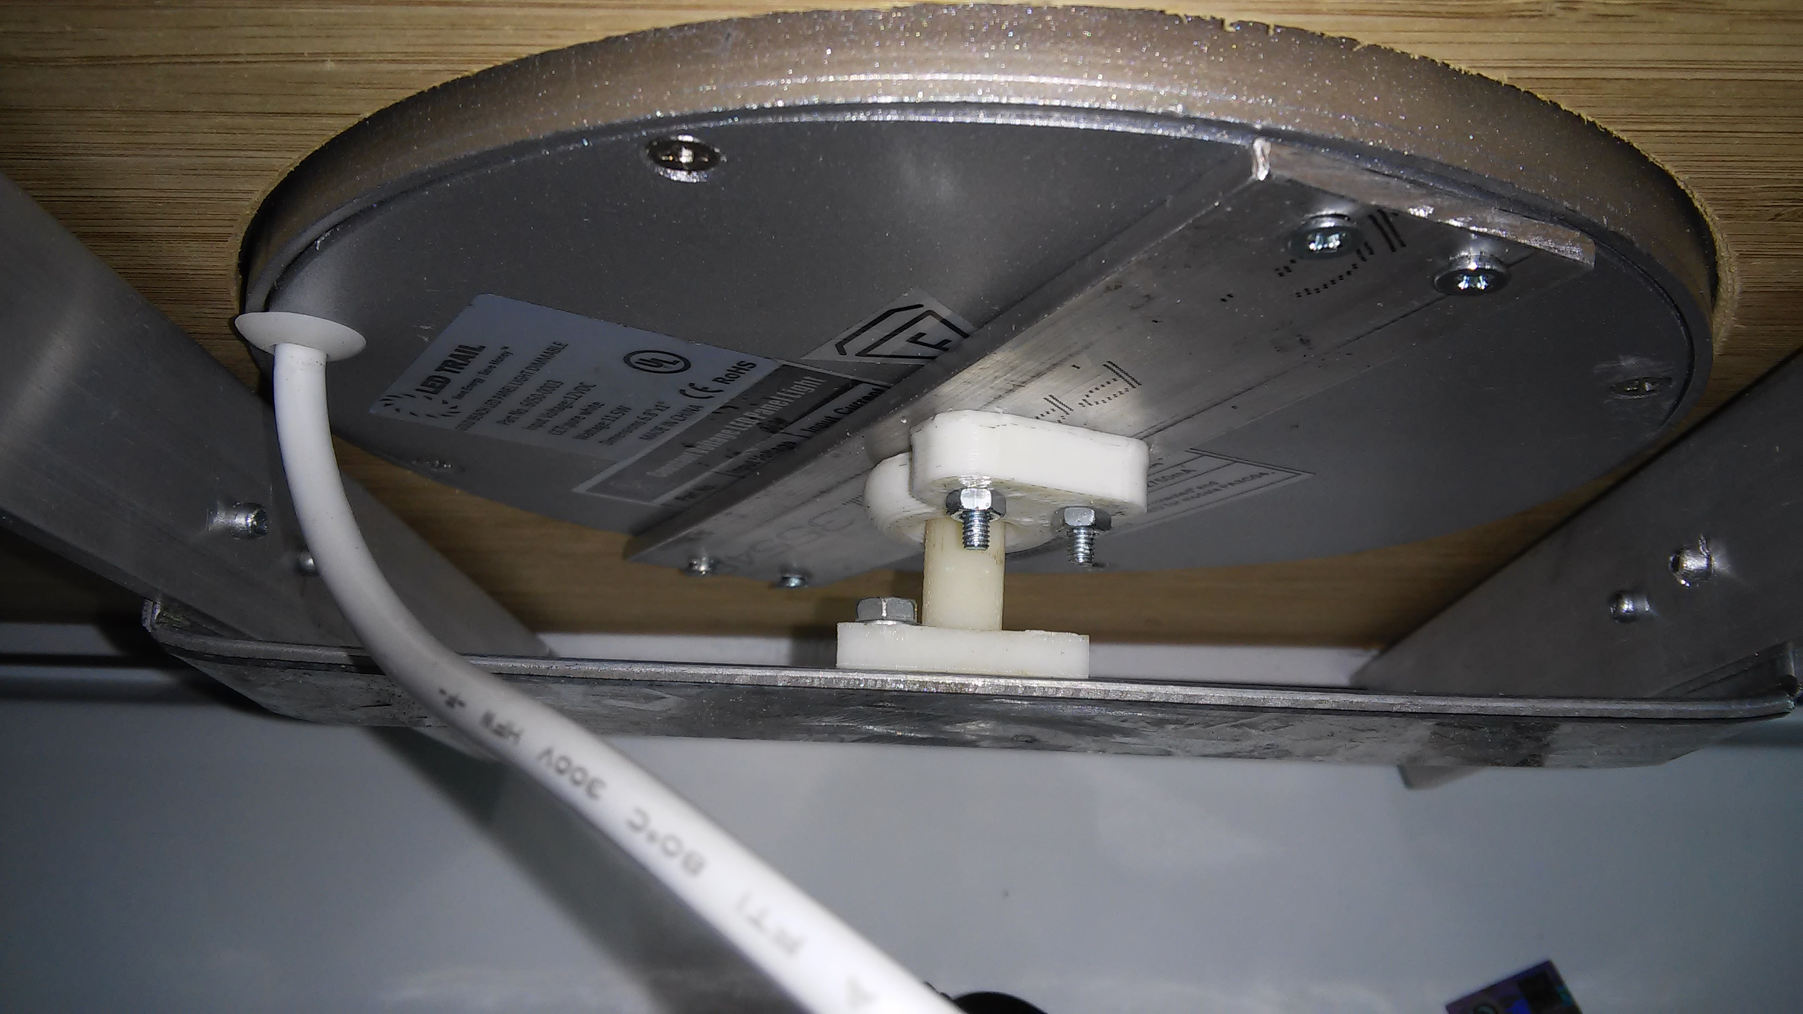

Figure 11: Close up of component attaching LED light to brackets in final prototype

The fascia of the troffer allows some movement of space. This is intentional in the design, since the way the light is to be removed is to grab the edge of the light and pull it down. The fascia has a little give and the user can push it up slightly to get purchase on the edge of the light to pull it down and detach the light by pulling the cup off the post connection. This works perfectly in the position of the light on the ceiling.
For the capstone presentation, the light will be upside down resting on a table, upside down from its design position in a ceiling. This caused the fascia not to rest gently against the installed LED lights. Therefore, for the purpose of the capstone presentation, the final addition to the prototype was to add temporary shims between the fascia and metal brackets so the fascia would rest correctly for a visual inspection of the prototype. These final touches to the prototype are seen in Figure 12.
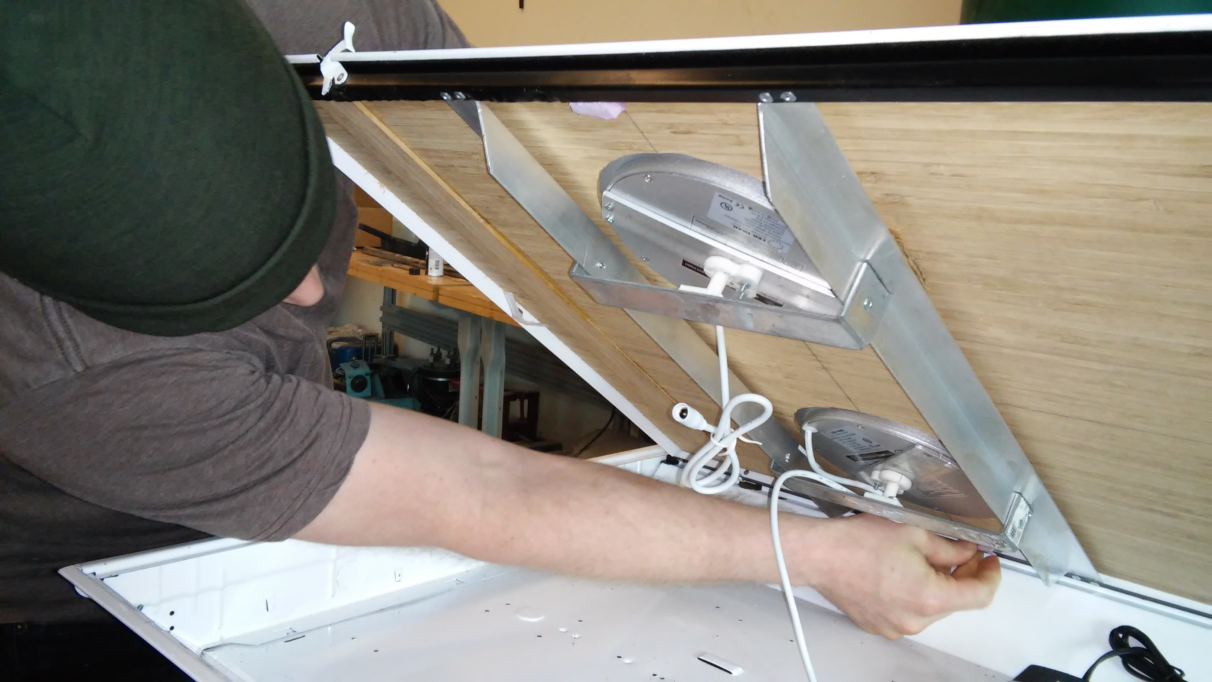

Figure 12: Adding temporary shims to prototype

Conclusion and Recommendations:
We carried this project through from design process to creation of a prototype. The main deliverable we have provided for our sponsor was a design concept of a new way to attach an LED light to the troffer structure holding it to the ceiling. Additional deliverables included a prototype light troffer, which essentially was built mainly to show off our design.
The very first step in our design process was getting information from our sponsor that we could use to create specifications. It is very important to understand exactly what the sponsor wants and to make sure we are all on the same page, so to speak. Not being on the same page or having a misunderstanding will result in an undesirable outcome. We had many conversations with Sam, our sponsor, both in person and by email, to make sure we were very clear on what he wanted. It may have seemed to take a longer time during this step, but it is important to do so if needed to make sure we are creating what the sponsor wants.
Once we had a clear idea of our sponsor’s wishes, we created the four important requirements of our product: inexpensive to manufacture, safe (for example it will stay assembled during an earthquake), easy to install for any untrained person, and a proprietary design. Starting from these requirements, during the initial brainstorming process we came up with many different designs. All group members participated, contributing ideas. As a group, we discussed each idea brought to the table and voted on the best ones to pursue going forward.
The post and cup was determined to be the best design, especially after alterations to the original design were made. From this design concept, we made two generations of prototypes to showcase our connector design.
Early conversations with our sponsor included designing not just the connection of the light to the troffer, but designing the whole troffer and the troffer to the ceiling. We felt that this was bigger than the scope and time frame of our capstone project. Perhaps a future capstone group could design these aspects of the LED light system. Also, the brackets created for the troffer prototype have not been analyzed as a robust design for manufacture. Instead, they are primarily for the purposes of the prototype only. Creating this design for manufacture could be an example of a project for a future capstone group. The same is true for the troffer itself used in the prototype. The troffer used was available for retail and modified for the purposed of the prototype.
An additional assignment discussed with our sponsor was to work up a price comparison between retrofitting a customer’s current fluorescent light troffer to become it our sponsor’s LED light system, or install a completely new troffer system using our sponsor’s LED light system. It was determined that we did not have all the information necessary for this analysis. Our parts were purchased retail, whereas our sponsor could have different prices for bulk purchases. Also, our sponsor would know more information we do not have access to, such as labor costs.
As a team, and as prospective engineers, we followed through the design process, learned much in this fascinating process and are very proud of the design we created. We feel it is a very good design for our sponsor and it meets and exceeds all the design requirements and more, as it is a robust design that will be great for future expansion of uses desired by our sponsor. We hope this prototype and design will provide LED Trail with the building blocks to create a marketable product.

Works Cited

Links to Troffers:
http://www.cree.com/Lighting/Products/Indoor/Troffers/ZR-Series
http://www.lithonia.com/commercial/parabolics.html#.VOZXUfnF9c4

Appendix A
Initial Designs for Bulb to Face Connection:

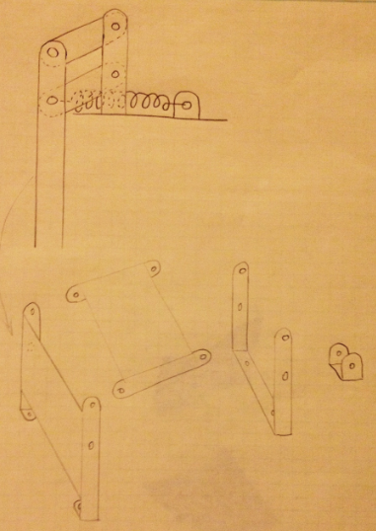

Figure A1: Pen design with a click in push lock design
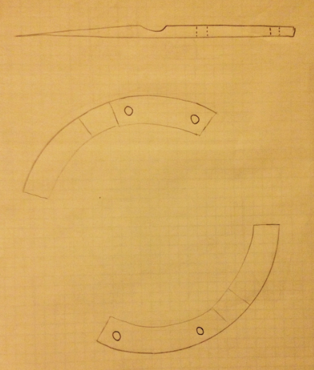

Figure A2: Ramped track while twisting design

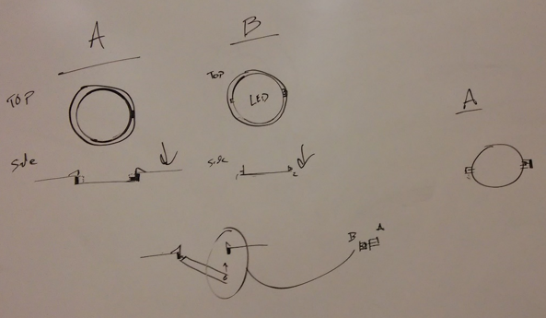

Figure A3: Ball bearing with spring loaded push gate

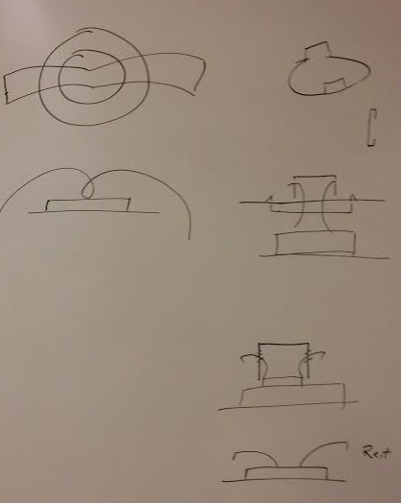

Figure A4: Wire spring design

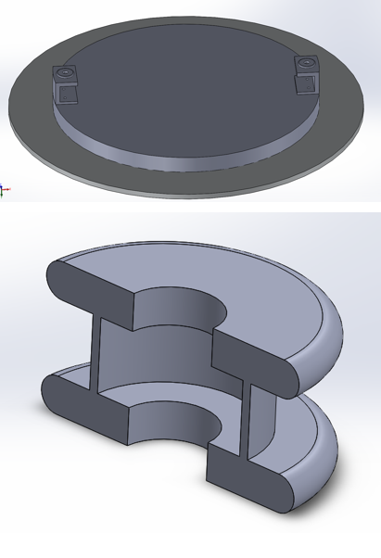

Figure A5: Friction pin using a gasket design

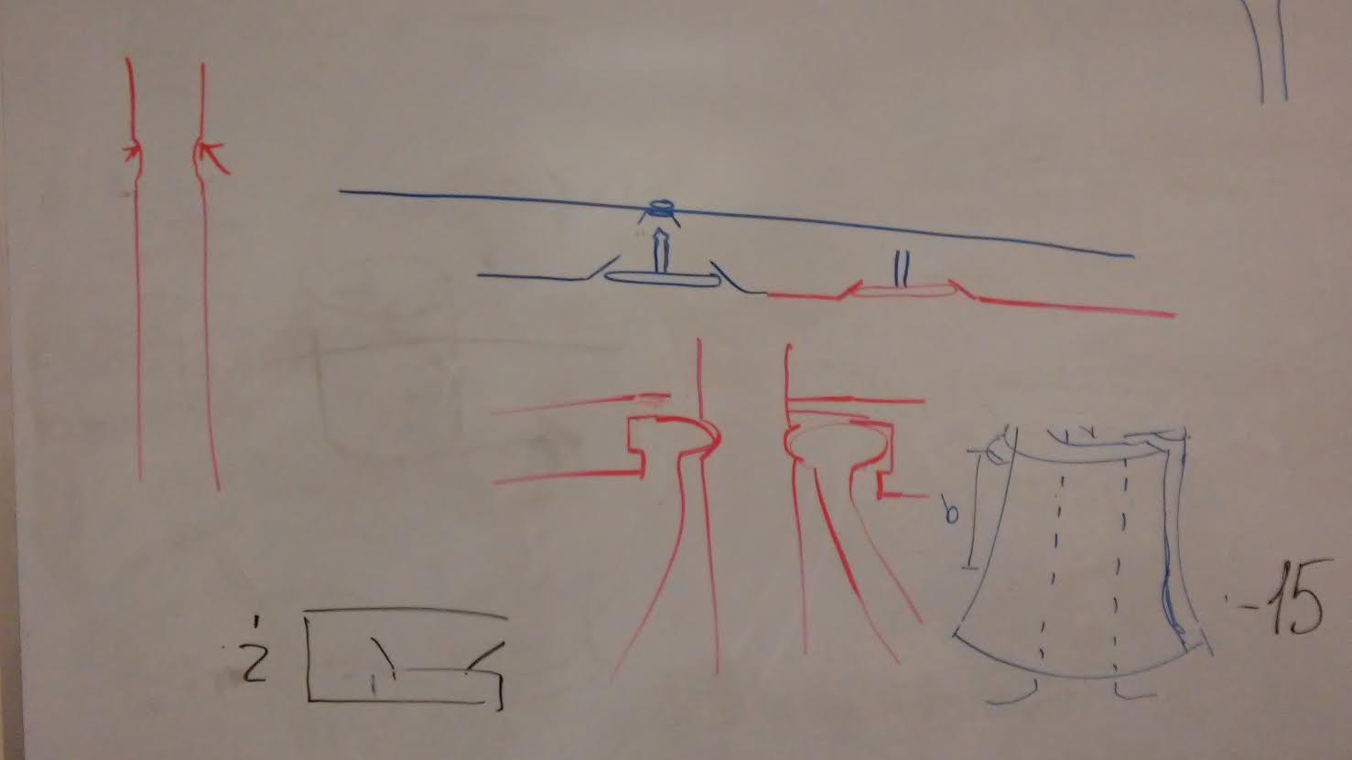

Figure-A6: Friction Pin Concepts

Appendix B
Dimensions of Cup and Post Design:

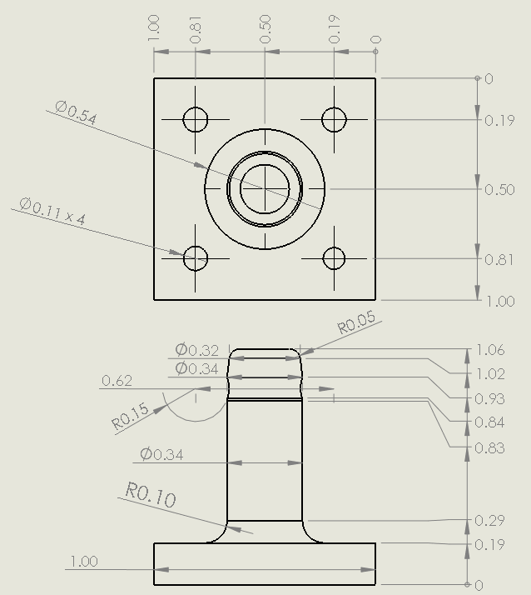

Dimensions on post component

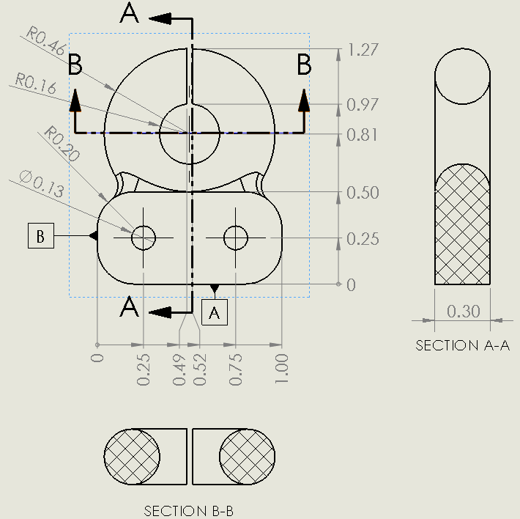
Dimensions on Cup Component

Appendix C

Bill of Materials:

4 Cup and Post connections, 3d printed
Troffer
Various Brackets, aluminum
Various fasteners, screws and rivets
4 LED lights (10” round)
4 drivers for lights
2 extension cords for prototype
Bamboo plywood fascia, 2’x4’

