Portland State University
Maseeh College of Engineering and Computer Science

Liquid Fuel Rocket Engine
Product Design Specifications Report
Winter 2016
Sponsor:
Portland State Aerospace Society

Academic Advisor:
Derek Tretheway

Authors:
Tamara Dib
Cam Yun
Bianca Viggiano
John Tucker
Taylor Rice
Kristin Travis

//2016

Table of Contents

Introduction | 2
Explanation of the Document | 2
Mission Statement | 3
Project Plan | 3
Customer Identification | 3
Customer Feedback and Interviews | 3
Product Design Specifications | 4
Conclusions | 7
Appendix A | 8
Appendix B | 9
Appendix C | 10

Introduction:
A liquid fuel rocket engine uses energy from the combustion of liquid fuel and liquid oxidizer to generate thrust. This mechanism works in the atmosphere and in the vacuum of space and is used by several organizations such as NASA and SpaceX to achieve manned and unmanned flight. Due to the inherent cost and complexity of manufacturing, liquid rocket engine systems have been largely excluded in small scale endeavors. However, recent advances in additive manufacturing and engineering technology have made design and construction of liquid fuel engines accessible to amateur and student group rocket enthusiasts.

Currently, there is a ‘space race’ between universities to launch the first unmanned vessel, created by a university or rocket club, past the von Karman line (the defining point between the atmosphere and outer space at an altitude of 100km). The Portland State Aerospace Society (PSAS), an interdisciplinary student aerospace engineering group, aims to achieve this goal. Scale models, testing, and hours of scientific research, along with proper manufacturing practices, material selection and launch procedures must still be developed. This project involves developing a design and testing an engineering development unit to generate a thrust of 50 lbs and determine design and manufacturing strategies for future liquid engines. The goal of this project is not to launch a rocket into space, but rather to generate the scientific foundation that makes this goal accessible to future students at Portland State University.

Explanation of the Document
The Product Design Specification defines the necessary requirements as agreed on by the students and industry advisors for the deliverable liquid fuel engine and related testing procedure and research. It serves to identify the quantifiable needs of the customer, Portland State Aerospace Society.

Mission Statement
Develop a liquid fuel rocket engine to generate 50 lbs of thrust and compile external and internal models and research, as well as procedural documents to be used by future members of Portland State Aerospace Society. A prototype and all additional documentation, including testing procedures and results, is to be completed by June 2016.

Project Plan
The major project milestones are: finalizing the design of the liquid fuel engine, manufacture of the engine, determining testing and data acquisition procedure, cold testing, and ignition and thrust measurement. The timeline is largely controlled by the manufacturing of the liquid fuel engine, as all other deliverable components follow from the production of the actual device. A preliminary Gantt chart is included in Appendix A. External and internal searches have already been conducted. Concept evaluation is in progress, design details and calculations have been started and are shown in Appendix B and C. The remaining tasks of the progress report, progress presentation, prototype, testing, and final report have yet to be completed.

Customer Identification:
The primary customers for this project are the future liquid fuel rocketry development teams of PSAS. Additional internal customers are Portland State University and Dr. Derek Tretheway due to their association with the ME 491/492/493 capstone class.

Customer Feedback and Interviews:
Several members of our team have been attending weekly PSAS meetings in order to coordinate and collaborate with our customer. PSAS has created their own project management Gantt chart that our team updates each week. Our capstone project is one part of the overall rocket design and weekly coordination with PSAS is essential to the overall mission of designing a rocket capable of reaching the von Karman line.

PSAS is organizing a separate team to complete the engine test-stand and provide ground support for engine testing. PSAS has already secured a source of liquid oxygen and securing a testing site is in progress. A NASA affiliated member of PSAS is providing our team with computational fluid dynamics (CFD) codes and assistance for design analysis and model validation.

Product Design Specifications:
Table 1 is a list of our customer’s design requirements and applicable parameters. The customer’s priority level is indicated with numbers, 3 representing high priority and 1 representing low priority.
Table 1:
Priority | Requirement | Customer | Metric | Target | Target Basis | Verification
Performance
3 | Nozzle Design | PSAS | thrust output | 50lbs | Customer Spec. | Testing,  Prototyping
3 | Injector Plate Design | PSAS | Pressure | Atomization pressure | Research | Testing,  Prototyping
3 | Plumbing Systems Design | PSAS | Flow Rate  Pressure | Reaction Requirements | Research | Testing,  Prototyping
3 | Cooling System Design | PSAS | Temp. | Temp < Melting Temp | Customer Spec/Research | Testing, Model
Safety
3 | Cryogenic Handling | PSAS | Yes/No | Yes | Safety Considerations | Licensure Attained
3 | Catastrophic Failure Prevention | PSAS | Yes/No | Yes | Team Safety | Design
2 | Fire Ordinance | PSAS | Yes/No | Yes | Legal | N/A
Environment
2 | Safe Fuel Acquisition & Handling | PSAS | Yes/No | Yes | Community Safety | N/A
2 | Sound Ordinance | PSAS | dBA | Community Ordinance | Legal | N/A
Installation
2 | Completed Testing Apparatus | PSAS | Yes/No | Yes | Test Feasibility | Design
3 | Remote Control Valves and Fittings | PSAS | Yes/No | Yes | Customer Spec. | Design
Cost
3 | Total cost | PSAS | USD | 6000 | Customer Spec. | Manufacturer Quote

Documentation
3 | PDS | PSU | Deadline | 2/2/2016 | Course requirement | N/A
3 | Progress Presentation | PSU | Deadline | 2/16/2016 | Course requirement | N/A
3 | Progress Report | PSU | Deadline | 3/8/2016 | Course requirement | N/A
2 | Final Report | PSU | Deadline | 5/12/2019 | Course requirement | N/A
3 | GitHub Documentation | PSAS | Deadline | 6/2/2016 | Customer Requirement | N/A
2 | Capstone Presentation | PSU | Deadline | 6/2/2016 | Course requirement | N/A
Material
3 | Material Selection | PSAS | Thermal Properties/  Strength | Melting Temp/Yield Strength | Research | Test, Design
Quantity
2 | Number of Engines | PSAS | unit | 1-2 | Customer Spec | Final product
Manufacturing
2 | Design for 3D Printing of Rocket Engine | Team | Yes/No | Yes | Customer Spec. | Design

Conclusion:
This document addresses issues and specifications of designing and manufacturing a 3D printed liquid fuel rocket engine. Key areas of difficulty include time constraints, safety, injector design, adequate combustion pressures, and adequate nozzle cooling. This project is the first engineering development unit for a liquid fuel engine for PSAS. This research will serve as the foundation for future rocket development at Portland State University. PSAS is currently flying on the largest solid rocket motor available and the von Karman line is not achievable without a liquid fuel engine.

Appendix A:
Draft Gantt Chart Project Schedule
Our first draft of the project schedule and tasks to be accomplished. This will be refined as we gather more information.
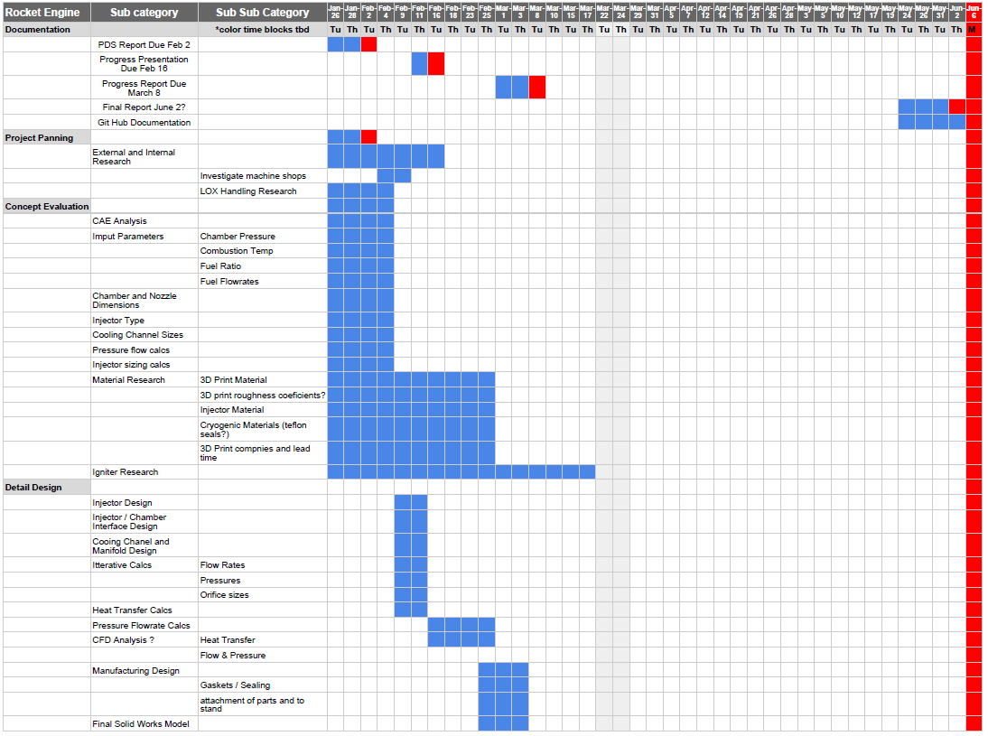
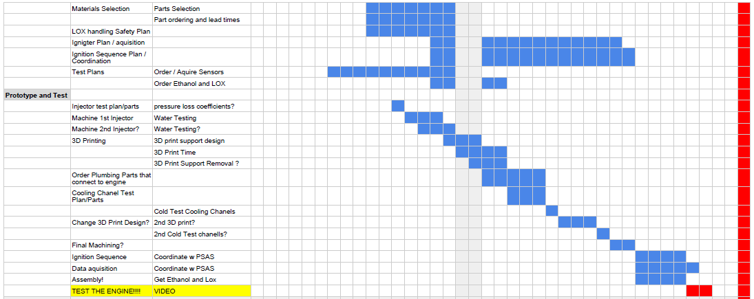
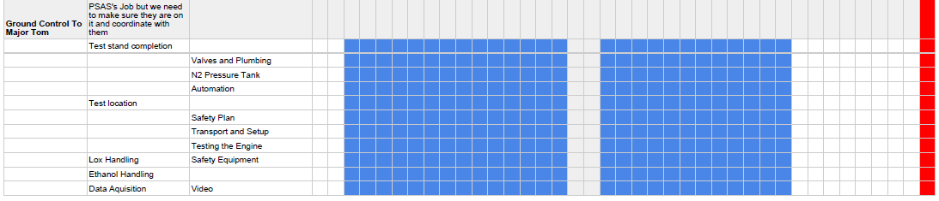

Appendix B:
SolidWorks model of nozzle and combustion chamber with cooling channels are shown in Figs. 2, and 3.This is the current iteration of our combustion chamber, nozzle and cooling channel design. This design will be refined as we complete the injector and heat transfer calculations.
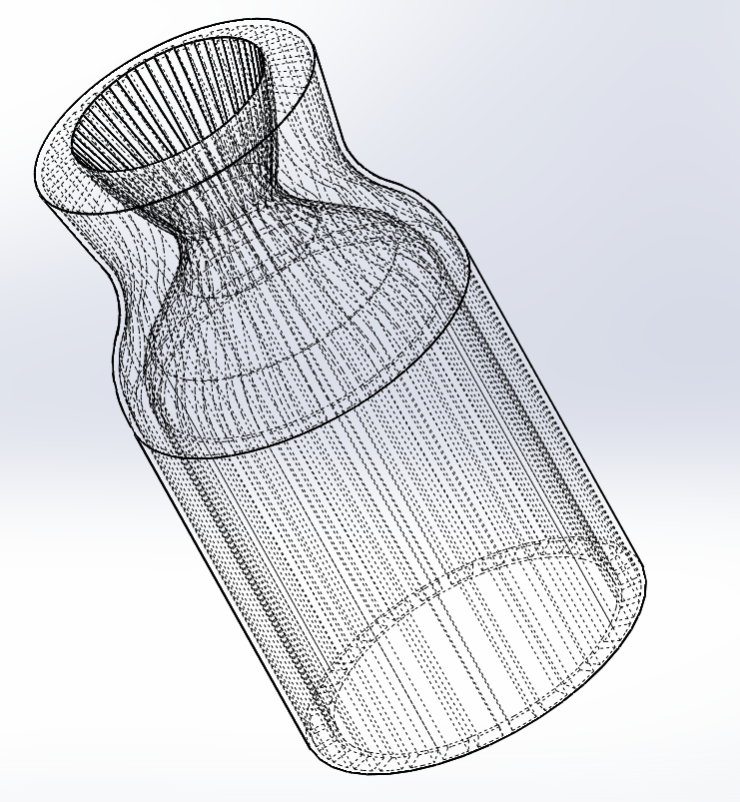
Figure 2 - Snapshot of liquid fuel rocket engine nozzle and combustion chamber with arbitrary scalable dimensions.
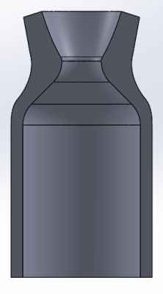
Figure 3 - Section of liquid fuel rocket engine combustion chamber and nozzle with arbitrary scalable dimensions.

Appendix C:
MathCAD Design Calculations
These are preliminary order of magnitude design calculations used to create the current SolidWorks model. The calculation are based on “How to design, build and test small liquid-fuel rocket engines” by Rocketlab. We will refine these calculations with more detailed analysis as we proceed.
