VOLCANIC LAKE ROV
PRODUCT DESIGN SPECIFICATIONS REPORT – WINTER 2012

1/30/2012

Group Members

Giang Le
Duc Nguyen
Son Nguyen
Stephen Phan
Chinh Vu
Christina Yugay
Portland State University Advisor
Dr. Faryar Etesami
Sponsor
Dr. Kenneth Stedman


Table of Contents

Introduction to the Product 1
Purpose of This PDS Document 3
Mission Statement 3
Project Plan 4
Customer Interview and Feedback Summary 6
Product Design Specifications 7
House of Quality 10
Technical Risk Management 11
Conclusion 11
Appendix A: Detail Project Timelines 12

Introduction to the Product

Portland State University conducts research on thermophilic archaebacteria Sulfolobus and their viruses. Sulfolobus bacteria are of great interest to biosciences because they can be used as a model to study the mechanisms of DNA replication and their proteins can be utilized in production of affitins which are artificial proteins that serve as substitutes for antibodies. Unfortunately, samples of Sulfolobus are of limited availability because these microorganisms live in harsh and inaccessible environments such as the volcanic lakes of Lassen Volcanic National Park, California (Figure 1).
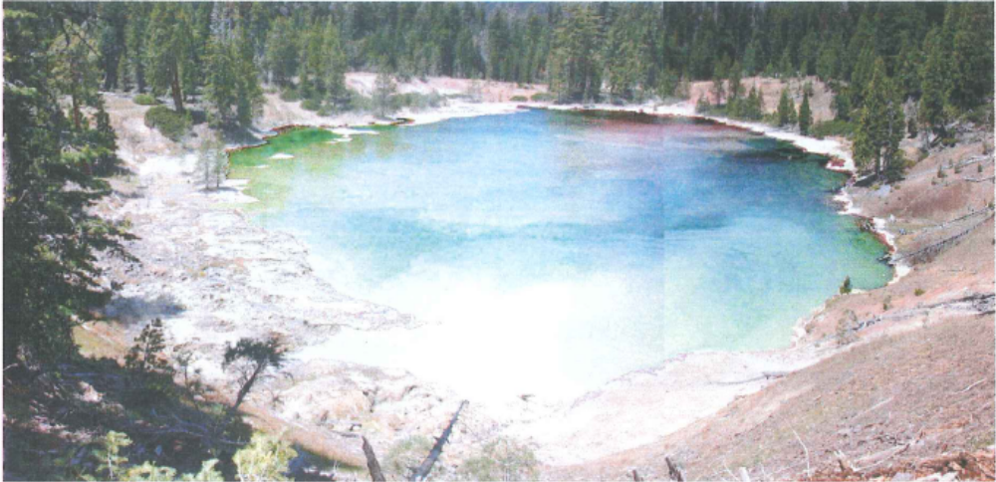
Figure 1. Boiling Spring Lake. Photograph Courtesy of Dr. G. Wolfe
A few years ago, in order to assist PSU bio scientists with their research into the living conditions of the thermophilic archaebacteria, a group of Mechanical Engineering students designed and manufactured a Remotely Operated Vehicle (ROV) (Figure 2). The ROV was made of corrosion resistant materials and equipped with a global positioning system (GPS) and a sonar unit. The ROV has since been used to map the depth and surface temperature distribution of Boiling Springs Lake of Lassen National Park.
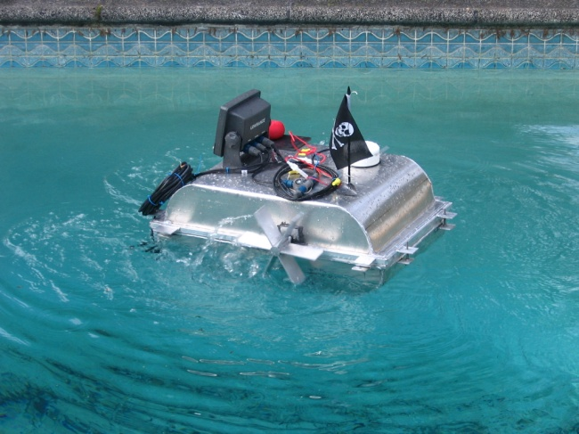
Figure 2. PSU Volcanic Lake ROV. Photograph Courtesy of Dr. Etesami

However, the ROV can only measure temperature at the lake’s surface and does not have water and sediment sampling capabilities. At the time of the ROV’s construction, an attempt was made to equip the vehicle with a water-sampling canister. However, the canister did not fit into the vehicle’s canister dock and the electromagnetic system that was to regulate the opening and closing of the canister failed. Additionally, the depth and global positioning information obtained by the GPS/sonar unit can only be recorded onto a memory card and then analyzed when the ROV comes back to shore.
In order to advance PSU’s bioresearch and make the most out of the existing ROV, the vehicle needs to be retrofitted with a functional water sampling system and a temperature probe that can be lowered to a desired depth. Both devices need to be fully compatible with the vehicle’s geometry (Figure 3), structure, and electrical systems. The vehicle’s GPS/sonar unit needs to be modified to incorporate a transmitter that will allow the transmission of position of the ROV, the canister’s depth, and water temperature data from the ROV to the shore in real time.
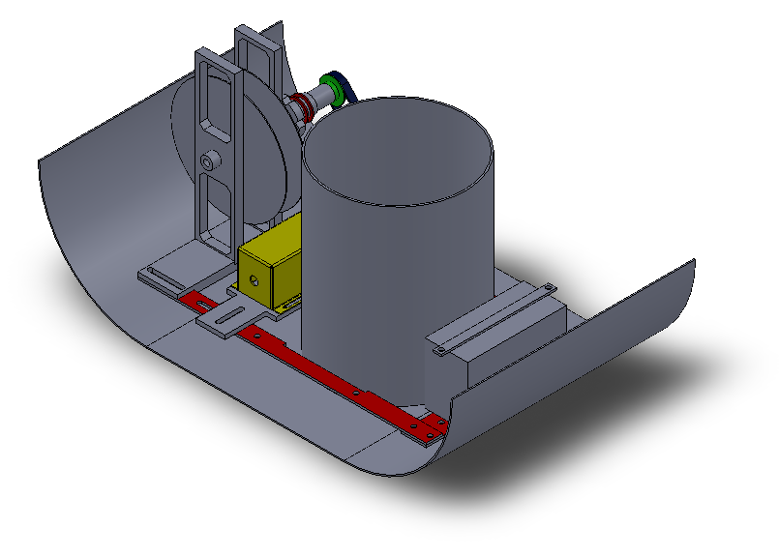
Figure 3. Solidworks Model of ROV's Base

Purpose of This PDS Document

This Product Design Specification (PDS) document defines the customers and their needs that will be integrated into the design to ensure the final product actually addresses customers’ requirements. The constraints, potential risks, and project milestone are also added in this document.

Mission Statement

The project’s main objectives are as follows:
- To design and manufacture a water and sediment collector compatible with the existing ROV. The collector will allow users, via remote operation, to collect samples of water (0.5 liters minimum) from a desired depth in the range of 0 to 10 meters as well as samples of volcanic lake sediment from the depth up to 10 meters.
- To measure water temperature up to 120 degrees Celsius at a desired depth (up to 10 meters) and desired location.
- To design the wireless data transmitting system to transmit the depth, position, and temperature data in real time from the ROV to the shore from a distance of 500 meters at the minimum.
If time and budget permit, the project can be extended to modify the current ROV closing and sealing system to allow for easier, quicker, and tool-free closing and opening of the vehicle.

Project Plan

The due date is the exact date to complete the milestones. The dates for each task are subject to change depending on the requirements and the current condition and status of the project.
Table 1. Project Plan
Project milestone
Task | Start date | Finish date | Due date
Project initiation | 11/7/2011 | 12/12/2011
Develop PDS | 1/10/2012 | 1/30/2012 | 1/30/2012
PDS presentation | 1/30/2012 | 1/30/2012
Concept development | 2/1/2012 | 2/28/2012
Concept selection | 2/29/2012 | 3/1/2012
Detailed design | 3/2/2012 | 3/12/2012
Writing progress report | 3/8/2012 | 3/11/2012 | 3/12/2012
Progress representation | 3/12/2012 | 3/12/2012
Prototype and test | 3/28/2012 | 5/19/2012
Manufacture | 5/20/2012 | 5/23/2012
Final report | 5/24/2012 | 6/6/2012

For details, See Appendix A: Detail Project Timelines.
Identification of Customers

Identification of customers is critically important in defining the specification for the product. The final product should match all or at least the main requirements. Volcanic ROV capstone team has two main customers which are PSU Biology Department and the MCECS capstone program.

Biology Department
Dr. Kenneth Stedman from the Biology Department initiated a student project to renovate the ROV that had been used for his biological research at Boiling Spring Lake in 2007. The report has revealed many design limitation of the current ROV model such as the maneuverability and the capability of sampling water and sediments at varying depth. Dr. Stedman intends to conduct another research at Boiling Spring Lake in which the ROV must be retrofitted to do new and more complex tasks. The requirements provided by Dr. Stedman are:
- The primary requirement is a design of a novel sampling device for water and sediment. The sampling device should be able to operate in an acidic environment.
- The secondary requirements include retrofitting a data transmitter system and the improvement of the sealing system, maneuverability, and sonar noise reduction.
- The budget is $500 or less.

PSU Capstone Program
- The PSU capstone program requires team to design, fabricate, and test a product specified by customers which in our case is the Biology Department. The process will be monitored through 3 classes: ME491, ME492 and ME493. The final products must be delivered by early June of 2012.
- Dr. Etesami, Mechanical Engineering Capstone Coordinator, requires a methodical design process which is tracked by technical reports and presentations. Non-technical skills such as writing, public speaking, and interpersonal skill are required.

Customer Interview and Feedback Summary

The capstone team has had two meetings with Dr. Stedman. Dr. Stedman has given the capstone team feedback on the ROV’s previous performance. The capstone team also has a weekly meeting with Dr. Etesami who had previously advised the ROV design team. The input from both professors guarantees the exact requirement for the Product Design Specification.

Initial Interview
Following the capstone project assignment and the meeting with Dr. Etesami, the team met the project’s sponsor (Customer), Dr. Kenneth Stedman.
During the meeting, Dr. Stedman expressed his interest in having the existing ROV retrofitted with a device/system that would allow him and his research team to collect water and sediment samples from Boiling Springs Lake in Lassen National Park. Dr. Stedman also expressed interest in having the ROV equipped with a temperature sensor that could be lowered to a desired depth in the lake. He pointed out that the installation of the temperature sensor would allow him and his colleagues to complete their study of the lake’s environment and that the water/sediment sampling system would help advance their knowledge of the organisms living in the lake as well as providing the researchers with the much needed samples of thermophilic archaeobacteria. Additionally, Dr. Stedman answered the team’s questions regarding the ROV’s working environment and past performance and other concerns.

Second Interview
The team met the capstone project’s customer Dr. Stedman so as to go over the Product Design Specifications for the water and sediment sampling system and temperature probe. Dr. Stedman and the team agreed on all the specifications. Regarding the transmission of data from the ROV to shore, Dr. Stedman indicated that the depth and temperature data were absolutely required for his research while the global positioning data were merely desired. He also made a point of requesting that the data transmission had a date and time stamp so that his research team could sort the data more easily.

Product Design Specifications
*** - High priority ** - Medium Priority * - Low Priority
Priority | Customer | Requirement | Metric | Target | Target Basis | Verification
Quantity
* | Dr. Stedman | Number | unit | 1 | Customer Feedback | Not necessary
Size and Shape
** | Dr. Stedman | Volume | in³ | 1400 | Customer Feedback | Design
** | Dr. Stedman | Maximum Diameter | in | 8 | Customer Feedback | Design
** | Dr. Stedman | Weight | lbs. | 5 | Customer Feedback | Design
Materials
*** | Self | Structure | Floatable  Non-corrosive | Aluminum  Alloy | Group Decision | Design
Environments
*** | Dr. Stedman | Minimum Temperature Resistance | ºC | 120 | Customer Feedback | Prototyping
*** | Dr. Stedman | Minimum pH Resistance | pH | 1 | Customer Feedback | Prototyping
Cost
*** | Self | Budget Management | $ | < 1000 | Group Decision | Design
Performance
*** | Dr. Stedman | Minimum Canister Capacity | L | 0.5 | Customer Feedback | Design
*** | Dr. Stedman | Minimum Temperature Sensor Capacity | ºC | 120 | Customer Feedback | Design
*** | Self | Minimum Distance of Transmitter Capability | ft. | 1640 | Group Decision | Prototyping
** | Self | Power Consumption | N/A | < 5% of the battery | Group Decision | Prototyping
** | Self | Power Compatibility | N/A | Compatible with existing battery | Group Decision | Prototyping
* | Self | Speed of Descend | ft/s | 1 | Group Decision | Prototyping
** | Self | Depth of Descend | ft. | 32.5 | Group Decision | Prototyping
* | Self | Accuracy of Descend | ft. | 0.5 | Group Decision | Prototyping
*** | Dr. Stedman | Remote Operation | N/A | Automatically lower to depth | Customer Feedback | Prototyping
** | Self | Salvageability | Yes/No | Yes | Group Decision | Prototyping
Software Requirement
* | Self | Compatibility | N/A | Inexpensive | Group Decision | Design
Safety
*** | Self | Electrical Insulation | Yes/No | Yes | Group Decision | Prototyping
*** | Self | Sealing System | Yes/No | Yes | Group  Decision | Prototyping
*** | Self | Sharp Edges | Yes/No | No | Group Decision | Prototyping
Ergonomic
** | Self | Ease of Use | Number of operators | 1 | Group Decision | Design
** | Self | Easy of Handling of Device | Number of handles | 1 | Group Decision | Design
Manufacturing Facility
** | Self | Fabrication Ability | N/A | PSU Shop | Group Decision | Design
Maintenance
** | Dr. Stedman | Life in Service | Years | 5 | Customer Feedback | Design
* | Self | Spare Part | N/A | Easy to find in market | Group Decision | Design
Testing
** | Dr. Stedman | Depth of Operation in Test | ft. | 8 | Customer Feedback | Prototyping
Shipping and Packing
*** | Dr. Stedman | Portability | N/A | Carried 1 mile of rough terrain | Customer Feedback | Prototyping
*** | Dr. Stedman | Transportability | N/A | Carried by car from Oregon to California | Customer Feedback | Prototyping
Timelines
*** | Dr. Stedman | Product Delivery | Deadline | Early June | Customer Feedback | Receipt
Documentation
*** | PSU | PDS Report and Presentation | Deadline | Jan-30 | Course Requirement | Receipt
*** | PSU | Progress Report and Presentation | Deadline | Mar-14 | Course Requirement | Receipt
*** | PSU | Final Report and Showcase | Deadline | Early June | Course Requirement | Receipt

House of Quality
Table 2. House of Quality
Parameter | Importance¹ | Customer | Engineering Requirements
Parameter | Importance¹ | Customer | Weight, lb_{f} | Size, ft³ | Life Cycle | Power, hp | Retail, $ | Material | Instrumentation
Portability | 3 | Dr. Stedman | **** | **** | * | ** | ** | *** | *
Cost | 4 | Dr. Stedman | ** | *** | ** | *** | **** | **** | ***
Sample Collector | 5 | Dr. Stedman | *** | *** | ** | ** | ** | *** | ****
Temperature Sensor | 5 | Dr. Stedman | * | * | * | ** | *** | ** | ****
Transmitter | 4 | Dr. Stedman | * | * | * | *** | *** | ** | ****
GPS Navigation | 3 | Dr. Stedman | * | * | ** | *** | *** | * | ****
Battery Charger | 3 | Dr. Stedman | * | * | **** | *** | ** | ** | ****
ROV Sealant | 2 | Dr. Stedman | ** | * | *** | * | * | **** | **
Batteries | 3 | Dr. Stedman | ** | * | *** | **** | ** | ** | **
Collection Canister | 4 | Dr. Stedman | ** | * | *** | * | ** | **** | **
Competition³ |  | Previous ROV | ** | ** | *** | *** | *** | *** | ***
Target for Current Design |  |  | *** | *** | ** | *** | **** | **** | ****

Legend:
¹Key: 1 - Least Important, 5 - Most Important
²Key: Stars Will Measure How Influential the Engineering Requirements Affects the PDS
³Key: Stars Will Measure How Well The Competition Did in Each Category.

Technical Risk Management
Risks | Causes | Effects | Possibility | Level of Risk | Mitigation Plan | Monitoring Plan
Team Communication | - Language Barrier  - Lack of Communication  - Conflict in Schedule | Severe | Possible | High | Exchange information weekly. Communicate via phone or emails | Update status in Capstone meeting
Product Not Delivered on Time | - Bad Project Plan | Severe | Unlikely | Medium | Follow deadlines seriously | Update status and check status weekly
Exceed Budget | - Expensive Equipment  - Complicated Design | Severe | Likely | High | Change the design/Request more fund from sponsor | Make Bill of Materials/Check the budget frequently
ROV Fails | - Bad Design | Catastrophic | Possible | High | Consult advisor and mentor | Communicate with advisor and mentor
Unable to Manufacture | - Complicated design  - Lacking Experiences | Catastrophic | Possible | High | Make simple solutions | Communicate with advisor and mentor

Table 3. Technical Risk Management

Conclusion

After interviewing the customers and several team meetings, all essential requirements are added to the PDS document. This document will serve as the reference during the design process of the ROV project. The mission statement clarifies the objectives of the project, which are canister fabrication and real-time transmitter of depth and temperature information. The project plan ensures everything follows the schedule. The PDS table and House of Quality list all the requirements and priorities from the customer and the Capstone team. The technical risk management projects obstacles that the team should overcome while doing this project.

Appendix A: Detail Project Timelines
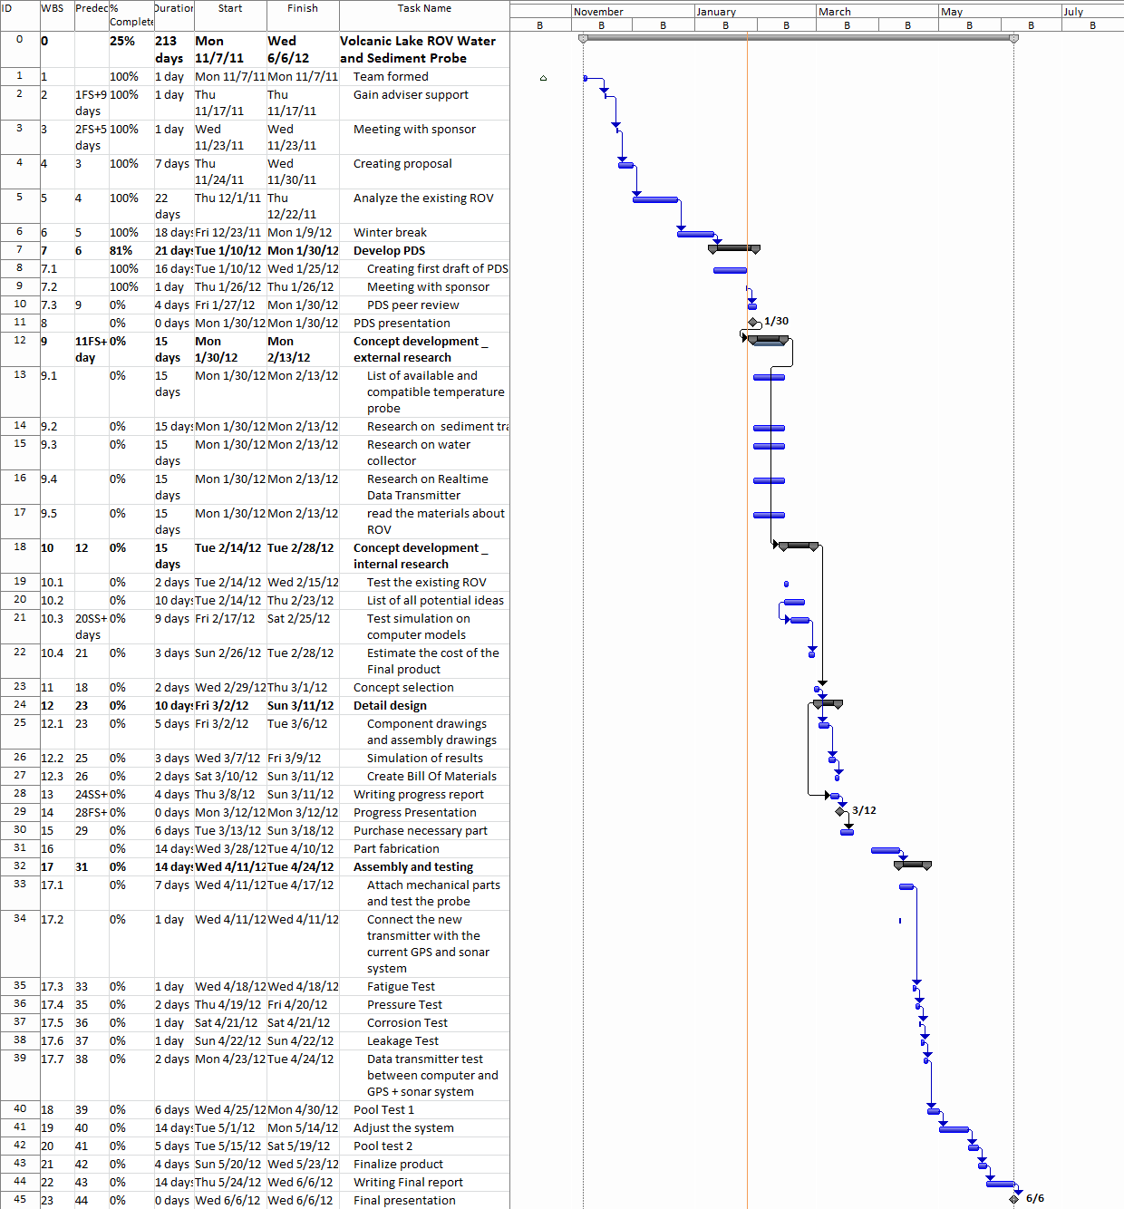
Figure 4. Project Timelines

