­­­

ReDESIGN OF THE oUTBOARD sUSPENSION

- ME 493 Final Report, SPRING 2012 -

Mechanical Engineering Design Team

Rick Rickert

Carole Gayley

Charles Larson

Efe Yıldırım

Jose Colin

Josh McCall

Industry Advisor: Evan Waymire

Academic Advisor: Dr. Lemmy Meekisho

# Executive Summary

The purpose of this capstone project is to redesign the 4-lug outboard suspension of the model year 2011 (MY11) Viking Motorsports (VMS) Formula SAE (FSAE) car to accommodate a centerlock (single lug) wheel on the MY12 car. VMS requested an outboard suspension design (hub, upright, brake hat, wheel nut retention system) that would reduce the weight, machine time and cost over MY11.

This project spanned over winter and spring terms, and began with the development of the Product Design Specification (PDS). VMS provided the Outboard Suspension (OS) Team with measureable areas of achievement. An external search was conducted to explore pre-existing options for centerlock systems. This was followed by an internal search, which involved brainstorming possible solutions which culminated in several designs.

The final design consists of a centerlock hub, upright, modular brake hat, wheel nut, and wheel centering and nut retention system. All of the steps leading to and validating the final design involved multi-disciplinary skills such as: theoretical calculations from mechanical engineering textbooks, using MathCad to assist with hand calculations, 3D modeling and Finite Element Analysis (FEA) using SolidWorks, and fabrication of both metal and polymer components. All of these activities occurred in parallel with a final completion date of June 11, 2012. VMS deliverables include the documented final design along with fabricated parts and spares for all four corners of the car. Capstone deliverables include a validated final design, report and prototype display.

Contents

Executive Summary 2

Introduction 6

Mission Statement 7

Main Design Requirements 7

Top Level Alternative Conceptual Solutions 8

Hubs 8

Wheel Engagement 8

Drive Shaft Engagement 9

Brake Hat 9

Uprights 10

Final Product Design 10

Hub 10

Bearings 11

Centerlock Wheel Nut 11

Heat Treatment 11

Upright 12

Brake Hat 12

Wheel Pilot 13

Wheel Nut Retainer 13

Wheel Nut Spacer 14

Drive Pins 14

Final Product Evaluation 14

Installation 14

Safety 15

Performance - Hub Weight 15

Performance – Load Capacity 15

Cost and Machine Time 16

Service Life 16

Ease of Assembly 16

Conclusions 16

Appendix A - Hub Material Selection 18

Reference 19

Appendix B – Full Product Design Specifications 20

Appendix C – Design and FEA 24

C.1 - Hub 24

C.2 – Upright 27

C.3 - Brake Hat 32

C.4 - Wheel Nut Spacer 34

References 36

Appendix D – Detailed Calculations 37

D.1 – Bearing-Hub Interference 37

D.2 – Bearing-Upright Interference 40

D.3 – Wheel Torque 42

D.4 – Drive Pin Contact Stress 45

D.5 – Bearing Loading and Life 48

Appendix E - Bill of Materials 51

Appendix F – Assembly Procedure 52

Appendix G – Service Manual 54

Appendix H - Detailed Drawings 55

Figure 1: Model year 2011 hub, showing complicated geometry and raw material used. 4

Figure 2: 2011 upright requiring 5-axis machining. 4

Figure 3: Large 2" diameter aluminum centerlock nuts 6

Figure 4: Non-integrated tulip sold by Taylor Racing 7

Figure 5: Model year 2011 hub showing the hub integrated brake hat (Left). Conceptual separate brake hat for model year 2012 (Right). 7

Figure 6: Two KYK sealed deep grove ball bearings are used, the same bearing as the 2011 car used. 9

Figure 7: An M16x2.0 Class 10 nut was chosen to secure the wheel to the centerlock hub. 9

Figure 8: The redesigned 2012 upright featuring an integrated wheel speed sensor mounting hole. 10

Figure 9: The 2012 non-integrated brake hat. 10

Figure 10: The aluminum wheel pilot that provides efficient wheel centering. 11

Figure 11: A 16 mm axel nut retainer and R clip keep this centerlock nut from moving. 11

Figure 12: An aluminum spacer distributes clamping force from the nut to the aluminum wheel. 12

Figure 13: Standard dowel pins purchased from McMaster-Carr 12

# Introduction

Viking Motorsports (VMS) is a Portland State University student operated team that competes in the Formula Society of Automotive Engineers (FSAE) race car design competition. FSAE student members design and fabricate a race car while adhering to regulations provided by the FSAE governing body. More than 140 college and university teams compete each June in Design, Cost and Manufacturing, Acceleration, Skid Pad, Autocross, Endurance, and Fuel Economy events.

The 2011 VMS race car was a clean sheet design, resulting in a car that greatly outperformed the 2010 model. The outboard suspension (OS) featured lighter uprights and a new hub. The 2011 OS consisted of hubs, uprights, wheel speed sensors, wheel bearings, and installation hardware. The rear hubs featured integrated constant-velocity (CV) joints.

VMS primarily wanted to simplify the hub and upright designs for the 2012 car, while incorporating a centerlock wheel retention method to match their custom wheel design. The 2011 hub’s geometry required a complex machining process on a CNC lathe (Fig. 2).

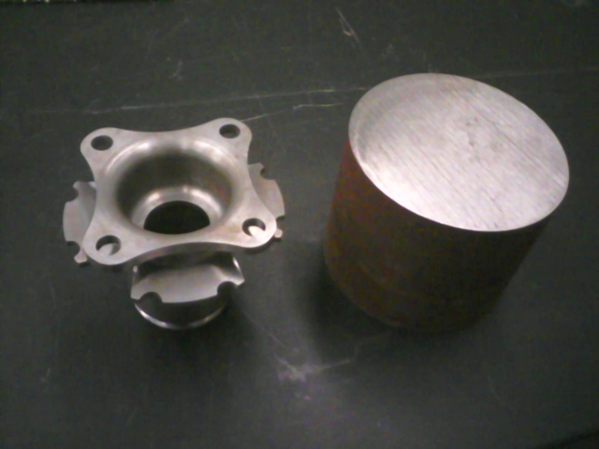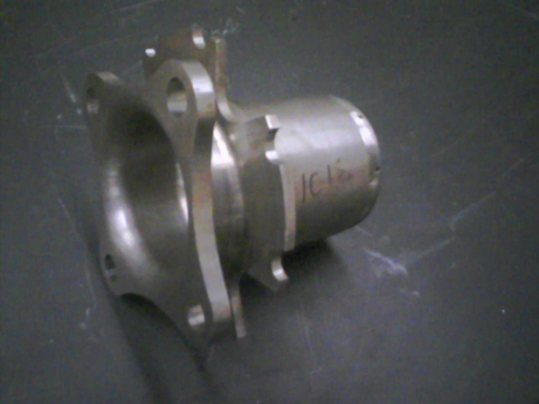

Figure 1: Model year 2011 hub, showing complicated geometry and raw material used.

The 2011 upright required 5-axis CNC machining because of an angled suspension mount (Fig. 2). 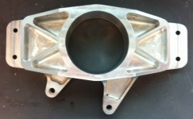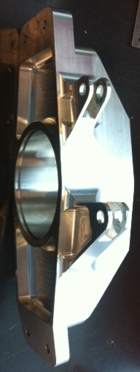

Figure 2: 2011 upright requiring 5-axis machining.

An outboard suspension redesign would reduce manufacturing resources and costs during fabrication and provide an opportunity to integrate a centerlock wheel retention system. In June 2012, the Viking Motorsports team, racecar and improved outboard suspension will go to Nebraska for the FSAE competition.

# Mission Statement

The FSAE Outboard Suspension Team (FSAE-OS team) will design, validate, and produce a new outboard suspension that will weigh less, have a reduced part machining time and integrate a centerlock system. The FSAE-OS team will produce all required drawings and BOMs along with a report of the design decisions and FEA analysis used to produce the new system.

# Main Design Requirements

As specified by VMS, the hubs must be no more than 2lbs, be able to withstand 2G lateral/longitudinal and 3G vertical chassis acceleration, and have a minimum service life of 2 years. The friction due to clamping force must be sufficient to transfer all torque between the wheel and hubs/brakes under any expecting loading. Drive pins may be used as a safety feature, but should not be the primary method of torque transfer.

The hub must integrate with the 2012 VMS centerlock wheel, and must have a center nut retention device that prevents the wheel nut from coming off the car during competition. No more than 300ft.lbf torque must be required to install the centerlock nut.

The hub must be machined in less than 80 minutes with a material cost of less than $200. Machine time does not include mid process heat treatment and final bearing surface finishing.

The whole system must have a design safety factor of at least 1.5. The hub and upright must be able to be assembled with no special tools or fixtures. The hub and upright must be compatible with the 2011 suspension, bearings, drive shafts, and steering linkage.

# Top Level Alternative Conceptual Solutions

## Hubs

Three types of centerlock hubs are typically used in FSAE type race cars. All three types were examined for our project.

A common off-the-shelf solution from Taylor Racing was designed for D-Sports Racers (DSR). DSR’s are approximately twice the weight of an FSAE car, and operate at much higher speeds with downforce, so they are clearly oversized for this application. The Taylor Racing parts are also outside of the budget at $4000 for a set of 4.

Two design concepts for custom made hubs are to use a large aluminum center nut, or a small steel center nut. The large aluminum center nuts are typically in the range of 2” diameter (Fig.3). Due to the requirement that the clamp force from the center nut must be the primary mode of hub to wheel drive and braking torque transfer, the torque requirement is outside of the maximum specified allowable installation torque (Appendix D.3).

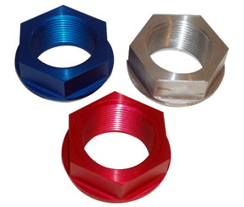

Figure 3: 2" diameter aluminum centerlock nuts

A smaller steel nut is capable of providing the required clamp force within the allowed 300ft.lbf installation torque specification. For this reason, a steel nut will be used.

## Wheel Engagement

In the event the center nut should come loose, three concepts were evaluated to ensure the brakes would continue to engage the wheel allowing the driver to safely stop the car.

A splined hub and wheel would keep the wheel engaged with the hub at all times. A review of the machine operations required to produce the spline on the hub and wheel showed that it took a large amount of time and specialized tools.

A shaft key can be used to prevent rotation of the wheel on the hub. A keyed shaft requires milling on the hub shaft and wheel center. Though this is not difficult, it introduces stress risers in the hub shaft, and requires additional machining operations.

Drive pins can be installed in the hub and will engage the brake hat and wheel. Three steel dowel pins were chosen to engage the hub, brake, and wheel, allowing the driver to safely stop the vehicle. Pins are inexpensive and easily sourced, and are the simplest to implement.

## Drive Shaft Engagement

The tulip (female side of the CV joint) attachment can either be a bolt on part to the back of the hub, or built into the hub itself (Fig.4). Per VMS request to retain 2011 axle geometry, the rear hubs will have tulips built in. This allows the hubs to use fewer parts, and have a lower overall weight. From contact stress calculation, the CV races inside the hub require an RC50 or higher hardness to prevent damage to the surface of the hub (Appendix A).

**[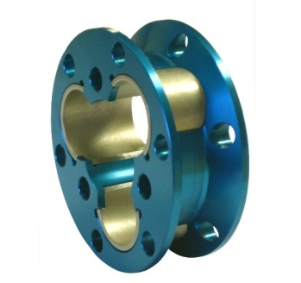](http://www.taylor-race.com/items.cfm?category=Chain%20Drive&subcategory1=Aluminum%20FSAE%20Tri-pod%20Housing)**

Figure 4: Non-integrated tulip sold by Taylor Racing

## Brake Hat

The VMS car uses a two piece floating brake design consisting of the brake rotor, hat, and bobbins that join the two. VMS will design the rotor itself, but the OS-team was asked to design the hat. The 2011 hub had the hat machined into the hub, increasing machine complexity (visible in Fig.1).

The brake hat can be built into the hub, or made a separate part. For 2012, the brake hat was removed from the hub and is now cut from plate. Removing the brake hat, as well as the 4-lug mounts, allows smaller diameter hub material. Separating the brake hat also opens up other material possibilities for the brake hat, potentially reducing the weight of the outboard assembly and rotational inertia.

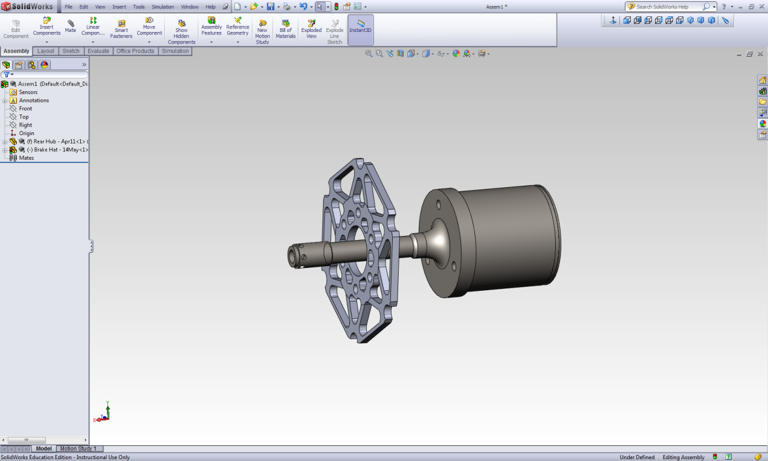

Figure 5: Model year 2011 hub showing the hub integrated brake hat (Left). Conceptual separate 2012 brake hat (Right).

## Uprights

Four styles of uprights were considered for the 2012 car.

Taylor Racing sells uprights that are designed for a DSR. These are excessively heavy for a FSAE vehicle and the provided budget does not allow for the purchase of these expensive parts.

Sheet metal welded uprights or cast aluminum uprights were two options considered for the outboard suspension redesign. Stressed welded elements introduce a large amount of uncertainty into the design, especially considering VMS has limited welding experience. The cost of tooling for cast aluminum uprights and the time to make the tooling were additional limitations for this project.

The uprights were left similar to the 2011 version and machined from billet aluminum with the addition of a wheel speed sensor mount in the center of the upright, and some geometry improvements in the brake mounting area to reduce caliper drag on the rotors, and increase web thickness near the mounting tabs. Fully machined uprights are costly to machine and have a significant lead time. For production runs, more time would be spent on changing to cast uprights.

# Final Product Design

## Hub

The hub has a built in tulip for the rear hubs. Detailed material selection is outlined in Appendix A. The bearings use the same 65mm ID bearings as specified by the Viking Motorsports team. The hub features an M16x2.0 Class 10 centerlock nut. The hub body is thru hardened to RC40 and the bearing races are ion-nitrided to RC65. By removing the brake hat, the 2012 hub can be produced from 3” round stock, vs. 5” round stock required for 2011.

## Bearings

A customer requirement was to use the same size bearings as was used on the 2011 car. These are 85mm OD x 65mm ID x 10mm wide single row deep groove ball bearings. The OS-team chose KYK 68132RS bearings, purchased from McGuire Bearing Co. KYK was chosen for their high life rating and reputation for quality. The bearings are to be installed by shrink fit to prevent movement during use, and a bearing spacer on the inner and outer race maintains even pressure on both bearings under axial loading.

The interference fit chosen for the 2011 bearings was high enough to cause significant bearing drag at room temperatures. 2012 design interference was calculated for both the bearing-hub and bearing-upright interfaces. Appendix D.1 derives the bearing-hub interference specification, while Appendix D.2 derives the bearing-upright interference.

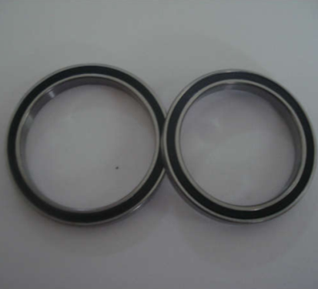

Figure 6: Two KYK sealed deep grove ball bearings are used, the same bearing as the 2011 car used.

## Centerlock Wheel Nut

VMS requested that the friction between the wheel and hub should be sufficient to prevent relative motion between the two. Clamp force and wheel nut torque requirement are derived in Appendix D.3. An M16x2.0 Class 10 but was chosen. This nut will provide the required 13,880lbf clamping force with an installation torque of 145.7ft.lbf.

## Heat Treatment

The final material condition of the hubs was determined through iterative design and FEA, based on geometric constraints and material properties. The centerlock shank required a yield strength of 95ksi, while the wheel bearing shoulder surface required a yield strength of 61ksi. In order to satisfy infinite life from cornering stresses, the hub required heat treating to RC40 [1].

Hertzian contact stress calculator results indicated a minimum strength of RC50 within the CV joints. To satisfy these requirements, the hubs were through hardened to RC40. The rear hubs were then masked and the CV joint surfaces were ion-nitrided to RC65.

## Upright

The upright is made of 6061-T6 billet aluminum. It has a nominal 85mm hub bore with a slight interference fit with the hub bearing to provide retention of the hub bearing. The upper and lower ball joint mounts are positioned to keep the same suspension geometry as the 2011 car. A wheel speed sensor will mount to the upright (Fig.7). The speed sensor will monitor slots cut into the brake disk and send data to the onboard data acquisition. The caliper mounting plane was shifted slightly to eliminate the drag caused by the caliper contacting the rotor in the 2011 design.

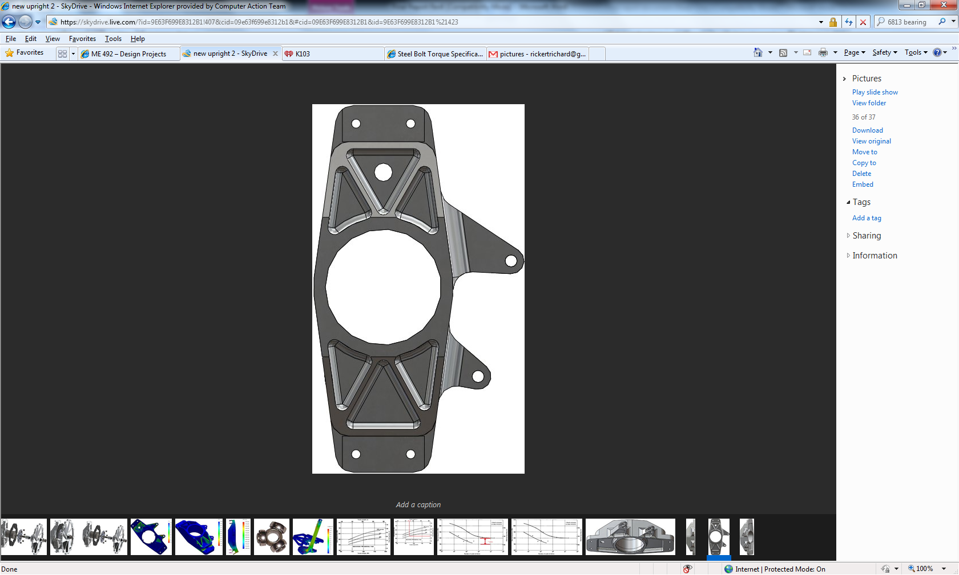

Figure 7: The redesigned 2012 upright featuring an integrated wheel speed sensor mounting hole.

## Brake Hat

The brake hat was removed from the hub, and is made from plate material that can be machined by VMS (Fig.8). This allows the hub to be machined from 3in round stock instead of 5in round stock reducing material cost, machine time, and complexity. The brake hat is made from 4130 steel, but if desired, a brake hat of other materials could be designed and interchanged easily.

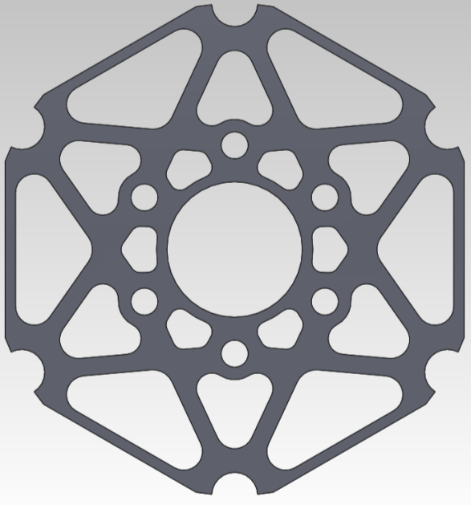

Figure 8: 2012 brake hat.

## Wheel Pilot

Because the 2012 hubs use a small center nut, a wheel centering feature had to be used to keep the wheel centered on the hub during installation. An aluminum centering feature was designed that can be installed over the shank of the hub (Fig.9). The wheel pilot can be machined at PSU.

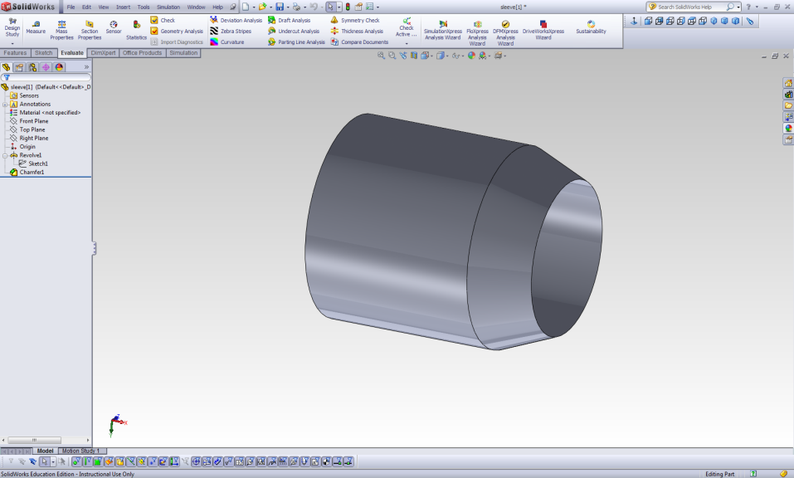

Figure 9: Aluminum wheel pilot that centers the wheel.

## Wheel Nut Retainer

A rule for FSAE cars is that if a center nut design is chosen, a wheel nut retention device must be used. A spindle nut retainer was chosen for the M16 nut used on the hub (Fig.10). The retainer is held in place with an R-clip.

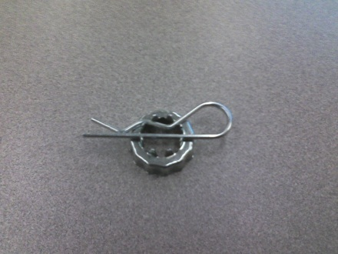

Figure 10: 16mm axle nut retainer and R-clip prevent the centerlock nut from rotating.

## Wheel Nut Spacer

A truncated conical spacer was designed to distribute the clamp force from the centerlock nut into the aluminum wheel (Fig.11). The aluminum spacer designed by the team can be machined at PSU on a lathe.

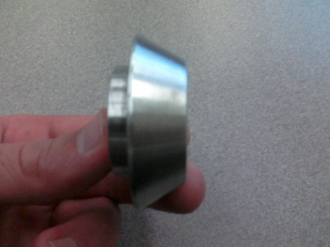

Figure 11: An aluminum spacer distributes clamping force from the nut to the aluminum wheel.

## Drive Pins

Three ¼in dowel pins are installed into each hub. The pins engage the brake hat and the wheel, which will allow the driver to safely stop the vehicle if clamping force is lost.

# Final Product Evaluation

Following the design, manufacture and assembly of the centerlock outboard suspension prototype, the functionality of the product was evaluated. The new outboard suspension was evaluated in terms of the original PDS items of highest priority, which were defined by Viking Motorsports at the onset of the project. A full list of PDS requirements can be seen in Appendix B. At the time of this report, the VMS custom centerlock wheel has not been manufactured; so on vehicle testing has not been possible. Product evaluation has been limited to analytical calculations, FEA analysis and prototype assembly testing. To date, the new outboard suspension meets most of the following PDS requirements:

Installation - **Interchangeable Parts:**

The redesigned 2012 centerlock outboard suspension maintains the same mating geometry as the 2011 suspension. Bearing surface diameters on the outside of the hub and inside the upright are the same. Upper and lower control arm mounting points on the 2012 upright are identical to the 2011 upright. The position of the tire contact patch in relationship to the car has not moved. Mating geometries were validated using a full assembly of the system in Solid Works.

Safety **- Centerlock Nut Retention:**

As required by the FSAE rules, the centerlock nut is retained with more than two threads exposed. Nut retention is achieved by use of a spindle nut retainer in combination with an R-clip. Two exposed threads were verified by an assembly in Solid Works.

Performance - Hub Weight**:**

The weight of one rear hub must be 2lbf or less. Hub weight was verified through testing with a digital scale. One new 2012 rear centerlock hub weighs 1.92lbf. The new centerlock hub weighs 44% less than the 2011 four lug hub.

Performance – Load Capacity**:**

As defined by the customer (Viking Motorsports) all outboard suspension parts withstand 2G lateral (cornering) and longitudinal (braking) loading, and 3G vertical (bump) loading. Outboard suspension parts were verified against these loading conditions separately, using a combination of FEA analysis and hand calculations. The centerlock hub shows a minimum factor of safety of 1.21 under the prescribed loads by FEA analysis (Appendix C.1). The hub was analyzed using endurance limit data for air-melted 4340. The OS-team recommends vacuum-melted 4340 to reduce the chances of inclusions, raising the endurance limit and therefore the factor of safety.

The upright’s factor of safety is greater than 1.48 during all loading conditions in all areas, except cornering with a 3G bump where the clevis touches the upright (Appendix C.2). The factor of safety in this area is 0.76, however this is acceptable. Under the worst expected loading condition, localized yielding will occur, followed by a decrease in stress. The region of localized yielding will not affect the overall integrity or geometry of the upright.

The brake hat also meets the design target while clamping force is maintained, with a factor of safety of 2.07 (Appendix C.3). With no clamping force (emergency situation), the brake hat has a factor of safety of 0.71. This value is assuming 2G braking, which is unrealistic in this scenario.

By design, loads are transmitted from the wheel to the hub completely using friction and clamping. The wheel nut clamp load required during 2G braking is 13,880lbf, which is achievable using the 16mm centerlock nut chosen. See Appendix D.3 for verification of clamping calculations.

If clamping force was ever lost, loads would be transmitted through three wheel pins. However wheel pins and pin holes are designed for careful car recovery, not the worst case racing conditions described above. For wheel pin loading limits see Appendix D.4.

Cost and Machine Time **– Hub:**

The cost to manufacture one hub should be less than $200, and require less than 80 minutes of machine time. Raw material cost for one hub is $109 (Appendix E). The hubs took 64 minutes each for initial machining. As of this report, the bearing surface finishing has not been completed, so the total manufacturing time is unknown. Expenses that may cause the hub to go over budget are the heat treatment of the 4340 hub material and post heat treat bearing surface machining. All services were donated however, so the budget was maintained.

Service Life**:**

The new outboard suspension must have a life of two years. Though two years have not passed, the only part on the centerlock system that would wear out and require replacement are the KYK deep groove ball bearings. Bearing life calculations verify that they will last at least two years with 90% reliability. This life assumes 500 miles of racing per year, with 75% of the loading straight line and 25% at full 3g bump and 2g lateral loading. The details of the bearing life calculations can be found in Appendix D.5.

Ease of Assembly**:**

As Viking Motorsports requested, no special tools or fixtures are required to assemble the outboard suspension. The centerlock wheel nut can be torqued by any team member using a standard ½ inch drive torque wrench. Ease of assembly is verified through the calculation of the required wheel nut torque. The centerlock nut must be torqued to 145.7ft.lbf to reach the clamping force required for all loads to be carried through friction, see Appendix D.3.

# Conclusions

The final hub and upright design have a reduced weight of 1.92lbf meeting the design goal of less than 2lbf. The hub uses a center lock design and is designed to accommodate the VMS turbine wheel. The brake hat is removable resulting in a required round stock of only 3” to make the hubs, reducing material cost, waste material, and machine time. The center wheel nut has a minimum torque specification of 145.7ft.lbf and a recommended torque specification of 175ft.lbf.

The uprights have a corrected caliper mounting location, wheel speed sensor mount, and simplified profile geometry. These design changes resulted in a product that satisfied the customer’s requirements for the outboard suspension.

Due to financial restrictions and time constraints from the donating companies, some of the parts were not able to be delivered in time to use these parts for 2012 competition. The hubs and uprights are scheduled to be delivered by the end of June 2012.

# Reference

[1] “Rockwell C Hardness Test Simulation by Finite Element Analysis,” last updated Feb 10, 2012, <http://www.varmintal.com/arock.htm>

# Appendix A - Hub Material Selection

The rear hubs required an integrated CV joint. To determine the required strength within the CV joint, the contact stress between the axle’s tripod (Figure A.1) and the inside of the hub had to be determined. The tripod uses three truncated 1.005” spheres, and the hub uses cylindrical races.

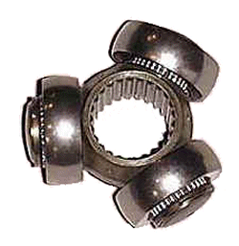

Figure A.1 – Taylor Race CV joint tripod

The OS-Team was unable to find an analytic solution to sphere-cylinder contact stress, so a freeware Hertzian contact calculator was used [1]. Based on internal geometric constraints, it was determined the races required a minimum yield strength of 225ksi to prevent pitting.

In order to construct the hub from aluminum, the CV joint would require hardened steel inserts to meet the required strength. This would require a larger OD than the specified wheel bearings allowed, so this option was ruled out. Using steel, the CV joints could be machined into the hub and then hardened as necessary.

AISI 4340 was chosen for its machinability while normalized, and through hardenability. In air-melted round stock, there is a large variance in the endurance limit due to inclusions. Figure A.2 shows ultimate tensile strength vs. endurance limit trends for 4340. Without fatigue testing a sample of the stock, the exact endurance limit is unknown.

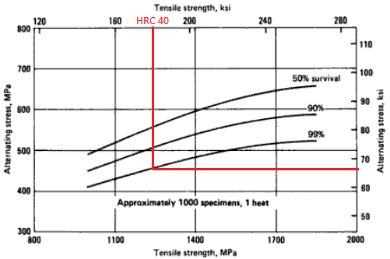

Figure A.2 – Statistical data for ultimate tensile strength vs. endurance limit for air-melted 4340. [2]

Vacuum-melted round stock was chosen to minimize the chance of premature failure in lieu of better data. Figure A.3 shows the typical offset in endurance limit between air and vacuum melted 4340.

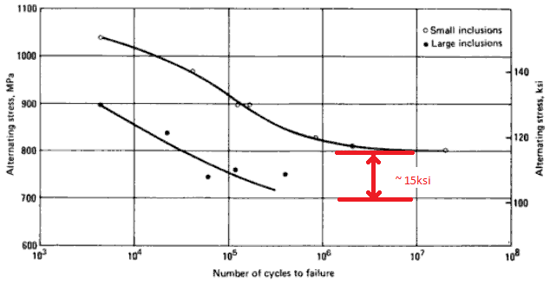

Figure A.3 – Endurance limit comparison for air and vacuum melted 4340. Ultimate tensile strengths of test specimens were not specified. [2]

Without detailed endurance limit data for vacuum-melted stock at various strengths, the endurance limit of air-melt was used in all analysis.

## Reference

[1] “Hertz Contact Stress Calculations,” accessed 10 June 2012, http://en.vinksda.nl/software-toolkit/hertz-contact-stress-calculations

[2] Boyer, Howard E. Atlas of Fatigue Curves, “Section 4 – Alloy Steels: Low- to High- Carbon, Inclusive.” ASM International, 1986, pp.97-106.

# Appendix B – Full Product Design Specifications

|  |  |  |  |  |  |  |  |
| --- | --- | --- | --- | --- | --- | --- | --- |
| **Final Design PDS** | | | | | | | |
| **Priority** | **Requirements** | **Primary Customer** | **Goal** | **Metric** | **Target** | **Target Basis** | **Verification** |
| 5 | 2011 & 2012 parts should be interchangeable | FSAE Team | Back-up system in case of failure | N/A | N/A | Customer defined | Prototype |
| 5 | Centerlock nut retention with two threads showing  (FSAE rule) | Driver | Keep the wheel on the car | On/Off | On | Driver’s Safety | Nut cannot be removed without removing cotter pin |
| 4 | Hub Weight | FSAE Team | Decrease weight | Pounds | 2lb | Customer defined | Prototype |
| 4 | Ease of hub manufacturing | FSAE Team / Mfg | Decrease complexity | Machining time (min) | 80 minutes | Customer defined | Prototype |
| 3 | Hub Cost | FSAE Team | Lower Cost | Dollars ($) | $200 Hub | Customer defined | Machine Shop invoice |
| 2 | Service Life | FSAE Team / Driver | Ensure sufficient reliability | Operating life (years) | Minimum 2 year life | Customer / group | FEA / Prototype |
| 5 | Load Capacity | FSAE Team | Withstand Racing Conditions | G | 2G lat/long  3G vertical | Customer Defined | Prototype |
| 5 | Factor of Safety | FSAE Team | Safe Operating Range | N/A | 1.5 | Driver’s Safety | FEA |

|  |  |  |  |  |  |  |  |
| --- | --- | --- | --- | --- | --- | --- | --- |
| **Installation** | | | | | | | |
| **Priority** | **Requirements** | **Primary Customer** | **Goal** | **Metric** | **Target** | **Target Basis** | **Verification** |
| 5 | Installation Torque | FSAE Team | 300 ft.lbf max | ft.lbf | 175 ft.lbf | Customer Defined | Prototype |
| 5 | Must interface with 2012 wheels | FSAE Team | Must be able to mount 2012 wheel to the hub | N/A | N/A | Customer Defined | Prototype |
| 5 | Floating Rotor | FSAE Team | Floating | N/A | N/A | Customer | Prototype |
| 5 | Drive Axle | FSAE Team | Integration with existing equipment | N/A | N/A | Customer  Defined | Prototype |
| **Production** | | | | | | | |
| **Priority** | **Requirements** | **Primary Customer** | **Goal** | **Metric** | **Target** | **Target Basis** | **Verification** |
| 4 | Assembly Quantity | FSAE Team | Sufficient Part Quantity | Quantity of Assemblies | 3 front  3 rear | Customer  Defined | Delivery Receipt |
| 4 | Upright Material | FSAE Team | Must be aluminum | ANSI Grade | 6061-T6 Aluminum or similar | Customer Defined | Prototype |
| **Documentation** | | | | | | | |
| **Priority** | **Requirements** | **Primary Customer** | **Goal** | **Metric** | **Target** | **Target Basis** | **Verification** |
| 4 | Full Engineering Documentation | FSAE Team | Project must be fully documented | N/A | N/A | Customer Defined | SolidWorks CAD files |
| 3 | Installation Instructions | Mechanic | Full assembly instructions | N/A | N/A | Customer Defined | Word Document |

|  |  |  |  |  |  |  |  |
| --- | --- | --- | --- | --- | --- | --- | --- |
| **Rules and Regulations** | | | | | | | |
| **Priority** | **Requirements** | **Primary Customer** | **Goal** | **Metric** | **Target** | **Target Basis** | **Verification** |
| 5 | Must adhere to all FSAE rules and regulations | FSAE Rule Book | Must pass tech inspection | N/A | N/A | Customer Defined | Prototype |
| **Legal (Patents, Product Liability)** | | | | | | | |
| **Priority** | **Requirements** | **Primary Customer** | **Goal** | **Metric** | **Target** | **Target Basis** | **Verification** |
| 4 | Minimize product liability issues | Design Team | Avoid legal ramifications | N/A | Use practices to minimize catastrophic failure | Design Team | Prototype |
| 4 | No patent infringement | Design Team | Avoid legal ramifications | N/A | Design must be unique | Design Team | Patent Search |
| **Aesthetics** | | | | | | | |
| **Priority** | **Requirements** | **Primary Customer** | **Goal** | **Metric** | **Target** | **Target Basis** | **Verification** |
| 2 | Aesthetically pleasing | FSAE Team | Must look well engineered | N/A | N/A | Customer Defined | Prototype |
| **Disposal** | | | | | | | |
| **Priority** | **Requirements** | **Primary Customer** | **Goal** | **Metric** | **Target** | **Target Basis** | **Verification** |
| 1 | Recyclable Material | FSAE Team | Minimize Disposal Cost | N/A | N/A | Customer Defined | MSDS |
| **Testing** | | | | | | | |
| **Priority** | **Requirements** | **Primary Customer** | **Goal** | **Metric** | **Target** | **Target Basis** | **Verification** |
| 5 | Must complete testing sequence before first use | FSAE Team | Verify assembly integrity | Hour | 4 | Design Team | Complete Testing Check-sheet |

|  |  |  |  |  |  |  |  |
| --- | --- | --- | --- | --- | --- | --- | --- |
| **Lower Priority PDS Requirements** | | | | | | | |
| **Priority** | **Requirements** | **Primary Customer** | **Goal** | **Metric** | **Target** | **Target Basis** | **Verification** |
| 3 | Rolling resistance | FSAE Team | Decrease Resistance | In*lb | <1in*lb | Customer defined | Prototype |
| 3 | Operating environment | FSAE Team | Operating in dust/water | N/A | N/A | Customer defined | Prototype |
| 4 | Operating temperature range | FSAE Team | Operate within operating temperature | °F | 600°F | Driver’s safety | Prototype / testing |
| 3 | Hub/wheel assembly | FSAE Team | Easy to assemble | Assembly time | Hub: <50min  Wheel: <1min | Customer defined | Prototype |
| 3 | Wheel  bearing | Mechanic | Ease of assembly | Time and tools required | No specialized tools/ fixtures | Mechanic crew | Assembly |

# Appendix C – Design and FEA

Each stressed component in the outboard suspension system was analyzed using Finite Element Analysis (FEA). Loads were assumed from given PDS requirements, and restraints were used as realistically as possible to prevent over-stiffness. When applicable, secondary components were used help prevent unrealistic loading or restraint conditions. Symmetry was used where applicable to reduce the number of meshing elements and therefor computation time. All stresses are derived using the Von Mises yield criterion.

CosmosWorks FEA was used in conjunction with SolidWorks to iteratively model and optimize each design. Since the upright was fundamentally unchanged from the 2011 model, it was analyzed only to provide supplementary information for Viking Motorsports (VMS).

Per Viking Motorsports, the target Factor of Safety (FOS) for all components is 1.5. Components using normalized or annealed material are displayed with FOS plots. The hub, which is hardened, is displayed with a stress plot, since CosmosWorks material properties cannot be adjusted.

## C.1 - Hub

The front and rear hubs are identical, apart from their inner surfaces. The rears have integrated CV joints, while the fronts are hollow. All external geometry was designed on the rear hub to facilitate geometric constraints. The front hub’s inner surface was then modified to meet the required FOS. Both front and rear hubs are designed for infinite life.

**Material**: 4340 steel heat treated to RC40, Sy = 170ksi [1], Se = 67ksi [2]

**Clamp Force**

VMS requested that the centerlock wheel nut’s clamp force be sufficient to prevent wheel-hub slippage under any expected loading. Assuming μ=0.45, a clamp force of 13,880lbf is required. During cornering an additional tensile load of 4784lbf is applied to the centerlock shank from the overturning moment. Each time the car changes direction is one cycle. These two forces contribute to low amplitude, high mean stress fatigue loading.

**Load**: 13,880lbf-18,664lbf applied to centerlock nut threads.

**Restraints**: One edge of the brake hat, far from the area of interest, was restrained. The face of the brake hat not contacting the hub was assigned a roller/slider restraint.

**Contact**: The faces of the hub and brake hat were assigned a No Penetration condition, μ = 0.3

**Results**: For the 13,880lb load, σmax in the shank’s fillet is 91ksi. For the 18,664lbf load, σmax is 120ksi. The mean stress (σm) is 105.5ksi, and the alternating stress amplitude (σa) is 14.5ksi. Figure C1 shows the meshed model and resulting stress distribution for the 13,880lbf load.

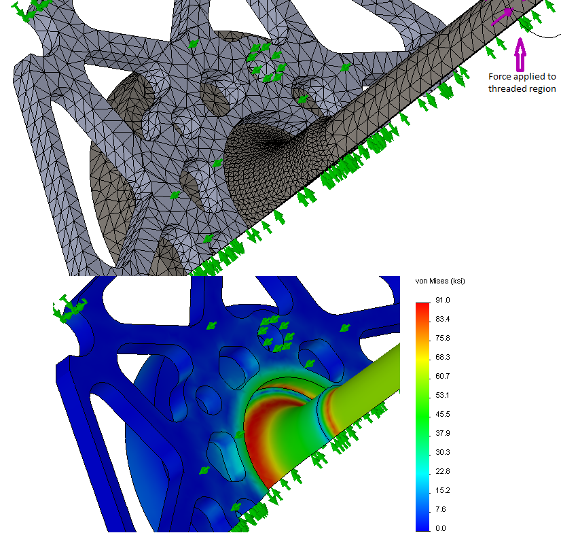

Figure C1 – Hub mesh density and stress distribution under clamp load. Stress distribution for the 13,880lbf load is shown.

The FOS in the shank was calculated the Gerber fatigue criterion:

$\frac{σ_{a}}{S_{e}}+{\left(\frac{σ_{m}}{S_{UT}}\right)}^{2}=\frac{1}{FOS}$ (C1)

**FOS = 1.91 for the centerlock shank**

**Cornering**

Loads are derived in Appendix D.5. The hub sees fully reversed tensile stress during cornering. The region of highest stress is in the shoulder fillet where the outer wheel bearing rests. The wheel bearing has a 0.024in radius chamfer, leaving very little room for a stress mitigating fillet. An offset 0.040in radius undercut was used, and proved successful (Fig.C2).

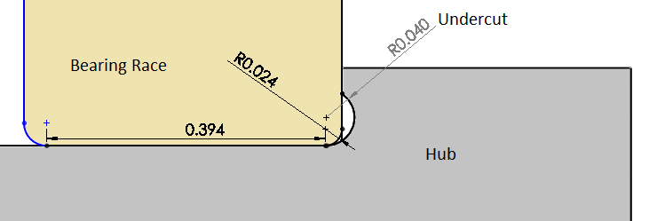

Figure C2 - Hub-bearing mounting surface, showing geometric constraints. The shoulder fillet undergoes full reversed tensile stress, which was reduced with a 0.040in undercut.

Figure C3 shows the hub with split lines indicating bearing locations. Forces were distributed over these areas as bearing loads. Interference stress from the bearing races were neglected, as they had a very small influence on total stress and increased computation time dramatically. Front and rear hubs were designed to have the same peak stress, so only the front is displayed in this section.

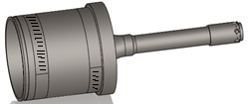

Figure C3 - Hub model showing bearing force zones. Inner (left) bearing force was applied downward onto the upper half, while outer (right) bearing force was applied upward onto the lower half.

The center of the contact patch is directly below the outer bearing, so any bumps take load off the outer bearing. For this reason, the worst case scenario of no vertical load was used.

**Loads**: Inner bearing = -4192lbf, outer bearing = 4192lbf

**Restraints**: The face of the hub that mounts to the wheel was restrained.

**Results**: The maximum stress in the hub is 56.9ksi. Figure C4 shows the mesh density and stress distribution.

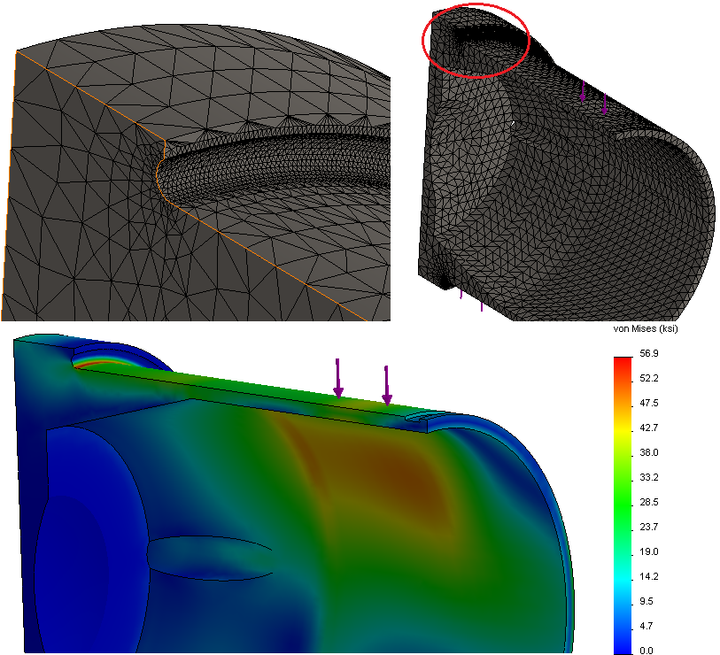

Figure C4 – Front hub mesh density and stress distribution under cornering. 0.010in mesh elements were used to ensure accurate results in the highly stressed shoulder fillet.

The hub failed to meet the 1.5 FOS criteria. The stress concentration could not be reduced any further without a major change. For this reason, the OS-Team recommended vacuum-melted 4340 to reduce inclusions, thereby raising the endurance limit.

**FOS = 1.21 in the shoulder fillet**

## C.2 – Upright

All four uprights are essentially identical; two are mirror images of the other two. The only modifications made to the upright by the OS-Team were repositioning the caliper mounts slightly, straightening the upper ball joint clevis mount, and adding a hole for the wheel speed sensor. FEA conducted on the upright was primarily for VMS information and was not used during modification.

**Material**: 6061-T6 aluminum, Sy = 40ksi [3]

**Braking**

The maximum braking torque of 6650in.lbf was derived in Appendix D3.

**Load**: 6650in.lbf torque was applied to the caliper mounting surface.

**Restraints**: A bearing restraint was applied to the center of the upright to allow it to rotate freely about its axis. Bearing restraints were then applied to each hole of the ball joint clevises. This allows them to rotate about the ball joints vertical axis, without being able to translate.

**Results**: Figure C5 shows the loads, restraints, and final mesh density in the region of high stress.

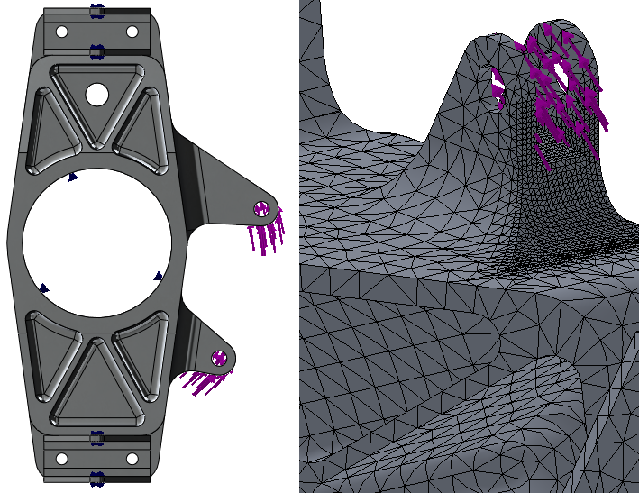

**Figure C5 – Upright loads, restraints, and mesh density. Bearing restraints shown as blue triangles. The mesh was refined in the region of highest stress- the short caliper mount.**

The short caliper mount had the highest stress of 27.6ksi as shown in Fig.C6. This is most likely due to the sharp corners within the caliper mount, and could be mitigated with fillet, and/or thickening the mounting tabs.

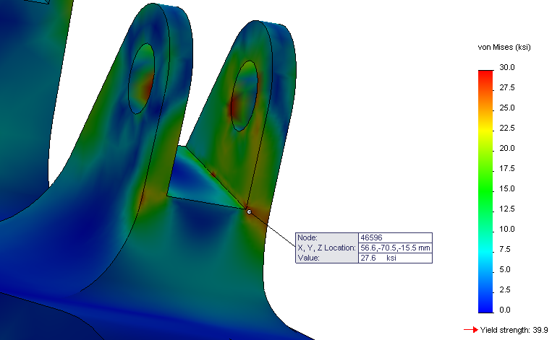

Figure C6 – Stress distribution in the short caliper mount.

**FOS = 1.48 in the short caliper mount**

**Cornering**

Horizontal forces applied to the upper and lower ball joints are derived by a static force balance using a cornering force of 2g and a vehicle weight of 700lbs. For steady state cornering at 2g, the entire weight of the car is distributed evenly between the two outside tires (100% load transfer). The vehicle uses pushrod suspension attached to the lower control arm, so a vertical load of 350lbf was applied to the lower ball joint clevis.

**Loads**: Upper ball joint = 377lbf, lower ball joint = 1077lbf, vertical force = 350lbf

**Restraints**: The wheel bearing surfaces were restrained.

**Results**: The maximum stress in the upright is 21.0ksi. This is a compressive stress where the lower ball joint clevis presses into the edge of a rib. The next highest stressed location is in the corner of the two vertical ribs, at 10.1ksi, annotated in Fig.C7.

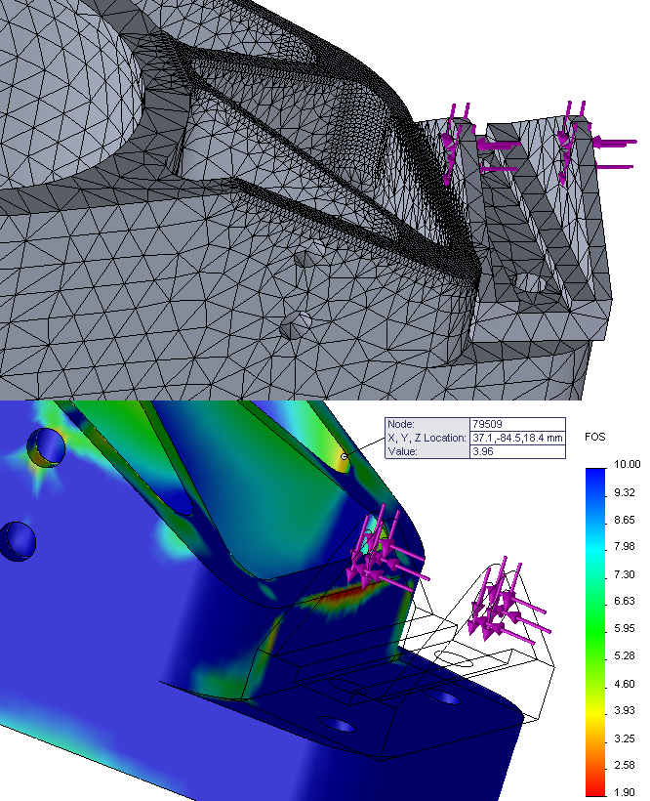

Figure C7 – Upright mesh density and stress distribution for cornering.

**FOS = 1.90 where the clevis presses into the upright**

**FOS = 3.96 in the vertical ribbing**

**Cornering with 3g Bump**

A 3g bump was simulated by accelerating mass of the vehicle acting on the upright (350lbf)

**Loads**: Upper ball joint = 377lbf, lower ball joint = 1077lbf, vertical force = 1050lbf

**Restraints**: A bearing restraint was applied to the bearing mounting surface inside the upright, and one edge of a snap ring groove was fully restrained to prevent rotation.

**Results**: The same mesh was used for cornering. The maximum stress in the hub with the 3g bump is 52.6ksi, well about the yield strength of the material (Fig.C8).

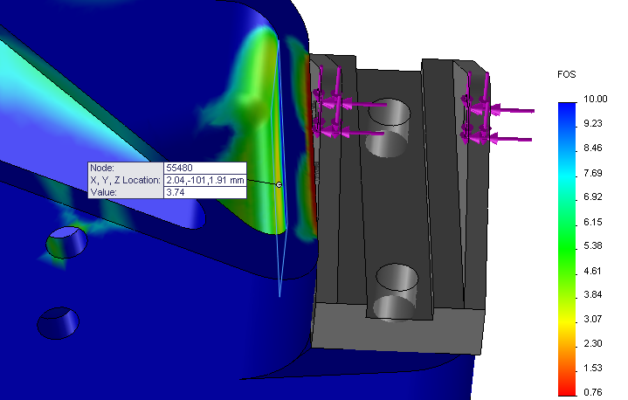

Figure C8 – Stress distribution for cornering with 3g bump. Factor of safety is well below the required 1.5.

One possible solution would be to stiffen the clevis so it doesn’t press into the upright as hard. The current aluminum clevis is relatively thin, allowing it to flex and transmit load directly into the adjacent face on the upright.

Aside from the clevis location, the next highest stress in the hub is 10.7ksi, also shown in Fig.C8. The stresses in the upright due to cornering are countered by vertical bump/weight force.

**FOS = 0.76 where the clevis presses into the upright**

**FOS = 3.74 away from the clevis**

## C.3 - Brake Hat

The 2011 brake hat was integrated into the wheel hub. This required excess material cost, machine time, and weight. The 2012 brake hat was designed as a separate part which slips over the hub, and is clamped between the wheel and hub, much like in a passenger car.

To ensure the best results, the brake hat was analyzed with six brake bobbins and three dowel pins, the same used in the final assembly.

**Material:** 4340 Normalized plate, Sy = 66.7ksi [3]

**Clamped**

During normal operation, the clamp force from the centerlock nut should provide sufficient friction between the wheel and the brake hat to prevent rotation. As such, the three dowel pins are not loaded, and only serve as a backup in case of insufficient clamp force.

**Load**: 6650in.lbf torque was applied to the face of the brake hat that contacts the wheel (Fig.C9)

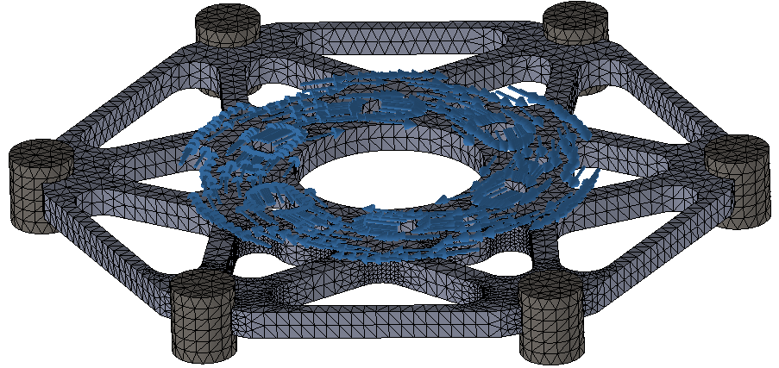

Figure C9 – Clamped brake hat mesh density and torque application. The mesh was refined in selected corners as well as the contact locations.

**Restraints**: The top and bottom faces of the brake bobbins were restrained. One face of the brake hat was assigned a roller/slider restraint to prevent out of plane rotation.

**Contact**: Each bobbin and its corresponding face on the brake hat were assigned as No Penetration condition, μ = 0.3

**Results**: The maximum stress in the brake hat is 32.2ksi on each of the loaded legs running from the bobbin to the pin hole. The contact stress between the bobbin and the hat was slightly higher (44.5ksi), but was ignored due to the strain hardening nature of cylindrical contact set. Figure C10 shows the stress distribution.

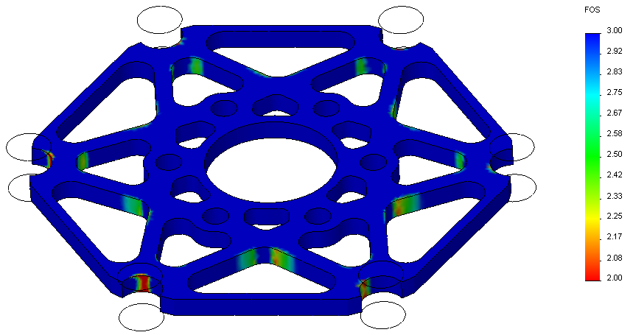

Figure C10 – Clamped brake hat stress distribution.

**FOS = 2.07**

**Pinned**

If the wheel nut were to come lose, resulting in a loss of clamping friction, the brake hat should be strong enough to allow the drive to stop the vehicle safely. With no clamp force, the entire braking torque is distributed from the wheel, into the three dowel pins, and finally into the brake hat.

**Load**: 6650in.lbf torque was distributed over the sides of the three dowel pins.

**Restraints**: The top and bottom faces of the bobbins were restrained. One face of the brake hat, as well as the top and bottom faces of the dowel pins were assigned a roller/slider restraint to prevent out of plane rotation.

**Contact**: Each bobbin and dowel pin, as well as their corresponding faces on the brake hat, were assigned a No Penetration condition, μ = 0.3

**Results**: The maximum stress in the pinned brake hat is 92.3ksi (Fig.C11). While below the yield strength of the material, this stress is confined to the contact between the pins and their holes. This will lead to localized yielding in the holes, resulting in reduced contact stress. The excess stress should not flow beyond the pinhole regions and risk the integrity of the brake hat. The maximum stress outside the pinhole region is 53.4ksi.

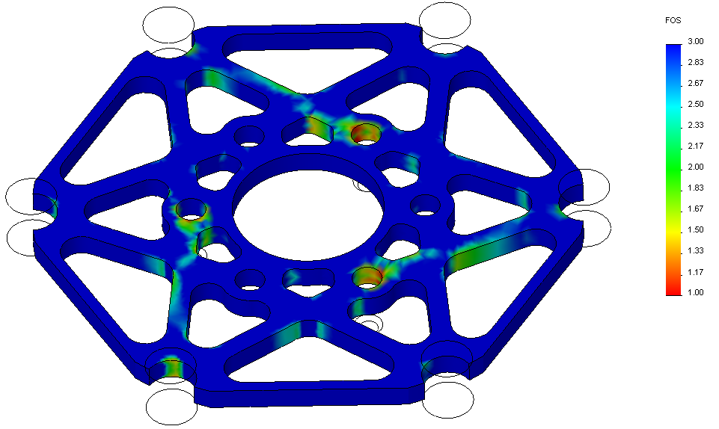

Figure C11 – Pinned brake hat stress distribution. The contact stress between the pins and the pin holes will yield the material, which will cause localized yielding and strain hardening.

**FOS = 0.71 inside the pinholes**

**FOS = 1.25 away from the pinholes**

## C.4 - Wheel Nut Spacer

Due to the decision to use a small diameter steel nut with high clamp force, a spacer had to be design to distribute the clamp load onto the aluminum wheel. The spacer is a 30* truncated cone. The smaller diameter equals that of the supplied M16 washer, the depth (and therefor larger diameter) was determined through iterative FEA. The cone has a 0.25in shoulder that centers inside the wheel bore to aid installation.

The wheel nut spacer is cheap and easy to manufacture, so it was considered a wear item, and only the stresses in the wheel were analyzed. The wheel model was simplified to reduce computation time. The wheel nut spacer was pressed into the wheel bore using the highest expected axial loading derived in Appendix D.5.

**Material**: 6061-T6 aluminum, Sy = 40ksi [3]

**Load**: 18,664lbf

**Restraints**: The rear (mounting) face of the wheel was fixed

**Contact**: The contact surface between the wheel nut spacer and the wheel was assigned a No Penetration condition, μ = 1.2

**Results**: The wheel was designed with a sharp corner to reduce machining time. As such, there is a sharp stress concentration when load is applied to the wheel nut spacer. Figure C12 shows the mesh density and stress distribution in the wheel.

The peak stress of 30.8ksi is an artifact of mesh density. Further refinement only increased the peak value, while the bulk distribution of stress remained unchanged. Material on the face of the wheel 0.050in away from the corner showed a stress of 8ksi. No usable FOS was gleaned from this analysis, however the wheel nut spacer was deemed sufficient to distribute the clamp load without appreciably damaging the wheel.

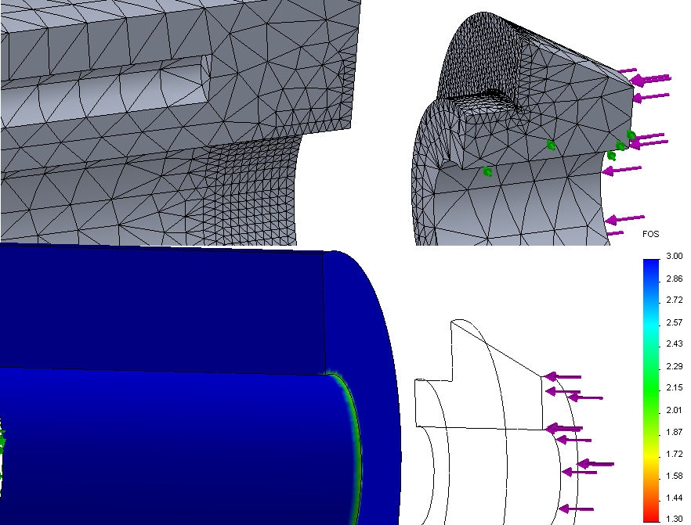

Figure C12 – Wheel and wheel nut spacer mesh density and stress distribution. The corner of the wheel bore is a stress concentration, so FOS values on the edge are arbitrary.

## References

[1] “Rockwell C Hardness Test Simulation by Finite Element Analysis,” last updated Feb 10, 2012, <http://www.varmintal.com/arock.htm>

[2] Boyer, Howard E. Atlas of Fatigue Curves, “Section 4 – Alloy Steels: Low- to High- Carbon, Inclusive.” ASM International, 1986, pp.97-106.

[3] “Material Property Data,” MatWeb, accessed 30 May, 2012, <http://www.matweb.com>

# Appendix D – Detailed Calculations

## D.1 – Bearing-Hub Interference

**Summary:**

The objective of this analysis is to determine interference fit required between the hub and bearing to prevent slipping during race conditions. Each corner of the car has and inner and outer wheel bearing, both NSK single row deep groove ball bearings, model 6813 DD. This analysis assumes maximum axial loading conditions of 700 lbs per hub, which equates to 350 lbs per bearing. The PDS criterion relevant to this analysis is the load capacity of the outboard suspension, a minimum of 2g lateral acceleration. The results of this analysis will be a radial interference to prevent bearing/hub slip. The radial interference to prevent slip is 0.0011 in.

**Evaluation:**

The results of the bearing/hub interference analysis are conservative. The design loading condition will likely not be seen during racing conditions. The only assumption that may cause variation in results is coefficient of friction between the steel hub and steel bearing. The coefficient of friction (μ=0.3) assumes no lubrication between surfaces. Any variation is compensated for by the conservativeness of the assumed racing conditions.

**Formulation:**

Given:

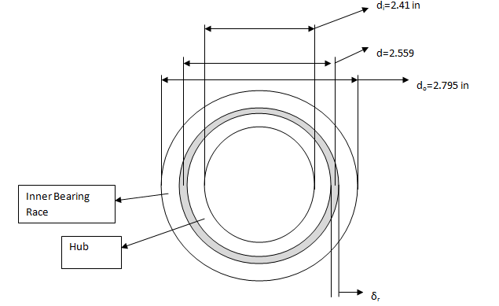

SF=350 lbs Axial Load

di=2.41 in Hub ID

Ei=29733 ksi Hub Elasticity

vi=0.3 Hub Poisson Ratio

μ=0.3 Friction [1]

d=2.559 in Nominal Diameter

do=2.795 in Bearing Race OD

Eo=29733 ksi Bearing Elasticity

vo=0.3 Bearing Poisson Ratio

w=0.3149 Bearing Contact Width

Find:

The radial interference required to prevent bearing/ hub slipping during lateral acceleration.

Assumptions:

Axial loading is distributed into and even pressure between the bearing and hub. Bearing race material is mild steel. The coefficient of friction is 0.3.

Solution: see [1] for solution method

Convert diametral dimensions into radial dimensions,

$$δ_{r}=\frac{δ}{2}=0.000555 in$$

$$r_{i}=\frac{d_{i}}{2}=1.205 in$$

$$R=\frac{d}{2}=1.279 in$$

$$r_{o}=\frac{d_{o}}{2}=1.398 in$$

Determine the bearing/hub contact area and pressure,

$$A=\left(π*d*w\right)=\left(2.559 in*0.3149 in*π\right)=2.532 {in}^{2}$$

$$p=\frac{SF}{A*μ}=\frac{350 lbs}{2.532 {in}^{2}*0.3}=460.77 psi$$

Calculate the required interference,

$$δ_{r}=p*R*\left[\frac{1}{E_{o}}\left(\frac{r_{o}^{2}+R^{2}}{r_{o}^{2}-R^{2}}+v_{o}\right)+\frac{1}{E_{i}}\left(\frac{R^{2}+r_{i}^{2}}{R^{2}-r_{i}^{2}}-v_{i}\right)\right]$$

$$=460.77 psi*1.279 in*\left[\frac{1}{29773}\left(\frac{{1.398}^{2}+{1.279}^{2}}{{1.398}^{2}-{1.279}^{2}}+0.3\right)+\frac{1}{29773}\left(\frac{{1.279}^{2}+{1.205}^{2}}{{1.279}^{2}-{1.205}^{2}}-0.3\right)\right]$$

$=0.000555$ in

Answer: Required radial interference δr=0.000555 in

**Conclusion:**

A radial interference required to prevent bearing hub slip is 0.000555 in. Results are dependent on the coefficient of friction between the steel hub and steel bearing. Any lubrication left on the mating surfaces will cause a change in axial force capacity. The radial interference is increased to 0.0006 in to ensure conservative design. Additional interference is not desired, as it will increase bearing drag and possibly damage the bearings.

**References:**

[1] Richard G. Budynas and J. Keith Nisbett, Shigley’s Mechanical Engineering Design, 9th edition, McGraw-Hill, 2011, pp. 573-587

## D.2 – Bearing-Upright Interference

**Summary:**

The objective of this analysis is to determine interference fit required between the upright and bearings to prevent slipping at ambient temperature (with no load applied), but also allow assembly by heating the upright. Each corner of the car has and inner and outer wheel bearing, both NSK single row deep groove ball bearings, model 6813 DD. Bearings are shrunk fit into the upright. This analysis assumes operating temperatures will never reach 320 °F, the aging temperature of 6061-T6 aluminum. The PDS criterion relevant to this analysis is ease of wheel bearing assembly (no specialty tools required). The results of this analysis will be the nominal internal diameter of the upright, the minimum assembly temperature, and the temperature required for bearing slip during racing use. The nominal upright ID is 3.340 in, the upright must be heated to a minimum of 272 °F for assembly, and assembled bearings will slip at 335 °F.

**Evaluation:**

The results of the bearing/hub interference analysis are conservative. The upright will likely never reach 320 °F. At this temperature the material properties of the aluminum upright will change. Retaining rings will prevent bearing movement if the slip temperature is ever reached. Any variation is compensated for by the conservativeness of the assumed racing temperatures and back-up safety systems.

**Formulation:**

Given:

Bearing outer diameter: d=3.346 in

Bearing coefficient of thermal expansion: αsteel=7.3*10-6 °F-1 [1]

Upright coefficient of thermal expansion: αal=12.3*10-6 °F-1  [1]

Customer specified machining tolerance =± 0.002 in

Find:

The nominal upright ID to prevent bearing slip and allow shrink fit assembly, the temperature to cause bearing slip, and the assembly temperature required.

Assumptions:

Bearing race material is mild steel. Operating temperature will never reach 320 °F. Ambient temperature is 65 °F.

Solution: see [2] for solution method

The maximum tolerance is specified by the customer,

$$Tolerance=\frac{D_{max}-D_{min}}{2}=0.002 in$$

The minimum assembly temperature (Tmin) and assembled bearing slip temperature (Tslip) were changed iteratively to get a tolerance of 0.002 in.

* Tmin needed to be roughly 50 °F less than the aluminum aging temperature of 320 °F to allow assembly time after upright is removed from the oven.
* Tslip needed to be higher than the aluminum aging temperature.

The relationships and results of the iterations were,

$$T_{min}=272 ℉$$

$$∆T1=T_{min}-65 ℉$$

$$D_{min}=\frac{d}{1+∆T1*α_{al}}=3.378 in$$

$$T_{slip}=335 ℉$$

$$∆T2=T_{slip}-65 ℉$$

$$D_{max}=\frac{d*\left(1+α_{steel}*∆T2\right)}{1+α_{al}*∆T2}=3.342 in$$

Solving for nominal upright diameter,

$$Upright ID=\frac{D_{min}+D_{max}}{2}=3.340 in$$

Answer: Required Upright ID =3.34 in

Heat Upright to at least Tmin=272 °F

Bearing slip can occur at Tslip=335 °F

**Conclusion:**

An internal upright diameter of 3.340 in will allow the bearings to be placed into the upright when it is heated to at least 272 °F. The upright should never be heated above 320 °F during assembly. An ID of 3.340 in will not allow the assembled bearings and upright to slip until a temperature of 335 °F is reached. Bearing movement is also limited by retaining rings.

**References:**

[1] Engineering Toolbox, Coefficients of Linear Thermal Expansion, http://www.engineeringtoolbox.com

/linear-expansion-coefficients-d_95.html, retrieved May 14th 2012

[2] Richard G. Budynas and J. Keith Nisbett, Shigley’s Mechanical Engineering Design, 9th edition, McGraw-Hill, 2011, pp. 573-587

## D.3 – Wheel Torque

**Summary:**

The objective of this analysis is to determine the axial clamping force prevent movement at the hub and wheel interface and the torque specification to achieve this clamping force. This analysis assumes maximum braking conditions (the car on its two front wheels), equivalent to a force of 700 lbs at the tire on each front wheel. Parts relevant to this analysis are the hub, wheel, and the wheel nut. The PDS criterion relevant to this analysis is the load capacity of the outboard suspension, a minimum of 2g longitudinal acceleration (equivalent to 700 lbs at the tire contact of each front wheel). The results of this analysis will be an axial clamping force to prevent braking slip and the torque that must be applied the centerlock nut. The clamp force to prevent braking slip is 13880 lbs and the nut torque required is 146 lb*ft.

**Evaluation:**

The results of the wheel torque analysis are conservative, the maximum hub/ wheel axial clamping force is taken at worst case braking, the car on its two front wheels. This severe loading condition is not seen during racing conditions. In addition if the car were to ever loose wheel clamp force, the drive pins on the hub would allow a safe recovery. The assumptions do not cause much variation in results, however hub and nut treads need to be kept clean and dry (K=2) so wheel nut torque is maintained. Any variation is compensated for by the conservativeness of the assumed racing conditions.

**Formulation:**

Given:

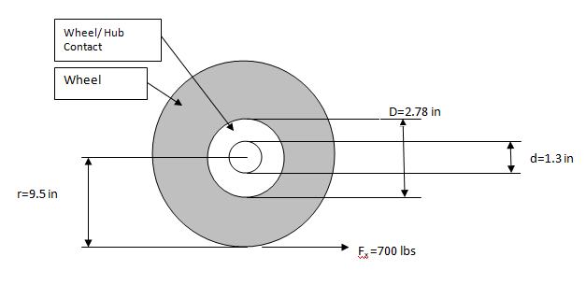

Car braking with rear wheels in air

acceleration = 2g (G=2)

car weight = 700 lbs

Centerlock Nut

major diameter: dn= 16 mm = 0.63 in

lubrication coefficient: K = 0.2 [1]

Coefficient of friction between aluminum wheel and steel hub [2]

f=0.45

Find:

The Axial clamping force required to prevent braking slip and the torque specification to achieve that clamp force.

Assumptions:

All loads transferred through the tire contact patch, single point loading, rigid members, and uniform cylindrical pressure between wheel and hub.

Solution: see [1] for solution method

Determine the force on wheel at tire contact patch during braking,

$$F_{x}=\frac{weight }{2}*G=\frac{700 lbs}{2}*2=700 lbs$$

Calculate torque developed during braking,

$$T=r*F_{x}=9.5 in*700 lbs=6650 lb*in$$

Determine an effective radius of contact between the hub and wheel,

$$re=\left(\frac{1}{3}\right)*\left[\frac{\left(D^{3}-d^{3}\right)}{\left(D^{2}-d^{2}\right)}\right]=\left(\frac{1}{3}\right)*\left[\frac{\left({2.78}^{3}-{1.3}^{3}\right)}{\left({2.78}^{2}-{1.3}^{2}\right)}\right]=1.065 in$$

Calculate the clamp force required to prevent braking slip,

$$F_{i}=\frac{T}{\left(f*re\right)}=\frac{6650 lb*in}{\left(0.45*1.065 in \right)}=13880 lbs$$

Maximum load on hub shank,

$F=F_{i}+F_{hub from cornering}$ = 13880 lbs + 4300 lbs = 18180 lbs

Determine the wheel nut torque specification,

$T=\left(K*F_{i}*d\right)=(0.2*13880 lbs*$ 0.63 in) = 1749 lb*in = 145.7 lb*ft

Answer: Axial Clamp Force = 13880 lbs

Torque Specification= 145.7 lb*ft

**Conclusion:**

An axial clamping force of 13880 lbs is required to cause complete torque transfer by hub/ wheel friction. The 16mm centerlock nut must be torqued to 145 lb*ft to achieve this lamping force. This torque specification is highly dependent on thread conditions; threads must be kept clean and dry to maintain clamping force.

**References:**

[1] Richard G. Budynas and J. Keith Nisbett, Shigley’s Mechanical Engineering Design, 9th edition, McGraw-Hill, 2011, pp. 573-587

[2] Engineers Edge, Coefficients of Friction (Static), http://www.engineersedge.com/coeffients_

of_friction.htm, retrieved May 14th 2012

## D.4 – Drive Pin Contact Stress

**Summary:**

The objective of this analysis is to determine the contact stress and between the aluminum wheel and the steel drive pins of the hub. A second objective is to find the shear stress at the wheel pin interface and make sure pitting will not happen. This analysis assumes maximum braking conditions (the car on its two front wheels), equivalent to a force of 700 lbs at the tire on each front wheel (see Wheel Torque Analysis for loading derivation). Parts relevant to this analysis are the hub pins and the wheel. The PDS criterion relevant to this analysis is the load capacity of the outboard suspension, a minimum of 2g longitudinal acceleration (equivalent to 700 lbs at the tire contact of each front wheel). The results of this analysis will be factors of safety against; wheel yielding and wheel pitting. The factor of safety against yielding in the aluminum wheel holes is 0.66 and the factor of safety against pitting is 1.4.

**Evaluation:**

The results of the wheel torque analysis are conservative, the maximum hub/ wheel axial clamping force is taken at worst case braking, the car on its two front wheels. This severe loading condition is not seen during racing conditions. The wheel pins are a back-up torque transfer device: if the car were to ever loose wheel clamp force, the drive pins on the hub would allow a safe recovery. The wheel pins will never be used for racing. The assumptions of cylinder to cylinder contact are valid. Localized yielding on the wheel is acceptable, as stress will quickly decrease. Any additional variation is compensated for by the conservativeness of the assumed racing conditions.

**Formulation:**

Given:

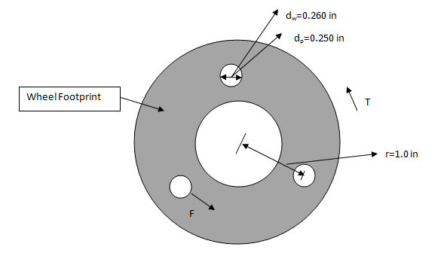

Loading Conditions

Braking force at wheel contact: Fx=700 lbs

Geometry

Number of pins: n=3

Pin circle radius: r=1 in

Pin diameter: dp=0.2502 in

Pin hole clearance: C=0.01 in

Contact length: l=0.5 in

Wheel radius: R=9.5 in

Material Properties

All material properties from [1]

Pin modulus of elasticity: Ep=30,500 ksi

Pin poisson ratio: vp=0.30

Wheel yield strength: yw= 40.0 ksi

Wheel modulus of elasticity: Ew=10,000 ksi

Wheel poisson ratio: vw=0.33

Find:

The factor of safety against localized wheel yielding and the factor of safety against wheel pitting.

Assumptions:

All loads transferred through the tire contact patch, single point loading, rigid members, and cylinder to cylinder contact between wheel pins and hub. Localized yielding on the wheel is acceptable.

Solution: see [2] for solution method

Determine the torque on the wheel,

$$T=F_{x}*R=\left(700 lbs*9.5 in\right)=6700 lb*in$$

Find the force experienced by each pin,

$$F=\frac{T}{r*n}=\frac{6700 lb*in}{1 in*3}=2233 lbs$$

Calculate the pin hole diameter,

$$d_{w}=d_{p}+C=0.2502 in +0.01 in=0.260 in$$

**Contact Stress:**

Determine the contact half-width,

$$b={\left[\frac{2F}{πl}*\frac{\frac{\left(1-v_{p}^{2}\right)}{E_{p}}+\frac{\left(1-v_{w}^{2}\right)}{E_{w}}}{\left(\frac{1}{d_{p}}\right)-\left(\frac{1}{d_{w}}\right)}\right]}^{1/2}= {\left[\frac{2*2233}{π*0.5}*\frac{\frac{\left(1-{0.3}^{2}\right)}{30.5*{10}^{6}}+\frac{\left(1-{0.33}^{2}\right)}{10*{10}^{6}}}{\left(\frac{1}{0.2502}\right)-\left(\frac{1}{0.260}\right)}\right]}^{1/2}=0.047 in$$

Determine the Hertz contact stress,

$$p_{max}=\frac{2*F}{π*b*l}=\frac{2*2233 lbs}{π*0.047 in*0.5 in}=60.6 ksi$$

Find the factor of safety against wheel yielding,

$$FS=\frac{y_{w}}{p_{max}}=\frac{40 ksi}{60.6 ksi}=0.66$$

Answer: Factor of safety against localized wheel yielding = 0.66

**Shear Stress:**

Determine the normal stress developed from contact in the z and x directions, assuming the highest shear stress with ζb=0.786 (see [2]),

$$σ_{z}=-p_{max}*\frac{1}{\sqrt{1+σ_{b}^{2}}}=\frac{-60.6 ksi}{\sqrt{1+{0.786}^{2}}}=-47.65 ksi$$

$$σ_{x}=-2*\left(\frac{v_{w}+v_{p}}{2}\right)*p_{max}*\left(\sqrt{1+ζ_{b}^{2}}-\left|ζ_{b}\right|\right)=$$

$$-2*\left(\frac{0.33+0.3}{2}\right)*60.6 ksi*\left(\sqrt{1+{0.786}^{2}}-0.786\right)=-18.55 ksi$$

Find the shear stress developed,

$$τ_{xz}=\frac{\left(σ_{z}-σ_{x}\right)}{2}=\frac{\left(-47.65 ksi+18.55 ksi\right)}{2}=-14.55 ksi$$

Find the factor of safety against wheel pitting,

$$FS=\frac{y_{w}}{2*\left|τ_{xy}\right|}=\frac{60.6 ksi}{2*14.55 ksi}=2.08$$

Answer: Factor of safety against wheel pitting = 2.08

**Conclusion:**

If nut clamp force was ever lost and the car underwent extreme 2g braking conditions, the aluminum wheel holes have a factor of safety of 0.66 against yielding and 2.08 against pitting. This means localized yielding would occur, however the stress would quickly dissipate a the pin and hole diameters grew closer. These factors of safety are acceptable because the pins are a back up torque transfer mechanism for car recovery, where only a short distance would be traveled.

R**eferences:**

[1] MatWeb Material Property Data, http://www.matweb.com/search/DataSheet.aspx?MatGUID=1b8c

06d0ca7c456694c7777d9e10be5b, retrieved May 16th 2012

[2] Richard G. Budynas and J. Keith Nisbett, Shigley’s Mechanical Engineering Design, 9th edition, McGraw-Hill, 2011, pp. 573-587

## D.5 – Bearing Loading and Life

**Summary:**

The objective of this analysis is to determine the life of wheel bearing that experiences the largest radial loading under a few common racing conditions (loading conditions). Each corner of the car has and inner and outer wheel bearing, both NSK single row deep groove ball bearings, model 6813 DD. The PDS criterion relevant to this analysis is the service life of the car, a minimum of 2 years or approximately 1000 miles of racing. The results of this analysis will be a bearing life in miles. The inner bearing on the car can withstand 1024 miles of racing.

**Evaluation:**

The results of the bearing analysis are conservative, 25% of the racing miles were taken to be full bump load and full cornering load (equivalent to car running on two wheels) and the other 75% were taken to be straight line (no cornering or bump loads). The assumptions do not cause much variation in results. Any variation is compensated for by the conservativeness of the assumed racing conditions. Bearing Failure would not have catastrophic results; the cars drag would increase and the bearing could be easily replaced.

**Formulation:**

Given:

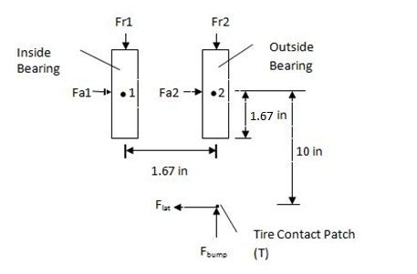

Full bump/ Full cornering:

Flat=700 lbs

Fbump=525 lbs

Straight Line:

Flat=0 lbs

Fbump=175 lbs

Tire Diameter = 20 in

Racing Conditions= 25% Full bump/ Full Cornering, 75 % Straight Line

Find:

The bearing life, in miles, of the bearing that experiences higher loading conditions.

Assumptions:

All loads transferred through the tire contact patch, single point loading, rigid members.

Solution: see [1] for solution method  
 Full bump/Full cornering Force Analysis

Summing forces in the radial direction,

$$\sum{F_{r}=F_{bump}-Fr2-Fr1=0}$$

Summing moments around point 2,

$$\sum{M_{2}=F_{lat}\left(10 in\right)-Fr1\left(1.67 in\right)=0}$$

$$Fr1=\frac{F_{lat}(10)}{1.67}=\frac{700 lbs (10)}{1.67}=4191.6 lbs=18.65 kN$$

$$Fr2=F_{bump}-Fr1=525 lbs-4191.6 lbs=-3666.6 lbs$$

Summing forces in the axial direction,

$$\sum{F_{a}=Fa1+Fa2+F_{lat}=0}$$

$$Fa1=Fa2$$

$$Fa1=Fa2=\frac{F_{lat}}{2}=\frac{700 lbs}{2}=350 lbs=1.56 kN$$

Straight Line Force Analysis

Summing moments around point 1,

$$\sum{M_{1}={-F}_{bump}\left(1.67 in\right)+F_{lat}\left(10 in\right)+Fr2\left(1.67 in\right)=0}$$

$$Fr2=F_{bump}-F_{lat}\left(6\right)=175 lbs-0\left(6\right)=175 lbs=0.78 kN$$

$$Fr1=F_{a1}=F_{a2}=0$$

Bearing Life Analysis

See [2] for bearing specifications.

Convert axial loading into an equivalent radial load,

V=1 for inner ring rotation

$\frac{F_{a}}{C_{o}}=\frac{1.56 kN}{12.1 kN}=0.129$, gives e=0.31

$\frac{F_{a}}{V*F_{r}}=$ $\frac{1.56 kN}{1*18.65 kN}=0.083$ < e, axial loading doesn’t make a difference

$$F_{e}= X_{i}VF_{r}+Y_{i}F_{a} = 1*1*18.65 kN+0*1.56 kN =18.65 kN$$

Calculate an equivalent bearing radial load given 25% of life under full bump/ full cornering conditions and 75% of life under straight line loading (e.g. l1=l2),

Relate L10 rated bearing life at 90% reliability to life at the specific loading condition,

$$F_{1}{L_{1}}^{0.333}=F_{2}{L_{2}}^{0.333}$$

$$11.9 kN {\left(1,000,000 cycles\right)}^{0.333}=11.72 kN{\left(L_{2}\right)}^{0.333}$$

$$L_{2}=1,032,424 cycles \left(\frac{1 mile}{1008.4 cycles}\right)=1023.8 miles$$

Answer: Bearing Life = 1023.8 miles

**Conclusion:**

The minimum bearing life of 1024 miles meets the PDS requirement of 2 years racing service at 500 miles per year. As the loading conditions are conservative, actual bearing life will likely be many times greater.

**References:**

[1] Richard G. Budynas and J. Keith Nisbett, Shigley’s Mechanical Engineering Design, 9th edition, McGraw-Hill, 2011, pp. 573-587

[2] NSK America, Deep Groove Ball Bearing Catalog, retrieved from http://www.nskamericas.com/ cps/rde/xbcr/na_en/Deep_Groove_Ball_Bearings.pdf

# Appendix E - Bill of Materials

|  |  |  |  |  |  |  |  |
| --- | --- | --- | --- | --- | --- | --- | --- |
| **Manufactured Components** | | | | | | | |
|
| **Part** | **Quantity** | **Material** | **Size** | | **Dimensions (in)** | **Cost ($)** | **Source** |
| Hub | 1 | 4340 Steel, Vacuum Melt | 3in round | | 7.0 long | 109.00 | [www.onlinemetals.com](http://www.onlinemetals.com/) |
| Upright | 1 | 6061 -T6 Aluminum | 6in square | | 10.25 long | 67.50 | [www.speedymetals.com](http://www.speedymetals.com/) |
| Brake Hat | 1 | 4130 Steel | 0.25in plate | | 5.0 dia. | 9.18 | [www.chassisshop.com](http://www.chassisshop.com/) |
| Brake Rotor | 1 | Grey Cast Iron | 11in round | | 0.197 long | 11.90 | [www.onlinemetals.com](http://www.onlinemetals.com/) |
| Brake Bobbins | 6 | 4340 Steel | 0.625in round | | 0.5 long | 0.26 | [www.onlinemetals.com](http://www.onlinemetals.com/) |
| Wheel Nut Spacer | 1 | 6061 -T6 Aluminum | 2in round | | 1.0 long | 2.65 | [www.onlinemetals.com](http://www.onlinemetals.com/) |
| Hub Pilot | 1 | 6061 -T6 Aluminum | 1.5in round | | 1.5 long | 2.25 | [www.onlinemetals.com](http://www.onlinemetals.com/) |
| **Purchased Components** | | | | | | | |
|
| **Part** | **Quantity** | **Description** | | **Part Number** | | **Cost ($)** | **Source** |
| Centerlock Nut | 1 | M16 x 2.0, Class 10.9 | | 99899A236 | | 0.95 | [www.mcmaster.com](http://www.mcmaster.com/) |
| Washer | 1 | M16, Class 10.9 | | 93162A350 | | 1.27 | [www.mcmaster.com](http://www.mcmaster.com/) |
| Nut Retainer | 1 | Dorman spindle retainer, 24mm hex | | 615-083 | | 1.32 | [www.advanceautoparts.com](http://www.advanceautoparts.com/) |
| Retention Pin | 1 | Hair pin cotter pin, 0.125in x 2.5in | | 98335A067 | | 0.27 | [www.mcmaster.com](http://www.mcmaster.com/) |
| E-Clips | 6 | E-Clip for 10mm groove | | 98543A218 | | 0.14 | [www.mcmaster.com](http://www.mcmaster.com/) |
| Bearings | 2 | KYK deep groove ball bearing | | 6813 2RS | | 66.67 | McGuire Bearing Company |
| Dowel Pins | 3 | 0.25 x 1.0in | | 98381A542 | | 0.27 | [www.mcmaster.com](http://www.mcmaster.com/) |

# Appendix F – Assembly Procedure

Figure B.1 shows the assembly of the outboard suspension.

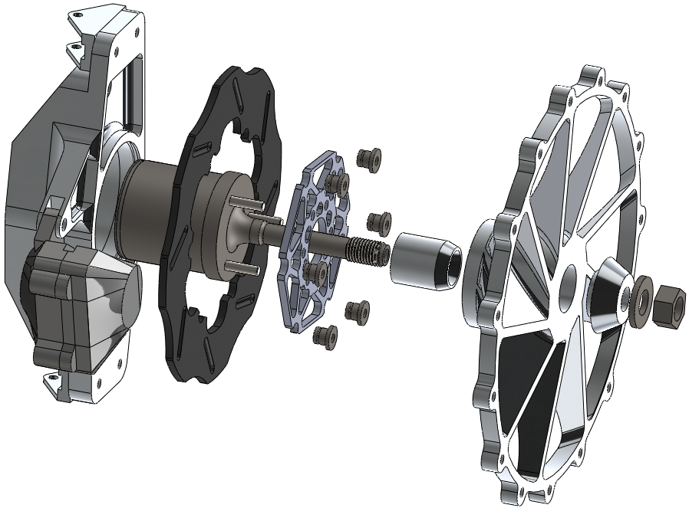

Figure B.1 - Exploded view of the outboard suspension system. From left to right there is the upright, brake caliper, hub, brake rotor, brake hat, brake bobbins, wheel pilot, wheel, nut spacer, washer, and nut

To assemble the outboard suspension:

1. Warm the wheel bearings in an oven to no more than 300°F and freeze the hub to around 0°F.
2. Remove the first bearing from the oven and install quickly over the hub.
3. Slide the inner and outer bearing spacers over the hub.
4. Put the hub back into the freezer until cool again.
5. Install the second wheel bearing making sure it is fully seated against the spacers.
6. Put the hub assembly back into the freezer and place the upright into the oven.
7. Once the parts saturate, install the hub assembly into the upright and allow them to stabilize at room temperature.
8. Next install the wheel speed sensor in the upright.
9. Install the brake rotor on the brake hat by inserting the brake bobbins in each set of aligned half holes and install an E-clip onto each.
10. Slide the brake assembly onto the hub pins.
11. Install the wheel pilot and brake caliper.
12. Apply anti-seize compound to the centerlock threads.
13. Install the wheel, wheel spacer, washer and nut.
14. Torque the wheel nut to 175ft.lbf.
15. Install the nut retainer, and R-clip.

# Appendix G – Service Manual

The serviceable components of the outboard suspension are the wheel/tire assembly, and brake pads. The replaceable components are the R-clip, nut retainer, nut, washer, wheel spacer, wheel pilot, brake rotor and brake hat.

To service the wheel tire assembly, remove the R-clip and nut retainer, loosen and remove the wheel center nut, remove the washer and wheel spacer, remove the wheel/tire assembly. To re-assemble, install the wheel, wheel spacer, washer, wheel center nut and torque to 175ft.lbs, install the nut retainer and R-clip.

To service the brake pads, remove the wheel/tire assembly (see above), remove the caliper mounting bolts, and remove the caliper. To re-assemble, install the brake caliper, caliper mounting bolts and torque to 20ft.lbs, re-install the wheel (see above).

To replace the R-clip, nut retainer, nut, washer, or wheel spacer, remove the necessary components and discard the worn or damaged parts. Re-assemble using new parts.

To replace the wheel pilot, remove the wheel (see above), slide the old wheel pilot off (this may require some tapping with a hammer or gentle prying to work the pilot off the hub shaft). Install a new wheel pilot and re-assemble (see above).

To replace the brake hat or rotor, remove the wheel and brake caliper (see above), slide the brake hat and rotor assembly off of the wheel pins. Replace the damaged parts, and re-assemble (see above).

# Appendix H - Detailed Drawings

Jose’s drawings will go here!