**Lifting Instrument for Tower Experiment Reloading**

ME 493 Final Report – Year 2012

Gabe Garbarino

Dan Houck

Lindzay Irving

Evan Rhead

Hanni Wehrman

Sponsor: Mark Weislogel

Academic Advisor: Dave Turcic

Industry Advisor: Bill Gelatly

June 11, 2012

# 1 Executive Summary

## For its Portland State University Senior Capstone project, this team designed a device to assist with loading and reloading experiment chassis into the Dryden Drop Tower (DDT). Professor Mark Weislogel asked for a device to help the drop tower operators lift and accurately place chassis weighing up to 100 lbs inside the drop tower drag shield. Working with our sponsor and advisors, the team determined the product design specifications (PDS) and a house of quality, performed a technical risk assessment, established a timeline, and conceptualized a final design. The design is based on a motor-driven power screw system mounted to the side of the drop tower. It powers the vertical movement of a three-elbowed arm. The arm has an interface at its end, which locks onto the chassis when lifting, and provides a quick and smooth release when weight is relieved.

## This report is a presentation of the final product along with various evaluations showing that it meets all the design specifications of the final users. It details what defines the final design and the validations used to fulfill the PDS. Because these specifications are unique to the drop tower, the final product is almost entirely of custom design and fabrication. To that end, the lift device is not intended to be commercially distributed; it is specifically engineered to facilitate better handling and operating for the drop tower users. From a fully contained and mobile device then an over-the-door and fixed arm device, the final design criteria ultimately shifted to a semi-permanent structure. The device is not mobile; instead, it is attached to the drop tower and removable when not in use. The doors of the drop tower were modified to allow for this simpler and more aesthetically pleasing device design.

# 2 Table of Contents

[1 Executive Summary 2](#_Toc327107684)

[2 Table of Contents 3](#_Toc327107685)

[3 Table of Figures 4](#_Toc327107686)

[4 Introduction 5](#_Toc327107687)

[5 Background 5](#_Toc327107688)

[6 Mission Statement 7](#_Toc327107689)

[7 Main Design Requirements 7](#_Toc327107690)

[8 Top Level Design Alternatives 8](#_Toc327107691)

[9 Final Design 10](#_Toc327107692)

[9.1 Electrical System 10](#_Toc327107693)

[*9.1.1* *Power* 10](#_Toc327107694)

[*9.1.2* *Motor* 10](#_Toc327107695)

[*9.1.3* *Trigger* 11](#_Toc327107696)

[9.2 Mechanical System 12](#_Toc327107697)

[*9.2.1* *Bracket* 12](#_Toc327107698)

[*9.2.2* *Power Screw* 13](#_Toc327107699)

[*9.2.3* *Arm* 14](#_Toc327107700)

[*9.2.4* *Experiment Chassis Interface* 16](#_Toc327107701)

[10 Evaluations 17](#_Toc327107702)

[10.1 Function and Performance 17](#_Toc327107703)

[10.2 Reliability/Structural Integrity 17](#_Toc327107704)

[*10.2.1* *Brackets, channel, and power screw assembly* 18](#_Toc327107705)

[*10.2.2* *Angle iron clevises at first joint and supporting steel plate* 19](#_Toc327107706)

[*10.2.3* *Aluminum Clevises* 20](#_Toc327107707)

[*10.2.4* *Hook Interface* 20](#_Toc327107708)

[10.3 Cost and Financial Performance 21](#_Toc327107709)

[10.4 Environment, Safety, and Ergonomics 21](#_Toc327107710)

[10.5 Manufacturability and Assembly 21](#_Toc327107711)

[11 Conclusions 21](#_Toc327107712)

[Appendix A: Product Design Specifications 22](#_Toc327107713)

[Appendix B: Power Screw Validation 1](#_Toc327107714)

[Appendix C: Bill of Materials 3](#_Toc327107715)

[Appendix D: Project Plan 5](#_Toc327107716)

[Appendix E: Installation Manual 6](#_Toc327107717)

[Appendix F: Operations Manual 8](#_Toc327107718)

# 3 Table of Figures

Figure 1: Chassis hanging inside the drag shield before drop; computer interface on left 5

Figure 2: Two people loading the chassis into the drag shield; one operator lifts and holds the

chassis and other clips it to the karabiner 6

Figure 3: Installation of battery on the power fixture inside Tower. The PVC mount shape was

cut with PSU’s laser cutter 10

Figure 4: Junction box with leads; motor is housed inside and attached to the power screw 11

Figure 5: Trigger housing with directional switch 12

Figure 6: Finished top clamp mounted to the tower 13

Figure 7: Linear actuator mounted to the tower with arm in folded position 13

Figure 8: First joint comprised of steel angle iron supports, 1 in steel dowel, and a

reamed steel bar welded to the first steel member 15

Figure 9: Second and third joints comprised of two mating aluminum clevises with set

screws to hold ¾ in dowels 15

Figure 10: Pin in stowed position 16

Figure 11: Pin in operating position 16

Figure 12: Second elbow restricting movement 16

Figure 13: Arm fully extended 16

Figure 14: Interface mating system consisting of aluminum forks and matching slotted plate 17

Figure 15: The arm is cantilever supported by the power screw’s rail system over the two

red faces. The power screw is tied to the channel continuously and the channel is

welded to the clamping brackets. The power screw is partitioned into five sections

along its vertical (z) axis. At each of these sections, the arm was loaded at a normal

position (as shown), at 45° from normal position, and at 90° from normal position,

in the xy plane. 18

Figure 16: Stress profiles of the arm, screw, channel, and bracket assembly under several

different loading scenarios. 19

Figure 17: The plate that attaches the arm to the power screw and its adjoining angle iron

clevis mounts that hold the dowel of the first joint are shown under load. Maximum

stresses were seven times less than the material’s yield strength. 19

Figure 18: Stress profile of aluminum clevis closest to the power screw under maximum

load. Red circle indicates maximum stress location. 20

Figure 19: Fork interface stress profile under full 300 lb load. Deformation is exaggerated

75 times. 20

# 4 Introduction

## The Dryden Drop Tower is a micro-gravity laboratory located in the Engineering Building at Portland State University in Portland, Oregon. The research conducted is aimed at developing models for the behavior of physical systems that occur aboard spacecraft. Both graduate and undergraduate engineering students conduct experiments to investigate fluids, combustion, and materials science. The DDT is a research facility available to the scientific community for basic research, K-12 as an educational tool, and industry. To this end, the DDT is designed to be as user friendly as possible in order to accommodate a wide range of possible experiments and users.

# 5 Background

Experiments deployed in the DDT are mounted on an aluminum chassis hung from a pin by a karabiner inside the DDT drag shield. The chassis is balanced in the DDT lab across the hall from the drag shield access point on the fifth floor of the Engineering Building. The experiment chassis, which currently weighs approximately 25 lbs, is carried from the lab to the drop tower access panel. It is lifted into the drag shield and up to the pin (about shoulder height, 1.5 feet in front of an operator), clipped to the karabiner hanging from the pin, and gently lowered to avoid oscillation (see Figure 1).

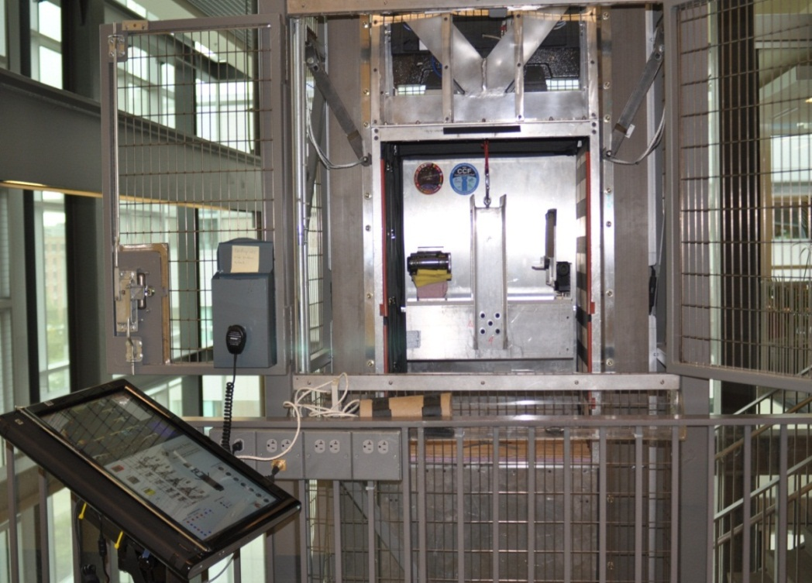  
Figure 1: Chassis hanging inside the drag shield before drop; computer interface on left

Once the operator clips the chassis in, the drag shield and chassis inside it hang from the same pin. When the operator gives the command, the two pieces are released simultaneously. The chassis falls within the drag shield and is weightless for 2.3 seconds; it then comes to rest on a platform inside the shield at the base of the drop tower.

Two DDT operators are usually needed to perform the installation operation (see Figure 2); it is awkward for one person because single handedly one cannot lift and hold the chassis while clipping the karabiner with the other hand. Future combined weights of the chassis and experiment could be as much as 100 lbs. In this situation, it will be impossible for one operator to perform drops using the current manual system and without load assist.

## 

Figure 2: Two people loading the chassis into the drag shield; one operator lifts and holds the chassis and other clips it to the karabiner

## The DDT has the capacity to perform up to 30 drops per day. A single person operates the tower using a computer interface. The only obstruction to this scenario is that the operator must be able to lift the chassis to the pin from the platform at the bottom of the drag shield to reset for each drop. Manually lifting and attaching the chassis between each drop is difficult for a single operator, as explained above, and will be impossible in the future. This impediment limits the efficiency of the DDT and its operators. The device designed by the DDT Capstone team is intended to overcome this limitation and improve the efficiency of DDT processes.

# 6 Mission Statement

The goal of the team is to design and fabricate a lift assist device that will mechanically assist in loading, unloading, and reloading DDT experiment chassis. The tower and surrounding building structure will be modified as little as possible. The team of PSU researchers using the drop tower device for daily drops represents our primary customer base, though outside researchers from other universities and organizations will be able to operate the device with limited instruction. The device will be stored in the nearby DDT lab when not in use or secured to the tower in such a way that prohibits unauthorized operation. The device will be built, thoroughly tested, and installed by June 2012.

# 7 Main Design Requirements

A complete list of the customer’s requirements for this project can be found in the PDS document in Appendix A. The main design requirements are summarized below:

* To load a chassis before a drop, the device must be able to lift the chassis off a horizontal surface near the drop tower; the first load should take fewer than 5 minutes
* For reloading operations, the device needs to quickly lift the chassis vertically from the platform inside the drag shield approximately 1 ft to the top of the drag shield; this reload should take less than 1 minute
* The device must lift at least 100 lbs (for future experiments)
* The device should be safe: no hazards, no protective equipment required, clean, tamperproof
* The device must be user-friendly: easy to control, intuitive to use, ergonomic
* The device must be aesthetically pleasing and look cool

# 8 Top Level Design Alternatives

During the external design search, mechanisms to power the vertical motion of the device were explored. The team chose the 2HBM20 Ball-Screw Linear Motion Actuator made by Thomson Linear, highlighted in Table 1. This system uses a 40 in. long power screw that rotates using an electric motor to translate payloads along the length of the device. The details of the analysis that led to this decision are outlined in Appendix B. The device will be mounted along the front right column of the tower and will provide 36 in. of stroke in the vertical direction.

*Table 1: Mechanisms explored to power vertical motion of the device*

|  |  |  |  |
| --- | --- | --- | --- |
| System | Pros | Cons |  |
| Pneumatic | •Speed  •Versatility  •Low Maintenance  •Clean | •Heavy  •Too big  •Needs compressed air  •$8,500 | Parker Z Series Pneumatic Linear Actuator |
| Hydraulic | •Strong  •Dependable | •Fluid hazards  •Dirty  •Maintenance req’d  •Slow  •$7,800 | Akron Hydraulic Linear Actuator |
| Power Screw | •Accurate  •Dependable  •Speed Variability  •$5,500 | •65-80% efficiency  •Heat 🡪increased tooth wear | Thompson Linear |

Initial internal design searches yielded a lifting device that would have to negotiate around the original drop tower doors, which opened French door style. After approval from the sponsor and structural engineers, the team determined the doors could be converted to a bi-fold door system. The folding door now opens to the left of the operator and sits out of the way of chassis loading and reloading. As a result, the semi-permanent tower-mounted system highlighted in Table 2 was chosen.

*Table 2: Possible concepts and final chosen design*

|  |  |  |  |
| --- | --- | --- | --- |
| System | Pros | Cons |  |
| Over the Door Power Screw | * Articulates over doors * No door change required * Self-aligning * Simpler motion * Fewer moving parts | * Rigid * Fewer degrees of freedom * May interfere with operators |  |
| Floor- Mounted Telescoping Column | * Lowers below path of doors * No door change required * Self-aligning | * May buckle * Many moving parts * In hallway * Expensive |  |
| Tower-Mounted Power Screw | * Several degrees of freedom * Looks cool | * Several degrees of freedom * Less rigid * Requires door change |  |

# 9 Final Design

# 9.1 Electrical System

# *9.1.1 Power*

Power is provided to the motor by an 18 V DeWalt rechargeable drill battery. The DDT operators constantly rotate and charge these batteries for other lab purposes. This system is compatible with what is already available in the DDT lab; it is convenient, less obtrusive, and the power source is removable and thus tamperproof. To begin use, the operators place the charged drill battery in the power fixture (a retrofitted DeWalt drill mounted to layers of PVC board and bolted to the tower; see Figure 3), which leads to an 18 V DeWalt drill motor in a junction box beneath the power screw.

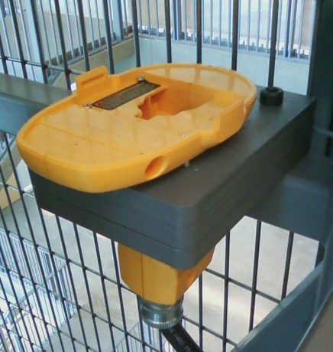 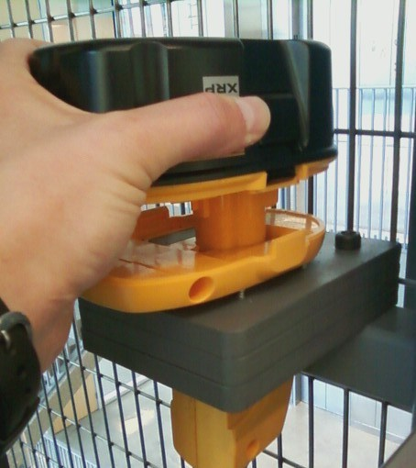 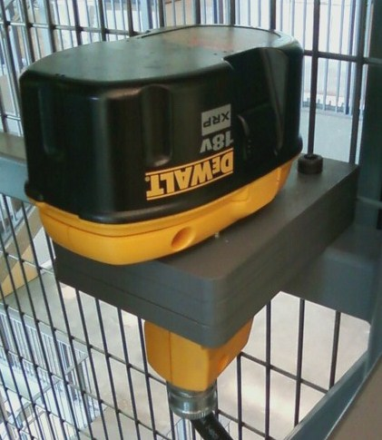

Figure 3: Installation of battery on the power fixture inside Tower. The PVC mount shape was cut with PSU’s laser cutter

# *9.1.2 Motor*

The 18 V DeWalt drill motor is housed in a junction box beneath the power screw (Figure 4). The motor was purchased with a special gearbox that provides a simple output shaft pattern. Without this gearbox, a custom spline sleeve would have had to be machined at great financial cost. To connect the gearbox to the power screw’s input flex collar (a hollow shaft element that allows for slight misalignment between the drive and the screw), a steel bar was turned down on the lathe to create a 3 in shaft. The motor leads attach to the 18 V battery and the controller; it spins the power screw, giving the vertical motion necessary to move the arm.

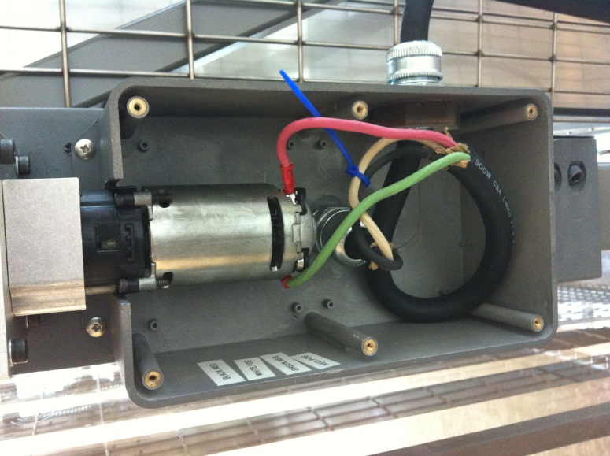 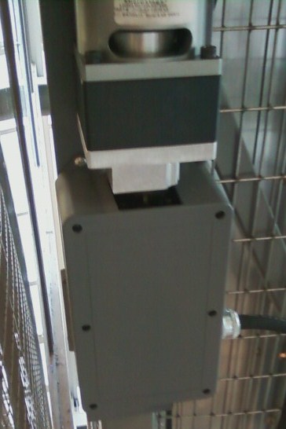

Figure 4: Junction box with leads; motor is housed inside and attached to the power screw

# *9.1.3 Trigger*

The 18 V DeWalt drill trigger switch is the operator’s tool for raising and lowering the arm when working with the experimental chassis. It is housed inside a modified drill handle from a DeWalt power drill. The leads from the trigger go down the handle and along the arm to the motor in the junction box. Pulling the trigger harder makes the motor spin faster; less pressure on the trigger slows the motor, just like a power drill. This enables more precise and continuous vertical motion and helps avoid abrupt contact with the ends of the power screw. Figure 5 shows the modified trigger switch housing. A directional switch attached to the trigger switch enables the user to reverse the motion of the power screw to move the arm up and down.

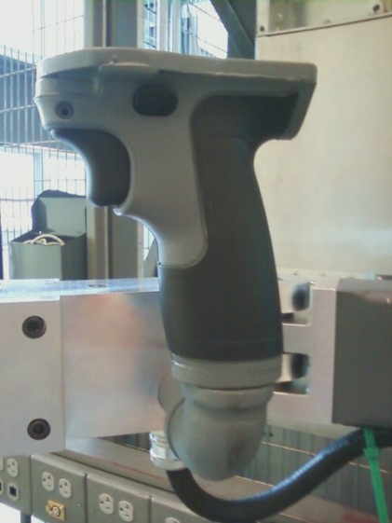

Figure 5: Trigger housing with directional switch

# 9.2 Mechanical System

# *9.2.1 Bracket*

The bracket is designed to affix to the column by clamping forces. The bracket consists of two clamps with mating steel angle sections clamped around the right front column of the tower by eight bolts each (Figure 6). To accommodate the size of both brackets necessary to hold the power screw to the tower, the wire cage surrounding the structure had to be cut. This also facilitated operating on the bracket system when necessary. The bracket was fabricated at Portland State University’s machine shop by the team.

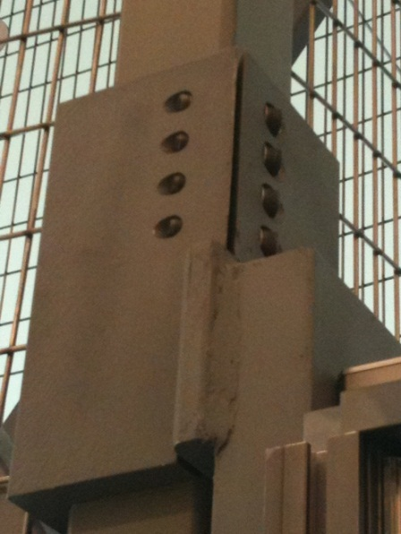

Figure 6: Finished top clamp mounted to the tower

# *9.2.2 Power Screw*

The lifting mechanism for the loader is the core of the design. The mechanism is a 2HBM20 Ball-Screw Linear Motion Actuator from Thomson Linear. It lifts the required load of 100 lbs along 36 in at a rate of up to 2 in/sec. The lifting motion of the power screw is smooth and precise; it is able to stop and start at any point along its stroke length. The power screw mounted in its final position along the tower is shown in Figure 7. To ensure ease of access to the drag shield, the power screw is located away from the center of the tower.

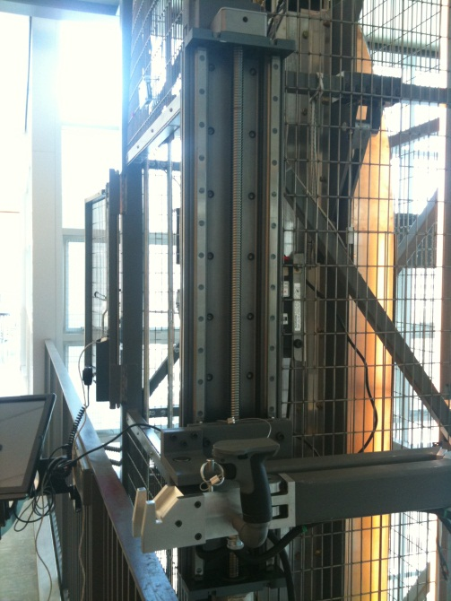

Figure 7: Linear actuator mounted to the tower with arm in folded position

# *9.2.3 Arm*

The arm consists of two arm members and three joints. The arm members are cut from 2 in x 3 in x 3/16 in gauge mild steel rectangular tubing. The joints are clevis, bushing, and dowel assemblies. The first joint connects the arm to a ½ in thick steel plate that bolts directly to the moving platform of the power screw as shown in Figure 8. Because this joint is required to resist the greatest moment loads, 3/4” steel angle iron sections were used to secure the joint to the plate. A solid steel bar was welded to the end of the first arm member and bored out to allow a 1 in steel dowel to be press fitted to the bar (all press fits were designed such that the dowel’s diameter was 0.0001” larger than that of the receiving clevis’s diameter). The ½ in thick steel plate was cut such that it allows the first member to rotate 270° relative to the plate, enabling the arm to reach behind the supporting tower column to which the screw is mounted. The 1 in dowel is linked to the ¾ in steel angle sections via bronze, oil-impregnated bushings fastened with Loctite.

The second and third joints are comprised of two clevises milled from 7075 T6 aluminum (6061 T6 aluminum failed to meet factor of safety requirements as determined by finite element analysis) as seen in Figure 9. The clevises are affixed to steel plates by 5/16 in counter sunk screws. The screws are tapped into ½ in steel plates that are welded to the ends of the steel tube members. The dowels in these less stressed joints are only ¾ in steel dowel and bushing assemblies. The bushings are fastened using Loctite to one clevis and the dowel is held in a fixed position relative to the receiving clevis by setscrews passing through the receiving clevis.

|  |  |
| --- | --- |
| Figure 8: First joint comprised of steel angle iron supports, 1 in steel dowel, and a reamed steel bar welded to the first steel member | Figure 9: Second and third joints comprised of two mating aluminum clevises with set screws to hold ¾ in dowels |

As a safety feature, when the arm is not in use it is retained by inserting a pin through the first joint’s steel clevis and into the interface block at the end of the arm as seen in Figure 10. When the arm is in use, the pin is reinserted to restrict movement of the first hinge such that the first member cannot pass over the banister as seen in Figure 11. The second joint’s geometry prevents the second member from extending beyond 180° relative to the first member, as seen in Figure 12. The two safety features are shown in action in Figure 13.

|  |  |
| --- | --- |
| Figure 10: Pin in stowed position | Figure 11: Pin in operating position |

|  |  |
| --- | --- |
| Figure 12: Second elbow restricting movement | Figure 13: Arm fully extended |

# *9.2.4 Experiment Chassis Interface*

To better facilitate various experiment chassis from visiting institutions, and in an effort to alter the current PSU chassis as little as possible, a universal interface mating system was developed. This consists of two bolted aluminum plates, mountable to an existing chassis; one plate is solid and the other has fork slots. These slots fit the aluminum hook interface on the block at the end of the arm. The two hooks at the end of the arm are what the operator gently leads into the plates on the chassis. Once cleared, the hooks are raised by the trigger driven arm and the plate bolted to the chassis is secure within the hook assembly. The end of the arm then takes the load of the chassis to lift it to the drop tower drag shield. The forked design does not allow the arm to displace any downward force to the chassis. So, when the operator is lowering the arm to transfer the chassis weight to the drag shield, there is no risk of the arm pulling down on the drag shield (a safety concern identified early in the design process). Figure 14 shows the aluminum plates on the experiment chassis and the hook interface that mates with the slotted face.

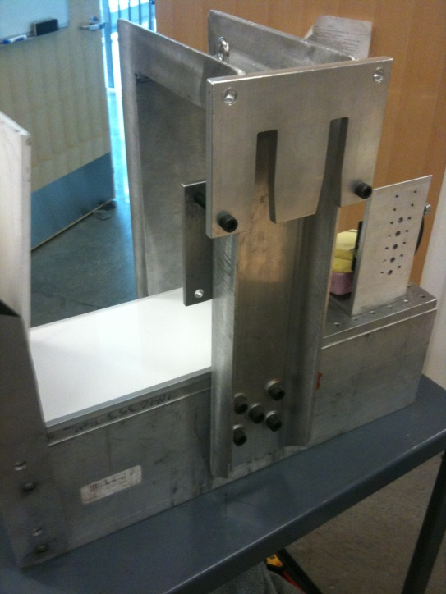 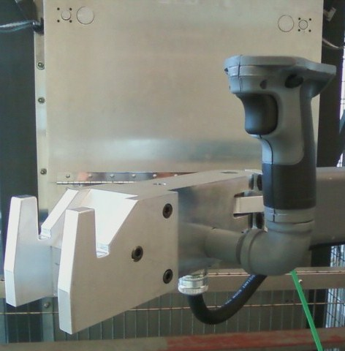

Figure 14: Interface mating system consisting of aluminum forks and matching slotted plate

The bill of materials for this project is listed in Appendix C.

# 10 Evaluations

# 10.1 Function and Performance

All components of the device function as designed. The motor drives the power screw smoothly and the trigger mechanism allows for a continuous range of speeds, resulting in a high degree of precision in control of vertical motion. The joints of the arm move smoothly and consistently and do not drift when the operator releases their grip. The arm-chassis interface is intuitive and effective; the chassis does not wobble or shift while the interface is engaged. After a series of test runs, the average loading time was determined to be \_\_\_\_\_, while the average reloading time was \_\_\_\_\_. Both of these values are well below the PDS requirements of 5 minutes and 1 minute, respectively. When loaded with a 100 lb chassis, the device operates as desired although the joints stiffen slightly.

# 10.2 Reliability/Structural Integrity

Because the device would be installed high above common areas that are frequently occupied by faculty and students, significant efforts were made to ensure that all components were structurally sound. Finite Element Analysis was performed on nearly every component, from the mounting brackets to the individual joint assemblies. For each analysis discussed below, a chassis load of 300 lbs was used to acquire the system’s reaction in accordance with the PDS’s structural Factor of Safety requirement of 3 with a 100 lb chassis load.

# *10.2.1 Brackets, channel, and power screw assembly*

Here we are concerned with how the power screws frame will transfer stress to the supporting steel channel spine and, in turn, to the clamping brackets. Because the arm can move a full 270° around the screw’s axis and can translate up and down the entire axial length of the power screw, there exist an infinite number of possible static loading scenarios. To discretize the loading possibilities, the arm was modeled at five different locations along the screw from the very top of the screw to the very bottom, as seen in Figure 15. In each location, stresses were recorded for the arm in three different positions within the xy plane: normal to the face of the screw, angled 45° from normal, and 90° from normal – effectively modeling 15 individual loading scenarios.

A 300 lb load was placed at the end of the arm and the base of the arm was tied to the power screw in such a way that would simulate the its moving plate interfacing with the its supporting rails (red section in Figure 15). Figure 16 shows the assembly’s stress profiles in several of the aforementioned loading scenarios. See Table 3 for the maximum stress observed in any of the scenarios (arm normal to the power screw and at the very top of the screw).

To accurately model the power screw, a simplified part strictly made of aluminum was created in SolidWorks to approximately the same dimension as the power screw (the actual power screw is mostly made of 6061 T6 aluminum with a small amount of steel reinforcement).

|  |  |
| --- | --- |
| \\khensu\Home05\garbargc\My Documents\Capstone\bracket\FEA\final interactions shot.png | Figure 15: The arm is cantilever supported by the power screw’s rail system over the two red faces. The power screw is tied to the channel continuously and the channel is welded to the clamping brackets. The power screw is partitioned into five sections along its vertical (z) axis. At each of these sections, the arm was loaded at a normal position (as shown), at 45° from normal position, and at 90° from normal position, in the xy plane. |

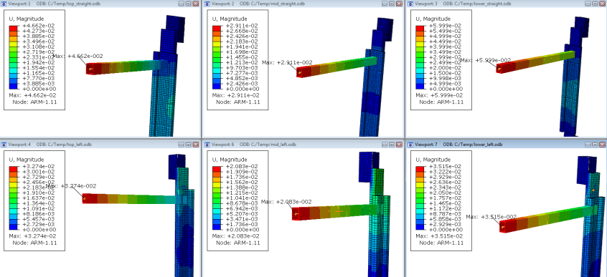

Figure 16: Stress profiles of the arm, screw, channel, and bracket assembly under several different loading scenarios.

# *10.2.2 Angle iron clevises at first joint and supporting steel plate*

A 300 lb downward load was applied to the bottom angle iron over an area equal to the contacting bronze bushing, and a moment load of 1400 ft-lb (56 in x 300 lbs / 12 in / ft) was applied to the vertical faces of the dowel holes in each angle iron. The plate was constrained at the four bolt holes where it is attached to the power screw. The stress profile is shown in Figure 17.

**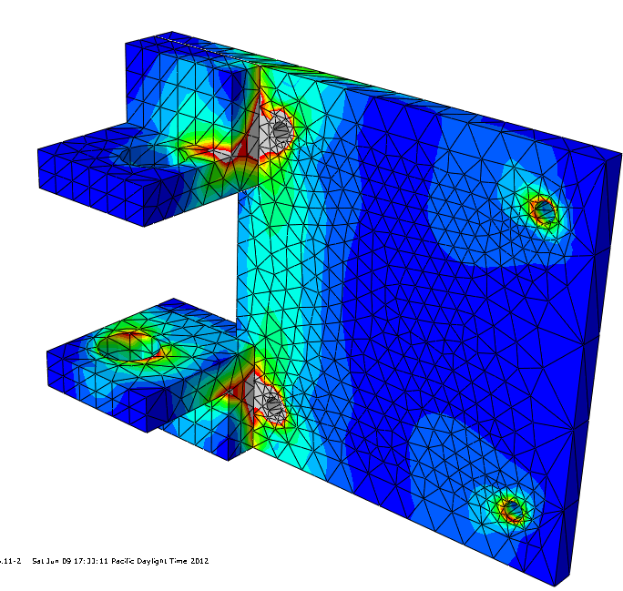**

Figure 17: The plate that attaches the arm to the power screw and its adjoining angle iron clevis mounts that hold the dowel of the first joint are shown under load. Maximum stresses were seven times less than the material’s yield strength.

# *10.2.3 Aluminum Clevises*

These intricate parts, particularly at the joint closer to the screw, are the most vulnerable parts in the system, as indicated by their factor of safety of 1.1 (with a 300 lb load applied to the end of a fully extended arm). Similar modeling methods to those used in the first joint analysis were used here to apply moments and vertical loads. Figure 18 shows the stress profile of the clevis that is closest to the power screw under max load. This study subsequently led to the team electing to use more massive bronze bushings and upgrading to expensive 7075 T6 aluminum for fabrication of the clevises.

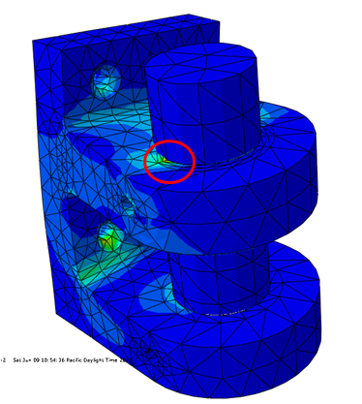

Figure 18: Stress profile of aluminum clevis closest to the power screw under maximum load. Red circle indicates maximum stress location.

# *10.2.4 Hook Interface*

A milder 6061 T6 aluminum was sufficient for these parts as they absorb little moment load due to their proximal location to the chassis load. Figure 19 shows the fork’s stress profile – the forks deformation has been exaggerated by a factor of 75 in this picture.

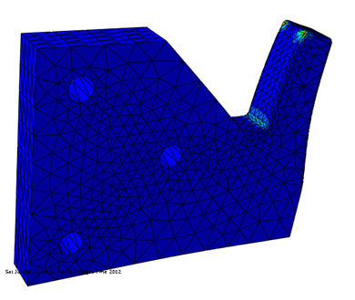

Figure 19: Fork interface stress profile under full 300 lb load. Deformation is exaggerated 75 times.

# 10.3 Cost and Financial Performance

The approved budget for this project was $7,851 plus a 20% contingency, bringing the total approved budget to $9,421. The budget details are shown in Table 3. Materials for the test fixture and additional outsourced machining resulted in exceeding the budget for the bracket and arm, respectively. Those excesses were offset by ending up substantially under budget for the motor and arm materials. Ultimately, the project was successfully completed $1,760 below the approved budget, or $190 below the initial subtotal without breaching the 20% contingency at all.

*Table 3*

|  |  |  |  |  |  |
| --- | --- | --- | --- | --- | --- |
| **Item** | **Quote** | **Cost** | **Spent** | **Difference** | **Notes** |
| Thomson HB20 worm gear with limit switches and freight | Yes | $ 5,051 | $ 4,793 | $ 258 | no limit, home/end switches |
| Two hooks for interface and two sets of chassis interface pieces | Yes | $ 600 | $ 424 | $ 176 | only one set of chassis pieces |
| Materials only for bracket | Yes | $ 200 | $ 559 | $ (359) | includes test fixture |
| Materials only for arm | Yes | $ 700 | $ 334 | $ 366 |  |
| Machining for arm and brackets | No | $ 500 | $ 920 | $ (420) | just for arm |
| Motor and controls | No | $ 800 | $ 540 | $ 260 |  |
| SUBTOTAL |  | $ 7,851 |  | $ 281 |  |
| 20% Contingency on subtotal |  | $ 1,570 | $ 91 | $ 1,479 | doors modification |
| **TOTAL** |  | **$ 9,421** | **$ 7,661** | **$ 1,760** |  |

# 10.4 Environment, Safety, and Ergonomics

When it comes to the drop tower environment, great care was taken to make it as safe as possible since the structure is located in a public hallway. To maintain a safe environment, the arm is held to the power screw by a pin when not in use. In addition, the power supply to the device is removed when not needed. It is located inside the tower with the drag shield; once the door is locked no one can tamper with the power supply. This prohibits unwanted vertical operation of the arm without a DDT operator’s permission.

With regards to ergonomics, upon test trials the DDT operators determined that a horizontally oriented trigger handle would be a better design over the current vertical handle. One reason this is more practical is it creates more working space to hook the experiment chassis to the attachment karabiner. The orientation of the directional switch will change to up and down versus side to side. The only request by the operators is to orient the directional switch such that it is intuitive as to what direction the arm will travel (push switch down, arm travels downward; push switch up, arm travels upward).

# 10.5 Manufacturability and Assembly

The design of the lifter is specific for its intended use with the PSU Dryden Drop Tower. Instructions for installing and removing the instrument are included in Appendix E. Instructions for reproducing the interface are in Appendix G.

# 11 Conclusions

The completed device meets the PDS requirements. The device quickly loads and reloads the experiment chassis, can lift and maneuver a 100 lb chassis, is user-friendly and matches the aesthetics of the existing drop tower. Maintenance should be minimal, but simple when necessary. The device is safe to use and cannot be activated when the battery is disengaged. In conclusion, the project fulfills the needs of the customer.

# Appendix A: Product Design Specifications

1. Performance

* First load: < 5 min
* Reload: < 1 min
* Must lift current/future chassis with experiment
* Must not damage the chassis or experiments
* Must lift ≥ 100 lb
* Will guide chassis into drag shield accurately, precisely

2. Aesthetics

* Must look super cool, appealing

3. Laws, codes, and standards

* Must comply with fire and structural codes
* Must modify tower and surrounding structures as little as possible

4. Ergonomics

* User-friendly, intuitive
* Limited reaching, lifting, and bending
* Space for at least one person to access drag shield and one person to stand nearby

5. Timeline

* Designed and parts ordered before finals of winter term
* Fabricated by mid-May at the very latest
* Testing with drop tower staff by end of May, 2012
* Project finished and submitted to Mark W. one week before hard deadline

6. Safety

* No sharp edges/corners, pinching places
* No danger of falling objects
* Lockable/storable/tamperproof
* No fire hazards
* Does not require protective equipment (glasses, hardhats, etc.)
* Clean
* Built in fail-safes where appropriate

7. Cost

“Thousands but not tens of thousands” – Mark W.

# Appendix B: Power Screw Validation

Linear Movement Actuator Dynamic Load Factor of Safety Analysis

The objective of this analysis is to determine the maximum torque applied to the linear actuator under dynamic loading (accelerating the payload in an upward direction). This analysis focuses exclusively on moment loading as all other forms of loading were well under the manufacture’s specifications. A schematic of the tower, the entire loading system, and the experiment chassis is shown below. The estimated dimensions of the arm fully extended are used to represent a worst-case scenario.



The result of the analysis is the maximum amount of torque applied to the linear actuator’s power screw around the z- and x- axes. This relatively high torque load was a leading design specification in selecting the 2HBM20, which is built specifically to handle high torque loading. The maximum torque was then entered into Thomson’s online system builder to determine the Bearing Load Safety Factor and the Ball Screw Load Safety Factor:

Torque in worst-case scenario around the z- and x- axes under dynamic loading: 1249.7 ft∙lb

Bearing Load Factor of Safety: 1.1 (3.3 with only 100 lb. load)

Ball Screw Load Factor of Safety: 3.4 (10.2 with only 100 lb. load)

*Evaluation*

**Find:**

Maximum torque applied under dynamic loading (arm accelerating in the y-direction)

**Given:**

Maximum load = 100 lbf

Factor of Safety (FS) = 3

Maximum acceleration (as determined by Thomson and customer) = 16 in./s2

Moment arm = 48 in.

**Solution:**

$$Max force with dynamic loading (F_{T})=Gravitation Force \left(F_{g}\right)+Force due to acceleation \left(F_{a}\right)$$

$$F_{g}=100 lbf×FS$$

$$F_{g}=300 lbf$$

$$F_{a}=Mass×Acceleration=\frac{300 lbf}{386 \frac{in.}{s^{2}}}×16 \frac{in.}{s^{2}}$$

$$F_{a}=12.4 lbf$$

$$F_{T}=312.4 lbf$$

$$M_{T}=F_{T}×Moment arm=312.4 lbf×48 in.$$

**Answer: $M_{T}=1249.7 ft∙lbf$**

**Conclusion:** The maximum torque is within the limits of the 2HBM20 System and complies with the PDS required factor of safety of 3 for all components.

# Appendix C: Bill of Materials

| **Vendor** | **QTY** | **Part Number** | **Description** |
| --- | --- | --- | --- |
| Applied Industrial Technologies | 1 | 2HB20LON1045-043N, 2613710 | Power Screw - Thomson 2HB20 System |
| BBC Steel | 1 | 304 #4 stainless steel Channel, 3.55" x 21" | Stainless Steel Channel for Door Modification |
|  | 1 | 1 1/2" x 1/8" SS piano hinge, 6' | Stainless Steel piano hinge for Door Modification |
| Blick Art Materials | 1 | Gravel Montna Spray Paing | Spray Paint for Door Modification |
|  | 1 | Masking Tape | Tape for Door Modification |
| Industrial Machine Services | 2 | 1/2" thick machined hooks | Aluminum hooks for arm/chassis interface |
|  | 1 | 1/4" Square plate | Aluminum Plate for Chassis |
|  | 1 | 3/8" Slotted Plate | Aluminum plate for arm/chassis interface |
|  | 1 | 1" x 1" beveled bar | Mounting plates to chassis |
|  | 1 | Large Clevis Joint Cap 6061 | Joint at power screw |
|  | 3 | Standard Clevisis 7075 | Joints |
| McMaster-Carr | 2 | 3731K15, Ultra tough oil lube bronze flanged bearing | 1" shaft diameter, 1.254" OD, 3/4" length, for arm pin at power screw joint |
|  | 4 | 3731K6, Ultra touch oil lube bronze flanged bearing | 0.75" shaft diameter, 1.004 OD, 3/4" length, pins in arm joints |
|  | 1 | 98381A924 Alloy Steel Dowel Pin | 1" diamter, 5" long, pins for 1st joint |
|  | 1 | 98381A847 Alloy Steel Dowel Pin | 3/4" diameter, 3" long, pins for arm distal arm joints, pack of 5 |
|  | 1 | 92393A390 Aluminum Clevis Pin with Cotter Pin | 3/8" dia, 3 1/4" length, safety pin |
| Metal Supermarkets | 5 | HA534, Hot angle 5.00" x 5.00" x 0.750" Wt, 9.00" | Angle Iron for Vertical support Friction Clamps |
|  | 1 | HC59, HR Standard Channel C5@9, 60.00" | Mount for arm to Power Screw |
|  | 4 | HTSQ2188, HSST Square 2.000" x 2.000" x 0.188" | End caps for arm |
|  | 1 | HTSQ3188, HSST Square 3.000" x 3.000" x 0.188" | End cap for segment closest to power screw |
|  | 4 | HTSQ212238, HSST Square 2.500" x 2.500" x 0.238" |  |
|  | 1 | HTRT32188, HSST RECT 3.000"x2.000"x0.188"x21" | Arm segment closest to power screw |
|  | 1 | HTRT32188, HSST RECT 3.000"x2.000"x0.188"x13.50" | 2nd arm segment |
|  | 1 | HF122, HR FLAT 0.500"x2.000"x 3.00" |  |
|  | 2 | HF128, HR FLAT 0.500"x3.000"x2.90" |  |
|  | 1 | HF128, HR FLAT 0.500"x8.000"x10.00" |  |
|  | 1 | CR1018/2 CR ROUND 1018 2.000" dia x 3.000" | Pin for arm joint at power screw |
| W.C. Winks Hardware | 16 | Cap Screw Socket Hex Aly 3/8"-24x1 3/4 | Friction Brackets |
|  | 20 | Cap Screw Socket Btn SS M8 x 20 | Power screw to channel |
|  | 2 | Set Screw Socket H-Dog Aly 10-24x3/8 |  |
|  | 4 | Cap Screw Socket Hex Aly 1/4-20x3 1/2 |  |
|  | 3 | Cap Screw Socket Hex Aly 5/16-18x2 1/2 |  |
|  | 3 | Cap Screw Socket Hex Aly 5/16-18x3 1/2 |  |
|  | 6 | Hex Nut Finished Br 8 ZC 5/16-18 |  |
|  | 4 | Hex Nut Finished Br 8 ZC 1/4-20 |  |
|  | 2 | Set Screw Socket Cup Aly 10-24x5/8 |  |
|  | 6 | Cap Screw Socket Hex, Aly 1/4"-30 |  |
| DeWalt Service Center | 1 | 152274-23 Switch kit incl. F/R bar | Switch kit / DeWalt trigger for handle control |
|  | 1 | 607981-04SV Clamsell Set | DeWalt Drill casing |
| Robot MarketPlace | 1 | 0-TD-RCM51D DeWalt Powerdrive drive shaft | Power drive from motor to power screw |
|  | 1 | 0-TD-RCM515 DeWalt Powerdrive Kit | Power drive from motor to power screw |
| Lowes Home Improvement | 1 | 33521 DW908 | DeWalt CS 18V Flashlight, Parts for Power receptor |
| Home Depot | 1 | 781756626675, 25' 16/3 Husky Cord | Conduit for Electrical |
|  | 1 | 028875009195, 18V Flex, DeWalt 18V | Xenon Flood Light, for Power |
| USR Electronics Inc. | 1 | CM2828K 1" SQ black adhesive cable tie mount | Secure cable to arm |
|  | 1 | 94800, 2218AWG Red vinyl F-Discon .187" term | insulated butted seam, female disconnect crimp terminal, 0.187" x 0.020" |

# Appendix D: Project Plan

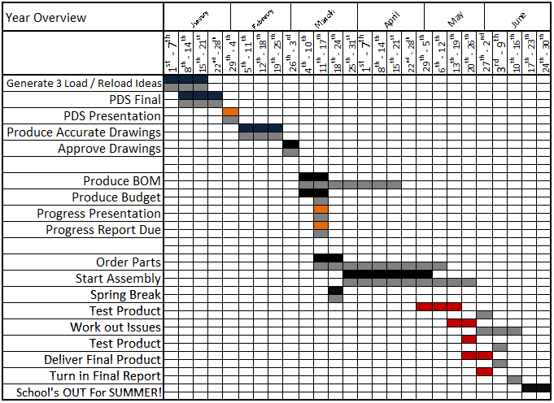

Top line is projected time span; bottom gray line is actual time span.

# Appendix E: Installation Manual

**Step 1: Install Channel with Power Screw to Tower**

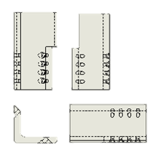

Friction Clamps (2 sets)

Shorter Friction Clamps on top

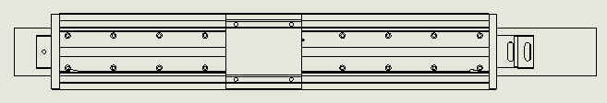

*Thomsen linear power screw and mounting plate on support channel (front shown)*

1. Attach Longer Friction Clamp to tower, top edge of bottom bracket 11” below top face of banister, using 3/8” x 1 ¾” cap screw hex bolts
2. Attach base of channel to the bottom clamp
3. Attach shorter friction clamp to tower and support channel

**Step 2: Arm Assembly**

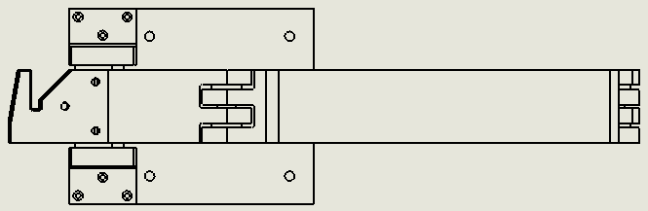

Arm with assembly plate

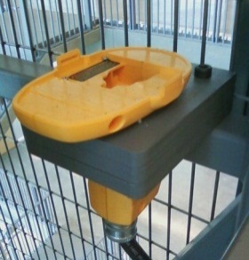

Battery receptor & mount

1. Attach arm assembly plate to mounting plate on the Thomsen linear power screw using 10 mm hex head cap screw
2. Install junction box (plastic box hosting motor, base of power screw)
3. Insert battery receptor into receptor mount
4. Feed wiring from battery receptor through hole to junction box
5. Feed wiring from arm into junction box
6. Install motor
7. Connect arm and power supply to motor
8. Insert battery into receptor and test
9. Install cover on junction box

# Appendix F: Operations Manual

|  |  |
| --- | --- |
| Connect battery to terminal inside of tower cage. | \\stash\mme_capstone\Final Pics\power fixture 3.jpg |
| Remove safety pin holding arm to the side of the cage. |  |
| Articulate arm away from tower and re-insert safety pin. |  |

**Vertical Motion:**

* Variable speed vertical motion is controlled by depressing trigger switch, the farther the trigger is depressed the faster the vertical motion of the arm.
* Reverse vertical motion by pushing the directional switch. This must be done when trigger is not depressed.
* When finished with loading arm, remove safety pin, fold against tower and insert pin back into the locked position.
* Remove battery from terminal.

**WARNING: AVOID PINCH POINT AT ELBOW**

**Appendix G: Chassis Interface**

**